
 | Rocznik Ochrona Środowiska
 | Volume 28 | Year 2026 ISSN 2720-7501 | pp. 250-269
 | https://doi.org/10.54740/ros.2026.019 open access
 | Received: March 2026 Accepted: April 2026 Published: May 2026
Statistical Analysis of Utilization of Bamboo Strips as Reinforcement
in Structural Concrete Elements
Mohit Verma¹, Shagun Pandey², Hanumant Sharan Singh³, Nakul Gupta^{4*}, Parveen Berwal^{5**}
¹Department of Civil Engineering, GLA University, Mathura, Uttar Pradesh, India
https://orcid.org/000000018128599X
²Civil Engineering Department, Rajkiya Engineering College, Bijnor, India.
³Bharat Ratna Sardar Vallabh Bhai Patel, Rajkiya Engineering College, Basti, India
⁴NICMAR Institute of Construction Management and Research, Delhi-NCR, Bahadurgarh, India
⁵Department of Civil Engineering, Galgotias College of Engineering and Technology,
Greater Noida, Uttar Pradesh, India
*corresponding author's e-mail: Nakul030588@gmail.com
**corresponding author's e-mail: berwalparveen88@gmail.com
Abstract: The world is moving toward more sustainable construction, which means we need to find eco-friendly substitutes for traditional materials. Steel reinforcement in concrete makes it very strong and long-lasting, but it poses significant environmental and economic problems. Bamboo is a cheap, eco-friendly choice because it grows quickly and can be used repeatedly. However, concerns about how well it holds up structurally have kept it from being used more widely. An examination of the strength and deformation properties of plain and bamboo-reinforced concrete beams was conducted. All beams that feature bamboo strips as reinforcement in the stress zone have been cast, cured in normal conditions for 28, 56, and 90 days, and then tested to failure with three-point loading. The grade of concrete for investigation was M25, with a proportion of cement, sand, and coarse aggregate of 1:1.34:2.5. Plain concrete beam (PCB) and bamboo-reinforced concrete beam (BRCB) with six other specifications and orientations were tested for flexural strength and deformation. It was observed that the split tensile strength follows a nearly linear relationship with compressive strength. This shows that bamboo reinforcement not only increases load capacity, but in some cases, BRCB6 also provides better energy absorption and ductility. The deflection at first crack was more than 100 percent as compared to PCB for BRCB6. It is also observed that the bitumen-coated BRCB shows higher flexural strength than the non-coated BRCB and PCB. BRCB6 exhibits the highest flexural strength compared to other beam designations on all test days.
Keyword: bamboo-reinforced concrete beam, load, deflection, bamboo strips, linear regressions
1. Introduction
Concrete, which contains cement, sand, water, coarse aggregate, and industrial wastes, is frequently used in construction but is weak in tension and cannot be utilized alone. We strengthened concrete with steel to increase its tensile strength. Since steel is expensive and energy-intensive, its use should be limited. Thus, it is a need of the hour to find a suitable substitute that is environmentally friendly and less energy-consuming. Bamboo is a suitable low-cost alternative to reinforcing steel in concrete (Archila et al., 2018).
In the contemporary era of sustainable development, there is increasing interest in using bamboo for modern construction due to its recyclability, cost-effectiveness, and favorable strength-to-weight ratio (Govindan et al., 2022). Bamboo is strong in both tension and compression, and it is widely available and cheap. Bamboo is an alternative to steel due to its great tensile strength. Bamboo is lighter than steel. In the past two decades, the majority of housing and infrastructure projects have been constructed with traditional materials such as steel and concrete. The demand for traditional building materials has increased in various ways. The production of such materials as steel and cement emits massive amounts of CO₂, which devastates the natural environment.
Bamboo imparts strength, durability, and flexibility when used as a reinforcing material in concrete. Overall, bamboo has been selected as the best, most cost-effective, and environmentally friendly alternative to steel for replacement in masonry structures (Mali & Datta, 2020). Bamboo is a fast-growing, sustainable, eco-friendly material. Bamboo absorbs 1 ton of CO₂ per culm from the environment. It is one of the most abundant commodities in tropical developing nations like India (Chin et al., 2020; Kathiravan et al., 2021). The response of bamboo strips depends on the material's elastic modulus. A finite element model with low accuracy, Bamboo exhibits a low modulus of elasticity and a straight stress-strain curve that increases to failure with no clear yield point (Mondal et al., 2020). Nodes were weaker than inter-nodes subjected to tensile loads, as they failed without warning. The study found that bamboo may substitute for steel in poor construction where steel-reinforced buildings are too expensive or scarce (Qaiser et al., 2020).
Using bamboo as reinforcement instead of steel has cut building costs by 10% to 20%. Using bamboo as reinforcement is 9 times cheaper than steel in terms of economic efficiency (Awolusi et al., 2023).
Numerous experimental and analytical investigations have been conducted in recent years about the mechanical properties of structural bamboo. The results of these investigations show that bamboo has a high strength-to-weight ratio and that its tensile strength ranges from 100 MPa to 400 MPa, depending on the type and age of the plant. One bamboo fiber can have a tensile strength of up to 1000 MPa, which is similar to some types of steel (Cai et al., n.d.; Li et al., 2025; Zhao et al., 2023)
We examined the FTIR and SEM properties of bamboo dust. We concluded that bamboo can be used as a ductile reinforcing material with high tensile strength, making it an excellent substitute for steel. Because of its bonding properties, bamboo can be an excellent material for members subjected to compression and bending (Karthik et al., 2017). There needs to be more research on how to use bamboo as an environmentally friendly building material that is faster to put up and adds value in terms of cost and environmental sustainability. The use of construction and industrial waste is advantageous for environmental friendliness (Dewi & Nuralinah, 2017). The use of pegs along the beam increases cracking and the beam's ultimate load capacity (Archila et al., 2018)
Wrapping the fibers around the bamboo-reinforced beam makes it very strong. The durability tests showed that adding bamboo splints to concrete beams strengthened them, but not by much. It was noted that the strength improved with age. Bamboo reinforcement can make concrete stronger than ordinary concrete and can even replace steel reinforcement in lightweight constructions (Etienne, 2019; Viswanathan et al., 2019).
It was found that bamboo has about half the tensile strength of mild steel and a third the modulus of elasticity of mild steel (Khan, 2014). Corrugated bamboo was discovered to be effective in improving the bond between bamboo and concrete. This contributes to bamboo-reinforced concrete beams having higher bending capacity and reduced deflection (Khatib & Nounu, 2017). Bamboo can be used in place of wood and other building materials. When seasoned bamboo is used as a reinforcing material, it should be waterproofed to reduce swelling when it comes into contact with concrete. The bamboo reinforcement technique is less expensive than steel reinforcement (Nayak, 2013). Bamboo has a very low density, making it a very light material. As the number of nodes increases, so does their capacity to absorb water. Tensile stress increases as the number of nodes increases (Gupta et al., 2015). Bamboo is weak at its nodes, and maximum failure occurs there. Because bamboo has low bond strength, it should be treated with an epoxy coating to improve bond strength. Bamboo has a low shear strength and thus cannot be used as a shear reinforcement (Kaware et al., 2013).
The idea of sustainability in construction has developed over time. The challenge of constrained resources, especially energy, and strategies to mitigate environmental effects garnered the most focus (Ghavami, 2005a). Due to its superior strength-to-weight ratio, reformed bamboo, when integrated with fiber-reinforced mortar, can substantially enhance mortar strength while reducing the composite's overall weight (Yao & Li, 2003). On average, the experimental failure loads of conventional concrete beams with bamboo reinforcement are 2.40 times the theoretical failure load. In contrast, for blended concrete beams with bamboo reinforcement incorporating 15% replacement of cement and 30% replacement of coarse aggregate by fly ash and blast furnace slag, respectively, the corresponding values are 2.43 times the theoretical failure loads. Before cracking, all beams showed linear elastic behavior, but as cracks initiated, inelastic response was observed (Kumar & Prasad, 2003). During an energy crisis, many researchers, both scientists and engineers, are looking for a natural material to replace steel in the construction industry. Bamboo is one of the most intriguing materials, with unique properties such as rapid growth, a high tensile strength-to-weight ratio, and easy availability in tropical regions worldwide. The results of this study indicate that the column reinforced with untreated bamboo had adequate strength to withstand the maximum axial force (Leelatanon et al., 2010).
Several negative consequences are a direct result of consumers' preference for industrialized items. These consequences include a reduction of activities in rural areas or even in small towns, as well as the waste of renewable materials and the resulting pollution that is sustainable. In this way, it's clear that ecological products meet these basic needs. These materials are made from farm waste, such as rice husk, coconut fibers, sisal, and bamboo. Because of this, they use less energy, protect both renewable and nonrenewable natural resources, lower pollution, and keep our environment healthy (Ghavami, 1988; Ghavami & Zielinski, 1988).
Bamboo offers significant economic advantages, as it attains full growth within a few months and reaches maximum mechanical strength in just a few years. Furthermore, it is prevalent in tropical and subtropical climates worldwide (Ghavami, 1995).
Bamboos are large grasses, not trees, as is often believed. They belong to the Bambusoideae family.
The bamboo culm is often a cylindrical shell divided by transverse diaphragms at the nodes. Bamboo shells are orthotropic materials, exhibiting high strength parallel to the fibers and low strength perpendicular to them. Bamboo is made up of long, parallel cellulose fibers that are held together by a structure that is shaped like lines. In the cross-section of a bamboo shell, the fibers are not spread out evenly across the whole length. A material with different functions that has changed over time because of how stress is distributed in its surroundings (Amada, 1997; Liese, 1992).
The research gaps are identified through previous studies by various researchers across the globe. Limited studies exist on the combined effects of bamboo orientation and surface treatment. During the study, it was found that there was a lack of a systematic comparison between coated and uncoated bamboo reinforcement. Insufficient statistical validation of experimental results is available in previous research.
The construction industry is under increasing pressure to adopt sustainable, low-cost alternatives to conventional materials such as steel, which are energy-intensive and contribute significantly to CO₂ emissions. Bamboo, being renewable, economical, and widely available, offers a promising alternative, but its structural applications remain limited due to concerns about durability, bond behavior, and performance variability.
Determining the flexural strength of bamboo-reinforced concrete beams is the objective of the research being conducted. Therefore, the purpose of the study was to analyze the outcomes of applying bamboo strips as reinforcement in concrete beams, with and without a bitumen coating, and to compare the results.
The novelty of this work includes studying the combined influence of bamboo strip orientation and bitumen coating on flexural behavior. The research introduces a new beam configuration (BRCB6) showing maximum strength and ductility. It also establishes a quantitative comparison between coated and uncoated bamboo reinforcement. The experimental study also incorporates statistical validation (ANOVA) to assess the significance of the results.
2. Bamboo as a Construction Material
Figure 1 illustrates the correlation between shell thickness, t, and internodal distance, L, relative to the height of bamboo represented in internodes for the species Dendrocalamus stictus (DS).
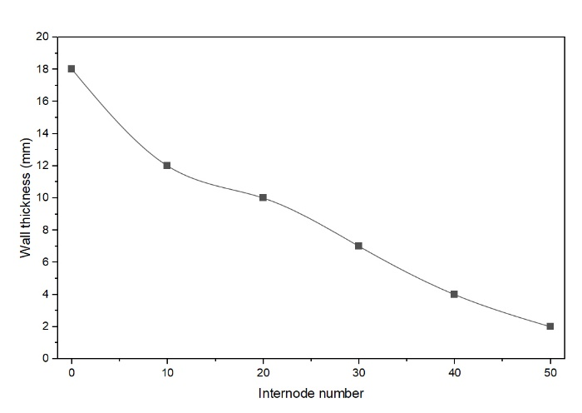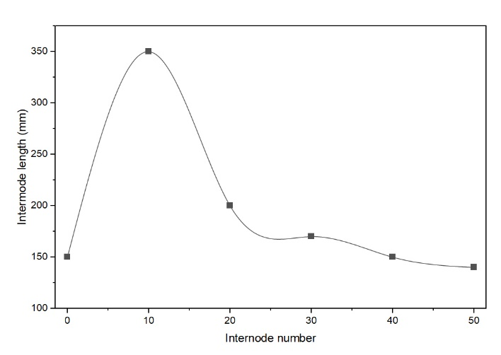
Fig. 1. Thickness and internodal length variation throughout the bamboo culm

In the middle of the culm, internodal lengths are longer. But the thickness goes down from the bottom to the top of the bamboo shell. Based on the data we have, we have created a mathematical formula that relates the internode thickness, t, to the internode position, n.
t = 16.47- 0.30n (1)
Equation (1) establishes the correlation between t and n for bamboo DS. The designer can select the required thickness for the bamboo species DS using this equation.
A primary limitation of bamboo is its water absorption when utilized as reinforcement. The water-absorption capacity of Dendrocalamus strictus (DS) was investigated.
The water absorption of bamboo increases over time. The maximum water absorption was 30 percent, as shown in Figure 2. Ghavami Khosrow performed the water absorption test on different species of bamboo and found out the similar results (Ghavami, 2005b). The dimensional fluctuations of untreated bamboo resulting from water absorption may induce micro- or macrocracks in finished concrete.
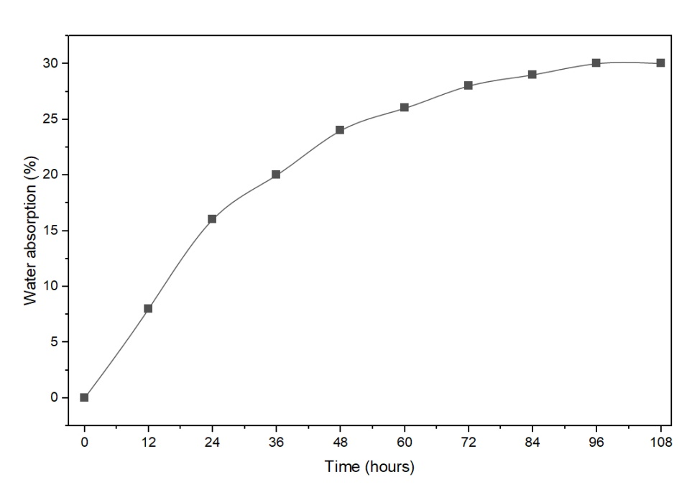
Fig. 2. Water absorption of DS bamboo
3. Experimental Program
Table 1. Material properties
Properties | Standard consistency | Initial setting time (Min.) | Final setting time (Min.) | Specific gravity of Cement | Fineness Modulus of FA | Specific gravity of FA | Zone of FA | Specific gravity of CA | Fineness Modulus of CA
Results | 33 % | 43 | 252 | 3.12 | 2.78 | 2.64 | III | 2.59 | 7.48

The experimental program of this study consists of flexural testing of bamboo-reinforced concrete beams. Flexural tests pertain specimen preparation, epoxy application to the specimens, test setup, and instrumentation. Beam testing involves designing a concrete mix, preparing bamboo and reinforcement, and casting concrete. The beam test setup and instrumentation are thoroughly described.
3.1. Sample Preparation
3.1.1. Bamboo
Bamboo culms had cylindrical shells divided into solid transverse diaphragms by nodes. The sample's thickness varied along its length because it is a natural material whose properties cannot be precisely controlled. To determine the sample's average size, we measured it at five locations along its length.
3.1.2. Bamboo Strips
Bamboo strips are more commonly used in construction than whole culms. Before use, the bamboo plant was chopped and left to dry and season for three to four weeks. The bamboo sample had to be prepared before the flexural strength test could be performed. Bamboo strips of 650 mm length and 30 mm width were cut and dried for 30 days, as shown in Figure 3.

Fig. 3. Bamboo strips
3.1.3. Preparation of Concrete Beams for Flexural Strength Test
A total of sixty-three beam specimens were cast of size 150×150×700 mm. The number of beams for each specification was 9. Seven different specifications were chosen, as listed in Table 2.

Table 2. Specification and pictorial view of Bamboo RCB
S.No | Beam Designation | Specification | Pictorial View
1 | PCB | Control mix | 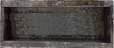
2 | BRCB1 | Bamboo strips were positioned with the polished side oriented towards the underside  of the beam | 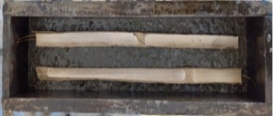
3 | BRCB2 | Bamboo strips were positioned with  the rough side oriented towards the bottom of the beam | 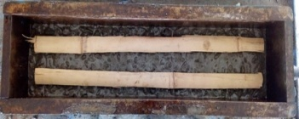
4 | BRCB3 | The thickness was anchored by concrete, with both bamboo strips oriented towards one another | 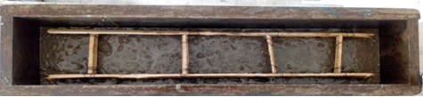
5 | BRCB4 | The polished surfaces of the bamboo strips were oriented downward, in contact with the bottom of the beam mold, and were  treated with bitumen | 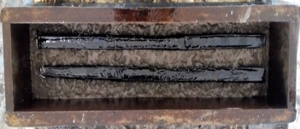
6 | BRCB5 | The rough side of the bamboo strips was oriented towards the bottom of the beam mold and was coated with bitumen | 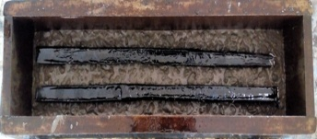
7 | BRCB6 | The thickness was anchored by concrete, with both bamboo strips oriented towards each other and coated with bitumen | 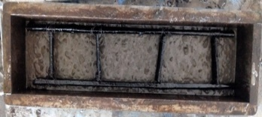
3.2. Beam Specimen and Curing
Concrete is poured into a mould measuring 150 mm by 150 mm and 700 mm in length. Bamboo strips were not used in the plain concrete beam. With a 30 mm effective cover for a moderate environment, two bamboo strips were placed at the bottom. The test specimens were stored at room temperature for 24 hours in a vibration-free atmosphere. The specimens were removed and marked after this time period. In an atmospheric curing tank, the specimens were soaked for 28, 56, and 90 days. Three specimens from each mix were cured and tested for 28, 56, and 90 days. Figure 4 shows the line diagram of the dimensions of the sample beam. Figure 5 shows the cross-section of a plain and bamboo-reinforced concrete beam for different designations.
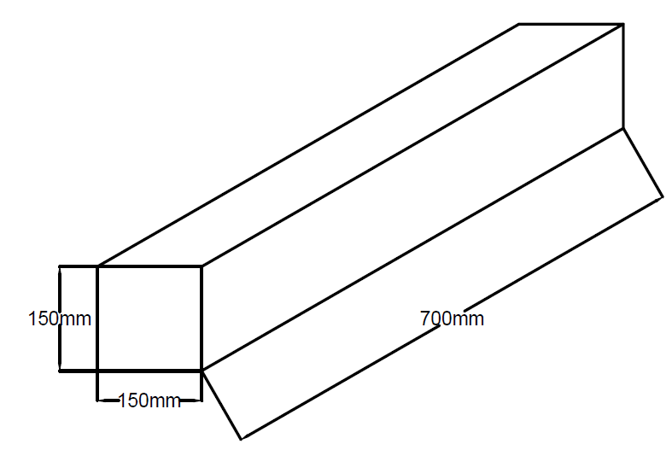
Fig. 4. Dimensions of the sample beam used in the experiment

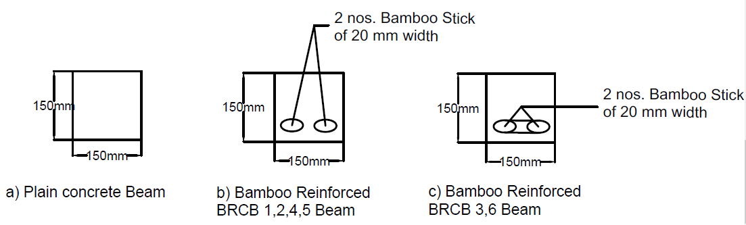
Fig. 5. Concrete Beam cross section with and without Bamboo Reinforcement for different beam designations
4. Test Results and Discussion
Mix Design of M25 Grade Concrete (OPC 43) has been made as per IS code 10262:2009. Proportion of cement, sand and coarse aggregate was 1:1.34:2.5. Cement, water, fine aggregate and coarse aggregate in proportion in one cubic meter were 438.13 kg, 197.16 kg, 1097 kg and 591.03 kg, respectively. Figure 6 shows the line diagram of the flexural strength test setup for the beam.

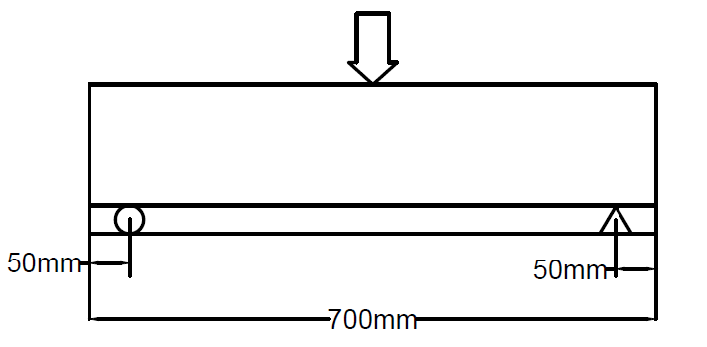
Fig. 6. Line diagram for the test setup for the flexural strength of the beam
4.1. Compressive and Split Tensile Strength and Their Ranalysis
Figures 7 and 8 show the compressive and split tensile strengths of concrete, respectively. The experimental data revealed that the compressive strength was 32, 35.2, and 37.4 MPa at 28, 56 and 90 days of testing, respectively.
It is also observed that the split tensile strengths were 3.1, 3.43, and 3.62 MPa at 28, 56, and 90 days of testing, respectively.
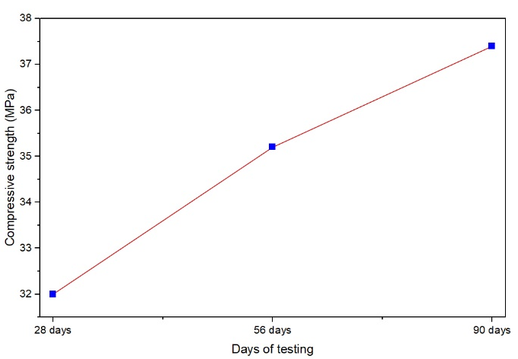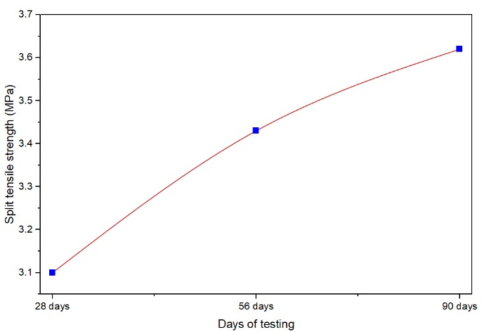
Fig. 7. Compressive strength of concrete Fig. 8. Split tensile strength of concrete

Figure 9 shows the linear regression between split tensile and compressive strength of concrete. The correlation between split tensile and flexural strength of concrete is given by f_{ct} = 0.50026+0.08244f_{ck} with a high coefficient of determination R² = 0.97899. This means that the split tensile strength goes up almost linearly with the compressive strength. Compressive strength explains about 97.9% of the variation in tensile strength. The results show that the compression strength of concrete can be used to determine its tensile strength precisely.

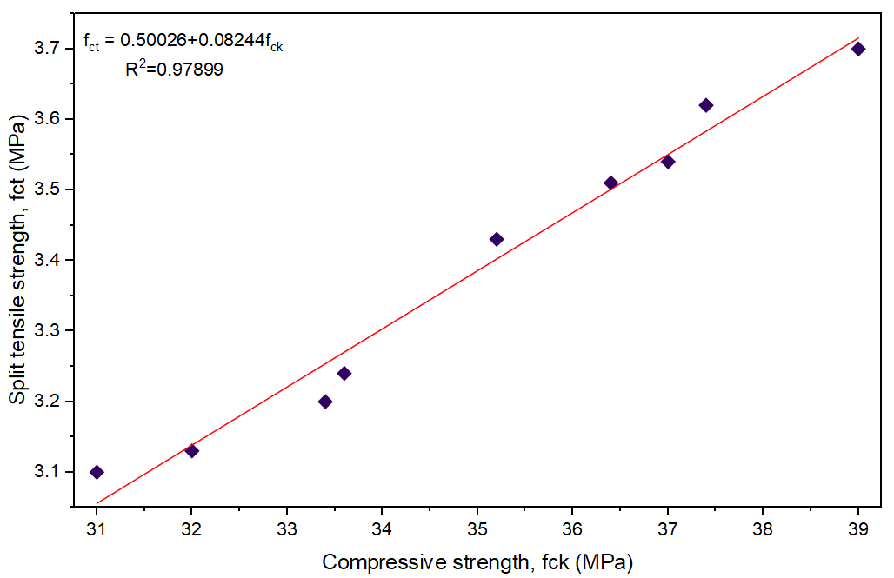
Fig. 9. Linear regression curve between split tensile and compressive strength of concrete
4.2. Load and Displacement at 28 Days of Testing
Table 3. Load and displacement at 28 days of testing
S.No. | Type of beam | Load at first crack (kN) | Deflection at first crack (mm) | Ultimate load (kN) | Diflection at ultimate load (mm)
1 | PCB | 15.10 | 1.30 | 18.0 | 2.17
2 | BRCB1 | 16.15 | 1.46 | 20.2 | 2.10
3 | BRCB2 | 16.30 | 1.12 | 20.4 | 1.80
4 | BRCB3 | 16.70 | 1.33 | 20.8 | 2.25
5 | BRCB4 | 16.60 | 2.4 | 20.75 | 3.20
6 | BRCB5 | 16.50 | 1.25 | 20.5 | 2.02
7 | BRCB6 | 17.60 | 2.98 | 22.0 | 4.95
Table 3 compares Plain Cement Beam (PCB) with Bamboo Reinforced Cement Beams (BRCB1–BRCB6) in terms of load at first crack, deflection at first crack, ultimate load, and deflection at ultimate load. The control beam (PCB) showed the first crack at 15.1 kN. All bamboo reinforced beams (BRCB1–BRCB6) exhibited higher cracking load (16.15–17.6 kN). The maximum improvement is observed in BRCB6, which is about 16.5% higher than PCB. This indicates that bamboo reinforcement enhances the cracking resistance compared to plain beams.
PCB deflected 1.3 mm at cracking. BRCBs show a range of 1.12–2.98 mm, indicating variability in stiffness due to bamboo placement and bond. BRCB2 showed the least deflection (1.12 mm, stiffer response), while BRCB6 showed the maximum (2.98 mm, more ductile response). This suggests bamboo reinforcement influences flexibility differently depending on beam configuration.
PCB failed at 18 kN, while bamboo reinforced concrete beams sustained 20.2–22 kN. The highest capacity was again for BRCB6, a 22% improvement over PCB. All bamboo beams carried higher ultimate loads, confirming their load-bearing enhancement.
PCB failed at 2.17 mm deflection. BRCBs had ultimate deflections ranging from 1.8 to 4.95 mm. BRCB2 showed a stiffer failure, whereas BRCB6 exhibited the highest ductility. This shows that bamboo reinforcement not only increases load capacity but, in some cases, BRCB6 also provides better energy absorption and ductility.

Table 4. Load and displacement at 56 days of testing
S.No. | Type of beam | Load at first crack (kN) | Deflection at first crack (mm) | Ultimate load (kN) | Deflection at ultimate load (mm)
1 | PCB | 16.00 | 1.38 | 19.60 | 2.25
2 | BRCB1 | 16.40 | 1.33 | 20.50 | 2.17
3 | BRCB2 | 16.34 | 1.13 | 20.35 | 1.80
4 | BRCB3 | 17.15 | 1.41 | 21.40 | 2.32
5 | BRCB4 | 17.65 | 2.36 | 20.80 | 3.90
6 | BRCB5 | 17.55 | 1.30 | 20.65 | 2.10
7 | BRCB6 | 17.70 | 3.13 | 22.50 | 5.17

Table 4 reflects the experimental data for load and deflection at 56 days of testing. The PCB showed a cracking load of 16 kN. All other beam designations exhibit greater load at first crack than PCB. BRCB6 showed 9.6% higher cracking load than PCB. The deflection was also observed to be greater in the BRCB case in all cases, compared to the PCB case. The ultimate load and deflection at ultimate load also followed the same trend as shown in Table 4.

Table 5. Load and displacement at 90 days of testing
S.No. | Type of beam | Load at first crack (kN) | Deflection at first crack (mm) | Ultimate load (kN) | Deflection at ultimate load (mm)
1 | PCB | 16.40 | 1.35 | 19.90 | 2.25
2 | BRCB1 | 16.74 | 1.40 | 20.30 | 2.32
3 | BRCB2 | 16.62 | 1.12 | 20.65 | 1.87
4 | BRCB3 | 17.22 | 1.40 | 21.50 | 2.32
5 | BRCB4 | 17.70 | 2.38 | 20.85 | 3.97
6 | BRCB5 | 17.60 | 1.35 | 20.70 | 2.25
7 | BRCB6 | 17.74 | 3.15 | 22.60 | 5.25

Three-point loading was applied to the beam specimen to obtain the cracking load, ultimate load, and deflection at the cracking load and at the ultimate load at 90 days of testing, as shown in Table 5. The bamboo-reinforced concrete beam for all beam designations showed higher cracking and ultimate load. BRCB6 achieved the highest value among the other beam designations. It is an 8.17% and 13.56% improvement in cracking load and ultimate load over PCB for BRCB6, respectively. BRCB6 also showed the highest ductility among the other beam designs. The deflection at first crack was 133 percent higher than PCB for BRCB6.

4.3. Load Deflection Plot Analysis
An illustration of the load–deflection behavior of the specimen at 90 days of testing may be found in Figure 10. The x-axis shows deflection, ranging from 0 to 2.25 mm. On the other hand, the y-axis shows the equivalent applied load, which ranges from 0 to 19.9 kN.

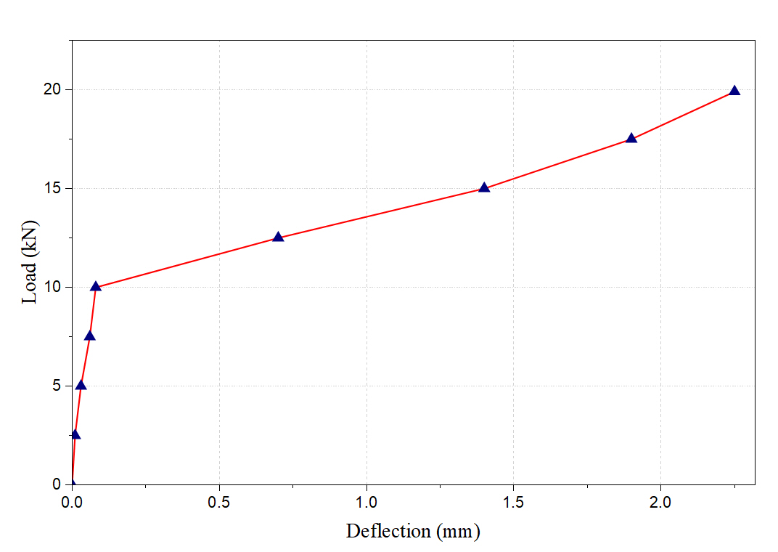
Fig. 10. Load-Deflection curve for plain concrete beam (PCB)

The plot indicates an initial sharp rise in load with minimum deflection, denoted by blue triangular points connected by a red line. The load reaches 10 kN with less than 0.1 mm of deflection. After this, there is a progressive, practically linear increase in load, accompanied by an increase in deflection. With a deflection of 2.25 mm, the load capacity continues to increase steadily, reaching 19.9 kN overall.
Following a more ductile response with maintained load-bearing capacity at greater deflections, the curve indicates that the specimen demonstrates strong initial stiffness, as evidenced by the steep initial slope. The steep slope supports this finding. The fact that this pattern occurs indicates that the structure is structurally sound and resistant to failure under gradually increasing loads.
The load-deflection relationship of the tested specimen at 90 days of testing is shown in Figure 11(a). The curve starts with a rapid increase, indicating it is quite stiff. The load reaches about 10 kN at a very small deflection (~0.08 mm). The slope starts to level out beyond this point, exhibiting a linear-like rise in load with deflection. The maximum recorded load is 20.3 kN at a deflection of 2.32 mm, indicating that the material is very ductile and can withstand significant loads over time.
Figure 11(b) shows a pattern similar to the first one, with a steep rise in load at first, followed by a gradual rise. The specimen reaches 10 kN with a deviation of about 0.1 mm, then shows a steady linear trend. The highest measured load, on the other hand, is 20.65 kN with a deflection of 1.87 mm. This means the material is less ductile and can only withstand a little less weight than in Figure 11(a). This suggests that it can absorb less energy.
Once more, Figure 11(c) shows strong initial stiffness, with 10 kN obtained with a deflection of about 0.08 mm. Then, the curve rises steadily until it reaches a maximum load of 21.5 kN at a deflection of 2.32 mm. This means it is more ductile than Figures 11(a) and 11(b), but its ultimate load is slightly lower than that of Figure 11(a).
All three figures have high initial slopes, indicating they are equally stiff in the elastic range. Figure 11(a) had the most strength, then Figure 11(c), and Figure 11(b) had the least. Figure 11(c) had the greatest deflection capacity, meaning it could deform more before breaking. Figure 11(a) is the best in terms of both strength and ductility, Figure 11(c) is the best in terms of ductility, and Figure 11(b) is the worst in both.

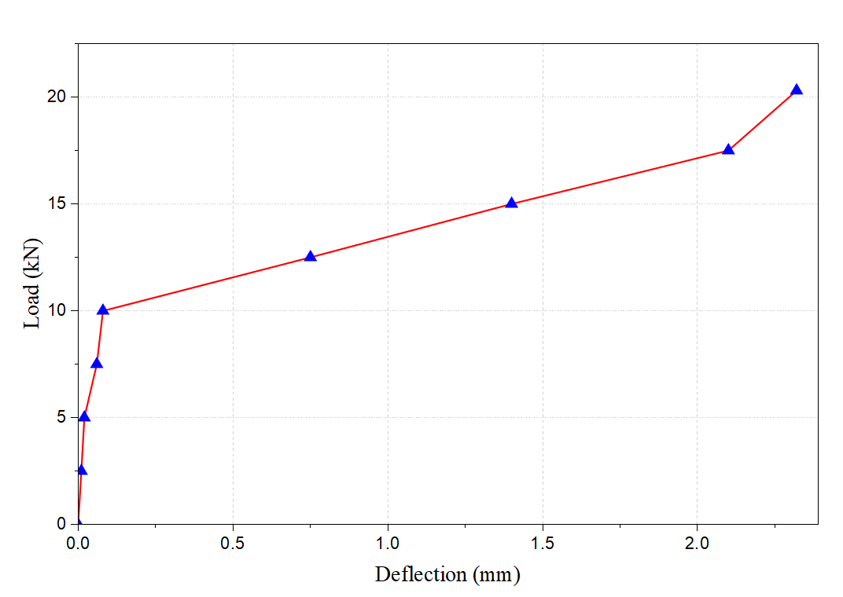
Fig. 11(a). Load-Deflection curve for BRCB 1

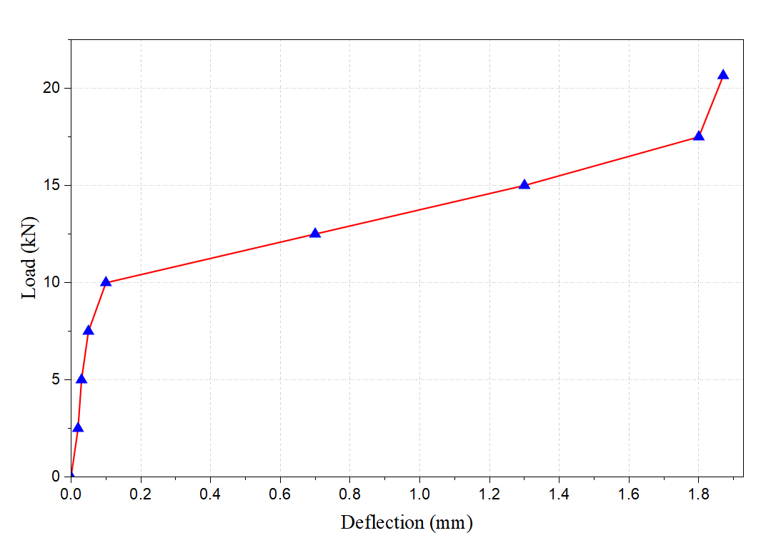
Fig. 11(b). Load-Deflection curve for BRCB 2
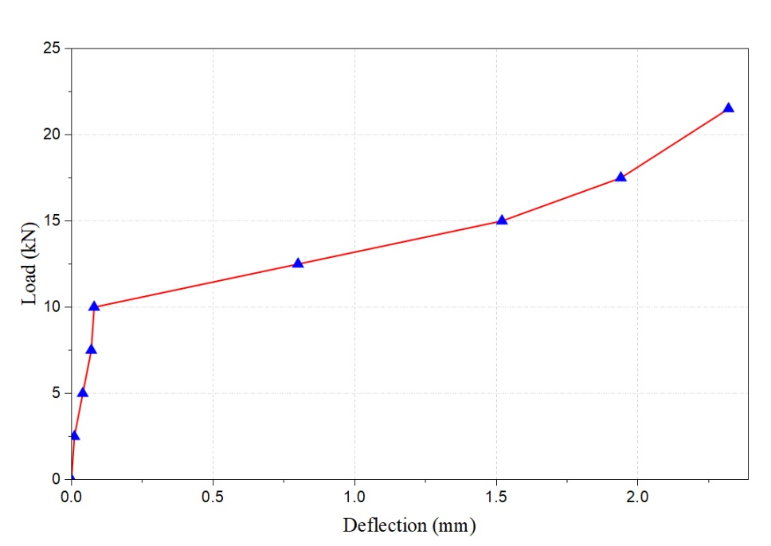
Fig. 11(c). Load-Deflection curve for BRCB 3

The load-deflection curve for the specimen at 90 days of testing is shown in Figure 12(a). The graph shows a sharp initial slope, and the load rises to 10 kN at about 0.08 mm of deflection, suggesting that the material is very stiff at first. The curve then moves in a straight line, reaching 20.85 kN at 3.97 mm of deflection. The wide deflection range shows that the material is quite ductile and can change shape significantly before reaching its maximum load.
Figure 12(b) shows a similar initial reaction, with the load quickly rising to 10 kN at a deflection of about 0.08 mm. The slope after that, on the other hand, is a little steeper than in Figure 12(a), and the maximum load is only 20.7 kN at a deflection of 2.25 mm. This shows that the material is less ductile than in Figure 12(a), but the ultimate load capacity is still similar.
Figure 12(c) also shows the typical steep beginning slope, which reaches 10 kN with a deflection of about 0.08 mm. The load continues to increase until it reaches a maximum of 22.6 kN at a deflection of 5.25 mm. This shows that this specimen has the greatest ductility of the three, with a wider range of deformation while maintaining the same peak load.
The starting stiffness of all three curves is approximately the same, with a load of 10 kN rising to ~0.08 mm deflection. The peak load remains about 22 kN across all scenarios, indicating that the material strength is probably the same.

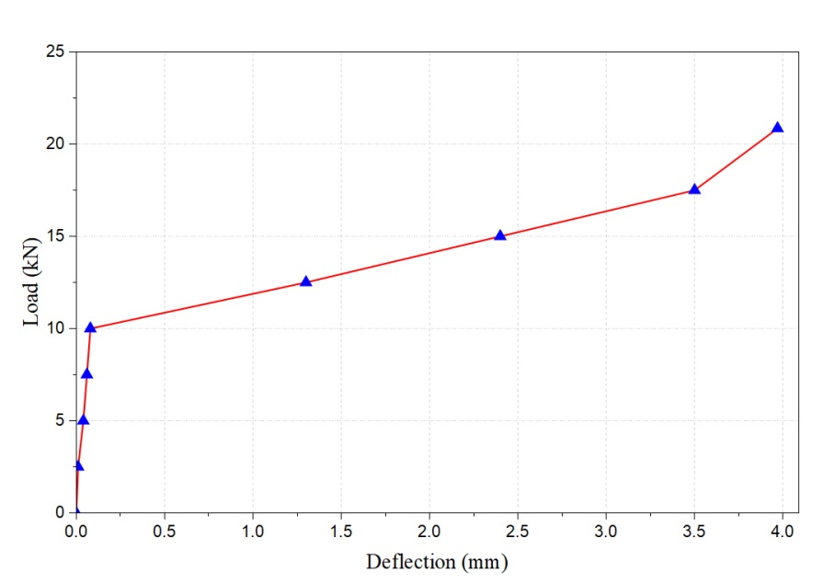
Fig. 12(a). Load-Deflection curve for BRCB 4
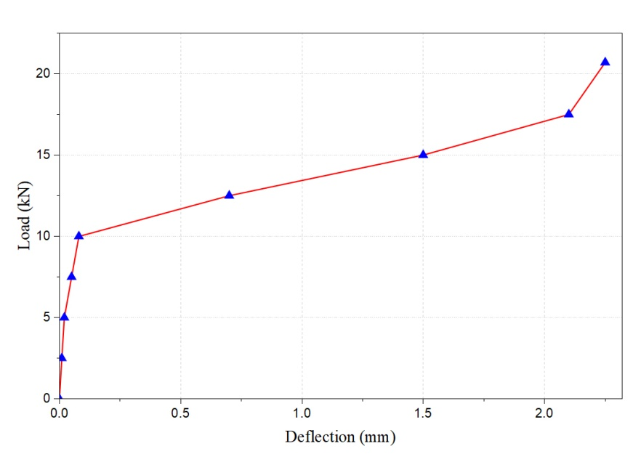
Fig. 12(b). Load-Deflection curve for BRCB 5

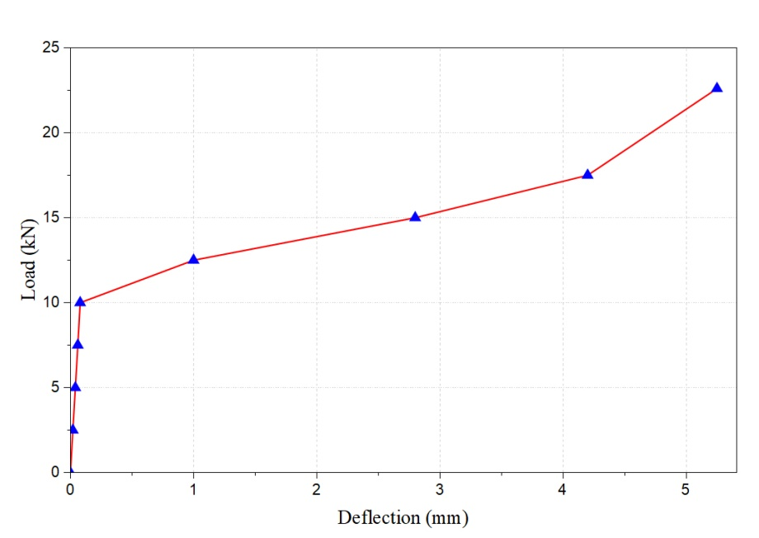
Fig. 12(c). Load-Deflection curve for BRCB 6

Figure 12(c) shows the greatest deformation capability, followed by Figure 12(a), and Figure 12(b) shows the least ductility. All of the samples can withstand the same amount of weight, although Figures 12(a) and 12(c) may work better when energy absorption and deformation tolerance are needed. Figure 12(c) is the best for ductile performance.
4.4. Comparison of Flexural Strength and Deflection of Beam for Various Days of Testing
From the experimental study, it is observed that the bamboo-reinforced concrete beam (BRCB) exhibits greater flexural strength than the plain concrete beam (PCB). Also, bitumen-coated BRCB shows higher flexural strength than BRCB.
Figure 13 shows that beam designation BRCB3 has a 15.62 percent higher flexural strength than PCB at 28 days of testing. Whereas beam designation BRCB6 shows 22.18 percent higher flexural strength than PCB and 5.67 percent higher than BRCB3 at 28 days of testing. The flexural strength also depends on the orientation of the bamboo strips. The maximum value occurs when the thickness is supported by concrete, with both bamboo strips oriented towards each other and coated, with or without bitumen, as in the beam designations BRCB3 and BRCB6. The same pattern of flexural strength for the beam designation was also observed for 56 and 90 days of testing.

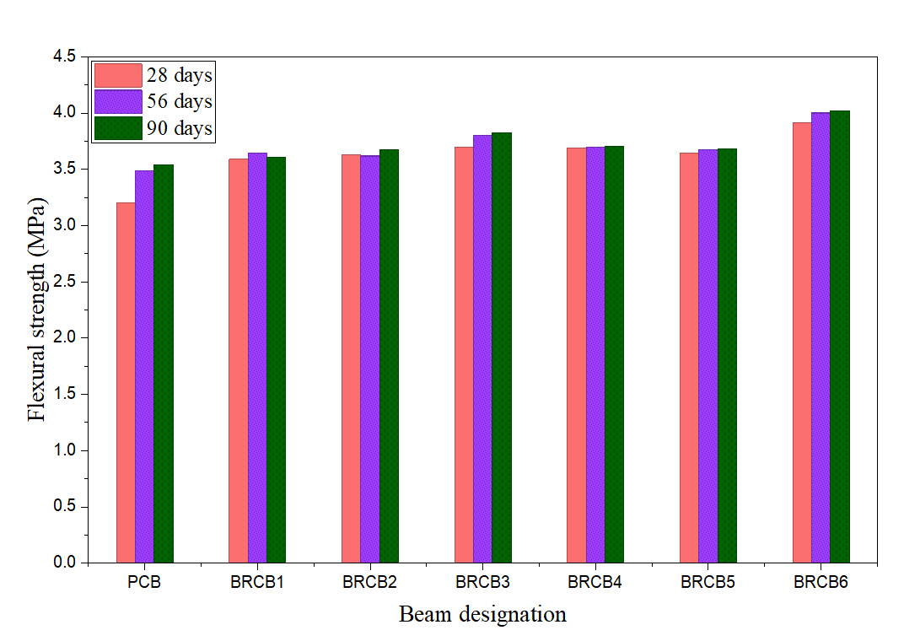
Fig. 13. Flexural strength of concrete beam for various days of testing

Figure 14 shows the deflection of the concrete beam for various beam designations. Bitumen-coated BRCB shows the highest deflection among the non-coated BRCB and PCB for all days of testing. A bamboo-reinforced concrete beam with strips facing each other, coated with bitemen, shows the maximum displacement. BRCB shows higher deflection than PCB. It is 3.68 percent higher than PCB. For beam designations BRCB4 and BRCB6, the deflections are 76.44 percent and 133 percent higher than PCB at 90 days of testing, respectively. A higher deflection value indicates the ductile nature of the bamboo-reinforced concrete beam.

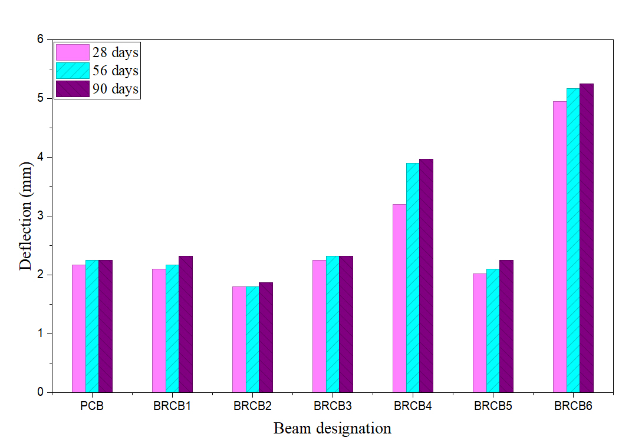
Fig. 14. Deflection of concrete beam for various days of testing

Crack Patterns: Initial cracks were observed in the tension zone (bottom fiber) of the beams under flexural loading. Bamboo reinforced beams showed delayed crack initiation compared to plain concrete beams. Crack propagation in BRCB specimens was more distributed and gradual, indicating improved stress redistribution.
Bamboo Behavior at Failure: Failure was primarily governed by flexural cracking, followed by gradual widening of cracks. Bamboo reinforcement exhibited no yielding plateau and sustained load throughout its linear elastic behavior until failure. In some cases, failure occurred due to slippage or bond loss between bamboo and concrete, especially in uncoated specimens. Bitumen-coated bamboo showed better bond performance and reduced premature debonding.
These observations confirm that bamboo reinforcement contributes to ductile failure behavior and improved energy absorption, compared to brittle failure in plain concrete beams.
4.5. Statistical Test Calculation Summary
4.5.1. Essential Aspects of One-Way ANOVA Analysis (Flexural Strength vs Curing Age)
A one-way ANOVA was used to evaluate the effect of curing age on flexural strength. Table 6(a), (b), and (c) show descriptive statistics, overall ANOVA, and fit values, respectively. A progressive increase in mean strength was noted with age, as shown in Figure 15(a), (b); however, statistical analysis revealed that the differences among curing ages were not significant at the 95% confidence level. The mean flexural strength shows a slight increase from 28 to 90 days, indicating ongoing hydration and strength enhancement. The data overlap indicates that the rise in flexural strength with age may be gradual rather than statistically significant, as shown in Figure 15(c).

Table 6(a). Descriptive Statistics
 | N Analysis | N Missing | Mean | Standard Deviation | SE of Mean
28 days | 7 | 0 | 3.62286 | 0.21345 | 0.08068
56 days | 7 | 0 | 3.70286 | 0.16228 | 0.06133
90 days | 7 | 0 | 3.72063 | 0.15750 | 0.05953

Table 6(b). Overall ANOVA
 | DF | Sum of Squares |  | Mean Square | F Value | Prob>F
Model | 2 | 0.03798 | 0.01899 |  | 0.58912 | 0.56516
Error | 18 | 0.58020 | 0.03223
Total | 20 | 0.61818

Table 6(c). Fit Statistics
R-Square | Coeff Variation | Root MSE | Data Mean
0.06144 | 0.04876 | 0.17954 | 3.68212

Table 6(d). Tukey Test
 | Mean Diff | SEM | q Value | Prob | Alpha | Sig | LCL | UCL
56 days 28 days | 0.08000 | 0.09597 | 1.17893 | 0.68754 | 0.05 | 0 | -0.16492 | 0.32492
90 days 28 days | 0.09778 | 0.09597 | 1.44091 | 0.57484 | 0.05 | 0 | -0.14714 | 0.34270
90 days 56 days | 0.01778 | 0.09597 | 0.26198 | 0.98128 | 0.05 | 0 | -0.22714 | 0.26270

Fig. 15(a). Bar Chart

Fig. 15(b). Means Plot (SD as Error)

Fig. 15(c). Box Chart

The Tukey test is performed to assess pairwise differences in mean flexural strength across curing ages following one-way ANOVA, as shown in Table 6(d). Tukey's HSD post-hoc analysis indicated no significant pairwise differences in flexural strength at 28, 56, and 90 days of curing, suggesting that the age-related increases in strength are minimal and within experimental variability. All comparisons yielded p-values exceeding 0.05, indicating no statistically significant differences across pairs of curing ages. All computed
q-values are below the threshold q-value for α = 0.05, indicating non-significance.
4.5.2. Essential Findings from One-Way ANOVA Examination (Deflection in Relation to Curing Age)
The bar chart in Figure 16(a) shows a gradual increase in mean deflection from 28 to 90 days, indicating time-dependent deformation behavior. The box plots illustrate overlapping interquartile ranges and similar spreads across curing ages, suggesting comparable variability within each group Figure 16(c). Mean deflection increases with age, as shown in Figure 16(b); however, within-group variability is significantly higher than the differences between group means. The overlapping distributions suggest that the one-way ANOVA will likely indicate that curing age does not exert a statistically significant effect on deflection at the 95% confidence level. Table 7(a), (b), and (c) present the descriptive statistics, the overall ANOVA, and the fit values, respectively. One-way ANOVA reveals that although mean deflection rises with curing age, the differences among 28, 56, and 90 days are not statistically significant, attributed to considerable overlap in data variability.
The ANOVA results indicate that variations with curing age (28, 56, 90 days) are not statistically significant (p > 0.05). However, the observed improvements in flexural strength and ductility are primarily due to reinforcement configuration (especially BRCB6 and bitumen coating), not curing age. Thus, statistical insignificance applies only to curing age, not to reinforcement type. Experimental trends still show consistent improvement in performance compared to control beams (PCB).

Table 7(a). Descriptive Statistics
 | N Analysis | N Missing | Mean | Standard Deviation | SE of Mean
28 days | 7 | 0 | 2.64143 | 1.11088 | 0.41987
56 days | 7 | 0 | 2.81571 | 1.2413 | 0.46917
90 days | 7 | 0 | 2.89 | 1.24133 | 0.46918

Table 7(b). Overall ANOVA
 | DF | Sum of Squares | Mean Square | F Value | Prob>F
Model | 2 | 0.22792 | 0.11396 | 0.07922 | 0.92416
Error | 18 | 25.89466 | 1.43859
Total | 20 | 26.12258

Table 7(c). Fit Statistics
R-Square | Coeff Var | Root MSE | Data Mean
0.00873 | 0.43107 | 1.19941 | 2.78238

Table 7(d). Tukey Test
 | MeanDiff | SEM | q Value | Prob | Alpha | Sig | LCL | UCL
56 days 28 days | 0.17429 | 0.64111 | 0.38445 | 0.96017 | 0.05 | 0 | -1.46193 | 1.8105
90 days 28 days | 0.24857 | 0.64111 | 0.54832 | 0.92084 | 0.05 | 0 | -1.38764 | 1.88479
90 days 56 days | 0.07429 | 0.64111 | 0.16386 | 0.99263 | 0.05 | 0 | -1.56193 | 1.7105

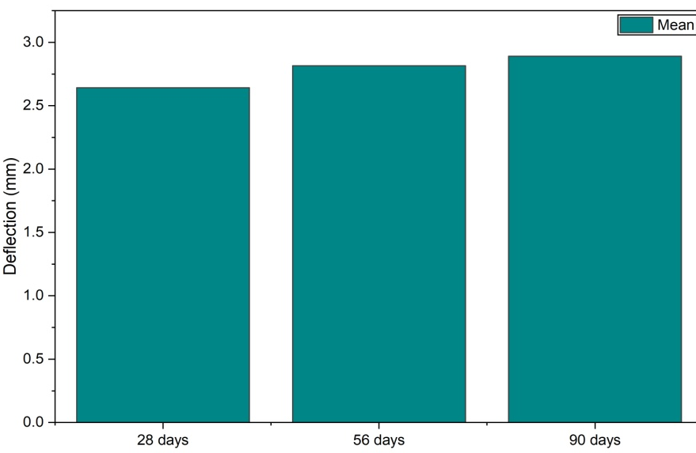
Fig. 16(a). Bar Chart

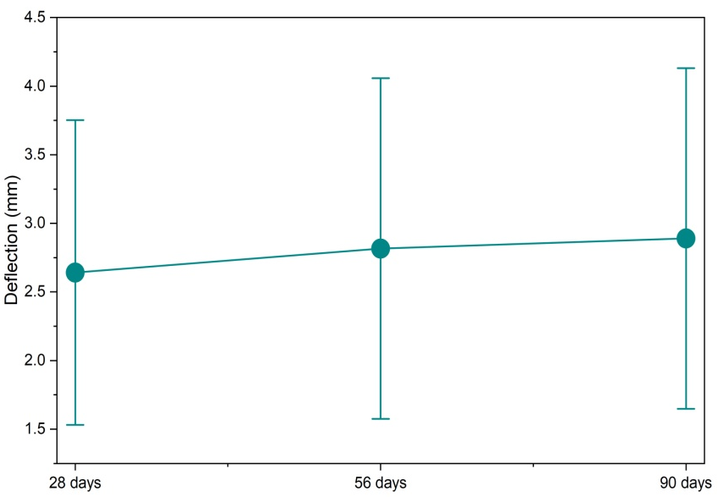
Fig. 16(b). Means Plot (SD as Error)

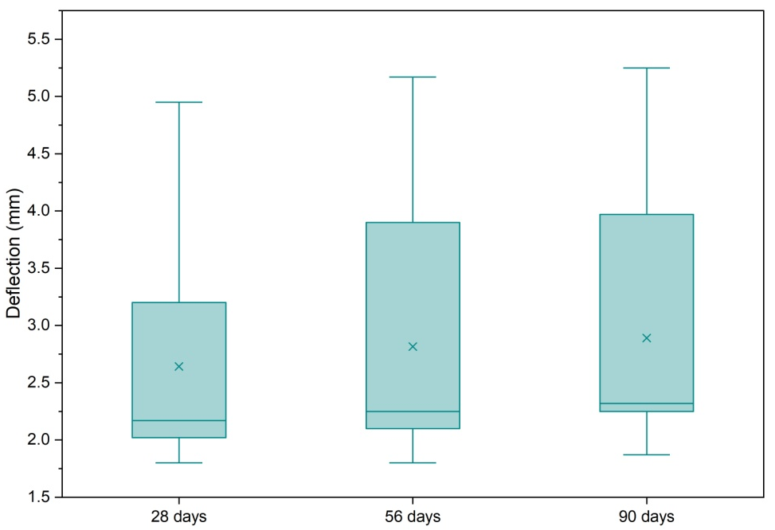
Fig. 16(c). Box Chart

The Tukey test, as shown in Table 7(d), is conducted to determine pairwise differences in mean deflection across curing ages of 28, 56, and 90 days, following a one-way ANOVA. All comparisons yield p-values significantly greater than 0.05, suggesting no statistically significant difference in deflection across curing ages. All calculated q-values are low and below the critical threshold at α = 0.05, indicating non-significance. Tukey's HSD post hoc analysis indicated no significant pairwise differences in deflection across the curing ages of 28, 56, and 90 days, suggesting that time-dependent changes in deflection are minimal and not statistically significant.
5. Conclusion
- The internodal length is increased in the center portion of the culm. The thickness, however, diminishes from the base to the apex of the bamboo shell.
- The water absorption of Dendrocalamus strictus (DS) was found to be 30%.
- The correlation shows that the compression strength of concrete can be used to determine its tensile strength precisely.
- All the load-deformation plots for all beam designations show a similar initial response, with the load rising to 10 kN at a deflection of less than 0.1 mm.
- BRCB 6 shows the most deformation capability, followed by BRCB 4 and BRCB 3. BRCB 2 shows the least ductility. BRCB 6 is the best for ductile performance.
- It was observed that bitumen-coated BRCB shows the highest flexural strength, followed by non-coated BRCB. Consequently, the load-bearing capacity of the beam specimen, in which bamboo is coated with bitumen, is enhanced.
- PCB showed the least flexural strength. Flexural strength is maximum for the BRCB6 beam designation and minimum for the PCB.
- Bitumen-coated BRCB showed the maximum deflection and thus the maximum ductility compared to non-coated BRCB and PCB. For beam designations BRCB4 and BRCB6, the deflections are 76.44 percent and 133 percent higher than PCB at 90 days of testing, respectively.
- One-way ANOVA and Tukey's HSD analysis indicate that, while flexural strength increases from 28 to 90 days of curing, the differences are not statistically significant at the 95% confidence level.
- One-way ANOVA followed by Tukey's HSD test showed that curing age did not affect flexural strength or deflection (p > 0.05), despite a slight increase in the mean values. The observed age-related changes are likely due to experimental variability rather than a meaningful performance shift.

References
Amada, S. (1997). Bamboo—A natural, super-advanced and intelligent material. Proc 2nd Int Conf on Non-Conventional Construction Materials (NOCMAT-97), Bhubaneswar, India, 1–9.
Archila, H., Kaminski, S., Trujillo, D., Zea Escamilla, E., & Harries, K.A. (2018). Bamboo reinforced concrete: a critical review. Materials and Structures/Materiaux et Constructions, 51(4), 1–18. https://doi.org/10.1617/s11527-018-1228-6
Awolusi, T.F., Aladegboye, O.J., Babalola, O.E., Ayo, E.K., Azab, M., & Deifalla, A.F. (2023). Optimizing the flexural behavior of bamboo reinforced concrete beams containing cassava peel ash using response surface methodology. Civ Eng J, 9(08), 1971–1990.
Cai, X., Wang, M., Lu, Y., Noori, A., Chen, J., Chen, F., Chen, L., Jiang, X., & Zhang, Q. (n.d.). Effect of Strain Rate on the Tensile Mechanical Properties and Failure Mechanism of Moso Bamboo. Available at SSRN 4229847.
Chin, S.C., Tee, K.F., Tong, F.S., Doh, S.I., & Gimbun, J. (2020). External strengthening of reinforced concrete beam with opening by bamboo fiber reinforced composites. Materials and Structures/Materiaux et Constructions, 53(6), 1–12. https://doi.org/10.1617/s11527-020-01572-y
Dewi, S.M., & Nuralinah, D. (2017). The Recent Research on Bamboo Reinforced Concrete. MATEC Web of Conferences, 103. https://doi.org/10.1051/matecconf/201710302001
Etienne, I. (2019). Effect of Bamboo Reinforcement on the Flexural and Tensile Strengths of Concrete Beams. 1(3), 124–132.
Ghavami, K. (1988). Application of bamboo as a low-cost construction material. Proceedings of International Bamboo Workshop, Cochin, India, 270–279.
Ghavami, K. (1995). Ultimate load behaviour of bamboo-reinforced lightweight concrete beams. Cement and Concrete Composites, 17(4), 281–288.
Ghavami, K. (2005a). Bamboo as reinforcement in structural concrete elements. Cement and Concrete Composites, 27(6), 637–649. https://doi.org/10.1016/j.cemconcomp.2004.06.002
Ghavami, K. (2005b). Bamboo as reinforcement in structural concrete elements. Cement and Concrete Composites, 27(6), 637–649.
Ghavami, K., & Zielinski, Z.A. (1988). Permanent shutter bamboo reinforced concrete slab. BRCS1, Dep. Civ. Eng. Concordia Univ. Montr. Canada.
Govindan, B., Ramasamy, V., Panneerselvam, B., & Rajan, D. (2022). Performance assessment on bamboo reinforced concrete beams. Innovative Infrastructure Solutions, 7(1), 16.
Gupta, A. K., Ganguly, R., & Mehra, A. S. (2015). Bamboo as green alternative to steel for reinforced concrete elements of a low cost residential building. Electronic Journal of Geotechnical Engineering, 20(6), 1523–1545.
Karthik, S., Rao, P.R. M., & Awoyera, P.O. (2017). Strength properties of bamboo and steel reinforced concrete containing manufactured sand and mineral admixtures. Journal of King Saud University - Engineering Sciences, 29(4), 400–406. https://doi.org/10.1016/j.jksues.2016.12.003
Kathiravan, N. S., Manojkumar, R., Jayakumar, P., Kumaraguru, J., & Jayanthi, V. (2021). State of art of review on bamboo reinforced concrete. Materials Today: Proceedings, 45(2), 1063–1066. https://doi.org/10.1016/j.matpr.2020.03.159
Kaware, A., Awari, U.R., & Wakchaure, M.R. (2013). Review of Bamboo as Reinforcement Material in Concrete Structure. International Journal of Innovative Research in Science, Engineering and Technology, 2(6), 2461–2464.
Khan, I.K. (2014). Performance of Bamboo Reinforced Concrete Beam. International Journal of Science, Environtment and Technology, 3(3), 836–840.
Khatib, A., & Nounu, G. (2017). Corrugated bamboo as reinforcement in concrete. Proceedings of the Institution of Civil Engineers: Structures and Buildings, 170(4), 311–318. https://doi.org/10.1680/jstbu.16.00067
Kumar, S., & Prasad, M.M. (2003). Performance of bamboo reinforced flexural members. Role of Cement Science in Sustainable Development – Proceedings of the International Symposium - Celebrating Concrete: People and Practice, 339–348. https://doi.org/10.1680/rocisd.32477.0033
Leelatanon, S., Srivaro, S., & Matan, N. (2010). Compressive strength and ductility of short concrete columns reinforced by bamboo. Songklanakarin Journal of Science and Technology, 32(4), 419–424.
Li, W., Liu, S., & Liu, J. (2025). Experimental and mesoscale numerical investigation of the mechanical behavior and failure modes of bamboo. Journal of Materials Science, 60(4), 1936–1951.
Liese, W. (1992). The structure of bamboo in relation to its properties and utilization. Zhu, S., Li, W., Zhang, X. Wang, Z. Ed., Bamboo and Its Use. Proceedings of the International Symposium on Industrial Use of Bamboo, Beijing, China, 7–11.
Mali, P.R., & Datta, D. (2020). Experimental evaluation of bamboo reinforced concrete beams. Journal of Building Engineering, 28, 101071. https://doi.org/10.1016/j.jobe.2019.101071
Mondal, B., Maity, D., & Patra, P.K. (2020). Tensile characterization of bamboo strips for potential use in reinforced concrete members: experimental and numerical study. Materials and Structures/Materiaux et Constructions, 53(5). https://doi.org/10.1617/s11527-020-01563-z
Nayak, A. (2013). Replacement of Steel by Bamboo Reinforcement. IOSR Journal of Mechanical and Civil Engineering, 8(1), 50–61. https://doi.org/10.9790/1684-0815061
Parveen Berwal, Ahmed A. Alamiery, Aseel Smerat, Mukhtar Hamid Abed, & Ali Majdi, (2026), Seismic Performance of 3D-Printed Concrete Structures: A Comprehensive Review of Material Behaviour, Geometry, and Optimization. SSRG International Journal of Civil Engineering, 13(1), 76–92,
https://doi.org/10.14445/23488352/IJCE-V13I1P107
Saini M., Aggarwal P., Berwal P., Asmari A., & Islam S. (2026). Towards Sustainable Pavement Materials: Statistical Modelling of Stability and Flow Characteristics in Recycled PET-Modified Bituminous Concrete. Rocznik Ochrona Środowiska, 28, 27-43, https://doi.org/10.54740/ros.2026.003
Qaiser, S., Hameed, A., Alyousef, R., Aslam, F., & Alabduljabbar, H. (2020). Flexural strength improvement in bamboo reinforced concrete beams subjected to pure bending. Journal of Building Engineering, 31, 101289. https://doi.org/10.1016/j.jobe.2020.101289
Verma, M., Singh, K., Gupta, N., Asmari, A., Goyal, R., Berwal, P., & Islam, S. (2025). Harnessing Agricultural Residues for Eco-Efficient Cement Substitution in Mortar: A Pathway to Low-Carbon and Sustainable Construction. Rocznik Ochrona Ś rodowiska, 27, 388–401. https://doi.org/10.54740/ros.2025.032
Viswanathan, G., Surya, G., Vijitha, S., & Visalatchi, S. (2019). Experimental study on bamboo reinforcement concrete beam by using fibers. 6(4), 4–7.
Yao, W., & Li, Z. (2003). Flexural behavior of bamboo-fiber-reinforced mortar laminates. Cement and Concrete Research, 33(1), 15–19. https://doi.org/10.1016/S0008-8846(02)00909-2
Zhao, W., Zhang, J., Zhang, W., Yuan, S., Chen, H., & Wu, A. (2023). Effect of bamboo unit morphology on the preparation of bamboo fibers by steam explosion. Industrial Crops and Products, 202, 117066.

