
 | Rocznik Ochrona Środowiska
 | Volume 28 | Year 2026 ISSN 2720-7501 | pp. 128-138
 | https://doi.org/10.54740/ros.2026.010 open access
 | Received: February 2026 Accepted: March 2026 Published: March 2026
Seasonal Assessment of Surface Water Quality in Oued Dradère
Using the Water Quality Index
Amina Essamett¹, Fatima Essalhi², Ilham Rhzali³, Hefdhallah Alaizari⁴, Mohammed Ennouali⁵, Mohammed Ouhssine¹
¹Laboratory of Natural Resources and Sustainable Development, Faculty of Science, Ibn Tofail University, Morocco
https://orcid.org/0009-0001-8846-9166
²Laboratory of Natural Resources and Sustainable Development, Faculty of Science, Ibn Tofail University, Morocco
https://orcid.org/0000-0002-1597-7629
³Laboratory of Biology and Health, Department of Biology, Faculty of Science, Ibn Tofail University, Kenitra, Morocco
https://orcid.org/0009-0007-5841-4192
⁴Laboratory of Natural Resources and Sustainable Development, Faculty of Science, Ibn Tofail University, Morocco
https://orcid.org/0000-0003-2080-7955
⁵Laboratory of Natural Resources and Sustainable Development, Faculty of Science, Ibn Tofail University, Morocco
https://orcid.org/0009-0001-0904-3969
⁶Laboratory of Natural Resources and Sustainable Development, Faculty of Science, Ibn Tofail University, Morocco
https://orcid.org/0009-0001-2748-2623
*corresponding author's e-mail: alaizari2@gmail.com
Abstract: Surface water quality is a vital indicator of environmental health, especially in northwest Morocco. This study evaluates seasonal variations in the surface water quality of the Oued Dradère using the Water Quality Index (WQI). The parameters included pH, dissolved oxygen, conductivity, nitrates, ammonium, sulfates, phosphates, and BOD₅, which were analyzed at three stations during the humid and dry seasons. The results of WQI values ranged from 66.51 to 158.30, classifying water from fair to unsuitable based on station and season, station 1 exhibited fair quality (WQI: 66.51) during the dry season, suitable for irrigation, station 2 recorded the poorest quality (WQI: 158.30), unsuitable for any use due to high pollutant levels, and station 3 maintained poor quality across seasons, only suitable for irrigation. The study emphasizes the need for improved water management strategies to reduce pollution, ensure sustainable water use, and protect public health in the region.
Keywords: Oued Dradère, surface water quality, Water Quality Index (WQI), Morocco
1. Introduction
Surface water quality plays a pivotal role in environmental sustainability, particularly in regions where water resources are critical for agricultural, industrial, and domestic uses. In many developing regions, such as North Africa, water bodies are often exposed to various pollution sources, including agricultural runoff, industrial discharges, and untreated wastewater, which degrade water quality (Alobaidy, Abid, & Maulood, 2010). The quality of surface water is influenced by several factors, including land use practices, seasonal variations, and climatic conditions, making continuous assessment essential for maintaining water health and usability (Abdel-Satar, Ali, & Goher, 2017; Hammoumi, Al-Aizari, Alkhawlani, Chakiri, & Bejjaji, 2024). The Oued Drader, located in northwest Morocco, is a vital watercourse for surrounding agricultural areas and ecosystems. However, this water body, like many others in the region, is subject to seasonal pollution due to increased agricultural activities, urbanization, and the seasonal fluctuations in water flow. During the humid season, water bodies often receive runoff from agricultural fields containing fertilizers and pesticides, which lead to nutrient overloads (Boutahar et al., 2019; Hammoumi, Al-Aizari, Alaraidh, et al., 2024). In contrast, during the dry season, lower water levels can result in the concentration of pollutants such as heavy metals, organic matter, and salts, making the water more susceptible to pollution (Kacimov, Obnosov, & Or, 2019).
The seasonal fluctuations in water levels and quality pose significant challenges for water resource management in the region. Oued Drader, as a primary water source for agriculture, faces pollution from diffuse sources, particularly from fertilizers and industrial effluents. This seasonal variability in pollution levels can lead to water that is unsuitable for both human consumption and agricultural use, particularly during the dry season when water quality tends to deteriorate significantly (Ayers & Westcot, 1999). Despite the significance of Oued Drader in sustaining local agriculture and communities, few comprehensive studies have been conducted to monitor the seasonal variations in its water quality. The lack of continuous water quality assessments has made it difficult for local authorities to develop effective water management policies that address pollution spikes during critical periods of the year (Boutahar et al., 2019). Additionally, the variability in water quality can severely affect agricultural productivity, as crops may be irrigated with water containing harmful levels of nutrients, salts, or organic pollutants (Ayers & Westcot, 1985). The WQI provides a clear indication of the overall water quality and its suitability for various uses, such as drinking, agriculture, and industrial applications. Several studies have demonstrated the importance of assessing water quality using WQI as a robust and integrative approach. For example, Idriss Hammoumi Driss conducted an assessment of the Nador Canal in Morocco using WQI and found significant seasonal fluctuations in water quality, particularly during the dry season when pollutants from agricultural runoff and urban discharges became concentrated (Hammoumi,
Al-Aizari, Alkhawlani et al., 2024). This study highlighted the negative impact of agricultural practices and lack of wastewater treatment on water quality, reinforcing the need for seasonal water monitoring. The results indicated that WQI values exceeded safe limits during the dry season, correlating with increased concentrations of nitrates, phosphates, and biochemical oxygen demand (BOD).
In a similar vein, research conducted by Ayers and Westcot (1985) on irrigation water quality standards provided foundational guidelines for assessing surface water used for agricultural purposes. Their work emphasized the impact of salinity, nutrients, and organic matter on soil degradation and crop productivity. High electrical conductivity (EC), sulfate (SO₄²⁻), and nitrate (NO₃⁻) levels were identified as primary factors that contribute to poor water quality, particularly in arid and semi-arid regions (Ayers & Westcot, 1985).
Other studies in North Africa and the Mediterranean basin have consistently identified the same seasonal trends, with higher water quality deterioration during the dry season. A study on the Sebou River in Morocco used WQI to evaluate surface water quality and found that nitrate and phosphate concentrations peaked during the summer months due to agricultural runoff, leading to higher WQI values and poorer water quality and found that nitrate and phosphate concentrations peaked during the summer months due to agricultural runoff, leading to higher WQI values and poorer water quality during the dry season (Benrabah, Attoui, & Hannouche, 2016).
The objective of this study is to assess the seasonal variations in the surface water quality of Oued Drader using the Water Quality Index (WQI). The primary scientific contribution of this work is the development and demonstration of a transparent, step-by-step analytical workflow. This workflow integrates spatial mapping (ArcGIS 10.8), statistical computation and visualization (OriginLab 2026), WQI calculation, and health risk assessment into a coherent, replicable model for environmental diagnostics. This approach not only clarifies the situation in Oued Dradère but also provides a template for researchers in similar data-scarce environments.
2. Materials and Methods
2.1. Study Area
The Oued Dradère watershed (Figure 1). located in the northwest of Morocco. covers an area of 621 km². Crossed by two rivers. This basin is known for various agricultural and forestry activities. In particular, the production of eucalyptus. Precipitation and groundwater are the main sources of its water supply. The overall surface water supply of the Oued Dradère basin is 50 Mm^{3,} including resurgences and returns from irrigation. Nearly 70% of this contribution joins the Merja Zerga by the Oued Dradère (Benhoussa, 2000). This study site opens into the Merja Zerga. In addition, the upper course of Oued Dradère in a North-South direction is temporary. While the middle and lower courses in an East-West direction are permanent and benefit from spills from resurgences of the Dhar El Hadechi aquifer on its right bank and El Fahis on the left bank (Aguedai, Lahlou, & El Mansouri, 2020). The Oued Dradère has a relatively large dowsing complex. The Oued Dradère downstream valley has an average low water flow of 180 l/s (i.e., nearly 5.6 Mm³) for an observed overall minimum flow of 50 l/s (1.6 Mm³).
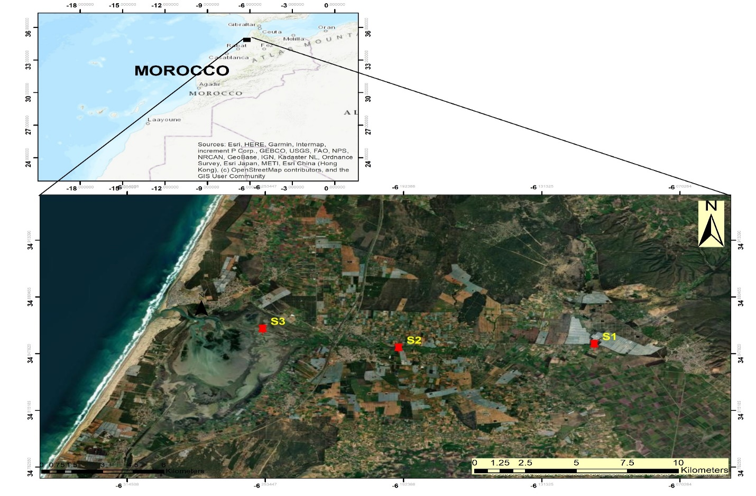
Fig. 1. Study area (Oued Dradère)
2.2. Samples
Water samples are taken bimonthly for two periods, respectively: dry 2022 and humid 2022, at three stations. As indicated by Rodier (Rodier, Legube, & Merlet, 2016). The water sampled was packaged in opaque bottles and kept cold until arrival at the laboratory. Three physical parameters (water temperature, pH, and conductivity) were measured on site with a HACH multi-parameter instrument model HQ40d. Ten other chemical parameters were evaluated. Namely, sulfate, nitrates, ammonium, and phosphates, BOD₅, COD, suspended matter, and dissolved oxygen (DO). Dissolved oxygen is measured in situ by the HACH-type multi-parameter model HQ40d. For the other parameters, the analysis methods are those recommended by the standards (Rodier et al., 2016).
2.3. Water Quality Index (WQI)
The Water Quality Index (WQI) is used to classify water quality by referencing international or Moroccan standards based on nine key physicochemical parameters: pH, Dissolved Oxygen (DO), Electrical Conductivity (EC), Temperature (T°C), Sulfate (SO₄²⁻), Biochemical Oxygen Demand (BOD₅), Phosphate (PO₄³⁻), Ammonium (NH₄⁺), and Nitrate (NO₃⁻). This index has been applied in various studies (Abdel-Satar et al., 2017; Sánchez et al., 2007; Tyagi, Sharma, Singh, & Dobhal, 2013) as an effective tool for assessing water quality. In this approach, each physicochemical parameter is assigned a numerical value, the relative weight (Wi). The relative weight is calculated using specific formulas, as shown in Table 1, to quantify each parameter's contribution to the overall water quality assessment. The Water Quality Index (WQI) can be summarized in one equation 1 as (Alobaidy et al., 2010):
$WQI=\sum_{i=1}^{n}{ wi*(\frac{Ci}{Si}*100)}$ (1)
where:
Wi – the relative weight of the parameter,
Ci – the concentration of the parameter,
Si – the standard or permissible limit for the parameter.

Table 2 presents the classification of water quality according to the Water Quality Index (WQI) (Brown, McClelland, Deininger, & Tozer, 1970).
Table 1. Weight of physico-chemical parameters and standards (Organization, WHO., & Staff, 2004) (Ayers & Westcot, 1985) water quality standard
Parameters | WHO 2004  (Ayers & Westcot, 1985) | Weight(wi) | Weight(wi)/$\sum_{n}^{i}{Weight(wi)}$
pH | 8.4 | 4.00 | 0.1
EC (µS/cm) | 2500 | 5.00 | 0.125
T (°C) | 25.00 | 5.00 | 0.125
NH₄⁺ (mg/L) | 5.00 | 5.00 | 0.125
NO₃⁻(mg/L) | 10.00 | 5.00 | 0.125
SO₄²⁻(mg/L) | 250.00 | 5.00 | 0.125
PO₄³⁻(mg/L) | 50.00 | 3.00 | 0.075
BOD₅ (mg/L) | 10.00 | 3.00 | 0.075
DO (mg/L) | 5.00 | 5.00 | 0.125

Table 2. Classification and possible use of water according to the WQI
WQI Range | Water Quality | Possible Use
0–25 | Excellent | Suitable for drinking, irrigation, and industrial use
26–50 | Good | Suitable for most uses, including drinking and irrigation
51–75 | Fair | Suitable for irrigation and industrial purposes
76–100 | Poor | Suitable only for irrigation and limited industrial use
101–150 | Very Poor | Suitable only for irrigation
>150 | Unsuitable for use | Unsuitable for drinking, irrigation, or industrial use
2.4. Methods of Statistical Analysis
Experimentally obtained data were analyzed using two primary software platforms:
- Spatial Analysis: ArcMAP 10.8 was used for GIS-based visualization (Figure 1).
- Statistical & Graphical Analysis: OriginLab 2026 was used for all statistical computations and figure generation.
3. Results and Discussion
3.1. Seasonal Variations in Water Quality Parameters in Oued Dradère
Table 3 and Figure 2 present the analysis results of water quality standards across all stations in Wadi Al-Dardar during both the rainy and dry seasons at three sampling stations (S1, S2, S3).

Table 3. The seasonal variation in water quality at three sampling stations (S1, S2, S3) under different conditions (Wet and Dry) in Oued Dradère
Station | pH | EC (µS/cm) | T  (°C) | NH₄⁺  (mg/l) | NO₃⁻(mg/l) | SO₄²⁻(mg/l) | PO₄  (mg/l) | BOD₅  (mg/l) | DO  (mg/l)
S1(Wet) | 7.47 | 1431.00 | 21.50 | 1.30 | 9.58 | 165.50 | 0.39 | 3.15 | 10.41
S1(Dry) | 7.71 | 909.00 | 14.45 | 0.14 | 7.96 | 125.00 | 0.20 | 6.00 | 9.83
S2(Wet) | 7.64 | 1283.00 | 21.10 | 1.22 | 43.33 | 121.33 | 0.45 | 3.60 | 10.12
S2(Dry) | 7.73 | 1073.00 | 17.50 | 0.96 | 81.41 | 67.67 | 0.37 | 5.50 | 9.26
S3(Wet) | 7.58 | 1322.00 | 23.07 | 1.60 | 28.77 | 83.67 | 0.48 | 4.83 | 7.72
S3(Dry) | 7.68 | 1419.67 | 11.73 | 0.59 | 22.56 | 90.00 | 0.47 | 9.00 | 7.91

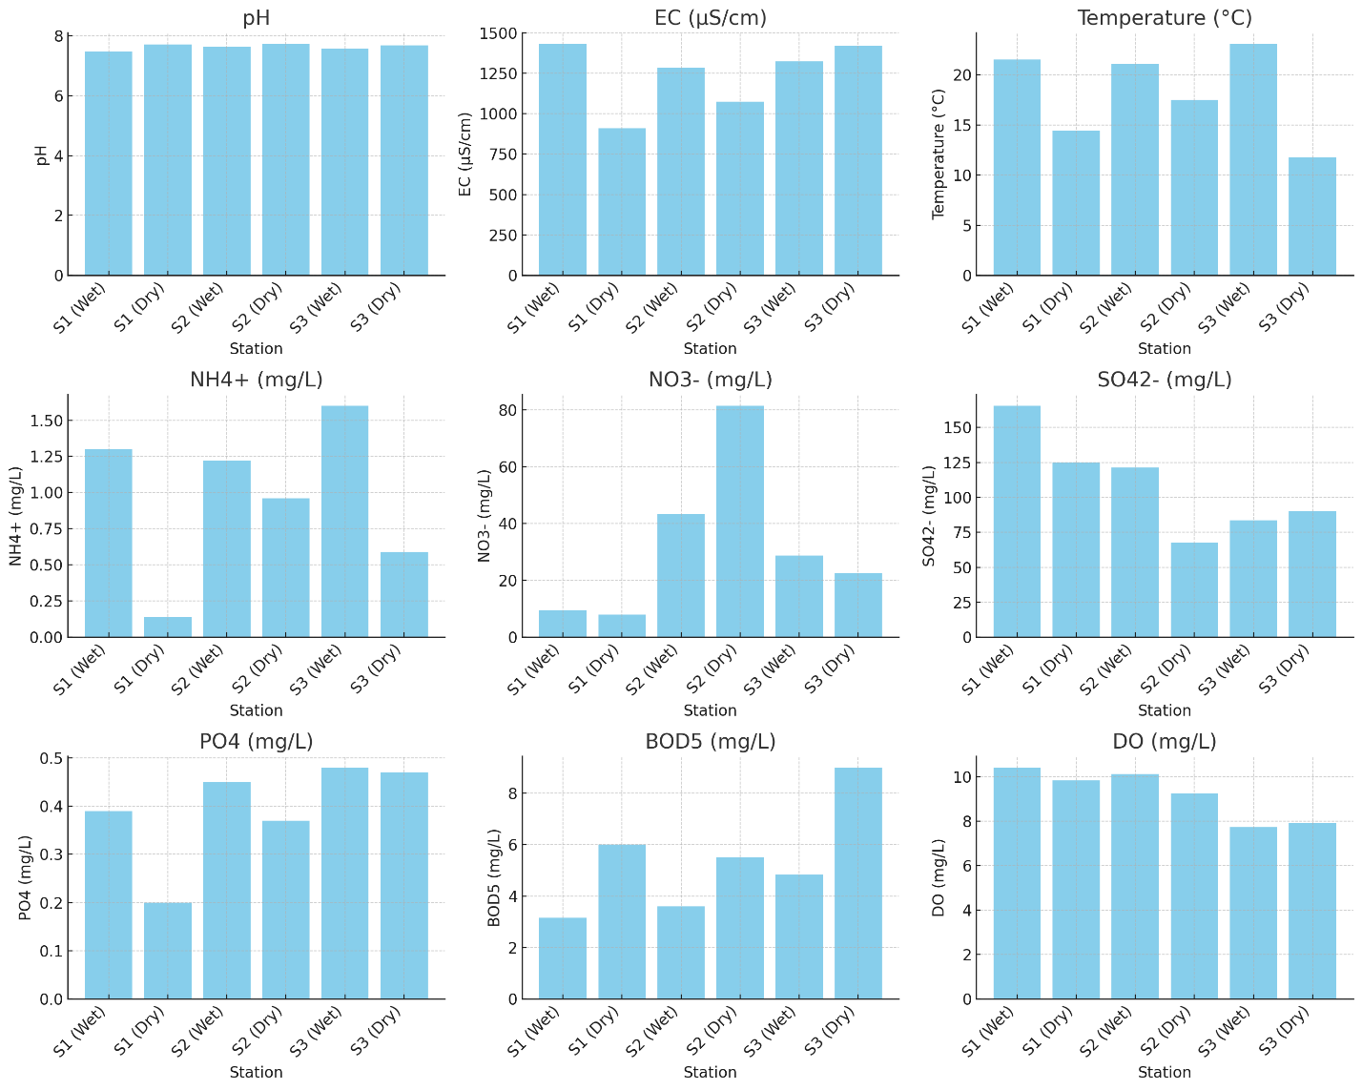
(a)
(h)
(o)
(f)
(d)
(b)
(e)
(i)
(c)
Fig. 2. The values of pH, (EC), (T°C), (NH₄⁺), (NO₃⁻), (SO₄²⁻), (PO₄³⁻), (BOD₅), and (DO) in Oued Dradère

The pH values across all stations remained relatively stable, ranging between 7.47 and 7.73, indicating neutral to slightly alkaline conditions. The dry season showed slightly higher pH levels than the humid season, likely due to reduced water dilution, resulting in higher concentrations of basic substances (Figure 2a). Electrical conductivity (EC) values decreased during the dry season at Stations S1 and S2, but increased at Station S3. Higher EC values during the humid season could be due to the influx of dissolved ions from rainfall and runoff. In contrast, during the dry season, evaporation may concentrate ions in some areas, as seen in Station S3 (Figure 2b). Temperatures were higher during the humid season, with the highest recorded at S3 (23.07°C) (Figure 2c). Expectedly, temperatures were lower during the dry season, likely due to cooler atmospheric conditions. These fluctuations can affect biological and chemical processes in the water. Ammonium levels were significantly higher during the humid season across all stations, particularly at S1 and S3. In the dry season, NH₄⁺ levels dropped considerably (Figure 2d). The higher concentrations in the humid season could be attributed to runoff from agricultural activities or to the decomposition of organic matter, which contributes more nitrogen compounds. Nitrate concentrations varied significantly between stations, with the highest levels recorded at S2 during the dry season (81.41 mg/L) (Figure 2e). Nitrate levels generally increased during the dry season, especially at Station S2, possibly due to higher nutrient concentrations resulting from reduced water flow or increased agricultural runoff during irrigation. Sulfate concentrations were higher during the humid season, especially at S1 (165.50 mg/L) and S3 (83.67 mg/L) (Figure 2f). In the dry season, SO₄²⁻ levels decreased across all stations, likely due to reduced sulfate input from runoff, which is a primary source during rainfall events.
Phosphate levels remained generally low but showed a slight increase during the dry season at Stations S2 and S3 (Figure 2i). Phosphates tend to be more concentrated during the dry season, potentially due to reduced water volume and increased agricultural inputs. BOD₅ values were higher during the dry season, particularly at S1 (6.00 mg/L), S2 (5.50 mg/L), and S3 (9.00 mg/L), indicating increased organic pollution (Figure 2h).
Lower water flow during the dry season may reduce the river's capacity to assimilate and degrade organic matter, leading to higher BOD₅ values. Dissolved oxygen (DO) levels were generally higher during the humid season, particularly at S1 (10.41 mg/L) (Figure 2o). In the dry season, DO decreased across all stations, likely due to higher temperatures and increased organic pollution, which could enhance microbial oxygen consumption. The hydrochemical analysis of the Oued Dradère reveals a clear pattern of seasonal variation driven by hydrological cycles and anthropogenic pressure, primarily agriculture. The pH stability within a neutral to slightly alkaline range (7.47–7.73) is typical of surface waters buffered by carbonate minerals. Still, it shows a slight dry-season increase, consistent with evaporation concentrating basic ions and reducing dilution (Adimalla, 2020).
The inverse relationship between Electrical Conductivity (EC) and water flow is evident. The general increase in EC during the humid season at most stations can be attributed to the leaching and runoff of dissolved ions from the watershed. Conversely, the localized spike at S3 during the dry season points to concentrated pollutant input, likely from focused agricultural or wastewater sources in that area, exacerbated by evaporation.
The seasonal dichotomy in nitrogen species is particularly telling. The elevated ammonium (NH₄⁺) during the humid season is a direct indicator of fresh, untreated organic pollutionfrom fertilizer runoff, manure, or decaying vegetation transported by surface flow (Alam et al., 2021). In contrast, the sharp increase in nitrate (NO₃⁻) during the dry season, especially at S2 (81.41 mg/L), aligns with global observations of groundwater-dominated baseflow in dry periods carrying accumulated nitrate from soil leaching, as well as concentrated irrigation return flows (Adimalla, Qian, & Li, 2020; Arya et al., 2021). This nitrate peak is the primary driver of the elevated health risks, particularly for infants and children, as quantified by the Hazard Quotient (THQ) and consistent with studies from India and Pakistan (Adimalla, 2020; Alam et al., 2021; Waghet al., 2020).
The parallel increases in phosphate and BOD₅ during the dry season confirm a state of elevated nutrient pollution and organic loading under low-flow conditions. Reduced water volume decreases dilution and the river's self-purification capacity, leading to the accumulation of agricultural chemicals and organic waste and, in turn, raising BOD₅ (Murphy, 2020). This biochemical oxygen demand directly explains the critically low Dissolved Oxygen (DO) levels observed in the dry season. Higher temperatures and microbial activity fueled by organic pollution consume oxygen faster than stagnant water can intake it from the atmosphere, creating hypoxic conditions threatening aquatic life (Liu, He, & Cai, 2020).
In summary, the Oued Dradère system shifts from a "dilution and transport" phase in the humid season (higher DO, NH₄⁺, SO₄²⁻ from runoff) to a "concentration and impact" phase in the dry season. The latter is characterized by dangerously high nitrate, phosphate, and BOD₅ levels, and by critically low DO. This pattern underscores a direct link between intensive agriculture, seasonal hydrology, and deteriorating water quality, resulting in both significant ecosystem stress and human health risks, particularly from nitrate exposure, which is associated with methemoglobinemia and long-term carcinogenic risks (Levallois & Phaneuf, 1994; Ward et al., 2018). These findings necessitate urgent, targeted mitigation strategies including improved agricultural practices, controlled irrigation, and potentially nitrate-specific remediation technologies in critical zones (Temkin et al., 2019).
The results from the three stations of the Oued Dradr watercourse, measured under wet and dry conditions, and compared with the WHO standards (Ayers & Westcott, 1985) for irrigation water quality, indicate that all pH values, ranging from 7.47 to 7.73, are within the safe range (6.5-8.4), and do not pose any threat to soil health. The electrical conductivity (EC) values, ranging from 909 µS/cm to 1431 µS/cm, indicate slight to moderate restriction due to moderate salinity, which may affect sensitive crops. Ammonium (NH₄⁺) concentrations are within the safe limits, ranging from 0.14 to 1.60 mg/L, indicating no direct threat to plant health from nitrogen toxicity. Nitrate (NO₃⁻) levels at station S1 are within the safe range (7.96-9.58 mg/L), but at station S2, they are elevated (43.33-81.41 mg/L), which can lead to nutrient leaching and groundwater contamination. Sulphate (SO₄²⁻) levels exceed the WHO standard (<20 mg/L), ranging from 67.67 to 165.50 mg/L, which can lead to salinity-related soil degradation. Phosphate (PO₄³⁻) levels are low (0.20-0.48 mg/L) at all stations, which is favorable for preventing algal blooms. Biochemical oxygen demand (BOD₅) is generally within acceptable levels (3.15-6.00 mg/L), except at station S3 (dry conditions), where it reaches 9.00 mg/L, which may indicate moderate organic contamination. Dissolved oxygen (DO) levels range from 7.72 to 10.41 mg/L, which is sufficient to maintain healthy aquatic environments. Comparing these results with those of the study by Idriss Hammoumi Driss on the Nador Canal in Morocco, which also assessed irrigation water quality, similar concerns were noted regarding nitrate and sulfate levels (Hammoumi, Al-Aizari, Alaraidh, et al., 2024). In the Moroccan study, nitrate concentrations frequently exceeded safe levels, as was the case at station S2 here, indicating widespread problems with agricultural runoff. High levels of sulfate were also observed, posing salinity risks for irrigation. Both studies highlight the need for careful irrigation water management to prevent long-term soil degradation and reduced crop yields caused by salinity and nutrient imbalances.

3.2. Water Quality Index
The results of the water quality index for the three stations on the Oued Dradère are shown in Table 4. At Station S1, the WQI is 78.72 during the wet season and 66.51 during the dry season, indicating poor water quality in the wet season and fair water quality in the dry season. Despite the differences, the water is generally suitable for irrigation. At Station S2, the WQI values are 117.52 during the wet season and 158.30 during the dry season, reflecting very poor water quality during the wet season and unsuitable quality in the dry season. This suggests that the water is increasingly less suitable for irrigation, particularly during the dry season, likely due to elevated levels of nitrates and sulfates, which increase salinity risks. At Station S3, the WQI values are 94.47 during the wet season and 82.99 during the dry season, indicating poor water quality in both seasons. Although still considered suitable for irrigation, the values suggest potential long-term risks if contaminants continue to rise. In a study conducted at the Nador Canal in Morocco, similar trends were observed, with water quality deteriorating more during the dry season (Hammoumi, Al-Aizari, Alaraidh, et al., 2024). This is consistent with the findings at Station S2 in the current study, highlighting the significant impact of seasonal variations on water quality, with dry conditions typically leading to higher pollutant concentrations. Both studies emphasize the need for careful monitoring and management, especially during dry periods, to mitigate the risks posed by poor water quality. The Water Quality Index (WQI) values for the three stations in Oued Drader, under both wet and dry conditions, show varying suitability for irrigation. Figure 3 and Table 4 illustrate that Station S2 has the highest WQI values, particularly during the dry season, indicating the poorest water quality among the three stations. Conversely, Station S1 has the lowest WQI values, reflecting relatively better water quality suitable for irrigation. Station S3 shows moderate WQI values, ranking it between Stations S1 and S2 in terms of water quality. These results underscore the significant differences in water quality across the stations and the importance of seasonal variations on irrigation suitability. S1 and S3 show a decrease in WQI from the wet season to the dry season, indicating an improvement in water quality during the dry period. S2 has a significant increase in WQI during the dry season, suggesting a deterioration in water quality compared to the wet season.

Table 4. The results of WQI in Oued Dradère
Station | WQI | Type of water
S1(Wet) | 78.7 | Poor water quality.
S1(Dry ) | 66.5 | Fair water quality.
S2(Wet) | 117.5 | VeryPoor water quality.
S2(Dry ) | 158.3 | Unsuitable water quality.
S3(Wet) | 94.5 | Poor water quality.
S3(Dry ) | 82.98 | Poor water quality.

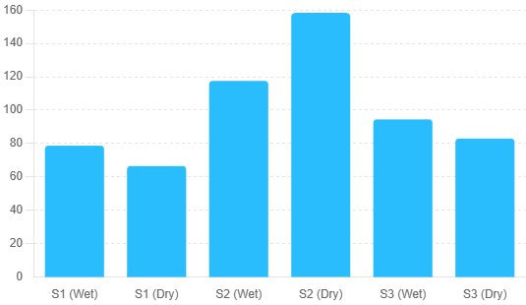
Fig. 3. Water Quality Index (WQI) for the different stations in Oued Dradère

3.3. Multivariate Analyses
Correlations
Figure 4 presents the Pearson correlation coefficients between key water quality parameters in the Oued Dradère. The analysis reveals several significant relationships that highlight the interconnected nature of the river's chemistry. The pH shows a strong negative correlation with Electrical Conductivity (EC, r = -0.77), Temperature (T, r = -0.71), and Ammonium (NH₄⁺, r = -0.77). This indicates that as pH decreases within its neutral to slightly alkaline range, levels of dissolved ions, temperature, and ammonium tend to increase. A moderate negative correlation exists between pH and Phosphate (PO₄³⁻, r = -0.54). A strong positive correlation is observed between Temperature (T) and Ammonium (NH₄⁺, r = 0.94), and a very strong positive correlation between T and Nitrate (NO₃⁻, r = 0.94), suggesting that warmer water temperatures are closely associated with increased concentrations of inorganic nitrogen species. Conversely, T has a strong negative correlation with Biochemical Oxygen Demand (BOD₅, r = -0.83). Nitrate (NO₃⁻) and Sulfate (SO₄²⁻) exhibit a strong negative correlation (r = -0.77), indicating an inverse relationship where higher nitrate levels often coincide with lower sulfate concentrations, potentially reflecting different pollution source dynamics or geochemical attenuation processes. Dissolved Oxygen (DO) demonstrates a strong positive correlation with Sulfate (SO₄²⁻, r = 0.77) and a strong negative correlation with BOD₅ (r = -0.60). This aligns with the expected biochemical relationship: higher organic pollution (BOD₅) consumes oxygen, while the positive link with sulfate may indicate common dilution/concentration patterns or cleaner, oxygenated water inflows. Other notable relationships include a moderate positive correlation between EC and Phosphate (PO₄³⁻, r = 0.60), and between Ammonium (NH₄⁺) and Phosphate (PO₄³⁻, r = 0.60), hinting at a combined source for these ions, such as agricultural or wastewater runoff. These correlations underscore key processes in the Oued Dradère. The strong links between temperature, NH₄⁺, and NO₃⁻ point to the dominance of agricultural nutrient runoff. The inverse relationship between BOD₅ and DO confirms the impact of organic matter on oxygen depletion. The strong negative correlation between NO₃⁻ and SO₄²⁻ may suggest distinct seasonal or spatial sources for these anions. Overall, the matrix confirms that water quality is governed by a combination of natural seasonal cycles (temperature, dilution) and anthropogenic inputs (nutrients, organic matter).
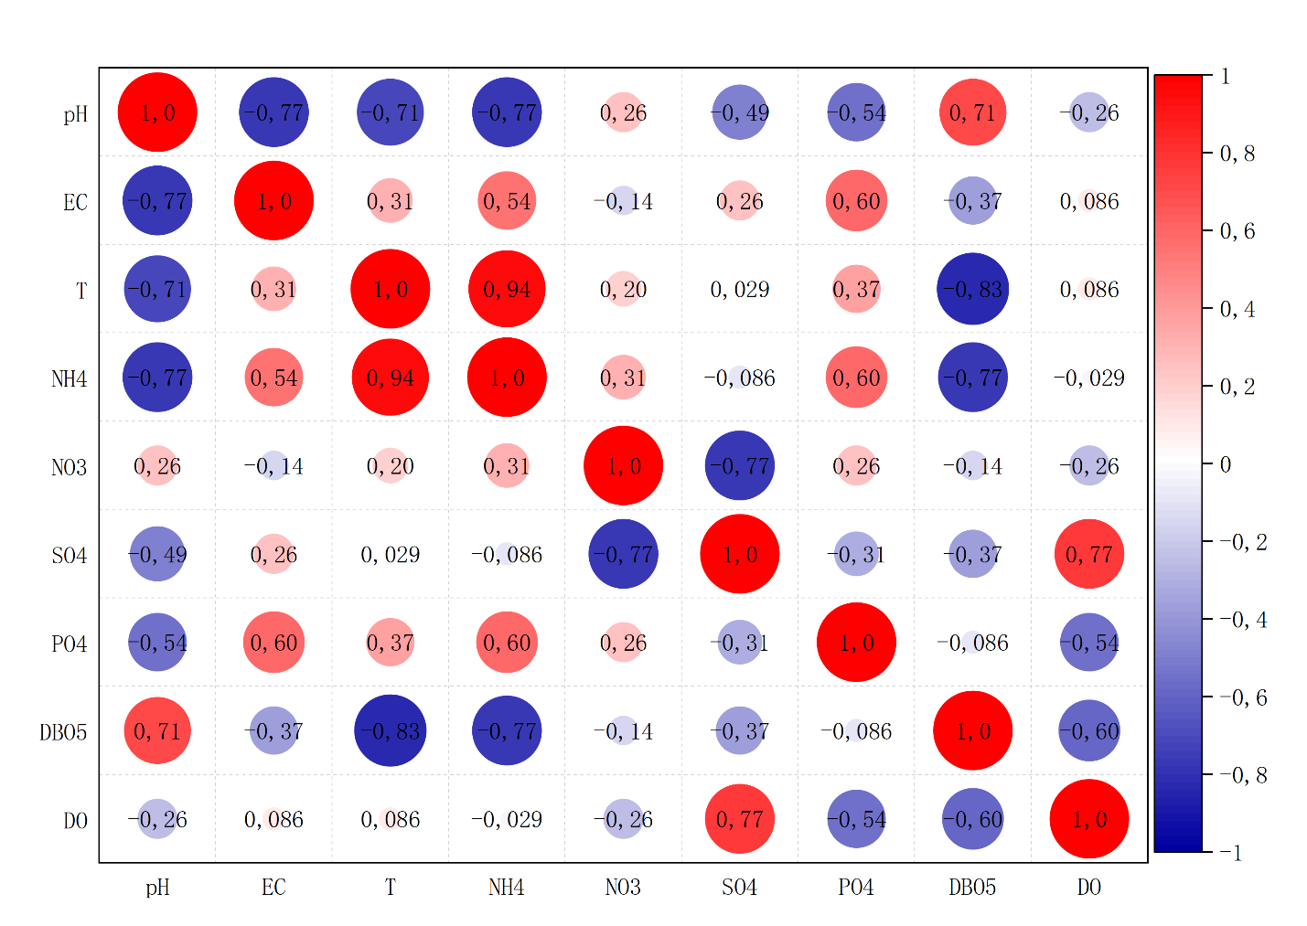
Fig. 4. Correlation Matrix of parameters
Principal Component Analyses
Figures 5 & 6 show the principal component analysis (PCA), which provides insights into the relationships among water quality variables in the Oued Dradère and reveals key patterns in the data. The first three principal components (PC1) have eigenvalues of 3.9605 and 2.7496 capturing 44%, and 30.6% of the variance, respectively. Together, they explain 96% of the total variability in the data, indicating that these three components effectively summarize the dataset (Table 4 and Figures 4, 5 & 6). The cumulative proportion shows that PC1 and PC2 together account for 74.6% of the variance. The first component, PC1, shows strong loadings for temperature (T), ammonium (NH₄), and electrical conductivity (EC), with positive loadings for sulfate (SO₄) and phosphate (PO₄). It suggests that this component reflects a combination of temperature and nutrient levels. The second component (PC2) is strongly influenced by dissolved oxygen (DO), sulfate (SO₄), and phosphate (PO₄), suggesting a relationship among DO and these anions, possibly indicating seasonal or dissolved-oxygen-driven processes. pH has a negative influence on PC1 and a minimal influence on PC2, implying that pH varies inversely with the other water quality parameters captured in PC1. BOD₅ has a significant negative contribution to PC1, suggesting that biochemical oxygen demand is inversely related to parameters such as temperature and nutrient levels. The PCA reveals that water quality parameters in the Oued Dradère can be grouped into major factors: one related to nutrient concentration and temperature (PC1) and another potentially associated with oxygen and anion balance (PC2).

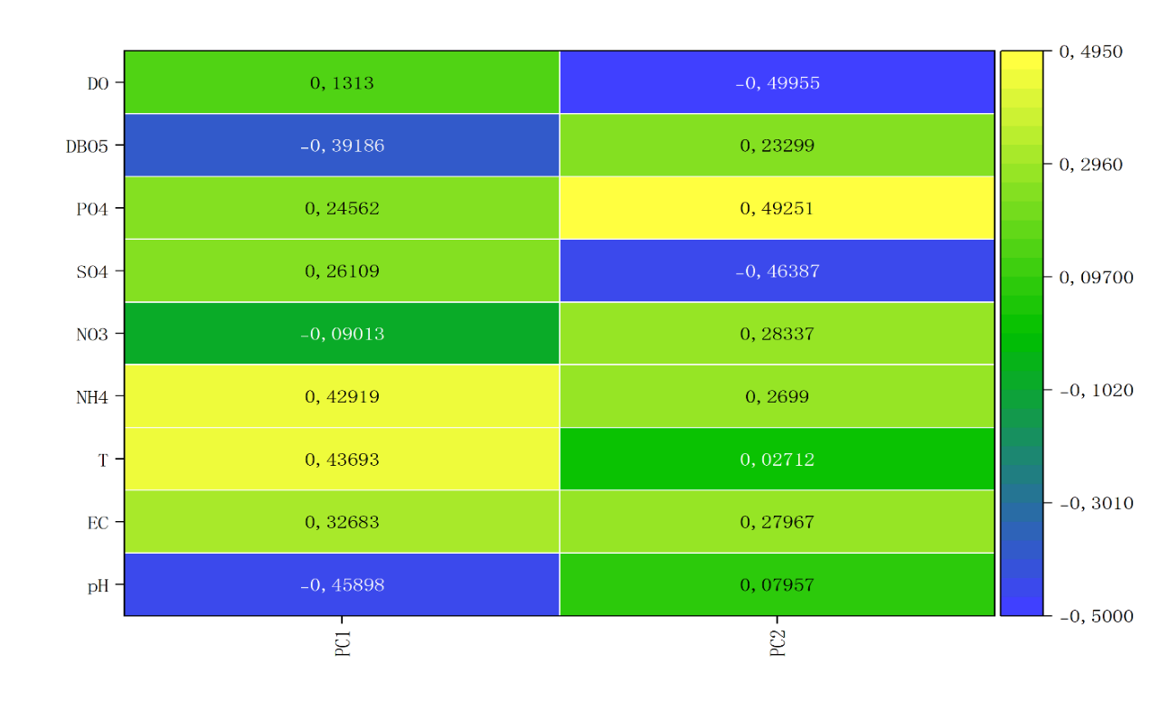
Fig. 5. Principal component analysis (PCA1 & PCA2) in Oued Dradère
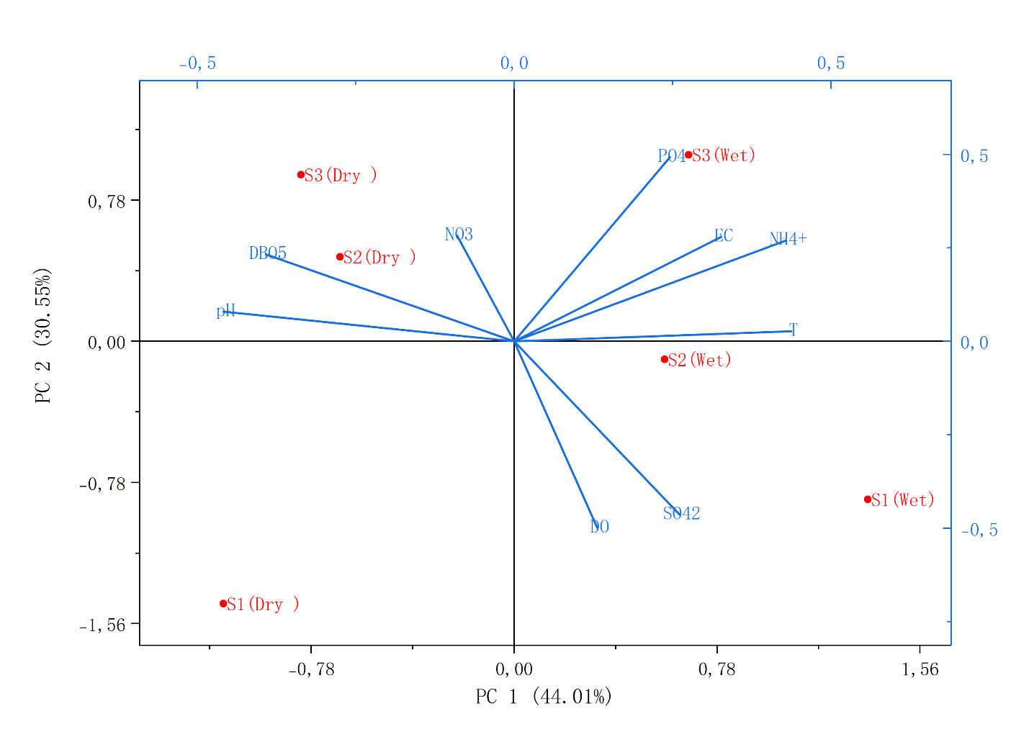
Fig. 6. Principal component analysis (PCA1 & PCA2) of station and parameters in Oued Dradère

3.4. Discussion
The results indicate that while pH and ammonium levels remain within safe limits, EC and sulfate (SO₄²⁻) levels consistently exceed irrigation guidelines (Ayers & Westcot, 1985), posing salinity risks. The nitrate levels at S2, in particular, represent a significant environmental and public health concern, echoing findings from groundwater studies in India and Pakistan (Adimalla, 2020; Alam et al., 2021). These seasonal dynamics align with patterns observed in other semi-arid and Mediterranean basins. For instance, research on the Nador Canal in Morocco (Hammoumi, Al-Aizari, Alkhawlani, et al., 2024) similarly identified deterioration in water quality during the dry season, with marked increases in nitrate and sulfate concentrations linked to agricultural return flows. Studies on the Sebou River (El Hajjami, Souabi, El Alami, & Taleb, 2019) and other North African watercourses have also reported peak nutrient levels during low-flow periods, reinforcing that seasonal concentration of pollutants is a regional hallmark of river systems under agricultural pressure. The nitrate levels recorded at Station S2 (81.41 mg/L in the dry season) are particularly alarming and are consistent with observations in intensively farmed regions worldwide. Similar nitrate pollution has been documented in agricultural watersheds in India (Adimalla, 2020) and Pakistan (Alam et al., 2021), where groundwater and surface water contamination pose significant health risks. This study's finding that nitrate is the primary driver of elevated WQI values and health risk echoes the conclusions of Ayers & Westcot (1985), who identified nitrate and salinity as key constraints on irrigation water quality. However, this study also reveals nuances not always highlighted in broader assessments. The strong inverse relationship between nitrate and sulfate observed in the correlation matrix suggests competing anion dynamics or distinct seasonal source patterns, a finding that adds specificity to the understanding of hydrochemical processes in Oued Dradère. Furthermore, identifying Station S2 as a severe, localized pollution hotspot provides actionable spatial insight, whereas many regional studies report averaged or basin-wide conditions.
5. Conclusion
The study on the water quality of the Oued Dradère, conducted under both wet and dry conditions, indicates that pH values across all stations remain within safe limits, indicating no risk to soil health. Electrical conductivity (EC) indicates a slight to moderate salinity restriction, which may affect sensitive crops. The ammonium levels are within acceptable limits, and phosphate concentrations are generally low, posing no significant issues. However, the elevated nitrate levels at Station S2, especially during the dry season, and the consistently high sulfate concentrations across all stations, suggest potential risks of nutrient leaching and salinity, which could degrade soil quality and harm crop production. Biochemical Oxygen Demand (BOD₅) levels are mostly acceptable, but during the dry season they are higher, indicating increased organic pollution. Dissolved oxygen levels are sufficient, particularly in the humid season, but they decrease in the dry season, potentially threatening aquatic life.
References
Abdel-Satar, A.M., Ali, M.H., & Goher, M.E. (2017). Indices of water quality and metal pollution of Nile River, Egypt. The Egyptian Journal of Aquatic Research, 43(1), 21–29.
https://www.sciencedirect.com/science/article/pii/S1687428516300917
Adimalla, N. (2020). Controlling factors and mechanism of groundwater quality variation in semi-arid region of South India : An approach of water quality index (WQI) and health risk assessment (HRA). Environmental Geochemistry and Health, 42(6), 1725–1752. https://doi.org/10.1007/s10653-019-00374-8
Adimalla, N., Qian, H., & Li, P. (2020). Entropy water quality index and probabilistic health risk assessment from geochemistry of groundwaters in hard rock terrain of Nanganur County, South India. Geochemistry, 80(4), 125544.
Aguedai, H., Lahlou, F., & El Mansouri, B. (2020). Hanaa Aguedai—Intrusion Zones Identification in the Mnasra Aquifer (Morocco) Using the Seawater Intrusion Models and the Geophysics Data. In Geospatial Technology (p. 51–68). Springer.
Alam, I., Rehman, J.U., Nazir, S., Nazeer, A., Akram, M., Batool, Z., … Tahir, M.B. (2021). Health risk assessment in different age-group due to nitrate, fluoride, nitrite and geochemical parameters in drinking water in Ahmadpur East, Punjab, Pakistan. Human and Ecological Risk Assessment: An International Journal, 27(7), 1747–1763. https://doi.org/10.1080/10807039.2021.1902264
Alobaidy, A.H.M.J., Abid, H.S., & Maulood, B.K. (2010). Application of water quality index for assessment of Dokan lake ecosystem, Kurdistan region, Iraq. Journal of Water Resource and protection, 2(9), 792–798.
Arya, S., Subramani, T., Vennila, G., & Karunanidhi, D. (2021). Health risks associated with fluoride intake from rural drinking water supply and inverse mass balance modeling to decipher hydrogeochemical processes in Vattamalaikarai River basin, South India. Environmental Geochemistry and Health, 43(2), 705–716. https://doi.org/10.1007/s10653-019-00489-y
Ayers, R.S., & Westcot, D.W. (1985). Water quality for irrigation. FAO irrigation and drainage paper, 20.
Ayers, R.S., & Westcot, D.W. (1999). The water quality in agriculture, 2nd. Campina Grande: UFPB.(Studies FAO Irrigation and drainage, 29).
Benhoussa, A. (2000). Caractérisation des habitats et microdistribution de l’avifaune de la zone humide de Merja Zerga (Maroc). These Doc. d’État, Université Mohamed V, Rabat.
Benrabah, S., Attoui, B., & Hannouche, M. (2016). Characterization of groundwater quality destined for drinking water supply of Khenchela City (eastern Algeria). Journal of Water and Land Development, 30(1), 13.
Boutahar, L., Maanan, M., Bououarour, O., Richir, J., Pouzet, P., Gobert, S., … Bazairi, H. (2019). Biomonitoring environmental status in semi-enclosed coastal ecosystems using Zostera noltei meadows. Ecological Indicators, 104, 776–793. Consulté à l’adresse https://www.sciencedirect.com/science/article/pii/S1470160X19302857
Brown, R.M., McClelland, N.I., Deininger, R.A., & Tozer, R.G. (1970). A water quality index-do we dare. Water and sewage works, 117(10).
El Hajjami, S., Souabi, S., El Alami, M., & Taleb, A. (2019). Spatio-Temporal Evaluation of the Contamination by Metallic Trace Elements of the Surface Waters of Oued Sebou, Morocco. International Conference on Advanced Intelligent Systems for Sustainable Development, 630‑642. Springer.
Hammoumi, D., Al-Aizari, H.S., Alaraidh, I.A., Okla, M.K., Assal, M.E., Al-Aizari, A.R., … Bejjaji, Z. (2024). Seasonal Variations and Assessment of Surface Water Quality Using Water Quality Index (WQI) and Principal Component Analysis (PCA) : A Case Study. Sustainability, 16(13), 5644.
Consulté à l’adresse https://www.mdpi.com/2071-1050/16/13/5644
Hammoumi, D., Al-Aizari, H.S., Alkhawlani, Z., Chakiri, S., & Bejjaji, Z. (2024). Water Quality Assessment Using the Water Quality Index, and Geographic Information Systems in Nador Canal, Morocco. Journal of Environmental & Earth Sciences, 6(2), 1–16.
Kacimov, A.R., Obnosov, Yu. V., & Or, D. (2019). Evaporation-Induced Capillary Siphoning Through Hydraulically Connected Porous Domains : The Vedernikov–Bouwer Model Revisited. Transport in Porous Media, 129(1), 231–251. https://doi.org/10.1007/s11242-019-01285-z
Levallois, P., & Phaneuf, D. (1994). Contamination of drinking water by nitrates : Analysis of health risks. Canadian journal of public health= Revue canadienne de sante publique, 85(3), 192–196.
Liu, G., He, W., & Cai, S. (2020). Seasonal variation of dissolved oxygen in the southeast of the Pearl River Estuary. Water, 12(9), 2475.
Organization, W. H., WHO., & Staff, W. H. O. (2004). Guidelines for drinking-water quality (Vol. 1). World Health Organization.
Rodier, J., Legube, B., & Merlet, N. (2016). L’analyse de l’eau-10e éd. Dunod.
Sánchez, E., Colmenarejo, M.F., Vicente, J., Rubio, A., García, M.G., Travieso, L., & Borja, R. (2007). Use of the water quality index and dissolved oxygen deficit as simple indicators of watersheds pollution. Ecological indicators, 7(2), 315–328.
Temkin, A., Evans, S., Manidis, T., Campbell, C., & Naidenko, O.V. (2019). Exposure-based assessment and economic valuation of adverse birth outcomes and cancer risk due to nitrate in United States drinking water. Environmental research, 176, 108442.
Tyagi, S., Sharma, B., Singh, P., & Dobhal, R. (2013). Water quality assessment in terms of water quality index. American Journal of water resources, 1(3), 34–38.
Wagh, V.M., Panaskar, D.B., Mukate, S.V., Aamalawar, M.L., & Laxman Sahu, U. (2020). Nitrate associated health risks from groundwater of Kadava river basin Nashik, Maharashtra, India. Human and Ecological Risk Assessment: an international journal, 26(3), 654–672.
Ward, M.H., Jones, R.R., Brender, J.D., De Kok, T.M., Weyer, P.J., Nolan, B.T., … Van Breda, S.G. (2018). Drinking water nitrate and human health : An updated review. International journal of environmental research and public health, 15(7), 1557.

