
 | Rocznik Ochrona Środowiska
 | Volume 28 | Year 2026 ISSN 2720-7501 | pp. 44-57
 | https://doi.org/10.54740/ros.2026.004 open access
 | Received: December 2025 Accepted: February 2026 Published: February 2026
Modelling and Simulation of Geopolymer Concrete Beams under Flexural Load Using ANSYS and Experimental Validation
Manoj Kumar Poonia^{1*}, Amardeep Boora¹, Dhafer Alqahtani², Saiful Islam²
¹Department of Civil Engineering, Jaypee University of Information Technology, Solan, Himachal Pradesh, India
²Civil Engineering Department, College of Engineering, King Khalid University, Abha 61421, Saudi Arabia
*corresponding author's e-mail: researcher0912@gmail.com
Abstract: Geopolymer Concrete (GPC) is an environmentally friendly alternative to conventional concrete. GPC has several advantages, including high compressive strength, excellent resistance to fire, chemicals, and acids, and low shrinkage. Due to its finer particle size compared to slag, FA is highly reactive, which enhances its binding efficiency. In addition, very limited work has been conducted on the flexural strength and durability of GPC based on an ambient-temperature-cured Class C-FA. Also, the flexural strength of GPC beams incorporating high-calcium FA has not been fully exploited to date. This paper compares ANSYS simulation results with experimental outcomes to certify the strength and durability of GPC specimens. GPC has excellent flexural strength, providing greater durability and less deformation under load than the nominal mix. The good agreement between ANSYS simulation results and experimental findings confirms the reliability of the structural performance prediction and thus proves its feasibility for practical engineering applications. Cost analysis indicated that the ACD2 and BCD3 GPC mixes achieved cost reductions of 17.32% and 14.84%, respectively, compared with the corresponding nominal mixes.
Keywords: Geopolymer Concrete, Microstructural Analysis, ANSYS, Cost Analysis, industrial by-products
1. Introduction
This concept was first introduced by Davidovits in 1979, representing a significant turn toward sustainable development in construction materials. Geopolymer concrete is one of these new approaches and presents an innovative, more 'green' alternative to Portland cement concrete. It is manufactured by alkali activation of various industrial by-products, such as fly ash and metakaolin, without the use of cement. This is why carbon emissions and energy consumption are significantly lower, which is consistent with modern ideas of sustainability (Karakoc et al., 2016). GPC has superior mechanical and durability properties compared to conventional concrete. Its high compressive and flexural strengths, low shrinkage, excellent thermal stability, and strong resistance to sulfate and chloride attack make it a tough, durable material (Chowdhury et al., 2021). In addition, the absence of calcium hydroxide minimizes dissolution and leaching, thereby further improving its long-term durability (Adak et al., 2014). While GPC boasts such advantages, its widespread acceptance in commercial practice remains limited due to the need for further research, optimization, and standardization of its mix design and curing (Al Bakri et al., 2011; Amardeep Boora et al., 2023). Production of GPC largely follows the conventional methods of concrete manufacture, with the important difference in its binder system. Its binder is developed through the action of alkaline solutions, such as sodium hydroxide and sodium silicate, on industrial waste material binders, such as FA or microsilica fume (MSF) (Ayeni et al., 2021). Depending on the precursor and application, GPC curing can be performed under ambient, dry, or steam conditions, each of which affects its mechanical properties. In turn, it shows higher flexural strength, greater load-carrying capacity, less deformation, and increased tensile strength, offering better resistance to crack development and thereby extending its applications to structural areas as well (Chandra et al., 2018).
Flexural strength is the most important parameter for assessing the suitability of GPC for load-carrying structural members, especially beams and pavements. Normally, the flexural strength of concrete is 10–20% of its compressive strength, underscoring its importance in design (Nguyen et al., 2016). It has been found that replacing fine aggregates with electric arc slag affects the strength characteristics of GPC. The compressive strength might be reduced by about 4% due to a 10% replacement of fine aggregate, whereas a marginal increase in the 28-day compressive strength can be achieved at 30% replacement. Beyond 30–50%, the flexural strength tends to decrease by 7–10% even before adding WRA (Nath et al., 2017). Finite element analysis (FEA) using ANSYS has been widely adopted for modeling and predicting the behavior of reinforced GPC beams under flexural loading conditions. The simulation process involves general and time-history post-processing to determine the detailed stress-strain analyses at various nodes and elements (Nagakumar et al., 2021; Sun et al., 2022). Comparisons between ANSYS 14.5 simulations and experimental results for first-crack load and ultimate load show very good agreement, demonstrating that the numerical models are sound and reliable (Mathew & Joseph, 2018; Noushini et al., 2018). GPC beams experience a loss of flexural stiffness due to crack propagation under increased applied loads, leading to a decrease in moments of inertia (Nematollahi et al., 2014).
Experimental investigations also reveal a good agreement between the measured and simulated deflections. For example, a nominal GPC mix had an experimental deflection of 3.71 mm and an analytical prediction of 3.66 mm. In cases of multiple replacements, experimental deflections were slightly higher than the analytical estimates, reflecting the sensitivity of GPC's mechanical response to its composition (Shaikh, 2013; Mukthar & Jawdhari, 2024). Generally, GPC exhibits very good resistance to flexural loads with minimum bending deformation and improved strength characteristics (Goonewardena et al., 2020; Pandimani, 2023). The strong agreement between ANSYS-based numerical simulations and experimental data justifies the use of computational modeling as an appropriate method for reliable predictions of flexural performance in GPC structures. In addition, GPC owes its environmental advantages to the use of industrial by-products and the absence of Portland cement; therefore, it offers an excellent alternative toward greener, more durable construction (Pandim et al., 2022; Choudhary, 2024; Singh et al., 2023). Essentially, the value of geopolymer concrete lies in its sustainable binder system, superior mechanical behavior, and exceptional durability. By replacing cement with materials like fly ash and microsilica fume, GPC not only reduces CO₂ emissions but also provides a technically sound, eco-efficient alternative for the construction industry. By reducing cement use, GPC helps protect the environment, reduces pollution from cement production, and reduces landfill waste (Parathi et al., 2021). GPC enhances strength, durability, and affordability, making it an eco-friendly and efficient construction material (Danish et al., 2022). It demonstrates high early strength, reduced shrinkage, and excellent resistance to sulfate attack, acid corrosion, and elevated temperatures, making it suitable for a wide range of environmental conditions and marine and industrial applications. The mechanical performance of GPC formulations is being enhanced through ongoing research and development, which provides a path for its future widespread use (Yang et al., 2022).
Despite the encouraging results, some aspects require further research. Most of the research has been carried out using design codes for Ordinary Portland Cement (OPC), such as ACI 318 or EC2, to model the GPC. However, the different stress-strain curve and increased brittleness of GPC may not be accurately modeled by the rectangular stress block parameters for OPC. Although GPC has been shown to exhibit lower drying shrinkage, there is a lack of long-term data on its flexural creep under sustained loads. Preliminary studies have shown that standard strain-compatibility methods (used for OPC) would underestimate the deflection of GPC beams after fire exposure. The mesoscale thermal shrinkage of geopolymers is still not accurately modeled. GPC has been found to have higher bond strength to steel than OPC. However, bond-slip mechanisms, particularly under cyclic or fatigue loading, are not yet incorporated into standard flexural analysis models. Most of the flexural studies have been carried out using 100% Fly Ash or 100% GGBS. There is a lack of understanding of the flexural performance of multi-precursor (Fly Ash + Red Mud + Rice Husk Ash) beams, which could provide improved ductility. In the present study, a comparison of simulation and experimental results has been carried out to validate the strength of GPC samples. One more comparison between GPC and ordinary PCC samples was conducted to demonstrate the superiority of GPC in structural applications.
2. Materials and Methodology
The flexural performance of Geopolymer Concrete (GPC) beams is primarily dependent on the chemical composition and microstructure of the geopolymer binder. The effectiveness of the geopolymerization reaction and, by extension, the beam's strength are largely dependent on the interaction between the chemical activators and the precursor materials. The molarity of the alkaline activator, which is usually Sodium Hydroxide (NaOH), controls the dissolution rate of the aluminosilicate precursors. Increasing the molarity of NaOH (from 8M to 14M) will generally increase the compressive and flexural strength due to the increased solubility of Si and Al ions. There is a "point of diminishing returns"; high molarity can result in a highly viscous mixture that is hard to compact, potentially resulting in voids that can compromise the flexural strength of the beam. Higher molarity will generally improve the bond between the geopolymer matrix and the steel reinforcement, which is very important in preventing bond-slip failure during flexural loading. The ratio of Silicon to Aluminum in the geopolymer gel (N-A-S-H or C-A-S-H) is perhaps the most important parameter in determining the structural integrity of GPC. A Si/Al ratio between 2.0 and 3.5 is optimal, providing a well-networked 3D polymeric structure. Ratios below this will tend to produce more crystalline materials, while ratios above will tend to produce more amorphous, glass-like binders. In flexural analysis, a Si/Al ratio that is too high tends to make the GPC beam more brittle, leading to catastrophic failure as soon as the first crack appears. The curing conditions have a profound effect on the maturity and porosity of the geopolymer matrix. Curing at 60°C to 90°C for 24 hours will accelerate the chemical reaction, resulting in high early-age flexural strength. This is particularly advantageous for fly ash-based GPC. In the case of GPC with GGBS (Slag), curing can be performed at ambient temperatures due to the slag's high reactivity. But in the case of GPC with pure fly ash, ambient curing can result in a "slow-setting" matrix that lacks the early-age stiffness required to resist its own weight or service loads effectively. Fast heat curing above 100°C can cause internal moisture to evaporate too rapidly, leading to microcracks that lower the modulus of rupture of GPC beams.
GPC is an eco-friendly alternative to traditional concrete, synthesized using industrial by-products and alkali activators instead of cement. The main materials in GPC include FA and MSF, which help form a strong bond, thereby improving strength and durability. Natural sand or EAS is used as fine aggregate, while crushed stone or WRA serves as coarse aggregate. The presence of different supporting materials helps provide greater impact resistance and lowers the overall weight of the geopolymer concrete mixes. Some specific alkaline activators, such as sodium hydroxide (NaOH) and sodium silicate (Na₂SiO₃), are very important for initiating and sustaining geopolymerization by promoting strong chemical bonding among aluminosilicate materials. Molarity significantly affects the time required for setting and gaining strength of GPC mixes. Another important additive is superplasticizer, which enhances workability, providing uniformity and moldability with satisfactory flow characteristics (Imtiaz et al., 2020; Azad & Samarakoon, 2021). In the present study, GPC samples were prepared using various industrial by-products, including fly ash (FA), microsilica fume (MSF), electric arc slag (EAS), and waste rubber aggregates (WRA). To induce polymerization, different alkali-activator solutions were used: sodium hydroxide (NaOH) and sodium silicate (Na₂SiO₃) at 8M and 12M, respectively. Mix proportions were optimized to result in both workability and mechanical strength. The experimental program aimed to investigate the flexural performance of GPC through a series of laboratory-based tests. The workflow diagram for the present study is shown in Fig. 1.

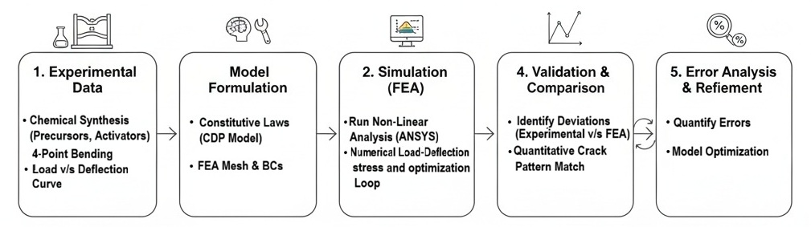
Fig. 1. Workflow diagram for the present experimental study

The GPC synthesis process began with the preparation of binders containing FA, MSF, and EAS. The alkali activators were combined in controlled concentrations for effective geopolymerization. Subsequently, all the materials were mixed to a homogenous state and cast into standard beam molds. Compaction was carried out thoroughly to ensure that no entrapped air remained in the specimens, and the specimens were then cured under ambient and heat conditions for a specified period of time (Ren & Zhang, 2019). The schematic of GPC synthesis is elaborated in Fig. 2. After the curing phase, the flexural strength tests were performed using a Universal Testing Machine (UTM) according to ASTM C78 and IS:516. The beams were subjected to either three-point or four-point bending over a fixed span, after which a gradually increasing load was applied at the center (three-point test) or at two equidistant points (four-point test) until failure. The maximum load at failure was recorded, and flexural strength was computed from the standard formula (Rahmati & Toufigh, 2022). Deflection behavior and crack propagation were monitored with the help of a digital dial gauge, and the corresponding load–deflection curves were plotted. The failure modes of all specimens were carefully recorded for comparative analysis (Un et al., 2015). Results from the validation of the flexural performance of GPC were compared with those of plain cement concrete (PCC). The PCC specimens were prepared using OPC of 43 grade as the single binder, serving as the control mix. Concrete was prepared with three substitution levels for each replacement material, as discussed in subsequent sections (Al-Duais et al., 2023; Singaram et al., 2025).

Numerical simulations in ANSYS Workbench were also conducted to confirm the experimental results. A precise 3D model of the GPC beam, with the required boundary conditions and meshing configurations, was developed. The material properties that have been obtained experimentally, such as compressive strength, flexural strength, modulus of elasticity, and Poisson's ratio, were embedded in the computational model. This simulation has replicated actual loading and support conditions to study stress distribution, deflection, and crack propagation under flexural loads. The numerical results obtained from ANSYS were compared with the experimental data to assess the accuracy, consistency, and reliability of the computational model (Uma et al., 2012; Venkatachalam et al., 2021). The integration of experimental and numerical approaches provided a comprehensive view of the flexural behavior of geopolymer concrete, demonstrating that it can serve as a durable, sustainable, and high-performance alternative to conventional cement-based materials.

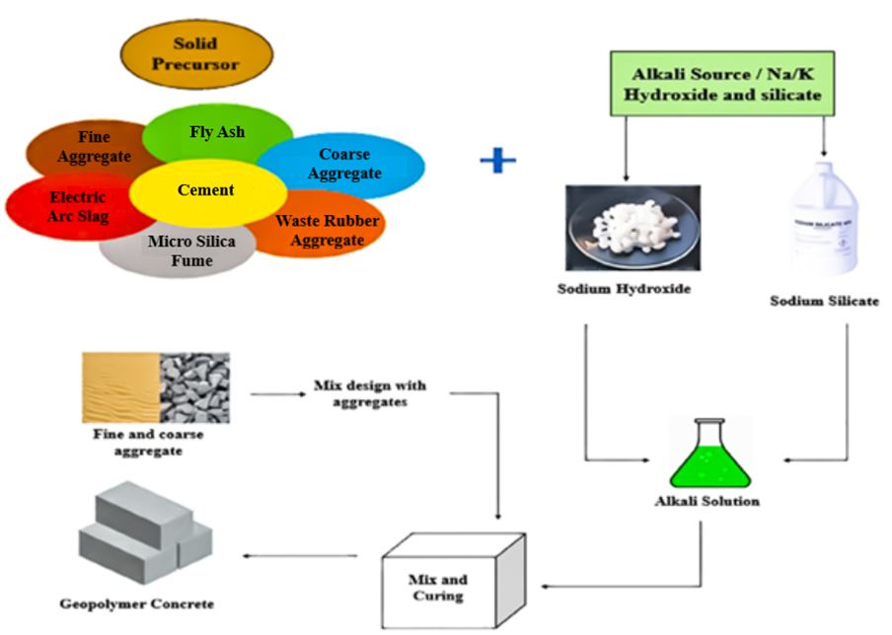
Fig. 2. Manufacturing process of geopolymerization

2.1. Planning for Casting of GPC Samples
This study discusses various GPC mix proportions by partially replacing conventional materials with industrial by-products, such as FA, MSF, EAS, and WRA. The control mix (M40) was used as a reference. The first set of mixtures, the A-Series, replaced FA with MSF at 0%, 4%, and 8%, and were activated with an 8M alkali solution. The AC-Series included EAS as the fine aggregate replacement at 10% and 20% and maintained a constant 92% FA and 8% MSF under the same 8M activation. The BC-Series followed a similar EAS replacement pattern but increased MSF to 12% and used a 12M alkaline activator (Hong et al., 2023). In the ACD-Series, WRA replaced coarse aggregate at 20% and 30%, combined with EAS at 30% and 40%, with an 8M activator. The BCD-Series followed the same replacement approach but with a 12M activator. Table 1 shows various mixed proportions prepared for the entire study.

Table 1. Mix proportions of various admixtures
S. No. | Composition | Acronym
1. | Control Mix (M40) | N
2. | FA 100% MSF 0% 8M | A1
3. | FA 96% MSF 4% 8M | A2
4. | FA 92% MSF 8% 8M | A3
5. | FA 92% MSF 8% EAS 10% 8M | AC1
6. | FA 92% MSF 8% EAS 20% 8M | AC2
7. | FA 88% MSF 12% EAS 10% 12M | BC1
8. | FA 88% MSF 12% EAS 20% 12M | BC2
9. | FA 88% MSF 12% EAS 30% 12M | BC3
10. | FA 88% MSF 12% EAS 40% 12M | BC4
11. | FA 92% MSF 8% WRA 20% EAS 30% 8M | ACD1
12. | FA 92% MSF 8% WRA 20% EAS 40% 8M | ACD2
13. | FA 92% MSF 8% WRA 30% EAS 30% 8M | ACD3
14. | FA 92% MSF 8% WRA 30% EAS 40% 8M | ACD4
15. | FA 88% MSF 12% WRA 20% EAS 30% 12M | BCD1
16. | FA 88% MSF 12% WRA 20% EAS 40% 12M | BCD2
17. | FA 88% MSF 12% WRA 30% EAS 30% 12M | BCD3
18. | FA 88% MSF 12% WRA 30% EAS 40% 12M | BCD4

Each mix was cast into specimens, cured, and tested to evaluate mechanical and microstructural properties. The results demonstrated that incorporating these supplementary materials improved the strength and durability of GPC, offering a sustainable alternative for construction applications. The Alkaline Activator Solution (AAS) was made approximately twelve hours before being mixed with the remaining ingredients. Sodium hydroxide and sodium silicate solutions have allowed them to rest at room temperature in the right proportion. Because the exothermic reaction generates heat, the mixture must cool before being blended with other ingredients. Before adding the activator solution, the mixture of fine and coarse aggregates and binder (FA) was thoroughly mixed in the mixing pan. To make a homogeneous slurry, the premixed AAS was gradually added. Samples of GPC that had been mixed and cast were examined in their transitory "fresh" phase, which has a significant impact on mechanical properties. Due to the usage of class C-FA, the GPC has a glossy black appearance. Comparing the load-deflection curves of AC2 and BC2, the BC2 mixture displayed a more consistent and straighter slope, suggesting that the addition of EAS improved rigidity (Al-Majidi et al., 2019;
Al-Sayed & Shaheen, 2020). However, the BC2 mixture failed earlier than the AC2 mixture. Among all triple replacement mixes, BCD3 showed the highest ultimate load-bearing capacity, attributed to increased bonding from MSF and EAS. The incorporation of EAS further enhanced the load-bearing ability. The deflection behavior varied with different replacement materials. Comparing ACD2 and BCD3, the latter exhibited a relatively smoother texture and an 8% higher load-bearing capacity than the nominal mix due to lower deflection values. The addition of 12% of MSF improved bonding between the components. Despite the reinforcement benefits of EAS, a 30% replacement was necessary to counteract any loss in specimen strength. An increased concentration of EAS leads to decreased rigidity, resulting in a more levelled deflection curve compared
to others.

3. Flexural Load Response
Among the valuable properties of GPC, which find applications in various cases where bending stress is significant, its structural performance has been of foremost importance. Unlike conventional PCC, GPC results from the geopolymerization process, which involves the reaction of aluminosilicate materials with alkaline activators, forming a strong, durable matrix. Among other factors, the flexural strength of GPC is influenced by the type and concentration of alkaline activators, curing conditions, aggregate properties, and the incorporation of supplementary materials, such as FA. Numerical simulation techniques provide more detailed insights into stress distributions, crack propagation, and deflections. Knowledge of these factors is important for determining the mechanical behavior of GPC, which is required to ensure its viability as a sustainable alternative in structural applications (Maranan et al., 2019).
3.1. Experimental Investigations of Flexural Load
Beam-shaped specimens measuring 1000 mm in length and 100 mm by 100 mm in cross section were cast for the purpose of testing flexural strength. Various mechanical and thermal evaluations were used to identify the optimal concrete mix proportions, which were then used to cast the beams for the nominal mix and additional replacement mixes. After casting, each experimental mixture's three beams were left to cure for 28 days. The beams underwent additional tests to determine their deflection and flexural strength. The conventional beam exhibited a significantly lower deflection during flexural testing than the nominal concrete specimens, which contributed to the latter's increased rigidity (Park et al., 2014; Li et al., 2009). To assess the performance and characteristics of the experimental concrete in relation to the reference material, four alternative materials, namely FA, MSF, WRA, and EAS, are substituted for the cementitious material, coarse and fine aggregates, respectively. The deflectometers are extracted, and the load is sustained until the point of failure, at which the specimen collapses. Subsequently, the deflection is measured for every 0.5 kN force increment. The load and deflection values for all concrete mixtures were plotted to explore the behavior patterns of the trend lines in the ultimate load test, shown in Fig. 3. Initial signs of cracking were observed after attaining a particular value of rigidness of the pavement of nominal mix, similar to the previous studies (Maranan et al., 2019; Zhao et al., 2023). All GPC beams have higher strength than the PCC beam. The strength of the concrete mix is slightly enhanced by increasing the FA/MSF ratio. Based on the BC2 deflection value, incorporating an MSF mix enhances adhesion and marginally increases strength compared to the nominal mix. The results in the two-component replacement mix category indicate that the combinations of WRA with FA and MSF achieved the highest level of strength. An incremental improvement of 3% has been accomplished in the nominal mix strength (Bhutta et al., 2017; Çelik et al., 2022).

Table 2. Density of four supplementary material replacement mixes
S. No. | Concrete Mix | Density (Kg/m³)
1. | N | 2443.36
2. | ACD1 | 2465.28
3. | ACD2 | 2466.39
4. | ACD3 | 2470.32
5. | ACD4 | 2474.56
6. | BCD1 | 2485.39
7 | BCD2 | 2492.74
8 | BCD3 | 2488.15
9 | BCD4 | 2512.36
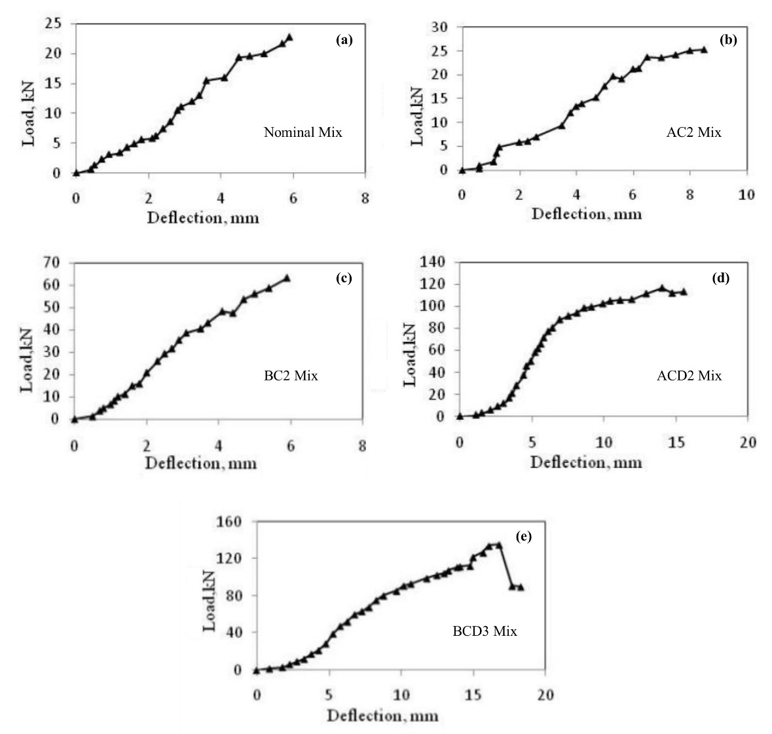
Fig. 3. Load v/s deflection curves for (a) nominal mix; (b) AC2 Mix; (c) BC2; (d) ACD2 and (e) BCD3 mix

To continue with the replacement of the triple components, it has been determined that the best replacement consists of a blend containing 10% to 20% FA and MSF. Moreover, from the load-deflection curves of AC2 and BC2, it can be inferred that BC2 has a smoother, more linear slope, confirming that the addition of EAS increases rigidity accordingly (Al-Majidi et al., 2019; Al-Sayed & Shaheen, 2020). However, it is found that the failure of the mixture BC2 occurs before that of the mixture AC2. The load-deflection curve is examined for ACD2 and BCD3, the three alternative materials used in the combination. Compared to the nominal mix, the BCD3 demonstrates a relatively smooth texture. Because of the low deflection value, the maximum load-bearing capacity is 8% higher than the nominal mix. The addition of 10% MSF to the mixture enhances the bonding between the components, including the steel beam. Despite the improvement provided by the EAS, a 30% replacement compensates for the reduced strength of the specimen. Due to the decrease in rigidity caused by the concentration of steel slag, the deflection value of the curve is relatively more level in comparison to the other mixtures. The deflection profile of the material is significantly greater than that of regular concrete, and the curves deviate from the 2 kN load itself. These results will be further compared with the analytical results discussed in the next section. The highest strength values of nominal, AC2, BC2, ACD2 and BCD3 mixes are found to be 0.9 N/mm², 1.0 N/mm², 2.2 N/mm², 3.5 N/mm² and 4.39 N/mm² respectively. Table 2 shows the density results of different mixes. Further, the slope values of the elastic portion were determined, and the results are depicted in Table 3, which indicate improved rigidity or ductility of the GPC concrete samples compared to traditional concrete samples.

Table 3. Slope of the elastic portion for mixes
S. No. | Mix | Slope
1. | Nominal | 1
2. | ACD3 | 1.28
3. | BCD3 | 1.45
3.2. Modelling and Simulation Using ANSYS
ANSYS software was used to examine the flexural behaviour of GPC and compare it with that of ordinary concrete. To replicate actual structural behaviour, a detailed 3D computer model was developed that accurately represented material properties, boundary conditions, and loading configurations. This simulation examined important factors, including stress distribution, fracture initiation, crack propagation, and failure modes, under flexural loads. The finite element model of reinforced GPC beams was developed in ANSYS and simulated under ambient-temperature curing conditions to represent real experimental conditions accurately. The two post-processing modes of the software, viz., general and time-history, were employed to derive comprehensive behavioural insights. The general post-processing mode enabled focused analysis of stress-strain variations at designated nodes and elements within the model, whereas the time-history post-processing mode facilitated the automatic generation of time-dependent parameters, including deflection and stress development.
3.2.1. ANSYS Procedure
The procedure adapted for analysis using ANSYS software is discussed below:
- Open ANSYS Workbench: Launch ANSYS Workbench and insert a static structural into the schematic. This module is used to analyze structures, such as beams and slabs, under different loading, forces, and stress conditions.
- Selection of the material: Select the option of "Engineering Data". In this case, the material used is Geopolymer Mixture. The data is shown in Fig. 4.

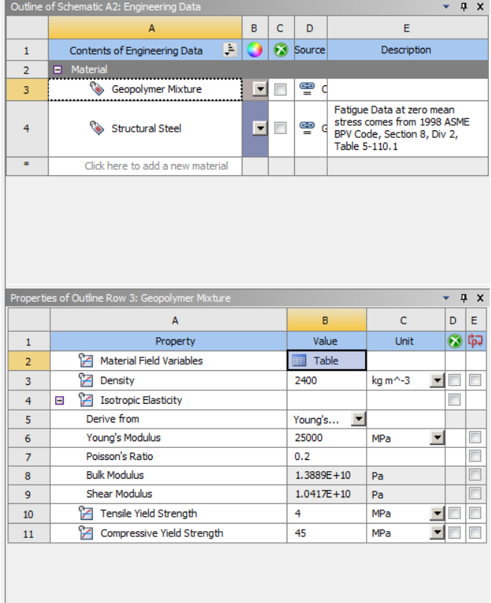
Fig. 4. Selection of material and data in ANSYS

- Geometry Creation: In Design Modeler, create a 3D sketch of the beam by first selecting the plane and then selecting the sketch option. Now sketch a rectangle of 100 mm × 100 mm. Convert the sketch to a surface using the "Surface from Sketch" option. Now, extrude the sketch to 500 mm by selecting the "Both side symmetry" option.
- Meshing: Click mesh, then generate. The mesh is generated, which is shown in Fig. 5. In this case, the element size is set to 5 mm. The bounding box is 1010.0 mm, and the minimum edge length is 100.0 mm. The number of elements is 80,000, and the number of nodes is 345681, of which 88641 are corner nodes, 257040 are mid nodes, and 80,000 are solid elements. The sheet body method used in the mesh, depicted in Fig. 5, is Quad dominant. The aspect ratio and other mesh qualities are also shown in Table 4.
- Boundary Conditions: The boundary conditions applied to the beam are listed in tabular form in Table 5.

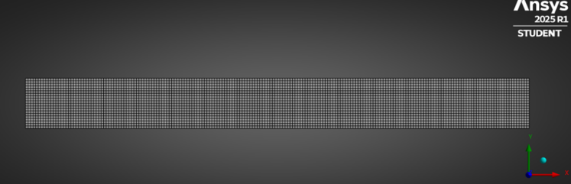
Fig. 5 Meshing used in the ANSYS

Table 4. Meshing properties used in ANSYS
BODY_TYPE | QUALITY_CRITERIA | ERROR_CHECK | TARGET_LIMIT | FAILURE_LIMIT
SHEETS | MAX_ASPECT_RATIO | n | 5 | 1000
SHEETS | MIN_ELEMENT_QUALITY | n | 0.05 | 0.01
SHEETS | MAX_ELEMENT_EDGE_LENGTH | n | 503.3971994 | 1006.794399
SHEETS | MAX_QUAD_ANGLE | n | 150 | 170
SHEETS | MAX_TRI_ANGLE | n | 160 | 170
SHEETS | MAX_CORNER_ANGLE | n | 150 | 170
SHEETS | MIN_ELEMENT_EDGE_LENGTH | n | 5.033971994 | 0.503397199
SHEETS | MIN_QUAD_ANGLE | n | 30 | 10
SHEETS | MIN_TRI_ANGLE | n | 20 | 10
SHEETS | MAX_SKEWNESS | n | 0.9 | 0.999
SHEETS | MAX_WARPING_ANGLE | n | 20 | 30
SOLIDS | MAX_ASPECT_RATIO | n | 5 | 1000
SOLIDS | MIN_ELEMENT_QUALITY | n | 0.05 | 0.000005
SOLIDS | MIN_JACOBIAN_RATIO_CORNER_NODES | n | 0.05 | 0.025
SOLIDS | MIN_JACOBIAN_RATIO_GAUSS_POINTS | n | 0.05 | 0.025
SOLIDS | MAX_ELEMENT_EDGE_LENGTH | n | 503.3971994 | 1006.794399
SOLIDS | MAX_CORNER_ANGLE | n | 150 | 170
SOLIDS | MIN_ELEMENT_EDGE_LENGTH | n | 5.033971994 | 0.503397199
SOLIDS | MAX_SKEWNESS | n | 0.9 | 0.999
SOLIDS | MIN_TET_COLLAPSE | n | 0.1 | 0.001
SOLIDS | MAX_WARPING_ANGLE | n | 20 | 30
SOLID_  SURFACES | MAX_ASPECT_RATIO | n | 5 | 1000
SOLID_  SURFACES | MAX_TRI_ANGLE | n | 160 | 170
SOLID_  SURFACES | MIN_ELEMENT_EDGE_LENGTH | n | 5.033971994 | 0.503397199
SOLID_  SURFACES | MIN_TRI_ANGLE | n | 20 | 10
SOLID_  SURFACES | MAX_SKEWNESS | n | 0.9 | 0.999

Table 5. The boundary conditions that are applied to the beam
S. No. | Condition type | Location (X) | Value Applied DOFs | Notes
1. | Pin Support | 100 mm | U_{x}=0; U_{y}=0; U_{z}=0 | Fixed in all Directions
2. | Roller Support | 900 mm | U_{x}= Free; U_{y}=0; U_{z}=0 | Beam Expansion
3. | Point load 1 | 333 mm | F_{y}= -2.5 kN | Downward Force
4. | Point load 2 | 666 mm | F_{y}= -2.5 kN | Downward Force

The simulation results indicated that GPC beams exhibited a more ductile failure mode than traditional concrete, characterized by a delayed crack onset and a more gradual load-deflection curve. A quantitative metric containing strain energy absorption and ductility index is shown in Table 6. These values support the claim, as the containing strain energy absorption and ductility index values are higher and hence indicate a ductile failure mode than traditional concrete. The stress contours exhibited a consistent distribution of tensile stress throughout the bottom fibre of GPC beams, signifying effective load transmission through the geopolymer matrix. Peak tensile stresses were localised at mid-span in both concrete types; however, GPC exhibited a more dispersed fracture pattern, indicating superior energy-dissipation capability.

Table 6. Quantitative Metric Values
S. No. | Mix | Energy Absorb (J) | Ductility Index
1. | N | 12.3 | 1.0
2. | BCD3 | 18.5 | 1.5

The comparison of the simulated and experimental findings demonstrated a strong agreement, with the maximum mid-span deflection from ANSYS differing by less than 7% from the laboratory observations. The anticipated first-crack load and ultimate load were within 5–10% of the observed values, hence confirming the precision of the finite element model. In the meantime, the parametric analysis demonstrated that increasing the amount of reinforcement enhanced flexural capacity and reduced deflection, but changes in curing methods made a significant impact on early-age stiffness and fracture resistance. GPC beams treated at hotter temperatures exhibited better performance, showing up to 15% higher flexural strength and a 10% reduction in crack width compared to those cured at ambient temperature. The results validate that ANSYS simulations are capable of predicting the structural performance of GPC, serving as an important tool toward the optimization of mix designs and reinforcing methods, as illustrated in Fig. 6. The verified model may consequently act as a reliable basis for further research on GPC under various loading and environmental conditions (Prabakaran et al., 2017; Ren & Zhang, 2019).
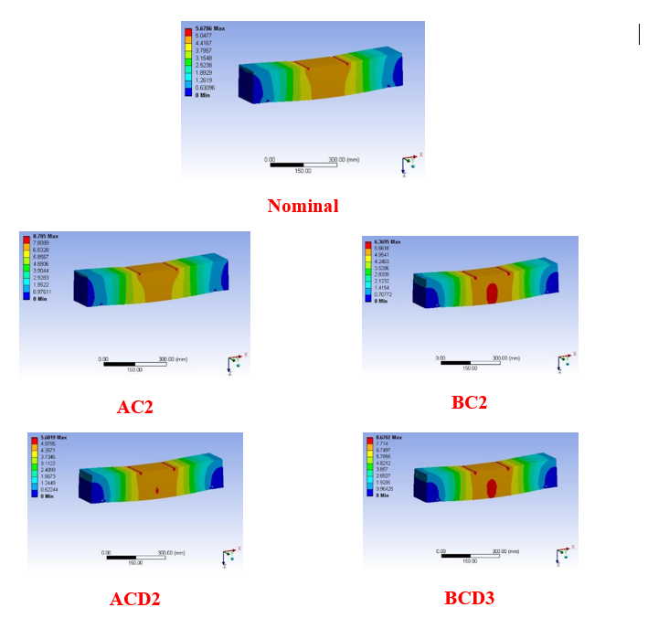
Fig. 6. Deflection pattern for concrete mixes using ANSYS
4. Results and Discussion
The transition from Ordinary Portland Cement (OPC) to Geopolymer Concrete (GPC) model represents a revolutionary approach to sustainable engineering, as it uncouples structural functionality from carbon-emitting processes. The first and foremost effect of the GPC model is the complete elimination of the carbon footprint associated with the traditional cement process. This is because the GPC model completely replaces the OPC with industrial by-products. The GPC model also optimizes the ambient curing process using chemical additives such as GGBS, eliminating the need for high-temperature kilns and reducing total embodied energy by up to 80%. More refined models enable reducing Sodium Silicate, the most carbon-intensive component of the activator, without compromising flexural strength.
The GPC models make the construction sector a "sink" for the world's industrial waste by encouraging a circular economy. The model consumes millions of tons of Fly Ash and Slag that would otherwise fill landfills. With the increased bond strength of steel in GPC models, there is justification for the use of slender beams, which, in turn, reduce the overall volume of concrete and steel needed to support the same load. In contrast to OPC, which consumes large amounts of water for hydration, geopolymerization consumes water only for workability, thereby reducing water consumption in the mix design by a significant margin.
Although the cost of chemical activators may be higher than cement, the economic model of GPC is superior in the long run. GPC beams are highly resistant to acids and sulfates. Simulations indicate a longer lifespan under adverse conditions, which in turn reduces maintenance and demolition costs by a huge margin over 50 years. GPC chemistry optimized for faster setting times in precast units increases factory output and reduces labor costs per unit.
The reliability of the results was confirmed by the strong correlation between FEA using ANSYS and laboratory results in this experimental and analytical evaluation of GPC. Although the experimental deflection values were slightly higher than the analytical predictions, this was due to idealized bond assumptions in the FEA, which assume that concrete and reinforcement interact perfectly, whereas in reality, they slip. The FEA successfully predicted the structural behavior of the GPC beams.
Bending and crack growth phenomena reduced the flexural rigidity with increasing load, thereby reducing the moment of inertia. Of the mixes tested, the BCD3 mix containing 40% EAS, 20% MSF, and 20% EAS achieved the highest flexural strength, increasing by 4% above the nominal mix. The work also analyzed the effectiveness of supplementary materials such as FA, MSF, WRA, and EAS in enhancing concrete performance.
The specimens were tested under flexural loading, and the test results showed that beams incorporating alternative materials had better mechanical properties. Test beams were cast, cured for 28 days, and subjected to load-deflection tests, with deflection recorded at 0.5 kN increments until failure. The findings confirm that GPC with these material replacements is a viable, sustainable alternative for structural applications.
4.1. Cost Analysis
A cost comparison analysis has been carried out for the M40 nominal mix with the synthesized GPC mixes, since they possess adequate physical and mechanical attributes. Furthermore, the highest strength parameter obtained from mechanical testing for the mixtures was also considered. Table 7 examines the use of auxiliary ingredients that can effectively reduce GPC's manufacturing expenditure.

Table 7. Cost comparison of M40 nominal mix with GPC mixes per m³
Mix | Cost per m³ (in INR) |  |  |  |  | Total Cost  (in INR) | Cost  Reduction (Percentage)
Mix | Cement | FA + MSF | Coarse  Aggregates | Fine Aggregates + EAS | NaOH  + Na₂SiO₃ | Total Cost  (in INR) | Cost  Reduction (Percentage)
N | 4250 | 0 | 3170 | 776 | 0 | 8196 | -
AC2 | 0 | 2434 | 3170 | 870 | 387 | 6861 | 16.28
BC2 | 0 | 2434 | 3170 | 870 | 580 | 7054 | 13.93
AC3 | 0 | 2434 | 3170 | 870 | 387 | 6676 | 17.32
BC3 | 0 | 2398 | 3170 | 916 | 580 | 6979 | 14.84

The cost analysis results demonstrate a 17.32% decrease in the GPC sample AC2 mix, making it the most cost-efficient alternative that includes additional components. The cost study demonstrates a comparable pattern of cost reduction, as documented by earlier studies, so, as compared to OPC concrete, GPC manufactured by FA and MSF has several financial advantages (McLellan et al., 2011; Wang et al., 2024; Yaser et al., 2021). Consequently, GPC is more affordable than PCC. Hence, GPC offers additional financial benefits in infrastructure projects.
5. Conclusion
The adoption of GPC in the construction industry is hindered by the research and development required to determine its performance and standardize its applications. The use of geopolymers provides a sustainable and cost-effective solution for managing industrial waste while enhancing concrete performance. In the present study, GPC samples were synthesized using fly ash, microsilica fume, electric arc slag waste rubber aggregates, and an alkaline activator solution. Compared to the nominal mix, the GPC mixes demonstrate a relatively smooth texture. The use of EAS as a replacement for fine aggregates in GPC mixes improved the mechanical properties of the mixes. The load-deflection curve is examined for GPC mixes and compared with the nominal mix experimentally and via ANSYS simulation. The conclusions drawn from the present study are as follows:
- The presence of MSF during polymerization enhanced the formation of amorphous solids, as observed in modified GPC samples.
- The low deflection value of the BCD3 mix indicates an 8% higher maximum load-bearing capacity than the nominal mix, improving flexural strength and load response.
- The BCD3 mix (FA 88%, MSF 12%, WRA 30%, EAS 30%, 12M) exhibits the highest strength value of 4.39 N/mm² among all the GPC mixes.
- The finite element model of GPC beams was developed in ANSYS and simulated under ambient-temperature curing conditions to represent real experimental conditions accurately. The simulation findings indicated that GPC beams had a more ductile failure mode than traditional concrete.
- The maximum mid-span deflection from ANSYS differs by less than 7% from laboratory observations. The comparison of simulated and experimental findings demonstrated a remarkable connection, establishing the reliability of the results.
- The cost analysis indicated a reduction in the cost of GPC mixes when compared to the nominal mix. Incorporating FA, MSF, WRA, and EAS combined reduced the cost by 17.32% in ACD2 and 14.84% in the BCD3 GPC mix.

Acknowledgement
The authors extend their appreciation to the Deanship of Scientific Research at the King Khalid University of Saudi Arabia, for funding this work through the Large Groups Research Project under Grant no. RGP.2/484/45.
References
Adak, D., Sarkar, M., & Mandal, S. (2014). Effect of nano-silica on strength and durability of fly ash-based geopolymer mortar. Constr Build Mater, 70, 453-9. https://doi.org/10.1016/j.conbuildmat.2014.07.093
Al Bakri, MM., Mohammed, H., Kamarudin, H., Niza, IK., & Zarina, Y. (2011). Review on fly ash-based geopolymer concrete without portland cement. Int Res J Eng Technol, I, 1-4. http://www.academicjournals.org/JETR
Al-Duais, IN., Ahmad, S., Al-Osta, MM., Maslehuddin, M., Saleh, TA., & Al-Dulaijan, SU. (2023). Optimization of alkali-activated binders using natural minerals and industrial waste materials as precursor materials. J Build Eng, 69, 106230. https://doi.org/10.1016/j.jobe.2023.106230
Al-Majidi, MH., Lampropoulos, AP., Cundy, AB., Tsioulou, OT., & Alrekabi, S. (2019). Flexural performance of reinforced concrete beams strengthened with fibre reinforced geopolymer concrete under accelerated corrosion. Istruc 1(19), 394-410. https://doi.org/10.1016/j.istruc.2019.02.005
Ayeni, O., Onwualu, AP., & Boakye, E. (2021). Characterization and mechanical performance of metakaolin-based geopolymer for sustainable building applications. Constr Build Mater, 272, 121938. https://doi.org/10.1016/j.conbuildmat.2020.121938
Azad, NM., & Samarakoon, SS. (2021). Utilization of industrial by-products/waste to manufacture geopolymer cement/concrete. Sustainability, 13(2), 873. https://doi.org/10.3390/su13020873
Bhutta, A., Borges, PH., Zanotti, C., Farooq, M., & Banthia, N. (2017). Flexural behavior of geopolymer composites reinforced with steel and polypropylene macro fibers. Cem Concr Compos, 80, 31-40.
https://doi.org/10.1016/j.cemconcomp.2016.11.014
Çelik, Aİ., Özbayrak, A., Şener, A., & Acar, MC. (2022). Numerical analysis of flexural and shear behaviors of geopolymer concrete beams. J Sustain Constr Mater Technol, 2, 70-80. https://doi.org/10.47481/jscmt.1116561
Chandra, Kumar, BS., & Ramesh, K. (2018). Analytical study on flexural behaviour of reinforced geopolymer concrete beams by ansys. Mater Sci Eng, 19, 455-012065. https://doi:10.1088/1757-899X/455/1/012065
Choudhary, L. (2024). Structural behavior of sustainable ternary geopolymer concrete and strength prediction using machine learning. SSRN, 16, 4940465. http://dx.doi.org/10.2139/ssrn.4940465
Chowdhury, S., Mohapatra, S., Gaur, A., Dwivedi, G, & Soni, A. (2021). Study of various properties of geopolymer concrete – a review. Mater Today: Proc, 46, 5687-95. https://doi.org/10.1016/j.matpr.2020.09.835
Danish, A., Ozbakkaloglu, T., Mosaberpanah, MA., Salim, MU., Bayram, M., Yeon, JH., & Jafar, K. (2022). Sustainability benefits and commercialization challenges and strategies of geopolymer concrete: a review. J Build Eng, 58, 105005. https://doi.org/10.1016/j.jobe.2022.105005
El-Abbasy, AA. (2023). Tensile, flexural, impact strength and fracture properties of ultra-high-performance fiber-reinforced concrete–a comprehensive review. Constr Build Mater, 408, 133621. https://doi.org/10.1016/j.conbuildmat.2023.133621
El-Sayed, TA., & Shaheen, YB. (2020). Flexural performance of recycled wheat straw ash-based geopolymer rc beams and containing recycled steel fiber. Istruc, 1(28), 1713-1728. https://doi.org/10.1016/j.istruc.2020.10.013
Goonewardena, J., Ghabraie, K., & Subhani, M. (2020). Flexural performance of frp-reinforced geopolymer concrete beam. J Compos Sci, 4,187. https://doi.org/10.3390/jcs4040187
Hong, F., Yu, S., Hou, D., Li, Z., Sun, H., Wang, P., & Wang, M. (2023). Study on the mechanical properties, gelling products and alkalization process of alkali-activated metakaolin: from experiment to molecular dynamics simulation. J Build Eng, 79, 107705. https://doi.org/10.1016/j.jobe.2023.107705
Imtiaz, L., Rehman, SK., Memon, SA., Khan, MK., & Javed, MF. (2020). A review of recent developments and advances in eco-friendly geopolymer concrete. Appl Sci, 10(21), 7838. https://doi.org/10.3390/app10217838
Karakoc, MB., Türkmen, İ., Maraş, MM., Kantarci, F., & Demirboğa, R. (2016). Sulfate resistance of ferrochrome slag based geopolymer concrete. Ceram Int, 42, 1254-60. https://doi.org/10.1016/j.ceramint.2015.09.058
Li, X., Liu, SF., Wang, PM. (2009). Flexural behavior of geopolymer mortar modified by re-dispersible polymer emulsion powder. J Build Mater, 12(2), 205-8.
Maranan, GB., Manalo, AC., Benmokrane, B., Karunasena, W., Mendis, P., & Nguyen, TQ. (2019). Flexural behavior of geopolymer-concrete beams longitudinally reinforced with gfrp and steel hybrid reinforcements. Eng Struct, 182, 141-52. https://doi.org/10.1016/j.engstruct.2018.12.073
Mathew, G., & Joseph, B. (2018). Flexural behaviour of geopolymer concrete beams exposed to elevated temperatures. J Build Eng, 15, 311-7. https://doi.org/10.1016/j.jobe.2017.09.009
McLellan, BC., Williams, RP., Lay, J., Riessen, AV., & Corder, GD. (2011). Costs and carbon emissions for geopolymer pastes in comparison to OPC. J Clean Prod, 19(9–10), 1080–90. http://doi:10.1016/j.jclepro.2011.02.010
Mukhtar, F., Jawdhari, A. (2024). RC beams flexurally strengthened with cfrp sheets combined with frc layer for mitigating debonding failures. Constr Build Mater, 427, 136274. https://doi.org/10.1016/j.conbuildmat.2024.136274
Nagakumar, MS., Ajay, N., & John, SE. (2021). An analytical approach to analysis of concrete overlay (white topping) over flexible pavement (hot mix asphalt) using ANSYS software. Sustainability Trends and Challenges in Civil Engineering. Lecture Notes in Civil Engineering, vol 162. Springer, Singapore. 363-379. https://doi.org/10.1007/978-981-16-2826-9_24
Nath, P., & Sarker, PK. (2017). Flexural strength and elastic modulus of ambient-cured blended low-calcium fly ash geopolymer concrete. Constr Build Mater, 130, 22-31. https://doi.org/10.1016/j.conbuildmat.2016.11.034
Nematollahi, B., Sanjayan, J., & Shaikh, FUA. (2014). Comparative deflection hardening behavior of short fiber reinforced geopolymer composites. Constr Build Mater, 70, 54-64. https://doi.org/10.1016/j.conbuildmat.2014.07.085
Nguyen, KT., Ahn, N., Le, TA., & Lee, K. (2016). Theoretical and experimental study on mechanical properties and flexural strength of fly ash-geopolymer concrete. Constr Build Mater, 106, 65-77. https://doi.org/10.1016/j.conbuildmat.2015.12.033
Noushini, A., Hastings, M., Castel, A., & Aslani, F. (2018). Mechanical and flexural performance of synthetic fibre reinforced geopolymer concrete. Constr Build Mater, 186, 454-75. https://doi.org/10.1016/j.conbuildmat.2018.07.110
Pandimani, P., Ponnada, MR., & Geddada, Y. (2022). Numerical nonlinear modeling and simulations of high strength reinforced concrete beams using ansys. J Build Pathol Rehabil, 7, 22. https://doi.org/10.1007/s41024-021-00155-w
Pandimani, P. (2023). Computational modeling and simulations for predicting the nonlinear responses of reinforced concrete beams. Multidiscip Model Mater Struct, 4, 728-747. https://doi.org/10.1108/MMMS-09-2022-0193
Parathi, S., Nagarajan, P., & Pallikkara, SA. (2021). Ecofriendly geopolymer concrete: a comprehensive review. Clean Technol Environ Policy, 23, 1701-13. https://doi.org/10.1007/s10098-021-02085-0
Park, Y., Abolmaali, A., Mohammadagha, M., & Lee, SH. (2014). Flexural characteristic of rubberized hybrid concrete reinforced with steel and synthetic fibers. Adv Civ Eng Mater, 3(1), 495-508. https://doi.org/10.1520/ACEM20140011
Prabakaran, PA., Premalatha, J., & Satheesh Kumar, KR. (2017). Experimental investigation on flexural behaviour of geopolymer concrete. Int J Civ Eng Technol, 8, 1692-1706.
http://http://iaeme.com/Home/issue/IJCIET?Volume=8&Issue=8
Rahmati, M., & Toufigh, V. (2022). Evaluation of geopolymer concrete at high temperatures: an experimental study using machine learning. J Clean Prod, 372, 133608. https://doi.org/10.1016/j.jclepro.2022.133608
Ren, X., & Zhang, L. (2019). Experimental study of geopolymer concrete produced from waste concrete. J Mater Civ Eng, 7, 04019114. https://doi.org/10.1061/(ASCE)MT.1943-5533.0002750
Shaikh, FUA. (2013). Deflection hardening behaviour of short fibre reinforced fly ash based geopolymer composites. Mater Des, 50, 674-82. https://doi.org/10.1016/j.matdes.2013.03.063
Singaram, KK., Khan, MA., & Talakokula, V. (2025). Review on compressive strength and durability of fly-ash-based geopolymers using characterization techniques. Arch Civ Mech Eng, 25(2), 1-34.
https://doi.org/10.1007/s43452-025-01116-7
Singh, RP., Vanapalli, KR., Cheela, VR., Peddireddy, SR., Sharma, HB., & Mohanty, B. (2023). Fly ash, ggbs and silica fume based geopolymer concrete with recycled aggregates: properties and environmental impacts. Constr Build Mater, 378, 131168. https://doi.org/10.1016/j.conbuildmat.2023.131168
Sun, J., Xie, J., Zhou, Y., & Zhou, Y. (2022). A 3d three-phase meso-scale model for simulation of chloride diffusion in concrete based on ansys. Int J Mech Sci, 219, 107127. https://doi.org/10.1016/j.ijmecsci.2022.107127
Uma, K., Anuradha, R., & Venkatasubramani, R. (2012). Experimental investigation and analytical modeling of reinforced geopolymer concrete beam. Int J Surv Struct Eng, 2(3), 817-27. https://doi:10.6088/ijcser.00202030010
Un, CH., Sanjayan, JG., San Nicolas, R., & Van Deventer, JS. (2015). Predictions of long-term deflection of geopolymer concrete beams. Constr Build Mater, 94, 10-9. https://doi.org/10.1016/j.conbuildmat.2015.06.030
Venkatachalam, S., Vishnuvardhan, K., Amarapathi, GD., Mahesh, SR., & Deepasri, M. (2021). Experimental and finite element modelling of reinforced geopolymer concrete beam. Mater Today: Proc, 45, 6500-6. https://doi.org/10.1016/j.matpr.2020.11.449
Wang, S., Zhang, S., Cheng, X., Wang, Z., Guo, F., & Zhang, J. (2024). An efficient molten steel slag gas quenching process: integrating carbon solidification and waste heat recovery. Waste Manag, 186, 249–58.
http://doi.org/10.1016/j.wasman.2024.06.024
Arun Kumar et al. (2022). Impact of Crumb Rubber Concentration and Plastic-Coated Aggregates on the Rheological Performances of Modified Bitumen Asphalt. Sustainability, 14(7). http://doi.org/10.3390/su14073907
Yang, H., Liu, L., Yang, W., Liu, H., Ahmad, W., Ahmad, A., Aslam, F., & Joyklad, P. (2022). A comprehensive overview of geopolymer composites: a bibliometric analysis and literature review. Case Stud Constr Mater, 16. https://doi.org/10.1016/j.cscm.2021.e00830
Yaser Sahloddin, Ahmad Dalvand, Masoud Ahmadi, Hossein Hatami, & Mohammad Houshmand Khaneghahi (2021). Performance evaluation of built-up composite beams fabricated using thin-walled hollow sections and self-compacting concrete. Construction and Building Materials, 305, 124645, ISSN 0950-0618, https://doi.org/10.1016/j.conbuildmat.2021.124645
Amardeep Boora, Kavita Rani, & Parveen Berwal. (2023). Slag and Bagasee Ash: a potential binder for sustainable rigid binder. ACS Omega. https://doi.org/10.1021/acsomega.3c04089
Zhao, C., Wang, Z., Wu, X., Zeng, X., Zhu, Z., Guo, Q., & Zhao, R. (2023). Study on the flexural properties and fiber‐selection method of fiber‐reinforced geopolymer concrete. Struct Concr, 24(1), 1364-85. https://doi.org/10.1002/suco.202200503

