
 | Rocznik Ochrona Środowiska
 | Volume 28 | Year 2026 ISSN 2720-7501 | pp. 27-43
 | https://doi.org/10.54740/ros.2026.003 open access
 | Received: January 2026 Accepted: February 2026 Published: February 2026
Towards Sustainable Pavement Materials: Statistical Modelling of Stability and Flow Characteristics in Recycled PET-Modified Bituminous Concrete
Mukesh Saini^{1*}, Praveen Aggarwal², Parveen Berwal^{3**},
Abdullah Faiz Al Asmari⁴, Saiful Islam⁴
¹Department of Civil Engineering, MM Engineering College, Maharishi Markandeshwar (Deemed to be University), Mullana, Ambala, India
²Department of Civil Engineering, NIT, Kurukshetra, India
³Department of Civil Engineering, Galgotias College of Engineering & Technology, Greater Noida, India
⁴Civil Engineering Department, College of Engineering, King Khalid University, Abha 61421, Saudi Arabia
*corresponding author's e-mail: mukeshsaini512@mmumullana.org
**corresponding author's e-mail: abhigreat00@gmail.com
Abstract: This research explores the use of data-driven modelling approaches to predict the stability and flow behaviour of bituminous concrete mixtures incorporating polyethylene terephthalate (PET) waste as a modifier. A total of 35 unique mix combinations were produced via the dry-mixing technique, varying both PET and bitumen contents, and tested in accordance with MoRTH and ASTM D1559 protocols. Three predictive frameworks, Multiple Linear Regression (MLR), Artificial Neural Networks (ANN), and Random Forest (RF), were developed using a 66:34 train-test data split. Model performance was assessed through the coefficient of determination (R²), mean absolute error (MAE), and root mean square error (RMSE). For stability estimation, RF achieved an R² of 0.9886 on the training set and 0.7902 on the test set, while ANN delivered 0.9916 and 0.9459, respectively. MLR provided a reliable yet lower R² of 0.8683 for the training data. Similar performance patterns were noted for flow value predictions. Although RF demonstrated superior accuracy during training, ANN showed better generalization on test data. MLR remained consistent and interpretable across both datasets. The findings demonstrate the effectiveness of machine learning in streamlining laboratory processes and enhancing the design of PET-modified asphalt mixes, contributing to environmentally sustainable pavement engineering.
Keywords: predictive modeling, machine learning, bituminous concrete, PET
1. Introduction
Bituminous concrete is commonly used for the wearing course of flexible pavements. The stability value of bituminous concrete mixes increases with the incorporation of low-density polythene in a partial replacement of coarse aggregates. It was found that the modified mixes had less creep stiffness and more indirect tensile strength than the conventional mix (Xing et al., 2023). Under real-world field conditions, the durability and moisture susceptibility of amended bituminous mixtures improved with the addition of a plastic polymer (Nasir et al., 2022). The behaviour of waste plastic in bituminous concrete mixtures containing Portland cement as filler and polyethylene terephthalate waste plastic as a modifier improves the mechanical properties using dry techniques (Muhammad et al., 2021). The rutting resistance of the modified waste plastic mixes was higher than that of the conventional mix (Radwan et al., 2022; Sangeeta et al., 2011). Mechanical properties of bituminous concrete mixes improve initially up to a certain extent, and the optimum quantity of PET was found to be 10% by weight of optimum bitumen content, which fulfills the requirement of mechanical properties for modified mixes using waste plastic as per IRC: SP:98-2013 specifications mix (Saini et al., 2025; Saini et al., 2019). Stability and the indirect tensile strength of bituminous concrete mixes increase by up to 29% compared to a conventional mix at 6% plastic content. The tensile strength ratio was likewise higher than that of conventional mixes with the addition of waste plastic (Yildiz and Atakanal, 2020). Bituminous concrete mixes can benefit from the use of polyethylene terephthalate as a modifier (Amoni et al., 2022). Optimum bitumen content for the semi-dense bituminous concrete mix using conventional aggregates was observed as 5.42%, whereas it was 5.24% for waste plastic-coated aggregate, resulting in a saving in bitumen content. The optimum quantity of waste plastic was observed to be 10% of the optimum bitumen content. The significant increase in the stability value indicates an improvement in the properties of the mix due to the plastic coating over the aggregate mix (Mistry & Roy., 2021; Jablonska et al., 2011; Amardeep Boora, Kavita Rani et al., 2023).
A model created with specific entities can be properly explained and shared with others to help them conduct their study on the right track. Because the accuracy, quality, and quantity of data provided determine a model's effectiveness, gathering the appropriate data in the right quantities is critical to modelling. Data modelling can be done in a variety of ways. These approaches are compared based on their accuracy in forecasting results, training duration, and error rate. Bituminous mix is traditionally designed based on previous experiences. Several trials on the mix proportion can yield a regular bituminous mix with all the required properties. However, because there are so many variables to adjust in a desired bituminous mix, empirical methods do not appear sufficient for mix design. Data mining techniques can be extremely useful in resolving the issue. Computational approaches and artificial intelligence applications have benefited all sectors of science and research in recent years. Data modelling, as in other domains, can be used to create bituminous mixes. It entails establishing a link between dependent and independent variables. The most significant properties of bituminous mix are stability and flow. Predicting the stability and flow value of bituminous mix can help manage the material's quality. Stability and flow are closely related to the actual values, and the ANFIS's predictive ability is suitable for obtaining these values by avoiding the expensive, time-consuming, and repetitive laboratory test mix (Mistry & Roy, 2020; Merve et al., 2017). Fuzzy logic and artificial neural networks: the Marshall Stability model for asphalt concrete gives significant values. mix (Ozgan., 2009; Ozgan., 2010; Ozgan., 2011). The established NN model can be utilised to forecast viscosity values for different types of CRM binders accurately. Sensitivity analysis of input factors revealed that changes in viscosity are as important as changes in asphalt binder grade, test temperature, and rubber content (Chaira & Veranita, 2020). A strong correlation (r = 0.961) is observed between the Marshall Stability Value and Indirect Tensile Strength for PET-modified mixes. Hence, the application of plastic waste (PET) in flexible pavements is an environmentally friendly solution for the disposal of non-biodegradable plastic waste, along with improvements in the mechanical properties of bituminous mixes (Thodesen et al., 2009). The use of waste plastic in flexible pavement can reduce the need for bitumen, promoting sustainable construction (Kumar et al., 2022).
The sensitivity analysis and essential indices of input variables in ANN models showed that the rheological characteristics of asphalt binders can be used to efficiently forecast resilient modulus values at various testing temperatures (Xiao & Amirkhanian, 2008). Fuzzy logic and statistical methods can be used to predict the stability of asphalt concrete under various freezing and thawing conditions (Ozgan, 2010). An Artificial Neural Network (ANN) and a Least Squares Support Vector Machine (LS-SVM) predict Marshall Characteristics, including stability, flow value, and air gaps. Compared with the LS-SVM model, the NN-based model is shown to be more compact, reliable, and predictable (Khuntia et al., 2014; Jayachandran et al., 2024; Kurzekar et al., 2024; Wagh et al., 2025). Despite the substantial body of research on the use of polyethylene terephthalate (PET) in bituminous concrete and the growing integration of machine learning techniques into material-prediction models, a clear synthesis of these domains for optimizing stability and flow properties is lacking. A majority of the literature has either tested PET-modified mixes empirically or applied data-driven models in isolation, without a sound comparative analysis. Moreover, few studies have examined the predictive accuracy of multiple regression, artificial neural network, and random forest models using a similar dataset in PET-modified mixes. This poses an essential research gap: evaluating which modelling method provides the most credible predictions of the mechanical behaviour of PET-modified bituminous concrete and which are the most general. The current paper fills this gap by systematically comparing these models and defining tested correlations between mix design variables and performance measures, with the purpose of reducing the number of experiments conducted while increasing predictive consistency to the maximum. The primary goal of this study is to reduce laboratory activities to support sustainable development, thereby reducing time and costs. To meet this demand, a predictive model of the required results is needed.
When elaborating the literature review, care was taken to incorporate the fundamental works on the subject, as well as recent work on PET modification in bituminous mixes and data modelling processes. Some sources can be listed more than once, but this repetition was indispensable to emphasize their versatile nature: mechanical performance improvement, mix optimization, and environmental influence. For example, papers such as Saini et al. (2025) not only present empirical evidence of PET-modified mixes but also comment on material savings, which is why it is worth repeating. Moreover, the work by Ozgan (2009) cuts across various modelling methods, such as fuzzy logic and artificial neural networks, in various environmental circumstances. To make it clearer, the unique functions of these researches have been expounded where necessary throughout the paper. This method will yield an interdisciplinary perspective on the research.
2. Objectives of the Study
The main aim of this research is to develop precise and valid predictive analytical models for assessing the stability and flow profile of PET-modified bituminous concrete blends. It is done by using three popular data modelling algorithms: Multiple Linear Regression (MLR), Artificial Neural Networks (ANN), and Random Forest (RF). The study aims to:
- Reduce the laboratory work and costs associated with traditional mix design methods. Ensure strong associations between the mix design variables and the mechanical properties.
- Compare the predictive accuracy of MLR, ANN, and RF models on the same dataset. Test the developed models on training and test data to ensure they are reliable and generalize well.
- Encourage sustainable pavement construction by incorporating plastic waste into bituminous mixtures using data.
3. Methodology
Marshall Specimens were cast with 1200 g of material (coarse aggregates, fine aggregates, and filler) in the desired gradation as per MORTH Specifications, as shown in Figure 1 (MoRT&H, 2013). The bitumen concentration ranged from 5.0 percent to 5.8 percent (with a 0.2 percent increment). Aggregates and bitumen were heated separately to 150°C and 170 °C, respectively. The materials were then mixed to create a homogeneous mixture, and the filler was added once the bitumen was properly coated over the aggregates. Hydrated lime was added at the end of the mixing process to regulate the voids in the mixture. At 160°C, the mixture was stirred until homogeneous. The mixture was poured into a Marshall Mould with a diameter of 10.16 cm and a height of 7.5 cm. With 75 hammer blows, the mould was compressed in the Marshall Compaction pedestal. The sample was inverted and compressed with the same number of blows on the opposite side. The collar and base plate were removed after compaction. After allowing the sample to cool to ambient temperature, it was extruded using a sample extractor (ASTM D-1559, 2004). The specimens for modified mixes were prepared using the dry process as per the flow chart given in Figure 2 (IRC-SP:98, 2013).

Fig. 1. Gradation of bituminous concrete (Grade – II) mix

 |  | Coarse Aggregate
 |  | 170˚C
 |  | Hot Aggregate |  | Waste Plastic
 |  |  | 150˚C
 |  | Plastic Coated Aggregate |  | Bitumen
Stone Dust |  | Plastic and Bitumen  Coated Aggregate |  | Lime
 |  | Bituminous Mix Material
Fig. 2. Casting process of the modified specimen

Three commonly used techniques for data modelling, namely multiple linear regression, artificial neural network, and random forest, are used in the present research work. Bitumen percentage, PET content, bulk density (G_{m}), theoretical density (G_{t}), and volume of bitumen (Vb) were used as input variables, whereas stability and flow were output variables. Specifically, these terms represent critical independent variables that influence the volumetric and mechanical properties of bituminous mixes, thereby significantly affecting the performance of PET-modified bituminous concrete mixes.

G_{m} (Specific Gravity of Aggregate Mix):
The specific gravity of the aggregate mix (G_{m}) directly influences the density, compaction characteristics, and overall volumetric behaviour of the bituminous concrete. Variations in aggregate specific gravity affect the void content, hence impacting the stability and durability of the mix.

G_{t} (Specific Gravity of Bitumen):
The specific gravity of bitumen (Gt) plays a key role in calculating the appropriate binder percentage required to achieve the expected mechanical properties and durability. It influences the efficiency of asphalt coating of the aggregates, the adhesion, and, as a result, the stability and the flow properties of the mixture.

V_{b} (Volume of Bitumen):
The amount of bitumen (V_{b}) is the amount of binder being added to the mix, and it directly affects the binder cohesiveness, flex and deformation resistance of the mix. Optimizing Vb ensures the mix is neither too stiff nor too flexible, and that it has sufficient strength and durability. These parameters were chosen based on previously tested literature and industry standards, as they are directly associated with the overall performance of bituminous concrete mixes (stability and flow characteristics). Data analysis was performed for 23 mixes (2/3 of the 35 mixes in total), selected at random from the 35 mixes of interest. The remaining 12 mixes served as validation data for the multiple linear regression technique. During the model development stage, the 35 mix designs were thoroughly checked for inconsistencies or aberrant behaviour. There were no points dropped; however, some mixes (like BC5.0-P4 and BC5.2-P12) showed comparatively large prediction errors in more than one model (especially in flow), which could suggest that they possess outlier properties. However, no formal statistical outlier detection methods (e.g., Cook's distance, leverage plots were applied, primarily due to the limited dataset size. Rather than excluding these data points, they were retained intentionally to preserve the dataset's variability and ensure the models learned from a realistic range of conditions. The impact of these influential data points was captured in the error analysis tables and visualized in percentage error plots. In future work, we plan to incorporate formal outlier diagnostics and influence analysis, especially when larger datasets become available, to better understand their effect on model stability and generalization.
4. Result Analysis
4.1. Multiple Linear Regression Modelling
The simplest and most effective data-handling and numerical-prediction technique is multiple linear regression. MLR analysis generates numerous linear models based on simple equations built between input and output parameters. In all disciplines of science and technology, the method has been widely acknowledged as a foundation for more complicated learning programmes. Equations 1 & 2 were developed to predict the stability and flow value of bituminous concrete mixes.
${Stability}_{(BC)}=+19.0438×Bitumen+0.0020×PET+127.2193×G_{m}-95.0365×G_{t}-12.0272×V_{b}$ (1)
${Flow}_{\left(BC\right)}=-1.8069×Bitumen+0.0200×PET+4.2272×G_{m}+3.1262×G_{t}+0.9211×V_{b}$ (2)

Table 1. Summary of statistical parameters of training for stability and flow using a multiple linear regression model
Property | Mix | Coefficient  of Correlation | Mean Squared Error (MSE) | Root Mean Square Error (RMSE)
Stability | Bituminous Concrete | 0.8683 | 0.6590 | 0.8120
Flow | Bituminous Concrete | 0.9439 | 0.0150 | 0.1210

Table 1 shows a strong relationship between the independent input variables and the corresponding output variables (stability and flow), as indicated by the correlation coefficients
4.1.1. Graphical Representation of MLR Performance
To further support the MLR model's statistical performance, graphical illustrations have been incorporated. Scatter plots comparing observed and predicted values for both stability and flow provide visual confirmation of the model's goodness of fit. Also, residual plots show the distribution of prediction errors, and this data will help identify any systematic bias or patterns. These graphical representations are used in addition to the numerical measures (e.g., R2, RMSE) and can enhance the readability of the model's predictive ability. Figure 3(a) reveals the experimentally measured values of stability of each mix of PET-modified bituminous concrete against the values proposed by the Multiple Linear Regression (MLR) model. This plot evaluates the MLR model's ability to predict the case's stability using the choice of input parameters (e.g., specific gravity of aggregate, specific gravity of bitumen, and volume of bitumen).

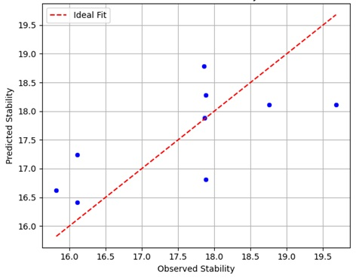
Fig. 3(a). Observed vs. Predicted Stability values (using Multiple Linear Regression - MLR) for Stability

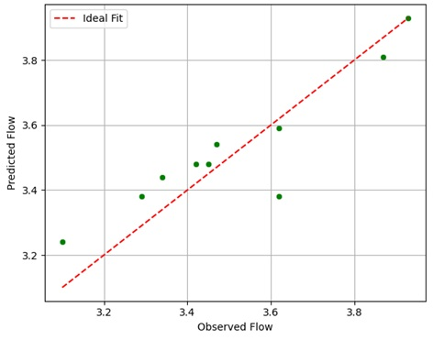
Fig. 3(b). Observed vs. Predicted Stability values (using Multiple Linear Regression - MLR) for Flow value
Figure 3(b) illustrates a similar comparison between observed and MLR-predicted flow values. To verify the effectiveness of the regression model in predicting flow characteristics of PET-modified mixes.

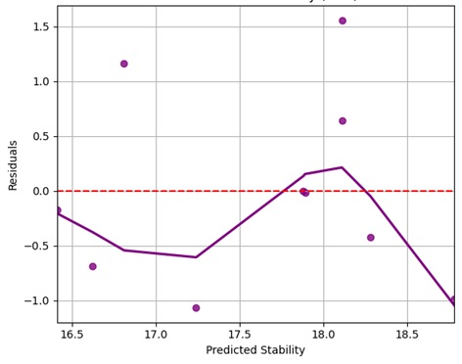
Fig. 3c. Residual Plot for Stability values (MLR)

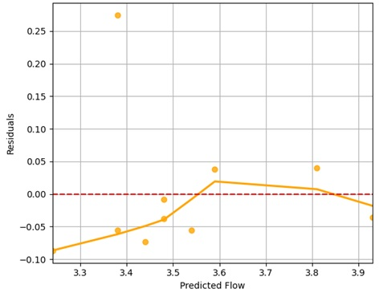
Fig. 3d. Residual Plot for Flow value (MLR)

Figure 3c shows the residual plot, which illustrates the difference between observed and predicted stability values (residuals) as a function of the predicted stability values from the Multiple Linear Regression (MLR) model. The primary goal of this plot is to visually examine whether the assumptions of linear regression, particularly homoscedasticity (constant variance) and linearity, are satisfied.
Figure 3(d) shows the Residual Plot for Flow Values (MLR). This residual plot shows the difference between observed and predicted flow values (residuals) plotted against the predicted flow values obtained from the Multiple Linear Regression (MLR) model.
This discussion investigates the behaviour of bituminous concrete mixes through observation, testing, and estimation using Equations 1 and 2 for stability and flow, and through a multiple linear regression (MLR) model. It will determine the mixes with the best predictions and those with the largest deviations, which can be used to optimize the mix design further. The data set is a mixture of different label combinations, denoted as BC5.0-P0, BC5.0-P4, BC5.0-P8, and likely so on. The expected and observed stability and flow values were used to train. Stability error is not the same across all mixes, and some are more devious than others. There are significant deviations in the mixes that include BC5.0-P0 and BC5.0-P4, and the errors exceed acceptable margins. Stability errors are lower than those of mixes like BC5.0-P12 and BC5.0-P6 and show greater consistency in being better predicted by the model. Flow errors are also typically smaller than stability errors, indicating that flow characteristics are better predicted. The deviations observed in the mixes, such as BC5.0-P0 and BC5.0-P4, are significant, and most of the other mixes exhibit relatively low flow errors. Lower-stability error mixes tend to have higher flow errors, suggesting a relationship between the two measures. The discussion shows that the multiple linear regression model has a fair share of accuracy when it comes to forecasting most mixes, yet there are mixes that show a greater error in deviation. Specialized optimization work should be implemented for mixes like BC5.0-P0 and BC5.0-P4, which consistently show greater errors in stability and flow predictions. This model may also be optimized in the future through the addition of more parameters or the incorporation of different predictive modelling methods.

Table 2. Observed and predicted stability and flow using multiple linear regression (validation)
Mix | Stability |  | % Error | Flow |  | % Error
Mix | Observed | Predicted | % Error | Observed | Predicted | % Error
BC_{5.0}-P₆ | 17.21 | 18.46 | -7.27 | 3.23 | 3.35 | -3.59
BC_{5.0}-P₁₄ | 16.98 | 17.53 | -3.21 | 3.39 | 3.35 | 1.25
BC_{5.2}-P₄ | 16.98 | 16.83 | 0.86 | 3.29 | 3.28 | 0.26
BC_{5.2}-P₈ | 18.78 | 18.20 | 3.09 | 3.54 | 3.54 | -0.11
BC_{5.2}-P₁₂ | 18.77 | 18.25 | 2.79 | 3.96 | 3.57 | 9.97
BC_{5.4}-P₀ | 16.99 | 15.79 | 7.07 | 3.65 | 3.57 | 2.20
BC_{5.4}-P₆ | 18.78 | 18.29 | 2.61 | 3.70 | 3.53 | 4.61
BC_{5.6}-P₄ | 16.98 | 17.10 | -0.70 | 3.73 | 3.69 | 0.94
BC_{5.6}-P₆ | 17.87 | 18.18 | -1.72 | 4.04 | 4.03 | 0.18
BC_{5.6}-P₁₂ | 18.76 | 19.15 | -2.11 | 4.10 | 4.09 | 0.27
BC_{5.8}-P₁₀ | 18.78 | 18.31 | 2.49 | 3.96 | 3.93 | 0.75
BC_{5.8}-P₁₄ | 17.46 | 18.61 | -6.60 | 4.05 | 4.18 | -3.16

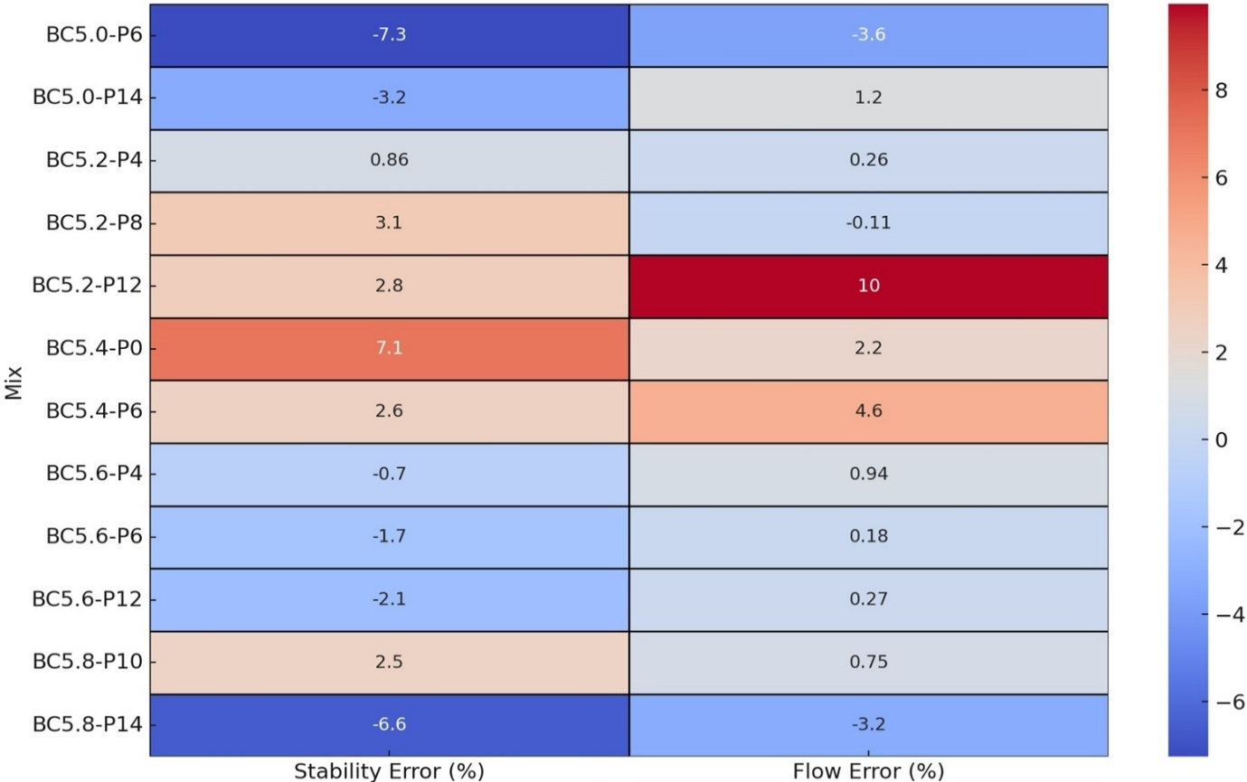
Fig. 4. Percentage error between observed and predicted values for stability and flow (validation)

Observed and predicted stability and flow values for bituminous concrete mixes used for validation are given in Table 2. The darker shades, as reported in Figure 4, reflect greater deviations between observed and predicted values. BC_{5.0}-P₆ and BC_{5.2}-P₁₂ exhibit significant inaccuracies in predicting stability and flow. Small Values of error: Light colours imply that the observed and predicted values are closely related. Mixes, including BC_{5.2}-P₄ and BC_{5.2}-P₈, have low error rates and report positive prediction accuracy. Comparative Performance: As with the training data, there is a clear correlation: cases with higher stability errors are associated with higher flow errors.
4.1.2. Interpretation of MLR Performance on Limited Dataset
Although the Multiple Linear Regression (MLR) model yielded correlation coefficients of 0.8683 with stability and 0.9439 with flow, both of which are not considered significant, they remain acceptable given the small training sample (n = 23). The main goal in applying MLR was not to increase accuracy but to produce a baseline, interpretable model that could be compared to more complex methods like ANN and RF. MLR provides information about linear dependencies between input and output parameters, which may be especially effective in the practical work of civil engineers to make predictions transparent and explainable. The model has shown stable performance on both the training and validation sets, although with low R-values, indicating that it would be stable and unlikely to overfit compared to other methods. With larger datasets, the performance is expected to improve, and this direction is planned for future studies.
4.2. Artificial Neural Network Modelling
Research on the human brain inspired a model based on artificial neural networks to anticipate outcomes from prior experience, without predetermined knowledge of underlying physical correlations. Training an ANN model on fed input parameters is required to establish the functional relationship between the input and output parameters. Each input parameter is assigned a weight, and weighted vectors are used to build a network that is as close as possible to the output value. ANNs can learn and anticipate outcomes even when input data is inadequate or contains errors, making them an effective machine learning method across all domains of research. ANNs are essentially rudimentary representations of biological brain networks. ANNs are a technology that can be used to solve problems for which no known solution algorithm exists. Artificial neural networks are data-driven, multi-layered, and trainable systems. An optimal number of nodes in the hidden layer is used to construct an artificial neural network model using a back-propagation neural network-based modelling algorithm. The ANN model was created using Weka 3.9.3. The user-defined parameters, as defined in Table 3, utilised to create the ANN models, were kept the same for the stability and flow values. The statistical parameters shown in Table 4 indicate the goodness of fit between the observed and predicted values of stability and flow. Tables 5 and 6 give the % error between observed and predicted stability and flow values for the training and validation datasets. The pictorial representations of the selected neural networks in Figures 4 and 5 show a layered structure with interconnected nodes representing neurons and weighted connections representing the flow of information.

Table 3. User-defined parameter in an artificial neural network for stability and flow
Learning Rate (L) | Momentum (M) | Training Time (N) | Hidden Layer (H)
0.2 | 0.1 | 2000 | 10

Table 4. Artificial neural network statistical parameters for stability and flow
Property | Data Sets | Coefficient  of Correlation | Mean Absolute Error (MAE) | Root Mean Square  Error (RMSE)
Stability | Training | 0.9916 | 0.1573 | 0.1922
Stability | Testing | 0.9459 | 0.3129 | 0.3685
Flow | Training | 0.9968 | 0.0211 | 0.0278
Flow | Testing | 0.7992 | 0.1373 | 0.1779

Table 5. Observed and predicted stability and flow using an artificial neural network (training)
Mix | Stability |  | % Error | Flow |  | % Error
Mix | Observed | Predicted | % Error | Observed | Predicted | % Error
BC_{5.0}-P₀ | 15.82 | 15.58 | 1.52 | 3.10 | 3.10 | 0.00
BC_{5.0}-P₄ | 16.11 | 16.04 | 0.43 | 3.34 | 3.32 | 0.60
BC_{5.0}-P₈ | 17.86 | 17.68 | 1.01 | 3.42 | 3.44 | -0.58
BC_{5.0}-P₁₀ | 18.76 | 18.79 | -0.16 | 3.62 | 3.63 | -0.28
BC_{5.0}-P₁₂ | 17.87 | 17.88 | -0.06 | 3.29 | 3.25 | 1.22
BC_{5.2}-P₀ | 16.11 | 16.27 | -0.99 | 3.45 | 3.46 | -0.29
BC_{5.2}-P₆ | 17.87 | 17.93 | -0.34 | 3.62 | 3.59 | 0.83
BC_{5.2}-P₁₀ | 19.68 | 19.31 | 1.88 | 3.47 | 3.46 | 0.29
BC_{5.2}-P₁₄ | 17.88 | 17.82 | 0.34 | 3.87 | 3.89 | -0.52
BC_{5.4}-P₄ | 17.88 | 17.82 | 0.34 | 3.93 | 3.93 | 0.00
BC_{5.4}-P₈ | 19.67 | 19.54 | 0.66 | 4.16 | 4.13 | 0.72
BC_{5.4}-P₁₀ | 20.55 | 20.37 | 0.88 | 3.99 | 3.95 | 1.00
BC_{5.4}-P₁₂ | 19.67 | 19.89 | -1.12 | 3.82 | 3.81 | 0.26
BC_{5.4}-P₁₄ | 19.32 | 19.45 | -0.67 | 3.92 | 3.93 | -0.26
BC_{5.6}-P₀ | 16.11 | 16.15 | -0.25 | 4.00 | 4.00 | 0.00
BC_{5.6}-P₈ | 18.77 | 18.34 | 2.29 | 4.17 | 4.14 | 0.72
BC_{5.6}-P₁₀ | 19.64 | 19.72 | -0.41 | 4.08 | 4.12 | -0.98
BC_{5.6}-P₁₄ | 17.87 | 17.93 | -0.34 | 4.02 | 4.00 | 0.50
BC_{5.8}-P₀ | 15.22 | 15.45 | -1.51 | 4.03 | 4.04 | -0.25
BC_{5.8}-P₄ | 16.11 | 16.35 | -1.49 | 4.06 | 4.06 | 0.00
BC_{5.8}-P₆ | 16.99 | 16.69 | 1.77 | 4.17 | 4.12 | 1.20
BC_{5.8}-P₈ | 17.88 | 17.73 | 0.84 | 4.22 | 4.14 | 1.90
BC_{5.8}-P₁₂ | 17.89 | 18.07 | -1.01 | 4.09 | 4.10 | -0.24

Table 6. Observed and predicted stability and flow using an artificial neural network (validation)
Mix | Stability |  | % Error | Flow |  | % Error
Mix | Observed | Predicted | % Error | Observed | Predicted | % Error
BC_{5.0}-P₆ | 17.21 | 16.52 | 4.01 | 3.23 | 3.34 | -3.41
BC_{5.0}-P₁₄ | 16.98 | 16.61 | 2.18 | 3.39 | 3.63 | -7.08
BC_{5.2}-P₄ | 16.98 | 17.24 | -1.53 | 3.29 | 3.55 | -7.90
BC_{5.2}-P₈ | 18.78 | 19.05 | -1.44 | 3.54 | 3.60 | -1.69
BC_{5.2}-P₁₂ | 18.77 | 18.81 | -0.21 | 3.96 | 3.54 | 10.61
BC_{5.4}-P₀ | 16.99 | 16.77 | 1.29 | 3.65 | 3.51 | 3.84
BC_{5.4}-P₆ | 18.78 | 18.67 | 0.59 | 3.70 | 3.79 | -2.43
BC_{5.6}-P₄ | 16.98 | 16.43 | 3.24 | 3.73 | 3.84 | -2.95
BC_{5.6}-P₆ | 17.87 | 17.54 | 1.85 | 4.04 | 4.09 | -1.24
BC_{5.6}-P₁₂ | 18.76 | 18.97 | -1.12 | 4.10 | 4.08 | 0.49
BC_{5.8}-P₁₀ | 18.78 | 18.19 | 3.14 | 3.96 | 3.82 | 3.54
BC_{5.8}-P₁₄ | 17.46 | 17.57 | -0.63 | 4.05 | 4.04 | 0.25

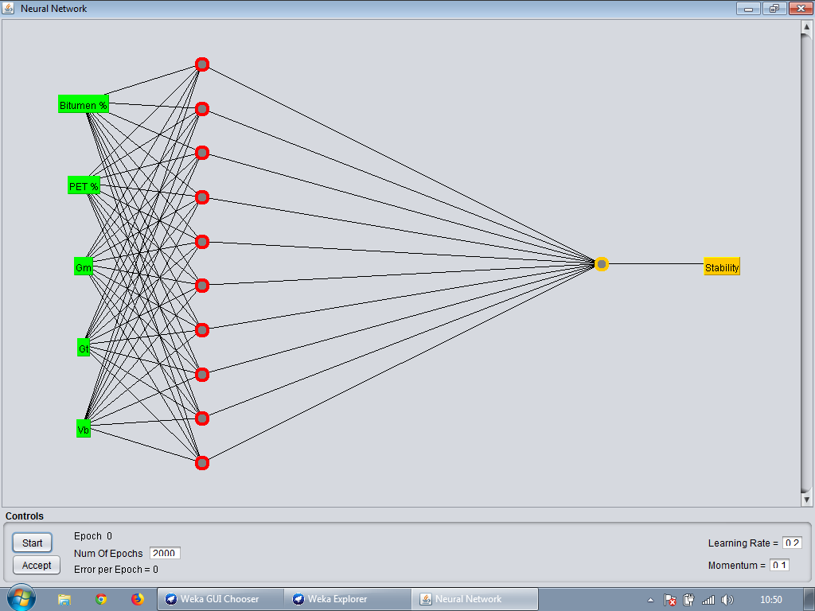
Fig. 5. Pictorial representation of a selected neural network for stability

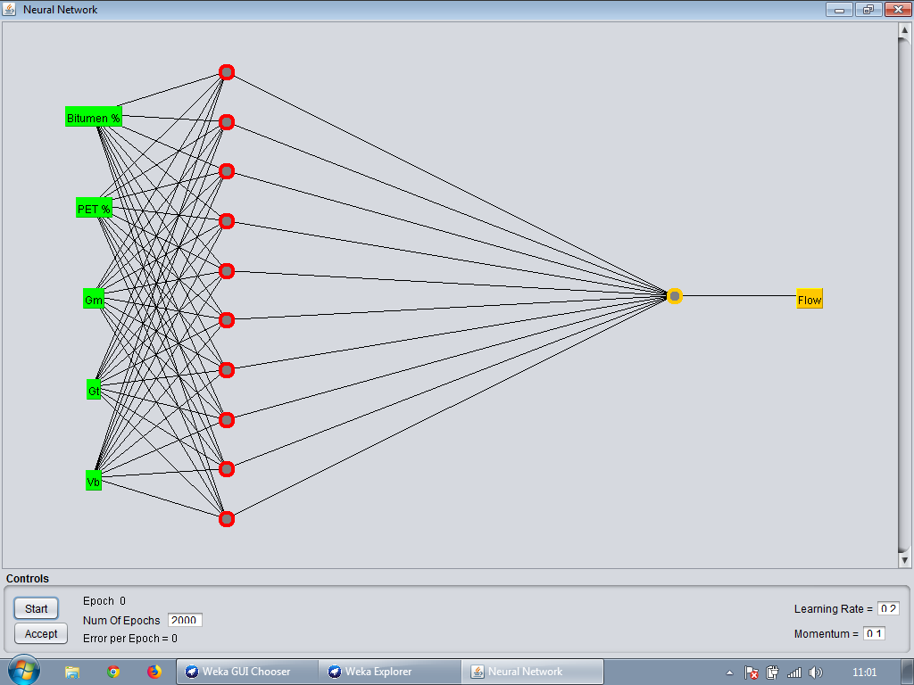
Fig. 6. Pictorial representation of a selected neural network for flow
4.2.1. Model Design Justification and Future Improvements
The Artificial Neural Network (ANN) model was designed with a single hidden layer of 10 neurons and trained via back-propagation in Weka 3.9.3. The hyperparameters (learning rate 0.2, momentum 0.1, and 2000 training cycles) were selected through tuning to balance training accuracy and convergence while avoiding excessive computation time. Although the model performed very strongly in terms of correlation coefficient (R² = 0.9916 on the training data (stability) and R² = 0.9968 on the training data (flow), we also recognize the decline in validation performance (stability R² = 0.7992 and flow R² = 0.9968), which might be a result of over fitting due to the limited number of samples (23 training samples). The main reason ANN was introduced was the possibility of investigating non-linear dependencies and the opportunity to compare its performance with other models that are more interpretable, such as MLR or ensemble algorithms, such as RF. Nevertheless, cross-validation, early stopping, and dropout regularization can be used to increase the model's generalizability, and these methods are suggested for future studies. Moreover, sensitivity and feature importance analyses were not presented in this study; thus, the study could be enhanced in terms of interpretability. Future developments will include significance assessment of input variables (e.g., the algorithm of Garson or permutation importance) to identify the most important parameters that predict stability and flow results. This would increase the rigor of science and assist in the practical determination of the design optimization of the mix design.

4.2.2 Hyperparameter Selection Approach
The hyperparameters for both the ANN and Random Forest (RF) models were selected through a manual, trial-and-error tuning approach rather than a fully systematic grid or randomized search. For the ANN, user-defined values such as a learning rate of 0.2, a momentum of 0.1, and 2000 training epochs were adjusted iteratively in the Weka 3.9.3 environment to balance model convergence and performance without overfitting. The hidden layer size was optimized to 10 neurons based on preliminary experiments showing minimal RMSE and high R².
4.3. Random Forest Modelling
Random forest (RF) is a classification and regression method that uses a set of tree predictors, each of which is constructed using a random vector sampled separately from the input vector. In regression, the tree predictor uses numerical values instead of the random forest classifier's class labels. In the current work, random forest regression was utilised to create a tree by employing specified variables at each node. A random forest model with user-defined parameters, as mentioned in Table 7, was utilised to build the model. The statistical parameters shown in Table 8 indicate the goodness of fit between the observed and predicted stability and flow values using random forest modelling.

Table 7. User-defined parameter for stability and flow
Property | Num features (K) | Num iteration (I)
Stability | 4 | 90
Flow | 3 | 70

Table 8. Random forest modeling statistical parameters for stability and flow
Property | Data Sets | Coefficient  of Correlation | Mean Absolute Error (MAE) | Root Mean Square Error (RMSE)
Stability | Training | 0.9886 | 0.2683 | 0.3156
Stability | Testing | 0.7902 | 0.3648 | 0.4993
Flow | Training | 0.9902 | 0.0366 | 0.0473
Flow | Testing | 0.8344 | 0.1242 | 0.1657

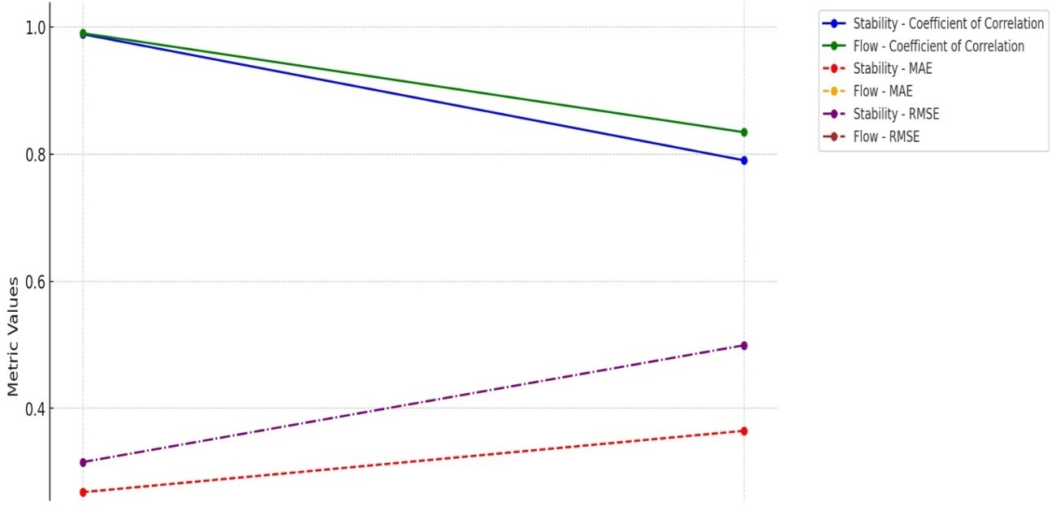
Fig. 7. Performance metrics for stability and flow

Figure 7 visualizes the performance metrics (Coefficient of Correlation, MAE, and RMSE) for Stability and Flow across Training and Testing datasets. High correlation during training (0.9886) but significantly reduced during testing (0.7902). Consistently high correlation, although it drops from training (0.9902) to testing (0.8344). Stability: Lower error in training (0.2683) compared to testing (0.3648). Flow: Very low error in training (0.0366), increasing to (0.1242) during testing. Low during training (0.3156), but higher during testing (0.4993). Flow: Low during training (0.0473) with an increase during testing (0.1657). Observed and predicted stability and flow values for bituminous concrete mixes using random forests are shown in Table 9, and the percentage error between observed and predicted values for stability and flow during training is shown in Figure 8.

Table 9. Observed and predicted stability and flow using random forest (training)
Mix | Stability |  | % Error | Flow |  | % Error
Mix | Observed | Predicted | % Error | Observed | Predicted | % Error
BC_{5.0}-P₀ | 15.82 | 16.05 | -1.45 | 3.10 | 3.22 | -3.87
BC_{5.0}-P₄ | 16.11 | 16.68 | -3.54 | 3.34 | 3.89 | -16.47
BC_{5.0}-P₈ | 17.86 | 18.12 | -1.46 | 3.42 | 3.46 | -1.17
BC_{5.0}-P₁₀ | 18.76 | 18.57 | 1.01 | 3.62 | 3.53 | 2.49
BC_{5.0}-P₁₂ | 17.87 | 18.17 | -1.68 | 3.29 | 3.30 | -0.30
BC_{5.2}-P₀ | 16.11 | 16.37 | -1.61 | 3.45 | 3.43 | 0.58
BC_{5.2}-P₆ | 17.87 | 17.87 | 0.00 | 3.62 | 3.55 | 1.93
BC_{5.2}-P₁₀ | 19.68 | 19.29 | 1.98 | 3.47 | 3.51 | -1.15
BC_{5.2}-P₁₄ | 17.88 | 18.45 | -3.19 | 3.87 | 3.90 | -0.78
BC_{5.4}-P₄ | 17.88 | 17.60 | 1.57 | 3.93 | 3.94 | -0.25
BC_{5.4}-P₈ | 19.67 | 19.39 | 1.42 | 4.16 | 4.09 | 1.68
BC_{5.4}-P₁₀ | 20.55 | 20.17 | 1.85 | 3.99 | 3.95 | 1.00
BC_{5.4}-P₁₂ | 19.67 | 19.49 | 0.92 | 3.82 | 3.89 | -1.83
BC_{5.4}-P₁₄ | 19.32 | 19.29 | 0.16 | 3.92 | 3.93 | -0.26
BC_{5.6}-P₀ | 16.11 | 16.30 | -1.18 | 4.00 | 4.04 | -1.00
BC_{5.6}-P₈ | 18.77 | 18.96 | -1.01 | 4.17 | 4.15 | 0.48
BC_{5.6}-P₁₀ | 19.64 | 19.65 | -0.05 | 4.08 | 4.08 | 0.00
BC_{5.6}-P₁₄ | 17.87 | 18.17 | -1.68 | 4.02 | 4.01 | 0.25
BC_{5.8}-P₀ | 15.22 | 15.77 | -3.61 | 4.03 | 4.04 | -0.25
BC_{5.8}-P₄ | 16.11 | 16.67 | -3.48 | 4.06 | 4.1 | -0.99
BC_{5.8}-P₆ | 16.99 | 17.21 | -1.29 | 4.17 | 4.15 | 0.48
BC_{5.8}-P₈ | 17.88 | 18.00 | -0.67 | 4.22 | 4.20 | 0.47
BC_{5.8}-P₁₂ | 17.89 | 18.03 | -0.78 | 4.09 | 4.10 | -0.24

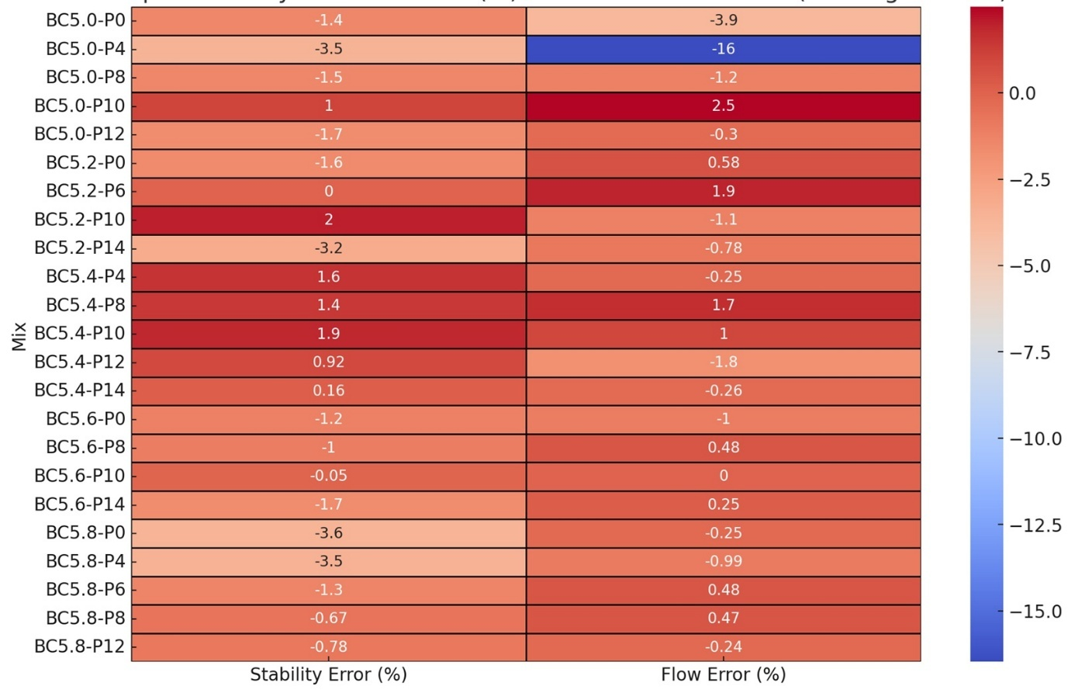
Fig. 8. Percentage error between observed and predicted values for stability and flow (training)

Several mixes show minimal error rates for both stability and flow, indicating good predictive accuracy of the model. For example, mixes like BC_{5.0}-P₀ and BC_{5.0}-P₈ have low errors in both stability and flow predictions. Some mixes, particularly BC_{5.0}-P₄, show high errors, especially in flow prediction (-16.47%). Such high errors suggest that the model may struggle to accurately predict certain mixes, likely due to complexity or insufficient training data. The model appears to be performing well across most mixes, but a few outliers show higher errors. Errors are generally more pronounced in flow prediction than stability prediction. Observed and predicted stability and flow value of bituminous concrete mixes using random forest (validation) are shown in Figure 9 and Table 10.

Table 10. Observed and predicted stability and flow using random forest (validation)
Mix | Stability |  | % Error | Flow |  | % Error
Mix | Observed | Predicted | % Error | Observed | Predicted | % Error
BC_{5.0}-P₆ | 17.21 | 17.36 | -0.87 | 3.23 | 3.41 | -5.57
BC_{5.0}-P₁₄ | 16.98 | 18.25 | -7.48 | 3.39 | 3.53 | -4.13
BC_{5.2}-P₄ | 16.98 | 17.00 | -0.12 | 3.29 | 3.54 | -7.60
BC_{5.2}-P₈ | 18.78 | 18.86 | -0.43 | 3.54 | 3.49 | 1.41
BC_{5.2}-P₁₂ | 18.77 | 18.93 | -0.85 | 3.96 | 3.55 | 10.35
BC_{5.4}-P₀ | 16.99 | 16.75 | 1.41 | 3.65 | 3.53 | 3.29
BC_{5.4}-P₆ | 18.78 | 18.23 | 2.93 | 3.70 | 3.70 | 0.00
BC_{5.6}-P₄ | 16.98 | 16.90 | 0.47 | 3.73 | 3.89 | -4.29
BC_{5.6}-P₆ | 17.87 | 17.68 | 1.06 | 4.04 | 4.06 | -0.50
BC_{5.6}-P₁₂ | 18.76 | 18.31 | 2.40 | 4.10 | 4.15 | -1.22
BC_{5.8}-P₁₀ | 18.78 | 18.13 | 3.46 | 3.96 | 4.05 | -2.27
BC_{5.8}-P₁₄ | 17.46 | 18.00 | -3.09 | 4.05 | 4.08 | -0.74

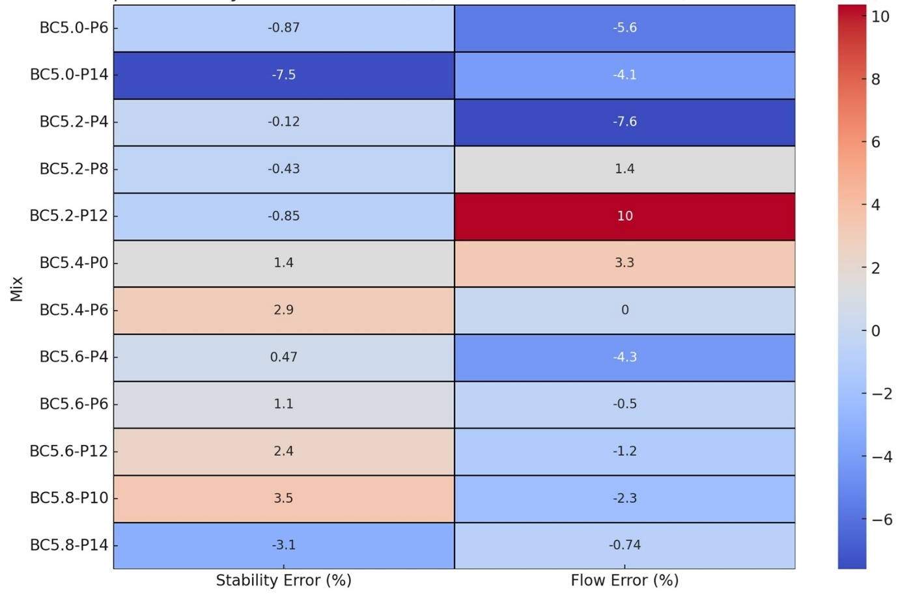
Fig. 9. Percentage error between observed and predicted values for stability and flow (validation)

The error rates in most mixes are low, indicating good predictive accuracy, as shown in Figure 9. It is important to note that mixes BC5.0-P6 and BC5.2-P4 produce very few errors in flow and stability prediction. Certain mixes, especially BC5.2-P12 and BC5.2-P6, exhibit elevated errors in Flow prediction. The large number of errors would indicate problems with accurately forecasting some of the mixes, probably due to the complexity of the characteristics or to the model acting as a constraint. In general, this model works well with most mixes but struggles in some specific cases, especially in Flow prediction. In the case of the RF model, it was also set by hand, where the number of iterations (trees) and the number of features (K) were 90 and 70, respectively in the case of stability and flow respectively, with 4 and 3 as the number of features (K) depending on prior knowledge of the domain and initial trial results. Although this strategy was satisfactory, we also recognize that stricter hyperparameter optimization algorithms, such as grid search, random search, or Bayesian optimization, in conjunction with cross-validation, would likely lead to better model stability and extrapolation. These are the strategies referred to in the future of work.
4.3.1. Model Overfitting and Mitigation Strategies
The Random Forest (RF) model was also highly effective on the training dataset (R2 = 0.9886 was used to assess model stability, and R2 = 0.9902 flow), but the accuracy significantly decreased during validation (R² = 0.7902 and 0.8344, respectively). This training performance-testing performance gap is one possible sign of overfitting that can be explained by the rather small range of data and default parameter choices. To reduce these problems, in future research, cross-validation will be used, and extensive hyperparameter optimization, including varying the number of trees (estimators), tree depth, and minimum sample split thresholds, will be employed. Moreover, ensemble averaging and feature selection techniques can be considered to enhance generalization with minimal impact on model interpretability.
4.3.2. Comparative Evaluation of Predictive Models
To enable a direct comparison of model performance, Table 11 summarizes the major statistical indicators for Multiple Linear Regression (MLR), Artificial Neural Network (ANN), and Random Forest (RF). The table shows the comparisons of the coefficient of correlation (R²), mean absolute error (MAE), and the root mean square error (RMSE) when using the training and testing datasets. The findings indicate that although RF and ANN are more accurate during training, RF, in turn, exhibits overfitting, leading to a significant decrease in validation accuracy. MLR, albeit with lower training accuracy, shows relatively lower variability in performance on both datasets, which indicates a higher rate of generalization in the smaller dataset. The comparison highlights the importance of model selection, which depends on dataset size and prediction stability.

Table 11. Comparative Evaluation of Predictive Models
Model | Dataset | R²(Correlation Coefficient) | MAE | RMSE
MLR | Training | 0.8683 (Stab), 0.9439 (Flow) | 0.6550* | 0.8120 (Stab), 0.1210 (Flow)
MLR | Testing | ~0.80 (est.) | – | –
ANN | Training | 0.9916 (Stab), 0.9968 (Flow) | 0.1573 | 0.1922 (Stab), 0.0278 (Flow)
ANN | Testing | 0.9459 (Stab), 0.7992 (Flow) | 0.3129 | 0.3685 (Stab), 0.1779 (Flow)
RF | Training | 0.9886 (Stab), 0.9902 (Flow) | 0.2683 | 0.3156 (Stab), 0.0473 (Flow)
RF | Testing | 0.7902 (Stab), 0.8344 (Flow) | 0.3648 | 0.4993 (Stab), 0.1657 (Flow)
4.3.3. Error Trends and Mix-Specific Performance Across Models
The comparison of prediction errors across MLR, ANN, and RF models reveals insightful trends. Artificial Neural Network (ANN) consistently yielded the lowest prediction errors during training, demonstrating strong learning capability for both stability and flow. However, during validation, the ANN showed higher deviations in certain mixes—particularly in flow predictions for BC5.2-P12 and BC5.0-P14 — suggesting sensitivity to small variations in mix composition.
Random Forest (RF) achieved the highest accuracy in training but demonstrated overfitting during testing, with errors increasing significantly for mixes such as BC_{5.2}-P₁₂ and BC_{5.0}-P₁₄, especially for flow. The Multiple Linear Regression (MLR) model, although less accurate in raw error metrics, showed more consistent predictive behaviour across all mixes, especially for typical mid-range designs like BC_{5.2}-P₄ and BC_{5.6}-P₄, indicating its robustness and reliability under limited data conditions.
Overall, ANN excelled at learning non-linear relationships for well-behaved datasets; RF performed best at complex pattern recognition but lacked generalization; and MLR provided the most interpretable and stable performance across all mix types, particularly when field variability is anticipated.
5. Conclusion
The study aimed to perform regression analysis of the stability and flow values of PET-modified bituminous concrete mixes using machine learning models, particularly the random forest model. The evaluation entailed appraising the model's performance on both the training and validation datasets in predicting stability and flow parameters.
During training, the Random Forest model demonstrated a high correlation (0.9886), stability (0.9902), and flow (0.9902) coefficients.
The good value of the mean absolute error (MAE) and the root mean square error (RMSE) indicated a high predictive potential for stability and flow in the training data.
In most mixes, there were minimal prediction errors, as indicated by the heat maps, and the model had a good fit to the training data.
When the model was tested, the stability and flow correlation coefficients reduced significantly, dropping to 0.7902 and 0.8344, respectively. Increased values of MAE and RMSE indicated a decrease in prediction accuracy when applied to unseen data.
The decrease in prediction accuracy during testing indicates the possibility of overfitting the training data and the need to tune the model further to achieve better generalization.
Future Scope and Model Enhancement Opportunities
Future research could further investigate adding hybrid or ensemble modelling methods, including stacked generalization, boosting, or blended architectures, that are capable of combining the advantages of the underlying models, such as ANN, RF, and MLR. These methods have demonstrated potential for handling non-linear, high-dimensional data with better generalization. Additionally, the fact that the other input parameters, i.e., climatic conditions (temperature variations, exposure to rain), traffic loading properties, and long-term aging influences, would increase the credibility and strength of the predictions. These variables would be important for integrating field performance and would allow the models to assist in assessing the performance of PET-modified bituminous mixes under different service conditions throughout the life cycle.
Practical Recommendations and Optimal PET Dosage
Based on experimental and statistical analysis, the optimal PET content in bituminous concrete mixes was consistently around 10% by weight of the optimum bitumen content, providing maximum stability and improved flow characteristics. Field application of this dosage is recommended to enhance the mechanical performance of flexible pavements while promoting sustainable utilization of waste plastic. Additionally, plastic-coated aggregates demonstrated better bitumen bonding, indicating their potential for large-scale road construction.
For practical implementation, contractors and highway engineers may consider adopting this PET dosage in accordance with the IRC: SP: 98-2013 guidelines, particularly for wearing courses on low- to medium-volume roads. The developed predictive models, especially the ANN and MLR, can be effectively used to estimate expected stability and flow values during mix design stages, thereby reducing reliance on repeated laboratory trials.
Acknowledgement
The authors extend their appreciation to the Deanship of Research and Graduate Studies at King Khalid University for funding this work through the Large Research Project under grant number RGP2/481/46.
References
Amoni, B.C., Freitas, A.D.L., Bessa, R.A., Oliveira, C.P., Bastos-Neto, M., Azevedo, D.C.S., Lucena, S.M.P., Sasaki, J.M., Soares, J.B., Soares, S.A. (2022). Effect of coal fly ash treatments on synthesis of high-quality zeolite A as a potential additive for warm mix asphalt. Mater. Chem. Phys, 275, 125197. https://doi.org/10.1016/j.matchemphys.2021.125197.
ASTM D-1559. (2004). Test for resistance to plastic flow of bituminous mixture using Marshall Apparatus. American Society for Testing Materials.
Chaira, Veranita. (2020). The Effect of Combining Coal Fly Ash and Lokan Shells as Filler Towards the Mixture of Asphalt Concrete Wearing Course. In Journal of Physics: Conference Series; IOP Publishing: Bristol, UK, 012033.
Amardeep Boora, Kavita Rani, Manju Suthar, Rishi Rana, Parveen Berwal et al. (2023). Slag and Bagasse Ash: Potential Binders for Sustainable Rigid Pavement. ACS Omega 2023, 8, 32867−32876. https://doi.org/10.1021/acsomega.3c04089
IRC: SP: 98. (2013). Guidelines for the use of waste plastic in hot bituminous mixes (dry process) in wearing courses. Indian Road Congress.
Jabłońska, B., Kiełbasa, P., Korenko, M., Dróżdż, T. (2019). Physical and Chemical Properties of Waste from PET Bottles Washing as A Component of Solid Fuels. Energies, 12(11), 2197. https://doi.org/10.3390/en12112197
Jayachandra., Reddy, Y.R., Nassar, A.H., Kangda, M.Z., Yashwanth, H.J., Khan, M.A., Asiri, A.N.M., Saiful I., Algburi, S. (2024). "Symbiotic impact of carbon quantum dots on microstructural development and mechanical behaviour of cement mortars. Case Studies in Construction Materials, 20, e03042.
https://www.sciencedirect.com/science/article/pii/S2214509524001931
Khuntia, S., Das, A.K., Mohanty, M., Panda, M. (2014). Prediction of Marshall Parameters of modified bituminous mixtures using artificial intelligence techniques. International Journal of Transportation Science and Technology, 3(3), 211-228. https://doi.org/10.1260/2046-0430.3.3.211
Kumar, A., Berwal, P., Al-Mansour, A., Khan, M.A., Alam, S., Lee, S.M., Malik, A., Iqbal, A. (2022). Impact of crumb rubber concentration and plastic-coated aggregates on the rheological performances of modified bitumen asphalt. Sustainability, 14(7), 1-9. https://doi.org/10.3390/su14073907
Kurzekar, A.S., Waghe, U., Ansari, K., Dabhade, A.N., Biswas, T., Algburi, S. Khan, M.A., Althaqafi, E., Islam, S., Palanisamy J. (2024), Development and optimization of geopolymer-based artificial angular coarse aggregate using cut-blade mechanism. Case Studies in Construction Materials, 21, e03826. https://doi.org/https://doi.org/10.1016/j.cscm.2024.e03826
Merve, S., Alize, Y., Esra, Y., Gulnare, A. (2017). Production of Epoxy Composite from the Pyrolysis Char of Washed PET Wastes, Energy Procedia, 118, 216-220, ISSN 1876-6102, https://doi.org/10.1016/j.egypro.2017.07.022
Mistry, R. & Roy, T.P. (2020). Predicting Marshall Stability and flow of bituminous mix containing waste fillers by the adaptive neuro-fuzzy inference system. Revista de la Construction, 9(2). http://dx.doi.org/10.7764/rdlc.19.2.209
Mistry, R., Roy, T.K. (2021). Performance evaluation of bituminous mix and mastic containing rice husk ash and fly ash as filler. Constr. Build. Mater, 268, 121187. https://doi.org/10.1016/j.conbuildmat.2020.121187
MoRT&H (Ministry of Road Transport and Highways). (2013). Specification for Road and Bridge Works. Indian Roads Congress.
Muhammad, J., Peng, T., Zhang, W., Cheng, H., Waqas, H., Abdul, S., Chen, K., Zhou, Y. (2021). Moisture susceptibility and fatigue performance of asphalt binder modified by bone glue and coal fly ash. Constr. Build. Mater, 308, 125135. https://doi.org/10.1016/j.conbuildmat.2021.125135
Nasir, N.H.M., Usman, F., Saggaf, A. (2022). Development of composite material from Recycled Polyethylene Terephthalate and fly ash: Four decades progress review. Curr. Res. Green Sustain. Chem., 5, 100280. https://doi.org/10.1016/j.crgsc.2022.100280
Ozgan, E. (2009). Fuzzy logic and statistical-based modelling of the Marshall stability of asphalt concrete under varying temperatures and exposure times. Advances in Engineering Software, 40(7), 527-534.
https://doi.org/10.1016/j.advengsoft.2008.10.005.
Ozgan, E. (2010). Modelling the stability of asphalt concrete with fuzzy logic and statistical methods for various freezing and thawing cycles. Mathematical and Computational Applications, 15(2), 176-186. https://doi.org/10.3390/mca15020176
Ozgan, E. (2011). Artificial neural network-based modelling of the Marshall stability of asphalt concrete. Expert Systems with Applications, 38(5), 6025-6030. https://doi.org/10.1016/j.eswa.2010.11.018
Radwan, A., Satar, M., Hassan, N., Rogo, K. (2022). The Influence of Coal Fly Ash on the Mechanical Properties of Hot Mix Asphalt Mixture. In IOP Conference Series: Earth and Environmental Science; IOP Publishing: Bristol, UK, https://doi.org/10.1088/1755-1315/971/1/012012
Saini, M., Aggarwal, P., Algburi, S., Asmari, A.FA., Berwal, P. (2025). Volumetric And Mechanical Properties of Bituminous Concrete Mixes with the addition of Polyethylene Terephthalate. Case Studies in Construction Materials, 23, 01-18. https://doi.org/10.1016/j.cscm.2025.e05013
Saini, M., Aggarwal, P., Chauhan, S. (2019). Behaviour of bituminous concrete mixes with addition of waste plastic bottle via dry process. International Journal of Innovative Technology and Exploring Engineering, 9(2), 732-736. https://doi.org/10.35940/ijitee.b7834.129219
Sangita., Khan, T.A., Sabina., Sharma, D.K. (2011). Effect of waste polymer modifier on the properties of bituminous concrete mixes. Construction and Building Materials, 25, 3841-3848. https://doi.org/10.1016/j.conbuildmat.2011.04.003
Thodesen, C., Xiao, F., Amirkhanian, S.N. (2009). Modeling viscosity behavior of crumb rubber modified binders. Construction and Building Materials, 23(9), 3053-3062. https://doi.org/10.1016/j.conbuildmat.2009.04.005
Wagh, M., Waghmare, C., Gudadhe, A., Thakur, N., Mohammed, S.J., Algburi, S., Majdi, H.S., Ansari, K. (2025). Predicting compressive strength of sustainable concrete using advanced AI models: DLNN, RF, and MARS, Asian Journal of Civil Engineering. https://doi.org/10.1007/s42107-025-01278-y
Xiao, F., Amirkhanian, S.N. (2008). Effects of binders on resilient modulus of rubberized mixtures containing RAP using artificial neural network approach. Journal of Testing and Evaluation, 37(2), 1-10. https://doi.org/10.1520/JTE101834
Xing, X., Han, K., Liu, R., Chen, Z., Li, H., Li, P., Zhou, Q., Wen, Y. (2023). Study on the Rheological Properties of Fly Ash Modified Asphalt Mastics. Coatings, 13(8), 1307. https://doi.org/10.3390/coatings13081307
Yıldız, K., Atakan, M. (2020). Improving microwave healing characteristic of asphalt concrete by using fly ash as a filler. Constr. Build. Mater, 262, 120448. https://doi.org/10.1016/j.conbuildmat.2020.120448

