
 | Rocznik Ochrona Środowiska
 | Volume 27 | Year 2025 ISSN 2720-7501 | pp. 825-836
 | https://doi.org/10.54740/ros.2025.066 open access
 | Received: December 2025 Accepted: December 2025 Published: December 2025
The Impact of Using a Simplified Method for Determining Hourly Heating Load
on the Electricity Consumption of an Air-to-Water Heat Pump in a Central Heating System
of a Single-Family Building
Piotr Kęskiewicz
Department of Air Conditioning, Heating, Gas Engineering, and Air Protection,
Faculty of Environmental Engineering, Wrocław University of Science and Technology, Poland
https://orcid.org/0000-0002-1580-5632
corresponding author's e-mail: piotr.keskiewicz@pwr.edu.pl
Abstract: As energy efficiency requirements for residential buildings continue to tighten, the need for detailed energy analyses of the impact of increasingly advanced energy-saving solutions is also growing. Unfortunately, calculating accurate hourly data typically requires advanced software and significant skill, experience, and time. This article presents an analysis of the effects of using the degree-hours method, one of the methods that allows for the relatively simple generation of estimated hourly data. The precision of the estimated results obtained using this method was analysed using the example of a typical single-family building located in five characteristic locations in Poland, supplied with heat by an air-to-water heat pump. The resulting estimated heating loads and electricity consumption data were compared with accurate results calculated using the EDSL TAS simulation programme. The accuracy of the method, along with its strengths and weaknesses, was presented based on the obtained data.
Keywords: energy consumption, degreehours, heat pump, accuracy of results
1. Introduction
The constantly tightening requirements for reducing the energy consumption of newly constructed buildings, e.g., the requirements contained in (Dz.U. 2002), or very detailed sets of parameters necessary to be met in the case of solutions that significantly exceed the current standard, for example, passive buildings (Schlagowski 2015), force the use of more and more accurate calculation methods. Methods that enable precise determination of the impact of applied changes, including: on the selection of devices, operation of systems, or the effects of introduced innovations on energy savings. Methods based solely on calculating the building's design heating load are, in practice, a thing of the past. Currently used methods that rely on less accurate monthly data are increasingly insufficient. In turn, very accurate calculation of detailed hourly data requires the designer to have access to advanced simulation software (e.g., EDSL TAS) and the ability to use it when developing often very complex simulation models of buildings. This approach also takes a lot of time and generates high costs, which in some projects or research may turn out to be unjustified, e.g., for economic reasons, work schedule limitations, etc.
Detailed hourly data on the heating load of a single-family building are used in an increasingly wide range of applications. They can be used to estimate heating costs for a building more accurately using the electricity available under a two-zone tariff. Access to precise heating load data for specific hours of the day allows assigning the appropriate tariff rate to all hours of the cold season and accurately calculating the operating costs of the building's central heating system. Accurate hourly data can also be used to analyse the operation of a short-term heat buffer supporting the operation of solar collector installations, heat pumps, etc. Knowledge of hourly demand fluctuations allows, for example, a more precise selection of a tank or a more detailed determination of changes in the amount of stored energy across various parts of the cold season. Such data can also be used, for example, to precisely determine the size of biofuel storage facilities, to perform detailed seasonal calculations of the efficiency of ecological heat source solutions, to conduct precise analyses of changes in heating load resulting from subsequent stages of thermal modernization of the building, etc. Calculations carried out with hourly accuracy are becoming a standard in computational analyses of commercial projects, in scientific works, and are even carried out more and more often at the level of diploma theses of students of technical universities (Grudzińska 2022) or (Kwestarz et al. 2023).

The positive effects of combining the trend toward increasingly energy-efficient solutions with hourly data to improve the quality of the results are particularly evident in the detailed selection and analysis of operating parameters for building heat sources using air-water heat pumps. These devices have instantaneous power and efficiency that are closely related to current and variable outdoor air temperature. Using only seasonal data, or even more accurate monthly data on heating energy consumption, may lead to significant errors in the final calculations, e.g., when calculating electricity consumption to drive the heat pump using constant, less accurate values of the device's COP coefficient. Additionally, the variability of meteorological data officially assigned by the legislator to specific cities, which is important for the operation of air-to-water heat pumps, is taken into account to a minimum extent in monthly and seasonal methods. This is another limitation of using these basic computational methods.
Taking the above into account, it can be concluded that detailed hourly data will be increasingly used in engineering calculations. The main problem with this precise calculation method is the limited availability of such detailed data. The solution to this problem may be the use of simplified methods for estimating hourly data, which require less user input than advanced simulation software. One such method is the use of the degreehours parameter (calculated from official meteorological data for the considered location) in combination with relatively simple-to-calculate monthly data on energy consumption for heating the building. For simplicity, this method is referred to as the "FI method" later in the article. This method is used in engineering practice and in less complex scientific research. It can also be used in situations where there is a need to depart from official data, e.g., (GOV 2025), and to use own datasets, as analysed in (Stokowiec et al. 2024). However, the literature lacks analyses that allow for the assessment of the precision of the results obtained and the identification of their strengths and weaknesses. The article attempts to fill these gaps, at least partially, using the example of a typical single-family building in Polish conditions, heated by an air-to-water heat pump. It was assumed that it was necessary to take into account assumptions related to the operation of the heat pump as close as possible to actual conditions: the possibility of alternating preparation of DHW and operation for the needs of central heating, the need to protect the system against complete shutdown of the heat pump at extremely low outdoor air temperatures, the need to defrost the evaporator exchanger, the cooling function of the heat pump used.
2. Description of the Research
The necessary calculations of the design heating load and useful energy demand for building heating (later EU') in selected locations were performed using EDSL TAS version 9.5.6, a graphical interface for the widely used and validated EnergyPlus advanced building energy calculation engine. Unlike standard OZC programmes, EDSL TAS enabled detailed calculations to be performed at the required hourly interval. Due to the programme's incompatibility with Polish standards, the obtained design heating load values were treated as estimates.
At each stage of creating computational models and generating final results, the built-in data validation tools of the EDSL TAS programme were used precisely as described in the guidelines (EDSL 2025). No errors or warnings were detected.
2.1. The building under examination
A typical single-family building (GUS 2025), consisting of two above-ground floors, with a compact, cube-like structure and a flat roof. It is assumed that the building is inhabited by a family of four, representatives of the Polish middle class.
- the heat transfer coefficients of all constructions used meet the requirements of WT 2021 (e.g., flat roof Uroof = 0.15 W/(m²K)) (Dz.U. 2002),
- total heat transfer coefficient of windows and doors U_{wd} = 0.900 W/(m²K), according to WT 2021
(Dz.U. 2002),
- total heated area of the building: 138.98 m²,
- clear height of the ground floor and first floor: 2.80 m,
- the building includes: a living room, a kitchen, three bedrooms, two bathrooms, two corridors, and a technical room,
- floor heating maintains a minimum internal air temperature: 24°C in bathrooms and 20°C in all other rooms (Dz.U. 2002),

- during the warm season, the cooling system prevents the internal air temperature from exceeding 24°C in the living room and bedrooms,
- gravity ventilation, with an assumed air exchange rate of 0.5 ach (PN EN 12831 2006),
- internal heat gains were assumed to be a constant average of 6.8 W/m² in the living room and bedrooms (Dz.U. 2015).

The building has two bathrooms. One has a medium-sized bathtub, the other has a standard shower cabin. The domestic hot water (DHW) system is equipped with a DHW heater with an active capacity of 500 dm³. Residents have expressed a desire to maintain a maximum DHW temperature of 45°C and to limit storage tank filling time to no more than 2 hours.
2.2. Selected locations
For the study, it was decided to select one city from each of Poland's five climate zones for which official data for a typical meteorological year are available (GOV 2025). The selection of these specific cities was also linked to the description contained in the article (Kowalski et al. 2023). Basic information about the selected cities is summarised in Table 1.

Table 1. Basic information about selected locations and their meteorological data
Location | Station no. | Latitude | Longitude | Climate zone | Design temperature
Koszalin | 12 105 0 | 54° 12’ N | 16° 09’ E | I | -16°C
Wrocław | 12 424 0 | 51° 06’ N | 16° 53’ E | II | -18°C
Warszawa | 12 375 0 | 52° 10’ N | 20° 58’ E | III | -20°C
Białystok | 12 295 0 | 53° 06’ N | 23° 10’ E | IV | -22°C
Suwałki | 12 195 0 | 54° 08' N | 22° 57' E | V | -24°C
2.3. The solution used
To reduce the number of variables, it was decided to select the same heat pump for all five building locations. Detailed device selection was based on guidelines from the literature, including (Lachman et al. 2020). To make this selection possible, it was necessary to use a device capable of operating at very low design outdoor air temperatures in climate zones IV and V. It was also assumed that the heat pump would need to provide domestic hot water independently for most of the warmer months. These conditions were met by the air-to-water heat pump, type SHW080VAA-YAA, from Mitsubishi Electric (Mitsubishi Electric, 2025), used for this article.
The selected heat pump ensures the ability to operate in heating or cooling mode, operation at outside air temperatures down to -28°C, smooth adjustment of the required power within the range from minimum to maximum values specified in the technical documentation of the device (Mitsubishi Electric, 2025) and COP values related to the device load shown in Fig. 1. The selected heat pump can independently heat the DHW at outside air temperatures greater than 15°C; at lower temperatures, it is necessary to support it with a 6 kW electric heater included with the device.

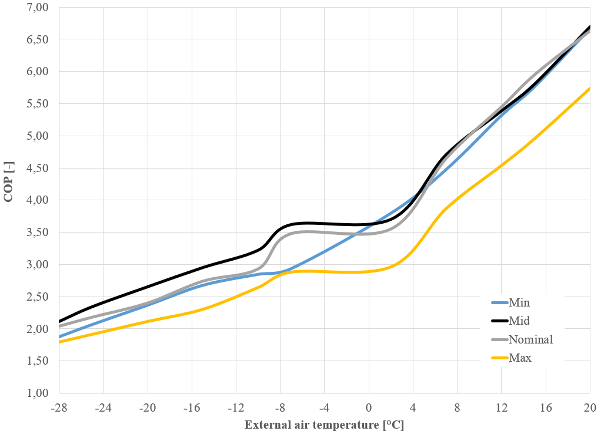
Fig. 1. COP values of the selected heat pump based on (Mitsubishi Electric, 2025) (subsequent legend markings refer to COP values appropriate for the heat pump load level in the following order: minimum, average, nominal, maximum)

Adopted details of the solution used:
- during the cold season, the heat pump operates only in heating mode, switching between the central heating system and the DHW heater,
- during the warm period, the heat pump switches between cooling mode and heating mode for DHW purposes,
- the building has a floor heating system with a maximum supply temperature of 35°C, a supply temperature control solution using a mixing valve,
- due to longer interruptions in the heat supply (DHW heating), the use of a central heating buffer is planned, with a constant supply temperature of 35°C, charging only during the cold season,
- the current power of the heat pump is adjusted to the actual needs of the central heating installation, taking into account the need to obtain the highest possible value of the COP coefficient,
- the additional electric heater is only for preparing DHW.
2.4. Assumed cold season duration
The current regulations define the cold season as "the period during which weather conditions require a continuous supply of heat to heat buildings" (Dz.U. 2007). However, there are no guidelines for precisely determining its length. The earlier, no longer applicable version of the Regulation (Dz.U. 2008) introduced a general method for calculating the duration of the cold season; its accuracy was assessed, for example, by Maludziński (2009). In countries other than Poland, the problem of determining the duration of the cold season is similar; it is, for example, discussed in the article by Nosyreva et al. (2018). At the same time, the duration of the cold season is also indirectly incorporated into electricity and gas sales and supply tariffs and is linked to changes in fee rates. This period is most often assigned to a specific city and does not take into account the heating needs of a specific building (e.g., the type of central heating system used, the building's insulation level and thermal storage capacity, etc.).
Based on the above and calculations for five very different locations, a decision was made to adopt a unique definition of the cold season. It was assumed that from the beginning of May to the end of August, the heat pump would operate in either building cooling or DHW mode; this would be the warm period. During the remaining time, from the beginning of September to the end of April, the heat pump could operate for DHW or floor heating system needs. Due to significant variation in data for a typical meteorological year across selected locations, an additional requirement was introduced to assign a given hour to the cold season: the average outside air temperature over the previous 12 hours had to be below 12°C. Only during hours when this requirement was met could the heat pump supply heat to the building's floor heating system. The durations resulting from this definition of the cold season are presented in Table 2 (annual summary values) and Table 3 (monthly summary values).
2.5. Design heating loads and EU'
The estimated heating loads for the building's design in the analysed locations were calculated using a modified EDSL TAS model. Climate data with constant parameters throughout the entire period were used, e.g., a constant outdoor air temperature equal to the design temperature of the given climate zone and zero values for global and diffuse solar radiation. Internal heat gains in the living room and all three bedrooms were also set to zero. The total heating load for all rooms in the last hour of the 30th day of the simulation period (stabilisation of all results was achieved) was assumed as the design heating load.
Seasonal/monthly EU' values for individual locations were determined as the sum of hourly heat loads for individual rooms that occurred during the hours assigned to the entire season or a given month of the cold season. Seasonal and monthly EU' values can be calculated using standard OZC software commonly used in design offices (hourly results cannot be obtained); therefore, they should be considered relatively easy to obtain.
Hourly EU' values for individual locations were determined in two different ways. In the first method, the hourly heat loads of individual rooms, obtained directly from the EDSL TAS, were summed to determine building EU'm. It should be assumed that the results obtained in this way achieve the highest possible accuracy, at the expense of the significant workload required to prepare them. In the second method, the monthly EU'm values and the sum of the Stg values for a given month (formula 1) were used to determine the monthly Wm index (formula 2), which, in turn, was used to calculate the estimated hourly EU'FI values (formula 3).
$Stg=t_{i}-t_{e}$ (1)
where:
- Stg – degreehours, [°C]
- t_{i} – constant, average internal air temperature in the building (assumed 20°C, simplification), [°C]
- t_{e} – outside air temperature at a given hour of the month during the cold season, [°C]
$W_{m}=\frac{EU'm}{\sum{Stg}}$ (2)
where:
- W_{m} – monthly indicator, [kWh/°C]
- EU'm – EU' value for a given month, [kWh]
- $\sum{Stg}$ – sum of the hourly Stg values of a given month, [kWh/°C]
$EU’FI=Stg∙W_{m}$ (3)
where:
- $EU'FI$ – EU' value estimated for a given hour using the Stg value, [kWh]

The method for estimating hourly EU'FI values assumes variability in a building's static and ventilation heat losses, which are solely related to the temperature difference between the building's internal and external air at a given location. This method does not account for other factors that may influence the results, such as changes in heat gain from solar radiation. However, it is used in practice when it is impossible or unjustified to use advanced calculation programmes that would allow for more accurate determination of hourly EU' values. The precision of the results obtained from this method was analysed based on the analyses conducted.
3. Research Results and Discussion
3.1. Location
The change in location of the building had an impact on both the obtained values of the building's design heating load (related to the change in the design outside air temperature of the climate zone) and the hourly EU'm values (related to hourly changes in the data of a typical meteorological year of the climate zone), the results are presented in Table 2.

Table 2. Summary of results for selected building locations
Location | Heating season hours | Design heating load | Usable energy season
- | h | W | kWh
Koszalin | 5 140 | 5 670 | 9 620
Wrocław | 5 014 | 5 950 | 9 447
Warszawa | 5 200 | 6 232 | 9 738
Białystok | 5 226 | 6 541 | 11 334
Suwałki | 5 205 | 6 834 | 12 245

As expected, the design heating load values for buildings located in cities in successive climate zones increased by approximately constant values, on average by 5.2%, as the design outside air temperature decreased. The energy required to heat buildings in Koszalin, Wrocław, and Warsaw was significantly lower than for the building in Białystok, especially for the building in Suwałki. The difference between the cities with extreme results (Wrocław and Suwałki) was 29.6%. This is due, among other things, to the lower average outside air temperature during the cold season in Suwałki (1.2°C) than in Wrocław (3.5°C). Further analysis of the phenomenon was possible only after obtaining monthly and hourly results.
When analysing the impact of data from a typical meteorological year for each location, attention was paid to hourly outdoor air temperature values (the lowest average daily value occurred in Suwałki in January) and global solar radiation (the highest average daily value occurred in Wrocław in April) for each city separately. A summary of these parameters is presented in Table 3.

Table 3. Monthly summary of results for the analysed locations
 | Koszalin – Zone I (-16°C) |  |  |  | Wrocław – Zone II (-18°C) |  |  |  | Warszawa – Zone III (-20°C)
Month | time CS | avg. air temp. | avg.  solar rad. | EU'm | time CS | avg. air temp. | avg.  solar rad. | EU'm | time CS |  | avg. air temp. | avg.  solar rad. |  | EU'm
- | h | °C | W/m² | kWh | h | °C | W/m² | kWh | h |  | °C | W/m² |  | kWh
I | 744 | -0.8 | 29 | 1 948 | 744 | -0.4 | 33 | 1 871 | 744 |  | -1.2 | 37 |  | 1 921
II | 672 | -0.8 | 40 | 1 719 | 672 | -0.7 | 55 | 1 619 | 672 |  | -0.9 | 52 |  | 1 681
III | 744 | 4.3 | 75 | 1 239 | 703 | 2.2 | 96 | 1 255 | 727 |  | 4.3 | 91 |  | 1 125
IV | 690 | 6.0 | 111 | 886 | 607 | 6.4 | 143 | 643 | 663 |  | 6.0 | 133 |  | 804
IX | 193 | 11.6 | 101 | 83 | 272 | 10.7 | 114 | 137 | 297 |  | 10.3 | 114 |  | 161
X | 633 | 8.5 | 55 | 663 | 552 | 7.2 | 67 | 643 | 633 |  | 7.1 | 63 |  | 782
XI | 720 | 3.6 | 31 | 1 388 | 720 | 3.8 | 38 | 1 349 | 720 |  | 2.9 | 30 |  | 1 471
XII | 744 | 2.0 | 22 | 1 693 | 744 | -1.1 | 31 | 1 930 | 744 |  | 0.8 | 24 |  | 1 793
 | Białystok – Zone IV (-22°C) |  |  |  | Suwałki – Zone V (-24°C)
Month | time CS | avg. air temp. | avg.  solar rad. | EU'm | time CS | avg. air temp. | avg.  solar rad. | EU'm
- | h | °C | W/m² | kWh | h | °C | W/m² | kWh
I | 744 | -4.9 | 28 | 2 383 | 744 | -5.3 | 28 | 2 458
II | 672 | -2.0 | 41 | 1 825 | 672 | -4.9 | 42 | 2 098
III | 738 | 1.6 | 80 | 1 501 | 744 | 1.3 | 70 | 1 601
IV | 556 | 5.1 | 130 | 783 | 565 | 4.6 | 127 | 844
IX | 380 | 10.7 | 117 | 184 | 335 | 10.4 | 101 | 219
X | 672 | 6.4 | 54 | 956 | 681 | 6.1 | 53 | 1 016
XI | 720 | 1.6 | 27 | 1 640 | 720 | 0.1 | 26 | 1 808
XII | 744 | -1.3 | 22 | 2 061 | 744 | -2.3 | 17 | 2 202
(symbols used: time CS – number of hours of the cold season, avg. air temp. – average outside air temperature,
avg. solar rad. – average global solar radiation, EU'm – total monthly value of usable energy)
3.2. Monthly results
The electricity consumption required to operate the heat pump in the central heating system of a building located in selected cities was calculated hourly, based on the EU' results from EDSL TAS and estimated using the FI method. The hourly values were summed for each month and presented in Table 4. It was observed that in the coldest months of the cold season, the obtained values did not differ from each other; this occurred in nine cases at all locations. The largest absolute differences were observed in the warmer months of the cold season. Still, they did not exceed 4 kWh, a value that is negligible from an engineering perspective in typical designs. No differences were observed in the results across all locations in September. This was due to the relatively few hours of cold weather that occurred that month.

Table 4. Monthly summary of the results of electricity consumption of the heat pump, calculated using the exact method – the sum of hourly EDSL TAS results, and the estimated FI method – the sum of hourly results obtained using the FI coefficient
 | Koszalin |  |  | Wrocław |  |  | Warszawa
Month | El. en. TAS | El. en. FI | Δ  TAS-FI | El. en. TAS | El. en. FI | Δ  TAS-FI | El. en. TAS | El. en. FI | Δ  TAS-FI
- | kWh | kWh | kWh | kWh | kWh | kWh | kWh | kWh | kWh
I | 536 | 534 | 2 | 507 | 506 | 1 | 526 | 526 | 0
II | 468 | 467 | 0 | 441 | 440 | 1 | 455 | 454 | 1
III | 309 | 306 | 3 | 330 | 326 | 4 | 283 | 280 | 4
IV | 213 | 209 | 3 | 155 | 153 | 2 | 197 | 193 | 4
IX | 16 | 16 | 0 | 28 | 28 | 0 | 33 | 33 | 0
X | 145 | 143 | 2 | 148 | 145 | 3 | 183 | 178 | 4
XI | 350 | 348 | 2 | 339 | 337 | 2 | 377 | 377 | 0
XII | 439 | 438 | 1 | 532 | 530 | 2 | 472 | 472 | 0
Sum | 2 475 | 2 462 | 13 | 2 479 | 2 465 | 15 | 2 526 | 2 512 | 13
 | Białystok |  |  | Suwałki
Month | El. en. TAS | El. en. FI | Δ  TAS-FI | El. en. TAS | El. en. FI | Δ  TAS-FI
- | kWh | kWh | kWh | kWh | kWh | kWh
I | 687 | 687 | 0 | 733 | 732 | 1
II | 502 | 502 | 0 | 602 | 602 | 0
III | 396 | 392 | 3 | 423 | 421 | 2
IV | 198 | 194 | 4 | 216 | 212 | 4
IX | 38 | 38 | 0 | 46 | 46 | 0
X | 226 | 222 | 4 | 240 | 237 | 3
XI | 438 | 438 | 0 | 487 | 485 | 1
XII | 568 | 568 | 0 | 615 | 614 | 1
Sum | 3 052 | 3 041 | 11 | 3 360 | 3 349 | 11

Therefore, analysing only monthly results would suggest a surprisingly high level of precision for the FI method in estimating energy demand at the monthly interval. However, this method is designed primarily to estimate hourly data, not monthly data. For this reason, it was decided to analyse the hourly calculation results in more detail.
3.3. Hourly results
The main advantage of estimating the hourly energy demand for the building heating system using the FI method is the direct use of the hourly outdoor air temperature values imposed in (GOV 2025). More accurate calculation methods are based on the same data. Because the COP of the selected heat pump depends primarily on outdoor air temperature, the resulting electricity consumption values are as accurate as possible. Their accuracy is the same as for advanced calculation methods, such as the EDSL TAS programme used in this article. Therefore, any inaccuracies in the FI method are directly related to the estimated hourly usable energy values. The main problem with the FI method is its inability to directly account for the impact of solar gains on reducing the energy demand for building heating. First, the phenomenon is illustrated using the example of the sunniest (27th day of the year) and least sunny (3rd day of the year) days of the month, with the lowest average outdoor air temperature of all analysed months, namely January in Suwałki.
On relatively cloudy, cold days, the hourly heating energy demand values estimated using the FI method are mostly slightly underestimated. On day 3, with the largest hourly difference between the results, the estimated electricity consumption using the FI method was only 85 Wh higher than that calculated from the EDSL TAS results. Only in one hour, during which the influence of global solar radiation was greatest, was the estimated value greater than the exact value; the difference was 17 Wh (results presented in Fig. 2). For such days, the accuracy of the FI method is entirely sufficient for most practical applications.

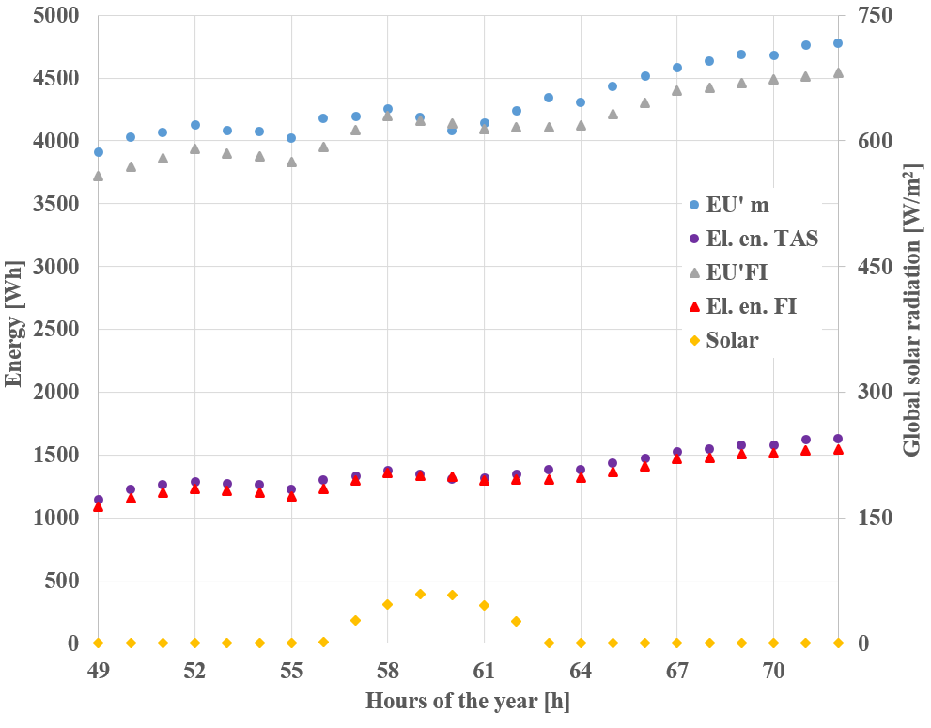
Fig. 2. Day 3 – the day with the lowest daily global radiation sum of the coldest month: January (middle of the cold season), Suwałki (symbols used: EU'm – energy used for heating the building calculated using EDSL TAS,
EU'FI – energy used for heating the building calculated using the FI method, El. en. – electrical energy of the heat pump, Solar – global radiation)

The situation changes on cold days, but with higher global radiation, such as on day 27. During all hours of the day, electricity consumption estimates using the FI method were overestimated. During hours when global solar radiation was 0 W/m², the average error in estimating electricity consumption was only 38 Wh, but for sunny hours, the average error in this parameter increased to 289 Wh, with a maximum difference of 451 Wh (results presented in Fig. 3). This example clearly illustrates that the FI method does not account for the reduced energy demand for heating system resulting from solar heat gains. In studies requiring accurate hourly data, applying the FI method to sunny hours during winter months may prove insufficient.
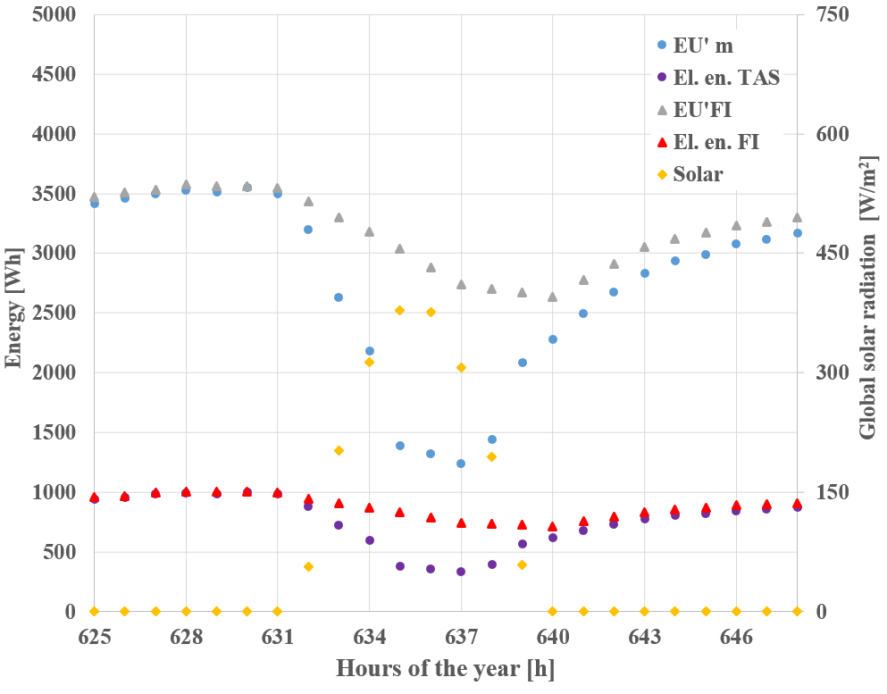
Fig. 3. Day 27 – the day with the highest daily global radiation sum of the coldest month: January (middle of the cold season), Suwałki (symbols used: EU'm – energy used for heating the building calculated using EDSL TAS,
EU'FI – energy used for heating the building calculated using the FI method, El. en. – electrical energy of the heat pump, Solar – global radiation)

Based on the analysis of data obtained for Wrocław on day 110, the day with the highest average daily outdoor air temperature of the cold season among all locations studied and the highest daily global radiation sum in April, another shortcoming of the FI method estimates was highlighted. During very sunny hours of the day, no significant decrease in electricity consumption was observed (Fig. 4), as was the case on most sunny but cooler days. Only detailed results for individual rooms allowed us to understand the mechanism of this phenomenon. Only in rooms without windows (both corridors) and in bathrooms with north-facing windows was heating required. The heat demand in the remaining rooms was fully satisfied by solar heat gains; the excess gains only increased indoor air temperature in these rooms (without a direct impact on overall heating electricity consumption). The lack of need to heat several rooms contributed to a reduction in the building's electricity demand. This phenomenon is not accounted for in the FI method estimates; therefore, all estimated hourly values for these 24 hours were overestimated. Because the observed phenomenon occurs only during the warmer days of the cold season, when building heating energy demand is relatively low, the associated error is small. For the 24 hours analysed, the average daily error was only 69 Wh. In addition, attention was paid to the first 4 hours of the 24 hours analysed. During these hours, the central heating system for the entire building was turned off; since it was outside the cold season, the graph shows zero energy consumption.
The impact of the phenomena described above on the accuracy of the FI method's estimations for calculating the heating system's electricity demand for the analysed building is presented in Fig. 5, using results for Wrocław (the largest difference in the annual results) as an example. The graph summarises the differences between the accurate results obtained directly from the EDSL TAS data and the values estimated using the FI method. Positive error values correspond to hours when the FI method underestimated the result.

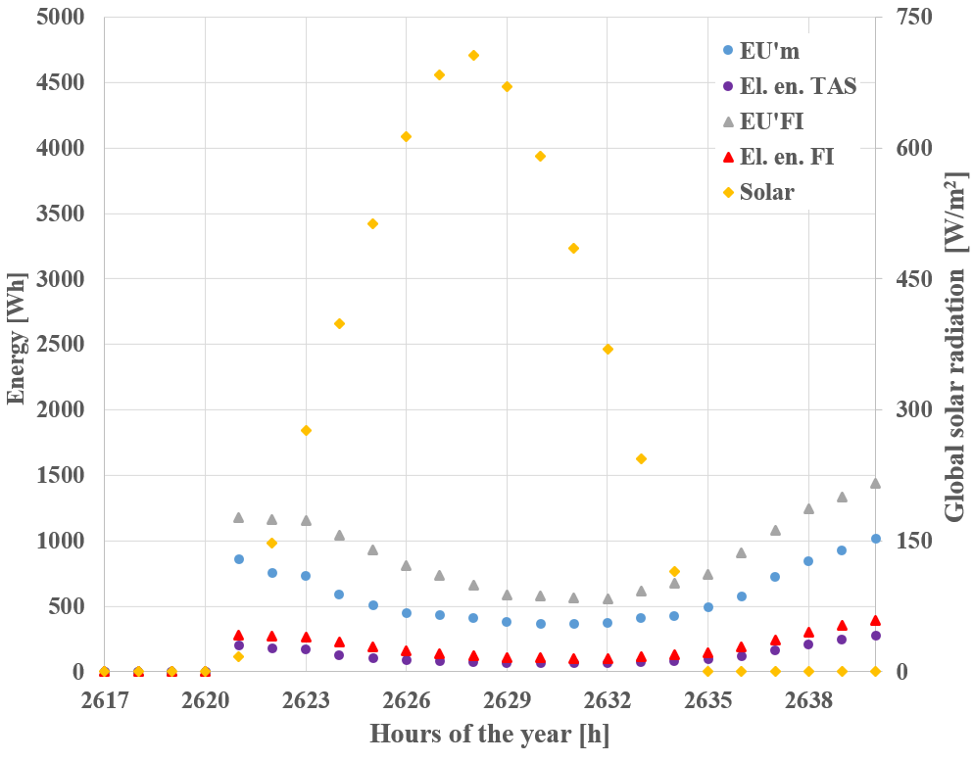
Fig. 4. Day 110 – the day with the highest daily global radiation sum in April (end of the cold season) Wrocław (symbols used: EU'm – energy used for heating the building calculated using EDSL TAS, EU'FI – energy used for heating the building calculated using the FI method, El. en. – electrical energy of the heat pump, Solar – global radiation)

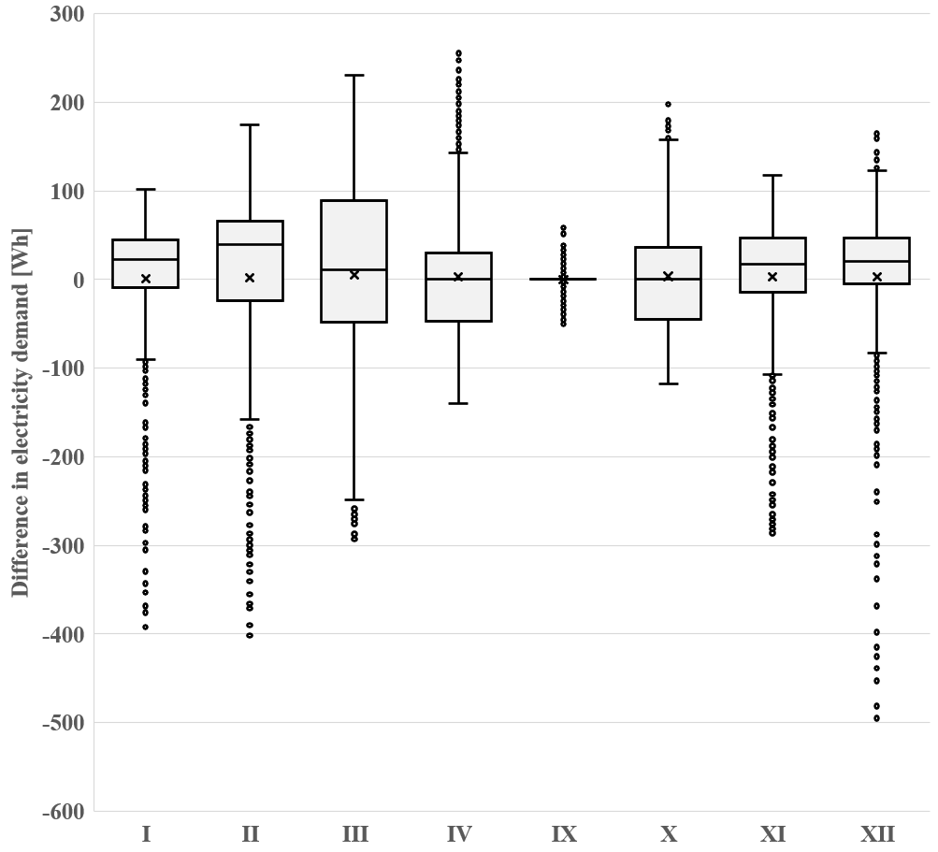
Fig. 5. Summary of the hourly differences between the electricity consumption for heating the building calculated based on the EDSL TAS values and those estimated using the FI method for Wrocław
Consistent with previous results, the arithmetic averages of the errors determined were close to zero for all months. In colder months, a significant portion of the estimated results were slightly underestimated, while overestimated hours with relatively greater global radiation were less frequent, a result of the FI method not accounting for solar heat gains. In warmer months, most results were more uniform, with medians of 0 Wh in April and October. The occurrence of extreme values (underestimated results) in these months was related, among other things, to the fact that the estimates did not account for the lack of need to heat certain rooms in the building. The data compilation confirmed the earlier observations.
4. Summary
Applying the Fi method to estimate hourly energy consumption for building heating requires relatively easy-to-obtain data on the building's monthly energy demand (e.g., calculations using a programme such as OZC) and official meteorological data specific to the location under consideration (GOV 2025). The obtained results can be used for more advanced calculations, such as analysing the heat storage process in buffers cooperating with heat pumps, as well as for more common applications, such as more accurate cost calculations for heating a building with an air-to-water heat pump operating under a dual-zone electricity tariff. Using the method significantly simplifies the calculation process compared to advanced simulation tools, at the cost of only slightly reducing the accuracy of the obtained results (the largest seasonal error obtained for the tested building was 15 kWh, or just 0.6% over the cold season). The method's error is small, especially compared to methods that use only monthly data, for example.
For not-so-sunny and cool days, the accuracy of the FI method is perfectly adequate for most practical applications. However, the results may be slightly underestimated. A similar situation occurs during the night hours of the warmer part of the cold season. This period accounts for the majority of the cold season and, moreover, the majority of the building's heat demand occurs during this period, further supporting the use of the FI method.
However, it should be noted that during sunny hours, especially at the beginning and end of the cold season, using the FI method yields hourly results with greater errors. The largest recorded error was 718 Wh, which represents 25.2% of the maximum hourly value for the entire season. In typical FI method applications, because heating energy demand is lower during this period, the significance of this inaccuracy is relatively small. For applications requiring significantly higher hourly accuracy, results from warmer, sunny days should be completely excluded from calculations, or the potential for significant overestimation should be accounted for.
Further increasing the accuracy of the FI method estimates is theoretically possible by applying it using monthly energy demand data for heating individual rooms separately. This approach will reduce the impact of increases in internal air temperature and temporary heating shutdowns in selected rooms on overestimating results. The need to obtain more accurate input data and to complicate the calculations increases the complexity of the FI method, but it will not significantly improve the accuracy of its results. This approach contradicts the assumption made at the outset of this article, which used the simplest possible calculation method.
References
Grudzińska, K. (2022). A technical, economic and comparative analysis of heat sources based on renewable energy sources and a heat source powered by natural gas for a detached house. Gaz, Woda i Technika Sanitarna, 3, 29-38. https://doi.org/10.15199/17.2022.3.6 (in Polish)
Kowalski, P., Cepiński, W., Szałański, P. (2023). The influence of room temperature changes on energy and gas consumption in single-family buildings with different energy standards in Polish climatic conditions. Gaz, Woda, Technika Sanitarna, 12, 26-34. https://doi.org/10.15199/17.2023.12.4 (in Polish)
Kwestarz, M., Kostrzewska, W. (2023). Hybrid renewable energy concept for a single-family house. Gaz, Woda i Technika Sanitarna, 5, 27-33. https://doi.org/10.15199/17.2023.5.5 (in Polish)
Lachman, P., et al. (2020). Guidelines for the design, implementation and acceptance of heat pump installations. Kraków: Polska Organizacja Rozwoju Technologii Pomp Ciepła. ISBN: 978-83-935382-9-4. (in Polish)
Maludziński, B. (2009). Calculating the duration of the heating season. Rynek instalacyjny, 9, 24-26. (in Polish)
Nosyreva, O. V., Barashkova, N. K., Kizhner, L. I. (2018). Determining the duration of the heating season in Tomsk. IOP Conf. Ser.: Earth Environ. Sci. (211) 012056. https://doi.org/10.1088/1755-1315/211/1/012056
Schlagowski, G., et al. (2015). Criteria for the passive building standard, the EnerPHit thermal modernization standard and the PHI energy-efficient building standard; ver. 9b, state 30.06.2015. Gdańsk (Osowa): Instytut Budynków Pasywnych. (in Polish)
Stokowiec, K., Kotrys-Działak, D. (2024). The Effect of the Temperature Increase on Heat Demand Calculation for Building in the Polish Climatology. Rocznik Ochrona Środowiska, 26, 128-136. https://doi.org/10.54740/ros.2024.013

Dz.U. 2002 nr 75 poz. 690 with later changes. Rozporządzenie Ministra Infrastruktury z dnia 12 kwietnia 2002 r. w sprawie warunków technicznych, jakim powinny odpowiadać budynki i ich usytuowanie.
Dz.U. 2007 nr 16 poz. 92. Rozporządzenie Ministra Gospodarki z dnia 15 stycznia 2007 r. w sprawie szczegółowych warunków funkcjonowania systemów ciepłowniczych.
Dz.U. 2008 nr 201 poz. 1240. Rozporządzenie Ministra Infrastruktury z dnia 6 listopada 2008 r. w sprawie metodologii obliczania charakterystyki energetycznej budynku stanowiącej samodzielną całość techniczno-użytkowa oraz sposobu sporządzania i wzorów świadectw ich charakterystyki energetycznej.
Dz.U. 2015 poz. 376 with later changes. Rozporządzenie Ministra Infrastruktury i Rozwoju z dnia 27 lutego 2015 r. w sprawie metodologii wyznaczania charakterystyki energetycznej budynku lub części budynku oraz świadectw charakterystyki energetycznej.
GUS. (2025). Construction in 2024. Warszawa. Główny Urząd Statystyczny. (in Polish)
PN EN 12831:2006 Instalacje ogrzewcze w budynkach – Metoda Obliczania projektowego obciążenia cieplnego.
EDSL Limited. (2025). TAS 3D Modeller v 3.5.6 documentation. Milton Keynes.
Mitsubishi Electric. (2025). Ecodan Renewable Heating Technology Data Book. Vol.4.1.
https://www.gov.pl/web/archiwum-inwestycje-rozwoj/dane-do-obliczen-energetycznych-budynkow [access: 12.2025]

