
 | Rocznik Ochrona Środowiska
 | Volume 27 | Year 2025 ISSN 2720-7501 | pp. 788-798
 | https://doi.org/10.54740/ros.2025.063 open access
 | Received: December 2025 Accepted: December 2025 Published: December 2025
Logistics Security in Transport and Decision-making Problems in the Management
of European Satellite Resources in Space
Marcin Mazur
Polish Space Agency, Poland
https://orcid.org/0009-0002-5681-4807
corresponding author's e-mail: marcin.mazur@polsa.gov.pl
Abstract: The development of space technology and its widespread use for civilian and military purposes are increasing the importance of space for the functioning of modern states, in terms of their security. This article addresses the management of satellite systems in Europe, which underpin the functioning and conduct of business by European economies. The widespread use of satellite services, the use of data and products in the daily lives of citizens, the progress of civilization, and the rising standard of living have led society to become dependent on daily access to technologies and services based on satellite resources. Economic functioning, production, trade in goods and services, and industrial development all rely on space resources. Naturally, the growing importance of space usage has led to an increase in potential threats, both natural and human-induced, stemming from the use of space and the development of anti-satellite (ASAT) capabilities. In this context, ensuring logistical security is a major challenge for all stakeholders interested in using space for various purposes, such as navigation, Earth observation, and communications. This applies to all critical services, from component production and supply, through ground infrastructure, to the maintenance and replacement of orbital components. Environmental protection is an important aspect of replacing worn orbital components. These activities should include the recycling of worn orbital components. In this process, attention should be paid to the issue of eco-logistics.
Keywords: national security, space safety, anti-satellite capabilities, space debris, eco-logistics, environmental protection
1. Introduction
The development of space technologies and their widespread use for civilian and military purposes are increasing the importance of space for the functioning of our economies. It should be noted that production, trade in goods and services, and industrial development rely on satellite resources. Limiting access or eliminating them would threaten the interests of European countries.
The massive increase in the number of satellite systems has led society, the economy, and public administration to become dependent on data, products, and services (DPS) originating from space. Whether you want to check the weather forecast, get up-to-date information on a train's location, or make an international money transfer, you need to utilize resources available in space.
Poland's needs related to space use were defined in the Polish Space Strategy of 2017, which emphasizes the importance of national capabilities in Earth observation, satellite communications, space observation, and the construction of launch vehicles into Earth orbit as key to Poland's construction and development.
The European Union also approved the Space Strategy for Europe in 2016, identifying space capabilities as key to ensuring security. In 2022, the role of space was emphasized in the Strategic Compass and in EU space-based defence capabilities. This document emphasizes that without space capabilities, the European Union cannot guarantee the community's strategic autonomy in the area of security and defence.
As a result of the above documents, the EU Space Strategy for Security and Defence was published in March 2023 as a response to the threats, challenges, and risks posed by the use of space. Because space currently plays a key role in terms of security and economic interests, it is also an arena where the interests of states vying for dominance compete.
A key aspect of utilizing space, which forms the foundation of a state's security system, is the ability to utilize space and secure access to national, European, allied, and other satellite resources based on bilateral agreements. Building national capabilities and taking responsibility for their own satellite platforms means that countries with their own satellites have greater opportunities to secure access to data, diversify data sources, and exchange capabilities with their partners. However, as a result of possessing national resources, these countries are responsible for the safe operation of their systems in orbit, which, in practice, means managing and operating their own satellites.

The main objective of this article is to address aspects related to the design and management of satellite resources in orbit, and the responsibilities arising from ownership of satellite systems. Furthermore, the article highlights the importance of the constraints and opportunities of European-led processes when making decisions about satellite resources.
Therefore, the article includes, among others:
- Legal aspects,
- Financial aspects,
- The ability to launch payloads into orbit,
- The changing technological developments,
- The security of our own resources in orbit.

The article is divided into five parts. The first describes the normative acts regulating the use of outer space and the responsibility for owning one's own orbital resources. The next part discusses the limited satellite launch capabilities of European states, which impacts planning and European independence. The third part highlights the financial aspect, comparing Europe to other continents. Due to dynamic technological changes and miniaturization, the article describes how these developments influence the planning of subsequent satellite constellations. The final part highlights the risks and challenges satellites will face after launch into orbit.
2. Challenges for Logistics Security in Transport in the Context of the European Satellite Systems
As a result of rapid technological changes and the consequent availability of high-performance algorithms, the perception of data availability and analysis in the context of logistics security has also changed. Digital technologies, space exploration, supply chain management, including critical infrastructure security, and large-scale data management have become particularly important in recent years for global business. Economic and geopolitical transformations have made logistics security increasingly important, both economically and militarily. Logistics security in space involves ensuring the continuity of services, from the production and supply of components, through ground infrastructure, to the maintenance and replacement of orbital elements.
In the article (Semenov et al. 2025), the authors noted that a key factor hindering management process improvement and increasing associated risk is the incompatibility of innovative AI applications with the traditional supply management architecture in the studied enterprise. The authors emphasized that the integration of human capital with AI is becoming a factor driving the efficiency of the company and its processes. Similarly, the authors of the article (Zgorzelski et al. 2025) highlighted the role of artificial intelligence as a key element of digital transformation in the transport sector. They pointed out that AI-based technologies contribute to increased efficiency and process automation, but their implementation also poses new challenges. These primarily concern data quality and security, system interoperability, and ensuring the transparency and reliability of algorithms used in critical transport infrastructure. The security of systems against cyberattacks is the subject of analysis by many authors and various scientific and research centers. For example, the authors of (Izdebski et al. 2024) presented the issue of cyberattacks in air transport, which is crucial for ensuring the safety and reliability of airports and air transport operations. The authors conducted security analyses using a method for predicting cyberattacks in air transport based on neural networks.
Logistics security encompasses not only classic risks, such as supply chain disruptions, but also threats related to digitalization and process automation, as well as the growing use of AI-powered processes. The use of cloud solutions, IoT, and sensor technology, as well as integration with information systems and autonomous transport systems, means that an attack on the digital layer can quickly translate into disruptions to material flows.
Kukulski et al. (2023) presented a risk mapping model for the operation of a multimodal transport system, highlighting the risks of disruptions in information flow as significant for system reliability. The authors indicated that digitalization improves the transparency and control of the logistics process, but simultaneously increases vulnerability to attack, requiring informed cyber risk management. Similarly, the authors of (Zieja et al. 2015) emphasize the importance of IT systems that support aircraft flight safety management. Wachnik, Kłodawski, and Kardas-Cinal (2022) discussed reducing the information gap in systems meeting Industry 4.0 requirements as a way to reduce energy consumption, while also significantly increasing process safety. Reducing the information gap allows for increased data integrity and availability, and consequently, the reliability of algorithms (e.g., artificial intelligence) and maintaining business continuity in disruptive situations.
Supply chain cybersecurity is particularly important for all space stakeholders (Table 1) who have been included in NIS2. It means greater audit requirements, incident reporting, and supplier oversight.

Table 1. Entities and their functions in the European space ecosystem
No. | Entity / institution | Tasks / Functions
1. | ESA | technology and satellite development
2. | EUSPA | operational and exploitation
3. | EU SST | 15 nation partnership for space awareness
4. | DG DEFIS | policy, budget, regulations
5. | Member states & private operators | implementation, maintenance, supply sector
Source: Own study

Due to the multitude of factors that must be considered in the management of satellite resources in space, as in transportation systems, risk management is a crucial issue. As evidenced by numerous studies in the field of transportation, risk management is a complex decision-making problem. This is determined by the fact that the transportation systems studied often have complex functional structures. In (Izdebski et al. 2022), the authors indicated that heuristic algorithms play a key role in risk management in road transport.
The methodology of risk management in road transport (Izdebski et al. 2025, Woźniak et al. 2015) or in airport processes (Gołda et al. 2021) using heuristic algorithms is a theoretical and practical apparatus that allows its use to solve specific decision-making problems related to risk management in various areas of research, including the management of satellite resources in space.
It should be noted that logistics security is becoming a domain not only of supply chains but is also beginning to encompass the potential of space, including communication, navigation, connectivity, and observation, supporting the operation of logistics systems. At the same time, it is inaccessible for testing solutions. Similarly, geographically distant logistics systems require the use of remote solutions, yet provide direct perception of experiences. Immersive technologies such as VR are used for this purpose. VR can be used to enhance logistics security through remote communication, training, and support for the design and testing of solutions.
Lewczuk and Żuchowicz (2024, 2025) proposed a methodology for using simulation models with an immersive VR layer to study the safety of intralogistics systems, pointing to the significant practical potential of this technology in the analysis of working conditions, ergonomic analysis of workstations, and dynamic redesign of solutions. The ability to quickly test and adapt solutions offers the potential to improve the logistics safety of the system, as well as increase the efficiency of the design process and enable its implementation also for systems with a space component.
3. Aspects to be Considered
3.1. Important normative acts regulating the use of outer space
Activities in outer space are regulated by existing international space law, which is part of public international law, regulating the legal status of outer space and the principles of activities conducted by states and entities authorized by states.
As a result of the work of the Standing Committee on the Peaceful Uses of Outer Space (COPUOS) at the UN General Assembly, five agreements in the field of space law were established:
- The Treaty on Principles Governing the Activities of States in the Exploration and Use of Outer Space, Including the Moon and Other Celestial Bodies of January 27, 1967 – the so-called Outer Space Treaty;
- The Agreement on the Rescue of Astronauts, the Return of Astronauts and the Return of Objects Launched into Outer Space of April 22, 1968 – the so-called Rescue Agreement;
- The Convention on International Liability for Damage Caused by Space Objects of March 29, 1972 – the so-called Liability Convention;
- The Convention on the Registration of Objects Launched into Outer Space of January 14, 1975 – the so-called Registration Convention;
- The Treaty on Principles Governing the Activities of States on the Moon and Other Celestial Bodies of December 18, 1979 – the so-called Moon Agreement.

The Outer Space Treaty serves as the primary legal document regulating these activities, establishing peaceful principles for the use of space and prohibiting the appropriation of outer space. The document guarantees the free exploration and use of space by all states, defining the legal status of outer space and the rights and obligations of states conducting activities. The Rescue Agreement, on the other hand, provides security to states in the event of equipment or object failures (such as spacecraft and their components), or emergency landings of cosmonauts, and their return to the launching state.
The Liability Convention is a document regulating the international liability of states for damage caused by their space activities. It expands and details the Outer Space Treaty. The Registration Convention of Space Objects establishes an international register of space objects and imposes obligations on states related to the identification and control of their objects. In the case of the Moon Agreement document, it serves a regulatory function, and its primary goal is to ensure that outer space is used peacefully, prohibiting its militarization, and is used on an equal basis and for the benefit of all states.
The most important of these documents is the 1967 Outer Space Treaty, with subsequent documents supplementing, clarifying, and expanding upon the established principles. When deciding to build, acquire, or possess space assets, existing international space law must be adhered to, defining the principles for conducting activities, registering planned launches, monitoring them during operational activities, and assuming liability for any damage caused by such activities.
3.2. The aspect of the limited possibilities of launching payloads into orbit in Europe
Currently, Europe has only two operational systems capable of launching satellites and their payloads into orbit: Ariane 6 and Vega C. These systems form the basis of the European Union's sovereign launch capability. At the same time, 29 new launch systems are in early or very early stages of development in six European countries.
The Ariane 6 is a launch vehicle, manufactured primarily in France and Germany, designed for heavy- and medium-lift missions. To date, the rocket has completed only three successful launches into orbit. Regular use of the rocket is planned from 2026 onward, with a frequency of approximately six launches per year.
Vega C, developed by the Italian company Avio, is a rocket designed exclusively for Low Earth Orbit (LEO). Due to its size, it is intended for the light and medium launch segment. Since its launch in July 2022, the Vega C has completed only five flights, four of which were successful. From 2026, the rocket is scheduled to complete five missions per year.
Figure 1 shows existing and operational payload launch systems as well as systems under development and planned for introduction, developed by Novaspace as part of a report for the European Commission entitled Support instruments for EU / European access to space.

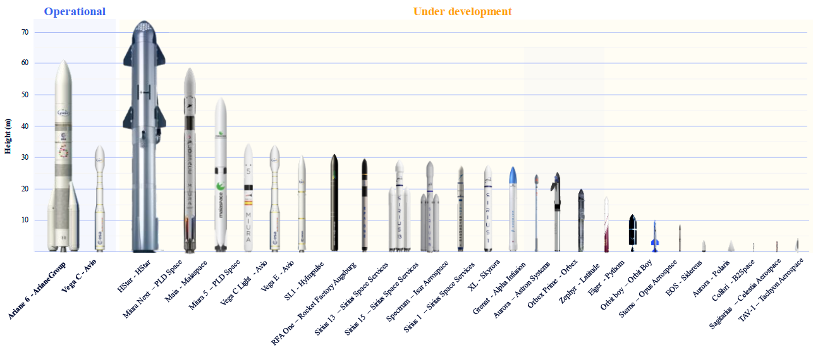
Fig. 1. Summary of operational and developing European launch systems
Resource: Novaspace (2025). Support instruments for EU / European access to space.

Outside of Europe, the global launch vehicle market is dominated by countries with advanced space potential and a large space heritage, such as the United States, Russia, China, India, and Japan.
The American company SpaceX has revolutionized the way satellites are launched by reusing parts or all of their rockets and aggressively pricing. SpaceX currently controls over 50% of the global commercial launch market and over 90% of the heavy launch capacity. This dominance has impacted pricing and the overall market, posing challenges for other providers regarding availability, reliability, and pricing.
Figure 2 shows the change in the price of commercial satellite launches in the period from the 1960s until the planned introduction of the large Starship launch vehicle into service, developed by the American Center for Strategic and International Studies.
The company currently launches satellites into orbit using Falcon 9 and Falcon Heavy rockets and is developing a large Starship launch vehicle capable of carrying payloads weighing up to 150 tons into low-Earth orbit (LEO). SpaceX boasts a very high reliability record, with no failures between 2015 and 2024. In 2024 alone, the company completed 136 launches (97 of which were for its own Starlink and Starshield constellations), accounting for more than half of the global total of 259 launches, according to Noivaspace's report for the European Commission, "Support instruments for EU / European access to space."
The above figure confirms that in the 1990s and early 2000s, the launch cost ranged from $6,200/kg (for the Chinese Long March 3B rocket) to $10,400/kg (for the American Delta IV rocket). Since 2015, the launch cost has fallen to $2,600/kg (for SpaceX's Falcon 9 rocket) and $1,500/kg (for SpaceX's Falcon Heavy rocket) for commercial users. Estimates suggest that once the Starship heavy-lift launch vehicle enters service, the cost will drop to around $200/kg.

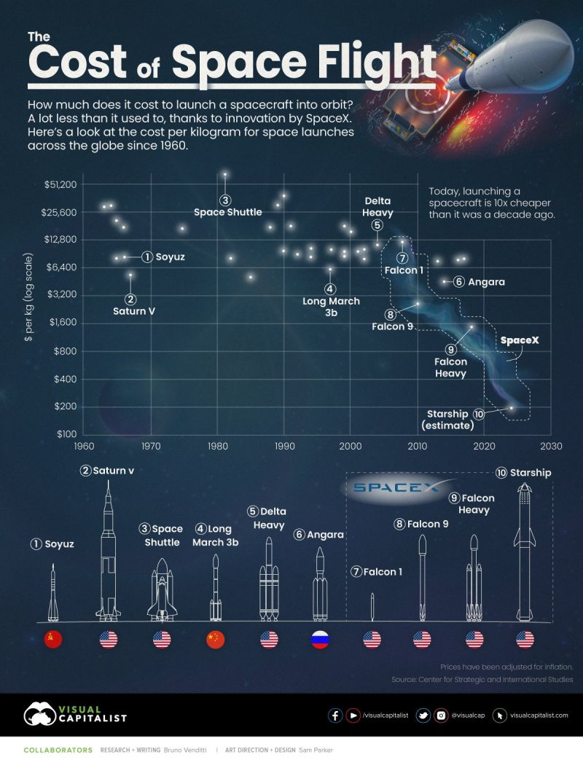
Fig. 2. Cost breakdown of launching payload (per kg) into orbit
Resource: Centre for Strategic and International Studies (2025).

The change in the approach to launching satellites into orbit, by allowing commercial entities to provide these services, has led to the development of technology and a reduction in the costs of launching payloads as a result of using part or all of the rockets. The development and demand for commercial services, primarily provided by the American market, have led to interest from European entities in the cheaper services provided by SpaceX and delays in the development of the European market.
3.3. The financial aspect
Due to the widespread use of space both in the country's economic development and state security, the number of satellite systems is growing, and the number of financial resources allocated to the development of satellite systems is increasing.
From 2022 onward, the main driver of growth in the overall public space budget is, of course, the military. The defence budget's share of funding has been growing, reaching 54% in 2024, with a 46% share of civilian spending. This is confirmed by the chart in Figure 3, prepared by the European Space Agency (ESA), as part of its Report on the Space Economy.
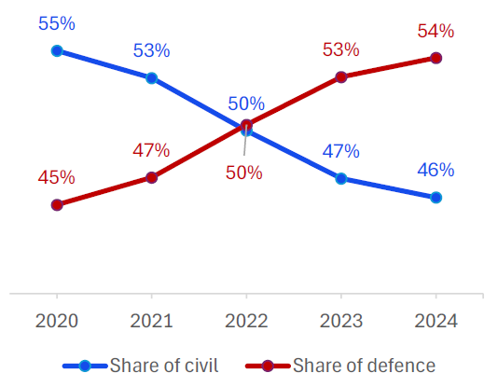
Fig. 3. Share of civilian and defence spending in global space budgets (2020-2024)
Resource: The European Space Agency. Report on the Space Economy (2025).

In Europe, the overall public space budget was €12.6 billion in 2024, representing a 2% increase compared to 2023 for the European continent, according to the aforementioned ESA report. However, Europe's share of the global space spending market only accounted for 10% of total spending, down from 15% five years ago, demonstrating a slow downward trend in the importance of the European market.

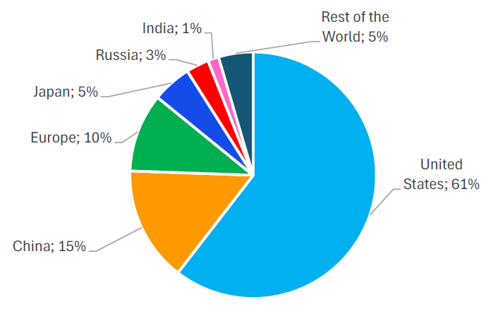
Fig. 4. Share of spending (civil and defence) on space in 2024
Resource: The European Space Agency (2025). Report on the Space Economy.

Financial considerations are crucial in planning the development and deployment of European satellite resources in space. Satellite systems are expensive investments that require long-term financial planning and a delayed return on investment.
3.4. Technological progress vs. safety of own resources
3.4.1. Issues of technological progress
The development and miniaturization of new technologies, and the resulting commercialization of satellite systems and orbital launch systems, have made space generally accessible to many countries previously unaffiliated with space exploration. Consequently, space has lost its reputation as a field of competition between great powers.
The chart in Figure 5, developed in 2023 by the European Space Policy Institute as part of the report entitled ESPI Yearbook 2022, Space Policies, Issues and Trends, illustrates the increase in the number of satellites launched into orbit, including primarily commercial resources, caused by the development of the satellite telecommunications services supply market, including SpaceX's Starlink resources (77.9% of the entire commercial market in 2020-2022).
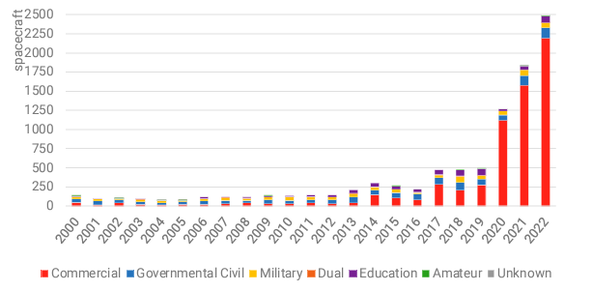
Fig. 5. The number of satellites launched into orbit
Resource: European Space Policy Institute (2023). ESPI Yearbook 2022, Space Policies, Issues and Trends.

As a result of the above, more and more private, public, and research entities from various countries around the world are placing their satellites in orbit to prove their skills, conduct research and tests in space, or conduct business activities using space. The graph in Figure 6, prepared by Novaspace as part of a report for the European Commission entitled "Support instruments for EU / European access to space," confirms the above trend of technological progress and commercialization of space, as a result of satellite systems planned to be launched into orbit by 2033.
The use of civilian space resources, which could be dual-use, is a method for supplementing military capabilities that can be used to ensure the functioning of the state's security system. This is because satellite platforms produced by contractors and suppliers are technically tailored to specific customers, depending on their needs. This means that some satellites can be used for both civilian and military customers, complementing the resources of the other party.
Civilian space resources are used in the daily lives of citizens in most countries around the world, providing access to satellite services for weather forecasting, navigation, border and water monitoring, monitoring agricultural crops, fisheries, forests, natural disasters, and emergency operations.

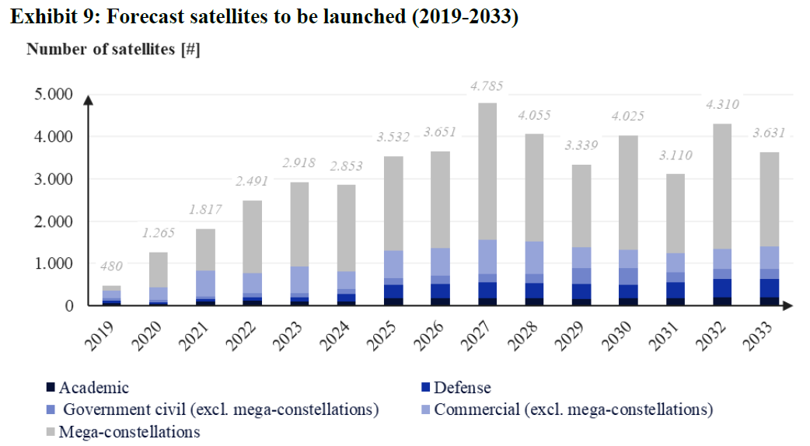
Fig. 6. The number of satellites to be launched into orbit (in 2019-2033)
Resource: Novaspace (2025). Support instruments for EU / European access to space.
It should also be noted that on the domestic market, a civilian institution – the Polish Space Agency (POLSA), subordinate to the minister responsible for economic affairs (currently the Minister of Finance and Economy). In accordance with the POLSA Act, the entity is tasked with supporting the development of the space industry in Poland, the use of space, as well as research and development of space technology, by engaging entities in national and international projects in order to develop the sector in Poland.
3.4.2. The safety aspect of your own resources
From a safety perspective, a growing number of nations are seeking to utilize space to enhance their security and build autonomous civil and military satellite capabilities. The growing importance of space has naturally led to an increase in potential threats stemming from space use and the development of anti-satellite capabilities (ASAT), which can be used to disrupt, degrade, or even destroy the satellite systems of opposing nations.
Therefore, threats in space can be divided into natural threats and those caused by human activity.
Natural hazards, based on the effects of space weather (SpWx), are primarily the physical consequences of solar activity, which include solar flares, coronal mass ejections (CMEs), solar energetic particles, and galactic cosmic rays. Natural hazards result in electromagnetic noise, electromagnetic wave interference, and energetically charged particles, which can negatively impact signal and data transmission by temporarily degrading transmission power, as well as potentially causing physical damage to the satellite's surface or its electronic components.
An example of solar activity, through solar flare emission and a coronal mass ejection, was the loss of 39 SpaceX Starlink satellites, which occurred on February 3, 2022. High-energy particles, forming the solar wind, reached Earth as the Starlinks were being launched into orbit. Although the solar geomagnetic storm was moderate, it contributed to the damage to the electronics of all the launched satellites.
It should be emphasized that space weather most often affects the functioning of SATCOM satellite communications, positioning systems, satellite navigation and PNT time, and HF high-frequency radio communications.
However, a much greater threat in space comes from threats caused by human activity, which come from the possibility of using tools or weapons on Earth or in space (so-called ASAT capabilities), or as a result of the existence of large numbers of artificial objects placed in Earth orbit (so-called space debris) to pose a threat to the space segment of satellite systems.
Earth orbits, especially LEO (Low Earth Orbit), are becoming increasingly crowded due to the development of new technologies, the miniaturization of satellite components and assemblies, and the reduction in design requirements and production costs of these systems. As a result, various countries and their entities are engaging in space exploration to utilize space resources, which has an impact on traffic congestion.
Consequently, according to ESA's Report on the Space Economy, there are several thousand satellites in LEO orbit, and an estimated 36,500 objects (satellite components) larger than 10 cm, traveling at a speed of approximately 27,000 km/h, which pose a collision risk to other moving artificial objects. According to the Space Defence Strategy of the French Ministry of the Armed Forces, it is estimated that 50% of the debris currently in orbit will still be in space in 20 years, not counting any that will be created in that timeframe.
3.4.3. Cyber threats
With the development of space technologies and the widespread use of satellite resources in our lives, the number of attacks on the space sector has increased, particularly on SATCOM systems and infrastructure. In the 1980s and 1990s, with the widespread use of satellite communications for satellite television and widespread broadcasting, incidents of signal interception began to occur. Figure 7, prepared by the French company CyberInFlight as part of the Space Cybersecurity Market Intelligence Report, shows the increase in cyber threats to satellite infrastructure from 1977 to 2023.
Then, at the beginning of the 21st century, jamming activities began to emerge, although initially they were more frequently used in areas where military operations were underway. However, with the growing importance of data and services provided by space assets, satellite jamming shifted to areas where there were no theaters of operations, and the activities had a predominant impact on civilian users, daily life, and economic stability.

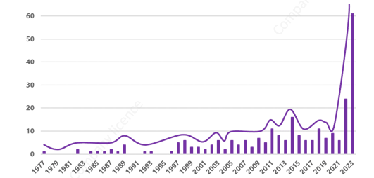
Fig. 7. Increase in cyberattacks on the space sector (1977 to 2023)
Resource: CyberInFlight (2025). Space Cybersecurity Market Intelligence Report.

The turning point came in 2022 with the start of Russia's invasion of Ukraine, confirming that satellite systems are crucial for conducting armed conflicts, and cyber threats in space, targeting satellite infrastructure, are becoming as common as those affecting regular ICT infrastructure.
An example of attacks on civilian infrastructure is the jamming of GNSS signals and the impact on civil aviation. Figure 8, prepared by the US Center for Strategic and International Studies as part of the Space Threat Assessment report, shows that jamming is quite common these days and occurs in various parts of the world. The daily number of disrupted flights worldwide reached 2,000 flights per day in 2024.

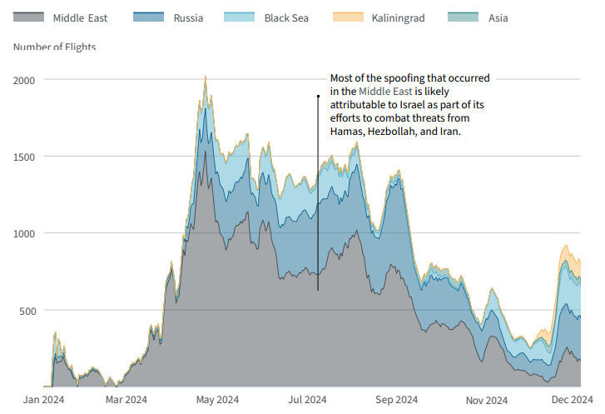
Fig. 8. Number of disrupted commercial flights, by world region, in 2024
Resource: Center for Strategic and International Studies (2025). Space Threat Assessment.

The most common effect of these attacks is a complete loss of service, data access, or at least a reduction in its quality. In the case of eavesdropping or data interception by a third party, the user may be unaware of the data loss, and as a result, the data or information may be exploited by an opposing party.
Space threats, both natural and caused by human activity, can have a significant impact on the functioning of the state's security system in the context of military defence, economic stability, critical and common infrastructure, as well as the everyday lives of citizens.
4. Conclusions and Summary
The development of space technology and its widespread use for civilian and military purposes are increasing the importance of space for the functioning of modern states, especially in terms of their security. The widespread use of satellite services, the use of data and products in the daily lives of citizens, the progress of civilization, and the rising standard of living have resulted in society becoming dependent on daily access to technologies and services based on satellite resources. Economic functioning, production, trade in goods and services, and industrial development all rely on space resources.
Of course, the growing importance of space exploration has led to an increase in potential threats, both natural and man-made, from space exploration and the development of anti-satellite (ASAT) capabilities. Since space now plays a key role in terms of security and economic interests, it is also an arena in which the interests of states vying for dominance compete.
Restricting access to or completely eliminating space resources could pose a threat to the pursuit of national interests. Therefore, space threats have a significant impact on the functioning of the national security system, including military defence, economic stability, critical and public infrastructure, and the daily lives of citizens.
When designing the architecture of a new satellite system and being responsible for the management of European satellite resources in space, various legal, financial, security and technology development aspects must be taken into account. Legal aspects related to the use of space, conducting business, registration, and liability are key considerations when initiating the planning process. Technological developments, the commercialization of services, and, consequently, the growing number of satellites in orbit influence the architecture and its management. Emerging threats, both natural and human-induced, will impact the management of space resources.
References
Gołda, P., Zawisza, T., & Izdebski, M. (2021). Evaluation of efficiency and reliability of airport processes using simulation tools. Eksploatacja i Niezawodność, 23(4), 659-669. https://doi.org/10.17531/ein.2021.4.8
Gołda, P., Kowalski, M., Wasser, C., Dygnatowski, P., & Szporka, A. (2019). Elements of the model positioning of aircraft on the apron. Archives of Transport, 51(3), 101-108. https://doi.org/10.5604/01.3001.0013.6166
Izdebski, M., Michalska, A., Jacyna-Gołda, I., & Laurian, G. (2024). Prediction of cyber-attacks in air transport using neural networks. Eksploatacja i Niezawodność, 26(4), 1-11. https://doi.org/10.17531/ein/191476
Izdebski, M., Jacyna-Gołda, I., Markowska, K., & Murawski, J. (2017). Heuristic algorithms applied to the problems of servicing actors in supply chains. Archives of Transport, 44(4), 25-34. https://doi.org/10.5604/01.3001.0010.6159
Izdebski, M., Jacyna-Gołda, I., & Gołda, P. (2022). Minimisation of the probability of serious road accidents in the transport of dangerous goods. Reliability Engineering & System Safety, 217, 108093. https://doi.org/10.1016/j.ress.2021.108093
Jacyna, M. (2022). Wspomaganie decyzji w praktyce inżynierskiej: metody, algorytmy, przykłady. Wydawnictwo Naukowe PWN, 210 s., ISBN 978-83-01-22255-0 (in Polish)
Kloskowski, D., Chamier-Gliszczynski, N., Murawski, J., & Wasiak, M. (2025). Interpolative Estimates of Electric Vehicle Recharging Point Locations in the Context of Electromobility. Energies, 18(23), 6281. https://doi.org/10.3390/en18236281
Kukulski, J., Lewczuk, K., Góra, I., & Wasiak, M. (2023). Methodological aspects of risk mapping in multimode transport systems. Eksploatacja i Niezawodność, 25(1), 1-11. https://doi.org/10.17531/ein.2023.1.19
Krasuski, K., Lalak, M., Gołda, P., Ciećko, A., Grunwald, G., Mrozik, M., & Kozuba, J. (2023). Analysis of the precision of determination of aircraft coordinates using EGNOS+SDCM solution. Archives of Transport, 67(3), 105-117. https://doi.org/10.5604/01.3001.0053.726
Lasota, M., Jacyna, M., & Szaciłło, L. (2024). Fault tree method as a decision-making tool for assessing the risks of transportation of dangerous loads. Zeszyty Naukowe. Transport – Politechnika Śląska, 123, 133-154. https://doi.org/10.20858/sjsutst.2024.123.6
Lasota, M., Sokołowski, M., Wojdat, Cz., & Pietrzak, A. (2025). Risk of adverse events in the transportation of oversize cargoes. Eksploatacja i Niezawodność, 27(1), 1-18. https://doi.org/10.17531/ein/197383
Lewczuk, K., & Żuchowicz, P. (2024). Virtual Reality Application for the Safety Improvement of Intralogistics Systems. Sustainability, 16(14), 1-26, 6024. https://doi.org/10.3390/su16146024
Myszona-Kostrzewa, K., & Kulińska-Kępa, Z. (2025). Podręczniki Prawnicze. Prawo kosmiczne międzynarodowe, europejskie i krajowe. Publishing house: C. H. Beck. (in Polish)
Murawski, J., Pryciński, P., Sierpiński, G., & Jachimowski, R. (2022). Prospects for the development of zero- and low-emission vehicles in urban distribution systems in terms of the situation on the fuel market. Systemy Logistyczne Wojsk, 57(2), 41-62. https://doi.org/10.37055/slw/163229
Polkowska, M. (2021). Space Security and Safety. Law, Management, Policy. IW EuroPrawo Sp. z .o.o.
Pryciński, P., Wawryszczuk, R., Korzeb, J., Pielecha, P., & Murawski, J. (2023). Selected vehicle emissivity assessment issues in passenger transport services. Combustion Engines, 195(4), 14-22. https://doi.org/10.19206/CE-169806
Semenov, I., Jacyna, M., Auguściak, I., & Wasiak, M. (2025). Hybrid Human–AI Collaboration for Optimized Fuel Delivery Management. Energies, 18(19), 1-25, 5203. https://doi.org/10.3390/en18195203
Szczepański, E., Żochowska, R., Izdebski, M., & Jacyna, M. (2025). Energies, 18(15), 1-17. https://doi.org/10.3390/en18153970
Wachnik, B., Kłodawski, M., & Kardas-Cinal, E. (2022). Reduction of the Information Gap Problem in Industry 4.0 Projects as a Way to Reduce Energy Consumption by the Industrial Sector. Energies, 15(3), 1108-1126. https://doi.org/10.3390/en15031108
Woźniak, W., & Wojnarowski, T. (2015). The method for a fast selection of the profitable transport offers derived from the freight exchange market. Proceedings of the 25th International Business Information Management Association Conference – Innovation Vision 2020: From Regional Development Sustainability to Global Economic Growth, IBIMA, p. 2073-2085, ISBN: 9780986041945
Zgorzelski, R., Murawski, J., & Chamier-Gliszczyński, N. (2025). Digital technologies and cybersecurity of transport infrastructure: challenges for rail transport. Archives of Transport, 75(3), 141-158. https://doi.org/10.61089/aot2025.yfgz9c91
Zieja, M., Smoliński, H., & Gołda, P. (2015). Information systems as a tool for supporting the management of aircraft flight safety. Archives of Transport, 36(4), 67-76. https://doi.org/10.5604/08669546.1185211
Żak, J., Gołda, P., Cur, K., & Zawisza, T. (2021). Assessment of airside aerodrome infrastructure by SAW method with weights from Shannon's interval entropy. Archives of Transport, 60(4), 171-185. https://doi.org/10.5604/01.3001.0015.6929
Żuchowicz, P., & Lewczuk, K. (2025). Leveraging Immersive Technologies for Safety Evaluation in Forklift Operations. Applied Sciences, 15(20), 1-23, 11048. https://doi.org/10.3390/app152011048
Act of 26 September 2014 on the Polish Space Agency. Sejm.
Website: https://isap.sejm.gov.pl/isap.nsf/DocDetails.xsp?id=wdu20140001533 (date: 5 Dec 2025).
Center for Strategic and International Studies (2025). CSIS.
Website: https://aerospace.csis.org/data/space-launch-to-low-earth-orbit-how-much-does-it-cost/
(date: 5 Dec 2025).
Center for Strategic and International Studies (2025). Space Threat Assessment. CSIS.
Website: https://www.csis.org/analysis/space-threat-assessment-2025 (date: 07 Dec 2025).
Cornell University, USA. (2023). https://arxiv.org/abs/2303.02330. (date: 5 Dec 2025).
CyberInFlight (2025). Space Cybersecurity Market Intelligence Report.
Website: https://www.cyberinflight.com/?page_id=1764 (date: 07 Dec 2025).
European Space Agency (2025). Report on the Space Economy. ESA.
Website: https://space-economy.esa.int/article/287/esa-report-on-the-space-economy-2025 (date: 5 Dec 2025).
European Space Policy Institute (2023). ESPI Yearbook 2022, Space Policies, Issues and Trends. ESPI.
Website: https://www.espi.eu/wp-content/uploads/2023/08/ESPI-Yearbook-2022.pdf (date: 05 Dec 2025).
French Armed Forces Ministry (2019). Space Defence Strategy.
Website: https://cd-geneve.delegfrance.org/IMG/pdf/space_defence_strategy_2019_france.pdf
(date: 04 Dec 2025).
NCI Agency. (2021). NATO Space Handbook. Introduction to Space Support in NATO Operations.
Website: https://www.scribd.com/document/749181375/NATO-2021-NATO-Space-Handbook-Introduktion-to-Space-Support-in-NATO-Operationer (date 05 Dec 2025).
Novaspace (2025). Support Instruments for EU / European Access to Space. (unavailable online).
Novaspace (2024). Space Logistics Markets. Novaspace.
Website: https://nova.space/hub/product/space-logistics-markets/ (date: 05 Dec 2025).
The EU Space Strategy for Security and Defence (2023). European External Action Service.
Website: https://www.eeas.europa.eu/eeas/eu-space-strategy-security-and-defence-0_en (date: 03 Dec 2025).
The Strategic Compass and EU space-based defence capabilities (2022). European Parliament.
Website: https://www.europarl.europa.eu/thinktank/en/document/EXPO_IDA(2022)702569 (date:04 Dec 2025).

