
 | Rocznik Ochrona Środowiska
 | Volume 27 | Year 2025 ISSN 2720-7501 | pp. 780-787
 | https://doi.org/10.54740/ros.2025.062 open access
 | Received: November 2025 Accepted: December 2025 Published: December 2025
Unconventional Solutions for Building Partitions in Sustainable
and Energy-Efficient Construction
Maria Teresa Małek
Institute of Environmental Engineering and Buildings Installations,
Faculty of Environmental Engineering and Energy, Poznan University of Technology, Poland
https://orcid.org/0000-0002-6731-1183
corresponding author's e-mail: maria.malek@put.poznan.pl
Abstract: This article presents construction and building solutions that align with the concept of sustainable, energy-efficient construction. They have been sorted depending on the stage of the construction process, whether we are dealing with the design phase (the stage of designing the building structure, the stage of selecting building materials) or with the already existing state (the stage of thermal modernization of an existing facility). The presented solutions differ from the classic approach, which only increases insulation thickness, thereby increasing costs and not significantly improving the partition's heat transfer coefficient.
Keywords: sustainable construction, nearly zero-energy building, Trombe wall, thermal barrier, phase-change material
1. Introduction
The idea of sustainable and energy-efficient construction has been recorded to varying extents and degrees in global, European, and Polish legal acts. The broad concept of sustainable development is based on the provision in the Report of the World Commission on Environment and Development of October 1987, which states that "sustainable development is development in which the needs of the present generation can be met without compromising the chances of future generations to meet their needs". Sustainable and energy-efficient construction aligns with the Sustainable Development Goals outlined in the 2030 Agenda – a document signed by the leaders of UN member states on 25 September 2015 (https://www.gov.pl/web/polska-pomoc/cele-zrownowazonego-rozwoju). At the European level, provisions directly referring to sustainable development in the construction sector can be found, among others, in the Directives and Regulations of the European Union.
Annex I to Regulation (EU) No 305/2011 of the European Parliament and of the Council of 9 March 2011, referred to in the Announcement of the Marshal of the Sejm of the Republic of Poland of 15 June 2021 on the uniform text of the Act on Construction Products, introduces the concept of sustainable use of natural resources at individual stages of the creation of a construction work, i.e. design, execution, and demolition. Such a procedure contributes to the durability of the construction object and, in the case of its demolition, thanks to the use of secondary raw materials, their reuse (Regulation EU No 305/2011, Journal of Laws 2021). Environmental product declarations are to enable the assessment of the "sustainable use of resources and the impact of buildings on the environment" (Regulation EU No 305/2011). The documents mentioned above are essential for the energy certification of buildings, such as the American LEED, the British BREEAM, and the German DGNB (Lass et al. 2023, Pawłowski & Małkowski 2023).
The nZEB standard – nearly zero-energy building in the Directive of the European Parliament and of the Council 2010/31/EU of 19 May 2010, is defined as "a building with very high energy performance" and using renewable energy sources (Directive 2010/31/EU). The latest Directive of the European Parliament and of the Council (EU) 2024/1275 of 24 April 2024 introduces energy classes from A (zero-emission building) to G (building with the worst energy performance) (Directive 2024/1275), which must be applied from 30 May 2026. This directive allows the use of class A+ for a building with an annual primary energy demand lower than the energy it produces from renewable sources, provided the maximum demand is at least 20% below the maximum level for zero-emission buildings. According to the Association for Sustainable Development (Bochnia & Szydłowski 2017), an A+ building (passive standard) has a usable energy index of less than 15 kWh/(m2·year), while for a zero-energy building, i.e., class A++, it does not exceed 10 kWh/(m2·year). The same directive (Directive 2024/1275) contains a regulation: "All new buildings should be zero-emission buildings by 2030, and existing buildings should be transformed into zero-emission buildings by 2050". Therefore, there is a need to implement new solutions in construction, both for new and existing buildings.
Achieving the best energy standards is possible through appropriate construction and building solutions. The classic approach is to increase insulation thickness, which, however, increases costs while only slightly improving the partition's heat transfer coefficient. For example, to reduce the heat transfer coefficient of an external wall from 0.20 W/(m²·K) to 0.15 W/(m²·K), 7 cm of polystyrene with a thermal conductivity coefficient of 0.04 W/(m·K) is needed, which translates to a saving of 2 W/m² at an internal and external temperature difference of 40 K. Insulating a wall area of 100 m² results in a saving of 200 W, while the cost of only the insulation material is PLN 1,214 (PLN 173.43/m³ – the source of the material price list is https://styronet.pl). At the same time, this 200 W can be offset by heat gains from people and the room's equipment (Pełech 2011). For this reason, the following article presents other solutions that can be implemented at a given stage of the construction process, i.e., during the design of the building structure and the selection of building materials, or afterward, i.e., when deciding on thermal modernization of an existing building.
2. Construction and Building Solutions Depending on the Stage of the Construction Process
2.1. The stage of designing the building structure
To achieve the most favorable energy-efficiency standards, specific solutions should be considered at the architectural design stage. Such solutions include, among others, those using solar radiation.
Direct – gain passive solar systems include transparent partition surfaces. Such solutions should be equipped with eaves or canopies to provide shading of the room during periods of increased solar radiation intensity; however, temperature fluctuations may still occur (Piątek & Sekret 2017). To reduce them, indirect-gain passive systems use heat accumulation in partitions. These types of systems include: the Trombe wall and the Trombe-Mitchel wall.
The classic Trombe wall named after its originator Felix Trombe (Bainbridge & Haggard 2013, Szyszka 2020) called collector – accumulation wall (Piątek & Sekret 2017, Górzyński 2020, Górzyński 2022) or collector – storage wall (Piątek & Sekret 2017) is a brick or monolithic structure with externally attached glazing (Szyszka 2020) – Fig. 1. This glazing is attached as close to the wall as possible, thus creating an unventilated air gap (Szyszka 2022) but not narrower than 4.7 cm (Sparrow & Azevedo 1985, Szyszka 2022). Short-wave solar radiation passes through the glazing and is absorbed by the wall surface (the absorber). Thanks to black matt paint coatings, which cover the wall surface, an even better effect can be achieved, even 3 times greater compared to light-colored paints (Szyszka 2020). Then, by conduction, a thermal wave propagates towards the inner surface, and the heat is then transferred to the room (Szyszka 2020). The process of heat transfer to the room can be intensified by using ventilation holes in the wall structure above the floor and under the ceiling of the room (Trombe-Mitchel wall) (Piątek & Sekret 2017) – Fig. 2. Air circulation then occurs: cold air is sucked out of the room through the lower hole, and then through the upper hole, it returns to the room as heated (Piątek & Sekret 2017).
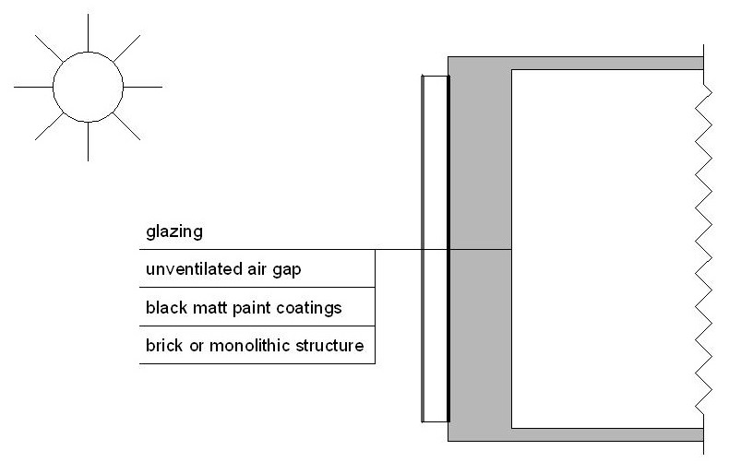
Fig. 1. The classic Trombe wall
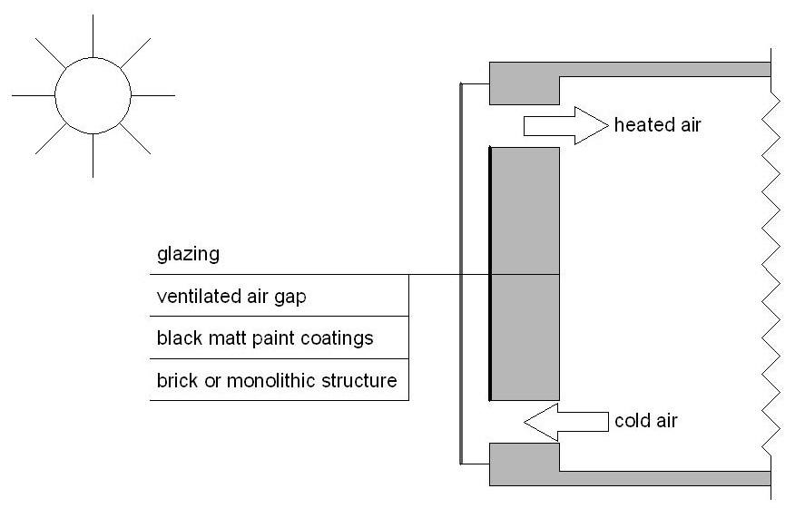
Fig. 2. The Trombe-Mitchel wall

These are not the only possible modifications to the Trombe wall. Tables 1-3 present improvements depending on the element they concern, what effects they bring, and provide the location of the tests or analyses. Additionally, a classic solution is presented for comparison.
The combination of the indirect gain system with a buffer space, where we deal with direct solar radiation, was used in the Balcomb system. The main element of this system is a veranda on the south side, fully glazed (Piątek & Sekret 2017).

Table 1. Classic and modified Trombe wall in terms of glazing solutions
 |  | Glazing
classic | type | single glass pane
classic | source/bibliography reference | Szyszka 2022
modified | type | PV glass panel | glazing with high thermal insulation (two-chamber and triple glazing) | A single glass with  a night shutter
modified | place  of research/analysis | Hefei (China)  31°49'N  winter | (Poland)  49°00'N-54°50'N | Izmir (Turkey)  38°26'N  winter
modified | effect | - electricity generation  - greater aesthetic value | reducing heating demand
modified | source/bibliography reference | Ji et al. 2007 | Kisilewicz 2009 | Koyunbaba & Yilmaz 2012

Table 2. Classic and modified Trombe wall solutions in terms of wall construction
 |  | Wall construction
classic | type | - material: concrete, stone, and brick  - thickness: 10-41 cm
classic | source/bibliography reference | Szyszka 2022
modification | type | - material: layer with phase change material hydrated salt CaCl₂·6H₂O  - thickness: 8 cm | - material: aerated concrete  - thickness: 20 cm | - material: brick  - thickness: 2 layers of 24 cm and 12 cm thick separated by an internal gap (slotted collector – accumulation wall)
modification | place  of research/analysis | Baghdad (Iraq)  33°20'N | Ancona (Italy)  43°37'N | (Poland)  49°00'N-54°50'N
modification | effect | improvement in heat capacity | reducing cooling energy needs | - improvement of thermal  insulation  - improvement of internal heat distribution in the wall
modification | source/bibliography reference | Khalifa & Abbas 2009 | Stazi et al. 2012 | Szyszka et al. 2017

Table 3. Classical and modified solutions of the Trombe wall in terms of the absorption layer (absorber)
 |  | Absorption layer (absorber)
classic | type | black or dark matte paint coating
classic | source/bibliography reference | Szyszka 2022
modification | type | water container  wall thickness: more than 3 inches (7.62 cm), probably less than 6 inches (15.24 cm)  (Water Trombe wall) | 0.5 mm thick steel panel with 100 mm thick polystyrene | dark painted sheet metal placed in the lower part of the wall (up to 70% of the chamber height)  (Thermo-Diode Trombe Wall)
modification | place  of research/analysis | Eugene, Oregon (USA)  44°03'N | Xining (China)  36°38'N | Rzeszów (Poland)  50°02'N
modification | effect | - reduce temperature  fluctuations | - enhance the indoor temperature | reducing heat loss during periods of reduced solar radiation intensity
modification | effect | - improvement in efficiency
modification | source/bibliography reference | Adams et al. 2010 | Ji et al. 2009 | Szyszka 2022  Szyszka & Lichołai 2022

Another solution for collecting solar radiation energy is a system based on a thermal barrier. In this case, solar radiation energy acquired in solar collectors is transferred to a multi-zone geothermal heat storage system and from there to a thermal barrier placed in the external walls – Fig. 3. The thermal barrier consists of polypropylene pipes arranged in a U-shape and supplied with a variable flow rate and supply temperature medium in such a way as to maintain a constant temperature in its location regardless of external conditions (Krzaczek & Kowalczuk 2011). Further research is also being conducted on the same solution. It was focused on the parameters of a partition with a thermal barrier that affect its efficiency (Szaflik 2023, Szaflik 2023). This research showed that a material with a high thermal conductivity coefficient should be used to form a thermal barrier layer, while striving to achieve the same thermal resistance on both sides of the barrier. The internal and external layers of the partition are made of insulation material.
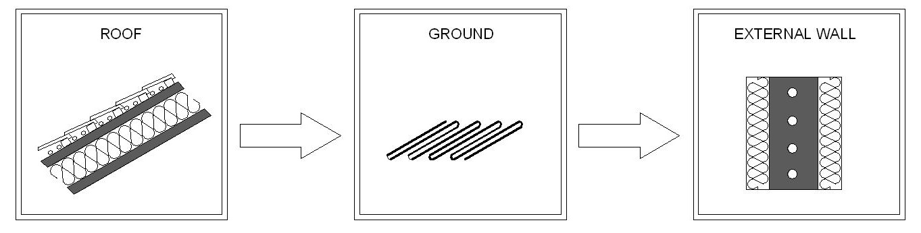
Fig. 3. The system based on a thermal barrier

Figure 4 presents the penetration through the external wall with a thermal barrier and the classic Trombe wall. For the external wall with a thermal barrier, the heat flux ${\dot{Q}}_{i}$ is transferred from the internal side to the thermal barrier, the heat flux ${\dot{Q}}_{e}$ is transferred from the thermal barrier to the external side, and the ${\dot{Q}}_{b}$ is the heat flux from the medium (Leciej-Pirczewska & Szaflik 2024). For the classic Trombe wall ${\dot{Q}}_{a}$ is the heat flux heating the absorber thanks to solar radiation, S_{i} (Lichołai & Szyszka 2012). Therefore, heat is supplied by the medium or solar radiation.

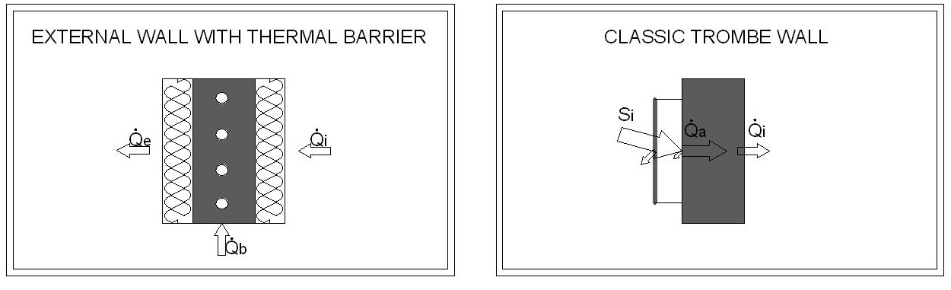
Fig. 4. The penetration through the external wall with thermal barrier and the classic Trombe wall
2.2. The stage of selecting building materials
Other methods to facilitate achieving the energy-efficient building standard involve improving or modifying building materials. Building products should be characterized by a low thermal conductivity coefficient to limit heat losses and a high thermal capacity to accumulate excess heat (Piątek & Sekret 2017).
Due to their high density, silicate materials achieve high thermal storage capacity; however, considering their high thermal conductivity coefficient, they should be used in at least two-layer structures, where one of the layers is an insulating material (Nowaczyk 2023).
The thermal capacity of a building can also be increased using phase-change materials (Jaworski 2009). This involves using the phase change phenomenon of the material, which involves the release and absorption of heat to and from the environment, thereby causing time delays in heat flow and limiting temperature fluctuations (Suresh et al. 2022). The most suitable technology for integrating a phase-change material with a building material is encapsulation, i.e., enclosing the phase-change material in a shell. The most commonly used method for this purpose is macroencapsulation, i.e., using a container with dimensions larger than 1 mm (Suresh et al. 2022). Ultimately, such a material can take the form of glass panels, copper pipes, plastic bags, or a stainless steel container (Lamrani et al. 2021). The possibilities for using phase-change materials in wall elements include their use in structural, insulating, or finishing layers, e.g., in plasters (Garbalińska & Bochenek 2012, Pomianowski et al. 2013).
Phase-change materials enable the improvement of already known solutions. In the previously mentioned Trombe wall, the phase-change material may not only replace the concrete structure (Table 2), but can also constitute a separate layer. The researchers (Lichołai et al. 2021) placed the phase-change material in an aluminum container between the glazing and the structural layer and simultaneously behind the air gap. Thanks to such an improvement and appropriate glazing adjusted to the degree of cloudiness during the day, heat losses through the partition can be reduced.
In terms of sustainable development, it should be noted that phase-change materials may also be of natural origin (bio-PCM). Such materials include non-toxic hydrated salts, vegetable oils and animal fats, and beeswax (Bruno & Bevilacqua 2023). In the case of the former ones, they were used in experimental studies of a wooden wall (Bruno & Bevilacqua 2023). The researchers have shown that bio-PCM has a beneficial effect on the thermal properties (time delay and thermal conductivity) of the building partition in both winter and summer conditions.
Another proposal is to use biomass even for the entire building structure. For this solution, the authors adopted the abbreviated name WBMES (whole biomass material envelope system). The structure was made of modules insulated with straw, while the shading was made of wood and bamboo. Simulations of a residential building showed that this technology is beneficial for both carbon footprint and costs, which are essential factors for sustainable development (Yan et al. 2024).
Another variant is the use of waste and by-product materials such as wood and plastic waste, blast furnace slag, fly ash, and bottom ash in the production of building materials. This procedure provides better thermal insulation properties (Tallini & Cedola 2018).
There is also an idea of using nano-insulating materials, e.g., vacuum insulation panels and aerogels (Moga & Bucur 2018, Moga et al. 2022). Thanks to them, it is possible to achieve the required thermal resistance of the partition, but with a thickness that is much lower than that of traditional insulation, even over 30 cm (Moga & Bucur 2018, Moga et al. 2022).
2.3. Thermal modernization stage of the existing facility
Omitting the latest energy-efficient solutions at the design stage does not eliminate the possibility of improving the building's energy performance. In the case of uninsulated walls, heat losses through such partitions amount to about 20%-30% of the total heat loss (Orłowska 2023), and a ten years older source gives values from 25% to 40% (Rutkowska et al. 2023). After thermal modernization and replacement of the heat source, it is possible to reduce annual energy demand by 43% and save PLN 12,000 per year, with a payback period of up to 7 years for a house with an area of 180 m² (Orłowska 2023). These are the main reasons for the continuous progress in the field of thermal modernization.
The most popular method of wall insulation is the light-wet method (SIS) (Gaciek 2016, Radziszewska-Zielina 2007), which can be used together with transparent insulation (Radziszewska-Zielina 2007). Transparent insulation is often used in the previously mentioned Trombe wall (collector – accumulation wall), and the most popular type of such insulation is a honeycomb type (Górzyński 2020, Górzyński 2022). Transparent insulation may also be used in the direct-gain system as a light-transmitting element (Świrska-Perkowska & Jęglet 2017). It is also possible to install a new layer of thermal insulation over the existing one, but this requires assessing the insulation's technical condition (Gaciek 2016).
Another solution related to thermal insulation, which could be used in the thermal modernization of buildings, was presented by Kalus et al. (2021). An active thermal insulation (ATI) system was proposed: thermal insulation boards with cables inside, powered by a renewable energy source. Improved insulation layers can be used in external walls, floors, and roofs.
Modifying the building's body, e.g., by constructing a superstructure using light steel technology, is also worth considering. One of those is a system of light curtain walls – wall cassettes filled with insulation (mineral wool) (Urbańska-Galewska & Kowalski 2017).
3. Summary and Conclusions
Many solutions reduce heat loss and improve a building's energy performance, including renewable energy sources, innovative building materials, and appropriate partition-layer configurations. The choice of a specific concept depends on an individual assessment of the situation. At every stage of the construction process, it is worth striving to maintain the idea of sustainable construction, whether in the initial design phase or in post-construction modernization. However, the best results can be achieved by focusing on energy efficiency from the outset of investment implementation. Thanks to this approach, it is possible to design an energy-efficient building with an innovative structure, using modern building materials, especially with the goal of achieving zero-emission buildings.

References
Adams, S., Becker, M., Krauss, D., & Gilman, C. (2010). Not a dry subject: optimizing water Trombe walls. SOLAR 2010 conference, Colorado ASES.
Bainbridge, D., & Haggard, K. (2013). Passive Solar Architecture: Heating, Cooling, Ventilation, Daylighting and More Using Natural Flows. White River Junction, Vermont: Chelsea Green Publishing.
Bochnia, K., & Szydłowski, R. (2017). Nearly zero-energy building. Builder, 21(4), 64-65. (in Polish)
Bruno, R., & Bevilacqua, P. (2023). Bio-PCM to enhance dynamic thermal properties of dry-assembled wooden walls: Experimental results. Building and Environment, 242, 110526. https://doi.org/10.1016/j.buildenv.2023.110526
Directive 2010/31/EU of the European Parliament and of the Council of 19 May 2010 on the energy performance of buildings.
Directive (EU) 2024/1275 of the European Parliament and of the Council of 24 April 2024 on the energy performance of buildings.
Gaciek, P. (2016). Applications of insulation – on – insulation technology. Izolacje, 21(7/8), 44-48. (in Polish)
Garbalińska, H., & Bochenek, M. (2012). The incorporation methods of phase change materials into wall elements. Materiały Budowlane, 2(474), 36-38. (in Polish)
Górzyński, J. (2020). Obtaining and processing renewable energy. Napędy i Sterowanie, 22(10), 70-77. (in Polish)
Górzyński, J. (2022). Obtaining and processing renewable energy. Napędy i Sterowanie, 24(10), 73-81. (in Polish)
Jaworski, M. (2009). Phase Change Materials (PCM) for construction applications. Polska Energetyka Słoneczna, 4-6, 47-50. (in Polish)
Ji, J., Yi, H., He, W., Pei, G., Lu, J., & Jiang, B. (2007). Modeling of a novel Trombe wall with PV cells. Building and Environment, 42(3), 1544-1552. https://doi.org/10.1016/j.buildenv.2006.01.005
Ji, J., Luo, C. L., Sun, W., Yu, H. C., He, W., & Pei, G. (2009). An improved approach for the application of Trombe wall system to building construction with selective thermo-insulation façades. Chinese Science Bulletin, 54, 1949-1956. https://doi.org/10.1007/s11434-009-0353-6
Journal of Laws (2021). Dziennik Ustaw Rzeczypospolitej Polskiej 2021 poz. 1213, Obwieszczenie Marszałka Sejmu Rzeczypospolitej Polskiej z dnia 15 czerwca 2021 r. w sprawie ogłoszenia jednolitego tekstu ustawy o wyrobach budowlanych. (in Polish)
Kalús, D., Straková, Z., & Kubica, M. (2021). Energy Balance of a Low Energy House with Building Structures with Active Heat Transfer Control. Periodica Polytechnica Mechanical Engineering, 65(3), 246-251. https://doi.org/10.3311/PPme.17462
Khalifa, A. J. N., & Abbas, E. F. (2009). A comparative performance study of some thermal storage materials used for solar space heating. Energy and Buildings, 41(4), 407-415. https://doi.org/10.1016/j.enbuild.2008.11.005
Kisilewicz, T. (2009). Glazed building wall as a solar thermal collector. Archives of Civil and Mechanical Engineering, 9(1), 83-99.
Koyunbaba, B. K., & Yilmaz, Z. (2012). The comparison of Trombe wall systems with single glass, double glass and PV panels. Renewable Energy, 45, 111-118. https://doi.org/10.1016/j.renene.2012.02.026
Krzaczek, M., & Kowalczuk, Z. (2011). Thermal Barrier as a technique of indirect heating and cooling for residential buildings. Energy and Buildings, 43(4), 823-837. https://doi.org/10.1016/j.enbuild.2010.12.002
Lamrani, B., Johannes, K., & Kuznik, F. (2021). Phase change materials integrated into building walls: An updated review. Renewable and Sustainable Energy Reviews, 140, 110751. https://doi.org/10.1016/j.rser.2021.110751
Lass, J. P., Benitz-Wildenburg, J., Rossa, M., & Seehauser, C. (2023). Climate-friendly construction Part 2. Energy-efficient, sustainable building products that dynamically adapt to current climate conditions. Świat Szkła, 28(6), 41-49. (in Polish)
Leciej-Pirczewska, D., & Szaflik, W. (2024). Heat Flow Through a Wall with a Thermal Barrier. Advanced in Science and Technology Research Journal, 18(5), 277-286. https://doi.org/10.12913/22998624/190474
Lichołai, L., Starakiewicz, A., Krasoń, J., & Miąsik, P. (2021). The Influence of Glazing on the Functioning of a Trombe Wall Containing a Phase Change Material. Energies, 14(17), 5243. https://doi.org/10.3390/en14175243
Lichołai, L., & Szyszka, J. (2012). Energy efficiency of the slotted thermal storage wall. Zeszyty Naukowe Politechniki Rzeszowskiej, Budownictwo i Inżynieria Środowiska, 283(59), 445-454. (in Polish)
Moga, L., & Bucur, A. (2018). Nano insulation materials for application in nZEB. Procedia Manufacturing, 22, 309-316. https://doi.org/10.1016/j.promfg.2018.03.047
Moga, L., Petran, I., Santos, P., & Ungureanu, V. (2022). Thermo-Energy Performance of Lightweight Steel Framed Constructions: A Case Study. Buildings, 12(3), 321. https://doi.org/10.3390/buildings12030321
Nowaczyk, J. (2023). Energy efficient and passive solutions in construction with the use of silicates. Izolacje, 28(5), 60A-63A. (in Polish)
Orłowska, M. (2023). Thermomodernization – Rescue for the Building. Rocznik Ochrona Środowiska, 25, 208-214. https://doi.org/10.54740/ros.2023.020
Pawłowski, K., & Małkowski, R. (2023). Sustainable construction – selected aspects. Izolacje, 28(7/8), 52-56. (in Polish)
Pełech, A. (2011). Ventilation and air conditioning – basics. Wroclaw: Oficyna Wydawnicza Politechniki Wrocławskiej. (in Polish)
Piątek, M., & Sekret, R. (2017). Selected technological concepts used in passive house building. Izolacje, 22(9), 68-72. (in Polish)
Pomianowski, M., Heiselberg, P., & Zhang, Y. (2013). Review of thermal energy storage technologies based on PCM application in buildings. Energy and Buildings, 67, 56-69. https://dx.doi.org/10.1016/j.enbuild.2013.08.006
Radziszewska-Zielina, E. (2007). Assessment of building thermal modernization methods – advantages, disadvantages, most common mistakes. Przegląd Budowlany, 78(9), 41-49. (in Polish)
Regulation (EU) No 305/2011 of the European Parliament and of the Council of 9 March 2011 laying down harmonised conditions for the marketing of construction products and repealing Council Directive 89/106/EEC.
Rutkowska, G., Klepak, O., & Podawca, K. (2013). Problems of Heat Loss in Existing Single-family Buildings in the Context of Construction Errors. Rocznik Ochrona Środowiska, 15, 2625-2639. (in Polish)
Sparrow, E. M., & Azevedo, L. F. A. (1985). Vertical channel natural convection spanning between the fully developed and the single – plate boundary – layer limit. International Journal of Heat and Mass Transfer, 28(10), 1847-1857.
Stazi, F., Mastrucci, A., & Munafò, P. (2012). Life cycle assessment approach for the optimization of sustainable building envelopes: An application on solar wall systems. Building and Environment, 58, 278-288. https://doi.org/10.1016/j.buildenv.2012.08.003
Suresh, C., Kumar Hotta, T., & Saha, S. K. (2022). Phase change material incorporation techniques in building envelopes for enhancing the building thermal comfort – A review. Energy and Buildings, 268, 112225. https://doi.org/10.1016/j.enbuild.2022.112225
Szaflik, W. (2023). Thermal barrier efficiency. Instal, 6, 15-18. https://doi.org/10.36119/15.2023.6.2 (in Polish)
Szaflik, W. (2023). Influence of partition parameters with a thermal barrier on the efficiency of the barrier. Instal, 7-8, 24-27. https://doi.org/10.36119/15.2023.7-8.3 (in Polish)
Szyszka, J. (2020). Collector – storage walls. Builder, 270(01), 48-51. https://doi.org/10.5604/01.3001.0013.6117 (in Polish)
Szyszka, J. (2022). From Direct Solar Gain to Trombe Wall: An Overview on Past, Present and Future Developments. Energies, 15(23), 8956. https://doi.org/10.3390/en15238956
Szyszka, J., Kogut, J., Skrzypczak, I., & Kokoszka, W. (2017). Selective Internal Heat distribution in Modified Trombe Wall. IOP Conf. Series: Earth and Environmental Science, 95(4), 042018.
https://doi.org/10.1088/1755-1315/95/4/042018
Szyszka, J., & Lichołai, L. (2022). Collector Storage Wall. Patent Office of the Republic of Poland 240650, 16 February 2022. (in Polish)
Świrska-Perkowska, J., & Jęglet, K. (2017). Dependence of energy efficiency of the building envelope with transparent insulation on insulation thickness. Roczniki Inżynierii Budowlanej, 17, 15-26. (in Polish)
Tallini, A., & Cedola, L. (2018). A review of the properties of recycled and waste materials for energy refurbishment of existing buildings towards the requirements of NZEB. Energy Procedia, 148, 868-875. https://doi.org/10.1016/j.egypro.2018.08.108
Urbańska-Galewska, E., & Kowalski, D. (2017). Superstructures and renovations – the use of lightweight building partitions. Builder, 21(7), 94-97. (in Polish)
Yan, S., Shi, F., Zheng C., Ma, Y., & Huang, J. (2024). Whole biomass material envelope system for nearly-zero energy houses: Carbon footprint and construction cost assessment. Journal of building Engineering, 86, 108757. https://doi.org/10.1016/j.jobe.2024.108757
https://styronet.pl

