
 | Rocznik Ochrona Środowiska
 | Volume 27 | Year 2025 ISSN 2720-7501 | pp. 746-766
 | https://doi.org/10.54740/ros.2025.060 open access
 | Received: November 2025 Accepted: December 2025 Published: December 2025
Environmental Impact Assessment of Urban Freight Transport
Based on Macroscopic Traffic Modelling
Jan Paszkowski¹, Emilian Szczepański^{2*}, Jakub Murawski³
¹Faculty of Transport, Warsaw University of Technology, Warsaw, Poland
https://orcid.org/0000-0002-9377-1466
²Faculty of Transport, Warsaw University of Technology, Warsaw, Poland
https://orcid.org/0000-0003-2091-0231
³Faculty of Transport, Warsaw University of Technology, Warsaw, Poland
https://orcid.org/0000-0003-2902-3882
*corresponding author's e-mail: emilian.szczepanski@pw.edu.pl
Abstract: This study investigates the environmental impacts of urban freight transport, with particular emphasis on energy consumption and pollutant emissions within the Upper Silesian–Zagłębie Metropolis (GZM). A calibrated macroscopic transport model developed in PTV Visum was extended to incorporate freight flows, allowing for a metropolitan-scale assessment of their contribution to overall emission levels. The analytical framework integrates traffic modelling with COPERT-based emission estimation, enabling high-resolution spatial identification of environmental burdens. The results reveal substantial heterogeneity in emission intensity across both road classes and Traffic Analysis Zones, with the highest concentrations observed along major transport corridors and in areas with intensive logistics activity. Scenario analyses that represent seasonal increases in freight volumes and the complete electrification of delivery fleets show marked variability in environmental outcomes. These findings underscore the sensitivity of urban emissions to fluctuations in freight demand and the technological composition of vehicle fleets, providing a robust basis for sustainable freight planning.
Keywords: pollutant emissions, cargo traffic, transportation modelling, environmental costs
1. Introduction
Contemporary metropolitan areas are highly complex systems shaped by overlapping social, economic, and spatial processes. One of the key forces driving their development is demographic transformation. Migration from rural areas and small towns to major urban centres, motivated by attractive labour markets and higher living standards, has led to a systematic increase in the population of urbanised regions. According to Statistics Poland (GUS), just over 38% of the population lived in cities in 1950, whereas by 2024 this share had exceeded 61% (Statistics Poland, 2025). At the same time, cities are experiencing progressive urban sprawl, with residents increasingly settling on the urban peripheries while employment, commerce, and services remain concentrated in city centres. This spatial restructuring generates growing mobility needs and intensifies the daily flows of people and goods.
Parallel to these demographic and spatial trends, cities are undergoing rapid economic transformation. Rising industrial activity, expanding trade, and increasing consumer expectations regarding delivery speed and service quality exert strong pressure on urban logistics systems. The scale of these changes is well illustrated by the dynamic development of the e-commerce sector, whose value in Poland reached USD 32.98 billion in 2024 (Poland E-Commerce Market Size & Forecast. Verified Market Research, 2025).
All these developments contribute to a substantial increase in road traffic volumes, particularly in freight transport. At the same time, the spatial structure and organisation of a city (its layout, density of development, distribution of activity centres, and service infrastructure) directly shape the functioning of urban transport systems, including distribution networks. This relationship is bidirectional: cities influence how transport systems are organised, while transport, in turn, affects urban life on a daily basis (Galkin 2017).
Superimposed on these dynamics are rising societal expectations concerning the quality of life. Residents seek the conveniences of a modern metropolis, such as broad access to services, rapid deliveries, and diverse retail options. Still, at the same time, they also expect quiet, safe, and environmentally friendly living environments. However, high traffic volumes, particularly in freight transport, intensify noise, deteriorate air quality, and reduce road safety. Consequently, a central question emerges: how can urban freight systems be organised and shaped to ensure efficient deliveries while minimising their negative impacts on residents?
This article addresses this challenge by examining the emission intensity of urban freight transport. The study focuses on the Upper Silesian–Zagłębie Metropolis (GZM), a densely urbanised and industrialised region characterised by high mobility demand and significant freight activity. Using macroscopic transport modelling, the analysis captures the complexity of contemporary urban logistics systems and provides a foundation for discussing how freight transport can be shaped to ensure that cities remain both efficient economic centres and attractive places to live.
The remainder of this article is structured as follows. Section 2 reviews the literature on urban freight transport in macroscopic transport models and on emission modelling frameworks, with particular emphasis on tools combining traffic assignment and emission estimation. Section 3 presents the GZM case study, including the structure of the macroscopic transport model, the derivation of freight traffic flows, the procedure for calculating emissions and energy consumption, and the definition of the research scenarios. Section 4 reports the results of the link- and zone-level analyses for the base case and compares the impacts observed under the seasonal freight peak and full freight fleet electrification scenarios. Finally, Section 5 summarizes the main findings and indicates directions for further research.
2. Literature Review
2.1. Urban freight transport in macroscopic modelling
Transportation modelling is a mathematical representation of user behaviour, decision-making processes, and traffic conditions within a transport network. A macroscopic model explicitly examines the behaviour of groups of users throughout their entire journey, from the likelihood of the trip occurring to their choice of transportation mode and route selection. Interactions between users are represented through broad traffic flow conditions such as congestion, saturation, and vehicle capacity. In a transportation model, supply refers to the transport network, which is characterized by the parameters linked to demand data, such as capacity and travel time, which vary with traffic volume. The basic unit in modelling is the Traffic Analysis Zone (TAZ), which generates traffic. The demand model is understood as the spatial distribution of trips across all transport subsystems. Specifically, demand captures every travel decision made by users, including the trip's origin (Dyczkowska et al. 2023), destination, and mode of transport within a specific time frame (Żochowska 2014).
Macroscopic transport models are used in urban and regional planning, with a primary focus on passenger mobility patterns. This orientation has led to limited development of research and methodologies for modelling urban freight flows. It has been observed that in both the literature and modelling practices, particularly in Polish cities, freight transport is often marginalized or represented in a simplified manner compared to passenger transport.
Among the various methods for developing macrosimulation models, we focus on the Four-Step Model. This approach includes four stages (Narayanan et al. 2025, Peng et al. 2024):
- Trip generation (TG) is the first stage, where spatial analysis is performed to determine the number of trips entering and leaving (production and attraction) each homogeneous area during peak hours. In terms of freight flow, this step corresponds to freight trip generation (FTG).
- Trip distribution then creates a matrix of trips between origin and destination (OD) areas using gravity functions that estimate the likelihood of trips based on production, attraction, distance, or travel time.
- Mode choice determines how many trips will be made using each available mode of transport, such as a car, public transport, or a bike. This step uses probability functions based on factors like distance, availability, and purpose to determine the preferred mode.
- Traffic assignment allocates routes for each trip generated, distributed, and assigned to a transport mode in the previous stages. This step typically uses Wardrop's principle of user equilibrium (Wardrop 1952), which assumes that all users choose the path with the lowest cost (represented, for example, by travel time) and that the transport system aims to reach an equilibrium, where no vehicle can change to a faster route. Because travel time on a link depends on traffic flow, determined by a volume-delay function, the four-step model requires iterative traffic assignments until equilibrium is reached.

Freight Trip Generation (FTG) represents the first stage (S1) of the four-step freight transport modelling framework and focuses on estimating the number of trips required for goods movement between suppliers and receivers in urban areas. It is the foundation of macroscopic freight transport analyses, essential for understanding logistics demand, energy use, and pollutant emissions.
Recent literature shows a shift from structural and aggregate FTG models toward integrated frameworks linking FTG with Land Use and Transport Interaction (LUTI). Comi et al. (2012) proposed classifying FTG models by their reference units (goods, vehicles, or deliveries) while emphasizing spatial-economic interdependencies. Similarly, Ducret and Gonzalez Feliu (2016) demonstrated that accounting for urban density and typology improves model transferability. FTG includes two complementary components: Freight Trip Production (FTP), originating from sites such as factories or warehouses, and Freight Trip Attraction (FTA), referring to destinations like retail outlets or restaurants. Contemporary studies have moved toward spatial and nonlinear modelling approaches (Woźniak et al. 2015). Sánchez-Díaz et al. (2016) found that FTA demonstrates concave relationships with employment, where trip generation grows at a decreasing rate. Studies by Venkadavarahan and Marisamynathan (2021) confirmed the significance of spatial effects, showing that ignoring them reduces predictive accuracy. The integration of spatial autocorrelation and nonlinear structures, along with data from ITS and FCD systems, has improved FTG accuracy and transferability. Emerging approaches use big data, ITS sensors, and statistical learning to enhance model precision, while newer frameworks include latent supply chain factors and distinguish between insourced and outsourced delivery types. Moreover, research highlights the freight-generating role of non-logistics facilities such as offices and institutions. Overall, FTG model development increasingly integrates spatial, operational, and socio-economic data for sustainable (Chamier-Gliszczynski 2016) and energy-efficient freight planning (Pompigna & Mauro 2020).
Trip distribution (S2) concerns the estimation of origin–destination (OD) matrices for freight flows. Historically, OD matrices were based on costly survey methods that combined roadside interviews and traffic counts (Cascetta 1984). These have now been complemented by dynamic, model-based, and data-driven techniques. For example, Asmael and Wazer (2022) showed that GIS-based spatial and land-use data can be used to estimate freight OD matrices, reducing reliance on traditional surveys. The Cell Transmission Model (CTM) and its derivatives enable OD estimation even with limited sensor coverage, while data-driven approaches use flow and speed data to infer trip patterns (Englezou et al. 2022, 2024b, 2024a). Recent work in deep learning has introduced models such as LSTM and autoencoders to predict OD matrices with high accuracy and resilience to missing data (Pamuła & Żochowska 2023, Pan 2006). Although initially developed for passenger transport, these methods are adaptable to freight modelling, as shown by Pan (2006) and Wisetjindawat et al. (2007), who used business registries and economic data to estimate freight OD matrices. The resulting models directly support environmental policy evaluation by linking OD estimates with emission inventories and fuel consumption data (Alho et al. 2017a, De Bok et al. 2022, Sakai et al. 2020). Freight OD matrix construction relies on integrating diverse data types (logistics (Dyczkowska et al. 2023a), telematics, and regulatory sources) and aligning them with FTG-based estimates. Despite challenges related to data confidentiality, this integration is essential for reducing uncertainty in energy and emission assessments and for improving freight policy design.
Mode choice represents the third step (S3) of the modelling sequence and remains less developed for freight transport. While passenger models use detailed discrete-choice frameworks (Szarata 2014), freight mode choice typically distinguishes between road, rail, and, occasionally, air transport. Early applications of logit and elimination-by-aspects (EBA) models captured cost and time trade-offs, while more recent approaches integrate behavioural diversity through stated preference (SP) experiments (Young et al. 1983). Hybrid frameworks such as the Freight Origin Destination Synthesis with Mode Choice (FODS MC) model link gravity-based flow estimation with binary mode choice and empty-trip modelling (Kalahasthi et al. 2022). Machine learning approaches, including SHAP-interpretable multinomial logit models and ensemble learning applied to the Commodity Flow Survey, have demonstrated over 90% predictive accuracy and improved transparency (Ansu & Anjaneyulu 2022, Liu et al. 2024, X. Xu et al. 2024). Despite these advances, urban freight modeling remains limited in its representation of new and emerging delivery modes, including cargo bikes, electric vans, and drones. The lack of models addressing modal splits at this granular level represents a significant research gap in urban logistics and sustainability studies (Chamier-Gliszczyński 2012).
Traffic Assignment (TAP) is the final stage (S4) of freight modelling and determines how flows are distributed across the transport network. Grounded in Wardrop's principles of user equilibrium (UE) and system optimum (SO) (Wardrop 1952), TAP identifies optimal routing under behavioural or system-wide efficiency assumptions. Advanced formulations, such as stochastic, boundedly rational, and dynamic user equilibria, add realism through temporal and behavioural flexibility. Computational advances now employ graph neural networks (Mądziel 2023), decomposition, and parallel algorithms to handle large-scale assignments efficiently. Environmental extensions embed emission and energy costs into objective functions, improving ecological realism (Shi et al. 2025, Z. Xu et al. 2024, S. Zhao et al. 2023). Although freight-specific TAP studies are rare, hybrid simulations (e.g., Simoni & Claudel 2018) and behavioral analyses (e.g., Davidich et al. 2021) show progress toward multimodal and environmentally adaptive freight models (Woźniak et al. 2015a). Overall, TAP research is evolving toward environmentally conscious, disruption-resilient, and machine-learning-enhanced models. The remaining challenge is integrating emissions, energy costs, and operator behaviour into unified frameworks suitable for sustainable urban freight management (Klodawski et al. 2024).
2.2. Emission models in urban freight transport
Emission models quantify pollutants such as CO₂, CH₄, N₂O, CO, NO₂, hydrocarbons, and particulate matter (PM), as well as energy consumption. Their calibration frequently depends on government-supported frameworks using Portable Emission Measurement Systems (PEMS) or laboratory tests. Macro models (e.g., MOVES, COPERT, HBEFA, TREM) rely on average emission factors linked to speed and vehicle type (Bo et al. 2025, Hu et al. 2021, Mangones et al. 2019, Schnieder et al. 2021). Micro-scale models (e.g., IVE, CMEM, PHEM) depend on real-world trajectories, Vehicle Specific Power, and driving cycles (Patiño-Aroca et al. 2022, Song et al. 2023, Turkensteen 2017).
Freight-specific applications remain limited, yet key insights have emerged. Studies such as Samaras et al. (2019) integrated AVL CRUISE with COPERT and AIMSUN to represent emission behaviours for non-standard vehicle types. Such integrations bridge the gap between micro-simulation precision and macro-applicability, particularly when data on freight vehicles is scarce.
Macroscopic modelling tools like SATURN, VISUM, EMME, TransCAD, and CUBE dominate large-scale emission studies. They are typically applied within top-down frameworks, linking traffic flows to emission models through aggregated variables. Early work, such as Namdeo et al. (2002), integrated SATURN with ADMS-URBAN to produce pollutant dispersion maps, while Nejadkoorki et al. (2008) used SATURN with MATLAB and ArcGIS to map CO₂ across road classes.
VISUM is the most widely adopted platform for macroscopic traffic-emission coupling. Applications include CO₂ reduction analysis in Gdynia (Oskarbski & Kaszubowski 2018), emission assessment of on-demand deliveries in New York (Schnieder et al. 2022), and multi-scenario energy modelling in Budapest (Al-lami et al. 2025). Studies for Dublin (Tang et al. 2017) and Bielsko-Biała (Jacyna et al. 2021) evaluated the effects of policies such as HGV restrictions and emission zones using COPERT and HBEFA. The EMITRANSYS framework (Jacyna et al. 2014) is among the most comprehensive approaches, integrating passenger and freight modules to compute modal splits and emissions for policy evaluation. Jacyna-Gołda et al. (Jacyna-Gołda et al. 2014) demonstrated that the EMITRANSYS framework enables a comparative assessment of alternative freight transport development scenarios while explicitly accounting for environmental costs. TransCAD supports spatial emission mapping, as in Florianópolis (Maes et al. 2019) and Macau (Zhang et al. 2016), while EMME and CUBE-based models have been used for high-resolution inventories in Thessaloniki (Nikolaou et al. 2002), Bogotá (Mangones et al. 2019), and Tartu (Orru et al. 2008). Despite varying geographical focus, these tools demonstrate the feasibility of combining macroscopic traffic assignment with emission modelling for urban freight analysis.
At smaller scales, micro- and mesoscopic tools such as VISSIM, AIMSUN, SUMO, CarSim/TruckSim, and AVL CRUISE enable detailed analysis of freight vehicle operations. For example, Sharma and Swami (2012) demonstrated that microscopic simulation using VISSUM can substantially improve estimates of emissions and energy consumption by accurately capturing heterogeneous traffic dynamics. Samaras et al. (2018) used AVL CRUISE to simulate the impacts of congestion on CO₂ emissions, while Dias et al. (2017) compared AIMSUN–Panis with VISSIM–EnViver models, finding superior accuracy in instantaneous emission estimation. SUMO has been increasingly employed for urban freight applications: Stolfi et al. (2018) assessed fleet restructuring in Malaga, Billhardt et al. (2022) tested access control strategies, and Shin et al. (2025) simulated low-emission zones in Glasgow. Enhancements to built-in HBEFA models, validated using PEMS data, further improve emission estimates (Varga et al. 2024). These platforms provide operational realism, though freight often appears as a marginal traffic class.
Agent-based modelling (ABM) enables the simulation of individual actor decisions within complex freight networks. MATSim is the dominant ABM tool used to evaluate the electrification of vehicle fleets, last-mile consolidation, and logistics reorganization. Martins-Turner et al. (2020) analysed BEV adoption in Berlin's retail sector, while Ewert et al. (2021, 2025) extended this to waste collection, finding that electric trucks are feasible but cost-intensive. Other applications in Aachen and Hamburg used MATSim to assess collaborative last-mile systems and hydrogen vehicle adoption (Adeniran et al. 2023, Buerklen et al. 2025, Ghazal et al. 2025). Comparative work by Tirico et al. (2025) showed that aligning MATSim with COPERT yields coherent emission results for inner cities, whereas aligning Symuvia with HBEFA is more suitable for highways. Although freight-dedicated ABMs such as SIMmobility Freight (Alho et al. 2017b, Sakai et al. 2020) or MASS-GT (De Bok et al. 2022) exist, they rarely incorporate emission models.
Beyond simulation tools, real-world data and AI-driven models increasingly contribute to emission analysis. GPS-based studies by Holguín-Veras et al. (2018) and C. Zhao et al. (2023) mapped vehicle traces to evaluate emission reductions from off-peak deliveries and spatial emission distributions in Chinese cities. Peng et al. (2024) applied gradient-boosting regression trees with the IVE model to analyse the influence of the built environment on freight vehicle emissions. Machine learning applications, such as those by Khajavi and Rastgoo (2023), have modelled CO₂ emissions from multi-city datasets using random forests, highlighting the value of integrating large-scale data into freight emission research.
Overall, macroscopic, micro- and mesoscopic, and agent-based approaches collectively advance understanding of urban freight emissions. Macro-scale models (e.g., VISUM, EMME, TransCAD) facilitate large-area scenario testing and policy evaluation but lack behavioural realism. Micro and meso simulations (AIMSUN, SUMO, VISSIM) capture congestion dynamics and vehicle-specific details, though freight representation remains limited. Agent-based frameworks (e.g., MATSim) excel at modelling behavioural and technological aspects of freight operations, such as electrification and collaboration.
Despite methodological progress, fully integrated urban freight-emission modelling remains rare. VISUM hybrids for Gdynia (Oskarbski & Kaszubowski 2018) and New York (Schnieder et al. 2022) and the EMITRANSYS applications for Poland (Jacyna et al. 2014, Jacyna-Gołda et al. 2017) illustrate scalable frameworks, while TransCAD (Maes et al. 2019) and SUMO-based studies (Stolfi et al. 2018) highlight spatially explicit inventories. However, most models treat freight as a secondary component of mixed traffic. Future progress depends on harmonizing micro-level behavioural realism with macro-level scalability and embedding freight-specific emission factors into integrated traffic-environment frameworks.
3. Research Methodology
3.1. GZM model
3.1.1. Demand modelling
The research focuses on the area of the GZM, a metropolitan union located in southern Poland. GZM comprises 41 cities and municipalities covering an area of approximately 2,500 km² and inhabited by more than 2.1 million residents (as of 2024). The region is situated at the intersection of major transport corridors, including the A1 and A4 motorways, the S1 and S86 expressways, and a dense network of railway lines. GZM benefits from extensive infrastructure and organisational capacity that enable the execution of complex logistics operations. Additional advantages of the region include the technological potential of its heavy industry and the presence of well-developed sectors such as electromechanical, automotive, and chemical industries. Approximately 280,000 business entities operate within the GZM area, making it one of the most important economic centres in the country. Factors such as its strategic location, highly developed road and rail infrastructure, and access to a skilled workforce contribute to the region's high level of economic growth (Burdzik et al. 2013).
The selection of GZM as the subject of analysis is also motivated by its high level of urbanisation and population density, which generate considerable traffic volumes and congestion. According to Caban (2021), residents of Katowice (the capital of the Silesian voivodeship) lost an average of 65 hours per year to road congestion in 2018, underscoring the scale of transport challenges faced by the metropolis.
The modelling phase is the most critical stage for providing robust indicators and a solid analytical foundation. For this purpose, an existing planning-oriented transport model developed in PTV VISUM for the GZM area was adapted to the needs of this study. This model is based on the classical four-step modelling approach. The study area was divided into Transport Analysis Zones (TAZ) in accordance with spatial development plans, natural barriers, administrative divisions, and historical boundaries. The road network reflects the actual road layout, and the impedance function is based on the BPR2 (Bureau of Public Roads) formula. The determination of (FTG) for each zone, comprising Freight Trip Production (FTP) and Freight Trip Attraction (FTA), was conducted using spatial studies supported by surveys among residents and suppliers, as well as data on population, employment, and the surface area of office, warehouse, industrial, and commercial buildings. The origin-destination (O-D) matrix was developed based on travel motivation surveys and calibrated using traffic counts on selected urban road sections. Travel purposes considered in the model included combinations of origins and destinations such as vehicle depots; warehouses and wholesale centres; retail and service facilities; industrial plants; logistics hubs; and others. Traffic measurements were also used to determine the vehicle mix on individual road segments, including public transport lines and freight transport vehicles. The assignment of traffic to the transport network was carried out using a distance-based impedance function between traffic zones (D), defined by Equation (1):
(1)
where the impedance coefficients α_{m}, β_{m}, γ_{m} were calibrated by the creators of the GZM model and enabled the derivation of travel distribution for different trip motivations (m), subsequently verified using traffic count data.
3.1.2. Transportation network link data description
Parameters of the transportation network links were selected to analyse emissions and energy consumption. The most important are:
- Link number,
- Typeno – link type, complementary to the road class,
- Capacity,
- Traffic volume: for the vehicle types,
- Vehicle kilometres travelled.

The base scenario shows the state of the traffic as modelled and calibrated during model creation. The model's traffic data, as well as the transport network, are up to date as of 2022. This is the base year for the analysis and also the reference year for the vehicle compositions in the emission model. The base scenario will also serve as the basis for the two simulated scenarios described below.
The whole model of the GZM metropolis carries 2629777 vehicle kilometres across all vehicle trips; among them, 419,675 vehkm (16%) are the trips of freight vehicles. The transportation network consists of 7 general road classes:
- A – highway,
- S – expressway,
- GP – main express road,
- G – main road,
- Z – secondary road,
- L – local road,
- service road.

In Figure 1, the map of the GZM metropolis with graphical representation of road classes is shown, whereas in Figure 2, traffic volumes on the network are shown. Moreover, Figure 3 shows the share of the vehicle kilometres for each road class. The backbone of traffic in the metropolis is made up of higher-category urban streets, from GP (main express) to Z (Secondary) class. This is a standard share in most urban areas in Poland. However, in this case, the A1 and, especially, the A4 highways account for a significant share of traffic due to their proximity to urban areas.

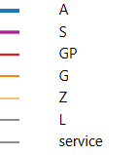
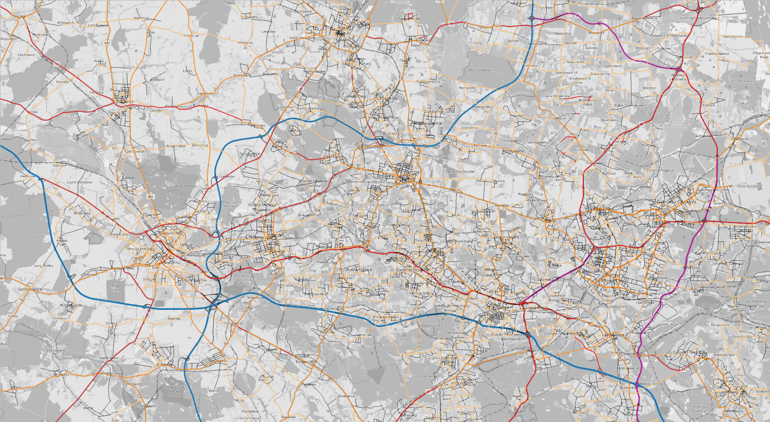
Fig. 1. Map of road classes in GZM metropolis
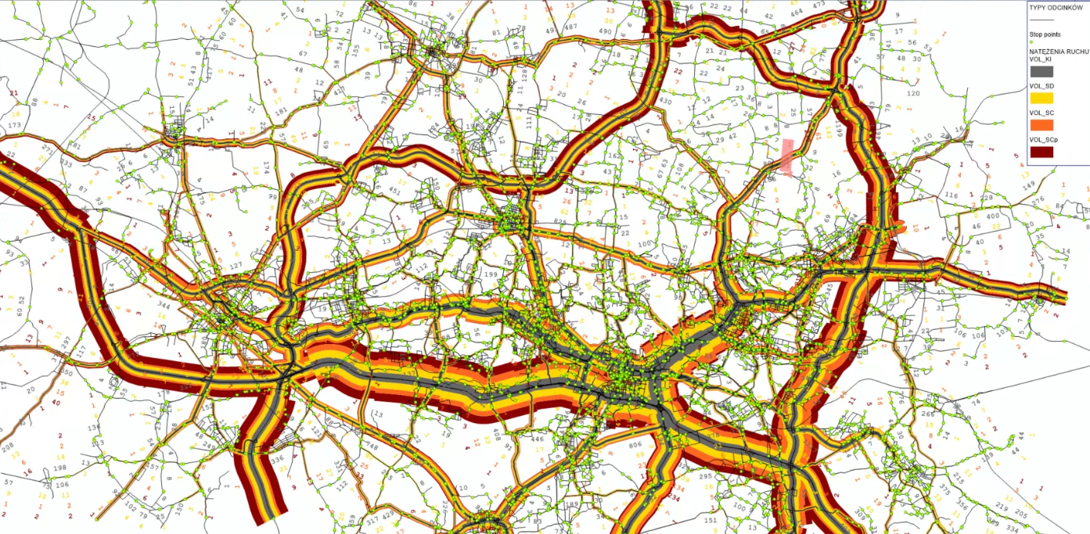
Fig. 2. Map of the traffic volume on the links in the GZM metropolis

Fig. 3. Total vehicle kilometres on transport network

The traffic assignment of the model calculates the traffic volumes on each road link. Additionally, the volume-capacity ratio is calculated, representing the percentage of capacity utilization in each link. Volume capacity ratio can be classified into levels of service (LoS), an indicator of the link's congestion level. In Table 1, volcap ratios are classified into the levels of services.

Table 1. Level of service according to the Volcap ratio in the model
Volcap ratio from | Volcap ratio to | Level of service
>=0 | <0,3 | 1
>=0,3 | <0,75 | 2
>=0,75 | <0,85 | 3
>=0,85 | <1 | 4
>=1 |  | 5

In Figure 4, a share of the LoS in each road class is shown. According to the data, highways and expressways tend to have a LoS 5, meaning congestion. However, a majority of the highways have the remaining traffic LoS in levels 1 and 2, indicating uninterrupted traffic. The lowest share of LoS 1 is in G-class (main roads), which is important given that the majority of traffic uses roads in those classes.

Fig. 4. Share of level of service in each road class
3.1.3. Traffic zones description
Traffic zone emission and energy consumption data have been calculated as the sum of links within the traffic zone. The links have been assigned to the specific zones using spatial analysis in QGIS. Therefore, the emission and energy consumption data have the same type as for the link. However, to describe the zones, parameters related to traffic potential have been used to show the influence of zone development and mobility on energy consumption and pollution within the zone. Traffic potential data have been aggregated into categories based on motivation and divided into two groups: passenger and cargo traffic. Passenger traffic includes trips generated by residential areas, workplaces, schools, universities, and other everyday activities. Cargo traffic, in turn, arises from functions such as warehouses and wholesale facilities, trade and retail establishments, manufacturing units, logistics centres, as well as other freight-related activities.
Traffic potentials have also been summed up for each zone to estimate the total development of the zone, and it was related to the zone area to estimate a development intensity. Finally, a dominating motivation of each zone has been selected.
Finally, to analyse energy consumption and emissions at the zone level, it was necessary to construct an indicator that distinguishes impacts generated within the zone from those resulting from vehicles merely transiting through it. For this purpose, a transit rate (TR) indicator was developed, as defined in Equation (2). Zone data include detailed trip-motivation characteristics, and the dominant trip motivations for each zone are illustrated in Figure 5.
(2)
where:
TR – transit rate,
TK – total kilometres travelled (sum of the vehicle kilometres in all of the links in the zone),
I – intensity (sum of all motivations in the zone).
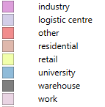
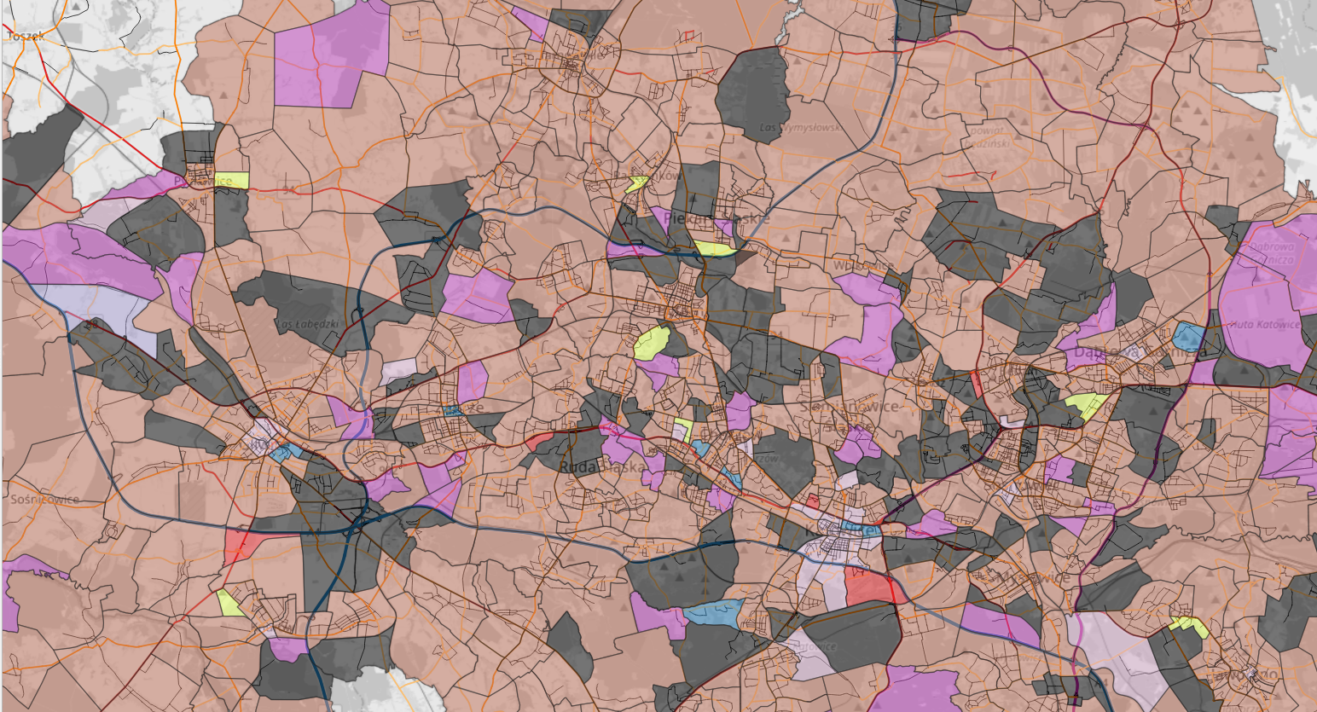
Fig. 5. Map of zone category
3.2. Emission and Energy data description
Using the average vehicle speeds on the links, unit emission factors, and unit costs, the total emission cost was calculated according to Equation (3), and energy consumption was estimated as expressed in Equation (4).
(3)
(4)
where:
CTPE – total emission cost [EUR],
C(p) – cost of pollutant type p [EUR/g],
EF(p,v) – unit emission factor of pollutant type p for vehicle class v on link l [g/km],
EC(p,v) – unit energy consumption factor for pollutant type p and vehicle class v on link l [MJ/km],
x(v,l) – traffic volume of vehicle class v on link l [vehicle-kilometers].
In relation to the stated research objectives, it is important to emphasize that this study provides a rare opportunity to embed freight flows into a calibrated, metropolitan-scale transport model and to analyse their environmental consequences with full spatial resolution. Such an integrated approach remains underrepresented in the existing body of research on urban emission modelling.
The values discussed below in this paper are calculated for the peak hour traffic for all vehicles together, separately for cars, light cargo vehicles, and heavy cargo vehicles, and for the cargo vehicles together. Vehicle fleet compositions to calculate the emissions are taken from the COPERT database. Among those, the compositions closest to the analysed area compositions have been selected. According to the base scenario year, the year of the vehicle composition is 2022. The country of the vehicle composition selected for COPERT is the EU27 countries. For the vehicle classes set in the Visum model, complementary classes have been selected from the Copert vehicle classes database (Table 2).

Table 2. Vehicle classes in the model
Visum vehicle class | Copert vehicle class
SO: Car | Personal car
SD: Freight vehicle up to 3,5 t | Light commercial vehicle
SC: Heavy freight vehicle | Heavy vehicle

Energy consumptions and emissions calculated by the emission modules makes it possible to estimate the total energy consumption of transport and to estimate the emission cost of the chosen emission factors. Energy consumption calculated is:
- gasoline consumption [g],
- diesel consumption [g],
- energy consumption of electric vehicles [MJ].

Those consumptions are summed up to present a total energy consumption [MJ] for the whole fuel types using the following energy production data of the fuels:
- gasoline energy production: 46.7 [MJ/kg],
- diesel energy production: 43.1 [MJ/kg].

Emission values are calculated in the COPERT module. The unit in which the results are presented is gram [g]. Those are:
- CO₂ carbon dioxide,
- CH₄ methane,
- N₂O nitrous oxide,
- PM particle matters up to 10 [µm],
- PM non-exhaust particle matters up to 10 [µm], non-exhaust,
- PM2.5 particle matters up to 2.5 [µm],
- PM2.5 non-exhaust particle matters up to 2.5 [µm], non-exhaust,
- BC exhaust black carbon, exhaust,
- BC non-exhaust black carbon, non-exhaust,
- Pb lead,
- NH₃ ammoniac,
- SO₂ sulphur dioxide,
- NO₂ nitrogen dioxide,
- HC hydrocarbons,
- NMHC non-methane hydrocarbons,
- benzene,
- NOx nitrogen oxide,
- CO carbon monoxide.

Among those emissions, emission costs have been calculated according to the Handbook on External Costs of Transport prepared by the European Commission. To calculate an emission cost for a better comparison of the results, three emission factors have been considered. Below, the emission costs have been shown:
- NO_{x}: 3900 [EURO/t],
- SO₂: 5600[EURO/t],
- PM2.5 174,500 [EURO/t].
3.3. Scenario description
The unit emission and energy consumption factors were sourced from the COPERT V model, while traffic volumes were derived from the traffic assignment results in the GZM transport model developed in PTV Visum. Emission and energy consumption assessments were conducted under three scenarios. These scenarios represented modifications to the base scenario (S0), which reflects average daily traffic conditions. The first scenario (S1) simulated peak seasonal traffic, while the second scenario (S2) assumed full electrification of delivery vehicles. This approach enabled an evaluation of the impact of urban logistics on overall traffic structure, as well as its contribution to total emissions and energy demand. To support strategic-level urban logistics planning, spatial analyses were carried out to identify road classes and city zones where additional regulations could have the most significant effects. These analyses also allowed for the assessment of the magnitude of such impacts. The research scenarios assumed:
- S0: Traffic in the existing state – base scenario represents standard traffic conditions as modelled in the GZM model and calibrated with the traffic research. Values of the base model will be compared and presented as nominal values of the energy consumption and the emission cost. Those values will then be compared with the S1 and S2 scenarios as the percentage of change referenced to S0.
- S1: Scenario of the seasonal freight traffic increase – according to literature (Dabo et al. 2025, Ranjbari et al. 2023), during the seasonal peak, freight traffic increase was set on 20% more than the standard freight flow. To reproduce this, a Visum model was modified. All of the trip generation (production and attraction) elements associated with the freight traffic have been enlarged by 20% (each data vector of the freight production and attraction has been multiplied by 1,2). Later, the whole procedure of the trip distribution, modal split, and traffic assignment was calculated.
- S2: Scenario of the freight traffic replacement to EVs – for the S2, custom freight vehicle categories in Copert were set. Instead of the mix of vehicles with various emission standards stated for the region and year, only the zero-emission vehicle types were chosen. In this case, no traffic flow has been changed. For this scenario only, the emissions were recalculated and compared with the S0.
4. Results
4.1. Traffic in the existing state
Energy consumption and emission costs have been presented for the links and related to per vehicle kilometer. It was presented for the road class (Figure 6) and the level of service (Figure 7).
Figure 6 shows that energy consumption and emissions are highest on the roads of the highest functional classes, primarily due to high travel speeds, which significantly increase aerodynamic drag and fuel demand. Similarly, roads of the lowest classes also exhibit elevated values, but for the opposite reason: very low speeds, frequent stops, and acceleration cycles, all of which worsen vehicle efficiency. In contrast, main roads demonstrate comparatively lower energy use and emissions, as traffic typically moves more smoothly and at near-optimal speeds, allowing vehicles to operate closer to their most efficient range.

Fig. 6. Consumption and emission of the vehicles in road classes (per vehkm)

Figure 7 presents energy consumption and emission costs of the road traffic depending on the road class and level of service from 1 (free flow of traffic) to 5 (traffic volume reaches capacity). Results show the sensitivity of the freight vehicles to the level of services connected with high traffic, especially on lower-class urban streets, such as main, secondary, and local streets.
Consumptions and emissions in the zones have been calculated using the transit rate coefficient described in the chapter, not to influence the results by the transit traffic, and are related to the area of the zone and shown per square kilometre (Figure 8).
In Figure 8, a chart of the energy consumption and emission cost by the square km of the zone area according to the zone type is presented. The results, obtained using the COPERT model, indicate that the highest total energy consumption and emission costs are associated with work and university zones, followed by residential and retail areas. Freight-related energy use and emission costs are the highest in other and warehouse zones, which represent city centre areas or areas with logistics activity. Industrial and logistics centre zones show relatively lower overall values due to their smaller spatial extent and limited internal traffic. The detailed map of the energy consumption for freight traffic is presented in Figure 9.

Fig. 7. Consumptions and emission of the vehicles in road classes in a level of service

Fig. 8. Consumption and emissions for the dominating function of the zone

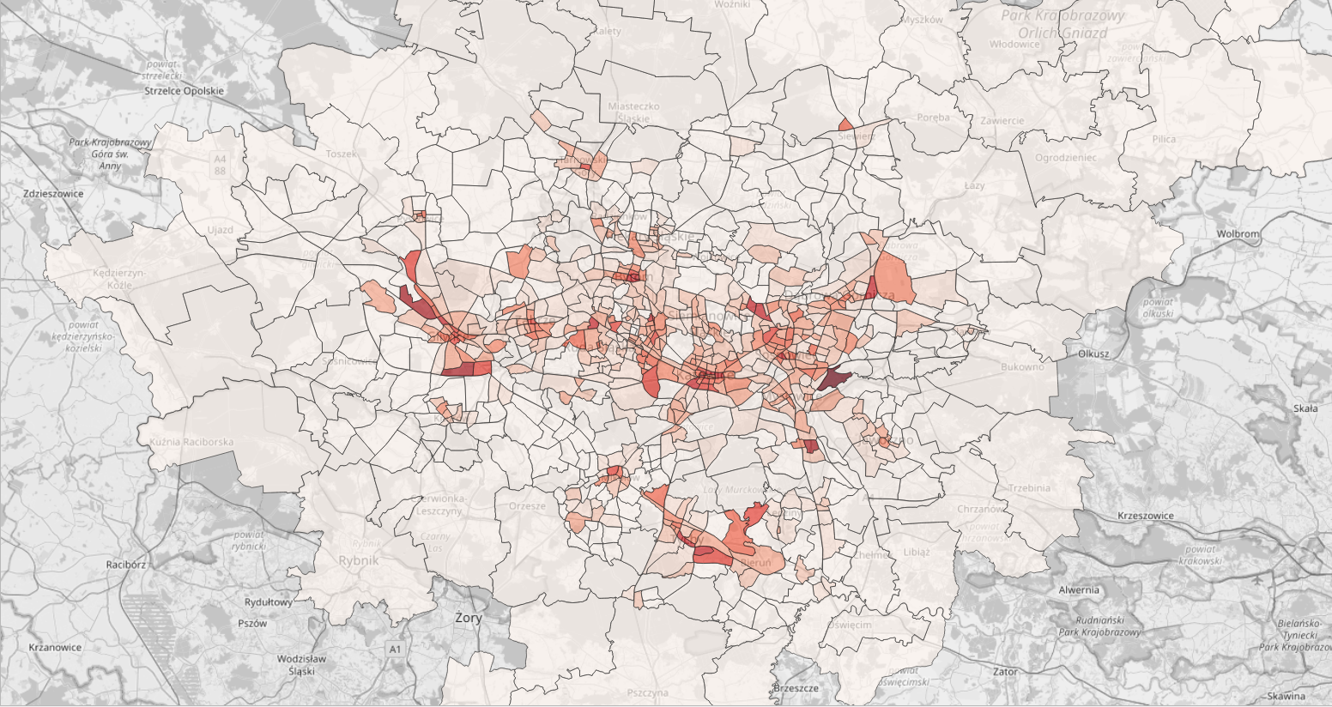
Fig. 9. Energy consumption map for freight traffic in the zones

Explaining Figure 9, in the case of energy consumption, the highest values are observed in areas characterized by the highest population density. This pattern reflects the concentration of households, commercial activities, and service infrastructure, which together generate higher overall energy demand.
4.2. Comparison of scenarios
In this subchapter, the scenarios described in subchapter 3.3 are analysed. First, spatial changes in freight energy consumption and emission costs for the seasonal peak scenario and the whole freight fleet electrification scenario are illustrated using link- and zone-level maps (Figure 10 and Figure 11). Subsequently, the overall impacts of the scenarios are summarised using charts that compare energy consumption and emission costs by road class (Figures 12 and 13) and dominant zone type (Figure 14).
During the peak freight traffic scenario, freight energy consumption increased much more noticeably in these densely developed regions, reflecting the concentration of freight-related movements.
Analogically, after the replacement of freight vehicles with zero-emission vehicles, several spatial effects can be observed. Freight energy consumption showed a more pronounced decline in regions with a high share of freight traffic, indicating that these areas benefited the most from the transition to zero-emission freight transport. The freight emission cost dropped to zero, as zero-emission vehicles do not produce the types of pollutants considered within this category.

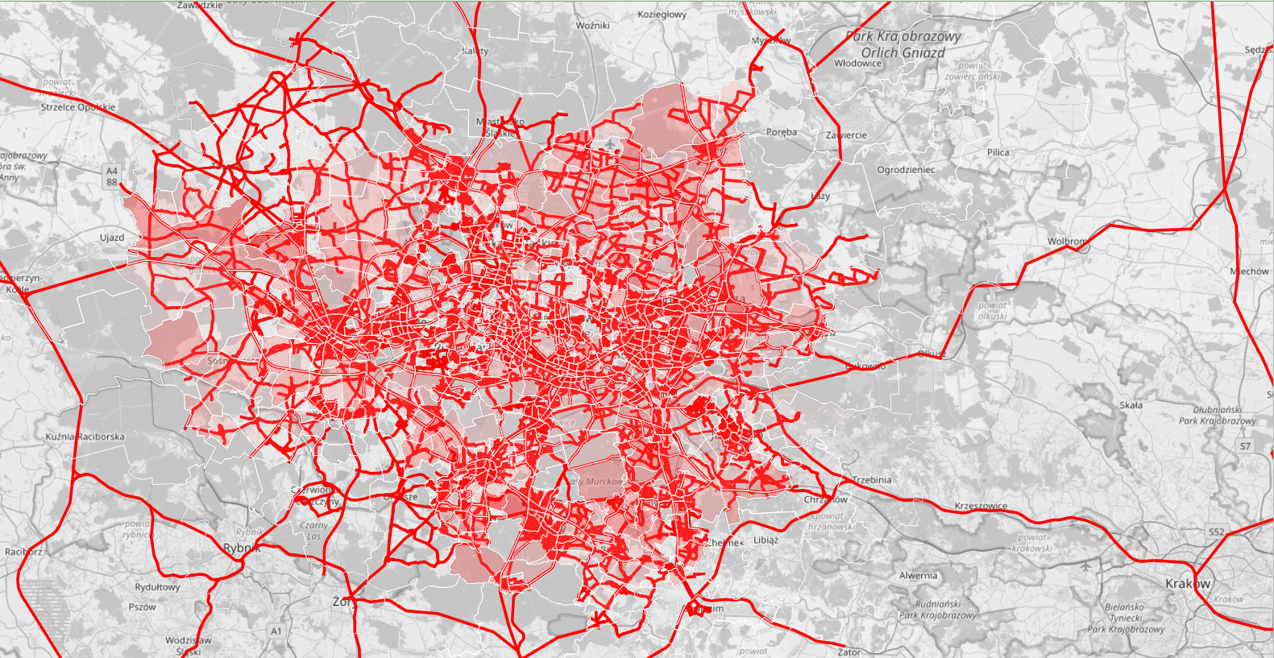 | 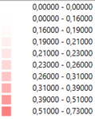
 | 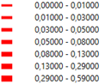
Fig. 10. Comparison of link and zone freight energy consumption changes for the peak freight traffic

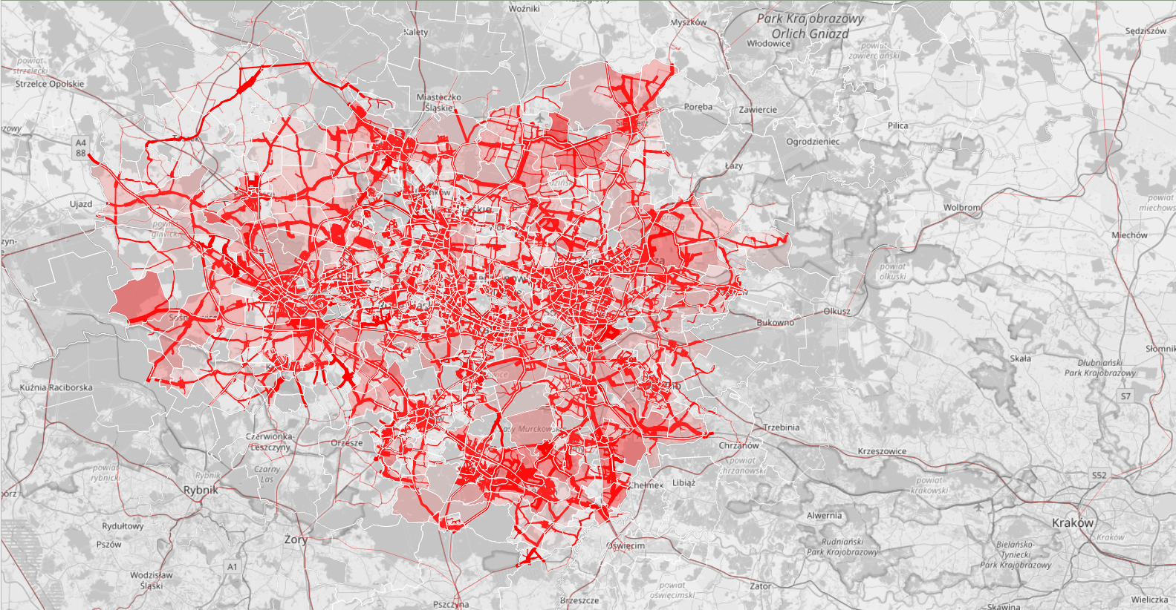 | 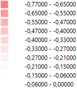
 | 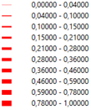
Fig. 11. Comparison of link and zone freight energy consumption changes for the zero emission freight traffic scenario = map shows a decrease in values

Fig. 12. Changes on the energy consumptions according to the road class

Fig. 13. Changes on the emissions according to the road class

Fig. 14. Changes in simulated scenarios according to the dominating zone type

As seen in Figures 12 and 13, for all vehicle classes, the biggest changes, both in the peak hour increases and zero-emission freight vehicles scenarios, are in the higher road classes, confirming the bigger share of the freight vehicles in those classes. When analysing the freight vehicles individually, it can be seen that the biggest changes occur in the lower road class, confirming the highest energy consumption in this vehicle type. Emission costs for the freight vehicles in this scenario decreased to 0.
Similarly to the previous case, emission differences in the scenario are the greatest in the zones with a greater share of the freight vehicles, especially logistic centres. For the same reason, considering only freight traffic, in the logistic centres, changes are the lowest in terms of energy consumption. Noticeable differences can also be seen in zones with dominating "residential" and "other" motivations.
5. Summary, Conclusions, and Further Studies
This study analyses the spatial distribution of energy consumption and emission costs generated by road traffic, with particular attention to freight vehicles and the functional characteristics of the road network and urban zones. The results show that roads in the highest functional classes experience the largest increases in total energy use and emissions, driven by high travel speeds and substantial traffic volumes. Roads of the lowest classes also exhibit elevated values due to low operating speeds and frequent stop-and-go conditions. In contrast, main roads operate closer to optimal speeds, resulting in comparatively lower impacts.
Zone-level analysis reveals strong differentiation in sensitivity to traffic variations. Total energy consumption is most sensitive to changes in zones dominated by "other" trip motivations and, to a lesser extent, logistics centres. Freight energy consumption responds most strongly in zones with a high share of retail-related activity, followed by warehouse areas. Total emission costs show the highest sensitivity in logistics centre zones (reflecting the dominant share of freight vehicles) and in retail areas. For freight emissions specifically, the most sensitive zones are those associated with "other" trip purposes, followed by warehouse zones.
Scenario analysis further highlights the mentioned patterns. Under peak freight traffic conditions, both total and freight-related energy consumption and emissions increase, with the strongest effects observed in zones with high development intensity and high freight shares. Conversely, replacing freight vehicles with zero-emission alternatives results in a marked decline in freight energy use, with the most substantial reductions observed in areas with intensive freight activity, and it also eliminates freight emission costs entirely. Across all scenarios, the largest changes for all vehicle classes occur on higher-class roads, whereas freight-specific impacts are most significant on lower-class urban streets. Emission and energy variations are also most pronounced in zones with a significant presence of freight traffic, especially in logistics centres.
The results obtained may serve as a foundation for formulating targeted transport policies to reduce the negative environmental impacts of freight transport within the GZM area. Such policies may include, for example, the introduction of transit traffic restrictions in metropolitan city centres, time-based limitations on delivery operations, or selective regulations concerning specific vehicle categories. Moreover, the findings may provide a basis for creating favourable conditions for the development of zero- and low-emission urban freight solutions, such as electric vehicles, cargo bikes, or pedestrian-based delivery systems. By identifying the spatial distribution of emissions in detail, it is possible to pinpoint zones where such measures are particularly critical, thereby enhancing the effectiveness of planned interventions.
Further research should focus on the following directions:
- Emission modelling and pollutant scope – refining the comparison of emissions and extending the range of scenarios considered, especially in the context of freight-related impacts. Although the current study applies COPERT emission factors and provides a consistent spatial picture of energy consumption and emission costs, future work should explore alternative emission modelling approaches and verify whether the same spatial patterns appear when using other datasets, particularly in zones with high shares of freight traffic. A broader comparison of pollutants, including non-exhaust emissions, may also help capture the full environmental burden associated with different road classes and zone types.
- Scenario design and demand assumptions – extending the analysis of scenarios could be extended by introducing more diverse assumptions regarding vehicle technologies, operational conditions, and changes in travel demand. Intermediate stages of freight fleet electrification, partial adoption of zero-emission vehicles, or adjustments to delivery timing could reveal additional sensitivities not captured in the current peak freight and full zero-emission scenarios. Exploring scenarios that incorporate changes in land-use intensity or the redistribution of logistics activities would allow for a more detailed understanding of how zone characteristics influence the magnitude of energy and emission responses.
- Empirical validation on emission patterns – a key direction of further work is the validation of the emission results through on-site measurements. While the current modelling approach provides a coherent spatial representation, direct measurements of pollutant concentrations near major roads and in zones with intensive freight activity would allow for testing whether the identified patterns correspond to actual emission levels. Such measurements, combined with short-term traffic counts or GPS-based observations of freight movements, could help determine how well the model captures the relationship between traffic conditions and local air quality. This type of validation is particularly important in logistics centres and other freight-dominated zones, where the most considerable changes were observed and where model uncertainty is typically the highest. Integrating empirical measurements with the modelling framework would allow future studies to assess not only the spatial tendencies identified here but also the extent to which they reflect real-world emission behaviour.
This research was funded by the National Science Centre, Poland (project no. 2022/04/Y/ST8/00134).
Project title: Energy optimal urban logistics as a service (E-Laas). Project implemented as part of the call ERA-NET Cofund Urban Accessibility and Connectivity (EN-UAC China Call) organized by JPI Urban
Europe and the National Natural Science Foundation of China (NSFC) funded from the European Union's Horizon 2020 research and innovation programme under grant agreement No 875022.
References
Adeniran, I. O., Ghazal, A., & Thaller, C. (2023). Simulation-Based Impact Assessment of Electric and Hydrogen Vehicles in Urban Parcel Delivery Operations. In U. Clausen & M. Dellbrügge (Eds), Advances in Resilient and Sustainable Transport (pp. 163-182). Springer International Publishing. https://doi.org/10.1007/978-3-031-28236-2_11
Alho, A., Bhavathrathan, B. K., Stinson, M., Gopalakrishnan, R., Le, D.-T., & Ben-Akiva, M. (2017a). A multi-scale agent-based modelling framework for urban freight distribution. Transportation Research Procedia, 27, 188-196. https://doi.org/10.1016/j.trpro.2017.12.138
Alho, A., Bhavathrathan, B. K., Stinson, M., Gopalakrishnan, R., Le, D.-T., & Ben-Akiva, M. (2017b). A multi-scale agent-based modelling framework for urban freight distribution. Transportation Research Procedia, 27, 188-196. https://doi.org/10.1016/j.trpro.2017.12.138
Al-lami, A., Török, A., Alatawneh, A., & Alrubaye, M. (2025). Future Energy Consumption and Economic Implications of Transport Policies: A Scenario-Based Analysis for 2030 and 2050. Energies, 18(12), 3012. https://doi.org/10.3390/en18123012
Ansu, V., & Anjaneyulu, M. V. L. R. (2022). The optimum strategy for mode choice modelling of interregional fish transport considering shippers' heterogeneity. Archives of Transport, 64(4), 7-26. https://doi.org/10.5604/01.3001.0016.1046
Asmael, N. M., & Wazer, Z. A. (2022). Prediction origin-destination matrix of freight travel demand in Baghdad city. Transport Problems, 17(3), 203-212. https://doi.org/10.20858/tp.2022.17.3.16
Billhardt, H., Fernández, A., Gómez-Gálvez, S., Martí, P., Prieto Tejedor, J., & Ossowski, S. (2022). Reducing Emissions Prioritising Transport Utility. In J. M. Corchado & S. Trabelsi (Eds), Sustainable Smart Cities and Territories 253, 300-311. Springer International Publishing. https://doi.org/10.1007/978-3-030-78901-5_26
Bo, Y., Zhang, L., Zhong, J., Zhong, W., & Zhu, P. (2025). Bottom-up analysis for carbon emissions from passenger and freight transport sectors in Xi'an: A city-level study using MOVES and LMDI models. Environmental Research Communications, 7(2), 025010. https://doi.org/10.1088/2515-7620/adb096
Buerklen, A., Adeniran, I., & Kehrt, C. (2025). A simulative assessment of collaborative last mile delivery solutions. Transportation Research Procedia, 82, 3925-3942. https://doi.org/10.1016/j.trpro.2024.12.004
Burdzik, R., Macioszek, E., Sierpiński, G., & Warczek, J. (2013). Analiza rozbudowy i lokalizacji centrów i obiektów logistycznych w aglomeracji śląskiej. Zeszyty Naukowe. Transport/Politechnika Śląska, 78, 19-29.
Caban, J. (2021). Traffic congestion level in 10 selected cities of Poland. Scientific Journal of Silesian University of Technology. Series Transport, 112, 17-31. https://doi.org/10.20858/sjsutst.2021.112.2
Cascetta, E. (1984). Estimation of trip matrices from traffic counts and survey data: A generalized least squares estimator. Transportation Research Part B: Methodological, 18(4-5), 289-299.
https://doi.org/10.1016/0191-2615(84)90012-2
Chamier-Gliszczyński, N. (2012). Structure analysis of system mobility in urban areas. Congress Proceedings, CLC 2012: Carpathian Logistics Congress, 509-515, 111467, Jesenik, Czech Republic, Tanger Ltd.
Chamier-Gliszczynski, N. (2016). City Logistics – Sustainable Urban Mobility. CLC 2015: Carpathian Logistics Congress – Conference Proceedings, 263-268, Jesenik, Czech Republic, Tanger Ltd.
Comi, A., Delle Site, P., Filippi, F., & Nuzzolo, A. (2012, March). Urban Freight Transport Demand Modelling: A State of the Art. http://hdl.handle.net/10077/6123
Dabo, A.-A. A., Mor, R., Albatal, M. M., Raji, M., & Aina, M. (2025). Logistics planning strategies for seasonal traffic management. Logforum, 21(2), 167-181. https://doi.org/10.17270/J.LOG.001150
Davidich, N., Galkin, A., Iwan, S., Kijewska, K., Chumachenko, I., & Davidich, Y. (2021). Monitoring of urban freight flows distribution considering the human factor. Sustainable Cities and Society, 75, 103168. https://doi.org/10.1016/j.scs.2021.103168
De Bok, M., Tavasszy, L., & Sebastiaan Thoen. (2022). Application of an empirical multi-agent model for urban goods transport to analyze impacts of zero emission zones in The Netherlands. Transport Policy, 124, 119-127. https://doi.org/10.1016/j.tranpol.2020.07.010
Dias, H. L. F., Bertoncini, B. V., Oliveira, M. L. M. D., Cavalcante, F. S. Á., & Lima, E. P. (2017). Analysis of emission models integrated with traffic models for freight transportation study in urban areas. International Journal of Environmental Technology and Management, 20(1/2), 60. https://doi.org/10.1504/IJETM.2017.086440
Ducret, R., & Gonzalez-Feliu, J. (2016). Connecting Demand Estimation and Spatial Category Models for Urban Freight: First Attempt and Research Implications. Transportation Research Procedia, 12, 142-156. https://doi.org/10.1016/j.trpro.2016.02.054
Dyczkowska, J., Olkiewicz, M., Chamier-Gliczynski, N., & Królikowski, T. (2023). Mobility-as-a-Service (MaaS) as a solution platform for the city and the region: case study. Procedia Computer Science, 225, 4092-4100, 196245. https://doi.org/10.1016/j.procs.2023.10.405
Dyczkowska, J., Olkiewicz, M., Chamier-Gliczynski, N., & Królikowski, T. (2023a). Decision support in the area of Logistics 4.0. Procedia Computer Science, 225, 4758-4765, https://doi.org/10.1016/j.procs.2023.10.475
Englezou, Y., Timotheou, S., & Panayiotou, C. G. (2022). Estimating the origin-destination matrix using link count observations and traffic flow dynamics. 2022 IEEE 25th International Conference on Intelligent Transportation Systems (ITSC), 3213-3218. https://doi.org/10.1109/ITSC55140.2022.9921951
Englezou, Y., Timotheou, S., & Panayiotou, C. G. (2024a). Dynamic origin-destination matrix estimation for networks operating under free-flow conditions using macroscopic flow dynamics. IFAC-PapersOnLine, 58(10), 213-218. https://doi.org/10.1016/j.ifacol.2024.07.342
Englezou, Y., Timotheou, S., & Panayiotou, C. G. (2024b). Path-Based Origin-Destination Matrix Estimation Utilizing Macroscopic Traffic Dynamics. IEEE Transactions on Intelligent Transportation Systems, 25(8), 8819-8836. https://doi.org/10.1109/TITS.2024.3370473
Ewert, R., Grahle, A., Martins-Turner, K., Syré, A. M., Nagel, K., & Göhlich, D. (2021). Electrification of Urban Waste Collection: Introducing a Simulation-Based Methodology for Technical Feasibility, Impact and Cost Analysis. World Electric Vehicle Journal, 12(3), 122. https://doi.org/10.3390/wevj12030122
Ewert, R., Martins-Turner, K., Grahle, A., Syré, A., Göhlich, D., & Nagel, K. (2025). Showing the cost benefits for commercial electric vehicles—Case Study of Battery Electric Vehicles in Urban Food Distribution. Transportation Research Procedia, 86, 532-539. https://doi.org/10.1016/j.trpro.2025.04.067
Galkin, A. (2017). Urban environment influence on distribution part of logistics systems. Archives of Transport, 42(2), 7-23. https://doi.org/10.5604/01.3001.0010.0522
Ghazal, A., Narayanan, S., Adeniran, I. O., Kehrt, C., & Antoniou, C. (2025). Analysis of logistics measures of CEP service providers for the last-mile delivery in small- and medium-sized cities: A case study for the Aachen city region. European Transport Research Review, 17(1), 5. https://doi.org/10.1186/s12544-025-00706-z
Holguín-Veras, J., Encarnación, T., González-Calderón, C. A., Winebrake, J., Wang, C., Kyle, S., Herazo-Padilla, N., Kalahasthi, L., Adarme, W., Cantillo, V., Yoshizaki, H., & Garrido, R. (2018). Direct impacts of off-hour deliveries on urban freight emissions. Transportation Research Part D: Transport and Environment, 61, 84-103. https://doi.org/10.1016/j.trd.2016.10.013
Hu, X., Chen, N., Wu, N., & Yin, B. (2021). The Potential Impacts of Electric Vehicles on Urban Air Quality in Shanghai City. Sustainability, 13(2), 496. https://doi.org/10.3390/su13020496
Jacyna, M., Wasiak, M., Kłodawski, M., & Lewczuk, K. (2014). Simulation model of transport system of Poland as a tool for developing sustainable transport. Archives of Transport, 31(3), 23-35. https://doi.org/10.5604/08669546.1146982
Jacyna, M., Żochowska, R., Sobota, A., & Wasiak, M. (2021). Scenario Analyses of Exhaust Emissions Reduction through the Introduction of Electric Vehicles into the City. Energies, 14(7), 2030. https://doi.org/10.3390/en14072030
Jacyna-Gołda, I., Gołębiowski, P., Izdebski, M., Kłodawski, M., Jachimowski, R., & Szczepański, E. (2017). The evaluation of the sustainable transport system development with the scenario analyses procedure. Journal of Vibroengineering, 19(7), 5627-5638. https://doi.org/10.21595/jve.2017.19275
Jacyna-Gołda, I., Żak, J., & Gołębiowski, P. (2014). Models of traffic flow distribution for various scenarios of the development of proecological transport system. Archives of Transport, 32(4), 17-28. https://doi.org/10.5604/08669546.1146994
Kalahasthi, L., Holguín-Veras, J., & Yushimito, W. F. (2022). A freight origin-destination synthesis model with mode choice. Transportation Research Part E: Logistics and Transportation Review, 157, 102595. https://doi.org/10.1016/j.tre.2021.102595
Khajavi, H., & Rastgoo, A. (2023). Predicting the carbon dioxide emission caused by road transport using a Random Forest (RF) model combined by Meta-Heuristic Algorithms. Sustainable Cities and Society, 93, 104503. https://doi.org/10.1016/j.scs.2023.104503
Klodawski, M., Jachimowski, R., & Chamier-Gliszczynski, N. (2024). Analysis of the Overhead Crane Energy Consumption Using Different Container Loading Strategies in Urban Logistics Hubs. Energies, 17(5), 985, https://doi.org/10.3390/en17050985
Liu, D., Lim, H., Uddin, M., Liu, Y., Han, L. D., Hwang, H., & Chin, S.-M. (2024). Improving the accuracy of freight mode choice models: A case study using the 2017 CFS PUF data set and ensemble learning techniques. Expert Systems with Applications, 240, 122478. https://doi.org/10.1016/j.eswa.2023.122478
Mądziel, M. (2023). Vehicle Emission Models and Traffic Simulators: A Review. Energies, 16(9), 3941. https://doi.org/10.3390/en16093941
Maes, A. D. S., Hoinaski, L., Meirelles, T. B., & Carlson, R. C. (2019). A methodology for high resolution vehicular emissions inventories in metropolitan areas: Evaluating the effect of automotive technologies improvement. Transportation Research Part D: Transport and Environment, 77, 303-319. https://doi.org/10.1016/j.trd.2019.10.007
Mangones, S. C., Jaramillo, P., Fischbeck, P., & Rojas, N. Y. (2019). Development of a high-resolution traffic emission model: Lessons and key insights from the case of Bogotá, Colombia. Environmental Pollution, 253, 552-559. https://doi.org/10.1016/j.envpol.2019.07.008
Martins-Turner, K., Grahle, A., Nagel, K., & Göhlich, D. (2020). Electrification of Urban Freight Transport—A Case Study of the Food Retailing Industry. Procedia Computer Science, 170, 757-763. https://doi.org/10.1016/j.procs.2020.03.159
Namdeo, A., Mitchell, G., & Dixon, R. (2002). TEMMS: An integrated package for modelling and mapping urban traffic emissions and air quality. Environmental Modelling & Software, 17(2), 177-188. https://doi.org/10.1016/S1364-8152(01)00063-9
Narayanan, S., Salanova Grau, J. M., Frederix, R., Tympakianaki, A., Masegosa, A. D., & Antoniou, C. (2025). Modeling of shared mobility services—An approach in between aggregate four-step and disaggregate agent-based approaches for strategic transport planning. Journal of Intelligent Transportation Systems, 29(4), 435-452. https://doi.org/10.1080/15472450.2023.2246374
Nejadkoorki, F., Nicholson, K., Lake, I., & Davies, T. (2008). An approach for modelling CO₂ emissions from road traffic in urban areas. Science of The Total Environment, 406(1-2), 269-278. https://doi.org/10.1016/j.scitotenv.2008.07.055
Nikolaou, K., Basbas, S., & G., T. (2002). Air pollutant emissions and concentrations based on urban traffic modelling. Fresenius Environmental Bulletin, 11, 494-498.
Orru, H., Kaasik, M., Antov, D., & Forsberg, B. (2008). Evolution of Traffic Flows and Traffic-Induced Air Pollution Due to Structural Changes and Development during 1993-2006 in Tartu (Estonia). The Baltic Journal of Road and Bridge Engineering, 3(4), 206-212. https://doi.org/10.3846/1822-427X.2008.3.206-212
Oskarbski, J., & Kaszubowski, D. (2018). Applying a Mesoscopic Transport Model to Analyse the Effects of Urban Freight Regulatory Measures on Transport Emissions—An Assessment. Sustainability, 10(7), 2515. https://doi.org/10.3390/su10072515
Pamuła, T., & Żochowska, R. (2023). Estimation and prediction of the OD matrix in uncongested urban road network based on traffic flows using deep learning. Engineering Applications of Artificial Intelligence, 117, 105550. https://doi.org/10.1016/j.engappai.2022.105550
Pan, Q. (2006). Freight Data Assembling and Modeling: Methodologies and Practice. Transportation Planning and Technology, 29(1), 43-74. https://doi.org/10.1080/03081060600585327
Patiño-Aroca, M., Parra, A., & Borge, R. (2022). On-road vehicle emission inventory and its spatial and temporal distribution in the city of Guayaquil, Ecuador. Science of The Total Environment, 848, 157664. https://doi.org/10.1016/j.scitotenv.2022.157664
Peng, T., Gan, M., Yao, Z., Yang, X., & Liu, X. (2024). Nonlinear impacts of urban built environment on freight emissions. Transportation Research Part D: Transport and Environment, 134, 104358. https://doi.org/10.1016/j.trd.2024.104358
Poland E-commerce Market Size & Forecast. Verified Market Research. (2025). [Data set]. https://www.verifiedmarketresearch.com/product/poland-ecommerce-market/
Pompigna, A., & Mauro, R. (2020). Input/Output models for freight transport demand: a macro approach to traffic analysis for a freight corridor. Archives of Transport, 54(2), 21-42. https://doi.org/10.5604/01.3001.0014.2729
Ranjbari, A., Diehl, C., Dalla Chiara, G., & Goodchild, A. (2023). What is the Right Size for a Residential Building Parcel Locker? Transportation Research Record: Journal of the Transportation Research Board, 2677(3), 1397-1407. https://doi.org/10.1177/03611981221123807
Sakai, T., Romano Alho, A., Bhavathrathan, B. K., Chiara, G. D., Gopalakrishnan, R., Jing, P., Hyodo, T., Cheah, L., & Ben-Akiva, M. (2020). SimMobility Freight: An agent-based urban freight simulator for evaluating logistics solutions. Transportation Research Part E: Logistics and Transportation Review, 141, 102017. https://doi.org/10.1016/j.tre.2020.102017
Samaras, C., Tsokolis, D., Toffolo, S., Magra, G., Ntziachristos, L., & Samaras, Z. (2018). Improving fuel consumption and CO₂ emissions calculations in urban areas by coupling a dynamic micro traffic model with an instantaneous emissions model. Transportation Research Part D: Transport and Environment, 65, 772-783. https://doi.org/10.1016/j.trd.2017.10.016
Samaras, C., Tsokolis, D., Toffolo, S., Magra, G., Ntziachristos, L., & Samaras, Z. (2019). Enhancing average speed emission models to account for congestion impacts in traffic network link-based simulations. Transportation Research Part D: Transport and Environment, 75, 197-210. https://doi.org/10.1016/j.trd.2019.08.029
Sánchez-Díaz, I., Holguín-Veras, J., & Wang, X. (2016). An exploratory analysis of spatial effects on freight trip attraction. Transportation, 43(1), 177-196. https://doi.org/10.1007/s11116-014-9570-1
Schnieder, M., Hinde, C., & West, A. (2021). Sensitivity Analysis of Emission Models of Parcel Lockers vs. Home Delivery Based on HBEFA. International Journal of Environmental Research and Public Health, 18(12), 6325. https://doi.org/10.3390/ijerph18126325
Schnieder, M., Hinde, C., & West, A. (2022). Emission Estimation of On-Demand Meal Delivery Services Using a Macroscopic Simulation. International Journal of Environmental Research and Public Health, 19(18), 11667. https://doi.org/10.3390/ijerph191811667
Sharma, H., & Swami, B. (2012). Emission and energy consumption characteristics of interrupted over-saturated flow for urban roads with heterogeneous traffic. Transport Problems, 7(3), 29-40.
Shi, Y., Lam, W. H. K., Fu, H., Ho, H. W., Tam, M. L., & Ma, W. (2025). Modeling instantaneous queuing effects in the traffic assignment problem with consideration of demand fluctuations in the modeling period. Transportation Research Part B: Methodological, 197, 103248. https://doi.org/10.1016/j.trb.2025.103248
Shin, H., Silverman, E., Heppenstall, A., Malleson, N., Ilic, M., Abeysinghe, S., & Sonnenschein, T. (2025). Are Low Emission Zones Effective in Reducing Emissions and Ambient Air Pollution? In J. Thompson & I. Stankov (Eds), Multi-Agent-Based Simulation XXV, 15583, 28-36. Springer Nature Switzerland.
https://doi.org/10.1007/978-3-031-88017-9_3
Simoni, M. D., & Claudel, C. G. (2018). A simulation framework for modeling urban freight operations impacts on traffic networks. Simulation Modelling Practice and Theory, 86, 36-54. https://doi.org/10.1016/j.simpat.2018.05.001
Song, R., Qin, W., Shi, W., & Xue, X. (2023). Optimizing Freight Vehicle Routing in Dynamic Time-Varying Networks with Carbon Dioxide Emission Trajectory Analysis. Sustainability, 15(21), 15504. https://doi.org/10.3390/su152115504
Statistics Poland. (2025). [Data set]. https://bdl.stat.gov.pl/
Stolfi, D. H., Cintrano, C., Chicano, F., & Alba, E. (2018). An Intelligent Advisor for City Traffic Policies. In F. Herrera, S. Damas, R. Montes, S. Alonso, Ó. Cordón, A. González, & A. Troncoso (Eds), Advances in Artificial Intelligence, 11160, 383-393. Springer International Publishing. https://doi.org/10.1007/978-3-030-00374-6_36
Szarata, A. (2014). The Multimodal Approach to The Modelling of Modal Split. Archives of Transport, 29(1), 55-63. https://doi.org/10.5604/08669546.1146968
Tang, J., McNabola, A., Misstear, B., & Caulfield, B. (2017). An evaluation of the impact of the Dublin Port Tunnel and HGV management strategy on air pollution emissions. Transportation Research Part D: Transport and Environment, 52, 1-14. https://doi.org/10.1016/j.trd.2017.02.009
Tirico, M., Bescond, V. L., Sengelin, D., Gastineau, P., & Can, A. (2025). Multi-scale comparison of modeling chains for traffic-related air pollutant emission assessment. Sustainable Cities and Society, 129, 106354. https://doi.org/10.1016/j.scs.2025.106354
Turkensteen, M. (2017). The accuracy of carbon emission and fuel consumption computations in green vehicle routing. European Journal of Operational Research, 262(2), 647-659. https://doi.org/10.1016/j.ejor.2017.04.005
Varga, B., Lulić, Z., & Tettamanti, T. (2024). Systematic Error Correction of SUMO Traffic Simulator's HBEFA Vehicle Emission Model. 2024 IEEE International Conference on Electrical Systems for Aircraft, Railway, Ship Propulsion and Road Vehicles &amp; International Transportation Electrification Conference (ESARS-ITEC), 1-6. https://doi.org/10.1109/ESARS-ITEC60450.2024.10819857
Venkadavarahan, M., & Marisamynathan, S. (2021). Exploring spatial interaction effects in freight trip generation model for intermediate and pure receiver establishment. Case Studies on Transport Policy, 9(4), 1582-1592. https://doi.org/10.1016/j.cstp.2021.08.007
Wardrop, J. G. (1952). Road paper. Some theoretical aspects of road traffic research. Proceedings of the Institution of Civil Engineers, 1(3), 325-362. https://doi.org/10.1680/ipeds.1952.11259
Wisetjindawat, W., Sano, K., Matsumoto, S., & Raothanachonkun, P. (2007). Micro-simulation model for modeling freight agents interactions in urban freight movement. Proceedings, 86th Annual Meeting of the Transportation Research Board.
Woźniak, W., & Wojnarowski, T. (2015). The method for a fast selection of the profitable transport offers derived from the freight exchange market. Proceedings of the 25th International Business Information Management Association Conference Innovation Vision 2020 from Regional Development Sustainability to Global Economic Growth IBIMA, Open source preview, pp. 2073-2085.
Woźniak, W., Stryjski, R., Mielniczuk, J., & Wojnarowski, T. (2015a). Concept for the application of genetic algorithms in the management of transport offers in relation to homogenous cargo transport. Proceedings of the 26th International Business Information Management Association Conference Innovation Management and Sustainable Economic Competitive Advantage from Regional Development to Global Growth IBIMA, Open source preview, 2015, pp. 2329-2339.
Xu, X., Yang, H.-C., Jeong, K., Bui, W., Ravulaparthy, S., Laarabi, H., Needell, Z. A., & Spurlock, C. A. (2024). Teaching freight mode choice models new tricks using interpretable machine learning methods. Frontiers in Future Transportation, 5, 1339273. https://doi.org/10.3389/ffutr.2024.1339273
Xu, Z., Peng, Y., Li, G., Chen, A., & Liu, X. (2024). Range-constrained traffic assignment for electric vehicles under heterogeneous range anxiety. Transportation Research Part C: Emerging Technologies, 158, 104419. https://doi.org/10.1016/j.trc.2023.104419
Young, W., Richardson, A. J., Ogden, K. W., & Rattray, A. L. (1983). An inter‐Urban freight mode choice model. Transportation Planning and Technology, 8(1), 61-80. https://doi.org/10.1080/03081068308717238
Zhang, S., Wu, Y., Huang, R., Wang, J., Yan, H., Zheng, Y., & Hao, J. (2016). High-resolution simulation of link-level vehicle emissions and concentrations for air pollutants in a traffic-populated eastern Asian city. Atmospheric Chemistry and Physics, 16(15), 9965-9981. https://doi.org/10.5194/acp-16-9965-2016
Zhao, C., Tang, J., Zeng, Y., Li, Z., & Gao, F. (2023). Understanding the spatio-temporally heterogeneous effects of built environment on urban travel emissions. Journal of Transport Geography, 112, 103689. https://doi.org/10.1016/j.jtrangeo.2023.103689
Zhao, S., Liu, L., & Zhao, P. (2023). Traffic assignment in urban transportation network problem with emission constraints in China: A cooperative game theory. Environmental Science and Pollution Research, 30(26), 69274-69288. https://doi.org/10.1007/s11356-023-27108-9
Żochowska, R. (2014). Selected Issues in modelling of traffic flows in congested urban networks. Archives of Transport, 29(1), 77-89. https://doi.org/10.5604/08669546.1146971

