
 | Rocznik Ochrona Środowiska
 | Volume 27 | Year 2025 ISSN 2720-7501 | pp. 693-704
 | https://doi.org/10.54740/ros.2025.056 open access
 | Received: October 2025 Accepted: November 2025 Published: November 2025
Numerical Modeling of Heat Transfer Through Ventilated Double-Chamber Windows
Borys Basok^{1*}, Oleksandr Obodovych², Dmytro Davydenko³, Olesya Stepanova⁴, Hanna Koshlak⁵
¹Institute of Engineering Thermophysics, National Academy of Sciences of Ukraine, Ukraine
https://orcid.org/0000-0002-8935-4248
²Institute of Engineering Thermophysics, National Academy of Sciences of Ukraine, Ukraine
https://orcid.org/0000-0001-7213-3118
³Institute of Engineering Thermophysics, National Academy of Sciences of Ukraine, Ukraine
https://orcid.org/0009-0003-5791-1980
⁴Institute of Engineering Thermophysics, National Academy of Sciences of Ukraine, Ukraine
https://orcid.org/0000-0002-7179-7251
⁵Faculty of Environmental Engineering, Geodesy and Renewable Energy, Kielce University of Technology, Poland
https://orcid.org/0000-0001-8940-5925
*corresponding author's e-mail: borys.basok@gmail.com
Abstract: Building windows are a dominant source of thermal energy loss, possessing significantly lower heat transfer resistance than insulated wall structures. Enhancing the energy efficiency of window systems is possible by integrating them into the building's ventilation scheme. Ventilated windows facilitate the controlled intake of external fresh air or the extraction of internal exhaust air, enabling partial heat recovery and tempering of the airflow. However, this air movement increases dissipative heat loss through the glass surfaces, necessitating an efficiency study. This research evaluates the effectiveness of ventilated windows by comparing the recovered thermal energy against these additional dissipative losses. The study is conducted via numerical modeling of coupled air flow and heat transfer within the window structure. A finite difference method is employed to solve the governing system of equations, which includes the continuity, momentum, and energy transfer equations for the air, as well as the heat conduction equation for the glass. The numerical results consistently demonstrate that the heat saved through pre-heating incoming air or recovering heat from exhaust air is greater than the additional dissipative heat loss through the glass. Therefore, the implementation of ventilated windows is confirmed to be an effective solution from an energy efficiency perspective.
Keywords: ventilated windows, air flow, heat transfer, energy efficiency, numerical modeling
1. Introduction
Among energy-saving measures in the construction industry, a critical focus remains on enhancing the thermal performance of fenestration systems, which are typically characterised by significantly higher heat losses compared to opaque components of the building envelope. One promising strategy for enhancing the energy performance of glazing and mitigating thermal losses is to integrate it into the premises' ventilation system for either air supply or removal (Nakorchevskii & Nedbailo 2015). This concept has attracted considerable research attention in recent years, leading to diverse operational designs (Ragab et al. 2025, Qiu et al. 2025).
Specific ventilated designs have been shown to function effectively as low-potential heat recuperators. One investigation examined a three-chamber window with integrated blinds, demonstrating its capacity to recover heat from exhaust air during ventilation and conditioning (Zhang et al. 2016). Numerical modelling of heat transfer through coupled double-glazed units, where exhaust air flows through the interstitial gap, established that the total heat loss (comprising both dissipative and ventilation components) is lower than when exhaust air is discharged directly to the ambient environment (Basok et al. 2024). This principle of exhaust air heat recovery highlights the potential for energy conservation through minimal structural modification.
Conversely, the utilisation of windows to supply external ventilation air has been an equally intensive area of study. In this supply configuration, a portion of the heat typically lost from the room through the glass is transferred to the incoming external air stream, facilitating effective pre-heating. Heat transfer studies for such designs have been conducted using both Computational Fluid Dynamics (CFD) and simplified analytical models (Gloriant et al. 2015). Furthermore, experimental research has validated the heat transfer characteristics of double-chamber windows used for external air supply. These studies generally conclude that, particularly in cold climates, ventilated windows operate as a passive heat recovery system, contributing substantially to energy savings for heating incoming air, especially when supply rates are low (Gloriant et al. 2021, Appelfeld & Svendsen 2011).
The results of thermal regime studies confirm the efficacy of pre-heating, showing temperature increases of approximately 10°C without solar radiation and 20°C with solar gain; crucially, the energy requirement for heating a room equipped with this system is reduced compared to conventional glazing (Michaux et al. 2019). Further research has assessed the thermal performance and air heating capacity across various geometric characteristics (Khosravi & Mahdavi 2021). The concept of a ventilated double window comprising two parallel panes forming an air gap for external air intake through dedicated apertures has also been investigated through both calculation studies and experimental validation (Carlos et al. 2011, Lee et al. 2020, Buyak et al. 2023, Pavlenko et al. 2014, Carlos et al. 2010). This system is demonstrated to function as a heat exchanger, utilizing both the heat removed from the room and solar radiation to pre-heat ventilation air, thereby reducing operating costs for air exchange systems.
More complex configurations include single windows operating as recuperative counter-current heat exchangers, simultaneously handling air intake and removal (Gosselin & Chen 2008). Numerical studies have confirmed that such double counter-current air flow windows significantly reduce the energy consumption for space heating, particularly in cold climates, whilst also improving indoor thermal comfort (Wei et al. 2010, Lago et al. 2019, Liu et al. 2017). Moreover, the integration of reflective films can be employed to mitigate undesirable solar gain during warmer periods (Lago et al. 2019).
Beyond these conventional passive and recuperative designs, the literature has recently expanded to incorporate active thermal regulation strategies. Specifically, comprehensive experimental and numerical investigations of heat transfer within double-glazed units featuring electric heating have demonstrated enhanced thermal characteristics and improved occupant comfort by successfully eliminating cold downdraughts and preventing surface condensation (Koshlak et al. 2024, Basok et al. 2024). These findings establish a supplementary pathway for managing energy within fenestration systems, effectively complementing the inherent heat recovery potential of ventilated configurations. Furthermore, research has also explored the combination of multiple double-chamber windows to achieve superior heat transfer characteristics across various climatic conditions (Basok et al. 2023).
The application of CFD remains a critical tool for detailed analysis and system optimisation. Recent academic work has focused on leveraging CFD to model natural ventilation flow patterns, enabling precise determination of the impact of window type, position, and opening mode on indoor air quality (IAQ) and thermal comfort (Xu et al. 2025, Bittar et al. 2025, Gan et al. 2025). Crucially, the necessity for accurate simulation extends beyond the glazing unit itself to rigorously address thermal bridging and specific heat losses through complex elements, such as the window frame. Dedicated CFD studies are therefore essential for accurately quantifying heat transfer characteristics through the profile and its edge areas, providing vital input for holistic building energy analysis (Basok et al. 2024). To support these detailed simulations, the development of robust numerical methodologies, such as the tridiagonal matrix method, has been pivotal in efficiently solving the complex grid equations governing hydrodynamics and heat transfer in these sophisticated systems (Davydenko 2008).
The newest trends in smart window technology also significantly intersect with ventilation research. Contemporary studies focus on glazing integrated with thermochromic materials and phase-change materials (PCM), which passively or actively modulate solar radiation (across both visible and infrared spectra) to optimise heating and cooling loads. Such technologies have been shown to facilitate reductions in annual energy demand exceeding 40% in certain climates (Jiang et al. 2025, Legendre & Papadakis 2025, Feng et al. 2022, Arasteh et al. 2023). The effective interplay between these dynamic systems and integrated ventilation represents a promising avenue for the development of future high-performance facades.
From the comprehensive analysis of the existing literature, it is evident that integrating ventilation functions into window units substantially enhances the energy efficiency of the air exchange system. However, a critical unresolved challenge persists within the body of research: both the pre-heating of supply air and the heat recovery from exhaust air inevitably lead to an increase in dissipative heat losses through the window glass, due to intensified forced convection within the air gaps.
Therefore, the present research aims to precisely determine the overall energy efficiency gain afforded by ventilated windows. This work will explicitly quantify the necessary balance between the beneficial reduction in air exchange energy loss and the simultaneous, measurable increase in dissipative heat losses through the glazing unit.
2. Problem Formulation
The integration of ventilation functions within window structures – termed ventilated windows – presents a complex thermodynamic problem where energy gains (heat recovery or pre-heating) must be balanced against amplified thermal losses. The fundamental premise of this technology is that the thermal energy recovered from the exhaust air, or transferred to the incoming supply air, outweighs the inherent increase in heat transfer through the glazing components. This increase, which we refer to as dissipative heat loss, is driven by forced convection within the window's air cavity.
Consequently, the primary objective of this study is to quantitatively assess the overall energy efficiency of ventilated window units under dynamic operating conditions. Specifically, this research aims to precisely determine the critical trade-off relationship between the additional dissipative heat loss through the glazing surfaces and the corresponding energy savings realised through two distinct mechanisms: the pre-heating of incoming external ventilation air and the recovery of thermal energy from exhaust air extracted from the room.
The study analysed heat transfer through two fundamental configurations of ventilated double-glazed windows: an exhaust configuration, where exhaust air was extracted from the conditioned space and vented to the environment via the window cavity; and a supply configuration, where external ventilation air was drawn into the room through the window cavity, consequently facilitating pre-heating.
3. Materials, Configurations, and Numerical Methodology
To determine the relative advantages and disadvantages of a ventilated window versus a conventional double-glazed unit, a comparative analysis of their thermal performance was conducted under identical internal and external ambient temperature conditions.
The case is considered when the external air temperature is t_{a,ext} = -10.0°С, and the internal air temperature is t_{a,in} = +20.0°С. The geometric dimensions of a conventional double-chamber window are: glass thickness – δ_{g} = 4 mm; distance between the outer and middle glass – δ_{a} = 10 mm, between the middle and inner glass – also δ_{a} = 10 mm. Total thickness of the double-chamber window B = 32 mm. Height of this window H = 1.0 m; width L = 0.75 m. The glass does not have low-emissivity coatings. The emissivity of all glass surfaces is ε = 0.86.
Ventilated double-chamber window, through which air from the environment is supplied to the room, structurally differs from the usual one in that in the upper part of the outer glass there is a gap with a height of Δh₁ = 66.7 mm for supplying ventilation air, and in the upper part of the inner glass there is also a gap with a height of Δh₃ = 66.7 mm for releasing ventilation air into the room. In the lower part of the middle glass, there is a gap with a height of Δh₂ = 53 mm, through which air flows from the outer chamber of the double-chamber window into the inner chamber. The temperature of the air entering the outer chamber of the double-glazed window is equal to the temperature of the outside air t_{a,ext} = -10.0°С.
The ventilated double-chamber window, through which air is removed from the room, differs from the one under consideration in that in it the gap with a height of Δh₃ = 66.7 mm for air supply is located in the lower part of the inner glass, and the gap with a height of Δh₁ = 66.7 mm for air removal to the environment is located in the lower part of the outer glass. The gap with a height of Δh₂ = 0.053 mm, through which air flows from the inner chamber of the double-chamber window to the outer chamber, is located in the upper part of the middle glass. The air entering the inner chamber of the double-chamber window has an air temperature in the room t_{a,in} = +20.0°C.
The problem of hydrodynamics and heat transfer is solved in a two-dimensional formulation for a vertical section of the glass unit, perpendicular to the plane of the glass and passing through its middle. The gas flow in the glass unit chambers is considered laminar and is described by a system of equations, which includes:
- continuity equation
(1)
- the equation of momentum transfer along the horizontal axis 0Y:
(2)
- the equation of momentum transfer along the horizontal axis 0Z:
(3)
- energy equation for a gaseous medium:
(4)
The density of a gaseous medium is related to the pressure and temperature of state of an ideal gas equation.
p = ρ_{a}R_{a}T (5)
The thermal conductivity equation describes heat transfer in glass
(6)
The horizontal coordinate 0Y is directed from the outer surface of the glass unit (y = 0) towards the room, and the axis 0Z is directed vertically upwards. The value z = 0 corresponds to the lower boundary of the window. The thermophysical properties of the glass are considered constant, and the thermal conductivity and viscosity of the gas medium depend on the temperature according to a linear law.
The following boundary conditions are applied to the surfaces of the glass unit facing the room and the outside. For a ventilated glass unit intended for heating outside air, the following conditions apply.
- on the outer surface of the window:
y = 0; z ≤ H-Δh₁:v = 0; w = 0;; z > H-Δh₁:v = v_{ext}; w = 0;;
- on the inner surface of the window:
y = B: z ≤ H-Δh₃:v = 0; w = 0;, z > H-Δh₃:p = p_{at}; w = 0;
where: α_{ext} = 23 W/(m²K) – heat transfer coefficient on the outer surface of the glass unit; α_{in} = 8.6 W/(m²K)
– heat transfer coefficient on the inner surface of the glass unit; v_{ext} – velocity at which air from the environment is supplied to the outer chamber of the glass unit; p_{аt} – atmospheric pressure.

For a ventilated double-chamber window designed to remove air from a room, the conditions on the outer and inner surfaces of the window are as follows:
- on the outer surface of the window:
y = 0; z ≤ Δh₁:p = p_{at}; w = 0; ; z > Δh₁:v = 0; w = 0;;
- on the inner surface of the window:
y = B: z ≤ Δh₃:v = - v_{in}; w = 0;; z > Δh₁:v = 0; w = 0;,
where v_{in} is the velocity at which air is removed from the room and enters the inner chamber of the double-chamber window (the direction of this velocity is opposite to the direction of the 0Y axis).

Thermal insulation conditions are set at the upper and lower ends of the glass unit
z = 0; H: .
On the glass surfaces facing the inside of the double-chamber window, conditions of the fourth kind are set, which were also used in (Basok et al. 2023). For the glass surfaces of the outer chamber, these conditions have the form:

where q_{r} is the density of radiant heat flux between opposite glass surfaces, determined by the Stefan-Boltzmann law. For glass surfaces facing the inside of the inner chamber of the double-chamber window, the conditions will be similar.
The system of hydrodynamic and heat transfer equations (1)-(6) with the given boundary conditions is solved by the finite difference method. The system of finite difference equations is solved by the matrix method (Davydenko 2008).
4. Results and Discussions
A comparison of the temperature fields and air velocity vectors within vertical cross-sections of three distinct configurations is presented in Fig. 1.
These configurations include a conventional double-glazed unit, a ventilated double-glazed unit with external air supply (v_{ext} = 0.02 m/s), and a ventilated double-glazed unit with exhaust air removal (v_{in} = 0.02 m/s).
The comparison clearly illustrates the differentiation in velocity patterns and temperature distributions across the three double-glazed units. In the sealed cavities of the conventional unit, the air flow is dominated by free convection currents, characterised by a typical rising flow near the hotter pane and a descending flow near the colder pane, establishing a standard up-down circulation loop.
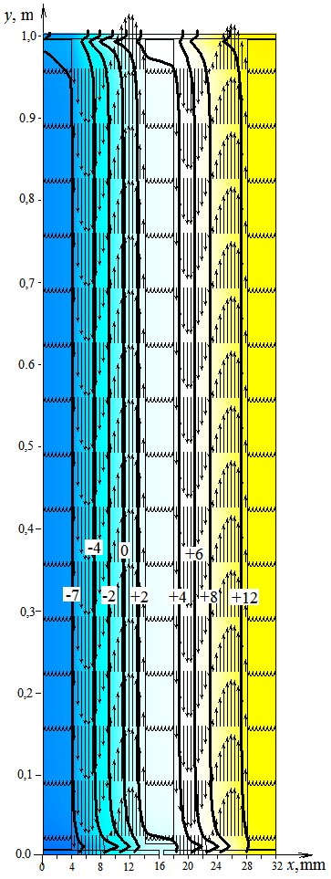 | 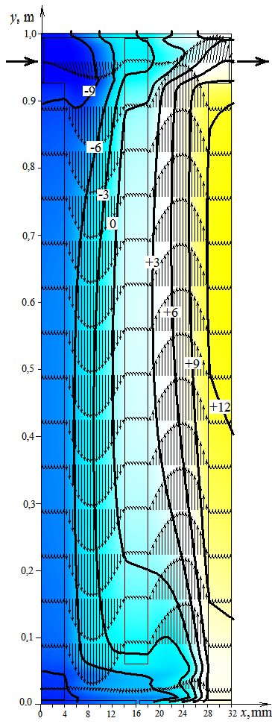 | 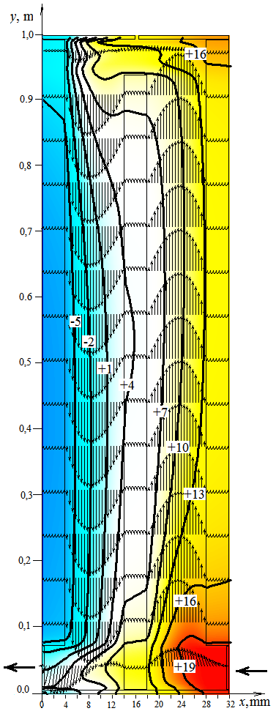
a) b) c)
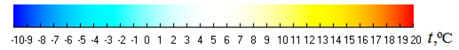
Fig. 1. Temperature field (°C) and air velocity directions in vertical sections of a conventional double-chamber window (a), a double-chamber window through which external ventilation air enters (b), and a double-chamber window through which air is removed from the room (c)

In the chambers of ventilated double-chamber windows, the air flow is mainly forced with a slight influence of free convection. In the outer chambers of ventilated double-chamber windows, the air flow is downward, and in the inner chambers, it is upward. From the comparison of the temperature fields, it can be seen that in a ventilated double-chamber window, through which air enters from the environment, the temperature values are generally lower (Fig. 1b) than in a conventional double-chamber window (Fig. 1a), and in a ventilated double-chamber window, through which air is removed from the room, they are higher (Fig. 1c) than in a conventional double-chamber window.
The difference in the characteristics of the air flow in the chambers of the double-chamber windows is also visible in Fig. 2, which shows a comparison of the vertical velocity distributions along the thickness of a conventional double-chamber window (Fig. 2a) and a ventilated double-chamber window through which outside air is supplied (Fig. 2b).
As illustrated in Fig. 2a, the air flow within the chambers of the conventional double-glazed unit is characterised by the aforementioned upward and downward circulation driven by free convection. In contrast, the air velocity distribution across the channel width in a ventilated double-glazed unit (Fig. 2b) closely resembles the profile expected during forced flow in a slotted channel.
Quantitatively, the maximum velocity magnitude of the free convection flow in the conventional unit under these conditions does not exceed 0.021 m/s. However, when air is supplied to the double-glazed unit at an inlet velocity of 0.02 m/s, the maximum velocity of the resulting forced air flow within the chamber rises significantly to 0.214 m/s (Fig. 2b). The velocity distribution across the channels of the double-glazed unit used for air removal from the room exhibits a similar profile to that shown in Fig. 2b.

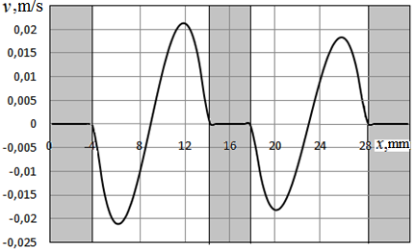
a)
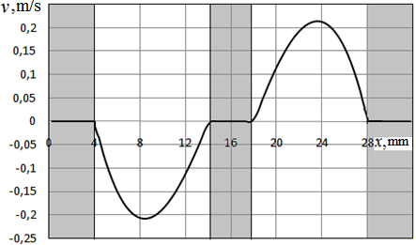
b)
Fig. 2. Distribution of vertical velocity along the thickness of a conventional double-chamber window (a) and a double-chamber window through which external ventilation air is supplied (b)

The temperature distributions along the width of a conventional double-chamber window and a ventilated double-chamber window through which outside air is supplied are presented in Fig. 3a.
As shown in this figure, the temperature distributions for both cases are similar. However, the temperature values for a ventilated double-chamber window are lower because that outside air with a temperature of t_{a,ext} = -10.0°С enters the double-chamber window.
A comparison of the temperature distributions along the width of a conventional double-chamber window and a ventilated double-chamber window through which air is removed from the room is presented in Fig. 3b. It can be seen from this figure that the temperature values in the double-chamber window through which air is removed from the room are higher than in a conventional double-chamber window, which is a consequence of the higher temperature in the room from which air is removed through the double-chamber window.
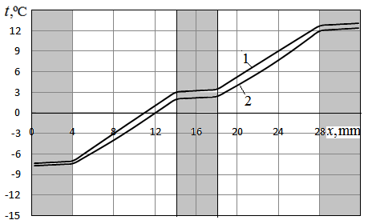
a)
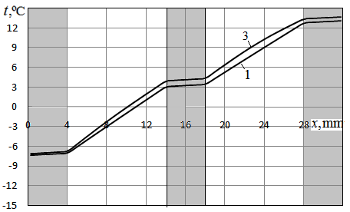
b)
Fig. 3. Comparison of the temperature distribution along the thickness of a conventional double-chamber window (curve 1) with the temperature distribution along the width of the window through which external ventilation air is supplied (curve 2 in Fig. 3a) and with the temperature distribution along the width of the window through which air is removed from the room (curve 3 in Fig. 3b)

A comparison of vertical temperature distributions on the external and internal surfaces of conventional and ventilated double-chamber windows is presented in Fig. 4. Fig. 4a compares the temperature distributions on the surfaces of a conventional double-chamber window and a double-chamber window through which outside air is supplied, and Fig. 4b compares the temperature distributions on the surfaces of a conventional double-chamber window and a double-chamber window through which air is removed from the room.
If in a conventional double-chamber window the temperature distributions on the surfaces are practically uniform, then in the case of a double-chamber window through which outside air enters, the temperature distributions on the surfaces have minima and maxima. The temperature of the outer surface of a conventional double-chamber window is approximately -7.4°C, and the temperature of the inner surface is +13... +14°C. The maximum temperature of the outer surface of a double-chamber window through which outside air enters is -7.67°C, and the maximum temperature of the outer surface of this double-chamber window is 12.67°C (Fig. 4a). That is, the temperature values of the surfaces of the double-chamber window through which the outside air is supplied are lower than the surface temperatures of a conventional double-chamber window. Fig. 4a also shows that the temperature distribution along the height of the gap through which air is removed from the double-chamber window (y > 0.93 m) is significantly uneven. The temperature of the air removed from the double-chamber window and entering the room varies within +3°C... +10°C (curve 2v, Fig. 4a).
From the temperature distributions on the surfaces of the double-chamber window through which air is removed from the room (Fig. 4b), it is clear that these distributions are also uneven. The minimum temperatures on the outer glass (-7.17°C) are observed in the middle part of the surface of this glass. The maximum temperature on the outer surface of the double-chamber window occurs in the lower part of this surface, i.e., near the gap through which air is removed from the room to the outside. The air temperature distribution along the height of this gap (y < 0.067 m) is uneven and varies from -2°C to +4°C.

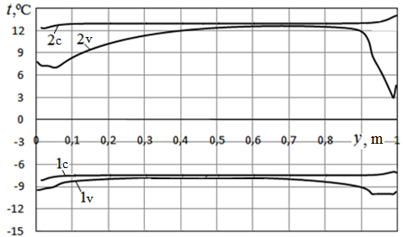
a)
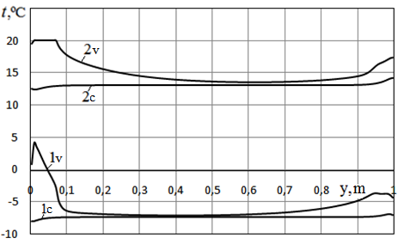
b)
Fig. 4. Comparison of the temperature distribution on the outer (1) and inner (2) surfaces of a conventional double-chamber window (curves 1c and 2c) with the temperature distribution on the surfaces of the double-chamber window through which external ventilation air enters (curves 1v and 2v in Fig. 4a) and with the temperature distribution on the surfaces of the double-chamber window through which air is removed from the room (curves 1v and 2v in Fig. 4b)

In the middle part of the inner glass, the temperature reaches its minimum value for this surface, at +13.55°C. In the upper and lower parts of the inner glass, the temperature values are higher. Comparing these temperature distributions with the distributions on the surfaces of a conventional double-chamber window, it follows that the temperature on the outer and inner surfaces of the ventilated double-chamber window, through which air is removed from the room, is higher than on the surfaces of a conventional double-chamber window.
The distributions of heat flux densities on the surfaces of a conventional double-chamber window and a double-chamber window through which outside air is supplied are shown in Fig. 5a.
The figure shows that in a conventional double-chamber window, the distributions of heat flux densities on the outer and inner surfaces are practically uniform and practically identical (q~60 W/m²) except for the lower and upper sections of the surfaces, where changes in the directions of free convection flow in the chambers of a conventional double-chamber window occur.
The distribution of heat flux on the surfaces of the double-chamber window, through which external ventilation air enters, is more complex. On the outer surface of such a double-chamber window, the distribution of heat flux is uneven and has a maximum in the middle part of the surface, q = 53.76 W/m² (curve 1v in Fig. 5a). In the upper and lower parts of the outer surface, the densities of heat flux are significantly lower.
The decrease in heat flux densities on the outer surface of the double-chamber window through which outside air is supplied, compared to a conventional double-chamber window, is explained by the fact that in the case of such a ventilated double-chamber window, due to the supply of cold air to the double-chamber window, the difference between the air temperature in its outer chamber and the temperature of the external atmospheric air decreases. Thus, compared to a conventional double-chamber window, the amount of heat removed through the outer glass is less than through the outer glass of a conventional double-chamber window.

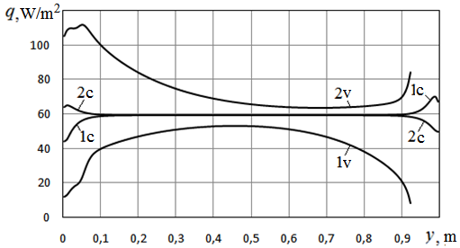
a)
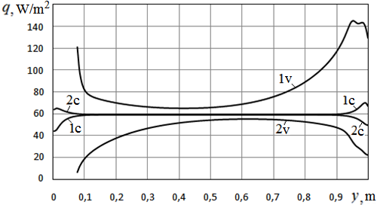
b)
Fig. 5. Comparison of the distribution of heat flux densities on the outer (1) and inner (2) surfaces of a conventional double-chamber window (curves 1c and 2c) with the distribution of heat flux densities on the surfaces of the double-chamber window through which external ventilation air enters (curves 1v and 2v in Fig. 5a) and with the distribution of heat flux densities on the surfaces of the double-chamber window through which air is removed from the room (curves 1v and 2v in Fig. 5b)

From Fig. 5a, it is also seen that the heat flux densities on the inner surface of the glass unit, through which the outside air is supplied to the room, are also distributed significantly unevenly. At the same time, these densities have maximum values (q~110 W/m²) in the lower part of the inner glass (curve 2v in Fig. 5a). Closer to the gap located in the upper part of the inner glass and through which the air is removed from the glass unit, the heat densities also increase (q~85 W/m²). The minimum values of the heat flux density on the surface of the inner glass are taken in the middle part of this surface (q~63.3 W/m²).
From the comparison of curves 2v and 2c in Fig. 5a, it follows that through the inner glass of such a ventilated double-chamber window, significantly more heat is removed from the room than in the case of a conventional double-chamber window. This is explained by the fact that the difference between the temperature of the air flowing through the inner chamber of the ventilated double-chamber window and the air temperature in the room is significantly greater than the difference between the air temperature in the inner chamber of a conventional double-chamber window and the air temperature in the room. Therefore, the amount of heat removed from the room through the inner glass of a ventilated double-chamber window is greater than the amount of heat removed from the room through the inner glass of a conventional double-chamber window.
From the comparison of the values of heat flux removed from the room through a conventional double-chamber window and a double-chamber window through which outside air enters the room, it follows that in the case of such a ventilated double-chamber window, Q_{g},_{in} = 51.71 W of heat is removed from the room through the inner glass, and in the case of a conventional double-chamber window – Q_{g},_{in} = 44.47 W, i.e. 7.24 W more heat is removed through the inner glass of a ventilated double-chamber window than through the inner glass of a conventional double-chamber window. At the same time, 30.25 W is removed through the outer glass of a ventilated double-chamber window, i.e., 14.22 W less than through the outer glass of a conventional double-chamber window.
If ventilation air with a temperature of t_{a,ext} = -10°C is supplied at a velocity of 0.02 m/s and a flow rate of G = 0.001 m³/s directly from the environment, then the amount of heat entering the room with this air is equal to Q_{a,ext} = G×C_{p}×ρ_{a,ext}×(t_{a,ext} + 273) = 354 W. If ventilation air is supplied to the room through a ventilated double-chamber window, then its average temperature at the outlet from the double-chamber window is ~+5.86°C and the amount of heat entering the room with the air will be equal to Q_{a,win} = 375.46 W, i.e. 21.46 W more than in the case when ventilation air enters the room directly from the environment. So, in the case of a ventilated double-chamber window, 7.24 W more heat flux is lost from the room through the inner glass than in the case of a conventional double-chamber window, and the ventilation air brings 21.46 W more heat flux into the room than in the case of air supplied directly from the environment. Thus, if a ventilation system is present in the room, a ventilated double-chamber window is more effective.
From Fig. 5b, which compares the heat flux densities on the surfaces of a conventional double-chamber window and a ventilated double-chamber window through which air is removed from the room, it is clear that in the case of a ventilated double-chamber window, the heat flux density on the inner glass will be lower than on the surface of a conventional double-chamber window, and on the outer glass, higher than on the outer surface of a conventional double-chamber window. On the surface of the inner glass of a ventilated double-chamber window, the maximum value of the heat flux density is found in its middle part and is equal to 55.5 W/m² (curve 2v in Fig. 5b). In the upper and lower parts of the inner glass surface, the heat flux densities are lower: q ~22.6 W/m² in the upper part of the surface and q is practically zero near the edge of the gap through which air enters the glass unit from the room. On the outer glass surface, the minimum values of the heat flux density are found in its middle part and are q ~65.13 W/m². In the upper and lower parts of the outer glass surface, the heat flux densities increase and reach 144 W/m² in the upper part of the surface and 121 W/m² near the gap through which air is discharged from the glass unit to the outside (curve 1v in Fig. 5b).
The reduction in heat loss from the room through the inner glass compared to a conventional double-chamber window is explained by the fact that air enters the inner chamber at a temperature equal to the room temperature. Therefore, the difference between the air temperatures in the outer chamber of the double-chamber window and the room is smaller than in the case of a conventional double-chamber window. In the outer chamber, into which air flows from the inner chamber, the air temperature is higher than in the case of a conventional double-chamber window. Therefore, the difference between the air temperature in this chamber and in the environment increases. Heat flux through the outer glass also increases.
A comparison of the amounts of heat loss through a conventional double-chamber window and through a ventilated double-chamber window, through which air is removed from the room, indicates that in the case of a ventilated double-chamber window on the inner glass, the heat flux removed from the room is Q_{g,in} = 32.40 W, and in the case of a conventional double-chamber window – Q_{g,in} = 44.47 W, i.e. 12.07 W less heat energy is removed through the inner glass of a ventilated double-chamber window than through the inner glass of a conventional double-chamber window. At the same time, ΔQ_{g,out} = 55.10 W - 44.47 W = 10.63 W, more heat is removed through the outer glass of such a ventilated double-chamber window than through the outer glass of a conventional double-chamber window.
If, during operation of the ventilation system, air with a room temperature of t_{a,in} = +20.0°С is removed from the room at a velocity of 0.02 m/s and a volumetric flow rate G = 0.001 m³/s, then the heat loss with this air will be Q_{a,in} = G×C_{p}×ρ_{a,in}×(t_{a,in}+273) = 354.09 W. If air is removed from the room through a ventilated double-chamber window, then since the air from the room is cooled in the double-chamber window, the heat loss with this air will be smaller and will be equal to Q_{a,ext} = 331.38 W. This value of heat loss will be smaller by ΔQ_{a} = (354.09 W - 331.38 W) = 22.71 W than in the case of direct removal of air from the room to the environment. This amount of heat, ΔQ_{a} = 22.71 W, which is saved when removing internal air through the ventilated double-chamber window, compensates for the increase in dissipative heat losses (by 10.63 W) through the outer glass in the ventilated double-chamber window.
5. Conclusions
The results of numerical simulation indicate that when operating the ventilation system in a room, it is advisable to use ventilated double-chamber windows. When supplying ventilation air from the environment through the ventilated double-chamber window into the room, additional dissipative heat losses through the inner glass are compensated by an increase in the energy of the ventilation air, which is obtained from the double-chamber window. When removing exhaust air from the room through the ventilated double-chamber window, additional dissipative heat losses through the outer glass are compensated by a decrease in heat losses with the air removed from the room into the environment.

Funding. Approaches to thermophysical modeling of heat transfer in vertical ventilated flat chambers in terms of calculation methodology correspond to the content of project No. 2025.06/0054 "Absorption and prevention of the spread of electromagnetic radiation in the infrared range and creation of means for thermal masking" of the National Research Foundation of Ukraine competition "Science for strengthening the defense capability and national security of Ukraine".
This research was funded in whole or in part by the National Science Centre, Poland,
DEC-2025/09/X/ST8/00339, "Integrating photovoltaics with electrically heated windows: a pilot investigation for enhanced building energy efficiency." For the purpose of Open Access, the author has applied a CC-BY public copyright licence to any Author Accepted Manuscript AAM version arising from this submission.

Symbols  B – thickness of the glass unit,  C_{p} – heat capacity,  g – acceleration of gravity,  G – volumetric flow rate,  H – height of the glass unit,  Δh – height of the gap,  L – width of the glass unit,  p – pressure,  Q – heat flux,  q – heat flux density,  R – gas constant,  t – temperature, °C,  T – absolute temperature, K,  v – horizontal velocity,  w – vertical velocity,  y – horizontal coordinate,  z – vertical coordinate. | Greek symbols  α – heat transfer coefficient,  δ – thickness,  ε – emissivity,  λ – thermal conductivity coefficient,  μ – dynamic viscosity coefficient,  ρ – density,  τ – time.  Subscripts  a – air,  at – atmospheric,  ext – external,  in – internal,  r – radiation,  g – glass.
References
Appelfeld, D., & Svendsen, S. (2011). Experimental analysis of energy performance of a ventilated window for heat recovery under controlled conditions. Energy Build, 43(11), 3200-3207. https://doi.org/10.1016/j.enbuild.2011.08.018
Arasteh, H., Maref, W., & Saber, H. H. (2023). Energy and Thermal Performance Analysis of PCM-Incorporated Glazing Units Combined with Passive and Active Techniques: A Review Study. Energies, 16(3), 1058. https://doi.org/10.3390/en16031058
Basok, B., Davydenko, B., Pavlenko, A., Novikov, V., & Goncharuk, S. (2023). Heat Transfer Characteristics of Combination of Two Double-chamber Windows. Rocznik Ochrona Środowiska, 25, 289-300. https://doi.org/10.54740/ros.2023.031
Basok, B., Pavlenko, A., Novikov, V., Koshlak, H., Ciosek, A., & Moroz, M. (2024). Comprehensive Investigation of the Thermal Performance of an Electrically Heated Double-Glazed Window: A Theoretical and Experimental Approach. Energies, 17(17), 19961073. https://doi.org/10.1016/j.egypro.2017.09.660
Basok, B., Pavlenko, А., Novikov, V., Koshlak, H., Goncharuk, S., & Davydenko, D. (2024). Influence of Ventilation Air Supply into the Space Between Two Glass Units on the Energy Characteristics of this Transparent System. Rocznik Ochrona Środowiska, 26, 65-73. https://doi.org/10.54740/ros.2024.007
Bittar, M., Araujo, A. L. D., Almeida, O. D., Martins, T. & Sousa, M. (2025). Enhancing indoor airflow: insights on cross ventilation through CFD simulations. Ambiente Construído, 25, 137844.
Buyak, N., Deshko, V., Bilous, I., Pavlenko, A., Sapunov, A., & Biriukov, D. (2023). Dynamic interdependence of comfortable thermal conditions and energy efficiency increase in a nursery school building for heating and cooling period. Energy, 283, 129076. https://doi.org/10.1016/j.energy.2023.129076
Carlos, J. S., Corvacho, H., Silva, P. D., & Castro-Gomes, J. P. (2011). Modelling and simulation of a ventilated double window. Applied Thermal Engineering, 31(1), 93-102. https://doi.org/10.1016/j.applthermaleng.2010.08.02
Carlos, J. S., Corvacho, H., Silva, P. D., & Castro-Gomes, J. P. (2010). Real climate experimental study of two double window systems with pre-heating of ventilation air. Energy and Buildings, 42, 928-934.
Davydenko, B. V. (2008). Tridiagonal Matrix Method for Solving Grid Equations of Hydrodynamics. Eastern – European Journal of Enterprise Technologies, 5(35). 7-11.
Feng, Y.-Q., Lv, M.-L., Yang, M., Ma, W.-X., Zhang, G., Yu, Y.-Z., Wu, Y.-Q., Li, H.-B., Liu, D.-Z., & Yang, Y.-S. (2022). Application of New Energy Thermochromic Composite Thermosensitive Materials of Smart Windows in Recent Years. Molecules, 27(5), 1638. https://doi.org/10.3390/molecules27051638
Gan, Daiwei, Junbing, Pan, Jiazhong, Xu, Rongli, Li, Yuhua, Luo, & Xin'an, Zhou. (2025). Research on the Influence of Window Structure on Indoor Ventilation Based on CFD. In 2024 6th International Conference on Civil Architecture and Urban Engineering (ICCAUE 2024), pp. 385-392. Atlantis Press. https://doi.org/10.2991/978-94-6463-688-8_40
Gloriant, F., Joulin, A., Tittelein, P., & Lassue, S. (2021). Using heat flux sensors for a contribution to experimental analysis of heat transfers on a triple glazed supply air window. Energy, 215, 119154. https://doi.org/10.1016/j.energy.2020.119154
Gloriant, F., Tittelein, P., Joulin, A., & Lassue, S. (2015). Modeling a triple-glazed supply-air window. Building and Environment, 84, 1-9. https://doi.org/10.1016/j.buildenv.2014.10.017
Gosselin, J. R., & Chen, Q. (2008). A Dual Airflow Window for Indoor Air Quality Improvement and Energy Conservation in Buildings. HVAC&R Research, 14(3), 359-372. https://doi.org/10.1080/10789669.2008.10391014
Jiang, Y., Wang, Y., Kong, D., Chen, Z., Yang, Z., Cao, N., Chi, H., Zhu, S., Zhang, Q., Zhu, J. & Zhu, B. (2025). A highly visible-transparent thermochromic smart window with broadband infrared modulation for all-season energy savings. National Science Review, 12(2), 408.
Khosravi, Sh. N., & Mahdavi, A. (2021). A CFD-based parametric thermal performance analysis of supply air ventilated windows. Energies, 14, 2420. https://doi.org/10.3390/en14092420
Koshlak, H., Borys, B., Pavlenko, A., Goncharuk, S., Davydenko, B., & Piotrowski, J. (2024). Experimental and Numerical Studies of Heat Transfer Through a Double-Glazed Window with Electric Heating of the Glass Surface. Sustainability, 16(21). 9374. https://doi.org/10.3390/su16219374
Lee, J., Park, S., & Kim, T. (2020). Development of a Ventilation System Using Window Cavity. Sustainability, 12(20), 8391. https://doi.org/10.3390/su12208391
Legendre, J., & Papadakis, G. T. (2025). Energy-efficient thermally smart windows with tunable properties across the near-and mid-infrared ranges. Nanophotonics. https://doi.org/10.1515/nanoph-2025-0219
Liu, M., Heiselberg, P. K., Larsen, O. K., Mortensen L. H., & Rose, J. (2017). Investigation of Different Configurations of a Ventilated Window to Optimize Both Energy Efficiency and Thermal Comfort. Energy Procedia, 132, 478-483.
Michaux, G., Greffet, R., Salagnac, P., & Ridoret, J.-B. (2019). Modelling of an airflow window and numerical investigation of its thermal performances by comparison to conventional double and triple-glazed windows. Applied Energy, 242(1), 27-45. https://doi.org/10.1016/j.apenergy.2019.03.029
Nakorchevskii, A. I., & Nedbailo, A. N. (2015). Influence of climatic factors on the heat transfer through ventilated two-chamber windows. Journal of Engineering Physics and Thermophysics, 88(3), 716-723. https://link.springer.com/article/10.1007/s10891-015-1241-3
Pavlenko, A., Usenko, B., & Koshlak, A. (2014). Thermal conductivity of the gas in small space. Metallurgical and Mining Industry, 6(2), 20-24.
Qiu, X., Gong, M., & Kaboorani, A. (2025). A Case Study on the Energy Efficiency of Windows in Institutional and Residential Buildings. Buildings, 15(19), 3478. https://doi.org/10.3390/buildings15193478
Ragab, A., Hassieb, M. M., & Mohamed, A. F. (2025). Exploring the impact of window design and ventilation strategies on air quality and thermal comfort in arid educational buildings. Scientific Reports, 15(1), 19596.
Taynara, G. S. Lago, Kamal, A. R. Ismail, Fátima, A. M. Lino. (2019). Ventilated double glass window with reflective film: Modeling and assessment of performance. Solar Energy, 185, 72-88. https://doi.org/10.1016/j.solener.2019.04.047
Wei, J., Zhao, J., & Chen, Q. (2010). Energy performance of a dual airflow window under different climates. Energy and Buildings, 42(1), 111-122. https://doi.org/10.1016/j.enbuild.2009.07.018
Xu, X., Yan, H., Huang, J., & Liu, T. (2025). Optimization of Natural Ventilation via Computational Fluid Dynamics Simulation and Hybrid Beetle Antennae Search and Particle Swarm Optimization Algorithm for Yungang Grottoes, China. Buildings, 15(6), 937. https://doi.org/10.3390/buildings15060937
Zhang, C., Cheng, K., Wang, J., & Xu, X. (2016). Numerical evaluation of heat recovery performance of a switchable exhaust air window. Energy Procedia, 88, 738-741. https://doi.org/10.1016/j.egypro.2016.06.056

