 | Rocznik Ochrona Środowiska
 | Volume 27 | Year 2025 ISSN 2720-7501 | pp. 677-684
 | https://doi.org/10.54740/ros.2025.054 open access
 | Received: September 2025 Accepted: October 2025 Published: November 2025

The Influence of Machining Conditions and Burnishing on the Surface Properties
of 41Cr4 Steel in the Context of Minimizing Environmental Impact
Jarosław Chodór^{1*}, Agnieszka Kułakowska², Lukasz Bohdal³, Kinga Olewińska
¹Department of Mechanical Engineering, Koszalin University of Technology, Koszalin, Poland
https://orcid.org/0000-0001-7153-7946
²Department of Mechanical Engineering, Koszalin University of Technology, Koszalin, Poland
https://orcid.org/0000-0001-5506-5440
³Department of Mechanical Engineering, Koszalin University of Technology, Koszalin, Poland
https://orcid.org/0000-0002-8085-9530
*corresponding author's e-mail: jaroslaw.chodor@tu.koszalin.pl
Abstract: This paper verifies the technological parameters of the sliding burnishing (SB) and turning processes. The sliding burnishing and turning processes are characterized, accounting for the effects of technological parameters on surface roughness Ra. Experimental studies of sliding burnishing and turning with established parameters are performed. The processes are analyzed and described in detail. Conclusions are drawn indicating the potential use of turning and sliding burnishing in finishing.
Keywords: smooth sliding burnishing, turning, technological parameters, technological process, surface roughness
1. Introduction
Modern technological processes in the engineering industry must meet growing demands not only for the quality of manufactured components, but also for sustainability and environmental protection. Faced with global challenges of reducing CO₂ emissions, limiting energy consumption, and minimizing industrial waste, attention is increasingly being paid to technologies that combine high machining efficiency with low environmental impact. Modern finishing methods, such as sliding burnishing, are gaining particular importance in this context and are increasingly used as alternatives or complements to traditional machining, including turning and milling.
Numerous studies have shown that appropriately selected turning parameters, especially when using modern cooling methods such as MQL (Minimal Quantity Lubrication) with the addition of nanofluids, can significantly reduce energy consumption and simultaneously improve the quality of the machined surface (Abbas 2019, Sahinoglu 2025). However, it is precisely sliding burnishing that shows the greatest potential for simultaneously improving surface functional properties and reducing environmental impact. This technology, which involves local plastic deformation of the surface layer, leads to reduced roughness (Ra, Rz), increased microhardness, the introduction of favorable compressive stresses, and improved corrosion and wear resistance (Kebede et al. 2022, Swirad et al. 2023, Kluz et al. 2021). Importantly, this procedure does not require the use of cooling or lubricating fluids, thereby significantly reducing environmental impact.
Research conducted on structural steels such as 41Cr4, 42CrMo4, and C45 confirms that sliding burnishing, both classic ball and diamond, improves tribological and fatigue properties, which translates into longer durability of machine components and less frequent need for replacement (Maximov et al. 2020, Grzesik 2012). This process, therefore, aligns perfectly with the assumptions of the circular economy and sustainable production, making it an interesting alternative to conventional finishing technologies.
The article compares the roughness parameters of shafts made of 41Cr4 steel after turning and burnishing. Comparing surface roughness after turning and after sliding burnishing is intended to assess the effectiveness of the burnishing and turning processes and to analyze their impact on surface quality and surface layer properties. Comparing roughness allows us to assess the hardening and densification effects of sliding burnishing, and comparing roughness after turning and burnishing allows us to predict how the component's performance will change during operation (e.g., its durability). Furthermore, such a comparison will allow us to select the best possible technological parameters for both types of processing.

2. Experimental Study of the Influence of Smooth Sliding Burnishing (SB) on the Value
of the Ra Parameter
Sliding burnishing is a cold forming process with well-understood operating principles and defined technological parameters. Thanks to its long-standing industrial application and reproducible quality results, it is considered a stabilized machining process. This process is characterized by high repeatability of results, especially in terms of surface roughness and strengthening. Therefore, the Ra roughness parameter was selected as the reference point for both treatments.
The SB parameters were determined based on (Przybylski 1987) for unhardened steels 40H (41Cr4) with a hardness of 180-350 HB in the following range:
• the radius of the diamond burnishing element r was 2.5-3.5 [mm]; r = 3.5 [mm] was assumed, for the experiment, the radius r was calculated from the formula r = 4.9 - 0.0055 [HV] = 3.44 [mm],
• burnishing force F: 120-250 [N],
• feed f: 0.03-0.08 [mm/rev],
• velocity V: 0.66-2 [m/s], the study adopted V = 1 [ m/s].

The surfaces before burnishing were prepared by turning on a CNC NEF 400 machining center. The steel hardness is 25 [HRC], 252 [HB], 265 [HV]. The Ra roughness parameter after turning was, on average, Ra = 1.4 [μm]. The number of tests and correlations between the burnishing force F and the feed f were determined using the Experiment Planner computer program.

Finish turning was used as a pre-burnishing treatment. For turning as a pretreatment, the following parameters were used:
• feed f = 0.08 [mm/rev],
• depth of cutting a_{p} = 1.5 [mm],
• rotational speed n = 2000 [rev/min],
• cutting velocity v_{c} = 307.72 [m/min].

The turning process was performed using a PF-4 WAP01 10, 20 tool. The radius r and the degree of wear of the diamond burnishing element were checked using a Werth VideoCheck IP 250 measuring device. The test resulted in r = 3.4 [mm]. The burnishing element was qualified for use in the test after determining that the measured r was within the specified range and its shape did not deviate from the nominal.
The tests were performed on 41Cr4 (40H) steel cylindrical samples with the dimensions shown in Fig. 1. The cylindrical samples were pre-turned to prepare the surface for burnishing. Using a 3.15 type center drill, holes were drilled to ensure proper coaxial support of the workpiece in the machine's tailstock. The cylindrical roller was divided into nine work areas. After mounting the roller in the machine's spindle, a lubricant in the form of machine oil was applied to its surface.

Fig. 1. Drawing of the sample used in the research. Source: own studies

Burnishing was performed using a tool manufactured by the Institute of Mechanical Engineering and Technology in Krakow (Fig. 2). Surface smoothing is achieved by the elastic pressure of the diamond burnisher against the surface of the rotating shaft.
During tool assembly, special attention was paid to the precise alignment of the burnisher's axis with the lathe spindle. The burnishing tip was manufactured from a diamond composite with a Ti₃SiC₂ ceramic binder. The burnishing tip features an innovative solution consisting of bonded burnishing tips, replacing the commonly used soldering technique.
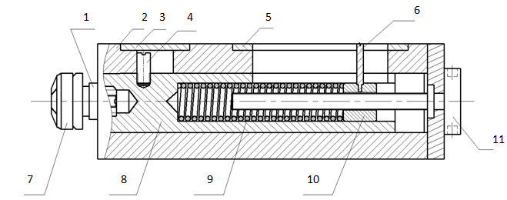
Fig. 2. Schematic diagram of a burnishing tool: 1) lock nut, 2) body, 3) blanking plate, 4) stop pin, 5) scale plate, 6) scale slider, 7) burnishing head, 8) guide shaft, 9) compression spring, 10) retaining nut, 11) adjusting screw. Source: own study

The burnishing force was set using the adjusting screw 11 (Fig. 2). The force value was read from the scale, where it was determined by the position of the pointer 6 on the millimeter scale. The slider position corresponds to the deflection of the compression spring 9. The translation of force F in [N] to the position of the slider 6 on the scale in [mm] was determined based on the graph (Fig. 3).

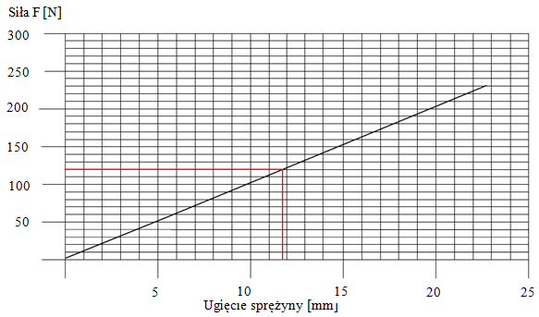
Spring deflection [mm]
Force F [N]
Fig. 3. Graph of the conversion of force F in [N] to the deflection of the compression spring in [mm]. Source: own study

Burnishing was performed using a tip with a radius of r = 3.5 [mm]. Prowadol VG 68 oil was used as the lubricant during the burnishing process, distributed as an oil film over the machined surface.
The test area was determined based on literature analysis, and for the conducted experiment, it was:
• X1 = F: 120-250 [N], burnishing force,
• X2 = f: 0.03-0.08 [mm/rev], feed.

Table 1 summarizes the Ra parameters obtained via SB, along with the technological parameters used, and lists the corresponding Ra profile graphs (Fig. 4). The read values were single measurements. During surface roughness measurement, an elementary section of lr = 0.8 [mm] and a measuring section of ln = 4 [mm] were used.

Table 1. Experiment plan and summary of the results obtained Ra
No. | Burnishing Force F [N] | Feed f [mm/rev] | Ra [µm] | Fig. 4.
1 | 139 | 0.0373 | 1.3 | a
2 | 139 | 0.0727 | 1.3 | b
3 | 231 | 0.0373 | 3.7 | c
4 | 231 | 0.0727 | 1.0 | d
5 | 250 | 0.0550 | 11.5 | e

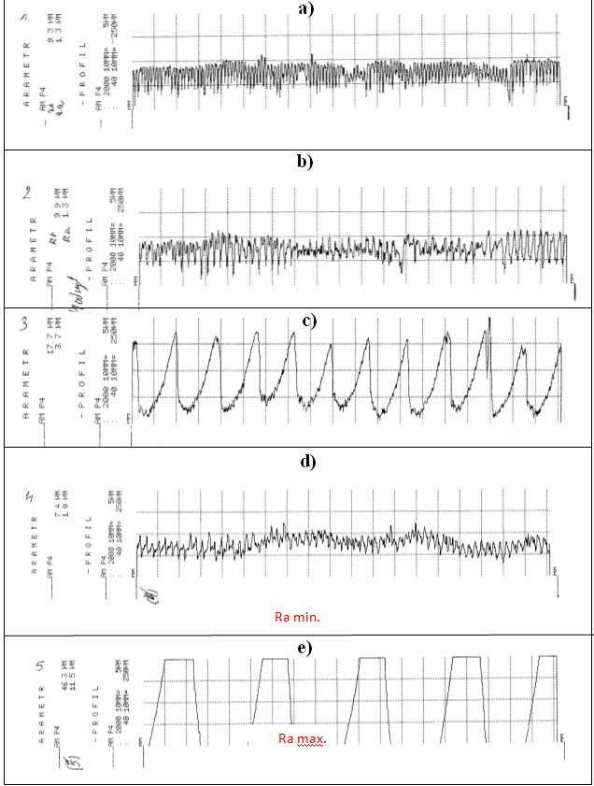
Fig. 4. Summary of Ra parameter graphs, sample working areas (according to technological parameters – Table 1):
a) Ra = 1.3 [µm], b) Ra = 1.3 [µm], c) Ra = 3.7 [µm], d) Ra = 1.0 [µm], e) Ra = 11.5 [µm]. Source: own study

Figure 4 presents a summary of the Ra parameter graphs for the individual working areas of the sample. The sliding burnishing performed did not produce the expected high surface quality. In each case, across various NŚ setting parameters, significant deterioration in surface quality and increases in Ra values were observed compared to the surface parameters after the preceding treatment. Surface quality deterioration occurred with increasing force F. At a maximum force of F = 250 [N], significant scuffing of the material occurred in the area of contact with the tool, manifested by a characteristic sound. At the same time, a noticeable vibration from the burnishing tool was observed, resulting in the experiment on sample 5 being discontinued.
The surface condition after burnishing with the highest force indicates the presence of vibrations in the OUPN system, as confirmed by literature analysis (Korzynski 2007). Applying a force F that is too high causes material separation from the machined surface, which is highly unfavorable.
Presumably, one of the causes of the described disruptions in the burnishing process is the imprecise method of lubricant application. In the study, the lubricant was applied directly to the machined surface with a brush. The method used likely does not ensure uniform lubrication across the entire machined surface. The uneven lubrication of the contact surface between the burnishing tip and the machined surface likely contributed, among other factors, to the described vibrations.
Burnishing with the lowest force, F = 120 [N], gave the lowest roughness Ra = 1.0 [µm]. Changing the feed value f for the same force F did not significantly affect the Ra value.
For F = 139 [N] and f = 0.0373 [mm/rev] and F = 139 [N] and f = 0.0727 [mm/rev], the roughness reached the same value of Ra = 1.3 [µm]. The obtained Ra results for different feed rates differ significantly from the literature data (Przybylski 1987, Chodor 2011, Korzynski 2007). where the dependence of Ra on the feed rate is clearly indicated. It should be noted that the literature data often concern tests conducted on materials other than 41Cr4 steel or on different heat-treatment states of the steel. Most studies show a relationship indicating an increase in roughness Ra with increasing feed rate f.
Based on experimental studies of the SB process, it was found that it is challenging to precisely determine the parameters required to achieve the desired surface quality. In the experiment, applying the literature guidelines for process parameter settings resulted in a deterioration of Ra parameters from 7 [%] to 1725 [%].
Technological parameters and interfering factors influence the process. It is impossible to eliminate the influence of interfering factors on the process and its outcome. However, efforts should be made to minimize the effects of this unfavorable phenomenon.
In the case of sliding burnishing, the desired effect can be achieved by:
• using equipment and tools in good technical condition,
• applying pretreatment that results in determined surface irregularities,
• uniform application of the lubricant,
• using a lubricant with appropriate properties,
• precise and stable clamping of the workpiece,
• process control based on the operator's appropriate qualifications.
The study clearly demonstrated the effect of burnishing force F on surface roughness. Increasing force F to Fmax = 250 [N] resulted in a deterioration of surface quality, achieving R = 11.5 [µm]. The roughness parameters obtained from burnishing indicate that the process was not performed correctly.
To achieve high surface quality for 41Cr4 steel using SB, significantly lower forces than those used in the experimental studies should be used. It should be emphasized that the study was conducted for a specific steel grade, which precludes drawing definitive conclusions regarding the effect of force F on surface roughness for other materials. Characteristic vibrations of the burnishing tool may indicate a faulty design or looseness in the OUPN system. Defining the cause of the vibrations requires additional analysis and investigation.
3. Experimental Studies of the Influence of Technological Parameters of the Turning Process on the Value of the Ra Parameter
The cutting tool used was a PF-4 WAP 01 10.20 cutter. The range of variation for the tested factors was determined as follows:
• longitudinal tool feed f = 0.12-0.32 [mm/rev],
• shaft peripheral speed v_{c} = 250-340 [m/min] => 4.2-5.67 [m/s].
To conduct the actual research, a five-level rotatable compositional plan (5LRotExp) was used. This plan allows for the identification of nonlinear objects described by second-order functions. The program was used to conduct identification studies, which involved conducting a specified number of experiments to determine the influence of the input factor on the object under study. Furthermore, experiments were conducted to create a mathematical model. The actual research on the turning process was conducted based on Table 2. The table summarizes the input factors and their configurations generated by the Experiment Planner program.

Table 2. The decoded experiment matrix in Experiment Planner
Uncoded experiment design matrix
No | f | v_{c} | No | f | v_{c} | No | f | v_{c}
No | [mm/rev] | [m/min] | No | [mm/rev] | [m/min] | No | [mm/rev] | [m/min]
No | A | B | No | A | B | No | A | B
1 | 0.1493 | 263.1802 | 5 | 0.32 | 295 | 9 | 0.22 | 295
2 | 0.2907 | 263.1802 | 6 | 0.12 | 295 | 10 | 0.22 | 295
3 | 0.1493 | 326.8198 | 7 | 0.22 | 340 | 11 | 0.22 | 295
4 | 0.2907 | 326.8198 | 8 | 0.22 | 250 | 12 | 0.22 | 295
 |  |  |  |  |  | 13 | 0.22 | 295
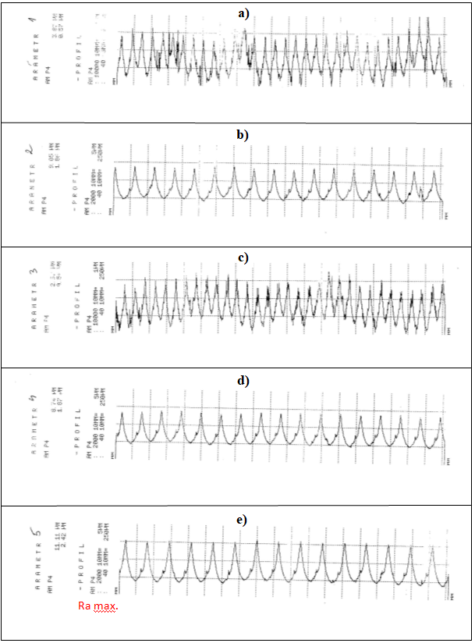
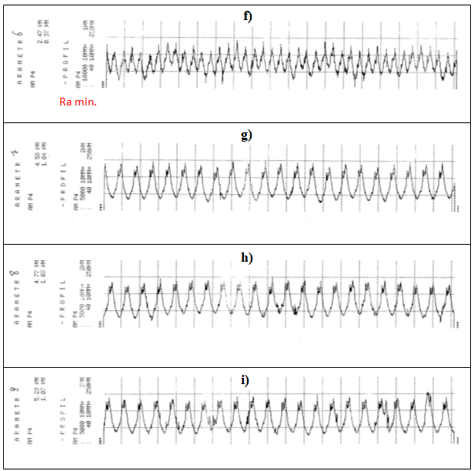
Fig. 5. Summary of graphs of the Ra parameter for individual values of technological parameters of the turning process: a) v_{c} = 263.18 [m/min], f = 0.1493 [mm/rev], Ra = 0.57 [µm]; b) v_{c} = 263.18 [m/min], f = 0.2907 [mm/rev], Ra = 1.86 [µm]; c) v_{c} = 326.82 [m/min], f = 0.1493 [mm/rev], Ra = 0.54 [µm]; d) v_{c} = 326.82 [m/min], f = 0.2907 [mm/rev], Ra = 1.87 [µm]; e) v_{c} = 275 [m/min], f = 0.32 [mm/rev], Ra = 2.42, [µm], (Ra max); f) v_{c} = 295 [m/min], f = 0.12 [mm/rev], Ra = 0.37 [µm], (Ra min); g) v_{c} = 340 [m/min], f = 0.22 [mm/rev], Ra = 1.04 [µm]; h) v_{c} = 250 [m/min], f = 0.22 [mm/rev], Ra = 1.03 [µm]; i) v_{c} = 295 [m/min], f = 0.22 [mm/rev], Ra = 1.07 [µm]. Source: own study

The model adequacy calculations were performed at the ɑ = 0.05 significance level. To assess the significance of the regression function coefficients, a Student's t-test was performed. For the selected regression function, the coefficients [0] and A have a significant impact on the outcome variables, and there is no reason to reject them. The coefficient B is not significant, as t_{i} = 1.954 < t_{α}; _{fE} = 2.220 and can be omitted.
Fig. 5 contains graphs of the Ra parameter from the measuring device. The Homel Tester T 2000 contact profilograph meter from HOMMELWERKE was used to measure the roughness. The read values were single measurements. During surface roughness measurement, an elementary section of lr = 0.8 [mm] and a measuring section of ln = 4 [mm] were used.
During the turning process, the influence of the process parameters on Ra is clearly visible. The influence of feed f is clearly visible: an increase in this value increases roughness Ra. The speed V also significantly influences the Ra value. Increasing the speed v_{c} decreases the roughness Ra.
8. Conclusions
Based on the experimental studies and literature analysis, it is possible to determine the effect of machining parameters on surface roughness after turning and sliding burnishing. The results obtained for the roughness parameters of the studied processes allow a comparison of turning and SB in terms of surface quality. Based on the conducted research, the turning process proved to be significantly more predictable than sliding burnishing. The obtained results confirm this. Experimental testing of sliding burnishing showed that the process is unpredictable in terms of expected Ra values. Applying the often divergent literature guidelines for sliding burnishing parameters does not always produce the desired surface quality. This finding makes this process particularly problematic for potential use in the production of machine parts. To precisely determine the technological parameters, experimental studies should be conducted to confirm their correct selection.
The application of literature recommendations regarding technological parameters for turning yielded significantly better results than for burnishing. Based on literature analysis and experimental studies, turning was found to be a predictable process for surface roughness. However, the minimum roughness values R obtained: turning Ra = 0.37 [µm], burnishing Ra = 0.23 [µm] allow us to conclude that SB is a competitive process compared to turning and other finishing methods. Conducting additional research and analysis on sliding burnishing will certainly contribute to the widespread adoption of this process for the manufacturing and regeneration of machine parts.
References
Abbas, A. T., Gupta, M. K., Soliman, M. S., Mia, M., Hegab, H., Luqman, M., & Pimenov, D. Y. (2019). Sustainability assessment associated with surface roughness and power consumption characteristics in nanofluid MQL-assisted turning of AISI 1045 steel. Int J Adv Manuf Technol, 105, 1311-1327. https://doi.org/10.1007/s00170-019-04325-6
Chodór, J. (2011). Modeling and analysis of the movement of the workpiece during microcutting and sliding burnishing, taking into account the nonlinearity of the process. Doctoral dissertation. Koszalin. Poland.
Grzesik, W. (2012). Functional properties of hardened steel parts generatedy turning and ball burnishing operations. Advances in manufacturing science and technology, 36(4), 5-17.
Kebede, F. T., Pásztor, I., & Felhő, C. (2022). Flat diamond sliding burnishing surface roughness investigation. Multidiszciplináris tudományok, 12, 186-195. https://doi.org/10.35925/j.multi.2022.3.17
Kluz, R., Antosz, K., Trzepieciński, T., & Bucior, M. (2021). Modelling the Influence of Sliding Burnishing Parameters on the Surface Roughness of Shafts Made of 42CrMo4 Heat‑Treatable Steel. Materials, 14(5), 1175. https://doi.org/10.3390/ma14051175
Korzyński, M. (2007). Sliding Burnishing. WNT Warsaw. (in Polish)
Maximov, J. T., Duncheva, G. V., Anchev, A. P., Dunchev, V. P., & Ichkova, M. D. (2020). Improvement in fatigue strength of 41Cr4 steel through sliding diamond burnishing. Journal of the Brazilian Society of Mechanical Sciences and Engineering, 42(4). https://doi.org/10.1007/s40430-020-02276-8
Przybylski, W. (1987). Burnishing processing technology. WNT Warsaw. (in Polish)
Sahinoglu, A. (2025). Investigation of energy consumption and surface roughness in hot work tool steel (DIN 1.2367) and cold work tool steel (DIN 1.2550). Transactions on Mechanical Engineering, 32(2). https://doi.org/10.24200/sci.2024.59724.6397
Swirad, S., Gradzik, A., Ochał, K., & Pawlus, P. (2023). Effects of the surface layer of steel samples after ball burnishing on friction and wear in dry reciprocating sliding. Scientific Reports, 13.
https://doi.org/10.1038/s41598-023-38534-7

