
 | Rocznik Ochrona Środowiska
 | Volume 27 | Year 2025 ISSN 2720-7501 | pp. 667-676
 | https://doi.org/10.54740/ros.2025.053 open access
 | Received: June 2025 Accepted: July 2025 Published: November 2025
Odours in Waste Management – Problems at Landfills
Jolanta Biegańska^{1*}, Barbara Tora²
¹Department of Hydrogen Energy, Faculty of Energy and Fuels,
AGH University of Krakow, Poland
https://orcid.org/0000-0003-2356-3247
²Department of Civil Engineering and Resource Management, Faculty of Environmental Engineering,
AGH University of Krakow, Poland
https://orcid.org/0000-0002-0850-3054
*corresponding author's e-mail: biega@agh.edu.pl
Abstract: The problem of air quality and its impact on the environment and, above all, human health has been an issue in various circles for years. Awareness of the problems associated with waste management and the negative impacts of waste processing is a crucial element in managing this sector. An important element of such activities is the odour nuisance that is perceived (signalled by complaints) in municipal waste management. A brief review of the odour-causing substances most frequently emitted, during treatment, from municipal waste landfills was carried out. The impact of odours on human health is demonstrated, and methods for assessing and quantifying these emissions are discussed. Attention was drawn to the lack of normative-legal regulations on odour nuisance.
Keywords: odours, waste, landfills
1. Introduction
The term 'odours' is not unambiguous – in everyday language, it commonly refers to an unpleasant olfactory sensation, while in environmental engineering, it denotes an 'odour'. This approach is consistent with the Latin root word, where: õdõr, õdõs means smell; (a) odour*; incense; delicacy*; (b) unpleasant odour; stench; (c) vapour; fume; whiff; breath; weathering; conjecture; guess; hunch (Kumaniecki 1977).
Similarly, in English and French, the words odour and odeur mean odour (PN 2009). Recognition of the analogous meaning of the Polish word "odour" makes it possible to call "odorants" all volatile substances that have the ability to stimulate the nerve cells of the olfactory epithelium (odorant, French substance odorante), regardless of whether they produce pleasant or unpleasant sensations (Kosmider et al. 2002).
The perception of odour as negative and repeated generates a nuisance. The nuisance caused by 'odours' (a frequent cause of complaints from residents) is undeniably related to waste management activities, particularly those involving municipal waste.
The issue of odorants is topical and forward-looking (for this group of wastes) due to projected generation volumes (Fig. 1).

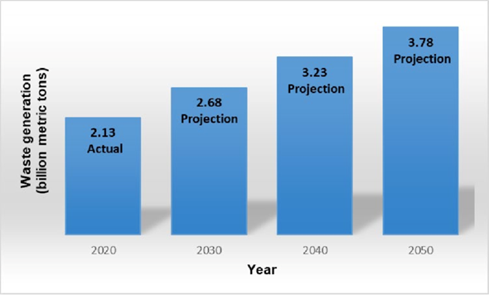
Fig. 1. Projections of global municipal solid waste production in 2030, 2040, and 2050 if urgent action is not taken (Alves 2024, Lenkiewicz 2024)

By 2050, global municipal solid waste production is projected to increase (relative to 2020), reaching almost 3.8 billion metric tonnes. This scenario is expected if no urgent actions (procedures) are taken.
In parallel with such a vision, an increase in the odour nuisance associated with the management of such waste can be assumed. This is all the more so because, to date, Poland has no formalized legislative measures to introduce a law against odour nuisance (the so-called Odour Act); attempts have been made in this respect.
- The Act of 14 December 2012 on waste (Journal of Laws 2020, item 797) in Chapter 1, Section II specifies that waste management should be carried out in such a way that it does not cause nuisance through noise or odours (The Act 2012).
- The Regulation of the Minister of the Environment of 30 April 2013 on landfill sites (Journal of Laws 2013, item 523) states that: "landfills should be surrounded by a green belt (minimum width of 10 meters) to minimize the inconvenience associated with the operation of the landfill, including the emission of odours" (The Regulation 2013).
- The developed Code against Odour Nuisance (Polish Ministry 2016) discusses in detail, among other things, the issue of landfilling and the odour nuisance associated with it.

Regulation due to EU membership:
- Best Available Techniques Reference Document (BREF) (Pinnasseau et al. 2018),
- Best Available Techniques (BAT) conclusions for waste treatment (Commission Implementing, 2018).

These documents were implemented into the content of the Act of 27 April 2001. Environmental Protection Law (Journal of Laws 2001 No. 62, item 627) (The Act of 27 April 2001) and constitute mandatory standards for waste. Within the provisions included were solutions related to the prevention of odour emissions. The BAT conclusions provide detailed descriptions of techniques that can be used to reduce odour emissions.
Although a target of 60% recycling by 2030 has been set for the Member States of the European Union (according to the European Commission 2009), this is expected to influence the reuse of waste and thus reduce waste generation (according to the Waste Framework Directive) management forecast (Fig. 2), a large amount of municipal waste will remain untreated or end up in landfills.
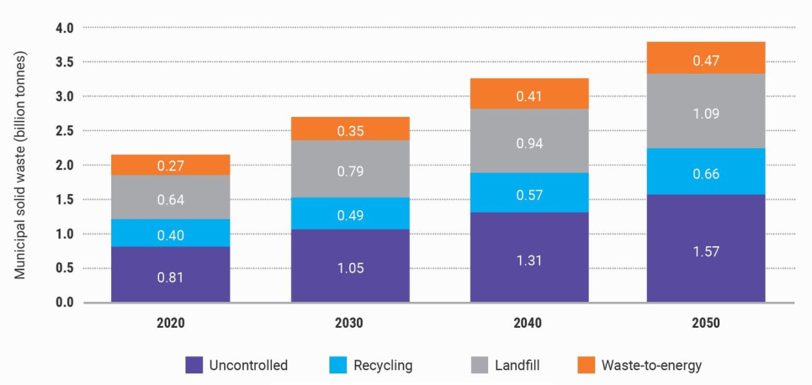
Fig. 2. Projected municipal solid waste management methods in 2030, 2040, and 2050 compared to 2020 (Storck 2024)

Based on such a scenario, it is not difficult to predict the health impacts associated with odour nuisance during the stage of inadequate waste management.
2. Sources of Odour Nuisance
In the case of municipal waste management, several phases are distinguished: collection, transport, processing, and disposal (Fig. 3). Disposal can be carried out through mechanical-biological treatment, composting, landfilling, and incineration. Each of these activities can be a source of odours, and the increase in the amount of waste generated necessitates an increase in the number of treatment and disposal facilities, which in turn can exacerbate excessive odour emissions.
Fig. 3. Simplified diagram of the waste management system (Jońca et al. 2022, Di Foggia et al. 2021, Jakubus 2021, Mohammadi et al. 2019, Pharino 2017)

Waste management is a multi-stage process, during which odours can be released at almost any stage. The primary source of emissions in this case is the organic waste fraction present in municipal waste (Boer et al. 2010, Chen 2018). They are a key source of odour emissions resulting from biological decomposition (Bruno et al. 2007, Sonibare et al. 2019).
Such processes produce a complex mixture of different chemical compounds. For example, 460 substances have been identified in the gases generated in a wastewater treatment plant, of which 100 are odours (Szymański et al. 2015).
When considering the percentage share of individual waste management systems (Fig. 4), it is evident that the landfill system and its various variants hold the advantage.

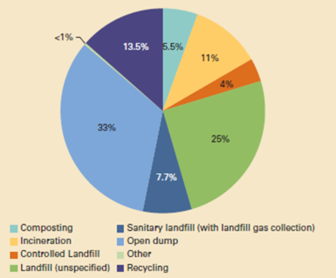
Fig. 4. Trends in global municipal waste treatment and disposal (Kaza et al. 2018)

Given the high proportion (over 60%) of landfill techniques (controlled landfill, unspecified, open), it is appropriate to identify the sources of odours in this method of municipal waste management.
In the landfill, decomposition stages of organic compounds involving microorganisms with varying degrees of odour emissions occur in the waste mass:
- Aerobic phase I – negligible nuisance of substances released,
- Anaerobic phase II – unpleasant-smelling products are produced,
- Acetogenic phase III (acetogenesis) – foul-smelling products (the most troublesome compounds) are released,
- Methanogenic phase IV – the gas produced contains substances with an unpleasant odour.
Depending on the proportion of gaseous odour components, landfill gas oscillates from moderately sweet to sour, bitter, and pungent.
The chemical composition of some fragrance mixtures is given in Table 1.

Table 1. Type of most frequently emitted substances from the landfill, odour and olfactory sensing thresholds S_{PWW}*
Chemical Compound | Smell | Threshold [ppm]
Hydrogen sulphide H₂S | rotten eggs | 0.018
Methanethiol CH₃SH | pungent sulphur smell | 0.001
Ethanethiol CH₃CH₂SH | rotting vegetables | 0.0011
Pentanethiol CH₃(CH₂)₄SH | garlic | 0.000121
Dimethyl sulphide CH₃SCH₃ | rotting vegetables | 0.0023
Dimethyl disulphide CH₃SSCH₃ | rotting vegetables, disgusting | 7.787
Diethyl sulphide C₂H₅SC₂H₅ | rotting vegetables | 0.004
Butanoic (butyric) acid CH₃(CH₂)₂COOH | rancid butter | 0.004
Diethyl ether C₂H₅OC₂H₅ | irritating, sweet | 0.01
Ethyl butyrate CH₃CH₂COOCH₂CH₃ | fruity | 0.015
Butyl butyrate CH₃CH₂CH₂COO(CH₂)₃CH₃ | fruity, pineapple | 0.0048
Propyl propionate CH₃CH₂COOCH₂CH₂CH₃ | fruity, apple | -
2-Butanol CH₃(CH₂)₃OH | sweetly rancid | 0.1
n-Propylbenzene C₆H₅CH₂CH₂CH₃ | aromatic | -
*(Amoore et al. 1983, Devos et al. 1990, Zwoździak et al. 2016)

The list does not include all identifiable odorants (several other odorous substances are also cited), which are influenced by various factors: the composition of the waste, the age of the landfill, the phases of decomposition, the rate of gas production, and the nature of the microorganisms present in the waste. In general, odorants can be divided into several chemical groups: sulfur compounds, nitrogen compounds, hydrocarbons (both unsaturated and saturated), aromatic compounds, terpenes, halogenated compounds, volatile fatty acids, carbonyls, and alcohols.
Weather conditions, including wind speed and direction, temperature, air pressure, and humidity, determine the spread of odours beyond the landfill boundaries.
2.1. Health effects of odours
Odours affect the environment and can pose a risk to human health, as perceived according to the World Health Organisation (WHO) as: "Health is not merely the absence of disease, but a state of complete physical, mental and social well-being" (De Feo et al. 2013).
The adverse effects of odours resulting from human activities in waste management should also be understood in this context. Exposure to odours can affect psychological well-being, and prolonged exposure can lead to unpleasant reactions, including fear or anxiety, as well as physical symptoms such as eye irritation, headaches, nausea, and respiratory distress (Aatamila et al. 2011, National Research Council Committee on Odours, 1979).
Research (Ivanowa et al. 2020) has shown that odour-evoked responses are largely dependent on odour properties:
- Hedonic tone – a synonym for valence, which describes the extent to which we like or dislike certain stimuli,
- Intensity,
- The chemical structure of the odour and individual factors:
- Knowledge of a particular odour,
- Experience.

Factors such as the individual characteristics of the person being tested, attitudes and expectations, mood changes, stress, and conditioned associations all play a role in the response to odours.
For a detailed analysis, a model (Fig. 5) of the relationship between odor exposure, odor perception, and irritation, as well as the effects of irritation and confounding factors, was developed.
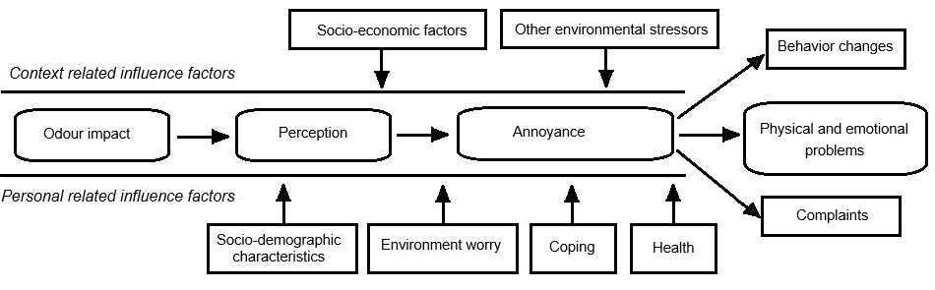
Fig. 5. A model of the relationship between odour exposure, perception, and irritation, the effects of irritation and confounding factors were developed for thorough analysis (Goshin & Budarina 2022, VDI 3883 2015, Sucker et al. 2008)

Several epidemiological studies have been published on the impact of odours on populations living in areas where businesses that emit these odours are located.
The ISI Web of Science, Scopus, and Pubmed databases contain the results of studies conducted in Western Europe, as well as in the USA and Canada (Atari et al. 2012, Bayle et al. 2018, Bull & Fromant 2014, Heaney et al. 2011, Sucker et al. 2008, 2009, Rethage et al. 2007, 2008, Herr et al. 2009, Schiffman & Williams 2005).
Conclusions from various analyses taking into account frequency, odour intensity, as well as distance from the source and concentration, did not give conclusive results, but showed a reduction in quality of life in many cases. The peak of impact was particularly felt at night (Sakawi et al. 2011).
Improper landfill management also generates other environmental damage (Fig. 6).

Fig. 6. Impact of waste disposal site on the surrounding environment (Mor & Ravindra 2023)

It has been noted that the odour impact of a municipal landfill is not only due to the decomposition of the deposited waste, but is the result of the accumulation of other factors (fires, groundwater contamination), creating adverse air quality and health risks.
Fires in wild landfills are particularly dangerous, emitting carcinogenic substances, including polycyclic aromatic hydrocarbons (PAHs), i.e., derivatives of anthracene, pyrene, and naphthalene (Cygan 2023).
2.2. Quantification of odour
For the evaluation of odorant emissions, the European standard EN 13725:2003 (PN 2007). was developed in the member states of the European Union between 1991 and 2003.
The standard describes a method for the objective determination of the 'odour concentration' of contaminants in a gaseous sample. The method involves the use of dynamic olfactometry.
The team of assessors must meet explicitly defined olfactory sensitivity criteria.
The odour unit (ouₑ) is 1 ou₍ₑ₎‧m⁻³ ≡ 40 ppb/v n-butanol.
The odour concentration corresponding to the sensing threshold is defined as 1 ouₑ/m³ – it is expressed as a multiple of the sensing threshold.
Odour intensity refers only to the magnitude (strength) of the odour sensation.
It has been shown (Leister 2002), that odour intensity follows a power function of chemical concentration according to Steven's law:
I (perceived) = k(C)ⁿ (1)
where:
I (perceived) – perceived intensity,
k – constant,
C – concentration,
n – power exponent (coefficient).

The above-mentioned law was confirmed (Amoore 1982) using a standard (n-butanol). The values of the power exponent (n) vary from 0.2 to 0.7 (Dravnikes 1972, Finger & Silver 1987). It was found, for example, that if n = 5, then the reduction in concentration is 75% (a reduction of 4 times), which will only result in a reduction in odour intensity by a factor of two.
The assessment of the character of the odour is carried out based on descriptive words or by confronting other odours. The verbal scale used in EU countries was adopted, based on the feelings of the assessors:
- no odour – 0,
- very faint odour – 1,
- faint odour – 2,
- clear smell – 3,
- strong smell – 4,
- very strong odour – 5,
- extremely strong smell – 6.

This scale was proposed based on the German standard VDI 3940 (VDI 3940, 2008).
In the case of landfill odour, the hedonic tone is usually unpleasant.
The relationship between perceived intensity and odour concentration is represented graphically as a logarithmic function – a regression line characterizes it, and its point of intersection with the axis level corresponds to the detection threshold.
3. Methods of Assessing Odour
Different methods are used to measure odour – based on mathematical analyses, instrumental measurements, sensory assessments (sensory measurements), or citizen surveys. Some methods are used to measure odours at the source of emissions, but also in the surrounding air – where residents are located and report these phenomena (citizen complaints about unpleasant sensations).
The emission measurement methods used are shown schematically in Fig. 7 (Bax et al. 2020).
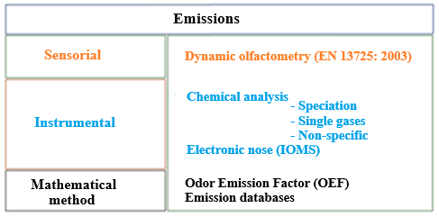
Fig. 7. Flow chart of unpleasant odor assessment methods (adapted from Bax et al. 2020)

The sensory method based on dynamic olfactometry is a standardized method (PN 2007) and can be used to verify compliance of odour concentration with regulatory limits. An instrument – olfactometer – is used for measurement. During the measurements, it is determined to what extent a sample of the tested gas should be diluted with clean air so that its odour is no longer perceptible by a group of people participating in the test.
Instrumental – chemical methods are not susceptible to human error and are among the reliable assessments.
Chemical analysis (with speciation) of odours involves the full identification of chemical compounds in an odour sample. The most common technique used for this is gas chromatography combined with mass spectrometry (GC-MS) – involves the full identification of the chemical compounds in an odour sample.
Chemical analysis of single gases (a rare case) involves the evaluation of the concentration of selected odorants, such as NH₃ and H₂S. At high concentrations (1-10 ppm), electrochemical sensors can be used for such substances. For concentrations in the ppb range, complex instruments are selected – for NH₃ determination, a chemiluminescence analyzer, and for H₂S, a gold flake analyzer (Wiśniewska et al. 2021).
Non-specific chemical analysis is usually applied for odour problems involving hydrocarbons.
The techniques used in this area include a flame ionisation detector (FID) or a photoionisation detector (PID) to assess the total amount of hydrocarbons. The total measured hydrocarbon concentration is difficult to correlate with the odour concentration.
An electronic nose is a device designed to mimic the mammalian sense of smell in detecting simple or complex odours. It consists of a sampling system, a gas sensor array that produces signals upon contact with volatile compounds, and a corresponding pattern classification system (Lu et al. 2021). The analytical signals received from the sensor arrays are processed in the following steps: data preprocessing, feature extraction, and dimension reduction, and pattern recognition algorithms.
Electronic noses provide rapid measurements, enabling continuous monitoring of the effectiveness of odour reduction systems (they are used in devices of this type) or direct determination of the effect of odour on receptors.
Mathematical methods, such as Odour Emission Factors (OEFs) and emission databases, are a simple way to predict odour emissions from a type of enterprise using one (or more) parameters (activity indicators) related to the odour emissions themselves. The activity indicator can be, for example, the area of the landfill or a unit of time (Lucernoni et al. 2016).
Some studies of the application of the OEF methodology estimate the odour emissions associated with landfill gas emitted from its surface. It has been recognized (Dincer et al. 2006, Sarkar et al. 2003, Saral et al. 2009) that landfill gas odour is the main source of nuisance odours from landfills.
In most cases, it is impossible to determine what the best method for measuring odours is – an individual approach is required. Each method has its limitations (advantages and disadvantages), and what is important is, besides the cost, the specific information that can be obtained using the method.
4. Summary
Odour nuisance related to landfilling and the transformations that take place at landfills is not an easy or straightforward issue to resolve. Firstly, there are still no clear legal regulations in this area. The issue is complicated by the variety of determination methods, which do not give unambiguous results and lead to misleading conclusions. The costs associated with testing are not insignificant.
Landfills are expected to play a crucial role in waste management in the long term, and this situation is not expected to change significantly in the future.
The variety of methods for analysing odour nuisance may make it easier to choose the most appropriate one for assessing the phenomenon of odorous emissions. Still, it seems unlikely to be the primary focus.
The efficiency of waste segregation and the proper management of landfills as engineering facilities can improve air quality in the surrounding area and thus reduce the number of complaints from residents living near such facilities.
It is reassuring that landfills are typically located away from residential areas, and thus the odour nuisance from such sources is limited.
References
Aatamila, M., Verkasalo, P. K., Korhonen, M. J., Suominen, A. L., Hirvonen, M. R., Viluksela, M. K., & Nevalainen, A. (2011). Odour annoyance and physical symptoms among residents living near waste treatment centres. Environmental Research, 111(1), 164-170. https://doi.org/10.1016/j.envres.2010.11.008
Alves, B. (2024). Global municipal solid waste generation 2020-2050. Statisa, Nov 7.
https://www.statista.com/statistics/916625/global-generation-of-municipal-solid-waste-forecast
Amoore, J. E., & Hautala, E. (1983). Odor as an aid to chemical safety: odor thresholds compared with threshold limit values and volatilities for 214 industrial chemicals in air and water dilution. Journal of Applied Toxicology, 3,
272-290. https://doi.org/10.1002/jat.2550030603
Amoore, J. E. (1982). Odor theory and odor classification. In: Fragrance chemistry: The science of the Sense of Smell. Theimer, E.T. (ed.), Academic Press, New York, 28-73.
https://api.pageplace.de/preview/DT0400.9780323138604_A23647325/preview9780323138604_A23647325.pdf
Atari, D. O., Luginaah, I. N., Gorey, K., Xu, X., & Fung, K. (2012). Associations between self-reported odour annoyance and volatile organic compounds in "Chemical Valley", Sarnia, Ontario. Environmental Monitoring and Assessment, 185(6), 4537-4549. https://link.springer.com/article/10.1007/s10661-012-2887-3
Bax, C., Sironi, S., & Capelli, L. (2020). How can odors be measured? An overview of methods and their applications. Atmosphere, 11(1), 92. https://doi.org/10.3390/atmos11010092
Bayle, S., Cadiere, A., Cariou, S., Despres, J. F., Fages, M., Roig, B., Sellier, A., Fanlo, J. L., & Chaignaud, M. (2018). Odour measurements at different methanisation sites. Chemical Engineering Transactions, 68, 79-84. https://doi.org/10.3303/CET1868014
Boer, den E., Jedrczak, A., Kowalski, Z., Kulczycka, J., & Szpadt, R. (2010). A Review of municipal solid waste composition and quantities in Poland. Waste Management, 30, 369-377. https://doi.org/10.1016/j.wasman.2009.09.018
Bruno, P., Caselli, M., de Gennaro, G., Solito, M., & Tutino, M. (2007). Monitoring of odor compounds produced by solid waste treatment plants with diffusive samplers. Waste Management, 27, 539-544.
https://doi.org/10.1016/j.wasman.2006.03.006
Bull, M. A., & Fromant, M. L. (2014). The performance of numerical odour assessment for the prediction of odour complaints from wastewater treatment works. Water and Environment Journal, 28, 316-322.
https://doi.org/10.1111/wej.12036
Chen, Y. C. (2018). Effects of urbanization on municipal solid waste composition. Waste Management, 79, 828-836. https://doi.org/10.1016/j.wasman.2018.04.017
Commission Implementing Decision (EU) 2018/1147 of 10 August 2018 establishing best available techniques (BAT) conclusions for waste treatment, under Directive 2010/75/EU of the European Parliament and of the Council. https://www.legislation.gov.uk/eudn/2018/1147/contents
Cygan, W. (2023). Long-term effects of wild landfill fires. Gazeta Uniwersytecka UŚ, 10(310), 22-23. (in Polish). https://gazeta.us.edu.pl/node/430083
De Feo, G., De Gisi, S., & Williams, I. D. (2013). Public perception of odour and environmental pollution attributed to MSW treatment and disposal facilities: a case study. Waste Management, 33(4), 974-987.
https://doi.org/10.1016/j.wasman.2012.12.016
Devos, M., Patte, F., Rouault, J., Laffort, P., & van Gemert, L. J. (1990). Standardized human olfactory thresholds. IRL Press at Oxford University Press, New York 1990. https://doi.org/10.1093/oso/ 9780199631469.001.0001
Di Foggia, G., & Beccarello, M. (2021). Market structure of urban waste treatment and disposal: Empirical evidence from the Italian industry. Sustainability, 13, 7412. https://doi.org/10.3390/su13137412
Dincer, F., Odabasi, M., & Muezzinoglu, A. (2006). Chemical characterization of odorous gases at a landfill site by gas chromatography–mass spectrometry. Journal of Chromatography A, 1122(1-2), 222-229. https://doi.org/10.1016/j.chroma.2006.04.075
Dravnieks, A. (1972). Odor perception and odorous air pollution. The Journal of the Technical Association of the Pulp and Paper Industry, 55(5), 737-742.
European Commission (2009). End-of-Waste Criteria. Joint Research Centre. Accessed: 26 January 2024
https://publications.jrc.ec.europa.eu/repository/handle/JRC53238
Finger, T. E., & Silver, W. l. (1987). Neurobiology of taste and smell. John & Wiley, New York.
Goshin, M. E., & Budarina, O. V. (2022). Methodology for assessment the impact of environmental odours on the population according to questionnaire surveys (literature review). Hygiene and Sanitation, 101(6), 615-621. https://doi.org/10.47470/0016-9900-2022-101-6-615-621
Heaney, C. D., Wing, S., Campbell, R. L., Caldwell, D., Hopkins, B., Richardson, D., & Yeatts, K. (2011). Relation between malodor, ambient hydrogen sulfide and health in a community bordering a landfill. Environmental Research, 111, 847-852. https://doi.org/10.1016/j.envres.2011.05.021
Herr, C. E. W., Nieden, Z. A., Kopka, I., Rethage, T., Gieler, U., Eikmann, T. F., & Stilianakis N. I. (2009). Assessment of somatic complaints in environmental health. International Journal of Hygiene and Environmental Health, 212(1), 27-36. https://doi.org/10.1016/j.ijheh.2008.01.003
Ivanova, S. V., Skovronskaya, S. A., Goshin, M. E., Budarina, O. V., & Kulikova A. Z. (2020). The study of the odour impact on physiological, emotional, and cognitive aspects of human health under experimental conditions (literature review). Hygiene & Sanitation, 99(12), 1370-1375. https://doi.org/10.47470/0016-9900-2020-99-12-1370-1375
Jakubus, M., & Michalak-Oparowska, W. (2021). Social participation in the biowaste disposal system before and during the COVID-19 pandemic. A case study for Poznań. Environment Protection Engineering, 47, 109-123. https://epe.pwr.edu.pl/2021/2_2021/Jakubus_2-2021.pdf
Jońca, J., Pawnuk, M., Arsen, A., & Sówka, I. (2022). Electronic noses and their applications for sensory and analytical measurements in the waste management plants-A Review. Sensors, 22, 1510. https://doi.org/10.3390/s22041510
Kaza, S., Yao, L. C., Bhada-Tata, P., & Van Woerden, F. (2018). What a waste 2.0: A Global snapshot of solid waste management to 2050. Urban Development. World Bank, Washington DC.
https://openknowledge.worldbank.org/handle/10986/30317
Kośmider, J., Mazur-Chrzanowska, B., & Wyszyński, B. (2002). Odours. Wyd. 1. Warszawa, PWN. (in Polish)
Kumaniecki, K. F. (1977). Latin-Polish dictionary, according to the dictionary H. Mengego i H. Kopii, Warszawa, PWN. (in Polish)
Laister, G. (2002). Prediction, management and control of odour from landfill sites. University of Natal, Durban. http://hdl.handle.net/10413/4874
Lenkiewicz, Z., United Nations Environment Programme (2024). Global Waste Management Outlook 2024: Beyond an Age of Waste – Turning Rubbish into a Resource. https://doi.org/10.59117/20.500.11822/44939
Lodge, Jr. J. P. (1980). Odors from stationary and mobile sources: National Research Council, National Academy of Sciences, Washington, D.C. Atmospheric Environment, 14(10), 1211-1212.
https://doi.org/10.1016/0004-6981(80)90194-8
Lu, Ch., Qing-Hao, M., Achim J, L., & Pei-Feng, Qi (2021). Development of compact electronic noses: a review. Measurement Science and Technology, 32(6), 062002. https://doi.org/10.1088/1361-6501/abef3b
Lucernoni, F., Tapparo, F., Capelli, L., & Sironi, S. (2016). Evaluation of an Odour Emission Factor (OEF) to estimate odour emissions from landfill surfaces. Atmospheric Environment, 144, 87-99.
https://doi.org/10.1016/j.atmosenv.2016.08.064
Mohammadi, M., Jämsä-Jounela, S. L., & Harjunkoski, I. (2019). Optimal planning of municipal solid waste management systems in an integrated supply chain network. Computers & Chemical Engineering, 123, 155-169.
https://doi.org/10.1016/j.compchemeng.2018.12.022
Mor, S., & Ravindra, K. (2023). Municipal solid waste landfills in lower- and middle-income countries: Environmental impacts, challenges and sustainable management practices. Process Safety and Environmental Protection, 174,
510-530. https://doi.org/10.1016/j.psep.2023.04.014
National Research Council Committee on Odours (1979). Odors from Stationary and Mobile Sources. Board on Toxicology and Environmental Hazards, Assembly of Life Sciences. National Research Council, National Academy of Sciences, Washington, DC.
Pharino, C. (2017). Challenges for Sustainable Solid Waste Management. Springer Briefs on Case Studies of Sustainable Development. Springer: Singapore. https://link.springer.com/book/10.1007/978-981-10-4631-5
Pinasseau, A., Zerger, B., Roth, J., Canova, M., & Roudier, S. (2018). Best Available Techniques (BAT) Reference Document for Waste treatment Industrial Emissions Directive 2010/75/EU (Integrated Pollution Prevention and Control). EUR 29362 EN. Publications Office of the European Union. Luxembourg. ISBN 978-92-79-94038-5.
https://publications.jrc.ec.europa.eu/repository/handle/JRC113018
PN-EN ISO 5492:2009. Sensory analysis. Terminology. (in Polish)
PN-EN 13725:2007. Air Quality-Determination of Odour Concentration by Dynamic Olfactometry. Warszawa 2007. Standard EN 13725:2003CEN: Brussels, Belgium, 2003. (in Polish)
Polish Ministry of the Environment (2016). Code against odour nuisance. Department of Air and Climate Protection. Warszawa, September 5, 2016 (in Polish). https://www.gov.pl/web/klimat/uciazliwosc-zapachowa
Rethage, T., Eis, D., Gieler, U., Nowak, D., Wiesmuller, G. A., Lacourf, M., Hodapp, V., Stilianakis, N. I., Eikmann, T. F., & Herr, C. E. W. (2008). Assessment of environmental worry in health related settings: Re-evaluation and modification of an environmental worry scale. International Journal of Hygiene and Environmental Health, 211(1-2),
105-113. https://doi.org/10.1016/j.ijheh.2007.01.030
Rethage, T., Nieden, Z. A., Eikmann, T., & Herr, C. E. W. (2007). Korperliche Beschwerden im Zusammenhang mit Geruchsbelastigungen im Wohnumfeld: Perspektiven fur eine systematische, effective Erfassung. Geruche in der Umwelt - Innenraum- und Ausenluft. Dusseldorf: VDI Verlag, 139-148.
Sakawi, Z., Sharifah, S. A., Mastura, O., Jaafar, M., & Mahmud, M. (2011). Community perception of odor pollution from the landfill. Research Journal of Environmental and Earth Sciences, 3(2), 142-145.
https://www.oalib.com/research/2568720
Saral, A., Demir, S., & Yildiz, S. (2009). Assessment of odorous VOCs released from a main MSW landfill site in Istanbul-Turkey via a modelling approach. Journal of Hazardous Materials, 168(1), 338-345. https://doi.org/10.1016/j.jhazmat.2009.02.043
Sarkar, U., Hobbs, S. U., & Longhurst, P. (2003). Dispersion of odour: a case study with a municipal solid waste landfill site in North London, United Kingdom. Journal of Environmental Management, 68(2), 153-160. https://doi.org/10.1016/S0301-4797(03)00060-4
Schiffman, S. S., & Williams, C. M. (2005). Science of odor as a potential health issue. Journal of Environmental Quality, 34(1), 129-138. https://doi.org/10.2134/jeq2005.0129a
Sonibare, O. O., Adeniran, J. A., & Bello, I. S. (2019). Landfill air and odour emissions from an integrated waste management facility. Journal of Environmental Health Science & Engineering, 17, 13-28. https://doi.org/10.1007/s40201-018-00322-1
Storck, S. (2024). EUWID Recycling and Waste Management, 06 March. https://www.euwid-recycling.com/news/policy/volume-of-uncontrolled-municipal-solid-waste-set-to-almost-double-by-2050-060324/
Sucker, K., Both, R., Bischoff, M., Guski, R., & Winneke, G. (2008). Odor frequency and odor annoyance. Part II: Dose-response associations and their modification by hedonic tone. International Archives of Occupational and Environmental Health, 81(6), 683-94. https://doi.org/10.1007/s00420-007-0262-4
Sucker, K., Both, R., & Winneke, G. (2009). Review of adverse health effects of odours in field studies. Water Science and Technology, 59(7), 1281-1289. https://doi.org/10.2166/wst.2009.113
Szymański, K., Janowska, B., & Piekarski, J. (2015). Methodological aspects of odorous substances measurement in the vicinity of a sewage treatment plant. Rocznik Ochrona Środowiska, 17, 603-615.
https://bibliotekanauki.pl/articles/1818134
The Act of 27 April 2001 Environmental Protection Law (Journal of Laws 2001 No. 62 item 627) (in Polish). https://isap.sejm.gov.pl/isap.nsf/download.xsp/WDU20010620627/U/D20010627Lj.pdf
The Act of 14 December 2012 on waste (Journal of Laws of 2020, item 797). (in Polish).
https://dziennikustaw.gov.pl/DU/2020/797
The Regulation of the Minister of the Environment of 30 April 2013 on waste landfills (Journal of Laws 2013 item 523). (in Polish). https://isap.sejm.gov.pl/isap.nsf/download.xsp/WDU20220001902/O/D20221902.pdf
VDI 3883 Sheet 1. (2015). Effects and assessment of odours – Assessment of odour annoyance – Questionnaires. VDI/DIN-Kommission Reinhaltung der Luft (KRdL) – Normenausschuss. VDI/DIN-Handbuch Reinhaltung der Luft, Düsseldorf 2015. https://www.vdi.de/richtlinien/details/vdi-3883-blatt-1-wirkung-und-bewertung-von-geruechen-erfassung-der-geruchsbelaestigung-fragebogentechnik accessed: 20.09.2023.
VDI 3940 (2010). Measurement of odour impact by field inspection – Determination of odour intensity and hedonic odour tone. VDI/DIN-Handbuch Reinerhaltung der Luft, Verein Deutscher Ingenieure e.V., Düsseldorf 2010. https://www.vdi.de/fileadmin/pages/vdi_de/redakteure/richtlinien/inhaltsverzeichnisse/1551917.pdf
Wiśniewska, M., Kulig, A., & Lelicińska-Serafin, K. (2021). The use of chemical sensors to monitor odour emissions at municipal waste biogas plants. Applied Sciences-Basel, 11(9), 3916. https://doi.org/10.3390/app11093916
Zwoździak, J., Dziewa, M., Szałata, Ł., Kwiecińska, K., Cuske, M., Piechocka, A., & Bartosik, M. (2016). List of substances and compounds that are causes of odour nuisance. (in Polish).
https://www.gov.pl/web/klimat/uciazliwosc/zapachowa

