 | Rocznik Ochrona Środowiska
 | Volume 27 | Year 2025 ISSN 2720-7501 | pp. 652-666
 | https://doi.org/10.54740/ros.2025.052 open access
 | Received: October 2025 Accepted: October 2025 Published: November 2025

Designing and Evaluating Sustainable Urban Logistics Plans
within a Stakeholder-based Framework
Emilian Szczepański
Faculty of Transport, Warsaw University of Technology, Poland
https://orcid.org/0000-0003-2091-0231
corresponding author's e-mail: emilian.szczepanski@pw.edu.pl
Abstract: In the face of growing urbanization and environmental challenges, developing effective planning tools that integrate the interests of municipal authorities, logistics operators, and local communities has become essential. This article focuses on the development of Sustainable Urban Logistics Plans (SULPs) that align operational objectives with urban policies and social expectations. The study draws on survey research and expert workshops involving representatives from public administration, academia, and the private sector. The results show broad consensus among stakeholders on the importance of delivery infrastructure, digitalization, and data integration, while highlighting differences in assessments of implementation barriers. The practical outcomes that add value to urban policy development include a logical SULP structure presented as a mind map, a set of recommendations for decision-makers, and a proposal for multi-scale Key Performance Indicators (KPIs) to support the monitoring and evaluation of urban logistics system performance.
Keywords: SULP, city logistics, urban freight planning, performance indicators, KPI
1. Introduction
Transport of goods in cities has become a key component of the modern urban fabric, significantly influencing sustainable environmental development, economic competitiveness, and the quality of life of residents (Savelsbergh & van Woensel 2016, Meryem et al. 2019, Haarstad et al. 2023). In the face of growing urbanization and the need to reduce negative environmental impacts, the demand for effective tools to manage and optimize urban logistics has been the subject of debates and research for many years. Sustainable Urban Logistics Plans (SULPs) have been introduced as strategic frameworks integrating logistics aspects with broader urban development plans, yet they are not mandatory. They aim to support efficient and environmentally friendly delivery systems while taking into account the interests of public authorities, logistics operators, and urban communities (Nuzzolo et al. 2016, Fossheim & Andersen 2017).
Urban logistics systems have a direct impact on congestion levels, pollutant emissions, noise, and the use of public space (Meryem et al. 2019, Taniguchi & Thompson 2002, Murawski et al. 2022, Jacyna et al. 2021). Despite this, urban logistics has long been marginalised in strategic mobility planning. The SULP framework aims to fill this gap by implementing a collaborative, multi-stakeholder approach (Haarstad et al. 2023, Russo & Comi 2020). However, the complexity of urban systems, the dispersion of responsibilities, and data gaps make the effective implementation and monitoring of SULPs significantly challenging. Guidelines for SULPs, such as those developed under the EGUM Project (2023) and the CIVITAS (2021), remain at a conceptual level and do not provide specific planning, implementation, or evaluation tools. In recent years, numerous attempts have been made to structure activities in the field of urban logistics. One example is the publication prepared under the CIVITAS (2021), which offers a comprehensive framework for developing Sustainable Urban Logistics Plans (SULPs). The guide outlines planning stages, examples of good practices, and integration with broader urban documents (such as Sustainable Urban Mobility Plans – SUMPs). However, like other strategic documents, it does not include concrete assessment tools, key performance indicators (KPIs), or methodologies supporting the implementation and monitoring of actions. This further emphasizes the importance of research aimed at filling these gaps and integrating the perspectives of various stakeholders in the SULP development process.
Despite the availability of models and good practices in urban logistics, there is a lack of research that systematically integrates the perspectives of key stakeholders: urban policymakers, logistics operators, and residents (Kiba-Janiak 2016, Russo & Comi 2020, Haarstad et al. 2023). Existing planning frameworks often focus either on public policy objectives or on the operational efficiency of the private sector. Meanwhile, social acceptance and behavioural conditions are crucial for the effective implementation of logistics policies (Meryem et al. 2019, Murawski et al. 2022, Baker et al. 2023, da Costa Braga França et al. 2025). In addition, there is a growing need to adapt better the KPIs used for evaluation to the realities of city operations, business activities, and social expectations (Kiba-Janiak 2016, Moufad & Jawab 2019, Bartuška et al. 2023, Les et al. 2024). Additionally, recent evidence on transport electrification planning as a lever for urban sustainability (Chamier-Gliszczyński et al. 2024), on energy-efficient operations in intermodal hubs (Kłodawski et al. 2024, Woźniak et al. 2016), and on the diffusion of green logistics practices among operators (Olkiewicz & Dyczkowska 2025), together broaden the policy-to-operations scope considered in this study.
The aim of this article is to analyse the directions of urban logistics development with consideration of the need to integrate diverse stakeholder priorities and the practical application of the SULP concept. The conducted research deepened understanding of expectations, barriers, and challenges in sustainable urban logistics planning. In particular, the study includes:
- an assessment of various perspectives on the organization of delivery processes in the urban environment,
- the identification of key barriers and needs of different stakeholder groups that should be considered during the SULP planning stage,
- and the formulation of recommendations for the development and evaluation of SULPs, including a logical plan structure presented as a mind map and a proposed set of performance indicators (KPIs).

The following part of the article includes a literature review (Section 2) focusing on the evolution of the urban logistics concept, the identification of a multi-perspective approach, and decision-support methods. Section 3 presents the research methodology. Section 4 shows the results of the empirical analyses. Section 5 provides recommendations related to the development of SULPs. The article concludes with a summary and an indication of directions for future research.
2. Literature Review
2.1. Evolution of urban logistics toward sustainable and smart management
Urban logistics is one of the key areas of contemporary transport policy, addressing the challenges arising from urbanization, the growth of e-commerce, and the pressure to reduce negative environmental impacts. Its development responds to the need to balance economic, social, and environmental interests within densely urbanized areas (Bosona 2020).
In classical approaches, urban logistics is perceived as a complex system involving multiple stakeholders, ranging from local authorities and logistics operators to enterprises and residents. Taniguchi and Thompson (2002), as well as Crainic, Ricciardi, and Storchi (2009), emphasized the necessity of integrating decisions made by different stakeholder groups and the need for flexible responses to spatial and temporal changes. In subsequent years, scientific research began to evolve toward stronger integration of planning strategies and operational tools, as highlighted by both systematic reviews (Neghabadi et al. 2018) and thematic evolution analyses using scientometric methods (Savelsbergh & van Woensel 2016, Hu et al. 2019). These studies indicate the growing importance of issues related to urban policy, sustainable development, and the use of data and digital technologies in decision-making processes.
In this context, SUMPs and SULPs play a crucial role, forming the foundation for implementing transport policies at the local level. Comparisons of national and regional approaches, presented among others by Fossheim and Andersen (2017) and Reda et al. (2020), indicate that the effectiveness of SULPs depends on the level of integration with spatial planning, the ability to coordinate stakeholders, and the institutional maturity of local authorities. A complementary stream highlights regulatory and investment drivers linked to alternative-fuel deployment and fleet transition in public transport, where structured, long-horizon electrification planning becomes a practical bridge between policy and operations. Significant contributions in this field were also made by Pan et al. (2021), who emphasized the importance of smart city technologies for implementing sustainable urban logistics systems that combine elements of the Internet of Things (IoT), data analytics, and information sharing among actors. In recent years, tools have also been developed to diagnose the "intelligence" level of urban systems, such as the conceptual Smart City Logistics Assessment Framework (SCLAF), which enables the evaluation of city maturity across four dimensions: governance, economy, stakeholders, and environment (Xenou et al. 2022).
In parallel, concepts based on knowledge management and information sharing have been developing. Iwan et al. (2024) note that the lack of integrated databases and information exchange platforms is a major limitation in planning and monitoring urban logistics. This challenge is not only technological but also organizational in nature, as it requires cross-sector cooperation and mutual trust among public administration, operators, and end users.
The social dimension of urban logistics is increasingly emphasized. Within the Logistics-as-a-Service (LaaS) approach, Beckers et al. (2023) propose involving consumers in the co-creation of logistics services via digital platforms, thereby increasing supply chain transparency and enabling more informed transport choices. A similar direction is represented by the studies of da Costa Braga França et al. (2025), who compare the perception of logistics issues across different countries, indicating that the effectiveness of implementing urban policies depends on local cultural and infrastructural conditions. At the operator level, evidence from Poland documents the scope and limits of "green logistics" adoption, including emission-reduction trajectories and strategic levers for cleaner operations (Olkiewicz & Dyczkowska 2025).
Sustainable development is becoming the overarching goal of urban logistics system planning. Modern concepts are based on the idea of balancing economic, social, and environmental interests, known as the triple bottom line (Morella et al. 2022). Les et al. (2024) introduced the synthetic indicator OEEM (Overall Equipment Effectiveness for Mobility), which allows for measuring system performance in an integrated manner. In turn, the studies by Batarlienė and Bazaras (2023) emphasize that implementing pro-environmental policies requires partnership-based cooperation between the public and private sectors, as well as an appropriate distribution of responsibilities among actors. Complementary to this, the research by Pryciński, Sierpiński, and Murawski (2023) demonstrates how the inclusion of zero-emission vehicles in transport plans enables cities to reduce their carbon footprint and improve the energy efficiency of distribution systems. Gayialis et al. (2022) show that integrating information technologies with operations research methods provides the basis for building more flexible and resilient urban systems capable of dynamically responding to changes in the logistics environment. In this context, framework documents such as the CIVITAS guides (CIVITAS, 2021) and the EGUM recommendations (EGUM Project, 2023) are also of particular importance, as they define the SULP planning process as a cycle of continuous improvement that integrates strategic, operational, and social actions.
The literature clearly indicates that urban logistics should be treated as a multi-stage process involving various actors and guided by the principle of sustainable development. The evolution of the concept — from classical system models to participatory strategies — demonstrates that effective urban logistics planning requires both integrated planning tools and mechanisms for cooperation grounded in data, knowledge, and social trust.
2.2. Methods of evaluation and decision support in urban logistics
Effective management of urban logistics requires tools that allow for an objective evaluation of the effectiveness of actions and support the decision-making process. With the development of the sustainable transport concept, the demand has increased for methods that enable the simultaneous consideration of economic, environmental, technical, and social aspects. For this purpose, various indicator systems, optimization models, simulation methods, and multi-criteria analyses are being developed.
The foundation for evaluating the effectiveness of actions in urban logistics is the use of KPIs, which make it possible to monitor changes over time and compare different solution variants. Bartuška et al. (2023) developed a methodology for selecting key indicators based on multi-criteria analysis, involving various stakeholders in the selection process. This approach provides a better reflection of the complex relationships between transport policy objectives and actual outcomes. In this context, Pajić et al. (2021) demonstrated that the appropriate selection and monitoring of KPIs in logistics processes have a direct impact on reducing operational costs. Soriano-Gonzalez et al. (2023) analysed the use of KPIs in the context of smart and sustainable cities, emphasizing the need to adapt indicators to the specifics of local mobility policies (Chamier-Gliszczyński 2012, Chamier-Gliszczyński 2012a, Dyczkowska et al. 2023). Meanwhile, the studies by Les et al. (2024) and Xenou et al. (2022) propose frameworks that integrate KPIs with SULP planning models, enabling the linkage of performance indicators to specific stages of the decision-making process. Despite progress in this area, there is still a lack of agreed-upon standards and unified evaluation methods, which makes it difficult to compare results between cities and projects (CIVITAS, 2021).
An important research trend includes optimization and simulation methods that allow for modelling complex logistics systems operating under conditions of uncertainty and dynamic change. These models are used, among other things, for route planning, fleet selection, emission assessment, and forecasting infrastructure demand. Kisielewski et al. (2024) developed a heuristic for large, heterogeneous fleets that include electric vehicles, taking into account real operational and structural constraints. Tarapata et al. (2022) applied machine learning algorithms to optimize parcel distribution in time-dependent networks, which made it possible to improve efficiency under high variability of traffic conditions. At the facility level, simulation-driven studies quantify energy implications of handling strategies (e.g., crane movement policies in intermodal terminals) linking micro-operational choices to hub energy efficiency and costs (Kłodawski et al. 2024, Woźniak et al. 2016).
In parallel, decision support methods based on multi-criteria analysis (MCA) are being developed, such as the Analytic Hierarchy Process (AHP) or optimization methods for multi-objective problems. Lasota et al. (2024) applied the AHP method to determine weights for environmental, economic, and time-related criteria, while Izdebski et al. (2024) integrated probabilistic models with evolutionary algorithms (ant colony and genetic) to plan routes for electric vehicles under uncertain access to charging points. Such approaches enable balancing conflicting criteria and are increasingly used in urban practice, particularly in last-mile delivery planning, environmental impact assessment, and fleet management. The importance of environmental factors is also confirmed by the studies of Izdebski and Jacyna (2021), who developed a hybrid algorithm to estimate the energy consumption of electric vehicles under urban conditions. The results indicate that route planning and EV fleet management can significantly reduce energy use and emissions if integrated adequately with urban charging infrastructure. In recent years, there has also been strong research development in shared systems concepts within urban logistics. Studies by Zhou et al. (2024) and Vahedi-Nouri et al. (2022) focus on collaboration between electric vehicles and operators (collaborative EVRP), proposing solutions based on hybrid models and matheuristics. These approaches align with the broader trend of integrating operational planning with the idea of sustainable development and the smart city concept. Practical decision-support tools for tour planning and delivery-bay booking have been prototyped to couple routing with time-window and curb-space allocation decisions (Comi et al. 2018), while macro-level cooperation mechanisms for joint service of multiple logistics systems show sizable efficiency gains and fleet savings (Galkin 2019, Woźniak et al. 2015).
From the perspective of applied research, simulation models are also of great importance, as they enable testing alternative implementation scenarios. In this area, for example, Zabielska et al. (2023) developed a simulation model to evaluate the efficiency of delivery processes within transport infrastructure, enabling the identification of bottlenecks and testing organizational variants. Meanwhile, the studies by Lasota et al. (2023) and Szczepański et al. (2024) show that simulation is a valuable tool for assessing the impact of different fleet configurations on pollutant emissions and energy efficiency. The integration of simulation methods with optimization and real-data analysis is also gaining importance, enabling dynamic adaptation of models to changing urban conditions.
In summary, the methods of evaluation and decision support in urban logistics are evolving toward greater integration and interdisciplinarity. The combination of KPIs with simulation, optimization, and analytical methods creates a coherent ecosystem of tools that supports both strategic planning and operational management. Their common goal is to provide city authorities and operators with reliable foundations for decision-making that enable the development of sustainable, efficient, and resilient urban delivery systems.
3. Research Methodology – Assumptions and Research Process
To examine the challenges and development directions of urban logistics from different perspectives, urban logistics workshops were held, one of which included a survey. The research approach was based on a multi-stage framework presented in Figure 1.

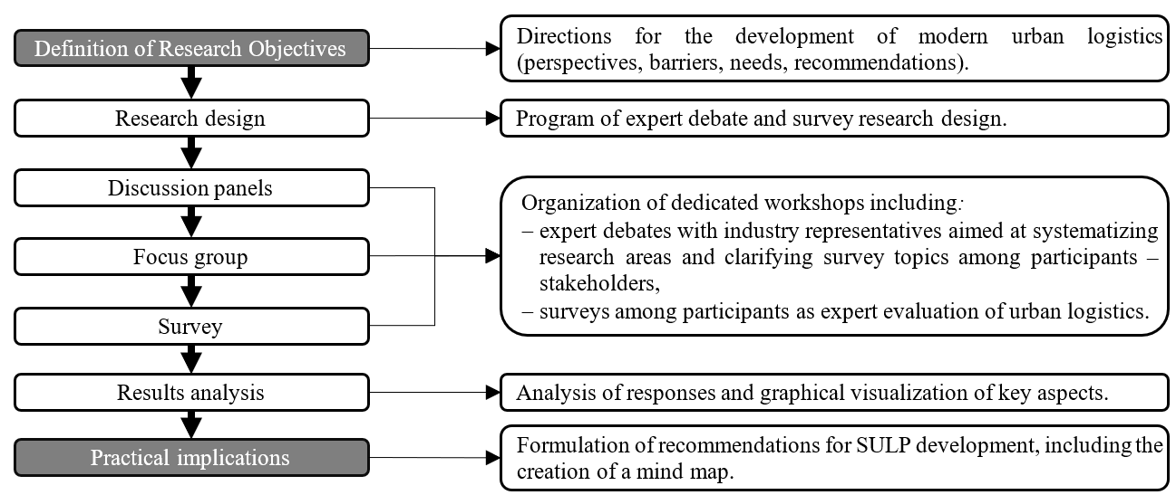
Fig. 1. Research methodology framework

In the first stage, key issues requiring exploration within the study of urban logistics development directions were identified, including planning conditions, operational challenges, and the potential for implementing modern logistics solutions in cities. Based on this, a two-track research program was developed, taking into account both the planning perspective (urban strategies, public policies) and the operational perspective (the activities of logistics operators within urban space).
Data collection was exploratory in nature and included discussion panels and survey research conducted among a focus group. Separate scenarios were prepared for both main perspectives, with their content closely linked to the survey questions. The expert panels took the form of moderated thematic debates aimed at systematizing knowledge, clarifying concepts, and identifying points of controversy. Participants included representatives of academic institutions, municipal and metropolitan administrations, and experts from courier companies, consulting firms, and the fleet management sector. The design of the discussion panel program and surveys was developed in consultation with urban logistics experts who did not participate in the workshops.
The next stage consisted of a survey of 20 participants from academia, the private sector, and public administration. The speakers on the discussion panels did not participate in the survey. The focus group, composed of stakeholders and experts, completed two questionnaires: the first on the conditions and elements of SULP planning, and the second on the challenges and needs of logistics operators (available in the dataset in an open repository; see Szczepański 2025). The surveys included questions in various formats (Likert scale, ranking, single or multiple choice) designed to capture both opinions and preferences regarding key aspects of urban logistics. The questions were directly derived from the issues discussed during the discussion panels.
The collected data were subjected to a comparative analysis combining qualitative and quantitative approaches. The analysis of results (described in detail in Section 4) enabled identification of key directions for the development of urban logistics, as well as the barriers and opportunities for implementing modern solutions. The findings were translated into specific practical implications for shaping urban logistics policy, presented in Section 5. At this stage, conclusions from the scientific literature were also used, particularly those concerning the residents' perspective, which was not directly included in the study due to the limited sample.
The conducted research is exploratory and combines qualitative and quantitative approaches, which entails certain limitations. First, the research sample was purposefully selected from among the workshop participants. The survey involved a group of 20 people representing a focus group of urban logistics stakeholders. These included representatives of academia, the private sector (logistics and consulting companies), and local administration. Although this ensured a broad range of perspectives and experiences, the sample size does not allow for full representativeness at the national or international level. However, it enabled achieving the research objectives, identifying the main challenges, and developing recommendations for shaping SULPs.
4. Discussion of Research Results
4.1. Planning perspective
The results of the SULP planning survey conducted among workshop participants are presented in Figure 2. Aggregated results are shown, while the complete survey data are available in the open repository (Szczepański 2025).
The research results confirm the growing awareness of the need for a systemic approach to urban logistics. Respondents identified freight transport optimization as the most essential priority within SULPs (40%), indicating a strong focus on improving operational efficiency. At the same time, there is a noticeable readiness to integrate logistics planning with other urban policies, primarily spatial (85% of responses) and climate policies (79%). Most respondents support shared responsibility for sustainable development, highlighting the need for cross-sectoral actions. The potential of modern delivery models was also rated highly, particularly parcel lockers, microhubs, and the integration of new business models and technological solutions such as artificial intelligence and the Internet of Things in shaping the future of logistics.
The analysis of responses makes it possible to identify several key barriers affecting the effectiveness of urban logistics:
- spatial and infrastructural barriers – 80% of respondents indicated architectural constraints as the main obstacle to deliveries, confirming the need for better spatial planning in cities with regard to logistics,
- institutional complexity – sectoral integration and policy inconsistency were identified as the most significant planning challenges, indicating the need for stronger coordination among entities responsible for transport, spatial planning, and the environment,
- non-compliance with regulations by delivery providers – as many as 80% of respondents consider rule violations to be common, with most acknowledging that the issue could be mitigated but is currently unavoidable,
- insufficient regulations – the majority of responses indicate that current legal frameworks are inadequate and require modification, particularly in the areas of access and parking.

Among the main areas for improvement that should be promoted within SULPs, the following can be identified:
- increasing the availability of parking infrastructure,
- improving traffic management,
- implementing digital tools for delivery planning,
- promoting models for shared use of infrastructure and data.

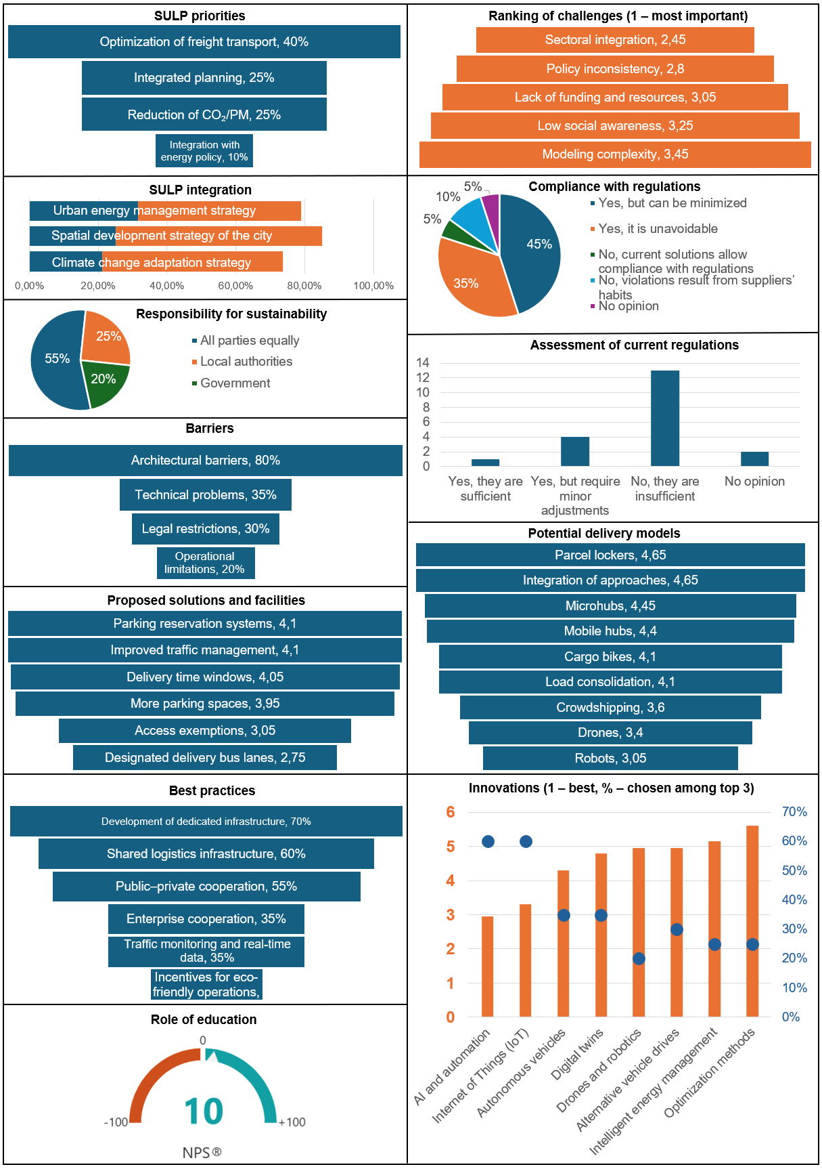
Fig. 2. Aggregated survey results – SULP planning perspective
4.2. Logistics operator perspective
The results of the survey on the operator perspective, conducted among workshop participants, are presented in Figure 3. As in the previous perspective, the results were aggregated, while the complete dataset is available in the data repository (Szczepański 2025).

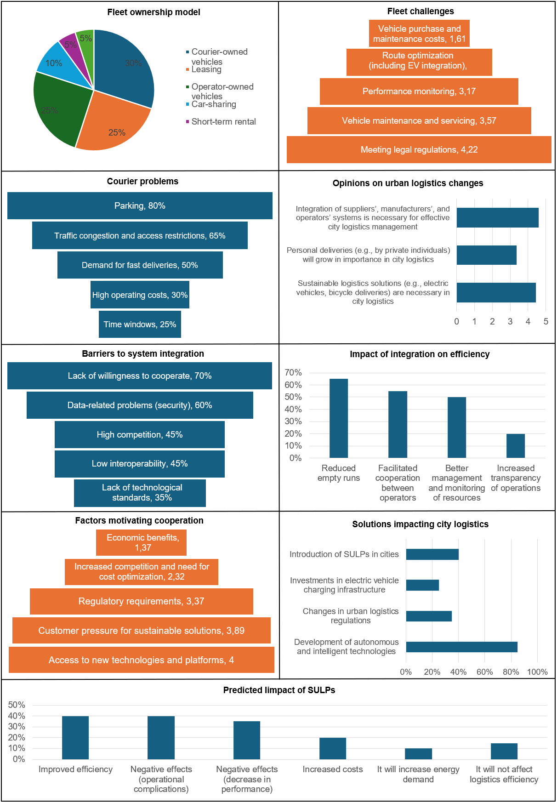
Fig. 3. Aggregated survey results – logistics operators' perspective

From the operators' perspective, the survey results reveal a diverse approach to fleet management and a growing openness to system integration and to implementing sustainable solutions. The most frequently indicated vehicle ownership model was courier ownership (30%), followed by leasing and operator ownership (25% each), indicating no dominant model and a market characterized by high operational flexibility. Respondents rated the importance of supply chain participant system integration highly (average score 4.6/5) and the implementation of sustainable logistics solutions (4.45). At the same time, less importance was placed on the development of deliveries by private individuals (3.35), indicating that operators remain cautious toward decentralized crowdshipping models. The indications concerning the future of urban logistics focus on technological innovations: 85% of respondents identified the development of autonomous and intelligent technologies as a key driver of transformation, surpassing regulatory changes or investments in charging infrastructure.
Among the main barriers and challenges faced by operators, three categories of issues were identified:
- Fleet and operational problems – the most significant were vehicle purchase and maintenance costs (average rank 1.61) and route optimization considering electric vehicles (2.33). A high level of difficulty was also observed in monitoring courier performance.
- Last-mile delivery problems – respondents most frequently pointed to parking difficulties (80%) and traffic congestion or access restrictions (65%), confirming recurring infrastructural limitations in city centres. Customer expectations for fast deliveries were also a significant challenge (50%).
- System integration barriers – the main obstacles were the lack of willingness to cooperate (70%) and data security issues (60%). High competition and the lack of system interoperability also play an important role, indicating a deficit of trust and the absence of common standards.

In the context of cooperation among operators, economic benefits were identified as the most important motivating factor (rank 1.37), significantly outweighing the influence of regulations or customer pressure. Operators particularly valued the potential to reduce empty runs (65%) and to improve resource management (50%) as key functions of integration platforms. The assessment of the impact of SULPs on operators' activities was varied:
- 40% of respondents see potential for improved efficiency,
- another 40% indicate possible complications or a decrease in performance,
- 20% expect an increase in costs.

This distribution of responses confirms operators' ambivalent attitude toward urban plans, which are perceived simultaneously as opportunities and threats.
4.3. Perspectives comparison
The research revealed significant similarities and differences between urban planners' perspectives and logistics operators' expectations and experiences. On the one hand, there is growing awareness of the need for system integration and innovation implementation. On the other hand, discrepancies emerge in the assessment of priorities and differing perceptions of barriers. The main comparative insights can be identified in the following areas:
- Action priorities – both planners and operators identify operational efficiency as a key goal. Route and freight traffic optimization received the highest ratings. However, planners place stronger emphasis on the need for integration with spatial and environmental policies, while operators focus on the practical aspects of fleet operation and infrastructure access.
- Barriers and limitations – both groups point to infrastructural problems, such as the lack of stopping areas and spatial constraints, as key limitations. Planners also highlight institutional issues and policy inconsistencies, whereas operators emphasize fleet costs, parking difficulties, and the lack of cooperation between companies.
- Needs and expectations – in both perspectives, there is a visible need for improved traffic management, the development of infrastructure for delivery providers, and the implementation of digital solutions (parking reservation systems, planning tools).

Operators also highlight the need to create platforms for cooperation and data exchange, a need that planners did not emphasize. This finding is particularly interesting, as such a data repository would be highly useful for planners in modelling and managing urban transport systems. Both groups consistently pointed to the key role of artificial intelligence, IoT, and automation in the future of logistics. However, operators are more sceptical about the direct impact of urban policies (SULPs) on the efficiency of their operations: only 40% see them as an opportunity, while an equal share anticipate complications. It should also be noted that 55% of planners expect shared responsibility among all parties to achieve sustainability, whereas operators identify financial incentives as the main driver of cooperation. The absence of a clear leadership structure may hinder the implementation of SULPs.
Additionally, considering the studies presented by França et al. (2025), which include the residents' perspective, it can be observed that planners prioritize strategy integration and environmental goals, operators focus on cost reduction and infrastructure accessibility, while residents primarily perceive safety, congestion, and emissions as key issues. Regarding barriers, operators point to a lack of cooperation and data exchange; planners emphasize policy inconsistency; and residents highlight problems such as illegal truck parking, occupation of sidewalks, and noise and pollution. Selected measures in this context, such as restrictions or infrastructure development, were also evaluated in surveys. Residents highly rate them, while operators fear higher costs and increased process complexity. This creates a risk of resistance from the industry toward tools perceived by the community as most effective. From this perspective, residents reinforce the emphasis on safety, spatial order, and environmental protection. Their perceptions often align with the planners' diagnoses but diverge from the operators' concerns (for example, access restrictions). Failure to include residents' voices in the SULP process risks a lack of social acceptance or pressure for excessive restrictions, which may escalate conflicts with the industry.
5. Recommendations in Selected Areas of SULP Development
The analysis of literature, expert debates, and survey research enabled the development of a conceptual structure of factors shaping SULPs, taking into account the main components necessary for their effective implementation and development in urban conditions. The purpose of the proposed structure is to identify the key elements that should be interconnected throughout the planning, implementation, and monitoring processes of SULPs. This structure is presented as a mind map, providing a visual representation of the recommended logic (Figure 4).
The mind map presents six interrelated areas, each centered on the core idea of the SULP framework. These areas are: strategic objectives, recommendations, barriers and challenges, priority innovations, implementation and monitoring mechanisms, and stakeholders. Each of these elements performs a distinct yet complementary function within the system for implementing sustainable urban logistics. The strategic objectives focus on improving residents' quality of life, reducing emissions, and integrating urban policies. Recommendations refer to specific infrastructure, organizational, and technological actions that support the achievement of these objectives. The identified barriers are divided into organizational, infrastructural, regulatory, and technological categories. A crucial component, addressed as a separate area, is innovation—both technological and organizational—which can support the development of efficient and environmentally friendly urban logistics systems. The success of implementing tailored plans depends on the use of appropriate implementation mechanisms, as well as on the active involvement of stakeholders in the planning, implementation, monitoring, and improvement processes of SULPs.

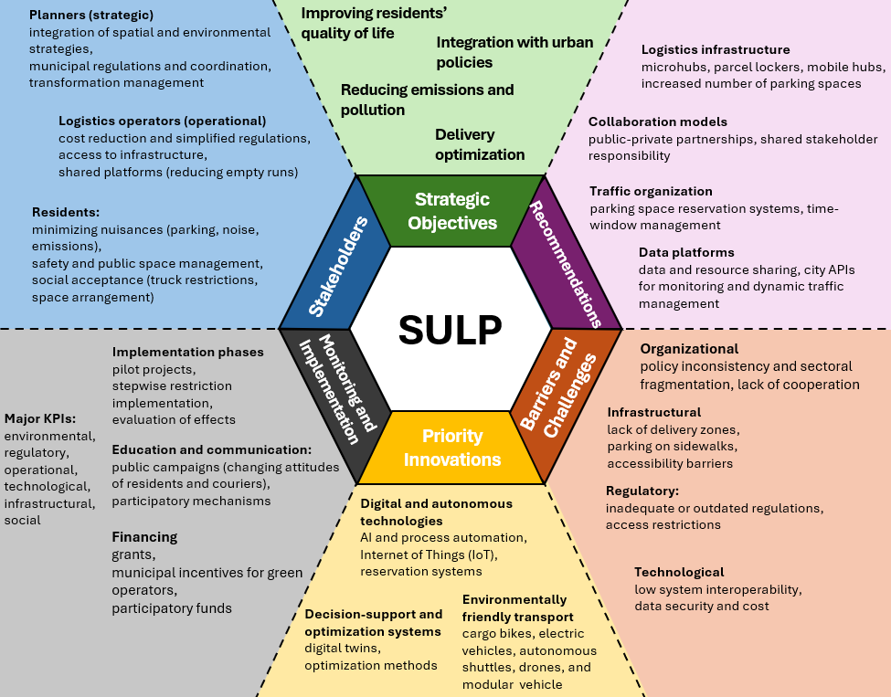
Fig. 4. SULP logic mind map

As a direct practical implication of the research, general recommendations for SULP provisions can be identified across different areas of impact, combining both planning and operator perspectives. These recommendations are presented in Table 1.

Table 1. Recommendations for shaping SULPs
Area  of Action | Recommendations | Direction | Expected Effect
Freight traffic management | Include in the plan objectives and indicators related to congestion and emission reduction through the planning of time windows, delivery zones, and traffic reorganization. | Spatial and  environmental  optimization | Improved traffic flow and reduced the negative impacts of freight transport on the city
Planning  integration | Integrate the SULP with mobility, energy,  spatial, and climate plans through shared  scenarios and investment priorities. | Cross-sectoral  coherence | Facilitates the implementation of synergistic actions (e.g., electromobility and charging infrastructure planning)
Logistics  infrastructure | Identify the location needs and technical  and functional standards for microhubs  and delivery parking zones. | Infrastructure adaptation and public space adjustment | Supports efficient last-mile logistics and reduces illegal parking
Regulations and access | Introduce unified access rules  (time-based, spatial, ecological) that consider local conditions. | Regulation  harmonization and enforcement | Facilitates delivery planning and operations while maintaining spatial order
Resource sharing and cooperation | Include tools supporting shared use of infrastructure (hubs, data, zones) and public-private partnerships. | Development of sharing models and data platforms | Increased system efficiency  and stakeholder integration
Digitalization and data | Implement monitoring systems, parking reservation tools, and traffic prediction based on city and operator data. | Process digitalization and data management | Enables real-time planning and improved operational decision-making
Technologies and innovations | Create conditions for testing and piloting innovative solutions (e.g., autonomous vehicles, AI, IoT, green fleets) in the urban space. | Moderate emphasis – stimulation of innovation rather than direct investment | The city as a catalyst and regulator of innovations consistent with sustainable development policy
Education and public communication | Include information and educational activities to raise awareness among residents and operators about urban logistics. | Increased social  acceptance | Reduced resistance to change and strengthened shared responsibility
A SULP is best understood as a dynamic framework for action rather than a static plan or policy, defined at both strategic and operational levels and adaptable to changes occurring within the urban system and to the growing maturity of its stakeholders. For this purpose, the key characteristics that the methodology for developing and implementing a SULP should possess are specified (Figure 5).

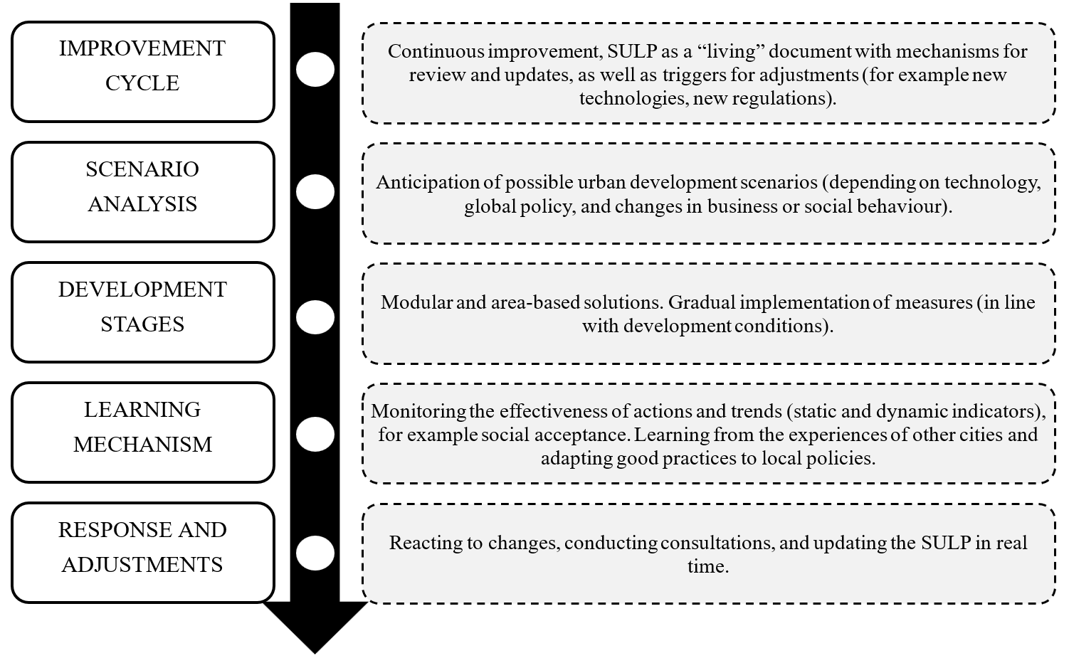
Fig. 5. Desired features in SULP development

Particular attention should be paid to the continuous improvement of urban logistics policy and to the precise definition of objectives, implementation methods (in a phased and alternative approach), and the possibility of periodic review and revision of the plan to adapt actions to the system's actual operating conditions. In this context, the proper design of performance indicators relevant to the various stakeholders of the urban logistics system is of key importance. The reference values for these indicators should serve as benchmarks for both SULP objectives and inter-city comparisons within benchmarking analyses. In the process of monitoring and evaluating progress, it is essential to use both static KPIs, which allow comparison with baseline conditions and the assessment of goal achievement, and dynamic KPIs, which enable observation of trends and directions of change in the system. At the same time, it should be emphasized that these indicators also perform a diagnostic function, identifying areas requiring adjustment and helping to determine the causes of undesirable phenomena such as increased delivery times or a rise in empty trips. Area- and type-specific examples of KPIs, developed based on the findings of this study, are presented in Table 2.

Table 2. Selected KPIs for SULP development and monitoring
 | Scale | Static | Dynamic | Diagnostic functions
  Cat.
Environmental | Macro | Total emissions of harmful substances from freight transport | Change in system-wide  emissions | Effectiveness of policies
Environmental | Meso | Emissions by vehicle type or district | Change in emissions  within zones | Areas requiring additional  regulatory measures
Environmental | Micro | Emissions per unit of cargo or delivery route | Trend in vehicle energy  efficiency | Effectiveness of EV deployment  and driver training
Regulatory | Macro | Number of violations  of delivery regulations  (access, time, routes) | Change in the number  of violations | Need for access rule revision  or increased supervision
Regulatory | Meso | Share of deliveries compliant with time windows | Compliance trend by segment | Evaluation of regulations  (acceptability, realism)
Regulatory | Micro | Number of illegal stops per task | Change in share of illegal stops | Assessment of infrastructure or regulations

Table 2. cont.
 | Scale | Static | Dynamic |  | Diagnostic functions
  Cat.
Technological | Macro | Share of fleets equipped with ITS/IoT systems |  | Change in fleet digitalization level |  | Need for innovation support
Technological | Meso | Coverage of zones by parking reservation systems |  | Trend in reservation usage |  | Assessment of operator awareness or trust
Technological | Micro | Use of GPS/ITS/IoT in individual delivery tasks |  | Change in the number of automatically reported events |  | Level of digital operational maturity
Infrastructural | Macro | Number and total area  of microhubs / loading bays |  | Growth in the number of hubs and bays |  | Degree of investment plan implementation/quality of planning
Infrastructural | Meso | Availability of logistics  infrastructure within districts |  | Trend in delivery space  turnover |  | Accuracy of location planning  or evaluation of reservation rules
Infrastructural | Micro | Availability of parking space during delivery |  | Frequency of unavailable spaces |  | Local infrastructure shortages
Operational | Macro | Average delivery time  in the city |  | Trend in delivery time changes |  | Assessment of network load  or poor zone planning
Operational | Meso | Number of deliveries  within a given segment |  | Change in efficiency |  | Direction of economic efficiency changes across segments
Operational | Micro | Duration of a single delivery |  | Delivery performance trend at specific locations |  | Recurring congestion and operational  barriers
Social | Macro | Level of residents' satisfaction with the logistics system |  | Trend in social acceptance |  | Need for communication or consultation activities
Social | Meso | Acceptance of peak-hour  deliveries within a zone |  | Trend in the share of complaints in a given zone |  | Adjustment of delivery time windows
Social | Micro | Nuisance of individual deliveries (noise, street blockage) |  | Change in frequency  of incidents |  | Local spatial problems

In addition, it is important that the indicators also correspond to the scale of the analysed process. In this classification, the following levels are distinguished: macro (city or metropolitan area level), meso (district, vehicle type, or user/freight segment level), and micro (individual task, route, or route-point level).
Moreover, given the strong interconnections between SULPs and other policies, it is worth considering indicators that assess SULP effectiveness in the areas where integration should occur. Examples include policies related to the city's energy system, where useful measures may include system-level energy consumption in urban logistics, energy use by vehicle type (electric, combustion, etc.), or energy consumption per individual delivery route.
It should be emphasized that the presented KPIs are illustrative and do not constitute an exhaustive list of possible indicators. The table can be supplemented, for example, with the works of Bartuška et al. (2023), Les et al. (2024), and Soriano-Gonzalez et al. (2023), while the selection of specific indicators should be adapted to the needs and priorities of decision-makers responsible for SULPs. It is also essential to maintain an area-based approach when developing the KPI structure, so that the indicators perform a diagnostic function and enable the identification of critical areas requiring improvement at different levels of management.
6. Conclusions and Summary
The conducted research confirmed that the overarching goal of SULPs is to simultaneously enhance delivery operational efficiency and reduce environmental impacts while maintaining spatial order. The convergence of views between planners and operators primarily concerns the need to develop curbside infrastructure (legal, accessible loading bays and microhubs), improve traffic management, and digitalize logistics processes. The implementation gap mainly stems from institutional inconsistencies, fragmented responsibilities, weak enforcement of regulations, and deficits in data interoperability and trust in information exchange.
The added value of this article lies in structuring the SULP logic (objectives–recommendations-barriers–innovations–implementation/monitoring–stakeholders) in the form of a mind map, translating it into specific regulatory, infrastructural, and operational recommendations, and proposing a multi-scale set of KPIs divided into static and dynamic indicators with a diagnostic function.
An important conclusion is the need to treat the SULP as a continuous improvement cycle, with mechanisms to trigger its revision and to implement subsequent stages and solutions. Within this cycle, attention should also be paid to the working conditions of delivery drivers and couriers (predictable time windows, legal parking spaces, minimization of unnecessary detours), along with consistent monitoring and enforcement of regulations. Delivery systems are not limited to delivery vehicles. Cargo bikes, electric bicycles, parcel lockers, and, in the future, delivery robots, drones, or modular autonomous vehicles play a significant role in urban logistics. Therefore, the SULP should anticipate pilot projects and pathways for scaling up innovations, while maintaining a realistic time horizon and clear economic incentives for operators.
Proper planning of SULPs requires integrating urban and operational data and establishing minimum interoperability and information-sharing standards. Another crucial aspect is the development of a coherent KPI framework and the standardization of measurement and reporting methods, which would enable comparable results, benchmarking, and the identification of best practices at both national and European levels.
Future research on urban policy should focus on the use of simulation and digital twins to analyse stakeholder interactions and on the development of data-sharing concepts. A comprehensive and adaptive approach to SULPs, based on cooperation, data integration, and cyclical monitoring, represents the most promising path toward creating a delivery system that is efficient, resilient, and socially acceptable.

This research was funded by the National Science Centre, Poland (project no. 2022/04/Y/ST8/00134). Project title: Energy optimal urban logistics as a service (E-Laas). Project implemented as part of the call ERA-NET Cofund Urban Accessibility and Connectivity (EN-UAC China Call) organized by JPI Urban
Europe and the National Natural Science Foundation of China (NSFC) funded from the European Union's Horizon 2020 research and innovation programme under grant agreement No 875022.
References
Baker, D., et al. (2023). Urban freight logistics and land use planning education: Trends and gaps through the lens of literature. Transportation Research Interdisciplinary Perspectives, 17. https://doi.org/10.1016/j.trip.2022.100731
Bartuška, L., Hanzl, J., Kampf, R., & Brlek, P. (2023). Indicators as a tool for assessing the level of sustainable urban freight logistics. Promet – Traffic & Transportation, 35(4). https://doi.org/10.7307/ptt.v35i4.137
Batarlienė, N., & Bazaras, D. (2023). Solutions to the problem of freight transport flows in urban logistics. Applied Sciences, 13(7), 4214. https://doi.org/10.3390/app13074214
Beckers, J., Cardenas, I., Pira, L., & Zhang, J. (2023). Exploring logistics-as-a-service to integrate the consumer into urban freight. Research in Transportation Economics, 101. https://doi.org/10.1016/j.retrec.2023.101354
Bosona, T. (2020). Urban freight last mile logistics—Challenges and opportunities to improve sustainability: A literature review. Sustainability, 12, 8769. https://doi.org/10.3390/su12218769
Chamier-Gliszczyński, N. (2012). Modeling system mobility in urban areas. Congress Proceedings, CLC 2012: Carpathian Logistics Congress, 501-508, 111467, Jesenik, Czech Republic, Tanger Ltd.
Chamier-Gliszczyński, N. (2012a). Structure analysis of system mobility in urban areas. Congres Proceedings, CLC 2012: Carpathian Logistics Congress, 509-515, 111467, Jesenik, Czech Republic, Tanger Ltd.
Chamier-Gliszczynski, N., Wyszomirski, A., Balewski, C., & Kłodawski, M. (2024). Green public transport in Poland—Planning the process of the electrification of the bus fleet of vehicles. Energies, 17(24), Article 24. https://doi.org/10.3390/en17246362
CIVITAS. (2021). Sustainable urban logistics planning: A guide for cities. European Union. https://civitas.eu/sites/default/files/sulp_guide_for_cities.pdf
Comi, A., Buttarazzi, B., Schiraldi, M., Innarella, R., Varisco, M., & Traini, P. (2018). An advanced planner for urban freight delivering. Archives of Transport, 48(4), 27-40. https://doi.org/10.5604/01.3001.0012.8363
Crainic, T., Ricciardi, N., & Storchi, G. (2009). Models for evaluating and planning city logistics systems. Transportation Science, 43, 432-454. https://doi.org/10.1287/trsc.1090.0279
da Costa Braga França, J., Kijewska, K., Iwan, S., Isler, C., & Oliveira, L. (2025). Citizens' perceptions of urban freight transport: An international comparison. Transportation Research Interdisciplinary Perspectives, 29. https://doi.org/10.1016/j.trip.2025.101342
Dyczkowska, J., Olkiewicz, M., Chamier-Gliszczynski, N., & Królikowski, T. (2023). Mobility-as-a-Service (MaaS) as a solution platform for the city and the region: case study. Procedia Computer Science, 225, 4092-4100. https://doi.org/10.1016/j.procs.2023.10.405
EGUM Project. (2023). Sustainable Urban Logistics Plan (SULP): Guidelines (Deliverable D1). EGUM Recommendations SG4 D1.
Fossheim, K., & Andersen, J. (2017). Plan for sustainable urban logistics – Comparing between Scandinavian and UK practices. European Transport Research Review, 9, 1-13. https://doi.org/10.1007/s12544-017-0270-8
Galkin, A. (2019). Mechanisms for increasing transportation efficiency using joint service of logistics systems. Archives of Transport, 49(1), 7-24. https://doi.org/10.5604/01.3001.0013.2770
Gayialis, S. P., Kechagias, E. P., & Konstantakopoulos, G. D. (2022). A city logistics system for freight transportation: Integrating information technology and operational research. Operational Research, 22(5), 5953-5982. https://doi.org/10.1007/s12351-022-00695-0
Haarstad, H., Rosales, R., & Shrestha, S. (2023). Freight logistics and the city. Urban Studies, 61, 3-19. https://doi.org/10.1177/00420980231177265
Hu, W., Dong, J., Hwang, B., Ren, R., & Chen, Z. (2019). A scientometrics review on city logistics literature: Research trends, advanced theory and practice. Sustainability, 11(10), 2724. https://doi.org/10.3390/su11102724
Iwan, S., Wagner, N., Kijewska, K., & Jensen, S. (2024). Concept of the knowledge-based city logistics: Problems and solutions. PLOS ONE, 19, e0305563. https://doi.org/10.1371/journal.pone.0305563
Izdebski, M., & Jacyna, M. (2021). An efficient hybrid algorithm for energy expenditure estimation for electric vehicles in urban service enterprises. Energies, 14(7), 2004. https://doi.org/10.3390/en14072004
Izdebski, M., Jacyna, M., & Bogdański, J. (2024). Minimisation of the energy expenditure of electric vehicles in municipal service companies, taking into account the uncertainty of charging point operation. Energies, 17(9), 2179. https://doi.org/10.3390/en17092179
Jacyna, M., Szczepański, E., Lewczuk, K., Izdebski, M., Jacyna-Gołda, I., Kłodawski, M., Gołda, P., & Gołębiowski, P. (2021). Noise pollution from transport. In R. Vickerman (Ed.), International Encyclopedia of Transportation (pp. 277-284). Elsevier. https://doi.org/10.1016/B978-0-08-102671-7.10723-7
Kiba-Janiak, M. (2016). Key success factors for city logistics from the perspective of various groups of stakeholders. Transportation Research Procedia, 12, 557-569. https://doi.org/10.1016/j.trpro.2016.02.011
Kisielewski, P., Duda, J., Karkula, M., Skalna, I., Redmer, A., & Fierek, S. (2024). Optimization of urban transport vehicle tasks for large, mixed fleet of vehicles and real-world constraints. Archives of Transport, 70(2), 65-78. https://doi.org/10.61089/aot2024.qnwb3h25
Kłodawski, M., Jachimowski, R., & Chamier-Gliszczyński, N. J. (2024). Analysis of the overhead crane energy consumption using different container loading strategies in urban logistics hubs. Energies, 17(5), Article 5. https://doi.org/10.3390/en17050985
Lasota, M., Zabielska, A., Jacyna, M., & Żak, J. (2023). Research and analysis of the operation of vehicles with various propulsion systems, including costs and CO₂ emissions. Combustion Engines, 4(195).
https://doi.org/10.19206/CE-169845
Lasota, M., Zabielska, A., Jacyna, M., Gołębiowski, P., Żochowska, R., & Wasiak, M. (2024). Method for delivery planning in urban areas with environmental aspects. Sustainability, 16(4), 1571. https://doi.org/10.3390/su16041571
Les, A., Morella, P., Lambán, M., Royo, J., & Sánchez, J. (2024). A new indicator for measuring efficiency in urban freight transportation: Defining and implementing the OEEM. Applied Sciences, 14(2), 779. https://doi.org/10.3390/app14020779
Meryem, O., Saâd, L., Mohamed, M., & Jouali, F. (2019). Review of good practices in urban freight transportation and benchmarking city logistics schemes. 2019 International Colloquium on Logistics and Supply Chain Management (LOGISTIQUA), 1-6. https://doi.org/10.1109/LOGISTIQUA.2019.8907328
Morella, P., Lambán, M., Royo, J., & Sánchez, J. (2022). Evaluating the impact of new trends in urban freight transportation attending the triple bottom line: A case study. Computers & Industrial Engineering, 174, 108756. https://doi.org/10.1016/j.cie.2022.108756
Moufad, I., & Jawab, F. (2019). A study framework for assessing the performance of the urban freight transport based on PLS approach. Archives of Transport, 49(1), 69-85. https://doi.org/10.5604/01.3001.0013.2777
Murawski, J., Pryciński, P., Sierpiński, G., & Jachimowski, R. (2022). Prospects for the development of zero- and low-emission vehicles in urban distribution systems in terms of the situation on the fuel market. Systemy Logistyczne Wojsk, 57, 41-62. https://doi.org/10.37055/slw/163229
Neghabadi, P., Samuel, K., & Espinouse, M. (2018). Systematic literature review on city logistics: Overview, classification and analysis. International Journal of Production Research, 57, 865-887. https://doi.org/10.1080/00207543.2018.1489153
Nuzzolo, A., Comi, A., Ibeas, A., & Moura, J. (2016). Urban freight transport and city logistics policies: Indications from Rome, Barcelona, and Santander. International Journal of Sustainable Transportation, 10, 552-566. https://doi.org/10.1080/15568318.2015.1014778
Olkiewicz, M. B., & Dyczkowska, J. A. (2025). Green logistics at selected logistics operators in Poland. Sustainability, 17(10), Article 10. https://doi.org/10.3390/su17104587
Pajić, V., Radivojević, G., & Kilibarda, M. (2021). Influence of KPI of logistics processes on logistics costs. International Journal for Traffic and Transport Engineering, 11(4). https://doi.org/10.7708/ijtte2021.11(4).09
Pan, S., Zhou, W., Piramuthu, S., Giannikas, V., & Chen, C. (2021). Smart city for sustainable urban freight logistics. International Journal of Production Research, 59, 2079-2089. https://doi.org/10.1080/00207543.2021.1893970
Pryciński, P., Sierpiński, G., & Murawski, J. (2023). Determination of transport plans in urban areas considering zero-emission vehicles. In G. Sierpiński, H. Masoumi, & E. Macioszek (Eds.). Challenges and solutions for present transport systems. (pp. 93-104). Springer. https://doi.org/10.1007/978-3-031-24159-8_8
Reda, A. K., Gebresenbet, G., Tavasszy, L., & Ljungberg, D. (2020). Identification of the regional and economic contexts of sustainable urban logistics policies. Sustainability, 12(20), 8322. https://doi.org/10.3390/su12208322
Russo, F., & Comi, A. (2020). Investigating the effects of city logistics measures on the economy of the city. Sustainability, 12. https://doi.org/10.3390/su12041439
Savelsbergh, M., & van Woensel, T. (2016). City logistics: Challenges and opportunities. Transportation Science, 50, 579-590. https://doi.org/10.1287/trsc.2016.0675
Soriano-Gonzalez, R., et al. (2023). Analyzing key performance indicators for mobility logistics in smart and sustainable cities: A case study centered on Barcelona. Logistics, 7(4), 75. https://doi.org/10.3390/logistics7040075
Szczepański, E. (2025). Dataset from survey research on sustainable urban logistics (1.0) [Data set]. Zenodo. https://doi.org/10.5281/zenodo.17340475
Szczepański, E., Jachimowski, R., & Rudyk, T. (2024). Simulation studies of fleet vehicle selection in terms of pollutant emissions. Combustion Engines, 63. https://doi.org/10.19206/CE-169802
Taniguchi, E., & Thompson, R. (2002). Modeling city logistics. Transportation Research Record, 1790, 45-51. https://doi.org/10.3141/1790-06
Tarapata, Z., Kulas, W., & Antkiewicz, R. (2022). Machine learning algorithms for the problem of optimizing the distribution of parcels in time-dependent networks: The case study. Archives of Transport, 61(1), 133-147. https://doi.org/10.5604/01.3001.0015.8269
Woźniak, W., Sasiadek, M., Stryjski, R., Mielniczuk, J., & Wojnarowski, T. (2016). An algorithmic concept for optimising the number of handling operations in an intermodal terminal node. Proceedings of the 28th International Business Information Management Association Conference Vision 2020 Innovation Management Development Sustainability and Competitive Economic GrowthOpen source preview. 1490-1500.
Woźniak, W., & Wojnarowski, T. (2015). The method for a fast selection of the profitable transport offers derived from the freight exchange market. Proceedings of the 25th International Business Information Management Association Conference Innovation Vision 2020 from Regional Development Sustainability to Global Economic Growth Ibima, 2073-2085.
Vahedi-Nouri, B., Arbabi, H., Jolai, F., Tavakkoli-Moghaddam, R., & Bozorgi-Amiri, A. (2022). Bi-objective collaborative electric vehicle routing problem: Mathematical modeling and matheuristic approach. Journal of Ambient Intelligence and Humanized Computing, 14(8), 10277-10297. https://doi.org/10.1007/s12652-021-03689-6
Xenou, E., Madas, M., & Ayfandopoulou, G. (2022). Developing a smart city logistics assessment framework (SCLAF): A conceptual tool for identifying the level of smartness of a city logistics system. Sustainability, 14(10), 6039. https://doi.org/10.3390/su14106039
Zabielska, A., Jacyna, M., Lasota, M., & Nehring, K. (2023). Evaluation of the efficiency of the delivery process in the technical object of transport infrastructure with the application of a simulation model. Eksploatacja i Niezawodność – Maintenance and Reliability, 25(1), 1. https://doi.org/10.17531/ein.2023.1.1
Zhou, F., Arvidsson, A., Wu, J., & Kulcsár, B. (2024). Collaborative electric vehicle routing with meet points. Communications in Transportation Research, 4, 100135. https://doi.org/10.1016/j.commtr.2024.100135

