
 | Rocznik Ochrona Środowiska
 | Volume 27 | Year 2025 ISSN 2720-7501 | pp. 628-634
 | https://doi.org/10.54740/ros.2025.050 open access
 | Received: August 2025 Accepted: October 2025 Published: October 2025
Thermal Performance of Phase Change Copper Heat Exchangers Produced with the Laser Technology – Development of Model Modification
Łukasz J. Orman^{1*}, Stanislav Honus², Norbert Radek³, Marcin Kargul⁴
¹Faculty of Environmental Engineering, Geodesy and Renewable Energy, Kielce University of Technology, Poland https://orcid.org/0000-0002-2221-1824
²Faculty of Mechanical Engineering, VSB – Technical University of Ostrava, Ostrava-Poruba, Czech Republic https://orcid.org/0000-0002-1039-2154
³Faculty of Mechanical Engineering, Kielce University of Technology, Poland
https://orcid.org/0000-0002-1587-1074
⁴Faculty of Mechanical Engineering, Kielce University of Technology, Poland
https://orcid.org/0000-0002-3682-1922
*corresponding author's e-mail: orman@tu.kielce.pl
Abstract: The boiling phenomenon that occurs on surfaces modified with the laser beam is very intense. The enhancement of heat flux in comparison to the unmodified surface is quite commonly reported in literature. However, a significant problem is the correct determination of heat flux dissipated from the laser-treated surfaces during pool boiling. This paper focuses on developing a modification of a model created by Rannenberg and Beer. It was initially proposed for a different type of microstructural coating, namely, wire meshes. The modified version of the model is used for predicting the heat flux transferred from laser-processed copper samples tested under boiling conditions of distilled water and ethyl alcohol. The modified correlation proved to provide reasonable accuracy in the analysed range of superheat values. The comparison of the experimental results and the results of the calculations made according to the modified model showed that the experimental points align along the q_{calc} = q_{exp} line of ideal matching. Moreover, a great majority of the experimental points fall within the ±100% error band.
Keywords: boiling, heat transfer model, laser treatment
1. Introduction
Phase–change heat exchangers enable the transfer of very large heat fluxes. In the case of boiling, when additional coatings are applied onto smooth surfaces, further improvement can be expected. The favourable effect of such microstructures can be observed both in flow (Kaniowski & Poniewski 2013, Piasecka et al. 2021) and pool (Hożejowska et al. 2021) boiling modes. In Poniewski and Thome (2008), a detailed overview of various types of microstructures is provided. They typically have a highly advantageous impact on the performance of heat exchangers, which manifests itself in higher heat fluxes that can be dissipated and/or lower temperature differences needed to dissipate the same amount of heat compared to the surface without additional coatings. Thus, better energy management is an additional benefit, which is quite essential, e.g., in heating, air conditioning, or refrigeration systems (Dudkiewicz et al. 2022, Dudkiewicz & Fidorów-Kaprawy 2020, Ratajczak et al. 2022) or in the area of renewable energy recovery (Nešovič et al. 2024, Nešovič & Kowalik 2025, Ratajczak & Szczechowiak 2020).
The modification of the surface based on thermal phenomena caused by the laser beam can lead to considerable advantages in terms of the amount of heat that can be transferred from phase-change heat exchangers. The boiling performance of horizontal samples made of steel and treated with a femtosecond laser was described by Kruse et al. (2015). The microstructures had a mound-like shape, while their peak-to-valley height was from ca. 7 μm to ca 36 μm. The authors claim that the heat transfer coefficient was even about three times larger than that of the reference (untreated) surface. The confirmation of the favourable impact of the laser can be found in (Ho et al. 2015), where the test results of HFE-7000 boiling on square-shaped aluminum heaters are presented. The surface had microcavities and microgrooves made as a result of thermal interaction. A more than 30% increase in heat exchange rate was reported for the laser-made heaters. A later paper (Ho et al. 2016) focused on the boiling performance of a different agent, namely FC-72, on surfaces produced using a laser beam with an AlSi10Mg base powder. Two types of microstructures were obtained: containing microcavities (up to 9x9 on one sample) and dome-like microfins (up to 15x15 on one sample). The value of the average heat transfer coefficient was larger by about seventy percent, while the value of the critical heat flux was larger by seventy-six percent, in relation to the unmodified surface. Moreover, it was observed that modifying the heaters led to a higher density of active nucleation sites. The paper by Liu (Liu et al. 2019) also deals with FC-72 boiling (of the subcooling of 1K). The authors reported almost no increase in the critical heat flux value for the samples of small spacing (up to 70 μm spacing), but it was improved by 91% for a large spacing sample (200 μm spacing). On the other hand, the heat transfer coefficient was significantly improved (by almost six times) for the surface of small spacing (up to 70 μm spacing). In the paper, a modified model for the critical heat flux is proposed, which considers the departure frequency of coalesced bubbles, the Jakob number, as well as capillary wicking effects. The authors also stated that improved wickability is not the only mechanism for enhancing critical heat flux in the FC-72 fluid. In (Voglar et al. 2018), water boiling on low-thickness foils, on which parallel lines, squares, and circles were generated with a laser, was investigated. All the samples demonstrated a positive effect on the heat transfer coefficient, which was over four times higher, while the critical heat flux was almost four times higher compared to the smooth surface. The most optimal spacing between the laser-made areas was stated to equal the capillary length of the boiling agent (which is 2.5 mm for water).
Recently, the authors (Berce et al. 2024) experimentally analyzed boiling on TiO2-water nanofluids (with mass concentrations up to 0.1%) on superhydrophobic laser-treated copper specimens. It was reported that this type of nanoparticle led to a deterioration of the heat transfer coefficient of up to 90% compared to pure water. This effect was attributed to nanoparticle deposition on the heater, which, at the same time, was mitigated by the fact that the surface was superhydrophobic. However, the critical heat flux values of the nanofluids were improved (up to 27%) in comparison to pure water. On the other hand, the study by Hadžič et al. (2024) on water boiling on laser-textured aluminum surfaces clearly shows that both the heat transfer coefficient and the critical heat flux values were larger than those of the untreated reference surface. Moreover, boiling was initiated at much lower temperature differences. Among the three different types of structures used in the study, the hexagonal micropillar pattern proved to be the most effective. At high temperature differences, this pattern enabled the development of distinct vapour-liquid pathways, which mitigated the creation of dryout areas.
The search for more reliable and efficient heat exchangers is not only focused on the modification of the surface, but also on the use of other boiling agents (Pavlenko & Basok 2005a, Pavlenko & Basok 2005b). Quite promising are different types of nanofluids (Wciślik & Taler 2024), which might offer significant advantages for heat transfer augmentation.
It is worth noting that the development of efficient heat exchangers involves both experimental (Kotrys-Działak & Stokowiec 2023, Wcislik 2016, Wojtkowiak et al. 2019) and modeling (Jurišević et al. 2022, Kosiń et al. 2020, Major & Major 2014) activities. Modeling of boiling on surfaces without any coatings or modifications has been the focus of scientific work for decades, and the knowledge in this field is broader. In Stojanović et al. (2022), a review of models of boiling on untreated surfaces has been presented. The models and correlations were discussed, ranging from the earliest ones to the very recent. The authors stated that all the models can generally be divided into 4 types: vapor-liquid exchange models, bubble agitation models, latent heat and macro-/micro-layer evaporation models, as well as dry spot models. However, it was also concluded that one of the important unresolved issues in predicting nucleate and transition boiling heat fluxes is the knowledge of the density of active nucleation sites.
The textbook (Poniewski & Thome 2008) contains, among others, an overview of models and correlations used for the calculation of heat flux values based on selected parameters (typically geometrical, material properties of the surface, and the boiling agent). Many formulas could be used; however, their accuracy might be disputed. The reason behind it – according to the recent paper (Ustinov et al. 2025) – might be a multi-layered phase exchange nature, which extends from the development of a viable nucleus at the metastable initial phase, via the phase growth, up to the hydrodynamics of the heterogeneous fluid system with the moving interface of the liquid-vapour phase.
Moreover, the number of possible modifications to the surface may be one of the reasons why a universal model of pool boiling on microstructural coatings is not available. The paper (Ustinov et al. 2025) lists several microstructures used for boiling enhancement, including attached layers (such as meshes or plasma-sprayed particles), surfaces modified through techniques like laser drilling, etching, or micro structuring, as well as combinations of these techniques. The authors proposed a classification system that, according to them, is universal. It was formulated considering the physical mechanisms behind the nucleation process, as well as the enhancement mechanisms during different stages of vapor bubble growth.
Modelling of boiling heat flux performance on modified surfaces is still very challenging. The present paper aims to develop a modification of an existing correlation (proposed initially for a different type of microstructural coating) for boiling heat flux dissipated from laser–treated surfaces.

2. Materials and Methods
The application of the laser beam enables the precise design of the microgeometry of the samples, specifically the width, height, and distance between the grooves generated through the evaporation of metal from the surface. Figure 1a presents a specimen, a copper disc with a diameter of 3 cm and grooves. The nature of the thermal interaction of the beam with the surface is such that the edges of the grooves are slightly irregular (Fig. 1b). Obviously, the edges could be mechanically smoothed using various tools. Even the simplest method based on the emery paper could be selected for this purpose; however, each irregularity can be advantageous for boiling heat transfer enhancement, because it might become an active nucleation site (a location where vapour bubbles are formed). Thus, there seems to be no need to treat the laser–made samples with smoothing techniques. On the other hand, it is worth noting that the process of sample production using a laser is highly repeatable.

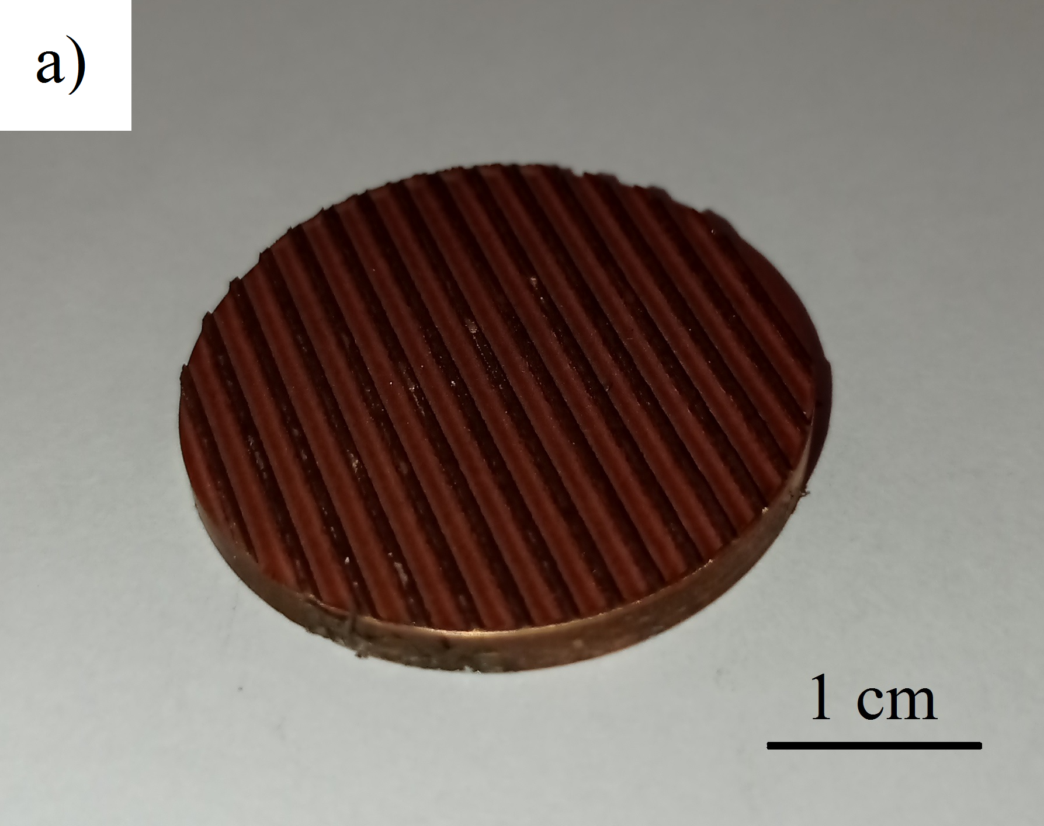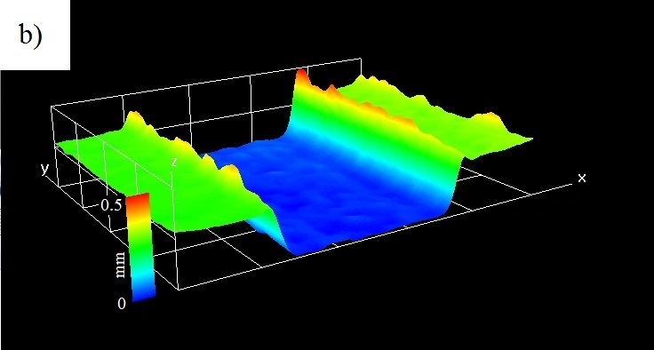
Fig. 1. Photo of a laser–treated sample (a), shape of a chosen groove (b)

As shown in Figure 1b, the bottom of the groove is also irregular. The roughness generated there is also favourable and promotes heat transfer. Figure 2a and b provide details of the microstructure morphology created on the bottom, as an optical microscope image and distribution of roughness values, respectively. In the case of the analysed sample, the surface roughness of the bottom area is mainly within the range of about 25-42 μm. Nevertheless, it is quite irregular. This feature is typical of the laser–made copper specimens considered in the present study.

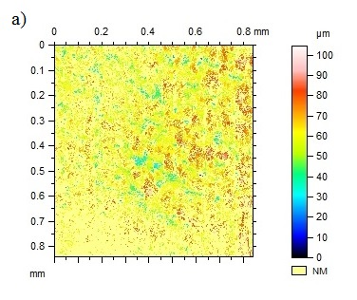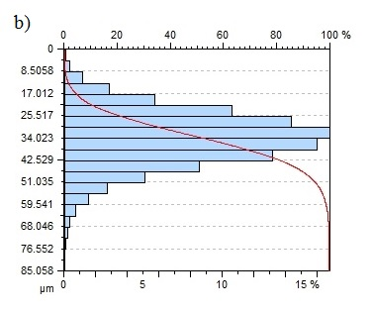
Fig. 2. Surface morphology of the laser-treated sample: optical microscope image (a), roughness distribution (b)

The boiling experiments were conducted on the stand, as described in detail in the open-access paper by the authors (Orman et al. 2020). The most important part is the heater, on which the sample undergoing the investigation is located. It is immersed in the boiling agent (distilled water and ethyl alcohol). Due to the high temperature within the heater, proper insulation materials were used in the design of the experimental setup. In Pavlenko and Szkarowski (2018), performance insulation materials were discussed and analyzed, which could further reduce heat losses.
3. Results and Discussion
The development and movement of vapor bubbles significantly influence the heat transfer phenomenon during pool boiling. Figure 3 presents the results of the visualization study obtained using a high–speed digital camera at a high heat flux (88 kW/m²) supplied by the electric heater. Bubbles might be leaving the surface from an isolated spot, but they can also merge before moving up into the pool of liquid. This phenomenon is clearly visible in the figure, where two neighbouring bubbles merge (at t = 0.004 s) and depart from the heater surface (at t = 0.01 s). It is one of many reasons why the boiling phenomenon is such a complicated process and, at the same time, difficult to model with high precision.

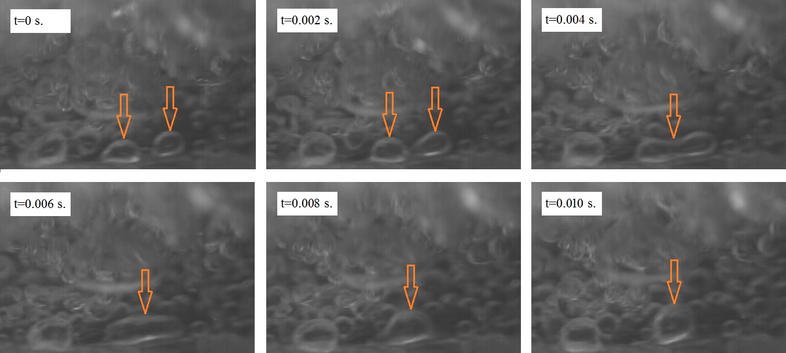
Fig. 3. Bubble coalescence during water boiling at the heat fluxes of 88000 W/m²

Significant difficulty arises from the accurate determination of heat flux (q) values based on the geometrical and material properties of samples and boiling agents. There may be significant discrepancies between experimental results and calculations based on models and correlations. Figure 4 presents the comparison of the test results obtained for the laser–processed sample (Orman et al. 2024) – denoted as "1" in the figure – with the calculation results according to the equations proposed by (Rannenberg & Beer 1980) – denoted as "2" – and (Nishikawa et al. 1979) – denoted as "3". In the figure, T_{sur} is the surface temperature, while T_{sat} is the saturation temperature at ambient pressure.
The model proposed in (Rannenberg & Beer 1980) was initially developed for the meshed surface, so specific modification had to be implemented to use it for the laser – made surface (the wire diameter was replaced with the thickness of the microfin and denoted as "d", while the aperture with the width of the groove – determined in the middle of its height – "w").

Fig. 4. Comparison of the experimental data for the laser - treated sample with selected models: 1 – boiling heat flux data adopted from (Orman et al. 2024), 2 – calculation results according to the model (Rannenberg & Beer 1980),
3 – calculation results according to the model (Nishikawa et al. 1979): a) water, b) ethanol

As can be seen, the calculation results provide either too low or too high heat flux values with regard to the experimental results of water and ethanol boiling. Thus, neither of the selected models can be applied to determine the amount of heat dissipated from the laser–processed surfaces. Consequently, a modification to the model (Rannenberg & Beer 1980) will be proposed to increase its accuracy. This model was chosen because it already provides better results (closer to the experimental data) than the other model (Nishikawa et al. 1979), which overestimates the heat flux significantly across the entire range of temperature differences.
The experimental data of pool boiling heat transfer on laser–textured surfaces presented in (Orman et al. 2020, Orman et al. 2024) have been used to modify the original model (Rannenberg & Beer 1980) with the value of two constants. In total, 70 measurement points were considered (covering two boiling agents: distilled water and ethyl alcohol), obtained during the experiments on seven differently shaped copper surfaces. The modified equation differs from the original one in the value of the constant, namely 23291.88, and the exponent of 0.09 adjacent to the thickness of the microstructure. The modified formula for the pool boiling heat flux, based on (Rannenberg & Beer 1980), takes the following form:
(1)
where the hydraulic diameter D_{h} can be obtained from the following formula:
(2)
The value of the effective radius R_{ef} was taken as half of the hydraulic diameter D_{h}, m, while the other elements in the above equations are as follows: λ_{l} – thermal conductivity of the liquid phase, W/(mK), λ_{eff} – effective thermal conductivity (calculated based on the solid and liquid phase thermal conductivity values as well as volumetric porosity), W/(mK), ε – volumetric porosity, without the unit, δ – height of the microstructure (microfins), m, c_{pl} – specific heat of the liquid phase, J/(kgK), r – heat of vaporization, J/kg, d – width of the microfin, m, w – distance between the microfins, m.
Figure 5 presents the comparison of the experimental results of boiling on laser–made samples adopted from the papers (Orman et al. 2020, Orman et al. 2024) with the calculation results according to the original model (Rannenberg & Beer 1980) – Figure 5a, and according to this model, but modified with two constants, as in equation (1). The dashed red line is the line of ideal matching where q_{calc} = q_{exp}, while the green lines represent the ±100% error band.

Fig. 5. Comparison of the experimental data for the laser-treated surfaces adopted from (Orman et al. 2020, Orman et al. 2024) with the calculation results according to the original model (Rannenberg & Beer 1980) – (a), and according to the modified model (Rannenberg & Beer 1980) – (b)

As shown in Figure 5a, the original model (Rannenberg & Beer 1980) was unable to accurately determine the heat flux values properly dissipated from the laser–treated surfaces considered in the present study. The spread of the data is significant, and only some experimental points fall within the ±100% error band. On the other hand, the modified correlation results (Figure 5b) align with the line representing q_{calc} = q_{exp,} and a great majority of the experimental points fall within the ±100% error band. The most vital thing is that the spread of the data has been eliminated, which suggests that the model may be quite successful in determining the performance of laser–treated heaters.
The most visible limitation of the study is the use of two boiling agents with quite similar characteristics and only one sample material (copper). However, this seems justified due to the high thermal conductivity and widespread heat transfer applications of copper. The nature of the modelling process might be quite similar for other boiling agents (possibly the values of the constants could be different for different types of agents, for example, nanofluids).
4. Summary and Conclusions
The application of laser–treated surfaces could provide significant advantages for improving boiling heat transfer conditions and elevating heat flux exchanged in the process. However, determining heat flux values based on geometrical and material properties is very challenging. Two correlations adopted from the literature failed to accurately determine the heat flux dissipated from the laser–made samples. Thus, a modification of the selected model was developed. The modification was focused on determining the values of two constants. The comparison of the experimental results and the results of the calculations made according to the modified model showed quite a reasonable agreement with the experimental points aligning along the q_{calc} = q_{exp} line. Moreover, a great majority of the experimental points fall within the ±100% error band.

The work in the paper was supported by the project:
"REFRESH – Research Excellence For REgion Sustainability and High-tech Industries, (VP2),
(Reg. No.: CZ.10.03.01/00/22_003/0000048) co-funded by the European Union".

References
Berce, J., Hadžič, A., Može, M., Arhar, K., Gjerkeš, H., Zupančič, M., & Golobič, I. (2024). Effect of surface wettability on nanoparticle deposition during pool boiling on laser-textured copper surfaces. Nanomaterials, 14, 311. https://doi.org/10.3390/nano14030311
Dudkiewicz, E., Fidorów-Kaprawy, N., & Szałański, P. (2022). Environmental benefits and energy savings from gas radiant heaters' flue-gas heat recovery. Sustainability, 14, 8013. https://doi.org/10.3390/su14138013
Dudkiewicz, E., & Fidorów-Kaprawy, N. (2020). Hybrid domestic hot water system performance in industrial hall. Resources, 9, 65. https://doi.org/10.3390/resources9060065
Hadžič, A., Može, M.. Zupančič, M., & Golobič, I. (2024). Aluminum micropillar surfaces with hierarchical micro- and nanoscale features for enhancement of boiling heat transfer coefficient and critical heat flux. Nanomaterials, 14, 667. https://doi.org/10.3390/nano14080667
Ho, J. Y., Wong, K. K., & Leong, K. C. (2016). Saturated pool boiling of FC-72 from enhanced surfaces produced by Selective Laser Melting. International Journal Heat and Mass Transfer, 99, 107-121. https://doi.org/10.1016/j.ijheatmasstransfer.2016.03.073
Ho, J. Y., Wong, K. K., Leong, K. C., & Yang, C. (2015). Nucleate pool boiling from selective laser melted microgrooves/microcavities surfaces with HFE-7000. Proceedings of the First Thermal and Fluids Engineering Summer Conference New York City, USA, 1917-1928. https://doi.org/10.1615/TFESC1.mph.013076
Hożejowska, S., Kaniowski, R., & Pastuszko, R. (2021). Application of the Trefftz Method for Pool Boiling Heat Transfer on Open Microchannel Surfaces. Heat Transfer Engineering, 43, 362-370. https://doi.org/10.1080/01457632.2021.1874669
Jurišević, J., Gordić, D., & Vukicevic, A. (2022). Assessment of predictive models for the estimation of heat consumption in kindergartens. Thermal Science, 26, 1B, 503-516. https://doi.org/10.2298/TSCI201026084J
Kaniowski, R., & Poniewski, M. (2013). Measurements of two-phase flow patterns and local void fraction in vertical rectangular minichannel. Archives of Thermodynamics, 34, 3-21. https://doi.org/10.2478/aoter-2013-0007
Kosiń, M., Major, I., Major, M., & Kalinowski J. (2020). Model tests of bending and torsional deformations of thin-walled profiles stiffened with elements made in 3D printing technology. Case Studies in Construction Materials, 13, e00401. https://doi.org/10.1016/j.cscm.2020.e00401
Kotrys-Działak, D., & Stokowiec, K. (2023). Temperature distribution analysis on the surface of the radiator: infrared camera and thermocouples results comparison. Rocznik Ochrona Środowiska, 25, 37-44. https://doi.org/10.54740/ros.2023.005
Kruse, C. M., Anderson, T., Wilson, C., Zuhlke, C., Alexander, D., Gogos, G., & Ndao, S. (2015). Enhanced pool-boiling heat transfer and critical heat flux on femtosecond laser processed stainless steel surfaces. International Journal Heat and Mass Transfer, 82, 109-116. https://doi.org/10.1016/j.ijheatmasstransfer.2014.11.023
Liu, B., Zhang, Y., Wei, J., & Wang W. (2019). Experimental and theoretical study of pool boiling heat transfer and its CHF mechanism on femtosecond laser processed surfaces. International Journal Heat and Mass Transfer, 132, 259-270. https://doi.org/10.1016/j.ijheatmasstransfer.2018.12.003
Major, I., & Major, M. (2014). Modeling of wave propagation in the ADINA software for simple elastic structures. Advanced Materials Research, 1020, 171-176. https://doi.org/10.4028/www.scientific.net/AMR.1020.171
Nešović, A., Kowalik, R., Bojović, M., Janaszek, A., & Adamczak, S. (2024). Elevational Earth-sheltered buildings with horizontal overhang photovoltaic-integrated panels – new energy-plus building concept in the territory of Serbia. Energies, 17, 2100. https://doi.org/10.3390/en17092100
Nešović, A., & Kowalik, R. (2025). Single-glazed vacuum tube collector with SnAl2O3 selective flat absorber plate and gravity single-stage direct water flow: a comprehensive geometric optimization. Applied Science, 15, 1838. https://doi.org/10.3390/app15041838
Nishikawa, K., Ito, T., & Tanaka, K. (1979). Enhanced heat transfer by nucleate boiling on a sintered metal layer. Heat transfer – Japanese Research, 8, 65-81.
Orman, Ł. J., Honus, S., Radek, N., & Kargul, M. (2024). Augmentation of pool boiling heat transfer using the laser treatment technology. Rocznik Ochrona Środowiska, 26, 160-167. https://doi.org/10.54740/ros.2024.017
Orman, Ł. J., Radek, N., Pietraszek, J., & Szczepaniak, M. (2020). Analysis of enhanced pool boiling heat transfer on laser-textured surfaces. Energies, 13, 2700. https://doi.org/10.3390/en13112700
Pavlenko, A. M., & Basok, B. I. (2005). Regularities of boiling-up of emulsified liquids. Heat Transfer Research, 36, 419-424. https://doi.org/10.1615/HeatTransRes.v36.i5.90
Pavlenko, A. M., & Basok, B. I. (2005). Kinetics of water evaporation from emulsions. Heat Transfer Research, 36, 425-430. https://doi.org/10.1615/HeatTransRes.v36.i5.100
Pavlenkо, A., & Szkarowski, A. (2018). Thermal insulation materials with high-porous structure based on the soluble glass and technogenic mineral fillers. Rocznik Ochrona Środowiska, 20, 725-740.
Piasecka, M., Hożejowska, S. Maciejewska, B., & Pawińska, A. (2021). Time-dependent heat transfer calculations with Trefftz and Picard methods for flow boiling in a mini-channel heat sink. Energies, 14(7), 1832. https://doi.org/10.3390/en14071832
Poniewski, M. E., & Thome J. R. (2008). Nucleate boiling on micro-structured surfaces. Warsaw&Lausanne: Heat Transfer Research Inc. (HTRI, USA)
Rannenberg, M., & Beer, H. (1980). Heat transfer by evaporation in capillary porous wire mesh structures. Letters in Heat and Mass Transfer, 7, 425-436. https://doi.org/10.1016/0094-4548(80)90019-3
Ratajczak, K., Bandurski, K., & Płóciennik, A. (2022). Incorporating an atrium as a HAVC element for energy consumption reduction and thermal comfort improvement in a Polish climate. Energy and Buildings, 277, 112592. https://doi.org/10.1016/j.enbuild.2022.112592
Ratajczak, K., & Szczechowiak, E. (2020). The use of a heat pump in a ventilation unit as an economical and ecological source of heat for the ventilation system of an indoor swimming pool facility. Energies, 13, 6695. https://doi.org/10.3390/en13246695
Stojanović, A. D., Belošević, S. V., Crnomarković, N. Đ., Tomanović, I. D., & Milićević, A. R. (2022). Nucleate pool boiling heat transfer: Review of models and bubble dynamics parameters. Thermal Science, 26, 1A, 157-174. https://doi.org/10.2298/TSCI200111069S
Ustinov, A., Mitrovic, J., & Ustinov, D. (2025). Towards a universal system for the classification of boiling surfaces. Journal of Nuclear Engineering, 6,7. https://doi.org/10.3390/jne6010007
Voglar, J., Gregorčič, P., Zupančič, M., & Golobič I. (2018). Boiling performance on surfaces with capillary-length-spaced one- and two-dimensional laser-textured patterns. International Journal Heat and Mass Transfer, 127, 1188-1196. https://doi.org/10.1016/j.ijheatmasstransfer.2018.07.056
Wciślik, S. (2016). Thermal infrared mapping of the Leidenfrost drop evaporation. Journal of Physics: Conference Series, 745, 032064. https://doi.org/10.1088/1742-6596/745/3/032064
Wciślik, S., & Taler, D. (2024). Economic and exergy analysis of TiO₂ + SiO₂ ethylene-glycol-based hybrid nanofluid in plate heat exchange system of solar installation. Energies, 17, 3107. https://doi.org/10.3390/en17133107
Wojtkowiak, J., Amanowicz Ł., & Mróz T. (2019). A new type of cooling ceiling panel with corrugated surface—Experimental investigation. International Journal of Energy Research, 43(13), 7275-7286. https://doi.org/10.1002/er.4753

