
 | Rocznik Ochrona Środowiska
 | Volume 27 | Year 2025 ISSN 2720-7501 | pp. 620-627
 | https://doi.org/10.54740/ros.2025.049 open access
 | Received: September 2025 Accepted: October 2025 Published: October 2025
Analysis of Strength Characteristics of Adhesive-Board Reinforced Beams
Makhmud Abu-Khasan¹, Alexander Shkarovskiy², Shirali Mamedov³, Lali Kuprava⁴,
Vladimir Mikhaskin⁵, Rustam Sayganov⁶
¹Emperor Alexander I Saint Petersburg State Transport University, Russia
https://orcid.org/0000-0002-6782-2514
²Koszalin University of Technology, Poland
https://orcid.org/0000-0002-2381-6534
³Saint Petersburg State University of Architecture and Civil Engineering, Russia
https://orcid.org/0000-0003-0366-1085
⁴Emperor Alexander I Saint Petersburg State Transport University, Russia
https://orcid.org/0000-0003-3906-168X
⁵Saint Petersburg State University of Architecture and Civil Engineering, Russia
https://orcid.org/0000-0002-9801-1714
⁶Saint Petersburg State University of Architecture and Civil Engineering, Russia
https://orcid.org/0009-0004-5921-9848
*corresponding author’s e-mail: saigrustam@gmail.com
Abstract: This article presents a comparative analysis of the strength characteristics of glued-board reinforced beams for the first and second groups of limit states, considering both the reinforcement configuration and the reinforcement material. The main thesis is that the use of the SCAD calculation and graphic complex is effective for determining the rational configuration of reinforcement and the choice of reinforcement material, which enables an increase in the strength characteristics of wooden structures. This article examines how reinforcement configuration and properties influence the performance of glued laminated timber beams, offering a more comprehensive understanding of their performance characteristics. The work aims to determine the rational configuration of reinforcement and reinforcement material based on the strength of the first and second groups of limit states, as well as to minimize the mass of the structure.
Keywords: glued-to-board beams, strength, SCAD, stress-strain state, first and second groups of limit states, reinforcement
1. Introduction
Wood is widely used as a construction material in various industries. Its introduction into construction, transport, energy, and other areas is steadily growing, as are the requirements for its strength and deformation properties (Abu-Hasan et al. 2018a, Veselov et al. 2019). Increasing the natural strength characteristics of elements in wooden structures (WS) and glued wooden structures (GWS) is achieved using various methods (Kulish & Nakashidze 1974).
The choice of a rational method for increasing natural strength characteristics depends on many parameters and is made through a system analysis of factors that take into account the force impact on structural elements and a technical and economic comparison. In some cases, the most advantageous is the use of internal rod reinforcement (Temnev et al. 2020).
The authors of the article provide an analysis of the strength characteristics of glued-board reinforced beams in the SCAD calculation and graphic complex (Abu-Hasan et al. 2018c, Sycheva et al. 2016). Several configurations of glued laminated timber beams are used in the analysis, as shown in Fig. 1.
The calculation is carried out under the same operating conditions of glued-to-board beams, which will allow them to be compared according to the following parameters (Abu-Hasan & Egorov 2018, Svatovskaya et al. 2007):
- Beam mass,
- Section utilization factor,
- Maximum values of normal stress in the section,
- Maximum vertical movements.

These parameters are decisive for assessing the bearing capacity for the first and second groups of limit states, and also make it possible to determine the most effective configuration based on the condition of ensuring strength with a lower mass of structures (Arleninov & Becker 2015).
2. Research Methodology
The calculations were performed using the SCAD calculation and graphic complex, which employs the finite element method (Starchukov et al. 2017). To compare the selected configurations, a calculation scheme was modeled using rod elements. For the joint operation of plank elements in a package, a tool is used – combining displacements, while the rods are preliminarily divided into equal sections of 150 mm, in the near-support sections, we take the division of 40 mm (Egorov et al. 2018-1, Solovieva et al. 2017-2). The calculation scheme is shown in Fig. 2. The beam clamping is hinged.
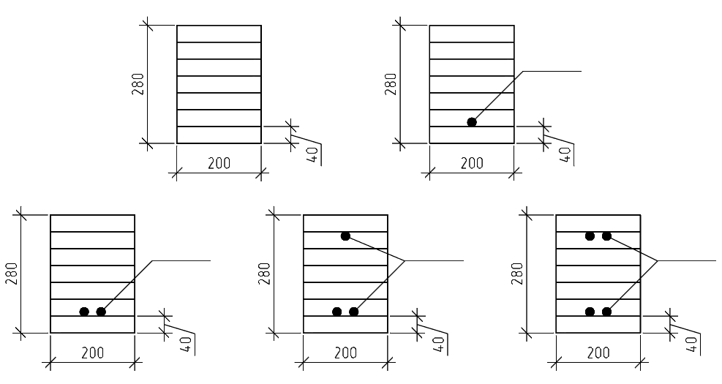
d20 mm
d20 mm
d20 mm
E)
d20 mm
C)
D)
B)
А)
Fig. 1. Configurations of glued-to-laminated beams for calculations: A – No reinforcement, B – Reinforcement with 1 rod, C – Reinforcement with 2 rods, D – Reinforcement with 3 rods, E – Reinforcement with 4 rods

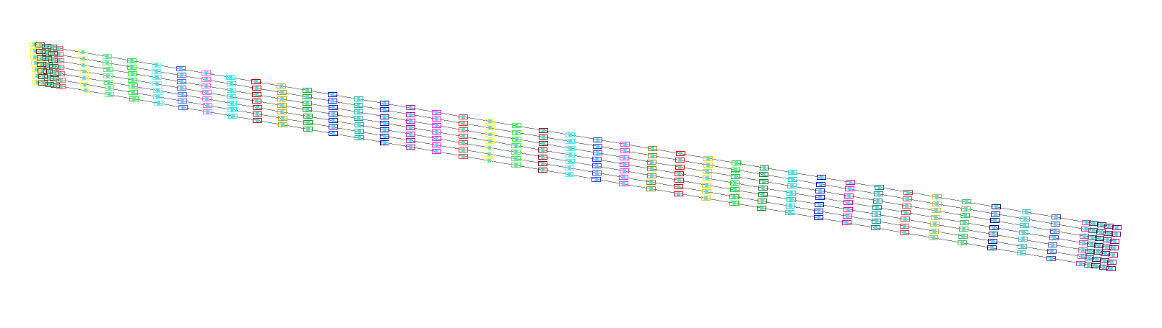
Fig. 2. Calculation scheme in SCAD

The analysis considers loads from dead weight (applied automatically). The load application diagram is shown in Fig. 3.
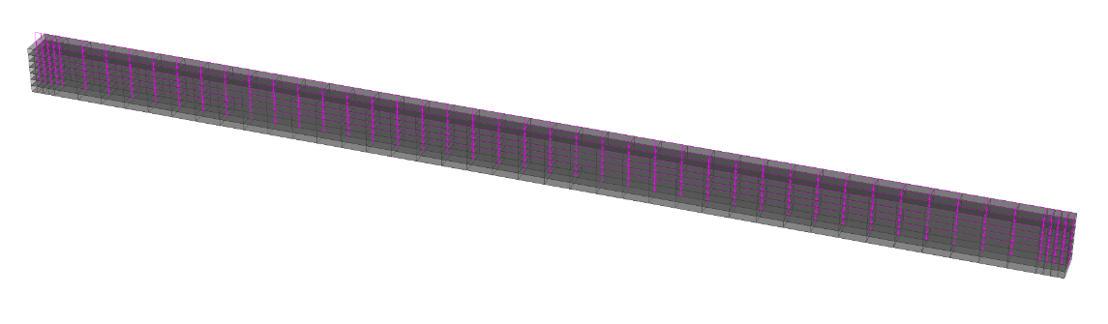
Fig. 3. Loads from own weight

For calculations for the first and second groups of limit states, calculated combinations of forces and displacements are assigned (Fig. 4).

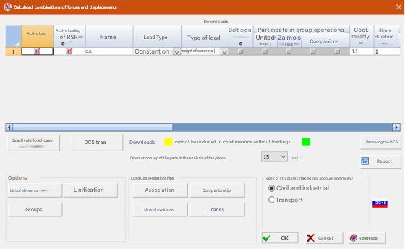
Fig. 4. Calculated combinations of forces and displacements

The calculations were based on the mechanical properties of grade 1 pine wood when used in laminated timber construction (Egorov et al. 2018-2).
The calculation parameters are illustrated in Fig. 5. The multi-frontal method enables the calculation of spatial elements of buildings for statics, dynamics, and stability (Solovieva et al. 2017).
After the static calculation, the values of maximum normal stresses in the cross-section of the glued-board beam were determined, and an examination of the cross-section was carried out; for this purpose, the value of the critical factor is used. If this value falls within the range of 0 to 1, the checked section ensures the bearing capacity for both the first and second groups of limit states.
The values of critical factors are determined according to the following criteria (8):
- flexibility of the element in the XOY plane,
- strength of an element under the action of a bending moment My,
- strength under transverse force Qz,
- stability of plane deformation.

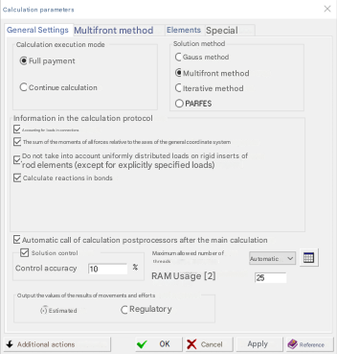
Fig. 5. Calculation parameters

The values of critical factors are shown in Figures 6 to 11.

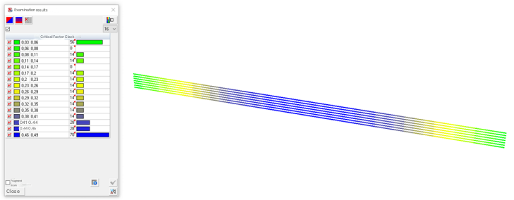
Fig. 6. Critical factor values: beam without reinforcement

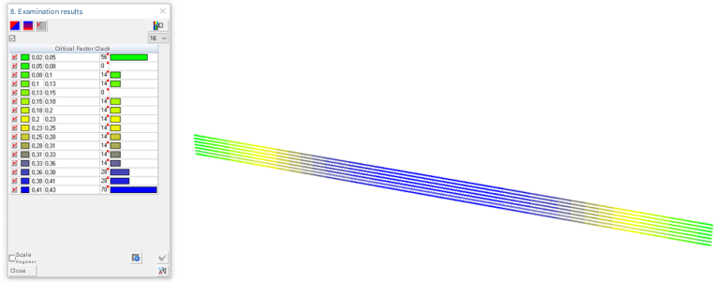
Fig. 7. Critical factor values: beam with one steel reinforcement bar

Even with the installation of one steel reinforcement rod, a significant reduction in the critical factor can be observed (Abu-Khasan et al. 2018-2). At the same time, the maximum values of normal stresses decreased from 540 t/m² to 475 t/m², representing a 12% decrease.

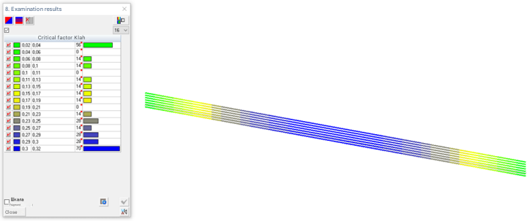
Fig. 8. Critical factor values: beam with two steel reinforcement bars

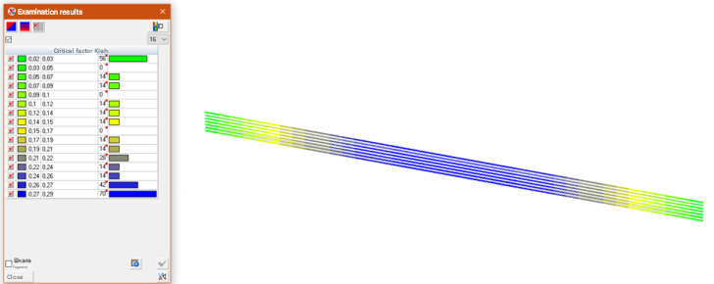
Fig. 9. Critical factor values: beam with three steel reinforcement bars

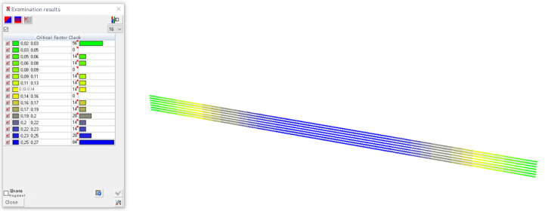
Fig. 10. Critical factor values: beam with four steel reinforcement bars

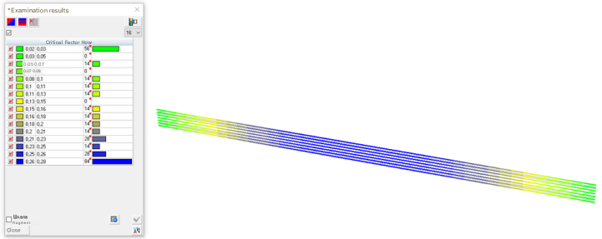
Fig. 11. Critical factor values: beam with four fiberglass reinforcement rods

Simultaneously with the utilization factor, an analysis was conducted to examine the changes in displacement, normal stress, and the mass of the structure. The calculation results are given in Table 1.

Table 1. Calculation results
Beam | Displacements, mm | Normal stress, t/m² | Utilization rate | Weight, kg
Without reinforcement | 112.40 | 540.00 | 0.49 | 270.00
1 rod (steel) | 99.17 | 475.19 | 0.43 | 284.82
2 rods (steel) | 88.73 | 424.10 | 0.32 | 299.64
3 rods (steel) | 80.27 | 382.80 | 0.29 | 314.46
4 rods (steel) | 73.28 | 348.73 | 0.27 | 329.28
4 rods (fiberglass) | 77.13 | 366.82 | 0.28 | 285.36

For greater clarity, the calculation results for all configurations of reinforced glued-board beams are summarized in Fig. 12.
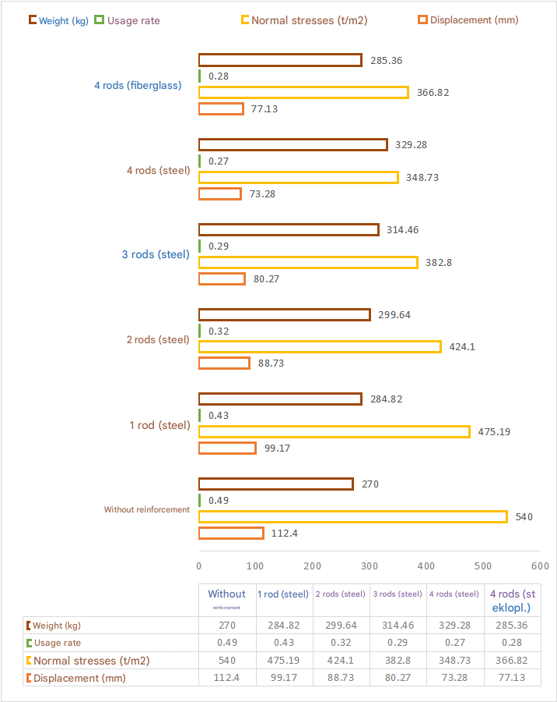
Fig. 12. Calculation results for all configurations of reinforced glued-board beams
3. Conclusion
Based on the calculation results, it can be concluded that reinforcement of glued-board beams is an effective method for increasing the rigidity and strength of this type of structure, so when reinforcing with four steel reinforcement bars, vertical movements were reduced by -34%, and the section utilization factor was reduced by -44%. However, when reinforcing, the beam mass increased by 18%.
When using fiberglass reinforcement, the values of vertical displacements compared to an unreinforced beam were reduced by -31%, the utilization factor of the cross-section was reduced by -44%, while the weight increased by only 5%.
Thus, the use of fiberglass reinforcement is the most effective way to increase the rigidity and strength of glued-board beams.
References
Abu-Hasan, M., Egorov, V., & Kuprava, L. (2018). Connections of wooden structures based on composite materials. Bulletin of construction equipment, 12(1012), 46-47. (in Russian)
Abu-Khasan, M. et al. (2018). Load Carrying Wooad and Metal Structures of Trusses of Covering of Long Spanned Rail Depot. IOP Conference Series: Materials Science and Engineering, 463, 042075. https://doi.org/10.1088/1757-899X/463/4/042075
Abu-Hasan, M., Rozantseva, N., & Kuprava, L. (2018). Innovative technology for installation of prefabricated energy-efficient roofs of large-span railway depots. Bulletin of construction equipment, 2(1002), 48-51. (in Russian)
Abu-Hasan, M., & Egorov, V. (2018). Constructions from wood-frame trusses. Collection of works of the XII St. Petersburg Congress: Professional education, science and innovation in the 21st century. St. Petersburg, 2018, 9-10. (in Russian)
Arleninov, D., & Becker, D. (2015). Effect of stress level on wood creep during bending. News of higher educational institutions. Forestry magazine, 6, 128-137. (in Russian)
Egorov, V. et al. (2018). Load-bearing wood-metal structures of roof trusses of large-span railway depots. Bulletin of construction equipment, 8(1008), 37-38. (in Russian)
Egorov, V., Abu-Hasan M., & Kuprava, L. (2018). New design solution for cornice units in the form of reinforced concrete inserts for three-hinged glued timber frames from rectilinear elements. Bulletin of construction equipment, 9(1009), 28-29. (in Russian)
Komokhov, P., Maslennikova, L., & Abu-Hasan, M. (2003). Control of strength of ceramic materials by forming a contact zone between clay matrix and leaner. Construction materials, 12, 44-45. (in Russian)
Kulish, V., & Nakashidze, V. (1974). Reinforcement of glued wooden beams and assessment of stress losses in fiberglass reinforcement. Construction and architecture, 3, 36-41. (in Russian)
Solovieva, V. et al. (2017). Innovative efficient concrete with reduced energy consumption for prefabricated structures. Proceedings of the IV international scientific and practical Internet conference: Innovative technologies in construction and geoecology. St. Petersburg, 2017, 17-20. (in Russian)
Solovieva, V. et al. (2017). Innovative high-strength concrete for high-voltage lines. Proceedings of the IV international scientific and practical Internet conference: Innovative technologies in construction and geoecology. St. Petersburg, 2017, 21-25. (in Russian)
Starchukov, D. et al. (2017). Increasing the durability of heavy concrete due to an insulated anti-corrosion barrier. Bulletin of construction equipment, 7(995), 58-61. (in Russian)
Svatovskaya, L. et al. (2007). Clay-phosphatic material. Patent for invention RU 2359937 C1, 27.06.2009. Application No. 2007147167/03 dated 18.12.2007.
Sycheva, A., Abu-Hasan, M., & Chernakov, V. (2016). Evaluation of energy absorption capacity of materials. Proceedings of the III international scientific and practical Internet conference: Innovative technologies in construction and geoecology. St. Petersburg, 2016, 50-53. (in Russian)
Temnev, V. et al. (2020). The mesh of shells of a bionic type to be operated in extreme habitats. IOP Conference Series: Materials Science and Engineering, 753, 022023. https://doi.org/10.1088/1757-899X/753/2/022023
Veselov, V., Egorov, V., & Abu-Hasan, M. (2019). Innovative designs of wooden beams in the conditions of the Far North. Bulletin of construction equipment, 3(1015), 16-19. (in Russian)

