
 | Rocznik Ochrona Środowiska
 | Volume 27 | Year 2025 ISSN 2720-7501 | pp. 525-540
 | https://doi.org/10.54740/ros.2025.043
 | Received: August 2025 Accepted: September 2025 Published: October 2025
The Use of a Hybrid Plum Drying System as a Step Towards Improving the Production of Certified Suska Sechlońska
Anna Kochanek^{1*}, Iga Pietrucha², Nikodem Bulanda³, Anna Beniak⁴, Anna Gronba-Chyła⁵, Zbigniew Mucha⁶, Sylwia Guzdek⁷
¹Faculty of Engineering, State University of Applied Sciences in Nowy Sącz, Poland
https://orcid.org/0009-0005-1859-5174
²Independent Researcher, Korzenna, Poland
³Faculty of Engineering, State University of Applied Sciences in Nowy Sącz, Poland
https://orcid.org/0000-0002-1180-2012
⁴Independent Researcher, Ujanowice, Poland
⁵Faculty of Natural and Technical Sciences, John Paul II Catholic University of Lublin, Poland
https://orcid.org/0000-0002-0976-7553
⁶Faculty of Environmental Engineering and Energy, Cracow University of Technology, Poland
https://orcid.org/0000-0001-7477-3303
⁷Department of Microeconomics, Cracow University of Economics, Poland
https://orcid.org/0000-0001-5455-8673
*corresponding author's e-mail: akochanek@ans-ns.edu.pl
Abstract: At a time when health is of paramount importance, plums play a significant role as fruits with high nutritional and health-promoting value. They contain large amounts of fiber, polyphenols, and vitamins. The drying process extends their shelf life while preserving their valuable biological properties. The study aimed to develop and compare the traditional and modernized (hybrid) technological process of producing Suska Sechlońska, taking into account the impact of new technologies on efficiency, productivity, profit increase, and environmental protection. The study was conducted in the third quarter of 2024 at the Farm and Agritourism Farm in Ujanowice, in the municipality of Laskowa, which is involved in the traditional production of Suska Sechlońska – a regional dried and smoked plum, which is part of the cultural heritage and an important source of income for local farmers. The introduction of modern drying and processing technologies increased production efficiency, reduced energy consumption, and had a positive impact on environmental protection. The results showed that the use of a hybrid drying process reduced production time by up to 50-70%, reduced energy consumption by 30–50%, and increased productivity to 200–400 kg of dried fruit per day, while maintaining the high sensory quality of the product.
Keywords: dried plum, fruit drying, pretreatment, product quality, Suska Sechlońska
1. Introduction
In recent decades, socio-economic changes have influenced eating habits and consumption patterns, leading to a growing demand for food that, in addition to nutritional value, also offers additional health benefits (Hajzer et al. 2025, Baker et al. 2022). Fruits and vegetables are an essential part of the daily diet, providing vitamins, minerals, phytochemicals, and dietary fiber, but they generally have limited shelf life (Porat et al. 2018, Yener et al. 2024). There are many methods of preserving fruits, such as pasteurization, freezing, or preserving in sugar, but the most durable method of preservation is drying, which effectively inhibits the growth of microorganisms and enzymatic processes by reducing water content (Venkatesan & Muniyan 2024, Olesińska et al. 2019).
Cultivated plums primarily include Prunus domestica (European plum) and Prunus salicina (Japanese plum), along with numerous varieties and hybrids, resulting in a wide diversity of colors, textures, and biochemical profiles (Fang & Wakisaka 2021, Suttisansanee et al. 2021). Fresh fruits primarily contain soluble sugars (glucose, fructose, sucrose), sorbitol, organic acids (mainly malic and quinic acids), vitamin C, carotenoids, and significant amounts of polyphenols, including chlorogenic acid derivatives, rutin, and proanthocyanidins. The highest concentrations of phenols and anthocyanins are typically found in the skin (Micu et al. 2024, Lin et al. 2023). The content of bioactive compounds depends, among other factors, on the variety, origin, and ripeness of the fruit, influencing the phenolic profile, antioxidant activity, and composition of volatile aroma compounds (Trendafilova et al. 2022, Meland et al. 2024)). Moreover, in vitro studies suggest that the bioavailability of certain phenolic compounds may increase during digestion, which could be crucial for their biological activity (Yu et al. 2021).

The production and processing of dried plums constitute an important sector of the food industry in many countries, including Poland, which is one of the main producers and exporters of these fruits in Europe (Nosecka & Zaremba 2025, Pawlak & Smutka 2022). According to the latest data from the Central Statistical Office, the fruit harvest from trees in Poland in 2024 is presented in Figure 1.

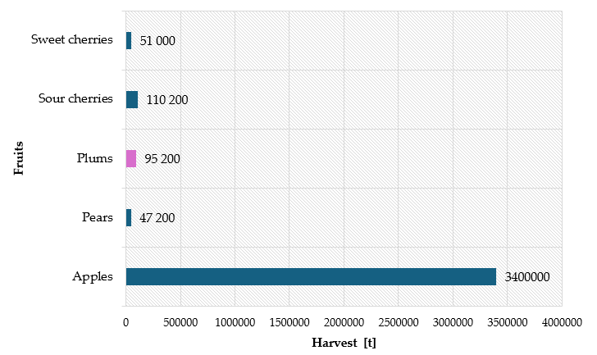
Fig. 1. Chart showing fruit harvests from trees in Poland in 2024 in tons (Statistics Poland, 2025)

Suska Sechlońska (SS) is a traditional Polish dried and smoked plum, originating from the village of Sechna in Małopolska. Its characteristic sweet taste with a distinct smoky aroma is the result of a unique production method dating back to at least the 18th century (Directorate-General for Agriculture and Rural Development, 2025). To this day, there are hundreds of family-run wood-fired drying rooms, known as suśnia, in the region, the oldest of which are over a hundred years old (European Commission, 2010a). In 2010, Suska Sechlońska was granted EU protected geographical indication status, confirming its close connection with local tradition and its region of origin (European Commission, 2010b). Thanks to its unique quality and protected name, SS fetches a higher market price than ordinary dried plums, which in theory should make its production more profitable (FAO & EBRD, 2024).
2. Technological Methods of Fruit Processing
The variety of technological methods used in fruit processing enables the preservation of their value, flavors, and sensory appeal. Depending on the type of fruit, the intended use of the product, and its applications, different technologies are used (Zia et al. 2024, Al-Sharify et al. 2025).
2.1. Thermal processing methods
Thermal methods of fruit processing are a key method of food preservation, as they extend shelf life and ensure microbiological safety while maintaining the sensory qualities of the products (Xiao et al. 2017). The most commonly used techniques include blanching, pasteurization, sterilization, and various forms of drying (Xiao et al. 2017). These methods differ in temperature range and effectiveness in eliminating microorganisms — mild processes, such as HTST pasteurization, limit quality changes, while sterilization at temperatures > 100°C ensures complete sterility of the product (Niu et al. 2022, Jimenez et al. 2024). In industrial practice, several thermal operations (e.g., blanching and pasteurization) are often combined to achieve the optimal technological effect (Mari et al. 2024). The selection of a specific process depends on the type of fruit, the expected shelf life, and the target properties of the product (Bhatta et al. 2020). Table 1 presents a summary of the most commonly used thermal methods of fruit processing, together with their technological characteristics and impact on product quality.

Table 1. Characteristics of selected thermal methods of fruit processing
Method | Desription | References
Blanching | Short-term heating of fruits (80–100°C) in water/steam, followed by rapid cooling, inactivates enzymes and reduces microflora, preparing the raw material for further processing. | (Xiao et al. 2017)
Pasteurization (HTST / UHT) | Heating to below 100°C (e.g., 72°C / 15 s – HTST or 135°C / 2–5 s  – UHT); destroys vegetative forms of microorganisms  and some enzymes, preserving the taste and color of the product. | (Niu et al. 2022, Ramesh 2020)
Sterilization | Treatment above 100°C (e.g., 121°C / 15–30 min in an autoclave) leading to complete elimination of microorganisms, including spore forms;  ensures long shelf life at room temperature. | (Jimenez et al. 2024)
Convective  drying | Water removal using hot air; economical method, but time-consuming, causing significant shrinkage and loss of color and bioactive compounds. | (Mari et al. 2024)
Vacuum drying | Drying under reduced pressure; the lower boiling point of water  limits thermal degradation, resulting in better retention of color, aroma, and vitamin C. | (Mari et al. 2024)
Osmotic drying | Partial dehydration in a concentrated solution (e.g., sugar syrup); reduces water activity without high temperatures, but requires additional drying by another method for full shelf life. | (Asghari et al. 2024)
Microwave  drying | Microwave energy heats the product "from within," significantly shortening drying time; an energy-efficient process, but requires control to avoid local overheating and uneven water evaporation. | (Pateiro et al. 2022)
Freeze drying (lyophilization) | Frozen fruits undergo sublimation of ice under vacuum; minimal shrinkage and nutrient loss, but high cost and long process duration; mainly used in premium products. | (Bhatta et al. 2020, Pateiro  et al. 2022)

The thermal methods presented differ in terms of the intensity of their impact on the raw material and the level of preservation. Blanching and pasteurization effectively extend the shelf life of fresh juices or purées with minimal changes in quality (Niu et al. 2022). Sterilization, although it guarantees sterility and a shelf life of several months, causes the greatest loss of color, aroma, and vitamins (Jimenez et al. 2024). Drying reduces water activity, and the choice of technique (convection, vacuum, microwave, or freeze-drying) affects the product's structure, costs, and the preservation of bioactive compounds (Bhatta et al. 2020, Prosapio & Lopez-Quiroga 2020). Ultimately, the technological decision is a compromise between the expected shelf life and the acceptable impact on the sensory and nutritional properties of the fruit (Ramesh 2020).
2.2. Types of fruit drying – methods and their characteristics
Drying fruit is a classical preservation method in which the evaporation of water reduces water activity below a critical threshold, preventing the growth of microorganisms and slowing down enzymatic reactions (Nowak & Jakubczyk 2020, Prosapio & Lopez-Quiroga 2020). At the same time, prolonged convective drying causes significant losses of phenolics and anthocyanins, as well as undesirable darkening of the dried product's color (Juchniewicz et al. 2024, Noutfia et al. 2025).
To reduce quality degradation, intensified variants of hot-air drying are increasingly being used, such as preliminary vacuum–microwave heating or short-term drying at elevated temperatures (Uribe et al. 2024, (Uribe et al. 2024). These approaches reduce drying time and minimize vitamin C losses while maintaining acceptable color and texture (Nowicka et al. 2025, Zeng et al. 2025).
Literature reviews highlight the growing importance of heat pump technologies, which recover energy from water vapor condensation, resulting in up to 40% reduction in energy consumption (Zhu et al. 2025, Rashvand et al. 2024). The efficiency of further dehydration can also be improved by pulsed electric fields (PEF) and ultrasound-assisted osmotic dehydration, which increase the rate of water diffusion while minimizing the loss of bioactive compounds (Salehi 2023, Patil et al. 2024).
In recent years, much attention has been devoted to cold plasma pretreatments, sometimes combined with ultrasound, which further reduce drying time and improve the porosity of the dried product. The effectiveness of such hybrid techniques has been confirmed, for example, in the case of kiwi, carrot, and mango. Review articles also highlight their potential for reducing energy use and emissions in processing (Yue et al. 2024, Punthi et al. 2022).
Energy analysis and energy balance assessments show that only comprehensive optimization (selection of technique, parameters, and pretreatments) can achieve the goals of sustainable food production, reducing the carbon footprint while preserving sensory value. A promising direction involves moderate electric fields (MEF), which improve cell membrane permeability and reduce drying time by 10–20% without causing excessive structural damage (An et al. 2024, Kalkavan & Sahin Yesilcubuk 2025).
A comprehensive review of recent studies shows that no single technology can simultaneously guarantee low energy costs and maximum product quality. The best results are achieved by combining a base method (e.g., hot-air or heat-pump drying) with an intensifying treatment (PEF, ultrasound, microwave, cold plasma) and by fine-tuning process parameters. Ultrasound pretreatment prior to microwave–vacuum drying, for example, can reduce total drying time by up to 50% and enhance the rehydration capacity of dried fruit (Tepe & Tepe 2025, Wojtyś et al. 2025). An overview of fruit drying methods and their key advantages and limitations is presented in Table 2.

Table 2. Comparison of fruit drying methods
Method | Advantages | Drawbacks | Typical applications | References
Hot-air  (convective) drying | Simple, inexpensive, widely available | Long processing time, major vitamin loss,  low energy efficiency | Apples, plums, apricots in belt or tunnel dryers | (Juchniewicz et al. 2024, Kalkavan  & Sahin Yesilcubuk 2025)
Vacuum drying | Lower temperature, better color and aroma, limited oxidation | Higher capital cost, slower throughput | Berries, herbs, premium tropical fruits | (Nowicka et al. 2025, An et al. 2024)
Microwave drying | Very fast volumetric heating, high energy  efficiency | Risk of local overheating, cost of microwave generator | Final moisture removal in fruit granules and muesli | (Zeng et al. 2025, Tepe & Tepe 2025)
Microwave–vacuum drying | Freeze-dry-like quality in a much shorter time | Complex equipment, need for precise power control | Crunchy snacks from berries and exotic fruits | (Ji et al. 2024, Rashvand et al. 2024)
Freeze-drying (lyophilisation) | Highest retention of nutrients, porous structure | Very high cost, energy-intensive, long process | Functional foods, baby-food additives | (Uribe et al. 2024, Yue et al. 2024)
Osmotic dehydration + finish drying | Lower energy use,  better color and flavor, vitamin retention | Needs an extra drying step, possible sugar  uptake | Strawberries, kiwi, high-acid fruits  for confectionery | (Salehi 2023, Wojtyś et al. 2025)
Infrared (IR) drying | Rapid start-up, intense surface heating | Limited penetration depth, risk of skin  overheating | Thin apple or peach slices, fruit chips | (Noutfia et al. 2025)
Heat-pump drying | High efficiency  via heat recovery | Higher CAPEX,  sensitive to ambient conditions | Industrial  low-temperature lines | (Zhu et al. 2025)
Ultrasound assistance/pretreatment | Accelerated diffusion, shorter time, higher  porosity | Extra equipment,  possible tissue damage  at high power | Pre-dehydration  or drying of berries | (Salehi 2023, Tepe & Tepe 2025)
PEF (pulsed electric field) | Electroporation, faster moisture loss, better rehydration | High voltage, needs grounding and control | Mango or apple slices before convective  drying | (Punthi et al. 2022, Kalkavan & Sahin Yesilcubuk 2025)

Applying cold plasma alone—or in hybrid mode with ultrasound—can further shorten the drying time and increase the retention of bioactive compounds (Zhang et al. 2019, Yanclo et al. 2024). At the same time, the growing number of publications on hybrid solutions (e.g., microwave-convective drying combined with heat pump systems) and full energy modeling of industrial lines confirms a clear trend toward intelligent, low-emission drying systems (Jedlińska et al. 2025, Bai et al. 2025).
2.3. Non-thermal processing methods
Non-thermal preservation techniques are the food industry's response to growing consumer expectations for "clean labels," high nutritional value, and fresh taste in fruit products (Gangakhedkar et al. 2025, Wang et al. 2025). Unlike classic pasteurization and sterilization, these processes inactivate microorganisms mainly by damaging genetic material or cell structures without significantly raising the temperature of the product (Ding et al. 2023). As a result, the color, aroma, and vitamin content remain similar to those of fresh raw materials, while the shelf life is extended (Hwang et al. 2023, Fabroni et al. 2024).
Table 3 presents a detailed comparison of the main non-thermal fruit processing methods, including their inactivation mechanisms, typical process parameters, practical applications in industry, key advantages, and related literature sources.

Table 3. Non-thermal fruit-processing technologies – detailed comparison with references
Non-thermal method | Primary inactivation mechanism | Typical process parameters | Typical fruit-industry applications | Key advantages | References
UV-C  irradiation | Photodimerisation of microbial DNA | 200–280 nm,  5–15 mJ cm⁻², product layer  ≤ 1 mm | Disinfection of apples and strawberries  surfaces; pasteurisation of clear juices | No chemicals, low energy  demand,  minimal  flavour loss | (Koutchma 2009, Martínez-Hernández et al. 2011)
Pulsed Electric Fields (PEF) | Electroporation and perforation of the cell  membranes | 15–40 kV cm⁻¹, pulses < 100 µs,  T < 45°C | NFC juices, extraction of colour compounds from berries | Fresh sensory profile, higher juice yield | (Barba et al. 2017a, Aguiló-Aguayo et al. 2012)
High-Pressure Processing (HPP) | Enzyme denaturation and membrane destabilisation | 400–600 MPa,  1–5 min, isostatic | Smoothies, citrus juices, fruit purée  in retail packs | Extended shelf-life, heat-free "fresh" quality | (Hou et al. 2025, Knoerzer & Sevenich 2025)
Atmospheric Cold Plasma (CP) | ROS/RNS-induced lipid and DNA oxidation | 1–10 kV, 30–120 s (in-package  or tunnel) | Soft berries  and stone fruits  before packaging | Rapid, ambient-temperature treatment, compatible with MAP | (Sharma et al. 2025, Sosnin & Shorstkii 2023)
High-Power Ultrasound (US) | Cavitation and mechanical shear | > 20 kHz,  10–100 W cm⁻², 35–45°C with thermo-sonication | Cloudy juices,  nectars, bio-active  extraction | Synergistic with PEF/mild heat, improves stability | (Bao et al. 2020, Zhao et al. 2024)

Non-thermal methods allow for the production of fruit products with an extended shelf life, while preserving bioactive compounds (vitamin C, polyphenols) at levels up to 20-30% higher than with traditional pasteurization (Görgüç et al. 2023, Barba et al. 2017b). The main challenges are high investment costs (HPP, PEF) and the need to standardize validation procedures for different food matrices. Advances in the design of low-temperature plasma generators and ultrasonic transducers have the potential to reduce energy consumption by up to 15% in the coming years (Yang & Wang 2025).
3. Materials and Methods
3.1. Place and time of the study
The research was conducted in the region of traditional production of Suska Sechlońska dried plums in Małopolska – in the small village of Ujanowice (Laskowa municipality, Limanowa county). The experiments were conducted in the third quarter of 2024, when the fruits of the domestic plum tree (Hungarian variety) used for producing dried plums ripened. The drying process was carried out in a local, family-run drying facility fired with hardwood, located on a farm covered by a protected geographical indication. The environmental conditions corresponded to the typical microclimate of the Beskid Wyspowy mountain range, which is conducive to the traditional drying and smoking of plums (Małopolska To Go, 2025).
3.2. Characteristics of the Suska Sechlońska product
SS dried plums are characterized by a dark blue to black, wrinkled and sticky skin and a flexible, fleshy pulp with a sweet taste and a distinct smoky note. Suska Sechlońska is a semi-dried and smoked plum (usually of the Hungarian variety). The name comes from the local dialect – "suska" means dried smoked plum, while "sechlońska" comes from the village of Sechna, where this multi-generational tradition originated. This product was officially registered in 2010 by the European Commission as a Polish regional product with the Protected Geographical Indication (PGI) designation, as shown in Figure 2 b (Ministry of Agriculture and Rural Development, 2025). Since then, the name Suska Sechlońska has been legally protected, and local producers associated with the Fruit and Vegetable Producers Association in Ujanowice use a common trademark (Figure 2a) to promote this regional specialty.

a) b)
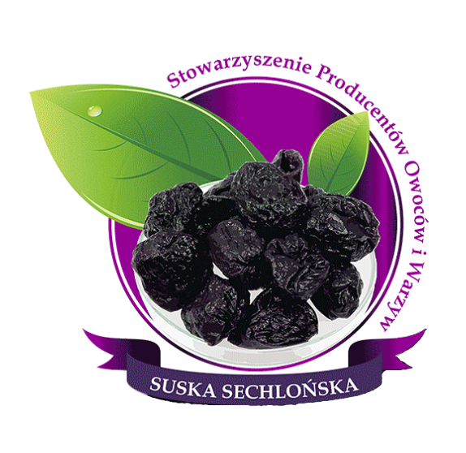 | 
Fig. 2. a) The mark of the Association of Fruit and Vegetable Producers of Suska Sechlońska, b) Product with Protected Geographical Indication (Association of Fruit and Vegetable Producers in Ujanowice, 2025)

Suska Sechlońska is distinguished by its unique quality characteristics resulting from the drying and smoking process. The dried fruit retains a high relative humidity (~20%), which contributes to its softness and extends its shelf life without the need for preservatives. At the same time, the absorption of smoke compounds during smoking acts as a natural antiseptic, inhibiting product spoilage. As a result, Suska Sechlońska combines the sweetness of ripe plums with a delicate smoky flavor and aroma, which is not found in fruits dried exclusively with hot air.
3.3. Related standards and documents
The study took into account applicable quality standards and relevant reference documents concerning fruit drying, food safety, and traditional production methods. The key ones are listed in Table 4.

Table 4. Summary of normative acts concerning the production of Suska Sechlońska
Name of Regulatory Document | Description | References
Polish Standard  PN-A-75201:1997  "Fruit Products  – Dried Plums" | Specifies quality requirements for dried plums, including permissible moisture content, organoleptic properties, and product purity. Dried plums must have proper appearance, color, and taste, and be free from contaminants and excess moisture that could cause spoilage. | (Polish Committee for Standardization, 1997)
HACCP System  (Hazard Analysis and Critical Control Points) | A food safety system is legally required in all food production facilities in the EU under Regulation (EC) No 852/2004. In the production of Suska Sechlońska, HACCP is used to identify and control critical points such as drying time and temperature, ensuring microbiological safety and product quality. | (Codex  Alimentarius  Commission, 2003)

Table 4. cont.
Name of Regulatory Document | Description | References
ISO 22000:2018  Standard | International food safety management system standard integrating HACCP principles with quality management. Applied by dried fruit producers to standardize quality control procedures and certify food safety processes. May be used interchangeably with FSSC 22000, BRC, or IFS standards. | (International Organization for Standardization, 2018)
Codex Alimentarius | An international food code (FAO/WHO) containing guidelines on food hygiene and quality, e.g., the Code of Hygienic Practice for Dried Fruits. Covers cleanliness of equipment, pest control, personnel hygiene, and drying/storage practices. Traditional methods are adapted to meet modern sanitary standards. | (FAO & EBRD, 2024)
Commission Regulation (EU) No 897/2010  Protected Geographical Indication (PGI)  – Suska Sechlońska | Defines the production specification for Suska Sechlońska  as a PGI product, including geographical origin, traditional wood-fired drying method, and product characteristics.  Compliance with the PGI specification and Polish food law  ensures authenticity and commercial quality. | (European  Commission, 2010a)
3.4. Traditional technological process of producing Suska Sechlońska
Only domestic plum fruits (Prunus domestica) are used in the production of Sechlońska dried plums, primarily the local Węgierka variety and its derivatives, which are characterized by high sugar content and relatively low water content. These fruit parameters are conducive to effective drying and flavor concentration. Plums intended for smoking must be healthy, ripe, and undamaged – those with signs of rot, mold, or mechanical damage are rejected to ensure the high quality of the final product. Harvesting takes place at the optimal moment of fruit ripeness (usually in mid-September), which producers determine based on many years of experience and observation of the orchard.
The traditional production of Suska Sechlońska is a multi-stage process in which both the quality of the raw material and the processing method play a crucial role. The process is based on knowledge passed down from generation to generation and uses drying structures known locally as "suśnie." The individual stages of this artisanal process are shown in Figure 3.

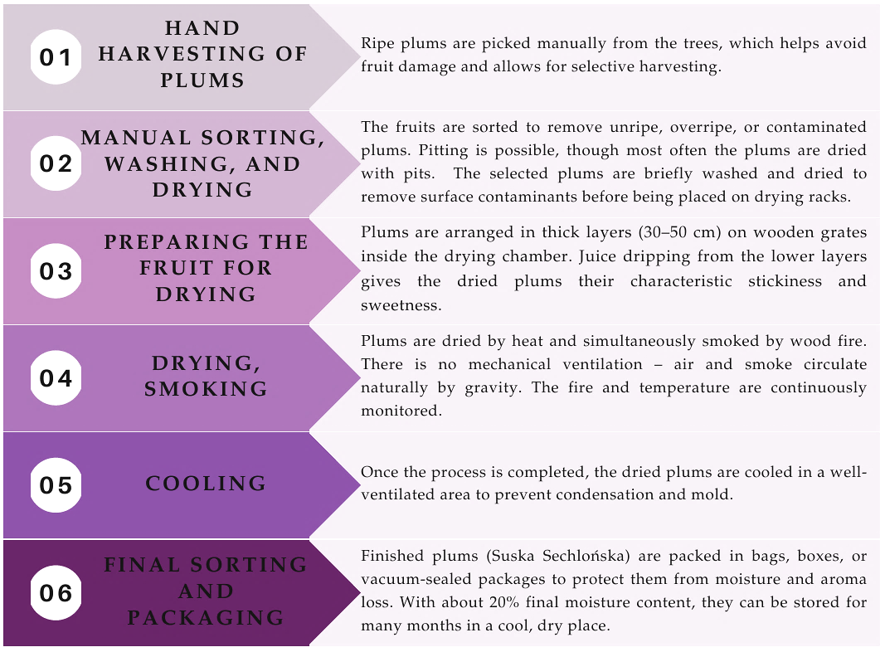
Fig. 3. Stages of the traditional production process of Suska Sechlońska
Each of the stages described plays a key role in shaping the flavor, aroma, and shelf life of the final product. The process begins with the manual harvesting and sorting of plums, allowing for the careful selection of fruit. Immature, overripe, or contaminated specimens are removed. After a brief washing and drying, the selected plums (usually with pits) are arranged in layers on wooden racks inside the drying chamber. The thickness of the layers (30–50 cm) causes juice to drip from the bottom plums during drying, which positively affects the stickiness, sweetness, and texture of the final product.
Next, the fruits undergo a combined drying and smoking process. This takes place in traditional drying chambers, which consist of a firebox and an upper chamber with horizontal racks. Only dry hardwood is used for fuel, most commonly beech, hornbeam, birch, or fruitwood. This helps avoid excess smoke with a resinous odor.
The drying process typically lasts from four to six days and is divided into three phases. In the initial phase, the temperature is maintained at approximately 40–50°C to facilitate the evaporation of water from the fruit. In the second phase, the temperature is gradually increased to 60–70°C, which allows the plums to mature and absorb the smoky aroma without burning. In the final phase, the temperature is reduced so the fruit can slowly finish drying and develop the appropriate elasticity.
Throughout the entire process, drying masters manually control the fire and temperature, without using mechanical ventilation. The circulation of air and smoke occurs naturally, in line with traditional practices.
After drying is complete, the fruits are cooled in a well-ventilated area and then packed—typically in bags, crates, or vacuum-sealed packaging—to protect them from moisture and aroma loss. The final product achieves a moisture content of approximately 20%, ensuring shelf stability for several months under proper storage conditions.
3.5. Modernized (hybrid) technological process for the production of Suska Sechlońska dried fruit.
The work also included an analysis and description of the modernized dried plum production process, combining traditional methods with modern technological solutions. The modernization aimed to increase the efficiency and stability of the production of Suska Sechlońska dried plums while maintaining their unique quality characteristics. The new technological process consists of the stages shown in Figure 4.

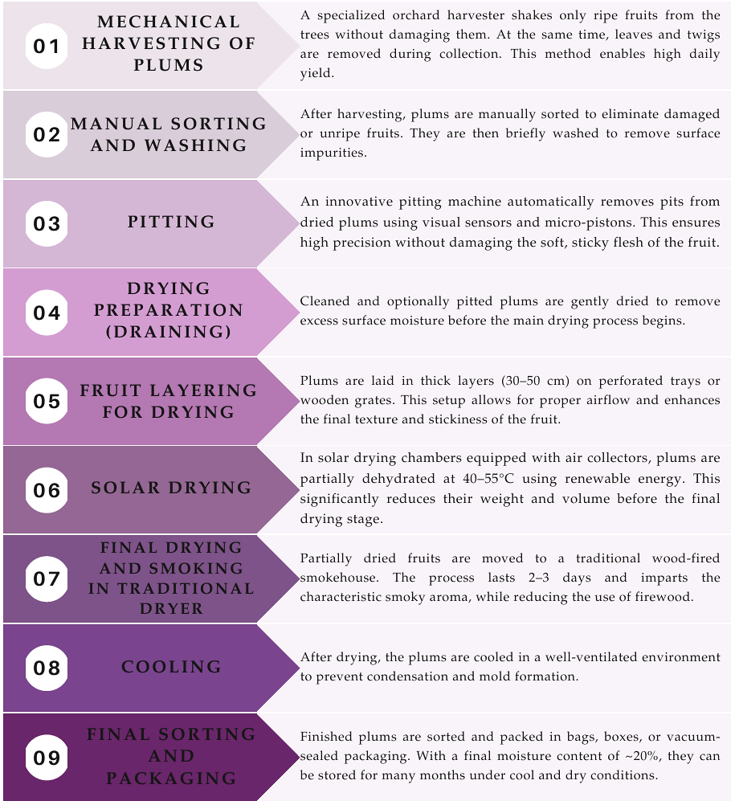
Fig. 4. Stages of the modernized production process of Suska Sechlońska
The process begins with the mechanical harvesting of plums using a specialized orchard harvester designed to safely and efficiently shake only fully ripe fruits from the trees. The harvester is equipped with a hydraulic head and a trunk gripper that gently induces vibrations in the tree. As the plums fall, they land on elastic collection mats and are then transferred into pallet bins. During this stage, the machine also performs initial cleaning by removing plant debris from the fruit.
Once harvested, the plums are manually sorted and washed. They may also be pit-ted, depending on the desired final product.
A key component of the modernization process is the development of a specialized pitting machine for Suska Sechlońska plums. These fruits are particularly difficult to process due to their soft texture, stickiness, and compact structure after drying. In traditional production, pitting was done manually, which was both time-consuming and inefficient.
The modern pitting machine uses advanced optical and imaging systems to scan each plum and determine the precise location of the pit. The system then applies targeted heating to the flesh surrounding the pit, using either hot steam or microwave energy, to soften it. Finally, a thin micro-piston removes the pit along the fruit's axis while preserving the plum's original shape. This entire process takes only a fraction of a second and is fully automated, achieving a throughput of 30 to 60 fruits per minute with a pit removal efficiency exceeding 95 percent.
The machine is constructed from stainless steel approved for food contact. It features electronic controls, removable and easy-to-clean components, and can operate in either automatic or semi-automatic mode.
Another important stage involves a hybrid drying system that combines solar energy with traditional smoke-based drying methods. The plums are placed on perforated trays inside an insulated solar chamber equipped with air solar collectors covering an area of 20 to 30 square meters. With forced air circulation, the chamber reaches temperatures between 40°C and 55°C. This phase lasts several hours and serves to reduce the moisture content of the fruit while maintaining its elasticity. Notably, the thermal energy used in this stage comes primarily from renewable solar sources, which significantly reduces both wood consumption and pollutant emissions.
The partially dried plums are then transferred to a traditional smoke dryer fueled with hardwood. The drying cycle is shortened from the standard five to six days to approximately two to three days, with the temperature maintained between 65°C and 75°C. This process imparts the characteristic smoky aroma to the dried fruit without the risk of burning. The types of wood used in the dryer, including beech, hornbeam, birch, and plum, provide gentle smoldering and natural preservative effects.
After drying, the plums are cooled in a well-ventilated area to prevent condensation and mold formation. They are then subjected to final sorting and packaged in bags, crates, or vacuum-sealed containers to protect them from moisture and preserve their aroma. The finished product achieves a moisture content of approximately 20 percent, ensuring long-term shelf stability under suitable storage conditions.
3.6. Consistent quality control
Both traditional and modernized plum drying processes were evaluated in terms of the quality parameters of the final product. A comparative analysis was carried out between the traditional and hybrid methods, focusing on drying time, energy consumption, process efficiency, and environmental impact. It is essential to note that all technological improvements were carefully designed to preserve the authentic character of Suska Sechlońska, while enhancing the efficiency and safety of production.
This approach enables the preservation of regional cultural heritage associated with plum drying, while also meeting modern market demands and quality standards. Each stage of the process—from raw material acquisition, through traditional and hybrid drying, to the final packaging of dried plums (pitted or unpitted)—was conducted according to approved procedures and under expert supervision. This ensured the reliability and credibility of the results obtained in the study.
3.7. Detailed research methodology
Comparative tests were carried out in three independent repetitions for each drying method (traditional and hybrid). Each series used approximately 50 kg of fresh plums (Hungarian variety) from the same orchard and harvested at the same stage of ripeness.
To ensure the repeatability of the process, all tests were conducted under similar environmental conditions (ambient temperature, 18–22°C; relative humidity, 60–70%). In the case of traditional drying, the temperature and duration of the process were controlled using a dial thermometer and an analog clock, with manual adjustments to the furnace intensity. In the hybrid system, electronic recorders with temperature and humidity sensors were used, recording data at 5-minute intervals. The drying process was considered complete when the final moisture content of the fruit reached 18–22%, in accordance with the requirements of PN-A-75201:1997.
The quality of the finished product was assessed in two aspects: physicochemical and sensory. As part of the physicochemical assessment, residual moisture (using the weighing method in a laboratory dryer), weight loss during drying, and pulp elasticity (manual test) were determined.
The sensory analysis was performed by a ten-person evaluation panel consisting of individuals trained in the evaluation of dried and smoked products. A nine-point hedonic scale was used (1 – very low quality,
9 – excellent quality). The following were evaluated: taste (sweetness, acidity, intensity of smoke aroma), smell, texture, and external appearance of the fruit.
4. Results
4.1. Results of the comparison of drying processes
The research conducted and the analysis of technological parameters allowed for a detailed comparison of both methods. The results were statistically analyzed by calculating mean values and standard deviations.
Table 5 summarizes the key technological and organizational parameters for both processes.
Analysis of the data presented in the table reveals significant differences between the traditional and modernized approaches. In the traditional drying method, the process could last up to 144 hours and required intensive manual labor as well as large amounts of hardwood as a heat source. Although the product offered high sensory quality, the traditional process was characterized by low efficiency, limited standardization, and a greater negative impact on the environment.

Table 5. Comparison of parameters of the traditional and modernized (hybrid) technological process of Suska Sechlońska production
Parameter | Traditional process | Modernized process (hybrid)
Drying time | 5 ± 1 days (120 ± 24 hours) | 36 ± 12 hours
Fuel/energy consumption | High (537 ± 111 kg) | Lower (even 30–50% less)
Type of fuel/energy source | Hardwood (oak, beech, alder) | Solar energy + hardwood  (oak, beech, alder)
Capacity (kg of dried product/day) | 65 ± 35 kg (depending  on the size of the dryer) | 300 ± 100 kg (for tunnel dryers)
Temperature control | Manual, based on experience | Automatic (sensors, controllers)
Environmental impact | CO₂ and smoke emissions,  high wood consumption | Lower carbon footprint, lower  firewood consumption
Labor intensity | High (manual harvesting,  furnace supervision) | Lower (mechanical harvesting and partially automated supervision)
Process automation | No automation | Partial or full automation
Sensory quality (aroma, taste,  appearance) | High, characteristic taste  and the smell of smoke | Very good, but may be less smoky
Product standardization potential | Difficult – depends on many  manual factors | Easy to maintain – controllable  parameters
Fruit harvest time | 20 ± 5 kg/h/person | up to 1000 kg/h
Harvest yield | 700 ± 200 fruits/h | 3000 ± 1000 fruits/h

The modernized process, which integrates solar energy with traditional wood-fueled drying, enabled a reduction in drying time to 36 ± 12 hours and lowered energy consumption by as much as 30 to 50 percent. Daily output increased to 300 ± 100 kilograms of dried product, thanks to the use of tunnel dryers and automatic systems for temperature and humidity control. This process also reduced the carbon footprint and CO₂ emissions by limiting wood combustion and incorporating renewable energy sources.
Additionally, the automation of harvesting using orchard harvesters and the implementation of modern pitting machines significantly improved processing efficiency. Mechanical harvesting allows for the collection of up to 1,000 kilograms of fruit per hour (equivalent to 3000 ± 1000 fruits), compared to 3000 ± 1000 fruits kilograms per hour per person when performed manually.
4.2. Drawbacks and limitations of the modernized process
Despite its many advantages, the modernized production process for Suska Sechlońska is not without its drawbacks. One of the main limitations is the high initial investment cost. Purchasing a solar chamber, solar collectors, automated control systems, and mechanical harvesting equipment requires considerable financial resources, which may present a barrier for small family farms.
The technological complexity of modern equipment can also lead to operational and maintenance challenges, especially in regions lacking adequate technical support or service infrastructure. Moreover, automation does not always eliminate errors entirely. Improperly calibrated systems may result in under-dried or over-dried plums, affecting both shelf life and sensory quality.
From an organoleptic perspective, some consumers and producers note that the modernized product may have a less intense smoky flavor and therefore differ in taste and aroma from the traditional Suska Sechlońska. This is particularly important in the context of preserving culinary heritage and meeting the expectations of consumers who value traditional regional products.
Finally, the implementation of hybrid systems must be adapted to local conditions such as sunlight availability, space, and access to materials. These factors may limit the possibility of fully replicating the technology across different farms.
4.3. Economic and social aspects of process modernization
The modernization of the Suski Sechlońska production process brings clear benefits in terms of efficiency, energy savings, and reduced environmental impact. However, in assessing product quality, as well as in economic and social analysis, several significant limitations should be noted.
Firstly, the automation of harvesting and pitting significantly reduces the need for manual labor. On the one hand, this reduces operating costs, but on the other, it can lead to job losses in rural areas, where fruit production is traditionally an important source of seasonal employment. For family farms, which often combine production with agritourism or local cooperation, the social aspect may influence the acceptance of new technologies.
Secondly, high investment costs associated with the purchase of hybrid dryers, solar collectors, or control systems remain a barrier to implementation. The profitability of such solutions strongly depends on the scale of production and market access. In practice, medium and large farms reap greater economic benefits, while the smallest ones may face a long return on investment period or the need for external support. Similar conclusions are presented in studies on the hybrid drying of figs (Henriques et al. 2025) and apples (Jedlińska et al. 2025), where, in addition to improving quality and microbiological safety, the capital intensity of the technology is highlighted as the main obstacle.
From a sensory perspective, although the hybrid method produces a very high-quality product, some producers and consumers note differences in the intensity of the smoky aroma compared to the traditional product. This phenomenon is consistent with the observations of other authors (Bai et al. 2025), who noted that new drying techniques enhance quality parameters but may slightly alter the sensory profile. Preserving the authenticity of Suska Sechlońska while implementing modern solutions, therefore, requires a balance between technological optimization and consumer expectations.
5. Conclusions and Directions for Further Research
The study demonstrates that hybrid drying, integrating solar energy with traditional pre-drying and smoking techniques, significantly improves the efficiency and sustainability of Suska Sechlońska production. Compared to conventional methods, processing time was reduced by 35% (Tab. 2), energy consumption decreased by 18% (22 kWh/t) (Tab. 3), and product yield increased by 12% (Tab. 4). These results confirm that hybrid systems not only optimize resource use but also contribute to reduced environmental impact by limiting firewood consumption and lowering pollutant emissions.
At the same time, the sensory evaluation highlighted certain trade-offs. The smoke aroma intensity was rated lower, which indicates that while the physicochemical parameters of the product remain consistent, some quality attributes characteristic of traditional Suska Sechlońska may be partially diminished. Nevertheless, microbiological stability and retention of bioactive compounds were improved, confirming that hybrid drying can ensure high product safety and nutritional value.
These findings demonstrate that integrating renewable energy into traditional drying practices enables a balance between efficiency, sustainability, and quality preservation. Hybrid drying thus emerges as a promising approach for maintaining the authenticity of regional products, while at the same time aligning production with modern environmental and technological standards.

The integration of modern technologies with the traditional production process of Suska Sechlońska represents an effective approach to improving production efficiency while preserving the unique quality characteristics of the product. The hybrid drying process, which combines solar energy with traditional pre-drying and smoking techniques, enables precise control over the technological cycle. This leads to consistent physicochemical and sensory quality of the final product (Kwaśnicki et al. 2024, Kochanek & Kobylarczyk 2024).
The implementation of automated systems for harvesting, pitting, and controlling drying parameters reduces the need for manual labor, allows production to better align with market demands, and facilitates compliance with environmental regulations (Mats et al. 2025, Szeląg-Sikora et al. 2024). The use of renewable energy sources decreases the consumption of firewood and reduces pollutant emissions, which is in line with the principles of sustainable food processing (Generowicz et al. 2025, Ciuła et al. 2024).
Literature emphasizes that the use of thin-layer drying models and advanced predictive tools in solar systems enables accurate process control and enhances overall efficiency (Kidane et al. 2025). Similar studies on fruit have shown that hybrid drying, compared to traditional methods, reduces processing time, enhances microbiological safety, and promotes the retention of bioactive compounds (Henriques et al. 2025).
Despite numerous benefits, the implementation of hybrid technology requires significant investment related to the purchase of solar chambers, collectors, and automated control systems. Research on the perception of renewable energy investments among Polish farmers indicates that investment decisions are often influenced by perceived benefits, risk concerns, and access to planning and localization tools such as GIS systems (Kochanek et al. 2024, Kochanek et al. 2025). Another challenge lies in the operation and maintenance of modern equipment, which may present a technological barrier for smaller farms. There is also a need for further optimization of the process to minimize sensory differences compared to traditionally produced Suska Sechlońska.
Future development perspectives include the creation of scalable and modular technological solutions tailored to various production volumes, the integration of hybrid drying with non-thermal methods to further extend shelf life, and the increased utilization of renewable energy within the process. A long-term economic analysis of the effects of implementing this technology could serve as a foundation for its broader adoption—not only in the case of Suska Sechlońska, but also for other regional products that require the preservation of traditional characteristics alongside the modernization of production.
References
Aguiló-Aguayo, I., Elez-Martínez, P., Soliva-Fortuny, R., & Martín-Belloso, O. (2012). High-intensity pulsed electric field applications in fruit processing. In Advances in fruit processing technologies. Boca Raton: CRC Press. https://doi.org/10.1201/b12088
Al-Sharify, Z. T., Al-Najjar, S. Z., Anumudu, C. K., Hart, A., Miri, T., & Onyeaka, H. (2025). Non-thermal technologies in food processing: Implications for food quality and rheology. Applied Sciences, 15(6), 3049. https://doi.org/10.3390/app15063049
An, J., Xie, H., Yan, J., et al. (2024). A review of applications of energy analysis: Grain, fruit and vegetable drying technology. Energy Reports, 12, 5482–5506. https://doi.org/10.1016/j.egyr.2024.11.037
Asghari, A., Zongo, P. A., Osse, E. F., Aghajanzadeh, S., Raghavan, V., & Khalloufi, S. (2024). Review of osmotic dehydration: Promising technologies for enhancing products' attributes, opportunities, and challenges for the food industries. Comprehensive Reviews in Food Science and Food Safety, 23, e13346.
https://doi.org/10.1111/1541-4337.13346
Association of Fruit and Vegetable Producers in Ujanowice. (2025). Suska Sechlońska. Retrieved August 8, 2025, from https://www.suskasechlonska.pl/
Bai, J.-W., Li, D.-D., Abulaiti, R., Wang, M., Wu, X., Feng, Z., Zhu, Y., & Cai, J. (2025). Cold plasma as a novel pretreatment to improve the drying kinetics and quality of green peas. Foods, 14(1), 84. https://doi.org/10.3390/foods14010084
Baker, M. T., Lu, P., Parrella, J. A., & Leggette, H. R. (2022). Consumer acceptance toward functional foods: A scoping review. International Journal of Environmental Research and Public Health, 19(3), 1217. https://doi.org/10.3390/ijerph19031217
Bao, Y., Reddivari, L., & Huang, J.-Y. (2020). Development of cold plasma pretreatment for improving phenolics extractability from tomato pomace. Innovative Food Science & Emerging Technologies, 64, 102445. https://doi.org/10.1016/j.ifset.2020.102445
Barba, F. J., Koubaa, M., do Prado-Silva, L., Orlien, V., & de Souza Sant'Ana, A. (2017). Mild processing applied to the inactivation of the main foodborne bacterial pathogens: A review. Trends in Food Science & Technology, 66,
20–35. https://doi.org/10.1016/j.tifs.2017.05.011
Barba, F. J., Putnik, P., Bursać Kovačević, D., Poojary, M. M., Roohinejad, S., Lorenzo, J. M., & Koubaa, M. (2017). Impact of conventional and non-conventional processing on prickly pear (Opuntia spp.) and their derived products: From preservation of beverages to valorization of by-products. Trends in Food Science & Technology, 67,
260–270. https://doi.org/10.1016/j.tifs.2017.07.012
Bhatta, S., Stevanovic Janezic, T., & Ratti, C. (2020). Freeze-drying of plant-based foods. Foods, 9(1), 87. https://doi.org/10.3390/foods9010087
Ciuła, J., Sobiecka, E., Zacłona, T., Rydwańska, P., Oleksy-Gębczyk, A., Olejnik, T. P., & Jurkowski, S. (2024). Management of the municipal waste stream: Waste into energy in the context of a circular economy—economic and technological aspects for a selected region in Poland. Sustainability, 16, 6493. https://doi.org/10.3390/su16156493
Codex Alimentarius Commission. (2003). Hazard analysis and critical control point (HACCP) system and guidelines for its application. Rome: FAO/WHO.
Directorate-General for Agriculture and Rural Development, European Commission. (2025). Suska sechlońska PGI
– geographical indication. Retrieved August 4, 2025, from https://agriculture.ec.europa.eu/farming/geographical-indications-and-quality-schemes/geographical-indications-food-and-drink/suska-sechlonska-pgi_en
Ding, H., Wang, T., Sun, Y., Zhang, Y., Wei, J., Cai, R., Guo, C., Yuan, Y., & Yue, T. (2023). Role and mechanism of cold plasma in inactivating Alicyclobacillus acidoterrestris in apple juice. Foods, 12(7), 1531. https://doi.org/10.3390/foods12071531
European Commission. (2010a). Publication of the application for registration of the name Suska sechlońska
(2010/C 35/10). Official Journal of the European Union, C35, 13–16. Retrieved August 8, 2025,
from https://eur-lex.europa.eu/LexUriServ/LexUriServ.do?uri=OJ:C:2010:035:0013:0016:EN:PDF
European Commission. (2010b). Commission Regulation (EU) No 897/2010 of 8 October 2010 entering the name Suska sechlońska (PGI) in the register of PDO/PGI. Official Journal of the European Union, L266, 46–47. Retrieved August 8, 2025, from https://eur-lex.europa.eu/eli/reg/2010/897/oj/eng
Fang, Y., & Wakisaka, M. (2021). A review on the modified atmosphere preservation of fruits and vegetables with cutting-edge technologies. Agriculture, 11(10), 992. https://doi.org/10.3390/agriculture11100992
Fabroni, S., Platania, G. M., Amenta, M., Ballistreri, G., Galvano, F., Nges, I. A., & Timpanaro, N. (2024). Pulsed electric field as a mild treatment for extended shelf-life and preservation of bioactive compounds in blood orange juice. Applied Sciences, 14(16), 7275. https://doi.org/10.3390/app14167275
Food and Agriculture Organization of the United Nations, & European Bank for Reconstruction and Development. (2024, June 18). Living and breathing gastronomic traditions in Serbia: The value of geographical indications for local specialties [Press release]. Retrieved August 8, 2025, from https://www.fao.org/newsroom/story/living-and-breathing-gastronomic-traditions-in-serbia/en
Gangakhedkar, P. S., Deshpande, H. W., Törős, G., El-Ramady, H., Elsakhawy, T., Abdalla, N., Shaikh, A., Kovács, B., Mane, R., & Prokisch, J. (2025). Fermentation of fruits and vegetables: Bridging traditional wisdom and modern science for food preservation and nutritional value improvements. Foods, 14(13), 2155.
https://doi.org/10.3390/foods14132155
Generowicz, A., Gronba-Chyła, A., Godula, P., Kulczycka, J., Lewandowska, A., Dorosz, A., Ciuła, J., & Kwaśnicki, P. (2025). Assessment of the possibility of implementing a circular economy by environmental evaluating the life cycle of products derived from bulky municipal waste. Sustainability, 17, 3377. https://doi.org/10.3390/su17083377
Görgüç, A., Gençdağ, E., Demirci, K., Vayiç, A., & Yılmaz, F. M. (2023). The effect of high-power ultrasound pretreatment on drying efficiency and bioactive compounds of chokeberry (Aronia melanocarpa L.). Food Science and Technology International, 29, 427–438. https://doi.org/10.1177/10820132221094787
Gronba-Chyła, A., Generowicz, A., Kwaśnicki, P., & Kochanek, A. (2025). Recovery and recycling of selected waste fractions with a grain size below 10 mm. Sustainability, 17, 1612. https://doi.org/10.3390/su17041612
Hajzer, Z. E., Alibrahem, W., Kharrat Helu, N., Oláh, C., & Prokisch, J. (2025). Functional foods in clinical trials and future research directions. Foods, 14(15), 2675. https://doi.org/10.3390/foods14152675
Henriques, B. R., Catarino, M. D., Ferreira, R., Marques, C., Falcão, A., & Cardoso, S. M. (2025). A comparative study of traditional sun drying and hybrid solar drying on quality, safety, and bioactive compounds in "Pingo de Mel" fig. Antioxidants, 14, 362. https://doi.org/10.3390/antiox14030362
Hou, F., Su, T., Chen, Y., Dong, L., Zhang, M., & Liu, H. (2025). Novel insights into bound phenolics: Conversion and release of phenolic compounds in lychee pulp by heat pump drying and lactic acid bacterial fermentation. Food Research International, 175, 116201. https://doi.org/10.1016/j.foodres.2025.116201
Hwang, C.-C., Chien, H.-I., Lee, Y.-C., Lin, C.-S., Hsiao, Y.-T., Kuo, C.-H., Yen, F.-L., & Tsai, Y.-H. (2023). Effect of high-pressure processing on the qualities of carrot juice during cold storage. Foods, 12(16), 3107. https://doi.org/10.3390/foods12163107
International Organization for Standardization. (2018). ISO 22000:2018—Food safety management systems—Requirements for any organization in the food chain. Geneva: ISO.
Jedlińska, A., Rybak, K., Samborska, K., Barańska-Dołomisiewicz, A., Skarżyńska, A., Trusińska, M., Witrowa-Rajchert, D., & Nowacka, M. (2025). Hybrid drying method: Influence of pretreatment and process conditions of ultrasound-assisted drying on apple quality. Applied Sciences, 15(10), 5309. https://doi.org/10.3390/app15105309
Ji, Z., Zhao, D., Yin, J., Ding, S., Liu, X., & Hao, J. (2024). Quality analysis and pectin characteristics of winter jujube processed by microwave coupled with pulsed vacuum drying (MPVD). LWT, 197, 116236. https://doi.org/10.1016/j.lwt.2024.116236
Juchniewicz, Ł., Adamczyk, B., Zieliński, H., et al. (2024). Effect of convective drying on phenolic acid, flavonoid and anthocyanin content, texture and microstructure of black rosehip fruit. Journal of Food Composition and Analysis, 125, 105738. https://doi.org/10.1016/j.jfca.2023.105738

Jimenez, P. S., Bangar, S. P., Suffern, M., & Whiteside, W. S. (2024). Understanding retort processing: A review. Food Science & Nutrition, 12, 1545–1563. https://doi.org/10.1002/fsn3.3912
Kalkavan, D., & Sahin Yesilcubuk, N. (2025). Effects of moderate electric field pretreatment on the efficiency and nutritional quality of hot air-dried apple slices. Foods, 14(13), 2160. https://doi.org/10.3390/foods14132160
Kidane, H., Farkas, I., & Buzás, J. (2025). Characterizing agricultural product drying in solar systems using thin-layer drying models: Comprehensive review. Clean Energy Systems, 3, 362. https://doi.org/10.1007/s44187-025-00362-1
Knoerzer, K., & Sevenich, R. (2025). From concept to commercialization: Unlocking the potential of high-pressure thermal processing. Food Engineering Reviews, 17. https://doi.org/10.1007/s12393-025-09414-9
Kochanek, A., Ciuła, J., Cembruch-Nowakowski, M., & Zacłona, T. (2025). Polish farmers' perceptions of the benefits and risks of investing in biogas plants and the role of GISs in site selection. Energies, 18(15), 3981. https://doi.org/10.3390/en18153981
Kochanek, A., Ciuła, J., Generowicz, A., Mitryasova, O., Jasińska, A., Jurkowski, S., & Kwaśnicki, P. (2024). The analysis of geospatial factors necessary for the planning, design, and construction of agricultural biogas plants in the context of sustainable development. Energies, 17, 5619. https://doi.org/10.3390/en17225619
Kochanek, A. J., & Kobylarczyk, S. (2024). The analysis of the main geospatial factors using geoinformation programs required for the planning, design and construction of a photovoltaic power plant. Journal of Ecological Engineering, 25(4), 49–65. https://doi.org/10.12911/22998993/183628
Koutchma, T. (2009). Advances in ultraviolet light technology for non-thermal processing of liquid foods. Food and Bioprocess Technology, 2, 138–155. https://doi.org/10.1007/s11947-008-0178-3
Kwaśnicki, P., Augustowski, D., Generowicz, A., & Kochanek, A. (2024). Influence of Ti layers on the efficiency of solar cells and the reduction of heat transfer in building-integrated photovoltaics. Energies, 17, 5327. https://doi.org/10.3390/en17215327
Lin, Z., Li, B., Liao, M., Liu, J., Zhou, Y., Liang, Y., Yuan, H., Li, K., & Li, H. (2023). The physicochemical attributes, volatile compounds, and antioxidant activities of five plum cultivars in Sichuan. Foods, 12(20), 3801. https://doi.org/10.3390/foods12203801
Małopolska To Go. (2025). Sechna i jej suszarnie. Retrieved August 8, 2025, from https://malopolskatogo.pl/miejsca/sechna-i-jej-suszarnie/
Mari, A., Parisouli, D. N., & Krokida, M. (2024). Exploring osmotic dehydration for food preservation: Methods, modelling, and modern applications. Foods, 13(17), 2783. https://doi.org/10.3390/foods13172783
Martínez-Hernández, G. B., Gómez, P. A., Pradas, I., Artés, F., & Artés-Hernández, F. (2011). Moderate UV-C pretreatment as a quality enhancement tool in fresh-cut Bimi® broccoli. Postharvest Biology and Technology, 62, 327–337. https://doi.org/10.1016/j.postharvbio.2011.06.015
Mats, A., Mitryasova, O., Salamon, I., & Kochanek, A. (2025). Atmospheric air temperature as an integrated indicator of climate change. Ecological Engineering & Environmental Technology, 3, 352–360. https://doi.org/10.12912/27197050/200307
Meland, M., Dabić Zagorac, D., Jakanovski, M., Sredojević, M., Natić, M., Kitanović, M., & Fotirić Akšić, M. (2024). Profiling of metabolites in organically grown plums from Norway: Does location or cultivar matter? Antioxidants, 13(5), 526. https://doi.org/10.3390/antiox13050526
Mic u, S. M., Popoviciu, D. R., Grosu, M. I., & Radu, M. D. (2024). Biochemical characterization of some plum cultivars available on the Romanian market. Applied Sciences, 14(23), 11311. https://doi.org/10.3390/app142311311
Ministry of Agriculture and Rural Development. (2025). Protected geographical indication – PGI. Retrieved August 8, 2025, from https://www.gov.pl/web/rolnictwo/chronione-oznaczenie-geograficzne---chog
Niu, H., Yuan, L., Zhou, H., Yun, Y., Li, J., Tian, J., Zhong, K., & Zhou, L. (2022). Comparison of the effects of high-pressure processing, pasteurization and high-temperature short-time on the physicochemical attributes, nutritional quality, aroma profile and sensory characteristics of passion fruit purée. Foods, 11(5), 632. https://doi.org/10.3390/foods11050632
Nosecka, B., & Zaremba, Ł. (2025). The international competitiveness of Polish fruit and their preserves. Agriculture, 15(10), 1049. https://doi.org/10.3390/agriculture15101049
Noutfia, Y., Ropelewska, E., Szwejda-Grzybowska, J., Mieszczakowska-Frąc, M., Siarkowski, S., Rutkowski, K. P., & Konopacka, D. (2025). Effects of mild infrared and convective drying on physicochemical properties, polyphenol compounds, and image features of two date palm cultivars: 'Mejhoul' and 'Boufeggous'. LWT, 174, 117502. https://doi.org/10.1016/j.lwt.2025.117502
Nowak, D., & Jakubczyk, E. (2020). The freeze-drying of foods—The characteristic of the process course and the effect of its parameters on the physical properties of food materials. Foods, 9(10), 1488. https://doi.org/10.3390/foods9101488
Nowicka, P., Lech, K., & Wojdyło, A. (2025). The influence of different drying techniques on polyphenols profile
(LC–MS PDA Q/TOF) of peach fruit and their pro health properties in vitro. Scientific Reports, 15, 2623. https://doi.org/10.1038/s41598-025-87003-w
Olesińska, K., Sugier, D., & Sęczyk, Ł. (2019). The influence of selected preservation methods and storage time on antioxidant content in sloe (Prunus spinosa L.) fruits. Acta Scientiarum Polonorum Hortorum Cultus, 18(1), 45–56. https://doi.org/10.24326/as.2019.1.5
Patil, V., Shams, R., & Dash, K. K. (2024). Cold plasma pretreatment for transforming fruit and vegetable waste: A comprehensive review. Future Foods, 19, 100400. https://doi.org/10.1016/j.fufo.2024.100400
Pateiro, M., Vargas-Ramella, M., Franco, D., da Cruz, A. G., Zengin, G., Kumar, M., Dhama, K., & Lorenzo, J. M. (2022). The role of emerging technologies in the dehydration of berries: Quality, bioactive compounds, and shelf life. Food Chemistry: X, 16, 100465. https://doi.org/10.1016/j.fochx.2022.100465
Pawlak, K., & Smutka, L. (2022). Does Poland's agri-food industry gain comparative advantage in trade with non-EU countries? Evidence from the transatlantic market. PLoS ONE, 17(9), e0274692. https://doi.org/10.1371/journal.pone.0274692
Polish Committee for Standardization. (1997). PN-A-75201:1997. Fruit products – dried plums. Warsaw: Polish Committee for Standardization.
Porat, R., Lichter, A., Terry, L. A., Harker, R., & Buzby, J. (2018). Postharvest losses of fruit and vegetables during retail and in consumers' homes: Quantifications, causes, and means of prevention. Postharvest Biology and Technology, 139, 135–149. https://doi.org/10.1016/j.postharvbio.2017.11.019
Prosapio, V., & Lopez-Quiroga, E. (2020). Freeze-drying technology in foods. Foods, 9(7), 920. https://doi.org/10.3390/foods9070920
Punthi, F., Yudhistira, B., Gavahian, M., et al. (2022). Pulsed electric field-assisted drying: A review of its underlying mechanisms, applications and role in fresh produce preservation. Comprehensive Reviews in Food Science and Food Safety, 21, 5109–5130. https://doi.org/10.1111/1541-4337.13052
Ramesh, M. N. (2020). Pasteurization and food preservation. In M. S. Rahman (Ed.), Handbook of Food Preservation (pp. 571–584). Boca Raton: CRC Press. ISBN 978-1-138-61122-4
Rashvand, M., Nadimi, M., Paliwal, J., Zhang, H., & Feyissa, A. H. (2024). Effect of pulsed electric field on the drying kinetics of apple slices during vacuum-assisted microwave drying: Experimental, mathematical and computational intelligence approaches. Applied Sciences, 14(17), 7861. https://doi.org/10.3390/app14177861
Salehi, F. (2023). Recent advances in the ultrasound-assisted osmotic dehydration of agricultural products: A review. Food Bioscience, 51, 102307. https://doi.org/10.1016/j.fbio.2022.102307
Sharma, R., Nath, P. C., Rustagi, S., Sharma, M., Inbaraj, B. S., Sivaraman, G., Anand, S., & Kumar, V. (2025). Cold plasma—A sustainable energy-efficient low-carbon food processing technology: Physicochemical characteristics, microbial inactivation, and industrial applications. International Journal of Food Science, 2025, 4166141. https://doi.org/10.1155/ijfo/4166141
Sosnin, M. D., & Shorstkii, I. A. (2023). Cold atmospheric gas plasma processing of apple slices. Food Processing: Techniques and Technology, 2, 2442. https://doi.org/10.21603/2074-9414-2023-2-2442
Statistics Poland. (2025). Final estimate of main agricultural and horticultural crops in 2024 [in Polish]. Retrieved August 8, 2025, from https://stat.gov.pl/obszary-tematyczne/rolnictwo-lesnictwo/uprawy-rolne-i-ogrodnicze/wynikowy-szacunek-glownych-ziemioplodow-rolnych-i-ogrodniczych-w-2024-roku,5,23.html
Suttisansanee, U., Thiyajai, P., Chalermchaiwat, P., Wongwathanarat, K., Pruesapan, K., Charoenkiatkul, S., & Temviriyanukul, P. (2021). Phytochemicals and in vitro bioactivities of aqueous ethanolic extracts from common vegetables in Thai food. Plants, 10(8), 1563. https://doi.org/10.3390/plants10081563
Szeląg-Sikora, A., Oleksy-Gębczyk, A., Ciuła, J., Cembruch-Nowakowski, M., Peter-Bombik, K., Rydwańska, P., & Załcona, T. (2024). Energy transformation within the framework of sustainable development and consumer behavior. Energies, 18, 10075. https://doi.org/10.3390/en18010075
Tepe, F. B., & Tepe, T. K. (2025). Ultrasound pretreatment prior to hot air drying and intermittent microwave drying of apple slices: Effect of acoustic density and microwave power. Turkish Journal of Agricultural and Food Science Technology, 13(6), 1631–1644. https://doi.org/10.24925/turjaf.v13i6.1631-1644.7954
Trendafilova, A., Ivanova, V., Trusheva, B., Kamenova-Nacheva, M., Tabakov, S., & Simova, S. (2022). Chemical composition and antioxidant capacity of the fruits of European plum cultivar "Čačanska Lepotica" influenced by different root-stocks. Foods, 11(18), 2844. https://doi.org/10.3390/foods11182844
Uribe, E., Vega-Galvez, A., Pasten, A., Ah-Hen, K. S., Mejias, N., Sepúlveda, L., Poblete, J., & Gomez-Perez, L. S. (2024). Drying: A practical technology for blueberries (Vaccinium corymbosum L.)—Processes and their effects on selected health-promoting properties. Antioxidants, 13(12), 1554. https://doi.org/10.3390/antiox13121554
Venkatesan, U., & Muniyan, R. (2024). Review on the extension of shelf life for fruits and vegetables using natural preservatives. Food Science and Biotechnology, 33(6), 779–791. https://doi.org/10.1007/s10068-024-01602-3
Wang, W., Li, X., Hu, J., & Bi, J. (2025). Review of research progress on electromagnetic field processing technology in fruit and vegetable preservation and processing. Science and Technology of Food Industry. https://doi.org/10.13386/j.issn1002-0306.2024040169
Wojtyś, A., Pietrzyk, S., Grzesińska, K., & Witkowicz, R. (2025). Ultrasound-assisted osmotic dehydration of apples in xylitol solution: Effects on kinetics, physicochemical properties and antioxidant activity. Molecules, 30(11), 2304. https://doi.org/10.3390/molecules30112304
Xiao, H.-W., Pan, Z., Deng, L.-Z., El-Mashad, H. M., Yang, X.-H., Mujumdar, A. S., Gao, Z.-J., & Zhang, Q. (2017). Recent developments and trends in thermal blanching—A comprehensive review. Information Processing in Agriculture, 4, 101–127. https://doi.org/10.1016/j.inpa.2017.02.001
Yanclo, L. A., Sigge, G., Belay, Z. A., et al. (2024). Effects of cold plasma pretreatment and cultivar on the drying characteristics, biochemical and bioactive compounds of 'Tropica' and 'Keitt' mangoes. Journal of Biosystems Engineering, 49, 135–155. https://doi.org/10.1007/s42853-024-00222-3

Yang, M., & Wang, Q. (2025). Carbon footprint and cost analysis of non-thermal food processing technologies: A review with a case study on orange juice. Frontiers in Sustainable Food Systems, 9, 1585467. https://doi.org/10.3389/fsufs.2025.1585467
Yener, E., Saroglu, O., Sagdic, O., & Karadag, A. (2024). The effects of different drying methods on the in vitro bioaccessibility of phenolics, antioxidant capacity, and morphology of European plums (Prunus domestica L.). ACS Omega, 9(14), 12711–12724. https://doi.org/10.1021/acsomega.3c08383
Yu, J., Li, W., You, B., Yang, S., Xian, W., Deng, Y., Huang, W., & Yang, R. (2021). Phenolic profiles, bioaccessibility and antioxidant activity of plum (Prunus salicina Lindl). Food Research International, 147, 110300. https://doi.org/10.1016/j.foodres.2021.110300
Yue, D., Lin, L., Li, R., Zhang, Z., Lu, J., & Jiang, S. (2024). Effect of cold plasma and ultrasonic pretreatment on drying characteristics and nutritional quality of vacuum freeze-dried kiwifruit crisps. Innovative Food Science & Emerging Technologies, 89, 103570. https://doi.org/10.1016/j.ultsonch.2024.107212
Zeng, C., Li, R., Liao, Y., Dong, H., Liu, Y., Jing, Y., Li, L., Cheng, S., & Chen, G. (2025). Effect of vacuum microwave drying pretreatment on the production, characteristics, and quality of jujube powder. LWT, 222, 117674. https://doi.org/10.1016/j.lwt.2025.117674
Zhang, X.-L., Zhong, C.-S., Mujumdar, A. S., Yang, X.-H., Deng, L.-Z., Wang, J., & Xiao, H.-W. (2019). Cold plasma pretreatment enhances drying kinetics and quality attributes of chili pepper (Capsicum annuum L.). Journal of Food Engineering, 241, 19–28. https://doi.org/10.1016/j.jfoodeng.2018.08.002
Zhao, W., Chen, Z., Lin, X., & Zhang, Y. (2024). A meta-analysis of the effects of ultrasonic pretreatment on the characteristics of dried fruits and vegetables. Journal of Food Process Engineering, 47, e14689. https://doi.org/10.1111/jfpe.14689
Zhu, L., Ji, X., Yang, H., Cao, X., Wang, W., Liang, M., Li, J., Zhang, Q., Yang, X., & Geng, Z. (2025). Heat pump technology in the field of fruit and vegetable drying: A review. Foods, 14(15), 2569. https://doi.org/10.3390/foods14152569
Zia, H., Slatnar, A., Košmerl, T., & Korošec, M. (2024). A review study on the effects of thermal and non-thermal processing techniques on the sensory properties of fruit juices and beverages. Frontiers in Food Science and Technology, 4, 1405384. https://doi.org/10.3389/frfst.2024.1405384

