|  |  |  |  |
| --- | --- | --- | --- |
|  |  | | |
| **Rocznik Ochrona Środowiska** | | |
| Volume 27 | Year 2025 ISSN 2720-7501 | pp. 517-524 |
|  | https://doi.org/10.54740/ros.2025.042 | | |
|  | Received: September 2025 Accepted: September 2025 Published: September 2025 | | |

Integration of Eco-design Principles in the Design and Building of a CNC Machine   
for Laboratory Applications

Jarosław Chodór1*, Agnieszka Kułakowska2, Jacek Tymiński, Kinga Olewińska

1Department of Mechanical Engineering, Koszalin University of Technology, Koszalin, Poland

<https://orcid.org/0000-0001-7153-7946>

2Department of Mechanical Engineering, Koszalin University of Technology, Koszalin, Poland  
https://orcid.org/0000-0001-5506-5440

*corresponding author's e-mail: jaroslaw.chodor@tu.koszalin.pl

**Abstract:** The aim of this article is to present eco-innovative design and construction solutions, as well as the construction process for a laboratory station with a CNC milling machine. In this paper, we present the design and implementation of a CNC milling machine, where structural and operational challenges were addressed through constructional modifications, material reinforcements, optimized assembly methods, and improved control system configuration. Additionally, computer simulations and strength analyses using modern tools bring environmental benefits, such as: reducing material waste by reducing failed attempts, reducing energy consumption by selecting optimal operating parameters, saving tools and extending their service life, reducing the carbon footprint associated with energy production and material transport.

**Keywords:** eco-design, CNC machine, numerical and experimental analysis, eco-innovation

1. Introduction

Responsible resource management, combined with the improvement of production processes, is one of the pillars of modern enterprise operations (Monticelli & Vezzoli 2025). Modern industrial plants must not only ensure high efficiency but also reduce the impact of their operations on the environment – soil, water, and air (Adamczyk 2004, Baran & Ryszko 2013). An important tool in this regard is the eco-balance, or life-cycle analysis, which allows for the assessment and comparison of the environmental impact of various products, technologies, and production methods. This allows for the identification of areas requiring improvement, the selection of appropriate materials, and the making of decisions supporting environmentally friendly solutions (Adamczyk 2004).

A fundamental element of the eco-balance is a systems approach – taking into account both raw material acquisition and production, as well as the distribution, use, and recycling of waste. Eco-innovations are developing on this basis, providing new design and organizational solutions that provide benefits to both customers and producers, while simultaneously reducing environmental pressure (Baran & Ryszko 2013). In the face of global challenges such as climate change, biodiversity degradation, resource scarcity, and air pollution, environmental technologies are gaining increasing importance. They encompass products, processes, and services whose life cycles have a lower negative impact on the environment compared to alternative solutions (Wrzesiewski 2010).

In this context, eco-design plays a crucial role – an approach that mandates the consideration of environmental aspects from the product development stage (Stawicki & Mikołajczyk 2023, Spilka et al. 2016). This obligation is defined in EU documents (Directive 2009/125/EC) and the ISO 14006 standard. In the case of CNC machine tools, this means looking beyond just technical parameters such as precision and reliability and incorporating criteria related to energy efficiency, recyclability, and structural durability into the design.

When designing and building a laboratory station with a CNC milling machine, it is possible to implement several solutions that align with the concept of eco-design, for example, in the areas of:

- construction materials: the use of recycled aluminum significantly reduces the carbon footprint. Plastics marked according to the ISO 11469 standard enable easy recovery and reuse of raw materials (European Aluminum Association 2018). The use of renewable materials is also possible.

- the use of modern design and calculation methods using the finite element method (Bohdal & Walczak 2013, Kukielka et al. 2016).

- energy efficiency through the selection of spindles with appropriate power and the use of high-efficiency power supplies (>90%) leads to reduced energy consumption. Intelligent energy management systems can further reduce standby losses by up to 70% (Diaz et al. 2011, Kara & Li 2011).

- modular design and serviceability through easy access to components, the possibility of quick replacement, and component standardization extend the machine's life cycle and reduce the amount of waste generated (Allwood et al. 2012).

- work safety and ergonomics through the use of energy-efficient filtration and dust removal systems, and the use of the MQL method in cooling processes, which utilizes biodegradable vegetable oils (Davim 2010).

- optimizing the machine's production processes by ensuring high material efficiency and using eco-friendly powder coatings and anodizing, which reduce environmental impact or innovative ecofriendly treatments (Kulakowska et al. 2014, Shrivastava 1995).

Incorporating eco-design principles into the development of a laboratory CNC milling machine allows for a reduction in environmental impact, lower operating costs, and improved ergonomics and durability. This makes the device not only a teaching and research tool but also a practical example of applying the concept of sustainable development in engineering.

The aim of this article is to present eco-innovative design and construction solutions, as well as the construction process for a laboratory station with a CNC milling machine. In this paper, we present the design and implementation of a CNC milling machine, where structural and operational challenges were addressed through constructional modifications, material reinforcements, optimized assembly methods, and improved control system configuration. Additionally, computer simulations and strength analyses using modern tools bring environmental benefits, such as: reducing material waste by reducing failed attempts, reducing energy consumption by selecting optimal operating parameters, saving tools and extending their service life, reducing the carbon footprint associated with energy production and material transport.

2. Design Assumptions and Problems Solutions

The milling machine should meet the following general requirements:

- the majority of the milling machine's structure should be made of furniture board,

- the work surface should be as large as possible,

- the machine's structure should be easy to transport,

- the machine's structure should be as rigid as possible,

- the design should allow for easy automation of the station,

- the station should be able to be connected to a material-handling robot,

- the work surface must be limited by limit switches to protect the structure,

- the machine should be controlled by a desktop computer running Mach 3 software,

- the machine should be capable of processing wood-based materials and soft metals.

The following solutions were implemented during the eco-design, after identifying problems during the design and building the CNC position:

- warped MDF elements were straightened by placing them on a flat surface;

- panboard delamination during screw installation was eliminated by pre-drilling holes and using smaller diameter fasteners;

- dimensional inaccuracies in the gantry and table parts were corrected by narrowing the table sides and properly mounting the gantry sides;

- the insufficient strength of the carriages was improved by using metal components and plastic prints;

- the limited mounting space was compensated for by using an angle head for the drill press;

- the strength of the Z axis was increased by changing the material to steel and replacing the screw connections with welded ones;

- additional mounting holes were made for the Y-axis rails to ensure proper mounting;

- transportation was made easier by adding holes in the table and changing the connectors in the gantry assembly;

- correct communication between the stepper motor drivers and the motherboard was ensured through proper configuration;

- interference with the motors was reduced by using shielded cables, separating the power supply, and changing the inverter position;

- overheating of the electrical cabinet components was eliminated by installing a fan;

- software limitations were resolved by editing the G-codes before launch;

- spindle speed discrepancies were resolved by reconfiguring and auto-calibrating the system;

- structure rigidity was increased by reinforcing the table sides and adding steel flat bars to the gantry;

- structural joints were modified, replacing fixed connections with bolted solutions, simplifying assembly and disassembly.

3. Structural Design and Strength Analysis

Modern eco-design tools were used to design the structure, which enabled detailed strength analyses to be carried out. The developed milling machine has a gantry design. Most of the machine's components are made of furniture board (MDF). The following sections describe the individual machine components and assemblies. Figure 1 shows the general view of the milling machine model, table assembly, and table cross-section in the X-Y plane c).

1. b)

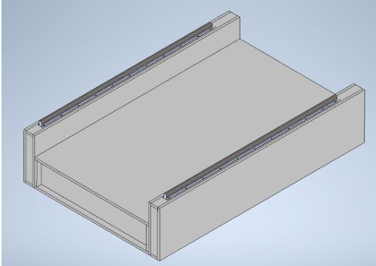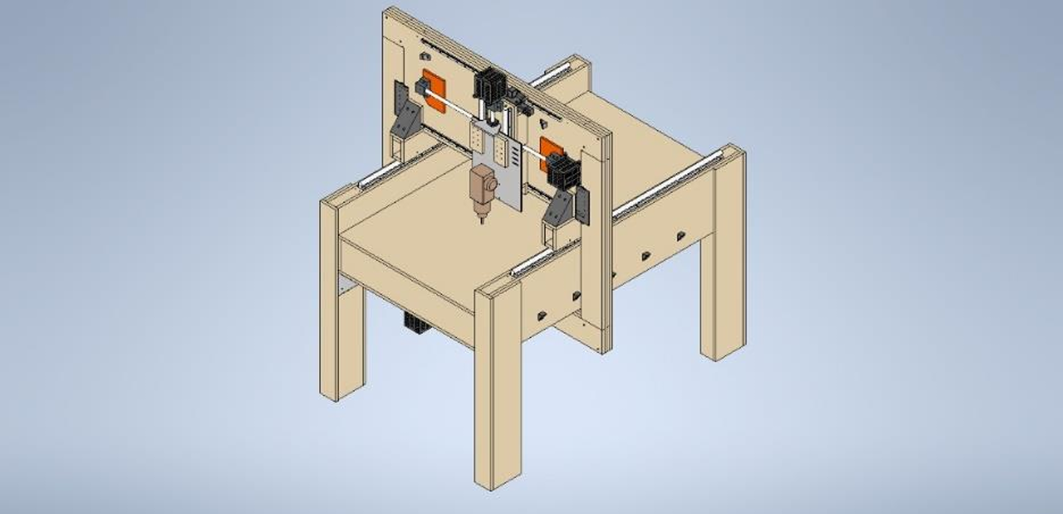 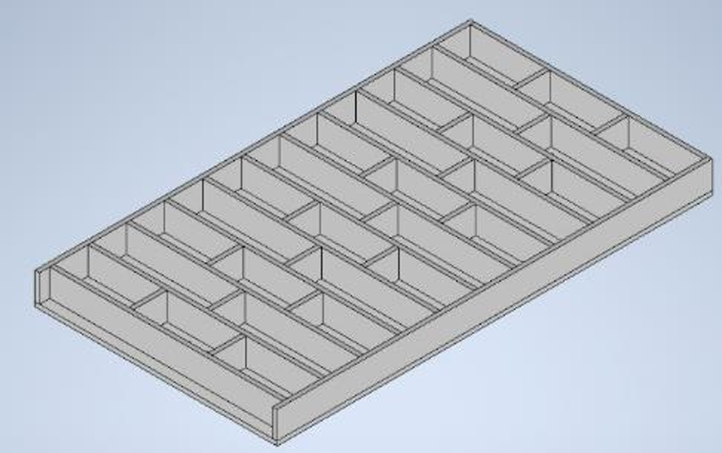

c)

**Fig. 1.** General view of the milling machine model a), table assembly b), table cross-section in the X-Y plane c)

The largest element of the structure is the table, which is rigid thanks to its ribbed structure. Assembly required the use of an angle head, marking the hole lines, pre-connecting it with carpenter's clamps, and gradually screwing the sides and partitions together. Next, holes were drilled for the bearing blocks, and a ball screw with a nut was installed. The table consists of a main section and two sides that support the rails with carriages. Assembly involved marking the holes, connecting the elements, and assembling the partition and rails while maintaining parallelism and perpendicularity. The table legs were constructed from supporting elements, an outer plate, and a protective plate. The process involved drilling holes, connecting them with screws, installing the plates, and reinforcing the edges. The gate consists of four components and requires high precision assembly. The lower section has a slot for the Y-axis nut. Next, the sides and top were fabricated, with holes prepared for the screws, rails, and bearing blocks. The entire assembly was then completed. The X axis has a ribbed structure supported by four carriages. After routing and drilling, the rails, bearing blocks, and side members were installed and then connected to the ribs and top. The Z axis was initially made of MDF, but due to structural weakness, it was replaced with steel. The nut element was welded to the front of the axis, leaving the carriage mounts unmodified. Holes were also added for mounting the chip extraction system. The carriages, responsible for supporting the gate on the Y-axis rails, consist of a frame, SME16OP carriages, and mounting brackets. Their wide spacing ensures stability and precise movement of the entire gate.

The purpose of the strength analysis is to verify whether the carriage will withstand the gate load with a safety factor δ. The selection of the factor corresponding to the impact load is dictated by the long-term vibrations caused by the spindle. A strength analysis was performed for the carriage, as it carries the weight of the gate. The force is distributed between two assemblies placed on rails mounted parallel to the sides of the table. The assembly was constructed using 18 mm MDF board, 440C stainless steel screws, and SME16OP carriages. To simplify the analysis, the entire carriage volume was assumed to be made of aluminum. Figure 2a shows the geometrical model of the carriage on which the test is carried out. In Figure 2b distribution (maps), Huber-Mises-Hencky's reduced stress is presented, as well as in Figure 3a. Figure 3b, 4a, and 4b present the distribution of displacement for different views – right view, left view, and back view. The carriage assembly components are not subject to deformation that would cause changes in machining accuracy on the milling machine. The loads to which the carriages are subjected do not exceed their strength.

1. b)

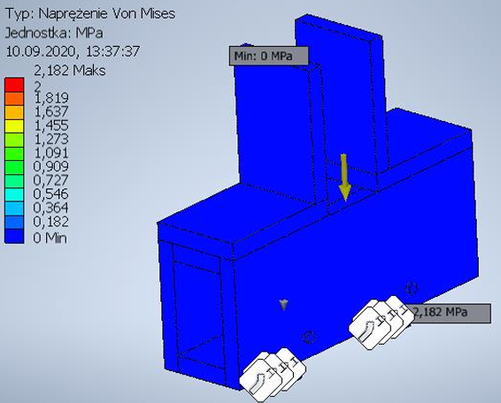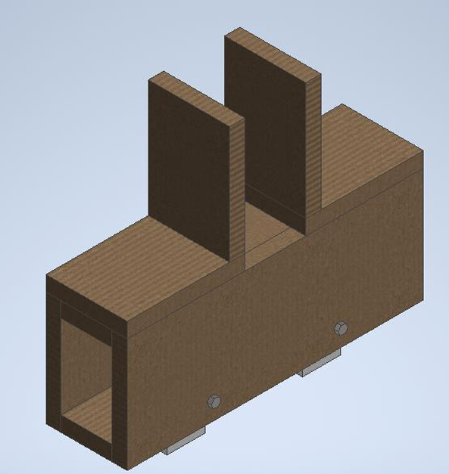

Type: Von Mises Stress

Unit: MPa

2.182 Max

2

1.819

1.637

1.455

1.273

1.091

0.909

0.727

0.546

0.364

0.182

0 Min

**Fig. 2.** Geometrical model of the carriage a), distribution (maps) of Huber-Mises-Hencky reduced stress (view 1) b)

1. b)

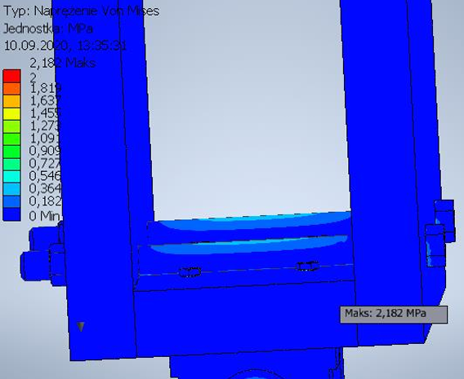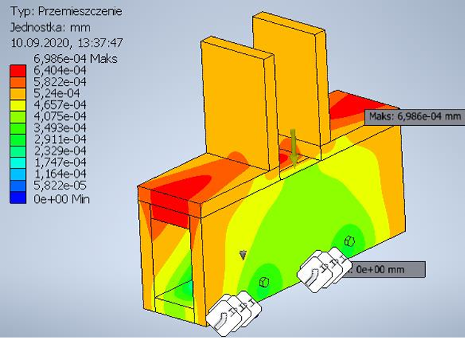

Type: Displacement

Unit: mm

Type: Von Mises Stress

Unit: MPa

2.182 Max

2

1.819

1.637

1.455

1.273

1.091

0.909

0.727

0.546

0.364

0.182

0 Min

6.986e-4 Max

6.404e-4

5.822e-4

5.24e-4

4.657e-4

4.075e-4

3.493e-4

2.911e-4

2.329e-4

1.747e-4

1.164e-4

5.822e-5

0 Min

**Fig. 3.** Distribution (maps) od Huber-Misess-Hencky's reduced stress a) and distribution of displacement (right view) b)

1. b)

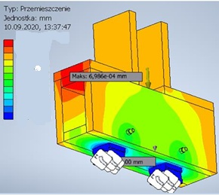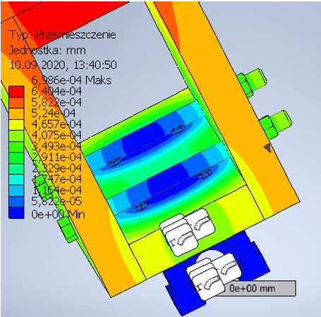

Type: Displacement

Unit: mm

6.986e-4 Max 6.404e-4

5.822e-4

5.24e-4

4.657e-4

4.075e-4

3.493e-4

2.911e-4

2.329e-4

1.747e-4

1.164e-4

5.822e-5

0 Min

Type: Displacement

Unit: mm

6.986e-4 Max 6.404e-4

5.822e-4

5.24e-4

4.657e-4

4.075e-4

3.493e-4

2.911e-4

2.329e-4

1.747e-4

1.164e-4

5.822e-5

0 Min

**Fig. 4.** Distribution of displacement: a) left view, back view b)

The highest loads are carried by the screws, which serve as reinforcement. The displacements visible in the simulation photos are so low that they can be considered insignificant. As can be seen in the Figure 2b and 3a, the greatest stress occurs at the bolt reinforcing the assembly's structure. This element was added during the gate assembly due to the insufficient strength of the connection between the lower part of the carriage and its sides. This was demonstrated when one of the carriages was damaged during the gate installation. The sides of the carriage press against the outermost parts of the bolt, causing stress in its central section. In Table 1, results from the numerical simulation are presented.

**Table 1.** Received results

|  |  |  |
| --- | --- | --- |
| Name | Minimum | Maximum |
| Volume | 3522540 mm3 | |
| Mass | 3.09757 kg | |
| HMH Stress | 0.0000000603521 MPa | 2.18231 MPa |
| Displacement | 0 mm | 0.000698614 mm |

4. Mechanical Elements

The supporting frame and the running system were constructed using components listed in Table 2.

**Table 2.** List of mechanical components

|  |  |  |
| --- | --- | --- |
| No. | Catalog name | Number |
| 1 | Bearing block BF 12 | 1 |
| 2 | Bearing block BK12 | 1 |
| 3 | Bearing block EF 20 | 2 |
| 4 | Bearing block EK 20 | 2 |
| 5 | Linear bearing in SME16OP housing | 8 |
| 6 | 20x05 UFS VTX Ball Screw Nut | 2 |
| 7 | CNC ball nut ø 16 [mm] pitch 5 [mm] | 1 |
| 8 | GH 45 hub – version B – aluminum | 6 |
| 9 | MDF board 2.07 x 2.8 [m] 18 [mm] | 4 |
| 10 | Roller support with roller ø 16 PW16/1500 | 2 |
| 11 | Roller support with roller ø 16 PW16/500 | 2 |
| 12 | Other parts (screws, bolts, nuts, sheets, and steel L-shaped pieces, cables) | 1 |
| 13 | Cable guide CNC cable guides 15x20 [mm] | 3 |
| 14 | Cable guide 2500.02.055.0 IGUS | 3 |
| 15 | LLTHR 15 P3 SKF rail | 2 |
| 16 | Ball screw GKL 2005-1500 [mm] | 2 |
| 17 | Ball screw GKL 2005-500 [mm] | 1 |
| 18 | SKF LLTHC 15 SU T1 P3 trolley | 4 |

The study included electrical diagrams, a list of logical signals with a description of their values, type, and function, and full drawing documentation of the milling machine, which were not presented in this article due to their considerable volume.

5. Control Program

The program used to operate the milling machine is Mach3, version R3.043.022. Due to its intuitive nature, this software is often used in milling machines, both those used in industry and those built by individuals for their own needs. The program is still being developed, and new versions are being created. The latest version is called Mach4. Among other things, compatibility with newer operating systems has been added, and data processing efficiency has been improved. The program used in the project was installed on a desktop computer equipped with Windows XP Professional version 2002. Upon launch, the software allows you to select a user profile. Due to the type of machine tool used in the project, the Mach3Mill profile designed for milling machines is used. The next element of the program is the main screen. Using this screen, the operator performs most of the operations within the program. Figure 5 shows the main screen.

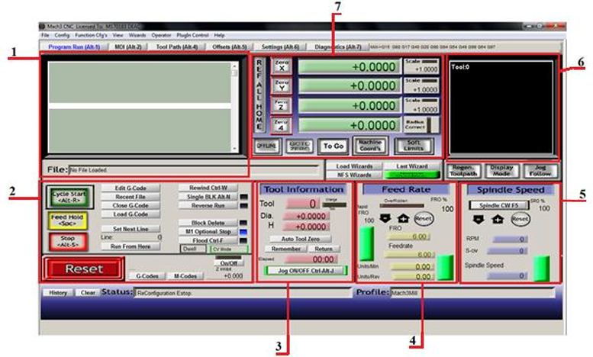

**Fig. 5.** Mach3 main screen; 1 – Program area, 2 – Program operation area, 3 – Tool information area, 4 – Feed rate controlarea, 5 – Spindle speed control area, 6 – Tool path visualization area, 7 – Tool position area

The first step the operator takes when operating the station is to run the program written using G-code. To do this, select the "Load G-Code" option from the program operation area and then select the desired file. Once the file is successfully loaded, the code, divided into lines, will appear in the program area, responsible for the tool's movement. The path generated by the program will appear in the tool path visualization area. If the program contains references to a tool in the program database, the information regarding its diameter, length, and catalog number will be updated in the tool information field. The next step for the operator is to find the appropriate starting point. To move the spindle to the desired location, use the manual movement (Jog) option. Manual movement can be performed using the keys on the keyboard or from the displayed panel. The panel is displayed using the Tab button.

After positioning the spindle at the desired position, set the program zero using the button located in the tool position field. It is important to set the Z-axis position precisely. For this operation to be successful, the best solution is to start the spindle. To start it, enter the desired value in the spindle speed field under the Spindle Speed tab. Then, start the spindle. For this to work, it is necessary to turn on the inverter and press the "Spindle CWF5" or "F5" button on the keyboard. Then, slowly lower the spindle until you hear contact between the material and the tool. At the point of contact, the operator establishes the zero position. When machining furniture boards, it is not necessary to level the top surface of the material. However, if metal or solid wood is being processed, it is necessary to level the top layer.

6. Electrical System

The CNC milling machine's electrical system is housed in a control cabinet containing all the necessary power, control, and safety components. The system includes an electrospindle, inverter, interference filter, computer with Mach3 software, soft-start module, power supply module, control motherboard, stepper motor drivers, transformer, limit switches, and an emergency button. The soft-start module protects the transformer from current spikes generated during connection to the mains, preventing fuses from tripping. The power module supplies power to the stepper motor drivers and peripheral components, and includes an unregulated power supply for the output stages, a stabilized 12V voltage, and LED indicators. A toroidal transformer powered by 230V provides 24V on the secondary winding, which is used in the system. The SSK-MB2 motherboard allows for the connection of stepper motor drivers, limit switches, and an emergency button, as well as spindle control via built-in relays. ARK connectors are used for external connections, and components exposed to heat are mounted on heat sinks.

1. b)

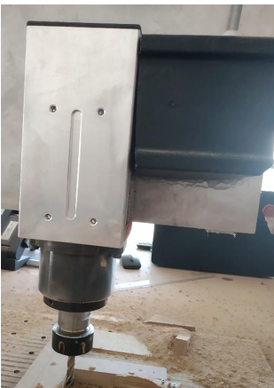 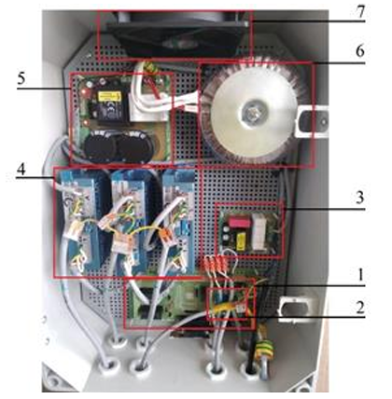

**Fig. 6.** Teknomotor DB 1.1 [kW] ER25 electrospindle a), electrical cabinet: 1 – main board, 2 – spindle control, 3 – softstart module, 4 – stepper motor drivers, 5 – power supply module, 6 – transformer, 7 – fan b)

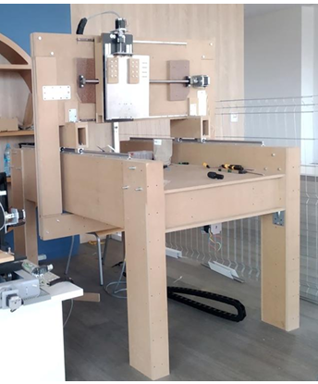 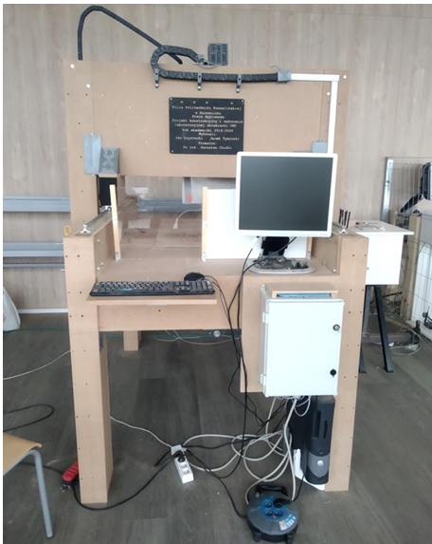

**Fig. 7.** The real view of the built CNC machine

The design incorporates three limit switches to control the X, Y, and Z axes, and a safety button is located on the side of the table, allowing for quick stopping. The Spindle Control module works with an inverter and allows for precise spindle speed adjustment using a potentiometer. The three-phase (3x400 V) inverter regulates the voltage supplied to the spindle and, consequently, its rotational speed. Due to its size and electromagnetic interference emissions, it was placed outside the electrical cabinet. The air-cooled spindle itself is equipped with ER25 collets, allowing the use of tools with diameters from 1 to 11 mm. It reaches a maximum speed of 24,000 rpm, regulated by an inverter, and can be powered by either a three-phase or single-phase inverter. The stepper motor drivers used in the project enable high accuracy thanks to the ability to set the stepping ratio from 1 to 512. Configuration is performed via switches and a communication port, and the devices are equipped with LEDs indicating operating status. The stepper motors drive the machine axes via ball screws connected by dog clutches, which compensate for any misalignment. The Z axis features additional silicone insulation between the spindle and the control system. The entire system is controlled by a computer equipped with Windows XP™ and Mach3 software, connected to the milling machine's motherboard via a 25-pin cable. The real view of the built CNC machine is presented in Figure 7.

8. Conclusions

This article presents the integration of Eco-design Principles in the Design and Manufacture of a CNC Machine for Laboratory Applications. A three-axis CNC milling machine was designed and built using MDF boards. The Z axis was replaced with a modified stainless steel structure. The working area measures 550x1100 mm. Frequency-generated interference has been eliminated. The machine can process soft and hard solid wood along and across the grain, MDF, HDF, particleboard, plywood, and soft metals. Machining at shallow depths is very precise, but accuracy decreases as the machining depth increases. The operator can control the rotational speed within the range s = 10,000-24,000 rpm and the feed rate vf = 0-540 mm/min. Components can be clamped with an accuracy of 0.01 mm. The accuracy of individual components was tested using a dial gauge. The design's complexity required the use of skills and knowledge in automation, structural design, and electrical systems, while taking into account eco-design principles. Additionally, computer simulations and strength analyses using modern tools bring environmental benefits, such as: reducing material waste by reducing failed attempts, reducing energy consumption by selecting optimal operating parameters, saving tools and extending their service life, reducing the carbon footprint associated with energy production and material transport.

References

Adamczyk, W. (2004). *Ecology of products*. Polish Economic Publishers, PWE. ISBN:83-208-1506-1. (in Polish)

Allwood, J. M., Cullen, J., McBrien, M., Milford, R., Carruth, M., Patel, A., Cooper, D., & Moynihan, M. (2012). Sustainable Materials – With Both Eyes Open, *UIT Cambridge*.

Baran, J., & Ryszko, A. (2013). Development and implementation of technical eco-innovations and eco-design – integration of processes and methodological guidelines for their implementation. *Innovations in management and production engineering*, pp. 34-46.

Bohdal, Ł, & Walczak, P. (2013). Eco-modeling of metal sheet cutting with disc shears. *Annual Set The Environment Protection*, *15*, 863-872.

Davim, J. P. (2010). Sustainable Manufacturing. *Wiley*, ISBN:9781118621653, https://doi.org/10.1002/9781118621653

Diaz, N., & Helu, M. (2013). *A framework to implement sustainability in manufacturing systems*. CIRP Annals Manufacturing Technology.

Diaz, N., Redelsheimer, E., & Dornfeld, D. (2011). *Energy Consumption Characterization and Reduction Strategies for Milling Machine Tool Use*. Conference materials, 18th CIRP International Conference on Life Cycle Engineering, 263-267.

Kara, S., & Li, W. (2011). Unit process energy consumption models for material removal processes. *CIRP Annals*, *60*(1), 37-40.

Kukiełka, L., Kukiełka, K., Kułakowska, A., Zbytek, Z., Lubiński, A., & Lubiński, J. (2016). Innovative solutions in terms of environmental protection in the new generation of batch seed dressing machines for cereal grains. *Annual Set The Environment Protection*, *18*, 445-465.

Kulakowska, A., Patyk, R., & Bohdal, Ł. (2014). The use of burnishing treatment in creating an ecological product. *Annual Set The Environment Protection*, *16*, 323-335.

Monticelli, E., & Vezzoli, C. (2025). From General to Company-Specific Ecodesign Strategies: Developing Guidelines for Eco-Efficient Product Design Across the Entire Product Portfolio of an Appliance Company. *Sustainability*, *17*, 4488. https://doi.org/10.3390/su17104488

Shrivastava, P. (1995). Environmental technologies and competitive advantage. *Strategic Management Journal*, *16*, 183-200.

Spilka, M., Kania, A., & Nowosielski, R. (2016). Engineering eco-design methodology. *Prace Instytutu Materiałów Inżynierskich i Biomedycznych, Politechnika Śląska, Gliwice*, *1*, 83-92. (in Polish)

Stawicki, H., & Mikołajczyk, P. (2023). Sustainable Design in Business: Overview of Initiatives and Trends. *Thematic Report nb 4, PARP*, Warsaw, 11-13. (in Polish)

Directive 2009/125/EC of the European Parliament and of the Council establishing a framework for the setting of ecodesign requirements for energy-related products, Directive – 2009/125-EN-EUR-Lex

European Aluminium Association: Environmental Profile Report 2018, (2018), https://european-aluminium.eu/wp-content/uploads/2023/01/European-Aluminium_Environmental-Profile-Report-2018_full-version.pdf.

ISO 14006:2020 Environmental management systems – Guidelines for incorporating ecodesign.