|  |  |  |  |
| --- | --- | --- | --- |
|  |  | | |
| **Rocznik Ochrona Środowiska** | | |
| Volume 27 | Year 2025 ISSN 2720-7501 | pp. 487-516 |
|  | https://doi.org/10.54740/ros.2025.041 open access | | |
|  | Received: February 2025 Accepted: July 2025 Published: September 2025 | | |

Trends in the Water Regime Changes of the Styr River (Lutsk Hydrological Station)   
During 1963-2022 Period

Ivan Kovalchuk1, Tetiana Pavlovska2, Vitalii Martyniuk3,   
Valentyna Stelmakh4*, Yurii Biletskyi5, Uliana Pas6

1Department of Geodesy and Cartography, National University of Life and Environmental Sciences of Ukraine, Kyiv, Ukraine   
https://orcid.org/0000-0002-2164-1259

2Department of Physical Geography, Lesya Ukrainka Volyn National University, Lutsk, Ukraine   
https://orcid.org/0000-0003-4931-0803

3Department of Natural Sciences, Rivne State University of Humanities, Rivne, Ukraine   
https://orcid.org/0000-0002-8654-3510

4Department of Physical Geography, Lesya Ukrainka Volyn National University, Lutsk, Ukraine   
https://orcid.org/0000-0002-7106-4242

5Department of Physical Geography, Lesya Ukrainka Volyn National University, Lutsk, Ukraine   
https://orcid.org/0000-0003-0477-4196

6Department of Physical Geography, Lesya Ukrainka Volyn National University, Lutsk, Ukraine

*сorresponding author's e-mail: stelmakh.valia@gmail.com

**Abstract:** The article investigates trends in long-term dynamics and intra-annual distribution of river discharge at the Styr River (Lutsk hydrological station) during 1963-2022 in relation to precipitation and air temperature. The research established that mean annual and maximum discharge are decreasing (trends are statistically significant). Summer-autumn discharge is decreasing while winter discharge is increasing (linear trends are not significant). The data series for mean annual discharge is homogeneous, as evidenced by the coefficient of variation (VϬ = 26.8%) and the constructed integral curve. The data series for maximum and minimum discharge is heterogeneous. A decrease in river discharge is observed for all months except January and February (all trends are statistically insignificant, except for March and April). The highest discharge occurs in March-April, and the lowest in August and September. Spring runoff accounts for 34% of the mean annual runoff, winter for 24%, and summer and autumn for 21% each. The cycles of low-water (with relatively low-water) and high-water (with relatively high-water) years for the Styr River last approximately 15 years. During 1963-2022, two nearly complete water cycles of the Styr River are traced (two phases of discharge increase and two phases of decrease), in precipitation fluctuation – two phases of annual totals increase and one phase of decrease, in mean annual air temperature fluctuation – one phase of increase and one phase of decrease. The years 1982, 1997, and 2013-2014 were breakpoints in the river's discharge fluctuations. The duration of water regime phases is about 15-16 years. Therefore, a further decrease in mean annual and minimum discharge of the Styr River can be predicted until approximately 2028.

**Keywords:** river discharge, water regime, hydrological station, climatic parameters, low-flow period, seasonal flood, flash flood, Styr River, water cycles

1. Introduction

# River basin systems hold a distinctive position among natural-anthropogenic systems on Earth, as their high natural potential has led to intensive human utilization. The functionality of rivers exhibits an inverse relationship with their size: smaller rivers demonstrate greater sensitivity to both climate change and economic activities within their catchment areas (Pavlovska 2005).

The Volyn region is one of the regions with a dense hydrographic network: rivers, lakes, and marshes are laced with reclamation canals, and the catchments of natural water bodies are complicated by ponds and reservoirs. The functioning of artificial reservoirs, not always rational water reclamation, the growth of arable land and surfaces with artificial coatings of poor infiltration capacity, the reduction of forests and meadows, and the ploughing of coastal protection strips and floodplains, Straightening of river channels, discharges of untreated or under-treated wastewater from enterprises into watercourses, groundwater and surface water abstraction lead to changes in river nutrition and, consequently, uneven flows, as well as eutrophication and pollution (Tsaryk et al. 2021, p. 38, 39). In recent decades, global and regional climate change has added to the anthropogenic impact on the water regime of rivers. The territory of Volyn is no exception in this regard (Pavlovska et al. 2023b, Pavlovska et al. 2023a). Therefore, the study of the water regime of small and medium-sized rivers is relevant from the standpoint of the basin approach methodology (Kovalchuk et al. 2022), justification of environmental protection, flow regulation, flood control, and renaturalisation measures for sustainable natural resource management within their catchments (Kovalchuk et al. 2023, p. 12).

Rivers flowing through important industrial and densely populated settlements require special attention. One of them is the city of Lutsk, which is located on both sides of the Styr River, which is a source of industrial water, a transport artery, a collector of surface runoff, and a place of biodiversity concentration, and thus recreation, etc (Pavlovska et al. 2020, p. 179).

The purpose of this study is to determine the trends in the long-term dynamics of the water flow of the Styr River (hydrological station (hereinafter – h/s) Lutsk) over sixty years (1963-2022) in relation to the climatic parameters (precipitation and air temperature) of the meteorological station (hereinafter – MS) Lutsk.

2. Literature Review

The study of the water regime of rivers under the influence of global climate change has long been in the focus of scientists. Among them are such Ukrainian scientists as S. Barandich, E. Vasylenko, V. Vyshnevsky, M. Hoptsiy, E. Hopchenko, L. Gorbacheva, Y. Goyan, V. Grebin, Y. Didovets, V. Ovcharuk, M. Martyniuk, and others. Martyniuk, S. Melnyk, A. Kutsii, L. Kushchenko, A. Lobanova, N. Loboda, O. Lukianets, O. Obodovskyi, E. Pavelchuk, O. Pochaevets, E. Rakhmatullina, S. Snizhko, O. Todorova, etc. (Lukianets et al. 2019, Obodovskyi & Lukianets 2017, Vasylenko & Hrebin n.d., Vasylenko et al. 2011, Hopchenko et al. 2018, Horbachova 2016, Horbachova & Barandich 2016, Hoian et al. 2020, Didovets et al. 2017, Report on research work development… 2013, p. 6, 55-57, Martyniuk & Ovcharuk 2023, Melnyk & Loboda 2021, Ovcharuk 2020, Pavelchuk & Snizhko 2017, Rakhmatullina 2015). Among foreign publications, we find works on this issue by V. Bisselink, I. Camilloni, V. Barros, S. Moreiras, G. Poveda and J. Tomasella, A. Fangmann, A. Belli, U. Haberlandt, P. Pekarova, P. Miklánek and J. Pekár, Renata J. Romanowicz, C. Yu, X. Yin, Zh. Yang, Zh. Dang, X. Zhang, K. D. Harvey, W. D. Hogg, T. R. Yuzyk et al. (Bisselink et al. n.d., Camilloni et al. 2020, Fangmann et al. 2013, Pekarova et al. 2003, Romanowicz 2017, Yu et al. 2017, Zhang et al. 2001).

The issues of analysing the dynamics of time hydrological series have been addressed in their scientific works: T. Bauzha, V. Vyshnevskyi, M. Voronchuk, L. Gorbacheva, T. Zabolotna, S. Snizhko, B. Khrystiuk, A. Fangmann, A. Belli, U. Haberlandt, X. Zhang, K. D. Harvey, W. D. Hogg, T. R. Yuzyk (Fangmann et al. 2013, Zabolotnia et al. 2019, Zhang et al. 2001, Bauzha & Horbachova 2013, Pavelchuk & Snizhko 2017, p. 74). The problem of homogeneity of hydrometeorological information is thoroughly studied by V. Hrebin, O. Obodovskyi, V. Zhovnir, K. Mudra, O. Pochaievets (Hrebin et al. 2019), L. Gorbacheva (Horbachova 2014).

A number of scientific works are devoted to modern studies of the Styr River basin, in particular: O. Vereshko, V. Voloshyn, O. Melnyk, Y. Melnyk, U. Nikoniuk, T. Pavlovska, V. Stelmakh characterised the water regime of the river and trends in its changes under the influence of climatic factors (Voloshyn et al. 2017, Nykoniuk & Stelmakh 2023, Pavlovska et al. 2020, Stelmakh 2024); the study of the intra-annual distribution of the water flow of the Styr River Styr was reflected in the works of E. Vasylenko, K. Danko, O. Dutko, O. Konovalenko, U. Nikoniuk, V. Nogachevsky, T. Pavlovska (Vasylenko et al. 2011, Nykoniuk et al. 2024); M. Hanushchak and N. Tarasyuk analysed the water factor in the development of natural and anthropogenic complexes of the Styr river basin (Hanushchak & Tarasiuk 2019); forecasting of the river water content for the coming years was carried out by L. Gorbacheva and B. Khrystiuk (Horbachova & Khristiuk 2021); physicochemical studies of water and monitoring of the ecosystem of the Styr River were carried out by M. Hanushchak, M. Zabokrytska, S. Kolomiets, V. Kopylov, Y. Molchak, I. Netrobchuk, N. Tarasiuk, M. Romashchenko, A. Sardak, V. Fesiuk, V. Khilchevskyi, et al. (Hanushchak & Tarasiuk 2015, Zabokrytska & Khilchevskyi 2016, Kopylov & Popovych 2023, Molchak et al. 2003, Netrobchuk & Hashynska 2018,   
Romashchenko et al. 2021), the level of pollution of river waters was studied in the works of A. Kondratiuk, V. Fesiuk, Z. Karpiuk, D. Zhurba, V. Stelmakh (Kondratiuk 2021, Stelmakh 2024, Fesiuk et al. 2023); information on monitoring of erosion processes in the upland part of the basin can be found in the work of M. Fedoniuk, I. Kovalchuk, V. Zhdaniuk, V. Fedoniuk, T. Pavlovska (Fedoniuk et al. 2020). Although there are a lot of scientific publications in the field of hydrology, hydrochemistry, and hydroecology of the Styr River, the issues of variability of the river runoff fluctuations and their forecasting are not sufficiently addressed.

3. Methodology

Using MS Excel software, we constructed chronological graphs of water content changes at the Lutsk hydrological station and meteorological parameters at the Lutsk weather station, fitted linear trends to them, and assessed the significance of linear trends (Report on research work development... 2013, pp. 31, 32, Ovcharuk 2020, p. 112). We also evaluated the homogeneity of hydrological characteristics. Statistical homogeneity means that all elements of a hydrological series and their sample statistical parameters (mean value, variance) belong to one population. Homogeneity of sample statistical parameters over time is called stationarity. If, as a result of statistical analysis, the hypothesis of stationarity is not rejected, then we can assume only their quasi-stationarity (Report on research work development... 2013, pp. 26-27).

Assessment of the homogeneity of hydrological characteristics involves both statistical analysis methods and hydrological-genetic methods. For statistical analysis of hydrological series, we calculated classical parametric criteria, including the Student's t-test to test the hypothesis of equality of arithmetic means of two samples (first and second half of the study period) and Fisher's F-test to test the hypothesis of equality of their variances. Additionally, the turning points test was applied to assess the randomness of the time series. Such a combination of methods is recommended in international and national manuals on hydrological analysis (WMO 1989, Kundzewicz & Robson 2004, Shvets 2004, Osadchyi & Kuzmenko 2008). Critical values of the criteria were determined at significance level α = 0.05, which corresponds to the generally accepted practice of statistical hypothesis testing in hydrology (Tallaksen & van Lanen 2004). Since it is impossible to prove the homogeneity of an observation series based on calculations using statistical criteria (one can only establish that the observation data do not contradict the homogeneity hypothesis at a certain significance level), many hydrological-genetic methods are used to detect non-homogeneity of hydrological series, including: construction and analysis of cumulative integral curves, difference-integral curves, double difference-integral curves of hydrological and climatic characteristics, combined chronological graphs of hydrological characteristics from different points, graphs of relationships between hydrological and meteorological characteristics, discharge rating curves (Report on research work development... 2013, p. 33). From the methods mentioned above, we applied the cumulative integral curves method. We studied the cyclicity of fluctuations of mean annual, maximum, and minimum water discharges of the Styr River, annual precipitation sums, and mean annual air temperature during the sixty years using the difference-integral curves method (Bauzha & Horbachova 2013, p. 35, Loboda & Ovcharuk 2005, p. 90, Ovcharuk 2020, p. 106, Pavelchuk & Snizhko 2017, p. 67). As is known, the cyclic nature of the river's water regime is expressed in the form of successive changes of high-water and low-water groups of years, which differ in the magnitude of deviation from the mean runoff value for the entire observation period and the duration of one or another group of years. The time interval during which an increase in water content is observed is called the high-water phase of the cycle (high-water period), and the decrease is called the low-water phase (low-water period) (Pavelchuk & Snizhko 2017, p. 67). Research on the cyclicity of fluctuations in river runoff also involved analysis of such important aspects as synchrony or asynchrony, in-phase or out-of-phase relationships (Bauzha & Horbachova 2013, p. 34).

The choice of a sixty-year data time interval is explained by the results of our previous studies of the water regime of rivers in the Volyn region, which provide grounds to believe that the phases of river runoff water content last approximately 15-16 years. Thus, the full water cycle lasts about 30 years. Taking this fact into account, one of the objectives of the study was to attempt to identify two consecutive cycles (four phases, respectively) of the Styr River's water content. This required hydrological data for at least sixty years. Since data collection for the study began at the end of 2023, the nearest sixty-year study period was 1963-2022.

In addition to determining the temporal framework of the study, an important task was to delineate its spatial boundaries. For this purpose, we analyzed the geography of weather stations within the Styr River basin. Weather stations in Brody, Kremenets, Dubno and Lutsk are located within the catchment area of 7,200 km² (up to the Lutsk hydrological station) (Fig. 1). The choice was made in favor of the Lutsk weather station due to its closest location (only 4.4 km) to the hydrological station of the same name, which allows establishing the strength of relationships between local hydrometeorological parameters and ensures maximum representativeness of meteorological data for characterizing runoff formation conditions at the studied river cross-section.

We found that many extreme floods (for example, July 1997, September 2001, August 2006, October 2008, May 2009, etc.) and even major floods (March and April 2005, 2013 and 2019, very extended floods of 2000 and 2010) at the Lutsk hydrological station were caused by local intensive or prolonged precipitation at the Lutsk weather station before or during high water, rather than by weather conditions in other parts of the basin. Since the response time of hydrological processes to meteorological phenomena in the area of the Styr hydrological station is shorter than the response time of water levels and discharges at this location to weather conditions in the upstream basin, research on the relationship between hydrometeorological parameters at our selected key points is necessary for timely response by enterprises of the Lutsk territorial community that withdraw river water or discharge used water into the river, and municipal services of the city to ensure optimal functioning of the urban system.

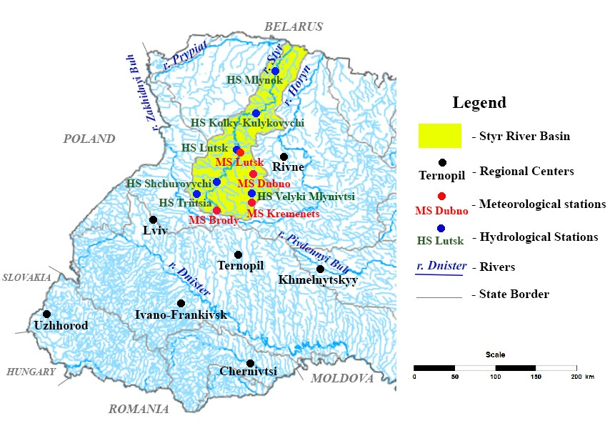

**Fig. 1.** Geographical location of the Styr River basin

4. Case Studies

The Styr River flows in the western part of Ukraine through three oblasts, as well as within neighboring Belarus. The total length of the river is 483 km (Styr n.d.). According to the technical documentation of VOCGM, the length of the Styr River from the Lutsk hydrological station to the mouth is 241 km. Thus, the length of the Styr River from the headwaters to the Lutsk hydrological station is 242 km. The alimentation of the Styr River is mixed, formed by rainfall, snowmelt, and groundwater components. Groundwater constitutes a significant part of the long-term runoff: at the Lutsk hydrological station, it amounts to about 49%. The relief features of the basin determine the morphology of the river valley. Its headwaters are represented by highland territory, the middle part is characterized by a combination of hilly-ridge relief and lowlands, and the lower reaches are located within the Volyn Polissya with predominance of low relief and significant waterlogging. The river valley is mainly trapezoidal, in some sections indistinctly expressed. Valley slopes are 5-15 m high, steep in the upper and middle reaches. The floodplain is bilateral, with an average width of 0.7-1.0 km. The channel in the upper and middle reaches is very meandering. The Lutsk hydrological station is located in the regional center on the right bank of the river, 1.1 km upstream from the confluence of the tributary Sapalaivka River. At the location of the hydrological station, the river valley is trough-shaped, meandering, with convex slopes up to 10-12 m high. The floodplain is bilateral, meadow, 500-600 m wide, and swampy in places. The channel is moderately meandering, unbranched, with steep banks 2-3 m high. The hydrological regime of the river is influenced by the operation of the Khrinnyky Reservoir and several ponds located within the watershed (Nykoniuk et al. 2024). The river is used for water supply, wastewater disposal, hydropower, and recreation. The land use structure of the basin reflects its natural-geographical features: the share of forests is 29%, arable land – 44%, wetlands – 1.8%, and the surface of ponds and reservoirs – 0.4%. The basin contains more than 500 settlements, almost a hundred of which are located directly along the riverbank (Hanushchak & Tarasiuk 2019).

For a comprehensive analysis of the Styr River's water regime, it is necessary to examine the climatic factors of its formation and the actual hydrological characteristics of runoff.

***Analysis of climatic parameters.*** The determining factor of the water regime of the Styr River is climatic parameters, particularly precipitation and air temperature (the latter is one of the indirect indicators of evaporation) (Horbachova 2016, p. 95). The mean annual air temperature at Lutsk meteorological station for the study period (1963-2022) is 7.9°C. There is a rapid increase in its values towards the present (the linear trend is significant) (Fig. 2, Table 1). Throughout the year, the highest air temperatures are characteristic for July   
– 19°C, and the lowest – for January (-3.8°C) (Fig. 3).

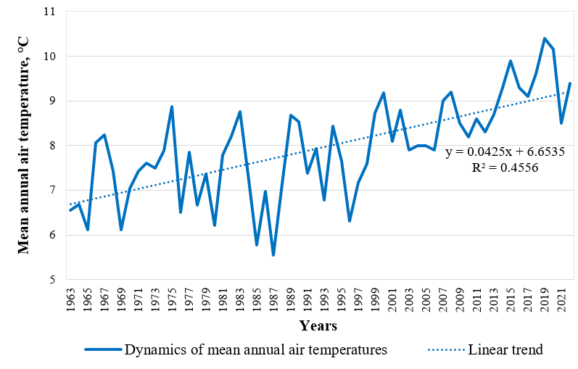

**Fig. 2.** Long-term dynamics of mean annual air temperatures at Lutsk meteorological station

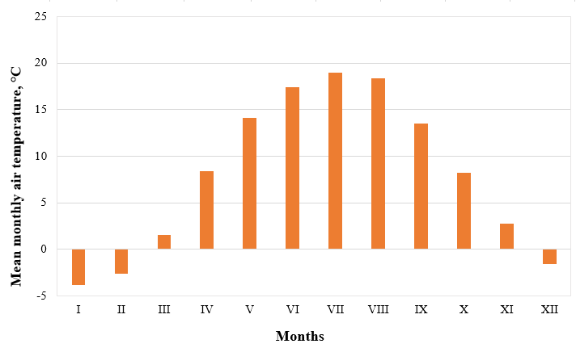

**Fig. 3.** Annual air temperature regime at Lutsk meteorological station (averaged for 1963-2022)

The tendency towards increasing air temperature is characteristic for all months of the year (Fig. 4-7). For January, February, April, June, July, August, October, and December, the linear trends are significant (see Table 1, shown in light beige color).

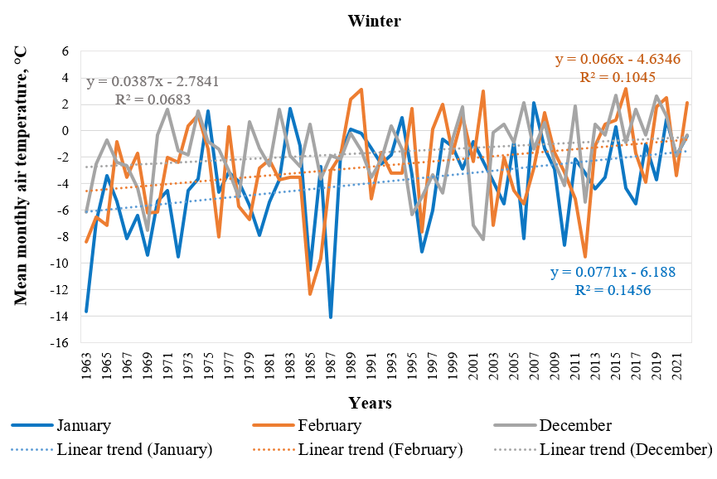

**Fig. 4.** Long-term dynamics of mean monthly air temperatures at Lutsk meteorological station in winter

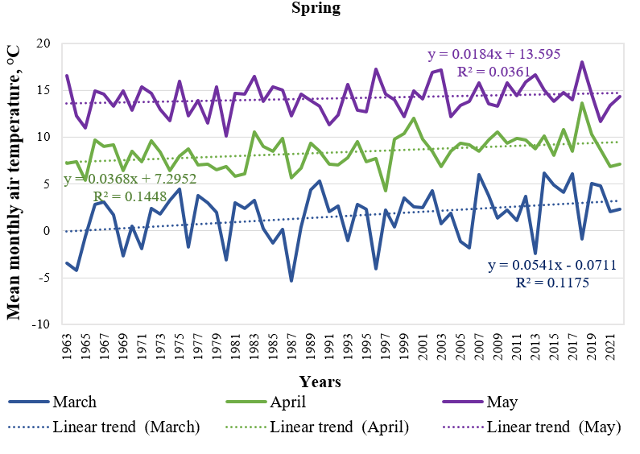

**Fig. 5.** Long-term dynamics of mean monthly air temperatures at Lutsk meteorological station in spring

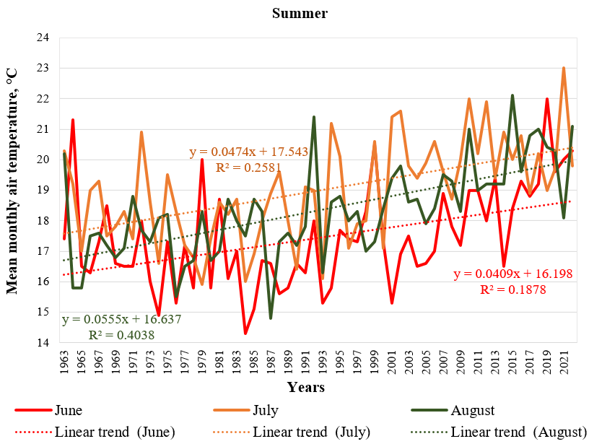

**Fig. 6.** Long-term dynamics of mean monthly air temperatures at Lutsk meteorological station in summer

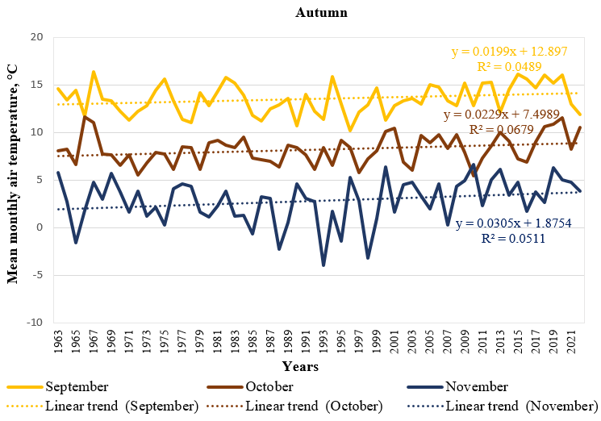

**Fig. 7.** Long-term dynamics of mean monthly air temperatures at Lutsk meteorological station in autumn

**Table 1.** Assessment of the significance of linear trends of meteorological parameters at Lutsk meteorological station during 1963-2022

|  |  |  |  |  |  |  |
| --- | --- | --- | --- | --- | --- | --- |
| Іndicator | Trend equation | R2 | R | σR | 2σR | Statistical  significance of the trend |
| ***Mean annual air temperature*** | y = 0.0425x + 6.6535 | 0.4556 | 0.675 | 0.071 | 0.142 | significant |
| Mean monthly air temperature (January) | y = 0.0771x – 6.188 | 0.1456 | 0.382 | 0.111 | 0.222 | significant |
| Mean monthly air temperature (February) | y = 0.066x – 4.6346 | 0.1045 | 0.323 | 0.117 | 0.233 | significant |
| Mean monthly air temperature (March) | y = 0.0541x – 0.0711 | 0.1175 | 0.343 | 0.115 | 0.229 | significant |
| Mean monthly air temperature (April) | y = 0.0368x + 7.2952 | 0.1448 | 0.381 | 0.111 | 0.223 | significant |
| Mean monthly air temperature (May) | y = 0.0184x + 13.595 | 0.0361 | 0.190 | 0.125 | 0.251 | insignificant |
| Mean monthly air temperature (June) | y = 0.0409x + 16.198 | 0.1878 | 0.433 | 0.106 | 0.211 | significant |
| Mean monthly air temperature (July) | y = 0.0474x + 17.543 | 0.2581 | 0.508 | 0.097 | 0.193 | significant |
| Mean monthly air temperature (August) | y = 0.0555x + 16.637 | 0.4038 | 0.635 | 0.078 | 0.155 | significant |
| Mean monthly air temperature (September) | y = 0.0199x + 12,897 | 0.0489 | 0.221 | 0.124 | 0.248 | insignificant |
| Mean monthly air temperature (October) | y = 0.0229x + 7.4989 | 0.0679 | 0.261 | 0.121 | 0.242 | significant |
| Mean monthly air temperature (November) | y = 0.0305x + 1.8754 | 0.0511 | 0.226 | 0.124 | 0.247 | insignificant |
| Mean monthly air temperature (December) | y = 0.0387x – 2.7841 | 0.0683 | 0.261 | 0.121 | 0.243 | significant |
| ***Annual precipitation totals*** | y = 1.0519x + 545.84 | 0.0387 | 0.197 | 0.125 | 0.250 | insignificant |
| Monthly precipitation totals (January) | y = 0.125x + 27.912 | 0.0161 | 0.127 | 0.128 | 0.256 | insignificant |
| Monthly precipitation totals (February) | y = –0.0914x + 32.788 | 0.0087 | 0.093 | 0.129 | 0.258 | insignificant |
| Monthly precipitation totals (March) | y = 0.145x + 23.523 | 0.0249 | 0.158 | 0.127 | 0.254 | insignificant |
| Monthly precipitation totals (April) | y = –0.0432x + 39.284 | 0.0012 | 0.035 | 0.130 | 0.260 | insignificant |
| Monthly precipitation totals (May) | y = 0.2224x + 54.487 | 0.0195 | 0.140 | 0.128 | 0.255 | insignificant |
| Monthly precipitation totals (June) | y = –0.0945x + 31.138 | 0.0236 | 0.154 | 0.127 | 0.254 | insignificant |
| Monthly precipitation totals (July) | y = 0.446x + 74.58 | 0.0348 | 0.187 | 0.126 | 0.251 | insignificant |
| Monthly precipitation totals (August) | y = 0.1007x + 58.582 | 0.0024 | 0.049 | 0.130 | 0.260 | insignificant |
| Monthly precipitation totals (September) | y = –0.0369x + 57.961 | 0.0003 | 0.017 | 0.130 | 0.260 | insignificant |
| Monthly precipitation totals (October) | y = –0.0548x + 40.393 | 0.0012 | 0.035 | 0.130 | 0.260 | insignificant |
| Monthly precipitation totals (November) | y = –0.0532x + 36.742 | 0.0033 | 0.057 | 0.130 | 0.260 | insignificant |
| Monthly precipitation totals (December) | y = 0.2391x + 32.303 | 0.0426 | 0.206 | 0.125 | 0.250 | insignificant |

The mean long-term (1963-2022) value of annual precipitation totals is 577.9 mm. During the study period, there is an increase in the values of this indicator (Fig. 8), but the trend is insignificant (see Table 1, shown in light gray color). The lion's share of precipitation (72%) falls during the warm period of the year. The highest monthly precipitation totals are characteristic for July, and the lowest for March (Fig. 9).

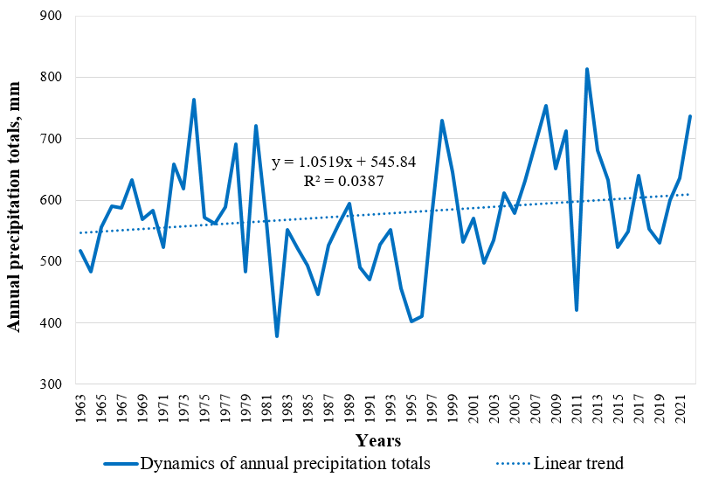

**Fig. 8.** Long-term dynamics of annual precipitation totals at Lutsk meteorological station

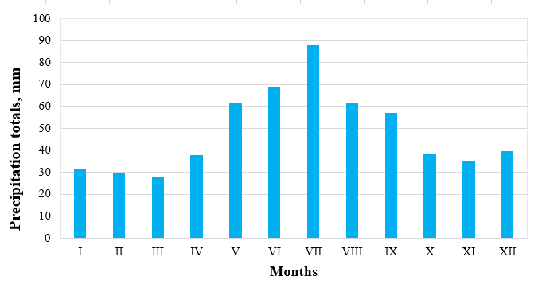

**Fig. 9.** Annual precipitation regime at Lutsk meteorological station (averaged for 1963-2022)

During the study period, there is an increase in monthly precipitation totals in January, March, May, July, August, and December, and a decrease – in February, April, June, September, October, and November (Fig. 10-13). Still, the linear trends of fluctuations in annual and monthly precipitation totals are insignificant (see Table 1).

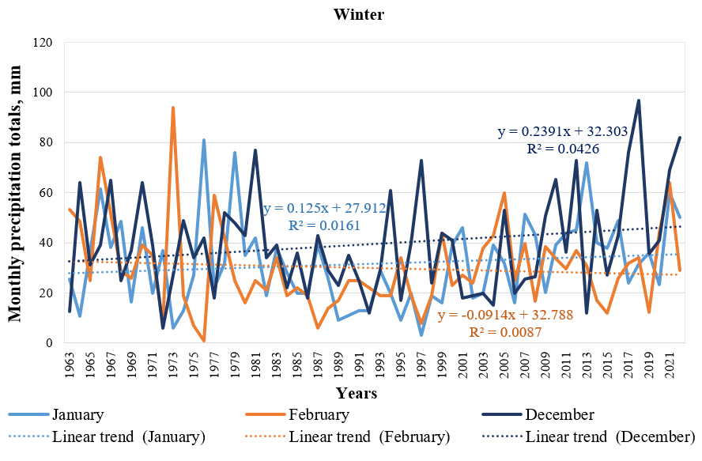

**Fig. 10.** Long-term dynamics of mean monthly precipitation totals at Lutsk meteorological station in winter

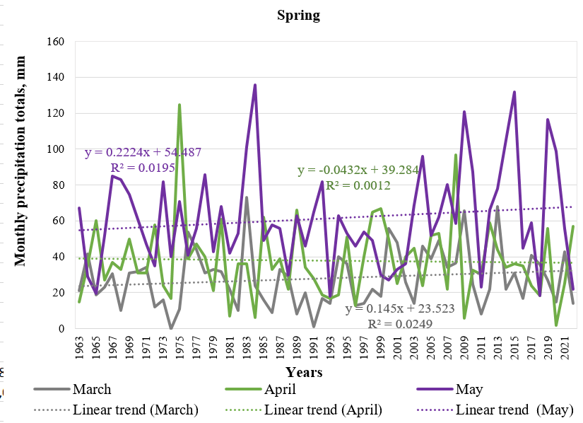

**Fig. 11.** Long-term dynamics of mean monthly precipitation totals at Lutsk meteorological station in spring

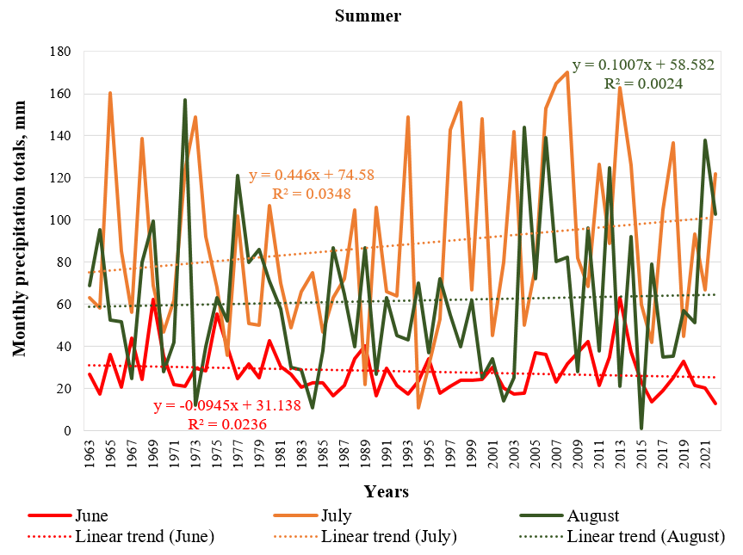

**Fig. 12.** Long-term dynamics of mean monthly precipitation totals at Lutsk meteorological station in summer

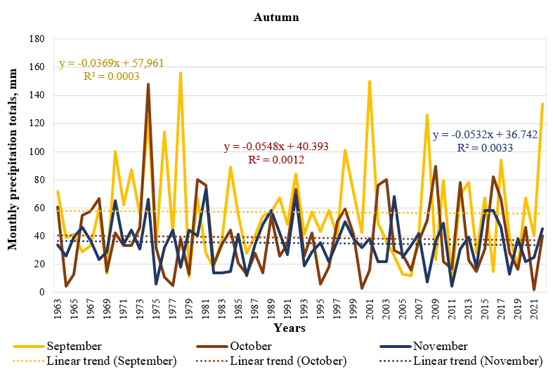

**Fig. 13.** Long-term dynamics of mean monthly precipitation totals at Lutsk meteorological station in autumn

The constructed cumulative curves of mean annual air temperature and annual precipitation totals and the calculated coefficients of variation (13.71%, 16.03% respectively) showed that the observation series of these meteorological parameters is homogeneous, as there are no significant changes in the directions of the curves (Fig. 14).

а) 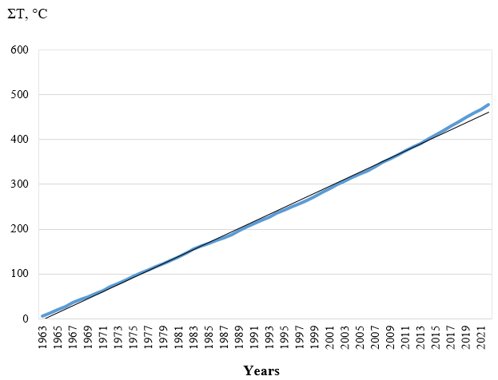

b) 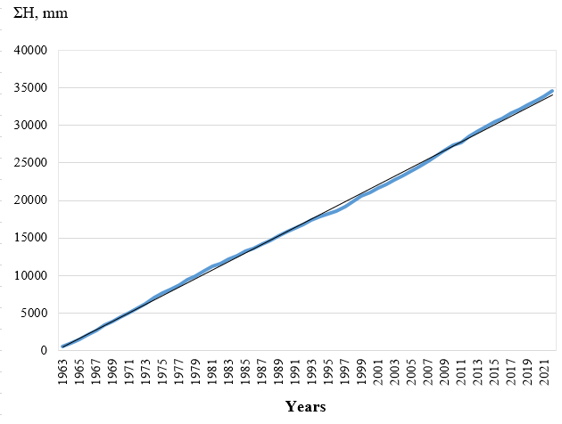

**Fig. 14**. Cumulative curves of mean annual air temperature: (a) annual precipitation totals, (b) at Lutsk meteorological station

***Analysis of the Styr River water regime.*** The mean value of mean annual discharges of the Styr River at the Lutsk hydrological station is 31.16 m³/s. The hydrological series of mean annual water discharges of the Styr River (1963-2022) is complete – data for all years of the study period are available, with no gaps. Statistical analysis of the mean annual discharge series of the Styr River (Table 2) showed that the data are homogeneous (t_fact = 0.888 < t_0.05 = 2.00; F_fact = 1.187 < F_0.05 = 1.86), indicating preservation of mean annual runoff formation conditions at an unchanged level. At the same time, regular cyclic fluctuations of water content were revealed (turning points criterion Z = 2.38 > 1.96), confirming the presence of natural 15-16-year water phases described in previous studies (and confirming the presence of regular fluctuations of water phases with characteristic duration of 15-16 years, identified by the difference-integral curves method). The coefficient of variation is 27.0%, indicating moderate runoff variability.

**Table 2.** Results of statistical analysis of the mean annual discharge hydrological series of the Styr River (1963-2022)

|  |  |
| --- | --- |
| Statistical indicator | Value |
| Number of observations (n) | 60 |
| Arithmetic mean (x̄), m³/s | 31.16 |
| Standard deviation (s), m³/s | 8.42 |
| Coefficient of variation (Cv), % | 27.0 |
| Minimum value, m³/s | 16.0 |
| Maximum value, m³/s | 51.2 |
| Turning points criterion (Z) | 2.38 |
| Series randomness | Non-random (cycles present) |
| Student's t-criterion (actual) | 0.888 |
| Fisher's F-criterion (actual) | 1.187 |
| Series homogeneity | Homogeneous |
| Standard error of mean (σx̄), m³/s | 1.087 |

The homogeneity of statistical values is also confirmed by the cumulative integral curve constructed for the mean annual water runoff series of the Styr River (Fig. 15). At the same time, the long-term dynamics of mean annual runoff are characterized by the presence of a statistically significant decreasing trend (Fig. 16, Table 3), indicating gradual changes in the water regime.

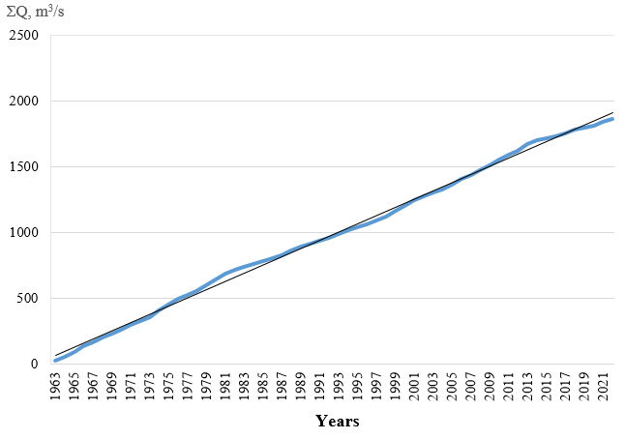

**Fig. 15.** Cumulative curve of mean annual water runoff of the Styr River

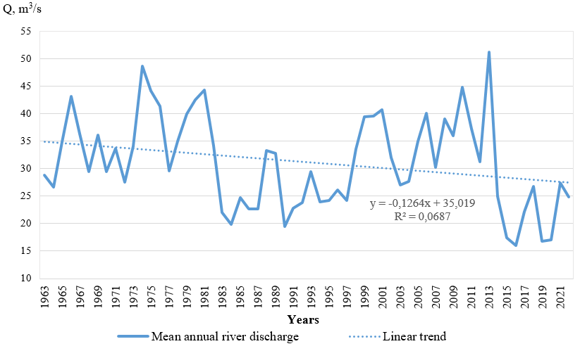

**Fig. 16.** Long-term (1963-2022) dynamics of mean annual runoff of the Styr River

Decrease in water runoff of the Styr River is characteristic of all months of the year, except January and February (Fig. 17-20). All trends in monthly mean values dynamics are statistically insignificant, except for March and April, which are characterized by a sharp decrease in water runoff (see Table 3).

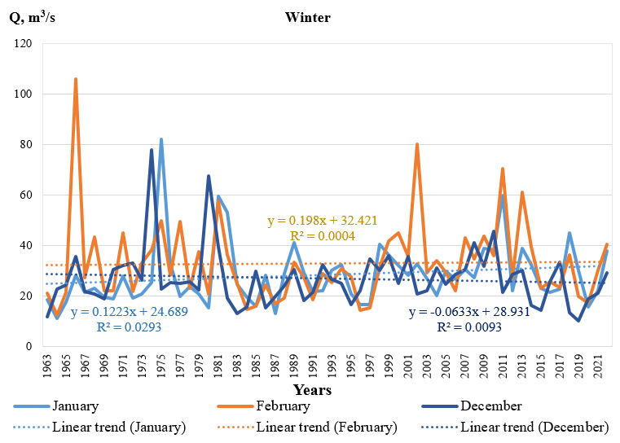

**Fig. 17.** Long-term dynamics of mean monthly river discharge of the Styr River in winter

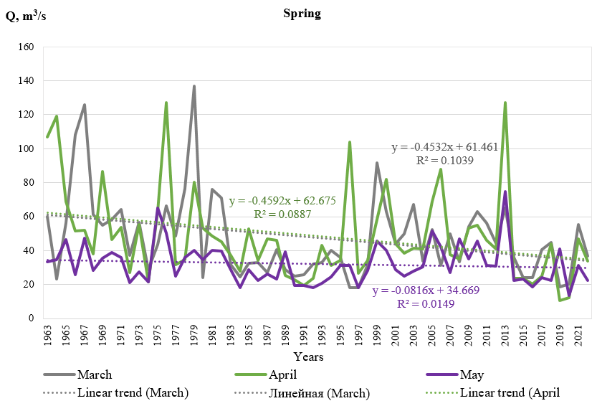

**Fig. 18.** Long-term dynamics of mean monthly river discharge of the Styr River in spring

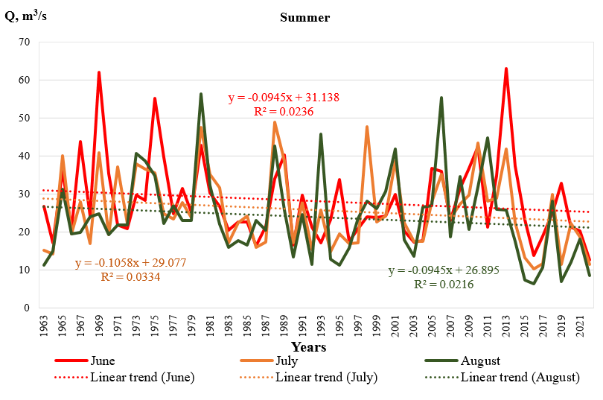

**Fig. 19.** Long-term dynamics of mean monthly river discharge of the Styr River in summer

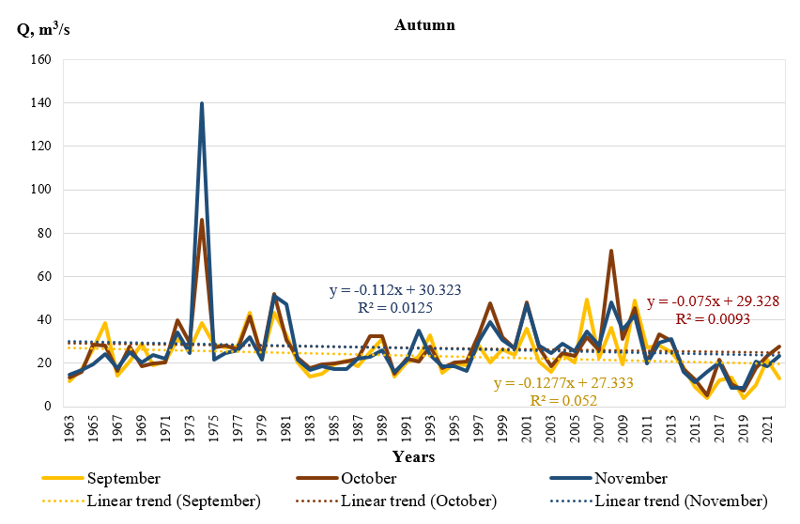

**Fig. 20.** Long-term dynamics of mean monthly river discharge of the Styr River in autumn

**Table 3.** Assessment of the significance of linear trends of hydrological parameters at Lutsk hydrological station during 1963-2022

|  |  |  |  |  |  |  |
| --- | --- | --- | --- | --- | --- | --- |
| Іndicator | Trend equation | R2 | R | σR | 2σR | Statistical significance of the trend |
| Mean annual river discharge | y = –0.1264x + 35.019 | 0.0687 | 0.262 | 0.121 | 0.242 | significant |
| Maximum river discharge | y = –2.3125x + 171.99 | 0.3213 | 0.567 | 0.088 | 0.177 | significant |
| Minimum river discharge  in the summer-autumn low season | y = –0.0382x + 15.969 | 0.0133 | 0.115 | 0.128 | 0.257 | insignificant |
| Minimum river discharge  in the winter low season | y = 0.0631x + 15.802 | 0.0218 | 0.148 | 0.127 | 0.255 | insignificant |
| Mean monthly river discharge (January) | y = 0.1223x + 24.689 | 0.0293 | 0.171 | 0.126 | 0.253 | insignificant |
| Mean monthly river discharge (February) | y = 0.0198x + 32.421 | 0.0004 | 0.02 | 0.130 | 0.260 | insignificant |
| Mean monthly river discharge (March) | y = –0.4532x + 61.461 | 0.1039 | 0.322 | 0.117 | 0.233 | significant |
| Mean monthly river discharge (April) | y = –0.4592x + 62.675 | 0.0887 | 0.298 | 0.119 | 0.237 | significant |
| Mean monthly river discharge (May) | y = –0.0816x + 34.669 | 0.0149 | 0.122 | 0.128 | 0.256 | insignificant |
| Mean monthly river discharge (June) | y = –0.0945x + 31.138 | 0.0236 | 0.154 | 0.127 | 0.254 | insignificant |
| Mean monthly river discharge (July) | y = –0.1058x + 29.077 | 0.0334 | 0.183 | 0.126 | 0.252 | insignificant |
| Mean monthly river discharge (August) | y = –0.0945x + 26.895 | 0.0216 | 0.147 | 0.127 | 0.255 | insignificant |
| Mean monthly river discharge (September) | y = –0.1277x + 27.333 | 0.052 | 0.228 | 0.123 | 0.247 | insignificant |

**Table 3.** cont.

|  |  |  |  |  |  |  |
| --- | --- | --- | --- | --- | --- | --- |
| Іndicator | Trend equation | R2 | R | σR | 2σR | Statistical significance of the trend |
| Mean monthly river discharge (October) | y = –0.075x + 29.328 | 0.0093 | 0.096 | 0.129 | 0.258 | insignificant |
| Mean monthly river discharge (November) | y = –0.112x + 30.323 | 0.0125 | 0.112 | 0.129 | 0.257 | insignificant |
| Mean monthly river discharge (December) | y = –0.0633x + 28.931 | 0.0093 | 0.096 | 0.129 | 0.258 | insignificant |

Regarding the intra-annual distribution of water runoff, the highest discharge of the Styr River occurs in March-April during the spring flood. At the same time, it is lowest in August and September during the summer-autumn low flow period (Fig. 21). In spring, 34% of the mean annual runoff is formed, in winter, 24%, and in summer and autumn, 21% each. The largest share of winter runoff was observed in 1966, 2002, 2011, 2016, and 2022. The graph (Fig. 22) shows its gradual increase towards the present. In contrast, the share of spring runoff was highest at the beginning of the study period (1963 – 58%, 1964 – 55%, 1967 – 52%, 1979 – 52%). No significant changes are noticeable in the fluctuation of autumn and summer runoff.

In Fig. 23, we displayed the river water content (calculated by the authors according to (Horbachova & Khristiuk 2021, p. 157)) annually throughout the study period. In the interval from 1965 to 1981, high-water and relatively high-water years prevailed; from 1983 to 1997, low-water and relatively low-water years; from 1999 to 2013, high-water and relatively high-water years; from 2014 to 2022, low-water and relatively low-water years. Given the cyclical nature of the Styr River water content formation, it can be assumed that in the next 5-6 years, the river's water content will be below its average value.

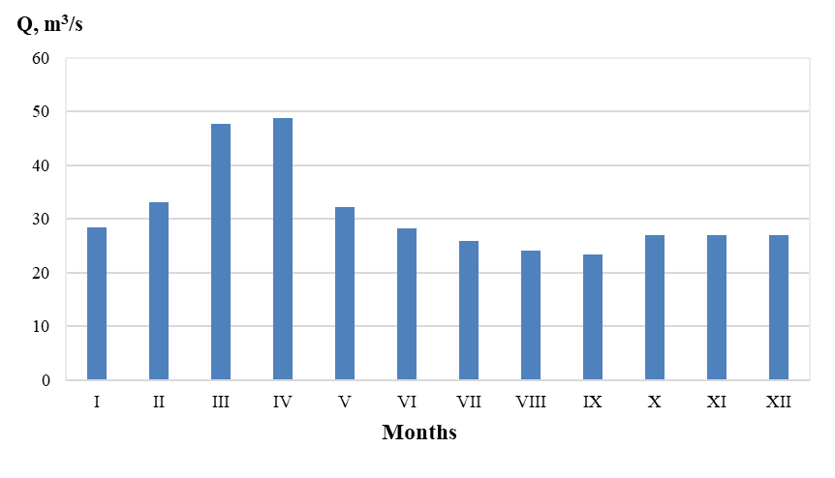

**Fig. 21.** Intra-annual distribution of water runoff of the Styr River (Lutsk hydrological station, averaged for 1963-2022)

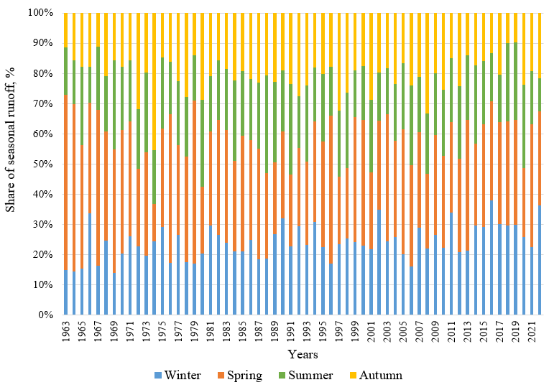

**Fig. 22.** Seasonal structure of water runoff of the Styr River (Lutsk hydrological station)

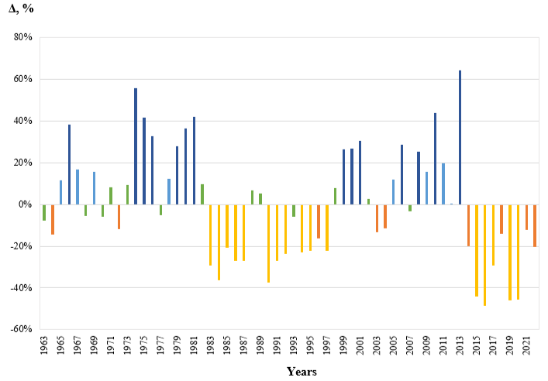

low-water years

relatively dry years

average years in terms of water content

relatively watery years

high water years

**Fig. 23.** Water content of the Styr River during 1963-2022

The mean value of maximum discharges of the Styr River during the study period is 101.46 m³/s. The maximum water discharge series (1963-2022) is complete – there are no gaps in the sample, which allowed for the correct assessment of its homogeneity and variability. Statistical analysis of the maximum discharge series of the Styr River (Table 4) showed its non-homogeneity both by Student's criterion (t_fact = 2.91 > t_0.05 = 2.00) and by Fisher's criterion (F_fact = 4.64 > F_0.05 = 1.86).

**Table 4.** Results of statistical analysis of the minimum discharge hydrological series of the Styr River (1963-2022)

|  |  |
| --- | --- |
| Statistical indicator | Value |
| Number of observations (n) | 60 |
| Arithmetic mean (x̄), m³/s | 14.80 |
| Standard deviation (s), m³/s | 5.78 |
| Coefficient of variation (Cv), % | 39.1 |
| Minimum value, m³/s | 4.0 |
| Maximum value, m³/s | 28.7 |
| Turning points criterion (Z) | 0.52 |
| Series randomness | Random |
| Student's t-criterion (actual) | 0.90 |
| Fisher's F-criterion (actual) | 1.58 |
| Series homogeneity | Homogeneous |
| Standard error of mean (σx̄), m³/s | 0.75 |

This indicates statistically significant changes in both mean values and variability of maximum runoff during the study period, especially in the second half, which correlates with the identified negative linear trend. The mean value of maximum discharges in the first half of the period (1963-1992) was 126.70 m³/s, and in the second (1993-2022), 76.22 m³/s, confirming the trend toward decreasing maximum runoff. Maximum discharge fluctuations have a random character (Z = 0.10 < 1.96), indicating the dominance of trend changes over cyclic ones. The coefficient of variation is 70.2%, indicating very high variability of maximum discharges and significant instability of the flood regime. Long-term dynamics of maximum runoff are characterized by the presence of a decreasing (Fig. 24) and statistically significant trend (Table 3).

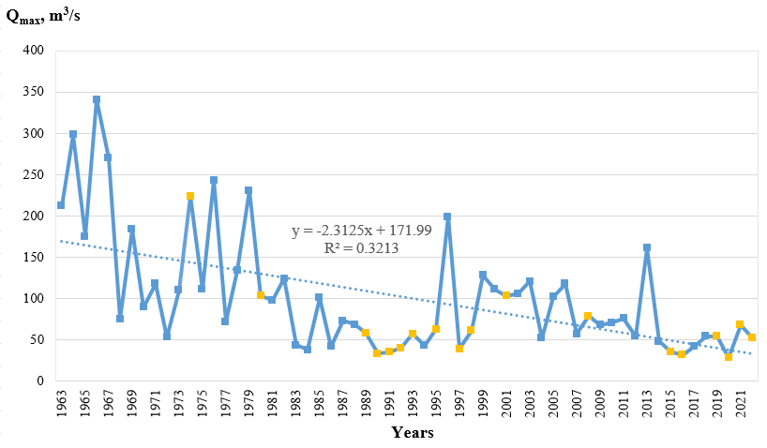

spring freshetflash flood

**Fig. 24.** Long-term dynamics of maximum runoff of the Styr River (Lutsk hydrological station)

For rivers in the plain part of Ukraine, including the Styr River, summer-autumn low flow is characteristic (when groundwater reserves are depleted), which is interrupted by rain floods, as well as winter low flow, which is interrupted in some years by water level rises due to snow melting during thaws. Winter low flow is higher because increased groundwater inflow is formed due to autumn moistening, as well as due to groundwater feeding by meltwater during thaw periods (Hrebin et al. 2019). Summer-autumn low flow in the temperate climate in Ukraine lasts from the end of spring flood (or summer floods) to autumn floods, or until the beginning of winter ice formation. At the Lutsk hydrological station, the lowest discharges of the open channel period are most often observed in August and September. However, in some years of the study period, they were recorded from March to December inclusive. The lowest discharges of the winter period are usually recorded in December and January. However, they are also possible in November, February, and March. Note that during the year, the minimum discharge value may repeat several times on different dates, and therefore in different months. In this regard, the sum of cases of observation of minimum summer-autumn discharges (and similarly the sum of cases of observation of minimum winter low flow discharges) is greater than the number of years in the study period.

Mean values of summer-autumn and winter low flow discharges are 14.81 m³/s and 17.73 m³/s, respectively. The minimum discharge series for both summer-autumn and winter low flow periods (1963-2022) are also complete – the data are continuous, which ensures the reliability of statistical verification results. Statistical analysis of minimum discharge series (Table 5) showed their homogeneity: mean low flow values did not change significantly (t_fact = 0.90 and 1.70 < t_0.05 = 2.00), as well as their variability (F_fact = 1.58 and 1.39 < F_0.05 = 1.86), indicating stability of minimum runoff formation conditions throughout the study period. The coefficient of variation is 39.1% for summer-autumn low flow and 42.0% for winter low flow, reflecting the natural high variability of low flow discharges while maintaining stable formation conditions. Minimum discharge fluctuations have a random character (Z = 0.52 and 1.45 < 1.96), which is typical for low flow formed mainly by groundwater supply and indicates the absence of systematic cycles or trends in its variability.

Long-term dynamics of minimum discharges demonstrate decreasing values of summer-autumn low flow toward the present (Fig. 25) and increasing values of winter low flow over time (Fig. 26), but neither linear trend is statistically significant (see Table 3).

**Table 5.** Results of statistical analysis of minimum discharge hydrological series of the Styr River (1963-2022)

|  |  |  |
| --- | --- | --- |
| **Statistical indicator** | **Summer-autumn low flow values** | **Winter low flow values** |
| Number of observations (n) | 60 | 60 |
| Arithmetic mean (x̄), m³/s | 14.81 | 17.73 |
| Standard deviation (s), m³/s | 5.78 | 7.45 |
| Coefficient of variation (Cv), % | 39.1 | 42.0 |
| Minimum value, m³/s | 4.0 | 5.85 |
| Maximum value, m³/s | 28.7 | 44.4 |
| Turning points criterion (Z) | 0.52 | 1.45 |
| Series randomness | Random | Random |
| Student's t-criterion (actual) | 0.90 | 1.70 |
| Fisher's F-criterion (actual) | 1.58 | 1.39 |
| Series homogeneity | Homogeneous | Homogeneous |
| Standard error of mean (σx̄), m³/s | 0.75 | 0.96 |

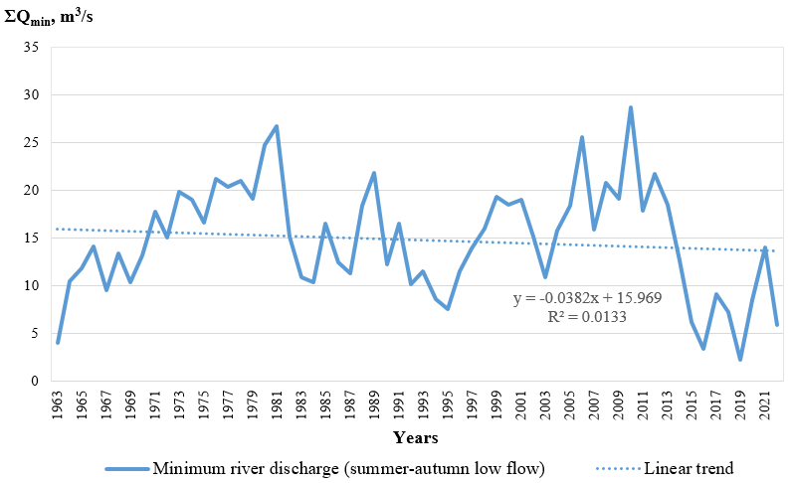

**Fig. 25.** Long-term dynamics of minimum river discharge during summer-autumn low flow of the Styr River (Lutsk hydrological station)

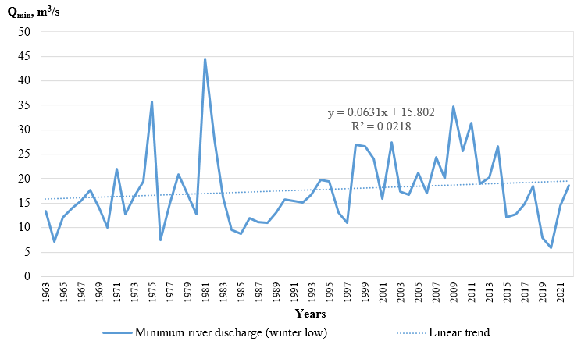

**Fig. 26.** Long-term dynamics of minimum river discharge during winter low flow of the Styr River (Lutsk hydrological station)

To identify the strength of the relationship between climatic parameters and water runoff values of the Styr River, we calculated the corresponding correlation coefficients (Table 6).

**Table 6.** Correlation strength of hydrometeorological parameters at Lutsk hydrological station

|  |  |
| --- | --- |
| Іndicator | Correlation coefficient and its interpretation  (Pedchenko 2018, р. 222) |
| Mean annual air temperature and mean annual river discharge | r = –0.15262±0.1  (inverse weak correlation) |
| Annual precipitation totals and mean annual river discharge | r = 0.367108±0.1  (direct moderate correlation) |
| Monthly precipitation totals and mean monthly river discharge (January) | r = 0.087046±0.1  (no correlation) |
| Mean monthly air temperature and mean monthly river discharge (January) | r = 0.40388±0.1  (direct moderate correlation) |
| Monthly precipitation totals and mean monthly river discharge (February) | r = 0.266771±0.1  (direct weak correlation) |
| Mean monthly air temperature and mean monthly river discharge (February) | r = 0.297258±0.1  (direct weak correlation) |
| Monthly precipitation totals and mean monthly river discharge (March) | r = 0.124928±0.1  (direct weak correlation) |
| Mean monthly air temperature and mean monthly river discharge (March) | r = 0.037526±0.1  (no correlation) |
| Monthly precipitation totals and mean monthly river discharge (April) | r = 0.054002±0.1  (no correlation) |
| Mean monthly air temperature and mean monthly river discharge (April) | r = –0.07633±0.1  (no correlation) |
| Monthly precipitation totals and mean monthly river discharge (May) | r = –0.01272±0.1  (no correlation) |
| Mean monthly air temperature and mean monthly river discharge (May) | r = 0.083096±0.1  (no correlation) |
| Monthly precipitation totals and mean monthly river discharge (June) | r = 0.282859±0.1  (direct weak correlation) |
| Mean monthly air temperature and mean monthly river discharge (June) | r = –0.1401±0.1  (inverse weak correlation) |
| Monthly precipitation totals and mean monthly river discharge (July) | r = 0.244603±0.1  (direct weak correlation) |
| Mean monthly air temperature and mean monthly river discharge (July) | r = –0.09159±0.1  (no correlation) |
| Monthly precipitation totals and mean monthly river discharge (August) | r = 0.092871±0.1  (no correlation) |
| Mean monthly air temperature and mean monthly river discharge (August) | r = –0.33872±0.1  (inverse moderate correlation) |
| Monthly precipitation totals and mean monthly river discharge (September) | r = 0.222646±0.1  (direct weak correlation) |
| Mean monthly air temperature and mean monthly river discharge (September) | r = –0.31424±0.1  (inverse moderate correlation) |
| Monthly precipitation totals and mean monthly river discharge (October) | r = 0.397752±0.1  (direct moderate correlation) |
| Mean monthly air temperature and mean monthly river discharge (October) | r = –0.03455±0.1  (no correlation) |

**Table 6.** cont.

|  |  |
| --- | --- |
| Іndicator | Correlation coefficient and its interpretation  (Pedchenko 2018, р. 222) |
| Monthly precipitation totals and mean monthly river discharge (November) | r = 0.341744±0.1  (direct moderate correlation) |
| Mean monthly air temperature and mean monthly river discharge (November) | r = –0.05345±0.1  (no correlation) |
| Monthly precipitation totals and mean monthly river discharge (December) | r = 0.12761±0.1  (direct weak correlation) |
| Mean monthly air temperature and mean monthly river discharge (December) | r = 0.1104±0.1  (direct weak correlation) |
| Annual precipitation totals and maximum river discharge | r = –0.06879±0.1  (no correlation) |
| Mean annual air temperature and maximum river discharge | r = –0.37053±0.1  (inverse moderate correlation) |
| Annual precipitation totals and minimum river discharge of the summer-autumn period | r = 0.392173±0.1  (direct moderate correlation) |
| Mean annual air temperature and minimum river discharge of the summer-autumn period | r = –0.19585±0.1  (inverse weak correlation) |
| Annual precipitation totals and minimum river discharge of the winter period | r = 0.126039±0.1  (direct weak correlation) |
| Mean annual air temperature and minimum river discharge of the winter period | r = 0.273252  (direct weak correlation) |

The strongest (moderate) direct correlation is observed between annual precipitation totals and mean annual river discharge, between mean monthly air temperature in January and mean river discharge of this month, between monthly precipitation totals in October and mean river discharge of this month, between monthly precipitation totals in November and mean river discharge of this month, between annual precipitation totals and minimum river discharge of the summer-autumn period. The strongest (moderate) inverse correlation is characteristic for mean air temperature in August and mean river discharge of this month, mean air temperature in September and mean river discharge of this month, mean annual air temperature, and maximum river discharge. All other investigated relationships have weak correlation, or no correlation at all (see Table 6).

Figure 27 clearly shows two almost complete cycles of water content in the Styr River. From 1964 to 1982 inclusive, there was an increase in mean annual discharge (phase duration – 20 years), from 1983 to 1997   
– a decrease (phase duration – 15 years), from 1998 to 2013 – an increase again (phase duration – 16 years). From 2014 to the end of the study period, there is a decrease in water content. In precipitation fluctuations, the phase of their increase was observed during 1964-1980, 1998-2022, and the decrease during 1981-1997. In general, the fluctuations of these hydrometeorological values occurred in phase, but asynchronously, with a shift in discharge fluctuations relative to precipitation by 1-2 years.

As a result, in some years, out-of-phase fluctuations are observed. For example, in 1971, 1974-1976, 1979, 1981, 2001, 2002, 2004, 2011, 2014, 2017, opposite trends in the fluctuations of the analyzed parameters are noticeable. Probably, in addition to the natural effect of delay in hydrological phenomena relative to weather and climate conditions, the cause of asynchronous fluctuations in discharge and precipitation during the study period was the influence of reclamation measures carried out in the river basin (Zuzuk et al. 2012, p. 141, 178, 209), the launch of the Khrinnyky Reservoir in 1957, its subsequent drawdowns and filling with water. From 1982 to 1999, fluctuations in precipitation and mean annual discharge were synchronous and in phase. Until 2014, the fluctuations of these hydrometeorological values were in phase, but with a mismatch between water discharge and precipitation fluctuations by approximately 1-2 years. During 2020-2022, fluctuations in mean annual discharge and annual precipitation totals were synchronous but out of phase. The consistency of fluctuations in the analyzed parameters during 1963-2022 confirms the direct moderate correlation between them (see Table 6).

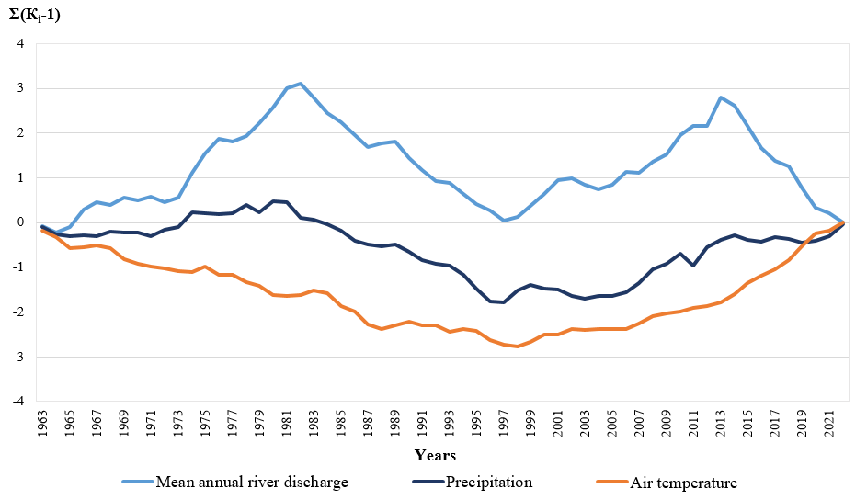

**Fig. 27.** Cyclicity of mean annual river discharge of the Styr River (Lutsk hydrological station), annual precipitation totals, and mean annual air temperature (Lutsk meteorological station) according to difference-integral curves

While in the fluctuations of mean annual discharge we observe almost 2 complete cycles (2 phases of increasing water content and 2 phases of its decrease), in precipitation fluctuation – 2 phases of increasing annual totals and 1 phase of their decrease, in the fluctuation of mean annual air temperature – 1 phase of increase and 1 phase of decrease. The first cycle of water content in the study period corresponds to the phase of decreasing mean annual air temperature, and the second cycle of water content to the phase of its increase (see Figure 27). The weak consistency of fluctuations in mean annual discharge and mean annual air temperatures is also confirmed by the weak inverse correlation between these indicators (see Table 6).

In the fluctuation of maximum discharge and annual precipitation totals, in-phase and synchronous patterns can be traced from the beginning of the study period until 1995 (Figure 28). In subsequent years, the fluctuations of these hydrometeorological parameters were synchronous but out of phase, meaning that decreases in maximum discharge accompanied increases in mean annual temperatures. As a result, the value of the correlation coefficient between these indicators shows no correlation between them (see Table 6). Fluctuations in maximum discharge and mean annual air temperatures are out of phase and synchronous, which confirms the inverse moderate correlation between them (see Table 6). The first twenty years (1963-1982) of the mean annual air temperature decrease phase during the study period occurred against the background of significantly higher precipitation totals in January and February, with substantially lower mean monthly air temperatures compared to the subsequent period (1983-1998) of the same phase (Table 7). This most likely contributed to the formation of significant snow reserves and, consequently, powerful floods (the genesis of maximum discharge is shown in Figure 24) during 1963-1982, which led to the formation of the increasing phase of maximum water discharge during this period. The phase of maximum discharge decrease, which began in 1983, is associated with a significant reduction in spring flood discharge (see Figure 24) due to significant warming in all months of the year, especially in winter (see Figure 4, see Table 1) and a decrease in precipitation in autumn months (see Figure 13, see Table 1), which also does not contribute to the formation of moisture reserves for the spring flood of the following year.

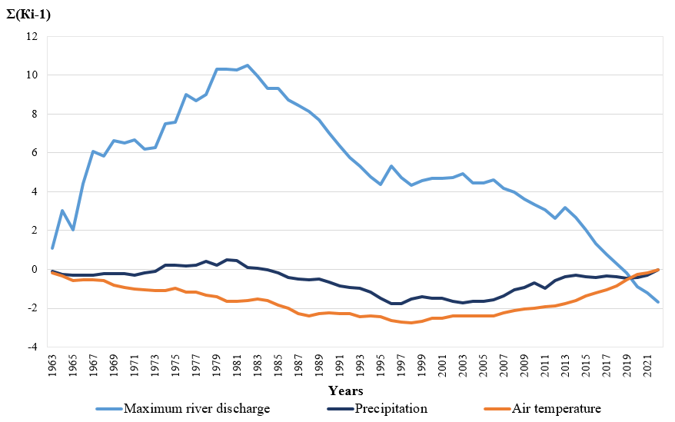

**Fig. 28.** Cyclicity of maximum river discharge of the Styr River (Lutsk hydrological station), annual precipitation totals, and mean annual air temperature (Lutsk meteorological station) according to difference-integral curves

**Table 7.** Mean monthly precipitation and air temperature values in January and February during different time periods of the mean annual air temperature decrease phase at Lutsk meteorological station

|  |  |  |
| --- | --- | --- |
| Indicators | Time period | |
| 1963-1982 | 1983-1998 |
| Mean precipitation in January | 34.7 mm | 19.8 mm |
| Mean air temperature in January | -5.7℃ | -3.3℃ |
| Mean precipitation in February | 34.9 mm | 20.1 mm |
| Mean air temperature in February | -3.7℃ | -2.8℃ |

Fluctuations in minimum discharge during the summer-autumn low-water period and annual precipitation totals (Figure 29) were in phase and synchronous during 1971-2013, and during 2014-2022, out of phase but synchronous. The rapid decrease in summer-autumn low-water discharge against the background of a relatively stable precipitation regime at the beginning of the study period (1963-1970) was obviously related to drainage reclamation (Zuzuk et al. 2012, p. 178-183, 209-214) and reservoir operation. A significant decrease in minimum discharge during the summer-autumn low-water period from 2014 against the background of, again, a relatively stable precipitation regime may be due to the rapid increase in mean annual air temperature during these years and, especially, mean temperatures in June, July, August, October (see Figure 4), which likely led to intensive evaporation from the catchment surface, water bodies, and watercourses during the summer-autumn low-water period and to a decrease in water discharge.

Fluctuations in minimum discharge during the summer-autumn low-water period and mean annual air temperatures (see Figure 29) were in phase and synchronous during 1963-1970, 1985-2013. The in-phase fluctuations of both indicators mean that a decrease in mean annual air temperatures was accompanied by a decrease in summer-autumn low-water discharge and vice versa, an increase in summer-autumn low-water discharge occurred against the background of increasing mean annual air temperatures. Such an illogical connection between these two processes in 1963-1970 was most likely related to reclamation and hydrotechnical interventions in the basin (Zuzuk et al. 2012, p. 178-182, 209-214).

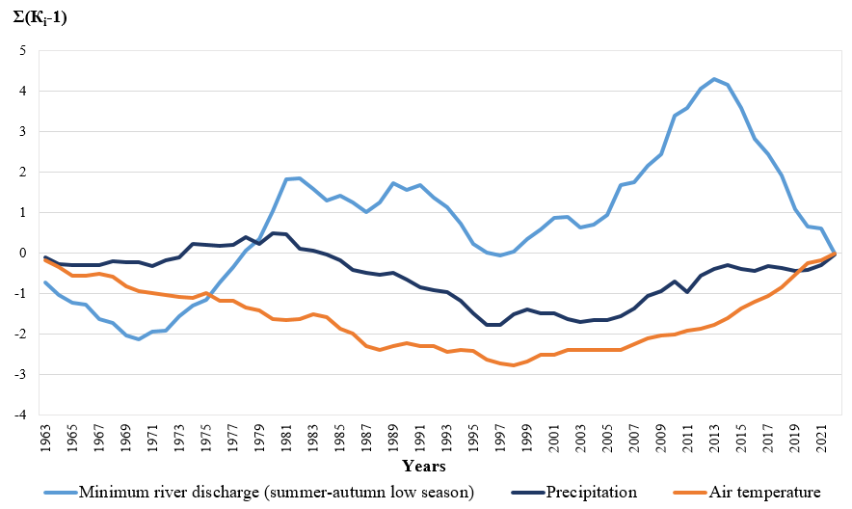

**Fig. 29.** Cyclicity of minimum river discharge of the Styr River (hydrological station Lutsk) during summer-autumn low-water period, annual precipitation totals, and mean annual air temperature (MS Lutsk) according to difference-integral curves

During 1971-1995 (except for 1986-1987), decreases in mean annual air temperatures led to increases in minimum discharge during the summer-autumn low-water period – the interdependence of the processes was natural. In 1996 and 1997, air temperature decreases occurred simultaneously with minimum discharge decreases. From 1998 to 2013, mean annual air temperatures increased with increasing summer-autumn low-water discharge. During 1992-2013, the regime of minimum discharge during the summer-autumn low-water period apparently responded more to the corresponding precipitation regime during this time interval. From 2014 to 2022, fluctuations in minimum discharge and air temperature became naturally out of phase and synchronous. Thus, it can be assumed that during 1963-1970, the minimum discharge of the summer-autumn low-water period responded most to anthropogenic activity; in 1971-1981, hydrological processes were naturally determined: minimum discharge increased against the background of increasing annual precipitation totals and decreasing air temperature; from 1982 to 2013, it was most consistent with fluctuations in annual precipitation totals, and from 2014 to 2022 – with fluctuations in mean annual air temperatures. The weak consistency of minimum water discharge of the Styr River with mean annual air temperatures is confirmed by the weak correlation between these indicators (see Table 6).

Fluctuations in minimum discharge during the winter low-water period and annual precipitation totals during 1963-1982 were out of phase and synchronous (Figure 30). From 1983 to 2019 (except for 2001, 2002, 2011, 2017) – synchronous and in phase, during 2019-2022 – synchronous and out of phase. Fluctuations in mean annual air temperatures and minimum discharge during the winter low-water period throughout the study period are synchronous and in phase, meaning that the minimum water discharge of the river in winter is directly dependent on annual air temperatures: a decrease in air temperature is accompanied by a decrease in discharge, and its increase – by an increase in discharge (see Figure 30). The greater consistency of minimum discharge during the winter low-water period with mean annual air temperature, compared to the consistency of fluctuations in minimum discharge during the summer-autumn low-water period and maximum discharge with mean annual air temperatures, is confirmed by the corresponding value of the correlation coefficient (see Table 6).

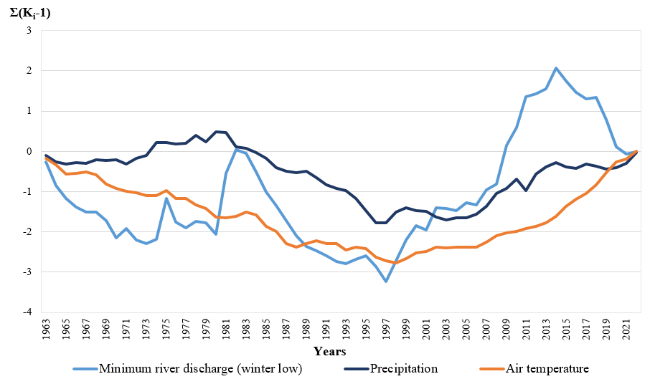

**Fig. 30.** Cyclicity of minimum river discharge of the Styr River (hydrological station Lutsk) during winter low-water period, annual precipitation totals, and mean annual air temperature (MS Lutsk) according to difference-integral curve

5. Conclusion

In the course of the study, we established that the mean annual and maximum runoff of the Styr River at the Lutsk hydrological station are decreasing (trends are statistically significant). Summer-autumn low flow discharges are decreasing, while winter low flow discharges are increasing (linear trends are insignificant). Statistical analysis using Student's and Fisher's criteria revealed that the mean annual discharge series is homogeneous. This is confirmed by the coefficient of variation and the constructed cumulative integral curve, while the turning points criterion confirmed the presence of systematic cycles of water content. The maximum discharge series proved to be non-homogeneous due to changes in their formation conditions during the study period. The minimum discharge series is homogeneous, indicating stability of low flow formation conditions. Decrease in water runoff of the Styr River is characteristic of all months of the year, except January and February (all trends are statistically insignificant, except for March and April). During the year, the highest discharges are observed in March-April, and the lowest in August and September. In spring, 34% of the mean annual runoff is formed, in winter, 24%, and in summer and autumn, 21% each. Cycles of low-water (with relatively low-water) and high-water (with relatively high-water) years for the Styr River last approximately 15 years each. During 1963-2022, 2 almost complete cycles of water content of the Styr River are observed (two phases of water content increase and two phases of its decrease), in precipitation fluctuations – two phases of annual sum increase and one phase of their decrease, in mean annual air temperature fluctuations – one phase of increase and one phase of decrease. In the fluctuations of mean annual and minimum runoff, the turning points are 1982, 1997, and 2013-2014 – they mark the beginning of water content phases. Thus, the duration of river water regime phases is approximately 15-16 years. Considering this, it is possible to forecast a further decrease in mean annual runoff and minimum discharges of summer-autumn and winter low flow of the Styr River under other equal conditions until approximately 2028. In maximum runoff fluctuations, 1982 is the watershed of water content phases. Since that year, the phase of maximum runoff decline has continued. Since its fluctuations are quasi-stationary, it is impossible to predict the beginning of the next phase of high water content of maximum runoff based on the data of this observation series.

References

Bauzha, T. O., & Horbachova, L. O. (2013). Tsyklichni kolyvannia hidrometeorolohichnykh kharakterystyk u baseini r. Rika [Cyclic fluctuations of hydrometeorological characteristics in the Rika River basin]. *Naukovi pratsi Ukrainskoho naukovo-doslidnoho hidrometeorolohichnoho instytutu [Scientific works of the Ukrainian Scientific Research Hydrometeorological Institute]*, *264*, 34-43. (in Ukrainian)

Bisselink, B., et al. (n.d.). Impact of a changing climate, land use, and water usage on water resources in the Danube river basin. *Publications Office of the European Union*, Luxembourg, 3-70. https://doi.org/10.2760/89828

Camilloni, I., Barros, V., Moreiras, S., Poveda, G., & Tomasella, J. (2020). *Floods and Droughts*. In J. M. Moreno, C. Laguna-Defior, V. Barros, E. Calvo Buendía, J. A. Marengo, & U. Oswald Spring (Eds.), Adaptation to Climate Change Risks in Ibero-American Countries − RIOCCADAPT Report (pp. 371-396). McGraw Hill.

Didovets, Y., Snizhko, S., Krysanova, V., Bronstert, A., & Lobanova, A. (2017). Ekoloho-hidrolohichne modeliuvannia richkovoho stoku v umovakh zminy klimatu za dopomohoiu chyselnoi modeli SWIM [Ecological-hydrological modeling of river runoff under climate change using the SWIM numerical model]. *In Pershyi Vseukrаinskiy hidrometrolohichnyi zizd z mizhnarodnoyu uchastiu [First All-Ukrainian Hydrometeorological Congress with international participation].* Odesa: Odeskyi derzhavnyi ekolohichnyi universytet, 130-131. (in Ukrainian)

Fangmann, A., Belli, A., & Haberlandt, U. (2013). Trends in beobachteten Abflusszeitreihen in Niedersachsen. *Hydrologie und Wasserbewirtschaftung*, *57*, 196-205. (in German)

Fedoniuk, M., Kovalchuk, I., Zhdaniuk, B., Fedoniuk, V., & Pavlovska, T. (2020). Use of multispectral satellite imagery to monitor erosion on the Volyn Upland. In XIV International Scientific Conference "Monitoring of Geological Processes and Ecological Condition of the Environment" (pp. 1-5). European Association of Geoscientists & Engineers. https://doi.org/10.3997/2214-4609.202056062

Fesiuk, V. O., Karpiuk, Z. K., & Zhurba, D. V. (2023). Vplyv vodohospodarskoho kompleksu m. Lutska na zabrudnennia vod r. Styr [Impact of Lutsk water management complex on water pollution of the Styr River]. *Ukrainskyi zhurnal pryrodnychykh nauk [Ukrainian Journal of Natural Sciences]*, *4*, 177-189. (in Ukrainian)

Hanushchak, M. M., & Tarasiuk, N. A. (2015). Otsinka yakosti poverkhnevykh vod baseinu r. Styr [Assessment of surface water quality in the Styr River basin]. *Hidrolohiia, hidrokhimiia, hidroekolohiia* [*Hydrology, hydrochemistry and hydroecology*], *1*(36), 110-118. (in Ukrainian)

Hanushchak, M. M., & Tarasiuk, N. A. (2019). Vodnyi chynnyk v rozvytku i funktsionuvanni pryrodno-antropohennykh kompleksiv baseinu richky Styr: monohrafiia [Water factor in the development and functioning of natural-anthropogenic complexes of the Styr River basin: monograph]. Lutsk: Vezha-Druk. (in Ukrainian)

Hoian, Y. O., Hoptsii, M. V., & Kushchenko, L. V. (2020). Osoblyvosti tsyklichnosti u kolyvanniakh minimalnoho stoku u period mezheni na terytorii Pryazovia za suchasnykh klimatychnykh umov [Features of cyclicity in fluctuations of minimum runoff during the low-water period in the Azov region under modern climatic conditions]. *In Ekolohiia, neoekolohiia, okhorona navkolyshnoho seredovyshcha ta zbalansovane pryrodokorystuvannia: Materialy VIII Mizhnarodnoi naukovoi konferentsii molodykh vchenykh [Proceedings of the VIII International Scientific Conference of Young Scientists' Ecology, Neoecology, Environmental Protection and Sustainable Nature Management']*. Kharkiv, 52-54. (in Ukrainian)

Hopchenko, Y. D., Ovcharuk, V. A., Hoptsii, M. V., & Todorova, O. I. (2018). Statystychni parametry chasovykh riadiv maksymalnoho stoku vesnianoho vodopillia v baseini Dnipra v umovakh minlyvosti klimatu [Statistical parameters of time series of maximum spring flood runoff in the Dnipro basin under climate variability]. *Hidrolohiia, hidrokhimiia i hidroekolohiia* [*Hydrology, hydrochemistry and hydroecology*], *4*(51), 47-55. (in Ukrainian)

Horbachova, L. O. (2016). Bahatorichni tendentsii richnoho stoku vody richok Ukrainy ta yoho klimatychnykh chynnykiv [Long-term trends of annual water runoff of Ukrainian rivers and its climatic factors]. *Naukovi pratsi UkrNDHMI [Scientific works of Ukrainian Hydrometeorological Institute UHMI]*, *269*, 94-106, (in Ukrainian)

Horbachova, L. O. (2014). Metodychni pidkhody shchodo otsinky statsionarnosti i odnoidnosti hidrolohichnykh riadiv sposterezhen [Methodological approaches to assessing stationarity and homogeneity of hydrological observation series]. *Hidrolohiia, hidrokhimiia i hidroekolohiia [Hydrology, hydrochemistry and hydroecology]*, *1*, 22-31. (in Ukrainian)

Horbachova, L. O., & Barandich, S. L. (2016). Prostorovo-chasova minlyvist maksymalnoho stoku vody vesnianoho vodopillia ta pavodkiv zmishanoho pokhodzhennia richok Ukrainy [Spatial-temporal variability of maximum water runoff of spring floods and mixed-origin floods of Ukrainian rivers]. Naukovi pratsi UkrNDHMI *[Scientific works of Ukrainian Hydrometeorological Institute UHMI]*, *269*, 107-114. (in Ukrainian)

Horbachova, L. O., & Khristiuk, B. F. (2021). Prohnozuvannia vodnosti richky Styr na naiblyzhchi roky [Forecasting water content of the Styr River for the coming years]. *Visnyk Kharkivskoho natsionalnoho universytetu imeni V.N. Karazina. Seriia «Heolohiia. Heohrafiia. Ekolohiia» [Bulletin of V.N. Karazin Kharkiv National University. Series' Geology. Geography. Ecology']*, *54*, 155-163. (in Ukrainian)

Hrebin, V. V., Obodovskyi, O. H., Zhovnir, V. V., Mudra, K. V., & Pochaievets, O. O. (2019). Otsiniuvannia odnoidnosti riadiv stokovykh kharakterystyk richok raioniv richkovykh baseiniv ta subbaseiniv Ukrainy [Assessment of homogeneity of runoff characteristics series of rivers in river basin and sub-basin regions of Ukraine]. Hidrolohiia, hidrokhimiia i hidroekolohiia [Hydrology, Hydrochemistry and Hydroecology], *1*(52), 36-50. (in Ukrainian)

Hrytsiuk, V. V. (2023). Vnutrishnorichnyi rozpodil vodnoho stoku r. Stokhid: vypuskna kvalifikatsiina robota [Intra-annual distribution of water runoff of the Stokhid River: graduation thesis]. Lutsk. (in Ukrainian)

Kondratiuk, A. V. (2021). Modeliuvannia i prohnozuvannia stanu zabrudnennia poverkhnevykh vod richky Styr [Modeling and forecasting of surface water pollution of the Styr River]. *Suchasni problemy Arkhitektury ta Mistobuduvannia [Modern problems of Architecture and Urban Planning]*, *61*, 395-409. (in Ukrainian)

Konovalenko, K. Y., Danko, K. Y., Vasylenko, Y. V., & Dutko, V. O. (2011). Zakonomirnosti vnutrishnorichnoho rozpodilu stoku richky Styr ta osoblyvosti yoho zmin [Patterns of intra-annual distribution of the Styr River runoff and features of its changes]. *Hidrolohiia, hidrokhimiia i hidroekolohiia [Hydrology, hydrochemistry and hydroecology]*, *1*(22), 80-87. (in Ukrainian)

Kopylov, V. P., & Popovych, V. V. (2023). Analiz fizyko-khimichnykh doslidzhen hidrohrafichnoi merezhi riky Styr v mezhakh mista Lutsk [Analysis of physico-chemical studies of the hydrographic network of the Styr River within the city of Lutsk]. *Ekolohichni nauky [Ecological Sciences]*, *6*(51), 44-49. (in Ukrainian)

Kovalchuk, I. P., Kovalchuk, A. I., Kovalchuk, I. V., Tsaryk, L. P., Pavlovska, T. S., & Pylypovych, O. V. (2023). Kontseptualni zasady doslidzhen heoekolohichnoho stanu richkovo-baseinovykh system ta yikh tsyfrovoho atlasnoho kartohrafuvannia [Conceptual principles of research of the geoecological state of river-basin systems and their digital atlas mapping]. *Naukovi zapysky Ternopilskoho natsionalnoho pedahohichnoho universytetu imeni Volodymyra Hnatiuka. Seriia: Heohrafiia [Scientific notes of Volodymyr Hnatiuk Ternopil National Pedagogical University. Series: Geography]*, *2*(55), 4-16. (in Ukrainian)

Kovalchuk, I., Kovalchuk, I., Fedoniuk, M., Martyniuk, V., Zhdanyuk, B. (2022). Achievements and challenges in studies of river systems and their catchment. *In* *European Association of Geoscientists & Engineers. International Conference of Young Professionals «GeoTerrace-2022»* (p.1-5). https://doi.org/10.3997/2214-4609.2022590045

Kundzewicz, Z. W., & Robson, A. J. (2004). Detecting trend and other changes in hydrological data. *Hydrological Sciences Journal*, *49*(1), 7-19.

Lobanova, A., et al. (2018). Hydrological impacts of moderate and high-end climate change across European river basins. *Journal of Hydrology: Regional Studies*, *18*, 15-30. https://doi.org/10.1016/j.ejrh.2018.05.003

Loboda, N. S., & Ovcharuk, V. A. (2005). Hidrolohichni rozrakhunky [Hydrological calculations]. Odesa: Vyd-vo. (in Ukrainian).

Lukianets, O., Obodovskyi, O., Grebin, V., & Pochaievets, O. (2019). Time series analysis and forecast estimates of the mean annual water runoff of rivers in of the Prut and Siret basins (within Ukraine). XXVIIІ Conference of the Danubian Countries on Hydrological Forecasting and Hydrological Bases of Water Management (pp. 133-139).

Martyniuk, M. O., & Ovcharuk, V. A. (2023). Prostorova i chasova minlyvist maksymalnoho stoku v baseini Visly v umovakh klimatychnykh zmin [Spatial and temporal variability of maximum runoff in the Vistula basin under climate change]. *Ekolohichni nauky [Ecological Sciences]*, *48*(3), 148-155. (in Ukrainian)

Melnyk, S. V., & Loboda, N. S. (2021). Otsinka zmin kharakterystyk stoku livoberezhnykh prytok verkhnoho Dnistra v umovakh poteplinnia [Assessment of changes in runoff characteristics of left-bank tributaries of the upper Dniester under warming conditions]. *Ukrainskyi hidrometeorolohichnyi zhurnal [Ukrainian Hydrometeorological Journal]*, *27*, 55-65. (in Ukrainian).

Molchak, Y. O., Fesiuk, V. O., & Kartava, O. F. (2003). Lutsk: suchasnyi ekolohichnyi stan ta problemy [Lutsk: current ecological state and problems]. Lutsk: RVV LDTU. (in Ukrainian)

Netrobchuk, I., & Hashynska, V. (2018). Ekolohichna otsinka yakosti vody r. Styr u misti Lutsku [Ecological assessment of water quality of the Styr River in Lutsk]. *Naukovyi visnyk Skhidnoievropeiskoho natsionalnoho universytetu im. Lesi Ukrainky. Heohrafichni nauky [Scientific Bulletin of Lesya Ukrainka East European National University. Geographical Sciences]*, *3*(376), 28-34. (in Ukrainian)

Nykoniuk, U. S., & Stelmakh, V. Y. (2023). Osoblyvosti hidrolohichnoho rezhymu richky Styr [Features of the hydrological regime of the Styr River]. *In Moloda nauka Volyni: priorytety ta perspektyvy doslidzhen [Young Science of Volyn: Priorities and Research Prospects]: Proceedings of the XVII International Scientific Conference*. Lutsk: VNU im. Lesi Ukrainky, 170-172. (in Ukrainian)

Nykoniuk, U. S., Nohachevskyi, V. V., & Pavlovska, T. S. (2024). Vnutrishnorichnyi rozpodil vodnoho stoku r. Styr (hidropost Lutsk, 2020 rik) [Intra-annual distribution of water runoff of the Styr River (hydropost Lutsk, 2020)]. *Universum [Universum]*, *4*, 242-248. (in Ukrainian)

Obodovskyi, O., & Lukianets, O. (2017). Patterns and forecast of long-term cyclical fluctuations of the water runoff of Ukrainian Carpathians rivers. *Research, Engineering & Management*, *73*(1), 33-47.

Osadchyi, V. I., & Kuzmenko, S. M. (2008). Hidrolohichni rozrakhunky: statystychni metody [Hydrological calculations: statistical methods]. Kyiv: Nika-Tsentr. (in Ukrainian)

Ovcharuk, V. A. (2020). Maksymalnyi stik vesnianoho vodopillia rivnynnykh richok Ukrainy [Maximum spring flood runoff of plain rivers of Ukraine]. Odesa: Vydavnychyi dim «Halvanika» (in Ukrainian)

Pavelchuk, Y. M., & Snizhko, S. I. (2017). Hidroloho-hidrokhimichni kharakterystyky richok Zhytomyrskoho Polissia v umovakh hlobalnoho [Hydrological and hydrochemical characteristics of rivers of Zhytomyr Polissya under global conditions]. Zhytomyr: V-vo «Volyn» (in Ukrainian)

Pavlovska, T. S. (2005). Transformatsiia struktury richkovoi systemy Horyni u druhii polovyni XX st. [Transformation of the Horyn river system structure in the second half of the XX century]. *Istoriia ukrainskoi heohrafii [History of Ukrainian Geography]*, *1*(11), 54-59. (in Ukrainian)

Pavlovska, T. S., Biletskyi, Y. V., & Valianskyi, S. V. (2023a). Prostorovyi rozpodil i rezhym vypadannia atmosfernykh opadiv u Volynskii oblasti [Spatial distribution and regime of precipitation in Volyn region]. *Heohrafichnyi chasopys Volynskoho natsionalnoho universytetu imeni Lesi Ukrainky [Geographical Journal of Lesya Ukrainka Volyn National University]*, *3*, 13-23. (in Ukrainian) https://doi.org/10.32782/geochasvnu.2024.3.02

Pavlovska, T. S., Fedoniuk, M. A., & Rudyk, O. V. (2023b). Temperaturnyi rezhym povitria u Volynskii oblasti: khronolohichnyi ta khorolohichnyi aspekty [Air temperature regime in Volyn region: chronological and chorological aspects]. *Heohrafichnyi chasopys Volynskoho natsionalnoho universytetu imeni Lesi Ukrainky [Geographical Journal of Lesya Ukrainka Volyn National University]*, *1*, 39-48. (in Ukrainian) https://doi.org/10.32782/geochasvnu.2023.1.04

Pavlovska, T. S., Kovalchuk, I. P., Martyniuk, V. O., & Rudyk, O. V. (2024). Tsyklichni kolyvannia seredniorichnykh vytrat r. Stokhid (prava prytoka Pryp'iati) [Cyclic fluctuations of mean annual discharge of the Stokhid River (right tributary of the Pripyat)]. *Heohrafichnyi chasopys Volynskoho natsionalnoho universytetu imeni Lesi Ukrainky [Geographical Journal of Lesya Ukrainka Volyn National University]*, *4*, 22-29. (in Ukrainian) https://doi.org/10.32782/geochasvnu.2024.4.02

Pavlovska, T. S., Semeniuk, O. I., & Poberezhnyi, V. V. (2020). Bahatorichna dynamika minimalnoho stoku richky Styr (hidropost «Lutsk») [Long-term dynamics of minimum runoff of the Styr River (hydropost "Lutsk")]. *In Suchasna nauka ta osvita Volyni [Modern Science and Education of Volyn]*. Lutsk: Vezha-Druk, 179-180. (in Ukrainian)

Pedchenko, H. P. (2018). Statystyka: navchalnyi posibnyk [Statistics: study guide]. Melitopol: Kolor Prynt. (in Ukrainian)

Pekarova P., Miklánek P. and Pekár J. (2003) Spatial and temporal runoff oscillation analysis of the main rivers of the world during the 19th -20th centuries. *Journal of Hydrology*, *274*, 62-79.

Rakhmatullina, E. R. (2015). Hidrolohichnyi rezhym richok baseinu Pivdennoho Buhu v zymovyi period v umovakh zmin klimatu [Hydrological regime of the Southern Bug basin rivers in winter under climate change conditions] (Doctoral dissertation). Kyiv. (in Ukrainian)

Report on research work development of scenarios of climate change in Ukraine for the medium and long term using data from global and regional models. (2013). Retrieved from https://uhmi.org.ua/project/rvndr/climate.pdf (in Ukrainian)

Romanowicz, R. J. (2017). *The Influence Of Climate Change On Hydrological Extremes: Floods & Droughts*. Science Trends. https://doi.org/10.31988/SciTrends.3899

Romashchenko, M. I., Kolomiiets, S. S., & Sardak, A. S. (2021). Metamorfizatsiia zonalnoho hidrokhimichnoho skladu poverkhnevykh i pidzemnykh vod Ukrainy pid vplyvom antropohennykh i pryrodnykh chynnykiv [Metamorphization of zonal hydrochemical composition of surface and groundwater of Ukraine under the influence of anthropogenic and natural factors]. *Melioratsiia i vodne hospodarstvo [Land Reclamation and Water Management]*, *2*,   
24-32. (in Ukrainian)

Shvets, L. L. (2004). Metody statystychnoi obrobky hidrolohichnykh danykh [Methods of statistical processing of hydrological data]. Kyiv: Nika-Tsentr. (in Ukrainian)

Stelmakh, V. Y. (2024). Analiz hidrohrafichnoi merezhi ta suchasnoho hidrolohichnoho rezhymu richky Styr (2020–2022 rr.) [Analysis of the hydrographic network and modern hydrological regime of the Styr River (2020-2022)]. *Ukrainskyi zhurnal pryrodnychykh nauk [Ukrainian Journal of Natural Sciences]*, *8*, 119-130. (in Ukrainian)

Styr. Rehionalnyi ofis vodnykh resursiv u Volynskii oblasti [Styr. Regional Office of Water Resources in Volyn Region]. (in Ukrainian). Retrieved from https://vodres.gov.ua/node/1353

Tallaksen, L. M., & van Lanen, H. A. J. (2004). Hydrological Drought: Processes and Estimation Methods for Streamflow and Groundwater. Elsevier.

Tsaryk, L. P., Tsaryk, P. L., Kuzyk, I. R., & Tsaryk, V. L. (2021). Pryrodokorystuvannia ta okhorona pryrody u baseinakh malykh richok [Nature management and nature protection in small river basins] (2nd ed.). Ternopil: SMP «Taip» (in Ukrainian)

Vasylenko, Y. V., & Hrebin, V. V. (n.d.). Suchasni zminy zhyvlennia richok baseinu Prypiati (v mezhakh Ukrainy) [Modern changes in the feeding of the Pripyat basin rivers (within Ukraine)]. (in Ukrainian). Retrieved from https://uhmi.org.ua/conf/climate_changes/presentation_pdf/poster_3/Vasylenko.pdf

Vasylenko, Y. V., Dutko, O. V., Konovalenko, O. S., & Danko, K. Y. (2011). Zakonomirnosti vnutrishnorichnoho rozpodilu stoku richky Styr ta osoblyvosti yoho zmin [Patterns of intra-annual distribution of the Styr River runoff and features of its changes]. *Hidrolohiia, hidrokhimiia i hidroekolohiia [Hydrology, hydrochemistry and hydroecology]*, *1*(22), 80-87. (in Ukrainian).

Voloshyn, V., Melnyk, O., Melnyk, Y., & Vereshko, O. (2017). Heoinformatsiine modeliuvannia rivniv vody r. Styr v pavodkovyi period u mezhakh terytorii m. Lutska [Geoinformation modeling of water levels of the Styr River during the flood period within Lutsk]. *Suchasni dosiahnennia heodezychnoi nauky ta vyrobnytstva [Modern achievements of geodetic science and production]*, *1*(33), 166-171. (in Ukrainian)

Vyshnevskyi, V. I., & Kutsyi, A. V. (2022). Bahatorichni zminy vodnoho rezhymu richok Ukrainy [Long-term changes in the water regime of Ukrainian rivers]. Kyiv: Naukova dumka. (in Ukrainian)

WMO. (1989). Manual on Low-flow Estimation and Prediction. Operational Hydrology Report No. 29. World Meteorological Organization, Geneva.

Yu, C., Yin, X., Yang, Z., & Dang, Z. (2017). Assessment of the degree of hydrological indicators alteration under climate change. In Proceedings of the 2017 6th International Conference on Energy and Environmental Protection (ICEEP 2017). Advances in Engineering Research. *Atlantis Press*, *143*, 210-216.

Zabokrytska, M. R., & Khilchevskyi, V. K. (2016). Vodni obiekty Lutska: hidrohrafiia, lokalnyi monitorynh, vodopostachannia ta vodovidvedennia [Water objects of Lutsk: hydrography, local monitoring, water supply and drainage]. *Hidrolohiia, hidrokhimiia i hidroekolohiia [Hydrology, hydrochemistry and hydroecology]*, *3*, 64-76. (in Ukrainian)

Zabolotnia, T., Gorbachova, L., & Khrystyuk, B. (2019). Estimation of the long-term cyclical fluctuations of snow-rain floods in the Danube basin within Ukraine. *Meteorology Hydrology and Water Management. Research and Operational Applications*, *7*(2), 3-11.

Zhang, X., Harvey, K. D., Hogg, W. D., & Yuzyk, T. R. (2001). Trends in Canadian streamflow. *Water Resources Research*, *37*(4), 987-998.

Zuzuk, F. V., Koloshko, L. K., & Karpiuk, Z. K. (2012). Osusheni zemli Volynskoi oblasti ta yikh okhorona [Drained lands of Volyn region and their protection]. Lutsk: Volyn. nats. un-t im. Lesi Ukrainky. (in Ukrainian)