|  |  |  |  |
| --- | --- | --- | --- |
|  |  | | |
| **Rocznik Ochrona Środowiska** | | |
| Volume 27 | Year 2025 ISSN 2720-7501 | pp. 460-468 |
|  | https://doi.org/10.54740/ros.2025.038 open access | | |
|  | Received: January 2025 Accepted: July 2025 Published: August 2025 | | |

Spatial Evaluation and GIS based Mapping of Heavy Metal Pollution   
in Beşgöz Lake of Turkiye

Muhammed Kamil Öden1, M. Cuneyt Bagdatlı2*

1Department of Environmental Protection Technologies, Sarayönü Vocational School, Selcuk University, Konya, Turkiye https://orcid.org/0000-0002-0573-5634

2Department of City and Regional Planning, Faculty of Architecture,   
Nigde Omer Halisdemir University, Nigde, Turkiye  
https://orcid.org/0000-0003-0276-4437

corresponding author's e-mail: [cuneytbagdatli@gmail.com](mailto:cuneytbagdatli@gmail.com)

**Abstract:** In this research, Beşgöz Lake in Sarayönü district of Konya province, located in the Central Anatolia Region of Turkiye, was chosen as the study area. The changes in heavy metal concentrations in Beşgöz Lake in different periods were examined spatially. To determine the heavy metal concentrations of Beşgöz Lake, water samples were taken from eight different points representing the lake in four different periods (spring, summer, autumn, and winter). Al, Cr, Fe, Cu, Ni, and Zn concentrations were examined seasonally in Beşgöz Lake water. Heavy metal concentrations in the samples were determined on the ICP-MS device. The obtained concentration values were spatially modeled using spline interpolation techniques with ArcGIS 10.3.1, one of the Geographic Information Systems (GIS) software. As a result of the research, the average of all periods was Al: 0.004±0.0012 mg/l, Cr: 0.023±0.0083 mg/l, Fe: 0.269±0.0286 mg/l, Cu: 0.115±0.0198 mg/l, Ni: 0.071±0.0099 mg/l, and Zn: 0.035±0.0085 mg/l. It was determined that the Fe, Cu and Ni concentrations in the lake water were higher than the upper permitted limit values. It is thought that the spatial modeling obtained from the study will significantly contribute to evaluating surface water resources and serve as an example for similar studies.

**Keywords:** water quality, heavy metal, GIS mapping, Beşgoz Lake, Turkiye

1. Introduction

Pollution threatens the environment and human health. It also has effects on urban climate and air quality. Climate elements and air pollutants interact in the atmosphere (Zateroglu 2021a, 2021b). The concentrations of air pollutants are influenced by climate elements and environmental factors such as an increase in fossil fuel combustion due to an increase in industrial activities and energy demand (Zateroglu 2022, 2024). An increase in air pollutants in the atmosphere contributes to climate change, which has adverse effects on natural resources, e.g., freshwater resources. Lakes are important freshwater resources with several ecosystem service functions, such as aquatic habitat, groundwater table maintenance, and biodiversity conservation (Zerizghi et al. 2020). However, with the rapid development of population, production, and economy, lakes are exposed to serious heavy metal pollution (Xu et al. 2020). Heavy metals (HMs) are typical inorganic pollutants produced during social and economic development (Kaur et al. 2022). They can have carcinogenic, teratogenic, mutagenic, and other effects due to their properties on the human body. If these pollutants are uncontrolled and widely distributed in the environment, they seriously threaten ecological safety and human health (Esmaeili et al. 2022).

Heavy metals primarily penetrate aquatic environments due to different factors (e.g., industrial, agricultural, combustion, and smelting factors, sewage effluents, and road vehicle activities) (Rajeshkumar et al. 2018). Exposure to heavy metals is known to be linked to many different negative health effects, such as cancer, mental and physical developmental deficiencies, mental retardation, kidney damage, and stillbirth (Alomary & Belhadj 2007, Rinklebe et al. 2019). Biomarkers in the aquatic environment are valuable tools for determining how biological systems interact with potential contaminants (chemical, physical, or biological) (US NRC 1989). For this reason, their effects on aquatic life are determined by evaluating the reactions of heavy metals in organisms (Hemmadi 2017, El-Agri et al. 2022). These heavy metals are also known to cause oxidative stress in fish by stimulating the formation of reactive oxygen species (ROS) that damage biological components such as lipids, proteins, and DNA. The effects of heavy metals on the aquatic environment are also observed in this way (Burgos-Aceves et al. 2018, Gobi et al. 2018).

In this research, the water quality of Beşgöz Lake in Sarayönü district of Konya province, located in the Central Anatolia Region of Turkiye, was examined periodically in terms of heavy metal content. The results obtained were evaluated and modeled spatially with the help of Geographic Information Systems (GIS). The data obtained in this study contribute significantly to monitoring the periodic water quality of the lake and evaluating water resources in the region.

2. Materials and Methods

2.1. Study Area

This research was carried out to investigate the water quality of Beşgöz Lake, located within the borders of Sarayönü district of Konya province of Turkiye, in terms of heavy metal content. The location of Beşgöz Lake, where the research was conducted, and the locations of the water samples taken are schematized in Figure 1.

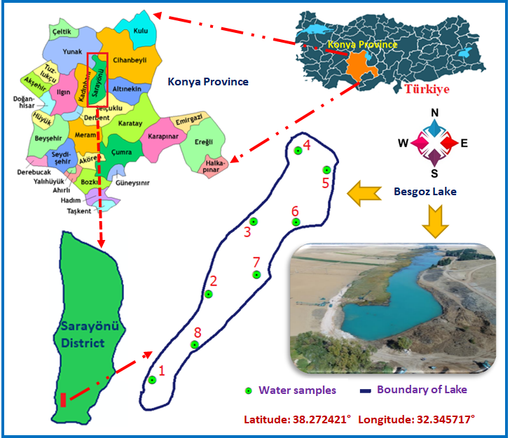

**Fig. 1.** The locations of the study area and water sampling points

Beşgöz Lake is located in Sarayönü district, which is located in the Central Anatolia Region of Turkiye and is 55 km away from Konya province. The lake surface, which has an average surface area of 8 km2, is exposed to pollution from industrial and residential waste.

The water source of the lake is mainly groundwater. Trout and carp farming is also carried out as aquaculture in the canals originating from Beşgöz Lake, which is located within the borders of Konuklar State Production Farm. Beşgöz Lake benefits from important spring waters, mostly coming from the bottom, and the water temperature in summer does not exceed 16-18°C. The water temperature in January is 5°C, the water temperature in March is 12°C, the water temperature in May is 16°C, and the water temperature in July is 18°C. The water in Beşgöz is slightly alkaline, and its pH values are around 7.5-8.0. The dissolved oxygen concentration in lake water is around 9 mg/l in every season due to the great influence of spring waters coming from the bottom. Nitrate nitrogen concentration (3.4 mg/l) and phosphorus concentration (0.57 mg/l) were also measured to be above normal values (Akköz et al. 2000). The average annual temperature of the research area is 11.5°C, and the average annual total precipitation is 374 mm. The semi-arid, cold Mediterranean climate is effective in the study area (Akman 1982).

2.2. Water quality analysis method

The containers where water samples were taken and the devices where analyses were performed were pre-cleaned using acid solution, then washed with pure water and dried in an oven to maintain and clean them. Water samples were collected approximately 30-40 cm below the water surface. It was taken for analysis by filling it into 500 ml bottles. Water sample containers were rinsed with lake water, and water samples were taken after this process. Sample volumes and appropriate sample containers specified in the TS EN ISO 5667-3 standard were used for heavy metal analyses in water samples (Anonymous 2018). Water samples were taken from the lake surface and from 8 different points representing the lake surface in 4 periods (spring, summer, autumn, winter). Heavy metal concentrations in the samples were determined on the Inductively Coupled Plasma and Mass Spectrometry (ICP-MS) device.

2.3. Evaluation of heavy metals in water samples

Heavy metal concentrations in water samples collected in four different periods in the research area were evaluated according to Turkish Standards (TS), World Health Organization (WHO), United States Environmental Protection Agency (EPA), and European Union (EC) criteria. Permissible limit values that can be allowed in terms of heavy metal levels in drinking water are summarized and presented in Table 1. In addition, the quality class of the water resource subject to the research was interpreted according to the classes of Turkiye's Inland water resources, taking into account the limit values given in Table 2.

**Table 1.** Permissible limit values of some heavy metals permissible in drinking water (Anonymous 1998, Anonymous 2005, Anonymous 2008, Anonymous 2017)

|  |  |  |  |  |
| --- | --- | --- | --- | --- |
| Heavy Metals | TS* | WHO* | EPA* | EC* |
| Al | 0.20 | 0.10 | 0.30 | 0.20 |
| Cr | 0.05 | 0.05 | 0.10 | 0.05 |
| Fe | 0.20 | - | 0.30 | 0.20 |
| Cu | 2.00 | - | 1.00 | 2.00 |
| Ni | 0.02 | 0.02 | 0.02 | 0.02 |
| Zn | - | 3.00 | - | - |
| TS: Turkish Standards 266 EPA: US Environmental Protection Agency  WHO: World Health Organization EC: European Union*: mg/l | | | | |

**Table 2.** Quality criteria according to classes of inland water resources (Anonymous 2004)

|  |  |  |  |  |
| --- | --- | --- | --- | --- |
| Heavy Metals | I | II | III | IV |
| High quality water (mg/l) | Slightly contaminated water (mg/l) | Dirty water (mg/l) | Very dirty water (mg/l) |
| Al | 0.30 | 0.30 | 1.0 | >1.0 |
| Cr | 0.02 | 0.05 | 0.2 | >0.2 |
| Fe | 0.30 | 1.00 | 5.0 | >5.0 |
| Cu | 0.02 | 0.05 | 0.2 | >0.2 |
| Ni | 0.02 | 0.05 | 0.2 | >0.2 |
| Zn | 0.20 | 0.50 | 2.0 | >2.0 |

2.4. Spatial GIS modeling

In the research, heavy metal contents in water samples were spatially analyzed and modeled. For this purpose, the ArcGIS 10.3.1 program, one of the Geographic Information Systems (GIS) software, was used to model the data spatially (Anonymous 2010). The coordinates of the points where water samples were taken using a hand-held GPS. The spline interpolation method was used in spatial modeling of heavy metal concentrations in water samples (Hou & Andrews 1978, Hummel 1983, Lee 1983).

3. Results and Discussion

In this research, water samples were taken from 8 different surface points in Beşgöz Lake, located in the Sarayönü district of Konya province of Turkiye in four seasons (spring, summer, autumn, and winter). The periodic spatial distributions of the Al values measured in the water samples taken are presented in Figure 2, and the Al concentrations according to the water sampling points are presented in Table 1.

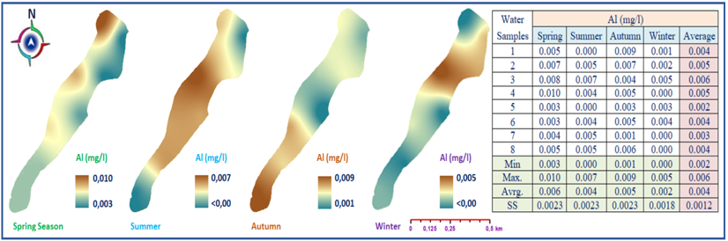

**Fig. 2.** GIS-based Spatial Modeling of Aluminum (Al)

In the water samples taken from the surface of Beşgöz Lake in the spring, the Al value was measured as a maximum of 0.01 mg/l. In the spring months, Al values were found to be higher in the northwestern part of the lake than in other parts of the lake. During the summer months, Al values were found to be higher in the middle parts of the lake compared to other parts. Al values were found to be 0.001-0.009 mg/l in the autumn months, and Al values were higher in the southwestern parts of the lake. In winter months, the highest Al value was determined as 0.005 mg/l. In this context, it was observed that the Al concentrations of Beşgöz Lake were well below the upper limit values given in Table 1.

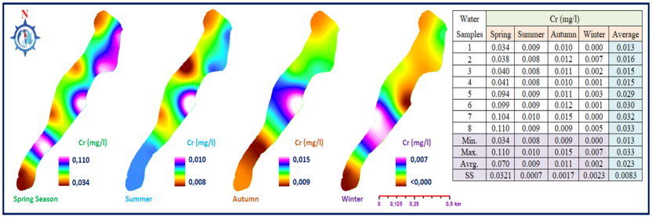

**Fig. 3.** GIS-based Spatial Modeling of Chromium (Cr)

When we look at the quality criteria according to the classes of Turkiye's intra-continental water resources in Table 2, it can be said that Beşgöz Lake falls into the first class, high-quality water class in terms of Al concentrations. Periodic spatial modeling of chromium concentrations of Beşgöz Lake is given in Figure 3.

Chromium values in water samples taken from the lake surface in spring varied between 0.034 and 0.110 mg/l. Cr values in water samples taken during the summer period ranged between 0.008 and 0.010 mg/l. Cr values in water samples taken in autumn varied between 0.009 and 0.015 mg/l. Especially in the Middle Eastern part of the lake, Cr values were detected at higher levels than in other surfaces.

The maximum Cr value in winter months was measured as 0.007 mg/l. According to the allowable upper limit value given in Table 1, the water quality of Beşgöz Lake was deemed appropriate in terms of Cr concentration.

According to the limit values given in Table 2, (slightly dirty water). The lake was classified as Class II water based on Cr concentrations. Periodic spatial modeling of iron (Fe) concentrations of Beşgöz Lake is given in Figure 4.

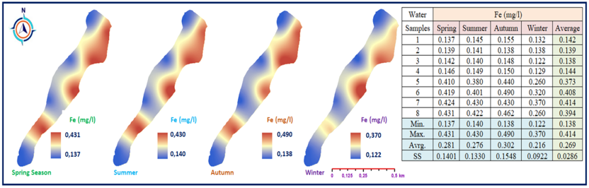

**Fig. 4.** GIS-based Spatial Modeling of Iron (Fe)

Fe values measured in water samples taken on the lake surface in spring varied between 0.137 and 0.431 mg/l. Especially Fe values in the eastern parts of the lake were determined to be higher than in other lake surface. Fe values in the summer period varied between 0.140 and 0.430 mg/l in the south of the lake. It was observed that Fe values in the water were higher in the western parts of the lake during the summer period than in other sampling points. In autumn, Fe concentration varies between 0.138 and 0.490 mg/l. During the winter period, Fe concentrations were distributed between 0.122 and 0.370 mg/l. It can be seen that the Fe concentrations of water samples taken especially in the winter period, are at lower levels compared to water samples taken in other periods, depending on seasonal conditions.

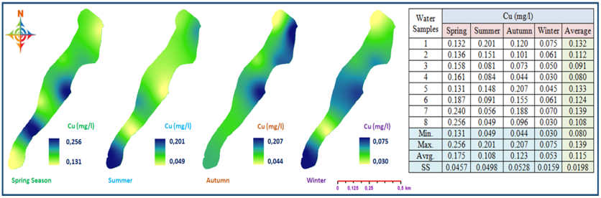

**Fig. 5.** GIS-based Spatial Modeling of Copper (Cu)

According to the limit values given in Table 1, it was observed that the Fe concentration of Beşgöz Lake was above the allowed limit values. According to the classification data given in Table 2, the lake has class I water quality and is at a level that can be included in the high-quality water category. Periodic spatial distribution modeling of Copper (Cu) concentrations in water samples taken from Beşgöz Lake is given in Figure 5.

A change between Cu: 0.13-0.256 mg/l was observed in the water samples taken from the surface of Beşgöz Lake in the spring. Cu concentrations, especially in the southwestern and the Middle Eastern parts of the lake surface, were distributed at relatively high levels compared to other parts. Cu in water samples taken during the summer period varied between 0.049 and 0.201 mg/l. The amount of Cu was higher in the south of the lake in the summer than in other parts. In water samples taken during the autumn period, Cu varies between 0.044 and 0.207 mg/l. Cu values in the northeastern and central parts of the lake were distributed at higher levels compared to other parts. In the winter period, Cu is distributed between 0.030 and 0.075 mg/l. When all periods were examined, it was seen that Cu concentrations varied between 0.025 and 0.207 mg/l. Considering the limit values in Table 1, it was determined that the Cu concentration in Beşgöz Lake was above the allowed limit values. According to the criteria given in Table 2, it falls into the class III water category (dirty water). Periodic spatial modeling of Ni concentrations in water samples taken from Beşgöz Lake is given in Figure 6.

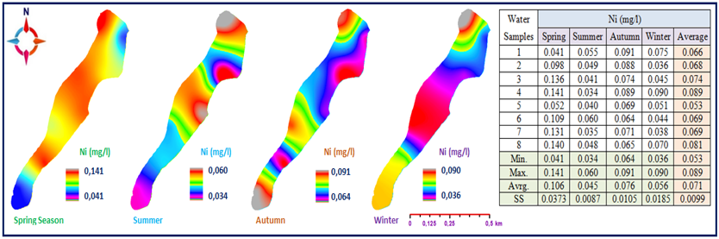

**Fig. 6.** GIS-based Spatial Modeling of Nickel (Ni)

Ni concentrations in water samples taken from Beşgöz Lake in spring varied between 0.041 and 0.141 mg/l. It was determined that Ni concentrations were higher in the middle parts of the lake compared to other parts. During the summer period, Ni varied between 0.034 and 0.060 mg/l. Ni concentrations were found to be higher than at other sampling points, especially in the central and northern parts of the lake during the summer period. Ni in the samples taken in autumn varies between 0.064 and 0.091 mg/l. Especially in the northern parts of the lake, Ni concentrations were distributed at higher levels than in other parts. In water samples taken during the winter period, Ni ranged between 0.036 and 0.090 mg/l. It was observed that Ni concentrations in water samples taken for all periods varied between 0.034 and 0.141 mg/l on average.

Taking into account the limit values given in Table 1, it was concluded that the Ni concentration in Beşgöz Lake was above the allowed limit values (0.02 mg/l). According to the classification of intra-continental water resources given in Table 2, Ni concentration in the lake is in the III class. It has been determined that it falls into the class water category (dirty water). Spatial modeling and distribution of Zn changes in Beşgöz Lake are given in Figure 7.

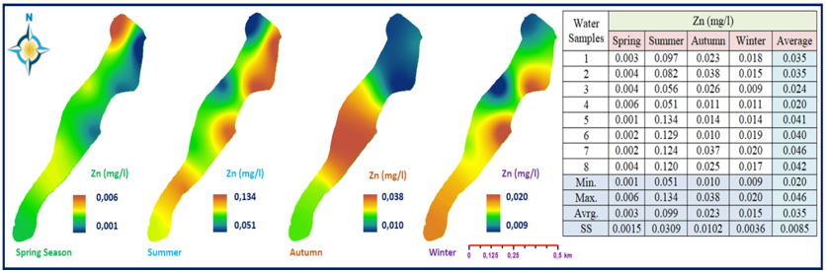

**Fig. 7.** GIS-based Spatial Modeling of Zinc (Zn)

Zn concentrations in water samples taken from Beşgöz Lake in spring varied between 0.001 and 0.006 mg/l. Elevated Zn concentrations were observed in the lake's northwestern region compared to other points where water samples were taken. Zn values in the summer period vary between 0.051 and 0.134 mg/l. During the summer period, a higher level of Zn concentration was observed in the northeastern parts of the lake compared to other sampling points. In autumn, Zn values varied between 0.010 and 0.038 mg/l. In the water samples taken during the autumn period, it was observed that the Zn value in the middle parts of the lake was lower than in the other parts. During the winter period, Zn concentration was distributed between 0.009 and 0.020 mg/l. It was observed that the Zn concentration in the water samples taken from the middle part of the lake was higher than the Zn concentration in the other parts. Generally speaking, it was revealed that the Zn concentration in Beşgöz Lake varied between 0.001 and 0.134 mg/l. According to the World Health Organization (WHO) criteria (Table 1), the Zn concentration was found to be below the upper allowable limit value (3 mg/l).

In terms of Zn concentration, it has been determined that the water quality of Beşgöz Lake falls into the first-class (high-quality water) category, in line with the criteria given in Table 2.

In a study conducted in Beyşehir Lake in Turkiye, heavy metals As, Cr, Cu, Ni, Zn, Pb, Cd, Hg, Fe, Al, and Mn were analyzed in water samples taken from the lake surface and sediment samples taken from the bottom sediments. The results obtained were analyzed spatially using IDW interpolation techniques in ArcGIS. As a result of the research, the average concentrations of heavy metals in the lake water were observed as   
Fe > Al > Mn > As > Zn > Ni > Pb > Cr > Cu > Hg > Cd.

The results obtained showed that the lake water was below the limit values in terms of heavy metals according to TS 266 and World Health Organization standards (Şener et al. 2023).

Multivariate statistical methods and Geographic Information Systems (GIS) technology are used effectively in water quality management (Arslan 2009). It is possible to find many studies in the literature on the spatial evaluation of water quality with GIS. In the studies carried out, different modeling techniques were used with the help of interpolation techniques in the GIS environment, and spatial analyses of water quality data were carried out (Ross & Tara 1993, Warwick & Haness 1994, Chen et al. 1997, Wang et al. 2005). In a study conducted in South Korea, water samples were taken from 118 different points to determine water quality in the Han River Basin. In these samples, temperature, pH, dissolved oxygen, biological oxygen demand, chemical oxygen demand, suspended solids, and total nitrogen parameters were examined.

The results obtained were modeled spatially in the GIS environment, and distribution maps for each parameter were produced (Chang 2008). In another study, water samples were taken from 14 different points along the Tigris River in Baghdad. Temperature, pH, electrical conductivity, total dissolved solids (TDS), turbidity, chlorophyll A, blue-green algae, and dissolved oxygen amounts were determined in the water samples taken. The results obtained were evaluated spatially with the help of GIS (Ahmed et al. 2023).

In another study, a study was carried out within the scope of spatial evaluation of water quality with GIS in two different lakes located in the Panchula region of India. In the research, 4 water samples were taken from different points in Lake 1, and water samples were taken from 3 different surfaces and 3 different depths (2, 3, and 4 m) in Lake 2. Temperature, dissolved oxygen, nitrate, and total phosphorus values were analyzed in the water samples taken. The obtained data were spatially modeled using the IDW interpolation method for both lake surfaces.

As a result of the study, quality changes on lake surfaces were obtained more easily and reliably with water quality surface models made with the help of GIS compared to traditional methods. In such studies, it has been concluded that modeling made in the GIS environment produces more reliable results (Vasistha & Ganguly 2022).

A study was conducted to determine water quality and pollution in the Little Akaki River of Ethiopia. For this purpose, 22 water samples were collected from the river. pH, EC, Temperature, dissolved oxygen, total solid matter, biological oxygen demand, chemical oxygen demand, heavy metals, Nitrate, Phosphate parameters were analyzed in the collected water samples. The determined values were spatially modeled using IDW interpolation techniques with the help of GIS, and a water quality change map for each parameter was created (Bushero et al. 2022).

In another research study, the water quality in the Brahmani River Basin in Odisha, India, was determined. To determine water quality, 5 different stations were established, and water samples were collected monthly. pH, temperature, dissolved oxygen, biological oxygen demand, electrical conductivity, total hardness, and CaCO3 parameters were analyzed in the collected water samples. The results obtained were evaluated spatially with the help of GIS using the IDW interpolation technique (Sarangi et al. 2023).

Water quality indicators were monitored between 2012 and 2016 using 13 sampling points in the Wadi El Bey basin of Tunisia. pH, temperature, biological oxygen demand, suspended solids, chemical oxygen demand, nitrate, phosphorus, and ammonium concentrations were analyzed in water samples. In the study, the examined parameters were evaluated spatially using the IDW interpolation method with the help of GIS. As a result of the study, the quality change in the river bed from which water samples were taken was revealed by map-based modeling (Khouni et al. 2021).

Research was conducted to evaluate the water quality in the water harvesting reservoir that provides drinking water, located in the central part of Nigeria. Water samples were taken from 5-10 m depths at 500 m-1 km intervals at 6 different points of the reservoir. pH, EC, dissolved oxygen, total dissolved solids,chemical oxygen demand, biological oxygen demand, turbidity, nitrate, Cl, Ca, Na, Fe, and K were analyzed in the water samples taken. The results were spatially analyzed using Geographic Information Systems and IDW interpolation techniques (Oseke et al. 2021).

As can be seen in the literature, spatial analyses made with GIS in water quality assessment studies reveal the spatial distribution of water quality change. The resulting spatial distribution models convey important information to decision-makers about the course and distribution of change.

4. Conclusions

This study was carried out in Beşgöz Lake, within the borders of Sarayönü district of Konya province, located in the Central Anatolia Region of Turkiye. Water samples were taken from the lake surface in 4 different periods. Al, Cr, Fe, Cu, Ni, and Zn analyses were determined in water samples taken from the lake surface using an ICP-MS device. The results obtained were modeled spatially with the help of the spline interpolation technique using the ArcGIS 10.3.1 program, one of the GIS software programs.

By spatially modeling the obtained results, the concentrations of the examined elements on the surface could be revealed. Spatial evaluation of the results obtained in such studies gives meaningful results regarding the distribution of concentration levels. Simply presenting information about laboratory results graphically may not produce meaningful results. However, spatial distribution models made in the GIS environment provide important information about the spatial distribution of water quality changes.

In this study conducted in Beşgöz Lake located in the Konya- Sarayönü district of Turkiye, some heavy metal concentrations in the water were examined periodically. Heavy metal concentration values obtained from laboratory results were also spatially modeled and analyzed in the GIS environment. Particularly, spatially examining water quality parameters in surface water resources and modeling the findings with GIS will provide important contributions to presenting the results more meaningfully.

*This study was financially supported by Selcuk University Scientific Research Coordinating Office   
(Project Number: 19401026) in Turkiye.*

References

Akköz, C., Küçüködük, M., Obalı, O., Öztürk, C., & Doğan, H. H. (2000). Beşgöz Gölü (Sarayönü/Konya) alg florası II: Epilitik ve epifitik algler. Selçuk Üniversitesi. *Fen Fakültesi Fen Dergisi*, *1*(16), 5-11. (in Turkish)

Akman, Y. (1982). Climats et Bioclimats, T. Mediterranees Turque. *Ecologia Mediterranea* VIII, 1,2, 73-87.

Alomary, A. A., & Belhadj, S. (2007). Determination of heavy metals (Cd, Cr, Cu, Fe, Ni, Pb, Zn) by ICP- OES and their speciation in Algerian Mediterranean Sea sediments after a five-stage sequential extraction procedure. *Environmental Monitoring and Assessment*, *135*, 265. https://doi.org/10.1007/s10661-007-9648-8

Anonymous (2018). TS EN ISO 5667-3 standard of heavy metal analyses. Turkish Standards Institute, Ankara, Turkiye

Anonymous (1998). European Standards for Drinking-Water, European Union (EC).   
https://environment.ec.europa.eu/topics/water/drinking-water_en

Anonymous (2004). Su Kirliliği Kontrolü Yönetmeliği, Başbakanlık Basımevi, Turkiye. (in Turkish)

Anonymous (2010). Arc GIS 10.3.1 software. ESRI Environmental System Research Institute, Redland, CA, USA

Anonymous (2005). Water intended for human consumption, In: Standards for Drinking Waters, TS266, Turkish Standards Institute, Ankara, Turkiye. (in Turkish)

Anonymous (2017). Guidelines for drinking-water quality. WHO Library Cataloguing-in-Publication data, Fourth Edition Incorporation The First Addendium

Anonymous (2008). National primary drinking water regulations related info. US Environmental Protection Agency (EPA) https://www.epa.gov/ground-water-and-drinking- water/national-primary-drinking-water-regulations,

Arslan, O. (2009). A GIS-Based Spatial-Multivariate Statistical Analysis of Water Quality Data in the Porsuk River, Turkey. *Water Quality Research Journal*, *44*(3), 279-293. https://doi.org/10.2166/wqrj.2009.029

Ahmed W., Mohammed, S., El-Shazly, A., & Morsy, S. (2023). Tigris River water surface quality monitoring using remote sensing data and GIS techniques. *The Egyptian Journal of Remote Sensing and Space Sciences*, *26*(2023), 816-825. https://doi.org/10.1016/j.ejrs.2023.09.001

Burgos-Aceves M. A., Cohen, A., Smith, Y., & Faggio, C. (2018). MicroRNAs and their role on fsh oxidative stress during xenobiotic environmental exposures. *Ecotoxicol Environ Saf*. *148*, 995-1000. https://doi.org/10.1016/j.ecoenv.2017.12.001

Bushero, D. M., Angello, Z. A., & Behailu, B. M. (2022). Evaluation of hydrochemistry and identification of pollution hotspots of little Akaki river using integrated water quality index and GIS. *Environmental Challenges*, *8*(2022), 100587. https://doi.org/10.1016/j.envc.2022.100587

Chang, H. (2008). Spatial Analysis of Water Quality Trends in The Han River Basin. *Water Research, South Korea*, *42*(2008), 3285-3304. https://doi.org/10.1016/j.watres.2008.04.006

Chen, C. H., Liaw, S. L., Wu, R. S., Chen, Q. L., & Chen, J. L. (1997). Development of a decision making theory and a decision support system for river basin water management. *Proc. Natl. Sci. Council A: Phys Sci Eng*., *21*, 389-409.

El-Agri A. M., Emam, M. A., Gaber, H. S., Hassan, E. A., & Hamdy, S. M. (2022). Integrated use of biomarkers to assess the impact of heavy metal pollution on Solea aegyptiaca fish in Lake Qarun. *Environmental Sciences Europe*, *34*(1), 74. https://doi.org/10.1186/s12302-022-00656-6

Esmaeili, A., Knox, O., Juhasz, A., & Wilson, S.C. (2022). Differential accumulation of polycyclic aromatic hydrocarbons (PAHs) in three earthworm ecotypes: implications for exposure assessment on historically contaminated soils. *Environ. Adv*., *7*, 100175. https://doi.org/10.1016/j.envadv.2022.100175

Gobi, N., Vaseeharan, B., Rekha, R., Vijayakumar, S., & Faggio, C. (2018). Bioaccumulation, cytotoxicity and oxidative stress of the acute expo sure selenium in Oreochromis mossambicus. *Ecotoxicol Environ Saf*., *162*, 147-159. https://doi.org/10.1016/j.ecoenv.2018.06.070

Hemmadi, V. (2017). A critical review on integrating multiple fish biomarkers as indicator of heavy metals contamination in aquatic ecosystem. *International Journal of Bioassays*, *6*(9), 5494-5506. https://doi.org/10.21746/ijbio.2017.9.5

Hou, H. S., & Andrews, H. C. (1978). Cubic splines for image interpolation and digital filtering. IEEE Trans. Acoust., Speech, *Signal Processing*, *26*(6), 508-517. https://doi.org/10.1109/TASSP.1978.1163154

Hummel, R. (1983). Sampling for spline reconstruction. *SIAM J. Appl. Math*., *43*, 278-288. https://doi.org/10.1137/0143019

Kaur, J., Sengupta, P., & Mukhopadhyay, S. (2022). Critical review of bioadsorption on modified cellulose and removal of divalent heavy metals (Cd, Pb, and Cu). *Ind. Eng. Chem. Res*., *61*(5), 1921-1954. https://doi.org/10.1021/acs.iecr.1c04583

Khouni, I., Louhichi, G., & Ghrabi. A. (2021). Use of GIS based Inverse Distance Weighted interpolation to assess surface water quality: Case of Wadi El Bey, Tunisia. *Environmental Technology & Innovation*, *24*(2021), 101892. https://doi.org/10.1016/j.eti.2021.101892

Lee, C. H. (1983). Restoring spline interpolation of CT images. *IEEE Trans. Med. Imaging*, *2*(3), 142-149. https://doi.org/10.1109/TMI.1983.4307628

Oseke, F. I., Anornu, G. K., Adjei, K. A., & Eduvie, M. O. (2021). Assessment of water quality using GIS tech niques and water quality index in reservoirs affected by water diversion. *Water-Energy Nexus*., *4*, 25-34. https://doi.org/10.1016/j.wen.2020.12.002

Rajeshkumar, S., Liu, Y., Zhang, X., Ravikumar, B., Bai, G., & X. Li. (2018). Studies on seasonal pollution of heavy metals in water, sediment, fsh and oyster from the Meiliang Bay of Taihu Lake in China. *Chemosphere*, *191*, 626-638. https://doi.org/10.1016/j.chemosphere.2017.10.078

Ross, M. A., & Tara, O. D. (1993). Integrated hydrologic modeling with geographic information systems. *Journal of Water Resources Planning and Management*, *119*(2), 129-140.   
https://doi.org/10.1061/(ASCE)0733-9496(1993)119:2(129)

Rinklebe, J., Antoniadis, V., Shaheen, S. M., Rosche, O., & Altermann, M. (2019). Health risk assessment of potentially toxic elements in soils along the Central Elbe River, Germany. *Environment International*, *126*, 76-88. https://doi.org/10.1016/j.envint.2019.02.011

Sarangi, P. P., Sabat, L., & Naik, B. (2023). Prediction and parametric evaluation of water quality on basin of River Brahmani by ANN and GIS. *materialstoday: PROCEEDINGS*. https://doi.org/10.1016/j.matpr.2023.06.041

Şener, E., Şener, Ş., & Bulut, C. (2023). Assessment of heavy metal pollution and quality in lake water and sediment by various index methods and GIS: A case study in Beysehir Lake, Turkey. *Marine Pollution Bulletin*, *192*(2023), 115101. https://doi.org/10.1016/j.marpolbul.2023.115101

Xu, M., Wang, R., Yang, X., & Yang, H. (2020). Spatial distribution and ecological risk assessment of heavy metal pollution in surface sediments from shallow lakes in East China. *Journal of Geochemical Exploration*, *213*, 106490. https://doi.org/10.1016/j.gexplo.2020.106490

Warwick, J.J., Haness, S.J. (1994). Efficacy of ARC/INFO GIS application to hydrologic modeling. *Journal of Water Resources Planning and Management*, *120*(3), 366-381.   
https://doi.org/10.1061/(ASCE)0733-9496(1994)120:3(366)

Wang, X., Homer, M., Dyerb, S., White-Hullb, C., & Changming, D. (2005). A river water quality model integrated with a web-based geographic information system. *J. Environ. Managemen*, *75*, 219-228. https://doi.org/10.1016/j.jenvman.2004.11.025

US NRC (National Research Council). (1989). *Biologic markers in reproductive toxicology*. The National Academies Press, DC. https://doi.org/10.17226/774

Vasistha, P., & Ganguly, R. (2022). Water quality assessment in two lakes of Panchkula, Haryana, using GIS: case study on seasonal and depth wise variations. *Environmental Science and Pollution Research*, *29*, 43212-43236. https://doi.org/10.1007/s11356-022-18635-y

Zateroglu, M. T. (2021a). Assessment of the effects of air pollution parameters on sunshine duration in six cities in Turkey. *Fresenius Environmental Bulletin*, *30*(02A), 2251-2269.

Zateroglu, M. T. (2021b). The Role of climate factors on air pollutants (PM10 and SO2). *Fresenius Environ mental Bulletin*, *30*(11), 12029-12036.

Zateroglu, M. T. (2022). Modelling The Air Quality Index For Bolu, Turkey. *Carpathian Journal of Earth and Environmental Sciences*, *17*(1), 119-130. https://doi.org/10.26471/cjees/2022/017/206

Zateroglu, M. T. (2024). Forecasting particulate matter concentrations by combining statistical models. *Journal of King Saud University – Science*, *36*(3), 103090. https://doi.org/10.1016/j.jksus.2024.103090

Zerizghi, T., Yang, Y., Wang, W., Zhou, Y., Zhang, J., & Yi, Y. (2020). Ecological risk assessment of heavy metal concentrations in sediment and fish of a shallow lake: a case study of Baiyangdian Lake, North China. *Environmental Monitoring and Assessment*, *192*(154). https://doi.org/10.1007/s10661-020-8078-8