
 | Rocznik Ochrona Środowiska
 | Volume 27 | Year 2025 ISSN 2720-7501 | pp. 448-459
 | https://doi.org/10.54740/ros.2025.037 open access
 | Received: June 2025 Accepted: July 2025 Published: August 2025
Application of Unmanned Aerial Vehicles and Microsimulation Optimization to Conduct Traffic Mobility Surveys: Case Study from the South Bohemia Region
Patrik Gross¹, Ondrej Stopka^{2*}, Ladislav Bartuška³, Jiří Hanzl⁴, Vladimír Ľupták⁵
¹Department of Transport and Logistics, Institute of Technology and Business in České Budějovice, Czech Republic https://orcid.org/0000-0002-3268-2232
²Department of Transport and Logistics, Institute of Technology and Business in České Budějovice, Czech Republic https://orcid.org/0000-0002-0932-4381
³Department of Transport and Logistics, Institute of Technology and Business in České Budějovice, Czech Republic https://orcid.org/0000-0003-3980-0729
⁴Department of Transport and Logistics, Institute of Technology and Business in České Budějovice, Czech Republic https://orcid.org/0000-0001-5121-9596
⁵Department of Transport and Logistics, Institute of Technology and Business in České Budějovice, Czech Republic https://orcid.org/0000-0001-7550-5714
*corresponding author's e-mail: stopka@mail.vstecb.cz
Abstract: The study explores the potential use of unmanned aerial vehicles (UAVs) for conducting road traffic surveys, developing, and optimizing a simulation model of a specific intersection in the South Bohemia region to enhance its traffic throughput. Input data on traffic intensity was retrieved by implementing a UAV and processed using the DataFromSky application. The spatial distribution of the intersection was created based on orthophoto images, whereby the AnyLogic software was applied to model traffic mobility behavior. Subsequently, an optimization experiment was conducted, focusing on adjusting the intervals of individual traffic light phases to minimize the mean transit time. Thefindings indicate that the optimization resulted in a reduction in the mean transit time from 48 to 28 seconds, representing a 41.6% streamlining. The study confirms that applying unmanned aerial vehicles and microsimulation optimization tools for mobility surveys and effective urban traffic management is highly beneficial. At the same time, shortening the time when vehicles pass through an intersection is also an aspect of environmental protection, as vehicles spend less time idling and emit fewer pollutants into the environment. In light of the above, there is less congestion at the intersection as well, which results in a positive environmental impact – the lower the traffic intensity at the intersection, the lower the emission of CO₂ and NO_{x}.
Keywords: mobility, environment, traffic survey, unmanned aerial vehicle, microsimulation, South Bohemia region
1. Introduction and Literature Review
Unmanned aerial vehicles (UAVs) represent a technological innovation that has become increasingly popular in recent years. Its application in the area of traffic surveys offers significant potential to enhance the efficiency of conducting studies, data collection, and evaluation of the collected data. This rapid evolution and ongoing technological advancement enable the acquisition of data that would otherwise be difficult or virtually impossible to obtain through conventional methods, such as ground-based measurement and manual data collection. The integration of unmanned aerial vehicles in traffic surveys offers several key advantages (Jurkus et al. 2025). In addition to significantly accelerating the entire data collection process, it also reduces operational costs by eliminating the need for large on-site teams or the use of sophisticated and costly technologies (Adamec et al. 2020).
UAVs, commonly referred to as drones, are typically equipped with systems capable of recording visual information and providing high-quality, reliable data on traffic flow, road capacity, driver behavior (Chamier-Gliszczynski 2017), and other essential aspects of transportation (Ahmed Amodu et al. 2024). This makes drones a valuable tool for analyzing and optimizing transport infrastructure. The primary disadvantage of applying this technology is its susceptibility to adverse weather conditions and limited operational endurance. Moreover, compliance with applicable regulatory frameworks and operational safety is necessary (Zhang et al. 2022).
The use of UAVs in transportation engineering has gained significant traction in recent years. Their ability to capture wide-area, high-resolution aerial imagery and video provides valuable data on traffic flow, vehicle classification, speed, origin-destination patterns (Kanistras et al. 2013), and traveler behavior (Chamier-Gliszczynski & Bohdal 2016). Applications such as DataFromSky facilitate the processing of this aerial data, enabling the extraction of accurate traffic intensity information, which is crucial for building robust simulation models (Gheorghe & Filip 2022).
Microsimulation software, such as AnyLogic, has become a powerful tool for modeling and analyzing complex traffic systems. These platforms enable the creation of detailed virtual environments, where the behavior of individual vehicles can be simulated based on real-world data (Borshchev 2013, Turek et al. 2024). Optimization experiments within these simulations enable the evaluation of different traffic management strategies, such as adjusting signal timings, to identify solutions that improve key performance indicators, including mean transit time (Schaffland et al. 2024).
Previous research has demonstrated the effectiveness of simulation-based optimization for improving traffic signal control (Kampf et al. 2022). Some studies have shown that adjusting signal phases and timings based on simulated traffic flow can lead to significant reductions in congestion and travel times, as demonstrated by Hewage and Ruwanpura (2004). The integration of real-world data, particularly accurate traffic counts and turning movements, is critical for the validity and applicability of these simulation models.
The increasing complexities of urban traffic demand necessitate innovative and efficient methods for data retrieval and traffic management. This study explores the synergistic application of Unmanned Aerial Vehicles (UAVs) for road traffic surveys and microsimulation optimization to enhance traffic throughput at intersections. This approach addresses limitations associated with traditional ground-based surveys and offers a flexible and cost-effective alternative for acquiring detailed traffic data (Colomina & Molina 2014).
This study builds upon this existing body of knowledge by combining the advanced data acquisition capabilities of UAVs with the analytical power of microsimulation. By utilizing UAV-derived traffic intensity data processed through applications such as DataFromSky to build and calibrate an AnyLogic simulation model, the research investigates the optimization of traffic light phases at a specific intersection. This aligns with the broader trend in transportation engineering towards leveraging advanced technologies for data-driven decision-making and the development of more efficient and sustainable transportation systems (Kota et al. 2025, Woźniak et al. 2015, Woźniak et al. 2016).
In line with the aforementioned, the general objective of this article is to address the issue of how advanced technologies can contribute to improving transport infrastructure and making traffic and transport more efficient, not only in cities. It is also worth emphasizing that, given the fact that vehicles spend less time at the intersection and emit fewer pollutants into the environment, reducing the time vehicles spend passing through an intersection is an aspect of environmental protection. Additionally, lower congestion at an intersection inherently benefits the environment by reducing the emission of carbon dioxide and nitrogen oxides due to decreased traffic intensity (Samad et al. 2022).
2. Data and Methods
For the implementation of the traffic survey using unmanned aerial vehicles, a suitable location was initially sought that met both the specific requirements of the case study and the operational safety standards for UAV deployment. The chosen segment needed to exhibit a sufficiently high traffic volume while allowing the UAV to operate at a safe distance from the road, ensuring flight safety without posing a risk for road users. Simultaneously, it was necessary to determine an optimal flight altitude to meet the technical specifications of the data extraction tool – the DataFromSky (DFS) application, particularly concerning video quality and the required resolution for subsequent analysis of the recording (Aron & Florin 2024, Sha et al. 2023).
Following the selection of the intersection, the timing of the survey was determined based on traffic intensity. The data collection was scheduled for peak traffic hours, which is a key prerequisite for obtaining a larger number of vehicle passes and a better evaluation of road user behavior in that section (Haberka & Jurecki 2024).
Next, aerial video footage was captured using a UAV, which was then processed through the DFS application. The application utilized advanced machine learning mechanisms to evaluate the video footage and determine vehicle counts, directional flows, and additional metrics, including average speed, waiting times, and safety indicators such as the number of risky interactions or occurrences of hard braking events, based on predefined parameters. The obtained data, including vehicle counts and movement trajectories, were then imported into the AnyLogic simulation tool to conduct a microsimulation of the traffic dynamics at the selected intersection (Su et al. 2024).

3. Obtained Results
3.1. DataFromSky
The DataFromSky (DFS) application is a specialized tool for traffic analysis, advanced data interpretation, and visualization of data collected through various types of camera systems. This application utilizes machine learning methods and artificial intelligence to analyze traffic, enabling high-precision analysis with considerable efficiency. Using this application, it is possible to extract traffic volume data across the entire monitored section, individual segments of the road, or for designated vehicle categories, offering classification capabilities for up to ten distinct object classes. Moreover, it enables the performance of advanced analysis of passing vehicle behavior, such as trajectory tracking of individual vehicles and comprehensive safety assessment. Key indicators in these analyses include heavy braking (HV), time to collision (TTC), and post-encroachment time (PET), as well as other dangerous behaviors, such as speeding or unauthorized entry into restricted road segments (Adamec et al. 2020).
The application is available in two basic versions, "AERIAL" and "LIGHT". "AERIAL" is designed for analyzing top-down (nadir, TOP-DOWN) footage typically captured by drones or other aerial devices. The "LIGHT" version is intended for processing recordings obtained from handheld cameras or cameras mounted on tripods (Gabrišová & Koman 2025). For this study, the AERIAL version was used, which, upon inputting global coordinates, enables the measurement of distance, speed, and acceleration of tracked objects in real-world units, namely meters, kilometers per hour, and meters per second (Paulsen 2020).
3.1.1. Trajectories
The trajectory analysis feature allows for the identification and tracking of individual vehicle paths. The application automatically backtracks the video to the point at which the selected vehicle first enters the frame, enabling precise trajectory visualization and evaluation (see Fig. 1).

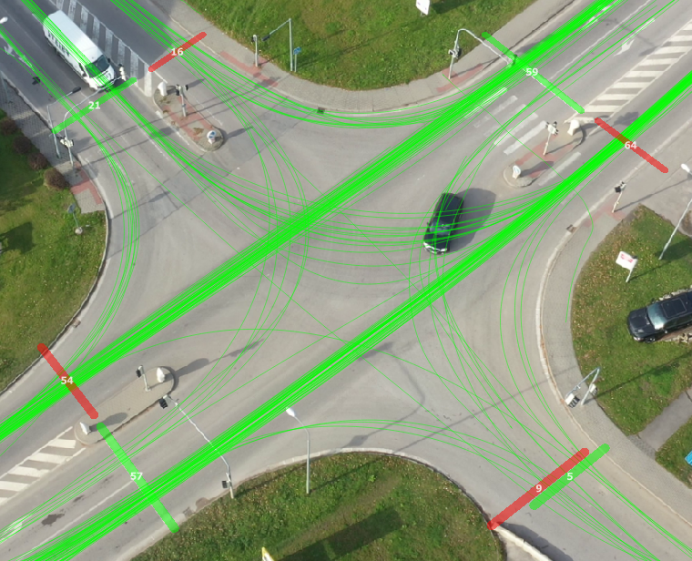
Fig. 1. Visualization of all detected trajectories at the monitored intersection using the DataFromSky application. Source: authors

Figure 2 displays the speed and acceleration graph for a specific object, object No. 27, a freight vehicle. The vertical green and red lines indicate the moment when the vehicle entered (green) and exited (red) the intersection.

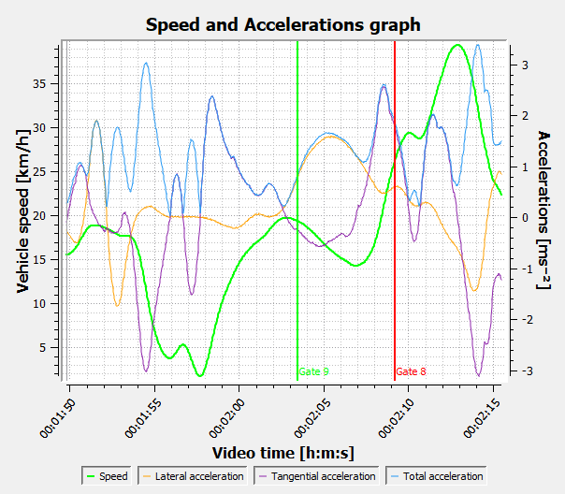
Fig. 2. Speed and acceleration graph for a specific object using the DataFromSky application. Source: authors

Figure 3 below shows the trajectories of all objects, color-coded according to their direction of movement.

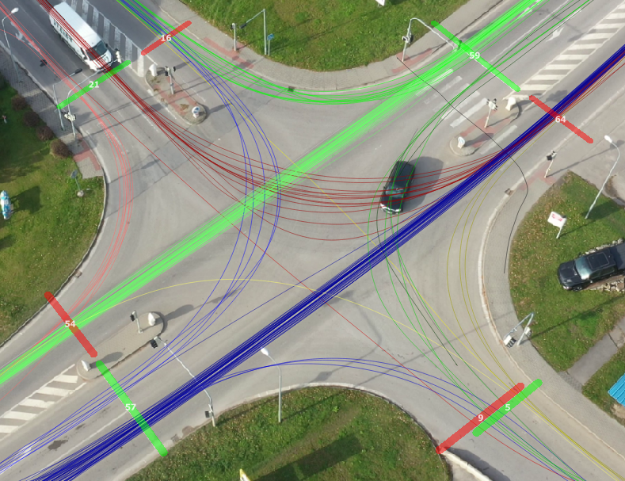
Fig. 3. All detected trajectories, color-coded according to their direction of movement using the DataFromSky application. Source: authors
3.1.2. Flow Graph
Figure 4 below displays a Flow Graph, illustrating the vehicle count at a specific time of the footage (green), along with a comparison of instantaneous traffic intensities on the two arms of the intersection with the highest measured traffic volume.

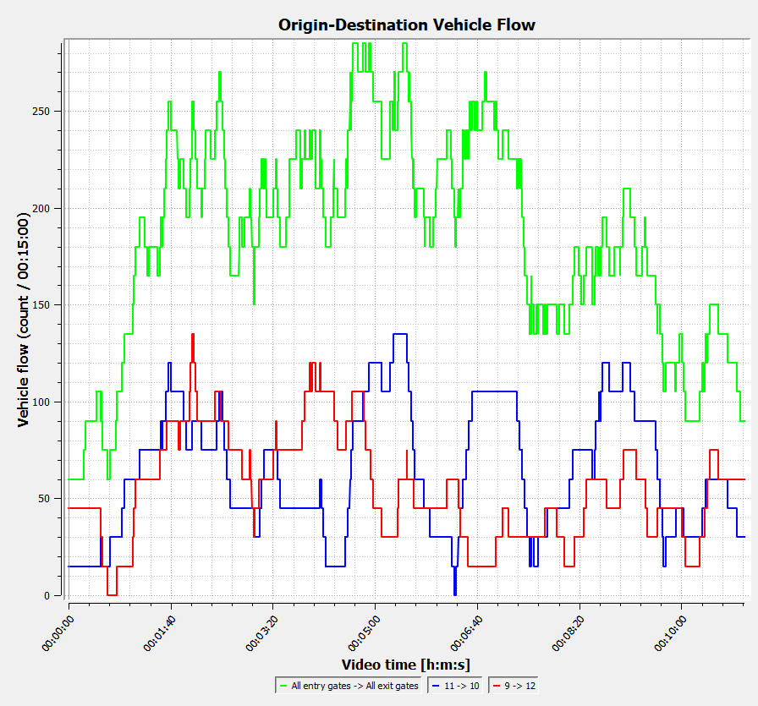
Fig. 4. Flow graph of the monitored intersection generated using the DataFromSky application. Source: authors
3.1.3. Traffic Intensity Pentlogram (Traffic Flow Diagram)
A pentlogram is a specialized type of traffic engineering diagram used to visualize traffic intensity in specific directions. It takes the form of a line diagram based on traffic survey data. The traffic flow diagram in Figure 5 provides a graphical representation of the recorded traffic volumes at the intersection being analyzed. It enables a quick assessment of the load on each arm of the intersection and helps identify the dominant traffic flows. In this case, the two primary-through movements are highlighted in dark blue and light green (Jiang et al. 2024).

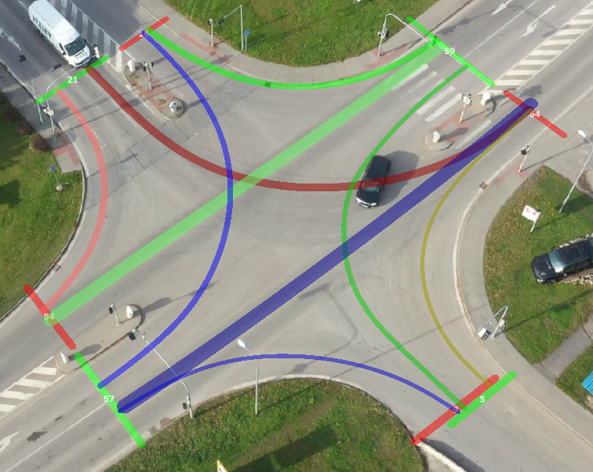
Fig. 5. Traffic flow diagram showing the intensity at the monitored intersection using the DataFromSky application. Source: authors
Table 1 below shows the Origin-Destination Statistics Matrix, displaying the average travel times for individual sections of the monitored intersection, i.e., the average time it takes a vehicle to pass between individual gates.

Table 1. Origin-Destination Statistics Matrix – Average Time. Source: authors
 | Exit Gate 1 | Exit Gate 2 | Exit Gate 3 | Exit Gate 4
Entry Gate 1 | --- | 00:07.194 | 00:03.832 | 00:03.670
Entry Gate 2 | 00:05.118 | --- | 00:03.388 | 00:06.039
Entry Gate 3 | 00:07.381 | 00:03.455 | --- | 00:03.737
Entry Gate 4 | 00:05.205 | 00:04.660 | 00:04.204 | ---
3.1.4. Visualization of Average Speed
For a more detailed intersection analysis, average speed visualization can be used to highlight sections with higher speeds. In this visualization, the primary traffic stream, with a significantly higher volume, is clearly identifiable (see Fig. 6). The average speed in this stream was 48 km/h.

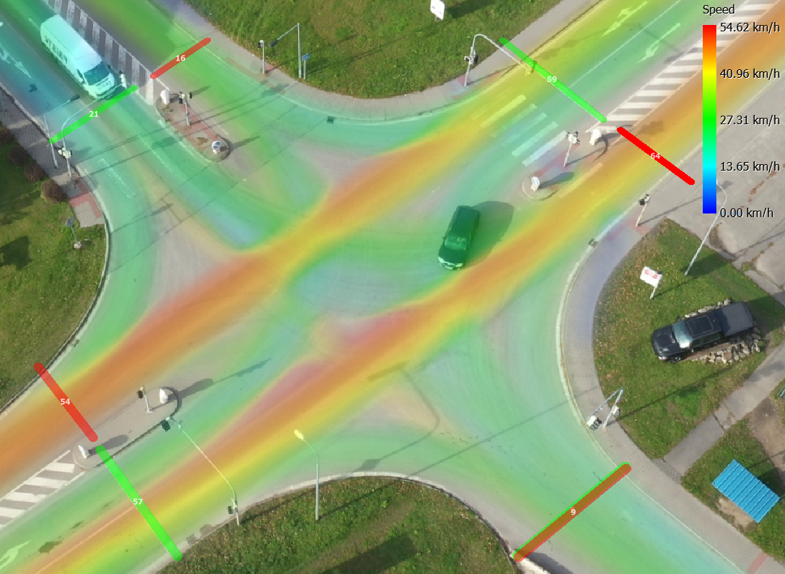
Fig. 6. Visualization of average speed – heat map using the DataFromSky application. Source: authors

Figure 7 presents a different form of average speed visualization known as a grid map. This visualization enables displaying the average value for each grid cell, with the cell size adjustable to meet the specific requirements of the analysis.
Figure 8 is a visualization of the average density of objects using the heat map method. In this visualization, the main route with significantly higher traffic intensity is clearly visible.

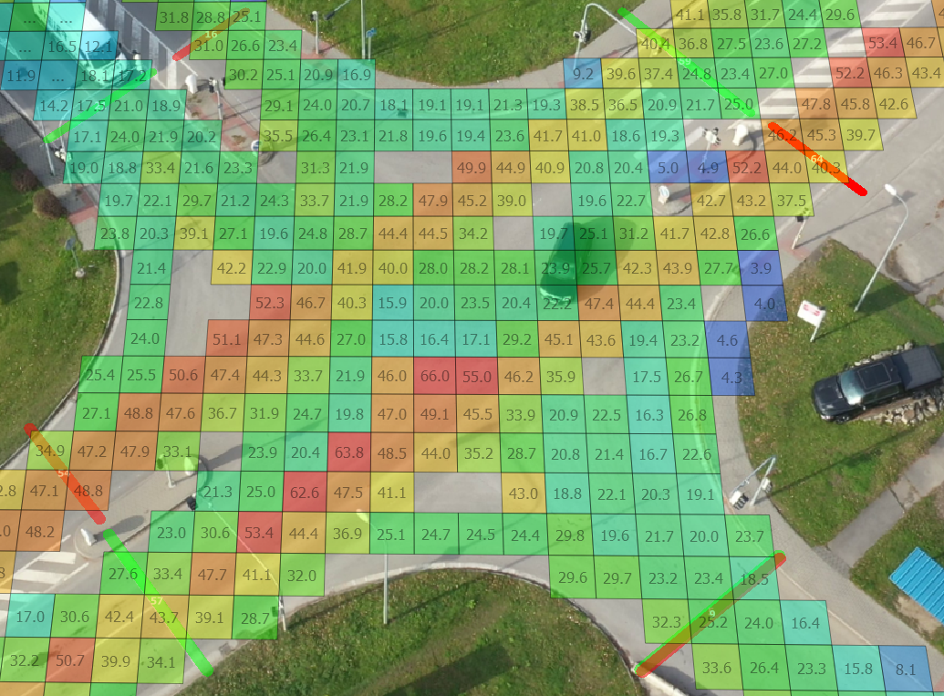
Fig. 7. Average speed visualization – grid map using the DataFromSky application. Source: authors

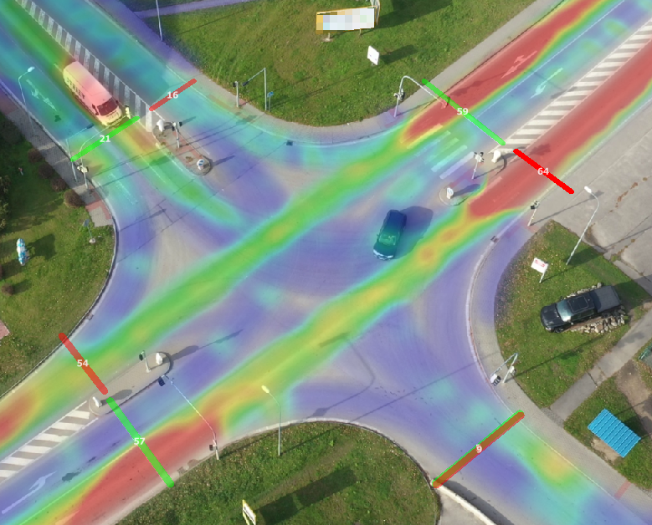
Fig. 8. Visualization of average object density – heat map using DataFromSky application. Source: authors
3.2. Simulation in the AnyLogic program
AnyLogic is a multimethod simulation modeling tool that supports agent-based, discrete-event, and system dynamics simulation methodologies. The software contains libraries specifically designed for simulating traffic scenarios, as well as tools for creating optimization experiments based on defined parameters.
- Graphical editor – workspace for creating and editing graphical diagrams of agents and experiments.
- Project view – provides access to AnyLogic models currently available in the workspace, allowing for easy navigation through the project tree.
- Palette view – contains a categorized list of model elements.
- Properties view – enables displaying and editing of the properties of the currently selected model components.
In this study, the AnyLogic program was used to create a microsimulation of the monitored intersection, aiming to optimize each phase of the traffic signal.
4. Discussion
As the base layer for creating the microsimulation of the observed intersection, an orthophoto image from Google Maps was used. Subsequently, the spatial layout of the simulation was constructed based on this image, and the movement logic for each agent was developed accordingly (Liubyi et al. 2025). The actual duration of each traffic light phase was measured on-site, and the vehicle counts were obtained using the DFS application (see Fig. 9).

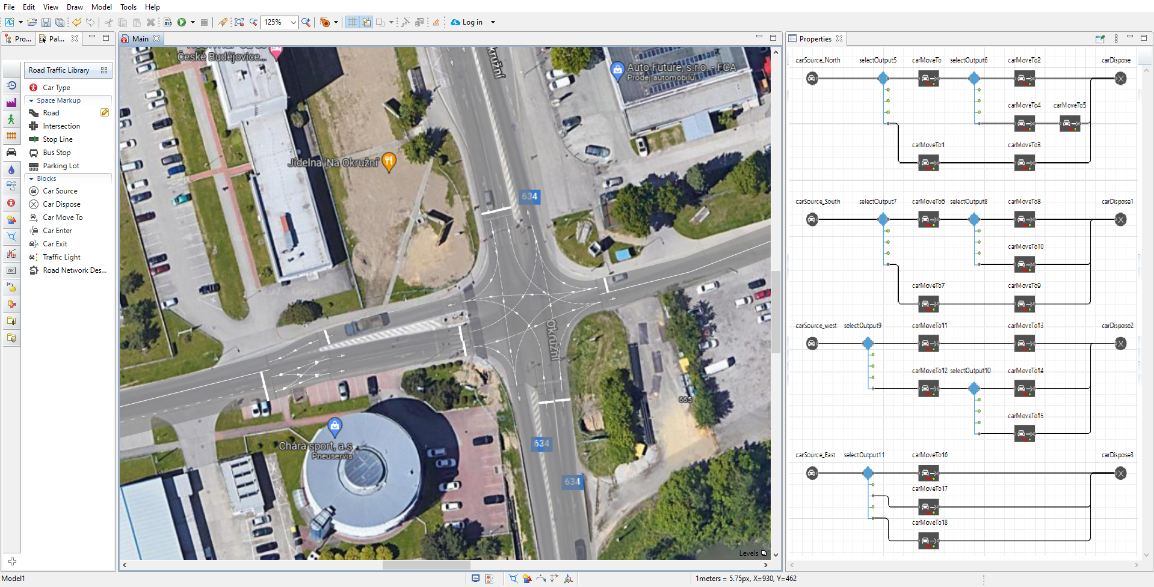
Fig. 9. Spatial layout of the simulation and movement logic of individual agents. Source: authors

After setting the basic parameters of microsimulation, an experiment in the AnyLogic program was conducted to determine the average time spent in the simulation for all agents from all directions. The simulation was based on the initial data on vehicle counts and the traffic light phases. The selected key indicator of intersection throughput was the average value of the TimeInModel parameter. This value represents the average time each agent (i.e., vehicle in this case) spent in the model, from entering the simulation to exiting it. In other words, it reflects the average travel time across the entire simulated section. Subsequently, a series of simulations was performed in which the number of vehicles ranged from 30% to 200% of the initial value. These simulations aimed to determine how the average time spent in the model changes with different traffic volumes. This value served as a baseline throughput benchmark for further optimization. The range from 30% to 200% was chosen, given that traffic volumes below 30% were so low that they had no meaningful impact on the optimization experiment outcome, while volumes above 200% rendered the section under investigation blocked due to excessive traffic congestion. Figure 10 presents a graph illustrating the average time spent in the simulation in relation to the percentage of the measured traffic volume at the monitored intersection.

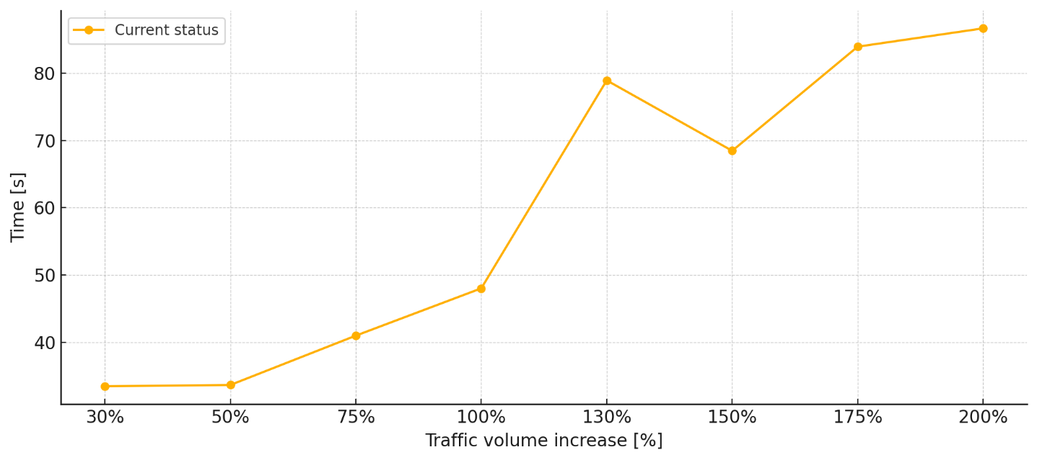
Fig. 10. Average time spent in the simulation at a given % of measured traffic volume. Source: authors

After obtaining the actual values, an optimization experiment was performed to minimize the average time spent by the agents in the simulation. The experiment setup involved setting parameters for individual traffic light phases and incorporating these parameters into the optimization experiment to minimize the average time spent in the simulation when adjusting these parameters. After launching the experiment, the program performed at least 500 iterations, during which it adjusted the length of each traffic light phase according to predefined steps to find the most optimal configuration. Once the set number of iterations was performed, the value of the parameters was entered as a duration in the simulation, which was then run to verify the results and calculate the average time spent in the simulation. Subsequently, the optimization experiment is run for each multiple of the measured intensity separately, and the simulation is rerun for the resulting parameter values. The average time spent in the simulation is then determined.
The chart in Figure 11 compares the average time spent in the simulation for each percentage of the measured intensity before and after optimization. The average time spent in the simulation before optimization was 48 seconds, while after optimization, it was reduced to 28 seconds. Based on the obtained data, it is possible to assess in detail the impact of changes in traffic volume and traffic light phase optimization on intersection throughput, providing valuable insights for improving traffic infrastructure.

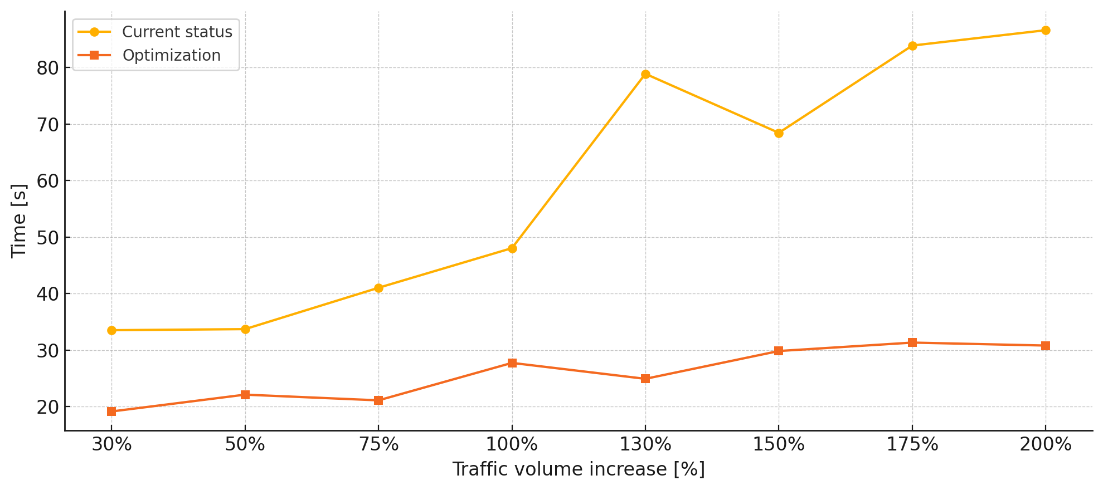
Fig. 11. Comparison of the average time spent in the simulation at a given percentage of measured traffic volume before and after optimization. Source: authors

5. Conclusion
Based on data obtained from a traffic survey using unmanned aerial vehicles, which enhances data collection efficiency and reduces staffing requirements for measurements in the field of traffic engineering, a microsimulation of a specific intersection was performed using the AnyLogic simulation program. The research included an optimization experiment aimed at adjusting the phases of the traffic lights to achieve more efficient traffic control, as well as modeling of urban logistics (Chamier-Gliszczynski 2016a). Based on the optimization experiment, the average time required to pass the monitored section of the simulated communication was reduced from 48 seconds before the optimization to 28 seconds after the optimization, resulting in an average time savings of 41.6%.
It is also important to consider the environmental benefits associated with reduced vehicle dwell time at intersections. By minimizing the time vehicles spend traversing an intersection, pollutant emissions are decreased. Moreover, the alleviation of congestion at the intersection leads to a demonstrably positive environmental impact, whereby lower traffic intensity directly corresponds to reduced emissions of carbon dioxide and nitrogen oxides.
Whilst the conducted research yielded promising findings, certain limitations as follows should be acknowledged:
- The optimization was executed on a single intersection; therefore, the results obtained may not be directly transferable or generalizable to other types of intersections with different geometric layouts, traffic volumes, or traffic patterns.
- The optimization was carried out within a simulation environment; thus, the accuracy of the findings is dependent on the precision of the simulation model, including the accuracy of the input data (traffic volumes, vehicle behavior) derived from the UAV survey and the calibration of the simulated traffic model. Real-world implementation may encounter unforeseen factors not fully captured in the simulation.
- The simulation conducted focused particularly on adjusting traffic signal phases. Other potential optimization parameters, such as cycle length, offsets between adjacent signals (if applicable in a network), or minor geometric modifications to the intersection, were not explored.
- The simulation likely operated under a specific traffic demand scenario captured by the UAV survey. Fluctuations in traffic volume and patterns throughout the day or under different conditions (e.g., peak hours, weekends) were not explicitly addressed in this specific optimization experiment.
- Whereas UAVs offer advantages, the accuracy of the traffic data extracted from aerial imagery and the efficiency of the data processing pipeline can affect the reliability of the simulation inputs. Potential errors in vehicle detection, classification, or speed estimation could impact the optimization results.

To build upon the outcomes of this study and address its limitations, the ensuing points for further research are suggested:
- Application of the developed methodology of UAV-based data retrieval and microsimulation optimization to a variety of intersection types (e.g., roundabouts, multi-leg intersections) and under different traffic conditions to evaluate its wider applicability and effectiveness.
- Implementation of the optimized signal timings in the real-world intersection and conducting field studies to validate the simulation results and quantify the actual improvements in traffic flow and travel times.
- Examination of multi-objective optimization experiments, considering both travel time reduction and other performance indicators, such as queue lengths, number of stops, fuel consumption, and emissions.
- Investigation of the potential of integrating real-time traffic data from UAVs or other sensors with adaptive traffic signal control algorithms within the microsimulation environment to optimize signal timings dynamically in response to fluctuating traffic demand.
- Examination of the potential impact of UAVs on intersection performance and the effectiveness of optimized signal timings in a mixed traffic environment through simulation studies.
- Further development and enhancement of the automated data processing techniques for UAV-captured traffic data to improve accuracy, reduce processing time, and facilitate seamless integration with simulation software.
- Execution of the comprehensive economic and environmental impact assessment of implementing UAV-based traffic data retrieval and simulation-optimized signal timings on a larger scale, when taking into account factors such as cost savings, reduced fuel consumption, and decreased emissions.
The manuscript is supported by the INTER-EXCELLENCE program, sub-program INTER-ACTION,
registration number: LUABA24085 "Analysis and optimization of Czech-German worker mobilities
to support cross-border cooperation (Locomotion)."
References
Adamec, V., Herman, D., Schullerova, B. & Urbanek, M. (2020). Modelling of Traffic Load by the DataFromSky System in the Smart City Concept. In: Lopes, N. (eds) Smart Governance for Cities: Perspectives and Experiences. EAI/Springer Innovations in Communication and Computing. Springer, Cham.
https://doi.org/10.1007/978-3-030-22070-9_7
Ahmed Amodu, O., Jarray, C., Azlina Raja Mahmood, R., Althumali, H. D., Ali Bukar, U., Nordin, R., Abdullah, N. F. & Cong Luong, N. (2024). Deep Reinforcement Learning for AoI Minimization in UAV-Aided Data Collection for WSN and IoT. Applications: A Survey. IEEE Access, 12, 108000-108040.
https://doi.org/10.1109/ACCESS.2024.3425497
Aron, C. & Florin, M. (2024). Current Approaches in Traffic Lane Detection: a minireview. The Archives of Automotive Engineering – Archiwum Motoryzacji, 104(2), 19-47. https://doi.org/10.14669/AM/190157
Borshchev, A. (2013). The Big Book of Simulation Modeling: Multimethod Modeling with AnyLogic 6. AnyLogic North America. Lightning Source Inc. 612 p. ISBN 978-0989573177
Chamier-Gliszczynski, N. & Bohdal, T. (2016). Mobility in urban areas in environment protection. Rocznik Ochrona Srodowiska, 18(1), 387-399.
Chamier-Gliszczynski, N. (2016a). City logistics – sustainable urban mobility. CLC 2015: Carpathian Logistics Congress – Conference Proceedings, 263-268.
Chamier-Gliszczynski, N. (2017). Travelling cost an assessment criterion of the model of city logistics. CLC 2016: Carpathian Logistics Congress – Conference Proceedings, 287-292.
Colomina, I. & Molina, P. (2014). Unmanned aerial systems for photogrammetry and remote sensing: A review. ISPRS Journal of Photogrammetry and Remote Sensing, 92, 79-97. https://doi.org/10.1016/j.isprsjprs.2014.02.013
Gabrišová, I. & Koman, G. (2025). Employer Branding and Brand Building in the Aviation Industry. LOGI – Scientific Journal on Transport and Logistics, 16(1), 1-12. https://doi.org/10.2478/logi-2025-0001
Gheorghe, C. & Filip, N. (2022). Road Traffic Analysis Using Unmanned Aerial Vehicle and Image Processing Algorithms. 2022 IEEE International Conference on Automation, Quality and Testing, Robotics (AQTR), 1-5, 19-21 May 2022, Cluj-Napoca, Romania. https://doi.org/10.1109/AQTR55203.2022.9802058
Haberka, K. W. & Jurecki, R. S. (2024). Drivers' use of different types of multimedia devices while driving - a survey study. The Archives of Automotive Engineering – Archiwum Motoryzacji, 103(1), 5-20. https://doi.org/10.14669/AM/182835
Hewage, K. N. & Ruwanpura, J. Y. (2004). Optimization of traffic signal light timing using simulation. Proceedings of the 2004 Winter Simulation Conference, 2, 1428-1433. https://doi.org/10.1109/WSC.2004.1371482
Jiang, X., Sengupta, R., Demmel, J. & Williams, S. (2024). Large scale multi-GPU based parallel traffic simulation for accelerated traffic assignment and propagation. Transportation Research Part C: Emerging Technologies, 169, 104873. https://doi.org/10.1016/j.trc.2024.104873
Jurkus, E., Taminskas, J., Povilanskas, R., Urbis, A., Mėžinė, J. & Urbis, D. (2025). Joining Application of Unmanned Aerial Vehicle Imagery with GIS for Monitoring of Soft Cliff Linear Habitats. Journal of Marine Science and Engineering, 13(1), 80. https://doi.org/10.3390/jmse13010080
Kampf, R., Soviar, J., Bartuška, L. & Kubina, M. (2022). Creation of SW for Controlling Unmanned Aerial Systems. LOGI – Scientific Journal on Transport and Logistics, 13(1), 198-209. https://doi.org/10.2478/logi-2022-0018
Kanistras, K., Martins, G., Rutherford, M. J. & Valavanis, K. P. (2013). A survey of unmanned aerial vehicles (UAVs) for traffic monitoring. 2013 International Conference on Unmanned Aircraft Systems (ICUAS), 221-234, 28-31 May 2013, Atlanta, GA, USA. https://doi.org/10.1109/ICUAS.2013.6564694
Kota, R.B., Pallela, S.S. & Lalam, G. (2025). Capacity analysis at urban uncontrolled intersections under mixed traffic conditions: a case study in Warangal city. Scientific Journal of Silesian University of Technology. Series Transport, 126, 97-116. https://doi.org/10.20858/sjsutst.2025.126.6
Liubyi, Y., Horbachov, P., Kovtsur, K., Muzylyov, D. & Ivanov, V. (2025). Simulation of the advance time of permissive traffic signal activation following the coordination plan on arterials: plan of the experiment. Scientific Journal of Silesian University of Technology. Series Transport, 126, 117-128. https://doi.org/10.20858/sjsutst.2025.126.7
Paulsen, M. (2020). Mesoscopic Simulation of Multi-Modal Urban Traffic. Department of Technology, Management and Economics, Technical University of Denmark. DTU Library. Ph.D. thesis, 154 p.
Samad, A., Alvarez Florez, D., Chourdakis, I. & Vogt, U. (2022). Concept of Using an Unmanned Aerial Vehicle (UAV) for 3D Investigation of Air Quality in the Atmosphere—Example of Measurements Near a Roadside. Atmosphere, 13(5), 663. https://doi.org/10.3390/atmos13050663
Schaffland, A., Nelson, J. & Schoning, J. (2024). Simulating Traffic Networks: Driving SUMO towards digital twins. SUMO Conference Proceedings, 5, 113-125; 13-15 May 2024, Berlin, Germany. https://doi.org/10.52825/scp.v5i.1105
Sha, D., Gao, J., Yang, D., Zuo, F. & Ozbay, K. (2023). Calibrating stochastic traffic simulation models for safety and operational measures based on vehicle conflict distributions obtained from aerial and traffic camera videos. Accident; analysis and prevention, 179, 106878. https://doi.org/10.1016/j.aap.2022.106878
Su, Y., Ghaderi, H. & Dia, H. (2024). The role of traffic simulation in shaping effective and sustainable innovative urban delivery interventions. EURO Journal on Transportation and Logistics, 13, 100130. https://doi.org/10.1016/j.ejtl.2024.100130
Turek, M., Kalupová, B., Cempírek, V., Tůmová, K. & Abramović, B. (2024). Electromobility and the Environment in the Czech Republic. LOGI – Scientific Journal on Transport and Logistics, 15, 1.
https://doi.org/10.2478/logi-2024-0018
Woźniak, W., Stryjski, R., Mielniczuk, J. & Wojnarowski, T. (2015). Concept for the application of genetic algorithms in the management of transport offers in relation to homogenous cargo transport. Proceedings of the 26th International Business Information Management Association Conference − Innovation Management and Sustainable Economic Competitive Advantage: From Regional Development to Global Growth, IBIMA 2015, 2329-2339.
Woźniak, W., Stryjski, R., Mielniczuk, J. & Wojnarowski, T. (2016). The concept of the profitability for the transport orders acquired from the transport exchange market. Proceedings of the 27th International Business Information Management Association Conference - Innovation Management and Education Excellence Vision 2020: From Regional Development Sustainability to Global Economic Growth, IBIMA 2016, 2375-2383.
Zhang, L., Wang, X., Su, L., Wang, F., Wei, W., Xu, J., Li, J., Yu, P. & Zhao, Q. (2022). Control Strategy of Frequent Overflow at Intersection Based on Remote Sensing of Unmanned Aerial Vehicle and Vehicle Trajectory Data. Journal of Sensors, 2022(13), 1-18. https://doi.org/10.1155/2022/5214240

