|  |  |  |  |
| --- | --- | --- | --- |
|  |  | | |
| **Rocznik Ochrona Środowiska** | | |
| Volume 27 | Year 2025 ISSN 2720-7501 | pp. 437-447 |
|  | https://doi.org/10.54740/ros.2025.036 open access | | |
|  | Received: May 2025 Accepted: August 2025 Published: August 2025 | | |

Assessment of the Residential Building Passivity According to the Criteria of the Passive House Institute and the PHPP Algorithm

Sylwia Wciślik

Faculty of Environmental Engineering, Geodesy and Renewable Energy, Kielce University of Technology, Poland   
https://orcid.org/0000-0003-2152-9686

corresponding author's e-mail: sylwiazw@tu.kielce.pl

**Abstract:** This study compares PHPP and ArCADia-TERMOCAD software and methodology in assessing the energy efficiency of a newly built single-family house. Three design scenarios were analysed to achieve a heating and ventilation energy demand of QH,nd ≤ 15 kWh/(m²∙a). PHPP results showed that only an 88% efficient heat recovery ventilation system met the criteria, classifying the building as Passive – Classic. Adding PV micro-installations increased the PER production rate to 44.7 kWh/m² annually, still below the 60 kWh/m² requirement for the Passive–Plus class. CO₂ emissions remained below 20 kg/m² annually. ArCADia-TERMOCAD results differed by 18-50%. While PHPP provides a detailed thermal bridge analysis, it does not comply with national reporting standards, and the use of certified solutions significantly increases the calculated energy demand. The EP indicator for non-renewable primary energy demand, due to the exclusion of household electricity consumption (e.g., for appliances and electronics), is lower under method M1 by 22% for scenario 1 (with hybrid ventilation) and up to 150% for scenario 2 (with mechanical ventilation). Additionally, the EP indicator in PHPP is calculated independently of photovoltaics, meaning the presence of PV installations does not directly reduce the EP value.

**Keywords:** passive house, PHPP software, PER, heating and cooling demand, heat pump, ArCADia-TERMOCAD

**1. Introduction**

Energy conservation is becoming increasingly essential in today's world. This necessity arises primarily from the fact that the overwhelming majority of energy consumed globally is still produced from non-renewable sources such as oil, natural gas, and coal. According to data published in 2024 by the Energy Institute in the Statistical Review of World Energy, fossil fuels – including oil, natural gas, and coal – accounted for 81.5% of global primary energy consumption in 2023. Although this share decreased slightly from 81.9% in 2022, fossil fuels continue to dominate the global energy mix (Energy Institute 2024). Similar figures are presented by the International Energy Agency (IEA) in its World Energy Outlook 2024 (World Energy Outlook 2024), which indicates that fossil fuels met 80% of the world's energy demand in 2023. Despite the dynamic growth of renewable energy sources such as solar and wind, and the increasing share of renewables in global electricity generation, fossil fuels remain the primary source of energy worldwide. However, their share is expected to decline gradually over the coming decades (Electricity 2024).

The depletion of easily accessible fossil fuel reserves is driving up extraction costs, leading to rising fuel prices and, consequently, higher prices for goods and services that rely on energy for their production. The negative environmental impacts of fossil fuel combustion can be largely eliminated by relying solely on renewable energy sources and partially mitigated by improving energy efficiency in end-use processes (Stokowiec et al. 2023).

The priorities of the European Union's energy policy include combating climate change by reducing greenhouse gas emissions and limiting dependence on imported energy resources (Ciria et al. 2021). Expectations regarding the implementation of environmentally friendly and energy-efficient solutions within the EU have been steadily rising, as evidenced by the adoption of the climate and energy package in 2008 (Directive 2008/16/EC). In line with EU requirements, by 2020, all new buildings were expected to achieve nearly zero-energy consumption. This has led to increased investment in energy-efficient technologies, renewable energy sources, and the modernization of existing buildings through the application of thermal insulation, energy-efficient heating systems, and intelligent energy management solutions aimed at reducing energy demand and carbon dioxide emissions (Wciślik 2017).

In Poland, as a result of these developments, the issuance of energy performance certificates for buildings has become mandatory. These certificates assess energy efficiency following the WT2021 regulations (Ministry of Infrastructure 2002; Ministry of Infrastructure and Construction 2017; Regulation of the Minister of Development, Labour and Technology 2020). Moreover, public awareness of energy efficiency and passive house standards is growing, as is interest in education and training in this field. This has contributed to the development of specialized courses and training programs focused on the design and construction of nearly zero-energy buildings (Wciślik & Kotrys-Działak 2021).

For a building to be constructed to the passive house standard and certified according to the criteria of the Polish Passive House Institute, it must meet a range of strict requirements. These include minimizing energy demand for heating and cooling, using appropriate materials and technologies that ensure excellent thermal insulation, and implementing mechanical ventilation with heat recovery (Dąbek et al. 2016). In addition, all building components – such as windows, doors, heating, and ventilation systems – must be certified, which guarantees high quality and compliance with energy efficiency requirements (Pavlenko & Szkarowski 2018). Only then can the passive house standard be achieved, offering exceptional comfort of use with minimal energy consumption. The specific requirements a passive house must meet are presented in Table 1, and are compared with the minimum standards defined in WT2021 (Ministry of Infrastructure 2002; Ministry of Infrastructure and Construction 2017; Regulation of the Minister of Development, Labour and Technology 2020) for newly designed buildings in Poland, which are, by definition, already considered energy-efficient.

**Table 1.** Requirements for thermal insulation of partitions and primary energy according to WT2017, WT2021, and the passive standard for a newly designed single-family house

|  |  |  |  |
| --- | --- | --- | --- |
| UC(max), W/(m2K) | WT 2017 | WT 2021 | Passive house |
| external walls | 0,23 | 0,20 | 0,15 |
| floors on the ground | 0,30 | 0,30 | 0,15 |
| windows | 1,1 | 0,9 | 0,8 |
| roofs, flat roofs | 0,18 | 0,15 | 0,15 |
| EP (non-renewable primary energy) for heating and ventilation and domestic hot water, kWh/(m2∙a) | 95 | 70 | All the primary energy < 120 |

The demand for non-renewable primary energy is defined somewhat differently across various European countries. In reference to WT2021, it refers to the non-renewable energy mainly consumed by technical systems, whereas according to the criteria provided by the Passive House Institute in Darmstadt (Passive House Institute 2023) for passive buildings, energy consumption for household purposes, such as that used by electronic and household appliances, is also taken into account.

The first building in Europe to meet passive house standards was constructed in Darmstadt-Kranichstein, Germany, in 1991. According to the concept developed by Prof. Bott, Ridder, and Westermeyer, a private housing cooperative completed a project of four single-family houses. These buildings are occupied in a typical manner. Simultaneously, an operational monitoring program has been conducted, providing valuable data on the effectiveness of enhanced thermal insulation elements, energy parameters of window joinery, the efficiency of mechanical ventilation with heat recovery, the influence of occupants' behaviour on the energy balance, indoor environmental quality, and the characteristics of internal heat sources (Feist et al. 2020).

Thus, Darmstadt became a symbol of modern solutions in ecological and energy-efficient construction. The building, known as the 'Passivhaus,' was the first building in Europe to meet passive house standards, becoming a pioneering example of modern, energy-efficient architecture. An interesting feature of this building was that despite its large size, it used a minimal amount of energy for heating due to the application of innovative technologies and technical systems. Basic characteristic parameters for the first officially declared passive building in Europe are presented in Table 2. Alternative, more detailed criteria are described in (Passive House Institute 2023).

Energy consumption measurements in various systems, which continue to be conducted to this day in the Darmstadt building, led to the development of the Passive House Planning Package (PHPP). The comparison between the measured energy consumption and the energy balance calculated by the PHPP for the Passive House in Darmstadt-Kranichstein does not exceed 10% (Feist 2007).

The use of renewable energy sources is an excellent complement to the efficiency of a standard passive house. During building certification, in addition to the standard 'Classic' class, a building can be classified into higher categories, namely Passive House 'Plus' or 'Premium'. The assignment of a specific class depends on the amount of energy produced by the building, for example, through the use of photovoltaic installations.

**Table 2** Requirements for a passive building according to the Passive House Institute in Darmstadt

|  |  |
| --- | --- |
| Energy demand to heat the building | $≤$ 15 kWh/(m2a) |
| The maximum demand for thermal power for heating the building | 10 W/m2 |
| Cooling and dehumidification demand | 15 kWh/(m2a) +  allowable dehumidification allowance |
| Heat transfer coefficient through external partitions | 0,15 W/(m2K) |
| Heat transfer coefficient through windows with a minimum solar energy transmittance coefficient | 0,8 W/(m2K)  50-60% |
| Building tightness n50 | 0,6 l/h |
| Efficiency of the recuperator when consuming electricity | $≥$ 75% $≤$ 0,45 Wh/m3 supplied volume of ventilation air |
| Primary energy consumption to meet all the energy needs of the home | $≤$ 120 kWh/(m2a) |
| No thermal bridges | $≤$ 0,01 W/(m $∙$ K) |

For a Passive House 'Classic', the maximum energy demand is 60 kWh/(m²∙a). The Passive House 'Plus' is more efficient and cannot consume more than 45 kWh/(m²∙a). Additionally, it should produce at least 60 kWh/(m²∙a) of energy relative to the floor area it occupies. For the Passive House 'Premium', the energy demand is limited to 30 kWh/(m²∙a), and the energy produced should be 120 kWh/(m²∙a) (see Fig. 1).



**Fig. 1.** Classification and requirements for passive buildings in accordance with (Passive House Institute 2023)

The confirmation that a designed and constructed building meets passive house standards is the obtained certification. This also applies to older buildings that have undergone thermal modernization. Such buildings can be certified according to passive house principles, for example, through the 'EnerPHit' certification when passive components are applied. Figure 2 shows the labels for passive certification.

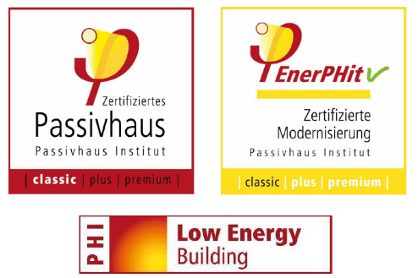

**Fig. 2.** The label that appears on the certificate confirming the passivity of a new premium class building, a thermally modernized building, and a low-energy building (Passive House Institute 2023)

The components used to construct a building intended to meet passive house standards should have passive certification, and the entire investment process is closely supervised in consultation with designers and contractors who possess appropriate knowledge and experience. The design and certification process itself is also quite costly and can reach up to €15,000 for a single-family house (<https://hexagreen.pl/>). In Poland, passive construction remains a niche topic, with only 19 certified buildings listed in the database (<https://passivehouse-database.org>), compared to 2,426 in Germany, 11 in Slovakia, 317 in the United Kingdom, and 154 in the USA.

This article aims to demonstrate the differences in energy performance indicators for newly designed buildings according to WT2021 standards (Ministry of Infrastructure 2002; Ministry of Infrastructure and Construction 2017; Regulation of the Minister of Development, Labour and Technology 2020) and for passive buildings according to the requirements of the Polish Passive House Institute, which correspond to those of the Passive House Institute (2023), as well as to compare these two methods and algorithms (PHPP and ArCADia-TERMOCAD) for assessing passivity. Table 3 presents a summary of these standards along with their respective evaluation methods to elucidate the comparisons throughout the paper.

**Table 3.** Overview of standards and corresponding assessment methods

|  |  |  |
| --- | --- | --- |
| Standard | Assessment method/software | No. |
| WT2021 (Polish Building Regulation) | ArCADia-TERMOCAD software | M1 |
| Polish Passive House Institute (PPHI) | PHPP algorithm | M2 |

2. Research Methods – Comparison of Two Methods and Algorithms   
(PHPP and ArCADia-TERMOCAD) for Passivity Assessment

The goal of passive building design is to ensure optimal thermal comfort while minimizing the demand for heating, cooling, and non-renewable primary energy and renewable energy. Such buildings can be classified into different standards — Classic, Plus, or Premium. Still, when certified according to the guidelines of the Passive House Institute, the demand for renewable primary energy (PER) and the amount of generated renewable energy are the determining factors. This represents a somewhat different way of assessing energy efficiency compared to the standard approach used in preparing energy performance certificates according to the ministerial Technical Conditions WT2021, which are required documents for building acceptance. In that case, the certificate result is decided by the EP indicator concerning the amount of non-renewable energy, as it is the basic indicator in Polish Construction Law (Construction Law). In the only available software on the market for certifying passive buildings, PHPP, the EP value is neither calculated by default nor used as the primary classical indicator. It can be estimated separately, for example for the energy certificate or for national programs such as "My Heat" or "Clean Air." However, this requires the use of additional software, such as   
ArCADia-TERMOCAD, Energy Audits, or Sankom Audytor OZC.

This study aims to compare the energy efficiency results for a newly designed building predisposed to passive standards. In this chapter, two research methods applied to solve the research problem and to calculate renewable (PER) and non-renewable (EP) primary energy demand indicators for a model passive building are described.

The first method (M1) refers to the calculation algorithm proposed by the Act of 29 August 2014 on the energy performance of buildings (Journal of Laws of 2014, item 1200, as amended) and the WT2021 guidelines (the first standard delineated in Table 3). The energy performance certificate is a document that specifies a building's energy demand for heating, cooling, domestic hot water, and ventilation, based on specified technical parameters of the building. Additionally, the methods for calculating the energy performance of buildings are defined in the Regulation of the Minister of Infrastructure and Development of 27 September 2013 on the detailed scope and form of the building energy performance certificate (Journal of Laws 2015, item 376). The basis for issuing such a certificate may also include standards and guidelines concerning building energy efficiency resulting from EU regulations, including Directive 2010/31/EU on the energy performance of buildings.

Below are the basic equations (1)-(7) relating to the calculation algorithm of method M1, taking into account the relations for useful energy, final energy, and primary energy. The newly designed building should also comply with the WT2021 guidelines presented in Table 1.

$Q_{H,nd}=Q_{H,ht}-η_{H,gn}Q_{H,gn}=Q_{tr}+Q_{ve}-η_{H,gn}Q_{H,gn}$

 

where $Q_{H,nd}$ is heat demand for heating and ventilation in the heated zone, i.e., without taking into account the efficiency of technical systems, kWh/(m2 year), is the energy used for heating and ventilation purposes in a building, kWh/(m2 year), is the heat gain utilization factor in the heated zone; refers to energy consumption for heating and cooling, $Q_{H,gn}$ total heat gains in the heated zone, $Q_{tr}+Q_{ve}$ the total amount of heat transferred from the heated zone by transfer and ventilation, respectively.

$Q_{W,nd}=Q_{k,W} η_{W,tot}$



where: $Q_{W,nd}$– annual useful energy demand for utility, $Q_{k,W}$– final energy demand for the preparation of domestic hot water (DHW), $η_{W,tot}$– average seasonal total efficiency in the DHW preparation system.

The final energy $Q_{K}$ is determined for individual technical systems (e.g., heating, water, cooling, or lighting $H/W/C/L$, respectively), taking into account the overall efficiency, $Q_{system,nd}$, its total efficiency, $η_{system,tot}$ and any week or daily breaks in operation, $w_{f}, w_{d}$, respectively, according to the relationship:

$Q_{K_system}=\frac{Q_{system,nd},\frac{GJ}{a}}{\frac{η_{system,tot}}{w_{f}·w_{d}}}$ (3)

On this basis, annual demand for non-renewable primary energy can be determined as following:

$Q_{P_system}= Q_{K_system}·w_{system}+E_{el,pom_system}·w_{el}$ (4)

where: $w_{system}, w_{el}$ are non-renewable primary energy input factors for the heating, DHW, cooling, or lighting system and electrical system, respectively, $E_{el,pom_system}$ annual demand for final auxiliary energy. The demand for non-renewable primary energy for other systems, such as the cooling system $Q_{P, C}$ or lighting $Q_{P, L}$, is calculated in a similar way to the heating system. In the following, the indices *H, W, el, C, L* refer to the heating systems, domestic hot water, auxiliary (i.e., electricity), cooling, and light systems, respectively.

The indicators of useful energy demand $EU$, final energy demand $EK$, and non-renewable primary energy demand $EP$ are referred to as the heated floor area $A_{f}$ and are calculated according to Equations (5)-(7):

$EU=\frac{\sum{Q_{U}}}{A_{f}, m^{2}}=\frac{Q_{H, nd}+Q_{W, nd}+Q_{C, nd}, \frac{kWh}{a}}{A_{f}, m^{2}}$ (5)

$EK=\frac{\sum{Q_{K}}}{A_{f}, m^{2}}=\frac{Q_{K, H}+Q_{K, W}+Q_{K, C}+Q_{K, L}+E_{el,pom, }, \frac{kWh}{a}}{A_{f}, m^{2}}$ (6)

$EP=\frac{\sum{Q_{P}}}{A_{f}, m^{2}}=\frac{Q_{P, H}+Q_{P, W}+Q_{P, C}+Q_{P, L}, \frac{kWh}{a}}{A_{f}, m^{2}}$ (7)

Method M2 concerns the determination of the PER (Primary Energy Renewable) indicator used to classify a newly designed building into the appropriate passivity class (the second standard delineated in Table 3). This indicator measures the consumption and production of renewable primary energy by the building. It includes heating, domestic hot water, cooling, lighting, and household appliances. Figure 3 shows a schematic decision diagram of the Passive House criteria, followed by a reference to the basic calculation methodology.



**Fig. 3.** Schematic decision diagram of Passive House criteria; ${U, U}_{D/W}$– heat transfer coefficient of building elements and, respectively, doors and windows W/(m²·a); $Q_{sol}$– solar heat gains, kWh/a, g – total solar energy transmittance factor, $Q_{Vent,rec\%}$– heat losses caused by ventilation, accounting for heat recovery efficiency (rec%), which reduces these losses when the building uses a mechanical ventilation system with heat recovery (heat recovery ventilation), kWh/a, $Q_{Heat}$– annual heating energy demand, kWh/(m²·a), $Q_{Cool}$– annual cooling energy demand, kWh/(m²·a), $n_{at}$ 
 – building airtightness 1/h

Finally, the PER (Primary Energy Renewable) indicator is defined as follows:

$PER=\sum{\left(Q_{final,i}⋅PER_{factor,i}\right)}$ (8)

where: $Q_{final,i}=Q_{K,i}$– final energy for the i-th use, kWh/a, $PER_{factor,i}$– PER factor for the given use (e.g., DHW, appliances).

3. Results and Discussion

The purpose of the analysis is to compare two computational methods for assessing a newly designed building in terms of energy consumption and demand for renewable (PER indicator) and non-renewable primary energy (EP indicator). The PER indicator is based on the calculation algorithm proposed by the Passive House Institute, which serves as the basis for obtaining the certificate confirming passivity. The dedicated PHPP software was used to determine it (method M1). In contrast, the EP indicator is the determinant of the energy performance of a new building, following the Technical Conditions (WT2021), for which the investor applies for the occupancy permit. The dedicated ArCADia-TERMOCAD software was used to determine it (method M2). Additionally, the ecological effect of the implementation variants of the given solution is also presented.

The model building is located in Central Europe (see Fig. 4), and its climatic data is presented in Fig. 5, whereas technical and functional parameters are provided in Table 4.

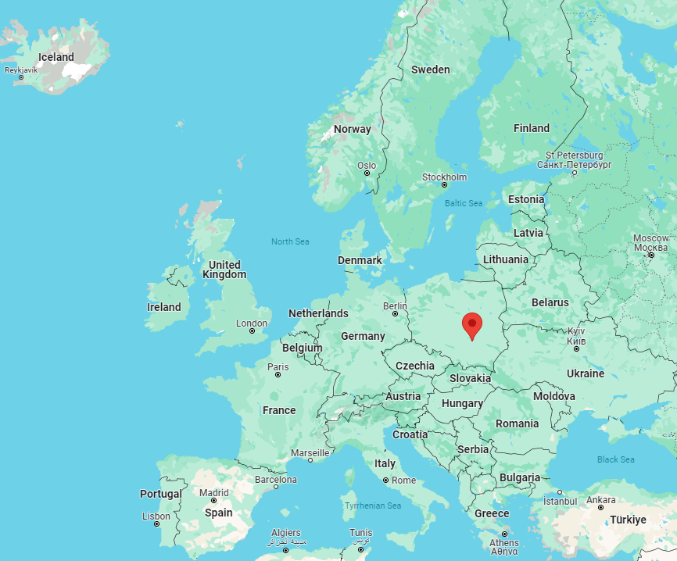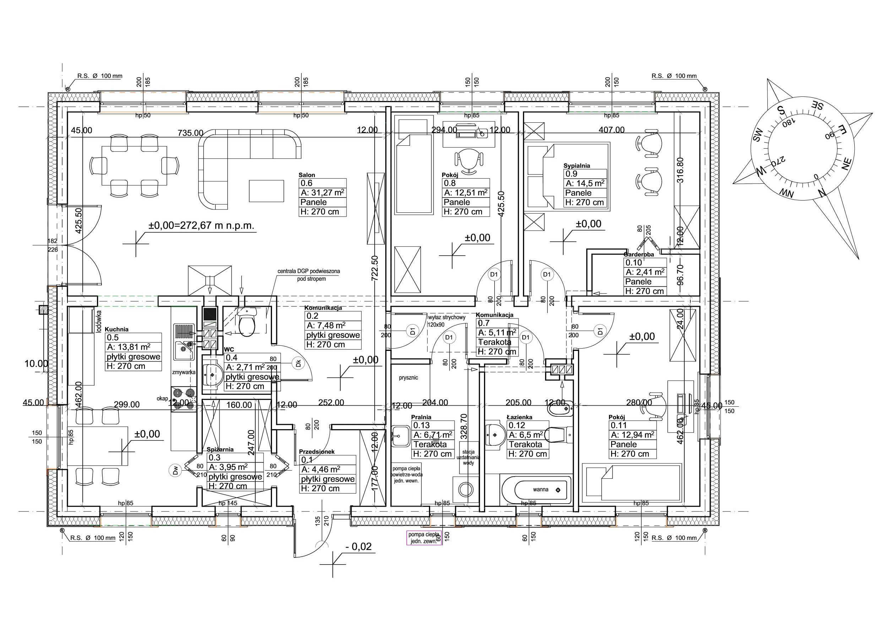

**Fig. 4.** Investment location, climate zone according to the PHPP software is cold

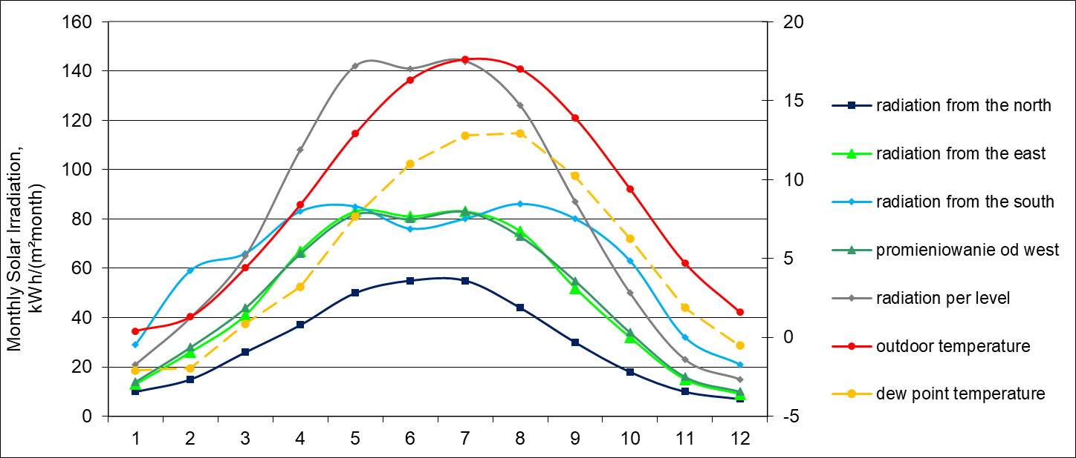

**Fig. 5.** Climatic data for the model building

**Table 4.** General technical data of the analysed building

|  |  |
| --- | --- |
| Description | Values |
| Structure | traditional |
| Year of construction | 2023 |
| Cubic capacity, m3 | 337.5 |
| Heated area of the building*, m2 | 125.0 |
| Usable floor area of the residential part, m2 | 125.0 |
| Form factor, m-1 | 0.46 |
| Building development area, m2 | 150 |
| Number of apartments | 1 |
| Building users, number | 4 |
| Total height of the building | 6.85 |
| The height of the external walls of the ground floor | 3.27 |
| Clear height of heated rooms | 2.7 |

* is equal to the floor space, m2

For comparison purposes, the following implementation variants of the investment were analysed, assuming:

1. Mechanical exhaust ventilation and an air-to-water heat pump for heating purposes,
2. Heat recovery ventilation and an air-to-water heat pump for heating purposes,
3. Heat recovery ventilation, an air-to-water heat pump for heating purposes, plus a micro PV installation and additional building insulation.

In each variant, the presence of solar collectors for domestic hot water (DHW) was assumed. The description of the scenarios is provided in Table 5.

**Table 5.** Characteristics of the design scenarios

|  |  |
| --- | --- |
| Scenarios | Characteristics |
| 1 | Installation of solar collectors/air exchange by infiltration, exhaust ventilation  nmin= 0.3h-1/hybrid/air-water heat pump/no PV installation/ n50=0.6 h-1. |
| 2 | Air handling unit with 88% heat recovery, inside the building's internal envelope. |
| 3 | Air handling unit with 88% heat recovery, inside the building's internal envelope/additionally PV installation on the S side, i.e. half of the roof/ external wall insulation is 22 cm and =0.034 W/mK |

For all three scenarios, Table 6 shows the results of energy efficiency indicators and CO₂ emissions determined using the two methods. It can be noted that the primary energy calculated based on method M2 – PHPP also includes electricity demand for household purposes, powering RTV, and household appliances.

**Table 6.** Comparison of results obtained by the two methods

|  |  |  |  |  |  |  |  |  |  |  |  |  |  |  |
| --- | --- | --- | --- | --- | --- | --- | --- | --- | --- | --- | --- | --- | --- | --- |
| Scenarios | Method M1 | | | | | | | Method M2 | | | | | | |
| QH,nd | QW,nd | EP* | EK | EU | HL,i/A | CO2 | PER | QH,nd | QW,nd | EP** | EP FLP*** | QH,nd/A | CO2 |
| kWh/m2 year | | | | | W/m2 | kg/m2 year |  | kWh/m2year | | | | W/m2 | kg/m2year |
| 1 | 35.4 | 19.3 | **60.0** | 39.1 | 61.7 | 60.7 | 18.1 | 57.3 | 29.4 | 27.4 | 75.1 | 21.7 | 15.6 | 20.2 |
| 2 | 20.4 | 19.3 | 46.9 | 33.9 | 46.7 | 36.6 | 11.0 | 45.5 | **12.0** | 27.4 | 60.6 | 21.7 | 9.9 | 17.1 |
| 3 | 19.1 | 19.3 | 8.4 | 26.3 | 23.5 | 35.9 | 3.4 | 44.9 | 11.0 | 27.4 | 59.1 | 21.7 | 9.3 | 16.9 |

*No need to calculate for live purposes, **with including EP FLP, ***For Live Purposes

Only the second calculation variant, which assumes mechanical ventilation with heat recovery at the level of 88%, allowed the building to be classified under the passive standard Classic and meet the basic requirement for useful energy demand below QH,nd < 15 kWh/m2year.

The useful heating energy results obtained by the two methods differ significantly, ranging from about 18% for the first variant to even around 50% for scenario 3. This is due to the very detailed analysis of thermal bridges and building components by the PHPP software. The database of these elements contains only certified materials, ensuring high airtightness and the absence of thermal bridges.

Regarding the EP coefficient for non-renewable primary energy demand, due to the lack of necessity to account for energy consumption for household needs (RTV and household appliances), it is lower for Method M1 by 22% for variant 1 up to even 150% for variant 2. Furthermore, the EP indicator in PHPP is calculated independently of photovoltaics – i.e., in the traditional version of PHPP, PV does not directly reduce EP. PHPP calculates EP based on the final energy required by the building and appropriate primary energy conversion factors. Photovoltaics are entered separately and influence the PER indicator, which accounts for renewable energy produced on-site, as shown in Fig. 6.

EP is the indicator of non-renewable primary energy, so the energy produced by PV (renewable) does not reduce this indicator. PV is part of the renewable energy system; therefore, its effect is accounted for only in the PER indicator. This also translates to carbon dioxide emissions for each variant; for method M1, there is a significant CO₂ reduction for variant 3 with photovoltaics, which method M2 does not consider.

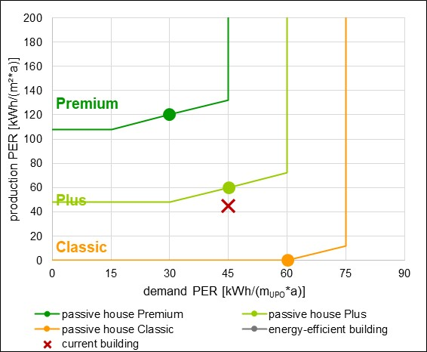

**Fig. 6.** Renewable primary energy PER (production to demand) – scenario 3

The PHPP software thus enables a very detailed thermal analysis of the building (Fig. 7), obtaining a certificate confirming the energy standard from the Passive House Institute. Still, it does not allow generating the report required for the occupancy permit under Polish conditions, which is provided by method M1. According to this algorithm, already in the first variant, the building meets the technical conditions (EP≤70 kWh/m²a) and will receive the occupancy permit.

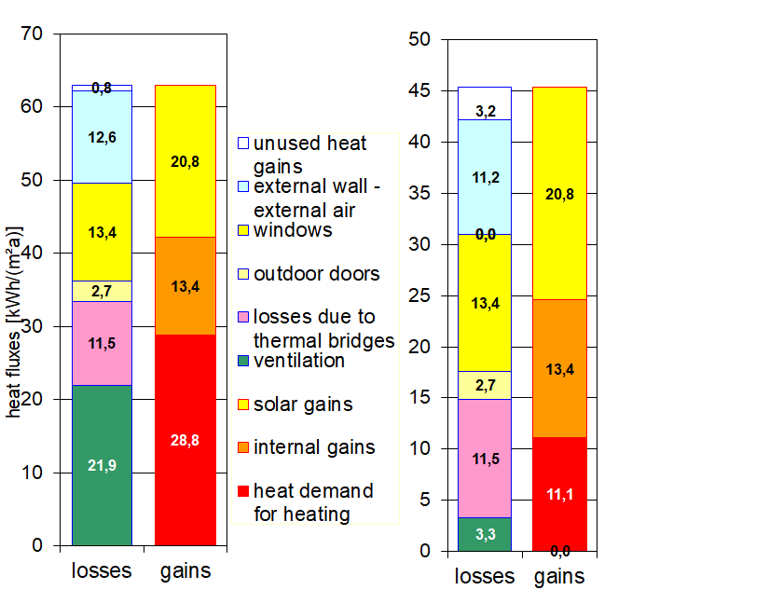

**Fig. 7.** Energy balance of heat for heating (annual method) for scenarios 1 and 3

4. Conclusions

Before proceeding with the comparison, it is important to clarify that PHPP (Passive House Planning Package) is both a methodology and a dedicated software tool developed by the Passive House Institute (PHI) in Germany for evaluating building energy performance following the international Passive House standard.

In contrast, ArCADia-TERMOCAD is a Polish software application commonly used for energy performance simulations based on national regulations, including those of WT2021. Thus, the comparison in this study involves both the differences in standards (Method 1 – WT2021 vs. Method 2 PHI) and in methods/software tools (ArCADia-TERMOCAD vs. PHPP).

Final general conclusions from the analysis of the two calculation methods, M1 and M2, are as follows:

* only the second calculation scenario, which assumes mechanical ventilation with heat recovery at a level of 88%, allowed the building to be classified under the Passive House 'Classic' standard (PER indicator at the level of 44.9 kWh/(m²year)) and to meet the basic requirement for useful energy demand below QH,nd<15 kWh/m2year,
* according to the M1 algorithm, already in the first variant, the building will meet the requirements of the technical conditions WT2021 (EP≤70kWh/m2year) and will receive an occupancy permit,
* the results of useful energy demand for heating purposes obtained using the two methods differ significantly, from approximately 18% to 50% depending on the implementation variant. This is due to the in-depth analysis of thermal bridges and the presence of certified building components selected from the PHPP database,
* the PHPP software enables obtaining a certificate confirming the energy standard from the Passive House Institute, but does not generate the report required for occupancy permits under Polish regulations,
* the EP indicator for non-renewable primary energy demand, due to the lack of a requirement to account for household energy use (for powering RTV and household appliances), is lower for method M1 – by 22% to 150% depending on the implementation variant – compared to method M2,
* the EP indicator in PHPP is calculated independently of photovoltaics – the presence of a small-scale renewable energy installation does not directly reduce the EP indicator,
* PHPP calculates EP based on the final energy needed by the building and appropriate primary energy conversion factors, while photovoltaic energy is entered separately and only affects the PER indicator, which accounts for renewable energy produced on-site.

*The project is supported by the program of the Minister of Science and Higher Education under the name: 'Regional Initiative of Excellence' in 2019-2023 project number 025/RID/2018/19   
financing amount PLN 12,000,000.*

References

Ciria, D., Orihuela Pilar, M., Becerra, J. N., Chacartegui, R. & Ramírez-Rico, J. (2021). Impact of flame confinement with inert ceramic foams on the particulate emissions of domestic heating systems. *Fuel*, *304*, 121264.   
ISSN 0016-2361, <https://doi.org/10.1016/j.fuel.2021.121264>

Dąbek, L., Kapjor, A., & Orman, Ł. J. (2016). Ethyl alcohol boiling heat transfer on multilayer meshed surfaces. Proc. of 20th Int. Scientific Conference on The Application of Experimental and Numerical Methods in Fluid Mechanics and Energy 2016. *AIP Conference Proceedings*, *1745*, 020005. https://doi.org/10.1063/1.4953699

Feist, W. (2007). PHPP: Far More Than Just An Energy Calculation Tool, Passive House Institute, 2007.   
https://passiv.de/former_conferences/Passive_House_E/PHPP.html

Feist, W., Pfluger, R. & Hasper, W. (2020). Durability of building fabric components and ventilation systems in passive houses. *Energy Efficiency*, *13*, 1543-1559. https://doi.org/10.1007/s12053-019-09781-3

Pavlenko, A., & Szkarowski, A. (2018). Thermal insulation materials with high-porous structure based on the soluble glass and technogenic mineral fillers. *Rocznik Ochrona Srodowiska*, *20*, 725-740.

Stokowiec, K., Wciślik, S., & Kotrys-Działak, D. (2023). Innovative modernization of building heating systems: The economy and ecology of a hybrid district-heating substation. *Inventions*, 8.1, 43.   
https://doi.org/10.3390/inventions8010043

Wciślik, S. (2017). *Energy efficiency and economic analysis of the thermomodernization of forest lodges in the Świętokrzyski National Park*. In: EPJ Web of Conferences. EDP Sciences, p. 02144. https://doi.org/10.1051/epjconf/201714302144

Wciślik, S., & Kotrys-Działak, D. (2021). Thermal building upgrade with off-grid PV system: a Polish case. *Energy Efficiency*, *14.7*, 70. https://doi.org/10.1007/s12053-021-09980-x

Construction Law – Act of 7 July 1994 – Journal of Laws of 2025, item 418.

Directive 2008/16/EC of 15 February 2008 amending Directive 98/8/EC of the European Parliament and of the Council to include etofenprox as an active substance in Annex I. Official Journal of the European Union, L 42, 16.2.2008, p. 48-51.

Directive 2010/31/EU of The European Parliament and of the Council of 19 May 2010 on the energy performance of buildings (OJ EU L of 18 June 2010).

Electricity 2024: Executive Summary. International Energy Agency, 2024.

Energy Institute. Statistical Review of World Energy, 2024.

<https://hexagreen.pl/> [access 13.05.2025]

https://passivehouse-database.org [access 13.05.2025]

Journal of Laws 2015, item 376 – Regulation of the Minister of Infrastructure and Development of 27 February 2015 on the methodology for determining the energy performance of a building or part of a building and energy performance certificates.

Journal of Laws of 2014, item 1200, as amended. Act of 29 August 2014 on the energy performance of buildings.

Ministry of Infrastructure (2002). Regulation of 12 April 2002 on the technical conditions to be met by buildings and their location (Journal of Laws 2002 No. 75, item 690); with subsequent changes.

Ministry of Infrastructure and Construction (2017). Regulation of 14 November 2017 amending the regulation on the technical conditions to be met by buildings and their location (Journal of Laws 2017, item 2285); with subsequent changes.

Passive House Institute (2023). Criteria for Buildings: Passive House – EnerPHit – PHI Low Energy Building (Version 10c, IP). Darmstadt, Germany.

Regulation of the Minister of Development, Labour and Technology of 21 December 2020 amending the regulation on the technical conditions to be met by buildings and their location, Journal of Laws of 2020, item 2351; with subsequent changes.

World Energy Outlook 2024. Pathways for the Energy Mix. International Energy Agency, 2024.