|  |  |  |  |
| --- | --- | --- | --- |
|  |  | | |
| **Rocznik Ochrona Środowiska** | | |
| Volume 27 | Year 2025 ISSN 2720-7501 | pp. 421-436 |
|  | https://doi.org/10.54740/ros.2025.035 open access | | |
|  | Received: April 2025 Accepted: August 2025 Published: August 2025 | | |

Recycling Strategies for Decommissioned Photovoltaic Module Panels

Andrzej Iwańczuk1*, Patrycja Krukurka2

1Faculty of Environmental Engineering, Wroclaw University of Science and Technology, Poland   
[https://orcid.org/0000-0002-4387-1936](https://orcid.org/0000-0002-4387-1936?lang=en)

2Faculty of Environmental Engineering, Wroclaw University of Science and Technology, Poland

*corresponding author's e-mail: andrzej.iwanczuk@pwr.edu.pl

**Abstract:** The growing popularity of the use of photovoltaic (PV) panels to obtain solar energy entails, in addition to indisputable benefits (cheap and renewable energy), also several risks. Such a dynamic development of photovoltaic installations carries the risk of generating large amounts of waste, which in the future will have to be recycled or stored in landfills. This publication aims to assess the feasibility and cost-effectiveness of the recovery of secondary raw materials from used solar panels. For this purpose, a literature review was carried out, taking into account the detailed structure of the panel and the problems related to its recycling. In addition, an analysis of panel production and recycling both in Poland and globally is presented.

**Keywords:** solar panels, photovoltaics, recycling, plastics, environmental protection

1. Introduction

Increasing knowledge about global warming means that in the context of electricity generation, renewable energy sources and their ecological and financial benefits are increasingly discussed, with solar and wind energy being the most popular. Already in 2019, they accounted for 90% of the share of new investments in the world in this area (Kulikowski 2019). Thanks to the rapid development of this technology, global investments in "clean energy" are now twice as large as in fossil fuel energy. It is estimated that in 2024 global expenditure in the renewable energy sector will exceed USD 2 trillion, while about USD 1 trillion will be invested in traditional energy sources (IEA 2024).

Poland, whose energy is mainly based on energy from hard coal and lignite-fired combined heat and power plants, achieved 29.6% of energy production from renewable sources in 2024. This is almost 100% more than assumed in the "National Plan for Energy and Climate for 2021-2030" (Forum Energii 2024). Such a large percentage of energy from RES (Renewable Energy Sources) in recent years is primarily due to the increase in popularity of photovoltaics, especially prosumer photovoltaics, i.e., used by people who simultaneously generate and consume energy produced thanks to renewable energy sources (Bauwens et al. 2022). Undoubtedly, such a large increase in sales of PV panels is possible thanks to numerous subsidies from the European Union, which has implemented several programs promoting "clean energy", and the growing awareness of the public about the benefits of its use, especially in the perspective of constantly rising electricity prices.

The term photovoltaics itself (*PV* for short) refers to the generation of energy from the processing of sunlight. The phenomenon has been known since the 19th century thanks to a French physicist, Alexandre Edmond Becquerel, who, during an experiment with metal electrodes and electrolyte, noticed that some of the materials used, when exposed to light, were able to produce small amounts of electricity. In 1954, the first photovoltaic module was created, which achieved an efficiency of 6% and powered a radio. Due to the high cost of producing photovoltaic panels, they were mainly used in space. It was only the production changes that took place in the following decades and the previously mentioned education about climate change that led to the appearance of panels at lower prices.

In addition, there is a noticeable increase in the leasing of land area in our country in favor of small photovoltaic farms, which may result in a large amount of used photovoltaic panels when their useful life ends.

The landowner will bear the total cost of disposing of such a panel. An additional problem in Poland is also the fact that few companies are dealing with the disposal of used photovoltaic panels. However, it is estimated that the number of recycling companies will continue to grow every year. This is mainly due to the constantly developing technologies for the disposal of panels and the value of recovered raw materials. Experts estimate that the largest waste stream from photovoltaic installations will occur after 2030 (IRENA 2025).

2. Construction of a Photovoltaic Panel

2.1. Types of photovoltaic cells

Photovoltaic panel technology is developing very quickly, providing greater efficiency and lower electricity prices, which increases the demand for this type of installation. However, despite such huge technological advancements, the basic design has hardly changed over the years.

In most cases, the panels used on the market are made of crystalline silicon wafers, which can be polycrystalline or monocrystalline. They belong to the so-called first generation, i.e., panels that are made based on silicon, using traditional technologies (Dias et al. 2016, Md et al. 2020, Padoan et al. 2019, Xu et al. 2021).

2.1.1. First generation panels – silicon cells

*Monocrystalline panels* have a higher efficiency (17 to 22%) (Kim et al. 2016, Lunardi et al. 2018). Single silicon crystals are used in their production. They are produced in the Czochralski process. In this process, polycrystalline silicon is melted in a quartz crucible with other admixtures of elements (Olson et al. 2013). They are introduced to obtain n- or p-type silicon, i.e., semiconductors with a predominance of donor dopants. The process takes place at a temperature of 1410°C and a protective atmosphere, allowing for no disturbance of the process. Then the mixture prepared in this way is slowly pulled out and rotated around its axis. The single crystals obtained by this method are 2 m long and 300 mm in diameter (Jing & Yu 2015, Padoan et al. 2019). Another method of producing monocrystalline panels is the zone melting method, which involves cutting blocks of silicon. However, it is ineffective due to the loss of half of the material. Monocrystalline panels, due to the aforementioned production processes, are one of the most expensive solutions for photovoltaic installations. Still, they have many advantages, including very good resistance to weather conditions and the aforementioned efficiency and durability (Huang et al. 2017, Kang et al. 2012, Kim & Lee 2012, Klugmann & Ostrowski 2010).

*Polycrystalline panels* are manufactured using purification and then casting processes that are simpler and less expensive than the Czochralski process. Such panels are less efficient than monocrystalline panels (14 to 16%) (Md et al. 2020), and therefore require more installation space. The advantages of this type of panel are that they are perfect for installation in conditions of weaker sunlight and that they have a longer service life (up to 25 years) and a lower price compared to the above-mentioned monocrystalline panels. The visual differences between the two types of panels are shown in Figure 1.

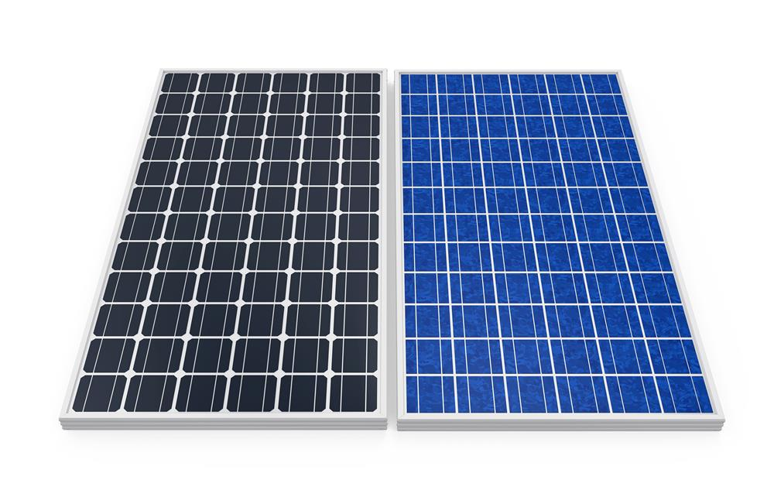

**Fig. 1.** Visual difference between monocrystalline (left) and polycrystalline (right) cells (SOL 2025)

2.1.2. Second generation panels – thin-film cells

Another type of photovoltaic panels is those belonging to the so-called second generation, i.e., thin-film panels (Raugei et al. 2007). They began to be created to reduce the consumption of expensive materials, mainly silicon, the price of which has begun to rise in recent years (Klugman-Radziemska 2014). They are also gaining popularity, and it is estimated that they will dominate the PV panel market in the future. As the name suggests, these panels consist of thin layers of material, 1 to 4 micrometers thick, deposited on a cheap substrate such as glass (Lunardi et al. 2018, Marwede et al. 2013, Sasal et al. 1996). The advantage of this type of panel is that it requires much less semiconductor material to produce electricity. In addition, these panels are flexible and can be used as building elements. Currently, there are three types of such panels:

* CIGS photovoltaic panels

Copper-indium-gallium selenide is used for production. Their efficiency is about 12-15%, and the thickness does not exceed a few micrometers. These panels are more efficient in winter when there is a large amount of scattered sunlight.

* CdTE Panels

These panels are made of cadmium telluride (Bustamante & Gaustad 2021). They achieve an efficiency of 10-15%, and achieve better efficiency at higher temperatures. If you use this type of panel, you have to take into account a higher disposal rate, because they have toxic cadmium in their structure (Ramos et al. 2017, Savvilotidou et al. 2017).

* Amorphous photovoltaic panels

The rarest type of installation. Silicon is also used in their production, but the difference is that in the case of these panels, amorphous silicon, i.e., non-crystallized, is used. Their efficiency ranges from 6-10%. However, they are the cheapest and have a low degree of sensitivity to temperature changes (Rabczak & Proszak-Miąsik 2020).

2.1.3. Third generation panels

It is the latest technology for the production of PV panels. It consists in resigning from the classic p-n connector. These panels are built based on polymers and dyes that use the phenomenon of photosynthesis. The biggest advantages include resistance to shading, but as in the case of previous generation panels, they achieve low efficiency and a shorter life. Currently, research is being conducted to increase their efficiency (Marszałek et al. 2024).

2.2. Solar Panel Components

Due to the greatest popularity of silicon crystalline cells, this publication focuses on the exact construction of these panels. Most of the panels used by prosumers consist of 60 cells connected in series by busbars (the electrical contacts connecting the cells allow current to flow through all cells in the circuit) (Guo et al. 2022). By contrast, larger panels, used for commercial purposes and farms, contain more than 71 cells and operate at higher voltages (Dias et al. 2016, Kim & Lee 2012, Tammaro et al. 2015, Zhang et al. 2013).

In addition to the photovoltaic cell, photovoltaic panels (Fig. 2) also include elements such as:

* tempered glass,
* EVA film,
* polymer layer,
* aluminium frame,
* junction box – diodes and connectors.

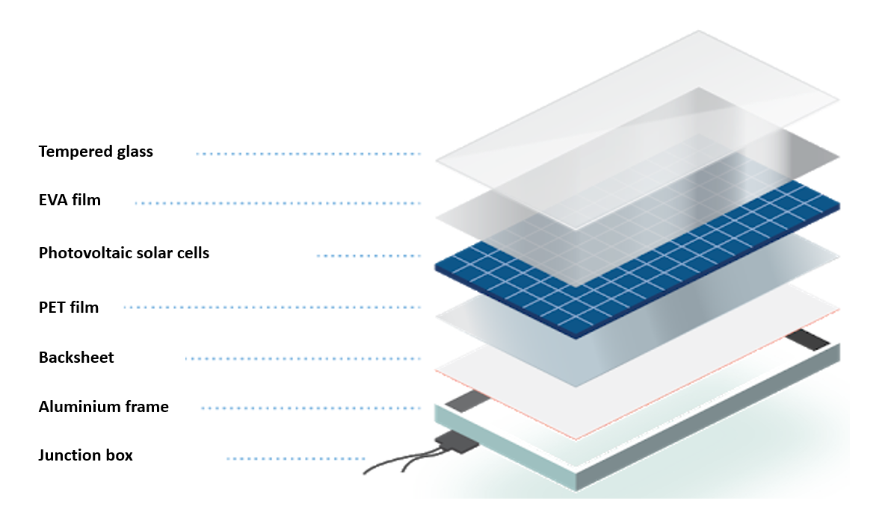

**Fig. 2.** Basic elements of photovoltaic panel installation construction [(ELVE 2025)](http://elve.pl/blog/elementy-budowy-instalacji-pv/)

2.2.1. Tempered glass

Tempered glass protects photovoltaic cells from weather conditions and airborne pollutants. It is characterized by high strength, mostly has a thickness of 3 to 4 mm, and is resistant to extreme temperature changes and mechanical loads. To be used in a photovoltaic installation, an IEC bump test must be carried out, which requires the photovoltaic panels to withstand the impact of hail with a diameter of 25 mm, moving at a speed of up to 27 m/s. Tempered glass is also safer in the event of a strong impact, because it breaks into small fragments. To improve performance, many manufacturers use high-transmittance glass with low iron content and an added anti-reflective coating.

2.2.2. EVA Film

EVA (ethylene polyvinyl acetate) film is a specially designed transparent polymer layer. The role of the EVA film laminate is to hold the panels in place during energy production. This material must be extremely resistant to changes in temperature and humidity, because it makes the photovoltaic system more durable, and prevents moisture and dirt from getting into the panel. To increase the protection of photovoltaic cells, many manufacturers use film on both sides of the cells. A high-quality film can extend the life of the panel, especially if water enters the cell, which can destroy the installation (Farrell et al. 2021).

2.2.3. Polymer layer

This layer is made of several types of polymers, e.g., PP (polypropylene), PVF (polyvinyl fluoride), and PET (polyethylene terephthalate) (Quin et al. 2020). It is designed to provide mechanical protection for cells as well as electrical insulation. Each of the plastics used provides different levels of thermal protection and UV resistance. The leading and most durable material is PVF. In the production of frameless panels, to better protect the cells, the glass mentioned above is usually used instead of a polymer layer. However, this increases the price of the panel.

2.2.4. Aluminium frame

The aluminium frame plays a very important role in the production of panels. It is designed to protect the edges of the laminate and the cells within it, and provides a robust structure for mounting the entire panel. The frame structure itself is designed to be lightweight, rigid, and capable of handling extreme loads and stresses caused by external forces.

2.2.5. Junction box

The junction box is the central point where all the links connect. The main requirements that must be met are resistance to weather conditions and a correct connection to the panels. The box itself consists of bypass diodes that prevent reverse current (created when photovoltaic panels are shaded or dirty). Therefore, diodes only provide current flow in one direction. In addition, the junction box has connectors that are used to connect the solar panels (SOL 2025).

3. Advantages and Disadvantages of Panels

Each method of generating energy has its advantages and disadvantages, even when it comes to obtaining energy from conventional sources, which at the time of their inception were the most efficient of all known technologies (Huang et al. 2017). It was only the knowledge of their impact on environmental pollution and dwindling fossil resources that led to the slow departure from this type of installation (Jaromin 2018).

3.1. Advantages of a photovoltaic installation

The most frequently cited advantages of photovoltaic panels include the fact that the energy generated with them does not emit harmful greenhouse gas emissions, and thus is environmentally friendly and in line with the European Union's strategy to reduce 40% of greenhouse gas emissions by 2030 (Muteri et al. 2020). In addition, the energy that is supplied is free and inexhaustible (Gonen & Kaplanoglu 2019). 1000 W/m² reaches the Earth's surface in the form of sunlight, of which 700 W/m² can be used to generate energy, which gives about 10^14 kW of power for the entire Earth's surface (Deng et al. 2019, Vellini et al. 2017, Cucchiella et al. 2015).

Poland's energy demand by 2030 is expected to reach 981.6 TWh/year, which is approximately 100 times the current energy reserve (Dishwasher 2013). An additional advantage of this type of installation is that they are constantly being developed and thus becoming cheaper every year, and heating buildings using such energy is safer than using conventional sources (Luo et al. 2021). The panel design itself is also easy to maintain and install. Less important, but equally important advantages include the quietness of photovoltaic panels and the lack of problems when building photovoltaic farms in the vicinity. The popularity of panels among other renewable energy sources is also influenced by the fact that photovoltaic panels can be installed on any surface, including water (Liu et al. 2020). The advantages of this type of installation are that glass-to-glass panels can be used on them, which increases the productivity and lifespan of such photovoltaic power plants by 20.59% compared to single-sided modules (Koohestani et al. 2023).

3.2. Disadvantages of using photovoltaic panels

The most important disadvantage of photovoltaic panels is the initial cost of the system. It includes the fee for installation, wiring, the inverter, and the production costs themselves. The basic price of such an installation in a single-family house is from 15,000 to 30,000 PLN. However, thanks to the subsidies, this cost is significantly lower than it was a few years ago.

Additionally, in a study conducted by the American National Renewable Energy Laboratory (NREL 2021) from a solar panel lifecycle perspective, the production of a single panel has a significant impact on the environment, creating a range of gaseous and liquid byproducts. This is due to the use of huge furnaces and high temperatures to produce metallurgical silicon, which is associated with high carbon dioxide and sulfide emissions (Louwen et al. 2014, Muteri et al. 2020, Raguei et al. 2007). In addition, the process of obtaining polycrystalline silicon involves a reaction of hydrochloric acid with hydrogen, which produces silicon tetrachloride, a toxic substance that must be disposed of under appropriate conditions (Amado et al. 2017). In recent years, the technologies used in the production of panels have significantly reduced their environmental impact through recycling. This process produces high-purity silicon at low production costs. Of course, the carbon footprint ("total greenhouse gas emissions during the full life cycle of products") in the production of panels depends on the manufacturers. For example, in China, which accounts for half of the world's panel production, the carbon footprint is twice as high as in the United States, as energy in China relies mainly on conventional sources (Li et al. 2020). In addition, research by the Fraunhofer Institute noted that glass-to-glass modules have a 7.5 to 12.5% lower carbon footprint than a standard framed module. The reason for this is the use of aluminium frames, which are very energy-intensive to produce (Fraunhofer ISE 2020).

It is also necessary to mention the efficiency of the installation, which depends on weather conditions, which is why it is so important to locate the installation correctly. The first most important criterion for the efficiency of an installation is insolation, i.e., the amount of solar radiation that reaches the surface in a given time. In Poland, this value is not uniform and ranges between 950 and 1160 kWh/m² per year. The southern and south-eastern parts of Poland are the best in this respect. The level of sunlight is also influenced by the season, and thus the length of the day. In the case of winter, it is about 7-8 hours, while in summer it is over 16 hours. However, excessively high temperatures and solar radiation intensities do not have a positive effect on photovoltaic panels, causing them to overheat and degrade. The optimal temperature for use is 25°C.

Another criterion is the location of the installation. The ideal positioning of the panel is to point it directly south at an angle of 35-38°. For comparison, at an angle of 60° directly to the south, the efficiency of the panel is 93%. However, with the same inclination and the panel facing east, the efficiency is only 76%. The last criterion affecting the efficiency of the installation is shading and dirt on the module, whether by leaves or falling shadows. Covering the installation affects the loss of power in the module and its replenishment from the adjacent panel, which causes the covered panel to heat up to high temperatures and, consequently, leads to damage to the module. To remedy this, manufacturers use bypass diodes, which disconnect the shaded cell. Manufacturers also recommend washing photovoltaic panels once a year, as the dust that settles also reduces their efficiency.

4. Photovoltaic Panel Market in Poland and the World

Photovoltaics in Poland is growing in popularity each year, placing Poland first in terms of the growth rate of photovoltaic power from 2016 to 2020. At that time, the growth rate was 114%, where the EU average was 10.3% (IEO 2024). In recent years, the RES market has slowed down slightly due to the reduction in subsidies for the purchase of installations.

Nevertheless, according to data from Polskie Sieci Elektroenergetyczne, in 2024, photovoltaics, for another year in a row, was the leader and the main flywheel in the RES market. It currently accounts for about 60% of RES capacity in our country. The total PV capacity in Poland for 2023 was 17 GW, which compared to 2022 (12.4 GW) represented an increase of 4.662 GW, i.e., an increase of 38% (Fig. 3).

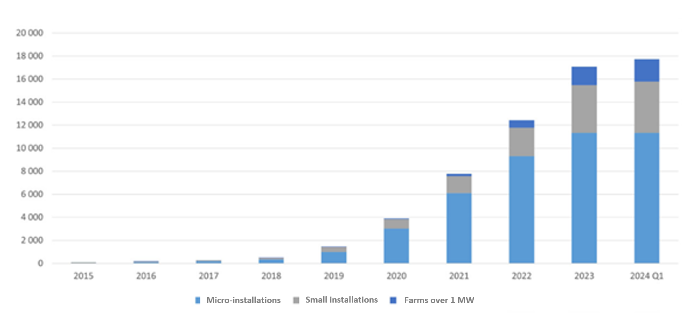

**Fig. 3.** Cumulative installed capacity in photovoltaics in Poland [MW] (IEO 2024)

Thanks to the great popularity of photovoltaics, in 2023. Poland was ranked 4th in terms of the increase in installed capacity in the European Union (at the level of 4.6 GW). The top three included countries such as Germany, Italy, and Spain.

As far as the global market is concerned, it can be said that Poland has established itself at the forefront in terms of both existing and growth of new PV sources (Fig. 4). In 2023, we were ranked 13th in the world between countries such as France and Vietnam. On the other hand, among the G20 countries, only Spain and the Netherlands are ahead of us. While in as many as nine G20 countries the capacity of photovoltaics is lower than in Poland, these are Canada, Indonesia, and the United Kingdom (Peeters et al. 2017).

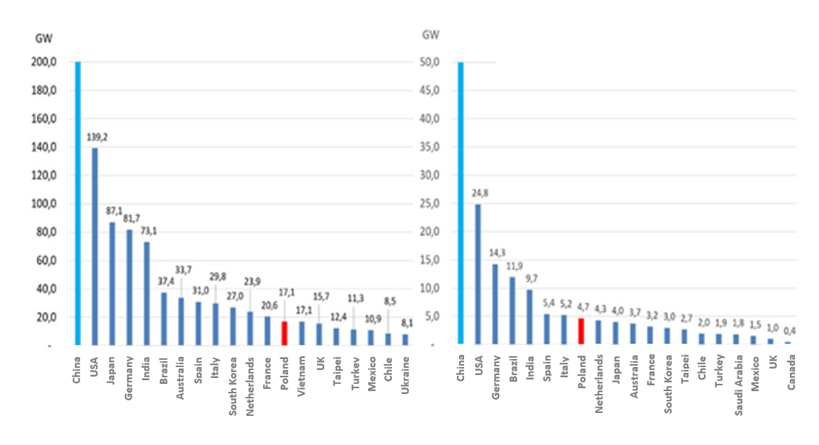

**Fig. 4.** Poland's place in the world in terms of installed capacity (left) and growth of new PV capacity (right) in 2023 (IEO 2024)

5. Predicted and Actual Lifetime of the Panels

Due to the great interest in photovoltaic panels, increasing attention is being paid to their reliability and service life. Thanks to the latest technology, manufacturers of photovoltaic panels provide a guarantee for their reliable use for 20-25 years (Ceglia et al. 2022). However, in reality, due to factors such as the method of operation and weather conditions, they can last much shorter. An additional factor that reduces the life of panels is the quality of the materials used in their production.

The oldest photovoltaic system has been in operation since 1982 and is located in Switzerland. The installation was built by scientists from the SUPSI (Scuola Universitaria Professionale della Svizzera Italiana) institute and had a capacity of 10 kWh. The system originally consisted of 288 crystalline modules. In 1992, the inverters were replaced and their number was reduced to 252. After 11 years, the researchers measured the efficiency of the panels against the initial nominal power; 59% of the operating modules had degraded by less than 10%. In the case of 35% of modules, their degradation was 10-20%. And only for 6% of the modules did the efficiency fall below 80% of the nominal power of the modules. The main reason for the deterioration of performance was the so-called hot spot, i.e., a problem with the transmission of power through one of the modules. This problem can arise as a result of local shading or mechanical rupture of cells. In another study in 2017, it was noted that 58% of the modules had a power greater than 80% of the initial power. In addition, attention was paid to the different degrees of degradation depending on the type of film used. In the case of the first supplier of PVB (polyvinyl butyral) film, the average degradation was 0.2% per year, which means that 93% of the initial power will be maintained after 35 years. With the second supplier, the average degradation was 0.62% per year, which may mean that after 35 years of operation, 76% of the initial power will remain. By contrast, when using PVB film, the third cheapest supplier, the modules were found to be useless (Detollenenaere & Masson 2021, Peeters et al. 2017). That is why the high quality of the materials used is so important.

Another factor that reduces the life of panels is climatic conditions. They particularly affect the operation of the inverter, which is the most faulty part of the module. The costs associated with its failure amount to about 59% of the entire system. Therefore, the inverter life prediction plays a crucial role in assessing operating costs and affects the reliability of the panel. The location of the installation close to the equator affects the high level of solar irradiation (the amount of solar radiation falling on surfaces, measured in a specific time and space) throughout the year. While in the case of regions located to the north, the level of solar irradiation in winter is usually low, and the intensity of solar radiation varies throughout the year. A comparable trend also applies to the temperature profile at the installation site, which directly affects the module and energy production. It also acts on the heat load of the power supply device. Panel companies do not take into account such a significant factor as panel degradation when assessing the service life, assuming that production and load are repeatable every year. In fact, the rate of degradation is influenced by climatic conditions, which vary from place to place (Chowdhury et al. 2020, Cucchiella et al. 2015, Deng et al. 2019).

6. Disposal of Used PV Panels

6.1. Legal standards

According to the International Renewable Energy Agency projections, by 2050 approximately 78 million tons of photovoltaic panels will reach the end of their life cycle, generating up to 6 million tons of waste per year. The problem is so significant that most countries have no idea how to deal with the increasing amount of waste (Frisson et al. 2000). Only India, Australia, and Japan have recycling requirements. In the United States, this is not covered by law; manufacturers voluntarily recycle used panels. Therefore, most companies do not offer it due to higher costs. Used panels end up in landfills or are transported to developing countries with poor environmental protection (Gui et al. 2017, Sener et al. 2014, Sokolowski 2020).

In the European Union, panel manufacturers are required to ensure proper recycling. This is set out in the Waste Electronic Equipment (WEEE) Directive, which aims to reduce the negative impact of the continuing increase in photovoltaic waste and accelerate the implementation of module recycling. The resources used in the production of panels are classified as a secondary raw material. For their recovery to be possible, they must meet several requirements set out in the directive (2012/19/EU), which does not specify the legal issues related to recycling and is only a recommendation.

In Poland, the Ministry of State Assets assures that the regulations clearly state that manufacturers deal with the costs associated with worn-out panels. This is due to the principle of extended producer responsibility under Articles 18 and 19 of the Waste Act. The problem may arise in the event of legal changes over the next few years, when the current contracts will expire and the future legal framework for recycling is uncertain.

In recent years, leasing land for photovoltaic farms has become increasingly popular. This is due to large profits reaching about PLN 15-25 thousand per year per hectare (as of 2025) and the possibility of installing panels even in the case of a small farm with a low soil class. The benefits of using land in this way can offset the challenges of managing damaged photovoltaic panels. This legal problem should rest with the panel manufacturer, but the inaccuracy appears in contracts concluded with companies. Namely, there is a risk of unjustified future transfers of costs to landowners by declaring bankruptcy just before the end of the contract. In such a scenario, in two decades, individual farmers will be left with damaged panels, and as a result, they may become insolvent. This is indicated by Article 3(1)(19) of the Waste Act, "the owner of waste located on the property is the owner of the land surface". In such a situation, local governments will be forced to take over insolvent land with equipment and, as a result, the costs of disposal will rest on local self-government communities.

In the United States, the issue of disposing of panels is even more complicated due to the lack of regulations. Because the recycling process is expensive and time-consuming, it is more profitable to store them or export them to developing countries. Discarded modules end up in landfills, where they decompose and release toxic substances such as cadmium and lead. An additional problem is the relatively low price of panels in the U.S. due to the policy of encouraging earlier replacement of panels with those with higher efficiency (Razykov et al. 2011).

According to the International Renewable Energy Agency (IRENA), the recycling of photovoltaic panels will grow significantly in the coming years, especially in Europe. On a global scale, it is forecast that by 2050 there will be about 60-80 million tons of panels to be processed. In Poland, the projected amount of waste is also significant. Taking into account only the panels installed in 2010, the amount of waste will be 1.5 million tons. Forecasts indicate that by the end of 2030, this amount will increase to tens of billions of tons. The waste hierarchy is defined by Directive 2008/98/EC of the European Parliament and of the Council on waste. It includes five elements of waste management: prevention, reuse, recycling, other recovery methods, and disposal (Broda & Tora 2021, Gonen et al. 2014).

6.2. Recycling methods of PV panels

Panel recycling technologies have been studied since 2007. This knowledge has provided the basis for the development of the plants, thanks to which various options for the recovery of raw materials have been created and are constantly being improved. Most of the research is related to the recycling of the most popular photovoltaic modules: silicon and thin-film. They are mainly made up of silicon, plastics, glass, and copper. Currently, there are two main recovery methods used for photovoltaic panels, divided by type of panel (Jeongeun et al. 2017, Pagnanelli et al. 2017, Lunardi et al. 2018).

6.2.1. Recycling of crystalline silicon panels

The first is the recycling of crystalline silicon photovoltaic panels (Fig. 5). The main components in them are glass, aluminium, and copper (Jing at al. 2015, Jung et al. 2016). To obtain low levels of contamination of the recovered materials, mechanical processes are combined with thermal and chemical processes (Fthenakis & Wang 2006, Gustafsson et al. 2014, Kuroiwa et al. 2014, Marwede et al. 2013). The first process is the separation of the main components, such as frames, wires, and laminated glass (Kang et al. 2012, Olson et al. 2013). Recycling glass from a panel is a relatively low-cost process that is handled by flat glass recycling companies (Granata et al. 2014). The process is carried out in batches to allow the equipment parameters to be adjusted and to take into account the small amounts of currently available material for processing. Devices for removing polymer residues from glass and adhesives include crushers, optical sorters, screens, induction sorters, and eddy current devices (Jeongeun et al. 2017, Klugmann & Ostrowski 2010, Youn et al. 2014). The resulting fraction of crushed glass may still be contaminated by silicon and metals (Park et al. 2015, Jung et al. 2016, Bothe et al. 2010). Despite these impurities, it is still used as a thermal insulation material in the production of glass foam or fiberglass, thanks to its mixing with recycled glass (Hunt et al. 2015). Studies show that 15-20% of the glass from the panels is used to produce the necessary mixture. It is estimated that as photovoltaic waste increases, the glass recycling market will invest in new recovery technologies that will reduce pollution.

|  |  |
| --- | --- |
|  | **Fig. 5.** Laminated glass recycling process (Heath et al. 2016) |

Aluminium or steel frames and copper cables are sent to metal recycling plants, where they can be converted into energy provided they meet certain requirements. The recovery of small amounts of valuable materials (e.g., silver, copper) (Dias et al. 2016b, Granata et al. 2014, Pagnanelli et al. 2019) and rare materials (e.g., tellurium) (Marwede et al. 2012) requires additional and more sophisticated processes. One of these is the pyrolysis process (a process that decomposes substances using high temperature and without the presence of oxygen) (Pestalozzi et al. 2018), which removes metallization layers and admixtures of various panel substances and casts silicon (Andres 2010, Yan et al. 2019, 2020, Zuo et al. 2014).

6.2.2. Recycling of thin-film photovoltaic panels

Due to the relatively small amount of waste from thin-film photovoltaic panels, their reprocessing is at an early stage of development, but is likely to improve with the increase in post-consumer waste (Berger et al. 2010, Granata et al. 2014, Pagnanelli et al. 2017). These panels are currently processed and recycled using a combination of mechanical and chemical treatments (Doi et al. 2001, Kim & Lee 2012, Tammaro et al. 2015). The combination of these processes allows for the recovery of 90% of glass and 95% of semiconductor pulp (Fig. 6) (Camalan 2020, Ma et al. 2021, Sun et al. 2023).

|  |  |
| --- | --- |
|  | **Fig. 6.** Thin-film panel recycling process (Heath et al. 2016) |

The first process is to shred the panels and crush them in a hammer mill into particles of 5 millimeters, this allows the laminated bonds to break (Giacchetta et al. 2013, Liu et al. 2021, Yuan et al. 2021 & Zhao et al. 2021). The resulting dust is then collected in an aspiration system equipped with a high-efficiency particulate air filter (Berger et al. 2010, Sasala et al. 1996). The semiconductor layer is extracted using a mixture of hydrogen peroxide and sulfuric acid (Berger et al. 2010, Yuta et al. 2018, Zhao et al. 2020, Luo et al. 2021). Glass and larger pieces of ethylene vinyl acetate are separated in a classifier and on a vibrating screen (Bogust & Smith 2020, Granata et al. 2014, Pagnanelli et al. 2017, Rubino et al. 2021, Song et al. 2020). Finally, the glass is washed with water and dried on a filter belt (Zhao et al. 2020). Filter liquid with metals, on the other hand, can be extracted using ion exchangers or precipitated for reuse in the photovoltaic industry (Ma et al. 2021).

6.3. Recycling costs

Manufacturers pay recycling fees (in Poland from 0.18 to 0.26 PLN per kilogram), and the owners of the installation also participate in the costs (about PLN 1.5-2 per kilogram). The European Union is promoting the circular economy, leading to new standards and international cooperation, such as the EU-funded PHOTORAMA project, which is developing sustainable recycling methods.

When implementing the process of recycling photovoltaic panels, it is important to understand the costs and environmental impact of the equipment. Because photovoltaic technology plays an increasingly important role as a key source of energy, it is important to ensure a sustainable life cycle of the panel (Kazmerski 2006). As the mass use of photovoltaic technology is relatively new, recycling technologies have not yet been sufficiently developed for greater efficiency. Therefore, solutions are used to recycle similar elements (Paodan et al. 2019, Rabczak et al. 2020, Vellini et al. 2017).

The costs of the process used are divided into three components: the recycling process, transport, and sale. In the case of recycling, private costs are taken into account (expenses for equipment and materials that the company must invest in to start the process, and electricity costs) and environmental damage, resulting from pollutants released during the process, which are beyond the company's control. In the case of transport, the company must cover the fuel costs and emissions generated while driving. The last costs are those related to recovery, including the costs of storing non-recovered materials in a landfill and their emissions (Rubino et al. 2021, Zeng et al. 2004).

6.4. PV panel recycling industry in Poland and the World

6.4.1. Poland

The European Union's Waste Electrical and Electronic Equipment (WEEE) Directive suggests recycling waste equipment within your own country. Every year, Poland is obliged to collect 65% of the weight of used panels placed on the market.

In our country, the recycling of PV panels is just gaining momentum, as most installations are still new   
– many of them are less than 10 years old, and their average lifespan is 25-30 years. However, the first plants specializing in this process are already being established. The key player is 2loop Tech, which in 2024 launched the first plant in Łódź capable of almost 100% recycling of panels, and recovers raw materials such as glass, aluminium, copper, silicon, and silver. This plant can process about 100 thousand panels per year, which is equivalent to about 2000 tons. Other companies, such as Thornmann Recycling in Toruń, also offer recycling services, focusing on the recovery of glass, aluminium, and silicon wafers.

6.4.2. Europe

In Europe, the PV panel recycling industry is more advanced than in many other regions of the world, thanks to strict EU regulations, such as the aforementioned WEEE Directive (Merla et al. 2023).

The network of recycling plants in Europe is growing, but it is still limited. In 2025, many countries will invest in expanding their processing capacity to meet IRENA's projections that up to 78 million tonnes of PV waste could be generated in Europe by 2050. Currently, mainly panels from the first installations (from 2000 to 2010), whose service life is coming to an end, are processed.

Countries such as Germany, France, Italy, and the Netherlands are pioneers. In France, for example, the first specialized recycling plant was established in 2018 in Rousset (Veolia and PV Cycle), where up to 95% of materials such as glass, aluminium, silicon, and precious metals (silver, copper) are recovered. Germany, on the other hand, is developing circular technologies, and companies like 2loop Tech (Poland, but with European ambitions) are introducing innovations that allow for the recovery of up to 99% of raw materials (Zhang et al. 2023).

6.4.3. The World

On a global level, the PV panel recycling industry is less developed than in Europe. Still, it is catching up quickly, especially in the regions with the highest number of installations.

China is the largest producer and installer of PV panels (over 60% of global production in 2025). For this reason, they face a huge recycling challenge. The country is investing in recovery technologies, but the infrastructure is still under development. Many panels end up in landfills, which raises environmental concerns related to heavy metals (lead, cadmium). Nevertheless, companies such as Jinko Solar and Trina Solar are working to close the raw material cycle.

The U.S. and Japan are also developing the industry for the recovery of plastics from PV panels, albeit at different rates. In the United States, local recycling laws have been introduced, but the number of facilities is limited – only a few dozen of them are in operation. Japan, after the Fukushima disaster, increased investments in renewable energy sources, which accelerated work on recycling, focusing on the recovery of silicon and metals.

In countries such as India, South Korea, and Australia, the infrastructure for the processing of end-of-life panels is just beginning to be built. In Africa, the PV market is growing, but recycling is almost non-existent due to a lack of regulation and resources.

7. Summary and Conclusion

Due to the constantly developing market of the photovoltaic industry, the waste recycling system in this industry is at an early stage of development. There are still a few companies dealing with the recovery of raw materials from PV panels. The problem may be the complicated construction of the panel, which is associated with difficulties during the recycling stage. The second factor is also the small waste stream, which results from the age of the installations that are still in operation. However, this is an industry that will certainly start to develop dynamically in the coming years. This can be seen, especially in the example of Germany, where the market for photovoltaic panels has already been well developed for about 15 years, and the number of research and recycling companies is increasing year by year.

The legal solutions specifying how to deal with panels after their useful life are also a problem. While this is defined by the "Waste Electronic Equipment (WEEE) Directive" in European law, there are still no guidelines for recycling panels in most countries worldwide, leading to a situation where many recyclable panels end up in landfills.

In conclusion, it can be optimistically stated that the future of the PV panel recycling industry in Poland is promising. Still, it requires further investment, better regulation, and public education. If these elements are properly addressed, Poland can not only meet the challenge of photovoltaic waste but also become a regional leader in the ecological and economically viable management of this resource. In the coming decades, this industry will be crucial for maintaining the sustainable development of solar energy in the country.

References

Adamo, I., Ferella, F., Gastaldi, M., Nicolò, M., & Paolo, R. (2023). Circular solar: Evaluating the profitability of a photovoltaic panel recycling plant. *Waste Management & Research*, *41*, 1144-54. https://doi.org/10.1177/0734242X221149327

Adamo, I., Michela, M., & Paolo, R. (2017). Economic feasibility for recycling of waste crystalline silicon photovoltaic modules. *International Journal of Photoenergy*, *2017*, 1-6. https://doi.org/10.1155/2017/4184676

Andres, U. (2010). Development and prospects of mineral liberation by electrical pulses. *International Journal of Mineral Processing*, *97*, 31-38. https://doi.org/10.1016/j.minpro.2010.07.004

Bauwens, T., Schraven, D., Drewing, E., Radtke, J., Holstenkamp, L., Gotchev, B., & Yildiz, O. (2022). Conceptualizing community in energy systems: A systematic review of 183 definitions. *Renewable and Sustainable Energy Reviews*, *156*, 111999. https://doi.org/10.1016/j.rser.2021.111999

Berger, W., Simon, F., Weimann, K., & Alsema, A. (2010). A novel approach for the recycling of thin film photovoltaic modules. *Resources Conservation & Recycling*, *54*, 711-18. https://doi.org/10.1016/j.resconrec.2009.12.001

Bogust, P., & Smith, Y. (2020). Physical separation and beneficiation of end-of-life photovoltaic panel Materials: Utilizing temperature swings and particle shape. *JOM: The Journal of the Minerals, Metals & Materials Society*, *72*, 2615-23. https://doi.org/10.1007/s11837-020-04197-2

Bohland, J., & Anisimov, I. (1997). *Possibility of recycling silicon PV modules*. IEEE Photovoltaic Specialists Conference, 1173-75. https://doi.org/10.1109/PVSC.1997.654298

Bothe, K., Krain, R., Falster, R., & Sinton. R. (2010). Determination of the bulk lifetime of bare multi-crystalline silicon wafers. *Progress in Photovoltaics: Research and Applications*, *18*, 204-08. https://doi.org/10.1002/pip.975

Broda, K., & Tora, B. (2021). Safe disposal or recycling of PV?, *Nowa Energia*, *4*, 54-57.

Bustamante, M., & Gaustad, G. (2014). Challenges in assessment of clean energy supply-chains based on byproduct minerals: A case study of tellurium use in thin film photovoltaics. *Applied Energy*, *123*, 397-414. https://doi.org/10.1016/j.apenergy.2014.01.065

Camalan, M. (2020). Correlating common breakage modes with impact breakage and ball milling of cement clinker and chromite. *International Journal of Mining Science and Technology*, *30*, 901-08. https://doi.org/10.1016/j.ijmst.2020.03.017

Ceglia, F., Esposito, P., Faraudello, A., Marrasso, E., Rossi, P., & Sasso, M. (2022). An energy, environmental, management and economic analysis of energy efficient system towards renewable energy community: The case study of multi-purpose energy community. *Journal of Cleaner Production*, *369*, 133269.   
https://doi.org/10.1016/j.jclepro.2022.133269

Chowdhury, Md., [Rahman](https://translate.googleusercontent.com/translate_f#2), Sh., [Chowdhury](https://translate.googleusercontent.com/translate_f#2), K. Sc., Nuthammachot, T., [Techato, N., Akhtaruzzaman](https://translate.googleusercontent.com/translate_f#2), K., [Sie Tiong, M.,](https://translate.googleusercontent.com/translate_f#2) Sopian, S. K., & Amin, K. N. (2020). An overview of solar photovoltaic panels' end-of-life material recycling. *Energy Strategy Reviews*, *27*, https://doi.org/10.1016/j.esr.2019.100431

Cucchiella, F., Adamo, I., & Rosa, P. (2015). End-of-life of used photovoltaic modules: A financial analysis. *Renewable & Sustainable Energy Reviews*, *47*, 552-61. <https://doi.org/10.1016/j.rser.2015.03.076>

Deng, R., Chang, N., Ouyang, Z., & Chong, C. (2019). A techno-economic review of silicon photovoltaic module recycling. *Renewable and Sustainable Energy Reviews*, *109*, 532-50. https://doi.org/10.1016/j.rser.2019.04.020

Detollenenaere, A., & Masson, G. (2021). Snapshot of Global PV Markets 2021.(accessed February 15, 2025). <https://iea-pvps.org/wp-content/uploads/2021/04/IEA_PVPS_Snapshot_2021-V3.pdf>

Dias, P., Schmidt, L., Gomes, L., Bettanin, A., Veit, H., & Bernardes, A. (2018). Recycling waste crystalline silicon photovoltaic modules by electrostatic separation. *Journal of Sustainable Metallurgy*, *4*, 176-86.   
https://doi.org/10.1007/pp.40831-018-0173-5

Dias, P., Benevit, M., & Veit, H. (2016). Photovoltaic solar panels of crystalline silicon: Characterization and separation. *Waste Management Research*, *34*, 235-45. https://doi.org/10.1177/0734242X15622812

Dias, P., Javimczik, S., Benevit, M., & Veit, H. (2016). Recycling WEEE: Polymer characterization and pyrolysis study for waste of crystalline silicon photovoltaic modules. *Waste Management*, *60*, 716-22.   
https://doi.org/10.1016/j.was man.2016.08.036

Dias, P., Javimczik, S., Benevit, M., Veit, H., & Bernardes, A. (2016). Recycling WEEE: Extraction and concentration of silver from waste crystalline silicon photovoltaic modules. *Waste Management*, *57*, 220-25. https://doi.org/10.1016/j.wasman.2016.03.016

Dishwasher, J. (2013). Renewable energy sources – selected problems. *Problems of Mechatronics – armament, aviation, safety engineering*, *4*, 37-58.

Doi, T., Tsuda, I., Unagida, H., Murata, A., Sakuta, K., & Kurokawa, K. (2001). Experimental study on PV module recycling with organic solvent method. *Solar Energy Materials and Solar Cells*, *67*, 397-403.   
https://doi.org/10.1016/S0927-0248(00)00308-1

Farrell, C., Osman, A., Harrison, J., Vennard, A., Murphy, A., Doherty, R., Russell, M., & Kumaravel, V. (2021). Pyrolysis kinetic modeling of a poly (ethylene-co-vinyl acetate) encapsulant found in waste photovoltaic modules. *Industrial & Engineering Chemistry Research*, *60*, 13492-504. https://doi.org/10.1021/acs.iecr.1c01989

Fraunhofer ISE (2020), Jahresbericht 2020/21, Accessed on: <https://www.ise.fraunhofer.de/content/dam/ise/de/documents/infomaterial/jahresberichte/fraunhofer-ise-jahresbericht-2020-2021.pdf> (accessed February 15, 2025).

Frisson, L., Lieten, K., Bruton, T., Declercq, K., Szlufcik, J., de Moor, H., Goris, M., Benali, A., & Aceves, A. (2000). Recent improvements in industrial PV module recycling. In: Proceedings of the 16th European Photovoltaic Solar Energy Conference and Exhibition (EUPVSEC), Glasgow, Glasgow, 2160-63.

Fthenakis, V. (2000). End-of-life Management and recycling of PV modules. *Energy Policy 28*(14), 1051-58. https://doi.org/10.1016/S0301-4215(00)00091-4

Fthenakis, V. (2004). Life cycle impact analysis of cadmium in CdTe PV production. *Renewable & Sustainable Energy Reviews*, *8*, 303-34. https://doi.org/10.1016/j.rser.2003.12.001

Fthenakis, V., & Wang. W. (2006). Extraction and separation of Cd and Te from cadmium telluride photovoltaic manufacturing scrap. *Progress in Photovoltaics: Research and Applications*, *14*, 363-71. https://doi.org/10.1002/pip.676

Giacchetta, G., Leporini, M., & Marchetti, B. (2013). Evaluation of the environmental benefits of new high value process for the management of the end of life of thin film photovoltaic modules. *Journal of Cleaner Production*, *51*, 214-24. https://doi.org/10.1016/j.jclepro.2013.01.022

Gonen, C., & Kaplanoglu, E. (2019). Environmental and economic evaluation of solar panel wastes recycling. *Waste Management & Research*, *37*, 1-7. https://doi.org/10.1177/0734242X19826331

Granata, G., Pagnanelli F., Moscardini, E., Havlik, T., & Toro, L. (2014). Recycling of photovoltaic panels by physical operations. *Solar Energy Materials and Solar Cells*, *123*, 239-248.

Gui, E., & Macgill, I. (2017). Typology of future clean energy communities: An exploratory structure, opportunities, and challenges. *Energy Research & Social Science*, *35*, 94-107. https://doi.org/10.1016/j.erss.2017.10.019

Guo, M., Zhao, Y., Guo, J., Byambajav, E., Yan, G., Zhang, Z., Zhao, P., Ni, Z., & Zhang, B. (2022). Removal behavior and mechanism of AAEMs and Fe in Zhundong coal under acidic ionic liquid system. *Fuel*, *320*, 123997. https://doi.org/10.1016/j.fuel.2022.123997

Gustafsson, A., Steenari, B., & Ekberg, C. (2015). Recycling of CIGS solar cell waste Materials: Separation of copper, indium, and gallium by high-temperature chlorination reaction with ammonium chloride. *Separation Science & Technology*, *50*, 2415-25. https://doi.org/10.1080/01496395.2015.1053569

Gustafsson, A., Foreman, M., & Ekberg, C. (2014). Recycling of high purity selenium from CIGS solar cell waste materials. *Waste Management*, *34*, 1775-82. https://doi.org/10.1016/j.wasman.2013.12.021

Heath, G., Wade, A., & Weckend, I. (2016). End-of- life Management Solar Photovoltaic Panels, Accessed February <https://www.irena.org/-/media/Files/IRENA/Agency/Publication/2016/IRENA_IEAPVPS_End-of-Life_Solar_PV_Panels_2016.pdf> (accessed February 10, 2025).

Huang, B., Zhao, J., Chai, J., Xue, B., Zhao, F., & Wang., X. (2017). Environmental influence assessment of china's multi- crystalline silicon (multi-si) photovoltaic modules considering recycling process. *Solar Energy*, *143*, 132-41. https://doi.org/10.1016/j.solener.2016.12.038

Huang, W., Shin, W., Wang, L., Sun, W., & Tao, M. (2017). Strategy and technology to recycle wafer-silicon solar modules. *Solar Energy*, *144*, 22-31. https://doi.org/10.1016/j.solener.2017.01.001

Hunt, A., Matharu, A., King, A., & Clark, J. (2015). The importance of elemental sustainability and critical element recovery. Green Chemistry. https://doi.org/10.1039/C5GC90019K.IEA International Ergonomics Association. 2021.

Jaromin, M. (2018). Evaluation of the calculation model of photovoltaic installation operation based on measurement results. *Archives Institute of Thermal Technology*, *4*, 37-63.

Jeongeun, S., Jongsung, P., & Nochang. P. (2017). A method to recycle silicon wafer from end-of-life photovoltaic module and solar panels by using recycled silicon wafers. *Solar Energy Materials and Solar Cells*, *162*, 1-6. https://doi.org/10.1016/j.solmat.2016.12.038

Jing, T., & Yu. S. (2015). Review on feasible recycling pathways and technologies of solar photovoltaic modules. *Solar Energy Materials and Solar Cells*, *141*, 108-24. https://doi.org/10.1016/j.solmat.2015.05.005

Jung, B., Park, J., Seo, D., & Park, N. (2016). Sustainable System for raw-metal recovery from crystalline silicon solar panels: From noble-metal extraction to lead removal. *ACS Sustainable Chemical Engineering*, *4*, 4079-83. https://doi.org/10.1021/acssuschemeng.6b00894

Kang, S., Yoo, S., Lee, J., Boo, B., & Ryu. H. (2012). Experimental investigations for recycling of silicon and glass from waste photovoltaic modules. *Renewable Energy*, *47*, 152-59. https://doi.org/10.1016/j.renene.2012.04.030

Kazmerski, L. (2006). Solar photovoltaics R&D at the tipping point: A 2005 technology overview. *Journal of Electron Spectroscopy & Related Phenomena*, *150*, 105-35. https://doi.org/10.1016/j.elspec.2005.09.004

Kim, B., Kim, D., Kwonn, S., Park, S., Li, Z., Zhu, K., & Jung, H. (2016). Selective dissolution of halide perovskites as a step towards recycling solar cells. *Nature Communications*, *7*, 1-9. https://doi.org/10.1038/ncomms11735

Kim, Y., & Lee, J. (2012). Dissolution of ethylene vinyl acetate in crystalline silicon PV modules using ultrasonic irradiation and organic solvent. *Solar Energy Materials and Solar Cells*, *98*, 317-22.   
https://doi.org/10.1016/j.solmat.2011.11.022

Klugmann, E., Ostrowski, P., Drabczyk, K., Panek, P., & Szkodo, M. (2010). Experimental validation of crystalline silicon solar cells recycling by thermal and chemical methods. *Solar Energy Materials and Solar Cells*, *94*, 2275-82. https://doi.org/10.1016/j.solmat.2010.07.025

Klugmann, R., & Ostrowski, P. (2010). Chemical treatment of crystalline silicon solar cells as a method of recovering pure silicon from photovoltaic modules. *Renewable Energy*, *35*, 1751-59. https://doi.org/10.1016/j.renene.2009.11.031

Klugman-Radziemska, E. (2014). Advances in photovoltaics – current cell production technologies. *Czysta Energia*, *5*, 40-42.

Koohestani, S., Nizeti, S., & Santamouris, M. (2023). Comparative review and evaluation of state-of-the-art photovoltaic cooling technologies. *Journal of Cleaner Production*, *406*, 136953. https://doi.org/10.1016/j.jclepro.2023.136953

Kulikowski, A. (2019). Windmills, biogas plants, or maybe photovoltaics? *Farmer*, *5*, 14-15.

Kuroiwa, K., Ohura, S., Morisada, S., Ohto, K., Kawakita, H., Matsuo, Y., & Fukuda, D. (2014). Recovery of germanium from waste solar panels using ion-exchange membrane and solvent extraction. *Minerals Engineering*, *55*, 181-85. https://doi.org/10.1016/j.mineng.2013.10.002

Lee, J., Ahn, Y., Kang, G., & Wang. J. (2017). Recovery of Pb-Sn Alloy and copper from photovoltaic ribbon in spent solar module. *Applied Surface Science*, *415*, 137-42. https://doi.org/10.1016/j.apsusc.2017.02.072

Li, Y., Zhao, H., Sui, X., Wang, X., & Ji, H. (2022). Studies on individual pyrolysis and co-pyrolysis of peat–biomass blends: Thermal decomposition behavior, possible synergism, product characteristic evaluations and kinetics. *Fuel*, *310*, 122280. https://doi.org/10.1016/j.fuel.2021.122280

Liu, C., Zhang, Q., & Wang, H. (2020). Cost-benefit analysis of waste photovoltaic module recycling in China. *Waste Management*, *118*, 491-500. https://doi.org/10.1016/j.wasman.2020.08.052

Liu, C., Zhu, Y., Huang, K., Yang, Z., & Liang, S. (2021). Studies of benzyl hydroxamic acid/calcium lignosulphonate addition order in the flotation separation of smithsonite from calcite. *International Journal of Mining Science and Technology*,31, 1153-58. https://doi.org/10.1016/j.ijmst.2021.09.005

Louwen, A., Sark, W., Turkenburg, S., & Faaij, A. (2014). Lifecycle greenhouse gas emissions and energy payback time of current and prospective silicon heterojunction solar cell designs. *Progress in Photovoltaics: Research and Applications*, *23*, 1406-28. https://doi.org/10.1002/pip.2540

Lunardi, M., Alvarez, J., Bilbao, J., & Corkish, R. (2018). A review of recycling processes for photovoltaic modules. *Solar Panels and Photovoltaic Materials*. https://doi.org/10.5772/intechopen.74390

Luo, M., Liu, F., Zhou, Z., Jiang, L., Jia, M., Lai, Y., Li, J., & Zhang, Z. (2021). A comprehensive hydrometallurgical recycling approach for the environmental impact mitigation of EoL solar cells. *Journal of Environmental Chemical Engineering*, *9*, 106830. https://doi.org/10.1016/j.jece.2021.106830

Ma, F., Tao, D., Tao, Y., & Liu, S. (2021). An innovative flake graphite upgrading process based on HPGR, stirred grinding mill, and nanobubble column flotation. *International Journal of Mining Science and Technology*, *31*, 1063-74. https://doi.org/10.1016/j.ijmst.2021.06.005

Marszałek, K., Dyndał, K., & Lewińska, G. (2024). *Photovoltaics*. Kraków, Wyd. Mining Academy0-Metallurgy.

Marwede, M., & Reller, A. (2012). Future recycling flows of tellurium from cadmium telluride photovoltaic waste. *Resources Conservation & Recycling*, *69*, 35-49. https://doi.org/10.1016/j.resconrec.2012.09.003

Marwede, M., Berger, W., Schlummer, M., MaEurer, A., & Reller, A. (2013). Recycling paths for thin-film chalcogenide photovoltaic waste – Current feasible processes. *Renewable Energy*, *55*, 220-29. https://doi.org/10.1016/j.renene.2012.12.038

Md, S., Kazi, S., Tanjia, C., Narissara, N., Kuaanan, T., Md, A., Sieh, K., Kamaruzzaman, S., & Nowshad. A. (2020). An overview of solar photovoltaic panels' end-of-life material recycling. *Energy Strategy Reviews*, *27*, 100431. https://doi.org/10.1016/j.esr.2019.100431

Merla, K., & Sanket, P. (2023). A typology of business models for energy communities: Current and emerging design options. *Renewable and Sustainable Energy Reviews*, *176*, 113165. https://doi.org/10.1016/j.rser.2023.113165

Muteri, V., Cellura, M., Curto, D., Franzitta, V., Longo, S., Mistretta M., & Parisi, M. L. (2020). Review on Life Cycle Assessment of Solar Photovoltaic Panels, *Energies*, *13*, *252.*

Olson, C., Geerligs, B., Goris, M., Bennett, I., & Clyncke, J. (2013). *Current and future Priorities for mass and material in silicon PV module recycling*. 28th European Photovoltaic Solar Energy Conference and Exhibition, 4629-33rd https://doi.org/10.4229/28thEUPVSEC2013-6BV.8.2

Padoan, F., Altimari, P., & Pagnanelli, F. (2019). Recycling of end of life photovoltaic panels: A chemical prospective on process development. *Solar Energy*, *177*, 746-61. https://doi.org/10.1016/j.solener.2018.12.003

Pagnanelli, F., Moscardini, E., Granata, G., Atia, T., Altimari, P., Havlik, T., & Toro, L. (2017). Physical and chemical treatment of end of life panels: An integrated automatic approach viable for different photovoltaic technologies. *Waste Management*, *59*, 422-31. https://doi.org/10.1016/j.wasman.2016.11.011

Pagnanelli, F., Moscardini, E., Altimari, P., Padoan, F., Atia, T., Beolchini, F., Amato, A., & Toro, L. (2019). Solvent versus thermal treatment for glass recovery from end of life photovoltaic panels: Environmental and economic assessment. *Journal of Environmental Management*, *248*, 109313. https://doi.org/10.1016/j.jenvman.2019.109313

Park, J., Kim, A., Cho, B., Lee, H., & Park, N. (2015). An eco-friendly method for reclaimed silicon wafers from a photovoltaic module: From separation to cell fabrication. *Green Chemistry*, *18*, 1706-14. https://doi.org/10.1039/C5GC01819F

Peeters, J., Altamirano, D., Dewulf, W., & Duflou, R. (2017). Forecasting the composition of emerging waste streams with sensitivity analysis: A case study for photovoltaic (PV) panels in Flanders. *Resources Conservation & Recycling*, *120*, 14-26. https://doi.org/10.1016/j.resconrec.2017.01.001

Pestalozzi, F., Eisert, S., & Woidasky, J. (2018). Benchmark comparison of high voltage discharge separation of photovoltaic modules by electrohydraulic and electrodynamic fragmentation. *Recycling*, *3*, 13.   
https://doi.org/10.3390/recycling3020013

Qin, B., Lin, M., Huang, Z., Qiu, R., Ruan, J., Tang, Y., & Qiu, R. (2020). Preparing cedrene from ethylene-vinyl acetate copolymer and polyethylene terephthalate of waste solar cells. *Journal of Cleaner Production*, *254*, 120065. https://doi.org/10.1016/j.jclepro.2020.120065

Rabczak, S., & Proszak-Miąsik, D. (2020). Analysis of Energy Yields from Selected Types of Photovoltaic Panels, *Journal of Ecological Engineering*, *21*, 20-28.

Ramos, A., Wilkening, J., Field, J., & Sierra, R. (2017). Leaching of cadmium and tellurium from cadmium telluride (CdTe) thin-film solar panels under simulated landfill conditions. *Journal of Hazardous Materials*, *336*, 57-64. https://doi.org/10.1016/j.jhazmat.2017.04.052

Raugei, M., Bargigli, S., & Ulgiati, S. (2007). Life cycle assessment and energy pay-back time of advanced photovoltaic modules: CdTe and CIS compared to poly-Si. *Energy*, *32*, 1310-18. https://doi.org/10.1016/j.energy.2006.10.003

Razykov, T., Ferekides, C., Morel, D., Stefanakos, E., Ullal, H., & Upadhyaya, H. (2011). Solar photovoltaic electricity: Current status and future prospects. *Solar Energy*, *85*(8), 1580-608. https://doi.org/10.1016/j.solener.2010.12.002

Romeo, A., Terheggen, M., Abouras, D., Bätzner, D., Haug, F., Kälin, M., Rudmann, D., & Tiwari, A. (2004). Development of thin-film Cu (In,Ga)Se2 and CdTe solar cells. *Progress in Photovoltaics: Research and Applications*, *12*, 93-111. https://doi.org/10.1002/pip.527

Rubino, A., Schiavi, P., Altimari, P., & Pagnanelli, F. (2021). Valorization of polymeric fractions and metals from end of life photovoltaic panels. *Waste Management*, *122*, 89-99. https://doi.org/10.1016/j.wasman.2020.12.037

Sasala, R., Bohland, J., & Śmigielski, K. (1996). Physical and chemical pathways for economic recycling of cadmium telluride thin-film photovoltaic modules. IEEE Photovoltaic Specialists Conference, 865-68. https://doi.org/10.1109/PVSC.1996.564265

Savvilotidou, V., Antoniou, A., & Gidarakos, E. (2017). Toxicity assessment and feasible recycling process for amorphous silicon and CIS waste photovoltaic panels. *Waste Management*, *59*, 394-402.   
https://doi.org/10.1016/j.wasman.2016.10.003

Sener, C., & Thenakis, V. (2014). Energy policy and financing options to achieve solar energy grid penetration targets: Accounting for external costs. *Renewable and Sustainable Energy Reviews*, *32*, 854-68. <https://doi.org/10.1016/j.rser.2014.01.030>

Sokolowski, M. (2020). Renewable and citizen energy communities in the European Union: How (not) to regulate community energy in national laws and policies. *Journal of Energy & Natural Resources Law*. https://doi.org/10.1080/02646811.2020.1759247

Song, B., Zhang, M., Fan, Y., Jiang, L., Kang, J., Gou, T., Zhang, C., Yang, N., Zhang, G., & Zhou, X. (2020). End-of-life management of bifacial solar panels using high-voltage fragmentation as pretreatment approach. *Journal of Cleaner Production*, *276*, 24212. https://doi.org/10.1016/j.jclepro.2020.124212

Sun, Z., Zhao, Y., Yan, G., Yuan, H., Zhang, M., & Zhang, B. (2023). A novel method for low-rank coal drying using steam transient flash evaporation. *Fuel*, 354, 129238. https://doi.org/10.1016/j.fuel.2023.129238

Tammaro, M., Rimauro, J., Fiandra, V., & Salluzzo, A. (2015). Thermal treatment of waste photovoltaic module for recovery and recycling: Experimental assessment of the presence of metals in the gas emissions and in the ashes. *Renewable Energy*, *81*, 103-12. https://doi.org/10.1016/j.renene.2015.03.014

Vellini, M., Gambini, M., & Prattella, V. (2017). Environmental impacts of PV technology throughout the life cycle: Importance of the end-of-life management for Si-panels and CdTe-panels. *Energy*, *138*, 1099-111. July 31, 2017. https://doi.org/10.1016/j.energy.2017.07.031

Wang, T., Hsiao, J., & Du, C. (2012). *Recycling of materials from silicon base solar cell module*. Photovoltaic Specialists Conference, 002355-58th https://doi.org/10.1109/PVSC.2012.6318071

Wang, W., & Fthenakis, V. (2005). Kinetics study on separation of cadmium from tellurium in acidic solution media using ion-exchange resins. *Journal of Hazardous Materials*, *125*, 80-88.   
https://doi.org/10.1016/j.jhazmat.2005.02.013

Wu, P., Xia, B., & Zhao, X. (2014). The importance of use and end-of-life phases to the life cycle greenhouse gas (GHG) emissions of concrete – a review. *Renewable and Sustainable Energy Reviews*, *37*, 360-69. https://doi.org/10.1016/j.rser.2014.04.070

Xu, X., Lai, D., Wang, G., & Wang, Y. (2021). Nondestructive silicon wafer recovery by a novel method of solvothermal swelling coupled with thermal decomposition. *Chemical Engineering Journal*, *418*, 129457. https://doi.org/10.1016/j.cej.2021.129457

Yan, G., Zhang, B., Zhao, P., Zhuang, S., Zhou, E., & Zhao, Y. (2020). Investigating the influence of mineral characteristics on induced effect of high-voltage pulse discharge by synthetic minerals. *Minerals Engineering*, *153*, 106380. https://doi.org/10.1016/j.mineng.2020.106380

Yan, G., Zhang, Z., Zhang, B., Zhu, G., Yao, H., Zhu, X., Han, J., Liu, R., & Zhao, Y. (2019). Preferential sequence crushing of copper ore based upon high-voltage pulse technology. *Minerals Engineering*, *131*, 398-406. https://doi.org/10.1016/j.mineng.2018.11.035

Yan, X., Li, J., Tan, Q., Anesia, L., & Yang, C. (2018). Global status of recycling waste solar panels: A review. *Waste Management*, *75*, 450-58. https://doi.org/10.1016/j.wasman.2018.01.036

Youn, K., Hyun, S., Tam, T., Sung, K., Myong, J. (2014). Recovering valuable metals from recycled photovoltaic modules. *Journal of the Air & Waste Management Association*, *64*, 797-807. https://doi.org/10.1080/10962247.2014.891540

Yuan, Z., Zhao, X., Lu, J., Lv, H., & Li. L. (2021). Innovative pre-concentration technology for recovering ultrafine ilmenite using superconducting high gradient magnetic separator. *International Journal of Mining Science and Technology*, *31*, 1043-52. https://doi.org/10.1016/j.ijmst.2021.10.011

Yuta, A., Atsushi, I., & Etsuro, S. (2018). High-voltage pulse crushing and physical separation of polycrystalline silicon photovoltaic panels. *Minerals Engineering*, *125*, 1-9. https://doi.org/10.1016/j.mineng.2018.05.015

Zeng, D., Born, M., & Wambach, K. (2004). Pyrolysis of EVA and its application in recycling of photovoltaic modules. *Journal of Environmental Sciences*, *16*, 889-93. https://doi.org/10.3321/j.issn:1001-0742.2004.06.003

Zhang, J., Lv, F., Ma, L., & Yang, L. (2013). The status and Trends of crystalline silicon PV module recycling treatment methods in Europe and China. *Advanced Materials Research*,724-725, 200-04.   
https://doi.org/10.4028/www.scientific.net/AMR.724-725.200

Zhang, Q., Liu, C., & Zheng, S. (2023). Investment and pricing in solar photovoltaic waste recycling with government intervention: A supply chain perspective. *Computers & Industrial Engineering*, *177*, 109044. https://doi.org/10.1016/j.cie.2023.109044

Zhang, X., Huang, D., Jiang, W., Zha, G., Deng, J., Deng, P., Kong, X., & Liu, D. (2020). Selective separation and recovery of rare metals by vulcanization-vacuum distillation of cadmium telluride waste. *Separation & Purification Technology*, *230*, 115864. https://doi.org/10.1016/j.seppur.2019.115864

Zhao, H., Song, Q., Liu, S., Li, Y., Wang, X., & Shu, X. (2018). Study on catalytic co-pyrolysis of physical mixture/staged pyrolysis characteristics of lignite and straw over an catalytic beds of char and its mechanism. *Energy Conversion and Management*, *161*, 13-26. https://doi.org/10.1016/j.enconman.2018.01.083

Zhao, H., Ruan, R., Niu, X., Li, L., & Zhang, E. (2021). A nanoscale qualitative study on the role of sodium hydrosulfide in oxidized carrollite flotation. *International Journal of Mining Science and Technology*, *31*, 1085-1093. https://doi.org/10.1016/j.ijmst.2021.10.008

Zhao, P., Guo, J., Yan, G., Zhu, G., Zhu, X., Zhang, Zhang, & Zhang, B. (2020). A novel and efficient method for resources recycling in waste photovoltaic panels: High voltage pulse crushing. *Journal of Cleaner Production*, *257*, 120442. https://doi.org/10.1016/j.jclepro.2020.120442

ELVE (2025). Accessed: <http://elve.pl/blog/elementy-budowy-instalacji-pv/> (accessed February 15, 2025).

Forum Energii (2024). 2024_wrapped, Accessed: <https://www.teraz-srodowisko.pl/aktualnosci/prawie-30-procent-OZE-produkcja-energii-elektrycznej-2024-forum-energii-16123.html> (accessed February 20, 2025). (in Polish)

IEA (2024). World Energy Investment 2024, Accessed Accessed https://www.iea.org/reports/world-energy-investment-2024 (accessed February 20, 2025).

IEO (2024). Photovoltaics in Poland in 2024 and 2024: new capacities and new challenges. (accessed February 20, 2025). <https://ieo.pl/aktualnosci/1684-fotowoltaika-w-polsce-w-2023-i-2024-nowe-moce-i-nowe-wyzwania>

IEO (2024). Photovoltaic market in Poland, Accessed: <https://ieo.pl/raport-rynek-fotowoltaiki-w-polsce-2024> (accessed February 20, 2025).

IRENA (2025). <https://www.irena.org> (accessed February 15, 2025).

NREL (2021). Life cycle greenhouse gas emissions from electricity generation: update, Accessed on: <https://www.nrel.gov/docs/fy21osti/80580.pdf> (accessed on 20 February 2025).

SOL (2025). Accessed: <https://baltic-energy.pl/> (accessed February 15, 2025).