|  |  |  |  |
| --- | --- | --- | --- |
|  |  | | |
| **Rocznik Ochrona Środowiska** | | |
| Volume 27 | Year 2025 ISSN 2720-7501 | pp. 402-408 |
|  | https://doi.org/10.54740/ros.2025.033 open access | | |
|  | Received: June 2025 Accepted: July 2025 Published: August 2025 | | |

Effects of Contamination with Gasoline and Diesel Oil on the Value of the Oedometric Compressibility Modulus of Fine Sand

Bartłomiej Brzeziński1*, Szymon Czyżykowski2, Kornelia Marchwat3,   
Andrzej Olchawa4, Marianna Wierzbicka5

1University of Applied Sciences in Elbląg, Poland   
https://orcid.org/0000-0002-0268-0551

2University of Applied Sciences in Elbląg, Poland   
https://orcid.org/0009-0008-7093-5430

3University of Applied Sciences in Elbląg, Poland   
https://orcid.org/0009-0005-9748-4789

4University of Applied Sciences in Elbląg, Poland   
https://orcid.org/0000-0002-6211-4375

5University of Applied Sciences in Elbląg, Poland   
https://orcid.org/0000-0002-9788-277X

*corresponding author's e-mail: b.brzezinski@ans-elblag.pl

**Abstract:** The following publication presents the results of a study on the effect of contamination by engine fuels, such as petrol and diesel, on the oedometric compressibility modulus of fine sand - FSa according to EN ISO 14668-1. Sand samples were contaminated with fuels at percentages of 1, 3, 5, and 10% relative to the dry mass of the soil skeleton. The results demonstrated that for the same amounts of contamination, a higher deformability was observed when diesel was the contaminant, regardless of the compressive stress range. The differences in oedometric deformation decrease with increasing impurity content in the sample. For 10% impurities, the oedometric compressibility modulus values are comparable to those of soil with a natural moisture content of 10%.

**Keywords:** motor fuels, fine sand, soil contamination, oedometric compressibility modulus

1. Introduction

Land contamination by petroleum fuels is a serious environmental problem, arising from a variety of contamination sources and taking a variety of forms (Chmielewski et al. 2020, Gierak 1995). Soil sorption is referred to as the retention of ions, liquid, and solid particles, as well as microorganisms, by the solid phase of the soil (Surygała 2000). The soil is a sorbent for petroleum-based pollutants. Transported hydrocarbons contained in fuels form a thin film around the soil grains. This phenomenon is called adsorption, which can affect basic geotechnical parameters. Petroleum contamination accounts for almost 40 per cent of all events that may pose an environmental emergency (Warchałowska 1999). These products can significantly alter the properties of the soil in terms of the foundation of structures, as well as environmentally by changing biological and chemical properties (Izdebska-Mucha 2005, Korzeniowska-Rejmer & Izdebska-Mucha, 2006, Czado et al. 2010, Marinescu et al. 2011, Tumanyan et al. 2017, Arbili & Karpuzcu 2018, Azam et al. 2022, Podlasek & Gmur 2024). Contaminants in the soil can occur in the form of a point, a sequence of points, or larger areas (Karkush & Kareem 2017, Brzeziński & Olchawa 2023). The distribution of contaminants in soil depends on the type of soil, the grain size, and the presence of clay minerals characterized by electrostatic properties (Guo & Yu 2017) as well as the filter properties of the soil. Contamination is mostly the result of human industrial activities during the production of fuels, their transport, and the operation of the various types of equipment that run on them (Sari et al. 2018, Al-Obaidy & Shaia 2019, Abu-Khasan & Makarov 2021, Adeniran et al. 2023, Sutormin et al. 2024). We are therefore faced with a large area of potential for ground contamination. Particularly the areas around refineries, transmission facilities, as well as green spaces and farmland. All of these instances can lead to serious environmental problems, adversely affecting the environment.

Previous studies in the literature (Mikołajków 2006) have shown that the coefficient of permeability k is higher when the filter medium is petrol compared to the medium being diesel oil. These differences are probably brought about by the different viscosity of the fluid and the different surface tension, which can affect the effective porosity of the soil and, therefore, the size of the pores through which the fluid can flow. Analyses show that the filtration coefficient of petrol is two to three times higher than that of diesel. The greatest differences were observed in fine-grained soils, where the filtration coefficient of diesel can be two to five times lower compared to coarse-grained sands. It has also been shown that the sorption of benzene and paraffin by organic matter in the soil can differ by up to 10-500 times from reference values obtained under controlled laboratory conditions (Van Leeuwen 1995). It is therefore advisable to test the sorption of hydrocarbons for each soil individually (Surygała 2000). Petroleum-based contaminants can affect the structure of the soil, changing the way water moves through its porous spaces. The effect of petroleum-based contaminants on the compressibility of soils may result from the electrostatic attraction of their particles across the soil surface, resulting in a "slip" effect.

This study aims to evaluate the effect of soil contamination, with petroleum-based contaminants, on the value of the oedometric compressibility modulus of fine sand (FSa). In the experimental work, the sand was contaminated with diesel and petrol at 1, 3, 5, and 10% relative to the dry weight of the soil skeleton. The work is a continuation of previous research on the effects of propellant contamination on selected properties of coarse-grained soils (Brzeziński &Olchawa 2023).

2. Materials and Methods

2.1. The soil

Soil samples were taken from the Nowina gravel pit near the city of Elbląg. Based on the granulometric composition tests carried out following PN-EN ISO14688-1:2018-05P and classification according to PN-EN ISO 14688-1:2006, the soil on which the experimental tests were carried out is fine sand (FSa).

**Table 1.** Grain-size content of the soil as percentage

|  |  |  |
| --- | --- | --- |
| Si | Sa | Gr |
| d < 0.063 | 0.063 < d < 2 | 2 < d < 63 |
| 8% | 87% | 5% |

2.2. Contaminants

The soil samples were contaminated with two types of contaminants, i.e., diesel oil and petrol with an octane number of 95. The density of the motor fuels measured in the soil mechanics laboratory of the State University of Applied Sciences of Elbląg was 0.797 ∙ 103 kg/m3 for petrol and 0.845 ∙ 103 kg/m3 for diesel oil, respectively.

2.3. Sample preparation

Three types of samples were prepared for the study, which were contaminated with diesel oil, petrol, and a clean control sample containing only water with a moisture content close to the natural moisture content of 10%. Contamination of the samples was carried out under laboratory conditions by manually mixing the sand with the contaminants. To redistribute the contaminant in the samples and homogenize the test material, the samples were stored for 10 days in sealed containers. While preparing the samples, the method used to prepare the samples for shear strength tests was repeated (Olchawa 2023). The samples prepared in this manner were placed in oedometer rings according to the procedure described in section 6 of PN-88/B-04481. Additionally, to reduce evaporation of contaminants from the samples, a rubber gasket with a diameter equal to the inner diameter of the ring was placed on the filter paper. The gasket deformation was included in the calculation of the oedometric compressibility modulus. The sequence in which the samples were prepared for testing is illustrated in Figure 1. Oedometric tests were then carried out to determine the compressibility moduli.



**Fig. 1.** Procedure for preparing the test sample

2.4. Oedometric Compressibility Modulus Test

An EL-1 mechanical edometer was used to carry out the oedometric tests. A linear digital gauge with an accuracy of up to one-thousandth of a millimeter was employed for precise measurement of soil volume changes. According to the procedure described in the standard (PN-88/B-04481), loads in the range of 0-400 kPa were applied, and the applied loads satisfied the condition σ(i+1)/σi = 2. Deformation of the sample from the applied load was considered complete if the deformation in the time interval of successive measurements was less than 0.03 mm. Readings were taken at intervals of 8, 15, 30 minutes, and after 1, 2, 3, 24 hours, and at 24-hour intervals until the settlement process was completed. Compressibility modulus values were calculated according to the following formula:

$M_{0}=\frac{∆σ ∙ H_{i-1}}{H_{i-1}- H_{i}}$ (1)

where:

𝑀0 – soil compressibility modulus [kPa],

$∆$ 𝜎 – increase in effective stress [kPa],

𝐻i–1 – is the height of the sample before applying the next load 𝜎i [mm],

𝐻i – the height of the sample after completion of settlement from a given load i [mm].

3. Results

The calculated values of the compressibility oedometric moduli of contaminated soils for varying compressive stress ranges are shown in Figures 2-7. The values of the compressibility oedometric modulus decrease with increasing engine fuel content, irrespective of fuel type and compressive stress range.

Figures 8-10 show the values of the compressibility moduli of sand contaminated with diesel oil and petrol. As can be seen in the figures for the same contaminant content, higher modulus values can be observed when the contaminant is petrol. This relationship is observed regardless of the size of the contaminant and the range of compressive stresses. Comparing the values of the oedometric compressibility moduli of soil containing 10% water, diesel oil, and petrol, it can be seen that samples contaminated with diesel oil, petrol, and water, respectively, have the highest values. The modulus values are shown in Table 2.

The moduli of contaminated soils are 6 to 18% higher compared to those with water content.

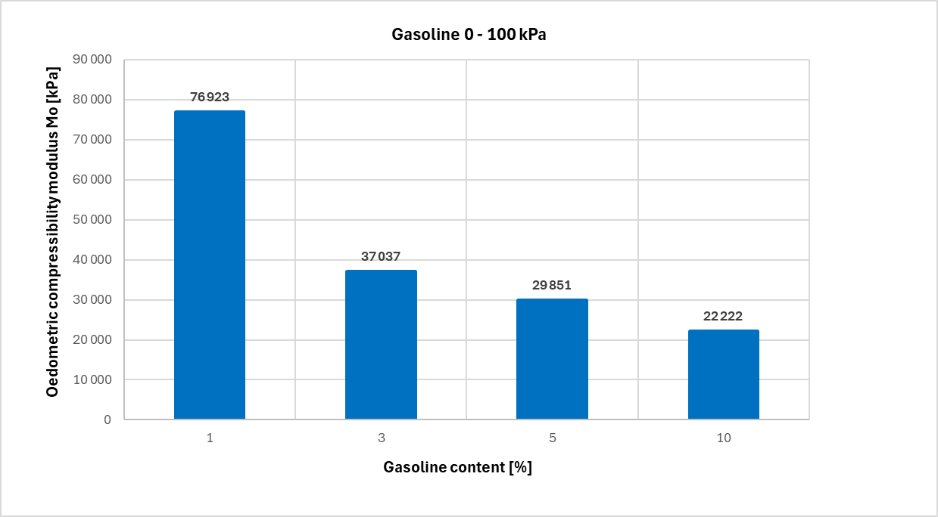

**Fig. 2.** Experimental oedometric compressibility moduli for gasoline-contaminated soil in the stress range of 0-100 kPa

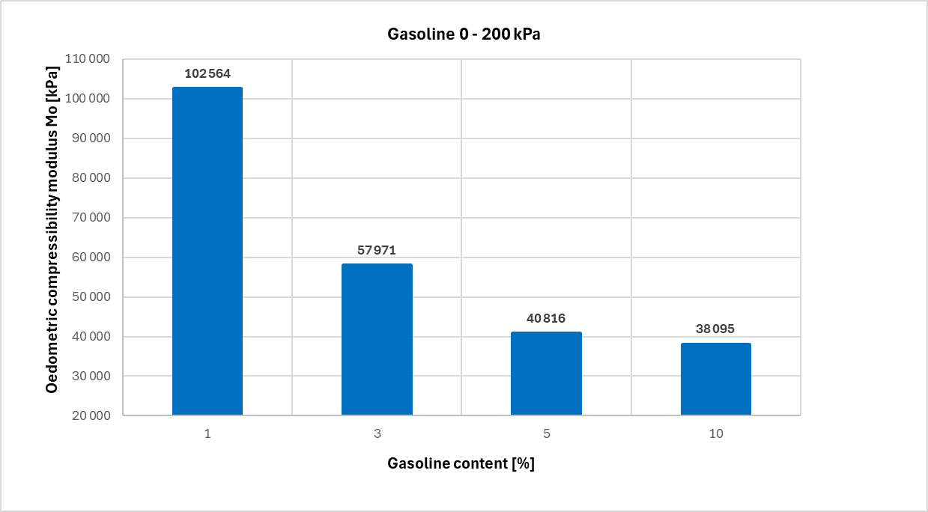

**Fig. 3.** Experimental oedometric compressibility moduli for gasoline-contaminated soil in the stress range 0-200 kPa

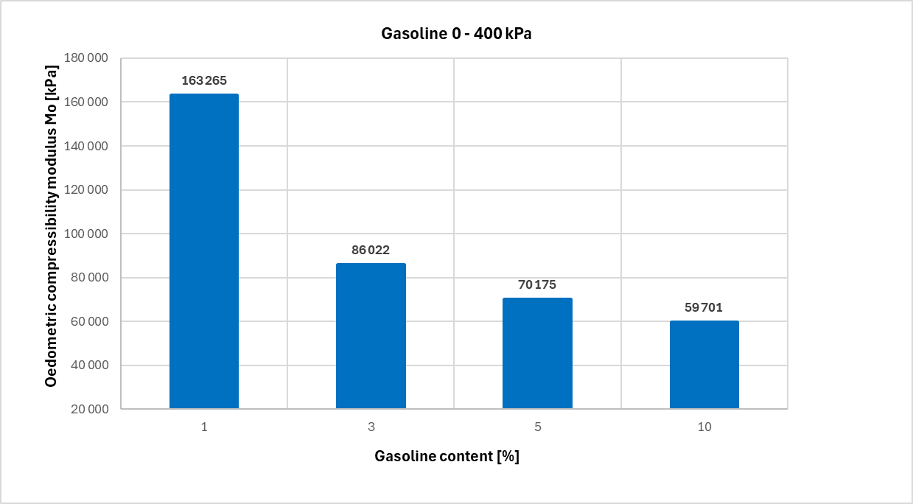

**Fig. 4.** Experimental oedometric compressibility moduli for gasoline-contaminated soil in the stress range 0-400 kPa

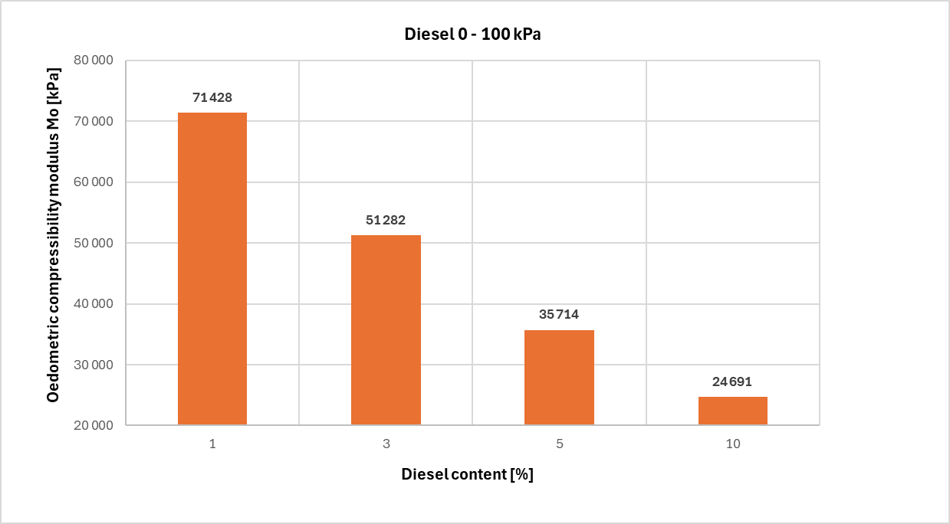

**Fig. 5.** Experimental oedometric compressibility moduli for diesel oil contaminated soil in the stress range 0-100 kPa

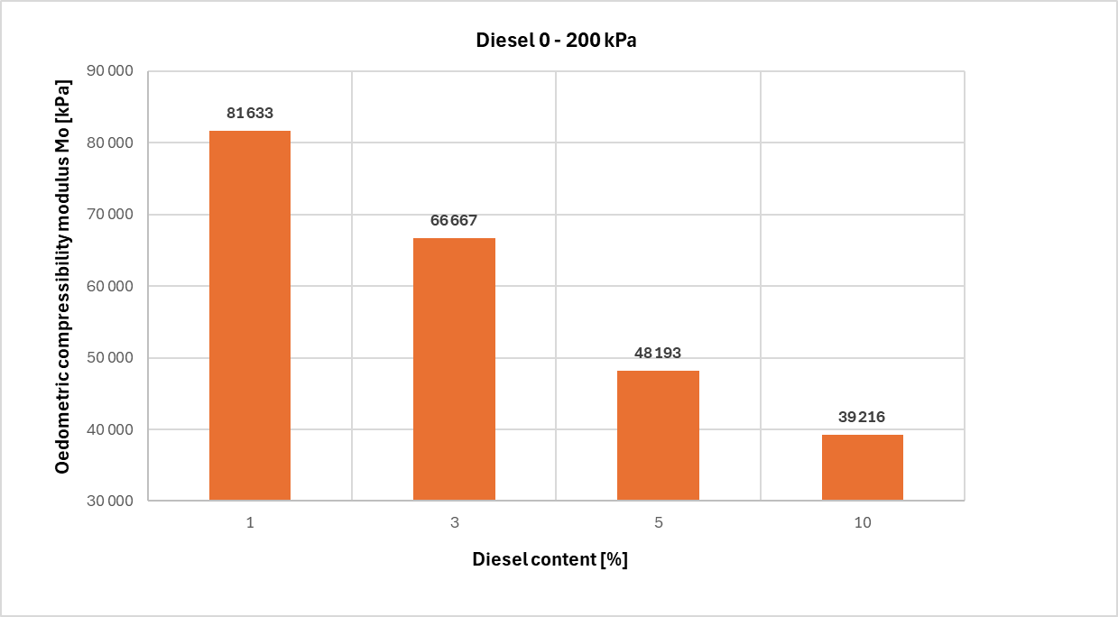

**Fig. 6.** Experimental oedometric compressibility moduli for diesel oil contaminated soil in the stress range 0-200 kPa

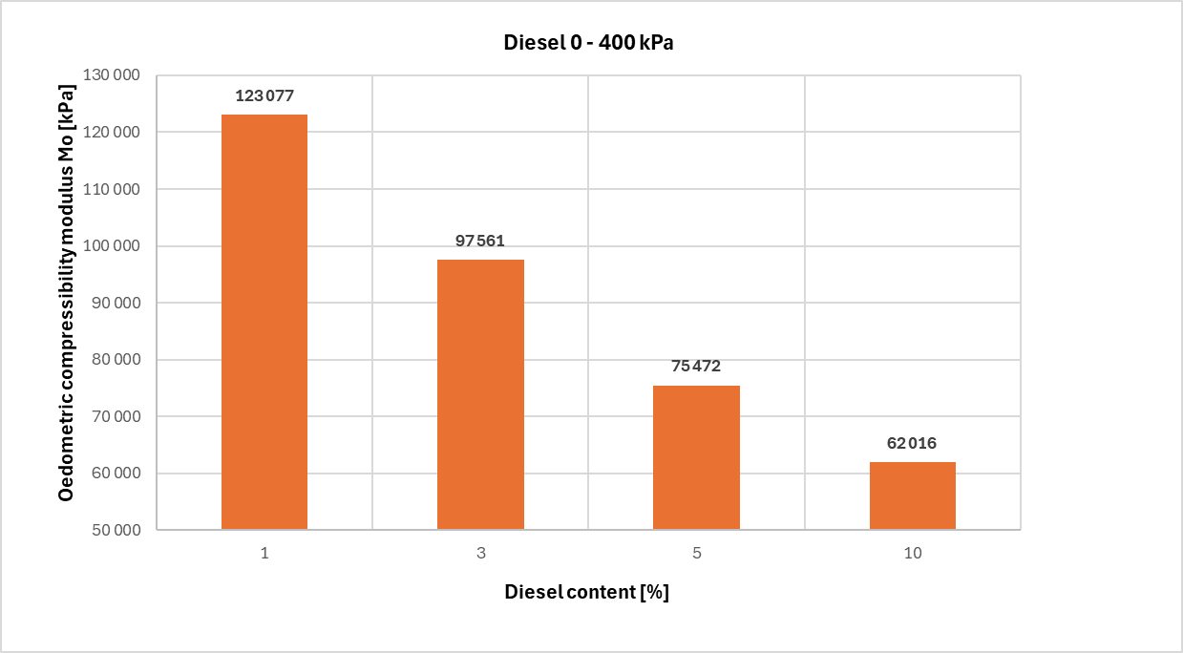

**Fig. 7.** Experimental oedometric compressibility moduli for diesel oil contaminated soil in the stress range 0-400 kPa

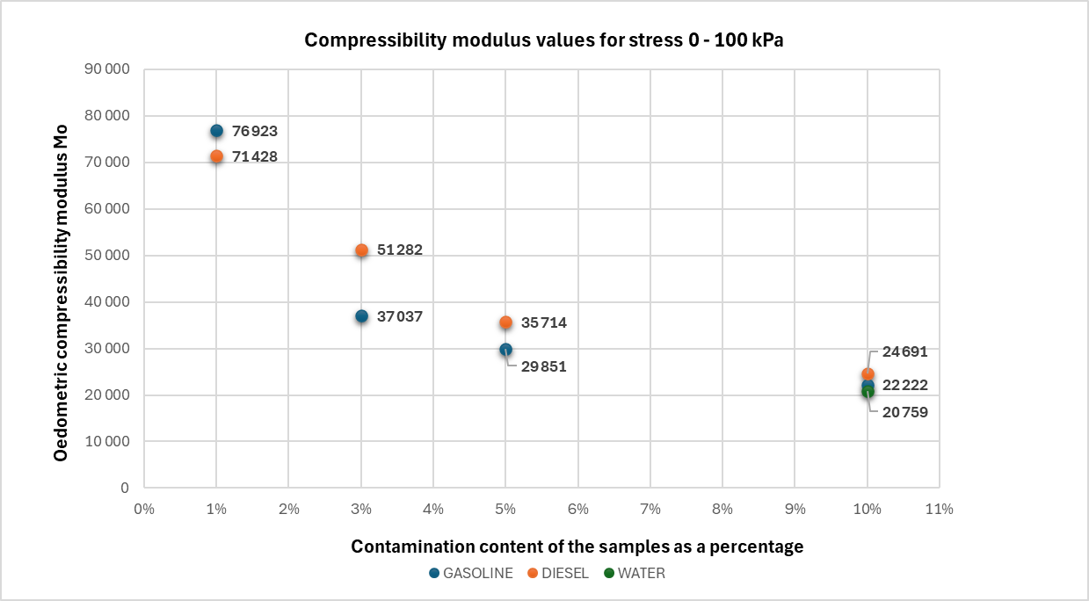

**Fig. 8.** Compressibility moduli of the tested samples with various contamination content for the stress range of 0-100 kPa

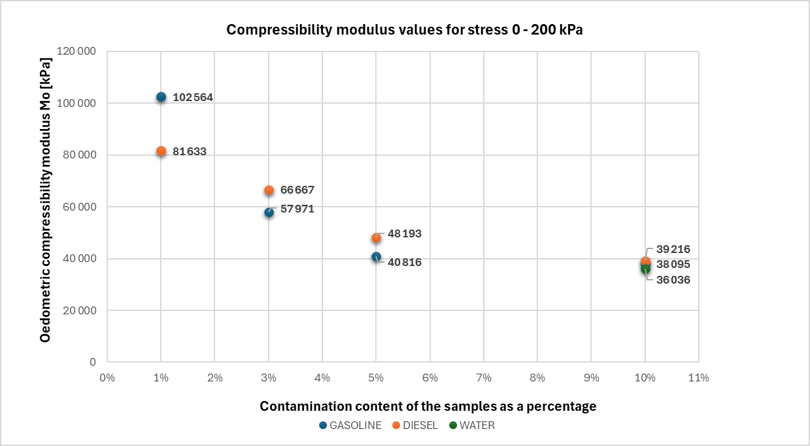

**Fig. 9.** Compressibility moduli of the tested samples with various contamination content for the stress range of 0-200 kPa

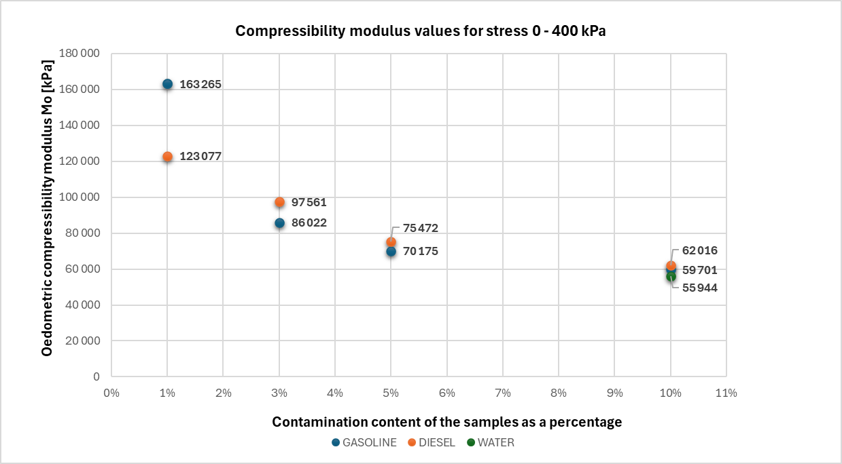

**Fig. 10.** Compressibility moduli of the tested samples with various contamination content for the stress range of 0-400 kPa

**Table 2.** Values of the oedometric compressibility modules for fine sand with 10% water content and petroleum impurities

|  |  |  |  |
| --- | --- | --- | --- |
| Range of applied stress | 0-100 [kPa] | 0-200 [kPa] | 0-400 [kPa] |
| Diesel oil | 24691 | 39216 | 62016 |
| Gasoline | 22222 | 38095 | 59701 |
| Water | 20759 | 36036 | 55944 |

4. Conclusions

The following paper presents the results of an experimental laboratory study to investigate the effect of engine fuel contamination on the oedometric compressibility moduli of fine sand.

The results of the research and their analysis allow the following conclusions to be drawn:

1. Compressibility modulus values decrease with increasing petroleum contaminant content in the soil.
2. For the same pollutant content, a higher modulus value is observed when the pollutant is petrol, regardless of the range of compressive stresses. An inverse relationship was observed when the pollutant contamination was 1%.
3. The content of petroleum contaminants can be a predictor for estimating compressibility modulus values for a known contaminant value, expressed in terms of the ratio of contaminant mass to the soil skeleton mass.
4. For an impurity content of 10%, the compressibility moduli are greater compared to the moduli of the same soil with a moisture content of 10%. This phenomenon requires a detailed study to interpret it. This may be related to the propellant properties, such as viscosity. It may also indicate weaker electrostatic bonds of sand particles with petroleum substances compared to the dipole bonds of water molecules.
5. In engineering practice, contamination of the coarse-grained subsoil with petroleum substances will not bring about its increased settlement.

References

Abu-Khasan M. S., & Makarov Y. I. (2021). Analysis of soil contamination with oil and petroleum products. *Earth and Environmental Science*, *937*, 022046. https://doi.org/10.1088/1755-1315/937/2/022046

Adeniran, M. A., Michael A. Oladunjoye, M. A., & Doro, K. O. (2023). Soil and groundwater contamination by crude oil spillage: A review and implications for remediation projects in Nigeria. *Frontiers in Environmental Science*, *11*. https://doi.org/10.3389/fenvs.2023.1137496

Al-Obaidy, N. K., & Shaia, H. (2019). Evaluation the geotechnical properties of oil-polluted soil from two selected areas in Thi-Qar Governorate-Iraq. *University of Thi-Qar Journal*, *14*(1), 17-30.

Arbili, M. M. A., & Karpuzcu, M. (2018). Effect of Crude Oil Contamination on physical and Chemical Properties of Soil of Tarjan Refineries Erbil Province – North of Iraq. *Polytechnic Journal*, *8*(2), 159-170. https://doi.org/10.25156/ptj.2018.8.2.216

Azam, M. S., Xiao, Z., Mia, M. R., Rahman, M. M., & Zaman, T. (2022). Effects of Oil Contamination on the Geotechnical Properties of Clayey Soil. *Journal of ICT, Design, Engineering and Technological Science*, *6*(2), 8-14. https://doi.org/10.33150/JITDETS-6.2.2

Brzeziński, B., & Olchawa A. (2023). Effects of Contamination with Gasoline and Diesel Oil on Shear Strength of Coarse Grained Soil. *Rocznik Ochrona Środowiska*, *25*, 222-227. <https://doi.org/10.54740/ros.2023.022>

Chmielewski, J., Żeber-Dzikowska, I., Pawlas, K., Nowak-Starz, G., Chojnowska-Ćwiąkała, I., Dębska, A., Szpringer, M., Gworek, B., & Czarny-Działak, M. (2020). Substancje ropopochodne. Zagrożenie dla środowiska i zdrowia w kontekście edukacji ekologicznej. *Przemysł chemiczny*, *1*(6), 39-45. (in Polish) <https://doi.org//10.15199/62.2020.6.1>

Czado, B., Korzeniowska-Rejmer, E., & Pietras, J. S. (2010). Analiza zmian nośności podłoża budowlanego w wyniku jego zanieczyszczenia substancjami ropopochodnymi na przykładzie gruntów piaszczystych. *Górnictwo i Geoinżynieria*, *34*(2). (in Polish)

Gierak, A. (1195). Zagrożenie środowiska produktami ropopochodnymi. *Ochrona Środowiska*, *2*, 31-34.

Guo, Y., & Yu, B. (2017). Characterizing the surface charge of clay minerals with Atomic Force Microscope (AFM). *AIMS Materials Science*, *4*(3), 582-593. <https://doi.org//10.3934/matersci.2017.3.582>

Izdebska-Mucha, D. (2005). Wpływ zanieczyszczeń ropopochodnych na wybrane geologiczno-inżynierskie właściwości gruntów spoistych. *Przegląd Geologiczny*, *53*(9), 766-769. (in Polish)

Karkush, MO., & Abdul Kareem Z. (2017). Investigation the impacts of fuel oil on the geotechnical properties of cohesive soil. *Journal of Engineering*, *21*(4), 127-137.

Korzeniowska-Rejmer, E., & Izdebska-Mucha, D. (2006). Ocena wpływu zanieczyszczeń ropopochodnych na uziarnienie i plastyczność gruntów spoistych. *Inżyniera i Ochrona Środowiska*, *9*(1), 89-103. (in Polish)

Marinescu, M., Toti, M., Tanase, V., Plopeanu, G., Calciu, I., & Marinescu, M. (2011). The effects of crude oil pollution on physical and chemical characteristics of soil. *Research Journal of Agricultural Science*, *43*(3), 125-129.

Mikołajków, J. (2006). Badania przepuszczalności gruntów piaszczystych dla typowych zanieczyszczeń ropopochodnych. *Przegląd Geologiczny*, *54*(11), 993. (in Polish)

Podlasek, A., & Gmur, A. (2024). Laboratory studies on the effects of oil pollution on soil properties. *Acta Sci. Pol. Architectura*, *23*, 319-328.

Sari, G. L., Yulinah Trihadiningrum, Y., & Ni'matuzahroh. (2018). Petroleum Hydrocarbon Pollution in Soil and Surface Water by Public Oil Fields in Wonocolo Sub-district, Indonesia. *Journal of Ecological Engineering*, *19*(2), 184-193. https://doi.org/10.12911/22998993/82800

Surygała, J. (2000). Zanieczyszczenia naftowe w gruncie. Oficyna Wydawnicza Politechniki Wrocławskiej, Wrocław. *Przemysł Chemiczny*, *78*(9), 323-325. (in Polish)

Sutormin, O. S., Goncharov A. S., Kratasyuk, V. A., Petrova, Y. Y., Bajbulatov, R. Y., Yartsov, A. E., & Shpedt, A. A. (2024). Effects of Oil Contamination on Range of Soil Types in Middle Taiga of Western Siberia. MDPI. *Sustainability*. *16*. <https://doi.org/10.3390/su162411204>

Tumanyan, A. F., Tyutyuma, N. V., Bondarenko, A. N., & Shcherbakova, N. A. (2017). Influence of oil pollution on various types of soil. *Chemistry and Technology of Fuels and Oils*, *53*, 369-376.

Van Leeuwen J. L. M. (1995). Sorbtion of organic contaminants to soil in Rotterdam. *Contaminated Soil '95*, Kluwer, 1, 445-452.

Warchałowska, T. (1999). *Analiza zdarzeń mogących spowodować nadzwyczajne zagrożenie środowiska w 1 kw. 1999 r*. Raport GIOŚ, Warszawa. (in Polish)

PN 88/B-04481 Grunty budowlane. Badania próbek gruntu. (in Polish)

PN-EN ISO14688-1:2018-05P Rozpoznanie i badania geotechniczne. Oznaczanie i klasyfikowanie gruntów. Część 1: Oznaczanie i opis. (in Polish)

PN-EN ISO 14688-1:2006 Badania geotechniczne. Oznaczanie i klasyfikowanie gruntów. Część 1: Oznaczanie i opis.