|  |  |  |  |
| --- | --- | --- | --- |
|  |  | | |
| **Rocznik Ochrona Środowiska** | | |
| Volume 27 | Year 2025 ISSN 2720-7501 | pp. 388-401 |
|  | https://doi.org/10.54740/ros.2025.032 open access | | |
|  | Received: March 2025 Accepted: June 2025 Published: August 2025 | | |

Harnessing Agricultural Residues for Eco-Efficient Cement Substitution in Mortar: A Pathway to Low-Carbon and Sustainable Construction

Mohit Verma1, Kunwar Raghvendra Singh2, Nakul Gupta3*, Abdullah Faiz Al Asmari4,   
Rajesh Goyal5, Parveen Berwal6**, Saiful Islam7

1Department of Civil Engineering, GLA University, Mathura, Uttar Pradesh, India

2Department of Civil Engineering, NITTTR Kolkata, India

3NICMAR Institute of Construction Management and Research, Delhi-NCR, Bahadurgarh, Haryana, India

4Civil Engineering Department, College of Engineering, King Khalid University, Abha, Saudi Arabia

5NICMAR Institute of Construction Management and Research, Delhi-NCR, Bahadurgarh, Haryana, India

6Department of Civil Engineering, Galgotias College of Engineering and Technology, Greater Noida, India

7Civil Engineering Department, College of Engineering, King Khalid University, Abha, Saudi Arabia

*corresponding author's e-mail: [nakul.gupta@ncr.nicmar.ac.in](mailto:nakul.gupta@ncr.nicmar.ac.in)  
**corresponding author's e-mail: [parveenberwal@gmail.com](mailto:parveenberwal@gmail.com)

A**bstract:** Several studies have explored the use of agricultural waste materials in construction. Using these materials in building not only eliminates them but also prevents environmental contamination. The purpose of this study is to evaluate the impact of rice husk ash (RHA) as a partial replacement of cement. An assessment was conducted to determine the compressive strength, flexural strength, porosity, water absorption, and density of the hardened samples. Furthermore, the microstructures and chemical compositions of several samples were analyzed using SEM and XRD analysis. The replacement levels of rice husk ash were 0%, 5%, 10%, 15%, 20%, 25%, and 30% by weight of cement. From the findings, it was observed that the possible utilization of RHA was up to 20 percent. The water absorption, porosity, and dry density of RHA mixed mortar samples were observed to increase with the percentage addition of RHA. This is due to the greater number of voids in RHA compared to cement. However, it decreases as curing age increases. XRD and SEM analysis matched the macro-property analysis and helped explain the positive effect of RHA. The linear regression between flexural strength and compressive strength was found to be fcr = 0.1146 fck + 1.0882, with an R² value of 0.9602. The statistical analysis using a dendrogram revealed three distinct cluster formations for the different variables.

**Keywords:** rice husk ash, cement, compressive strength, flexural strength, water absorption

1. Introduction

Environmentalists are concerned about waste reduction and the sustainability of building materials (Bilodeau & Malhotra, 2000). Recently, agricultural by-products such as rice husk ash, sugarcane bagasse ash, palm oil ash, peanut husk ash, agro-industrial wastewater, sesame stalk ash, and dustwood ash have been used as substitutes for cement. Many surveys and studies have been done on these ashes (Abd-Elrahman et al. 2023, Alyami et al. 2023, Amin et al. 2022, Chatveera & Lertwattanaruk 2009, de Azevedo et al. 2022, Foo & Hameed 2009, Ganesan et al. 2007, Hakeem et al. 2022, Maglad et al. 2023, Boora et al. 2023). It has been demonstrated that ash from farms exhibits a strong pozzolanic reaction and can be utilized as an alternative cement ingredient. They can improve the microstructure of the interface transition zone because they have a wide range of particle sizes and can exhibit pozzolanic properties (Davidovits 1988, Duxson et al. 2007, Shah 2017). The study was based on the idea that inexpensive and readily available agro-waste materials could be utilized because they are sustainable (Verma & Singh 2025).

Through the process of sustainable development, the transformation of waste into building materials has emerged as an essential component. Two examples of common industrial wastes used in geopolymers to improve the microstructure and strength of the material are glass powder and red mud (Hu et al. 2018, Nie et al. 2019). Furthermore, recent reviews have extensively examined the role of fibers in enhancing the performance of geopolymer concrete, highlighting their influence on mechanical properties and crack resistance (Sharma et al. 2024). Rice is a primary food source in nations such as China, India, Indonesia, Vietnam, Pakistan, Bangladesh, and Malaysia, due to population habits and favorable weather conditions. Each year, these countries produce a significant amount of rice husk in addition to rice production. The predominant use of rice husk is as a fuel for steam boilers or power production. Incineration of the material may result in a weight contribution of 20% to Rice Husk Ash (RHA) (Anwar et al. 2000, Bie et al. 2015, Mehta 1999).

The rice milling industry produces a by-product known as rice husk. The rice husk primarily consists of lignin, cellulose, silica, and moisture (Thiedeitz et al. 2020). Rice husk ash, also known as RHA, is produced by the combustion of rice husk. When the combustion temperature is lower than 700 degrees Celsius, it is possible to obtain RHA that contains more than 80 percent amorphous silica (Chindaprasirt & Rukzon 2008, Rashid et al. 2010). RHA quality depends on the combustion rate, length, cooling process, and burning temperature. Gradual cooling in an average oxygen supply yields amorphous silica, whereas an oxidizing atmosphere produces crystalline silica. Amorphous silica RHA is more reactive due to its higher porosity and larger surface area. Furthermore, studies have shown that the reactivity of RHA increases as the fineness of the substance increases (Bui et al. 2012).

The availability of rice husk is considerable in countries that are engaged in rice production. More than 130 million tons of rice husk are produced worldwide every year (Vayghan et al. 2012). Rice paddy is typically used to obtain rice husk, which is one of the most important agricultural by-products found in agriculture. Research has demonstrated that one ton of husk is produced for every four tons of rice (Jha & Gill 2006). In most cases, the rice husk produced is allowed to dry thoroughly before being burned, resulting in the emission of carbon dioxide into the atmosphere. For this reason, incorporating leftover rice husk into mortar not only offers environmental benefits but also transforms the mortar into a sustainable material. Several studies have been conducted using rice by-products to enhance the performance of cement-based mortars and concretes for use in building applications. The mechanical and durability properties of cement mortar were stabilized through the utilization of rice husk ash (Sanou et al. 2019). For the purpose of determining the mechanical properties, rice husk ash was applied to mortar, and the results were studied (Pavía et al. 2014). Figure 1 shows the samples and setup to examine compressive and flexural strength.

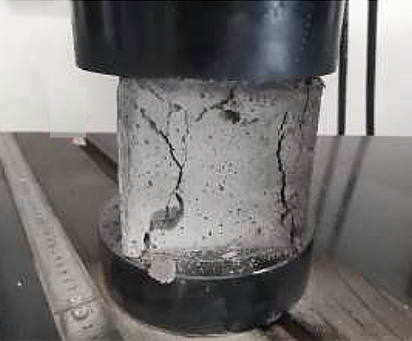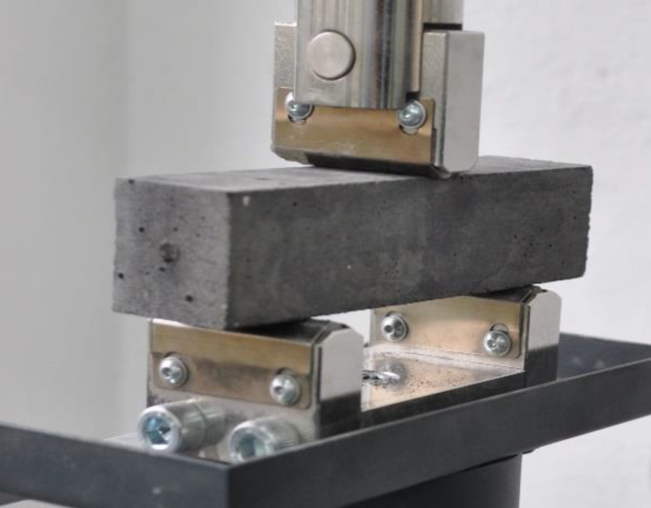

**Fig. 1.** Samples and setup for compressive and flexural strength

The projected rice production volume in India for the financial year 2022 exceeded 130 million metric tons, with the country producing almost 26 million metric tons of rice husk (Arulkumaran et al. 2019). The open disposal of rice husks pollutes water and consumes a significant amount of land. It harms the environment and doesn't generate revenue (Hu et al. 2020). Burning rice husk in the open air is the most popular method of disposing of rice husk. This method generates a substantial amount of rice husk ash waste in remote regions, which adds to air pollution and respiratory problems that are airborne. Due to the poor disposal of RHA waste, this production cannot be considered completely environmentally friendly. It is therefore a sustainable method to utilize such waste resources to generate environmentally friendly building materials (Zhang et al. 2020). Similar strategies have been successfully applied in road construction through the use of recycled aggregates, promoting both environmental conservation and sustainable infrastructure development (Berwal et al. 2024). The results of the study advocate for the utilization of rice husk as a highly sustainable substitute for sand (Mahapatra et al. 2024).

The exploitation of RHA has several essential goals, one of which is to enhance the performance of cement mortar and concrete products. It was stated that the compressive strength of cement can rise by up to 6% when 10% RHA is substituted for cement, but that the compressive strength decreases when more than 10% RHA is substituted (Bheel et al. 2018). The study demonstrated that a mortar composed of discarded rice husk ash and coconut coir fiber had enhanced flexural strength, thermal properties, cost-effectiveness, and sustainability. (Silva & Naveen 2024).

In the manufacturing process of self-compacting concrete, a significant amount of RHA was used as a replacement for fine ground aggregate (Sua-iam & Makul 2014). The researchers found that SCC with 20% fine aggregate and 25% RHA had a compressive strength greater than 40 MPa after 180 days. Additional research indicates that RHA enhances the mechanical characteristics and durability of concrete (Madandoust & Ghavidel 2013). On the other hand, there is a paucity of information regarding the RHA's detailed effect on durability, such as sulfate resistance, as well as the process by which it contributes to the formation of the concrete's microstructure. Furthermore, throughout the process of exploring sustainable building materials, the most important issues being taken into consideration are the cost analysis and the environmental friendliness of utilizing RHA. The reduction in the cost of cement and concrete that can be achieved via the utilization of certain substitutes of RHA has only been proved in a limited quantity of published literature. In the case of cement, for instance, it has been established that the cost of cement can be lowered by 31.5% when 25% RHA is substituted (Gastaldini et al. 2009, Khan et al. 2012). However, few studies have shown the environmental impact of RHA in concrete. Adding extracted micro silica (EMS) enhanced the consistency of the cement paste. Compared to OPC, EMS has a low specific gravity and a large specific surface area, requiring more water for typical flow (Khan et al. 2020). At all curing ages, substituting 50% recycled glass (RG) for sand led to decreased flexural and compressive strength. The use of RHA in RG-incorporated samples resulted in enhanced flexural and compressive strength after 28 days of curing. The highest strength was attained by substituting 30% of cement with RHA (Nasiru et al. 2021).

The substitution of Ordinary Portland Cement (OPC) with fly ash in cement mortar, ranging from 0% to 30%, is a significant research focus aimed at addressing environmental and performance-related issues in modern construction materials. This work is highly significant in reducing the carbon footprint. Replacing up to 30% of cement with fly ash. Fly ash is a by-product of coal combustion in power generation stations. Its incorporation into cement mortar improves waste recycling and diminishes landfill demand. Fly ash is frequently less expensive than Ordinary Portland Cement (OPC). Substituting a fraction of cement reduces the total material expense of mortar. At reduced replacement levels (5-15%), fly ash enhances workability owing to its spherical particle morphology and finer texture.

Despite extensive studies on the utilization of fly ash as a partial substitute for cement in mortar and concrete, significant gaps remain. Recognizing these gaps informs the trajectory and significance of the current study, facilitating the advancement of more effective and sustainable construction methodologies. Most previous studies emphasize low to moderate levels of fly ash replacement (often 10-20%). Research frequently prioritizes compressive strength exclusively. Crucial factors, such as workability, water absorption, durability, setting time, and microstructural behavior (SEM/XRD), are either inadequately addressed or overlooked. Numerous studies assess qualities solely at 28 days, neglecting long-term performance (56, 90 days), during which fly ash exhibits improved pozzolanic effects. Authors could also add failure analysis to strengthen the study.

2. Materials and Methods

2.1. Materials

Ordinary Portland cement (OPC) with 53 grade was employed as a binding agent to confirm Type I of the Indian Standard. The whole contents of the mortar were composed of river sand that had a size range of less than 1.18 millimeters.

For the purpose of this investigation, the RHA utilized was direct waste material produced by the boiler of the rice mill facility. The RHA was manufactured using regulated heat of combustion. The production of highly reactive RHA occurs when the combustion temperature is set at 500°C for two hours under regulated conditions. The RHA was stored in a controlled condition furnace at a temperature of 500°C for a duration of 2 hours to generate the RHA.

**Table 1.** Physical properties of materials

|  |  |  |  |
| --- | --- | --- | --- |
| Type of sample | Specific gravity | Blaine fineness (m2/g) | Specific surface area (m2/cm3) |
| OPC (Ordinary Portland cement) | 3.12 | 0.361 | 0.724 |
| RHA (Rice husk Ash) | 2.16 | 0.76 | 1.668 |
| NS (Natural Sand) | 2.61 | 0.88 | – |

The physical characteristics of regular Portland cement, rice husk ash, and natural sand are presented in Table 1. Using a laser particle size analyzer, the particle size distribution of cement and RHA was analyzed in a liquid condition. Hydroxyapatite (RHA) and cement were dispersed in water and ethanol, utilizing ultrasonic treatment equipment. Figure 2 illustrates the distribution of particle sizes for both RHA and cement.

**Fig. 2.** Particle size distribution of RHA and cement

2.2. Mix design and mortar preparation

In this work, the mortar mixes were formulated using a 1:2 cement-to-sand ratio, following the standard guidelines for wall plaster. Partial substitution of cement with rice husk ash was employed, with weight percentages ranging from 0% to 30%. The dry components, including cement, river sand, and RHA, were first combined for a period of five minutes. Following the addition of water, the mixture was agitated for 5 minutes using a mechanical mixer at an angular velocity of 50 rpm. Once the mixture had achieved a homogenized state, it was poured into the molds. The water-cement ratio was maintained at 0.5 throughout the investigation for the mortar. The chemical composition of OPC, RHA, and natural sand (NS) is tabulated in Table 2.

**Table 2.** Chemical composition of materials

|  |  |  |  |  |  |  |  |  |
| --- | --- | --- | --- | --- | --- | --- | --- | --- |
| Materials | SiO2 | Al2O3 | CaO | Fe2O3 | K2O | SO3 | MgO | LOI |
| OPC | 19.03 | 4.21 | 66.06 | 3.16 | 0.34 | 2.74 | 2.54 | 2.11 |
| RHA | 89.91 | 0.13 | 0.76 | 0.95 | 2.75 | 0.83 | 0.3 | 2.99 |
| NS | 92.91 | 3.8 | 0.34 | 1.01 | 0.92 | - | 0.1 | 0.76 |

2.3. Mix proportions

The replacement of cement by rice husk ash (RHA) was 0%, 5%, 10%, 15%, 20%, 25%, and 30% by weight. Based on this replacement level, the samples are designated as shown in Table 3. RH stands for rice husk ash, followed by the percentage of replacement with cement.

**Table 3.** Mix Constituents and designation

|  |  |  |  |  |  |  |  |
| --- | --- | --- | --- | --- | --- | --- | --- |
| Sample ID | RH-00 | RH-05 | RH-10 | RH-15 | RH-20 | RH-25 | RH-30 |
| RHA (%) | 0 | 5 | 10 | 15 | 20 | 25 | 30 |
| OPC (%) | 100 | 95 | 90 | 85 | 80 | 75 | 70 |

2.4. Sample preparation

The rice husk was incinerated in a controlled furnace to determine the optimal settings for both temperature and combustion duration. This was undertaken to optimize the efficiency of the combustion process. As part of the initial phase of this investigation, the temperature was raised by 100°C every hour. Following each hour, the sample, which weighed 500 grams, was removed from the furnace, allowed to cool, and then weighed. The results were then represented as a percentage based on the weight of the sample after it had been dried at 105°C. A sample of 200 grams of rice husks that had been dried at 105°C was burned at 200, 300, 400, 500, 600, 700, and 800°C. This was done to determine the most suitable burning time. After 2 hours of burning, the sample was withdrawn from the furnace, allowed to cool, and then weighed. This was done for each of the different burning temperatures. After that, the difference in weight was calculated. Figure 3 shows the characteristics of rice husk on ignition with respect to dry husks at 105°C.

A customized Los Angeles machine was used to accomplish the grinding process. The material, weighing one kilogram, was burned at 500°C for two hours.

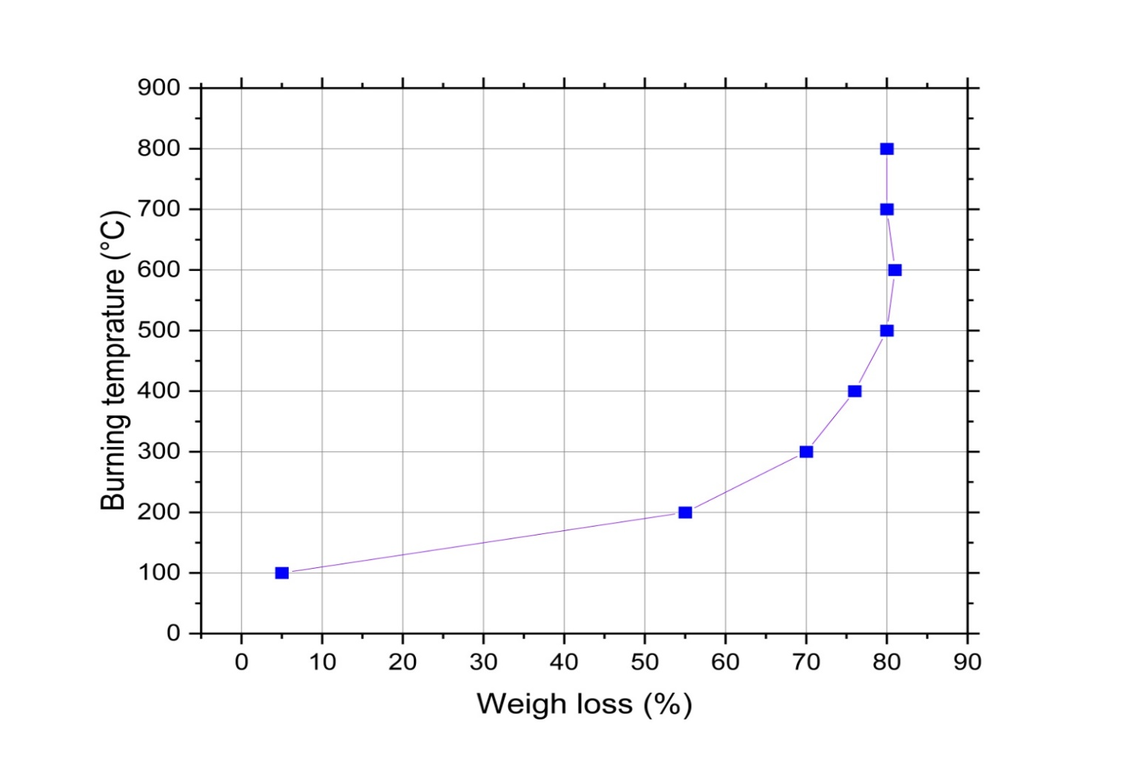

**Fig. 3.** Characteristics of rice husk on ignition with respect to dry husks at 105°C

2.5. Characterization of rice husk ash (RHA)

An automated general-purpose X-ray diffraction device was used to investigate the mineralogy of the finely ground RHA and to determine its crystalline phase. The scanning range lasted for 2 hours and spanned from 10 to 80 units, with a scanning speed of 5 units per minute.

Figure 4 displays the XRD patterns of RHA. The prominent peak observed at approximately 22 degrees was indicative of -cristobalite, the high-temperature phase of silicon dioxide. Conventionally, the diffractogram shows clear and well defined peaks for the crystalline phases, whereas a single broad peak indicates the amorphous phases. Given that the region beneath the wide peak was considerably larger than that beneath the crystalline peaks, it may be concluded that the recalcinated RHA mainly consisted of amorphous SiO2. This finding was consistent with a prior investigation.

|  |  |
| --- | --- |
| C:\Users\gla\AppData\Local\Microsoft\Windows\INetCache\Content.Word\XRD patterns of RHA.JPG | C:\Users\gla\AppData\Local\Microsoft\Windows\INetCache\Content.Word\SEM Image of RHA.JPG |
| **Fig. 4.** XRD pattern of RHA | **Fig. 5.** SEM image of RHA |

Both RHA and mortar samples were examined for their morphology using a scanning electron microscope (SEM). A scanning electron microscopy (SEM) image of the recalcinated RHA is shown in Figure 5. It is evident that the controlled burning and grinding situation resulted in the production of primarily tiny particles, which indicates a high specific surface area. Additionally, a small number of sizable particles with non-uniform forms were acquired. The high prevalence of tiny RHA particles ensured a strong pozzolanic characteristic.

3. Test Results and Discussion

3.1. Dry Density

Figure 6 shows the experimental data on the dry density of RHA-based cement mortar after 28 days of curing. It is evident from the graph that the dry density decreases with an increase in the percentage of RHA content. It decreases continuously and was decreased by 24.54% for RHA 30% replacement compared to the control mix mortar. This is due to the lower density of rice husk ash as compared to cement. It is advantageous to produce lightweight mortar due to its lower dry density.

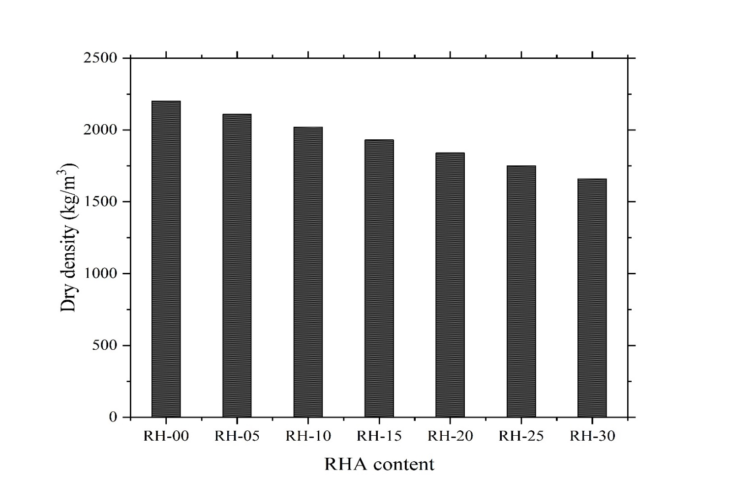

**Fig. 6.** Dry density of RHA mixed cement mortar for various replacements

3.2. Water absorption

Figure 7 illustrates the outcomes of water absorption tests conducted on RHA mixed mortar after 7, 28, and 90 days of curing. These experiments were conducted at various time intervals. Empirical evidence has shown that the water absorption percentage of RHA mortar samples decreases as the curing age progresses from early to later stages throughout the mortar hardening process, when submerged in water.

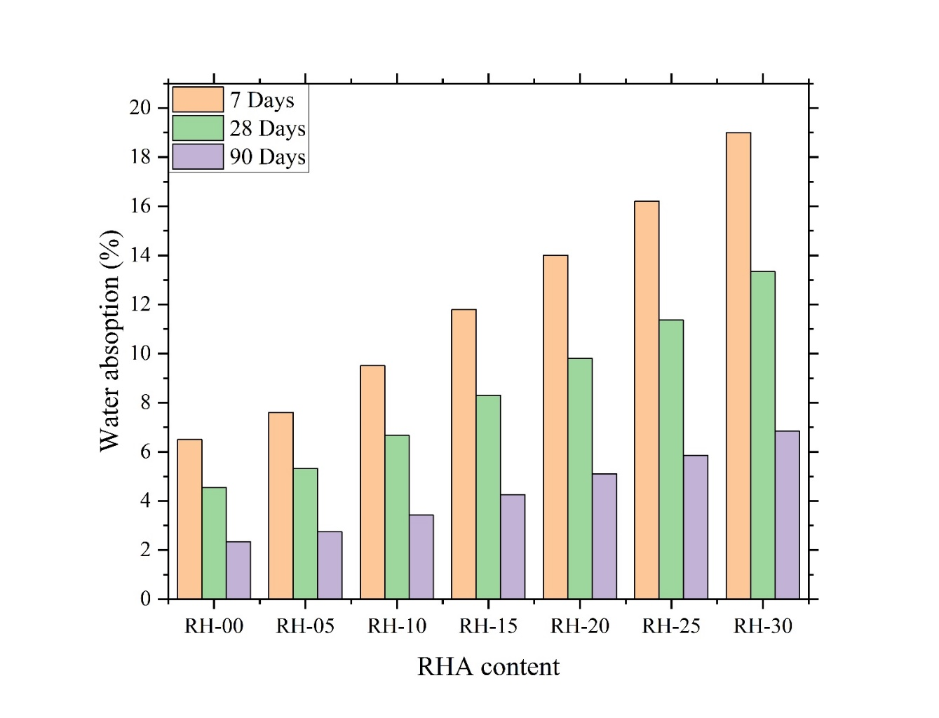

**Fig. 7.** Water absorption of cement mortar samples for different curing ages

At 7 days, the water absorption of the control mix mortar was 6.5%, which decreased continuously and reached 2.34% at 90 days of curing. The water absorption increases as the percentage of RHA in the mortar mix increases. It was 6.84% for a 30% replacement of cement at 90 days of testing. Thus, an increased amount of RHA replacement leads to a larger absorbed water content of the mortar. Moreover, the workability of RHA mixed mortar declines as the replacement amount increases due to its high specific surface area.

3.3. Porosity

RHA mix mortars were tested for total porosity using Mercury Intrusion Porosimetry (MIP) at 7, 28, and 90 days of curing. Figure 8 shows complete RHA mix mortar porosity at different curing ages. As the curing age of RHA mixed mortar increases, the porosity decreases. This is due to the pozzolanic reaction and the formation of a strong calcium silicate hydrate bond, which creates a homogeneous microstructure at later ages.

The porosity decreases as the RHA content in the mixed mortar increases. It was 8.64% for normal mortar and increased to 21.6% for RH-30 at 90 days of testing.

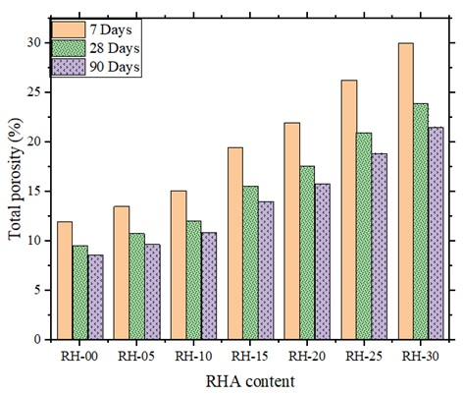

**Fig. 8.** Porosity of RHA mix cement mortar

Previous research on the dry density, water absorption, and porosity of concrete also draws the same conclusion when RHA is incorporated as a cement substitute. Selvaranjan et al. and Khan Kaffayatullah et al. studied the effect of rice husk ash and microsilica extracted from RHA on the development of sustainable mortar. The conclusion from their research justifies the results obtained during our experimental investigation (Khan et al. 2020, Selvaranjan et al. 2021).

3.4. SEM

Figure 9(a) displays the scanning electron microscope pictures of the plain mortar, and Figure 9(b) displays the SEM of mortar blended with rice husk ash. The inclusion of RHA results in a more compact structure with reduced porosity, as indicated by the data. When the sample is combined with both RHA, the water absorption coefficient is further lowered. This is likely due to the ability of RHA to penetrate small pores, allowing the RHA to generate more C-S-H gel and decrease porosity.

|  |  |
| --- | --- |
| C:\Users\gla\AppData\Local\Microsoft\Windows\INetCache\Content.Word\SEM plain cement mortar.jpg | C:\Users\gla\AppData\Local\Microsoft\Windows\INetCache\Content.Word\SEM cement mortar with RHA.JPG |
| **Fig. 9(a).** SEM of plain Mortar | **Fig. 9(b).** SEM of Mortar blended with RHA |

3.5. Compressive strength

The compressive strength of mortar, including RHA as a partial substitute for cement, is depicted in Figure 10. Clearly, the results indicate that the compressive strength diminishes as the fraction of RHA increases for an early age of 7 days. After 28 days of testing, the compressive strength increases by up to 20 percent with a 20 percent replacement of RHA with cement compared to the control mortar. The positive trends continued after the RHA mortar had been allowed to cure for a period of 90 days. This is due to an increase in density and a decrease in porosity as the replacement level of RHA increases with cement. The plot indicates that the compressive strength decreases when the replacement level exceeds 20 percent. This is due to the non-reactive RHA present in the mixed mortar. Through pozzolanic and filler action, it is widely recognized that incorporating finer RHA into concrete and mortar results in an increase in the material's compressive strength. Therefore, the utilization of RHA, whether of smaller or finer size, in mortar results in a significant increase in compressive strength due to its pozzolanic and filler activity.

The analysis of Chindaprasirt and Rukzon corroborates the conclusions. Investigation revealed that finer RHA had a higher affinity for CH. Furthermore, it has been demonstrated that the proper organization of smaller RHA particles enhances the compressive strength through the filler effect (Chindaprasirt & Rukzon 2015).

Rice husk ash (RHA) is a highly pozzolanic material rich in amorphous silica, making it suitable as a supplementary cementitious material (SCM). It improves strength and durability when used correctly. However, improper usage or unfavourable conditions can lead to the failure of the cement mortar. Rice husk ash-based cement mortar shows a reduction in early-day strength when the replacement level increases. The mortar with excessive rice husk ash shows weak interfacial transition zones between the paste and aggregate.

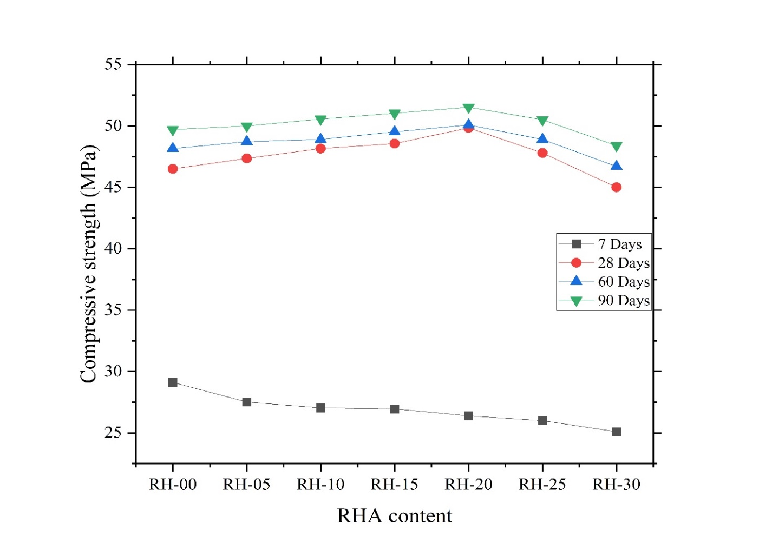

**Fig. 10.** Compressive strength of RHA mixed cement mortar

3.6. Flexural strength

The flexural strength of RHA-based cement mortar was calculated using a prism specimen of size 40×40×160 mm.

The specimens underwent testing at 7, 28, and 90 days of cure using a universal testing machine at a constant loading rate. The flexural strength decreases as the percentage replacement of RHA increases at 7 days of testing, as shown in Figure 11. The flexural strength increases by up to 15% and 20% with 28% and 90-day testing, respectively, for a 15% and 20% replacement of cement by RHA. The flexural strength increases by 6.55% compared to the control mortar for a 20% replacement of cement by RHA at 90 days of testing. This is due to low water absorption, low porosity, and high density. The partial substitution of cement with RHA results in a decrease in the C3S compound, which is crucial for the early development of strength.

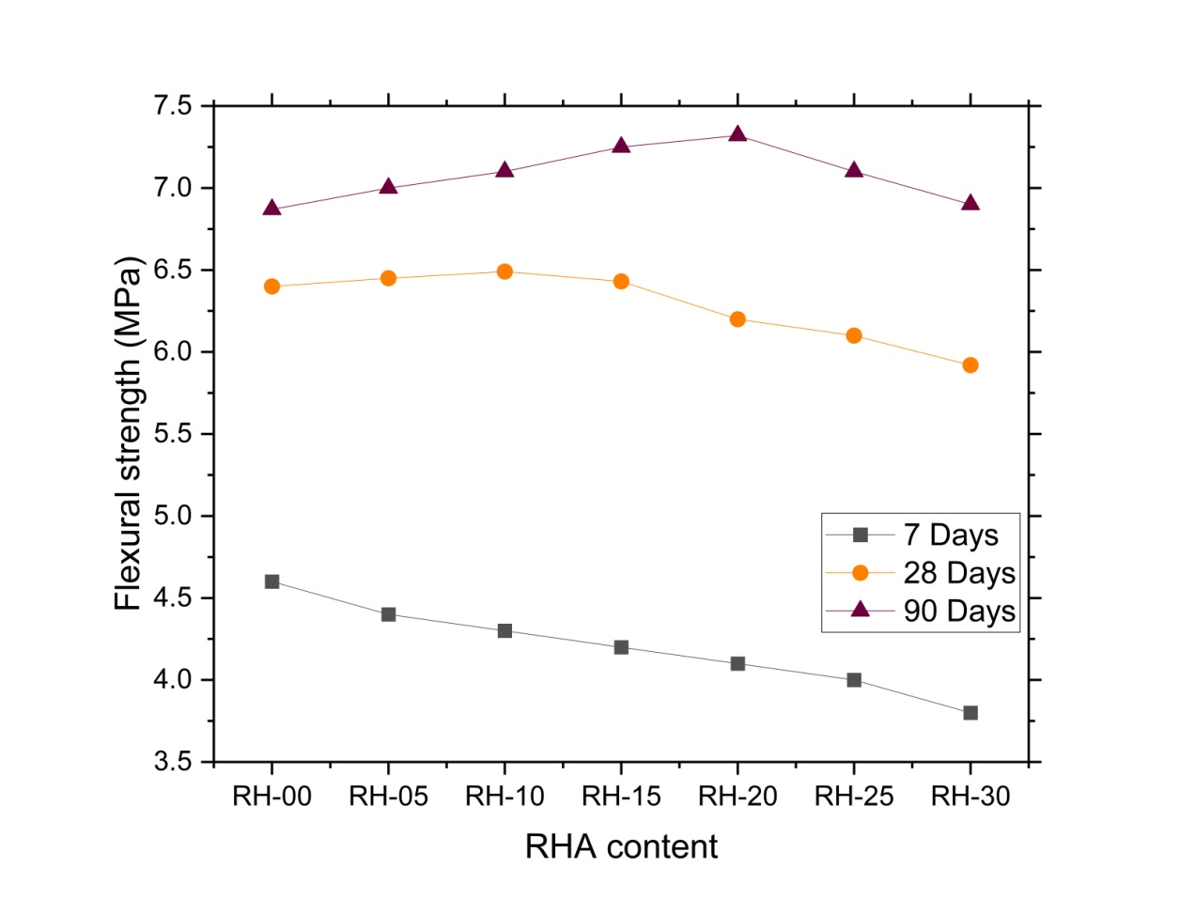

**Fig. 11.** Flexural strength of RHA mixed cement mortar

Similar results of compressive strength and flexural strength have been obtained by M. Jamil et al. The results suggest that the impact of RHA on the characteristics of mortar is primarily determined by the pozzolanic reaction of RHA, which is significantly influenced by its particle size (Jamil et al. 2016).

3.7. Statistical analysis of the correlation between fcr and fck

According to the Indian Standard, IS 456:200, the flexural strength can be calculated using the empirical formula fcr = 0.7×√fck, where fck represents the compressive strength of concrete. Figure 12 illustrates the linear regression between the flexural strength and compressive strength of concrete. Based on the experimental data, it can be observed that the flexural strength is determined by the equation fcr = 0.1146 fck + 1.0882, with an R² value of 0.9602.

**Fig. 12.** Linear regression between flexural and compressive strength

**Table 4.** Descriptive summary for RHA mixed Mortar

|  |  |  |  |  |  |
| --- | --- | --- | --- | --- | --- |
| Variable (N) | Mean | Standard Deviation | Minimum | Median | Maximum |
| Dry Density | 1930 | 194.42 | 1660 | 1930 | 2200 |
| Water Absorption | 2.07 | 0.32 | 1.72 | 2.03 | 2.6 |
| Porosity | 1.90 | 0.90 | 1.05 | 1.7 | 3.4 |
| Compressive Strength | 50.24 | 1.01 | 48.4 | 50.5 | 51.52 |
| Flexural Strength | 7.08 | 0.16 | 6.87 | 7.1 | 7.32 |

Table 4 represents a descriptive summary of the dry density, water absorption, porosity, compressive strength, and flexural strength of RHA mixed mortar after 90 days of testing. The mean value of dry density was 1930 kg/m3 and was maximum for sample RH-00. The mean value of water absorption was 2.07 percent, with a standard deviation of 0.32. The minimum porosity value was 1.05 for sample RH-30. The maximum value of compressive and flexural strength was 51.52 and 7.32 MPa for sample RH-20 with standard deviation 1.01 and 0.16, respectively. Other statistical values, such as minimum, maximum, mean, standard deviation, and median, are presented in Table 4.

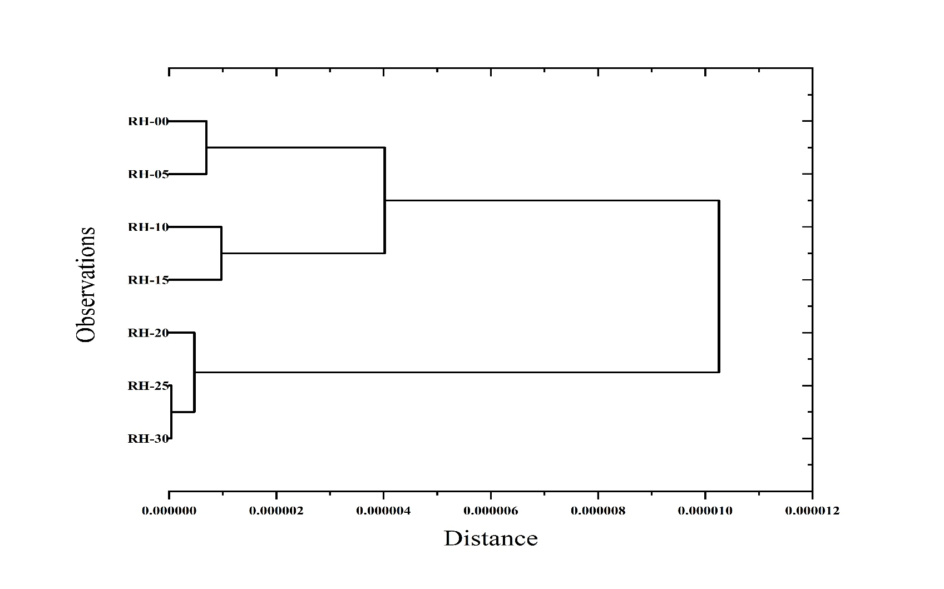

**Fig. 13.** Clustering analysis

Cluster analysis is a critical statistical method utilized to classify datasets into distinct groups based on inherent similarities. In the present study, cluster analysis was applied to categorize data pertaining to the properties of RH-based mortar after 90 days of curing, as shown in Figure 13. This approach facilitated the identification of associations and patterns within the dataset. The analysis produced a dendrogram, which visually represented the clustering of the data. For this analysis, five parameters (dry density, water absorption, porosity, compressive strength, and flexural strength) have been used. Based on the dendrogram, it was observed that three clusters were formed. The first cluster was formed by RH-00 and RH-05, which exhibit the same behavior. The mortar specimens containing 10, 15, 20, and 25 percent RHA exhibited similar characteristics and were grouped into the same cluster. In contrast, the specimens containing RHA at 25 and 30 percent formed a distinct group. Furthermore, the specimens containing 0 and 5 percent RHA demonstrated comparable behavior and were clustered together in a separate group.

4. Conclusion

The purpose of this study was to investigate the physical and chemical impacts of RHA resulting from controlled combustion on the strength of mortar and the creation of microstructures. The results of the investigation led to the following conclusions:

1. An analysis found that rice husk ash mortars had significantly lower embodied carbon dioxide emissions and energy consumption compared to reference mortars, making them more environmentally friendly.
2. Rice husk was burned at different temperatures for 2 hours. Weight loss was obtained. The ignition temperature of rice husk was 500°C.
3. The dry density, water absorption, and Porosity of RHA mixed cement mortar decreased with an increase in the percentage of RHA in the mortar. It was observed that these values also decrease as the curing age increases.
4. Adding RHA to mortar specimens increases their compressive strength due to filler and pozzolanic effects. The optimum level of replacement of RHA in RHA mix cement mortar was 20 percent. However, at an early age, the compressive strength decreases due to the pozzolanic reaction of RHA having little impact on mortar strength development. The RHA pozzolanic reaction is influenced by particle size, cement replacement levels, and the age of curing.
5. The flexural strength of RHA-based cement mortar increases with the partial replacement of cement by RHA. The optimum level of RHA was found to be 20 percent. It increased due to the increased pozzolanic and filler properties of the ash. However, the flexural strength decreases at an early age due to the tri-calcium silicate compound, which is responsible for early strength.
6. Introducing RHA as a microfiller and generating secondary C-S-H gels through RHA-induced pozzolanic reactions enhances the mechanical characteristics of materials containing RHA.
7. Confirmation of the absence of CH in RHA samples resulting from the pozzolanic reaction was achieved through XRD and SEM examination.
8. Test results obtained from statistical analysis and a dendrogram show that the variables are clustered into three distinct groups.

*The authors extend their appreciation to the Deanship of Research and Scientific Studies at King Khalid University for funding this work through large group Research Project under grant number RGP2/306/45.*

References

Abd-Elrahman, M. H., Agwa, I. S., Mostafa, S. A., & Youssf, O. (2023). Effect of utilizing peanut husk ash on the properties of ultra-high strength concrete. *Construction and Building Materials*, *384*, 131398.

Alyami, M., Hakeem, I. Y., Amin, M., Zeyad, A. M., Tayeh, B. A., & Agwa, I. S. (2023). Effect of agricultural olive, rice husk and sugarcane leaf waste ashes on sustainable ultra-high-performance concrete. *Journal of Building Engineering*, *72*, 106689.

Amin, M., Attia, M. M., Agwa, I. S., Elsakhawy, Y., Abu El-hassan, K., & Abdelsalam, B. A. (2022). Effects of sugarcane bagasse ash and nano eggshell powder on high-strength concrete properties. *Case Studies in Construction Materials*, *17*, e01528.

Anwar, M., Miyagawa, T., & Gaweesh, M. (2000). Using rice husk ash as a cement replacement material in concrete. In *Waste management series* (Vol. 1, pp. 671-684). Elsevier.

Arulkumaran, K., Suthan, S., Pallewatta, T. M., Nishanthini, A., & Dolage, D. A. R. (2019). *Optimum level of partial replacement of cement with ground rice husk ash (GRHA) in concrete*.

Berwal, P., Gupta, N., Kumar, R., Sherif, E., & Kumar, A. (2024). Environmental Conservation by Using Recycled Aggregates: Enhancing Sustainability in Road Construction. *Rocznik Ochrona Środowiska*. *6*. 510-524. https://doi.org/10.54740/ros.2024.047

Bheel, N., Meghwar, S. L., Sohu, S., Khoso, A. R., Kumar, A., & Shaikh, Z. H. (2018). Experimental study on recycled concrete aggregates with rice husk ash as partial cement replacement. *Civil Engineering Journal*, *4*(10), 2305-2314.

Bie, R.-S., Song, X.-F., Liu, Q.-Q., Ji, X.-Y., & Chen, P. (2015). Studies on effects of burning conditions and rice husk ash (RHA) blending amount on the mechanical behavior of cement. *Cement and Concrete Composites*, *55*, 162-168.

Bilodeau, A., & Malhotra, V. M. (2000). High-volume fly ash system: concrete solution for sustainable development. *Materials Journal*, *97*(1), 41-48.

Boora A., Rani, K., Suthar, M., Rana, R., Berwal, P., Al Asmari AFS, Khan, M. A. & Saiful Islam (2023). Slag and Bagasee Ash: a potential binder for sustainable rigid binder. *ACS Omega*, *8*, 32867-32876. https://doi.org/10.1021/acsomega.3c04089

Bui, L. A., Chen, C., Hwang, C., & Wu, W. (2012). Effect of silica forms in rice husk ash on the properties of concrete. *International Journal of Minerals, Metallurgy, and Materials*, *19*, 252-258.

Chatveera, B., & Lertwattanaruk, P. (2009). Evaluation of sulfate resistance of cement mortars containing black rice husk ash. *Journal of Environmental Management*, *90*(3), 1435-1441.

Chindaprasirt, P., & Rukzon, S. (2008). Strength, porosity and corrosion resistance of ternary blend Portland cement, rice husk ash and fly ash mortar. *Construction and Building Materials*, *22*(8), 1601-1606.

Chindaprasirt, P., & Rukzon, S. (2015). Strength and chloride resistance of the blended Portland cement mortar containing rice husk ash and ground river sand. *Materials and Structures*, *48*, 3771-3777.

Davidovits, J. (1988). Geopolymers of the first generation: SILIFACE-Process. *Geopolymer*, *88*(1), 49-67.

de Azevedo, A. R. G., Amin, M., Hadzima-Nyarko, M., Agwa, I. S., Zeyad, A. M., Tayeh, B. A., & Adesina, A. (2022). Possibilities for the application of agro-industrial wastes in cementitious materials: A brief review of the Brazilian perspective. *Cleaner Materials*, *3*, 100040.

Duxson, P., Fernández-Jiménez, A., Provis, J. L., Lukey, G. C., Palomo, A., & van Deventer, J. S. J. (2007). Geopolymer technology: the current state of the art. *Journal of Materials Science*, *42*, 2917-2933.

Foo, K. Y., & Hameed, B. H. (2009). Value-added utilization of oil palm ash: A superior recycling of the industrial agricultural waste. *Journal of Hazardous Materials*, *172*(2-3), 523-531.

Ganesan, K., Rajagopal, K., & Thangavel, K. (2007). Evaluation of bagasse ash as supplementary cementitious material. *Cement and Concrete Composites*, *29*(6), 515-524.

Gastaldini, A. L. G., Isaia, G. C., Hoppe, T. F., Missau, F., & Saciloto, A. P. (2009). Influence of the use of rice husk ash on the electrical resistivity of concrete: a technical and economic feasibility study. *Construction and Building Materials*, *23*(11), 3411-3419.

Hakeem, I. Y., Amin, M., Zeyad, A. M., Tayeh, B. A., Maglad, A. M., & Agwa, I. S. (2022). Effects of nano sized sesame stalk and rice straw ashes on high-strength concrete properties. *Journal of Cleaner Production*, *370*, 133542.

Hu, L., He, Z., & Zhang, S. (2020). Sustainable use of rice husk ash in cement-based materials: Environmental evaluation and performance improvement. *Journal of Cleaner Production*, *264*, 121744.

Hu, W., Nie, Q., Huang, B., Shu, X., & He, Q. (2018). Mechanical and microstructural characterization of geopolymers derived from red mud and fly ashes. *Journal of Cleaner Production*, *186*, 799-806.

Jamil, M., Khan, M. N. N., Karim, M. R., Kaish, A. B. M. A., & Zain, M. F. M. (2016). Physical and chemical contributions of Rice Husk Ash on the properties of mortar. *Construction and Building Materials*, *128*, 185-198. https://doi.org/10.1016/j.conbuildmat.2016.10.029

Jha, J. N., & Gill, K. S. (2006). Effect of rice husk ash on lime stabilization of soil. *Journal of the Institution of Engineers(India), Part CV, Civil Engineering Division*, *87*, 33-39.

Khan, K., Fahad, M., Shahzada, K., Nasir, M., Bibi, T., Wahab, N., & Aljaafari, A. (2020). Effective use of micro-silica extracted from rice husk ash for the production of high-performance and sustainable cement mortar. *Construction and Building Materials*, *258*, 119589. https://doi.org/10.1016/j.conbuildmat.2020.119589

Khan, R., Jabbar, A., Ahmad, I., Khan, W., Khan, A. N., & Mirza, J. (2012). Reduction in environmental problems using rice-husk ash in concrete. *Construction and Building Materials*, *30*, 360-365.

Madandoust, R., & Ghavidel, R. (2013). Mechanical properties of concrete containing waste glass powder and rice husk ash. *Biosystems Engineering*, *116*(2), 113-119.

Maglad, A. M., Amin, M., Zeyad, A. M., Tayeh, B. A., & Agwa, I. S. (2023). Engineering properties of ultra-high strength concrete containing sugarcane bagasse and corn stalk ashes. *Journal of Materials Research and Technology*, *23*, 3196-3218.

Mahapatra, D., Madav, V., Babu, A., & Puttaranga, T. (2024). Mechanical and dynamic thermal performance evaluation of rice husk blended cement plaster when used with different bricks Ordinary Portland cement. *Journal of Building Engineering*, *82*(July 2023), 108120. https://doi.org/10.1016/j.jobe.2023.108120

Mehta, P. K. (1999). Concrete technology for sustainable development. *Concrete International*, *21*(11), 47-53.

Nasiru, S., Jiang, L., Yu, L., Chu, H., Huang, Y., Pei, C., Gu, Y., Jin, W., Eyram, E., & Guo, M. (2021). Properties of cement mortar containing recycled glass and rice husk ash. *Construction and Building Materials*, *299*, 123900. https://doi.org/10.1016/j.conbuildmat.2021.123900

Nie, Q., Hu, W., Huang, B., Shu, X., & He, Q. (2019). Synergistic utilization of red mud for flue-gas desulfurization and fly ash-based geopolymer preparation. *Journal of Hazardous Materials*, *369*, 503-511.

Pavía, S., Walker, R., Veale, P., & Wood, A. (2014). Impact of the properties and reactivity of rice husk ash on lime mortar properties. *Journal of Materials in Civil Engineering*, *26*(9), 4014066.

Rashid, M. H., Molla, M. K. A., & Ahmed, T. U. (2010). Durability of mortar in presence of rice husk ash. *Pan*, *100*(41.5), 493-495.

Sanou, I., Sawadogo, M., Seynou, M., Zerbo, L., & Ouedraogo, R. (2019). Study of the mechanical behaviour of mortars modified with rice husk ash. *Journal of Minerals and Materials Characterization and Engineering*, *7*(6), 373-384.

Selvaranjan, K., Gamage, J. C. P. H., Silva, G. I. P. De, & Navaratnam, S. (2021). Development of sustainable mortar using waste rice husk ash from rice mill plant : Physical and thermal properties. *Journal of Building Engineering*, *43*(April), 102614. https://doi.org/10.1016/j.jobe.2021.102614

Shah, A. (2017). Optimum utilization of GGBS in fly ash based geopolymer concrete. *Kalpa Publications in Civil Engineering*, *1*, 431-440.

Sharma, U., Gupta, N., Bahrami, A., Özkılıç, Y. O., Verma, M., Berwal, P., Althaqafi, E., Khan, M. A., & Islam, S. (2024). Behavior of Fibers in Geopolymer Concrete: A Comprehensive Review. *Buildings*, *14*(1), 136. https://doi.org/10.3390/buildings14010136

Silva, G. H. M. J. S. De, & Naveen, P. (2024). Effect of rice husk ash and coconut coir fiber on cement mortar : Enhancing sustainability and efficiency in buildings. *Construction and Building Materials*, *440*(May), 137326. https://doi.org/10.1016/j.conbuildmat.2024.137326

Sua-iam, G., & Makul, N. (2014). Utilization of high volumes of unprocessed lignite-coal fly ash and rice husk ash in self-consolidating concrete. *Journal of Cleaner Production*, *78*, 184-194.

Thiedeitz, M., Schmidt, W., Härder, M., & Kränkel, T. (2020). Performance of rice husk ash as supplementary cementitious material after production in the field and in the lab. *Materials*, *13*(19), 4319.

Vayghan, A. G., Khaloo, A. R., Nasiri, S., & Rajabipour, F. (2012). Studies on the effect of retention time of rice husk combustion on the ash's chemo-physical properties and performance in cement mixtures. *Journal of Materials in Civil Engineering*, *24*(6), 691-697.

Verma, M., & Singh, K. R. (2025). A statistical approach to examine the utilization of bamboo and jute fiber in the sustainable development of concrete. *Innovative Infrastructure Solutions*, *10*(4), 1-11.

Zhang, Z., Yang, F., Liu, J.-C., & Wang, S. (2020). Eco-friendly high strength, high ductility engineered cementitious composites (ECC) with substitution of fly ash by rice husk ash. *Cement and Concrete Research*, *137*, 106200.