|  |  |  |  |
| --- | --- | --- | --- |
|  |  | | |
| **Rocznik Ochrona Środowiska** | | |
| Volume 27 | Year 2025 ISSN 2720-7501 | pp. 373-378 |
|  | https://doi.org/10.54740/ros.2025.030 open access | | |
|  | Received: May 2025 Accepted: July 2025 Published: August 2025 | | |

Influence of Cyclic Humidification on the Strength of Multi-layer Laminated Veneer Lumber

Pavel Koval1, Stefania Mironova2, Alexander Shkarovskiy3, Shirali Mamedov4*, Egor Danilov5

1Saint Petersburg State University of Architecture and Civil Engineering, Russia   
<https://orcid.org/0000-0003-1911-5169>

2Saint Petersburg State University of Architecture and Civil Engineering, Russia   
https://orcid.org/0000-0003-2730-017X

3Koszalin University of Technology, Poland   
<https://orcid.org/0000-0002-2381-6534>

4Saint Petersburg State University of Architecture and Civil Engineering, Russia   
<https://orcid.org/0000-0003-0366-1085>

5Saint Petersburg State University of Architecture and Civil Engineering, Russia   
<https://orcid.org/0000-0002-8919-4600>

*corresponding author’s e-mail: mamedov_am@bk.ru

**Abstract:** This paper presents a study of hygro fatigue – the effect of repeated cyclic moistening on the strength of laminated veneer lumber (LVL). The method of cyclic humidity used for laminated veneer composite material in the work is described. Samples made of such material were pre-conditioned for extended periods under high-humidity conditions. Cross-fibre compressive strength across fibres in the plane of veneer layers has been investigated. The influence of technological weakening (notching) on the crack opening process of peeled veneer has been proven. It has also been revealed that the area around the knot of the tree, which leads to the curvature of the growth layers, is a place of crack concentration. A significant reduction in the strength properties of multi-layer laminated veneer lumber under cyclic moistening (up to 18% after three cycles) has been proven. The dynamics of crack growth due to the influence of the moisture factor is given. The need to treat LVL elements with wax-containing compositions to reduce the negative impact of humidity on the engineering wood was confirmed.

**Key words:** multi-layer material, glued veneer, wooden structures, strength, cyclic moistening, shrinkage cracks, hygro fatigue

1. Introduction

Changes in moisture content are a significant factor destabilising mechanical properties for wood and wood-based materials (Chernykh et al. 2021, Kulinich et al. 2019). This can be particularly strong under cyclic moistening. Laminated veneer lumber (LVL) is made from sheets of thick veneer (approximately 3 mm). The veneer contains microcracks that tend to grow as it swells and shrinks.

The cause of crack formation is the cutting process, which involves the formation of microcracks during the veneer peeling process (Mironova & Nighegorodtsev 2018, Pot et al. 2015). The cutting process occurs naturally due to the cross-fibre stretching of the wood layer under alternating loads (Pałubicki et al. 2010, Mironova 2021).

The general requirements for structures made from wood should also be applied to the bearing elements of wood-based composite materials (Chernykh et al. 2020). To ensure the reliable and trouble-free performance of laminated veneer lumber, its moisture content should be fairly stable, typically between 8% and 12% (Roshchina 2009).

However, during operation in service, moisture fluctuations can significantly exceed the permissible values. A typical example is swimming pool slabs (Chernykh & Korolkov 2022). This inevitably leads to a decrease in material strength and requires a current assessment of the residual strength of the structures (Lomakin 2014, Kudryavtsev 2022). In addition, LVL is a relatively new construction material, and the limited experience with long-term use makes it challenging to characterise and evaluate its behaviour over time (Mironova & Nighegorodtsev 2018, Ishimaru et al. 2001, Korolkov et al. 2020).

The production technology of laminated veneer lumber enables the formation of wax-containing paint coatings as a means to increase resistance to the negative effects of moisture (Ivanov et al. 2010, Shniewind 1966). However, there are no traces of such a coating on the samples examined in this study. According to available statistics, today, only 60% of the output volume is treated with a protective agent.

2. Materials and Methods

In order to reveal the effect of repeated cyclic moistening on the cross-fibre compressive strength in the plane of laminated veneer lumber, appropriate tests were carried out. The experimental research methodology was as follows. In accordance with the State Standard of the Russian Federation, GOST 33124-2021, samples with dimensions of 135x31x31 mm were made, in the outer layers of which there were no visible defects (knots). The scheme is presented in Fig. 1. Unidirectional LVL with a thickness of 31 mm made of pine veneer was used as a material for manufacturing samples, which had been aged for a long time (more than 10 years) in conditions of high humidity – over 75% and conditioned for two months in laboratory conditions (temperature 20°C, air humidity up to 65%). The moisture content of the material after conditioning is 12±2%. Control samples of the same dimensions were prepared from new material that had been conditioned for two months under laboratory conditions.

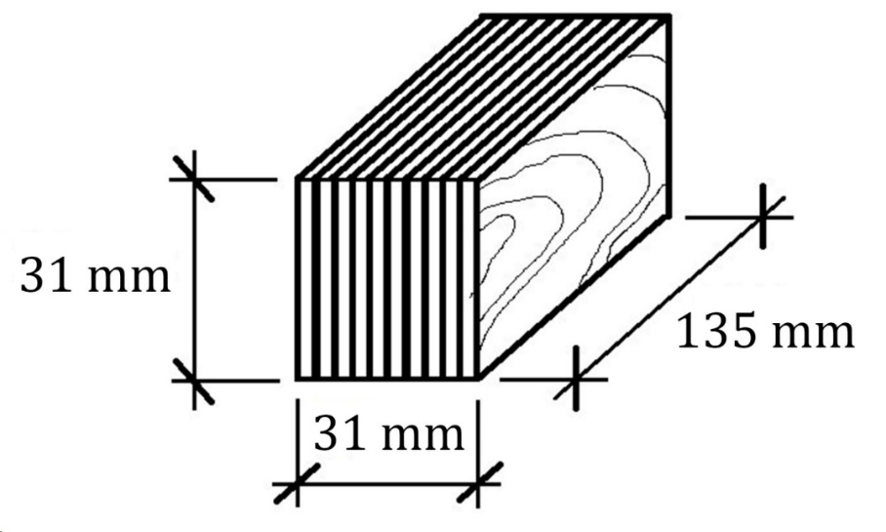

**Fig. 1.** Scheme of LVL cross fibre compression test specimens in the plane of veneer layers

After conditioning in the laboratory, control specimens of unaged LVL (10 pieces) were subjected to mechanical tests to determine cross-fibre compressive strength in the plane of the veneer plies. The tests were carried out using a universal electromechanical testing machine, Instron 5969, at a system loading head rate of motion of 4 mm/min. During the test, the compression strains were determined by measuring the motion of the machine rod.

Samples from the aged material were soaked in water at a temperature of 20±2°C in accordance with the State Standard of the Russian Federation, GOST 33121-2014, in three series of 20 pieces: 1, 2, and 3 cycles of 48 hours each. The water covered the samples by 2-3 cm, which was ensured by pressing them down. After the expiration of 1 cycle (48 hours), the samples were removed from the water and wiped with a clean, dry cloth.

Half of the samples from the series (10 pieces) were measured and mechanically tested to determine cross-fibre compression strength in the plane of the veneer plies. The remaining specimens were dried under normal temperature and humidity conditions. This has been achieved by conditioning in a climatic chamber at 20°C and 65% humidity until the initial humidity reached 12±2% within 10 days (Figure 2).

The other part of the samples from the series (10 pieces) was also tested for compression across the fibres in the plane of the veneer layers after drying. After 10 days in the climatic chamber, samples of the remaining series were soaked again under the same conditions (cycle 2). After 48 hours, they were removed from the water, wiped, and 10 pieces were measured and mechanically tested. The rest were dried in a climatic chamber for 10 days. After that, 10 specimens were tested in compression across the fibres in the plane of the veneer layers, and the remaining specimens were soaked and tested in the same manner (cycle 3).

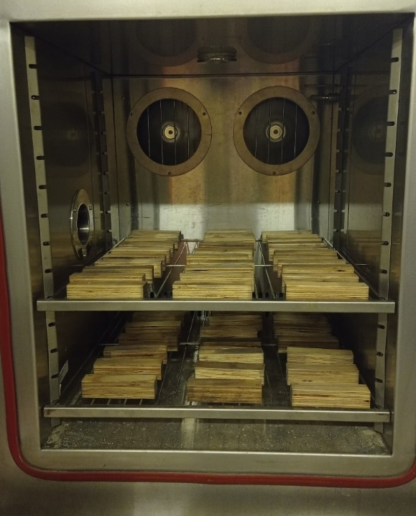 **Fig. 2.** Conditioning of samples in the climate chamber

3. Results and Discussion

In the outer layers of the LVL veneer, cracks were visible to the naked eye (Fig. 3) and their dimensions were determined by digital microscopy. The maximum crack opening width was up to 2 mm near large knots. In general, the entire veneer surface is covered with parallel microcracks of varying lengths. In 20% of control samples from unaged LVL, microcracks with an opening width of up to 0.2 mm and a length of up to 40 mm were recorded.

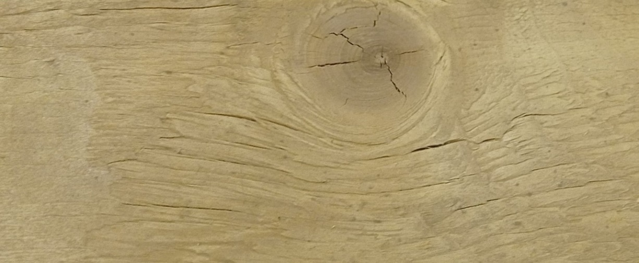

**Fig. 3.** Cracks in the outer layers of aged LVL specimens

The measurement of microcracks in samples of 1-3 series (after 1, 2 and 3 soaking cycles, respectively) in the surface layers of the veneer was carried out after their conditioning:

- after 1 cycle length – up to 40 mm, opening width – up to 0.838 mm,

- after 2 cycles length – up to 135 mm, opening width – up to 1.812 mm,

- after the 3rd cycle length – up to 135 mm, opening width – over 2.0 mm.

After the third moistening cycle, delamination of veneer wood along the border of the growth layers was observed. A photo recording of material homogeneity violations is presented in Fig. 4.

When testing the specimens, the failure occurred along the cracks opened due to cyclic changes in humidity, and delamination along the glue joint was also observed (Fig. 5).

The standard compressive strength was determined in accordance with the Russian Federation Code of Practice (SP 64.13330.2017).

According to the test results, it was possible to confidently state a significant decrease in the compressive strength across the fibres in the plane of the veneer layers with the increase in the number of wet-dry cycles.

The quantitative hydro-fatigue of the material was determined with sufficient accuracy, reaching up to 18% after three cycles. This allows the use of the obtained data in assessing the condition of the material during the operation of building structures.

Summary results of the research are presented in Table 1.

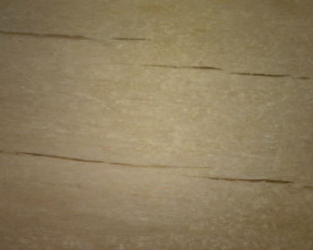

a

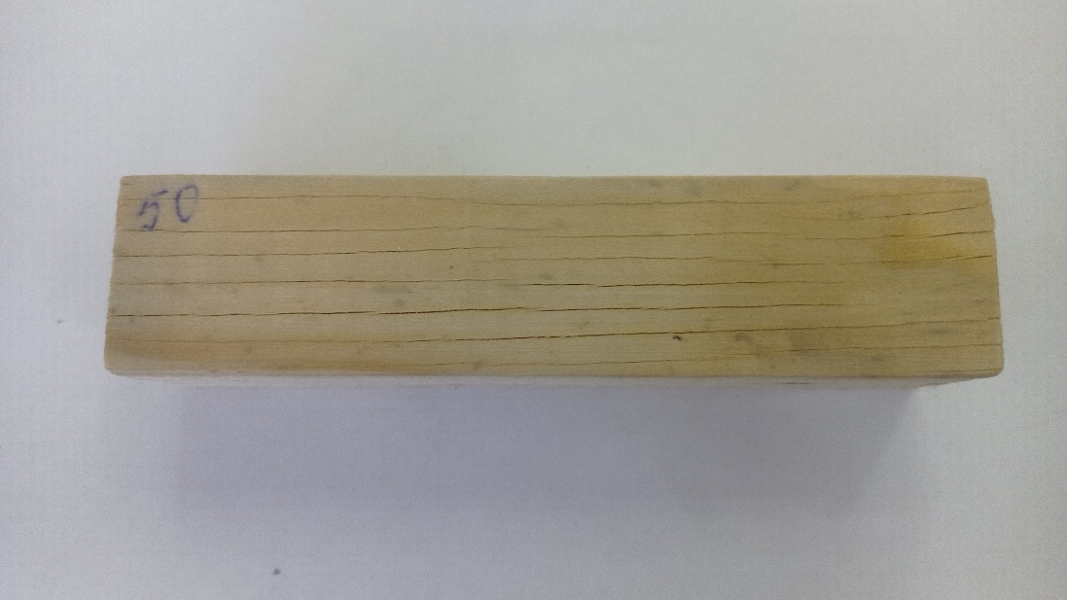

b

**Fig. 4.** Photo recording of veneer cracks: a – after the 2nd soaking cycle; b – after the 3rd soaking cycle

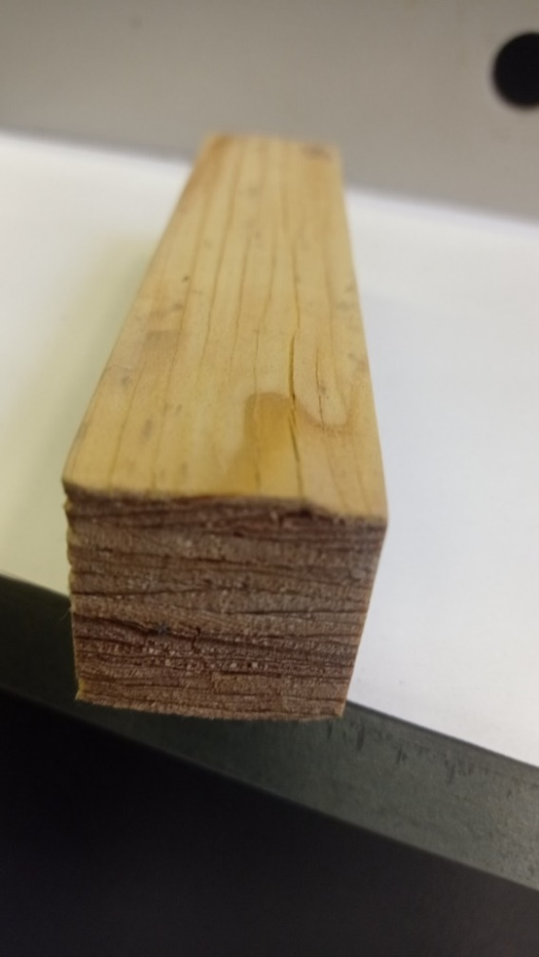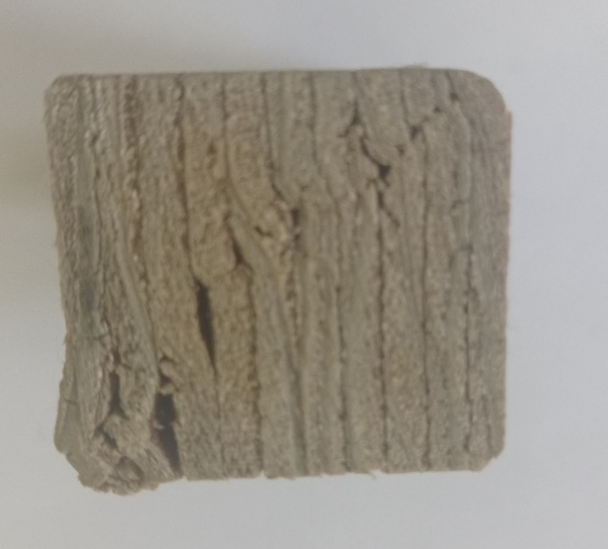

**Fig. 5.** Examples of failure of the tested specimens

**Table 1.** Summary results of strength tests of specimens

|  |  |  |
| --- | --- | --- |
| No. moistening of cycle | Type of specimens | Compressive strength  across fibres, MPa |
| - | Control samples | 6.64 |
| 1 | Wet samples | 2.17 |
| Samples after conditioning | 4.68 |
| 2 | Wet samples | 1.89 |
| Samples after conditioning | 4.19 |
| 3 | Wet samples | 1.78 |
| Samples after conditioning | 3.85 |

Graphical interpretation of the results obtained is presented in Figure 6.

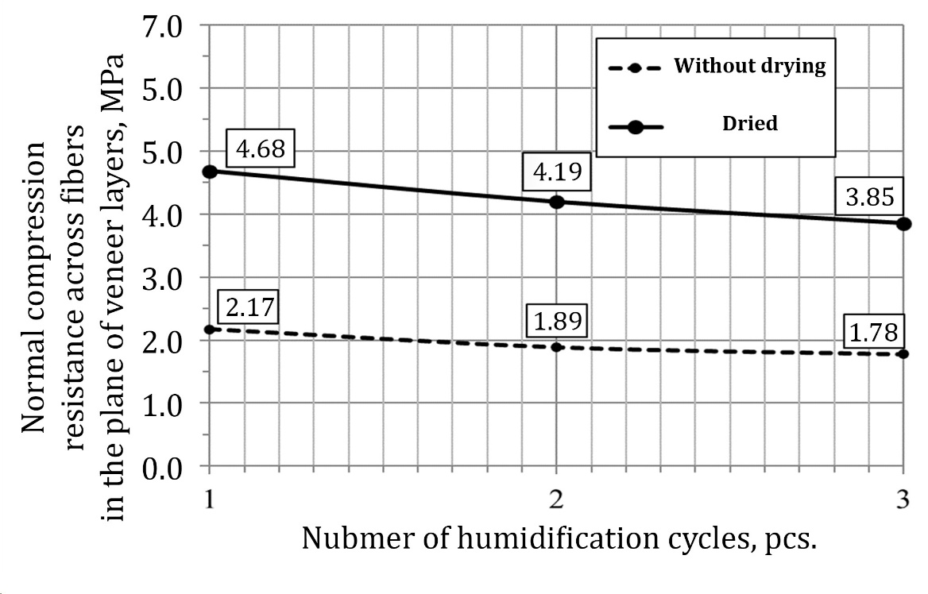

**Fig. 6.** Variation of strength of LVL specimens according to the number of moistening cycles

4. Conclusions

The study of the material properties of laminated veneer lumber, examining the effect of cyclic moistening on its integrity and changes in strength properties, has shown a significant decrease in compressive strength across the fibres in the plane of the veneer layers, accompanied by cracking of the outer layers, each 3.2 mm thick.

Thus, in the absence of moisture protection, the surface layers of the material are subject to continuous cracking, which reduces their cross-sectional area. Absence of wax-containing treatment on the surface of the samples also contributes to the cracking process.

The obtained results allow us to recommend mandatory treatment of laminated veneer lumber materials with protective wax-containing or polymer compositions.

The obtained quantitative research results can be recommended for operational assessment of hydro-fatigue in building structures made of laminated veneer, which are permanently located in conditions of high and variable humidity.

*The work was carried out within the framework of the research topic No. 22C24 with the financial support of a grant of St. Petersburg State University of Architecture and Civil Engineering.*

References

Chernykh, A., Korolkov, D., & Pakina, A. (2021). *Evaluation of the results of calculation of the residual resource of a building using information modelling technology*. In: Innovations in wooden construction: Proceedings of the 11th International Scientific and Practical Conference, St. Petersburg, 22-23 April 2021. St. Petersburg: St. Petersburg State University of Architecture and Civil Engineering, 229-243. (in Russian)

Chernykh, A., Korolkov, D., & Pakina, A. (2021). *Evaluation of the results of calculation of the residual resource of a building using information modelling technology*. In: Innovations in wooden construction: Proceedings of the 11th International Scientific and Practical Conference, St. Petersburg, 22-23 April 2021. St. Petersburg: St. Petersburg State University of Architecture and Civil Engineering, 229-243. (in Russian)

Chernykh, A., Mironova, S., & Mamedov, S. (2020). Ecological peculiarities and problems of glued timber structures reinforcement. *Rocznik Ochrona Srodowiska*, *22*(1), 203-213.

Ivanov, A., Shendrikov, M., Babenkova, E., & Pozdnyakov, E. (2010). *Technology of obtaining glued wood of increased strength.* In: Forest and chemical complexes – problems and solutions: Collection of articles on the materials of the All-Russian scientific and practical conference dedicated to the 80th anniversary of the university, Krasnoyarsk: Siberian State Technological University, 256-259. (in Russian)

Ishimaru, Y., Arai, K., Mizutani, M., Oshima, K., & Iida, I. (2001). Physical and mechanical properties of wood after moisture conditioning. *J Wood Sci*, *47*, 185-191. https://doi.org/10.1007/BF01171220

Korolkov, D. Chernykh, A., & Gravit, M. (2020). *Method for Determining the Residual Resource of Building Structures by the Terms of Their Operation.* In: Energy, Environmental and Construction Engineering, St. Petersburg, 19-20. Cham: Springer, 389-402.

Kudryavtsev, I. (2022). Cyclic changes in wood moisture content and their influence on the long-term strength of the material. *Tendencies of Science and Education*, *86*(2), 77-79. (in Russian)

Kulinich, A., Anufrovic, V., & Kutuzov, E. (2019). *Influence of moisture content on crack resistance of wood*. In: Resource-saving and ecology of building materials, products and structures collection of scientific papers of the 2nd International Scientific and Practical Conference. Kursk, 01 October 2019. Kursk: South-West State University, Vol. 1, 234-238. (in Russian)

Lomakin, A. (2014) Features of protection of load-bearing glued timber structures. *Bulletin of the Scientific Research Center Construction*, *11*, 30-39. (in Russian)

Mironova, S., & Nizhegorodtsev, D. (2018). *Hidden features of a new construction material*. In: Architecture – construction – transport: Proceedings of the 74th scientific conference of the faculty and postgraduate students of the university, St. Petersburg, 03-05 October 2018. St. Petersburg: St. Petersburg State University of Architecture and Civil Engineering, 23-29. (in Russian)

Mironova, S. (2021). Influence of technological cracks of peeled vener on the shear strength of ultralam bars. XXII International Scientific Conference Energy Management of Municipal Facilities and Sustainable Energy Technologies (EMMFT-2020). *E3S Web of Conferences*, *244*, 19010. https://doi.org/10.1051/e3sconf/202124409010

Pałubicki, B., Marchal, R., Butaud, J. C, Denaud, L., Bl´eron, L., Collet, R. & Kowaluk, G. (2009). A method of lathe checks measurement; SMOF device and its software. *European Journal of Wood and Wood Products*, *68*(2), 151-159. https://doi.org/10.1007/s00107-009-0360-y

Pot, G., Denaud, L., Collet, R., Girardon, S., & Cottin, F. (2015). *Influence of veneer lathe checks on the mechanical properties of LVL*. In: 22th International Wood Machining Seminar, At Quebec City, Canada, 1-9.

Roshchina, S. (2009). *Strength and deformability of glued reinforced wooden structures under long-term load action.* Dissertation for the degree of Doctor of Technical Sciences. Speciality 05.23.01 - Building structures, buildings and constructions. Moscow, 330 p. (in Russian)

Shniewind, A. (1966). On the influence of moisture content changes on the creep of beech wood perpendicular to the grain including the effects of temperature and temperature changes. *Holz Roh Werkstoff*, *24*, 87-98.