|  |  |  |  |
| --- | --- | --- | --- |
|  |  | | |
| **Rocznik Ochrona Środowiska** | | |
| Volume 27 | Year 2025 ISSN 2720-7501 | pp. 320-340 |
|  | https://doi.org/10.54740/ros.2025.026 open access | | |
|  | Received: April 2025 Accepted: May 2025 Published: June 2025 | | |

Recycling of Sewage Sludge in Poland – Environmental Aspects and Risks Related   
to Its Management in a Circular Economy

Józef Ciuła1, Iwona Wiewiórska2*, Halina Potok3, Aneta Babiarz4

1Faculty of Engineering Sciences, University of Applied Sciences in Nowy Sącz, Poland

https://orcid.org/0000-0002-9184-9282

2Faculty of Engineering Sciences, University of Applied Sciences in Nowy Sącz, Poland

https://orcid.org/0000-0002-6360-7702

3Faculty of Medicine and Health Sciences, University of Applied Sciences in Nowy Sącz, Poland

https://orcid.org/0000-0003-2973-1520

4Siberians School Complex No 2 in Nowy Sącz, Poland

*corresponding author's e-mail: [iwiewiorska@ans-ns.edu.pl](mailto:iwiewiorska@ans-ns.edu.pl)

**Abstract:** Sewage sludge generated in the process of household and industrial wastewater treatment plants should be utilized in line with the principles of sustainable development, taking into account the processes that are an inherent part of the circular economy. The research conducted for this paper has shown that, on average, in Poland between 2019 and 2023, over a million sewage sludge deposits were created; 57% of these were household and 43% were industrial sewage sludge. The generated sewage sludge is processed in four major processes, covering its use: in agriculture (56.09%), thermal processing (20.62%), storage (17.5%), and compost production (4.72%). The analysis of technical and environmental aspects has demonstrated that the available technologies are sufficient to utilize sewage sludge in accordance with the principle of a circular economy, utilizing state-of-the-art technologies. On the other hand, the heavy metals contained in sewage sludge pose a potential threat to human health if the sludge is not properly managed and safety rules are not adhered to in waste management. The research results form a basis for discussion, focusing on both the quality and quantity aspects, leading to the optimization of methods for utilizing sewage sludge in thermal, organic, or material recycling processes to increase the recycling rate of sewage sludge in Poland.

**Keywords: s**ewage sludge, circular economy, health aspects, recycling, sustainable development

1. Introduction

Waste management that involves storage – also of sewage sludge – was the leading method of disposal in Poland in the previous decades. Poland's accession to the European Union led to the emergence of new, modern investments aimed at improving access to water supply and sewerage systems (Ciuła 2021, Wysowska et al. 2024). These investments forced the development of wastewater treatment plants in terms of increasing their capacity and adapting to growing environmental requirements. The consequence is the increasing production of sewage sludge, both municipal and industrial, which poses a serious challenge to water and wastewater management (Gaska et al. 2023, Wiewiórska et al. 2023). Sludge generated in municipal and industrial wastewater treatment processes must be managed following legal requirements, including the waste hierarchy, as specified in the circular economy (Kołecka et al. 2017, Maizel & Remucal 2017). The Act on Waste, dated 14 December 2012, as amended, governs the management of municipal sludge. This act defines municipal sewage sludge as sludge from digesters, other systems used for the wastewater treatment plant, as well as other wastewater with a composition similar to that of municipal wastewater originating from wastewater treatment plants (Act of 14 December 2012 on Waste, Gaska et al. 2019). The Announcement of the Minister of Climate and Environment, dated 18 November 2022, is the implementing act to the Act on Waste, based on the consolidated text of the Regulation of the Minister of Environment on the Application of Municipal Sewage Sludge (Announcement of the Minister of Climate and Environment 2022). The Regulation outlines the specific conditions governing the application of municipal sewage sludge, including permissible sludge dosages for land application, as well as the scope, frequency, and standardized methods for testing both the sewage sludge and the land to which it will be applied (Martín-Gómez et al. 2024, Shaban et al. 2022). Sewage sludge produced during treatment at a municipal wastewater treatment plant is classified as waste under code 19 08 99. It may undergo further processing either within the same system at the wastewater treatment plant or externally. Should the secondary sewage sludge comply with the parameters stipulated by relevant legislation,   
it is reclassified as waste under code 19 08 05, referring to stabilized sewage sludge (Regulation of the Minister of Climate 2020). The subsequent management of stabilized sewage sludge must adhere to the waste management hierarchy, prioritizing recovery processes, with disposal methods being employed as a last resort (Jurczyk et al. 2024, Liu et al. 2023). Sewage sludge disposal options include, inter alia, landfilling after meeting the permissible limit of less than 6 MJ/kg of dry mass (Przydatek et al. 2024) or landfilling of thermal treatment residues (Mukawa et al. 2022, Mierzwiński et al. 2021). In contrast, recovery processes involve utilizing sewage sludge as biomass in industrial reclamation applications, agricultural use, or composting (Gronba-Chyła et al. 2024, Grąz et al. 2023, Melo et al. 2018, Kacprzak et al. 2017).

The utilization of sewage sludge poses a significant challenge in meeting the EU targets related to sustainable development regarding bio-waste. One of these goals is to reduce the amount of stored waste, including sewage sludge, by 50% by 2050 compared to 2000. Due to the limited number of dumping grounds and widespread bans on storing waste (Lasaridi et al. 2018, Baldi et al. 2021), plants opt for burning sewage sludge, thus reducing its mass by as much as 70% and releasing toxic substances that are hazardous to the environment. This process is the energy recycling of sewage sludge, taking advantage of its fuel properties, which affects the sustainable development of the environment (Basta & Szewczyk 2024, Fijalkowski et al. 2017, Wu et al. 2020, Đurđević et al. 2019, Makarichi et al. 2018). Because of the considerable financial outlay needed for dehydrating or drying sewage sludge before burning it, some alternative ways of utilizing sewage sludge are used, such as land reclamation, gardening, and landscape management, forestry, industrial processes, regaining resources and energy (Baldi et al. 2023, Fijalkowski 2017, Makarichi et al. 2018). Sewage sludge may also be subjected to fermentation, which can lead to the generation of biogas. Following appropriate technological purification, this biogas can be effectively harnessed to generate heat, electricity, or mechanical energy. It may also be used in gas turbines, microturbines, and fuel cells in combined heat and power (CHP) units (Basta & Szewczyk 2024, Fijalkowski et al. 2017, Wu et al. 2020, Đurđević et al. 2019, Makarichi et al. 2018).

To process sewage sludge in a closed circuit, we must adhere to strict quality and safety standards (Sobolewska-Mikulska & Cienciała 2020, Sugurbekova et al. 2023). Sewage sludge needs to be carefully examined to prevent excessive levels of heavy metals, which may migrate between soil layers and reach groundwater or surface waters when intended for use in agriculture (Szopińska et al. 2022, Nartowska 2019, Zerrouqi et al. 2020, Basta & Szewczyk 2024). The mobility of heavy metals found in sewage sludge depends largely on its chemical composition (Janaszek et al. 2024); approximately 80-90% of sewage sludge from household waste contains heavy metals. It is assumed that organic and mineral fertilizers based on sewage sludge, with the addition of mineral fertilizers, are suitable for the soil due to their slow release of nutrients into the environment (Kominko et al. 2017). The stored sewage sludge mixed with soil is stable and often burdened with NO3, which, if present in excessive concentrations, may pose a risk to ground and surface waters, causing their eutrophication. The sludge may also contain heavy metals and pathogens dangerous to human life (Szopińska et al. 2022). In soils characterized by a considerable distance between the surface and surface waters, the processes of washing out heavy metals may be limited, which in turn limits the risk of surface water contamination. However, it does not eliminate this risk, as the long-term and intense use of sludge in deep layers of the soil may affect the chemical composition of surface waters (Laonamsai et al. 2023). Sewage sludge added to soil in a controlled manner improves, inter alia, the level of carbon and total nitrogen in the soil, thus enhancing its fertility (El Hammoudani et al. 2019).

The final product of the thermal processing of sewage sludge, consisting of burning it, is ash. It contains high amounts of phosphorus, which is considered to be the new anthropogenic substitute for natural phosphorus resources, based on waste, which, contrary to phosphate rocks, is available in most countries, with the annual production of sewage sludge of 1.4-38.7 kg per capita (Wang et al. 2016, Liu et al. 2021). Sewage sludge, as one of the main types of household waste, has been considered a supplementary phosphorus absorber, necessary to satisfy future demand for phosphorus and for environmental protection (Liu et al. 2021, Bornø et al. 2023). The materials from which phosphorus can be obtained in the wastewater treatment plant are raw waste, over-sludge liquids from dehydrating sewage sludge, dehydrated sewage sludge, or ashes from burning sewage sludge. The rates of phosphorus regained from waste and ashes from sewage sludge are, respectively, 15% and 85% (Kasprzyk et al. 2017). The analysis of sewage sludge extraction reveals that the largest amount of phosphorus bound to organic matter is released when sulfuric acid is used. In contrast, sequential extraction leads to the total recovery of phosphorus at a 40-60% level (Kasina 2023). Single sewage sludge incineration plants constitute one of the alternative ways of neutralizing household sewage sludge through thermal methods, mostly because they offer possibilities of regaining energy from the process of sewage sludge incineration and utilizing it in the process of drying, as well as the potential possibility of recovering phosphorus from the ashes. The use of sewage sludge in agriculture appears to be a competitive alternative to incineration; however, one needs to pay attention to the quality of the processed sewage sludge (D'Imporzano & Adani 2023).

The wastewater treatment sludge is also used as a base for cement materials, with the addition of, inter alia, fly ash, rice husk, and slag, to improve the mechanical properties of the cement matrices. They are also used as ingredients in the material mix for the production of cement and constitute an active addition to non-organic binders, such as concrete or mortar, in construction ceramics, as a substitute for cement in lightweight material synthesis, and in road construction (Tripathi 2023). Biochar can be obtained in solid form through the thermal conversion of biomass (dry carbonization, pyrolysis, or gasification), or in the form of sludge through the hydrothermal carbonization of biomass under pressure. Biochar is rich in organic matter and nutrients; its highly porous structure makes it an attractive alternative to traditional waste management methods. This offers a potential solution that can be utilized to achieve a circular economy (Khan et al. 2023, Zhao et al. 2023). The methods of processing sewage sludge depend on the available and utilized technologies, which stem directly from the implemented technical solutions in mechanical engineering. The methods of mechanical processing of sludge include sieving, sorting, and preparing it for specific processes. These processes place the main emphasis on preparing the sludge in such a way that it constitutes the raw material for the production of final products, including, for example, composites. This approach to the process promotes resource-efficient production and contributes to the implementation of a circular economy (Ville & Kärki 2018, Vinoth et al. 2024).

Waste management, including management of wastewater treatment sludge, which constitutes waste from the process of waste treatment, is governed by the Commission Implementing Decision (EU) 2018/1147 of 10th August 2018 establishing best available techniques (BAT) conclusions for waste treatment, under Directive 2010/75 EU of the European Parliament and of the Council (OJ L 208 from 17.08.2018). These conclusions concerning the best available techniques for processing waste form the basis for choosing waste processing technology suitable for applied technical solutions aimed at reducing the amounts of acceptable emission levels, thanks to which such emissions, in normal working conditions, will not exceed the levels guaranteed by best available techniques specified in conclusions on BAT. Technical solutions used in sewage sludge processing technologies contain elements and modules attributed to mechanical engineering, which covers neutralizing and regaining waste, including initial processing of waste intended for incarceration or co-incarceration and biological processing (Decisions Commission Implementing Decision (EU) 2018/1147, Directive 2010/75/EU of the European Parliament and the Council).

One of the key elements of wastewater treatment sludge management is optimizing the waste supply chain, including sewage sludge for processing. The processes of regaining in the supply chain link are of particular importance, as waste transfer charts are reviewed to determine if they contain environmental considerations. This process encompasses the diversification of aspects of mechanical engineering, environmental engineering, and transport and logistics (Kowalski et al. 2022). The concept of "reverse logistics" that can be found in the subject literature entails all processes of managing waste flow, from the place it was generated to its destination, to implement recycling processes aimed at minimizing the negative impact of waste on our natural environment (Di Maro et al. 2024, Alves et al. 2022).

The management of wastewater treatment sludge should be conducted following sanitary conditions to minimize its potential negative impact on human health. As the use of sewage sludge accounts for a significant portion of agricultural processing methods, assessing toxic and carcinogenic substances in sludge is crucial when determining how to utilize sewage sludge in agriculture (Jurczyk et al. 2019, Yakamercan et al. 2021). Examined wastewater treatment sludge samples taken from 22 municipal sewage treatment plants in Turkey to assess ecological and health threats to people related to the presence of heavy metals in sludge samples and to determine their potential use in agriculture (Jurczyk et al. 2019, Yakamercan et al. 2021). The research demonstrated the presence of the following metals in decreasing order of concentration: Zn, Cu, Cr, Pb, Ni, Mo, As, Cd, Se, and Hg, with no discernible seasonal effect. The scientists also assessed the carcinogenic and non-carcinogenic threats to health and calculated the values of total cancer risk (TCR) and the hazard index (HI) for 22 measurement points, representing the sum of exposures to all heavy metals through consumption, inhalation, and skin contact in both children and adults. The share of inhalation exposure caused by floating dust in agricultural work in total health risk seems negligible compared to swallowing and skin contact. The carcinogenic risk for adults was within the acceptable scope (10-6 to 10-4) proposed by USEPA on the basis of estimates (2.4∙10-5), but for children, the value of the risk was slightly higher than safety levels for children (1.6∙10-4). The HI values for adults were lower than the reference value of 1, whereas they were higher for children, reaching a maximum of 2.52. Pb, As, and Cr were the primary metals contributing to carcinogenic risk for both children and adults. Although the concentration of heavy metals in the samples was within the legal norms concerning the use of arable land proposed by the Environmental Protection Agency (EPA), the results of the health risk assessment for people indicated that such risk may be particularly concerning for children (Koc-Jurczyk et al. 2022, Mathney 2011).

The research group organized by the World Health Organization conducted a preliminary examination of the health risk assessment resulting from the agricultural use of sewage sludge containing metals. The researchers proved that cadmium appears to be the most serious contaminant, as it can accumulate in soil and then be assimilated by certain vegetables, which are subsequently consumed by people and livestock (Dean & Suess 1985). Similarly, Duan and Feng examined samples of sewage sludge and manure from cattle and pig farms to compare the potential threats to ecology and human health posed by the heavy metals they contained. The research results showed that sewage sludge and animal manure had high concentrations of Cu, Cr, and Zn. The average pollution index (PI) revealed that Cu, Zn, As, and Cr in sewage sludge and animal manure posed a potential ecological threat, whereas pig manure carried the highest potential ecological risk for agricultural use. The daily exposure to Cu, Zn, and Cr was higher than exposure to other heavy metals from sewage sludge and manure. However, exposure to heavy metals was consistently higher in children than in adults, with consumption being the main exposure route. On the other hand, non-carcinogenic risk was primarily caused by Cu and Cr, based on higher hazard quotient (HQ) values for both adults and children (Duan B. & Feng Q. 2021). The research confirmed the necessity of assessing health and ecological hazards related to the presence of heavy metals in sludge used in agriculture, such as municipal and industrial sewage sludge, manure, and slurry, before finally classifying such sludge as acceptable in agriculture.

The article aimed to conduct a quantitative analysis of sewage sludge generated in the process of municipal and industrial wastewater treatment in Poland, an analysis of sewage sludge management methods, and their qualitative analysis in terms of the content of organic substances, total nitrogen, total phosphorus, calcium, magnesium and metals (including heavy metals), in the aspect of environmental and health risks associated with their management.

2. Research Methods

The research conducted in this paper consists of a review of the literature on the subject of using wastewater treatment sludge from municipal and industrial wastewater treatment plants in Poland (Local Data Bank, Statistics Poland, Błaszczyk 2014, Poluszyńska 2015, Milik 2016, Nowak 2010). The quantitative and qualitative analysis of literature on environmental, technological, and health aspects was performed based on published research on the physicochemical parameters of wastewater treatment sludge from various sewage treatment plants in Poland. The sludge generated in municipal wastewater treatment came from various wastewater treatment plants and constituted mostly mechanical and biological technologies with the following parameters:

M1_A mechanical-biological wastewater treatment plant treats sewage from a city inhabited by approximately 100,000 people, stabilized sludge.

M2_B mechanical-biological wastewater treatment plant, with a maximum flow capacity of 25,000 m3/d, containing the biological component – dephosphatation (with periodical chemical support), nitrification and denitrification, stabilized sludge.

M3_C mechanical-biological wastewater treatment plant, municipal and rural, treats municipal sewage from the town and rural commune inhabited by approximately 75 thousand people, composted sludge.

M4_D mechanical-biological wastewater treatment plant, treats sewage from a rural commune inhabited by approximately 20 thousand residents, composted sludge.

M5_E mechanical-biological wastewater treatment plant, treats sewage from a rural commune, with maximum flow capacity of 26,000 m3/d, stabilized sludge.

M6_F mechanical-biological wastewater treatment plant, treats sewage from a rural commune inhabited by approximately 10 thousand residents.

M7_G municipal wastewater treatment plant, uses the method of active sludge in multi-function biological reactors (oxidation of organic compounds, nitrification, denitrification and biological de-phosphatation), with maximum flow capacity of 43,000 m3/d, stabilized in anaerobic conditions sludge.

M8_H mechanical-biological wastewater treatment plant, treats municipal sewage from an area inhabited by approximately 200 thousand residents, fermented and composted sludge.

The sludge that was generated in the process of treating industrial sewage came from various wastewater treatment plants, which used the following generation processes:

I1_A industrial wastewater treatment plant – mineral water plant,

I2_B industrial wastewater treatment plant – hardboard (fiberboard) production plant,

I3_C industrial wastewater treatment plant – beverage production plant,

I4_D industrial wastewater treatment plant – vegetable processing plant,

I5_E industrial wastewater treatment plant – meat processing plant,

I6_F industrial wastewater treatment plant – food sector (brewery),

I7_G industrial wastewater treatment plant – chemical sector.

The results of this research were then compared to the legal requirements of the country, the European Union, and the World Health Organization. The results were analyzed statistically using the Statistica software version 14.1.0.4. To compare specific types of sewage sludge management and physicochemical parameters, an analysis was conducted for three variables, XYZ. An analysis was performed on three XYZ variables to facilitate comparison across different wastewater sludge management methods. The results were visualized as 3D scatter plots, illustrating the correlations among three or more variables, with X, Y, and one or more Z (vertical) coordinates representing each data point in three-dimensional space. The study's findings were presented using the 3D trajectory, which can be interpreted as the movement of data points within a three-dimensional space. To analyze the concentration of heavy metals in sewage sludge, a correlation coefficient was used, which measures the relationship between variables. To compare particular values of heavy metals, cluster analysis was performed, using the Ward agglomeration method. This method is used to estimate the distance between clusters and applies the variation analysis approach, resulting in the minimization of the sum-of-squares deviation between any two clusters. The Euclid distance was used as the distance measure in this method. This is a geometrical distance in multi-dimensional space. In this method, Euclidean distances (and the squares of Euclidean distances) are calculated based on raw data rather than standardized data (Statistica, version 14.1.0.4, 2023).

3. Research Results and Discussion

3.1. The quantitative analysis

Based on the type of wastewater treated, sludge from industrial wastewater treatment plants and municipal wastewater treatment plants has been distinguished. Sludge generation at wastewater treatment plants is closely related to the amount of wastewater fed into the plant and the treatment technology applied. As regards municipal wastewater in the period 2019-2023, 6.78 million dm3 of wastewater was subjected to treatment processes, mainly through the following processes: mechanical, chemical, biological, and enhanced nutrient removal (Environment 2019 Statistics Poland, Environment 2020 Statistics Poland, Environment 2021 Statistics Poland, Environment 2022 Statistics Poland, Environment 2023 Statistics Poland). The waste generated in these processes, in the form of sewage sludge, requires appropriate management due to its specific properties. Figure 1 shows the amount of sewage sludge generated at municipal wastewater treatment plants in each province in Poland from 2019 to 2023 (Local Data Bank, Statistics Poland).

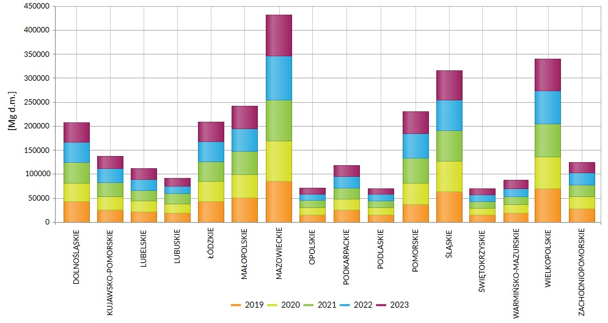

**Fig. 1.** Sewage sludge generated in 2019-2023 at municipal wastewater treatment plants by province

The largest amount of municipal sewage sludge was generated in the Masovian Province (Mazowieckie) with 432,046 Mg d.m., followed by the Greater Poland Province (Wielkopolskie) with 339,500 Mg d.m. and the Silesia Province (Śląskie), where 316,104 Mg d.m. of municipal sludge was generated at municipal wastewater treatment plants. However, the provinces with the smallest amount of generated municipal sludge are the Podlaskie Province (Podlaskie) – 70,026 Mg d.m. and the Świętokrzyskie Province (Świętokrzyskie) – 70,350 Mg d.m. **Industrial wastewater** generated in plants engaged in business, manufacturing, or service activities is typically treated within their own systems. Figure 2 presents the amount of sewage sludge generated in 2019-2023 at municipal wastewater treatment plants in each province (Local Data Bank, Statistics Poland).

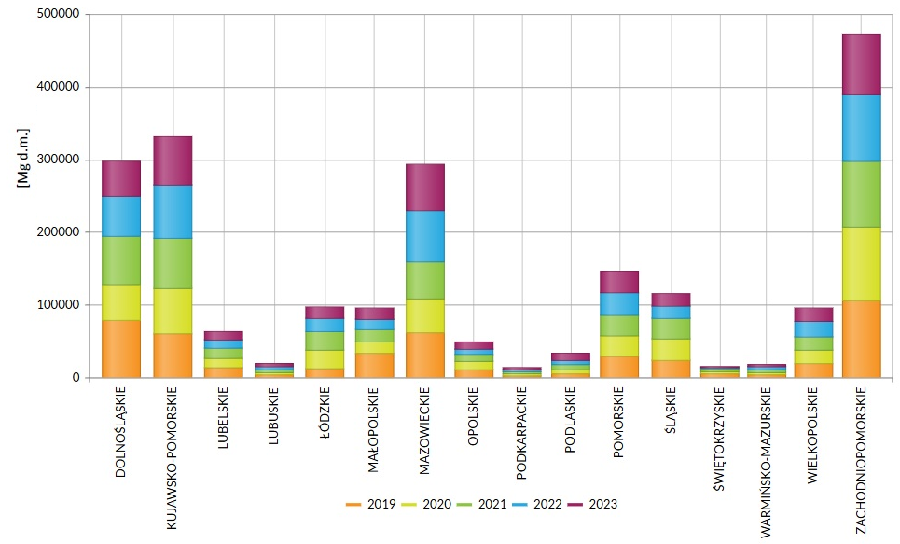

**Fig. 2.** Sewage sludge generated in 2019-2023 at municipal wastewater treatment plants by province

In 2019-2023, the largest amount of industrial sewage sludge was generated in the West Pomeranian Province (Pomorskie): 472,599 Mg d.m. and the Kuyavian-Pomeranian Province (Kujawsko-Pomorskie): 331,996 Mg d.m. and the Lower Silesia Province (Dolnośląskie): 298.630 Mg d.m., respectively. The lowest amount of industrial sewage sludge was generated in the Subcarpathian Province (Podkarpackie): 14,600 Mg d.m. and the Świętokrzyskie Province (Świętokrzyskie): 15,344 Mg d.m.

The analysis of sewage sludge generation in Poland in quantitative terms leads to the conclusion that, over the five-year period, more municipal sewage sludge was generated than industrial sludge. Table 1 presents the volumes of sewage sludge generated at municipal and industrial wastewater treatment plants in Poland in 2019-2023.

**Table 1.** Sewage sludge generated in municipal and industrial wastewater treatment plants in Poland in 2019-2023

|  |  |  |  |
| --- | --- | --- | --- |
| Year | Municipal sludge | Industrial sludge | In total |
| [Mg d.m.] | | |
| 2019 | 574,643 | 474,044 | 1.048,687 |
| 2020 | 567,858 | 420,633 | 988,491 |
| 2021 | 584,754 | 441,036 | 1,025,790 |
| 2022 | 580,659 | 431,777 | 1.012,436 |
| 2023 | 549,702 | 396,824 | 946,526 |

The quantity of municipal sewage sludge produced at wastewater treatment plants between 2019 and 2023 exhibited significant variability, with a noticeable decline of 6.0% in 2023 compared to 2021 when the sludge production reached its peak at 584,754 Mg d.m. In contrast, the volume of sewage sludge generated at industrial treatment plants over the same five-year period decreased by 16.28%. This trend is attributed to an 18.48% decrease in the volume of wastewater treated by industrial facilities during the review period. On average, the total amount of sludge generated annually exceeds 1 million Mg d.m., which poses a considerable challenge for the waste management sector regarding the appropriate handling of sewage sludge.

3.2. The analysis of the ways of using sewage sludge

Sewage sludge, a direct by-product of the wastewater treatment process (commonly referred to as raw primary sludge), is classified as waste under code 19 08 99 and may undergo further processing within the treatment facilities. This treatment results in stabilized sewage sludge, categorized under code 19 08 05, which is subject to legal requirements for management through either disposal or recovery processes, typically carried out off-site. Table 2 presents the methods and quantities by which sewage sludge generated at municipal wastewater treatment plants over the past five years was managed.

**Table 2.** Management methods of sewage sludge generated in 2019-2023 at municipal wastewater treatment plants in terms of weight

|  |  |  |  |  |  |  |  |
| --- | --- | --- | --- | --- | --- | --- | --- |
| Year | Used in Agriculture  (UA) | Thermally Treated  (TT) | Stored  Temporarily  (ST) | Used to grow plants for compost production  (PCB) | Used for soil  reclamation,  Including  for agriculture  (RA) | Storage  (STO) | Other  purposes  (OP) |
| [Mg d.m.] | | | | | | |
| 2019 | 123,777 | 70,172 | 50,144 | 30,546 | 15,195 | 9,372 | 275,437 |
| 2020 | 137,772 | 98,576 | 50,063 | 29,459 | 17,503 | 6,951 | 227,534 |
| 2021 | 156,000 | 93,550 | 51,734 | 21,414 | 13,141 | 6,029 | 242,886 |
| 2022 | 157,598 | 105,230 | 54,366 | 22,779 | 19,797 | 8,204 | 212,685 |
| 2023 | 147,279 | 89,800 | 55,942 | 22,563 | 12,729 | 6,046 | 215,343 |

Given that waste management prioritizes the reuse of sewage, including sewage sludge, every effort should be made to ensure that recycling processes become the predominant method of treatment. The research conducted highlights the prevalence of recovery processes in the management of municipal sewage sludge, particularly through its application in agriculture, the production of compost for land reclamation, and energy recovery via thermal treatment. Disposal methods for municipal sewage sludge include storage in landfills, provided that the legal requirements for acceptable parameters are met. Additionally, sewage sludge may be temporarily stored before its safe management in a manner that poses no threat to human health or the environment. Data provided by Statistics Poland identifies the largest category of sewage sludge management as its application for other purposes (Di Maro 2024, Alves 2022). This method of sludge management can be utilized, for instance, in the production of lightweight aggregates, as an additive to construction materials, in biogas plants through co-digestion processes (primarily outside wastewater treatment plants), and as a raw material for the production of advanced biocomponents. The management of sewage sludge within the framework of a circular economy presents a significant challenge for the wastewater industry, as treatment methods must be carefully selected to eliminate potential risks to both the environment and public health. Furthermore, these methods must represent the best available technology and adhere to applicable laws, including the Act on Waste and related regulations (Environment 2019 Statistics Poland, Environment 2020 Statistics Poland, Environment 2021 Statistics Poland, Environment 2022 Statistics Poland). Table 3 provides a breakdown of the methods employed for managing sewage sludge generated at municipal wastewater treatment plants between 2019 and 2023, expressed as a percentage of the total.

In terms of municipal sewage sludge management methods, the largest proportion, averaging 41.07%, pertains to sludge allocated for other purposes. Due to the lack of publicly available data detailing the specific processes within this category, the study treated this method as a singular management process without distinguishing between individual treatment methods. This absence of detailed information in public documents necessitated this approach. Among the remaining 6 methods of sludge management, the largest share is attributed to the application of sludge in agriculture, which averaged 25.25% and exhibited a 5.6% increase over the past five years. Another significant method was thermal treatment, accounting for 16.01%, with a nearly 6% increase over the same period. In contrast, a decline was observed in the storage of sludge and its use for crop cultivation aimed at compost production. Figure 3 presents a comparative analysis of the application of municipal sewage sludge in agriculture, with an average of 25.28%, alongside the two subsequent methods: thermal treatment and temporary storage of sludge.

**Table 3.** Management methods of sewage sludge generated in 2019-2023 at municipal wastewater treatment plants in percentage

|  |  |  |  |  |  |  |  |
| --- | --- | --- | --- | --- | --- | --- | --- |
| Year | Used in Agriculture  (UA) | Thermally Treated  (TT) | Stored  Temporarily  (ST) | Used to grow plants for compost production  (PCB) | Used for soil reclamation, Including  for agriculture  (RA) | Storage  (STO) | Other  purposes  (OP) |
| [%] | | | | | | |
| 2019 | 21.54 | 12.21 | 8.73 | 5.32 | 2.64 | 1.63 | 47.93 |
| 2020 | 24.26 | 17.36 | 8.82 | 5.19 | 3.08 | 1.22 | 40.07 |
| 2021 | 26.68 | 16.00 | 8.85 | 3.66 | 2.25 | 1.03 | 41.54 |
| 2022 | 27.14 | 18.12 | 9.36 | 3.92 | 3.41 | 1.41 | 36.63 |
| 2023 | 26.79 | 16.34 | 10.18 | 4.10 | 2.32 | 1.10 | 39.17 |
| Average | 25.28 | 16.01 | 9.19 | 4.44 | 2.74 | 1.28 | 41.07 |

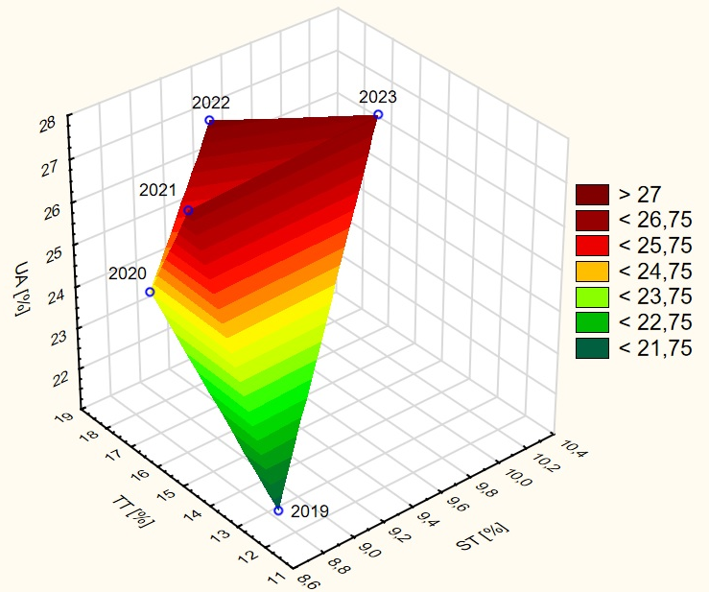

**Fig. 3.** Comparison of the generated municipal sewage sludge management applied in agriculture versus thermally treated and temporarily stored sludge

An analysis of the management methods for municipal sewage sludge reveals a significant prevalence of wastewater application in agriculture. This practice primarily pertains to organic recycling related to the fertilizer potential inherent in the sludge, particularly the nitrogen and phosphorus content, as well as its soil-forming properties. The correlation among the three principal methods of sludge management – agricultural use, thermal treatment, and temporary storage – indicates that 2019 exhibited the lowest utilization levels for these methods, represented by the variable coordinates (x = 12.21; y = 8.73; z = 21.54). Conversely, in 2022, there was an average increase of 3.93% in the utilization of these management forms, with the corresponding variables as follows: (x = 18.12; y = 9.36; z = 27.14). Overall, the cumulative average share of these three methods during the analyzed five-year period amounted to 50.47% in relation to other methods of municipal sewage sludge management.

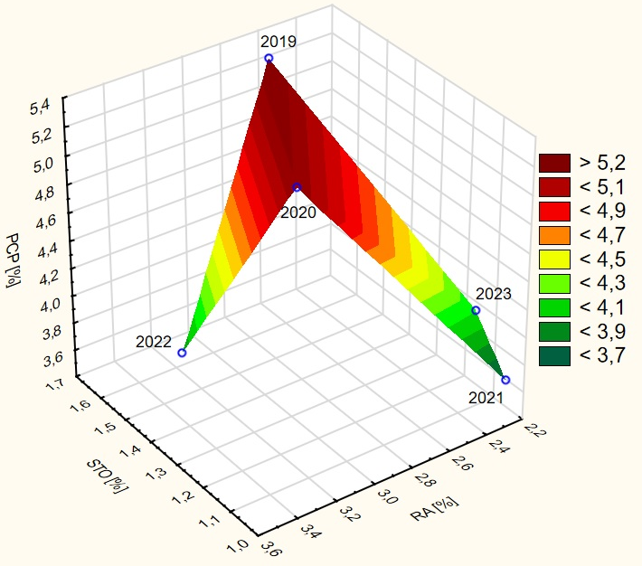

**Fig. 4.** Comparison of the management of generated municipal sewage sludge used for compost production in agriculture versus sludge used for land reclamation and stored

The analysis of various methods employed for managing municipal sewage sludge indicates that the least favored approaches include using sludge for compost production in agriculture, land reclamation, and storage. Correlation analysis among these three methods (compost production, land reclamation, and storage) revealed that 2022 exhibited the lowest levels of utilization for these forms, as reflected by the variable coordinates   
(x = 1.41; y = 3.41; z = 3.92). In contrast, the same year recorded an average increase of 0.81% in these management methods, with the corresponding variables amounting to (x = 1.36; y = 2.64; z = 5.32). Over the analyzed five-year period, the cumulative average share of these three management methods was found to be 8.46% in relation to other methods of municipal sewage sludge management.

Furthermore, the volume of sewage sludge generated at industrial wastewater treatment plants has exhibited a downward trend over the past 20 years. Several factors contribute to this decline, including a reduction in the number of operational industrial wastewater treatment facilities and a corresponding decrease in the volume of industrial wastewater produced. **Table 4** illustrates the management methods employed for sewage sludge generated at industrial wastewater treatment plants, presented by weight.

**Table 4.** Sewage sludge generated in 2019-2023 at industrial wastewater treatment plants management methods by weight

|  |  |  |  |  |  |  |  |
| --- | --- | --- | --- | --- | --- | --- | --- |
| Year | Thermally Treated  (TT) | Storage  (STO) | Used  in Agriculture  (UA) | Stored  Temporarily  (ST) | Used for soil reclamation,  Including  for agriculture  (RA) | Used to grow plants for compost production  (PCB) | Other  purposes  (OP) |
| [Mg d.m.] | | | | | | |
| 2019 | 125,524 | 103,897 | 18,080 | 20,102 | 9,352 | 1,139 | 195,950 |
| 2020 | 120,865 | 56,910 | 22,642 | 22,113 | 9,031 | 1,083 | 187,989 |
| 2021 | 128,285 | 77,999 | 19,471 | 22,990 | 9,917 | 1,646 | 180,728 |
| 2022 | 149,795 | 60,457 | 19,804 | 22,169 | 9,336 | 1,542 | 168,674 |
| 2023 | 139,015 | 55,392 | 19,340 | 11,277 | 10,481 | 757,0 | 160,562 |

Similar to the findings regarding municipal sewage sludge, data reported by Statistics Poland indicate that the predominant category of industrial sewage sludge management pertains to other purposes (Environment 2019 Statistics Poland, Environment 2020 Statistics Poland, Environment 2021 Statistics Poland). However, this category lacks detailed information concerning specific management methods and associated quantities. Among the remaining six methods of industrial sewage sludge management, energy recovery through thermal treatment appears to be the most significant. Between 2019 and 2023, a total of 663,484 Mg of dry matter from sewage sludge underwent thermal treatment, with year-to-year records showing consistent increases, except in 2023 (Environment 2021 Statistics Poland, Environment 2022 Statistics Poland, Local Data Bank Statistics Poland). Another management approach involves disposing of sludge via landfilling in designated facilities, provided that the sludge meets the specified limit values as regulated by relevant legislation. Table 5 presents the various methods employed for managing sewage sludge generated at industrial wastewater treatment plants, expressed in percentage terms.

**Table 5.** Sewage sludge management methods generated in 2019-2023 at industrial wastewater treatment plants by weight

|  |  |  |  |  |  |  |  |
| --- | --- | --- | --- | --- | --- | --- | --- |
| Year | Thermally Treated  (TT) | Storage  (STO) | Used  in Agriculture  (UA) | Stored Temporarily  (ST) | Used for soil reclamation,  Including  for agriculture  (RA) | Used to grow plants for compost production  (PCB) | Other  purposes  (OP) |
| [%] | | | | | | |
| 2019 | 26.48 | 21.92 | 3.81 | 4.24 | 1.97 | 0.24 | 41.34 |
| 2020 | 28.73 | 13.53 | 5.38 | 5.26 | 2.15 | 0.26 | 44.69 |
| 2021 | 29.09 | 17.69 | 4.41 | 5.21 | 2.25 | 0.37 | 40.98 |
| 2022 | 34.69 | 14.00 | 4.59 | 5.13 | 2.16 | 0.36 | 39.07 |
| 2023 | 35.03 | 13.96 | 4.87 | 2.84 | 2.64 | 0.19 | 40.46 |
| Average | 30.81 | 16.22 | 4.61 | 4.54 | 2.23 | 0.28 | 41.31 |

Regarding the various methods of municipal sewage sludge management, the largest proportion – averaging 41.31% – is attributed to sludge designated for other purposes. Due to the lack of specific information on the individual processes within this category, the study considered the overall method of sludge management as a singular process, without delineating detailed treatment methods. In contrast, among the remaining 6 methods of industrial sludge management, energy recovery through thermal treatment constitutes the largest share at an average of 30.81%, exhibiting an increase of 8.55% over the past five years. Additionally, storage represents another method of sewage sludge management, accounting for 16.22% of total management practices, which reflects a decrease of 7.96%. Figure 5 provides a comparative analysis of the management approaches for industrial sewage sludge, highlighting the distinctions between thermally treated sludge, stored sludge, and agricultural sludge.

The analysis of municipal sewage sludge management methods reveals a significant prevalence of thermal treatment for industrial sewage sludge. A correlation among the three primary methods—thermal treatment, agricultural use, and storage—indicated that 2019 exhibited the lowest utilization of these approaches, with variable coordinates of (x = 21.92; y = 3.81; z = 26.48). Conversely, in 2023, there was a notable increase in thermal treatment by 8.55%, while the practice of sludge storage decreased by 7.96%. The corresponding variables for these correlations were as follows: (x = 13.96; y = 4.87; z = 35.03). Over the analyzed five-year period, the cumulative average share of these three methods accounted for 51.64% of the total municipal sewage sludge management practices, highlighting their significance relative to other management strategies. Figure 6 provides a comparative analysis of the management of generated industrial sludge, contrasting temporarily stored sludge with sludge utilized for land reclamation and compost production.

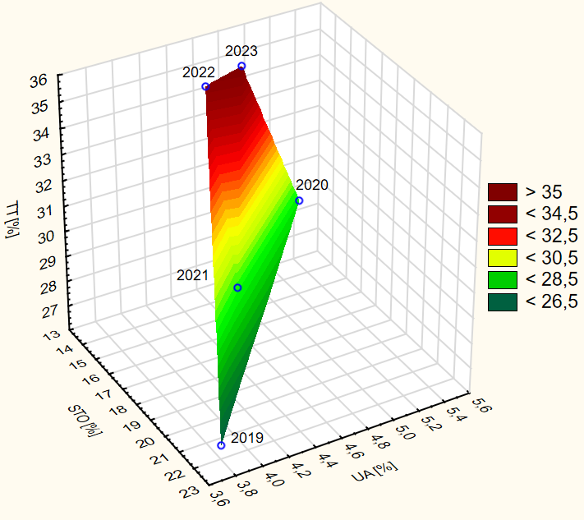

**Fig. 5.** Comparison of the management of industrial sewage sludge, thermally treated sludge, versus sludge stored and used in agriculture

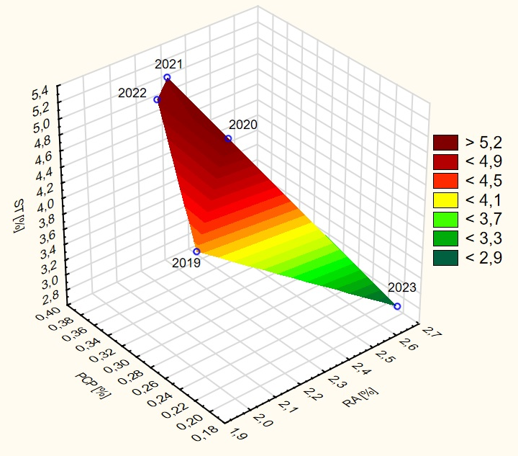

**Fig. 6.** Comparison of the management of generated industrial sewage sludge, stored temporarily versus sewage sludge used for land reclamation and compost production

The analysis of various methods for municipal sewage sludge management indicates that utilizing sludge for the cultivation of plants intended for compost production is the least favored approach, followed by land reclamation, including agricultural applications and temporary storage. A correlation analysis among these three methods revealed that 2023 exhibited the lowest levels of utilization, with variable coordinates recorded as (x = 2.64; y = 0.19; z = 2.84). Conversely, in 2021, there was a 2.37% increase in temporary storage and a 0.18% increase in compost production, while the application of industrial sludge for land reclamation decreased by 0.39%. The corresponding variables for 2021 are as follows: (x = 2.25; y = 0.36; z = 5.21). Over the analyzed five-year period, the cumulative average share of these three methods accounted for only 7.06% of the overall municipal sewage sludge management practices. Figure 7 presents a comparative analysis of the total volumes of municipal and industrial sludge generated from 2019 to 2023, alongside sludge designated for other purposes.

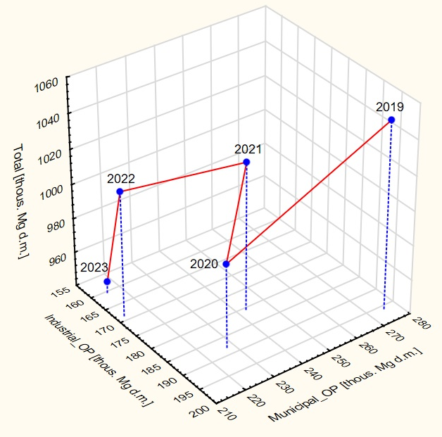

**Fig. 7.** Comparison of the amount of municipal and industrial sludge generated in 2019-2023 to sludge for other purposes

The management of municipal and industrial sludge categorized as "for other purposes," as presented in the statistics for the years 2019 to 2023, reveals an average value of 41.07% for municipal sludge, while the corresponding value for industrial sludge is 41.31%. Throughout the analyzed five-year period, these values fluctuated between 36.63% and 47.93% for municipal sludge and between 39.67% and 44.69% for industrial sludge. The three-dimensional (3D) trajectory employed in this study illustrates the movement of data in three-dimensional space, reflecting the regression of variables where the variable *x* denotes industrial sludge and the variable *y* denotes municipal sludge. Specifically, the variables for the year 2019 are recorded as (x = 1.2;   
y = 0.67), while for the year 2023, the variables are (x = -1.08; y = -0.70). The study's findings indicate a decrease in the generation of municipal sludge by 60.09 Mg d.m., while the generation of industrial sludge diminished by 35.39 Mg d.m. Thermal treatment of municipal and industrial sludge is one of the methods for sludge processing, and the changes in the share of this method from 2019 to 2023 are presented in Figure 8.

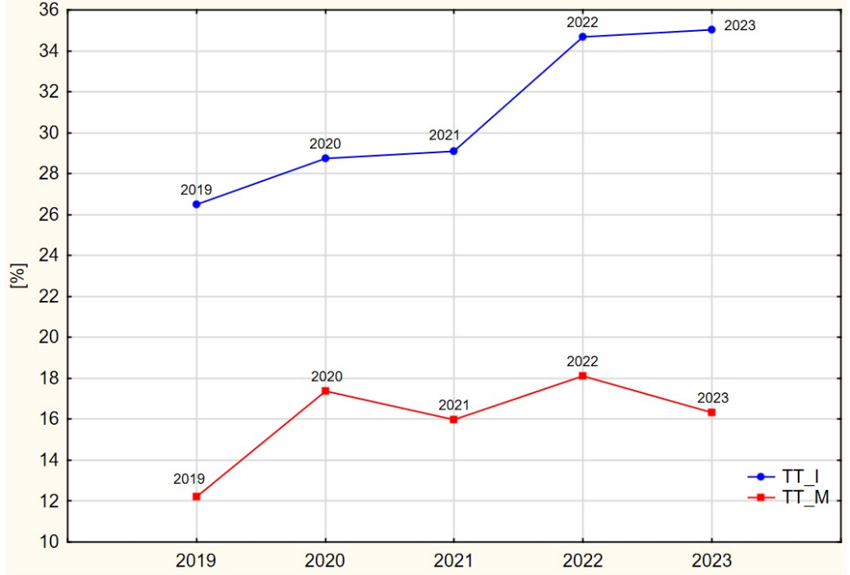

**Fig. 8.** Thermal treatment of municipal and industrial sewage sludge in 2019-2023

The thermal treatment of municipal sewage sludge from 2019 to 2023 varied between 12.21% and 18.12% compared to other management methods within this category. Notable increases in this treatment method were recorded in the years 2020 and 2022, reaching 17.36% and 18.12%, respectively. In contrast, the proportion of industrial sludge undergoing thermal treatment was significantly higher, ranging from 26.46% to 30.81%. The data indicates a dynamic growth in the application of this treatment method for industrial sludge during the period from 2019 to 2023, suggesting a positive outlook for future developments in this area.

3.3. Qualitative analysis

A qualitative analysis of the parameters of sludge resulting from the treatment of municipal wastewater in Poland has been carried out for sludge from different-sized wastewater treatment plants (Błaszczyk 2014, Poluszyńska 2015). Sewage sludge resulting from the municipal wastewater treatment process, for further management, was first subjected to anaerobic digestion at the wastewater treatment plant for stabilization (Milik 2016, Nowak 2010). Then, depending on their physico-chemical parameters, they were subjected to appropriate treatment methods. The presented sewage sludge test results are from wastewater treatment plants using mechanical-biological treatment technologies, serving various treatment plant sizes and types of areas. Table 6 summarises the results of analyses of the physicochemical parameters of sewage sludge from eight selected municipal wastewater treatment plants in Poland.

The use of sewage sludge in agriculture for the analyzed municipal sewage treatment plants in Poland accounts for an average of 29.72% of the total mass of municipal sludge, which constitutes a significant share of the total sludge generated in Poland. The factor of assessing the concentration of toxic and carcinogenic chemical substances in sludge, such as heavy metals, should be of key importance when making proper decisions concerning methods of using sewage sludge in agriculture (Yakamercan 2021). The Regulation of the Minister of Environment of 6th February 2015 on using municipal sewage sludge determines how such sludge can be used in Poland, Schedule 1 to this Regulation determines limits for concentration of heavy metals in municipal sludge, expressed in mg/kg of dry mass of sludge, which may be – as long as they meet quality requirements – used in agriculture and reclamation of land for agricultural purposes (Regulation of the Minister of Environment 2015).

Since sewage sludge constitutes a valuable source of organic matter, phosphorus, nitrogen, calcium, and potassium – essential for the proper growth of plants and the improvement of soil physicochemical properties – it is used on a large scale for agricultural purposes (Tytla 2022). The content of the organic substance in analyzed sludge (Table 6) ranges from 43.8% to 85.5% d.m., total nitrogen from 3.90% to 8.05% d.m., calcium from 0.55% to 6.73% d.m., and magnesium from 0.18% to 1.40% d.m. It should be remembered, however, that the presence of heavy metals in sewage sludge is associated with a potential hazard, both in the ecological aspect (secondary contamination of water and the ground environment) and the health aspect (toxic influence on people through various absorption routes). Heavy metal absorption through accidental consumption, inhalation, or skin contact with sewage sludge leads to its accumulation in human tissues and may negatively affect their immune, nervous, and hormonal systems, potentially making it carcinogenic. Therefore, considering the potential health effects of exposure to the toxic activity of heavy metals, this issue must be given top priority (Zhang 2020).

**Table 6.** The results of the examination of parameters of sewage sludge from 1 municipal sewage from selected sewage treatment plants in Poland (Błaszczyk 2014, Poluszyńska 2015, Milik 2016, Nowak 2010)

|  |  |  |  |  |  |  |  |  |  |
| --- | --- | --- | --- | --- | --- | --- | --- | --- | --- |
| Parameter | Unit | Sludge from municipal sewage treatment plants | | | | | | | |
| M1_A | M2_B | M3_C | M4_D | M5_E | M6_F | M7_G | M8_H |
| pH | - | 7.30 | 7.90 | 7,00 | 6.70 | 6.60 | 7.40 | 8.20 | 8.30 |
| Organic matter | % d.m. | 50.50 | 72.10 | 65,50 | 85.50 | 55.80 | 43.80 | 62.00 | 63.70 |
| Total nitrogen (N) | % d.m. | 5.25 | 7.47 | 5,25 | 2.98 | 3.90 | 4.45 | 8.05 | 5.10 |
| Total phosphorus (P) | % d.m. | 3.75 | 3.98 | 2,68 | 2.10 | 0.46 | 1.53 | 1.74 | 2.90 |
| Calcium (Ca) | % d.m. | 3.50 | 4.20 | 0,55 | 1.58 | 1.66 | 6.73 | 5.81 | 2.88 |
| Magnesium (Mg) | % d.m. | 0.70 | 1.40 | 0,18 | 0.44 | 0.61 | 0.29 | 0.32 | 0.78 |
| Zinc (Zn) | mg/kg d.m. | 2361.50 | 1072.00 | 112,00 | 580.00 | 78.75 | 4990.00 | 2046.00 | 1950.00 |
| Lead (Pb) | mg/kg d.m. | 187.50 | 15.60 | 56,60 | 20.71 | 11.09 | 320.20 | 130.10 | 70.00 |
| Cadmium (Cd) | mg/kg d.m. | 35.10 | 8.88 | 3,00 | 1.66 | 1.17 | 22.80 | 2.80 | 4.27 |
| Chromium (Cr) | mg/kg d.m. | 690.75 | 14.20 | 49,70 | 580.00 | 708.80 | 23.30 | 33.80 | 97.00 |
| Copper (Cu) | mg/kg d.m. | 67.20 | 128.00 | 121,20 | 190.20 | 126.60 | 190.20 | 95.80 | 351.00 |
| Nickel (Ni) | mg/kg d.m. | 190.00 | 14.00 | 21,60 | 16.10 | 16.12 | 170.40 | 128.90 | 85.00 |

The differences observed in the content of heavy metals in particular samples of sludge from sewage treatment plants, are presented in Table 6 and probably result from various characteristics of sewage flowing into a given treatment plant. The distribution of concentrations of heavy metals (from the lowest to the highest) in samples of sludge from particular analyzed municipal treatment plants is as follows:

M1_A: Zn>Cr>Ni>Pb>Cu>Cd

M2_B: Zn>Cu>Pb>Cr>Ni>Cd

M3_C: Cu>Zn>Pb>Cr>Ni>Cd

M4_D: Cr>Zn>Cu>Pb>Ni>Cd

M5_E: Cr>Cu>Zn>Ni>Pb>Cd

M6_F: Zn>Pb>Cu>Ni>Cr>Cd

M7_G: Zn>Pb>Ni>Cu>Cr>Cd

M8_H: Zn>Cu>Cr>Ni>Pb>Cd

It was observed that cadmium constitutes the smallest part (mg/kg d.m.) of all examined heavy metals in the samples of all municipal sludge. In contrast, zinc, copper, and chromium have the highest concentrations. As for zinc, the maximum norm for using sludge in agriculture is 2500 mg/kg d.m. In the examined samples, all analyzed municipal sludge meets the above norm, except for the sludge from the M6_F treatment plant, where an increased content of zinc, exceeding the norm, was found – 4990.0 mg/kg d.m. (norm: 2500 mg/kg d.m.). Zinc enters the human body mainly via the respiratory and alimentary systems, whereas it is practically not absorbed through the skin (Agency for Toxic Substances and Disease Registry, 2015). According to the Regulation (Regulation of the Minister of Environment 2005), the content of cadmium in sludge should not exceed 20 mg/kg d.m. The analysis of the sludge showed that the cadmium norm was exceeded in the M1_A treatment plant (35.1 mg/kg d.m.) and the M6_F treatment plant (22.80 mg/kg d.m.). Also, chromium norms were exceeded in sludge from the M1_A plant, where it reached 690.75 mg/kg d.m., in the M4_D plant – 580.00 mg/kg d.m., and in the M5_E plant – 708.8 mg/kg d.m. (CR norm = 500 mg/kg d.m.) (Agency for Toxic Substances and Disease Registry 2015). Other analyzed heavy metals in sludge from specific sewage treatment plants meet the standards of the Regulation of the Minister of Environment from February 6, 2015, on municipal sewage sludge. The sludge, in which the concentration of heavy metals exceeds the norm, cannot be used in agriculture, according to the Regulation. Yakamercan et al. examined wastewater treatment sludge samples from 22 municipal sewage treatment plants in Turkey to assess ecological and health threats to people related to the presence of heavy metals in the sludge samples and to determine their potential use in agriculture. The research demonstrated the presence of the following metals in decreasing concentration: Zn, Cu, Cr, Pb, Ni, Mo, As, Cd, Se, Hg (Yakamercan et al. 2021). Figure 9 shows a dendrogram of the analysis of heavy metal concentration in municipal sewage sludge.

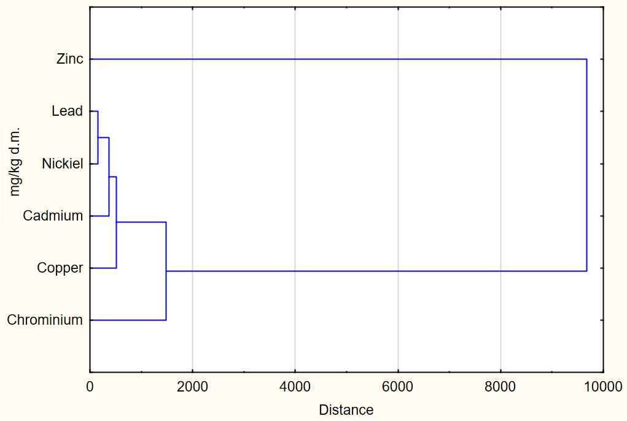

**Fig. 9.** A dendrogram of heavy metals in municipal sludge

The analysis of the research results revealed that objects form clusters, resulting in the emergence of three main clusters. The first one contains lead and nickel, the second – cadmium, copper and chromium, whereas the third one – zinc. The smallest distance between bonds can be found on the level of the first cluster for the agglomeration distance (x = 167.25; y = 4.51), whereas for the second cluster, the distance is (x = 1482.18; y = 1.96). The third cluster has the following parameters (x = 9665.48; y = 6.01), thus constituting the biggest distance in these bonds. This state of bonds in the dendrogram demonstrates the clear advantage of zinc in municipal sludge compared to other parameters. The qualitative analysis of the parameters of sludge from industrial sewage treatment in Poland was conducted for sludge from various processes representing selected industries and sewage treatment plant size (Błaszczyk 2014, Nowak 2010, Iżewska 2013, Krzywy 2013). The physicochemical parameters for industrial sewage sludge are presented in Table 7.

**Table 7.** The results of the analysis of parameters of industrial sludge from industrial sewage treatment in selected treatment plants in Poland (Błaszczyk 2014, Nowak 2010, Iżewska 2013, Krzywy 2013)

|  |  |  |  |  |  |  |  |  |
| --- | --- | --- | --- | --- | --- | --- | --- | --- |
| Parameter | Unit | Sludge from industrial sewage treatment plants | | | | | | |
| I1_A | I2_B | I3_C | I4_D | I5_E | I6_F | I7-G |
| pH | - | 6.89 | 6.78 | 6.90 | 7.10 | 7.30 | 6.12 | 8.80 |
| Organic matter | % d.m. | 43.50 | 49.48 | 83.10 | 63.10 | 70.10 | 29.20 | 21.80 |
| Total nitrogen (N) | % d.m. | 6.54 | 5.88 | 6.32 | 6.24 | 3.11 | 2.45 | 1.21 |
| Total phosphorus (P) | % d.m. | 3.02 | 2.53 | 1.20 | 0.20 | 0.16 | 0.72 | 6.62 |
| Calcium (Ca) | % d.m. | 0.42 | 0.52 | 1.01 | 1.59 | 1.18 | 0.15 | 15.60 |
| Magnesium (Mg) | % d.m. | 0.32 | 0.12 | 0.29 | 0.14 | 0.30 | 0.27 | 1.69 |
| Zinc (Zn) | mg/kg d.m. | 52.73 | 67.50 | 150.00 | 141.0 | 394.83 | 536.00 | 115.00 |
| Lead (Pb) | mg/kg d.m. | 8.03 | 7.22 | 2.25 | 9.80 | 0.14 | 25.80 | 50.40 |
| Cadmium (Cd) | mg/kg d.m. | 0.40 | 0.50 | 4.34 | 2.49 | 3.65 | 0.83 | 0.87 |
| Chromium (Cr) | mg/kg d.m. | 1.61 | 2.10 | 36.20 | 10.10 | 0.04 | 9.47 | 1.77 |
| Copper (Cu) | mg/kg d.m. | 35.10 | 55.2 | 26.00 | 92.60 | 27.41 | 259.00 | 21.00 |
| Nickel (Ni) | mg/kg d.m. | 0.63 | 2.50 | 10.70 | 16.20 | 57.40 | 23.19 | 1.52 |

The content of organic substances in the examined sludge (Table 7) ranges from 21.8% d.m to 83.1% d.m., total nitrogen from 1.21% to 6.54% d.m., total phosphorus (0.2%-3.02% d.m.), calcium from 0.42% to 15.6% d.m. and magnesium from 0.12% to 1.69% d.m. It must be noted that industrial sewage sludge also serves as a source of organic matter and biogenic and mineral compounds that can be utilized in agriculture. Regarding heavy metals, all research results indicate that sludge from industrial sewage treatment plants contains lower concentrations of heavy metals than municipal sewage sludge, and these concentrations are within the norm, as specified in the Regulation (Minister of Environment 2015). The authors draw attention to the need to conduct sediment tests and analyze the results before making a final decision on how to manage them.

The differences observed in the concentration of heavy metals in particular samples of sludge from industrial sewage treatment plants, as presented in Table 7, are likely due to the different characteristics of sewage flowing through a particular plant and the effectiveness of its treatment, as is the case with municipal sewage treatment plants. The distribution of heavy metals (from the smallest to the biggest concentration) in the analyzed samples from particular industrial treatment plants varies and is as follows:

I1_A: Zn>Cu>Pb>Cr>Ni>Cd

I2_B: Zn>Cu>Pb>Ni>Cr>Cd

I3_C: Zn>Cr>Cu>Ni>Cd>Pb

I4_D: Zn>Cu>Ni>Cr>Pb>Cd

I5_E: Zn>Ni>Cu>Cd>Pb>Cr

I6_F: Zn>Cu>Pb>Ni>Cr>Cd

I7_G: Zn>Pb>Cu>Cr>Ni>Cd

It has been observed that cadmium constitutes the smallest part (g/kg d.m.) of all analyzed heavy metals in the samples from all municipal sludge except for M3_C, where Pb had a lower concentration, and M4_D, where Cr had a lower concentration. In contrast, zinc, copper, and chromium are at the top of the concentration ranking. The highest concentration of zinc in all samples of sludge was observed. Figure 10 shows a dendrogram of the analysis of heavy metal concentration in industrial sewage sludge.

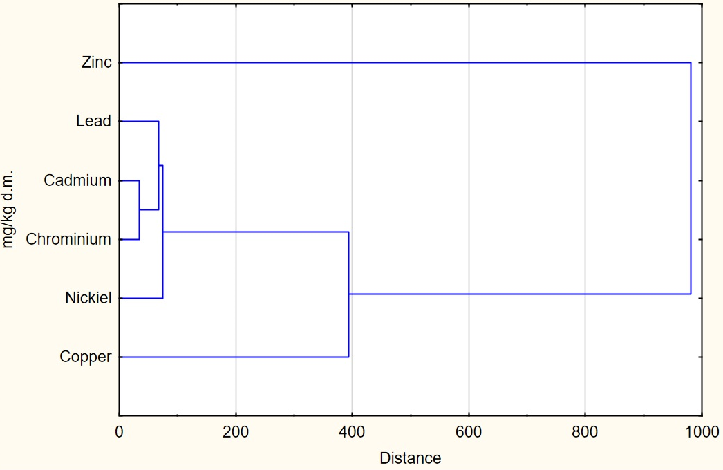

**Fig. 10.** A dendrogram of heavy metals in industrial sludge

The analysis of the research results showed that objects form clusters, as a result of which four main groupings (clusters) originated. The first contains cadmium and chromium, the second contains lead and nickel, the third comprises copper, and the fourth contains zinc. The smallest distance between bonds can be found on the first level of the cluster for the agglomeration distance (x = 35.01; y = 3.51), whereas within the second cluster, the distance is (x = 75.54; y = 3.16). The third cluster has the following parameters (x = 392.53; y = 2.07), and the fourth one concerns zinc, amounting to (x = 980.11; y = 6.01), thus constituting the largest distance in these bonds. This state of bonds demonstrates the dominant value of zinc in industrial sewage sludge compared to other parameters.

The utilization of sewage sludge poses a major challenge in meeting targets related to sustainable development, particularly in terms of bio-waste management. One of these goals is to reduce the amount of stored waste, including sewage sludge, by 50% by 2050 compared to 2000. Due to the limited number of dumping grounds and widespread bans on storing waste (Lasaridi et al. 2018, Baldi et al. 2021), plants opt for burning sewage sludge, thus reducing its mass by as much as 70% and releasing toxic substances that are hazardous to the environment. To process sewage sludge in a closed circuit, we must adhere to strict quality and safety standards (Sobolewska-Mikulska & Cienciała 2020, Sugurbekova et al. 2023). Sewage sludge needs to be carefully examined to prevent excessive levels of heavy metals, which may migrate between soil layers and reach groundwater or surface waters when used in agriculture (Szopińska et al. 2022, Nartowska 2019, Zerrouqi et al. 2020, Basta & Szewczyk 2024). The mobility of heavy metals found in sewage sludge depends largely on its chemical composition (Janaszek et al. 2024); approximately 80-90% of sewage sludge from household waste contains heavy metals. It is assumed that organic and mineral fertilizers based on sewage sludge, with the addition of mineral fertilizers, are suitable for the soil due to their slow release of nutrients into the environment (Kominko et al. 2017).

4. Summary

The article presents a quantitative analysis of sewage sludge generated in the process of municipal and industrial wastewater treatment in Poland, an analysis of sewage sludge management methods and their qualitative analysis in terms of the content of organic substances, total nitrogen, total phosphorus, calcium, magnesium and metals (including heavy metals), in the aspect of environmental and health hazards related to their management.

The largest category of sewage sludge management is the "use of sludge for other purposes". This sludge management method can be utilized, for example, to produce lightweight aggregates, as an additive to construction materials, in biogas plants through co-fermentation processes (primarily outside sewage treatment plants), and as a raw material for the production of advanced biocomponents. The conducted studies emphasize the commonality of recovery processes in municipal sewage sludge management, particularly through their use in agriculture, the production of compost for land reclamation, and energy recovery through heat treatment. The analysis of municipal sewage sludge management methods reveals the considerable commonness of heat treatment of industrial sewage sludge. The analysis of municipal sewage sludge management methods reveals the considerable commonness of sewage used also in agriculture. This practice primarily concerns organic recycling related to the fertilizing potential of the sludge, specifically its content of nitrogen and phosphorus, as well as its soil-forming properties. The analysis of subsequent methods of managing municipal sewage sludge showed that the least popular method is the use of sludge for producing compost in agriculture.

As in the case of municipal sewage sludge, the largest group of industrial sludge subjected to management is waste intended for other purposes. On the other hand, from the other methods of industrial sewage sludge management, it is evident that energy recovery, as a result of their thermal processing, dominates in these methods.

Currently, there are 11 wastewater treatment plants in Poland equipped with thermal treatment systems for sewage sludge, with a total capacity of approx. 160 thousand Mg/year of dry sludge mass. This capacity facilitates the incineration of about 30% of the generated sludge mass. The calorific value of sewage sludge varies significantly based on its processing method, moisture content, and preparation for incineration, ranging from 4 MJ/kg to 16 MJ/kg. Thermal treatment of sewage sludge constitutes a form of energy recovery, leveraging its fuel properties. The thermal treatment process typically employs mono-incineration techniques, such as those used in fluidized bed incinerators, where dewatered sludge is directed for incineration as the primary fuel source. In such systems, biogas produced during the anaerobic digestion of sewage sludge serves as an additional energy source. The thermal energy generated during this process is harnessed to provide process heat for drying the sludge and for heating the air supplied to the fluidized bed incinerator.

An alternative method for managing sewage sludge is co-incineration, commonly conducted in cement plants. This approach enables complete mineral recycling of the sludge, which can be used in the production of clinker or construction materials. To achieve maximum calorific value, the sludge must undergo processes such as drying and granulation. Currently, Poland operates 13 cement plants that incorporate alternative fuels into their production processes, including municipal waste, rubber waste, and sewage sludge, which contribute to 70% of the fuel value utilized. Cement plants co-incinerate sewage sludge in compliance with legal regulations, using it as an alternative fuel source. This practice not only aligns with the principles of a circular economy but also contributes to reducing carbon emissions, treating the process as CO2 neutral. The cement industry thus represents a critical component apart from the thermal processing of waste. Another dominant recycling process is the use of sludge in agriculture and the production of compost through organic recycling. This process, in the case of household sludge, accounts for 29.72% of the total annual mass of household sludge. Regarding industrial sludge, organic recycling accounts for an annual average of 4.89% over the past five years. In the stream of generated sewage sludge, a considerable amount is not recycled, although it is neutralized during storage processes. For household sludge, this amounts to 12.8%, whereas for industrial sludge, it is 16.22%. The documented annual average value of household sewage sludge subjected to recycling processes is 45.47%, whereas for industrial sewage sludge, this value is lower, at 37.93% on average over the past five years.

The assessment of environmental aspects and risks related to the content of potentially harmful elements and chemical compounds in sludge, such as heavy metals, should be crucial for making appropriate decisions regarding the use of sewage sludge in the circular economy. Qualitative analysis of municipal and industrial wastewaters has highlighted the need to assess the risks associated with their management, including both health and ecological risks. This assessment should take into account the concentration of heavy metals in sludge used in agriculture, such as municipal and industrial sewage sludge, before determining whether it is acceptable for agricultural purposes.

Municipal and industrial sewage sludge can be used in agriculture if it is stabilized and prepared for the purpose and way of its use, especially when it is subjected to biological, chemical, thermal, or other processing, which lowers the susceptibility of municipal sewage sludge to decay and eliminates the hazard of contamination with heavy metals that are toxic for the environment and human health.

Following the amendments to the Environment Protection Law, the best available techniques (BAT) developed for waste management include technical solutions resulting from advancements in mechanical engineering for sewage sludge processing. The adopted solutions have become established standards, rather than guidelines and recommendations, that should be taken into account when issuing integrated permits and selecting technologies. Taking the above into consideration, the best available techniques (BAT) constitute an environmental protection instrument leading us towards a circular economy, as far as the management of household and industrial sewage sludge is concerned, in waste management, including sewage sludge, thereby closing the circular economy circle.

References

Act of 14 December 2012 on Waste. Available online: https://isap.sejm.gov.pl/isap.nsf/download.xsp/WDU20130000021/U/D20130021Lj.pdf (accessed on 20 September 2024) (in Polish)

Agency for Toxic Substances and Disease Registry: Toxicological profile for zinc. United States Department of Health and Human Services, *Public Health Service*, Atlanta 2005.

Alves, O., Garcia, B., Rijo, B., Lourinho, G., & Nobre, C. (2022). Market Opportunities in Portugal for the Water-and-Waste Sector Using Sludge Gasification. *Energies*, *15*, 6600. https://doi.org/10.3390/en15186600

Announcement of the Minister of Climate and Environment of November 18, 2022 on the announcement of the uniform text of the regulation of the Minister of the Environment on the use of municipal sewage sludge. https://isap.sejm.gov.pl/isap.nsf/download.xsp/WDU20230000023/O/D20230023.pdf (accessed on 20 September 2024) (in Polish)

Baldi, M., Martinotti, A., Sorlini, S., Katsoyiannis, I. A., Abbà, A., CarnevaleMiino, M., & Collivignarelli, M. C. (2021). Extraction and purification of phosphorus from the ashes of incinerated biological sewage sludge. *Water*, *13*(8), 1102. https://doi.org/10.3390/w13081102

Basta, E., & Szewczyk, P. (2024). The Use of Methane from Landfill Gas to Generate Energy and its Management at the Plant as a Way to Reduce Climate Change. *Rocznik Ochrona Środowiska*, *26*, 236-250. https://doi.org/10.54740/ros.2024.024

Błaszczyk, K., & Krzyśko-Łupicka, T. (2014). Review of sewage sludge testing methods used in Poland. *Inżynieria I Ochrona Środowiska*, *17*(1), 117-133. https://bibliotekanauki.pl/ (accessed on 16 January 2025) (in Polish)

Bornø, M. L., Zervas, A., Bak, F., Merl, T., Koren, K., Nicolaisen, M. H., Jensen, L. S., & Müller-Stöver, D. S. (2023). Differential impacts of sewage sludge and biochar on phosphorus-related processes: An imaging study of the rhizosphere. *Science of The Total Environment*, *905*, 166888, https://doi.org/10.1016/j.scitotenv.2023.166888

Ciuła, J. (2021). Modeling the migration of anthropogenic pollution from active municipal landfill in groundwaters. *Architecture Civil Engineering Environment*, *14*(2), 81-90. https://doi.org/10.21307/ACEE-2021-017

Dean, R. B., & Suess, M. J. (1985). The risk to health of chemicals in sewage sludge applied to land. *Waste Management & Research*, *3*(3), 251-278. <https://doi.org/10.1016/0734-242X(85)90115-6>

Decisions Commission Implementing Decision (EU) 2018/1147 of 10 August 2018 establishing best available techniques (BAT) conclusions for waste treatment, under Directive 2010/75/EU of the European Parliament and of the Council, L208/38,17.8.2018.https://eur-lex.europa.eu/legal-content/PL/TXT/?uri=CELEX:32018D1147 (accessed on 30 December 2024).

Di Maro, M., Gargiulo, L., Gomez d’Ayala, G., & Duraccio, D. (2024). Exploring Antimicrobial Compounds from Agri-Food Wastes for Sustainable Applications. *International Journal of Molecular Sciences*, *25*, 13171. https://doi.org/10.3390/ijms252313171

D'Imporzano, G., & Adani, F. (2023). Measuring the environmental impacts of sewage sludge use in agriculture in comparison with the incineration alternative, *Science of The Total Environment*, *905*, 167025.   
https://doi.org/10.1016/j.scitotenv.2023.167025

Directive 2010/75/EU of the European Parliament and of the Council of 24 November 2010 on industrial emissions   
(integrated pollution prevention and control), L208 z 17.08.2018. https://eur-lex.europa.eu/legal-content/EN/TXT/PDF/?uri=CELEX:32010L0075. (accessed on 30 December 2024).

Duan, B., & Feng, Q. (2021). Comparison of the Potential Ecological and Human Health Risks of Heavy Metals from Sewage Sludge and Livestock Manure for Agricultural Use. *Toxics*, *9*(7), 145. <https://doi.org/10.3390/toxics9070145>

Đurđević, D., Blecich, P., & Jurić, Ž. (2019). Energy Recovery from Sewage Sludge: The Case Study of Croatia. *Energies*, *12*(10), 1927, https://doi.org/10.3390/en12101927

El Hammoudani, Y., Fouad, D., & El Ouarghi, H. (2019). Characterization of sewage sludge generated from wastewater treatment plant in relation to agricultural use. *Environmental and Water Sciences, public Health and Territorial Intelligence Journal*, *3*, 47-52.

Environment 2019, Statistics Poland, Warszawa 2019. https://stat.gov.pl/obszary-tematyczne/srodowisko-energia/srodowisko/ochrona-srodowiska-2019,1,20.html (accessed on 14 September 2024) (in Polish)

Environment 2020, Statistics Poland, Warszawa 2020. https://stat.gov.pl/obszary-tematyczne/srodowisko-energia/srodowisko/ochrona-srodowiska-2020,1,21.html (accessed on 19 September 2024) (in Polish)

Environment 2021, Statistics Poland, Warszawa 2021. https://stat.gov.pl/obszary-tematyczne/srodowisko-energia/srodowisko/ochrona-srodowiska-2021,1,22.html (accessed on 22 September 2024) (in Polish)

Environment 2022, Statistics Poland, Warszawa 2022. https://stat.gov.pl/obszary-tematyczne/srodowisko-energia/srodowisko/ochrona-srodowiska-2022,1,23.html (accessed on 25 September 2024) (in Polish)

Environment 2023, Statistics Poland, Warszawa 2023. https://stat.gov.pl/obszary-tematyczne/srodowisko-energia/srodowisko/ochrona-srodowiska-2023,1,24.html (accessed on 29 September 2024) (in Polish)

Fijalkowski, K., Rorat, A., Grobelak, A., & Kacprzak, M. J. (2017). The presence of contaminations in sewage sludge – the current situation. *Journal Environmental Management*, *203*, 1126-1136.   
https://doi.org/10.1016/j.jenvman.2017.05.068

Gaska, K., Generowicz, A., Gronba-Chyła, A., Ciuła, J., Wiewiórska, I., Kwaśnicki, P., Mala, M., & Chyła, K. (2023). Artificial Intelligence Methods for Analysis and Optimization of CHP Cogeneration Units Based on Landfill Biogas as a Progress in Improving Energy Efficiency and Limiting Climate Change. *Energies*, *16*, 5732. https://doi.org/10.3390/en16155732

Gaska, K., Generowicz, A., Lobur, M., Jaworski, N., Ciuła, J., & Mzyk, T. (2019). *Optimization of Biological Wastewater Treatment Process by Hierarchical Adaptive Control*. IEEE XVth International Conference on the Perspective Technologies and Methods in MEMS Design 2019, 119-122. https://doi.ogr/10.1109/MEMSTECH.2019.8817382

Grąz, K., Gronba-Chyła, A., & Chyła K. (2023). Microplasticsfound in compost as a barrier to the circular economy (CE). *Przemysł chemiczny*, *102*(4), 381-383. https://doi.org/10.15199/62.2023.4.7

Gronba-Chyła, A., Generowicz, A., Alwaeli, M., Mannheim, V., Grąz, K., Kwaśnicki, P., & Kramek, A. (2024). Municipal waste utilization as a substitute for natural aggregate in the light of the circular economy. *Journal of Cleaner Production*, *440*, 140907. https://doi.org/10.1016/j.cej.2021.131928

Iżewska, A., Wołoszyk, C., & Sienkiewicz, S. (2013). Assessment of physical, chemical and energetic properties of sludge in industrial and municipal sewage treatment plant. Zeszyty Naukowe, Inżynieria Środowiska, *152*(32), 94-104. https://www.semanticscholar.org. (accessed on 1 February 2025)

Janaszek, A., Furtado da Silva, A., Jurišević, N., Kanuchova, M., Kozáková, L., & Kowalik, R. (2024). The Assessment of Sewage Sludge Utilization in Closed-Loop Economy from an Environmental Perspective. *Water*, *16*(3), 383. https://doi.org/10.3390/w16030383

Jurczyk, L., Koc-Jurczyk, J., & Balawejder, M. (2019). Quantitative Dynamics of Chosen Bacteria Phylla in Wastewater Treatment Plants Excess Sludge After Ozone Treatment. *Journal of Ecological Engineering*, *20*(3), 204-213. https://doi.org/10.12911/22998993/99784

Jurczyk, M., Banaś, M., Pająk, T., Dziedzic, K., Łapczyńska-Kordon, B., & Jewiarz, M. (2024). The Influence of Selected Parameters of the Mathematical Model on the Simulation Performance of a Municipal Waste-to-Energy Plant Absorber. *Energies*, *17*, 6382. https://doi.org/10.3390/en17246382

Kacprzak, M., Neczaj, E., Fijalkowski, K., Grobelak, A., Grosser, A., Worwag M., Rorat A., Brattebo, H., Almas A., & Singh B. R. (2017). Sewage sludge disposal strategies for sustainable development. *Environ. Research*, *156*,   
39-46, https://doi.org/10.1016/j.envres.2017.03.010

Kasina, M. (2023). The assessment of phosphorus recovery potential in sewage sludge incineration ashes – a case study. *Environmental Science and Pollution Research*, *30*, 13067-13078, https://doi.org/10.1007/s11356-022-22618-4

Kasprzyk, M., Gajewska, M., & Molendowska, S. (2017). Possibilities of phosphorus recovery from leachates, sewage sludge and ash after thermal treatment of sewage sludge. *Inżynieria Ekologiczna*, *18*, 65-78. https://doi.org/10.12912/23920629/74978 (in Polish)

Khan, R., Shukla, S., Kumar, M., Zuorro, A., & Pandey, A. (2023). Sewage sludge derived biochar and its potential for sustainable environment in circular economy: Advantages and challenges, *Chemical Engineering Journal*, *471*, 144495, https://doi.org/10.1016/j.cej.2023.144495

Koc-Jurczyk, J., Jurczyk, Ł., Balawejder, M., & Kisała, J. (2022). The impact of 3,3',5,5’-tetrabromobisphenol-A (TBBPA) solution pretreatment by ozonolysis and photocatalysis on the activated sludge respirometric activity. *Desalination and Water Treatment*, *246*, 1-11. <https://doi.org/10.5004/dwt.2022.28035>

Kołecka, K., Gajewska, M., Obarska-Pempkowiak, H., & Rohde, D. (2017). Integrated dewatering and stabilization system as an environmentally friendly technology in sewage sludge management in Poland. *Ecological Engineering*, *98*, 346-353. https://doi.org/10.1016/j.ecoleng.2016.08.011

Kominko, H., Gorazda, K., & Wzorek, Z. (2017). The Possibility of Organo-Mineral Fertilizer Production from Sewage Sludge. *Waste Biomass Valoriz*, *8*, 1781-1791. https://doi.org/10.1007/s12649-016-9805-9

Kowalski, S., Opoka, K., & Ciuła, J. (2022). Analysis of the end-of-life the front suspension beam of a vehicle. *Maintenance and Reliability*, *24*(3), 446-454, http://doi.org/10.17531/ein.2022.3.6

Krzywy, E., & Możdżer, E. (2013). The use of industrial waste and municipal sewage sludge for the production of fertilizer granules. *Chemik*, *67*(7), 620-627. https://bibliotekanauki.pl/articles/1216367. (accessed on 3 February 2025)   
(in Polish)

Laonamsai, J., Pawana, V., Chipthamlong, P., Chomcheawchan, P., Kamdee, K., Kimmany, B., & Jul-phunthong, P. (2023). Groundwater Quality Variations in Multiple Aquifers: A Comprehensive Evaluation for Public Health and Agricultural Use. *Geosciences*, *13*, 195. https://doi.org/10.3390/geosciences13070195

Lasaridi, K. E., Manios, T., Stamatiadis, S., Chroni, C., & Kyriacou, A. (2018). The Evaluation of Hazards to Man and the Environment during the Composting of Sewage Sludge. *Sustainability*, *10*, 2618. https://doi.org/10.3390/su10082618

Liu, H., Hu, G., Basar, I. A., Li, J., Lyczko, N., Nzihou, A., & Eskicioglu, C. (2021). Phosphorus recovery from municipal sludge-derived ash and hydrochar through wet-chemical technology: A review towards sustainable waste management. *Chemical Engineering Journal*, *417*, 129300. https://doi.org/10.1016/j.cej.2021.129300

Liu, Q., Chen, Y., Hu, W., Dong, J., Sun, B., & Cheng, H. (2023). Underground Logistics Network Design for Large-Scale Municipal Solid Waste Collection: A Case Study of Nanjing, China. *Sustainability*, *15*, 16392. https://doi.org/10.3390/su152316392

Local Data Bank, Statistics Poland. https://bdl.stat.gov.pl (accessed on 29 September 2024) (in Polish)

Maizel, A. C., & Remucal, C. K. (2017). The effect of advanced secondary municipal wastewater treatment on the molecular composition of dissolved organic matter. *Water Research*, *122*, 42-52.   
https://doi.org/10.1016/j.watres.2017.05.055

Makarichi, L., Jutidamrongphan, W., & Techato, K. (2018). The evolution of waste-to-energy incineration: a review. *Renewable Sustainable Energy Reviews*, *91*, 812-821. https://doi.org/10.1016/j.rser.2018.04.088

Martín-Gómez, A. M., Pineda-Ganfornina, M., Ávila-Gutiérrez, M. J., Agote-Garrido, A., & Lama-Ruiz, J. R. (2024). Balanced Scorecard for Circular Economy: A Methodology for Sustainable Organizational Transformation. *Sustainability*, *16*, 1464. https://doi.org/10.3390/su16041464

Mathney, J. M. J. (2011). A Critical Review of the U.S. EPA's Risk Assessment for the Land Application of Sewage Sludge. *New Solutions*, *21*(1), 43-56. <https://doi.org/10.2190/NS.21.1.h>

Melo, W., Delarica, D., Guedes, A., Lavezzo, L., Donha, R., de Araújo, A., de Melo, G., & Macedo, G. (2018). Ten years of application of sewage sludge on tropical soil. A balance sheet on agricultural crops and environmental quality. *Science of The Total Environment*, *643*, 1493-1501. https://doi.org/10.1016/j.scitotenv.2018.06.254

Mierzwiński, A., Mierzwiński, M. Tomaszewski, K., Obłąkowska, K., & Moskwik, K. (2021). *Cement industry in waste management*. Jagiellonian Institute, Warsaw, 2021. (in Polish)

Milik, J., Pasela, R., Szymczak, M., & Chalamoński, M. (2016). Evaluation of the Physico-chemical Composition of Sludge from Municipal Sewage Treatment Plant. *Rocznik Ochrona Środowiska*, *18*, 579-590.   
https://ros.edu.pl/index.php?option=com_content&view=article&id=483&Itemid=168&lang=pl   
(accessed on 28 January 2025) (in Polish)

Mukawa, J., Pająk, T., Rzepecki, T., & Banaś, M. (2022). Energy Potential of Biogas from Sewage Sludge after ThermalHydrolysis and Digestion. *Energies*, *15*, 5255. https://doi.org/10.3390/en15145255

Nartowska, E. (2019). The effects of potentially toxic metals (copper and zinc) on selected physical and physico-chemical properties of bentonites. *Heliyon*, 5, e02563. https://doi.org/10.1016/j.heliyon.2019.e02563

Nowak, M., Kacprzak, M. & Grobelak, A. (2010). Sewage Sludge as a Substitute of Soil in the Process of Remediation and Reclamation of Sites Contaminated with Heavy Metals. *Inżynieria i Ochrona Środowiska*, *13*(2), 121-131. https://bibliotekanauki.pl/articles/297732 (accessed on 15 January 2025). (in Polish)

Poluszyńska, J., & Ślęzak, E. (2015). Phosphorus from municipal sewage sludge. Scientific Works of Institute of Ceramics and Building, *Materials*, *22*, 44-55.   
https://www.academia.edu/101853348/Mo%C5%BCliwo%C5%9Bci_odzysku_fosforu_z_osad%C3%B3w_%C5%9Bciekowych. (accessed on 18 January 2025) (in Polish)

Przydatek, G., Generowicz, A., & Kanownik, W. (2024). Evaluation of the Activity of a Municipal Waste Landfill Site in the Operational and Non-Operational Sectors Based on Landfill Gas Productivity. *Energies*, *17*, 2421. https://doi.org/10.3390/en17102421

Regulation of the Minister of Climate of January 2, 2020 on the Waste Catalog.   
Available online: https://isap.sejm.gov.pl/isap.nsf/download.xsp/WDU20200000010/O/D20200010.pdf   
(accessed on 27 June 2024) (in Polish)

Regulation of the Minister of Environment of 6 February 2015 on the use of municipal sewage sludge.. https://sip.lex.pl/akty-prawne/dzu-dziennik-ustaw/stosowanie-komunalnych-osadow-sciekowych-18169040   
(accessed on 15 March 2025) (in Polish)

Shaban, A., Zaki, F.-E., Afefy, I. H., Di Gravio, G., Falegnami, A., & Patriarca, R. (2022). An Optimization Model for the Design of a Sustainable Municipal Solid Waste Management System. *Sustainability*, *14*, 6345. https://doi.org/10.3390/su14106345

Sobolewska-Mikulska, K., & Cienciała, A. (2020). Legal-Surveying Documentation in the Registration of Rights to Properties of the Treasury and of Territorial Self-government Units–Case Study of Poland. *Real Estate Manag. Valuat*, *28*, 76-88. https://doi.org/10.1515/remav-2020-0017

Statistica, version 14.1.0.4; TIBCOI Software Inc.: Palo Alto, CA, USA (2023).

Sugurbekova, G., Nagyzbekkyzy, E., Sarsenova, A., Danlybayeva, G., Anuarbekova, S., Kudaibergenova, R., Frochot, C., Acherar, S., Zhatkanbayev, Y., & Moldagulova, N. (2023). Sewage Sludge Management and Application in the Form of Sustainable Fertilizer. *Sustainability*, *15*(7), 6112. https://doi.org/10.3390/su15076112

Szopińska, K., Cienciała, A., Bieda, A., Kwiecień, J., Kulesza, Ł., & Parzych, P. (2022). Verification of the Perception of the Local Community concerning Air Quality Using ADMS-Roads Modeling. *International Journal of Environmental Research and Public Health*, *19*, 10908. https://doi.org/10.3390/ijerph191710908

Tripathi, P., Basu, D., & Pal, P. (2023). Environmental impact of recycling sewage sludge into cementitious matrix: A review. *Materialstoday: Proceedings*, *78*(1), 179-188. <https://doi.org/10.1016/j.matpr.2023.01.186>

Tytla, M. (2022). Heavy metals in sewage sludge in view of health risk. Laboratorium – Przegląd Ogólnopolski. *ELAMED Media Group.*, *4*, 44-49. Identyfikator YADDA:   
bwmeta1.element.baztech-a92b8722-6dec-4d45-a1f5-09f46bb84fa1

Ville, L., & Kärki, T. (2018). Mechanical Sorting Processing of Waste Material Before Composite Manufacturing-A Review. *Journal of Engineering Science & Technology*, *11*(6), 35-46.   
http://jestr.org/downloads/Volume11Issue6/fulltext61162018.pdf (accessed on 29 December 2024).

Vinoth, V., Sathiyamurthy, S., Ananthi, N., & Jayabal S. (2024). Mechanical characterization and study on morphological properties: Natural and agro waste utilization of reinforced polyester hybrid composites. Proceedings of the Institution of Mechanical Engineers, Part C. *Journal of Mechanical Engineering Science*, *238*(19), 9577-9588. https://doi.org/10.1177/09544062241258077

Wang, L., Li, A., & Chang, Y. (2016). Hydrothermal treatment coupled with mechanical expression at increased temperature for excess sludge dewatering: Heavy metals, volatile organic compounds and combustion characteristics of hydrochar. *Chemical Engineering Journal*, *297*. 1-10, https://doi.org/10.1016/j.cej.2016.03.131

Wiewiórska, I., Lobur, M. Vovk, M., Makara, A., & Kowalski, Z. (2023). Analysis of the impact of changes in surface water quality on the dynamics of treatment processes in drinking water treatment technological systems. *Desalination and Water Treatment*, *315*, 1-12. https://doi.org/10.5004/dwt.2023.30053

Wu, B., Dai, X., & Chai, X. (2020). Critical review on dewatering of sewage sludge: influential mechanism, conditioning technologies and implications to sludge re-utilizations. *Water Research*, *180*, 115912.   
https://doi.org/10.1016/j.watres.2020.115912

Wysowska, E., Wiewiórska, I., & Kicińska, A. (2024). The Problem of Health Risk Resulting from the Presence of Pharmaceuticals in Water Used for Drinking Purposes: A Review. *Journal of Ecological Engineering*, *25*(5), 244-256. https://doi.org/10.12911/22998993/186371

Yakamercan, E., Ari, A., & Aygün, A. (2021). Land application of municipal sewage sludge: Human health risk assessment of heavy metals. *Journal of Cleaner Production*, *319*, 128568. <https://doi.org/10.1016/j.jclepro.2021.128568>

Zerrouqi, Z., Reda Tazi, M., Chafi, A., & Zerrouqi, A. (2020). Impact of Sewage Sludge Leaching on Soil Constituents and Quality. *Environmental Research, Engineering and Managemen*, *76*(4). https://doi.org/10.5755/j01.erem.76.4.25632

Zhang, H., Huang, Y., Zhou, S., Wei, L., Guo, Z., & Li, J. (2020). Pollution level and risk assessment of heavy metals in sewage sludge from eight wastewater treatment plants in Wuhu City, China. *Spanish Journal of Agricultural Research*, *18*(2), e1103. [https://doi.org/10. 5424/sjar/20201 82-15796](https://doi.org/10.%205424/sjar/20201%2082-15796)

Zhao, L., Sun, Z., Pan, X., Tan, J., Yang, S., Wu, J., Chen, Ch., Yuan, Y., & Ren, N. (2023). Sewage sludge derived biochar for environmental improvement: Advances, challenges, and solutions. *Water Research*, *X*, 18, 100167, https://doi.org/10.1016/j.wroa.2023.100167