|  |  |  |  |
| --- | --- | --- | --- |
|  |  | | |
| **Rocznik Ochrona Środowiska** | | |
| Volume 27 | Year 2025 ISSN 2720-7501 | pp. 135-151 |
|  | https://doi.org/10.54740/ros.2025.012 open access | | |
|  | Received: November 2024 Accepted: February 2025 Published: March 2025 | | |

IoT-Powered Flexible Road Dividers for Accident Impact Reduction

Deepti Khurge1, Prachi Palsodkar2, Prasanna Palsodkar3, Abdullah Faiz Al Asmari4,   
Tinku Biswas5, Khalid Ansari6*, Dhiraj Agrawal7, Ahmed M. Abdulhadi8, Saiful Islam9

1Department of Electronics and Telecommunication Engineering,   
Pimpri Chinchwad College of Engineering, Pune, Maharashtra, India  
https://orcid.org/0000-0001-8475-6099

2Department of Electronics Engineering, Yeshwantrao Chavan College of Engineering, Nagpur, Maharashtra, India https://orcid.org/0000-0002-6036-2842

3Department of Electronics Engineering, Yeshwantrao Chavan College of Engineering, Nagpur, Maharashtra, India https://orcid.org/0000-0002-0203-3311

4Civil Engineering Department, College of Engineering, King Khalid University, Abha, Saudi Arabia

5Deputy Manager, Central quality assurance, DLF Ltd, Gurgaon, India

6Department of Civil Engineering, Yeshwantrao Chavan College of Engineering, Nagpur, Maharashtra, India   
https://orcid.org/0000-0003-4054-6502

7Department of Civil Engineering, Yeshwantrao Chavan College of Engineering, Nagpur, Maharashtra, India

8Al-Safwa University College, Kerbala, Iraq

9Civil Engineering Department, College of Engineering, King Khalid University, Abha, Saudi Arabia

*corresponding author's e-mail: [ksansari@ycce.edu](mailto:ksansari@ycce.edu)

**Abstract:** In road safety, accidents involving collisions with road dividers often result in severe injuries and fatalities. To mitigate the impact of such accidents, this study focuses on designing and testing flexible road dividers to reduce collision severity and real-time alerting through IoT Integration. A novel flexible road divider incorporates advanced materials like expanded polystyrene separators and barriers (EPS), and specific engineering principles like design, shape, and flexibility make dividers capable of absorbing and dissipating kinetic energy after impact. The system is engineered to be durable, resilient, and cost-effective, making it a viable solution for enhancing road safety in the Indian transportation system. Detailed measurements of forces, deformation, and energy absorption are recorded to quantify the system's effectiveness in reducing the severity of accidents. The findings of this research have implications for road design and infrastructure and offer valuable insights into the development of safer transportation systems with a real-time collision alert mechanism using vibration sensors. Ultimately, adopting flexible road dividers with enhanced impact-reducing properties could represent a significant step forward in safeguarding the lives of road users and reducing the economic burden associated with road accidents. The new prototype discussed in this is anticipated to enhance the energy-absorbing capacity of concrete barriers and lessen the effect of cars beside concrete barriers   
– a unit weight of 1650 kg/m3.

**Keywords:** accident, collision, safety, IoT, road safety, flexible road, environment

1. Introduction

The number of accidents is rapidly increasing in proportion to the daily growth in vehicle traffic. An accidental fatality on Indian Road is recorded every minute (Akki et al. 2023). These accidents might be attributed to various factors, such as impaired concentration caused by mental issues or false sensations of oncoming vehicles. This endeavor revolves around the accident. While it is crucial to maintain a safe driving environment, stray animals, poor road conditions, and driver mistakes can all result in accidents. The initial minutes following an incident are crucial for accident victims since receiving medical attention in these moments significantly increases their chances of survival compared to waiting. That's why it's so important to have a system that can recognize emergencies and alert the appropriate authorities so that people who need help may get it. From 1990 to 2019, the road survey shown in Fig. 1(a) shows the top 10 countries prone to accidents, where the leading ones are China, India, and the USA. Analysis shows after 2010, China, the USA, and Russia's accidental death rate started decreasing by a significant amount. In contrast, in India, this rate is still higher compared to other countries, as shown in Fig. 1(b) (Panda et al. 2022, Basu et al. 2022).

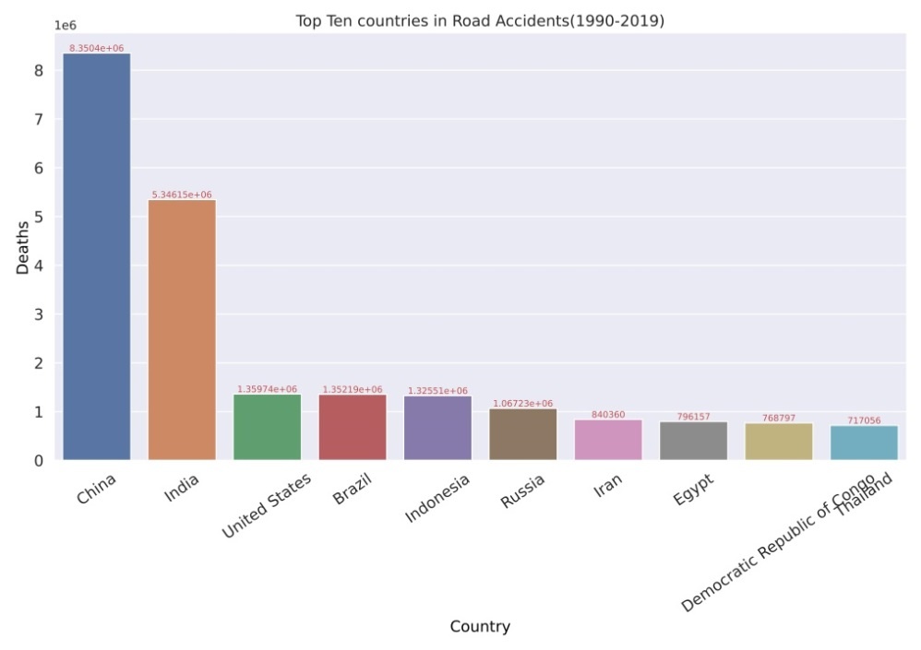

(a)

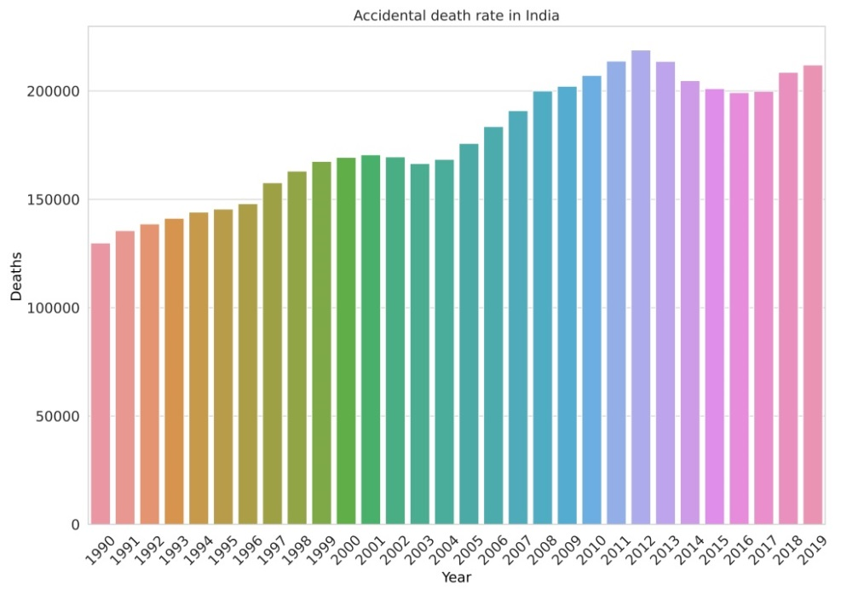

(b)

**Fig. 1.** (a) Top Ten Countries in Road Accidents from (1990-2019), (b) Accidental Death Rate in India

Road traffic accidents (RTAs) are the eighth biggest cause of death globally, and they are supposed to move to the fifth position by 2030 if proper precautions are not followed (Bokaba et al. 2022). This work intends to improve road safety by erecting expanded polystyrene separators and barriers (EPS) and IoT. These are non-biodegradable materials, leading to environmental pollution. Using EPS as a partial replacement for fine aggregates in concrete will create the advantage of contributing to pollution management and road accident safety. In deaths due to road accidents, 50% of fatalities occurred due to overspeed. Mostly, these accidents were recorded on just five percent of the highways, hinting that preventive measures must be taken to reduce accidents on these stretches. Authorities must discover more of these sections across the country and implement preventative steps, such as modifying speed limits, repairing blind spots, and removing excessive undulations, among the leading causes of road accidents. On average, it is estimated that there are around 3,700 road traffic-related deaths worldwide every day, which translates to approximately 154 fatalities per hour. Developing nations are the target of daily traffic accidents. Infrastructure, traffic, and accident management are the primary culprits (Athiappan et al. 2022).

All passengers in a car are immediately at risk of death in the case of a collision. Everything depends on how quickly they can react to spare them a few minutes or seconds of death. Statistics show that shortening accident delays by even one minute can save 6% of lives. As a result, developing a system that can reduce the severity of traffic accidents is critical. While the number of fatalities on the road continues to rise, it is crucial to implement an integrated approach to improve road safety (Vastava et al. 2023). EPS road dividers can be used when subjected to collision fractures with minimal elastic deformation without significant deformation (Deshmukh et al. 2022). EPS road dividers behave like brittle materials and receive relatively little energy before breakage (Akyıldız et al. 2022). Also, the cost is comparable to road dividers made from conventional fine aggregates. Installing collision-detection sensors at regular intervals enables the sensors to detect a collision and transmit its location to the appropriate place (Talukder et al. 2022, Yun et al. 2023). LED indicators can be added to the structure to make dividers visible in low light conditions on the road, hence reducing the probability of accidents (Kamilya et al. 2022). The shape of the road dividers must also be redesigned to reduce the impact made after the collision.

The higher the vehicle speed, the shorter the time a driver must stop and avoid a crash. A car traveling at 50 km/h typically requires 13 meters to stop, while a vehicle traveling at 40 km/h will stop in less than 8.5 meters. An increase in the average speed of 1 km/h typically results in a 3% higher risk of a crash involving injury, with a 4-5% increase in crash speed also contributing to the impact's severity when a collision occurs. Hence, a system that can reduce the severity of road accidents is an urgent task. Mortality on roads is increasing, and it is necessary to ensure an integrated approach to creating safe road conditions. Vehicles with high speed and vehicles after the collision can crash on road dividers and alongside walls, causing severe damage to cars, death, personal injury, and material damage to transported goods. One of the ways to reduce the impact of collisions in accidents is installing accident impact-reducing structures on the roads and IoT-enabled technology to detect accident locations early. This work aims to bring out novel changes in the design of road dividers and the use of EPS material at the most impact-making points on its surface (Jiang et al. 2022) (Özer et al. 2022). Fig. 2 shows the existing road divider structures in India (Rashid et al. 2023).

|  |  |
| --- | --- |
|  |  |

**Fig. 2.** Existing shapes of the road divider

2. Road Divider's Prior Research Synthesis

The history of concrete road dividers, also known as concrete median barriers or simply concrete barriers, spans over a century and reflects the evolution of road safety engineering. In the early 20th century, concrete road dividers were used to respond to the increasing number of automobile accidents. Earlier dividers were often low-profile and primarily served as a visual separation between opposing lanes of traffic. In the Mid-20th Century, there was a growing recognition of the need for more effective road dividers to prevent head-on collisions and crossover accidents. Engineers and researchers began designing taller and more robust concrete barriers capable of redirecting or containing vehicles in the event of an impact.

The concept of the Jersey Barrier, a modular precast concrete barrier with a distinctive "New Jersey" shape, was developed in the United States during this period and gained widespread use (Secco et al. 2022). Fig. 3 shows various shapes of road dividers.

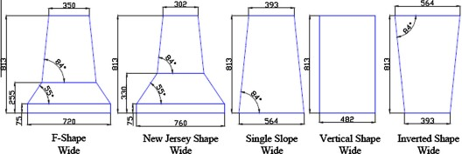

**Fig. 3.** Safety shapes of the road divider (Meddage et al. 2022)

During the late 20th century, the design and construction of concrete road dividers continued to evolve. Innovations included the development of barrier systems that were better at absorbing and dissipating kinetic energy upon impact, reducing the severity of accidents. Reflective markings and improved visibility features were added to enhance safety, especially at night. The 21st century has seen ongoing advancements in concrete barrier technology, focusing on reducing injury severity in accidents. High-performance concrete materials have been introduced, offering enhanced durability and resistance to impact. Research and development efforts have explored designs accommodating various vehicle types and collision scenarios. Many countries have adopted standardized specifications and crash-testing procedures for concrete barriers to ensure their effectiveness.

Today, concrete road dividers are an integral part of road safety infrastructure in many countries. They are widely used on highways, freeways, and urban roads. Modern concrete barriers come in various designs, including rigid barriers preventing crossover accidents and more forgiving semi-rigid or flexible barriers that absorb energy during impacts. Efforts continue to enhance the safety performance of the concrete obstacles and to address specific challenges such as motorcycle safety and the transition between different types of barriers (Ferko et al. 2022).

3. Methodology

3.1. Material selection

Expanded Polystyrene (EPS) is a white foam plastic manufactured from polystyrene solid particles. Primarily, it is utilized for packaging, insulation, etc. It is a closed-cell, rigid foam substance made from Styrene, which creates the cell structure. Expanded polystyrene (EPS) beads made from a combination of cement, aggregate, and polystyrene beads with additives increased the workability and durability of the material employed in trials. EPS is light, having a density between 15 and 25 kg/m3. EPS is an excellent insulator with minimal heat conductivity. Due to the cost of raw ingredients and the energy necessary to create it, concrete is often more costly than EPS. The creation of concrete significantly impacts the environment because greenhouse gases are released throughout the manufacturing process of concrete.

In contrast, the production of EPS has a reduced environmental impact. Expanded polystyrene (EPS) is good for the environment. EPS contains 98% air and no hazardous ingredients; it is also 100% reusable. EPS is simple to install on the job site. In addition to construction and packing, EPS is utilized to manufacture protective crash helmets for athletes and others. Table 1 shows the Properties of EPS Beads.

**Table 1.** Properties of EPS beads used in project (Özer et al. 2022)

|  |  |  |  |
| --- | --- | --- | --- |
| Properties | Values | Properties | Values |
| Density | 9.50 Kg/m3 | Shear Modulus (G) | 2.97 Mpa |
| Maximum bead diameter | 6.3 mm | Bulk Modulus (K) | 1.72 MPa |
| Melting Point | 160°C | Average heat of degradation | 820J/g 195.86 cal/g) |
| Volatilization Point | 475-500°C | Water absorption | ≈ 0 |

For the construction of the Flexible Road Divider, Portland Type 1 cement is used (Meng et al. 2022). Also, the SF is used. SF means Silica Fume. SF as a material is excellent in size. Its size may vary by a small margin. Agglomeration may render the distribution of particle dimensions unpredictable; also, this substance has a much greater adequate average particle size of particles than non-agglomerated substances. Using SF to strengthen the link between EPS beads and cement particles boosts the durability of the combinations even more. Natural sand and Crushed aggregates are other materials used to construct the flexible road divider. Also, as per the specifications in Table 2, the EPS Beads are used. EPS beads help to reduce the weight of the concrete. EPS beads also impact the strength of the EPS Concrete. Also, as per the material requirement, enough water is added to the mixture. The proportion of water to reinforcing ingredients must be minimized to achieve concrete's required strength properties and fluidity. Also, superplasticizers are used in the mixer to enhance the workability and compactness of concrete, increase its strength, and enhance the concrete's surface polish.

**Table 2.** Material Composition

|  |  |  |  |
| --- | --- | --- | --- |
| Material | Quantity | Material | Quantity |
| Cement (Kg/m3) | 355.5 | Sand (Kg/m3) | 700 |
| SF (Kg/m3) | 39.5 | Coarse Aggregate (Kg/m3) | 784 |
| Water (Kg/m3) | 190 | Superplasticizers (ml/kg of cement) | 4.1 |
| EPS Beads (Kg/m3) | 1 |  |  |

3.2. Mixing procedure

As shown in Figure 4, the materials were first combined in a precise sequence. About 40% water with superplasticizer was fed into the mixers. Afterward, dried EPS beads were poured and stirred for approximately 2 minutes to create EPS beads moistened with water and superplasticizer. The remaining water was then gradually added to the mixer when the final concrete ingredients were added. Mixed thoroughly till a consistent slurry is created and EPS beads are more evenly distributed. Both slump and fresh density measurements were taken.

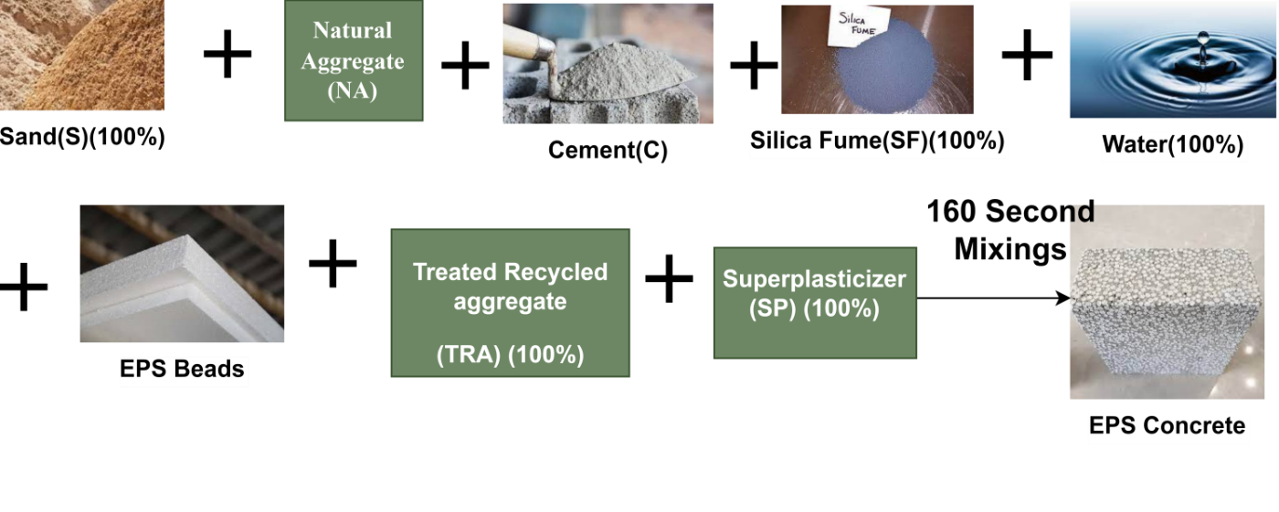

**Fig. 4.** Making of EPS

3.3. Key parameters that differentiate concrete and EPS

EPS is much weaker than concrete, particularly in terms of compressive strength. Concrete may be used as a load-bearing material in construction, but EPS is not meant to support major loads. Concrete is a very robust material that may endure for decades, while EPS may degrade over time because of its vulnerability to moisture and temperature fluctuations. Concrete is a dense substance with a density of around 2,400 kg/m3, while EPS is a lightweight material with a density of approximately 15-25 kg/m3. EPS is an excellent insulator with low heat conductivity, while concrete is a poor insulator with significant thermal conductivity. Due to the cost of raw ingredients and the energy necessary to create it, concrete is often more costly than EPS. Yet, the price of concrete might vary significantly based on the specifications of a given project. Due to the emission of greenhouse gases throughout the manufacturing process, the production of concrete has a significant environmental effect, while the manufacture of EPS has a lesser environmental impact.

Concrete barriers provide superior durability and protection, whereas EPS barriers are more flexible in cost and application. The decision of which to use depends on each project's unique needs and conditions. Generally, concrete is a versatile and strong material. It is ideal for supporting heavy loads, while EPS concrete is better for insulation and thermal shielding. Ultimately, the choice of material depends on factors such as budget, environmental concerns, and the desired level of strength and endurance.

3.4. Shape of road divider

A developed road divider can reduce the impact of the collision on the vehicle during a road accident. The crucial part of the flexible road divider is the design. The design of the divider makes it different from other road dividers. Flexible Road Divider comprises a composite of EPS material and concrete. Making the road divider of a composite of EPS and concrete gives better efficiency. It is found that EPS concrete energy absorption capability increases and decreases with the volume of EPS Concrete. Concrete also provides the required strength for the divider. The Flexible Road divider uses the property of EPS material to absorb the impact. In a flexible road divider, many factors, such as shape, length, width, and joint connections, affect the design of the divider. The shape of the divider is the most crucial part. Because of the shape of the divider, the impact of road accidents is reduced. Figure 5a shows the design of the flexible road dividers structure side view. The divider's shape differs from that of a standard road divider; primarily, the design of the flexible road divider is divided into three parts: one middle part and two outer parts.

3.4.1. Flexible road divider shape and width

In a flexible road divider, the energy of the vehicle collision is absorbed by the divider using its shape. Also, the shape of the divider helps redirect the colliding vehicle to its correct route; the incorrect route, cable, and road divider have high mass because of that, and the impact is dissipated into the whole divider. When a collision happens on the flexible road divider, its outer parts, which face the vehicle, get damaged, so only that part needs to be replaced. Also, the curves of the top and the bottom of the flexible road divider are an essential part of the design.

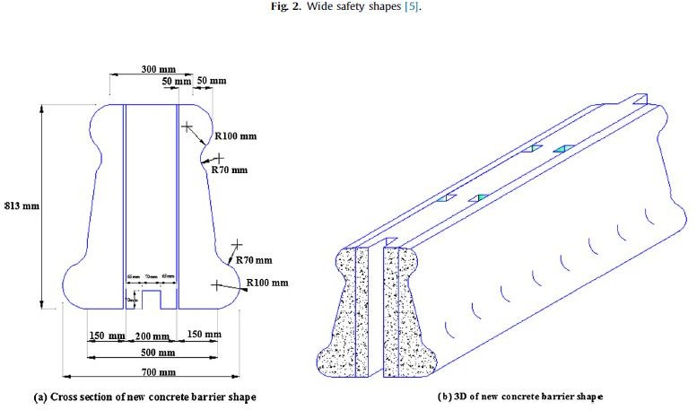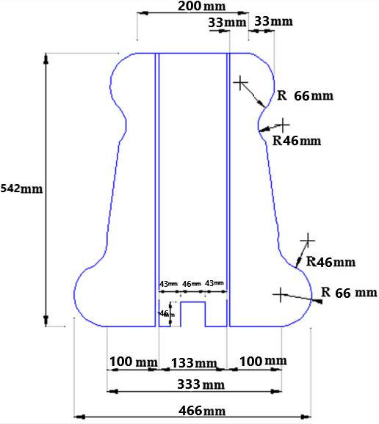**Fig. 5a.** Flexible road divider design shape

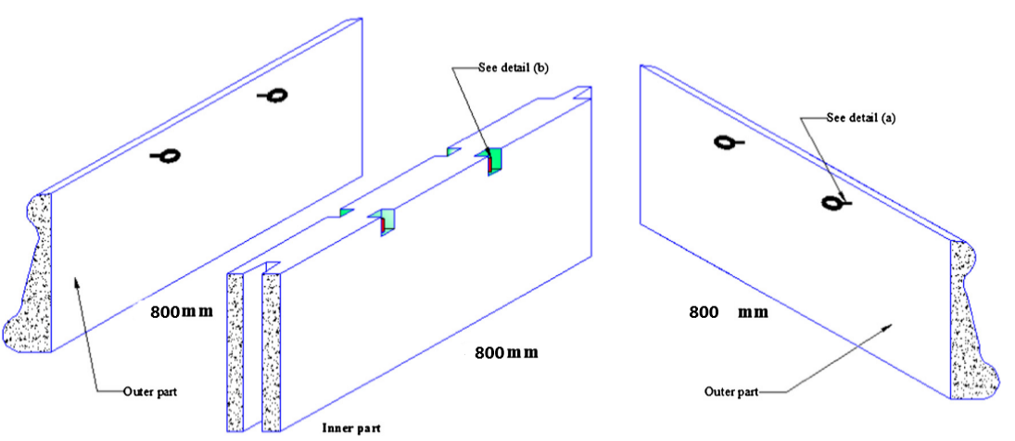

**Fig. 5b.** Proposed part of concrete and EPS barrier connection

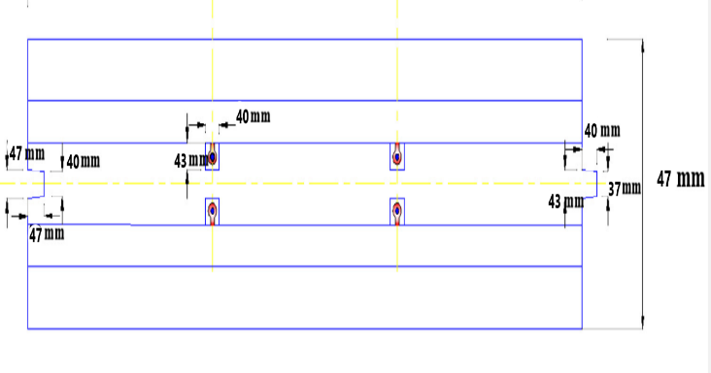

**Fig. 6.** Flexible road divider design top view

The curve at the bottom of the road divider prevents the vehicle from getting punctured, which may cause that vehicle to overturn and get more damaged. Also, the shape of the divider helps the vehicle not to get clamped on the divider, which allows the car to redirect to its actual direction. When the width of the road divider is increased, the structural efficiency of the divider is also increased, and if the divider width is reduced, then the weight of the road divider decreases. For the proper stability of the divider, it must be proportional to its height. Figures 5a, 5b, and 6 show the top view, cross-sectional view of the divider, and the connection.

3.4.2. 3D model Design and Simulation for collision analysis

Abaqus/CAE (interactive licenses) is a Fully Integrated Environment for Abaqus. It is used for preprocessing, modeling, and analyzing mechanical parts and assemblies and for displaying finite element analysis results. Fig. 7 shows the 3D model of the Flexible Road Divider. Using the Abaqus CAE simulation tool, the 3D diagram of the Flexible Road divider is created. Abaqus CAE provides various types of features, such as choosing the material of the design. Customize the design of the shape, etc. As per the materials in Table 2, all the materials were added to the design. The primary reason for using this curved shape is because whenever a vehicle collides with this road divider, the force exerted by the divider is reduced. Fig. 8a, 8b, 8c, 8d shows the actual designed road divider through a different view.

|  |  |  |
| --- | --- | --- |
|  |  |  |

**Fig. 7.** Simulation view – Abaqus

|  |  |
| --- | --- |
|  |  |

**Fig. 8a.** Flexible road divider model top view **Fig. 8b.** Flexible road divider outer part side view

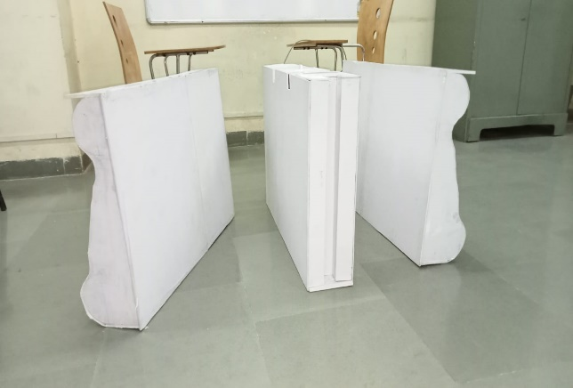 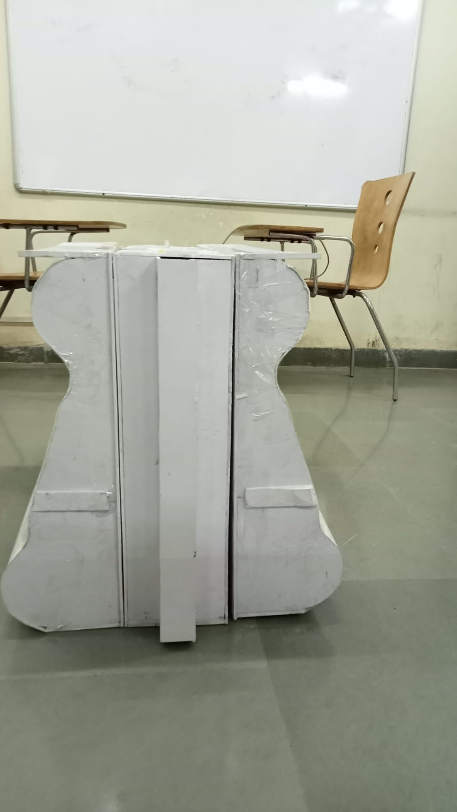

**Fig. 8c.** Flexible road divider model parts front view **Fig. 8d.** Flexible road divider model back view

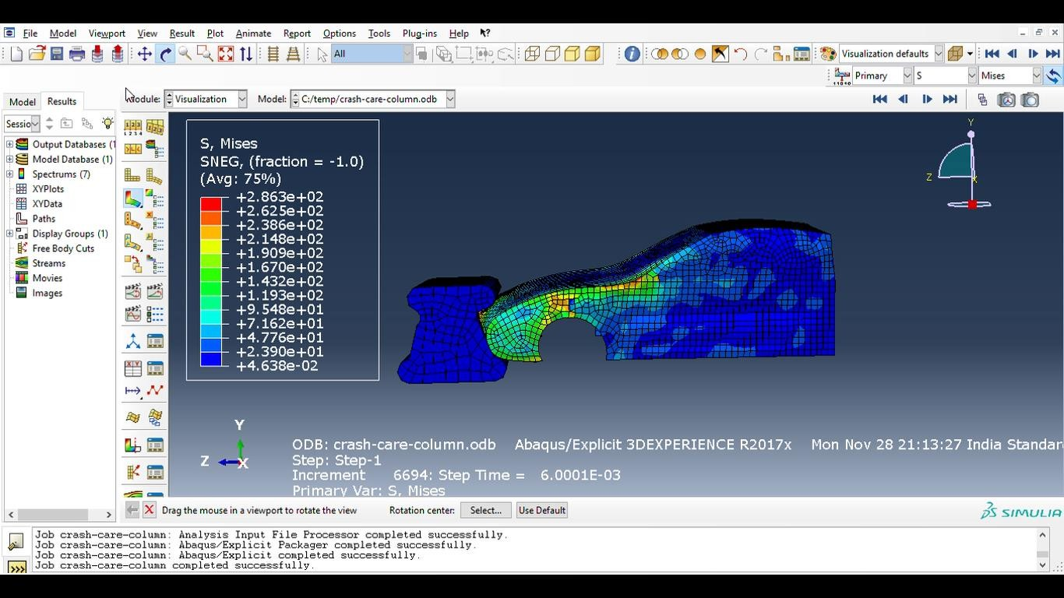

**Fig. 9a.** Simulation in Abaqus CAE Simulia Software

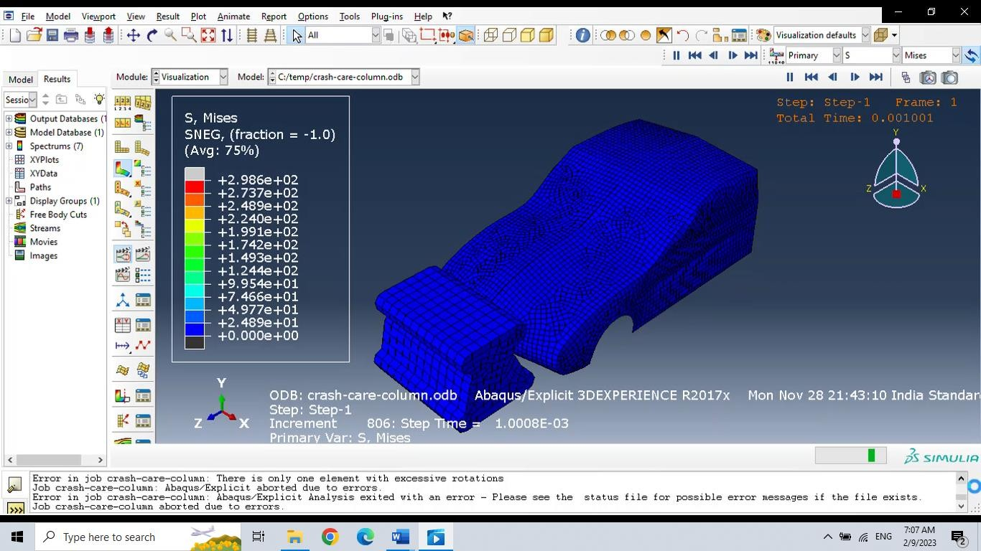

**Fig. 9b.** Simulation in Abaqus CAE Simulia Software for impact analysis

Abaqus CAE Simulia Software was used for this simulation. Using Simulia software can simulate the actual scenarios of the road accident. Figures 9a and 9b show the simulation results of the flexible road divider. The strength and other parameters of the road divider were tested using a vehicle. To check the strength of the road divider, the simulation car traveled towards the divider at different speeds, and the readings of the divider damage at different speeds were taken. Figures 9a and 9b show various views of the simulation of road divider collision. On the left-hand side, the box of levels shows the collision impact as per different levels. The box has measuring parameters of levels from low to high, as shown in Figure 10.

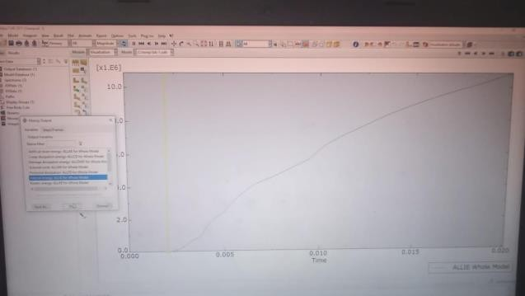

**Fig. 10.** Simulation graph of kinetic energy of the whole model

The Abaqus CAE software provides a range of design features that allow for the customization of the road divider design to meet specific project requirements, including the ability to adjust the shape, size, and other design parameters. The curved shape of the road divider was intentionally designed to minimize the force exerted on vehicles during collisions, potentially reducing the severity of accidents and enhancing overall safety. Reduced Force Transmission: The primary goal of the curved design is to reduce the force transferred to vehicles upon colliding with the road divider. The report should include empirical observations and analysis demonstrating the reduction in force transmission, highlighting the benefits of this design. The Flexible Road Divider, designed to minimize force exertion during collisions, is expected to enhance road safety by reducing potential damages and injuries. The report should provide evidence or simulations illustrating the improved safety performance of the road divider design. The Simulia CAE software enables the creation of an accurate and highly detailed 3D model of the flexible road divider, ensuring a faithful representation of its complex geometry. The software provides precise material assignment capabilities, allowing for accurate simulation of the mechanical properties and behaviors of the chosen materials within different components of the road divider.

Simulia CAE software facilitates the simulation of dynamic loading scenarios, such as vehicle collisions, enabling thorough analysis of the road divider's response and behavior under real-world impact conditions. The software comprehensively analyzes the road divider's deformation during collisions or other loading scenarios. This analysis provides valuable insights into the flexibility of the design, its ability to absorb and distribute forces, and its potential to minimize damage to both the divider and vehicles. Simulia CAE offers powerful tools for analyzing the stress and strain distribution within the road divider structure. This analysis helps to identify critical areas of high-stress concentration or potential failure, ensuring the design's robustness and capacity to withstand actual operating conditions.

Flexible Road Divider is made of a composite of EPS material and concrete. Making the road divider of a composite of EPS and Concrete gives better efficiency. It is found that EPS concrete energy absorption capability increases and decreases with the volume of EPS Concrete. Concrete also provides the required strength for the divider. The Flexible Road divider uses the property of EPS material to absorb the impact. In Flexible Road Divider, many factors, such as shape and length, affect the design of the divider, such as shape and length. A flexible road divider comprises different parts; one is the outer part of the divider, which is made of expanded polystyrene material. Another part of the project is the middle part of the design, which is made of concrete only. Generally, during the collision of a concrete road divider, the divider gets damaged, and then the concrete segment requires repair or replacement with a new one. Also, the maintenance of these broken dividers is expensive in the case of a standard concrete divider. Now, in the case of the Flexible Road Divider, when a collision happens on the flexible road divider, the outer parts facing the vehicle get damaged, so only that part needs to be replaced. Other parts do their work of preventing accidents from worsening (Mohammed et al. 2016), making it more cost-effective than a standard concrete barrier.

4. Testing Strategies and Test Procedure

Testing the hardware ensures each system component operates and performs according to the local specifications. It is the finest method for removing errors. So, the hardware testing is followed in a particular manner, as shown in Fig. 11 and 12. In this diagram, the first stage is to obtain a block of EPS material, as shown in Fig 13, which is a composition of expanded polystyrene and cement. UTM Machine is an instrument used to test mechanical characteristics like tensile, flexural, compressive, and shear when outfitting a laboratory (Saritha et al. 2023). This piece of actual specimen must be tested with a UTM Machine. Product development is one of the primary reasons why compound and resin manufacturers utilize UTMs for testing compounds. It shows the result as a graph. Consequently, after testing, we receive graphs for both the EPS and concrete materials. By comparing these two parameters on a graph, we can determine the impact of a vehicle on a road divider made of two distinct materials with varying force-absorbing capacities.

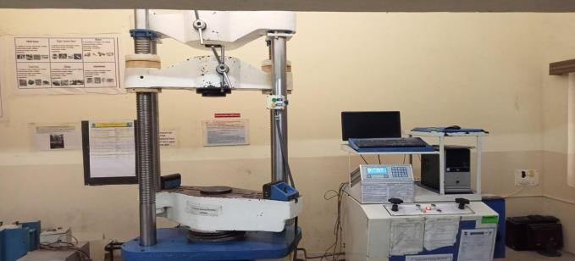

**Fig. 11.** UTM machine

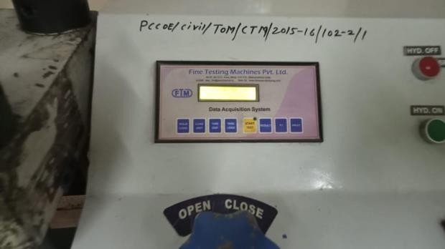

**Fig. 12.** UTM machine display: UTM delivers the amount of the maximum pressure

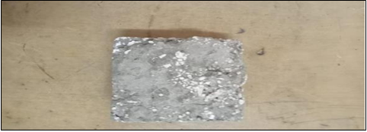

**Fig. 13.** EPS specimen for testing

The UTM machine was used to test the strength of the EPS material. After connecting the steel support arrangement to the concrete floor, the inner portion of the model concrete barrier is positioned atop the steel supports. A suitable computer program was also attached to the data logger to record the values of lateral deflection and concrete strains. Type of Portland cement was used to accomplish this investigation; supplemental cementation material known as SF and I that complied with BS 8500-1:2006 criteria was used.

UTM delivers the amount of the maximum pressure and the corresponding deformations. Using the observed value, the load-deflection graph is derived with load value along the Y axis and deformation along the X axis. The deformation is the displacement of the crossheads resulting from applying load, according to Fig. The stress-strain analysis, modulus of elasticity, and ultimate tensile of the test piece may be derived from the load-deflection graph. A universal Turing machine (UTM) is a device that scans the given inputs and can simulate anything with the help of a Turing computer. The universal machine accomplishes this by examining the description of the equipment to be mimicked and the inputs for that machine out of its tapes.

UTM machines are one of the most fundamental types of machines for material testing, with properties like tensile strength, elastic limits, and more. Compression Tests are used to determine material behaviors under compressive pressure loads. During the test, different properties of materials, such as elastic limits, proportional limits, yield points, yield strength, and more, are observed (AIMIl 2018).

Figure 14 shows the input parameter added to the EPS specimen for testing purposes. During testing of the specimen from 0 kN till the 402 kN pressure is applied to the specimen. After the elongation vs. load graph was observed, the input parameters applied to the specimen are shown in Figure 14. The above graph shows when the load is applied to the specimen and how the CHT responds. The complete form of CHT is Crosshead Travel. CHT means that when the load is used on the top side of the specimen, the specimen's ability to absorb the pressure applied in the EPS specimen testing is increased; the CHT was huge compared to standard concrete specimens.

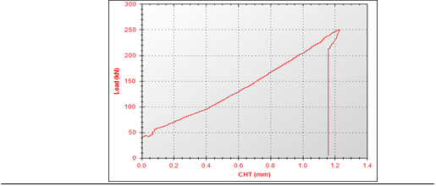

**Fig. 14.** Testing results of EPS concrete

Table 3 shows the input parameter added to the concrete specimen for testing purposes. During the testing of the specimen, colossal pressure was applied to the specimen after the elongation vs. load graph was observed. The input parameters applied to the specimen are shown in Table 4. When pressure is applied to the concrete specimen, its load increases linearly with the pressure. But the CHT changes very slowly. In the case of the concrete specimen testing, the CHT was observed to be very small compared to the EPS concrete specimen. Testing material with a universal test machine is essential for designing and manufacturing. The testing of materials using a universal testing machine gives information on the properties of materials to avoid failure and aid in selecting materials. Mechanical testing is a destructive type of testing that uses static or dynamic forces to determine the material's properties. Tension tests, strength properties, impact tests, tensile tests, creep tests, bend tests, etc., are types of mechanical testing. The results of the before and after-testing samples are shown in Fig. 15.

|  |  |
| --- | --- |
|  |  |

**Fig. 15.** Specimen testing material

**Table 3.** Compression test Report-Specimen 1: Machine Model: TUE-C-1000 Machine Serial No: 2014/110

|  |  |  |  |
| --- | --- | --- | --- |
| Input Data | | Output Data | |
| Specimen Shape | Concrete cube | Load at Peak | 250.130 kN |
| Specimen Type | Concrete Cube | Elongation at Peak | 1.230 mm |
| Specimen Description | | Compression Strength | 52.659 N/mm2 |
| Specimen Width | 95 mm | Loat at 0 mm | 0 kN |
| Specimen Thickness | 50 mm | Elongation at 0 kN | 0 mm |
| Beam Span | 0 mm |
| Pre-Load Value | 0 kN |
| Max. Load | 1000 kN |
| Max. Elongation | 250 mm |
| Specimen Cross Section Area | 4750 mm2 |

**Table 4.** Compression Test Report-Specimen 2: Machine Model: TUE-C-1000 Machine Serial No: 2014/110

|  |  |  |  |
| --- | --- | --- | --- |
| Input Data | | Output Data | |
| Specimen Shape | Concrete cube | Load at Peak | 401.770 kN |
| Specimen Type | Concrete cube | Elongation at Peak | 37.060 mm |
| Specimen Description | | Compression Strength | 84.583 N/mm2 |
| Specimen Width | 95 mm | Loat at 0 mm | 0 kN |
| Specimen Thickness | 50 mm | Elongation at 0 kN | 0 mm |
| Beam Span | 0 mm |  | |
| Pre-Load Value | 0 kN |
| Max. Load | 1000 kN |
| Max. Elongation | 250 mm |
| Specimen Cross Section Area | 4750 mm2 |

**Table 5.** Comparative performance of EPS and concrete

|  |  |  |
| --- | --- | --- |
| Property | EPS | Concrete |
| Density (kg/m³) | ~1650 | ~2300 |
| Energy Absorption | High | Low |
| Flexibility | Flexible and deformable | Rigid and brittle |
| Durability | Excellent weather resistance | Durable but prone to cracking |
| Repair & Maintenance | Partial replacement possible | Full segment replacement needed |
| Strength-to-Weight Ratio | Favorable | High compressive strength, low tensile |
| Environmental Impact | Lower emissions, lightweight | High emissions during production |

Table 5 shows EPS materials outperform traditional concrete in applications requiring lightweight, energy absorption, and low maintenance. While concrete remains a strong and durable material for heavy-duty uses, EPS offers a modern alternative that reduces costs, enhances safety, and minimizes environmental impact in scenarios like flexible road dividers. For broader adoption, addressing EPS's recyclability and environmental concerns is essential.

5. Accident Detection System

It is vital to have a system that can identify and transmit an emergency alert to the relevant agencies so that those in need receive the proper assistance (Zhang et al. 2023). In our design, the system detects the collision when any vehicle collides with the road dividers our system detects the collision. An accident notification system using the cloud, which consists of a Node MCU Microcontroller Board and a Vibration Sensor (Kamilya et al. 2022, Himanshu et al. 2016), has been built. This system can detect an accident and send the Emergency E-mail to an authorized e-mail, using MATLAB, Thing speak Server, and IFTTT service. SW420 is favored over all other motion sensors due to its switch-like working and reduced-price (Bhardwaj et al. 2023).

Figure 16 shows a power supply is an electrical equipment that provides electricity to an electrical load, including other things such as a server or a computer; the primary function of a power supply is to transform electric current from a source into the appropriate voltage, current, and frequency to power the load. It is possible to convert from AC to DC or DC to AC. Power supplies are, therefore, also referred to as electric power converters. Some power sources are installed in the device or have an in-built power supply; some are external. Every power supply has a power input connection that accepts energy from a source and one or more power output connectors that deliver current to the electrical load. The energy source may be the electrical grid, which usually provides AC power. Energy storage devices like solar power equipment, batteries, generators, and other power sources typically give a DC power supply. A vibration sensor measures the magnitude and frequency of vibration in a machine, system, or equipment. Using these measurements, it is possible to spot balances or other issues with the asset and predict impending failures. The Printed Circuit board of the circuit is shown in Fig. 17a and 17b. The ESP8266 Wi-Fi Module, a self-contained SOC with a built-in TCP/IP protocol stack, enables any microcontroller to connect to your Wi-Fi network. The ESP8266 can host an application or delegate all Wi-Fi networking duties to another application processor. Combining Cloud Functions with Cloud IOT Core and other fully managed services allows you to build backends for telemetry data collection, real-time processing, and analysis from Internet of Things (IoT) devices. You may quickly apply your unique custom logic to each event using Cloud Functions.

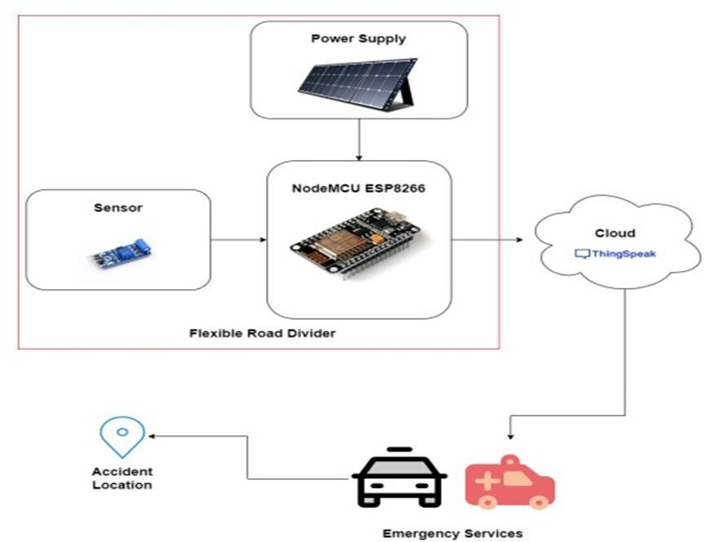

**Fig. 16.** Block diagram

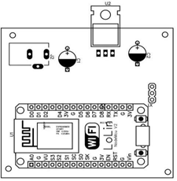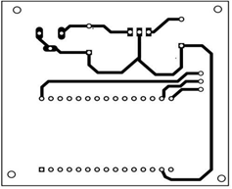

**Fig. 17a.** Bottom layer of PCB **Fig. 17b.** Top layer of PCB

The vibration sensor detects and transmits the electrical signal to the ESP8266 Microcontroller board. This signal is then sent to the Thing Speak cloud, as shown in Figures 18 and 19. By utilizing the Thing Speak about cloud, we can analyze when accidents occur and monitor real-time tracking of accidents and vibrations. A real-time e-mail with information about the accident is also sent to the registered e-mail ID (Azlan & Salimin 2023, Dange et al. 2023, Padmapriya et al. 2023).

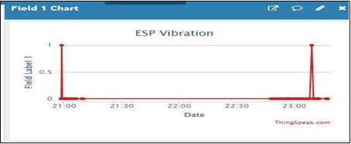

**Fig. 18.** Vibration analysis on cloud



**Fig. 19.** E-mail sent on registered mail ID

6. Comparative Analysis of EPS and Concrete Divider

The use of EPS beads, made from a combination of cement aggregate and polystyrene beads with additives, has enhanced the workability and durability of the material in experimental settings. In contrast, reinforced concrete comprises cement aggregate and water, with steel reinforcing bars added to provide strength and stability. In EPS-based flexible road dividers, their shape allows for energy absorption from impacts while also redirecting vehicles back into the proper lane. Additionally, the bulk of the barrier and anchoring its segments to the road surface helps absorb the impact's energy. On the other hand, concrete road dividers are modular concrete barriers used to separate traffic lanes, reduce vehicle damage in the event of a collision, and prevent vehicles from crossing over into opposing lanes, which could lead to a head-on collision.

6.1. Flexible Road Divider

The new prototype is anticipated to enhance the energy-absorbing capacity of concrete barriers and lessen the effect of cars beside concrete barriers—a unit weight of 1650 kg/m3. When a vehicle crashes, the airbags deploy; with the new concrete prototype, just the exterior components of the car have to be replaced, thus decreasing the cost and complexity of maintenance. When a vehicle collides with the barrier, the bulk of the impact is absorbed by the outer portion facing the striking vehicle. Hence, just one-half of the barrier is damaged, while the other two sections continue operating normally. If a car collides with a concrete barrier, the barrier is damaged, and the broken section must be repaired or replaced by an entirely new segment. The costly upkeep of the damaged portion through replacing or repairing it may entail a road closure. With the current EPS design, replacing only the portion confronting the vehicle may be necessary, hence lowering the cost and complexity of the repair. The EPS concrete was employed in outer portions to mitigate the impact of vehicle crash energy on concrete barriers.

6.2. Concrete Divider

Concrete barriers may also safeguard drivers from accidents resulting from cars leaving or running off the road, such as when a vehicle falls over a cliff or into a ditch. The unit weight of concrete is 2300 kg/m3. If a car collides with the concrete barrier, the barrier is damaged, and the damaged section must be repaired or replaced with a new segment. The costly upkeep of the damaged section via repair or replacement may require a road closure (Patwardhan et al. 2023).

6.3. EPS-based dividers

EPS-based dividers have lower transportation, installation, and maintenance costs due to their lightweight design and partial replacement capability, reducing road closures. Concrete dividers, being heavier, incur higher installation costs and require full segment replacement, leading to expensive repairs and disruptions. While EPS dividers have a moderate initial material cost, their long-term savings outweigh the upfront expense. Concrete dividers, though durable, result in significantly higher lifecycle costs.

7. Conclusions

An essential problem in road safety, collisions with road dividers, is addressed in this study with a potentially effective remedy. Our goal is to lessen the impact of these kinds of crashes by designing and testing novel flexible road dividers and utilizing IoT integration to deliver real-time alerts. Our new method improves road dividers' flexibility and impact-absorbing capabilities using specially designed engineering concepts and cutting-edge materials such as expanded polystyrene separators and barriers (EPS). Through comprehensive measurements of forces, deformation, and energy absorption, we have quantified the effectiveness of our system in reducing the severity of accidents. The new prototype is anticipated to enhance the energy-absorbing capacity of concrete barriers and lessen the effect of cars beside concrete barriers – a unit weight of 1650 kg/m3. Simple replacement reduces total maintenance expenses and helps accident victims receive care as soon as possible. This Internet of Things (IoT)-enabled dividers may notify the closest hospital about accidents and send vital medical data for appropriate care. Concurrently, the maintenance industry is notified instantly of the exact location of the incidents so that repairs may be made quickly. In summary, IoT-integrated movable road dividers offer a novel approach to improving traffic safety. They enhance road users' safety and increase our road networks' effectiveness by absorbing the effects of accidents, notifying surrounding hospitals, and accelerating maintenance operations.

Statements and Declarations

**Acknowledgment**

The authors extend their appreciation to the Deanship of Scientific Research at King Khalid University for funding this work through a large group Research Project under grant number RGP2/72/44.

**Declaration of Competing Interest**

Not Applicable

References

Akki, B., Basavaraj, & Pramukh, N. (2023). Road safety measures in urban scenario: A case study in Bengaluru. *i-Manager's Journal on Civil Engineering*, *13*(1), 32.

Akyıldız, M. H., & Yetiz, F. (2022). A comparison of EPS geofoam filling material and ground filling materials in terms of economic and transport strength-deformation. *Arabian Journal of Geosciences*, *15*(20), 1586.

Areef, S., et al. (2023). *A study on cloud and IoT-based accident detection & prevention systems*. 2023 International Conference on Sustainable Computing and Data Communication Systems (ICSCDS). IEEE.

Athiappan, K., et al. (2022). Identifying Influencing Factors of Road Accidents in Emerging Road Accident Blackspots. *Advances in Civil Engineering*, *2022*(1). https://doi.org/10.1155/2022/9474323

Azlan, H. H., & Salimin, S. (2023). Vehicle accident detection system using accelerometer. *Evolution in Electrical and Electronic Engineering*, *4*(1), 195-202.

Basu, S., & Saha, P. (2022). Evaluation of risk factors for road accidents under mixed traffic: Case study on Indian highways. *IATSS Research*, *46*(4), 559-573.

Bhardwaj, A., Mary, S. P., & Ankayarkanni, B. (2023). *Automatic accident detection and reporting system using NodeMCU*. 2023 7th International Conference on Trends in Electronics and Informatics (ICOEI). IEEE.

Bokaba, T., Doorsamy, W., & Paul, B. S. (2022). Comparative study of machine learning classifiers for modelling road traffic accidents. *Applied Sciences*, *12*(2), 828.

Dange, V., et al. (2023). IoT-based detection of vehicle accident and an emergency help using application interface. *Microsystem Technologies*, 1-9.

Deshmukh, R., Iyer, S., & Bhangare, P. (2022). Geotechnical characterization of expanded polystyrene (EPS) beads with industrial waste and its utilization in flexible pavement. *Materials Today: Proceedings*, *61*, 187-196.

Ferko, M., et al. (2022). Influence of road safety barriers on the severity of motorcyclist injuries in horizontal curves. *Sustainability*, *14*(22), 14790.

Himanshu, C. (2016). Recent trends of measurement and development of vibration sensors. *IEEE Sensors Journal*.

Jiang, P., et al. (2022). Strength properties and microscopic mechanism of lime and fly ash modified expandable polystyrene lightweight soil reinforced by polypropylene fiber. *Case Studies in Construction Materials*, *17*, e01250.

Kamilya, S., et al. (2022). Design and implementation of auto (light) intensity controlling system using IoT and without IoT. *EPRA* *International Journal of Multidisciplinary Research* (IJMR), *8*(4), 77-81.

Meddage, D. P. P., et al. (2022). Exploring the applicability of expanded polystyrene (EPS)-based concrete panels as roof slab insulation in the tropics. *Case Studies in Construction Materials*, *17*, e01361.

Meng, W., et al. (2022). Near-infrared photoluminescence of Portland cement. *Scientific Reports*, *12*(1), 1197.

Mohammed, H. J., & Zain, M. F. M. (2016). Experimental application of EPS concrete in the new prototype design of the concrete barrier. *Construction and Building Materials*. Elsevier.

Padmapriya, G., et al. (2023). *Internet of Things-based accident detection and alerting system to save lives*. 2023 7th International Conference on Intelligent Computing and Control Systems (ICICCS). IEEE.

Panda, C., Dash, A. K., & Dash, D. P. (2022). Assessment of risk factors of road traffic accidents: A panel model analysis of several states in India. *Vision: The Journal of Business Perspective*. https://doi.org/10.1177/09722629221113251

Patwardhan, D., Ghorpade, R. R., & Karandikar, K. V. (2023). Finite element analysis of a road divider for impact testing and material selection. *Journal of Physics: Conference Series*, *2426*(1). IOP Publishing.

Qishunsteel. (n.d.). EPS beads-Expandable polystyrene King Pearl Granules EPS pellets. Retrieved from https://qishunsteel.en.made-in-china.com/product/jXkxoPMCAzRL/China-EPS-Beads-EPS-Expandable-Polystyrene-King-Pearl-Granules-EPS-Pellets.html

Rashid, H. M., & Mohammed, H. J. (2023). Evaluating bonding strength among concrete comprising recycled demolition aggregate and steel bars using a new technique. *AIP Conference Proceedings*, *2775*(1). AIP Publishing.

Saritha, G., et al. (2023). Micro universal testing machine system for material property measurement. Materials Today: Proceedings.

Secco, H., et al. (2022). Evaluating impacts of road expansion on porcupines in a biodiversity hotspot. *Transportation Research Part D: Transport and Environment*, *102*, 103151.

Talukder, S., et al. (2022). Vehicle collision detection & prevention using VANET-based IoT with V2V. arXiv preprint arXiv:2205.07815.

Tasgaonkar, P. P., Garg, R. D., & Garg, P. K. (2023). An IoT-based framework of vehicle accident detection for smart city. *IETE Journal of Research*, 1-14.

Tolga Özer, A., & Akay, O. (2022). Interface shear strength of EPS-concrete elements of various configurations. *Journal of Materials in Civil Engineering*, *34*(6), 04022102.

Vastava, S. S., et al. (2023). Automatic movable road divider using Arduino UNO with Node Micro Controller Unit (MCU). *Materials Today: Proceedings*, *80*, 1842-1845.

Yun, J., et al. (2023). A before-and-after study of a collision risk detecting and warning system on local roads. *Journal of Advanced Transportation*, 2023.

Zhang, M., et al. (2023). A construction accident prevention system based on the Internet of Things (IoT). *Safety Science*, *159*, 106012.