|  |  |  |  |
| --- | --- | --- | --- |
|  |  | | |
| **Rocznik Ochrona Środowiska** | | |
| Volume 27 | Year 2025 ISSN 2720-7501 | pp. 25-36 |
|  | https://doi.org/10.54740/ros.2025.004 open access | | |
|  | Received: December 2024 Accepted: February 2025 Published: February 2025 | | |

Environmentally Sustainable Clean Energy Solution: Optimizing Photovoltaic Systems Using the Gazelle-Nelder-Mead (GOANM) Algorithm

Christal Merlin S C1*, Marsaline Beno M2

1Department of Electrical and Electronics Engineering, St. Xavier's Catholic College of Engineering, Chunkankadai, Nagercoil, Tamilnadu, India   
https://orcid.org/0009-0004-1436-5657

2Department of Electrical and Electronics Engineering, St. Xavier's Catholic College of Engineering, Chunkankadai, Nagercoil, Tamilnadu, India   
https://orcid.org/0000-0002-8189-5613

*corresponding author's e-mail: [christalmerlins@gmail.com](mailto:christalmerlins@gmail.com)

**Abstract:** The best ways to maximize electricity production in places where there is not enough room for the installation of renewable power generation systems are to optimize the operational efficiency of already-existing plants and select an optimal location for newly constructed Photovoltaic (PV) power plants that will offer a favorable climate and surrounding environment. Sustainable energy development strategies must be developed using renewable generation technologies to drive energy transition towards sustainability. Based on battery technology and energy storage assets, the study proposed a new hybrid Gazelle-Nelder-Mead (GOANM) algorithm for solar power storage solutions to satisfy the growing need for reliable and convenient renewable energy sources. This model looks at the sustainability of solar energy generation. At this crucial juncture, the research helps pave an intellectual and useful path toward a more promising and ecologically conscious future. It promotes solar energy as a clean, renewable energy source to mitigate climate change and severely cut carbon emissions. The study focuses on sustainable solar panel manufacturing methods, addressing issues with materials and industrial processes. The simulation result of the proposed GOANM algorithm highlights the importance of sustainable management methods and adequate site selection in mitigating the negative consequences of solar plant development.

**Keywords:** photovoltaic energy, sustainability, sustainable development, clean energy, environmental impact, GOANM algorithm

1. Introduction

Research into renewable and environmentally friendly power sources available in the modern world is vital for mitigating the harmful consequences of climate change and reducing reliance on a finite supply of fossil fuels. Solar energy is regarded as one of several types of renewable energy and an excellent, conveniently accessible option for clean energy. The Sustainable Development Goals, which include lowering global warming and guaranteeing access to inexpensive, clean energy, depend more and more on power generation systems based on renewable energy. Solar and wind power dominate renewable energy sector, with geothermal and biomass energy making up a very small portion (Hemeida et al. 2022).

PV solar power plants are an innovative new approach to producing clean, long-term electricity from sunshine. PV solar power facilities need to be carefully studied and managed since, like any other power plant, they can negatively affect the environment (Bosnjakovic et al. 2019). Every aspect of PV systems' environmental impact, from manufacturing to disposal, is carefully considered, and innovative design strategies are suggested to lessen them (Tawalbeh et al. 2021). Three alternative approaches, Levenberg-Marquardt (LM), Scaled Conjugate Gradient (SCG), and Bayesian Regularization (BR) for maximum power point tracking (MPPT) energy harvesting in solar PV systems are evaluated using artificial neural networks (ANNs) (Roy et al. 2021). Different metaheuristics for extracting PV model parameters explain the behavior of multiple approaches. There is a tabulation and comparison of some regularly used performance indicators for evaluating competitiveness, robustness, accuracy, and resource consumption, along with a discussion of the benefits and drawbacks of different approaches (Gu et al. 2023).

For photovoltaic cells, modules, panels, arrays, and systems, the effectiveness of various tracking techniques is analyzed and contrasted with fixed systems. Due to several factors like the weather, the type of tracking, the location, and the application itself, the investigation revealed significant disparities (8%:85%) between tracking moods and fixed systems (Hafez et al. 2018). By being aware of the various types of defects that might occur in a solar PV system, they can choose the best diagnosis method depending on the system's performance metrics (Venkatakrishnan et al. 2023). Maximum power point tracking, or MPPT, is required due to solar photovoltaics' nonlinear behavior to guarantee optimal power generation. Despite being a straightforward, affordable, and effective MPPT algorithm, Hill Climbing (HC) displays steady-state oscillations around MPP in uniform weather (Awan et al. 2023).

This work is valuable for future research on the deterioration and performance analysis of PV power plants, and it compares several PV simulation tools to choose the best software (Umar et al. 2018). A 60 [W] PV system was used to experimentally test different irradiance and partial shade scenarios while the proposed method was simulated as closely as feasible to real-world operational conditions. The suggested technique was evaluated through the design and construction of a two-phase grid-connected photovoltaic system (Abo et al. 2021).

Hussain et al. (2024) have proposed, in addition to illuminating homes, solar photovoltaic electricity has reduced greenhouse gas emissions, improved energy security, and expanded access to clean energy, all of which have contributed to Bangladesh's sustainability and brighter future. (Nieto et al. 2024) have suggested that an extensive examination of technical, financial, environmental, and regulatory aspects is required to ascertain whether recycling decommissioned photovoltaic modules is sustainable. (Kumar et al. 2023) have reported that the SIAFL-DO is used for both the MPPT operation and battery charge monitoring. There is just one cost-effective, high-performance, current sensor-based charging adapter. Additionally, accurate MPPT and charge management are made possible by the SIAFL-DO algorithm's improved condition estimation and decision-making abilities.

Duong et al. (2019) have reported that three algorithms, the artificial bee colony method, the particle swarm optimization algorithm, and the genetic algorithm (GA), are utilized to compare the outcomes produced. As a result, the implemented method provides higher solution quality and accuracy while accelerating convergence.

Hossain et al. (2020) have discussed a focus on technical, financial, and environmental factors placed on the viability of utilizing biomass-based hybrid supply systems in conjunction with solar photovoltaic (PV) technology to power off-grid LTE cellular macrocell BSs in Bangladesh. (Khadka et al. 2020) have described a brief overview of the parameters influencing solar module performance and re-discuss their usefulness in cleaning intervention decision-making models.

Razmjoo et al. (2023) have proposed that these two locations can generate electricity with their unique location and high levels of sun irradiation. Prathibha et al. (2024) have reported that to alleviate the problems that isolated and poor villages endure due to frequent power outages, a solar electrification station has been built as a sustainable energy option.

Ammach et al. (2019) have suggested that four more locations worldwide have evaluated the sun tracker system, which has been deployed for the Jeddah, Saudi Arabia region. The results have shown that it is cost-effective, energy-efficient, simple to use, and reliable in various weather conditions. (Shaw et al. 2019) have discussed the findings of the simulation, which indicate that in a steady-state regulated environment, as the solar panel's irradiance decreases, so do the output voltage, current, and power.

Oufettoul et al. (2023) have proposed that a photovoltaic module's performance and longevity are greatly influenced by its position, orientation, and tilt angle. This study compares the performance of two different panel placements using PSIM and MATLAB software models and an actual practical test.

The following explains the main contributions of this work:

* This research aims to demonstrate the current environmental impact of PV solar power plants using the most recent data.
* The proposed hybrid GOANM algorithm for solar power storage satisfies the increasing need for dependable and easily available sustainable energy sources by utilizing battery technology and energy storage materials.
* The novel GOANM algorithm is designed for precise parameter extraction in solar PV systems.
* The simulation results of the study's proposed GOANM algorithm emphasize the need for sustainable management practices and appropriate site selection to reduce the negative effects of establishing solar plants.

2. Materials and Methods

The possibility for accommodating variable renewable energy sources while enhancing power network management Amrouche et al. (2016).

2.1. Solar PV system

Photovoltaic systems use photovoltaic technology, also called PV or solar power systems, to provide electricity without solar radiation. The solar inverter, which changes the output from direct to alternating current, and solar panels, which collect and transform sunlight into power, mounting, wiring, and other electrical accessories are some of the many parts of this functional system. Many utility-scale PV systems use tracking sensors to follow the sun's daily movement across the sky, generating more electricity than fixed-mount systems.

PV systems provide a renewable energy source that drastically lowers greenhouse gas emissions compared to fossil fuels. But they do affect the environment. PV panel production includes energy-intensive manufacturing procedures that emit carbon dioxide, consume raw materials like silicon, silver, and rare metals, and require toxic chemicals for processing. Land use can also be an issue, especially for large-scale solar farms, which may disrupt local ecosystems and biodiversity. PV panels also have a short lifespan, usually 25 to 30 years, which raises issues with electronic waste management and end-of-life disposal. Recycling initiatives are progressing; however, the present techniques are still expensive and ineffective. Another consideration is the amount of water used to cool and clean PV installations, especially in desert areas. The environmental impact of PV systems should be carefully controlled through sustainable manufacturing, enhanced recycling technologies, and prudent land use planning, even though these systems greatly lessen reliance on fossil fuels.

Furthermore, the high energy requirements for refining these materials increase carbon emissions unless they come from sustainable sources. Reducing the environmental impact of PV systems will need sustainable procurement, improvements in material efficiency, and recycling as demand for these systems rises.



**Fig. 1.** Block schematic of the proposed renewable energy source for sustainability

2.2. Battery Energy Storage System (BESS)

The study underlines the significance of BESS in assuring the consistent and cost-effective operation of renewable energy-powered electric networks. The researchers used a bidirectional DC/DC converter and a network of lead acid battery packs to connect the BESS to the DC bus. The BESS seeks to maintain a consistent common DC link voltage, which results in stable DC bus voltage and minimized voltage ripple, ensuring the grid's steady and reliable operation. Table 1 illustrates the System parameters for batteries that store energy.

**Table 1.** System parameters for batteries that store energy

|  |  |
| --- | --- |
| Parameters | Values |
| Efull | 234 V |
| Eexp | 210 V |
| Qexp | 60 Ah |
| Enom | 200 V |
| Cnom | 240 Ah |
| Initial SoC | 60% |
| Internal resistance R of the battery | 0.016667 Ω |
| Normal capacity | 300 Ah |

2.3. PV system sustainability

PV (Photovoltaic) system sustainability in a clean environment refers to the ability of solar power systems to generate electricity while minimizing their impact on the environment throughout their entire lifecycle. Here are key aspects of PV system sustainability.

*2.3.1. Environmental Benefits*

*Renewable Energy Source:* Solar energy is a clean and sustainable source that reduces dependency on fossil fuels while minimizing climate change.

*Zero Emissions:* PV systems produce no greenhouse gas emissions or pollutants during operation.

*Reduced Water Usage:* Unlike traditional power plants, PV systems require minimal water for maintenance.

2.4. Photovoltaic module model

The model depicts the link between temperature, incident sun irradiance, and the electrical characteristics of a PV module. Usually derived from the equivalent circuit model, the analogous model presents the PV module as a multi-component electrical circuit. A current source, diode, series resistance, and shunt resistance make up an equivalent circuit model. The model indicates that the PV module is made up of a single diode that is coupled to a current source in parallel. The parallel and series cell counts are denoted by *Np* and *Ns* respectively, in Figure 4, which depicts the similar circuit of a solar module.

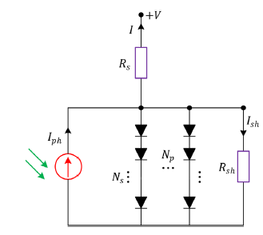

**Fig. 2.** Photovoltaic module equivalent circuit

2.5. Solar energy technologies

Reduced environmental impact from solar cell manufacture and waste depends on sustainable manufacturing and recycling practices. The capacity to manipulate quantum dots' band gaps allows for the exact alteration of their light absorption properties, enhancing their ability to capture light energy Viale et al. (2023). Solar cell manufacturing necessitates using finite resources, emphasizing the significance of building an effective supply chain to ensure the technology's long-term viability. As perovskite solar panels gain popularity, more people are becoming aware of their viability and affordability as an alternative to conventional silicon-based solar energy-producing systems Izci et al. (2022). A special class of materials known as perovskites has a crystal structure that effectively separates charges and absorbs light. In general, solar cells use a combination of organic-inorganic perovskite materials. The enormous energy conversion efficiencies that material solar cells have demonstrated the potential to achieve are on par with, and in some cases even higher than, that of conventional silicon-based cells. Figure 3 depicts an array of solar cells arranged in a grid pattern to capture solar light efficiently.

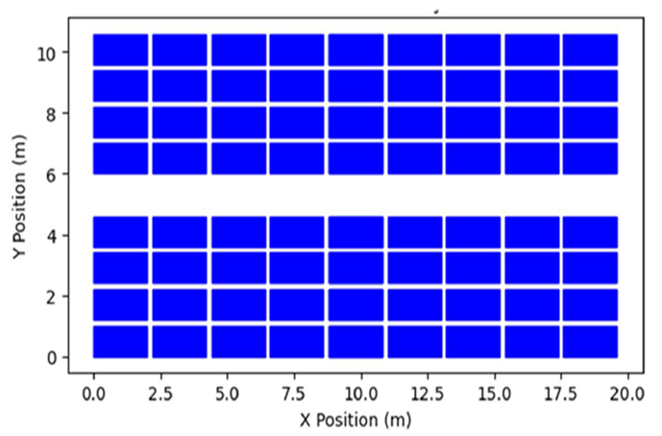

**Fig. 3.** Graphical depiction of a solar panel array

2.6. Hybrid Gazelle-Nelder–Mead (GOANM) Algorithm

These case studies give sample situations for assessing the efficacy of the GOANM technique across various solar PV systems. We used various statistical analytic approaches to analyze and interpret the data,   
allowing us to make relevant conclusions about how well the GOANM methodology optimizes solar PV models. In the following sections, describe the full experimental setup, explain the acquired data, and provide a comprehensive statistical analysis to compare the performance of the recommended GOANM technique to other methods.

Figure 4 illustrates the GOANM method in detail. The NM method is integrated in such a way that it improves the efficacy of the GOA without adding a major computing cost. The proposed hybrid version of the GOANM algorithm uses the original GOA to start and update agent placements. After 10 iterations, the discovered solution is used to construct a simplex, and the NM algorithm handles the rest of the optimization.

A Brownian motion pattern represents gazelles' movements during grazing.

$f_{B}\left(x,μ,σ\right)=\frac{1}{\sqrt{{2πσ}^{2}}}e^{(-\frac{(x-μ^{2)}}{{2σ}^{2}}})=\frac{1}{\sqrt{2π}}e^{(\frac{x^{2}}{2})}$ (1)

Equation 2, represents the mathematical model for this phenomenon.

${gazelle}_{i+1}={gazelle}_{i}+s.R*.R_{B}*\left({Elite}_{i}-R_{B}*.{gazelle}_{i}\right)$ (2)

Where, ${gazelle}_{i+1}$ has to do with the solution at the next iteration while ${gazelle}_{i}$ is the solution at this iteration. The option specifies the gazelles' grazing speed. In contrast to $R_{B}$, which is a vector of random integers that simulates Brownian motion, the vector 'R' is made up of uniform random values between 0 and 1. During this part of the algorithm, Levy flight is used, which consists of short steps punctuated by big jumps every now and again. Equation 3 describes the Levy distribution,

$L\left(x_{j}\right)≈|{x_{j}|}^{1-∝}$ (3)

This equation uses the flying distance, $x_{j}$, and the power-law exponent, 𝛼, which is constrained to a certain range [1,2]. Equation 4, which uses 𝛼 values between 0.3 and 1.99, describes the operation of the method.

$Levy\left(∝\right)=0.05×\frac{x}{|{y|}^{\frac{1}{∝}}}$ (4)

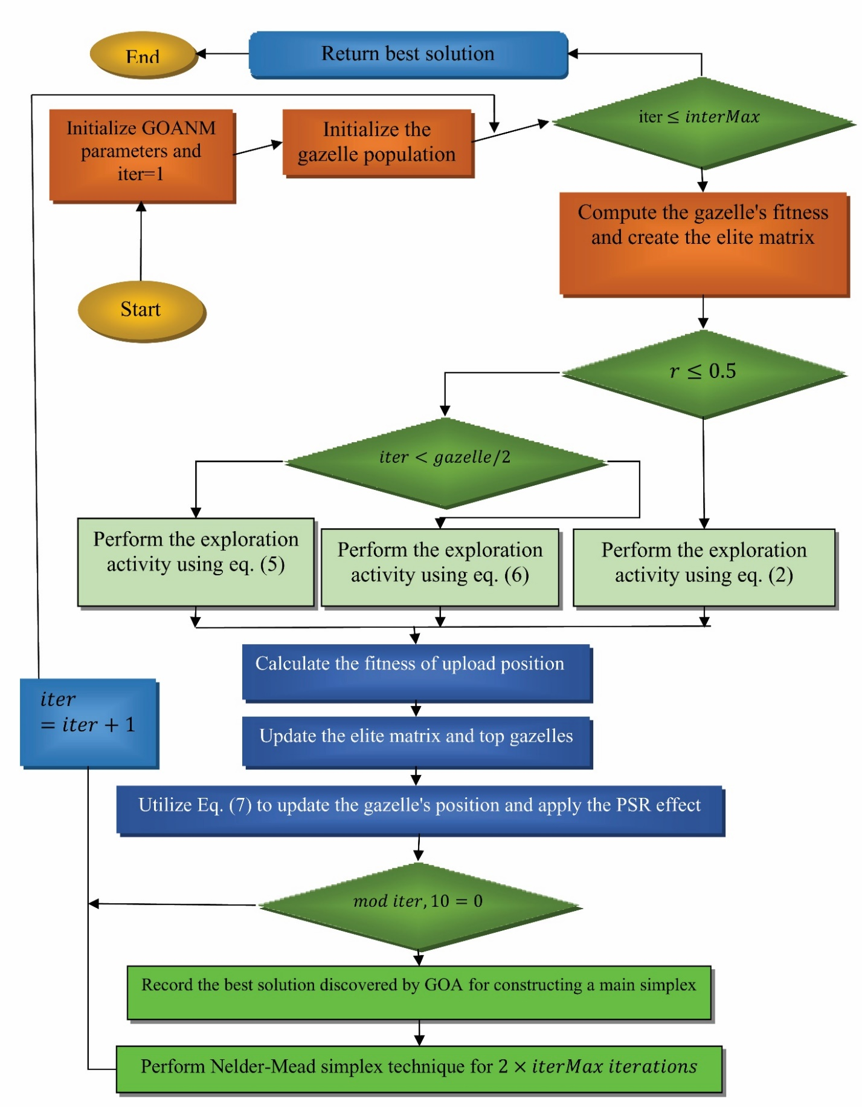

**Fig. 4.** Hybrid gazelle-Nelder–Mead algorithm’s process

The definitions of the variables 𝛼, x, and y are as follows: y possesses a normal distribution with variance $σ_{y}^{2}$ and mean 0, x has a normal distribution with variance $σ_{x}^{2}$ and mean 0, and y is put at 1.5. Equation 5 quantifies the gazelle's behavior when it detects a predator.

$\vec{{gazelle}_{i+1}=}\vec{{gazelle}_{i}}+S.μ.\vec{R*}.\vec{R_{L}*}.(\vec{{Elite}_{i}}-\vec{R_{L}}*.\vec{{gazelle}_{i}})$ (5)

In this equation, *S* indicates the gazelle's maximum speed and $\vec{R_{L}}$ is a random number vector based on the Levy distribution. Equation 6 mathematical model describes the predator's behavior as it chases the gazelle.

$\vec{{gazelle}_{i+1}=}\vec{{gazelle}_{i}}+S.μ.CF*.\vec{R_{B}*}.(\vec{{Elite}_{i}}-\vec{R_{L}}*.\vec{{gazelle}_{i}})$ (6)

Equation 6, calculates the cumulative effect of the predator as $CF= {(1 -iter∕iterMax)}^{(2 *iter∕iterMax)}$. This study on Mongolian Gazelles found an annual survival rate of 0.66, meaning predators are only effective in 0.34. A gazelle's capacity to flee and the likelihood of local minima trapping are both influenced by the predator success rate (PSR). Equation 7 represents the influence of PSR.

$\vec{{gazelle}_{i+1}}=\left\{\begin{aligned}\vec{{gazelle}_{i}}+CF\left[\vec{LB}+\vec{R}*.\left(\vec{UB}-\vec{LB}\right)\right]*.\vec{U} ;ifr≤PSRs \\ \vec{{gazelle}_{i}}+\left[PSRs\left(1-r\right)+r\right]\left(\vec{{gazele}_{r1}}-\vec{{gazelle}_{r2}}\right); else\end{aligned}\right.$ (7)

Equation 7, presents $\vec{U}$, a constructed binary vector, which, for $\vec{U}$ = 0 for *r* < 0.34 when given a random number r from the interval [0, 1]. The gazelle matrix has random indexes and .

3. Result and Discussion

To minimize these consequences, it is vital to understand when they occur in a PV plant's life cycle and what factors influence their intensity. The other sections of the study concentrate on the predominant environmental implications, encompassing land utilization, greenhouse gas emissions, dangerous chemicals, water usage, aesthetic consequences, noise, and waste generated after a photovoltaic plant's lifespan.

3.1. Land use

Photovoltaic solar power plants represent a significant technological breakthrough in the global transition to a low-carbon energy system. The installation of PV systems, however, necessitates a substantial amount of land, which may pose issues for land use planning, environmental preservation, and public acceptance. Their research concluded that while photovoltaic power generation systems require a lot of land, bioproductive land must be included in a thorough review for full resource utilization Biswas et al. (2021). Additionally, the following are the main challenges associated with the usage of land for PV power plants:

* ***Land use conflicts:*** PV plants installed on the ground may put land uses like forestry, urbanization, agriculture, and conservation in competition. Therefore, rigorous site selection and land use planning are required to minimize or prevent negative consequences while maximizing favorable synergies.
* ***Environmental impacts:*** The following are some instances of the direct or indirect consequences of PV systems on the environment: glare, water use and pollution, soil erosion or pollution, habitat loss or fragmentation. PV systems can be put on rooftops or outside. Therefore, environmental impact assessments and mitigation strategies are needed to guarantee adherence to pertinent regulations and legislation and promote environmental sustainability.

**Table 2.** The PV system requires a place for multiple power plants

|  |  |
| --- | --- |
| Power Plant Type | Required Area ($m^{2}$/MWh) |
| PV power generator | 0.3-14.0 |
| Solar concentrated (CSP) | 7.8-18.0 |
| Coal-fired power plants | 0.2-5.0 |
| Nuclear power plants | 0.1-1.0 |
| Power plants on oil derivatives | 0.1-0.5 |

A comparison of various energy infrastructures with the amount of space allocated for building PV power plants. Table 2 illustrates that PV power plants require more space than traditional energy facilities, except for biomass power plants.

3.2. Simulation result

Figure 5 depicts a simulation model of PV sustainable energy generation utilizing an ECP-configured GOANM algorithm to optimize the sustainable clean energy source output of a GPV battery system. Table 3 shows the specifications for the GPV Battery System.

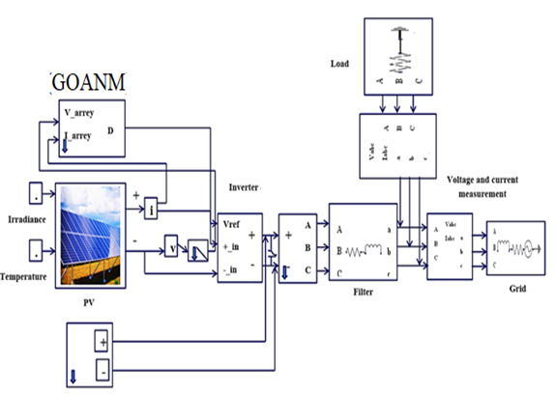

**Fig. 5.** Simulation model of GOANM model

**Table 3.** Specifications for the GPV Battery System

|  |  |  |
| --- | --- | --- |
| p-q parameters |  | Load |
| Output power | 4.40 kW | Load 4.40 kW |
| Grid-side controller carrier frequency | 5.0 kHz |  |
| Boost converter | L = 3.6 mH, C = 631 μF |
| PI coefficients | KpVdc = 3.8, KiVdc = 6.3,  KpId = 5.0, KiId = 322,  KpIq = 5.0, KiIq = 320 |

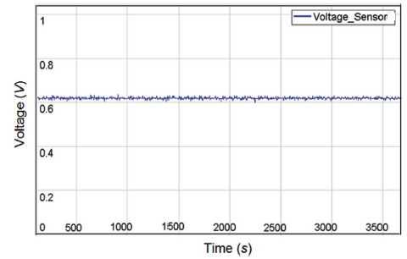

**Fig. 6.** PV panel terminal voltage

Figure 6 depicts the PV panel terminal voltage, which has been adjusted to remain constant. Due to the fairly flat curves and the very low voltage sensitivity of the peak output, the power output is only marginally decreased when a partially darkened cell is loaded with the same voltage as a fully illuminated cell.

**Fig. 7.** Response of sustainability PV power output in background

Figures 7 and 8 depict the response of sustainable PV power output in the background during a heatwave using the suggested hybrid GOANM algorithm. This demonstrates the models' ability to accurately represent the PV power fluctuation patterns that occur under harsh climatic circumstances. Following a thorough evaluation, the RF models perform admirably across all four scenarios, with modest predicted errors. Overall, they successfully identify the diurnal trend of PV power, notably during heatwaves.

**Fig. 8.** Response of sustainability PV power output in Heatwave

The close alignment of anticipated and actual data highlights the models' strong adaptability and robustness to extreme environmental fluctuations, as well as their more acute and accurate predictive responses as compared to baseline conditions.

Figure 9 shows how the GOA and GOANM algorithms converge during the SDM optimization phase. The graphic shows that the GOANM method converges to a stable solution faster and with smoother convergence behavior than GOA. This supports the planned GOANM approach's sustainable, clean energy sources.

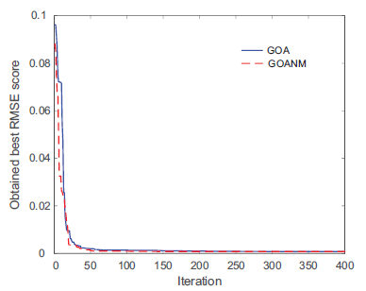

**Fig. 9.** Convergence behavior of gazelle optimization and hybrid gazelle-Nelder–Mead algorithms for single diode model

**Table 4.** Performance comparison of proposed vs existing algorithm

|  |  |  |  |  |  |
| --- | --- | --- | --- | --- | --- |
| Reference | Algorithm used | $R_{s}$ (Ω) | $R_{sh}$ (Ω) | n | Root-Mean-Square Error (RMSE) |
| Premkumar et al. (2022) | CCNMGBO | 1.2013 | 981.9819 | 48.6428 | 2.4251E−03 |
| Qaraad et al. (2023) | IMFOL | 1.2003 | 992.2601 | 48.6788 | 2.4252E−03 |
| Yu et al. (2023) | RTLBO | 1.2013 | 981.9822 | 48.6428 | 2.4251E−03 |
| Li et al. (2023) | DLMVO | 1.2013 | 981.9823 | 48.6428 | 2.4251E−03 |
| Chauhan et al. (2023) | OBL-RSACM | 1.2009 | 983.7382 | 48.5955 | 2.4251E−03 |
| Proposed | GOANM | 1.2356 | 821.6098 | 47.5981 | 2.0528E−03 |

**Fig. 10.** Flowchart for Performance comparison of proposed vs existing algorithm

Table 4 and Figure 10 compare the predicted parameters and RMSE values for the double diode model generated using the GOANM method to other more recent optimization approaches. The results demonstrate the GOANM's superior performance, as it has the lowest RMSE value of any approach studied. This underscores the importance of the proposed GOANM algorithm, which converges to a stable environment solution and shows smoother convergence behavior than existing algorithms. This indicates the efficacy and efficiency of the suggested GOANM methodology.

4. Conclusion

Storage technology and renewable energy sources must be closely coordinated for sustainable power generation. The study proposed a new hybrid GOANM algorithm for solar power storage solutions based on battery technology and energy storage materials to fulfill the growing demand for reliable and accessible sustainable energy sources. The revolutionary GOANM approach was created to retrieve accurate parameters in solar PV systems. Sunlight is emphasized as a clean, renewable energy source because of its capacity to reduce carbon emissions and stop climate change significantly. To summarize, PV energy is a clean energy source that contributes significantly less to climate change than any other traditional power-producing method. The simulation yields the lowest RMSE value of any approach examined. This underscores the importance of the proposed GOANM algorithm, which converges to a stable environment solution and shows smoother convergence. Future research directions include expanding GOANM to different PV models and assessing its adaptability in various environmental circumstances.

*The author would like to express his heartfelt gratitude to the supervisor for his guidance   
and unwavering support during this research for his guidance and support.*

References

Abo-Khalil, A. G., Alharbi, W., Al-Qawasmi, A. R., Alobaid, M., & Alarifi, I. M. (2021). Maximum power point tracking of PV systems under partial shading conditions based on opposition-based learning firefly algorithm. *Sustainability*, *13*(5), 2656. https://doi.org/10.3390/su13052656

Ammach, S., & Attia, A. (2019, November). Design and Implementation of Autonomous Energy Efficient Solar Tracking System for PV Power Plants. In *2019 International Conference on Electrical and Computing Technologies and Applications (ICECTA)* (pp. 1-6). IEEE. https://doi.org/10.1109/ICECTA48151.2019.8959537

Amrouche, S. O., Rekioua, D., Rekioua, T., & Bacha, S. (2016). Overview of energy storage in renewable energy systems. *International journal of hydrogen energy*, *41*(45), 20914-20927. https://doi.org/10.1016/j.ijhydene.2016.06.243

Awan, M. M. A., Khan, A. U., Siddiqui, M. U., Karim, H., & Bux, M. (2023). Optimized hill climbing algorithm for an islanded solar photovoltaic system. *Mehran University Research Journal of Engineering & Technology*, *42*(2), 124-132.

Biswas, A., Husain, D., & Prakash, R. (2021). Lifecycle ecological footprint assessment of grid-connected rooftop solar PV system. *International Journal of Sustainable Engineering*, *14*(3), 529-538. https://doi.org/10.1080/19397038.2020.1783719

Bošnjaković, M., & Tadijanović, V. (2019). Environment impact of a concentrated solar power plant. *Tehnički glasnik*, *13*(1), 68-74. https://doi.org/10.31803/tg-20180911085644

Chauhan, S., Vashishtha, G., & Kumar, A. (2023). Approximating parameters of photovoltaic models using an amended reptile search algorithm. *Journal of Ambient Intelligence and Humanized Computing*, *14*(7), 9073-9088. https://doi.org/10.1007/s12652-022-04412-9

Duong, M. Q., Pham, T. D., Nguyen, T. T., Doan, A. T., & Tran, H. V. (2019). Determination of optimal location and sizing of solar photovoltaic distribution generation units in radial distribution systems. *Energies*, *12*(1), 174. https://doi.org/10.3390/en12010174

Gu, Z., Xiong, G., & Fu, X. (2023). Parameter extraction of solar photovoltaic cell and module models with metaheuristic algorithms: A review. *Sustainability*, *15*(4), 3312. https://doi.org/10.3390/su15043312

Hafez, A. Z., Yousef, A. M., Soliman, A., & Ismail, I. M. (2018, June). A comprehensive review for solar tracking systems design in Photovoltaic cell, module, panel, array, and systems applications. In *2018 IEEE 7th World Conference on Photovoltaic Energy Conversion (WCPEC)(A Joint Conference of 45th IEEE PVSC, 28th PVSEC & 34th EU PVSEC)* (pp. 1188-1193). IEEE. https://doi.org/10.1109/PVSC.2018.8547901

Hemeida, M. G., Hemeida, A. M., Senjyu, T., & Osheba, D. (2022). Renewable energy resources technologies and life cycle assessment. *Energies*, *15*(24), 9417. https://doi.org/10.3390/en15249417

Hossain, M. S., Jahid, A., Islam, K. Z., & Rahman, M. F. (2020). Solar PV and biomass resources-based sustainable energy supply for off-grid cellular base stations. *IEEE access*, *8*, 53817-53840. https://doi.org/10.1109/ACCESS.2020.2978121

Hussain, M. N., Zaman, M. R., Halim, M. A., Ali, M. S., & Khan, M. Y. A. (2024). A Comprehensive Review of Renewable and Sustainable Energy Sources with Solar Photovoltaic Electricity Advancement in Bangladesh. *Control Systems and Optimization Letters*, *2*(1), 1-7. https://doi.org/10.59247/csol.v2i1.59

Izci, D., Ekinci, S., Budak, C., & Gider, V. (2022, October). PID controller design for DFIG-based wind turbine via reptile search algorithm. In *2022 Global Energy Conference (GEC)* (pp. 154-158). IEEE. https://doi.org/10.1109/GEC55014.2022.9986617

Khadka, N., Bista, A., Adhikari, B., Shrestha, A., Bista, D., & Adhikary, B. (2020). Current practices of solar photovoltaic panel cleaning system and future prospects of machine learning implementation. *IEEE Access*, *8*,   
135948-135962. https://doi.org/10.1109/ACCESS.2020.3011553

Korpi, A. G., Ţălu, Ş., Bramowicz, M., Arman, A., Kulesza, S., Pszczolkowski, B., ... & Gopikishan, S. (2019). Minkowski functional characterization and fractal analysis of surfaces of titanium nitride films. *Materials Research Express*, *6*(8), 086463. https://doi.org/10.1088/2053-1591/ab26be

Kumar, N. (2023). EV charging adapter to operate with isolated pillar top solar panels in remote locations. *IEEE Transactions on Energy Conversion*. https://doi.org/10.1109/TEC.2023.3298817

Li, J., Dang, J., Xia, C., Jia, R., Wang, G., Li, P., & Zhang, Y. (2023). Dynamic leader multi-verse optimizer (DLMVO): A new algorithm for parameter identification of solar PV models. *Applied Sciences*, *13*(9), 5751. https://doi.org/10.3390/app13095751

Nieto-Morone, M. B., Rosillo, F. G., Muñoz-García, M. A., & Alonso-García, M. C. (2024). Enhancing photovoltaic module sustainability: Defect analysis on partially repaired modules from Spanish PV plants. *Journal of Cleaner Production*, *461*, 142575. https://doi.org/10.1016/j.jclepro.2024.142575

Oufettoul, H., Lamdihine, N., Motahhir, S., Lamrini, N., Abdelmoula, I. A., & Aniba, G. (2023). Comparative performance analysis of PV module positions in a solar PV array under partial shading conditions. *IEEE Access*, *11*, 12176-12194. https://doi.org/10.1109/ACCESS.2023.3237250

Prathibha, S., Chandran, S. S., Kirthiga, M., Dhanya, K., Gopal, S. A., & Manish, M. (2024, April). Design and Implementation of Solar Electrification Station for Sustainable Energy Access. In *2024 International Conference on Communication, Computing and Internet of Things (IC3IoT)* (pp. 1-6). IEEE. https://doi.org/10.1109/IC3IoT60841.2024.10550242

Premkumar, M., Jangir, P., Ramakrishnan, C., Kumar, C., Sowmya, R., Deb, S., & Kumar, N. M. (2022). An enhanced Gradient-based Optimizer for parameter estimation of various solar photovoltaic models. *Energy Reports, 8*, 15249-15285. https://doi.org/10.1016/j.egyr.2022.11.092

Qaraad, M., Amjad, S., Hussein, N. K., Badawy, M., Mirjalili, S., & Elhosseini, M. A. (2023). Photovoltaic parameter estimation using improved moth flame algorithms with local escape operators. *Computers and Electrical Engineering,* *106*, 108603. https://doi.org/10.1016/j.compeleceng.2023.108603

Razmjoo, A., Ghazanfari, A., Østergaard, P. A., & Abedi, S. (2023). Design and analysis of grid-connected solar photovoltaic systems for sustainable development of remote areas. *Energies*, *16*(7), 3181. https://doi.org/10.3390/en16073181

Roy, R. B., Rokonuzzaman, M., Amin, N., Mishu, M. K., Alahakoon, S., Rahman, S., ... & Pasupuleti, J. (2021). A comparative performance analysis of ANN algorithms for MPPT energy harvesting in solar PV system. *IEEE Access*, *9*, 102137-102152. https://doi.org/10.1109/ACCESS.2021.3096864

Shaw, R. N., Walde, P., & Ghosh, A. (2019). Effects of solar irradiance on load sharing of integrated photovoltaic system with IEEE standard bus network. *Int. J. Eng. Adv. Technol*, *9*(1), 424-429. https://doi.org/10.35940/ijeat.A3188.109119

Tawalbeh, M., Al-Othman, A., Kafiah, F., Abdelsalam, E., Almomani, F., & Alkasrawi, M. (2021). Environmental impacts of solar photovoltaic systems: A critical review of recent progress and future outlook. *Science of The Total Environment*, *759*, 143528. https://doi.org/10.1016/j.scitotenv.2020.143528

Umar, N., Bora, B., Banerjee, C., & Panwar, B. S. (2018). Comparison of different PV power simulation softwares: case study on performance analysis of 1 MW grid-connected PV solar power plant. *International Journal of Engineering Science Invention (IJESI)*, *7*(7), 11-24.

Venkatakrishnan, G. R., Rengaraj, R., Tamilselvi, S., Harshini, J., Sahoo, A., Saleel, C. A., ... & Riffat, S. (2023). Detection, location, and diagnosis of different faults in large solar PV system—a review. *International Journal of Low-Carbon Technologies*, *18*, 659-674. https://doi.org/10.1093/ijlct/ctad018

Viale, A., Çelik, O., Oderinwale, T., Sulbhewar, L., & McInnes, C. R. (2023). A reference architecture for orbiting solar reflectors to enhance terrestrial solar power plant output. *Advances in Space Research*, *72*(4), 1304-1348. https://doi.org/10.1016/j.asr.2023.05.037

Yu, X., Hu, Z., Wang, X., & Luo, W. (2023). Ranking teaching–learning-based optimization algorithm to estimate the parameters of solar models. *Engineering Applications of Artificial Intelligence*, 123, 106225. https://doi.org/10.1016/j.engappai.2023.106225