|  |  |  |  |
| --- | --- | --- | --- |
|  |  | | |
| **Rocznik Ochrona Środowiska** | | |
| Volume 27 | Year 2025 ISSN 2720-7501 | pp. 13-18 |
|  | https://doi.org/10.54740/ros.2025.002 open access | | |
|  | Received: January 2025 Accepted: February 2025 Published: February 2025 | | |

Reliable Precipitation Data for Dimensioning Drainage of Areas and Buildings

Bartosz Kaźmierczak1*, Katarzyna Wartalska2, Marcin Wdowikowski3,   
Bogdan Ozga-Zieliński4, Marek Sidorczyk5, Andrzej Kotowski6

1Faculty of Environmental Engineering, Wroclaw University of Science and Technology, Wroclaw, Poland  
https://orcid.org/0000-0003-4933-8451

2Faculty of Environmental Engineering, Wroclaw University of Science and Technology, Wroclaw, Poland  
https://orcid.org/0000-0002-5855-3607

3Faculty of Environmental Engineering, Wroclaw University of Science and Technology, Wroclaw, Poland  
https://orcid.org/0000-0003-2693-0946

4Institute of Meteorology and Water Management – National Research Institute, Warsaw, Poland  
https://orcid.org/0000-0002-8702-3541

5Insanit Ltd, Pieszyce, Poland  
https://orcid.org/0009-0003-8206-2538

6Faculty of Environmental Engineering, Wroclaw University of Science and Technology, Wroclaw, Poland  
https://orcid.org/0000-0003-0446-5051

*corresponding author's e-mail: bartosz.kazmierczak@pwr.edu.pl

**Abstract:** In recent years, the issue of rainwater drainage has become particularly relevant due to increasing urbanization and climate change. The increasing frequency of extreme rainfall leads to urban flooding and infrastructure damage. These events sometimes also lead to legal consequences for designers and contractors of drainage systems. The design of these systems in Poland has encountered difficulties due to the lack of a reliable, publicly available method for determining the reliable rainfall intensity. The study aims to present the PMAXTP atlas made available by the Institute of Meteorology and Water Management – National Research Institute (IMGW-PIB) as a tool for the precise determination of the maximum rainfall characteristics for a specific duration and probability of exceedance for any location in Poland. IMGW-PIB plans to update the PMAXTP atlas every 10 years to reflect climate changes and the increasing frequency of intense rainfall. The publication also presents computational examples for applications in engineering practice. Using this tool in design practice will allow for the safe and effective design of drainage systems that will be resistant to climate change and extreme weather conditions.

**Keywords:** stormwater drainage system, combined sewage system, rainfall intensity, rainfall atlas

1. Introduction

The issue of draining rainwater from urbanized areas has gained particular significance in recent years. On the one hand, the ever-increasing land surface sealing increases rainwater runoff coefficients. On the other hand, more and more attention is being paid to the ongoing climate change, especially in the context of the increasing frequency of extreme weather events. An increase in the average annual temperatures all over the globe triggers increased water circulation in the hydrological cycle and affects, among others, the frequency of heavy rainfall. Both increasing urbanization and climate change have a negative impact on the efficiency of land and building drainage (IPCC 2021, Trenberth, Fasullo & Shepherd 2015).

In recent years, intense rainfall (alternating with periods of drought) has led to local flooding or urban flooding in virtually all regions of Poland. Due to intense rainfall, traffic difficulties occurred, basements or underground garages of buildings were flooded (which was associated with material losses), but roofs also collapsed (which was also associated with a threat to life). In many cases, these events have also had legal consequences, with an increasing number of proceedings in the courts concerning the correctness of the design and construction of drainage systems (Rutkiewicz & Sieczowski 2017, Wojciechowski, Józefczyk & Sulik 2023).

In turn, abnormally high air temperatures, heat waves, and long periods without rain lead to drought, in the first stage atmospheric and then hydrological, and soil drought, with a consequent reduction in water availability, both for municipal and industrial needs. In recent years, there has also been a strong trend of drought mitigation measures in Poland, including designing blue-green infrastructure and rainwater retention systems and facilities (Journal of Laws 2021, Przestrzelska et al. 2024).

The current legal status imposes on both designers and contractors of construction objects a great responsibility and obligation of careful and safe design and construction of objects – following the art of construction, resulting from the best available technical knowledge. Correct estimation of the amount of precipitation (with a certain duration and probability of exceeding) is crucial in the case of dimensioning stormwater management, retention, or drainage systems (Wałęga, Kaczor & Stęplewski 2016, Wałęga & Michalec 2014, Wartalska et al. 2020). Meanwhile, many investments implemented in recent years and are currently being implemented have been designed for low (compared to the current) amounts of precipitation. This results in an underestimation of sewer diameters or retention basin volumes. The main reasons for this are the developer or contractor's desire (especially in design-build projects) to reduce expenditure on drainage systems.

In many cases, however, the fault lies with the designer, who, using calculation formulas that are no longer valid, fails to consider climate change by assuming underestimated rainfall amounts in the calculations. For example, Błaszczyk's formula for calculating rainfall, widely used in design practice, was developed in 1954 based on rainfall data from 1837-1891 and 1914-1925 from Warsaw. This formula underestimates precipitation amounts by as much as 30-40% on average (Kotowski 2015, Kotowski, Kaźmierczak & Dancewicz 2010, Węglarczyk 2013, Węglarczyk 2014)!

It should be noted here that reliable rainfall data has been difficult for designers to access over the years. Many scientific papers have pointed out the need to replace the Błaszczyk model with up-to-date maximum precipitation models developed based on the longest possible measurement series and a dense network of stations. The scientific community has emphasized that the introduction of a uniform and universally accessible (as in Germany or the USA, for example) precipitation atlas will allow, among other things, a safer dimensioning of land and building drainage than before (Burszta-Adamiak & Licznar 2018, Kotowski 2015, Kotowski, Kaźmierczak & Dancewicz 2010, Mazurkiewicz, Skotnicki & Dymaczewski 2020). In 2022, the Institute of Meteorology and Water Management – National Research Institute (IMGW-PIB) released probabilistic models of maximum rainfall in the form of the PMAXTP rainfall atlas. The publicly available tool allows the characteristics of maximum precipitation of a specific duration and probability of exceedance to be read out for any location in Poland. Its use in design practice allows safe dimensioning of rainwater management, retention, and drainage systems.

2. PMAXTP application

Data sources for the development of the PMAXTP application by IMGW-PIB included data from the period 1986-2015 coming from one hundred measurement points covering the whole area of the country (taking into account orography – higher density of measurement points in sub-mountainous and mountainous terrain). First, local probabilistic models were developed for each measurement point (so-called point estimation), and then geostatistical methods were used to interpolate between measurement points the results of the rainfall models (so-called area estimation) (Ozga-Zieliński, eds. 2022). The developed characteristics of maximum precipitation with specific duration and probability of exceedance have been made available on <https://klimat.imgw.pl/opady-maksymalne/> (IMGW-PIB 2022) in the form of an interactive map (Fig. 1).

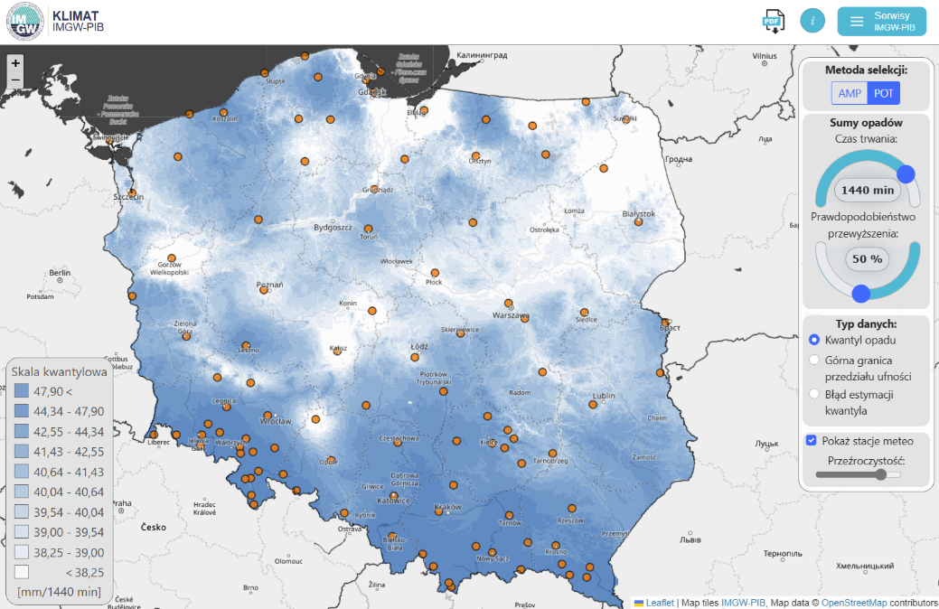

**Fig. 1.** General view of the PMAXTP interactive application (IMGW-PIB 2022)

The application allows the reading of the maximum precipitation *h* (in mm) with a duration from *t* = 5 min to *t* = 4320 min and a probability of exceedance in the basic range from *p* = 99.9% (1 time per 1 year) to   
*p* = 2% (1 time per 50 years) for any location in Poland. The results presented can be saved as a spreadsheet (also in the extended range for 27 probabilities of exceedance to probability *p* = 0.1% – 1 time per 1000 years). In addition to precipitation height data, the application also presents values for the upper limits of the confidence intervals and estimation errors for a specific location. An example of a set of maximum precipitation heights in the basic range read from the PMAXTP application for the Kłodzko station is shown in Table 1.

**Table 1.** Maximum rainfall heights (*h* in mm) for the Kłodzko station according to PMAXTP application   
(according to the POT method)

| Rainfall duration *t* (min) | Probability of exceedance *p* | | | | |
| --- | --- | --- | --- | --- | --- |
| 2% | 10% | 20% | 50% | 99.9% |
| 5 | 17.99 | 15.10 | 13.68 | 11.47 | 8.57 |
| 10 | 22.29 | 18.33 | 16.45 | 13.66 | 10.31 |
| 15 | 25.27 | 20.52 | 18.32 | 15.13 | 11.49 |
| 30 | 31.31 | 24.89 | 22.03 | 18.01 | 13.82 |
| 45 | 35.49 | 27.88 | 24.53 | 19.95 | 15.39 |
| 60 | 38.79 | 30.20 | 26.48 | 21.45 | 16.62 |
| 90 | 43.97 | 33.82 | 29.50 | 23.75 | 18.51 |
| 120 | 48.06 | 36.64 | 31.84 | 25.54 | 19.99 |
| 180 | 54.48 | 41.03 | 35.47 | 28.28 | 22.27 |
| 360 | 67.50 | 49.78 | 42.65 | 33.68 | 26.78 |
| 720 | 83.64 | 60.39 | 51.28 | 40.10 | 32.21 |
| 1080 | 94.80 | 67.62 | 57.12 | 44.41 | 35.88 |
| 1440 | 103.62 | 73.27 | 61.66 | 47.75 | 38.74 |
| 2160 | 117.46 | 82.04 | 68.68 | 52.88 | 43.16 |
| 2880 | 128.39 | 88.90 | 74.14 | 56.86 | 46.60 |
| 4320 | 145.53 | 99.54 | 82.58 | 62.97 | 51.91 |

As noted earlier, the PMAXTP application's data source was from 1986-2015 from one hundred measurement points (Bisaga et al. 2022). The IMGW-PIB promises to update the included measurement data (and thus the maximum rainfall characteristics) every 10 years. Therefore, the precipitation heights estimated by the PMAXTP application will consider progressive climate change in the context of increasing frequency of intense precipitation events over the analyzed period. They will be aligned with the international recommendations of the World Meteorological Organisation (WMO 2017).

3. Calculation Examples

In engineering practice, the concept of unit intensity (*q* in dm3/s·ha) of rainfall is used interchangeably with the rainfall height (*h* in mm). Rainfall heights can be easily converted to unit rainfall intensity using the formula (Kotowski 2015, Kotowski, Kaźmierczak & Dancewicz 2010, Wdowikowski, Kaźmierczak & Kotowski 2021, Wdowikowski et al. 2023):

$q=166.7\frac{h}{t}$ (1)

where:

*q* – unit rainfall intensity (dm3/s·ha),

*h* – maximum rainfall height (mm),

*t* – rainfall duration (min).

The maximum unit rainfall intensities converted from the rainfall readings from the PMAXTP application for the example station Kłodzko (Table 1) are shown in Table 2.

For comparison, for rainfall duration *t* = 15 min and probability of exceedance *p* = 20% (1 time per 5 years), the maximum unit rainfall intensity *q* = 131.6 dm3/s·ha was calculated from Błaszczyk's formula (the annual average precipitation in Kłodzko of 601 mm for the 1991-2020 period was used for the calculations) – with 203.6 dm3/s·ha from the PMAXTP application (a difference is as much as 55%!).

**Table 2.** Maximum unit rainfall intensity (*q* in dm3/s·ha) for Kłodzko station according to PMAXTP application (according to the POT method)

| Rainfall duration *t* (min) | Probability of exceedance *p* | | | | |
| --- | --- | --- | --- | --- | --- |
| 2% | 10% | 20% | 50% | 99.9% |
| 5 | 599.8 | 503.4 | 456.1 | 382.4 | 285.7 |
| 10 | 371.6 | 305.6 | 274.2 | 227.7 | 171.9 |
| 15 | 280.8 | 228.0 | 203.6 | 168.1 | 127.7 |
| 30 | 174.0 | 138.3 | 122.4 | 100.1 | 76.8 |
| 45 | 131.5 | 103.3 | 90.9 | 73.9 | 57.0 |
| 60 | 107.8 | 83.9 | 73.6 | 59.6 | 46.2 |
| 90 | 81.4 | 62.6 | 54.6 | 44.0 | 34.3 |
| 120 | 66.8 | 50.9 | 44.2 | 35.5 | 27.8 |
| 180 | 50.5 | 38.0 | 32.8 | 26.2 | 20.6 |
| 360 | 31.3 | 23.1 | 19.7 | 15.6 | 12.4 |
| 720 | 19.4 | 14.0 | 11.9 | 9.3 | 7.5 |
| 1080 | 14.6 | 10.4 | 8.8 | 6.9 | 5.5 |
| 1440 | 12.0 | 8.5 | 7.1 | 5.5 | 4.5 |
| 2160 | 9.1 | 6.3 | 5.3 | 4.1 | 3.3 |
| 2880 | 7.4 | 5.1 | 4.3 | 3.3 | 2.7 |
| 4320 | 5.6 | 3.8 | 3.2 | 2.4 | 2.0 |

To determine the maximum rainfall heights for durations other than those listed in Table 1, the results can be interpolated using a power function of the form:

$h=at^{b}$ (2)

where:

*h* – maximum rainfall height (mm),

*t* – rainfall duration (min),

*a*, *b* – dimensionless parameters of the power equation.

An analogous interpolation can be made for the maximum unit rainfall intensities (Table 2) using relation (2), thus obtaining a value for any rainfall duration *t* that is not included in the PMAXTP atlas result tables, e.g., *t* = 20 or 100 min. Example interpolation results are shown graphically in Fig. 2.

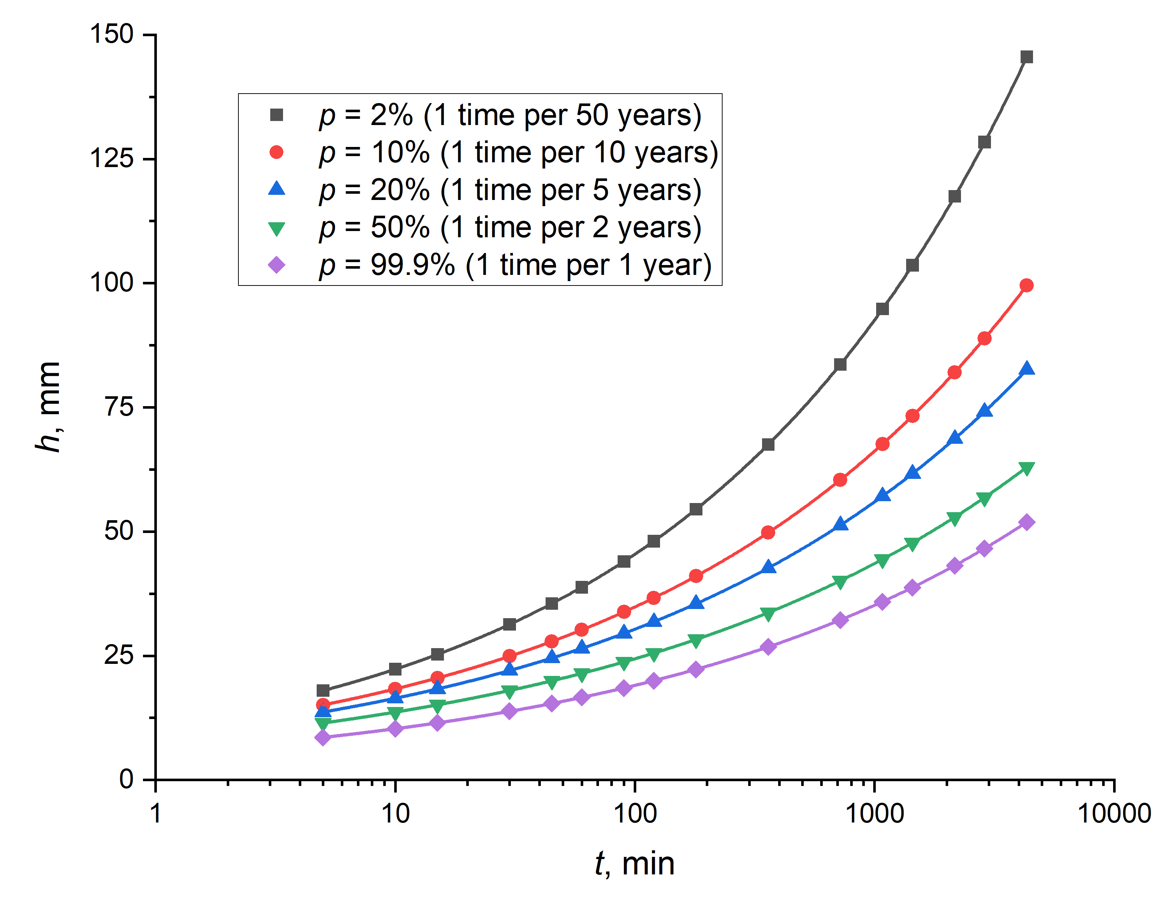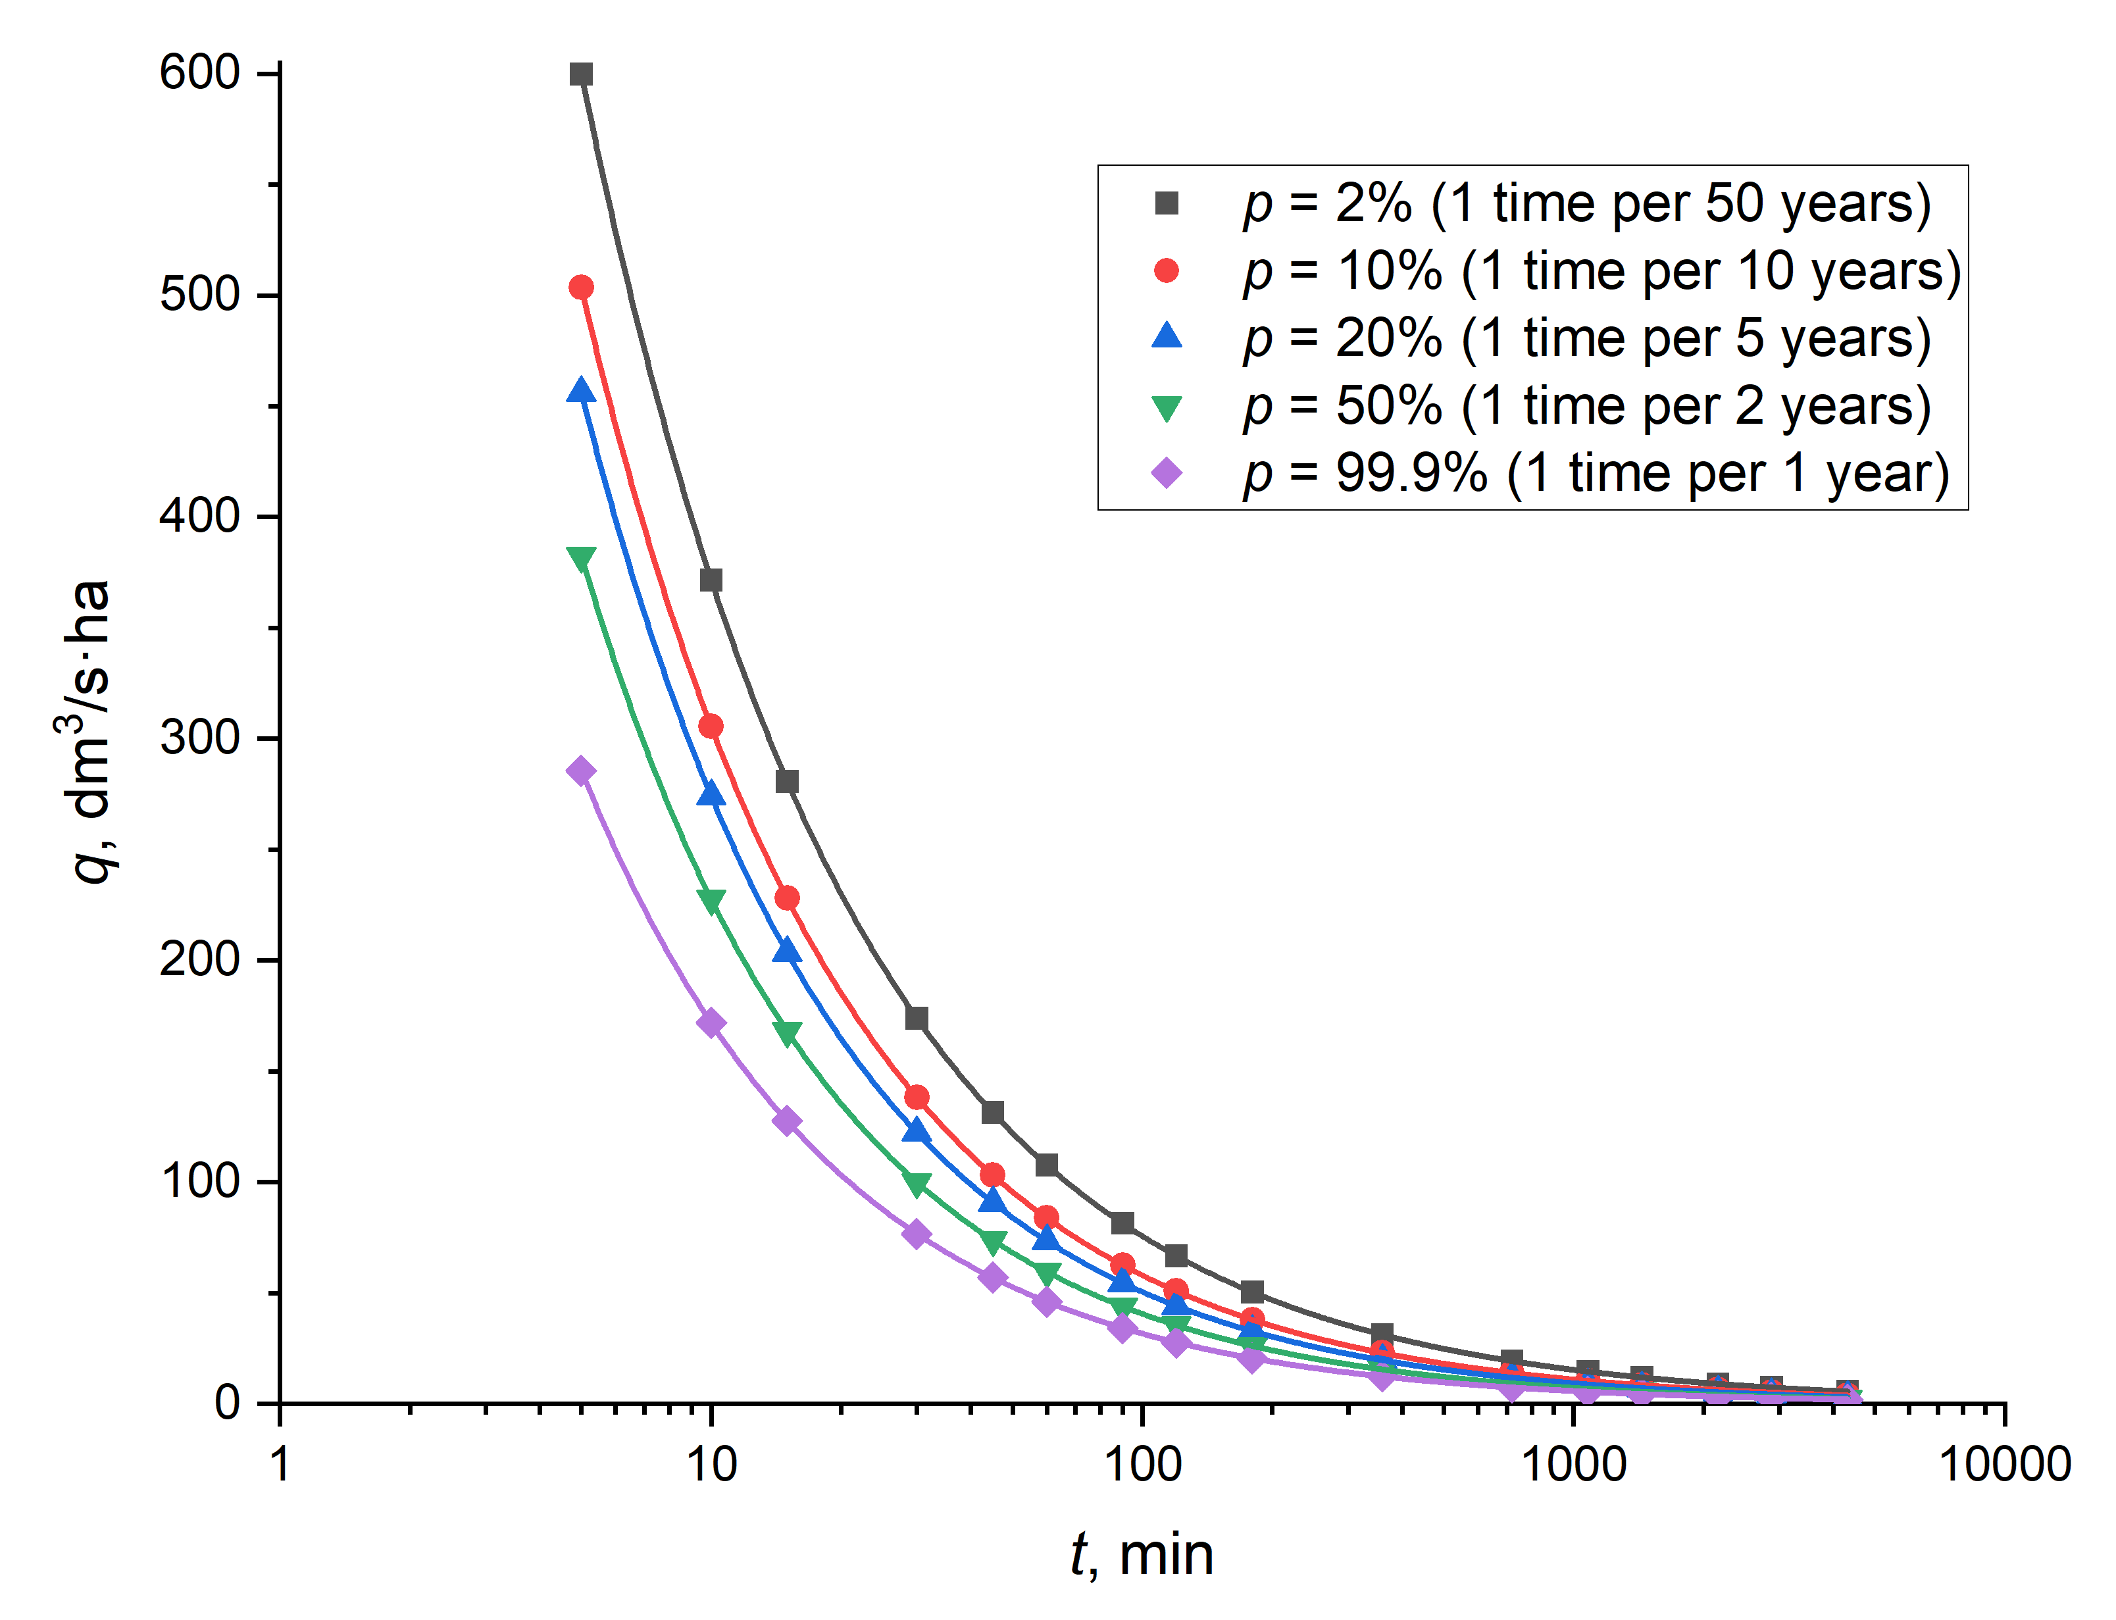

**Fig. 2.** Interpolated maximum rainfall heights (left) and maximum unit rainfall intensities (right) for the Kłodzko station according to the PMAXTP application

4. Estimation Errors

When dimensioning the drainage of areas and buildings of particular importance (e.g., critical infrastructure where potential spills could be catastrophic in their impact), the calculations must consider estimation error. The PMAXTP application provides values for the upper limit of the confidence interval of maximum rainfall heights for each rainfall duration interval. An example of the upper limits of the confidence intervals of maximum precipitation heights for the Kłodzko station is shown in Table 3.

**Table 3.** Upper limits of the confidence intervals of the maximum rainfall amounts (*h* in mm) for the Kłodzko station according to the PMAXTP application (according to the POT method)

| Rainfall duration *t* (min) | Probability of exceedance *p* | | | | |
| --- | --- | --- | --- | --- | --- |
| 2% | 10% | 20% | 50% | 99.9% |
| 5 | 19.78 | 16.17 | 14.49 | 12.01 | 8.59 |
| 10 | 23.71 | 19.18 | 17.10 | 14.13 | 10.38 |
| 15 | 26.68 | 21.4 | 18.98 | 15.54 | 12.06 |
| 30 | 34.16 | 26.45 | 23.11 | 18.56 | 13.84 |
| 45 | 39.54 | 30.07 | 26.01 | 20.65 | 15.40 |
| 60 | 44.85 | 33.11 | 28.34 | 22.27 | 16.62 |
| 90 | 49.30 | 36.74 | 31.50 | 24.75 | 18.52 |
| 120 | 53.81 | 39.77 | 33.97 | 26.60 | 20.01 |
| 180 | 62.12 | 44.88 | 38.07 | 29.64 | 22.28 |
| 360 | 75.63 | 54.05 | 45.52 | 35.09 | 26.80 |
| 720 | 95.36 | 65.87 | 54.82 | 41.80 | 32.22 |
| 1080 | 112.34 | 75.37 | 61.85 | 46.29 | 35.88 |
| 1440 | 139.29 | 85.48 | 67.86 | 49.54 | 38.84 |
| 2160 | 137.24 | 90.93 | 74.26 | 55.34 | 43.16 |
| 2880 | 144.41 | 96.95 | 79.47 | 59.47 | 46.65 |
| 4320 | 165.50 | 108.75 | 88.58 | 66.03 | 51.94 |

Relating the upper limits of the confidence intervals of the maximum rainfall heights (Table 3) to the maximum rainfall heights *h* (Table 1) gives the relative estimation errors. For the Kłodzko station analyzed for the example, the relative estimation errors do not exceed 5% for the probability of exceedance *p* = 99.9% and *p* = 50%. For a probability of exceedance of *p* = 2%, estimation errors are already significant – several percent on average. When dimensioning stormwater management, retention, or drainage systems of particular importance, the upper limits of the confidence intervals for maximum rainfall heights should be adopted in the hydraulic calculations – to increase the safety of the dimensioned systems (especially in the context of increasing frequency of extreme weather events).

4. Conclusions

In recent years, there has been an increase in the frequency of extreme weather phenomena, such as intense and prolonged rainfall, which leads to spillages and urban flooding. These phenomena generate significant economic losses, necessitating continuous improvement in the design and dimensioning of drainage systems for land and buildings.

In Poland, the design of drainage systems encountered difficulties resulting from the lack of a reliable, publicly available method of determining the rain intensity to be reliable. Made available by the Institute of Meteorology and Water Management – National Research Institute, the PMAXTP rainfall atlas makes it possible to read out the characteristics of maximum precipitation of a specific duration and probability of occurrence for any location in Poland. The IMGW-PIB promises to update the included measurement data (and thus the maximum precipitation characteristics) every 10 years. The precipitation amounts estimated by the PMAXTP application will, therefore, consider progressive climate change in the context of increasing frequency of intense precipitation events.

The widespread implementation of the PMAXTP application into design practice will allow for the safe dimensioning of stormwater management, retention, and drainage systems.

The work is the result of cooperation between the Institute of Meteorology and Water Management   
– National Research Institute and the Faculty of Environmental Engineering at Wrocław University   
of Science and Technology, which aims, among other things, to provide reliable precipitation data   
for the dimensioning of land and building drainage through the development of the PMAXTP application

References

Burszta-Adamiak, E., Licznar, P. (2018). An analysis of the time structure of maximum precipitation of the Polish Atlas of Rainfall Intensity (PANDa). *Instal*, *3*, 49-53. (in Polish)

IMGW-PIB. (2022). PMAXTP Maximum rainfall atlas. Retrieved from: https://klimat.imgw.pl/opady-maksymalne/   
(accessed 26 January 2025)

IPCC (2021). *Summary for Policymakers of the Climate Change 2022: Impacts, Adaptation and Vulnerability. Working Group II Contribution to the IPCC Sixth Assessment Report*. Cambridge (UK) and New York (USA): Cambridge University Press. https://doi.org/10.1017/9781009325844.001

Kotowski, A. (2015). *Basics of safe dimensioning of land drainage. Vol. I. Sewage systems*. *Vol. II. Special facilities.* Warszawa: Wyd. Seidel–Przywecki. (in Polish)

Kotowski, A., Kaźmierczak, B., Dancewicz, A. (2010). *Rainfall modeling for sewer dimensioning*. Warszawa: Wyd. Komitetu Inżynierii Lądowej i Wodnej PAN. (in Polish)

Mazurkiewicz, K., Skotnicki, M., Dymaczewski, Z. (2020). Duration of a Design Rainfall for Urban Drainage System Modelling. *Rocznik Ochrona Środowiska*, *22*, 892-904.

Ozga-Zieliński, B., red., collective work of authorship: Bisaga, W., Bryła, M., Kaźmierczak, B., Kielar, R., Kitowski, M., Marosz, M., Miętek, B., Ozga-Zieliński, B., Tokarczyk, T., Walczykiewicz, T., Żelazny, M. (2022). *Probabilistic models of maximum precipitation with specified duration and exceedance probability – PMAXTP project*. Warszawa: Instytut Meteorologii i Gospodarki Wodnej – Państwowy Instytut Badawczy. (in Polish)

Przestrzelska, K., Wartalska, K., Rosińska, W., Jurasz, J., Kaźmierczak, B. (2024). Climate Resilient Cities: A Review of Blue-Green Solutions Worldwide. *Water Resources Management*, *38*, 5885-5910.   
https://doi.org/10.1007/s11269-024-03950-5

Regulation of the Minister of Infrastructure of 15 July 2021 on the adoption of the Drought Effects Counteracting Plan (Dz. U. 2021 poz. 1615). Retrieved from: <https://isap.sejm.gov.pl/isap> (accessed 26 January 2025) (in Polish)

Runkiewicz, L., Sieczowski, J. (2017). Atmospheric and environmental factors influencing threats, failures and disasters of buildings. *Przegląd budowlany,* *10*, 103-107. (in Polish)

Trenberth, K.E., Fasullo, J. T., Shepherd, T. (2015). Attribution of climate extreme events. *Nature Climate Change*, *5*(8), 725-730. https://doi.org/10.1038/nclimate2657

Wałęga, A., Michalec, B. (2014). Characteristics of extreme heavy precipitation events occurring in the area of Cracow (Poland). *Soil and Water Resources*, *9*(4), 182-191. https://doi.org/[10.17221/99/2013-SWR](http://dx.doi.org/10.17221/99/2013-SWR)

Wałęga, A., Kaczor, G., Stęplewski, B. (2016). The Role of Local Precipitation Models in Designing Rainwater Drainage Systems in Urban Areas: a Case Study in Krakow, Poland. *Polish Journal of Environmental Studies*, *25*(5),   
2139-2149. https://doi.org/[10.15244/pjoes/62961](http://dx.doi.org/10.15244/pjoes/62961)

Wartalska, K., Kaźmierczak, B., Nowakowska, M., Kotowski, A. (2020). Analysis of hyetographs for drainage system modeling. *Water*, *12*(1), 1-21. https://doi.org/10.3390/w12010149

Wdowikowski, M., Wartalska, K., Kaźmierczak, B., Kotowski, A. (2023). The principles for formulating the heavy rainfall probabilistic models. *Gaz, Woda i Technika Sanitarna*, *1*, 22-29. <https://doi.org/10.15199/17.2023.1.4> (in Polish)

Wdowikowski, M., Kaźmierczak, B., Kotowski, A. (2021). *Probabilistic modeling of maximum rainfall on the example of the Upper and Middle Odra River Basin.* Wrocław: Oficyna Wydawnicza Politechniki Wrocławskiej. (in Polish)

Węglarczyk, S. (2013). On the correctness of the Blaszczyk equations for design rainfall calculations. *Infrastruktura   
i Ekologia Terenów Wiejskich*, *3*, 63-76. (in Polish)

Węglarczyk, S. (2014). Design rainfall: the past and the present, theory and practice. In: A. Magnuszewski (Eds.), *Hydrologia w ochronie i kształtowaniu środowiska: II Krajowy Kongres Hydrologiczny. T. 2* (43-56). Warszawa: KGW-PAN. (in Polish)

WMO. (2017). Guidelines on the Calculation of Climate Normals. WMO-No. 1203. Geneva.

Wojciechowski, S., Józefczyk, Ł., Sulik, P. (2023). Safety of roofs of large-area halls made using prestressed concrete prefabrication technology in the event of an unintended load. *Budownictwo, Technologie, Architektura*. *4*, 70-74.   
(in Polish)