|  |  |  |  |
| --- | --- | --- | --- |
|  |  | | |
| **Rocznik Ochrona Środowiska** | | |
| Volume 26 | Year 2024 ISSN 2720-7501 | pp. 383-392 |
|  | https://doi.org/10.54740/ros.2024.037 open access | | |
|  | Received: June 2024 Accepted: August 2024 Published: September 2024 | | |

Properties of a Sand and Bentonite Mixture as a Material for Spot Seals of Low Flood Embankments in the Area of Żuławy Elbląskie

Bartłomiej Brzeziński1*, Szymon Czyżykowski2, Andrzej Olchawa3, Marianna Wierzbicka4

1University of Applied Sciences in Elbląg, Poland  
https://orcid.org/0000-0002-0268-0551

2University of Applied Sciences in Elbląg, Poland   
https://orcid.org/0009-0008-7093-5430  
3University of Applied Sciences in Elbląg, Poland  
https://orcid.org/0000-0002-6211-4375

4University of Applied Sciences in Elbląg, Poland  
https://orcid.org/0000-0002-9788-277X

*corresponding author's e-mail: b.brzezinski@ans-elblag.pl

**Abstract:** The paper presents the test results of a bentonite and sand mixture as a mineral material used for spot seals of low flood embankments in the area of Żuławy Elbląskie. The test results showed very good properties of the mixture, i.e., good compaction, a low filtration coefficient, and significantly higher shear strength compared to the construction material of the flood embankment in Nowe Dolne. The obtained water permeability values of 10-8 m/s are characteristic of very low permeable soils. The strength parameters of the mixture are φ = 34.8o and cohesion c = 72.69 kPa. It should also be noted that the shear strength of the B/Sa mixture is significantly higher compared to the shear strength of the construction material of the flood embankment in Nowe Dolno.

**Keywords:** low embankments, the filler, bentonite/sand mixture, hydraulic conductivity, shear strength, compaction

1. Introduction

In the area of Żuławy Elbląskie, nearly all the flood embankments are classified as III and IV class hydro-technical structures. For their construction, revitalisation or modernisation, local organic soils such as aggregate mud, gyttja, and, less often, peat are used. These soils are obtained from the deepened riverbed or so-called material ditches located near the revitalised or modernised embankment (Borys 1993, Borys et al. 2002, Olchawa 2003, Borys & Rycharska 2004, Olchawa & Walter 2004, Brzeziński et al. 2023). Observations of these embankments and information obtained from their users indicate a rapid process of technical degradation. It results from the degradation of the construction material itself, i. e. organic soil. The degradation results from structural changes in the soil and biochemical organic matter transformation processes. Embankments made of organic soils are exploited for 25 to 30 years, whereas embankments of the same construction but made of mineral soils are exploited for at least one hundred years (Olchawa 2003).

In the exploitation process, spot gaps tend to appear through which the water filters. It may lead to the removal of the soil from the body of the embankment resulting from increasing energy of filtering water. As a result, so-called filter blurring of the body may occur. The gaps are continuously filled with local organic soil and compacted by hand. The main problem when performing spot seals is the lack of information on the soil and the range of the field working water content of the soil. In practice, it is impossible to quickly fill the gaps and bring the organic soil to the field working water content.

The alternative for using local organic soils can be mineral material consisting of easily available materials, i.e. sand and bentonite (Cichy & Bryk 2006, Pytlowany et al. 2022). The mixture of such materials does not undergo degradation processes during the operation of the embankment and is characterised by better performance parameters than organic soil. An additional advantage of such a mixture is its good compaction and well-known field working water content range. Bentonite-sand mixtures are also used in various areas of earth construction, such as seals of various types of waste landfills and anti-filtration seals. (Kockar et al. 2005, Chalermyanont & Arrykul 2005, Akgün et al. 2006, Akgün 2010, Gueddouda et al. 2016, Sharma et al. 2017, Yang et al. 2017, Ghadra & Assadi-Langroudib 2018, Nath et al. 2023, Zhang et al. 2024). Such mixtures are also used together with other mineral materials, such as fly ash and with binders such as cement (Falaciński et al. 2005, Alkaya & Esener 2011, Iravanian & Bilsel 2016, Cheng et al. 2022).

The paper presents the results of selected properties of a sand and bentonite mixture which can be used for spot seals of low flood embankments in the area of Żuławy Elbląskie.

2. Materials and Methods

2.1. The soil

The soil from the Stare Miasto gravel pit near Dzierzgoń was used to make the mixtures. To classify the soil type, a sieve analysis was performed based on which the granulometric composition was determined, following PN-EN ISO14688-1:2018-05P standard. The soil was classified according to PN-EN ISO 14688-1:2006 standard based on the results obtained. Due to its granulometric composition, the soil was classified as sand (Sa). Table 1 shows the results of the granulometric analysis.

**Table 1.** Grain-size content of the soil as a percentage

|  |  |
| --- | --- |
| Si | Sa |
| d < 0.063 | 0.063 < d < 2 |
| 0.7% | 99.03% |

2.2. Bentonite

Bentonite from Milowice (B) was used to modify the sand properties. Its external specific surface area is ESSA = 67. 5 m2/g (External Specific Surface Area). The measurement was made based on the method proposed in the paper (Olchawa 1994). The external specific surface area was determined based on desorption moisture at vapour pressure p/po = 0.5 after cations in the natural complex had been replaced with a potassium cation K+. The aim was to close the interlayer space for water molecules, and water desorption took place only on the particle's outer surface. The ESSA value was calculated from the formula:

ESSA = [WD (0.5)] ∙ 5.55 m2/g (1)

where:

WD (0.5) – water content of bentonite after completion of the desorption process in relative vapour pressure, p/p0 = 0.5.

The tests of the chemical composition of bentonite carried out in the Department of Soil Science of the Faculty of Agriculture at the Bydgoszcz University of Technology showed the content of SiO2 – 59.15%, Al2O3 – 20.05%, Fe2O3 – 4.06%, FeO – 0.13%, MgO – 3.54%, CaO – 0.78%, K2O – 1.62%, Na2O – 0.93% and SiO2/R2O3 – 4.44%. The roasting losses amounted to 9.07%.

The diffractometric tests were performed at the Department of Building Ceramics, Faculty of Chemistry, Gdańsk University of Technology. The studies of Atterberg limits (Whitlow 2000, Pisarczyk 2005) were carried out in the soil science laboratory of the Polytechnic Institute of the Academy of Applied Sciences in Elbląg, and the studies of the external specific surface of bentonite were carried out in the soil science laboratory of the Polytechnic Institute. All of the above studies are presented in Table 2.

**Table 2.** Properties of Milowice bentonite

|  |  |  |  |  |  |
| --- | --- | --- | --- | --- | --- |
| Liquid limit | Plastic limit | External specific surface area, ESSA | Particle size distribution as a percentage | | |
| % | % | m2/g | Sand | Silt | Clay |
| 221.1 | 49.5 | 67.5 | 1.2% | 36.1% | 62.7% |

The results of exchangeable cation tests have shown that the predominant cation is Na+, whose content concerning the cation exchange capacity – CEC, 0.69 mVal/g, is 91.2%, followed by K+ 5.57%, Mg+ 1.4% and Ca+ 0.35%. The results are presented in Table 3.

**Table 3.** Exchangeable cations content

|  |  |  |  |  |
| --- | --- | --- | --- | --- |
| Na+ | Ca++ | K+ | Mg++ | ∑ |
| mg/g | mg/g | mg/g | mg/g | mg/g |
| 12.423 | 0.0417 | 1.298 | 0.430 | 14.95 |
| mVal/g | mVal/g | mVal/g | mVal/g | mVal/g |
| 0.5401 | 0.0021 | 0.0332 | 0.0088 | 0.5952 |

Diffractometric tests were performed on the DRON 2 diffractometer. The diffractogram is shown in Figure 1.

**Fig. 1.** Milowice bentonite diffractogram (powder test)

The diffractogram shows that the main silty mineral is montmorillonite. Kaolinite and illite are also present in bentonite. The presence of montmorillonite is indicated by its basic reflection in the band 14.14 Ǻ (1.414 nm), and the presence of kaolinite is indicated by its basic reflection in the bands 7.15 Ǻ (0.715 nm) and 3.73-3.57 Ǻ (0.373-0.357 nm). Illite is represented by lines 9.98 Ǻ, 3.35 Ǻ and 2.56 Ǻ (0.998, 0.335, 0.256 nm). The intensity of the illite and kaolinite lines indicates their low content concerning montmorillonite. Among the non-silty minerals, quartz 4.24 Ǻ, 3.35 Ǻ (0.424, 0.335 nm) is present. The intensity of the quartz line indicates its significant content in the rock. The diffractogram shows a low calcite content as well.

2.3. Samples preparation

Tests of the mixture in the mass ratio B/Sa were carried out for the first stage. After the first pilot tests, all mixtures were rejected, which, after concentration to Is = 0.92, were characterised by a filtration coefficient of k10 > 10-8 m/s.

Mixtures were made with a B/Sa mass ratio of 0.05, 0. 1, 0.125, 0.25, 0.5, and 0.725. The B/Sa ratio refers to bentonite's dry mass and sand's dry mass. It was assumed that further tests would be carried out on a material that meets two criteria, i.e. the minimum content of bentonite and the maximum value of the filtration coefficient not higher than 10-8 m/s (i.e. log k10 ≤ -8).

Mixtures with the ratio of the mass of bentonite to the mass of sand stated above were made by carefully mixing 3 kg of sand and an appropriately selected mass of bentonite. The mixing was conducted in laboratory conditions using a mechanical mixer simulating mixing of materials in a built – in place with specialised equipment, e.g., a self-propelled concrete mixer type 500 RMX.

2.4. Research methods

First of all, to determine the relationship between water content and volume density of the soil skeleton, the "Proctor test" according to PN 88/B-04481 was performed (the so-called Normal method, compaction energy 0.59 MJ/m3). On this basis, the water content was determined, for which $\frac{ρ_{d}}{ρ_{dmax}}$ = 0.92. This value is the minimum density index Is for the earth masses in flood embankments belonging to the III and IV classes of hydro-technical structures (PN-97/B-12095).

Based on the curve of the relationship between ρd and water content w, a mixture of sand and bentonite was prepared with water content corresponding to the Proctor curve of 0.92 ρds, both on the dry and wet side. The samples thus prepared were compacted in a Proctor apparatus. After the compaction process was completed, soil samples were cut from the bottom cylinder of the Proctor apparatus with a 100 cm3 metal Kopecki cylinder for filtration rate testing. In the same way, the material for strength tests was collected by cutting out the soil with a steel mold whose dimensions were consistent with the dimensions of the direct shear apparatus box.

During filtration coefficient tests, it is essential to saturate the water sample, i.e. Sr = 1. The cut-out sample was saturated "from below" according to the scheme in Figure 2. A hollow cylinder of the same diameter was applied to the cylinder with the soil, and a rubber band was applied to the contact edge of the cylinders. Such a set was put into a 1-litre beaker. A nylon mesh was applied to the bottom of the cylinder with soil. Such a set was set on wooden beams measuring 5 mm by 5 mm and 80 mm long. Water was poured into the beaker below the upper edge of the empty cylinder (head pressure H = 9 cm). The soil saturation process was considered complete when water appeared in the upper cylinder.



**Fig. 2.** Schematic diagram of the method of saturation of soil samples before the hydraulic conductivity test

Then, the cylinder with the soil was transferred to the tube of the apparatus (Figure 3), which was used to measure the filtration coefficient based on Darcy's experiment. The hydraulic gradient values used in the experiment were 2, 4, 6, 8 and 10. These decreases are greater than during water filtration in periods when the water level is rising. The analysis of the actual hydraulic gradient in low embankments is presented in the section on the analysis of results. The filtration coefficient k was calculated from the formula:

V = $k∙i∙t∙A$ (2)

where:

V – the volume of filtrate flowing through the soil over time t [m3],

k – filtration coefficient [m/s],

A – soil cross-sectional area [m2],

t – time of measured flow [s],

i – hydraulic gradient.

|  |  |
| --- | --- |
|  | **Fig. 3.** Soil permeability testing apparatus |

For strength tests in the direct shear apparatus, soil from a steel mold was transferred. The transfer method ensured that the compaction of the soil remained the same as at the end of the compaction process.

|  |  |
| --- | --- |
|  | **Fig. 4.** The scheme of composite Material collection using a knife from the lower cylinder of the Proctor Apparatus |

The applied normal stresses σn were 25, 50, 75, 100, 125, 150, 175 and 200 kPa, respectively. The specimens were sheared at a speed of 0.1 mm / 1 minute. The shear strength τf was calculated:

- for sand:

|  |  |
| --- | --- |
|  | (3) |

where:

Qmax – maximum shear force [kN],

a – the apparatus frame width,

r – the length of the frame displacement concerning the box when the force is reached Qmax [cm].

- for sand and bentonite mixture:

$τ_{f}=\frac{Q_{10}}{0.9 ∙ a^{2}}$ (4)

where:

Q10 – shear force corresponding to 10 % of the apparatus box movement [kN],

a – the apparatus frame width.

3. Test Results

The material with the lowest bentonite to sand ratio B/Sa of 0.05 met the assumed criterion for hydraulic conductivity. All the presented test results refer to the base material and the mixture with the composition B/S = 0.05. Figure 5 shows the "Proctor curve for the mixture B/Sa.

**Fig. 5.** The relations between dry density of the mixture and water content in Proctor's compaction test

Figure 6 shows the value of the hydraulic gradient of the water during the flow through the flood embankment at the highest water level, which was calculated based on the net flow.



**Fig. 6.** Flow net for the low flood embankment for the extreme water impoundment

The value of the hydraulic gradient between equipotential lines 21-20 and 8-7 was calculated as below.



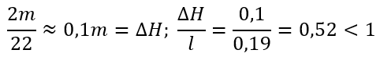

The calculated values of the coefficient of permeability (the flow constant) of the mixture B/Sa for the different values of hydraulic gradients adopted in the experiment are shown as decimal logarithms in Figures 7 and 8. The tests were performed four times, and the average values from these measurements were included in the figures.

**Fig. 7.** Logarithm of the coefficient of permeability of the bentonite – sand mixture B/Sa = 0.05

**Fig. 8.** Logarithm of the values of the coefficient of permeability of the sand. Coefficient k10 expressed in m/s

Based on the calculated actual hydraulic gradient in the flood embankment, for water flow calculations through the body, the value of k10 must be adopted, and that is determined for the hydraulic gradient i = 2. Figures 9 and 10 show the results of shear strength tests in a direct shear apparatus performed thrice. The shear strength values are the average values of these three measurements.

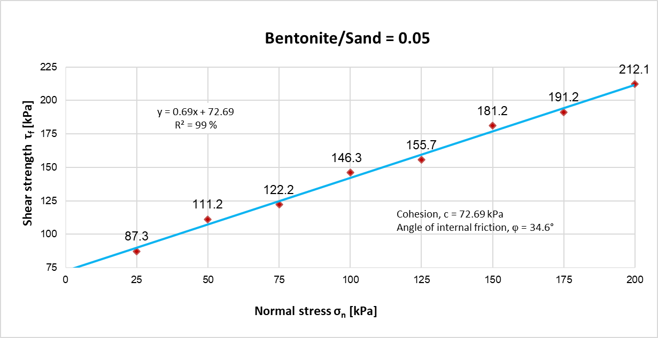

**Fig. 9.** Shear strength of bentonite – sand mixture B/MSa = 0.05

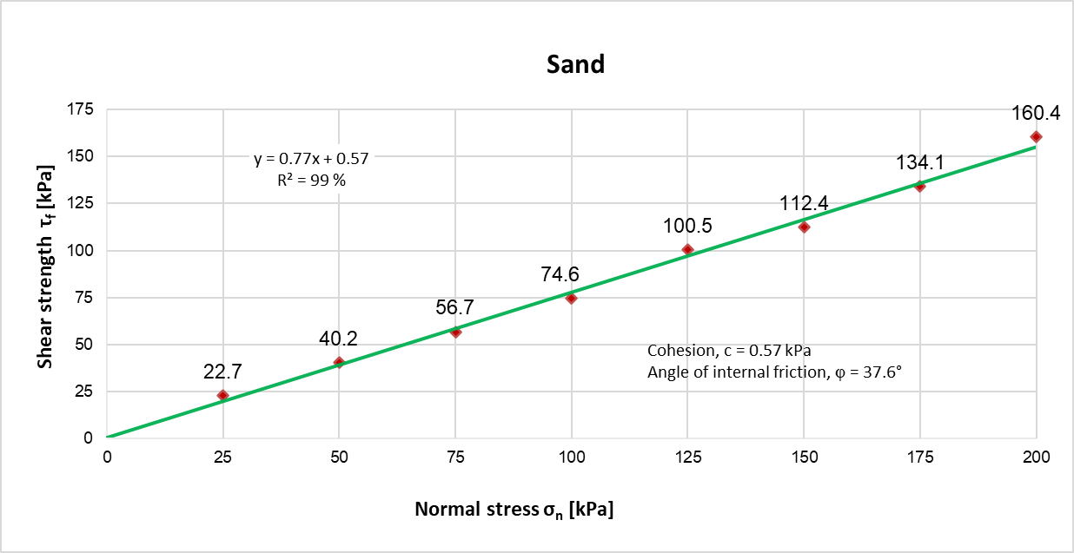

**Fig. 10.** Normal stress vs peak shear strength

4. Analysis of Results

The test results of the B/Sa mixture indicate the great suitability of this kind of material for spot seals of low flood embankments. The qualities of the mixture include good compaction and a relatively wide range of field water content ∆w = 11%. A low permeability coefficient characterises the mixture, 10-8 m/s, which, according to accepted criteria (Lambe & Whitman 1969), is classified as soil of very low permeability (Figures 7 and 8). Laboratory studies of the filtration coefficient based on the Darcy experiment showed the effect of the applied hydraulic gradient on the filtrate volume per unit of time. For the analysis of the filtration coefficient of the suitable mixtures, the relevant value of k10 should be calculated for the hydraulic gradient I ≤ 2 because the hydraulic gradient estimated by the authors in low flood embankments is below one even in case of the highest water level.

The carried out shear strength tests have shown that for the whole normal stress range σn, the shear stresses of the mixture are greater compared to the stresses of the sand constituting the base material of the mixture, as shown in Figures 9 and 10. The strength parameters of the sand and bentonite mixture are higher than those of cohesive native soils included in the PN-81-B-03020 standard. The strength parameters of the mixture and the construction material from which the flood embankment was made in Nowe Dolno (Olchawa 2003) are respectively φ = 34.6° and cohesion c = 72.69 kPa and φ = 7.4° and cohesion c = 25.4 kPa. These parameters are significantly higher than the parameters of the soil used for constructing and modernising the embankment body in Nowe Dolno.

5. Conclusions

Based on the analysis, the following conclusions have been drawn:

1. The mixture is a well-compactable material with a fixed range of field-working moisture.
2. The coefficient of permeability of the material is 10-8 m/s, which, according to recognised criteria, characterises soils of very low permeability. For analyses of water flow through the embankment body, the values of k10 should be adopted from Darcy's experiment calculated for values of hydraulic gradient i ≤ 2.
3. The shear strength of the B/Sa mixture is higher than sand as the mixture's base material and organic soil as the structural material of the flood embankment in Nowe Dolno.
4. This material meets all the suitability criteria for spot seals of low embankments in the area of Żuławy Elbląskie.
5. The great advantage of the material is its ability to be used for "dry mixing" in field conditions using simple equipment, e.g., a concrete mixer.
6. Good compaction of the material makes it possible to be compacted in field conditions using simple equipment, e.g., a plate compactor.
7. This kind of mixture can be made immediately after identifying a spot leak without a "seasoning" period.
8. The B/Sa mixture is easy to make, and the materials of the mixture can be stored all year round in the area of flood control stations.
9. Another material can replace the Milowice bentonite with similar properties (e.g., Wyoming bentonite), but the studies described in the paper should be carried out before its use.
10. The economic effect resulting from using the mixture consists in the ingredients' general availability and relatively low costs.

References

Akgün, H., Koçkar, M., Aktürk, Ö. (2006). Evaluation of a compacted bentonite/sand seal for underground waste repository isolation. *Environ Geol*, *50*, 331-337. https://doi:10.1007/s00254-006-0212-6

Akgün, H. (2010). Geotechnical characterisation and performance assessment of bentonite/sand mixtures for underground waste repository sealing. *Applied Clay Science*, *49*(4), 394-399. https://doi:10.1016/j.clay.2009.08.020

Alkaya, D., Esener, A.B. (2011). Usability of sand-bentonite-cement mixture in the construction of unpermeable layer. *Scientific Research and Essays*, *6*(21), 4492-4503. https://doi:10.5897/SRE10.1189

Borys, M., Jędryka, E., Filipowicz, P., Generowicz, J., Kamińska, A., Kosmulski, J., Kowalski, M., Wolski, J., Barszczewska, I. (2002). *Ocena stanu technicznego wybranych odcinków wałów przeciwpowodziowych na terenie żuław elbląskich w basenie jeziora Druzno*. Instytut Melioracji i Użytków Zielonych, Falenty. (in Polish)

Borys, M. (1993). *Niskie nasypy z miejscowych gruntów organicznych dla potrzeb budownictwa wodno-melioracyjnego*. Falenty. Rozprawa habilitacyjna. Instytut Melioracji i Użytków Zielonych, Falenty. (in Polish)

Borys, M., Rycharska, J. (2004). *Ocena stanu obwałowań przeciwpowodziowych wykonanych z namułów organicznych na przykładzie Żuław Elbląskich*. Woda Środowisko Obszary Wiejskie. Instytut Melioracji i Użytków Zielonych, Falenty. (in Polish)

Brzeziński, B., Olchawa A., Wierzbicka M. (2023). Wybrane właściwości gruntowych materiałów kompozytowych jako materiału konstrukcyjnego do budowy niskich nasypów obwałowań przeciwpowodziowych. *Materiały Budowlane*, *6*(610), 32-36. (in Polish) https://doi:10.15199/33.2023.06.08

Chalermyanont, T., Arrykul S. (2005). Compacted sand-bentonite mixtures for hydraulic containment liners. *Songklanakarin Journal of Science and Technology*, *27*(2), 313-323.

Cheng, H., Li, W., Chen, R., Yi, Y. (2022). Workability study of sand-bentonite-cement mixtures for construction of two-phase cut-off wall. *Construction and Building Materials*, *345*. https://doi:10.1016/j.conbuildmat.2022.128058

Cichy, W., Bryk, J. (2006). *Doszczelnianie gruntów naturalnych za pomocą bentonitu. Etap III. Analiza wymagań I zaleceń dotyczących projektowania doszczelniania gruntów naturalnych za pomocą bentonitu. Analiza wymagań dotyczących kontroli jakości robót związanych z doszczelnianiem gruntów naturalnych za pomocą bentonitu*. Gdańsk. [http://www.zmbzura.pl/zalaczniki/30/Doszczelnianie_gruntow_bentonitem.pdf 05.06.2024](http://www.zmbzura.pl/zalaczniki/30/Doszczelnianie_gruntow_bentonitem.pdf%2005.06.2024). (in Polish)

Falaciński, P., Garbulewski, K., Kledyński, Z., Skutnik, Z., Ziarkowska, K. (2005). Fluidised Fly-Ash Cement-Bentonite Cut-off Walls in Flood Protection. *Archives of Hydro-Engineering and Environmental Mechanics*, *52*(1), 7-20.

Ghadra, S., Assadi-Langroudib, A. (2018). Structure-based hydro-mechanical properties of sand-bentonite composites. *Engineering Geology*, *235*, 53-63. https://doi:10.1016/j.enggeo.2018.02.002

Gueddouda, M.K., Goual, I., Benabed, B., Taibi, S., Aboubekr, N. (2016). Hydraulic properties of dune sand–bentonite mixtures of insulation barriers for hazardous waste facilities. *Journal of Rock Mechanics and Geotechnical Engineering*, *8*(4), 541-550. https://doi:10.1016/j.jrmge.2016.02.003

Iravanian, A., Bilsel, H. (2016). Tensile Strength Properties of Sand-bentonite Mixtures Enhanced with Cement. *Procedia Engineering*, *143*, 111-118. https://doi:10.1016/j.proeng.2016.06.015

Kockar, M., Akgün, H., Akturk, O. (2005). Preliminary Evaluation of a Compacted Bentonite/Sand Mixture as a Landfill Liner Material. *Journal of Solid Waste Technology and Management*, *31*(4), 187-192.

Lambe, T.W., Whitman, R.V. (1969). *Soil Mechanics*. John Wiley & Sons, New York.

Nath, H., Kabir, H., Al Kafy, A., Rahaman, Z.A., Rahman, M.T. (2023). Geotechnical properties and applicability of bentonite-modified local soil as landfill and environmental sustainability liners. *Environmental and Sustainability Indicators*, *18*, 100241. https://doi:10.1016/j.indic.2023.100241

Olchawa, A. (1994). Determination of surface area of clays from desorption water content. *Wiadomości Instytutu Melioracji i Użytków Zielonych*, *Falenty*, *XVIII*(1), 107-118.

Olchawa, A. (2003). Właściwości gruntowych kompozytów jako materiału do budowy obwałowań przeciwpowodziowych. *Woda Środowisko Obszary Wiejskie. Instytut Melioracji i Użytków Zielonych, Rozprawy naukowe i monografie, Falenty*. (in Polish)

Olchawa, A., Walter, T. (2004). *Zastosowanie miejscowych materiałów gruntowych dla ograniczenia procesu degradacji gruntów organicznych w obwałowaniach przeciwpowodziowych polderowych obszarów Żuław*. Elbląg. Report on Statutory Theme 6.1. Typescript. (in Polish)

Pisarczyk, S. (2001). Gruntoznawstwo inżynierskie. *Scientific Publishing PWN*. Warszawa. (in Polish)

PN-81-B-03020 Grunty budowlane. Posadowienie bezpośrednie budowli. Obliczenia statyczne i projektowanie. (in Polish)

PN 88/B-04481 Grunty budowlane. Badania próbek gruntu. (in Polish)

PN-97/B-12095 Urządzenia wodno-melioracyjne. Nasypy. Wymagania i badania przy odbiorze. (in Polish)

PN-EN ISO 14688-1:2006 Badania geotechniczne. Oznaczanie i klasyfikowanie gruntów. Część 1: Oznaczanie i opis. (in Polish)

PN-EN ISO14688-1:2018-05P Rozpoznanie i badania geotechniczne. Oznaczanie i klasyfikowanie gruntów. Część 1: Oznaczanie i opis. (in Polish)

Pytlowany, T., Chmielowski, K., Skrzypczak, I., Studziński, A., Bacewicz, D. (2022). Wybrane właściwości fizykomechaniczne mieszanek kruszywowo-bentonitowych. *Materiały Budowalne*, *11*(603), 165-167. https://doi:10.15199/33.2022.11.47

Sharma, L.K, Singh, R., Ahmad, M., Umrao, R.K., Singh, T.N. (2017). Experimental Evaluation of Geomechanical Behaviour of Bentonite-Sand Mixture for Nuclear Waste Disposal. *Procedia Engineering*, *191*, 386-393. https://doi:10.1016/j.proeng.2017.05.195

Whitlow, R. (2000). *Basic Soil Mechanics*. 4th Edition by Prentice Hall Life.

Yang, Y.L. Du, Y.J, Reddy, K.R., Fan, R.D. (2017). Phosphate-amended sand/Ca-bentonite mixtures as slurry trench wall backfills: Assessment of workability, compressibility and hydraulic conductivity. *Applied Clay Science*, *142*, 120-127. https://doi:10.1016/j.clay.2016.10.040

Zhang, B., Zhu, W., Hou, R., Yue, Y., Feng, J., Ishag, A., Wang, X., Qin, Y., Sun, Y. (2024). Recent advances of application of bentonite-based composites in the environmental remediation. *Journal of Environmental Management*, *362*, 121341. https://doi:10.1016/j.jenvman.2024.121341