|  |  |  |  |
| --- | --- | --- | --- |
|  |  | | |
| **Rocznik Ochrona Środowiska** | | |
| Volume 26 | Year 2024 ISSN 2720-7501 | pp. 160-167 |
|  | https://doi.org/10.54740/ros.2024.017 open access | | |
|  | Received: April 2024 Accepted: April 2024 Published: May 2024 | | |

Augmentation of Pool Boiling Heat Transfer Using the Laser Treatment Technology

Łukasz J. Orman1*, Stanislav Honus2, Norbert Radek3, Marcin Kargul4

1Faculty of Environmental Engineering, Geodesy and Renewable Energy, Kielce University of Technology, Poland https://orcid.org/0000-0002-2221-1824

2Faculty of Mechanical Engineering, VSB – Technical University of Ostrava, Ostrava-Poruba, Czech Republic https://orcid.org/0000-0002-1039-2154

3Faculty of Mechanical Engineering, Kielce University of Technology, Poland   
https://orcid.org/0000-0002-1587-1074

4Faculty of Mechanical Engineering, Kielce University of Technology, Poland   
https://orcid.org/0000-0002-3682-1922

*corresponding author's e-mail: orman@tu.kielce.pl

**Abstract:** The paper discusses applying the laser technique to modify the copper heater surface. The interaction of the laser beam with the base material leads to its melting, and various shapes can be obtained during the process. The study is focused on the boiling heat transfer analyses of the specimen in the form of a disc with longitudinal microfins of a height of 0.5 mm. The optical microscope was used to determine the morphology of the surface. The laser beam generated significant roughness, which benefitted the overall thermal performance. Considerable heat transfer augmentation was recorded for the laser–made surface in relation to the untreated sample, which served as a reference. The heat flux was several times higher, while the laser–treated sample's boiling curves were shifted to the area of smaller temperature differences. Two boiling models proved unsuccessful in predicting the heat exchange process occurring during pool boiling of distilled water and ethyl alcohol. According to the Smirnov, Xin and Chao models, the average differences between the experimental data and calculation results were ca. 93 kW/m2 and 116 kW/m2 for water, 78 kW/m2 and 68 kW/m2 for ethanol.

**Keywords:** boiling, heat exchanger, laser beam

1. Introduction

The need for efficient use of energy, its recuperation and production from renewable energy sources requires the application of effective heat exchangers (Dudkiewicz et al. 2022, Holubčík et al. 2024, Voznyak et al. 2023). They are needed in all technological devices, ranging from small to large scale ones, and in all areas of everyday engineering – from sewage treatment plants (Janaszek & Kowalik 2023, Janaszek et al. 2024) to nuclear power plants. A typical feature of improved design is proper surface modification, which might extend the heat transfer area (Wojtkowiak et al. 2019, Wojtkowiak & Amanowicz 2020). However, the exchange heat fluxes can significantly increase with phase – change processes such as boiling (Kaniowski & Poniewski 2013, Pastuszko et al. 2021, Pavlenko & Basok 2021). Even larger heat fluxes might be dissipated if the surfaces of the heat exchangers are modified using various techniques to produce more porous or irregular microstructures. One of the surface modification methods is the application of the laser beam. This relatively new technique enables shaping the metal elements without many constraints and, consequently, producing surfaces that can be highly efficient for heat exchange applications – presumably both in the pool and flow nucleate boiling conditions.

The studies of boiling on laser–made surfaces are quite scarce. In the article (Kruse et al. 2015) distilled water was boiled on stainless steel samples, whose surface was modified with the laser beam. The morphology consisted of mound-like shapes with the coating of nanoelements. The roughness of the specimens was measured to be up to about 36 μm. The augmentation of heat transfer occurred in the form of elevated values of the critical heat flux and the maximal heat transfer coefficient – by about one and a half and three times, respectively (in relation to the smooth surface without laser treatment). The study (Ho et al. 2015) is focused on the boiling phenomenon of the HFE-7000 agent on aluminium heaters with AlSi10Mg powder shapes made with a laser. The specimens contained sets of microcavities, whose average mouth diameter was 500 μm and 700 μm. The cavities were additionally separated by microgrooves with the mean distance of 120-150 μm. Heat transfer augmentation of over thirty per cent was reported. In another paper (Ho et al. 2016) FC-72 boiling was tested on the surface with micro-fins and micro-cavities generated with the help of a laser from AlSi10Mg powder. The authors reported that micro-fins were more efficient in terms of heat dissipation. The boiling performance for the laser–made samples was better than that of the smooth ones. It was discovered that the average heat transfer coefficient was maximally ca. 70% higher, while the critical heat flux ca. 76% higher. It might have been caused by the surface features of the samples, which interrupted the bubbles' coalescence, thus delaying the critical heat flux. The same fluid was studied in (Liu et al. 2019). The sample that underwent laser processing augmented heat transfer and dissipated a few times higher heat fluxes than the smooth surface. The improvement in the value of the critical heat flux (by around ninety per cent) was also reported. Distilled water was used in the paper (Voglar et al. 2018) for boiling experiments on low-thickness foils processed with a fibre laser. Various kinds of textures were made, however, all produced specimens augmented boiling conditions. The value of the heat transfer coefficient was reported to exceed four times the value for the smooth surface. A similar enhancement was observed regarding the critical heat flux value. The researchers also stated that the specimens' performance improved with the rising share of the treated surface fabricated on it. The paper (Zakšek et al. 2020) contains boiling data collected for the same surface material, however with distilled water, ethyl alcohol, and their mixes as boiling agents. The laser beam was applied to produce lines on the surfaces, whose width was up to 2.5 mm. All of the laser–processed samples augmented heat transfer – the heat transfer coefficient for water was even ca. 3 times larger than for the smooth surface. In the case of ethyl alcohol, the enhancement was ca. 2.7 times. Laser processing was reported to lower the boiling initiation temperature and lead to the development of a bigger number of sites on the surface where vapour bubbles can grow. A confirmation of the presence of more nucleation sites on the laser–made surfaces can be found in (Zupančič et al. 2017a). The authors used water that boiled on 25 μm-thick steel foils treated with Nd:YAG laser. The augmentation of heat flux reached one hundred and ten per cent (in relation to the untreated sample). In another paper (Zupančič et al. 2017b), the authors focused on water boiling tests conducted on specimens coated with polydimethylsiloxane-silica and treated with laser. It was concluded that the smooth stainless steel heater requires high nucleation activation temperatures. The highest heat transfer coefficient and nucleation site density were recorded on a laser-textured surface with nonuniform wettability and multi-scale microcavities.

Efficient heat exchangers produced with the laser beam can be used in refrigeration/air conditioning applications – including even small–scale domestic devices (Kotrys-Działak & Stokowiec 2023, Krawczyk et al. 2023, Pavlenko & Szkarowski 2018, Pavlenko et al. 2014). Due to the significant practical application potential of such surfaces and the scarcity of experimental data in this area, the present paper is focused on the analysis of the laser–made heater and its boiling heat transfer performance and on the validation of selected boiling heat transfer models.

2. Material and Method

The experiments were conducted under ambient pressure using two types of boiling liquids: distilled water and high-purity ethyl alcohol. The authors (Orman et al. 2020) have presented the details of the experimental apparatus together with error analysis and data reduction methodology. The production of the samples involved the application of the laser, which was used to generate longitudinal grooves on the copper specimens (Figure 1). The depth of the grooves and their width can be designed and set in the laser control unit, so that the process can produce samples of precisely defined geometrical dimensions. Copper was selected as the base material due to its high thermal conductivity and, thus, preferable properties for heat exchanger fabrication. A commercial high-purity copper block of 3 cm diameter was purchased and cut into slices of 3 mm thickness to produce the samples. Consequently, both the laser–treated and the untreated specimens came from the same copper block – of the same material properties.

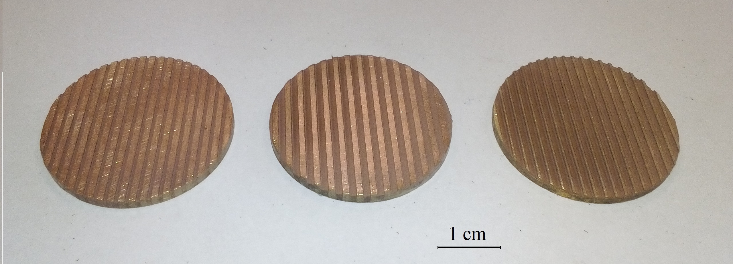

**Fig. 1.** Photo of various laser–treated samples

A closer examination of the laser–made sample's surface reveals that the lines are highly regular (Figure 2a), however, the thermal phenomena of laser melting produce some irregularities (protruding elements) at the edges of the grooves (Figure 2b). Moreover, the groove cross-section seems asymmetrical, which might happen but is quite uncommon.

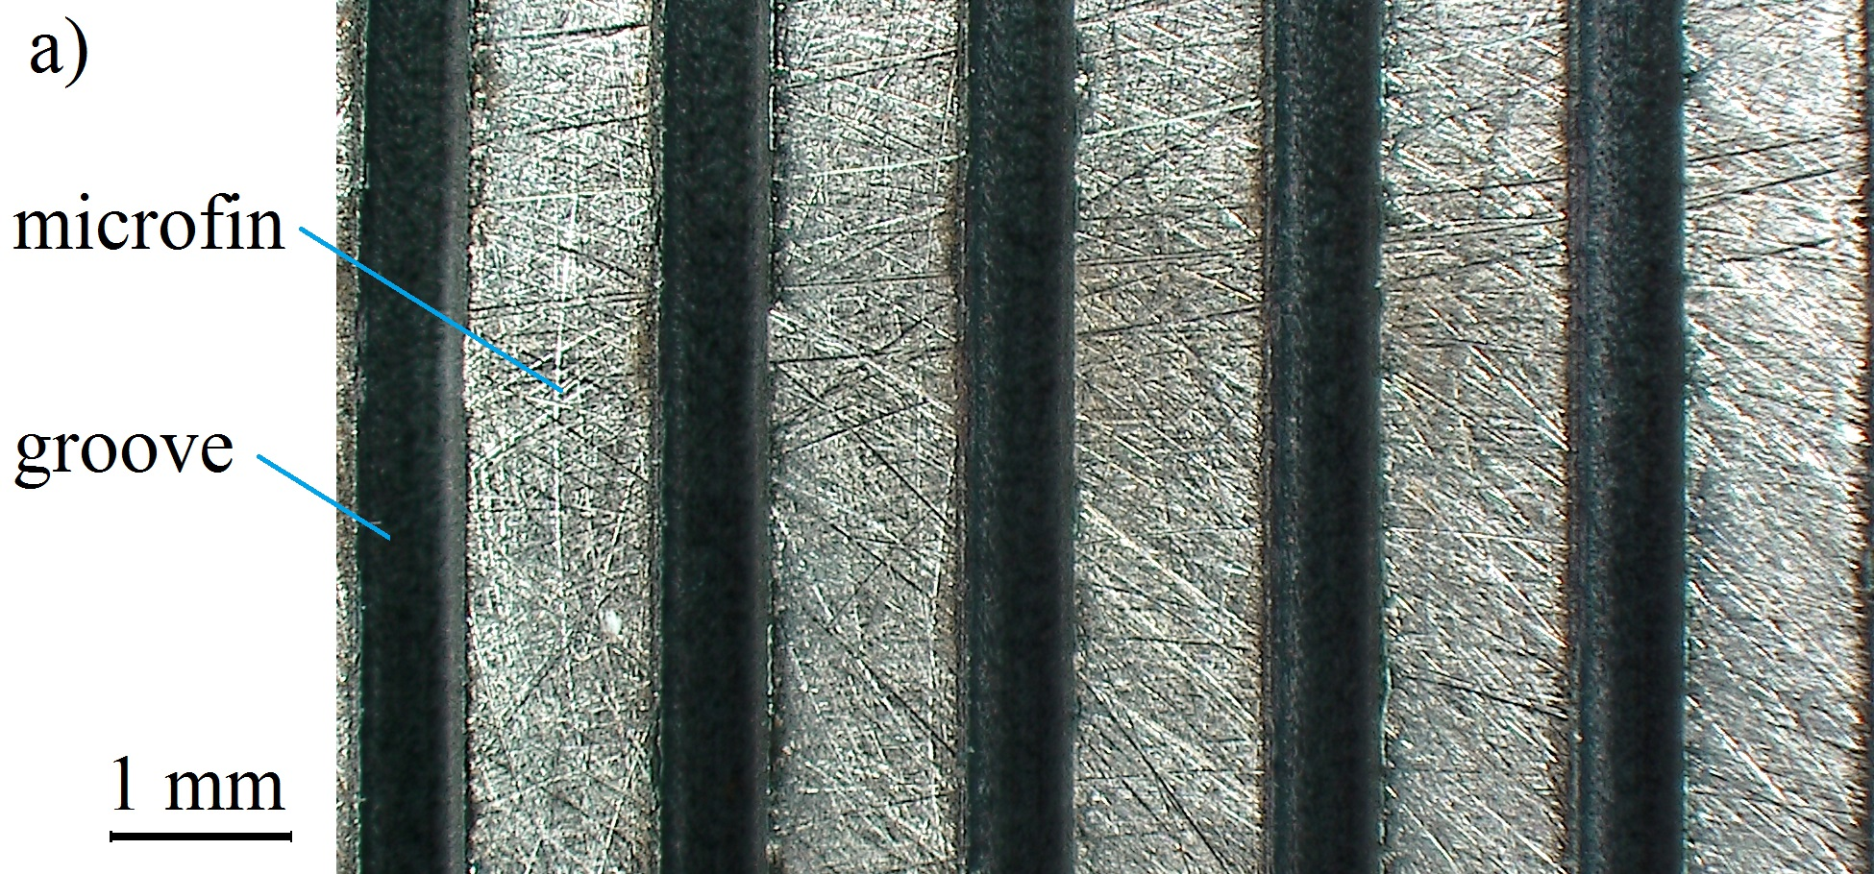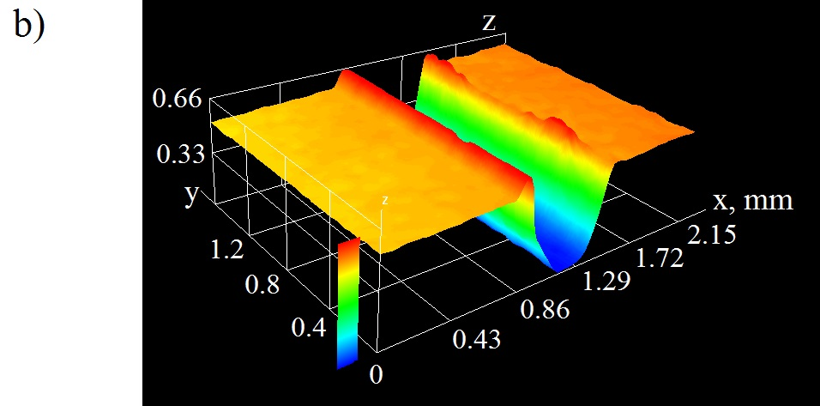

**Fig. 2.** Close-up view of the laser–made sample (a), optical microscope image of a chosen groove (b)

Melting and later solidification of the remaining base material leads to the development of small hill-like microstructures of height up to ca. 0.15 mm. They can be removed with mechanical polishing. It must be remembered that the creation of the patterns on the surface is a process that requires repetition of the laser beam's interaction with the surface, during which evaporation of the metal into ambient air occurs. However, one of the most vital issues for boiling augmentation is the creation of elevated roughness at the bottom of the grooves. It is especially advantageous for phase–change heat exchangers because these are the locations where vapour bubbles can be created and function cyclically, releasing bubbles into the pool of liquid (where they either disappear if subcooled boiling occurs or travel to the fluid's surface where vapour is released). It enhances the thermal performance of the specimens. The difference in the morphology of the copper heaters with and without laser treatment has been presented in Figures 3 and 4. The first figure presents the surface that did not undergo laser processing. Its roughness amounts to a few micrometres (mostly falling from about 5.7 to 6.8 μm, as seen in Figure 3b). Consequently, it can be stated that it is quite smooth, albeit with some shallow lines made during polishing.

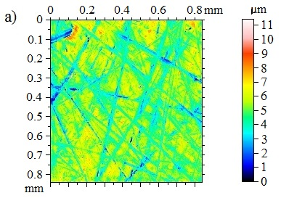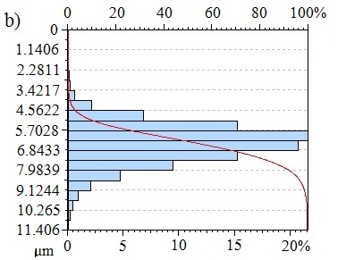

**Fig. 3.** Surface morphology of the untreated sample: optical microscope image (a), distribution of roughness values (b)

However, in the copper heater processed with the laser beam, the area at the bottom of the grooves is characterised by highly elevated roughness. Figure 4 provides details of the microstructure morphology generated during the interaction of the laser beam with the copper base.

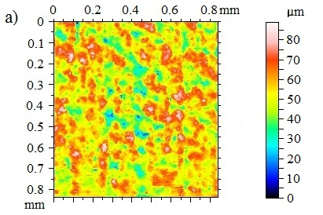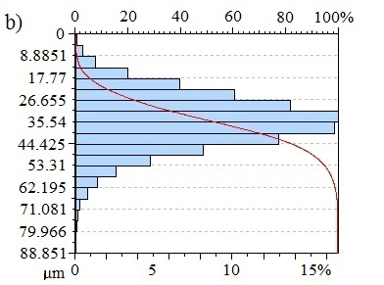

**Fig. 4.** Surface morphology of the laser-treated sample: optical microscope image (a), distribution of roughness values (b)

The sample's roughness is significantly elevated – to a few dozen micrometres (mostly from about 35.5 to 44.4 μm). Naturally, in both of the analysed cases, there will always be lower and higher dips on the surface, but the influence of the laser on the morphology cannot be neglected. Moreover, these are the selected spot locations of the area 0.8 x 0.8 mm, so it might also vary on the whole surface of the specimen – especially at the edges. Nevertheless, both surfaces exhibit significantly different features, which can considerably impact their performance during the boiling experiments.

The ability of a sample to dissipate heat via phase–change is described graphically in the form of a boiling curve. This curve presents the dependency of how much heat is exchanged vs the temperature difference between the sample's outer surface temperature and the saturation temperature of the liquid (the outer surface of the laser–made sample is assumed to be at the tip of the microfins, thus both types of specimens have the same height of 3 mm). Thermocouples are located below the samples, so the temperature value at the outer part of the specimen is determined using the Fourier law of conduction (knowing the heat flux supplied to the sample from the electric heater located underneath).

The measurements of temperature values within the experimental setup make it possible to provide the information needed to draw the boiling curve according to the methodology described in detail in the open-access paper of the authors (Orman et al. 2020). It also contains the error analysis, which shows that the largest measurement errors occur for the lowest heat flux values.

3. Results and Discussion

The boiling phenomenon is very complex and involves several heat exchange mechanisms occurring simultaneously. During the nucleate pool boiling mode, the growth and departure of vapour bubbles is especially important due to significant heat fluxes being driven via latent heat exchange, thus, visualisation studies are needed to analyse this issue thoroughly. Figure 5 presents the bubble behaviour on the laser–made surface at different heat fluxes with the time step of 0.02 seconds.

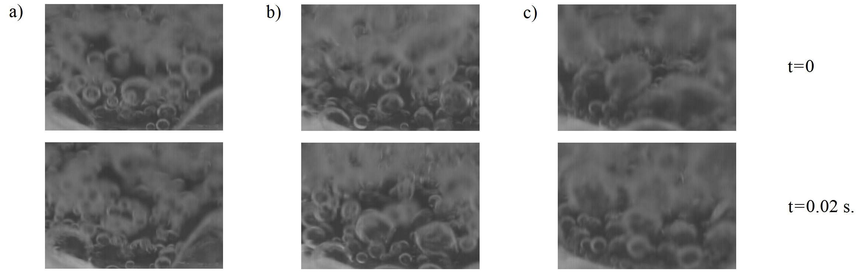

**Fig. 5.** Bubble formation during water boiling at increasing heat fluxes: 21000 W/m2 (a), 45000 W/m2 (b), 88000 W/m2 (c)

As can be seen, the rising temperature from "a" to "c" leads to more bubbles being created on the surface and their merging within the liquid pool. Further rise in the surface temperature leads to film boiling, creating a blanket of vapour. It reduces the heat flux dissipated to the liquid and, thus, can damage the experimental stand. The critical heat flux was not measured in the present study, but it is typically much larger than for the untreated sample.

The boiling phenomenon on the surface without any modifications starts with the occurrence of single bubbles at isolated locations on the surface (which are typically cracks, cavities or other irregularities present on the surface). At first, bubbles are generated there, but as the temperature increases, they tend to occur at more and more locations until they cover the surface with a vapour blanket.

The results of the boiling heat transfer experiments will be presented for the sample shown in Figure 2   
– of the groove depth of 0.5 mm and groove width 0.5 mm (as measured in the middle of the depth). Figure 6 presents the boiling heat transfer performance of that specimen as a dependence of heat flux vs. the temperature difference between the sample's outer surface temperature (Tsur) and saturation temperature (Tsat) of the liquid (commonly called 'superheat'). Saturation temperature can be adopted from literature as a function of ambient pressure, but in the present study, this value was directly measured with a thermocouple located in the pool of liquid (at some distance from the heater).



**Fig. 6.** Boiling curves of the laser-treated surface with two boiling agents: distilled water (a) and ethyl alcohol (b)

The surface of the modified microgeometry dissipates significantly higher heat fluxes than the untreated sample (which served as reference material). The phenomenon of boiling heat transfer enhancement with other types of microfins has already been reported, e.g. (Kaniowski & Pastuszko 2018), however in the case of laser-made samples, the cross-sectional dimensions of the fins are different in the way that the thickness of them changes and becomes smaller at the top, while the bottom part is larger (see Figure 2). Such a design improves vapour removal from the heater.

In the case of both boiling agents investigated in the study, the boiling curves are shifted leftwards to the area of smaller temperature differences. Consequently, higher efficiencies can be achieved with such heat exchangers. The boiling process starts at smaller temperatures on the heater's surface, so higher application potential is possible with these kinds of microstructures (for example, using low-temperature waste heat sources). Similarly, the heat flux value exchanged with the liquid pool for the same temperature difference is overwhelmingly higher in relation to the untreated surface. This ratio cannot even be presented for ethanol, but it can be done for water, albeit for a limited temperature difference of 7.1-8.2 K, which is the range where the boiling curves for the treated and untreated specimens coincide. Thus, the enhancement ratio (calculated as heat flux exchanged from the laser–made sample divided by the heat flux from the untreated surface) has been presented for this limited temperature difference range in the figure below (the data were obtained from Figure 6 with mathematical smoothing of the experimental results).



**Fig. 7.** Enhancement factor for water boiling

Despite a small temperature range, the graphs backs the claims of the authors' previous works (Orman et al. 2020), that the augmentation potential diminishes as the temperature difference increases. It occurs almost linearly to the point when the heat flux removed from the laser–made sample is about seven times higher than from the untreated specimen. It seems that the removal of the vapour phase from the grooves becomes a problem if the generation of the vapour becomes significant and the volumes are difficult to transport effectively to the liquid pool.

Another issue to consider at the design stage of heat exchangers is the correct determination of heat flux as a function of the heater's geometrical and material characteristics. The research on this topic covering many decades has not resulted in developing a commonly acceptable model of boiling, even though many methods have been applied for such analyses (Hożejowska et al. 2021, Krechowicz et al. 2022a, Krechowicz et al. 2022b).

In the present research project, the experimental results from Figure 6 will be compared with two boiling models selected from the open literature. The first one chronologically is Smirnov's model (Smirnov 1977). This model was created to model heat transfer from a set of independent microfins as a function of the geometric and material features of the surface. Although it was proposed for the meshed surfaces, it can be effective because these are also microstructures of regular geometry. The second model taken for the analyses was proposed by (Xin & Chao 1987). Here, the microstructure is considered longitudinal microfins of the 'T' shape. However, the formula for the heat flux enabled us to set the width at the bottom, and the tip as equal, which is more-or-less true for the microstructure analysed in the present study.



**Fig. 8.** Comparison of the experiment (for water) with selected models: 1 – boiling curve data from Figure 6,   
2 – calculation results according to (Smirnov, 1977), 3 – calculation results according to (Xin & Chao, 1987)

The graphs above prove that both models selected from the literature (and for both liquids) did not correctly predict the thermal performance of the laser–made heater. The discrepancy between the experimental data and the calculation results according to the Smirnov's model could have been regarded as negligible for the smallest temperature difference. However, the heat flux was significantly underestimated for the second model, and the temperature difference was the same (about three times). Generally, the differences ranged from ca. 10% to 374% in the case of water boiling and from ca. 88% to 319% for high-purity ethyl alcohol). The discrepancies between the calculated and actual heat flux values a few times indicate that there is a need to develop a new model, especially for surfaces produced with laser technology.

The study's limitations are mainly related to the fact that the tests have been conducted for low-temperature differences (of a few Kelvin), which falls into the nucleate boiling mode of heat transfer. Moreover, the results can only be applied to boiling under ambient pressure because variations of pressure values have not been considered. The paper analyses only pool boiling, while the phenomena occurring on the laser-treated surfaces might differ under flow boiling conditions, for example, in minichannels or within pipes.

The present study has been focused on boiling of pure liquids' only. However, future studies could be performed with mixtures or even nanofluids as boiling agents. Nanofluids are commonly known as highly efficient heat-enhancing fluids (Mukherjee et al. 2024), which could augment the boiling performance of the laser–made heat exchangers even further.

4. Summary and Conclusions

The application of laser technology to produce phase–change heat exchangers proved successful. The boiling performance of such a surface has been much better than that of the untreated surface. Heat fluxes can be a few times higher if laser–made heaters are used as part of heat exchangers. Moreover, boiling curves of the modified surface are shifted to the area of smaller temperature differences (in relation to the untreated surface), which should lead to increased efficiency.

The study has also shown that the existing boiling models might not be effective in predicting the heat flux dissipated from the laser-made heaters. Neither of the models selected for the analyses has been successful. Thus, a new model or a correlation would need to be created in the future for this type of heater. In the case of water, the average difference between the experimental data and calculation results according to the Smirnov and Xin and Chao models was ca. 93 kW/m2 and 116 kW/m2, respectively. The respective differences regarding ethanol boiling amounted to 78 kW/m2 and 68 kW/m2.

*The work in the paper was supported by the project: "REFRESH – Research Excellence For REgion   
Sustainability and High-tech Industries, (VP2), (Reg. No.: CZ.10.03.01/00/22_003/0000048)   
co-funded by the European Union".*

References

Dudkiewicz, E., Fidorów-Kaprawy, N., Szałański, P. (2022). Environmental Benefits and Energy Savings from Gas Radiant Heaters' Flue-Gas Heat Recovery. *Sustainability*, *14*, 8013. https://doi.org/10.3390/su14138013

Ho, J.Y., Wong, K.K., Leong, K.C. (2016). Saturated pool boiling of FC-72 from enhanced surfaces produced by Selective Laser Melting. *International Journal Heat and Mass Transfer*, *99*, 107-121. https://doi.org/10.1016/j.ijheatmasstransfer.2016.03.073

Ho, J.Y., Wong, K.K., Leong, K.C., Yang, C. (2015). Nucleate pool boiling from selective laser melted microgrooves/microcavities surfaces with HFE-7000. *Proceedings of the First Thermal and Fluids Engineering Summer Conference New York City, USA,* 1917-1928. https://doi.org/10.1615/TFESC1.mph.013076

Holubčík, M., Trnka, J., Čajová Kantová, N. (2024). Using heat exchanger for construction of electrostatic precipitator in a small heat source, *Journal of Electrostatics*, *128*, 103884. https://doi.org/10.1016/j.elstat.2023.103884

Hożejowska, S., Kaniowski, R., Pastuszko, R. (2021). Application of the Trefftz Method for Pool Boiling Heat Transfer on Open Microchannel Surfaces. *Heat Transfer Engineering*, *43*, 362-370. https://doi.org/10.1080/01457632.2021.1874669

Janaszek, A., Kowalik, R. (2023). Analysis of heavy metal contaminants and mobility in sewage sludge-soil mixtures for sustainable agricultural practices. *Water*, *15*, 3992. https://doi.org/10.3390/w15223992

Janaszek, A., Silva, A.F.d., Jurišević, N., Kanuchova, M., Kozáková, Ľ., Kowalik, R. (2024). The assessment of sewage sludge utilisation in closed-loop economy from an environmental perspective. *Water*, *16*, 383. https://doi.org/10.3390/w16030383

Kaniowski, R., Pastuszko, R. (2018). Comparison of heat transfer coefficients of open micro-channels and plain micro-fins. *EPJ Web of Conferences*, *180*, 02041. https://doi.org/10.1051/epjconf/201818002041

Kaniowski, R., Poniewski, M. (2013). Measurements of Two-Phase Flow Patterns and Local Void Fraction in Vertical Rectangular Minichannel. *Archives of Thermodynamics*, *34*, 3-21. https://doi.org/10.2478/aoter-2013-0007

Kotrys-Działak, D., Stokowiec, K. (2023). Temperature Distribution Analysis on the Surface of the Radiator: Infrared Camera and Thermocouples Results Comparison. *Rocznik Ochrona Środowiska*, *25*, 37-44. https://doi.org/10.54740/ros.2023.005

Krawczyk, N., Dębska, L., Piotrowski, J. Zb., Honus, S., Majewski, G. (2023). Validation of the Fanger Model and Assessment of SBS Symptoms in the Lecture Room. *Rocznik Ochrona Środowiska*, 25, 68-76. https://doi.org/10.54740/ros.2023.008

Krechowicz, A., Krechowicz, M., Poczeta, K. (2022). Machine learning approaches to predict electricity production from renewable energy sources. *Energies*, *15*, 9146. https://doi.org/10.3390/en15239146

Krechowicz, M., Krechowicz, A., Lichołai, L., Pawelec, A., Piotrowski, J.Z., Stępień, A. (2022). Reduction of the risk of inaccurate prediction of electricity generation from PV farms using machine learning. *Energies*, *15*, 4006. https://doi.org/10.3390/en15114006

Kruse, C.M., Anderson, T., Wilson, C., Zuhlke, C., Alexander, D., Gogos, G., Ndao, S. (2015). Enhanced pool-boiling heat transfer and critical heat flux on femtosecond laser processed stainless steel surfaces. *International Journal Heat and Mass Transfer*, *82*, 109-116. https://doi.org/10.1016/j.ijheatmasstransfer.2014.11.023

Liu, B., Zhang, Y., Wei, J., Wang W. (2019). Experimental and theoretical study of pool boiling heat transfer and its CHF mechanism on femtosecond laser processed surfaces. *International Journal Heat and Mass Transfer*, *132*, 259-270. https://doi.org/10.1016/j.ijheatmasstransfer.2018.12.003

Mukherjee, S., Wciślik, S., Mishra, P.C., Chaudhuri, P. (2024). Nanofluids: Critical issues, economics and sustainability perspectives. *Particuology*, *87*, 147-172. https://doi.org/10.1016/j.partic.2023.06.021

Orman, Ł.J., Radek, N., Pietraszek, J., Szczepaniak, M. (2020). Analysis of enhanced pool boiling heat transfer on laser-textured surfaces. *Energies*, *13*, 2700. https://doi.org/10.3390/en13112700

Pastuszko, R., Kaniowski, R., Dadas, N., Bedla-Pawlusek, M. (2021). Pool boiling enhancement and a method of bubble diameter determination on surfaces with deep minichannels. *International Journal of Heat and Mass Transfer*, *179*, 121713. https://doi.org/10.1016/j.ijheatmasstransfer.2021.121713

Pavlenko, A.M., Basok, B.I. (2005). Regularities of boiling-up of emulsified liquids. *Heat Transfer Research*, *36*(5), 419-424. https://doi.org/10.1615/HeatTransRes.v36.i5.90

Pavlenkо, A., Szkarowski, A. (2018). Thermal insulation materials with high-porous structure based on the soluble glass and technogenic mineral fillers. *Rocznik Ochrona Środowiska*, *20*, 725-740.

Pavlenko, A., Szkarowski, A., Janta-Lipińska, S. (2014). Badania spalania emulsji paliwowych. *Rocznik Ochrona Środowiska*, *16*(1), 376-385.

Smirnov, G.F. (1977). Približennaja teorija teploobmena pri kipenii na poverchnostjach pokrytych kapilljarno – poristymi strukturami. *Teploenergetika*, *9*, 77-80.

Voglar, J., Gregorčič, P., Zupančič, M., Golobič I. (2018). Boiling performance on surfaces with capillary-length-spaced one- and two-dimensional laser-textured patterns. *International Journal Heat and Mass Transfer*, *127*, 1188-1196. https://doi.org/10.1016/j.ijheatmasstransfer.2018.07.056

Voznyak, O., Spodyniuk, N., Antypov, I., Dudkiewicz, E., Kasynets, M., Savchenko, O., Tarasenko, S. (2023). Efficiency Improvement of Eco-Friendly Solar Heat Supply System as a Building Coating. *Sustainability*, *15*, 2831. https://doi.org/10.3390/su15032831

Wojtkowiak, J., Amanowicz Ł., Mróz T. (2019). A new type of cooling ceiling panel with corrugated surface – Experimental investigation. *International Journal of Energy Research*, *43*(13), 7275-7286. https://doi.org/10.1002/er.4753

Wojtkowiak, J., Amanowicz, Ł. (2020). Effect of surface corrugation on cooling capacity of ceiling panel, *Thermal Science and Engineering Progress*, *19*, 100572. https://doi.org/10.1016/j.tsep.2020.100572

Xin, M.-D., Chao, Y.-D. (1987). Analysis and experiment of boiling heat transfer on T-shaped finned surfaces. *Chem. Eng, Comm. 50*, 185-199.

Zakšek, P., Zupančič, M., Gregorčič, P., Golobič, I. (2020). Investigation of nucleate pool boiling of saturated pure liquids and ethanol-water mixtures on smooth and laser-textured surfaces. *Nanoscale and Microscale Thermophysical Engineering*, *24*, 29-42. https://doi.org/10.1080/15567265.2019.1689590

Zupančič, M., Može, M., Gregorčič, P., Golobič, I. (2017). Nanosecond laser texturing of uniformly and non-uniformly wettable micro structured metal surfaces for enhanced boiling heat transfer. *Applied Surface Science*, *399*,   
480-490. https://doi.org/10.1016/j.apsusc.2016.12.120

Zupančič, M.; Može, M.; Gregorčič, P.; Sitar, A, Golobič, I. (2017). Evaluation of enhanced nucleate boiling performance through walltemperature distributions on PDMS-silica coated and non-coated laser textured stainless steel surfaces. *International Journal Heat and Mass Transfer*, *111*, 419-428. https://doi.org/10.1016/j.ijheatmasstransfer.2017.03.128