|  |  |  |  |
| --- | --- | --- | --- |
|  |  | | |
| **Rocznik Ochrona Środowiska** | | |
| Volume 26 | Year 2024 ISSN 2720-7501 | pp. 152-159 |
|  | https://doi.org/10.54740/ros.2024.016 open access | | |
|  | Received: November 2023 Accepted: April 2024 Published: May 2024 | | |

Study on the Coordinated Development Model of Ecological Economy and Environmental Protection

Zhihua Liang

School of Public Finance and Taxation,   
Hebei University of Economics and Business, Shijiazhuang 050000, Hebei, China  
https://orcid.org/0009-0000-0532-3771

*corresponding author's e-mail: liangzhihua889@outlook.com

**Abstract:** This paper establishes a comprehensive evaluation index system of the ecological environment and the economy, and the coupling degrees and coordination degrees from 2015 to 2019 are calculated. The results show that (1) There is a relationship between economic growth and environmental pollution. Discharging industrial pollutants is an important factor affecting the coordinated development of the ecological environment and economic coupling. (2) The comprehensive evaluation index of the ecological environment and economic development systems is increasing yearly, and the quality of the ecological environment and the level of economic development are constantly improving. (3) The value of the coupling degree and coupling coordination degree between ecological environment and economic development is increasing yearly, and the development trend is good. The coupling degree gradually shifts from low-level coupling to high-level coupling stage.

**Keywords:** Anshan City, ecological environment, economic development, coupling

1. Introduction

In the process of construction and development of Chinese cities, resource-based cities are the main type of cities, not only having a complete industrial system but also making great contributions to the development of the national economy. However, with the adjustment and change of the industrial structure, resource-based cities generally suffer from resource depletion, structural imbalance, and urban development problems in the process of national development. Therefore, in optimizing China's economic structure, the transformation and upgrading of resource cities has become the focus of supply-side structural reforms (Dong & Futawatari 2015, Gultekin 2019, Chirozva 2015). Anshan occupies an important position in China's steel base and is an important resource-based city in Northeast China. Due to the advantages of mineral resources and geographical conditions, it has formed an industrial structure system based on heavy industry in the long-term development (He et al. 2018, Xu et al. 2018, Xiong et al. 2017, Zhou 2020). However, with the development of resources and heavy industry, the ecological environment of Anshan City has been severely damaged. With the continuous promotion of ecological environmental protection work, the atmospheric environmental quality of Anshan City has not yet been effectively improved (Pao et al. 2015, Tang et al. 2015, Han & Zhu 2011).

Economic development has always been the top priority for the development of human society. Still, the traditional economic development method has caused a sharp reduction in the stock of resources. It has caused a series of ecological and environmental problems, affecting social development and the progress of human civilization (Broman & Robèrt 2017, Pasape et al. 2015, Jeffery 2015, Lee et al. 2015, Biglar et al. 2016). Most empirical research on China shows that rapid economic growth is the cause of deterioration in domestic environmental quality, and the impact of environmental regulations implemented to improve environmental quality on the economy is significantly uncertain. Some scholars believe that pursuing higher environmental quality will promote green economic transformation and achieve a win-win situation. Some research results show that environmental regulations can cause employment losses and economic downturns, while others have found a non-linear relationship between the two. The significant differences in research results are mainly due to the fact that the indicators chosen by the researchers largely influence the conclusions of empirical analysis (Buckley 2015).

Based on the above background, this article starts from the general environment, takes Anshan City as the research object, builds an evaluation index system for the coordinated development of ecological environment and economic coupling, and uses the coupling coordination degree model to explore the time change and spatial comparison of the coupling relationship between ecological environment and economic development. Based on drawing on previous research results, this article intends to use coupling degree and coupling coordination degree models, select appropriate indicators to measure and evaluate the collaborative development of environmental protection systems and economic systems, analyze the shortcomings of high-quality development in Anshan, and provide theoretical support and policy suggestions for achieving high-quality collaborative development in Liaoning Province.

2. Materials and Methods

Coupling is a concept in physics. It mainly refers to the interaction of two or more things on each other during the movement. It also refers to the force and mutual influence formed by oneself on each other during the movement. In the change process of urban economic development and environmental coupling, the influence of several combined elements on each other can be defined as the coupling degree of the economic environment to express the strength of the effect of a single urban environmental system (Ya et al. 2020).

In the research process of the coupling between the economy and environment in Anshan City, the economic development must be clarified by determining the analysis sequence; secondly, the accuracy of data comparison must be ensured by non-dimensional processing. In the non-dimensionalization process, the range standardization method is mainly used; the third step is to clarify the relationship between the two behaviours by solving the correlation coefficient; finally, in the process of solving the average value, the correlation degree of the system coupling is obtained model. To better determine the degree of coordination of system coupling from different evaluation angles, the following formula can be written, and the degree of coupling between economic development and the ecological environment in Anshan City can be determined according to the calculation result of the calculation formula (Li 2019).

|  |  |
| --- | --- |
|  | (1) |

*C* means the degree of coupling, *t* observed value, *m*, *l* mean sample size, *i*, *j* mean ordinal number, *ξij* means value of evaluation indicator *j* for year *i*.

3. Results and Discussion

3.1. The evolution of Anshan's industrial structure

In the development process of Anshan City, the secondary industry has always occupied a dominant position. During the city's construction, the development of the primary and tertiary industries is relatively slow. In the entire process of urban industrial structure changes, before 1984, the secondary industry mainly dominated the industrial structure, the primary industry was larger than the tertiary industry. After 1984, it gradually evolved into the secondary industry, the tertiary industry type of industrial structure larger than the primary industry.

Since Anshan City is a city developed relying on abundant mineral resources, in the long-term development process, it not only relies on the advantages of resources but also relies on the convenient transportation location and the development direction of the city with heavy industry as the main The industrial sector structure of the entire city shows the typical "heavy and light" structural characteristics. In the process of economic and social development of Anshan City, although the proportion of ferrous metal smelting has been declining year by year, the industry still plays an important role in the economic control of the entire Anshan City. At the same time, since resource consumption is the main feature in the industrial structure of Anshan City, in the development process of Anshan City, the output value of resource-based industries has always accounted for more than 70% of the total industrial output value of Anshan City. It is declining, but from the perspective of the large industrial structure, resource consumption is still an important economic development feature of Anshan City.

Third, from the perspective of industrial ownership structure, state-owned industries have always been the mainstay of Anshan's industrial economy during the development of the country's industrial economy. Since there was no common development of multiple-ownership economies before the 1990s, the state-owned economy occupied a major position as the main body of the industrial economy in Anshan City. Under the background of the reorganization and restructuring of state-owned enterprises, the proportion of state-owned industries declined in 2003. At the same time, the proportion of other economic industries has greatly increased, even reaching 70%. Among other types of economic industries, individual industries account for the largest proportion of about 40%.

3.2. Evolution of environmental quality in Anshan City

Environmental quality mainly refers to the suitability of certain elements in the environment for human society and economic development in a specific environment. This evaluation standard is mainly a model of environmental evaluation. As a basic concept of environmental science, environmental quality is subject to the influence of many factors, in the process of studying the evolution of environmental quality in Anshan City, three types of water environment, atmospheric environment, and solid waste environment are mainly analyzed.

First of all, as far as the water environment is concerned, in the overall development of Anshan City, although the total amount of industrial wastewater discharge continuously decreases, the amount of discharge is still relatively large. With the continuous development of society and the increasing awareness of ecological and environmental protection, the total amount of industrial wastewater discharge in Anshan City has generally shown a downward trend. In 2003, the total amount of wastewater discharge was significantly reduced compared with 1980. In the process of sewage discharge, its general discharge can be divided into three stages. The discharge of industrial wastewater from 1981 to 1991 has been in a reduced stage, and from 1991 to 1993, the total amount of industrial wastewater discharged has fluctuated upward. However, the total amount is still low compared to the previous wastewater discharge. In 1993, the total amount of industrial wastewater discharge in Anshan City had significantly increased, but since 1993, the industrial wastewater discharge in Anshan City has been increasing yearly. As the total wastewater discharge decreases, the overall wastewater reduction rate also slows down.

Secondly, as far as the atmospheric environment of Anshan City is concerned, in the process of continuous social and economic development and changes, the total industrial waste gas emissions of Anshan City have been in the process of fluctuating and rising. At the same time, there are obvious periodicities in the rising trend of fluctuations. Practical problems. However, the total amount of industrial wastewater discharge in Anshan City fluctuates, and the discharge of industrial carbon dioxide, industrial dust, and industrial smoke and dust has been continuously reduced throughout the entire urban development process.

Judging from the overall emissions of industrial smoke, dust, and sulfur dioxide in Anshan City, since the early 1990s, the overall emissions have been relatively stable. There are four main demarcation points in the actual atmospheric environment judgment process in Anshan City. First, the overall total industrial emissions in 1995 showed an upward trend and a larger growth rate; in 1990, it showed a downward trend; in 1996, it rose; and in 2000, it showed a downward trend as a whole. Judging from the entire city's total industrial waste gas emissions, it still shows a certain growth rate. At the same time, although there is a fluctuating process, the overall industrial smoke and dust emissions are relatively stable.

Finally, the solid waste environment is evolving in terms of environmental quality. During the long-term economic development and construction of Anshan City, the output and storage of solid waste have continued to rise, and there is an obvious trend of greater volatility. Judging from the construction history of Anshan City, there were two cyclical increases in the amount of solid waste generated in the mid-1980s and early 1990s. After that, the amount of solid waste generated in Anshan City has been relatively stable, but the overall scale is still larger. With the continuous advancement of ecological civilization construction, the solid waste in Anshan City has gradually shown a downward trend after a steady increase in the 1990s. The decline has gradually increased with the deepening of urban environmental protection.

3.3. Research on the coupling of economic development and ecological environment in Anshan City

To ensure the scientificity and effectiveness of the coupling research, it is necessary to construct a scientific and reasonable evaluation index system to ensure the accuracy of its evaluation results. Therefore, certain evaluation principles should also be followed in the research on coupling economic development and ecological environment in Anshan City (Table 1). First of all, we must follow the principle of scientificity and base the construction of the index system on scientificity to ensure that its research results objectively and truthfully show the coupling relationship between Anshan's economic development and the ecological environment (Fan 2019).

Secondly, constructing the index system must adhere to the principles of comprehensiveness and systemicity. Since Anshan City's economic development and ecological environment and research involve two systems, economic development and ecological environment, the establishment of the index system must comprehensively consider the involvement of the system. The scope covers the comprehensive content of the indicator system, thus fully reflecting the system's relationship.

Third, the index evaluation system should be based on the principle of dynamics. As the coupling relationship between economic development and the ecological environment in Anshan City is constantly changing under the background of dynamic development, in the dynamic development process, the study of coupling relationship should be based on the principle of dynamics through its indicator system dynamic principle To ensure that the indicators can be adjusted accordingly based on the actual development background.

Finally, in the process of constructing the index system, we must adhere to the principle of operability and ensure the feasibility and comparability of the entire research activities through effective treatment of factors that are difficult to quantify in the research process and respond accordingly according to the actual development of Anshan City. The choice of data ensures the objectivity of the index system.

Fourth, Anshan City Economic Development and Ecological Environment Coupling Analysis.

**Table 1.** Basic indicator data (X means Ecological economy indicators, Y means environmental protection indicators)

|  |  |  |  |  |  |  |  |  |  |  |  |  |  |  |
| --- | --- | --- | --- | --- | --- | --- | --- | --- | --- | --- | --- | --- | --- | --- |
|  | Index | Economic level | | | Economic structure | | | People's living standards | | | Economic vitality | | | Mean |
| X1 | X2 | X3 | X4 | X5 | X6 | X7 | X8 | X9 | X10 | X11 | X12 |
| Ecological  environment  level | Y1 | 0.62 | 0.67 | 0.68 | 0.62 | 0.70 | 0.64 | 0.65 | 0.76 | 0.77 | 0.71 | 0.66 | 0.65 | 0.67 |
| Y2 | 0.70 | 0.67 | 0.67 | 0.81 | 0.65 | 0.55 | 0.59 | 0.68 | 0.67 | 0.59 | 0.59 | 0.70 |
| Y3 | 0.75 | 0.82 | 0.80 | 0.69 | 0.61 | 0.55 | 0.62 | 0.69 | 0.73 | 0.59 | 0.54 | 0.65 |
| Ecological  environment  pressure | Y4 | 0.82 | 0.75 | 0.74 | 0.70 | 0.56 | 0.51 | 0.58 | 0.62 | 0.63 | 0.52 | 0.50 | 0.62 | 0.67 |
| Y5 | 0.74 | 0.74 | 0.74 | 0.67 | 0.68 | 0.60 | 0.66 | 0.75 | 0.74 | 0.63 | 0.62 | 0.66 |
| Y6 | 0.84 | 0.80 | 0.74 | 0.68 | 0.58 | 0.52 | 0.62 | 0.67 | 0.69 | 0.55 | 0.53 | 0.62 |
| Y7 | 0.88 | 0.81 | 0.80 | 0.64 | 0.64 | 0.57 | 0.67 | 0.70 | 0.72 | 0.59 | 0.59 | 0.60 |
| Y8 | 0.87 | 0.79 | 0.82 | 0.65 | 0.61 | 0.57 | 0.65 | 0.68 | 0.71 | 0.56 | 0.55 | 0.59 |
| Conservation  of ecosystem | Y9 | 0.51 | 0.52 | 0.79 | 0.53 | 0.67 | 0.74 | 0.71 | 0.60 | 0.60 | 0.59 | 0.72 | 0.59 | 0.63 |
| Y10 | 0.49 | 0.50 | 0.53 | 0.56 | 0.62 | 0.69 | 0.62 | 0.56 | 0.57 | 0.55 | 0.69 | 0.63 |
| Y11 | 0.69 | 0.73 | 0.51 | 0.62 | 0.69 | 0.62 | 0.67 | 0.75 | 0.78 | 0.65 | 0.60 | 0.64 |
| Mean | | 0.72 | 0.71 | 0.71 | 0.65 | 0.64 | 0.60 | 0.61 | 0.60 | 0.69 | 0.61 | 0.60 | 0.53 | – |
| 0.71 | | | 0.63 | | | 0.67 | | | 0.61 | | |  |

In the actual research process of the coupling degree between economic development and ecological environment in Anshan City, it is found through calculation that the coupling degree between economic development and ecological environment in Anshan City is 0.6567, which shows a strong coupling effect (Fig. 1 and 2). According to the correlation between the two systems, it can be proved that the economic development of Anshan City is closely related to the ecological environment. Based on exploring the coupling degree of economic development and ecological environment in Anshan City, the index of coupling degree of economic development and ecological environment of Anshan City is for the coordinated development of the entire economic and environmental system of Anshan City. Has an important guiding role. Before 2016, its ecosystem had always been superior to its economic system, indicating that Anshan paid more attention to investment in the environmental field in its development. With improved environmental quality, Anshan's economy has also further developed since 2016. The economy and ecology have entered a win-win development stage of mutual promotion and complementarity.

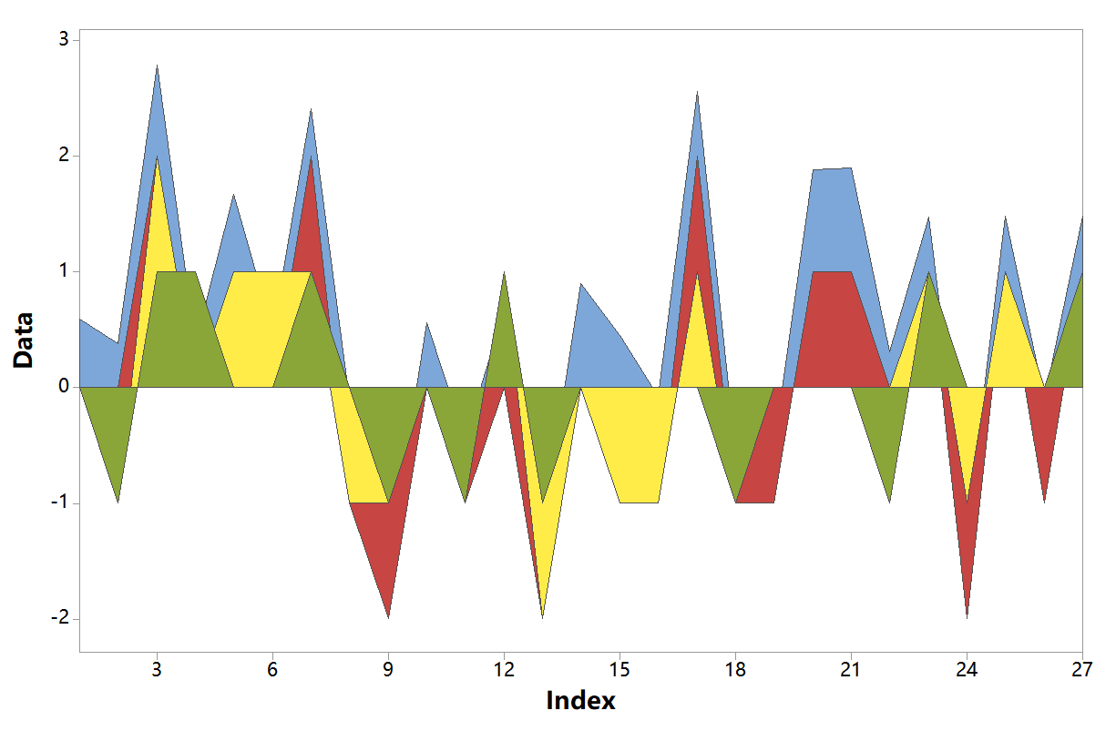

**Fig. 1.** Statistics and analysis results

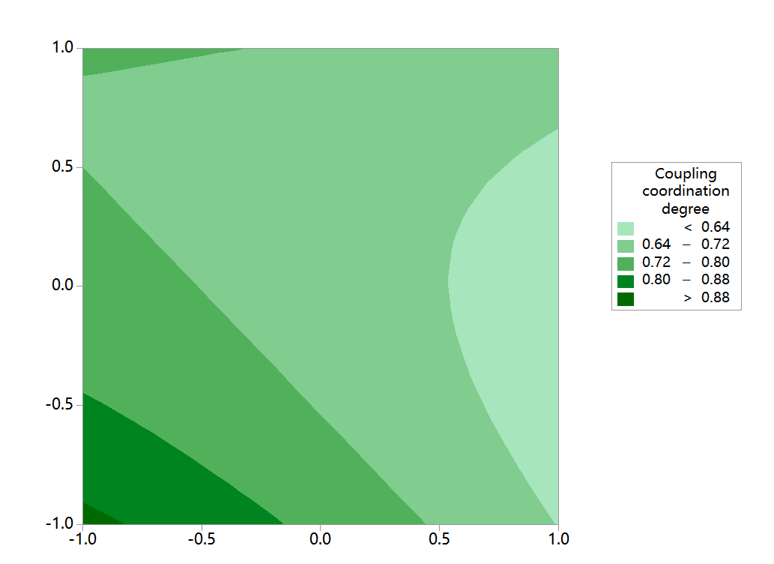

(a)

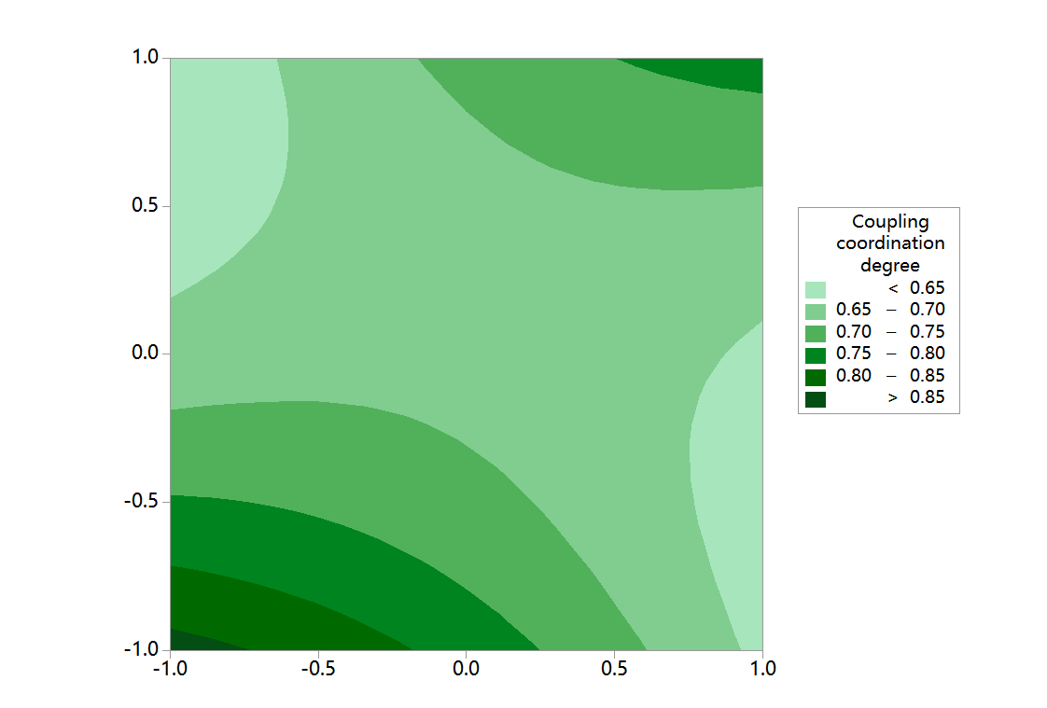

(b)

**Fig. 2.** Contour Plot of Coupling coordination degree

*(1) The coercive effect of the economy on the ecological environment*

First of all, among the various indicators of the above economic system, the per capita GDP growth can best reflect the economic growth level of Anshan City. In the coupling process of economic development and ecological environment in Anshan City, due to its economic level subsystem and ecological environment, the significance of the system's association is significant, the value of which indicates the inevitable impact on the ecological environment during the economic development process.

In the overall development process of Anshan City, economic growth has brought about the deterioration of the ecological environment. Under the long-term development of heavy industry, although Anshan City's geographical expansion and urbanization process has been accelerated, the entire city has developed. The energy consumption and resource utilization brought about by the process have also been increased simultaneously. In the process of urban construction, the discharge of waste and the increase of environmental pollution have affected the ecological environment and led to the deterioration of the quality of the ecological environment.

Secondly, in developing the ecological environment, the people's life subsystem and the ecological environment showed a correlation of 0.670. Various data showed that in the process of ecological environment changes, the ecological environment and the increase in average wages of employees are also closely related. Relationship, in the intuitive embodiment of the residents' living standards, the increase in income has improved living standards. At the same time, due to the continuous growth of people's living standards, the residents' awareness of environmental protection is gradually awakening, and the increase in the quality of the living environment leads to economic development. In the process, the interactive coercive effect of economy and ecology appeared.

Finally, in the process of urban development in the Anshan area, the dominant position of heavy industry has led to the emergence of environmental pollution. At the same time, the core industrial structure dominated by the secondary industry has also caused the urban environment to continue to deteriorate. Therefore, in the context of regional development, Anshan City starting from the core industry, increasing the proportion of the tertiary industry to promote the rationalization of the urban development industrial structure, thereby promoting changes in the city's water resources and energy structure through the industrial structure, and ensuring that Anshan City's ecological and environmental protection work in the process of seeking economic growth Continued to advance.

*(2) The restraint of ecology on economic development*

From the overall economic development and ecological environment coupling data, it can be found that in the urban construction process of Anshan City, the degree of correlation between the ecological environment level subsystem and the economic development system is 0.668. This kind of data shows that the development process of Anshan City and the type of land are closely related to the city's construction.

In the process of urban development, changes in the quality and area of greening affect the city's environment, as well as the future development direction of the city. For the future construction of a single city, its development is inseparable from the environment's carrying capacity. As the core of the environment carrying capacity, the carrying capacity of water and soil resources is an important indicator that affects the carrying capacity of the environment of a single city. Therefore, in the economic development process of the city in the middle, the ecological environment will restrict the level of economic development as a whole, restricting its development while confining its economy to a fixed geographical range.

Secondly, in the research process of the economic development system, the correlation between the ecological level pressure subsystem of Anshan City and the economic development system is 0.665, which means that in the process of urban economic development, due to the constraints of the ecological environment, some important The ecological environment affects the ecological environment quality of the entire city. When the ecological environment is continuously destroyed during the process of economic development, it will cause the ecology to react to economic development. Especially for Anshan City, in the process of development, due to its damage to the ecological environment, when the development of the city faces scarce water and soil resources and environmental pollution, the air quality of the city restricts the future economic development of Anshan City. Affected the urban construction and sustainable development of Anshan City.

For the overall economic development of Anshan City, it destroyed the local ecological environment in the process of developing heavy industry, and after the ecological environment was continuously destroyed, its negative feedback effect on the economic development of Anshan City affected The sustainable economic development of Anshan area and its unitary industrial structure have also caused the practical problem of insufficient stamina on the road to urban reform. Therefore, in order to promote a win-win situation between the economy and the environment in the context of urban development, the city's construction process should not only pay attention to economic development, explore measures to optimize the industrial structure but also reduce environmental damage in the process of economic development through corresponding protection.

We will comprehensively enhance our technological innovation capabilities. We need to promote the development of innovation platforms and build innovative research and development zones in high-tech zones. We implement a gradient cultivation plan for technology-based enterprises. We will deepen the battle against pollution and accelerate the promotion of green and low-carbon development.

We should remain steadfast in optimizing the ecology and focus on promoting innovative and green development. We will comprehensively enhance our technological innovation capabilities. We need to promote the development of innovation platforms and build innovative research and development zones in high-tech zones. We implement a gradient cultivation plan for technology-based enterprises. We will deepen the battle against pollution and accelerate the promotion of green and low-carbon development.

4. Conclusion

From the results of the coupling of the overall economic development and ecological environment of Anshan City, under the interaction of the ecological environment and economic development, the ecological environment is under the pressure of economic development, and the rapid expansion of economic development has caused certain damage to the ecological environment. The restraint on economic development is also reflected in the sustainable development of Anshan City. The destruction of the ecological environment limits its future development direction. The results show that (1) There is a relationship between economic growth and environmental pollution. Discharging industrial pollutants is an important factor affecting the coordinated development of the ecological environment and economic coupling. (2) The comprehensive evaluation index of the ecological environment and economic development systems is increasing yearly, and the quality of the ecological environment and the level of economic development are constantly improving. (3) The value of the coupling degree and coupling coordination degree between ecological environment and economic development is increasing yearly, and the development trend is good. The coupling degree gradually shifts from low-level coupling to high-level coupling stage.

*This work was supported by Research on the mechanism, measurement and path of digital technology   
driving the high-quality development of the real economy (HB21YJ033), Research on the Reform of Public Economic Responsibility Allocation Mechanism and Performance Improvement of Central and Local   
Governments (21BJL025), and Research on the Mechanism, Measurement and Policy of Beijing-Tianjin-Hebei "New Infrastructure" to Promote Economic Growth (HB23LJ004).*

References

Buckley, R. (2015). Understanding and managing tourism impacts: an integrated approach. *Journal of Ecotourism*, *10*, 177-178. https://doi.org/10.1080/14724049.2011.568754

Biglar, M., Danehkar, A., Pourebrahim, S. (2016). Application of strategic fuzzy assessment for environmental planning: Case of Bird Watch Zoning in Wetlands. *Open Journal of Geology*, *6*, 1380-1400. https://doi.org/10.4236/ojg.2016.611099

Broman, G.I., Robèrt, K.H. (2017). A framework for strategic sustainable development. *Journal of Cleaner Production*, *140*, 17-31. https://doi.org/10.1016/j.jclepro.2015.10.121

Chirozva, C. (2015). Community agency and entrepreneurship in ecotourism planning and development in the Great Limpopo Transfrontier Conservation Area. *Journal of Ecotourism*, *14*, 1-19.

Dong, Q.Y., Futawatari, T. (2015). A review of the progress in China's renewable energy generation, and its links with energy conservation, environmental degradation and economic growth. *Fresenius Environmental Bulletin*, *24*, 405-411.

Fan, Y.P., Fang, C.L., Zhang, Q. (2019). Coupling coordinated development between social economy and ecological environment in Chinese provincial capital cities-assessment and policy implications. *Journal of Cleaner Production*, *229*, 289-298. https://doi.org/10.1016/j.jclepro.2019.05.027

Gultekin, U. (2019). Renewable electricity generation for sustainable development and environmental management in Turkey. *Fresenius Environmental Bulletin*, *28*, 8171-8174.

Han, S., Zhu, J. (2011) Research on the dynamic relationship of the Energy-Economy-Environment (3E) system-based on an empirical analysis of China. *Energy Procedia*, *5*, 2397-2404. https://doi.org/10.1016/j.egypro.2011.03.412

He, Y., Lin, K., Zhang, F., Wang, Y., Chen, X. (2018). Coordination degree of the exploitation of water resources and its spatial differences in China. *Science of the Total Environment*, *644*, 1117-1127. https://doi.org/10.1016/j.scitotenv.2018.07.050

Jeffery, L.R. (2015). Erratum to: Ecological restoration in a cultural landscape: conservationist and Chagossian approaches to controlling the 'coconut chaos' on the Chagos Archipelago. *Human Ecology*, *43*, 185-186. https://doi.org/10.1007/s10745-014-9716-y

Lee, T.H., Jan, F.H., Huang, G.W. (2015). The influence of recreation experiences on environmentally responsible behavior: the case of Liuqiu Island, Taiwan. *Journal of Sustainable Tourism*, *23*(6), 947-967. https://doi.org/10.1080/09669582.2015.1024257

Li, N. (2019). Analysis of rural ecological environment governance and economic and social development in the background of digitization. *Fresenius Environmental Bulletin*, *28*, 10076-10082.

Pao, H., Chen, H.A., Li, Y. (2015). Competitive dynamics of energy, environment, and economy in the U.S. *Energy*, *89*, 449-460. https://doi.org/10.1016/j.energy.2015.05.113

Pasape, L., Anderson, W., Lindi, G. (2015). Assessment of indicators of sustainable ecotourism in Tanzania. *Anatolia*, *26*, 73-84.

Tang, X., McLellan, B.C., Snowden, S., Zhang, B., Hook, M. (2015). Dilemmas for China: Energy, economy and environment. *Sustainability*, *7*, 5508-5520. https://doi.org/10.3390/su7055508

Xiong, S., Tian, Y., Ji, J., Ma, X. (2017). Allocation of energy consumption among provinces in China: a weighted ZSG-DEA model. *Sustainability*, *9*(12), 2115-2116. https://doi.org/10.3390/su9112115

Xu, Y.P., Wang, M., Qin, M., Shi, H.X., Sui, B.W., Jia, X.Z., Lu, D.L. (2018). Study of the relationship between economic growth and environmental quality with the Kuznets curve in Guangxi, China. *Fresenius Environmental Bulletin*, *27*, 2818-2828.

Ya, R., Kong, F.L., Zhang, T.Y. (2020). Evaluation and analysis of coordinated development of eco-environment and ethnic region economy. *Fresenius Environmental Bulletin*, *29*, 1672-1676.

Zhou, H.Y. (2020). Incentive mechanism of low carbon economic growth quality based on fuzzy cluster analysis. *Fresenius Environmental Bulletin*, *29*(4), 2350-2356.