|  |  |  |  |
| --- | --- | --- | --- |
|  |  | | |
| **Rocznik Ochrona Środowiska** | | |
| Volume 26 | Year 2024 ISSN 2720-7501 | pp. 146-151 |
|  | https://doi.org/10.54740/ros.2024.015 open access | | |
|  | Received: November 2023 Accepted: February 2024 Published: April 2024 | | |

Study on Sustainable Development Model of Community Renewal   
based on the Green Development Model

Minting Zhao1, Teng Ge2, Dan Chen3*

1School of Art & Design, Shaanxi University of Science and Technology, Shaanxi 710021, Xi'an, China   
https://orcid.org/0009-0002-2942-546X

2School of Pharmacy, Xi'an Medical University, Shaanxi 710021, Xi'an, China   
https://orcid.org/0009-0002-3059-9037

3School of Art & Design, Shaanxi University of Science and Technology, Shaanxi 710021, Xi'an, China   
https://orcid.org/0009-0008-1087-2271

*corresponding author's e-mail: yinbao020381@163.com

**Abstract:** The community is an important part of the city. With the city's development, it is faced with the problem of renewal and reconstruction of the old community. It is necessary to explore the sustainable development of the community. In this paper, evaluation and analysis of the coordinated development of the ecological environment and economy of the community are studied. The indicators were selected appropriately to reflect the SE and EE development status comprehensively. The results show that Nanjing, Wuhan and Xi'an take the top spot in terms of CCD, meaning it has the most harmonious relationship between the social-economic subsystem and eco-environment subsystem; Xi'an has the highest SE value, while Lianyungang has the lowest evaluation result. Nanjing has the highest EE value, indicating it has the best eco-environment development, while Suqian has the worst. This study provides a scientific basis and effective measures for sustainable development in China.

**Keywords:** economy, community, ecological environment, coordinated development

1. Introduction

The community is an important place for urban residents to live and an important part of the urban fabric. With the development of the city, many urban communities cannot meet the daily needs of urban residents due to material ageing, and community renewal has become an urban need (Huangfu & Liu 2021). facing social problems. With the city's development, it faces the problem of renovation and renovation of old communities. It is necessary to explore the sustainable development of communities (Tong 2021).

The sustainable development of the ecological environment and social economy has always been the focus of attention worldwide. The coordinated development of the ecological environment and social economy was the common responsibility and pursuit of the international community. As the world's largest developing country, China has created the "miracle of China" at an average annual rate of 9.8% over 30 years of reform and opening up. Still, the "high investment, high pollution and high emissions" model has also led to a series of environmental problems. Environmental pollution and ecological destruction gradually evolved into constraints of China's economic and social sustainable development of the outstanding obstacles.

At present, economic growth continues, and at the same time, the environment is worsening, and the ecological damage is becoming more and more serious. Comprehensive environmental economic evaluation has been a widespread concern in academia (Vosniakos & Farmakis 2000, Zimmermann et al. 2015). Scholars have studied from the perspective of coordinated development on social economy and ecological environment, ecological security warning, economic growth and environmental pollution, and ecological economy (Wang et al. 2019). But on the whole, there were few studies on the relationship between social economic development with ecological quality and environmental quality at home and abroad, and lacked macroeconomic research on the development stage and path of regional environmental economy. Some developed countries mainly focus on the study of micro-scale, such as the atmospheric environment (Zivin & Neidell 2012), water environment (Grossman & Krueger 1995) and other aspects of pollution characteristics, pollution on biological and human health (Zhao & Tang 2018) and macro-scale focuses on pollution emissions and economic growth, cross-border pollution and regional environmental quality (Gozgor et al. 2018) and so on.

A single study cannot guide the overall regional environmental governance; other issues have increasingly arisen in solving some problems (Hu et al. 2018). Currently, several methods are used in regional environmental assessment, such as ecological footprint, coordination degree, matter element analysis (Price & Keppo 2017) and ecological health risk analysis. Although these methods have their advantages, they cannot objectively evaluate the region's comprehensive socio-economic development level, the development stage and the main contradictions.

It is urgent to develop clear information evaluation models to simulate the relationship between the ecological environment and social economic development for management and decision-making. Three-dimensional model has been gradually applied to the evaluation field, such as the city's environmental quality (Yousaf et al. 2018), eco-city planning (Zhao & Wang 2015), and the natural capital utilization.

In this paper, evaluation and analysis of the coordinated development of the ecological environment and economy of the community are studied. The indicators were selected appropriately to reflect the SE and EE development status comprehensively.

2. Materials and Methods

This study applies the concept of coupling in physics to express the coupling degree of SE and EE development of the community. Coupling refers to the mutual relationship influenced by each other among different systems, and the coupling degree indicates the degree of correlation among systems. However, it does not reflect the synergy among systems. This study introduces a coupling coordinated degree model to investigate the coordinated development level of SE and EE subsystems of cities. The coupling coordination degree (CCD) model is present in this paper.

3. Results and Discussion

3.1. SE subsystem

The evaluation results of the community under the evaluation method are listed in Fig. 1. Fig. 1 indicates that the biggest SE value is 0.642, the smallest is 0.384. The city of Xi'an has the highest SE value, while Lianyungang has the lowest evaluation result. The community undergoes inadequate social economic development. These discrepancies exist because cities such as Xi'an and Wuhan have a strong economic basis and pay greater attention to the high-quality development of all aspects of society. The SE development level can be improved by adopting a "low input, low consumption, low discharge, and high efficiency" economic development pattern.

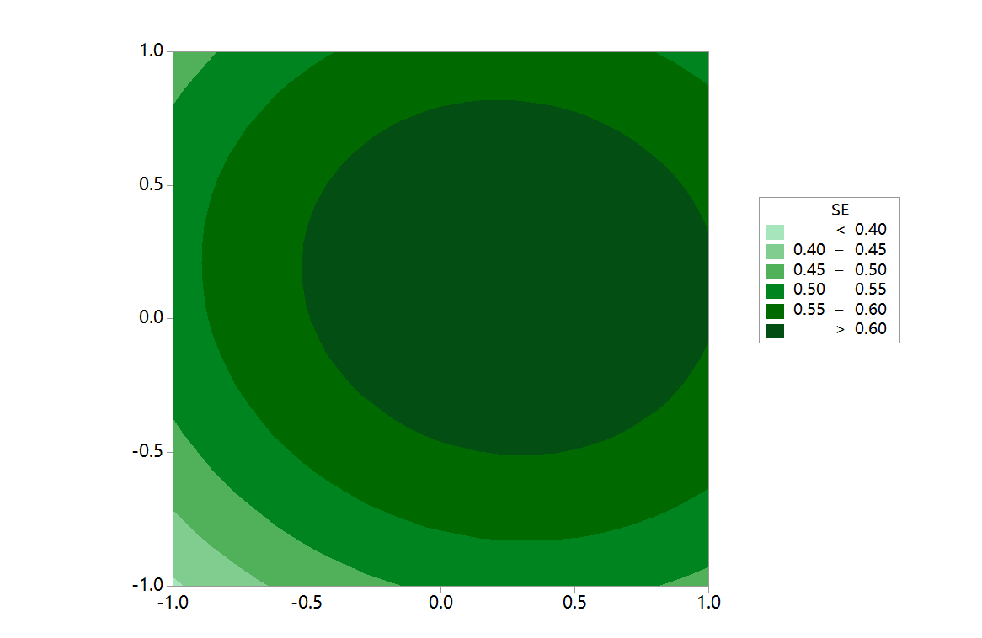

**Fig. 1.** Evaluation results for the community studied

3.2. EE subsystem

Fig. 2 shows that the highest EE value is 0.542, the smallest is 0.284. There is not much discrepancy in the EE value compared with the SE value. Nanjing has the highest EE value, indicating it has the best eco-environment development, while Suqian has the worst. 10 cities have bad ecological and environmental systems. Few communities have a bigger ecological carrying capacity or environmental capacity. Nanjing and Xi'an have made achievements in the construction of ecological civilization.

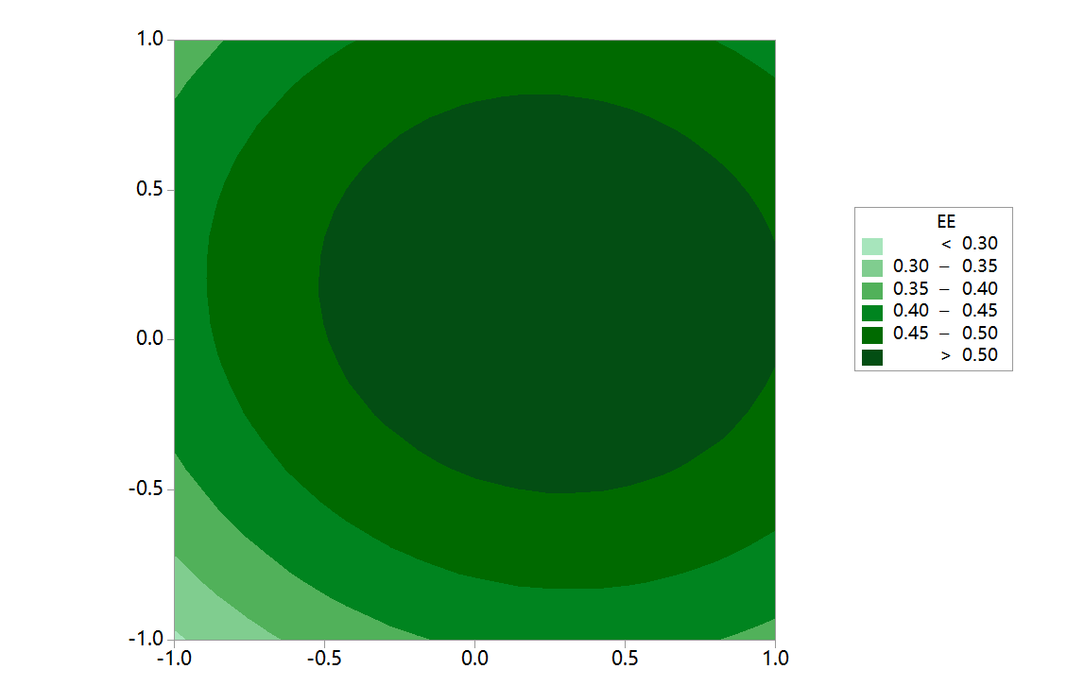

**Fig. 2.** EE (ecological environment) development in 27 communities

3.3. Comprehensive analysis of SE, EE subsystems and CCD

How much did the SE and EE subsystems contribute to the total development of the communities? Fig. 3 shows a reply to this question. Nanjing, Wuhan and Xi'an, where the two subsystems are in a virtuous circle. These three cities have high GDP and fiscal revenue, which allows larger investment in ecological environmental governance and environmental protection measures. Also, the optimization of the eco-environment can bring greater economic benefits. Changchun, Jilin, and Anshan in No. 2. The SE development of these cities has been in good shape, but the EE background is not so fine. It demonstrates that economic development makes greater achievements relative to the EE, whereas SE development advances by sacrificing the environment. Hence, conducting pollution prevention and treatment and implementing rigid environmental assessments is essential. Dandong, Baicheng and Yichun present clear advantages in the ecological carrying capacity and environmental protection compared to their SE systems. Nevertheless, these advantages have not offered beneficial conditions for social economic development. Consequently, developing the ecological economy and putting the district on a sustainable development path is necessary.

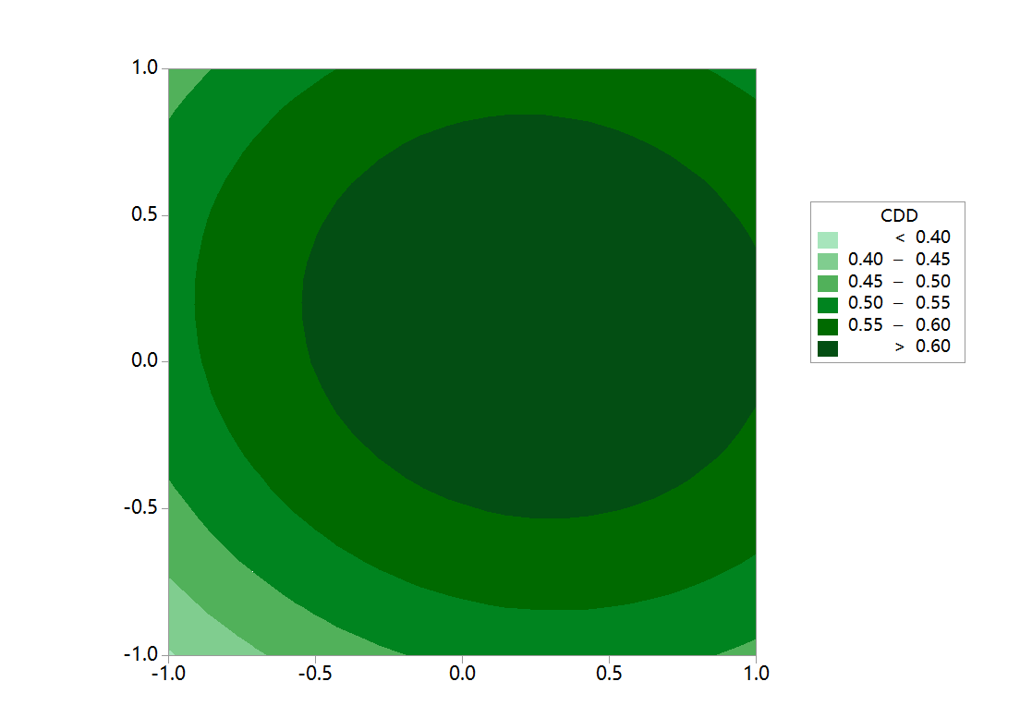

(a)

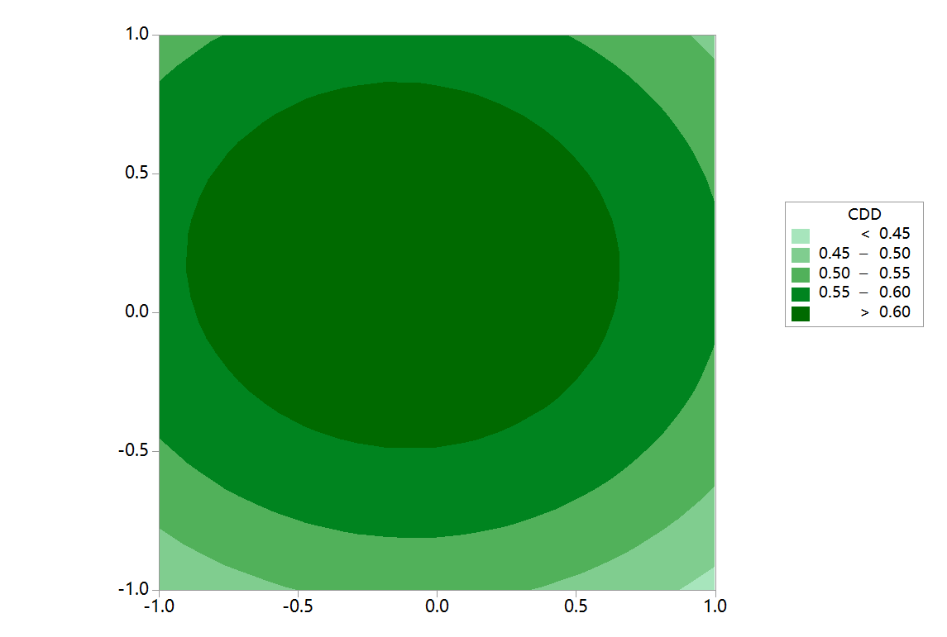

(b)

**Fig. 3.** Comprehensive analysis of SE, EE subsystems and CCD

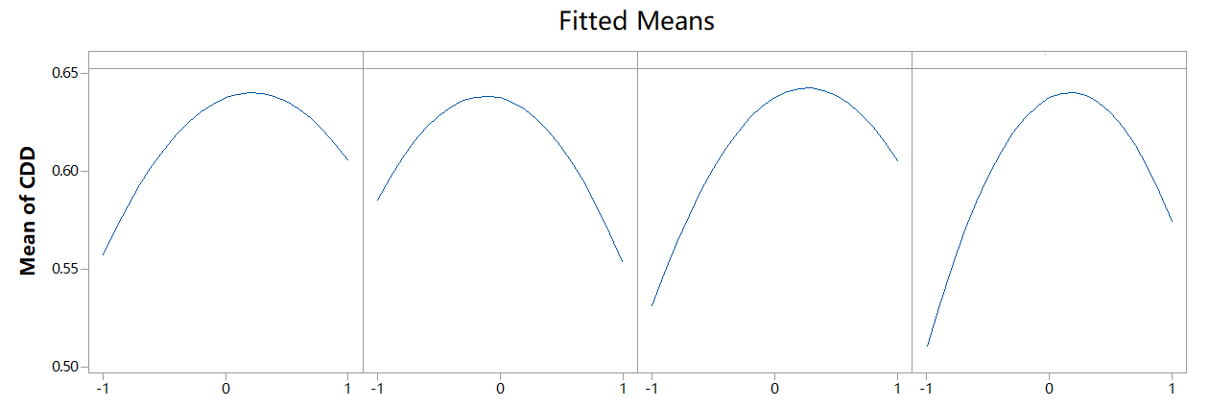

(c)

**Fig. 3.** cont.

3.4. Countermeasures

Based on the evaluation results, advances in the coordinated development of China's social economy and eco-environment are proposed to promote sustainable urban development. The ecological environment has a certain degree of saturation. Otherwise, the environmental carrying capacity is saturated, making it difficult to achieve healthy development. Therefore, each city should, following the requirements of the government, effectively formulate reasonable measures, actively invest funds to improve the ecological environment, reduce pollutant emissions, and make economic advantages play a positive role in protecting the ecological environment. Neighbouring provinces or cities should strengthen mutually beneficial cooperation, learn from each other's strengths, promote and summarize successful experiences, develop dislocations, and transform high-quality ecological advantages into rapid economic development advantages.

Buildings are fundamentally renewed and replaced and provide public facilities and equipment, improve accessibility to public spaces, accommodate ageing trends, and add elevators and barrier-free facilities. Pay attention to the energy saving of buildings and the utilization of renewable energy, actively promote new energy-saving technologies and materials, and use passive solar energy technology for multi-storey buildings. The roof adopts a lighter and more durable thermal insulation roof system. The wall adopts a flexible and detachable passive assembly integrated window and wall thermal insulation and energy-saving system so that the original wall does not need to be damaged. It is strong and can be used for the original building wall and roof effective protection. The use of prefabricated assembly components ensures the accuracy and high quality of construction, improves the speed of construction, reduces air pollution during construction, and promotes the development of the local construction industry assembly industry. At the same time, part of the aging pipeline system can be updated so that the indoor living environment can be fully improved.

4. Conclusions

This paper assesses social economic development level, ecological environment level, and coupling coordinated development between SE and EE. The indicators were selected appropriately to reflect the SE and EE development status comprehensively. The results show that Nanjing, Wuhan and Xi'an take the top spot in terms of CCD, meaning it has the most harmonious relationship between the social-economic subsystem and eco-environment subsystem; Xi'an has the highest SE value, while Lianyungang has the lowest evaluation result. Nanjing has the highest EE value, indicating it has the best eco-environment development, while Suqian has the worst. This study provides a scientific basis and effective measures for sustainable development in China. We need to expand the research scale to cover more cities and even county-level administrative regions to have more practical guiding significance.

*This work was supported by the soft science research project of Shaanxi Science and Technology Department “Research on Construction Strategy of Regional Brands of Shaanxi Agricultural Products”   
(No.2023-CX-RKX-027), and the key project of Shaanxi Provincial Department of Education   
“Research on the Development Status and Design Strategy of Shaanxi Classic Domestic Brands   
in the New Era” (No. 23JZ022).*

References

Grossman, G.M., Krueger, A.B. (1995). Economic Growth and the Environment. *Quarterly Journal of Economics*, *110*(2), 353-377. https://doi.org/10.2307/2118443

Gozgor, G. Chi, K.M.L., Lu: Z. (2018). Energy Consumption and Economic Growth: New Evidence from the OECD Countries. *Energy*, *153*, 27-34. https://doi.org/10.1016/j.energy.2018.03.158

Hu, Y., Peng, L., Li, X., Yao, X., Lin, H., Chi, T. (2018). A Novel Evolution Tree for Analyzing the Global Energy Consumption Structure. *Energy*, *147*, 1177-1187. https://doi.org/10.1016/j.energy.2018.01.093

Huangfu, Y.R., Liu, L. (2021). Rural Construction Method based on the Concept of Ecological Environment Protection. *Journal of Environmental Protection and Ecology*, *22*(5), 1961-1971.

Price, J., Keppo, I. (2017). Modelling to Generate Alternatives: A Technique to Explore Uncertainty in Energy-Environment-Economy Models. *Applied Energy*, *195*, 356-369. https://doi.org/10.1016/j.apenergy.2017.03.065

Tong, L.L. (2021). On the Green Supply Chain Decision-making Mechanism and Environment-friendly Sustainable Development of Technology Oriented Enterprises. *Journal of Environmental Protection and Ecology*, *22*(5), 1972-1980.

Vosniakos, F.K., Farmakis, K.S. (2000). Radioactive Releases from Nuclear and Thermoelectric Power Plant Operation and Their Effect to the Environment of Northern Greece. *Journal of Environmental Protection and Ecology*, *1*(2), 255-257.

Wang, W., Chen, R.P., Zhou, Y.L. (2019). Study on Environmental Protection in Tourist Towns based on Ecological Theory. *Fresenius Environmental Bulletin*, *28*(11), 8800-8805.

Yousaf, K., Abbas, A., Zhang, X.J., Soomro, S.A., Ameen, M., Chen, K.J. (2018). Effect of Multi-stage Drying on Energy Consumption, the Rate of Drying, Rice Quality and Its Optimization during Parboiling Process. *Fresenius Environmental Bulletin*, *27*(12), 8270-8279.

Zivin, J.G., Neidell, M. (2012). The Impact of Pollution on Worker Productivity. *American Economic Review*, *102*(7), 3652-3673. https://doi.org/10.1257/aer.102.7.3652

Zimmermann, J., Glöckner, G., Jahn, R., Enke, N., Gemeinholzer, B. (2015). Metabarcoding vs. Morphological Identification to Assess Diatom Diversity in Environmental Studies. *Molecular Ecology Resources*, *15*(3), 526-542. https://doi.org/10.1111/1755-0998.12336

Zhao, Y.B., Wang, S.J. (2015). The Relationship between Urbanization, Economic Growth and Energy Consumption in China: An Econometric Perspective Analysis. *Sustainability*, *7*, 5609-5627. https://doi.org/10.3390/su7055609

Zhao, J.F., Tang, J.M. (2018). Industrial Structure Change and Economic Growth: A China- Russia Comparison. *China Economic Review*, *47*, 219-233. https://doi.org/10.1016/j.chieco.2017.08.008