|  |  |  |  |
| --- | --- | --- | --- |
|  |  | | |
| **Rocznik Ochrona Środowiska** | | |
| Volume 26 | Year 2024 ISSN 2720-7501 | pp. 94-105 |
|  | https://doi.org/10.54740/ros.2024.010 open access | | |
|  | Received: December 2023 Accepted: March 2024 Published: April 2024 | | |

Emissions of Gases and Dust into the Air as a Result of the Conversion of Landfill Gas   
into Electricity and Heat in a Cogeneration Plant

Natalia Zwolińska1, Emilia Basta*2

1Faculty of Engineering Sciences, State University of Applied Sciences in Nowy Sącz, Poland

2Faculty of Engineering Sciences, State University of Applied Sciences in Nowy Sącz, Poland   
https://orcid.org/0009-0006-2911-4193

**\***corresponding author's e-mail: ebasta@ans-ns.edu.pl

**Abstract:** The consequence of landfilling is biogas production in the waste bed, the main parameter of which is methane. The capture of biogas and its energetic use in a cogeneration system is the optimal solution for both environmental and energetic aspects. Nevertheless, the emission of gases and dust into the air from the cogeneration plant as a result of the combustion of biogas poses a potential threat not only to the surrounding ecosystem but also poses a serious risk to human health, especially to the respiratory system, leading to a variety of diseases. The gas and dust emission tests performed in the study showed significant values for CO2 173.08 [kg ∙ h-1] and for CO 0.7545 [kg ∙ h-1], NO2 0.7129 [kg ∙ h-1], SO2 0.3958 [kg ∙ h-1] and total dust 0.0013 [kg ∙ h-1] respectively. The work aims to demonstrate the actual emissions of gases and dust into the air as a result of the combustion of landfill gas and to use them to calculate fees for the use of the environment. Since no emission standards have been defined for this type of installation and there is no need to use reducing devices, it is crucial to regularly monitor pollutant emissions by installation operators to optimize the biogas combustion process and reduce emissions. Replacing the reference values with measurement data regarding air emissions will make the actual impact of the cogeneration installation on the environment more realistic.

**Keywords:** emissions, landfill gas, atmosphere, cogeneration plant

1. Introduction

In recent years, municipal waste management has been implemented with reference to European Union law and national law in accordance with the waste hierarchy, which promotes all available methods except landfilling (Delgado et al. 2023). Disposal of waste by landfilling is treated by law as a last resort and is subject to drastic requirements with respect to other methods, including mp. recycling (Generowicz & Kulczycka 2020). Municipal waste landfills constitute a construction facility that must meet stringent conditions to be permitted (Jara-Samaniego et al. 2017, Balcerzak, et al. 2014). Over the past decade or so, there has been a noticeable increase in the amount of municipal waste produced per capita worldwide (Sokka et al. 2007). The lack of effective management of this municipal waste stream brings serious consequences for society and the environment (Abdel-Shafy & Mansour 2018, Bajdur et al. 2023). In light of the above problem, it becomes important to reduce the generation of unnecessary materials and to implement appropriate practices to enable their reuse (Ebreo & Vining 2001, Hare & Poznanski 2021).

One way to reduce landfilling and reuse municipal waste is to produce fuel from waste for heating and cement plants (Gaska et al. 2019, Frąckowiak 2023). However, not all waste has the required calorific value and properties for recycling. With this in mind, the Polish legal system has implemented appropriate legal conditions and rules that establish strategies to support environmental protection and designate appropriate sites for waste storage and deposition (Alwaeli 2015, Przydatek & Basta 2019, Kowalski et al. 2012). Despite proper management of municipal waste at the landfill, there is still a growing risk of hazards, including emerging leachate and landfill gas generated in the waste deposit (Nanda & Berruti, 2021, Generowicz et al. 2023). Leachate generated at landfills poses potential threats to soil, groundwater and surface water. Uncontrolled leachate migration can lead to contamination of individual and collective water intakes, consequently leading to health risks for people using these resources (Babenko et al. 2020, Wysowska & Kicinska 2021). With this in mind, it is crucial to monitor groundwater and water within landfills to detect potential risks (Wysowska et al. 2022). The basis for properly managing leachate at a landfill is its capture by a sealed above-film drainage system, pretreatment with aeration, or treatment before discharge into sanitary sewer systems. This way of handling leachate at the landfill will allow leachate to be safely received and treated along with other municipal wastewater without causing technological problems at wastewater treatment plants (Gaska et al. 2019, Ciuła et al. 2029, Xu et al. 2022).

The gas produced is a product of anaerobic digestion of organic origin from municipal waste (Willumsena 1990). Chemicals emitted from this gas negatively affect the quality of human life and living organisms in ecosystems (Vaverkova 2019). As López et al. (2011) show in their work, the predominant components in the gas content are mixtures of methane (CH4) and carbon dioxide (CO2) chemical compounds, as well as the harmful pollutants H2S, H2O, ammonia and siloxanes that occur. Vaverkova et al. (2019) point out that uncontrolled emissions of landfill gas from municipal waste carry the risk of threats to plant biota, causing degradation and changing the mineral composition of the soil. Weitz et al. (2011) point out another consequence due to the CO2 content. Failure to reduce emissions from landfill gas leads to water contamination, degrading it. The landfill gas produced contributes to an increase in the undesirable greenhouse effect, worsening negative climate change (Lambardi et al. 2006). In addition, the negative impact of landfill gas on the environment is determined by the need to eliminate it from potential threats to human life and health (Slack et al. 2005). Consequently, efforts are being made to monitor and minimize the risks associated with gas and dust emissions into the atmosphere using modern technologies (Scheutz & Kjeldsen 2019). A key element of preventive measures is the issue of capturing and energetically utilizing the biogas generated at the landfill (Barros et al. 2018, Ciuła et al. 2023a).

Landfill biogas extracted from the waste bed can be used energetically in various ways. The most common method is combustion in gas engines to generate energy. Alternatively, biogas can be converted to biomethane after its prior purification and removal of CO2 using one of its many upgrading technologies and biocarbon production (Walowski 2012, San et al. 2015). When a landfill operator decides to produce biohydrogen, the key aspect is to estimate the abundance of biogas in the waste bed and its energy parameters mainly methane content. Key to this decision is the performance of an economic analysis, which should indicate whether the methanation process will be financially viable (Gorre et al. 2019, Barbera et al. 2019). The biomethane produced can be injected into the natural gas grid, while the biomethane can be used as a gaseous fuel to power motor vehicles, such as municipal waste collection vehicles or public transportation buses (Winslow et al. 2019, de Souza Ribeiro et al. 2012).

A combined heat and power system is the optimal process for converting gas to energy (Raj et al. 2011). Biogas is used as a gaseous fuel and plays a key role in converting hazardous landfill gas into electricity and heat (Un 2023). Landfill heat management methods should be an economically and environmentally optimal solution. Dedicated solutions allow its use for social and technological purposes, such as drying alternative fuel or evaporation of leachate (Pereira Nascimento et al. 2019). The energetic possibilities of gas transformation used in this way contribute to reducing gas and dust emissions into the atmosphere at the landfill (Xiaoli et al. 2016). Special attention should be paid to the biogas processing stage. Studies by Niskanen et al. (2013) have shown that after landfill gas is burned in cogeneration systems, there is a noticeable reduction in carbon dioxide emissions hazardous greenhouse gases and a reduced risk of groundwater contamination. Nevertheless, subjecting the acquired biogas to cyclic quality checks during the energy generation process is extremely important. Biogas monitoring at each stage should include analysis of chemical composition and impurity content, control of gas purification processes, verification of potential changes in combustion process conditions, and adjustment of combustion parameters (Ciupek et al. 2018, Ciuła et al. 2023b). In addition, regulations for regular and cyclic inspections of pollutant emissions from cogeneration installations are set out in the Minister of Climate and Environment Regulation on assessing levels of substances in the air (Journal of Laws 2020, item 2279). Regular measurements are crucial for plant operators because the most dangerous gases, i.e., CO2 and CH4, are emitted into the atmosphere during landfill gas combustion processes (Rajaram et al. 2011). Emissions of the element CH4 into the air can contribute to the deterioration of air quality and cause negative climate change (Paolini et al. 2018). It has been studied that as a result of landfill gas combustion, CO2 emissions into the air can contribute to smog formation and increase the concentration of other harmful pollutants in the atmosphere (Sharma et al. 2013). The combustion of landfill biogas also introduces dust and pollutants into the air, i.e. hydrogen sulfide (H2S), water (H2O), nitrogen oxides (NOx), ammonia (NH3) and siloxanes. Hydrogen sulfide is a gas with an unpleasant and characteristic odor, which, especially at high concentrations, can lead to unconsciousness and even human death. What's more, studies have shown that high concentrations of hydrogen sulfide in released landfill gas also contribute to corrosion in gas engines and excessive wear and tear of metal components, which, like in motor vehicles, leads to frequent breakdowns and downtime of cogeneration units (Kowalski et al. 2023).

Emitted ammonia into the atmosphere is also becoming a similar threat to humans (Bragnaca et al. 2020). The combustion of landfill gas also leads to the emission of nitrogen oxides (NOx), which can contribute to the formation of acid rain (Singh & Agrawal 2008). The possibility of reducing potential losses as much as possible with cogeneration systems carries the potential for energy use of landfill gas. Nevertheless, it is necessary to verify the potential risks of dust and gas emissions into the air generated during the combustion of landfill gas. It is of utmost importance to carry out appropriate tests to verify the basic parameters of landfill gas during testing, as well as the parameters of the gas engine exhaust gas and to identify the individual concentrations of substances in the gas that are subsequently emitted into the atmosphere (Kowalski et al. 2023). The results obtained are crucial for optimizing potential risks and the correct use of renewable energy sources. It should also be noted that siloxanes, as a result of their decomposition into silicon dioxides, can be deposited on industrial installations, causing corrosion processes (Nyamukamba et al. 2020). This publication aims to test the emissions of gases and dust from the combustion of landfill gas as real values that can replace emission indicators for calculating fees for the use of the environment. Since emission standards did not cover the cogeneration installation, which is the subject of the research, the results of the work will also be used to optimize the biogas combustion process to monitor emissions.

2. Materials and Methods

2.1. Object of research

The study object is a landfill for non-hazardous and inert waste, with an area representing approximately 3.4 hectares. The study site has a landfill gas intake installation consisting of vertical degassing wells from which biogas is sucked, using a gas suction with a capacity of up to 250 m3 per hour. In addition, a cogeneration plant is operated as an energy source, with an electrical output of 285 kW and a thermal output of 340 kW. The landfill gas fueling the gas engine undergoes purification from silicon compounds, siloxanes and hydrogen sulfide in a conditioning plant based on solid filters and activated carbon. In the last calendar year, the plant extracted 978453 m3 of biogas from the landfill for energy use in a cogeneration unit. This volume of biogas allowed the production of 1712.30 MWh of electricity and 2005.83 MWh of thermal energy, operating 7845 hours per year. The electricity generated by the cogeneration plant is primarily used for the facility's own needs, while the remaining volume is transmitted to the external electric grid. The heat from biogas combustion in the cogeneration unit is used for the facility's social and technological needs.

2.2. Methodology of the study

To determine the type and magnitude of emissions from the landfill gas engine, 2 measurement series were carried out at 4-hour intervals on the cogeneration plant located at the landfill. Measurements were made of emissions and concentrations of the following parameters: carbon dioxide (CO2), carbon monoxide (CO), sulfur dioxide (SO2), nitrogen oxides NOx (as NO2) and total dust. For the measurement of CO2, CO, SO2, the methodology derived from PN-ISO 10396:2007 and PN-EN 15058:2006 was used. For the determination of nitrogen oxides as NO2, the PN-ISO 14792:2017 standard was used. The PN-EN 13284-1:2018-02 standard was used for determining total dust, and for oxygen, the PN-EN 14789:2017-04 standard was used. Concentrations and emissions obtained from the measurements were determined by calculations and presented graphically in tables and graphs using Statistica version 14.1.0.4 software.

In parallel with the measurement of gas and dust concentrations and emissions, measurements were made of the landfill gas quality parameters: methane, oxygen, carbon dioxide and hydrogen sulfide, using a portable biogas analyzer. The device has an ATEX II designation, can be used in hazardous areas, and was calibrated according to the plant operator's measurement procedure.

3. Results and Discussion

Landfill gas testing was carried out per the plant operator's procedure and analyzed quantitatively and qualitatively. According to a study by Qin et al. (2001), landfill gas combustion processes identify carbon dioxide (CO2) and methane (CH4) as two gaseous compounds that show particular danger due to their greenhouse properties. Similarly, a study conducted by Paolini et al. (2018) showed that the substances emitted into the atmosphere have a significant global warming potential, which consequently increases the risk of negative environmental impacts, leading to climate change and soil, water and air quality degradation. To minimize the risk of hazards associated with gas and dust emissions, according to the recommendations presented by Krause et al. (2023), it is important to identify the parameters of landfill gas. On this basis, a study of basic parameters correlated over time with the study of biogas combustion emissions was conducted. Table 1 presents the basic parameters of landfill gas, measured after the installation of its conditioning.

**Table 1.** Basic parameters of landfill gas during the study (own study)

|  |  |  |  |  |
| --- | --- | --- | --- | --- |
| Parameter | Unit | Measurement results | | Average |
| Series 1 | Series 2 |
| CH4 | % | 45.1 | 44.7 | 44.9 |
| CO2 | % | 39.8 | 39.4 | 39.6 |
| O2 | % | 0.3 | 0.2 | 0.25 |
| H2S | [ppm] | 67 | 69 | 68 |

The study results show that the average methane content of 44.9% maintains the methane production process's stability, which implies a valid methanogenic phase in the landfill. Analyzing the phenomenon of waste condensation, the obtained value of the average oxygen content of 0.25% indicates the correctly conducted landfill operation in the context of the waste compaction process. As a result, such operations effectively counteract the migration of oxygen into the area of landfilled waste. The hydrogen sulfide contained in the biogas before its treatment in the filter was 475 ppm. The average hydrogen sulfide content after its treatment in the activated carbon filter was 68 ppm. The average value of hydrogen sulfide is well below the permissible value for cogeneration units of 200 ppm. Noteworthy is the high hydrogen sulfide reduction efficiency of 85.7%.

Based on the study report (2022) on the basic parameters of landfill gas, the variation of methane content during the study was verified. The results are presented in Figure 1.

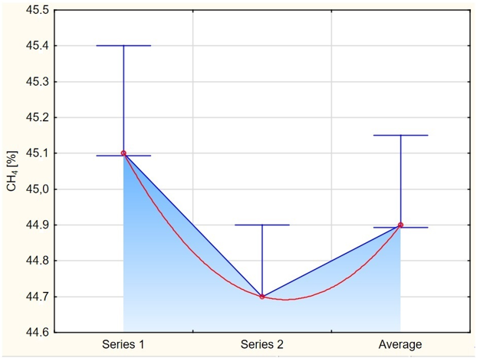

**Fig. 1.** Variability of methane content during the study (own study)

The variation in methane content throughout the study shows little variation between measurement series. Series 1 recorded a methane content of 45.1%, while series 2 yielded results of 44.7%. The difference between the obtained results of series 3 and series 2 was only 0.2%. The minimum deviations show a stable level of methane in the studied landfill gas in the different series of measurements, which, as a result, may indicate that a controlled methanogenesis process is carried out at the landfill. Measurements were taken at the exhaust manifold of the gas engine downstream of its muffler at the pipe outlet to study the magnitude of gas and dust concentrations and emissions into the air. The current parameters of the gas in the pipe during the measurements are shown in Table 2.

**Table 2.** Parameters of gas in the gas engine exhaust line (own study)

|  |  |  |  |  |
| --- | --- | --- | --- | --- |
| Parameter of gas in the exhaust pipe | Unit | Measurement results | | Average |
| Series 1 | Series 2 |
| Flue gas temperature | K | 387.0 | 394.0 | 390.5 |
| Dynamic pressure | Pa | 100.0 | 100.0 | 100.0 |
| Static pressure | Pa | 48.89 | 49.77 | 49.33 |
| Wet gas density under measurement conditions | $$kg∙{kg}^{-1}$$ | 0.048 | 0.050 | 0.049 |
| Relative humidity | % obj. | 7.43 | 7.71 | 7.57 |
| Average speed | $$m∙s^{-1}$$ | 10.50 | 10.70 | 10.60 |
| O2 content | % | 5.69 | 5.30 | 5.50 |
| CO2 content | % | 11.86 | 11.80 | 11.83 |
| Density of wet gas under measured conditions | $$kg∙m^{-3}$$ | 0.887 | 0.869 | 0.878 |
| Gas density under normal conditions | $$kg∙m_{N}^{-3}$$ | 1.305 | 1.302 | 1.304 |
| Density of gas under conventional conditions | $$kg∙m_{U}^{-3}$$ | 1.345 | 1.344 | 1.344 |

The increase in temperature from 387.0 K in series 1 to 394.0 K in series 2 shows changes that can affect the efficiency of combustion processes. The stability of the static pressure at 100.0 Pa and the increase in dynamic pressure by 0.88 Pa show that the exhaust gas flow is in equilibrium. The average speed of exhaust gas movement remains stable at 10.6 m ∙ s-1, which is important for ensuring engine efficiency. Wet gas density and gas density under normal and contractual conditions remain similar, indicating little change in ambient conditions. Nevertheless, monitoring these parameters is key to maintaining optimal gas engine performance and compliance with emission standards. Regular measurement and monitoring of operating conditions are essential for effective emissions control and minimization of environmental impact. As Stanuch et al. (2020) demonstrate in their study, changes in combustion process conditions that can potentially occur during gas compression can affect pressure and temperature differences, ultimately contributing to instability in the control of gaseous and particulate emissions into the atmosphere. Table 3 presents the concentration values for each substance.

**Table 3.** Identification of individual substance concentrations in gas under contractual conditions converted to 3% oxygen content (own study)

|  |  |  |  |
| --- | --- | --- | --- |
| Parameter | Measurement results | | Average |
| Series 1 | Series 2 |
| $$mg∙ m_{U}^{3}$$ | | |
| Total dust | 1.93 | 1.97 | 1.95 |
| CO2 | 273383.8 | 265022.1 | 269203.0 |
| SO2 | 584.4 | 646.0 | 615.2 |
| NOx (as NO2) | 1059.5 | 1156.4 | 1108.0 |
| CO | 1085.4 | 1259.0 | 1172.2 |

Performing an analysis of the proportion of individual substance concentrations in the gas under contractual conditions converted to 3% oxygen content, it was found that their presence increased, with CO2 being the dominant concentration, reaching 269203.0 mg ∙ mU3. High carbon dioxide concentrations can exacerbate the greenhouse effect, generate adverse climate change and promote smog formation. Another important component, characterized by elevated levels, is CO, which has a concentration of 1172.2 mg ∙ mU3. Such a high value indicates the lack of an optimal combustion process, which can lead to potential environmental pollution. Nitrogen oxide concentration at 1108.0 mg ∙ mU3 can contribute to acid rain and smog accumulation in the atmosphere. The proportion of sulfur dioxide also reached a high score as 615.2 mg ∙ mU3. High concentrations of SO2 are particularly dangerous because of its toxic odour and because it contributes to the acidification of soils and the formation of corrosion. The value obtained for total dust, 1.95 mg ∙ mU3 indicates a relatively low degree of dustiness. Fluctuations of nitrogen oxides during measurements are shown in Figure 2.

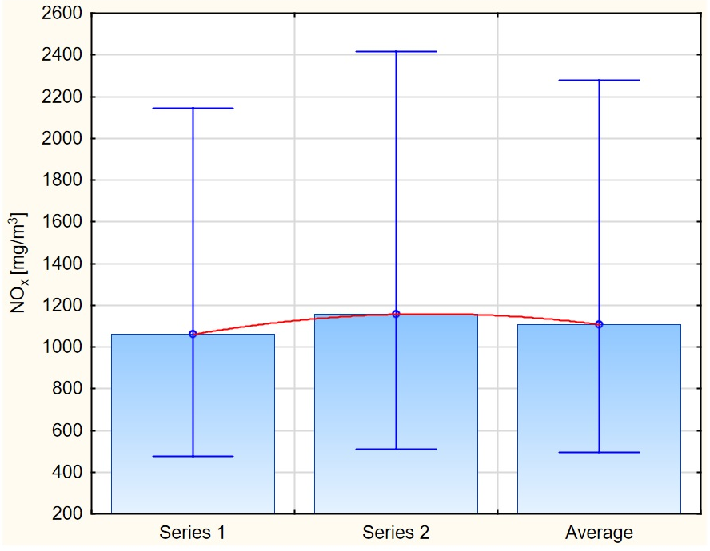

**Fig. 2.** Variability of NOx concentration during measurements *(own study)*

The variability of NOx concentration during the measurements confirms the high level of nitrogen oxides in the landfill gas studied, and the difference between the results obtained in the two different series shows the irregularity of compounds in NOx concentration. The increase in NOx concentration from 1059.5 mg ∙ mU3 in series 1 to 1156 mg ∙ mU3 in series 2 may be due to improper execution of the gas cleaning process from impurities or other changes in the combustion process taking place. Conducting regular and cyclic monitoring of pollutant emissions is important in assessing the effectiveness of emission reduction processes and adjusting procedures to minimize environmental impact. A comparison of the values obtained from the tests with the manufacturer's data and literature data is shown in Figure 3.

**Fig. 3.** Comparison of the magnitude of the average concentrations of selected parameters (own study)

The obtained test results show elevated values for the compared parameters, which may be, in order, a consequence of improper fuel mixture composition (Lambda probe analysis), which is related to the lack of optimal combustion conditions in the engine compartment. Nitrogen oxides (NOx), the sum of NO, NO2 and N2O, are pollutants whose emissions depend only in part on the nitrogen content of the fuel. In fact, their emissions directly result from the conditions of the combustion process and the fuel-oxygen mixing process that determines the lambda coefficient. The results of the tests at the facility showed that the elevated values of nitrogen oxides as an average value of 1108.0 mg ∙ mU3, which should result in the optimization of the entire biogas combustion process, starting with the quality of the fuel, the preparation of the fuel mixture and the combustion itself in the chamber of the gas engine. For the test object, the average concentration of sulfur dioxide in the flue gas showed a value of 615.2 mg ∙ mU3, with a SO2 content of 68 ppm in the treated biogas. The value of this concentration in the flue gas could have been considerably higher in the absence of landfill gas treatment, amounting to an annual average of 385.8 ppm. The biogas purification plant is a sulfur dioxide pollution reduction device in this case. The results of carbon monoxide concentration tests showed an average value of 1172.2 mg ∙ mU3, representing an elevated value in relation to the value derived from the manufacturer's recommendations and literature data. Such a condition may be caused by changes related to the supply of oxygen (air) to the combustion process, resulting in incomplete combustion. The emission measurements and calculations of their average value are presented in Table 4.

**Table 4.** Emission rate from burning landfill gas in a gas engine (own study)

|  |  |  |  |
| --- | --- | --- | --- |
| Parameter | Measurement results | | Average |
| Series 1 | Series 2 |
| kg ∙ h-1 | | |
| Total dust | 0.0012 | 0.0013 | 0.0013 |
| CO2 | 173.74 | 172.42 | 173.08 |
| SO2 | 0.3714 | 0.4202 | 0.3958 |
| NOx (as NO2) | 0.6734 | 0.7523 | 0.7129 |
| CO | 0.6898 | 0.8191 | 0.7545 |

The results of emission measurements during landfill gas combustion show that CO2 dominates in the amount emitted, reaching 173.08 kg ∙ h-1. Long-term inhalation of CO2-polluted air can cause respiratory tract inflammation and aggravate asthma symptoms (Gladka & Zatoński 2016). Similar symptoms can be induced by CO and NO2, where their average values have been recorded at 0.7545 kg ∙ h-1 and 0.7129 kg ∙ h-1. During their study, Yadava& Bhatt (2021) found that carbon monoxide contributes to changes in the cardiovascular and respiratory systems, leading to dizziness and syncope. In contrast, as Singh & Pandey (2021) showed, NO2 causes acid rain and is a highly toxic gas. The emission of gases and particulates into the air from combined heat and power installations resulting from the combustion of landfill gas in a gas engine is not regulated for installations of this electrical capacity. No emission standards exist for these installations, specifying the limit values and ways to reduce these pollutants (Journal of Laws 2020, item 1860). The main way to reduce gas and dust emissions into the air for this type of installation is to clean the gas, especially from sulfur and silicon compounds, and to clean the heat exchangers installed on the flue gas systematically. In the case of carbon dioxide emissions from biogas, landfill gas, a renewable energy source, we are dealing with so-called bionic CO2, which does not change the actual emissions (Verma & Borongan 2022). In managing landfill biogas, conducting an inventory of landfill emissions using, for example, life cycle assessment (LCA) is important. Such an approach will allow the development of appropriate scenarios for handling biogas and the selection of the most optimal solution for a given landfill, with particular attention to potential organized emissions into the air (Beylot et al. 2013). Figure 4 shows the variability of carbon dioxide during measurements.

In series 1, CO2 emissions of kg ∙ h-1 were observed, while series 2 showed a minimal decrease in CO2 values to 172.42 kg ∙ h-1. The differences between the series are relatively small, amounting to 1.32 kg ∙ h-1. The variability of CO2 emissions obtained from the measurements shows the regularity of the combustion processes. Nevertheless, due to such a high level of CO2 emissions, it is necessary to conduct regular emissions monitoring. Carrying out an appropriate emissions management policy will allow emissions to be reduced, which, as a result, will also contribute to minimizing the risks associated with the release of carbon dioxide into the atmosphere. Figure 5 contains the correlations between the values of concentrations and emissions concerning temperature for the analyzed parameters.

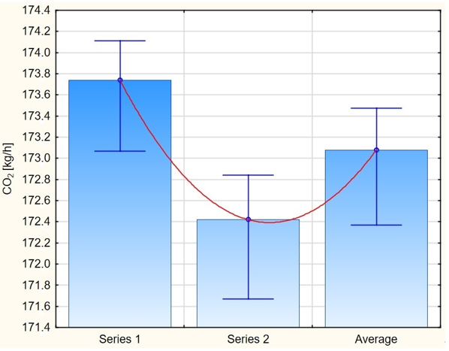

**Fig. 4.** CO2 emissions obtained from measurements (own study)

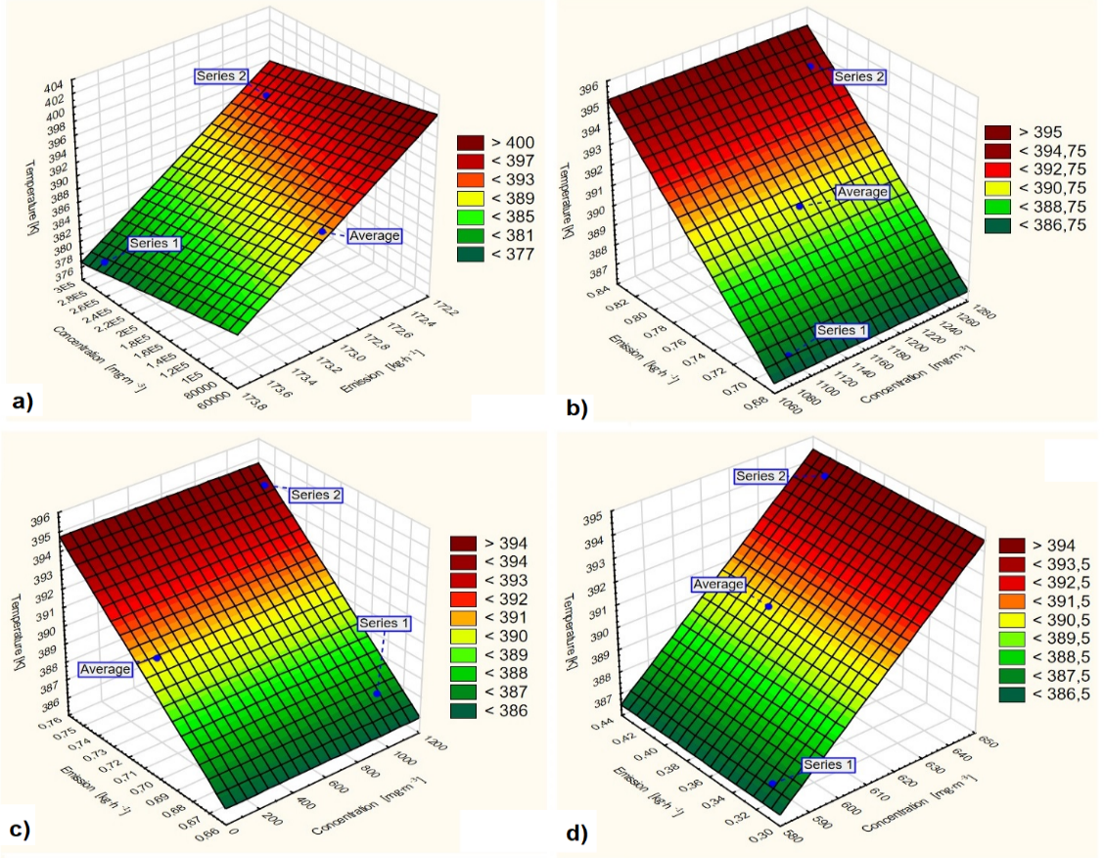

**Fig. 5.** Temperature dependence of concentration and emissions for: a) CO2; b) CO; c) NOx; d) total dust (own study)

A comparative analysis of emissions and concentrations concerning the temperature of gases in the duct showed a mutual correlation of the values of concentrations and emissions depending on the magnitude of the temperature. Noteworthy is that the values of the second series of measurements are located in the upper-temperature values.

With reference to the test results of the two measurement series presented in Table 4, regarding the instantaneous emissions of individual gases and total dust, the annual emissions were calculated according to expression (1).

$E_{rx}=E∙T_{i}$ (1)

where:

$E_{rx}$– annual emissions of individual gases and dust, kg ∙ year-1,

– average result, the value of obtained measurements of a given substance, kg ∙ h-1,

– annual operating time of the cogeneration plant, h.

The calculated average annual emissions of individual pollutants are as follows: carbon dioxide CO2 1357812.63 kg ∙ year-1, sulfur dioxide SO2 3105.68 kg ∙ year-1, nitrogen oxides NOX (as NO2) 5592.75 kg ∙ year-1, carbon monoxide CO 5 919.11 kg ∙ year-1, total dust 10.21 kg ∙ year-1. Based on the parameters obtained for the research object, the cogeneration plant carried out an annual balance of power and heat generation and the volume of gaseous and particulate pollutants emitted into the air. The installation operator can use the average emission results obtained from the research and calculations to calculate environmental fees instead of using the indicators published by the National Center for Balancing and Emission Management (KOBIZE). The consequence of these studies is that gas and dust emissions into the air can be controlled and monitored to balance the environmental impact of the entire facility, a landfill, and the existing installations. Figure 6 presents the annual balance of operation of the cogeneration plant in terms of quantity and quality fed with landfill gas.

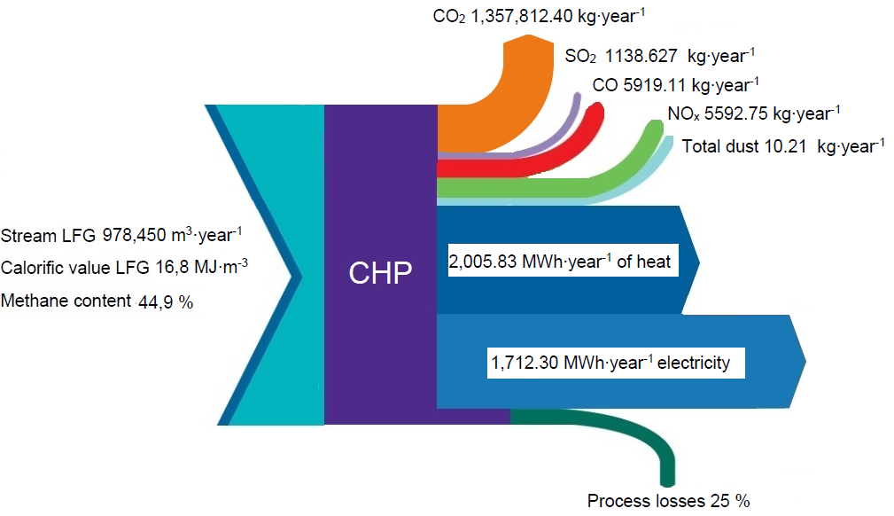

**Fig. 6.** Annual operating balance of a landfill gas-fired cogeneration unit (own study)

Annual electricity production of 1,712.30 MWh was 75% used for the facility's own needs, the remaining amount was transferred to the power grid, representing income for the plant operator. In the case of heat production, about 64% was used at the facility for technological and social purposes; the remaining heat value was not managed. This area needs to be analyzed to look for additional opportunities to manage the surplus heat for the infrastructure located at the landfill, e.g. evaporation of leachate drying of waste fuel.

**4. Conclusions**

A landfill for non-hazardous and inert waste uses a landfill gas capture plant and a cogeneration unit that uses biogas as an energy source. Despite the efficient landfill gas treatment process, significant gas and dust emissions from the cogeneration unit are observed in the atmosphere. The results of emission measurements during the combustion of this gas show that CO2 dominates in the amount emitted, reaching 173.08 kg ∙ h-1. Similar average emission values were recorded for CO at 0.7545 kg ∙ h-1 and for NO2 with a value of 0.7129 kg ∙ h-1. The analysis also showed total dust emissions of 0.0013 kg ∙ h-1 and sulfur dioxide with a value of 0.3958 kg ∙ h-1, which was converted into the value of average annual emissions of individual pollutants at the level of carbon dioxide CO2 as 1357812.63 kg ∙ h-1, sulfur dioxide SO2 as 3105.68 kg ∙ h-1, nitrogen oxides NOX as 5592.75 kg ∙ h-1, carbon monoxide CO as 5919.11 kg ∙ h-1 and total dust as 10.21 kg ∙ h-1.

From the results of studies and calculations, it is crucial to purify landfill gas before it is burned in a gas engine, along with controlling its basic parameters. A consequence of these measures should be monitoring the composition of the gaseous fuel, which translates into the type and amount of emissions of pollutants and concentrations into the air to identify potential hazards. With the increase in municipal waste worldwide, it is becoming necessary to implement selective collection systems, reducing the potential amount of landfilled waste. Introducing strategies to reduce waste generation and practices that enable reuse is essential. Although landfill gas is a renewable fuel, containing mainly methane and carbon dioxide, its conversion into electricity and heat results in negative environmental impacts. This includes the generation of hazardous waste during the operation of the cogeneration unit, but most importantly, the emission of gases and dust into the air from the combustion of landfill gas.

The added value in this process is the generated electricity and heat, primarily used for the landfill and associated facilities. This situation reduces the cost of operating the plant due to the avoided purchase of energy and the sale of surplus energy. Optimal management of landfill gas, fugitive emissions from the landfill's surface, and organized emissions from fuel combustion is feasible, which consequently contributes to reducing the negative environmental impact of such facilities. For small cogeneration plants fuelled by landfill gas, technical solutions should be sought to reduce gas and dust emissions into the air. One solution may be to use a catalyst to reduce flue gas emissions at their outlet. A thorough technical and economic analysis must precede such a solution. The qualitative and quantitative research on gas and dust emissions into the air for installations below 0.5 MW may constitute actual data that installation operators use, for example, for reporting purposes, air quality monitoring and environmental fees.

References

Abdel-Shafy, H. Mansour, M. (2018). Solid waste issue: Sources, composition, disposal, recycling, and valorization. *Egyptian Journal of Petroleu, 27*(4), 1275-1290. https://doi.org/10.1016/j.ejpe.2018.07.003

Alwaeli , M. (2015). An over view of municipal solid waste management in Poland. The current situation, problems and challenges*. Environment Protection Engineering, 41*(4), https://doi.org/181-193. 10.5277/epel50414

Babenko, D.A., Pashkevich, M.A., Alekseenko, A.V. (2020). Water Quality Management at the Tailings Storage Facility of the Gaisky Mining and Processing Plant. *Rocznik Ochrona Środowiska*, *22*, 214-225.

Bajdur, W., Zielińska, A., Gronba-Chyła, A. (2023). Product Life Cycle Assessment (LCA) as a Tool for Environmental Management. *Rocznik Ochrona Środowiska*, *25*, 389-398. https://doi.org/10.54740/ros.2023.040

Balcerzak, W., Generowicz, A., Mucha, Z. (2014). Application of a multi-criteria analysis for selection of a method of reclamation method of a hazardous waste landfill. *Polish Journal of Environmental Studies*, *23*(3), 983-987.

Barbera, E., Menegon, S., Banzato, D., D'Alpaos, C., Bertucco, A. (2019). From biogas to biomethane: A process simulation-based techno-economic comparison of different upgrading technologies in the Italian context. *Renew. Energy*, *135*, 663-673. https://doi.org/10.1016/j.renene.2018.12.052

Barros, R., Filho, G., Santos, A., Ferreira, C., Pieroni, M., Moura, J., Freitas, J. (2018). A potential of the biogas generating and energy recovering from municipal solid waste*. Renewable Energy Focus, 25*, 4-16. https://doi.org/10.1016/j.ref.2018.02.001

Beylot, A., Villeneuve, J., Bellenfant, G. (2013). Life Cycle Assessment of landfill biogas management: Sensitivity to diffuse and combustion air emissions. *Waste Management*, *33*(2), 401-411. <https://doi.org/10.1016/j.wasman>.2012.08.017

Bragança, I., Sánchez-Soberón, F., Pantuzza, G., Alves, A., Ratola, N. (2020). Impurities in biogas: Analytical strategies, occurrence, effects and removal technologies. *Biomass and Bioenergy*, *143*, 105878. https://doi.org/10.1016/j.biombioe.2020.105878

Ciuła, J., Gaska, K., Siedlarz D., Koval V. (2019). Management of sewage sludge energy use with the application of bi-functional bioreactor as an element of pure production in industry. *E3S Web of Conferences*, *123*, 01016. https://doi.org/10.1051/e3sconf/201912301016

Ciuła, J., Kowalski, S., Wiewiórska, I. (2023a) Pollution Indicator of a Megawatt Hour Produced in Cogeneration – the Efficiency of Biogas Purification Process as an Energy Source for Wastewater Treatment Plants. *Journal of Ecological Engineering*, *24*(3), 232-245. https://doi.org/10.12911/22998993/158562

Ciuła, J., Wiewiórska, I., Banaś, M., Pająk, T., Szewczyk, P. (2023b). Balance and Energy Use of Biogas in Poland: Prospects and Directions of Development for the Circular Economy. *Energies*, *16*, 3910. https://doi.org/10.3390/en16093910

Ciupek, B., Urbaniak, R., Bartoszewicz, J. (2018). Concept of biogas energy plant for large landfills. *Rynek Energii*, *6*(55-59). (in polish). https://www.cire.pl/pliki/2/2019/09_ciupek_urbaniak_bartoszewicz.pdf [accessed 6 October 2023]

de Souza Ribeiro, N., Barros, R.M., Silva dos Santos, I.F., Filho, G.L.T., Galdino da Silva, S.P. (2012). Electric energy generation from biogas derived from municipal solid waste using two systems: landfills and an aerobic digesters in the states of São Paulo and Minas Gerais, Brazil. *Sust. Ener. Techn. and Assess.*, *48*, 101552. https://doi.org/10.1016/j.seta.2021.101552

Delgado, M., López, A., Esteban-García, A., Lobo, A. (2023). The importance of particularising the model to estimate landfill GHG emissions. *J Environ Manage*, *3259*(B), 116600. https://doi.org/10.1016/j.jenvman.2022.116600

Ebreo, A., Vining, J. (2001). How Similar are Recycling and Waste Reduction? Future Orientation and Reasons for Reducing Waste As Predictors of Self-Reported Behavior. *Environment and Behavior*, *33*(3), 424-448. https://doi.org/10.1177/0013916012197

Frąckowiak, S. (2023). Sustainable Approaches to Plastics. *Rocznik Ochrona Środowiska*, *25*, 128-140. https://doi.org/10.54740/ros.2023.013

Gaska K., Generowicz A., Lobur M., Jaworski N., Ciuła J., Vovk M. (2019). Advanced algorithmic model for poly-optimization of biomass fuel production from separate combustible fractions of municipal wastes as a progress in improving energy efficiency of waste utilization. *E3S Web of Conferences*, *122*, 01004. https://doi.org/10.1051/e3sconf/201912201004

Gaska, K., Generowicz, A., Lobur, M., Jaworski, N., Ciuła, J., Mzyk, T. (2019). Optimization of Biological Wastewater Treatment Process by Hierarchical Adaptive Control, *IEEE XVth International Conference on the Perspective Technologies and Methods in MEMS Design*, 119-122. https://doi.ogr/10.1109/MEMSTECH.2019.8817382

Generowicz, A., Gronba-Chyła, A., Kulczycka, J., Harazin, P., Gaska, K., Ciuła, J., Ocłoń, P. (2023). Life Cycle Assessment for the environmental impact assessment of a city' cleaning system. The case of Cracow (Poland). *Journal of Cleaner Production*, *382*, 135184. https://doi.org/10.1016/j.jclepro.2022.135184

Generowicz, N., Kulczycka, J. (2020). Recovery of Tantalum from Different Resources. *Arch Civil Eng Environ.*, *13*, 79-84. https://doi.org/10.21307/acee-2020-031

Gładka, A., Zatoński, T. (2016). Impact of air pollution on respiratory diseases. *Kosmos*, *65*(4), 573-582. (in polish). http://kosmos.icm.edu.pl/PDF/2016/573-ang.pdf

Gorre, J., Ortloff, F., van Leeuwen, C. (2019). Production costs for synthetic methane in 2030 and 2050 of an optimized Power-to-Gas plant with intermediate hydrogen storage. *Appl. Energy*, *253*, 113594. https://doi.org/10.1016/j.apenergy.2019.113594

Jara-Samaniego, J., Pérez-Murcia. M.D., Bustamante, M.A., Pérez-Espinosa, A., Paredes, C., López, M., López-Lluch, D.B., Gavilanes-Terán, I., Moral, R. (2017). Composting as sustainable strategy for municipal solid waste management in the Chimborazo Region, Ecuador: Suitability of the obtained composts for seedling production. *J. of Clean. Prod.*, *141*, 1349-1358. https://doi.org/10.1016/j.jclepro.2016.09.178

Knutel, B., Gaze, B., Zając, K., Góraj, S., Bukowski, P. (2022). Multifaceted Analysis of Landfill Gas Use for Energy Purposes. *Energies*, *15*, 8590. https://doi.org/10.3390/en15228590

Kowalski, Z., Generowicz, A., Makara, A. (2012). Evaluation of municipal waste disposal technologies by BATNEEC. *Przemysł Chemiczny*, *91*(5), 811-815.

Kowalski, S., Opoka, K., Ciuła, J. (2022). Analysis of the end-of-life the front suspension beam of a vehicle. *Maintenance and Reliability*, *24*(3), 446-454, http://doi.org/10.17531/ein.2022.3.6

Kowalski, Z., Kulczycka, J., Banach, M., Makara, A. (2023). A Complex Circular-Economy Quality Indicator for Assessing Production Systems at the Micro Level. *Sustainability*, *15*, 13495. https://doi.org/10.3390/su151813495

Krause, M., Detwiler, N., Eades, W., Marro, D., Schwarber, A., Tolaymat, T. (2023). Understanding landfill gas behavior at elevated temperature landfills. *Waste Management*, *163*, 83-93. https://doi.org/10.1016/j.wasman.2023.04.023

Lombardi , L., Carnevale, E., Corti, A. (2006). Greenhouse effect reduction and energy recovery from waste landfill. *Energy*, *31*(15), 3208-3219. https://doi.org/10.1016/j.energy.2006.03.034

López, M.E., Rene, E.R., Veiga, M.C., Kennes, C. (2012). *Biogas Technologies and Cleaning Techniques*. In: Lichtfouse, E., Schwarzbauer, J., Robert, D. (eds) Environmental Chemistry for a Sustainable World. Environmental Chemistry for a Sustainable World. Springer, Dordrecht. https://doi.org/10.1007/978-94-007-2439-6_9

Nanda, S., Berruti, F. (2021). Municipal solid waste management and landfilling technologies: a review. *Environmental Chemistry Letters*, *19*, 1433-1456. https://doi.org/10.1007/s10311-020-01100-y

Niskanen, A., Värri, H., Havukainen, J., Uusitalo, V., Horttanainen, M. (2013). Enhancing landfill gas recovery*. Journal of Cleaner Production*, *55*, 67-71. https://doi.org/10.1016/j.jclepro.2012.05.042

Nyamukamba, P., Mukumba, P., Chikukwa, E., Makaka, G. (2020). Biogas Upgrading Approaches with Special Focus on Siloxane Removal-A Review. *Energies*, *13*(22), 6088. https://doi.org/10.3390/en13226088

Paolini, V., Petracchini, F., Segreto, M., Tomasse, L. (2018). Environmental impact of biogas: A short review of current knowledge. *Journal of Environmental Science and Health*, 5*3*(10), 899-906. https://doi.org/10.1080/10934529.2018.1459076

Pereira Nascimento, D., Menezes, V.L., Carvalho, M., Chacartegui, R. (2019). Energy analysis of products and processes in a sanitary landfill. *IET Renewable Power Generation*, *13*, 1063-1075. https://doi.org/10.1049/ietrpg.2018.5777

Polish Standard PN-EN 13284-1:2018-02 Stationary source emissions – Determination of low range mass concentration of dust – Part 1: Manual gravimetric method

Polish Standard PN-EN 14789:2017-04 Stationary source emissions – Determination of volume concentration of oxygen – Standard reference method: Paramagnetism

Polish Standard PN-EN 14792:2017 Stationary source emissions – Determination of mass concentration of nitrogenoxides – Standard reference method: chemiluminescence

Polish Standard PN-EN 15058:2006 Stationary source emissions – Determination of the mass concentration of carbon monoxide (CO) – Reference method: Non-dispersive infrared spectrometry

Polish Standard PN-ISO 10396:2007 Stationary source emissions – Sampling for the automated determination of gas emission concentrations for permanently-installed monitoring systems

Przydatek, G., Basta, E. (2019). Systemic Efficiency Assessment of Municipal Solid Waste Management in the Suburban Municipality. *E3S Web of Conferences*, *154*, 03001. https://doi.org/10.1051/e3sconf/202015403001

Qin, W., Egolfopoulos, F.,Tsotsis, T. (2001). Fundamental and environmental aspects of landfill gas utilization for power generation. *Chemical Engineering Journal*, *82*(1-3), 57-172. https://doi.org/10.1016/S1385-8947(00)00366-1

Pandey, S.K., Singh, J. (2021). Chapter 22 – Nitrogen dioxide: Risk assessment, environmental, and health hazard. *Hazardous Gases Risk Assessment on the Environment and Human Health*, 273-288. https://doi.org/10.1016/B978-0-323-89857-7.00001-3

Raj, N., Iniyan, S., Goic, R. (2011). A review of renewable energy based cogeneration technologies. *Renewable and Sustainable Energy Reviews*, *15*(8), 3640-3648. https://doi.org/10.1016/j.rser.2011.06.003

Rajaram, V., Siddiqui, F.Z., &Emran Khan, M. (2011). From Landfill Gas to Energy: Technologies and Challenges (1st ed.). CRC Press. https://doi.org/10.1201/b11598

Regulation of the Minister of Climate and Environment of December 11, 2020 on assessing levels of substances in the air (Dz.U. 2020 poz. 2279 z póz. zm.). (in polish), https://isap.sejm.gov.pl/isap, [accessed 5 January 2024]

Regulation of the Minister of the Climate of September 24, 2020 on emission standards for certain types of installations, fuel combustion sources and waste incineration or co-incineration equipment (Dz.U. 2020, poz. 1860). https://isap.sejm.gov.pl/isap. (in polish). [accessed on 6 January 2024]

Scheutz, C., Kjeldsen, P. (2019). Guidelines for landfill gas emission monitoring using the tracer gas dispersionmethod. *Waste Management*, *85*(15), 351-360. https://doi.org/10.1016/j.wasman.2018.12.048

Sharma, S., Jain, S., Khirwadkar, P. i Kulkarni, S. (2013). The effects of airpollution on the enviroment and humanhealth. *Indian Journal of Research in Pharmacy and Biotechnology*, *1*(3), 391-396. https://www.ijrpb.com/issues/Volume%201_Issue%203/ijrpb%201(3)%2020%20page%20391-396.pdf. [accessed 16 October 2023]

Singh, A., Agrawal, M. (2008). Acidrain and its ecological consequences. *Journal of Environmental Biology*, *2*9(1), 15-24. https://www.jeb.co.in/journal_issues/200801_jan08/paper_02.pdf. [accessed 11 November 2023]

Slack, R., Gronow, J., Voulvoulis, N. (2005). Household hazardous waste in municipal landfills: contaminants in leachate. *Science of The Total Environment*, *33*(1-3), 119-137. https://doi.org/10.1016/j.scitotenv.2004.07.002

Sokka, L., Antikainen, R., Kauppi, P. (2007). Municipal solid waste production and composition in Finland – Changes in the period 1960-2002 and prospects until 2020. *Resources, Conservation and Recycling*, *50*(4), 475-488. https://doi.org/10.1016/j.resconrec.2007.01.011

Stanuch, I., Sozańska, M., Biegańska, J., Cebula, J., Nowak, J. (2020). Fluctuations of the elemental composition in the layers of mineral deposits formed on the elements of biogas engines. *Sci. Rep*., *10*, 4244. https://doi.org/10.1038/s41598-020-61212-x

Sun, Q., Li, H., Yan, J.,Liu, L., Yu, Z., Yu. X. (2015). Selection of appropriate biogas upgrading technology-a review of biogas cleaning, upgrading and utilization. *Renew. Sustain. Energy Rev.*, *15*, 521-532. https://doi.org/10.1016/j.rser.2015.06.029

Un, C. (2023). A Sustainable Approach to the Conversion of Waste into Energy: Landfill Gas-to-Fuel Technology. *Sustainability*, *15*(20), 14782. https://doi.org/10.3390/su152014782

Vaverková, M., Maxianová, A., Winkler, J., Adamcová, D., Podlasek, A. (2019). Environmental consequences and the role of illegal waste dumps and their impact on land degradation. *Land Use Policy*, *89*, 104234. https://doi.org/10.1016/j.landusepol.2019.104234

Vaverkova, M. (2019). Landfill Impacts on the Environment-Review. *Journals Geosciences*, *9*(10), 431. https://doi.org/10.3390/geosciences9100431

Verma, R.L., Borongan, G. (2022). Emissions of Greenhouse Gases from Municipal Solid Waste Management System in Ho Chi Minh City of Viet Nam. *Urban Science*, *6*(4), 78. https://doi.org/10.3390/urbansci6040078

Wałowski, G. (2012). Assessment of the flow of substrate and agricultural biogas through the adhesive skeleton bed in phenomenological and numerical terms. *Arch Thermodyn.*, *42*(3), 243-253. https://doi.org/10.24425/ather.2020.138118

Weitz, K., Thorneloe, S., Nishtal, S., Yarkosky, S., Zannes, M. (2011). The Impact of Municipal Solid Waste Management on Greenhouse Gas Emissions in the United States. *Journal of the Air & Waste Management Association*, *52*(9), 1000-1011. https://doi.org/10.1080/10473289.2002.10470843

Willumsen, H. (1990). Landfill gas. *Resources, Conservation and Recycling*, *4*(1-2), 121-133. https://doi.org/10.1016/0921-3449(90)90037-5

Winslow, K.M., Laux, S.J., Townsend, T.G. (2019). An economic and environmental assessment on landfill gas to vehicle fuel conversion for waste hauling operations. *Resources, Conservation and Recycling*, *142*, 155-166. https://doi.org/10.1016/j. resconrec.2018.11.021

Wysowska, E., Kicińska. A. (2021). Assessment of health risks with water consumption in terms of content of selected organic xenobiotics. *Desalination and Water Treatment*, *234*, 1-14, https://doi.org/10.5004/dwt.2021.27720

Wysowska, E., Wiewiórska, I., Kicińska, A. (2022). Minerals in tap water and bottled waters and their impact on human health. *Desalination and Water Treatment*, *259*, 133-151. https://doi.org/10.5004/dwt.2022.28437

Xiaoli, C., Tonjes, D., Mahajan, D. (2016). Methane emissions as energy reservoir: Context, scope, causes and mitigation strategies. *Progress in Energy and Combustion Science*, *56*, 33-70. https://doi.org/10.1016/j.pecs.2016.05.001

Xu, L., Sun, F., Han, X. (2022). Assessment of Treatment Effect of Heavy Metal Pollution from Sewage Sludge in Wastewater Treatment Plant Discharge in China's Nanjing MV Industrial Park. *Rocznik Ochrona Środowiska*, *24*, 276-293. https://doi.org/10.54740/ros.2022.020

Yadava, R.N., Bhatt, V. (2021). Chapter 8 – Carbon monoxide: Risk assessment, environmental, and health hazard. *Hazardous Gases Risk Assessment on the Environment and Human Health*, (83-96). https://doi.org/10.1016/B978-0-323-89857-7.00030-X

Zając, P., Poznański, J. (2021). Management Model Improving Environmental Protection. *Rocznik Ochrona Środowiska*, *23*, 384-407. <https://doi.org/10.54740/ros.2021.026>