|  |  |  |  |
| --- | --- | --- | --- |
|  |  | | |
| **Rocznik Ochrona Środowiska** | | |
| Volume 26 | Year 2024 ISSN 2720-7501 | pp. 84-93 |
|  | https://doi.org/10.54740/ros.2024.009 open access | | |
|  | Received: February 2024 Accepted: March 2024 Published: March 2024 | | |

Review of Methods for Converting Biomass into Biofuels

Paweł Lesiak

Kielce University of Technology, Kielce, Poland   
https://orcid.org/0009-0009-6585-6372

corresponding author's e-mail: [plesiak@tu.kielce.pl](mailto:plesiak@tu.kielce.pl), pawel_l_1991@wp.pl

**Abstract:** Thermochemical processes are among the most effective methods of obtaining hydrogen-rich gases from biomass. These technologies mainly include pyrolysis, gasification and hydrothermal liquefaction. Thermochemical conversion of dry biomass is similar to the conversion of fossil fuels using gasification and pyrolysis methods. Products obtained through thermochemical processes (CO and CH4) can be processed into other biofuels, e.g. syngas, a raw material for producing synthetic hydrocarbons, methanol and alcohols. In recent years, advanced research has been carried out using biomass to produce liquid fuels. The biomass pyrolysis process in the presence of a catalyst is based on the rapid heating of the biomass to a temperature of approximately 500°C in the so-called inert atmosphere in which there are no reactive gases. This process produces a liquid product: pyrolysis oil, gas and charcoal. The bio-oil produced in this process constitutes 60-75% of the mass of the biofuel and is thermally unstable because it contains up to 300 different chemical compounds. However, the bio-oil obtained in this way is incompatible with conventional liquid transport fuels (gasoline, diesel) due to its high oxygen content. Pyrolysis in the presence of a zeolite catalyst is a process that allows for the effective conversion of biomass in economic and ecological terms. A zeolite catalyst makes it possible to remove oxidized compounds in situ and modify the properties of the biofuel to ensure its compatibility with conventional transport fuels. The catalyst plays a crucial role in this process because it removes oxygen from oxygenates and, consequently, creates stable reaction products that can then be treated to obtain renewable transport fuels or other useful chemicals. The article presents methods of biomass conversion via pyrolisis, microorganisms usage, zeolite-based catalysis, biocatalysis and photo-fermentation, which poses a big possibility of diversification of renewable energy sources.

**Keywords:** biomass, biomass conversion, biofuels, microoganisms, renewable energy

1. Introduction

As civilization develops and technological progress progresses, people's living standards improve and the demand for primary energy increases. However, the extent of this increase is offset by energy saving and energy efficiency measures. It is estimated that over the next 25 years, the energy demand will increase only by about 30%, and the dominant energy carrier will be electricity, which uses about 70% of primary energy sources. At the same time, the analysis of changes in the structure of energy consumption indicates that renewable energy sources, which are characterized by the greatest development dynamics today, will use approximately 45% of primary energy in the future (Dale 2023). Figure 1 shows the structure of electricity production for Poland in 2023.



Structure of electric energy

in Poland in year 2023

**Fig. 1. Structure of production of energy in Poland in year 2023 (Produkcja energii elektrycznej w Polsce 2023)**

**The use of biofuels and biomass for electricity production increased from 0.5% in 2019 to 2.9% in 2021 (Produkcja energii elektrycznej w Polsce 2023), and the consumption of bioethanol and biodiesel increased from 631 thousand tons in 2014 to 794 thousand tons in 2018. As shown by the trends in Figures 2 and 3, the global biofuel market is expected to increase in value from nearly 121 billion USD in 2020 to nearly 202 billion USD in 2030. Global biomass production is expected to increase in value from over 127 billion USD in 2021 to over 210 billion USD in 2030 (Biofuels Market Size 2023, Biomass Power Market 2023). The aim of this article is to present various methods of biomass conversion and their possible usage.**

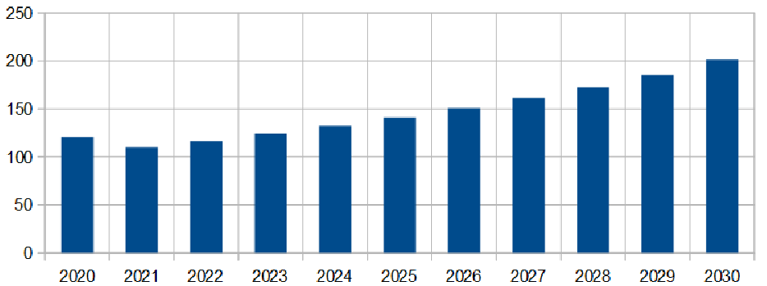

Biofuels market size 2020 to 2030

Years

Billions of USD

**Fig. 2. Size of Biofuels market trends (Biofuels Market Size 2023, Biomass Power Market 2023)**

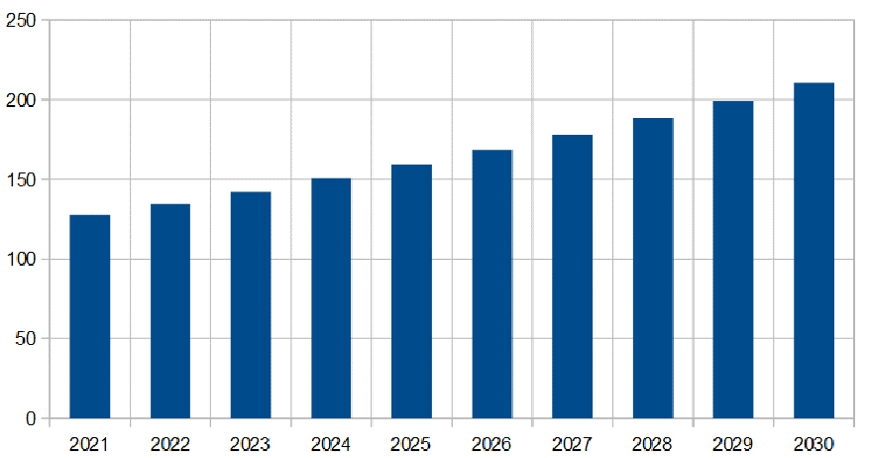

Biomass power market size 2021 to 2030

Years

Billions of USD

**Fig. 3. Size of Biomass market trends (Biofuels Market Size 2023, Biomass Power Market 2023)**

One of the pillars of sustainable economic development is using biomass as a raw material for producing fuels and biofuels. Using renewable raw materials in a sustainable manner should apply to all technological processes, including one of the most important ones, which is the production of energy and its carriers (Bogumił 2020). Three energy carriers are important when using biomass for energy purposes: electricity, heat, and transport fuel (liquid and gaseous). Biomass can be converted using various technologies. To demarcate the sectoral use of biofuels, it is assumed that liquid biofuels are fuels used in transport, and bioliquids and solid and gaseous biofuels are fuels used to generate electricity and heat. The starting point in the development of the biofuel market is biomass obtained from various sources. Concerning the primary process of photosynthesis, biomass can be divided into primary (plants), secondary (animals) and tertiary (post-process, post-consumer). Similarly, primary production, secondary production, and processing/consumption waste can be classified as primary, secondary and tertiary. Each of these biomass sources can be converted into a useful energy carrier – liquid, gaseous and solid biofuel. In terms of energy use, it is important to divide biofuels into primary (unprocessed biomass burned directly, e.g. firewood, pellets, briquettes) and secondary (processed biomass), both in solid form (e.g. charcoal) and liquid (e.g. bioethanol, biodiesel), and gas (e.g. biogas, synthesis gas, hydrogen) (Gołaszewski et al. 2020).

2. Main Methods of Biomass Conversion

The use of biomass to produce heat in the processes of direct combustion or co-combustion with coal, consisting in the conversion of the chemical energy of carbon compounds, hydrogen and oxygen contained in it into thermal energy in boilers, is at the same time, the cheapest, but – according to many experts – the least effective and economically the least profitable solution. In the case of combined production of heat and electricity in biomass-fired power plants (wood, straw, raw materials from energy plantations, RDF, etc.), the investment outlays are slightly higher, but thanks to fluidized bed combustion, cogeneration systems, trigeneration, ORC systems, etc., the efficiency conversion increases, and the economic and ecological effect improves. However, the most advantageous methods of biomass processing, both from the economic and technical point of view, are its partial oxidation, gasification and pyrolysis for the production of liquid fuels, with the possible use of Fischer-Tropsch synthesis, hydrogenation and hydrocracking in relation to the products of thermal decomposition of biomass. The biomass conversion methods include thermochemical, biochemical and agrochemical techniques presented in Figure 4 (Lewandowski et al. 2011).

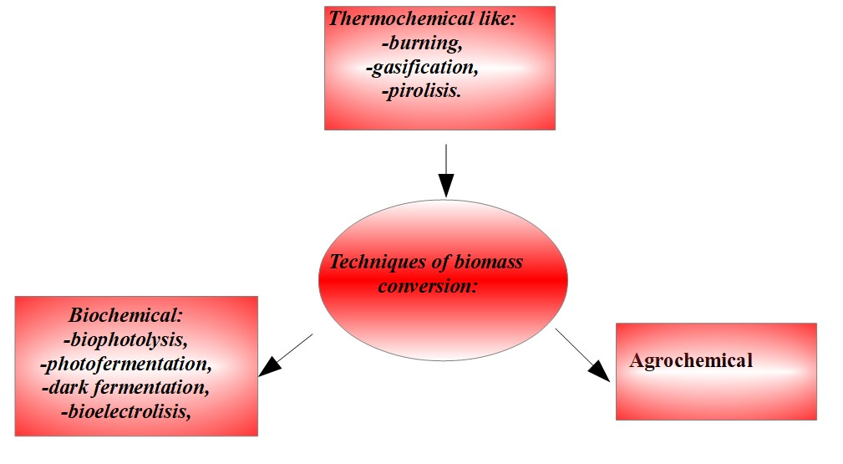

**Fig. 4.** Various techniques of biomass conversion (Lewandowski et al. 2011)

Another method is the pyrolysis of solid fuels such as coal or biomass. It's a thermochemical decomposition process without oxygen, resulting in solid, liquid and gaseous products. Organic matter leads to the formation of solid residue and tar, and decomposition of water and gas. This process transforms waste particularly harmful to humans or the environment into neutral or less hazardous compounds. There are two main stages of pyrolysis:

1. Degassing of the material and thermal decomposition of the main components, during which transformations such as dehydrogenation, dehydration and decarboxylation occur.

2. During the second stage, secondary reactions occur between the solid and gas phase components, such as polymerization or condensation (Nadziakiewicz et al. 2012, Czarnocka 2015). Fuel conversion is a physicochemical transformation involving the transformation of fuel energy into another type of energy, called direct transformation, which may include combustion or the transformation of fuel into another form, called indirect transformation. Intermediate fuel transformation processes include pyrolytic processes, in which the supplied heat is responsible for the transformation, and oxidative processes, in which free or bound oxygen in the form of CO2 or H2O is responsible for the transformation. However, hydrogen is the main factor causing fuel conversion in hydrogenation processes (Nadziakiewicz et al. 2012). The products of pyrolysis of organic substances are most often pyrolysis gas, liquid fraction (water-tar-oil) and char. Pyrolysis gas usually includes carbon dioxide, carbon monoxide, methane, hydrocarbons, hydrogen sulfide, dust and trace impurities. The char contains inorganic feedstock components being processed (Nadziakiewicz et al. 2012). Depending on the temperature of the process, a distinction is made between low-temperature pyrolysis, in the temperature range of 450°C to 700°C, and high-temperature pyrolysis, also known as coking, in the temperature range from 900°C to 1200°C. For solid fuels, this process is called degassing, while for liquid fuels, it is called cracking (Nadziakiewicz et al. 2012).

Depending on the speed of the process, a distinction can be made between slow pyrolysis and fast pyrolysis. Most often, pyrolysis is carried out at temperatures from 400°C to 1000°C, and the residence time of the raw material in the reactor ranges from several minutes in the case of slow pyrolysis and up to 0.5 seconds in the case of very fast pyrolysis. Low process temperatures and slow raw material heating favour solid product formation, while high temperatures allow for obtaining larger amounts of liquid products. Gaseous products can be obtained if very fast pyrolysis is used at a temperature of 900°C. Depending on the type of raw material, appropriate process conditions are selected to obtain the desired product. Conventionally used pyrolysis, in which the temperature increases slowly, has been used for thousands of years, and its main product is charcoal. In the slow pyrolysis process, the biomass is heated to approximately 500°C. The residence time of the vapours in the reactor is from 5 to 30 minutes. It takes place much slower than in the case of fast pyrolysis. The long residence time of particles in the chamber causes secondary conversion of the originally formed products. The gas phase components react with each other to create a solid phase – carbon and a liquid phase. The pyrolyzed raw material can be kept at a constant temperature or slowly heated, and the vapours can be systematically removed. Another pyrolysis variant is carrying out the process in vacuum conditions (Czarnocka 2015). Fast pyrolysis is a high-temperature process in which biomass is heated at high speed without air. The products of this process include gaseous products, aerosols and carbonized residue. After cooling and condensing the gas phase and aerosols, a brown liquid is obtained, the calorific value of which is half that of traditionally obtained diesel oil. In the fast pyrolysis process, 60-75% by weight of liquid bio-oil, 15-25% by weight of solid carbon products and 10-20% by weight of gaseous products that have not been condensed are obtained, and their amount depends on the type of raw material used. The advantage of the process is that it does not generate waste because bio-oil and carbonized products are used as fuel, and the gases can be returned to the process. Several characteristic features can characterize fast pyrolysis. One of them is the previously mentioned high heating rate. In this process, the heat transfer rate is important, and the use of finely ground material facilitates it. Another feature of fast pyrolysis is careful control of the process temperature, which ranges from 450 to 900°C. The third feature of speed pyrolysis is the short residence time of the vapours in the reactor (less than 2 seconds). The last characteristic feature is the rapid cooling and condensation of vapours and aerosols to obtain bio-oil (Mohan et al. 2006). The differences between fast and slow pyrolysis are presented in detail in Table 1.

**Table 1.** Comparison of slow and fast pyrolysis (Retajczyk & Wróblewska 2018)

|  |  |  |  |  |
| --- | --- | --- | --- | --- |
| Type  of pyrolysis | Process conditions | Product content | | |
| Liquid fraction [%] | Char[%] | Gas[%] |
| Fast pyrolysis | The process takes place at temperatures from 500°C to 700°C, short residence time of the primary products in the conversion zone | 75 | 13 | 12 |
| Slow pyrolysis | Low process temperature, below 550°C, long residence time of primary products in the conversion zone | 30 | 35 | 35 |

Biomass gasification is a technology based on converting carbon compounds contained in biomass into a gaseous fuel called syngas or bio-syngas. The biomass gasification process is carried out in various reactors, e.g. fixed bed or fluidized bed. Depending on the structure and reactor type, biomass gasification occurs at temperatures of 700-1500°C in an atmosphere of air, water vapor or pure gases such as oxygen, nitrogen, and carbon dioxide (Gołaszewski et al. 2020). Gasification is a process of oxidation of biomass, as a result of which the chemical energy of the bonds of carbon structures is released and then stored in the bonds of gaseous products. Syngas contains mainly CO, CO2, H2, and N2. Byproducts of the gasification process are small amounts of biochar, ash, tar and oil (Gołaszewski et al. 2020). The typical share of products is – biochar 5%, oil 10% and syngas 85%. The low O/C ratio influences the efficiency of syngas production in the biomass, therefore, before the gasification process, the raw material is often conditioned in the torrefaction process. In addition to reducing the O/C ratio, torrefaction increases the energy concentration and hydrophobicity of substrates, which contributes to improving the efficiency of the technology but also the quality of the obtained syngas (Sharma et al. 2015, Tripathi et al. 2016). Syngas obtained in significant quantities from lignocellulosic biomass is used to produce various types of chemical compounds (De Bhowmick et al. 2018). Moreover, gasification produces H2 from biomass on an industrial scale, and wet biomass can increase the H2 content in the gas by up to 40% compared to dried biomass. Additionally, using catalysts can increase the efficiency of hydrogen production and thus adapt the gas composition to further application stages, e.g. Fischer-Tropsch synthesis (Gołaszewski et al. 2020, Kan et al. 2016, Szufa 2015).

2.1. Biofuels from biomass

Liquid biofuels, produced from solid biomass (biomass-to-liquid), are an alternative to traditional petrochemical fuels. Currently, the main raw materials for liquid biofuels, ethanol and biodiesel, are food crops, such as cereals, sugar beet, rapeseed or potatoes. For example, in Poland, the production of rapeseed and cereals for biofuels, respectively, increased from 1.69 and 0.52 million tons in 2014 to 2.20 and 0.65 million tons, respectively, in 2018 (Szymańska 2019) and biomass and biogas together in the first half of 2022. They accounted for 20% of energy production from renewable energy sources (Załęcki & Molenda 2022). However, straw from the production of cereal and oil plants, as well as residues from sugar and starch production, are still an attractive lignocellulosic material with future potential for producing 2G (Second Generation) biofuels. Pure methane's heating value (HHV) is 37.78 MJ/m3. In biogas, the methane concentration depends on the amount of fats, proteins and carbohydrates in the fermented biomass, ranging from 50 to 70%. Moreover, there is an additional high concentration of CO2 in the raw biogas. For the above reasons, the real energy value of raw biogas is estimated in the range of 19-26 MJ/m3 or 6-6.5 kWh/m3, which is equivalent in energy to approximately 0.65 dm3 of crude oil (Deublein & Steinhauser 2010). However, raw gas energy values reported in the literature vary significantly depending on the lignocellulosic material used. It is mainly due to the different C/H and C/O ratios. This ratio defines whether the production of CH4 or CO2 will be favoured (Basu 2010). Raw biogas has a very limited scope of use due to the presence of trace compounds that may negatively affect installation components and the process. Therefore, to avoid problems with biomass utilization, H2S, NH3, high concentrations of H2O, and siloxanes should be avoided (Beil & Beyrich 2013, Cozma et al. 2015). The effects of using unpurified gas may include corrosion, a decrease in the specific calorific value or the formation of undesirable products after the combustion process (Gołaszewski et al. 2020). Various fuels obtained from biomass are presented in Table 2.

**Table 2.** Types of biofuels produced from different types of biomass (Bogumił 2020)

|  |  |  |  |
| --- | --- | --- | --- |
| Fuel | Typical raw materials | TRL/FRL | Major technology providers |
| HVO/HEFA | vegetable oils (mainly palm oil,  used cooking oil, jatropha, camelina), fats, alternatively tall oil and algae oils, tobacco, pyrolysis  and hydrothermal oils | 9/9, currently a clear focus  on diesel production | UE, USA,  Indonezja |
| BTL  (from the Fischer-Tropsch process) | wood (industrial wood,  waste wood, energy plants), stems (mainly straw,  triticale, miscanthus), black lye (waste  from papermaking processes), municipal waste (USA) | 5-6/5 | EU, USA |

**Table 2.** cont.

|  |  |  |  |
| --- | --- | --- | --- |
| Fuel | Typical raw materials | TRL/FRL | Major technology providers |
| DME  (dimethyl ether) | wood, black lye  (waste from papermaking processes), solid organic waste (wood,  municipal solid organic waste, straw), biogas | 4-6/5 | EU, USA |
| OME  (ethylene oxide ether) | wood, solid organic waste (wood,  solid organic waste, straw) | 3-4/3 | PRC, Germany |
| Methanol | wood, black lye  (waste from papermaking processes), solid organic waste (wood,  municipal solid organic waste, straw), alternatively biogas or glycerol | 4-6/5 | USA, PRC, EU |
| Ethanol from  lignocellulose | several types of lignocellulose  (mainly straw, corn straw, bagasse (pomace) from sugar cane,  wood, grasses), distributed (municipal) waste,  industrial waste streams | 7-8/7  for fermentation | USA, PRC, UE, Brazil |
| Biomethane | agricultural and forestry waste  (straw, sawdust)  municipal solid waste (landfill gas) | 7-9/7 | Netherlands, France, Norway, USA (landfill gas) |

TRL – Technical Readiness Level

FRL – Fuel Readiness Level

HVO – Hydrotreated Vegetable Oil

HEFA – Hydroprocessed Esters and Fatty Acids

3. Zeolites as Catalysts in Biomass Conversion into Biofuel

Another possibility of converting biomass into biofuels is using zeolites as chemical reaction catalysts. This is particularly profitable because it allows easy use and recycling of fly ash. Biogas, although it is a renewable form of energy, usually contains 40-45% CO2, which significantly reduces its calorific value (Narang 2019). Various porous materials have been adapted to adsorb CO2 gas from the biogas stream to obtain 95-97% biomethane. Zeolites are one of the promising porous materials that can significantly contribute to the upgrading process through selective adsorption of CO2 gas from biogas (Narang 2019). Using natural material as a catalyst or substrate for the production of a catalyst not only reduces the costs associated with the production of catalysts but also makes the process environmentally friendly. Moreover, the use of waste materials reduces the problem of waste disposal. The most abundant resources of technology byproducts include primarily waste from agriculture, mining and metal production, and in particular, the steel industry (Książek et al. 2017). In recent years, the use of zeolites in biomass conversion processes has developed significantly. More precise technologies for converting biomass components are gradually replacing traditional biomass cracking processes, comparable to today's petroleum-based petrochemical industrial activities. Consequently, lignocellulosic biomass can be converted into a sustainable feedstock to produce bulk chemicals and fuels in the coming years (Qazi et al. 2022). Zeolites have the potential to be used in these types of processes, and their availability and adaptability make them a fascinating prospect to explore. While this is crucial for developing renewable bulk chemicals that can be used in various applications, it is also essential to reduce the overall environmental impact of the chemical industry (Qazi et al. 2022). Figure 5 shows examples of zeolites used to produce various types of biofuels.

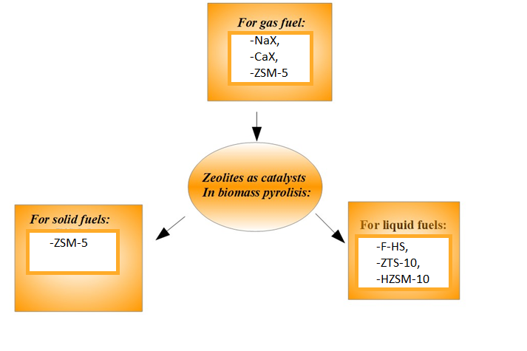

**Fig. 5.** Examples of zeolites used as catalysts in biomass conversion into various biofuels (Narang 2019, Atchimarungsri et al. 2022, Shabani et al. 2022, Gao et al. 2023)

Biodiesel is typically produced from vegetable oils and methanol, producing glycerol as a byproduct. To improve the overall economic performance of the process, the selective formation of methanol from glycerol is important in biodiesel production. In work (Książek et al. 2017), HZSM-5 zeolite modified with CaO was obtained by impregnation and used to convert glycerol to methanol. 10% CaO/HZSM-5 with a Si/Al ratio of 38 showed the highest methanol selectivity of 70%, with glycerol conversion of 100% at 340°C and atmospheric pressure. The characterization results showed that introducing a small amount of CaO into HZSM-5 did not affect the structure of the zeolite. Incorporating HZSM-5 as an acid catalyst and CaO as a basic catalyst in a synergistic catalytic system led to higher glycerol conversion and methanol selectivity (Atchimarungsri et al. 2022).

4. Microorganisms Usage

An alternative method of producing biofuels is the biochemical process using microorganisms such as Clostridium butyricum, Enterobacter aerogenes or Enterobacter cloacae (Gołaszewski et al. 2020), in which hydrogen is one of the products of their metabolism. Biotechnological methods include those involving light, such as direct and indirect biophotolysis and photofermentation. The second group of processes are those occurring without access to light, such as dark fermentation, bioelectrolysis or bioconversion of carbon monoxide. A significant advantage of biochemical processes for hydrogen production is the ability to perform them without the need to use increased pressure and temperature – they can occur in ambient conditions, which is of great economic importance. Lignocellulosic biomass consists of carbohydrate polymers and lignins. Agricultural waste and all processing residues contain approximately 32-47% cellulose, 19-27% hemicellulose and 5-24% lignin, and these proportions depend on the origin of the biomass (Wyman 1994). Both hemicellulose and lignin must be hydrolyzed beforehand to be used effectively by microorganisms (Gołaszewski et al. 2020).

5. Biophotolysis

Biophotolysis is a process that uses water as a substrate, which is decomposed into hydrogen and oxygen in anaerobic conditions by microalgae or cyanobacteria. The process occurs in anaerobic conditions because the hydrogenase activity is inversely proportional to the oxygen content in the reaction medium. This is because, in aerobic conditions, electrons generated by the breakdown of water do not participate in hydrogen production but are used to reduce carbon monoxide. Biophotolysis is a two-stage process. In the first stage, oxygen is released, and in the second stage, hydrogen is released. This method of conducting the process makes it easier to maintain anaerobic conditions. The disadvantages of this process are its low efficiency and the relatively high cost of bioreactors (Gołaszewski et al. 2020).

6. Photofermentation

Photofermentation is a process during which organic acids are converted to hydrogen and carbon dioxide by photosynthesis under the influence of specific strains of anaerobic bacteria. Hydrogen is produced thanks to the enzyme nitrogenase. As a nitrogenase inhibitor, oxygen is not produced due to such a transformation. Hydrogen yields are similar to those from biophotolysis. Additionally, such a process requires specialized types of microorganisms, an appropriate type of medium designed for the appropriate type of photofermentation, and appropriate light intensity. The photofermentation process is often combined with the dark fermentation process (Gołaszewski et al. 2020). Volatile fatty acids generated during dark fermentation, in addition to hydrogen and methane, are an excellent source of electrons and hydrogen for reducing carbon dioxide and a source of sulfur-free carbon for bacteria responsible for photosynthesis.

The dark fermentation process is one of the most promising hydrogen production processes (Łukajtis et al. 2018). The net energy equivalent, i.e. the amount of fuel needed as an energy equivalent to replace 1 kg of hydrogen produced in this way, is 1.9. For comparison, the hydrogen production process based on methane steam reforming has an energy equivalent of 0.64 (Manish & Banerjee 2008). The dark fermentation process is also one of the best-known processes among biotechnological methods of obtaining hydrogen. Dark fermentation involves the conversion of substrates by anaerobic microorganisms that multiply in the dark. Hydrogen is a key substrate for the metabolism of many anaerobic bacteria. These microorganisms can consume hydrogen-rich particles when they are available and use electrons from hydrogen oxidation to produce energy. In the absence of external electron acceptors, microorganisms have an excess of electrons generated in metabolic processes and, as a result, reduce protons, which leads to the formation of molecular hydrogen. The mechanism of dark fermentation occurring with the participation of hydrogenase has already been well described in the literature (Gołaszewski et al. 2020, Kozłowski et al. 2016).

7. Bioelectrolysis

Bioelectrolysis converts biodegradable materials into hydrogen using modified microbial fuel cells (MFCs – microbial fuel cells), also called MEC (microbial electrolysis cells), whose efficiency is between 60 and 80%. MEC reactors consist of two chambers (anode and cathode), which can be separated by a diaphragm. The process occurs under the influence of an external source of electrical energy (Parkhey & Gupta 2017). In the anode chamber, an organic medium with a high glucose content, like sugar beet or corn (Gołaszewski et al. 2020), is oxidized as a result of the metabolism of bacteria such as Gammaproteobacteria, Deltaproteobacteria or Shewanella (Logan 2007), as a result of which protons and electrons are produced at the anode. The anode chamber is seeded with exoelectrogenic anaerobic bacteria that can transfer electrons outside the cell (Logan 2007). They capture electrons before they reach the cathode. The resulting protons migrate through the diaphragm separating the chambers to the cathode, where they are reduced and molecular hydrogen is released. Theoretically, a voltage of 0.2 V is enough to carry out the process. In reality, however, this range is higher. It amounts to 0.6-0.8 V. This value depends on the type of organic substrate being oxidized and, as a result, strongly determines the amount of hydrogen obtained (Kadier et al. 2016).

**8. Conclusions**

Using organic raw materials to produce biofuels using zeolite-based catalysts is one of the prospective options for increasing market resources and developing distributed renewable energy, in which biomass is locally obtained and used for own needs. The reasons for the development of the market for many types of biofuels include the lack of competition with food production for arable land and the possibility of using inedible plant parts and waste from agricultural production and agri-food processing, additionally making lignocellulosic biomass a key renewable energy resource, which is becoming an important element of sustainable development, including the development of a circular bioeconomy (reducing greenhouse gas emissions, mitigating climate change, using waste for energy purposes). Technologies for converting biomass into solid, liquid and gaseous biofuels are systematically improved. An opportunity for further development of liquid and gaseous biofuels is biorefinery processes that involve cascade processing of biomass, including treating the energy use of biomass as one of the final stage options in the value chains of bio-based products. In addition to using biomass from dedicated woody plant crops, a wide range of agro-forestry post-production and post-consumer residues require intensive research and development work integrating not only the technological sphere but also the economic and social sphere.

References

Atchimarungsri, T., Gao, X., Wang, K., Ma, Q., Zhang, J., Fan, S., He, F., Tian, J., Reubroycharoen, P., Zhao, T. (2022), Selective Conversion of Glycerol to Methanol over CaO-Modified HZSM-5 Zeolite. *Molecules*, *27*(21), 7221. <https://doi.org/10.3390/molecules27217221>

Basu, P. (2010). *Biomass gasification and pyrolysis: Practical design*. 1st ed., Elsevier, Kidlington, Oxford

Beil, M., Beyrich, W. (2013). Biogas upgrading to biomethane, [in:] Wellinger, A., Murphy, J., Baxter, D., *The biogas handbook: Science, production and application*, Woodhead Publishing Ltd., Cambridge, 364-377.

Biofuels Market Size, Share & Growth Analysis Report, By Fuel Type (Biodiesel and Ethanol), By Feedstock (Coarse Grain, Sugar Crop, Vegetable Oil, Jatropha, Molasses) – Global Industry Analysis, Trends, Revenue, Segment Forecasts, Regional Outlook 2024-2033. Retrived from: **https://www.precedenceresearch.com/biofuels-market**

Biomass Power Market (By Technology: Combustion, Gasification, Anaerobic Digestion, Others; By Feedstock: Solid Biofuel, Liquid Biofuel, Biogas, Others; By End Use: Industrial, Commercial, Residential) – Global Industry Analysis, Size, Share, Growth, Trends, Regional Outlook, and Forecast 2023-2030. Retrived from: **https://www.precedenceresearch.com/biomass-power-market/**

Bogumił, D. (2020). Biomasa jako surowiec do produkcji biopaliw. *Paliwa Płynne*, 10,11,12/2020. (in Polish)

Cozma, P., Wukovits, W., Mamalig, I., Friedl, A., Gavrilescu, M. (2015). Modeling and simulation of high pressure water scrubbing technology applied for biogas upgrading. Clean *Technology Environmental Policy*, *17*, 373-391. https://doi.org/10.1007/s10098-014-0787-7

Czarnocka J., (2015), The use of microwave pyrolysis for biomass processing, *The Archives of Automotive Engineering*, *67*, 141.

Dale, S. (2023). *BP Energy Outlook 2023*, bp.com. Retrived from: <https://www.bp.com/content/dam/bp/business-sites/en/global/corporate/pdfs/energy-economics/energy-outlook/bp-energy-outlook-2023.pdf>

De Bhowmick, G., Sarmah, A.K., Sen R. (2018). Lignocellulosic biorefinery as a model for sustainable development of biofuels andvalueadded products. *Bioresource Technology*, 247, 1144-1154. https://doi.org/10.1016/j.biortech.2017.09.163

Deublein, D., Steinhauser, A. (2010). *Biogas from Waste and Renewable Resources*. An Introduction. 2nd, Revised and Expanded Edition, Wiley-VCH

Gołaszewski, J., Krzyżaniak, M., Olba-Zięty, E., Stolarski, M., Radawiec, W., Konkol, M., Kowalski, R., Rój, E., Faber, A. (2020). *Technologie rynkowe przetwarzania biomasy lignocelulozowej do biopaliw stałych, ciekłych i gazowych*. Wydawnictwo Uniwersytetu Warmińsko-Mazurskiego w Olsztynie. (in Polish)

Gao, Z., Xiang, M., He, M., Zhou, W., Chen, J., Lu, J., Wu, Z., Su, Y. (2023). Transformation of CO2 with Glycerol to Glycerol Carbonate over ETS-10 Zeolite-Based Catalyst. *Molecules*, *28*(5), 2272. https://doi.org/10.3390/molecules28052272

Kadier, A., Sahaid Kalil, M., Abdeshahian, P., Chandrasekhar, K., Mohamed, A., Farhana Azman, N., Logrono, W., Simayi, Y., Abdul Hamid, A. (2016). Recent advances and emerging challenges in microbial electrolysis cells (MECs) for microbial production of hydrogen and value-added chemicals. *Renewable and Sustainable Energy Reviews*, 61, 501-525. https://doi.org/10.1016/j.rser.2016.04.017

Kan, T., Strezov V., Evans T.J. (2016). Lignocellulosic biomass pyrolysis: A review of product properties and effects of pyrolysis parameters. *Renewable and Sustainable Energy Reviews*, 57, 1126-1140. https://doi.org/10.1016/j.rser.2015.12.185

Kozłowski, K., Lewicki, A., Cieślik, M., Jańczak, D., Czekała, W., Smurzyńska, A., Dach, J. (2016). Biologiczne metody produkcji wodoru. *Technika Rolnicza Ogrodnicza Leśna*, 5, 26-28. (in Polish)

Książek, S., Kida, M., Koszelnik, P. (2017). Możliwości Katalitycznego Zastosowania Materiałów Odpadowych, *Journal of Civil Engineering, Environment and Architecture*, XXXIV, 64, (2/II/17), 55-62. https://doi.org/10.7862/rb.2017.81

Lewandowski, W., Klugmann-Radziemska, E., Ryms, M., Ostrowski, P. (2011). Modern Methods of Thermochemical Biomass Conversion into Gas, Liquid and Solid Fuels. *Ecological Chemistry and Engineering S*, *18*, 39-47.

Logan, B. (2007). *Microbial fuel cells*, John Wiley and Sons, New York.

Łukajtis, R., Hołowacz, I., Kucharska, K., Glinka, M., Rybarczyk, P., Przyjazny, A., Kamiński, M. (2018). Hydrogen production from biomass using dark fermentation. *Renewable & Sustainable Energy Reviews*, *91*, 665-694. https://doi.org/10.1016/j.rser.2018.04.043

Manish, S., Banerjee, R. (2008), Comparison of biohydrogen production processes. *International Journal of Hydrogen Energy*, 33, 279-86. https://doi.org/10.1016/j.ijhydene. 2007.07.026

Mohan, D., Pittman Jr., C.U., Steele, P.H. (2006). Pyrolysis of Wood/Biomass for Bio-Oil: A Critical Review. *Energy Fuels*, 20, 848-889. <http://dx.doi.org/10.1021/ef0502397>

Nadziakiewicz, J., Wacławiak, K., Stelmach, S. (2012). *Procesy termiczne utylizacji odpadów*, Wydawnictwo Politechniki Śląskiej, Gliwice. (in Polish)

Narang, K. (2019). Tailoring of adsorptive properties of zeolites for Biogas Upgrading. *Engineering Materials Division of Materials Science Department of Engineering Sciences and Mathematics (TVM)*, Luleĺ.

Parkhey, P., Gupta, P. (2017). Improvisations in structural features of microbial electrolytic cell and process parameters of electrohydrogenesis for efficient biohydrogen production: a review. *Renewable and Sustainable Energy Reviews*, *69*, 1085-1099. https://doi.org/10.1016/j.rser.2016.09.101

Produkcja energii elektrycznej w Polsce. (2023). Retrived from: **https://globenergia.pl/produkcja-energii-elektrycznej-w-polsce-mamy-nowe-statystyki/** (in Polish)

Qazi, U., Javaid, R., Ikhlaq, A., Khoja, A., Saleem, F. (2022). A Comprehensive Review on Zeolite Chemistry for Catalytic Conversion of Biomass/Waste into Green Fuels. *Molecules*, *27*(23), 8578,   
https://doi.org/10.3390/molecules27238578

Retajczyk, M., Wróblewska, A. (2018). Pyrolysis of biomass as a source of energy. *Wiadomości chemiczne*, *72*, 3-4. (in Polish)

Shabani, J., Ameh, A., Oyekola, O., Babajide, O., Petrik, L. (2022). Fusion-Assisted Hydrothermal Synthesis and Post-Synthesis Modification of Mesoporous Hydroxy Sodalite Zeolite Prepared from Waste Coal Fly Ash for Biodiesel Production. *Catalysts*, *12*(12), 1652. https://doi.org/10.3390/catal12121652

Sharma, A., Pareek, V., Zhang, D. (2015). Biomass pyrolysis – A review of modelling, process parameters and catalytic studies. *Renewable and Sustainable Energy Reviews*, *50*, 1081-1096. https://doi.org/10.1016/j.rser.2015.04.193

Szufa, Sz. (2015). Sposoby konwersji biomasy w celu poprawy jej właściwości paliwowych.   
Retrived from: https://www.proakademia.eu/gfx/baza_wiedzy/165/szufa7.pdf (in Polish)

Szymańska, M. (2019). *Produkcja biopaliw szansą dla wyższych cen rzepaku*. Retrived from: https://www.tygodnik-rolniczy.pl/pieniadze/produkcja-biopaliw-szansa-dla-wyzszych-cen-rzepaku-2377573 (in Polish)

Tripathi, M., Sahu, J.N., Ganesan, P. (2016). Effect of process parameters on production of biochar from biomass waste through pyrolysis: A review. *Renewable and Sustainable Energy Reviews*, *55*, 467-481. https://doi.org/10.1016/j.rser.2015.10.122

Wyman, C.E. (1994). Ethanol from lignocellulosic biomass: Technology, economics, and opportunities. *Bioresource Technology*, 50, 3-15. https://doi.org/10.1016/0960-8524(94)90214-3.

Załęcki, J., Molenda, P. (2022). Instalacje OZE w Polsce – raport za pierwsze półrocze 2022 roku. Retrived from: https://top-oze.pl/instalacje-oze-w-polsce-raport-za-pierwsze-polrocze-2022-roku Department of Thermal Technology and Refrigeration, Faculty of Mechanical Engineering, Lodz University of Technology. (in Polish)