 | Rocznik Ochrona Środowiska
 | Volume 26 | Year 2024 ISSN 2720-7501 | pp. 65-73
 | https://doi.org/10.54740/ros.2024.007 open access
 | Received: January 2024 Accepted: February 2024 Published: February 2024
Influence of Ventilation Air Supply into the Space Between Two Glass Units
on the Energy Characteristics of this Transparent System
Borys Basok^{1*}, Аnatoliy Pavlenko², Volodymyr Novikov³,
Hanna Koshlak⁴, Svitlana Goncharuk⁵, Dmytro Davydenko⁶
¹Institute of Engineering Thermophysics of the National Academy of Sciences of Ukraine, Ukraine
https://orcid.org/0000-0002-8935-4248
²Kielce University of Technology, Poland
https://orcid.org/0000-0002-8103-2578
³Institute of Engineering Thermophysics of the National Academy of Sciences of Ukraine, Ukraine
https://orcid.org/0000-0003-1062-7336
⁴Kielce University of Technology, Poland
https://orcid.org/0000-0001-8940-5925
⁵Institute of Engineering Thermophysics of the National Academy of Sciences of Ukraine, Ukraine
https://orcid.org/0000-0002-5609-7337
⁶Institute of Engineering Thermophysics of the National Academy of Sciences of Ukraine, Ukraine
*corresponding author’s e-mail: basok@ittf.kiev.ua
Abstract: By the method of numerical simulation, the heat transfer from the room to the environment through a system of two double-chamber windows, into the gap between which ventilation air from the room supplies, is being researched. Distributions of air velocity and temperature in the chambers of double-chamber windows and in the gap between double-chamber windows are determined. The influence of the flow of ventilation air entering the space between the double-chamber windows on the amount of heat transferred from the room to the space between windows through the inner window and the amount of heat removed from the gap to the environment through the external double-chamber window is investigated. The energy advantages of the method of removing ventilation air through the gap between double-chamber windows over the method of direct removal of ventilation air from the room to the environment are determined.
Key words: profile, window frame, double-glazed unit, heat transfer, thermal resistance, modeling
1. Introduction
One of the methods of reducing heat loss from the room and increasing the energy efficiency of window structures is the supply of air removed from the room as a result of ventilation through window structures. There are options for supplying air, which is removed from the room and has the temperature of this room, between two glasses in a single-chamber window, or supplying this air to the outer chamber of a double-chamber glass unit (Basok et al. 2023a). In (Gloriant et al. 2015), it is proposed to use a window through which air is supplied from the environment to the room as a passive heat recovery system that promotes ventilation of the building. In this case, part of the heat transferred from the room through the glass to the environment is recovered by the air flow. Studies of the heat transfer process under consideration are carried out both by CFD modeling and by a simplified calculation model. The results of experimental studies of the thermal state of a triple-glazed supply-air window in steady state condition are presented in (Gloriant et al. 2021). In (Taynara et al. 2019), the heat transfer through a ventilated double-glazed window is studied by numerical simulation. The case of the presence of a reflective film attached to the inner surface of an outer sheet of glass is considered. In (Khosravi & Mahdavi 2021), a detailed parametric analysis of the thermal characteristics of ventilated windows having different geometric characteristics was carried out, and their ability to preheat the ventilation air supplied to the room was assessed. In (Carlos et al. 2011) it is proposed to use a double window to preheat ventilation air. A ventilated double window consists of two parallel windows that create a gap through which air flows. The gap that is formed between the windows is supplied with fresh air from outside through vents on the base of the outer window. The heat transfer mathematical model in this system and results of a simulation work based on it is proposed. In (Lee et al. 2020), a room ventilation system is considered in which an additional window frame with a ventilation function is applied to the existing window. A cavity, which is created between window frames, serves as an air path for ventilation. In (Zhanga et al. 2016), the characteristics of a translucent structure, which is a triple-glazed window connected with blinds between the panes, are studied. This window provides the ability to remove air from the room to the environment. It has been shown that such a window can contribute to energy saving and this window structure provide alternative solution for recovering the low-grade energy from air-conditioning exhaust air. The results of studies of the energy and comfort characteristics of various types of ventilated windows are presented in (Heiselberg et al. 2017). Analysis of various types of ventilated windows showed that they can be used to reduce the energy demand for cooling and/or heating and improve the indoor comfort performance depending on the season. The results of an experimental study of the thermal performance of a window system, which consists of doubling an existing window and converting it into a ventilated double window, are presented in (Carlos et al. 2010). The air coming from outside circulates up the channel between the windows and enters the building through a vent at the top of the window frame. This window system has been found to act as an efficient heat exchanger, using heat loss and solar radiation to preheat ventilation air, thereby reducing the building's operating energy costs. In (Basok et al. 2023) the numerical modelling is performed to study the characteristics of heat transfer through a system of two double-chamber windows. The distributions of temperature and airflow velocity due to natural convection in the chambers of double-chamber windows and the space between the windows are analyzed. The purpose of this study is to examine the effect of air supply from the room through the gap between two double-chamber windows on the temperature state of this system and the level of heat loss from the room to the environment.
2. Statement of the Problem
The numerical modeling method is used for the research. We are considering a system of two double-chamber glass units located in one window opening parallel to each other. The distance between the inner surface of the outer glass unit and the outer surface of the inner glass unit is Δ = 32 mm. Each glass unit has dimensions of height H = 0.72 m; width L = 0.94 m; thickness 0.032 m. Double-chamber windows consist of three glasses with a thickness of δ_{g} = 4 mm and two air layers δ_{a} = 10 mm. Glass surfaces do not have low-emission coatings. Radiation coefficients of all surfaces ε = 0.89. Thermal conductivity of glass λ_{g} = 0.74 W/(m·K). Numerical studies are performed under boundary conditions of the first kind: the temperature on the outer surface of the outer double-chamber window, which is in contact with the environment, is equal to t_{out} = -5.0°С, and the temperature of the inner surface of the inner double-chamber window is t_{in} = +15.0°С. The problem is solved in a two-dimensional setting in a vertical section of the window structure, which is perpendicular to the glass surfaces and passes through the middle of the double-chamber window. The mathematical formulation of the problem of hydrodynamics and heat transfer, as well as the method for numerical solution of the system of transport equations are the same as in (Basok et al. 2023c). The geometry of these windows and the boundary conditions on the outer surface of the outer window and the inner surface of the inner window are the same as in the case considered in (Basok et al. 2023a) under the condition Δ = 32 mm. But if in (Basok et al. 2023c) the lower and upper horizontal cross-sections of the gap between the glass units were impermeable (the air velocity was equal to zero) and the boundary conditions on these cross-sections corresponded to the thermal insulation conditions, then in this case the velocity of air supply from the room is U > 0 and its temperature were set on the lower horizontal cross-section of the gap between the windows t_{in} = +15.0°С, which corresponded to the temperature of the inner surface of the inner glass unit facing the room. Air was removed from the upper section of the gap between the windows. There, the pressure corresponding to the pressure in the room at the height at which the upper section of the gap is located was set. For the energy equation, the boundary condition on this section was set in the form of a zero value of the temperature derivative along the vertical coordinate. The cases of U = 0.1 m/s and U = 0.2 m/s were studied.
3. Numerical Simulation Results
Obtained as a result of solving the problem of the velocity and temperature fields in the vertical sections of the system of two double-chamber glass units for the case of no air supply in the gap between the glass units, as well as for the cases of air supply with velocities U = 0.1 m/s and U = 0.2 m/s, presented in Figure 1. Comparing the data shown in Figure 1a, which refers to the case of no air supply to the gap, with the data shown in Figures 1b and 1c, it can be seen that when air is supplied to the gap between the glass units, the temperature and velocity distributions in this gap change significantly. If the results presented in Figure 1a fully correspond to the flow pattern characteristic of natural convection (rising-falling flow), then in the case of the supply velocity U = 0.1 m/s (Fig. 1b) the influence of forced convection is clearly visible, i.e. observed mixed free-forced air movement in the gap. The flow near the inlet cross-section in the gap resembles the flow in the core of the jet, or in the initial section of the channel. Further along the height of the channel, the rising-falling character of the flow begins to prevail, which is more consistent with free convection in a closed space.

The forced flow regime has an even more significant effect on the pattern of the velocity and temperature fields at the air supply velocity U = 0.2 m/s (Fig. 1c). In this figure, the flow pattern corresponds even more to the flow in the initial section of the channel. The influence of natural convection in this case is already less noticeable. Its effect is observed only near the inner surface of the outer glass unit, where, due to natural convection, the downward movement of air occurs, and as a result of forced convection, there is a rising movement. Near the outer surface of the inner glass unit, the directions of natural and forced flow coincide.

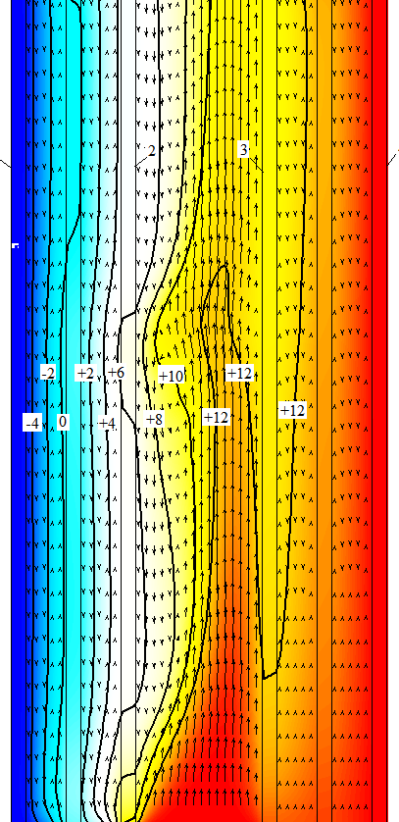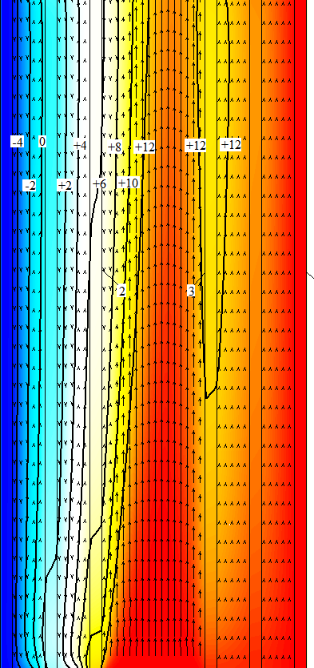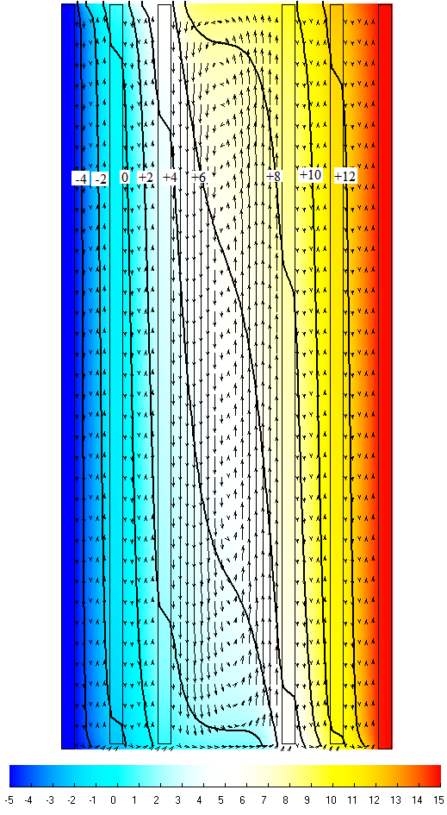
а) b) c)
Fig. 1. Temperature field (°C) and directions of gas medium velocity in the vertical section of a system of two double-chamber glass windows, the distance between which is 32 mm: a – without air supply between the double-chamber windows; b – air supply velocity U = 0.1 m/s; c – air supply velocity U = 0.2 m/s

The distribution of the vertical velocity of the gas medium in the transparent structure under consideration along the horizontal is shown in Figure 2. Curve 1 corresponds to the case of no air supply in the gap between the glass units, curve 2 refers to the case when the air supply velocity is U = 0.1 m/s, and curve 3 corresponds to the air supply velocity U = 0.2 m/s. From the results of the calculation of the vertical velocity in chambers, it follows that in the absence of air supply to the gap between the glass units, the maximum velocity of natural convection in the chamber of the outer glass unit (in the outer chamber, Figure 2a) is ν = 0.0098 m/s. At the air supply velocity U = 0.1 m/s, the maximum velocity is ν = 0.0135 m/s, which is greater than in the case of no air supply. At the air supply velocity U = 0.2 m/s, the maximum velocity turns out to be even higher and is equal to ν = 0.0140 m/s. Air velocities in the inner chambers of the outer glass unit will in all cases be lower than in the outer chamber of the outer glass unit.
In the outer chamber of the inner glass unit, the maximum velocity of natural convection in the absence of air supply is ν = 0.00794 m/s (Fig. 2b). At the supply velocity U = 0.1 m/s, the maximum velocity in the outer chamber of the inner glass unit is ν = 0.00416 m/s, which is less than in the case of no air supply. At the supply velocity U = 0.2 m/s, the maximum velocity is even lower and is equal to ν = 0.00347 m/s. Air velocities will in all cases be slightly lower in the inner chambers of the inner glass unit than in the outer chambers of the inner glass unit. Therefore, the supply of air with room temperature to the gap between the double-chamber windows helps to increase the maximum velocities in the chambers of the outer double-chamber window and to reduce the air velocities in the chambers of the inner double-chamber window.
From the distribution of vertical velocities in the gap between the glass units (Fig. 2c), it can be seen that in the absence of air supply, the free-convection flow in the gap has a rising-falling character. The maximum values of the velocity of the rising-falling flow are equal to ν_{max} = 0.0685 m/s and ν_{min} = -0.071 m/s, respectively. When the velocity of air supply to the gap between the glass units is U = 0.1 m/s, the maximum velocity of the flow directed upwards is equal to ν_{max} = 0.268 m/s, and the velocity of the reverse flow near the inner surface of the outer glass unit is ν_{min} = -0.085 m/s. This distribution of velocity across the width of the channel is similar to the distribution characteristic of mixed convection (natural and forced). As already mentioned, at the air supply velocity U = 0.2 m/s, the downward flow takes place only in a small section of the channel near the inner surface of the outer glass unit and its velocity is equal to ν_{min} = -0.0054 m/s. On the greater part of the space between the glass units, the air flow is similar to the forced flow in a flat channel. The maximum velocity of the updraft is ν_{max} = 0.334 m/s.

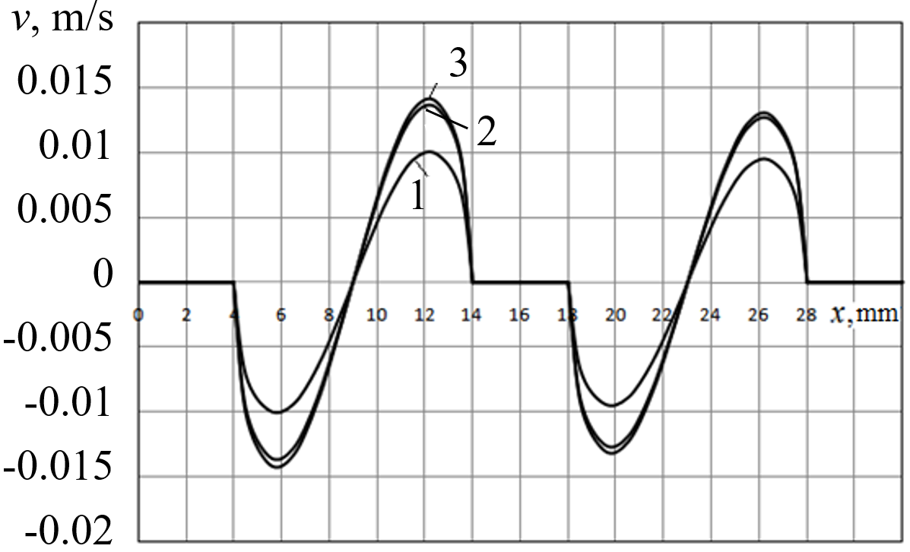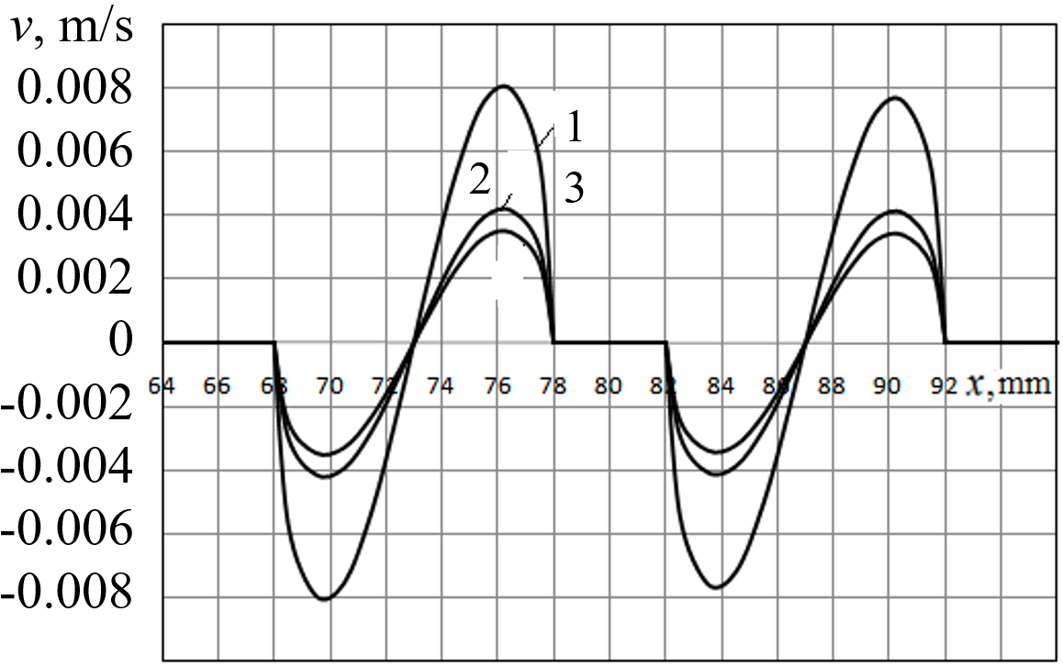
a) b)
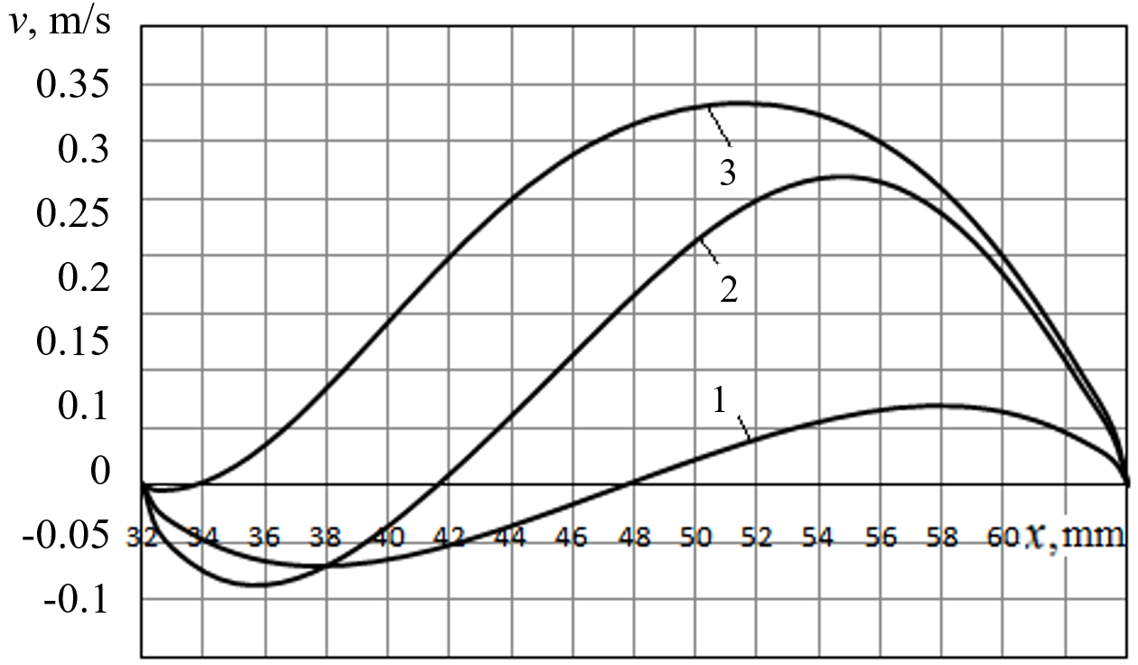
c)
Fig. 2. Distribution of vertical velocity across the thickness of the double-chamber glass unit system: a – outer glass unit; b – inner glass unit; c – gap between the glass units; 1 – without air supply between the double-chamber windows; 2 – air supply velocity U = 0.1 m/s; 3 – air supply velocity U = 0.2 m/s

The temperature distributions across the thickness of the outer and inner double-chamber glass units at different velocities of air supply to the gap between the double-chamber glass units are shown in Figure 3. It can be seen from this figure that the temperature distributions across the thickness of the gas layers in the chambers of the windows are close to linear. The temperature distributions along the glass thickness are also linear. It can also be seen from these figures that in the case of air supply in the gap between the glass units, the temperature difference between the surfaces of the outer glass unit becomes greater than in the case of no air supply. In the inner double-chamber window, the opposite is true. In the absence of air supply to the gap, the temperature difference between the surfaces of the inner glass unit is greater than in the case of air supply. This tendency becomes more significant when the air supply velocity increases.
The decrease in the temperature difference between the surfaces of the inner glass (Fig. 3b) unit and the increase in the temperature difference between the surfaces of the outer glass unit (Fig. 3a) is explained by the fact that the temperature of the air supplied to the gap between the two glass units is equal to a temperature of the inner surface of the inner glass unit. In these conditions, the difference between the air temperature in the space between the double-chamber windows and the inner surface of the inner double-chamber window is significantly reduced. At the same time, the outer surface of the inner glass unit transfer heat by radiation to the inner surface of the outer glass unit and due to this becomes colder than the air in the gap. Therefore, the outer surface of the inner glass unit does not give off, but receives heat by convection and heat conduction from the air in the gap. That is, heat is not transferred from the outer surface of the inner glass unit to the air in gap by convection, but heat coming from the air in the gap is absorbed by this surface.

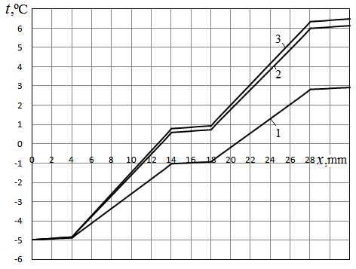
а)
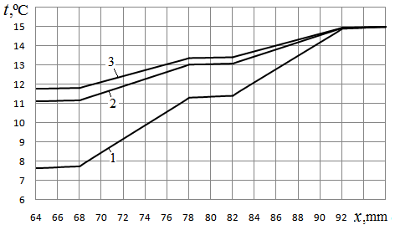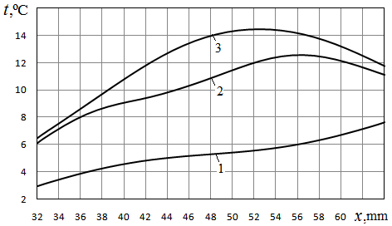
b) c)
Fig. 3. Temperature distribution across the thickness of the system of two double-chamber windows: a – outer glass unit; b – inner glass unit; c – gap between the glass units; 1 – without air supply between the double-chamber glass units; 2 – air supply velocity U = 0.1 m/s; 3 – air supply velocity U = 0.2 m/s

When air is supplied to the gap between the glass units, the temperature distributions across the width of the gap have maxima (curves 2 and 3 in Figure 3c). At U = 0.1 m/s, the maximum on the distribution curve of the temperature in the middle part of this interval is 12.56°С, and at U = 0.2 m/s this maximum is 14.47°С. Therefore, heat fluxes by convection and conduction are directed from the air flow to the sides of the opposite surfaces of the channel, which is created by the inner surface of the outer glass unit and the outer surface of the inner glass unit. But at the same time, the temperature of the outer surface of the inner double-chamber glass unit is higher than the temperature of the inner surface of the outer double-chamber glass unit. Therefore, radiation heat transfer takes place between them. Due to the fact that air is supplied to the space between the double-chamber windows, the temperature of which is close to the temperature inside the room, the inner double-chamber window practically does not participate in heat transfer, and almost all heat transfer by convection takes place between the air in the gap and the inner surface of the outer double-chamber window. Therefore, the temperature difference between the surfaces of the outer glass unit increases significantly when warm air is supplied to the gap between the glass units.
The distribution of heat fluxes on the outer and inner surfaces of the double-chamber glass units under consideration is presented in Figure 4.
A comparison of the heat flux distributions on the inner and outer surfaces of two double-chamber glass units shows that in the absence of air supply between them, the heat fluxes on the outer and inner surfaces of the outer double-chamber window increase with the increase of the vertical coordinate y (curves 1 and 2 in Figure 4a). On the outer and inner surfaces of the inner glass unit, heat fluxes decrease with an increase in the vertical coordinate y. In this case, in the lower part of the double-chamber glass unit, heat fluxes are smaller on the surfaces of the outer double-chamber window. In the upper part of the double-chamber window system, the opposite is true: on the surfaces of the outer glass unit, heat fluxes are greater than on the surfaces of the inner glass unit. The integrals of the heat fluxes on all surfaces are the same. The total heat flux transferred under these conditions through a system of two double-chamber glass units is equal to Q_{win} = 16.05 W. The heat transfer resistance of the outer double-chamber window is R_{out} = 0.337 m²K/W, and of the inner window is R_{in} = 0.314 m²K/W. In the case of air supply into the gap between the glass units at velocity U = 0.1 m/s, the heat fluxes on the surfaces of the outer glass unit change insignificantly with the height y. The heat fluxes on the outer and inner surfaces of the outer glass unit differ most significantly in the lower part of the glass unit (y < 0.04 m), where the heat fluxes on the inner surface of the outer glass unit (curve 2 in Figure 4b) significantly exaggerate the heat fluxes on the outer surface (curve 1 in Figure 4b). The heat fluxes on the inner and outer surfaces of the inner glass unit are almost the same except for the lowermost and uppermost parts of the glass unit. As the height y increases, the heat fluxes on the surfaces of the inner glass unit increase. At U = 0.2 m/s, the nature of the change in heat flux on the surfaces of the inner and outer glass units is almost the same as at U = 0.1 m/s. The difference is that in the middle parts of the surfaces, the heat fluxes on the inner and outer surfaces of the same glass unit differ even less. At the same time, for the outer double-chamber glass unit, the heat fluxes on the surfaces decrease with the height y, and for the inner double-chamber glass unit, they increase with the height y. The main difference between the cases of no air supply to the gap between the glass units and the presence of warm air supply from the room to this gap is that in the case of warm air supply, the heat fluxes are significantly less on the surfaces of the inner glass unit than on the surfaces of the outer glass unit. This is explained by the fact that when air with room temperature is supplied to the gap between the double-chamber windows, the inner and outer surfaces of the inner double-chamber window are in approximately the same temperature conditions. Therefore, heat fluxes on these surfaces are smaller than in the case when warm air is not supply. At the same time, the radiation heat flux transfers from the outer surface of the inner glass unit to the colder inner surface of the outer glass unit. Also heat flux transfers from the warm air flowing in the gap between the glass units, to the outer surface of the inner glass unit, which is colder than the air.

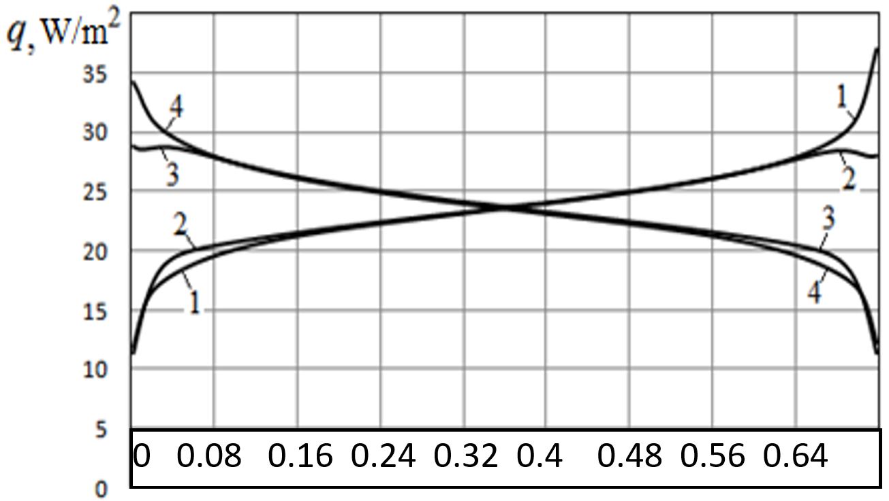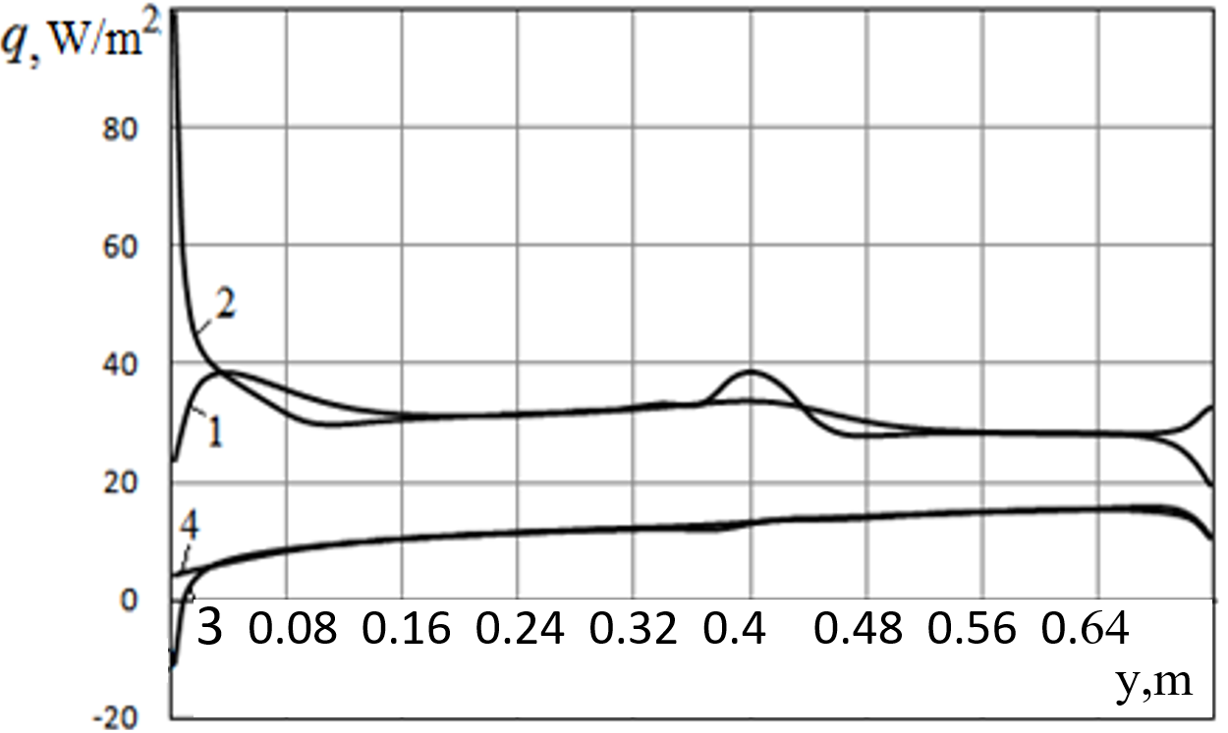
a) b)
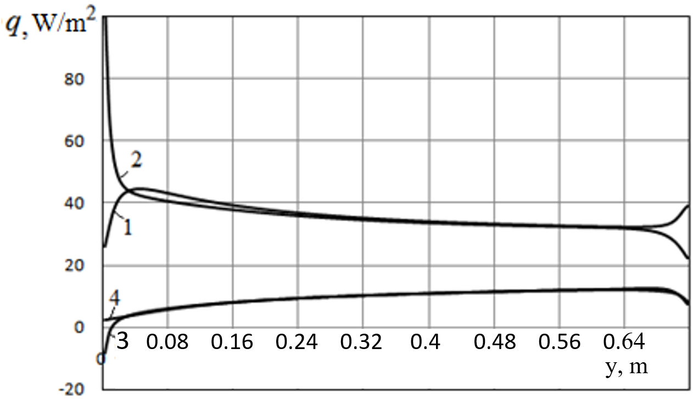
c)
Fig. 4. Distribution of heat flows on the outer (1) and inner (2) surfaces of the outer double-chamber glass unit and on the inner (3) and outer (4) surfaces of the inner double-chamber glass unit: a – without air supply between the glass units;
b – air supply velocity U = 0.1 m/s; c – air supply velocity U = 0.2 m/s

On the surfaces of the outer glass unit, heat fluxes are greater in the case of warm air supply in the gap than in the case of no air supply. If in the case of no air supply in the gap, its temperature in the gap is lower than the temperature in the room and higher than the ambient temperature, then in the case of air supply, the temperature in the gap is almost equal to the temperature in the room (only slightly lower). A higher temperature difference between the air in the gap and the air in the environment causes significantly greater heat fluxes through the outer glass unit than in the case of no air supply.
The results of the calculations of heat transfer characteristics through a system of two double-chambers glass units when air is supplied from the room at a velocity of U = 0.1 m/s into the space between them show that in the outer chamber of the outer glass unit, the radiation heat flux exceeds the convection flux. In total, they make 21.54 W. An even higher radiation heat flux is found in the inner chamber of the outer glass unit, where the temperature of the surfaces is higher than in the outer chamber of this unit. The total heat transfer resistance of the outer glass unit is R_{out} = 0.337 m²∙K/W.
In the outer chamber of the inner glass unit, the radiation flux also exceeds the conductive-convective flux. In the inner chamber of the inner glass unit, the radiation flux is slightly higher than in outer chamber. The total heat flux through the inner glass unit is 8.16 W. Its total heat transfer resistance is R_{in} = 0.311 m²∙K/W. In the gap between the double-chamber glass units, into which air is supplied from the room, the heat transfer conditions are different than in the chambers of glass units. The radiation heat flux transferred from the hotter outer surface of the inner glass unit to the colder inner surface of the outer glass unit is equal to 13.99 W. On the outer surface of the inner glass unit, the integral conductive-convection flux is negative and equal to -5.83 W. That is, heat does not transfer from the outer surface of the inner glass unit to the air in the gap, but on the contrary, from the air to the surface. On the inner surface of the outer glass unit, the conductive-convection flux is positive and equal to +7.55 W.
It follows from this that the total heat flux consisting of radiation and conductive-convection fluxes on the inner surface of the outer glass unit is equal to Q_{out} = 13.99 W +7.55 W = 21.54 W, and on the outer surface of the inner glass unit it is much smaller and equal to Q_{in} = 13.99 W - 5.83 W = 8.16 W. Therefore, the amount of heat entering the gap between the glass units from the room through the inner glass unit is much smaller than the amount of heat that is removed from the gap to the environment through the outer glass unit. The difference between the heat flux that is removed through the outer glass unit to the environment and the heat flux that is removed from the room into the gap between the glass units through the inner glass unit is equal to the difference between the convection heat flux that enters the space between the glass units and the convection heat flux that leaves the space between the glass units and transfer in the environment. The convection flux leaving the gap will be less than the convection flux entering the gap due to the cooling of the air flow in the gap. This difference in convection fluxes is 21.54 W - 8.16 W = 13.38 W. A similar trend is also observed for the case of air supply into the gap with a velocity of U = 0.2 m/s. But in this case, the difference between the heat flux leaving the room through the inner glass unit into the gap between the glass units, and the heat flux leaving the gap into the environment through the outer glass unit will be even greater and will amount to 17.99 W. At the same time, the heat flux leaving the room into the gap is equal to 6.40 W, i.e. less than at U = 0.1 m/s, and the heat flux leaving the gap into the environment through the external glass unit is 24.39 W, i.e. more than at
U = 0.1 m/s. The heat transfer resistance of the outer window is R_{out} = 0.335 m²∙K/W, and of the inner window is R_{in} = 0.310 m²∙K/W. Therefore, both in the case of the presence of air supply, and in the case of the absence of this supply, the heat transfer resistances of the external and internal double- chamber glass units practically do not change depending on the presence or absence of air supply.
To establish the expediency from the point of view of energy saving of the method of removing air from the room during the ventilation process, two options for this removal are compared. In the first variant, with which a comparison is made, the ventilation air, which has a temperature of t_{ent} = t_{in} = 15°C (the same as the inner surface of the inner glass unit) is removed directly to the environment. In this case, air from the room is not supplied to the gap between two double-chamber windows. It is assumed that the air is removed from the room to the environment through a special slit channel with dimensions L×Δ = 0.94 m × 0.032 m at a velocity of U = 0.1 m/s. This channel size, air flow rate, and its temperature correspond to the geometric dimensions of the space between the glass units, the air supply velocity, and the temperature of the air supplied to the space between the glass units. As already mentioned, under given conditions the heat flux removed through the system of two double-chamber glass units into the environment is equal to Q_{win,1} = 16.05 W. Together with the removal of ventilation air from the room, which has a temperature of t_{ent} = 15°C, air from environment enters the room through another slit channel of the same geometric dimensions and at the same velocity as the air that is removed. The temperature of the air entering the room from the environment is t_{out} = -5.0°C, which is the same as the temperature on the outer surface of the outer glass unit. In 1 second, the heat that is removed together with the ventilation air is equal to
, (1)
where G = L ∙ Δ ∙ ρ_{a} ∙ U is the mass flow of ventilation air. For the conditions under consideration, G_{а} = 0.003625 kg/s, and the energy loss from the room in 1 second will be Q_{out,1} = 72.85 W. Together with the dissipative heat loss Q_{win,1}, which is removed through the double-glazed system to the environment, the total heat loss from the room is:
. (2)
In the case of U = 0.1 m/s, this value will be equal to Q_{sum,1} = 72.85 W +16.05 W = 88.9 W.
In the case when the ventilation air is removed from the room to the environment through the gap between the double-chamber windows, the heat loss from the room will consist of dissipative losses through the external double-chamber window Q_{win,2, out} and heat losses Q_{ex,2} with the ventilation air that first passes through the gap between the double-chamber windows:
. (3)

Equation (3), unlike equation (1), instead of the temperature inside the room t_{in}, contains the average temperature of the air at the exit from the gap between the glass units t_{ex}, which will be less than the temperature of the room t_{in}. To determine the value , you can use the heat balance equation for the gap between the glass units. This equation is formed under the following conditions. The heat entering the gap consists of the heat coming from the side of the inner glass unit and the heat entering the gap with ventilation air from the room. The heat removed from the gap between the double-chamber windows consists of the heat transferred to the environment through the external double-chamber window and the heat removed from the room through the gap between the double-chamber windows with ventilation air . For stationary conditions, the heat balance equation for the gap has the form:
.
From this equation it follows that
(4)
Expression (4) is substituted into equation (3):
. (5)
This expression (5) indicates heat loss together with the ventilation air passing through the gap between the glass units. Together with the heat losses through the outer glass unit to the environment, the total heat losses are described by the expression:
,
or taking into account the expression (5):
(6)
From the expression (6) for total heat loss from the room it follows that for the case when ventilation air is supplied to the gap between the glass units this expression does not directly contain the amount of heat transferred to the environment through the outer window, but only the amount of heat, which is transferred through the inner glass unit into the gap between the double-chamber glass units. Therefore, thermal energy losses in the case when there is no supply of ventilation air in the gap between the glass units, and it is removed with a temperature of t_{in} directly into the environment, is described by the expression (2). And heat loss, when ventilation air is supplied to the space between the glass units, is described by the expression (6). To find the difference between the heat loss from the room (without taking into account other heat losses, in particular the dissipative heat loss through the walls) for the case where the ventilation air is directly removed from the room to the environment, and the heat loss for the case when the ventilation air is first passed through the gap between the glass units and then already is removed into the environment, it is necessary to subtract the value Q_{sum,2} (6) from the value Q_{sum,1} (2):
(7)
Expression (7) does not contain expressions for the amount of heat transferred by the ventilation air, but only contains the amount of heat loss through the system of double-chamber windows for the case when air is not supplied to the gap, and the amount of heat loss through the inner double-chamber window to the gap between the double-chamber windows in the case when the ventilation air is supplied into this gap.
From the obtained results it follows that for the conditions under consideration, if air is not supplied to the gap, Q_{win,1} = 16.05 W. In the case when the velocity of air supply to the gap is U = 0.1 m/s, Q_{win,2,in} = 8.16 W. In this case, the difference between heat losses from the room is ΔQ = 16.05 W - 8.16 W = 7.89 W. In the same case, when the velocity of air supply to the gap is U = 0.2 m/s, Q_{win,2,in} = 6.40 W. In this case, the difference between heat losses from the room is ΔQ = 16.05 W - 6.40 W = 9.65 W.
From the given results, it follows that with an increase in the velocity of ventilation air supply to the gap between the glass units, the difference between the heat loss from the room during the direct removal of the ventilation air to the environment and the heat loss during the preliminary supply of ventilation air to the gap between the glass units before its removal to the environment increases.
4. Conclusions
In the presence of room ventilation, when the ventilation air is supplied directly from the environment, and the exhaust air is removed from the room directly to the environment, the total heat loss from the room will consist of dissipative losses through enclosing structures, in particular through windows, and losses with air that has room temperature. In the case when the used ventilation air is passed between two double-chamber windows before being removed to the environment, the total heat losses will be lower than in the case when the ventilation air is directly removed to the environment. Heat savings in this case will be equal to the difference between the amount of heat removed through the double-chamber window without air supply into the gap, and the total amount of heat (convection and radiation) removed from the room through the inner glass unit into the gap between the glass units.
With an increase in the velocity of ventilation air supply to the gap between the glass units, the difference between the heat loss from the room during the direct removal of ventilation air to the environment and the heat loss during the preliminary supply of ventilation air to the gap between the glass units before its removal to the environment increases.

The article was written with the Ukrainian support of the National Research Foundation
within the framework of project No. 2022.01/0172 “Aerodynamics, heat transfer and innovations
to improve the energy efficiency of window structures and their use for the restoration
of war-damaged buildings in Ukraine”.
References
Basok, B., Pavlenko, A., Nedbailo, O., Bozhko, I., Moroz, M. (2023a). A Two-dimensional Numerical Model of Heat Exchange in the Soil Massif During the Operation of a Shallow Horizontal Soil Heat Exchanger. Rocznik Ochrona Środowiska, 25, 274-281. https://doi.org/10.54740/ros.2023.029
Basok, B.I., Davydenko, B.V., Pavlenko, A.M., Kuzhel, L.М., Novikov, V.H., Goncharuk, S.M., Ilienko, B.K., Nikitin, Ye.Ye., Veremiichuk, H.М. (2023b). Reduced heat loss through window structures. Energy Technologies & Resource Saving, 76(3), 43-57. https://doi.org/10.33070/etars.3.2023
Basok, B., Davydenko, B., Pavlenko, А., Novikov, V., Goncharuk, S. (2023c). Heat Transfer Characteristics of a Combination of Two Double-chamber Windows. Rocznik Ochrona Środowiska, 25, 289-300. https://doi.org/10.54740/ros.2023.031
Carlos, J.S., Corvacho, H., Silva, P.D., Castro-Gomes, J.P. (2011). Modelling and simulation of a ventilated double window. Applied Thermal Engineering, 31(1), 93-102.
Carlos, J.S., Corvacho, H., Silva, P.D. (2010). Castro-Gomes J.P. Real climate experimental study of two double window systems with preheating of ventilation air. Energy and Buildings, 42, 928-934. https://doi.org/10.1016/j.enbuild.2010.01.003
Jinuk, L., Sanghoon, P., Taeyeon, K. (2020). Development of a Ventilation System Using Window Cavity. Sustainability, 12(20), 8391, https://doi.org/10.3390/su12208391
Khosravi, S.N., Mahdavi, A. (2021). A CFD-based parametric thermal performance analysis of supply air ventilated windows. Energies, 14, 2420. https://doi.org/10.3390/en14092420
Lago, T.G.S., Ismail, K.A.R., Lino, F.A.M. (2019). Ventilated double glass window with reflective film: Modeling and assessment of performance. Solar Energy, 185, 72-88. https://doi.org/10.1016/j.solener.2019.04.047
Heiselberg, L.M., Kvols, P., Larsen, O.K., Hedegaard, M.L., Jørgen, R. (2017). Investigation of Different Configurations of a Ventilated Window to Optimize Both Energy Efficiency and Thermal Comfort. Energy Procedia, 132, 478-483.
Gloriant, F., Tittelein, P., Joulin, A., Lassue, S. (2015). Modeling a triple-glazed supply-air window. Building and Environment, 84, 1-9. https://doi.org/10.1016/j.buildenv.2014.10.017
Gloriant, F., Joulin, A., Tittelein, P., Lassue, S. (2021). Using heat flux sensors for a contribution to experimental analysis of heat transfers on a triple glazed supply-air window, Energy, 215, 119-154.
https://doi.org/10.1016/j.energy.2020.119154
Zhanga, C., Chenga, K., Wanga, J., Xu, X. (2016). Numerical evaluation of heat recovery performance of a switchable exhaust air window. Energy Procedia, 88, 738-741.

