|  |  |  |  |
| --- | --- | --- | --- |
|  |  | | |
| **Rocznik Ochrona Środowiska** | | |
| Volume 25 | Year 2023 ISSN 2720-7501 | pp. 399-412 |
|  | https://doi.org/10.54740/ros.2023.041 open access | | |
|  | Received: November 2023 Accepted: November 2023 Published: December 2023 | | |

Study on the Unexpected Loss Measurement of Environmental Pollution from Energy Consumption Waste Emissions in Industrial Parks Based on Extreme Value VaR Model

Tao Sun1, Peishi Shi2, Yu Zhao3, Xiuyan Han4*

1Research Office of Shandong Vocational and Technical University of International Studies, China  
https://orcid.org/0000-0003-3121-2340

2Rizhao Ecological Environment Bureau, Rizhao Shandong, China  
https://orcid.org/0009-0007-4950-9165

3School of Economics, Qufu Normal University – Rizhao Campus, Rizhao Shandong, 276826, China   
https://orcid.org/0009-0004-3265-8680

4School of Economics, Qufu Normal University – Rizhao Campus, Rizhao Shandong, 276826, China   
https://orcid.org/0000-0002-1860-1977

*corresponding author's e-mail: hanxy2015@163.com

**Abstract:** The waste emission of energy consumption in industrial parks causes huge expected environmental pollution loss but also causes serious environmental pollution losses in the form of accidents. To explore the measurement method of the environmental pollution losses of waste emissions from energy consumption in industrial parks and the effective way of its application, based on the literature review and theoretical analysis, extreme value theory and VaR theory was introduced to construct the extreme value VaR model for the measurement of environmental pollution losses of wastes emission from energy consumption in industrial parks. The maximum likelihood estimation method was used to estimate the parameters of the measurement model. Then, the application test was carried out with the case data of waste emission from energy consumption in Nanjing MV industrial park, which verifies the effectiveness of the research method and its application.

**Keywords:** environmental pollution losses, extreme value VaR model, energy consumption, energy waste emission, Industrial Park

1. Introduction

With the rapid development of China's economy, industrial parks have gradually become the main force of economic development. While promoting the rapid development of the regional economy, China's industrial parks also aggravate the pollution of the regional environment due to the concentration and accumulation of waste emissions from energy consumption, which poses a severe threat to people's living environment, health, and even life to a large extent. Therefore, promoting the improvement of the ecological and environmental quality of industrial parks through energy conservation, emission reduction, and environmental pollution control has gradually become the top priority of the Chinese government and the park management authorities (Barboza et al. 2023). In addition to the expected environmental pollution loss, environmental pollution losses are also caused by environmental pollution accidents and natural and man-made disasters (Bai et al. 2023). The environmental pollution losses of waste emissions from energy consumption are random, and the analysis shows that the loss distribution also has the feature of thick-tail distribution, which can be measured by the measurement theory and method of financial risk (Yuan et al. 2022). To improve the measurement method of environmental pollution loss of waste emission from energy consumption in industrial parks, in this paper, the extreme value distribution theory and method were introduced to construct a scientific and effective VaR measurement model based on the environmental pollution losses caused by wastes emission from energy consumption in industrial parks (Han & Cao 2021). Thus, the environmental pollution losses of waste emissions from energy consumption in industrial parks can be effectively measured.

There are few studies on environmental pollution losses and risks at home and abroad. The existing research mainly focuses on measuring environmental pollution losses, loss distribution, and risk loss assessment. The studies of environmental pollution losses began in the 1990s. Norton et al. (1996) analysed the problem of pollution risk management in resource utilisation, mainly studied the treatment methods of environmental accidents and the management methods of environmental pollution accident risk, and explored the effective ways to reduce the loss of environmental pollution accidents. Schmitt et al. (1998) analysed the risk of environmental pollution caused by refinery production and pollution to human health and the ecological environment and believed that early warning of environmental pollution loss risk and government supervision should be strengthened. Brown et al. (2002) investigated environmental pollution incidents and thought that environmental pollution incidents were more severe than the pollution loss caused by natural events. Watmough and Hutchinson (2004) measured the lead content in rural woodlands in south-central Ontario, Canada, studied the distribution function of lead content according to the measured results, and studied the lead pollution risk prevention strategy. Nam et al. (2010) estimated the welfare loss of health caused by air pollution in 18 Western European countries using the general equilibrium (CGE) analysis method. The welfare loss in 2000 was about 220 billion Euros, and the welfare loss in 2020 was between 370 billion Euros and 490 billion Euros, accounting for about 3% of GDP. Shen (2014) analysed the environmental pollution situation in China's Three Gorges Reservoir area, focused on the spatial distribution of environmental pollution, estimated the load of primary pollutants, and analysed the influencing factors. Shen et al. (2018) used the VaR method to study the risk transmission mechanism between energy markets. They believed that the transaction risk of energy markets had the exact nature of financial risk, which could be measured using the distribution function and extreme value model. Han (2019) studied the measurement of environmental pollution losses caused by waste emissions from energy consumption in industrial parks using the shadow pricing method and took Nanjing MV industrial park as an example for application research. Mamipour et al. (2019) carried out an empirical test on the environmental, economic, and social relations in Iran by using the Ca-VaR method, mainly studied the relationship between fossil fuels and carbon emissions in Iran and believed that environmental pollution was a primary factor impeding the sustainable development of Iran. Liu et al. (2020) studied the gate effect of environmental pollution losses from energy consumption in China's urbanisation construction and conducted empirical testing; Han and Cao (2021) studied the measurement method of environmental responsibility caused by energy consumption and pollution discharge in the MV Industrial Park in Nanjing, China, and conducted applied research; Wang et al. (2022) studied the assessment methods of heavy metal pollution in soil and sediment of mining areas in southwestern China, and conducted research on the loss and risk assessment methods of heavy metal pollution. Son et al. (2023) studied the performance evaluation method of ecological industrial park projects in South Korea, exploring ways to reduce environmental pollution losses in ecological industrial parks.

It can be seen from the above literature review that there are relatively few studies on the measurement and application of the environmental pollution losses of waste emissions from energy consumption at home and abroad. Existing research is still within the framework of loss distribution and limit loss measurement; most research focuses on specific pollutants, loss distribution, and risk measurement problems. The existing research has not combined the study of the expected environmental pollution loss and the environmental pollution losses of waste emission from energy consumption and has separated the relationship between the two, let alone has not realised the overall measure of environmental pollution loss. Therefore, in this case, generalised extreme value distribution, generalised Pareto distribution, and VaR measurement method are introduced to construct the extreme value VaR model of environmental pollution losses of waste emission from energy consumption in China's industrial parks. The application research is carried out with Nanjing MV industrial park as an example. It is of particular importance and urgency to improve the theory and method of environmental pollution loss measurement for waste emission from energy consumption in industrial parks to guide the measurement and prevention of environmental pollution losses from energy consumption in industrial parks.

2. Research Methods

2.1. Measurement principle of environmental pollution losses

The environmental pollution loss caused by waste emissions from energy consumption in industrial parks is the unexpected output risk losses caused by production energy consumption under specific production environments and conditions (Han & Cao 2022). It is mainly the economic loss caused by accidental environmental pollution accidents, including the accidental economic loss caused by human factors and natural disasters (Zhang et al. 2022). This part of the loss is the economic loss caused by the waste gas, wastewater, and waste residue emissions from the production energy consumption of the park. Because of the characteristics of extensibility, infectivity, and superposition of wastes emission, it is necessary to conduct environmental pollution treatment in time to achieve the goal of reducing environmental pollution losses (Han & Cao 2021, Wang et al. 2023). Environmental pollution losses are not the main part of energy consumption in industrial parks; they are waste economic losses. However, they are essential to economic losses, as they are not included in daily economic losses. Therefore, it is necessary to measure partial losses to improve the pollution discharge losses of energy consumption in industrial parks. To effectively measure the economic losses caused by the emission of energy-consuming pollutants in industrial parks, it is necessary to study the composition of the economic losses caused by the emission of energy-consuming pollutants, according to the actual analysis results, the composition of environmental pollution loss in the industrial park is shown in Figure 1.

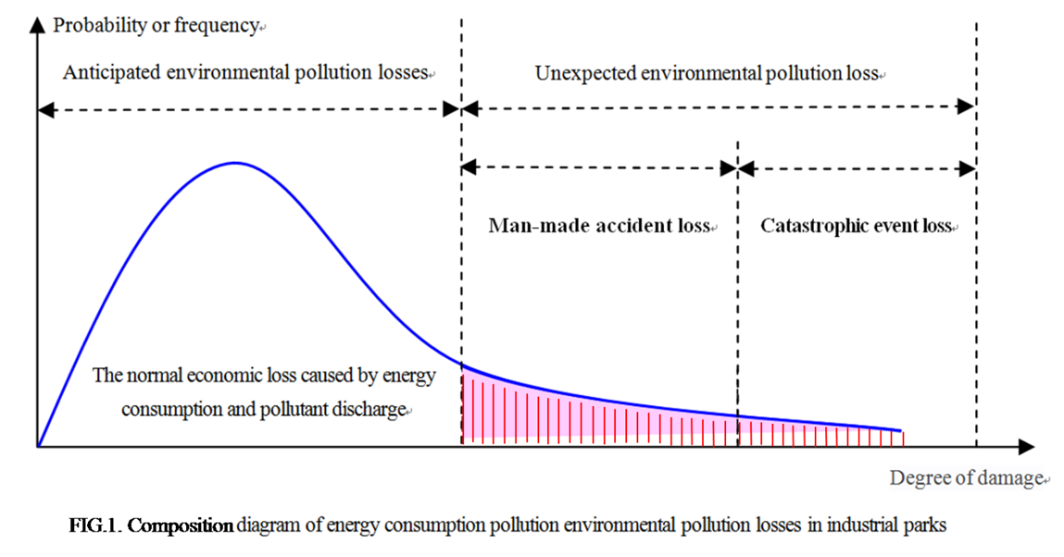

**Fig. 1.** Comparison diagram of environmental pollution from energy consumption loss in industrial parks

The environmental pollution losses of waste emissions from energy consumption in the industrial park are measured, that is, the regional loss covered by the red line under a certain degree of confidence in the above figure. To effectively measure the environmental pollution losses of waste emissions from energy consumption in industrial parks, the environmental pollution loss events disclosed in the industrial parks are counted, and the samples are arranged in descending order according to the amount of loss so that the environmental pollution accident loss event distribution can be subject to a generalised extreme value distribution and can be used to measure environmental pollution losses measurement through distribution tests and parameter estimates. According to the requirements of environmental pollution loss measurement, appropriate methods should be selected to determine the threshold under the distribution law of environmental pollution loss, and the over-threshold distribution approximately follows the generalised Pareto distribution according to the relevant theories of probability theory. The generalised Pareto distribution and VaR theory can be used to construct the measurement model of the maximum and limit value of the environmental pollution losses. Finally, taking Nanjing MV Industrial Park as an example, application research is carried out to verify the effectiveness of the research method.

2.2. Determination of the distribution function of environmental pollution loss

2.2.1. Construction of generalised extreme value distribution function

The environmental pollution losses caused by waste emissions from energy consumption in industrial parks are the maximum value (VaR) and extreme value (ES) of the distribution of extreme values of environmental pollution losses with a certain degree of confidence. The extreme value distribution function is the probability distribution of the maximum or minimum value in the probability theory. The maximum or minimum value selected from many independent samples should be subject to the probability density distribution function $f\left(X\right)$. If the sample $X_{1},X_{2},⋯,X_{n}$ of environmental pollution losses of energy consumption in industrial parks is an independent random variable with the same distribution, arranged in ascending order, its distribution function is $F\left(x\right)$. TMB represents the maximum value of the sample, tML represents the minimum value of the sample, and n is a natural number, then: MB = max[X1, X2, …, Xn], ML = min[X1, X2, …, Xn]. According to the extreme value distribution theory of probability theory, if FB (x) is used to represent the distribution function of the maximum value, and FL (x) is used to represent the distribution function of the minimum value, then the distribution function of the environmental pollution losses of wastes emission from energy consumption in industrial parks can be expressed as: FB (x) = Pr (MB≤x) = Pr (X1≤, X2≤,…, Xn≤), FL (x) = Pr (ML≤) = 1-FB (x) = 1-Pr (X1≤, X2≤,…, Xn≤). Wherein $x∈R$. In the above equation, R is the set of all real numbers. If the distribution function $F\left(x\right)$ is known, the maximum or limit value of environmental pollution losses can be accurately calculated. According to the extreme value theorem of probability theory, the following formula is valid for the existence of constant sequences $\left\{a_{n}>0\right\}$ and $\left\{b_{n}\right\}$:

|  |  |
| --- | --- |
|  | (1) |

H(x) is a degenerate distribution function in the above formula, and an and bn are normalised constants. After standardisation, the distribution of independent identically distributed random variables must belong to one of the following three types of distribution: (1) Gumbel distribution: H1(x) = exp{-e-x}, -∞<x<+∞; (2) Fréchet distribution: when x≤0, H2(x,α) = 0, when x > 0, H2(x,α) = exp{-x-α}, wherein α > 0; (3) Weibull distribution: when x≤0, H3(x,α) = exp{-(-x)α}, when x > 0, H3(x, α) = 1, wherein α > 0. The distribution of the three types looks very different but can be converted to each other through appropriate transformations. According to the extreme value theory, the maximum distribution is stable if and only if the distribution function is one of the three extreme value distributions. According to Mises' (1954) transformation, three types of extreme value distributions are simplified as follows: when ξ≠0, Hξ (x) = exp {-(1+ξx)-1/ξ}; when ξ = 0, Hξ (x) = exp {-x}. Where, ξ is the shape parameter, and when ξ≠0, then 1+ξX > 0. In this case, the above equation conforms to the condition of generalised extreme value distribution, which can be converted to generalised extreme value distribution. To convert it, the position parameter μ and size parameter σ are introduced to convert the above equation into the following equation:

|  |  |
| --- | --- |
|  | (2) |

The above equation is called a generalised extreme value distribution, denoted as a GEV distribution, where parameter ξ determines the shape and type of the distribution function, also known as the extreme value exponent of the GEV distribution. When ξ < 0, the above formula is Weibull distribution; When ξ = 0, the above formula is Gumbel distribution; When ξ > 0, the above formula is Fréchet distribution, this distribution has the characteristics of a thick-tailed distribution, and the positive correlation of the shape parameter determines the thickness of the tail ξ. According to the above GEV distribution function, the corresponding probability density function is determined as follows:

|  |  |
| --- | --- |
|  | (3) |

2.2.2. Construction of average excess function and threshold distribution function

When using the GEV distribution function to model the actual data, it is necessary to group the observation value sequence X1, X2, …Xn and divide it into k groups with length m. The maximum value from each group is denoted as Z, and then the maximum value sequence is Z1, Z2, …Zn. As long as the sample length m is large enough, the maximum sequence can be viewed as an independent co-distribution observation from the GEV distribution H ($x$; μ, σ, ξ). In actual modelling, the maximum value's boundary should also be considered beside the variable group's length. Assume that Z1, Z2, …Zn are independent identically distributed random variables, distribution function F on the support of the endpoint for Z*, there is a large enough fixed value u < Z*, u is called a threshold (threshold), if Z > u, it is called an over threshold (exceedance), Z > u is called an excess, according to the theory of the rule of law in probability theory, when threshold u is large enough, the excess X-u approximately obeys the Pareto distribution. Here, the distribution function of the excess is expressed as F[u] (z) = Pr(Z≤z| Z > u) = [F(z)-F(u)]⋅[1-F(u)]-1, z≥0. The above is the distribution function of the over-threshold variable of random variable X, or the excess distribution for short. According to relevant theories of probability theory, the density function of excess distribution corresponding to excess distribution is

|  |  |
| --- | --- |
|  | (4) |

Where $\bar{F}(u)$ is the average excess distribution functions due to the difference between the excess distribution and the over threshold distribution, the over threshold distribution function and the corresponding density function of zi, a random variable, according to the relevant theories of probability theory: when x≥u, the equation F[u](z) is shown above. When $z≥u$, $f_{[u]}\left(z\right)=f\left(z\right)⋅{\left[\bar{F}\left(u\right)\right]}^{-1}$. In actual modelling, to facilitate the use of the average excess distribution function, according to the relevant theories of probability theory, the average excess function of the extreme value distribution random variable is determined as follows:

|  |  |
| --- | --- |
|  | (5) |

If Z is a positive random variable, the distribution function is F (z), the mathematical expectation is limited, and the support is (Z0,∞), Z0 > 0, then for 0 < u < Z*, the distribution function is continuous, and there is Z > 0, then:

|  |  |
| --- | --- |
|  | (6) |

2.2.3. Construction of generalised Pareto distribution function

The limited distribution of environmental pollution losses of industrial parks' waste emission from energy consumption is subject to the generalised Pareto distribution. According to relevant theories of probability theory, if the limit distribution has a threshold value u that is large enough, when X > u, the distribution of   
X-u is approximately GP distribution. Therefore, the generalised Pareto distribution function must be studied to measure the environmental pollution losses of waste emissions from energy consumption. Suppose X1, X2, …Xn is a sequence of independent identically distributed random variables, and the random variables have the same cumulative distribution function F(x). If the position parameter is μ, μ∈R; Size parameter is , > 0; The shape parameter is ξ, ξ∈R. Then:

|  |  |
| --- | --- |
|  | (7) |

X is subject to the generalised Pareto distribution, denoted as a GPD or GP distribution. Sometimes, the shape parameters are also represented by α, and there is another representation form of the generalised Pareto distribution, which is convenient for studying the relationship between the generalised Pareto distribution and the generalised extreme value distribution. Another representation of the generalised Pareto distribution is: (1) When $x$ ≥μ, $G_{1}\left(x;μ,σ\right)=1-e^{-\left[\left(x-μ\right)/σ\right]}$；When $x<μ$， $G_{1}\left(x;μ,σ\right)=0$. (2) When $x≥μ+σ$， $G_{2}\left(x;μ,σ\right)=1-{\left[\left(x-μ\right)/σ\right]}^{-α}$；When $x<μ+σ$, $G_{2}\left(x;μ,σ,α\right)$ = 0, wherein $α>0$. (3) When $x<μ-σ$, $G_{3}\left(x;μ,σ,α\right)=0$, when $μ-σ≤x≤μ,α>0$, $G_{3}\left(x;μ,σ,α\right)=1-{\left[-{\left(x-μ\right)}/σ\right]}^{α}$ = $1-{\left[{\left(x-μ\right)}/σ\right]}^{-α}$. The three forms of the generalised Pareto distribution (GPD) are similar to those of the generalised extreme value distribution (GEV). When μ = 0 and σ = 1, it is called standard GPD, and the distribution function is denoted as G ($x$; μ, σ, ξ) or Gi (; μ, σ, ξ). The following is the research on the transformation relationship between GPD and GEV to facilitate the measurement of environmental pollution losses. When ξ > 0, within the interval [μ, +∞], if α = ξ-1, then:

|  |  |
| --- | --- |
|  | (8) |

When ξ < 0, within the interval [μ, μ-/], if α = -1/, G($x$; μ, σ, ξ), The form of the formula remains unchanged, only the signs of the variables change. It can be seen that GPD and GEV can be converted after a certain transformation. The probability density function of GPD can be determined by using the theory and method of probability theory as follows:

|  |  |
| --- | --- |
|  | (9) |

If gi is used to represent the probability density function of the distribution function Gi, the probability density functions of the three types of generalised Pareto distributions can be expressed as follows: When , G1(; μ, σ, ξ) = σ-1e-[(x-μ)/σ]; when +σ, α > 0, G2(μ,σ,ξ) = α σ-1[(x-μ)/σ]-(1+α); when , G3. According to relevant theories of probability theory, when the threshold value u of extreme value distribution is large enough, the excess distribution is approximately GP distribution, and the excess distribution function can be expressed as when $z>0$ also $1+\left(\text{z/}\hat{σ}\right)>0$, $G\left(z;\hat{σ},\right)=$ 1-(1+ξ (z/))-1/ξ, The average excess function of generalized Pareto distribution G (x; μ, σ, ξ) is:

|  |  |
| --- | --- |
|  | (10) |

Among them: when 0 ≤ ξ < 1, then u > μ. When ξ < 0, then $μ≤u<μ-\left(σ/\right)$.

2.3. Determination of loss distribution threshold and construction of risk measurement model

2.3.1. Determination of loss distribution threshold

The determination of the threshold value of the loss distribution function is related to the status of the measurement results of environmental pollution losses. Suppose the selected threshold value is too small. In that case, it cannot meet the requirement that the threshold value should be large enough to make the excess not subject to the generalised Pareto distribution, and the generalised Pareto distribution cannot be used to estimate the maximum loss and limit loss. If the selected threshold value is too large, the samples of excesses will be small, and the estimation error will increase. According to the properties of the generalised extreme value of the generalised Pareto distribution, if the maximum value Mn approximately obeys the GVE Distribution H ($x$; μ, σ, ξ), then the excess X-u approximately obeys the generalised Pareto distribution $G\left(x;\hat{σ},\right)$, and has the same shape parameter ξ.

|  |  |
| --- | --- |
|  | (11) |

After solving the integral in the above-average excess function and simplifying the integral solution result, we can get the following formula:

|  |  |
| --- | --- |
|  | (12) |

According to the properties of the extreme value distribution function, when the shape parameter ξ < 1, the integral converges, and the limit is 0; when 0 < ξ < 1, the excess mean function of loss distribution can be expressed as:

|  |  |
| --- | --- |
|  | (13) |

Were, $u∈D\left(σ,\right),<1$. To determine the average excess function, the derivative of u in the above equation can be obtained: de(u)/du = ${}/{(1-)}=k$ (constant), we know that $e\left(u\right)$ is a linear function of u. With $e\left(u\right)$ as the ordinate andas the abscissa, the scatter plot is made. When u presents noticeable linear change after exceeding a certain critical $e\left(u\right)$, the u value can be determined as the threshold. According to the condition of constant k, the tail distribution of the average excess function can be judged. When $k>0$, it is a thick-tailed distribution; when $k=0$, it is a thick-tailed exponential distribution; when $k<0$, it is a thin-tailed distribution.

2.3.2. Determination of VaR and ES models

The environmental pollution losses from energy consumption in industrial parks are uncertain. Combining generalised extreme value distribution and generalised Pareto distribution can determine its maximum value (VaR) and extreme value (ES).

(1) The VaR model. Value at Risk (VaR) is the maximum possible loss of an asset or portfolio in a certain period in the future under a certain degree of confidence. The VaR model is the earliest financial risk measurement method proposed and used by Allen (1994). Therefore, the VaR model is often used to measure financial risk for a long time. As the environmental pollution losses of waste emissions from energy consumption in industrial parks are also a risk, its loss occurrence and loss distribution function are basically the same. The applicable loss distribution function can be constructed to measure the maximum value of environmental pollution losses that may occur in a certain period in the future. Under the above research conditions, economic loss of assets is defined as X < 0, confidence is determined as ω, and the probability of occurrence of value at risk of environmental pollution losses under a certain confidence degree can be expressed as:

|  |  |
| --- | --- |
|  | (14) |

This paper combines the generalised extreme value distribution and the generalised Pareto distribution to calculate the maximum value VaR of the environmental pollution losses caused by waste emissions from energy consumption in industrial parks. When confidence ω has been set, the above equation can be converted into:

|  |  |
| --- | --- |
|  | (15) |

The "-" in the above formula represents the loss value, and the symbol is hidden in the model. The value at risk, VaR, can be solved from the above formula, so the VaR measurement model of the maximum loss of energy consumption and pollution of the industrial park due to environmental pollution losses can be expressed as:

|  |  |
| --- | --- |
|  | (16) |

(2) The ES models. Expect Shortfall (ES) refers to the conditional expected loss beyond VaR generated by the asset or portfolio in a certain period in the future under a certain confidence degree, that is, the limit loss of the environmental pollution losses caused by the waste's emission from energy consumption of the industrial park. Arzner et al. (1999) first proposed and applied the ES model as a measurement method for limiting risk loss. Under the same conditions as the VaR model, the ES model is expressed as:

|  |  |
| --- | --- |
|  | (17) |

The above extreme value theory is used to construct the maximum loss VaR model and the limit loss ES model of the environmental pollution losses in industrial parks under specific conditions and a certain degree of confidence. Based on the determination and parameter estimation of the generalised extreme value distribution function and the excess generalised Pareto distribution function of maximum loss of waste emission from energy consumption in industrial parks, the maximum and extreme value of environmental pollution losses of wastes emission from energy consumption can be easily measured in industrial parks.

2.4. Parameter estimation of the distribution function and measurement model

2.4.1. Parameter estimation of generalised extreme value distributions

Maximum likelihood estimation, probability weight moment estimation, L moment estimation and other methods are often used in parameter estimation of generalised extreme value distribution. This paper uses the maximum likelihood estimation method to determine GVE distribution parameters. Suppose $X_{1},X_{2},⋯,X_{n}$ are random variables that obey the GVE distribution, when parameter $≠0$, the distribution logarithmic likelihood function is: $l\left(μ,σ,\right)=-m\log{σ}-1+{}^{-1}\sum_{i=1}^{m}{\log\left[1+\left({\left(x_{i}-μ\right)}/σ\right)\right]}-\sum_{i=1}^{m}{{\left[1+\left({\left(x_{i}-μ\right)}/σ\right)\right]}^{-1/{}}},$ wherein $1+\left({\left(x_{i}-μ\right)}/σ\right)>0,i=1, 2, ⋯,m$. When $>-0.5$, the asymptotic distribution of the maximum likelihood $\left(\hat{μ},\hat{σ},\hat{}\right)$ is a multivariate normal distribution, and the mean vector is $\left(μ,σ,\right)$. If $I_{0}\left(θ\right)$ is the observation information matrix at the maximum likelihood estimation value, then the covariance matrix of the estimated variable $\left(\hat{μ},\hat{σ},\hat{}\right)$ is: $I_{0}^{-1}\left(θ\right)$. With parameter estimation, the quantile can be estimated. As for 0 < *P* < 1, the maximum likelihood of the quantile can be estimated as: When $\hat{}≠0$, ${\hat{x}}_{p}=\hat{μ}-\left({\hat{σ}}/{\hat{}}\right)$ (1-zp-ξ); when   
,P = . Where, ${ z}_{P}=-\log{P}$, according to the delta method, it can be known that: $VaR\left({\hat{x}}_{P}\right)≈∇x_{P}^{T}V∇x_{P}$, V is the covariance matrix for $\left(\hat{μ},\hat{σ},\hat{}\right)$. Especially when $P=1$, ${\hat{x}}_{1}=\hat{μ}-{\hat{σ}}/{\hat{}}$. That is, when ξ > -0.5, the results of maximum likelihood estimation are asymptotic; When -1 < ξ < -0.5, the maximum likelihood estimation results are not asymptotic; When ξ < -1, the maximum likelihood estimation has no solution; When ξ < -0.5, it is a particular case of super-short upper tail distribution, which does not affect the practical application of maximum likelihood estimation.

2.4.2. Parameter estimation of the generalised Pareto distribution

According to the above analysis, the high threshold excess distribution of the extreme value distribution obeys the generalised Pareto distribution. According to the definition of the generalised Pareto distribution, the shape parameter ξ $∈R$ and the size parameter $σ>0$ can be obtained from the distribution. If the position parameter is not considered, the value of $μ=0$ can be obtained. Then, the distribution tail of two-parameter GP distribution $G\left(x;σ,\right)$ is equal to the 1-tail distribution function, and the result is: When $x≠0$, $\bar{G}\left(x;σ,\right)=1+{\left(x/σ\right)}^{-1/}$; when $x=0$, $\bar{G}\left(x;σ,\right)=e^{-x/σ}$, $x∈D\left(σ,\right)$. In the above formula, when   
ξ $>0$, then $D\left(σ,\right)=[0,∞)$; when $<0,$ then $D\left(σ,\right)=[0,-σ/]$. To estimate the parameters of the distribution function, we suppose that ${ X}_{1},X_{2},⋯,X_{n}$ are independent and identically distributed random variables, and the distribution function is $F∈MDAH\left(x,\right),∈R$, then we select a high threshold u, $N_{u}=\sum_{i=1}^{n}{I_{\left|x_{i}>u\right|}}$ is the number of times that exceed u in the random variables $Δ_{n}\left(u\right)=\left\{i:X>u\right\}$ stands for the subscript set of observation values exceeding the threshold u, denotes the corresponding excess ($Z_{i}=X_{i}-u$) with $Z_{1},Z_{2},⋯,Z_{N_{u}}$, and the excess distribution function is:

|  |  |
| --- | --- |
|  | (18) |

According to the probability theory, when the threshold value is large enough, the extreme value distribution is approximately the generalised Pareto distribution: ${\bar{F}}_{u}\left(z\right)≈G\left(z;σ\left(u\right),\right)$. According to equation (17), it can be known that: ${\bar{F}}_{u}\left(u+z\right)={\bar{F}}_{u}\left(z\right)\bar{F}\left(u\right)$, the tail estimate of F can be obtained by using the estimated ${\bar{F}}_{u}\left(z\right)$ and $\bar{F}\left(u\right)$. The empirical distribution function is used to estimate: $\hat{F}\left(u\right)$ = ${\bar{F}}_{n}\left(u\right)=(1/n)\sum_{i=1}^{n}{I_{\left|x_{i}>u\right|}}$ = Nu/n, the approximate formula is used to estimate: ${\bar{F}}_{u}\left(z\right)=\bar{G}$ ($z;\hat{σ},\hat{}$). Where: =ξNu, , when>0, the tail $\bar{F}\left(u+z\right)$, fractile ${\hat{x}}_{p}$ and the estimation supporting the right endpoint $x^{*}$ are: *u* =⋅[]-1/ξ = () ⋅[1+(X-u)-1]-1/ξ, p = u+()⋅[(n/Nu)⋅-1], $\hat{x}$* = u-(/).

2.4.3. Test of the measurement model of environmental pollution losses

The VaR model test tests the difference between the measurement result and the actual loss. It is usually tested by calculating the probability that the actual loss exceeds VaR and using $Kupiec$ test method. If the total number of days for environmental pollution losses test is T and the number of days for failure is N, when the confidence degree is ω, the expected probability of failure is: P(N) = 1-ω. If the failure frequency is p = N/T and the null hypothesis is $p=p^{*}$, the probability that the failure frequency is N times in the total sample number T can be obtained is： $P^{N}×(1-P)^{T-N}$. Based on the theory and method of $Kupiec$ test, the maximum likelihood ratio test was performed for the null hypothesis $p=p^{*}$, and the maximum likelihood function was constructed for the probability of failure days as follows:

|  |  |
| --- | --- |
|  | (19) |

A null hypothesis, also known as the "null hypothesis", is usually a hypothesis that states that the hypothesis content is wrong. Under the null hypothesis, the statistic LR subjects to $χ^{2}$ cloth with 1 degree of freedom. In general, the test results depend on the sample size, and if the VaR model does not fail, the margin between N/T and $p^{*}$ will gradually decrease as the sample size increases, showing a significant feature that the VaR model tested may have defects.

2.4.4. Estimation of measurement model parameters

The VaR model is established based on the generalised extreme value distribution function and the generalised Pareto distribution function. Therefore, the distribution function and the measurement model have the same parameters, and the parameter estimation of the distribution function can be used in the practical modelling and application process. If the parameters of the distribution function are not estimated, an effective method can be used to estimate the parameters of the VaR model. In this paper, maximum likelihood estimation is selected. Since the generalised Pareto distribution is the limit distribution of the generalised extreme value distribution, F(Zi) can be approximately replaced by $G_{σ,ξ}\left(Z_{i}\right)$. When $≠0$, the maximum likelihood function is:

|  |  |
| --- | --- |
|  | (20) |

Where ${ N}_{u}$ is the number of samples above the threshold when ξ > 0, Zi≥0; When ξ < 0, 0≤Zi≤-σ/ξ. The partial derivatives of the parameters ξ and σ in the above equation are obtained, and they are set to be equal to 0 to obtain the following equations:

|  |  |
| --- | --- |
|  | (21) |

The above equations contain the estimated values of equation parameters and $\hat{σ}$ that need to be determined, and the parameters and $\hat{σ}$ can be solved from the equations to determine the maximum value of environmental pollution losses of waste emissions from energy consumption in industrial parks. If ξ = 0, the maximum likelihood estimation function can be simplified as L(Zi;σ) $=-N_{u}\ln{σ}-σ^{-1}$ ⋅ $\sum{Z_{i}}$, $i$ = 1~. We take the derivative of the simplified function σ and set it equal to zero, and solve for the parameter estimate .

3. Case Studies

3.1. Basic data collection and analysis

Nanjing MV industrial park was founded in 1995 and 2000 to form the production scale. With a total area of 52.98 square kilometres, the park has 46 production-oriented enterprises. By the end of 2018, there were 301.78 million employees at the end of the period, with a total registered capital of 4.01276 billion yuan, a total investment of 12.5521.8 billion yuan, an output value of 14.62387 billion yuan, and a total profit and tax of 1.52438 billion yuan. Nanjing MV Industrial Park is a production-oriented enterprise which is characterised by energy-consuming production enterprises. The work of environmental pollution control has been carried out earlier, with initial results in 2000. The statistical data of the loss frequency and scale of environmental pollution loss accidents in Nanjing MV industrial park from 2004 to 2022 are shown in Table 1.

**Table 1.** Primary data of loss frequency and scale of environmental pollution in Nanjing MV industrial park from 2004 to 2022

|  |  |  |  |  |
| --- | --- | --- | --- | --- |
| Year | Frequency of pollution accidents (times) | | Pollution loss amount (ten thousand yuan) | |
| Number of accidents | Ratio (%) | Amount of money | Ratio (%) |
| 2004 | 29 | 2.93 | 1862.31 | 2.12 |
| 2005 | 31 | 3.13 | 2302.37 | 2.62 |
| 2006 | 34 | 3.43 | 2868.29 | 3.27 |
| 2007 | 40 | 4.04 | 3682.29 | 4.20 |
| 2008 | 46 | 4.65 | 3938.38 | 4.49 |
| 2009 | 49 | 4.95 | 4242.37 | 4.84 |
| 2010 | 53 | 5.35 | 4532.79 | 5.17 |

**Table 1.** cont.

|  |  |  |  |  |
| --- | --- | --- | --- | --- |
| Year | Frequency of pollution accidents (times) | | Pollution loss amount (ten thousand yuan) | |
| Number of accidents | Ratio (%) | Amount of money | Ratio (%) |
| 2011 | 56 | 5.66 | 4907.28 | 5.59 |
| 2012 | 59 | 5.96 | 5276.28 | 6.01 |
| 2013 | 62 | 6.26 | 5562.58 | 6.34 |
| 2014 | 64 | 6.46 | 5827.54 | 6.64 |
| 2015 | 61 | 6.16 | 5678.27 | 6.47 |
| 2016 | 60 | 6.06 | 5537.28 | 6.31 |
| 2017 | 60 | 6.06 | 5423.47 | 6.18 |
| 2018 | 58 | 5.86 | 5328.37 | 6.07 |
| 2019 | 59 | 5.96 | 5354.27 | 6.10 |
| 2020 | 58 | 5.86 | 5218.25 | 5.95 |
| 2021 | 56 | 5.66 | 5139.26 | 5.86 |
| 2022 | 55 | 5.56 | 5056.33 | 5.76 |
| Total of average | 990 | 100 | 87737.98 | 100 |

According to the data in Table 1, the frequency and amount of environmental pollution losses occurring in Nanjing MV industrial park from 2004 to 2022 are plotted in rectangular coordinates, showing the changing trend of environmental pollution losses, as shown in Figure 2.

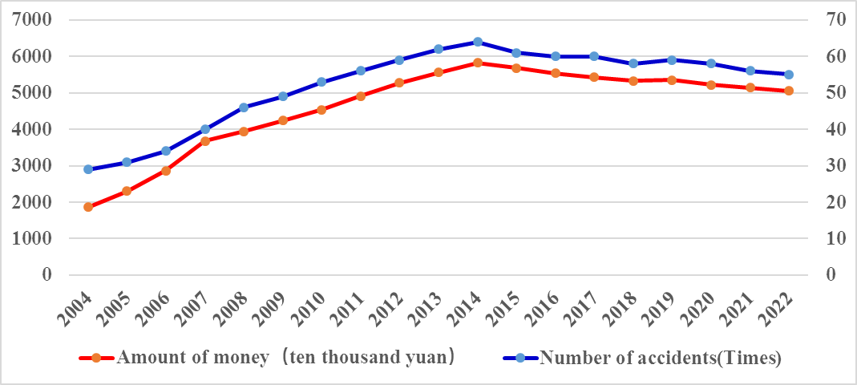

**Fig. 2.** Trend charts of loss frequency and loss amount of EPL in Nanjing MV industrial park

It can be seen from the figure above that the changes in the frequency and amount of environmental pollution losses of waste emission from energy consumption in Nanjing MV industrial park show the characteristics of approximate normal distribution, and the loss frequency and loss amount of environmental pollution losses have also shown a downward trend since 2014 which suggests that environment pollution treatment and control of park has been effective.

3.2. Test of sample normality and determination of distribution function

To verify the effectiveness of the GPD model, the statistical data of environmental pollution losses in Nanjing MV industrial park during 2004-2022 were selected. To measure the environmental pollution losses of industrial parks, these statistics should first be tested for non-compliance with normal distribution. Then, the related model parameter estimation and the environmental pollution loss measurement application research should be carried out.

(1) Normality test. If the extreme value distribution of the environmental pollution losses of the industrial park follows the normal distribution, the measurement of the environmental pollution losses becomes relatively simple. Therefore, generalised extreme value distribution and generalised Pareto distribution are introduced. The following QQ graph tests the normality of extreme value data of environmental pollution losses. According to the testing principle of the QQ graph, the actual quantile of the tested data and the quantile of the normal distribution are described in the figure below. If the tested data conforms to the normal distribution, the quantile of the QQ graph should show a diagonal change trend. The QQ graph drawn by relevant application software on the statistical data in Table 1 is shown in Figure 3.

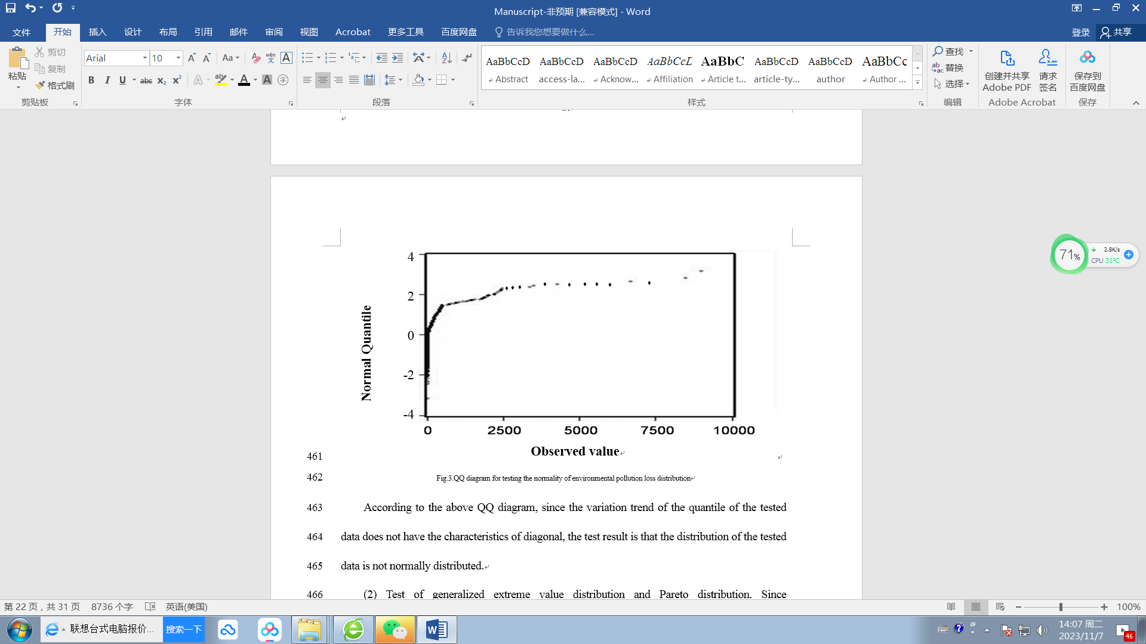

**Fig. 3.** QQ diagram for testing the normality of environmental pollution loss distribution

According to the above QQ chart, due to the diagonal feature of the data quantiles, it is proven that the data distribution is not normal.

(2) Test of generalised extreme value distribution and Pareto distribution. Since environmental pollution loss data of waste emissions from energy consumption in industrial parks are disclosed or submitted by enterprises, it is a certain period of extreme value. There are 990 samples of these statistics; all samples are arranged in descending order from large to small. The maximum value of the sample loss was 7,612.3641 million yuan, and the minimum value was 10.256 thousand yuan, which has the characteristics of generalised extreme value distribution. Since the generalised extreme value distribution and the generalised Pareto distribution have the same shape parameters, that is: ξ = 0.4217, the generalised extreme value distribution is $Fréchet$ distribution. According to the comprehensive analysis results, $Fréchet$ distribution has the characteristics of the thick-tailed distribution. The environmental pollution losses of waste emissions from energy consumption are determined using the generalised Pareto distribution function of excess quantity (X-u). According to the properties of the generalised Pareto distribution function, when the threshold value is determined to be 56 million yuan, the threshold value is large enough, and the number of excess quantities is 186, which is also large enough. Therefore, the distribution of $X-u$ is approximately GP, meeting the condition of using VaR and ES to measure the environmental pollution losses in the industrial park.

3.3. Threshold selection and parameter estimation

There are many methods to determine the threshold of extreme value loss distribution. In this paper, the mean excess function is selected. The mean excess function has been constructed, and the parameter estimation regarding formulas (3) ~ (6) has been studied. Based on the principle of the average excess function method, combined with the average excess sample, the average residual life of the sample is drawn in the rectangular coordinate system in Figure 4.

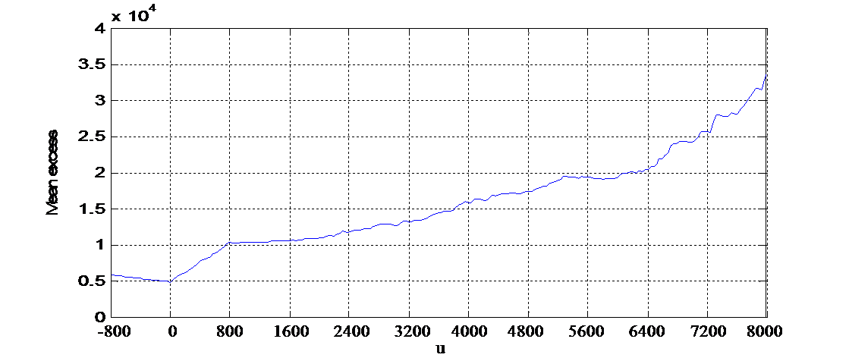

**Fig. 4.** Scatter plot of average excess of environmental pollution loss

According to the scatter plot diagram of the average excess of samples, the average excess of environmental pollution loss starts to be stable at 56 million yuan. According to the principle of determining the threshold value with the average excess method, the threshold value should be 56 million yuan, that is, u = 56 million yuan. The maximum likelihood function was carried out using formula (21), and the derivatives of σ and ξ were set equal to zero, respectively, to determine the parameters of the measurement model for the environmental pollution losses. The estimated values of the parameters $\hat{σ}$ and of the measurement model were obtained as follows: the threshold value u = 5600, scale parameter ξ = 0.4217, shape parameter σ = 186.4187, super threshold number Nu = 168. The parameters of the above equation can be used to determine the measurement model of environmental pollution losses of waste emissions from energy consumption in industrial parks and to judge the tail characteristics of the distribution. Since k = de(u)/du = ξ/ (1-ξ) = 0.4217/ (1-0.4217) = 0.7292 > 0, the tail of loss distribution has the characteristics of the thick tail distribution. In addition, as the threshold value is determined to be 56 million yuan, which is large enough, it is also sufficient to have 168 samples of the over-threshold value. The parameters of both models are greater than or equal to zero, and the estimation values of the parameters of these equations can be used to measure the maximum and limit loss of environmental pollution losses under different confidence degrees conveniently.

3.4. Determination of VaR and ES models

According to the above analysis result, the environmental pollution losses of wastes emission from energy consumption in Nanjing MV industrial park obey the generalised extreme value distribution; the excess distribution after determining the threshold is subject to the generalised Paretto distribution, the parameters of the measurement model of the environmental pollution losses of wastes emission from energy consumption in industrial parks have also been determined, the identified model parameters are substituted into the original model. As the number of samples is n = 990, the number of over-threshold samples is k = 168, and the confidence degree of model measurement is 0.95-0.99, the VaR and ES calculation results are shown in Table 2.

**Table 2.** Measurement results of value at risk (VaR) and expected shortage (ES)

|  |  |  |  |
| --- | --- | --- | --- |
| No. | Confidence level | VaR | ES |
| 1 | 0.95 | 4150.8921 | 6897.3131 |
| 2 | 0.96 | 4286.1636 | 7253.5124 |
| 3 | 0.97 | 4552.1438 | 7698.0762 |
| 4 | 0.98 | 5065.3216 | 8046.4217 |
| 5 | 0.99 | 5512.5726 | 8478.9416 |

The above table lists the measurement results of environmental pollution losses at different confidence degrees and determines the maximum and limit values of the environmental pollution losses in Nanjing MV industrial park. A maximum likelihood ratio test is carried out on the null hypothesis P = P*, to verify the validity of the measurement results using the test method. The failure rate returned is less than expected, and the model measurement results are compelling.

4. Analysis and Discussion of Measurement Results

4.1. Analysis of measurement result

Based on the above measurement results, the maximum and limited loss of the environmental pollution unexpected economic losses of the Nanjing MV industrial park from 0.95 to 0.99 confidence degree were determined, and the control scope of the environmental pollution losses was determined. The maximum environmental pollution losses range from 41,508,921 yuan to 55,125,726 yuan, and the limit loss ranges from 68,933,131 yuan to 84,789,416 yuan. To ensure the validity of the measure results, according to the research design, parameter estimation and test of the distribution function and measurement model were carried out, and we ensure that the statistical data of environmental pollution is consistent with the generalised limit distribution, the threshold determined is reasonable, the number of excess samples meets the requirements of the measurement and obeys the generalised Pareto distribution, the results show that environmental pollution loss in Nanjing MV industrial park has apparent characteristics of thick tail distribution and validity of measurement results is verified.

4.2. Discussion of measurement results

According to the above research results, the environmental pollution loss of waste emissions from industrial parks' energy consumption includes expected losses and unexpected risk losses. To discuss the measurement results of environmental pollution losses in Nanjing MV Industrial Park in terms of waste emission from energy consumption, according to the measurement results under five different confidence degrees, with the increase of confidence degree, the requirement to reduce the environmental pollution losses is increasing, and the corresponding maximum and limit values of the environmental pollution losses are also increasing. From the perspective of measurement results and the difference between them and actual loss, the environmental pollution losses of Nanjing MV industrial park account for between 5% and 10% of the total loss, and the unexpected environmental pollution loss management has gradually become an essential achievement for industrial parks to tap their potential and improve economic benefits. The measurement of environmental pollution losses caused by waste emissions from energy consumption in Nanjing MV Industrial Park broadens the scope of environmental pollution loss management. It divides the environmental pollution loss caused by waste emissions from energy consumption into expected loss and unexpected risk losses. According to Xiuyan Han et al. (2019) calculation results of expected environmental pollution loss of waste emission from energy consumption in Nanjing MV industrial park, the composition and relationship of expected and environmental pollution losses of waste emission from energy consumption in industrial park can be analysed. The above measurement model is used to measure the environmental pollution losses in Nanjing MV Industrial Park from 2016 to 2022, and the expected environmental pollution loss in the same period is collected. The specific data are as follows:

**Table 3.** Analysis table of EPL at the confidence degree of 0.95 in Nanjing MV industrial park

|  |  |  |  |  |  |  |  |
| --- | --- | --- | --- | --- | --- | --- | --- |
| In order (year) | 2016 | 2017 | 2018 | 2019 | 2020 | 2021 | 2022 |
| Anticipated EPL (ten thousand yuan) | 97554 | 97514 | 95113 | 96287 | 96268 | 91556 | 90625 |
| Unexpected loss VaR (ten thousand yuan) | 5805 | 5436 | 5169 | 4859 | 4637 | 4426 | 4151 |
| Unexpected loss VaR proportion (%) | 5.62 | 5.28 | 5.15 | 4.80 | 4.60 | 4.61 | 4.38 |
| Unexpected loss ES (ten thousand yuan) | 8108 | 7956 | 7784 | 7504 | 7298 | 7065 | 6897 |
| Percentage of unexpected losses (%) | 7.67 | 7.54 | 7.56 | 7.23 | 7.05 | 7.16 | 7,07 |
| The lower limit of total EPL (ten thousand yuan) | 103359 | 102950 | 100282 | 101146 | 100905 | 95982 | 94776 |
| The upper limit of total EPL (ten thousand yuan) | 105662 | 105470 | 102897 | 103791 | 103566 | 98621 | 97522 |

Note, EPL: environmental pollution losses.

As can be seen from the analysis results in the above table, when the confidence degree is 0.95, the expected environmental pollution loss and the environmental pollution losses of the MV industrial park in Nanjing show a slight downward trend during 2016-2022. The expected environmental pollution loss decreased from 975.54 million yuan in 2016 to 906.25 million yuan in 2022. The maximum loss of environmental pollution losses dropped from 58.05 million yuan in 2016 to 41.51 million yuan in 2022. The limit value of environmental pollution losses dropped from 81.08 million yuan in 2016 to 68.97 million yuan in 2022. The upper and lower limits of expected environmental pollution losses and environmental pollution losses over the years also show a slight downward trend. The total loss range in 2016 was [103359, 105662], and in 2022 it dropped into [103359, 105662].

5. Conclusions and Suggestions

This paper constructed an unexpected measurement model of environmental pollution losses and a threshold model of environmental pollution losses. The environmental pollution loss measurement method of pollutant emissions from energy consumption in Nanjing MV industrial park is studied and applied. Research has found that the proportion of unexpected losses caused by environmental pollution in Nanjing MV Industrial Park is between 5% and 10% of the total losses. Measuring and controlling unexpected losses caused by environmental pollution in industrial parks has become a significant task in controlling environmental pollution losses in industrial parks. According to this paper's research results, controlling and reducing unexpected losses caused by environmental pollution in industrial parks should be carried out from the following aspects:

1. Strengthen research on the distribution of environmental pollution losses from energy consumption in industrial parks and explore appropriate environmental pollution loss governance measures based on specific environmental pollution loss distribution functions;
2. Strengthen the research on the threshold of unexpected losses in environmental pollution and implement different governance strategies for unexpected losses in environmental pollution based on different threshold governance intervals;
3. Conduct in-depth research on the composition of environmental pollution losses from energy consumption in industrial parks and adopt different governance methods and levels based on the nature of unexpected losses caused by environmental pollution;
4. Strengthen the research on the distribution rule and threshold strategy of unexpected environmental pollution from energy consumption in industrial parks, strengthen the dynamic governance of unexpected environmental pollution losses from energy consumption in industrial parks, and promote sustainable development.

*This research was funded by the National Social Science Foundation of China, project number BJL035.   
The authors would like to thank the National Office of Philosophy and Social Sciences for funding.*

*This work has received funding from the general project of the National Social Science Foundation of China:   
"Research on the mechanism and supportive policies of environmental pollution cooperative governance in the process of regional integration development of the Yangtze River delta", Approval number: 19BJL035.*

Reference

Artzner, P., Delbaen, F., Eber, J-M., Heath, D. (1999). Coherent Measures of Risk. *Mathematical Finance*, *9*, 203-228. https://doi.org/10.1111/1467-9965.00068.

Barboza, E.P., Montana, F., Cirach, M., Iungman, T., Khomenko, S., Gallagher, J., Thondoo, M., Mueller, N., Keune, H., MacIntyre, T., Nieuwenhuijsen, M. (2023). Environmental health impacts and inequalities in green space and air pollution in six medium-sized European cities. *Environmental Research*, *237*(1), 116891.

Bai, J., Kailu, Guo, K.L, Liu, M.R., Jiang, T. (2023). Spatial variability, evolution, and agglomeration of eco-environmental risks in the Yangtze River Economic Belt, China. *Ecological Indicators*, *152*, 110375.

Brown, T.C., Nannini, D., Gorter, R.B., Bell, P.A., Peterson, G.L. (2002). Judged seriousness of environmental losses: reliability and cause of loss. *Ecological Economics*, *42*(3), 479-491.

Francová, A., Chrastný, V., Šillerová, H., Vítková, M., Komárek, M. (2017). Evaluating the suitability of different environmental samples for tracing atmospheric pollution in industrial areas. *Environmental Pollution*, *220*(1), 286-297.

Han, X.Y., Cao, T.Y. (2021). Study on corporate environmental responsibility measurement method of energy consumption and pollution discharge and its application in industrial parks. *Journal of Cleaner Production*, *326*, 129359.

Han, X.Y., Sun, T., Feng, Q. (2019). Study on environmental pollution loss measurement model of energy consumption emits and its application in industrial parks. *Science of the Total Environment*, *668*(11), 1259-1266.

Han, X.Y., Cao, T.Y. (2022). Study on the evaluation of ecological compensation effect for environmental pollution loss from energy consumption: Taking Nanjing MV Industrial Park as an example. *Environmental Technology & Innovation*, *27*, 102473.

Hashemi, S.J., Ahmed, S., Khan, F.I. (2015). Loss scenario analysis and loss aggregation for process facilities. *Chemical Engineering Science*, *128*(10), 119-129.

Liu, X.R., Sun, T., Feng, Q, Zhang, D. (2020). Dynamic environmental regulation threshold effect of technical progress on China's environmental pollution. *Journal of Cleaner Production*, *272*, 122780.

Mamipour, S., Yahoo, M., Jalalvandi, S. (2019). An empirical analysis of the relationship between the environment, economy, and society: Results of a PCA-VAR model for Iran. *Ecological Indicators*, *102*(7), 760-769.

Nam, K.M., Selin, N.S., Reilly, J.M., Paltsev, S. (2010). Measuring welfare loss caused by air pollution in Europe: A CGE analysis. *Energy Policy*, *39*(9), 5059-5071.

Phalitnonkiat, P., Sun, W.X., Grigoriu, M.D., Hess, P., Samorodnitsky, G. (2016). Extreme ozone events: Tail behavior of the surface ozone distribution over the U.S. *Atmospheric Environment*, *128*(3), 134-146.

Norton, R.L., Oakes, D.B., Cole, J.A. (1996). Pollution risk management for resource protection. *Water Science and Technology*, *33*(2), 119-131.

Schmitt, R.E., Klee, H., Sparks, D.M., Podar, M.K. (1998). Using Relative Risk Analysis to Set Priorities for Pollution Prevention at A Petroleum Refinery. *Advances in Chemical Engineering*, *24*, 329-399.

Son, C.H., Oh, D., Ban, Y.U. (2023). Eco-industrial development strategies and characteristics according to the performance evaluation of eco-industrial park projects in Korea. *Journal of Cleaner Production*, *416*, 137971.

Shen, Z.Y., Qiu, J.L., Qian, H, Chen L. (2014). Simulation of spatial and temporal distributions of non-point source pollution load in the Three Gorges Reservoir Region. *Science of The Total Environment*, *493*(17), 138-146.

Shen, Y.F., Shi, X.P., Variam, H.M.P. (2018). Risk transmission mechanism between energy markets: A VAR for VaR approach. *Energy Economics*, *75*(5), 377-388.

Wang, Z.X., Yu, Y.J., Ye, T.T., Fei, J.C., Song, X.Y., Peng, J.W., Zhou, Y.Y., Wu, H.H. (2022). Distribution characteristics and environmental risk assessment following metal(loid)s pollution incidents at Southwest China mining site. *Transactions of Nonferrous Metals Society of China*, *32*(12), 4062-4075.

Wang, W., Wang, H.B., Huang, J., Yang, H.J., Li, J.F., Liu, Q.L., Wang, Z.L. (2023). Causality and dynamic spillover effects of megacities on regional industrial pollution reduction. *Heliyon*, *9*, e14047. https://doi.org/10.1016/j.heliyon.2023. e14047

Watmough, S.A., Hutchinson, T.C., (2004). The quantification and distribution of pollution Pb at a woodland in rural south-central Ontario, Canada. *Environmental Pollution*, *128*(3), 419-428.

Yuan, R.X., Ma, Q., Zhang, Q.Q., Yuan, X.L., Wang, Q.S., Luo, C.W. (2022). Coordinated effects of energy transition on air pollution mitigation and CO2 emission control in China. *Science of The Total Environment*, *841*, 156482.

Zhang, H.W., Liu, R.Z., Liu, J., Zhang, Z.J. (2022). Formal probabilistic risk analysis of accidental air pollution in a development zone using Bayesian networks. *Journal of Cleaner Production*, *372*, 133774.