|  |  |  |  |
| --- | --- | --- | --- |
|  |  | | |
| **Rocznik Ochrona Środowiska** | | |
| Volume 25 | Year 2023 ISSN 2720-7501 | pp. 342-356 |
|  | https://doi.org/10.54740/ros.2023.035 open access | | |
|  | Received: December 2023 Accepted: December 2023 Published: December 2023 | | |

Use of Infrared Imaging Techniques to Investigate Thermal Losses   
of Flat Plate Solar Collectors

Paweł Znaczko

Koszalin University of Technology, Koszalin, Poland   
https://orcid.org/0000-0002-7050-914X

corresponding e-mail: [pawel.znaczko@tu.koszalin.pl](mailto:pawel.znaczko@tu.koszalin.pl)

**Abstract:** The paper presents ways to use advanced infrared imaging techniques to study and analyze the thermal losses of a flat plate solar collector. The techniques allowed us to precisely locate and measure areas where unwanted thermal losses occurred on the surface of the collectors studied. The study showed that these losses have a key impact on the energy efficiency of these devices. It was found that using the proposed methodology allows not only the detection of defects in existing structures but also the optimization of the design process of new technical solutions. The temperature of the working medium has a significant effect on heat losses on all analyzed surfaces. However, the influence of the medium flow varies depending on the specific surface. The conclusions of the research suggest that infrared imaging is a valuable tool in developing solar thermal systems, contributing to the reliability and efficiency of these systems. The technique is an important step toward sustainable and economical use of solar energy. Increasing the efficiency of the equipment used to carry out the photothermal conversion process will allow more efficient use of available renewable energy sources. It will have a positive impact on environmental protection.

**Keywords:** infrared imaging, solar collector, thermal losses, radiation, environmental protection

1. Introduction

Issues related to the growing challenges of climate change and the depletion of currently exploited fossil fuel resources are now a key aspect of many research efforts worldwide. The need to provide energy security and the desire to protect our planet's environment are forcing humanity to make collective efforts toward finding ways to diversify energy sources. Despite their many positive aspects, the use of renewable energy sources such as wind, solar, and geothermal energy also brings significant problems and challenges. The most important of these include the necessity of changing the energy infrastructure, the constant variability of energy demand, the problem of storing processed energy and the need to integrate new power grids with existing ones (Chamier-Gliszczynski et al. 2023). In addition to technical considerations, economic, political and often social problems remain. All these components affect the rate of adaptation of renewable energy technologies (Kabir et al. 2017). However, despite these problems, there is a clear trend toward increasing use of green energy sources. From an economic point of view, we can note huge investments in green energy worldwide, as well as the rapid development of technologies related to its processing. Efforts are constantly being made to increase the availability of renewable resources and improve the efficiency of their use. Renewable energy is already playing and will continue to play a key role in shaping our planet's sustainability, environmental protection and energy future (Suman 2021). As such, energy-related devices should be more user-oriented. Therefore, its development could be run by design thinking methodology (Kostrzewski 2018) and planning (Staniuk et al. 2022).

One of the most promising areas of renewable energy sources is solar energy. The energy flux emitted by the sun is a great example of an ecological and renewable energy source next to wind farms, photovoltaic and photothermal installations with water-flowing turbines (Maćkowiak et al. 2023). The electromagnetic wave spectrum includes light visible to the human eye, UV radiation and infrared. In addition, it can be converted into many useful forms of energy, such as heat or electricity. From an environmental point of view, solar energy is one of the best energy sources. Its ecological nature manifests itself mainly in its renewability – from a human perspective, the sun offers an inexhaustible energy source. Moreover, the extraction of such energy does not affect the Earth's environment as negatively as the mining of fossil fuels. The great availability of solar energy also remains an undeniable advantage. The only limitations and difficulties to its use come from the inability to control weather conditions and more prosaic economic (Lenort et al. 2019) factors due to the significant investment costs necessary to build an appropriate energy infrastructure (Kabir et al. 2017).

The most important topics undertaken in research on the broad topic of solar energy research in recent years are summarized in Table 1.

**Table 1.** Summary of research papers addressing issues in the field of solar energy utilization

|  |  |
| --- | --- |
| Research area | Source |
| Research on optimizing the distribution of flat plate solar collectors in a selected area | Jafari et al. 2022 |
| A comprehensive review of strategies for integrating solar heating systems for industrial processes | Tasmin et al. 2022 |
| Analysis of selected control methods in solar thermal systems. | Znaczko et al. 2022,  Znaczko et al. 2021,  Kuczynski et al. 2021 |
| Develop an original method that is an effective tool for assessing the condition of photovoltaic modules. | Trzmiel et al. 2021 |
| A mathematical study of the hybrid power system was developed and experimentally verified to simulate various operating conditions and evaluate optimal design results. | Tao et al. 2021 |
| An experimental and theoretical study of the presence of covalently functionalized graphene (Gr) suspended in distilled water as a working fluid inside an indoor flat plate solar collector (FPSC). | Alawi et al. 2021 |
| Statistical analysis of measurement results for photovoltaic modules installed in stationary and biaxial configurations. | Bugała et al. 2021 |
| Detailed study and optimization of an organic Rankine cycle working with CO2. | Bellos & Tzivanidis 2021 |
| A novel approach to using embedded control in power generation consisting of a hybrid system of solar and wind energy placed in isolated areas. | Nalina et al. 2023 |
| A classic and systematic literature review combined with a bibliometric analysis of the literature on electromobility logistics and the business ecosystem. | Grzesiak & Sulich 2023 |
| A preview of easy and reliable diagnostics of photovoltaic system faults. | Olchowik et al. 2023 |
| Analysis of the resonance problem of parallel harmonics for hybrid compensation systems consisting of active power filters and thyristor capacitors. | Wang et al. 2023 |
| A novel control strategy for 3-phase 4-wire PV inverters that provides PV active power transmission and simultaneous compensation of load imbalance and reactive power. | Mieński et al. 2023 |
| A method for evaluating the impact of radiated electromagnetic interference generated by a selected railroad traction vehicle on the process of operating trackside video surveillance systems (VMS). | Paś et al. 2022 |
| Experimental results of a flat plate solar collector with polyisocyanurate (PIR) foam thermal insulation. | Kaminski et al. 2019 |
| A procedure that determines the effect of specific design parameters on the thermal performance of a solar collector. | Kamiński et al. 2019a,  Znaczko 2021a |

The article is divided into six sections. Section 2 characterizes the study subject and introduces the theory of thermal imaging measurements. Section 3 presents the test stand used during the experimental work on the study of thermal losses of a flat plate solar collector. The obtained measurement data are presented in Section 4, which flows smoothly into Section 5, discussing the obtained test results. Section 6 summarises the research work, the most important conclusions from the results obtained and possible directions for further research.

2. Subject of the Study

In the energy sector, the use of solar radiation can be divided into two main groups (Carra et al. 2023):

* photovoltaic,
* photothermic.

Both groups include devices for harvesting and converting solar energy, but their applied uses are fundamentally different. Photovoltaics use solar energy to generate electricity, while photothermal systems allow using the sun's energy for heating purposes. The basic and, at the same time, the most important component of photothermal systems in energy storage and conversion is the solar collector (Daghigh et al. 2016). It is a device that converts solar energy into thermal energy thus, its primary use is to heat water or residential spaces. The literature separates two basic types of solar collectors, as shown in Figure 1.

**Fig. 1.** Comparison of the construction of vacuum tube collector (a) and flat plate collector (b)

Vacuum collectors are characterized by a specific design involving connecting several to a dozen long vacuum tubes together in a transverse channel, known as a manifold. Inside the tubes, there is a metal heat pipe (usually copper) filled with a small amount of liquid. The idea behind the heat pipe is the evaporation of the working fluid caused by the heat stored on the absorber. In this way, the heat is transferred toward the top and then to the working water flowing through the manifold. The cooled working fluid condenses in the heat pipe evaporator and then drops to the bottom, and the whole cycle begins again. The heat pipe is insulated from the environment by a vacuum created in a glass tube. Such a design significantly reduces heat loss and results in vacuum tube collectors showing higher energy efficiency than conventional flat-plate collectors (Carra et al. 2023). The principle of operation of a vacuum solar collector is presented in Figure 2.

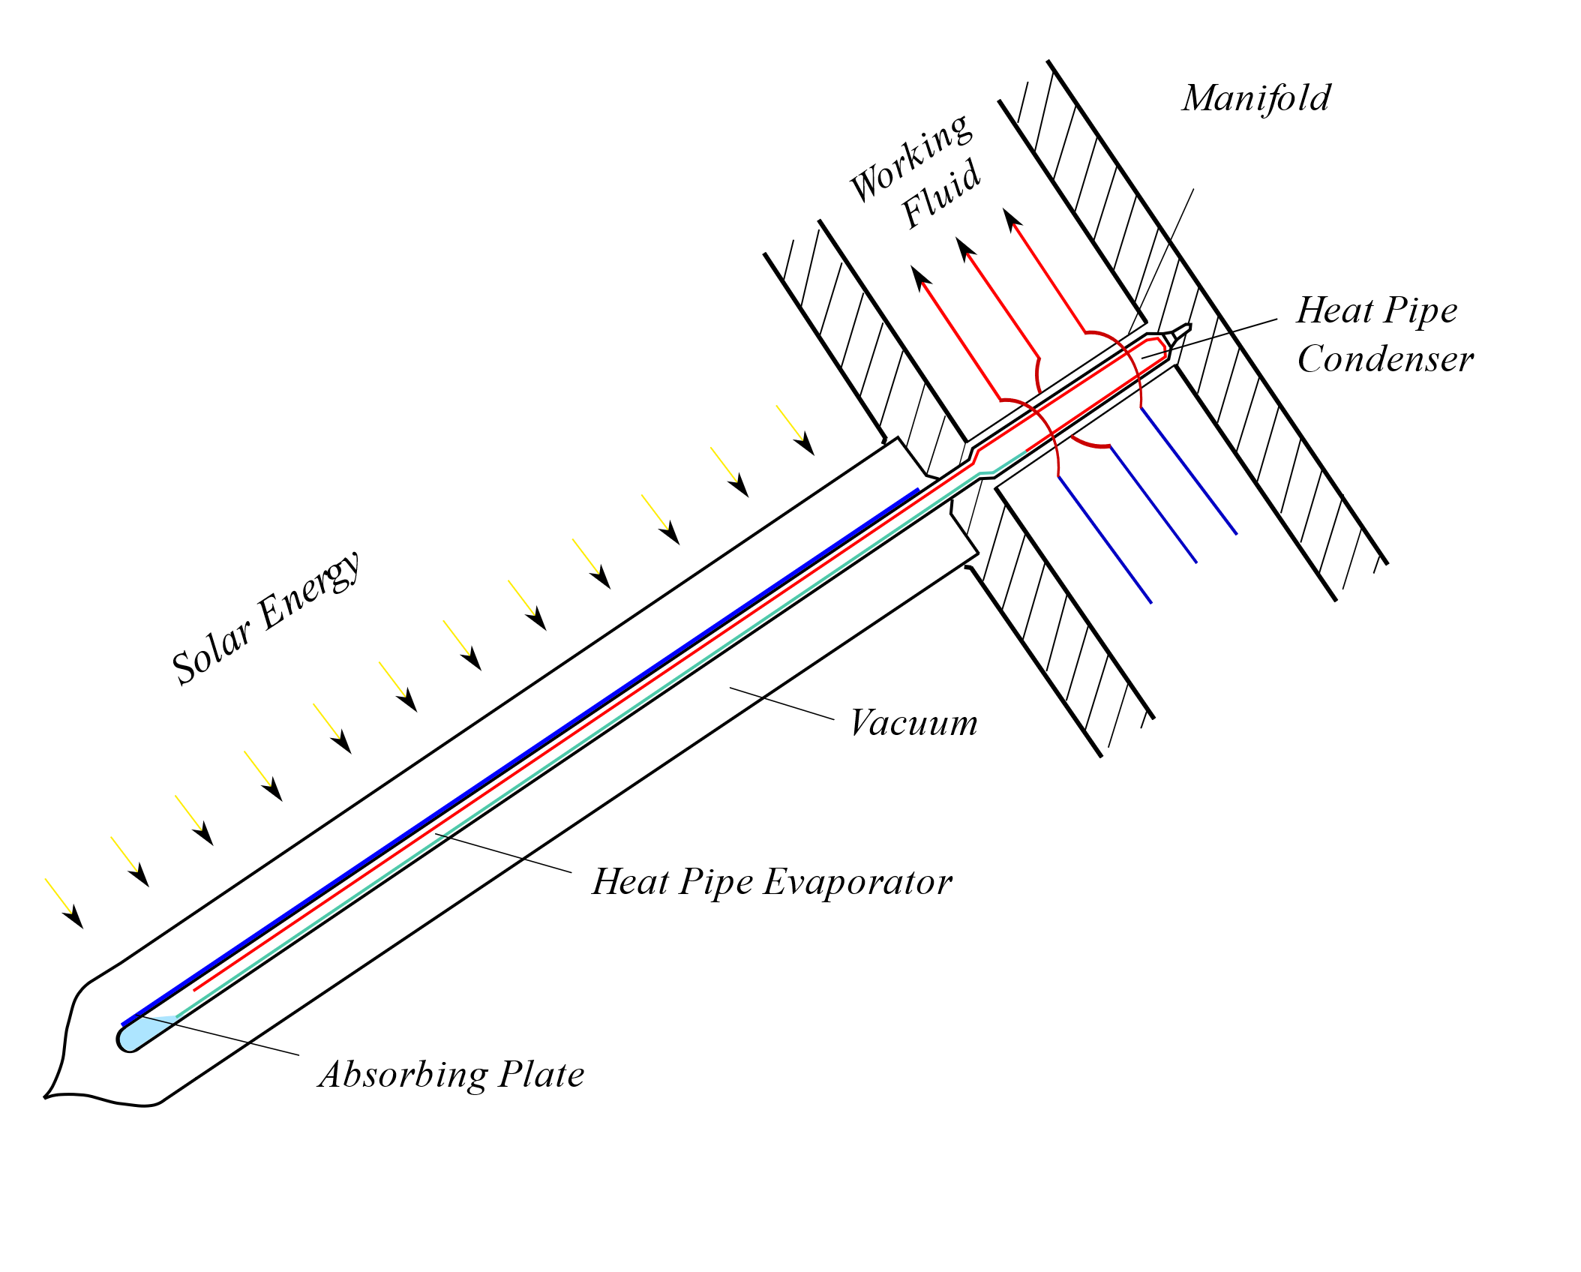

**Fig. 2.** The principle of vacuum tubes

However, flat plate structures are much more popular and far more common these days, and they will be the object of the study in this article.

A flat solar collector consists of a flat, usually rectangular frame to which an absorber plate is attached, which is a thin sheet of aluminium or copper coated with a highly selective coating to absorb as much solar radiation as possible. The absorber itself is always placed on a layer of insulation to minimize heat loss on the sides and back of the collector. It is connected to vertical copper tubes through an ultrasonic welding process. These tubes are brazed into different types of structures to form a heat exchanger, usually with a meander or harp shape. Such a structure is covered with a transparent, well-transparent glass covering, often tempered to protect the absorber from external factors (Kalogirou 2004). A cross-section through the design of a flat plate solar collector is presented in Figure 3.

**Fig. 3.** Construction of a flat plate solar collector

In the most basic terms, solar radiation that reaches the surface of the collector should infiltrate the glass covering of the structure and reach the absorber with as much quantity as possible. On its surface, solar radiation energy is converted into thermal energy. This heat is transferred to the working medium (glycol or water) flowing through the exchanger pipes, transported in the system and collected by water from the storage tank.

Many external and internal factors affect the efficiency of flat plate solar collectors. Some of the most important include the collector's angle with respect to the sun and the absorber used. However, one of the key factors is the quality of the thermal insulation of the structure. This issue can be considered in several aspects (Duffie et al. 2013):

**Type of insulation** – the type of material, preferably with low thermal conductivity, often mineral wool or polyurethane. The material must resist harsh operating conditions such as moisture or high temperature.

**Insulation thickness** – the dependence of losses on the thickness of the insulating layer is very intuitive. The thicker the insulation layer, the lower the measured thermal losses on the collector should be. Increasing the thickness of the insulation layer, however, is associated with undesirable increases in the weight and size of the structure.

**Fire safety** – materials selected for insulating solar collector structures should be non-combustible to avoid fire risks.

**Insulation tightness** – any leaks and leakage through the insulating layer will significantly affect its ability to retain heat inside the structure. Therefore, it is crucial to connect and seal around the joints and edges of the collector properly.

**Lifespan** – the materials used should be characterized by resistance to degradation over time. The resistance of the insulating material of the collector determines the maintenance of its energy efficiency.

The glass covering also hugely influences the degree of insulation of a flat plate solar collector structure (Duffie et al. 2013). The solar radiation flux on the collector, without additional optical concentration, can be approximately more than 1000 [W/m2]. Most of this energy is transferred to the working medium as thermal energy. The remaining energy, on the other hand, is lost to the environment by the solar collector through radiation and convection. It was decided that a flat plate solar collector would be subjected to thermographic testing for heat loss. This decision was based on several key factors:

* it is the most widely used solar collector design, which makes any research based on the use of these devices more applicable,
* in general, flat plate collectors are less expensive than vacuum collectors, so studying them provides information on more economically viable devices,
* such designs have existed longer on the market; therefore, in most scientific studies, flat plate solar collectors serve as the standard and benchmark to compare with new devices.

The next stage of the research work was to study the thermal losses of a flat plate solar collector using a thermal imaging camera. A popular flat plate solar collector design from Kospel with the model designation KSH-2.0 was selected for the study. Basic information about the studied collector is collected in Table 2.

**Table 2.** Technical specification of the KSH-2.0 solar collector

|  |  |
| --- | --- |
| Type of solar collector: | Flat-plate liquid-based |
| Manufacturer / Brand: | KOSPEL S.A. / KSH-2.0 |
| Gross / Aperture / Absorber area: | 2.27 / 1.98 / 2.00 [m²] |
| Length / Width / Height of the collector: | 2.12 / 1.1 / 0.09 [m] |
| Absorber construction: | Parallel channels |
| Connection method: | Ultrasonic welding |
| Number of working channels | 9 pcs |
| Absorber material (channels / absorbing plate): | Copper / Copper |
| Dimensions of the absorbing plate (height / width / thickness): | 985 / 2030 / 0.2 [mm] |
| Liquid volume: | 1.13 [dm³] |

A test stand was prepared to conduct thermal loss tests of the selected collector model.

3. Experimental Setup

Emissivity tables for specific surfaces are used to determine the surface temperature of materials using a thermal imaging camera. However, there are strong reasons to determine the emissivity coefficients for each material independently in this type of research, without relying entirely on the table values but using them only as a suggestion and aid. The same materials may have different surface emissivity, e.g. due to surface defects or gaps in the covering of elements (Zhu et al. 2022, Zheng et al. 2023). Therefore, at the beginning of the work, it was determined that the surfaces for which the emissivity coefficients would be determined were points on the solar collector casing. The collector housing is a composite of the front, side and rear surfaces. For the tests, the rear and side surfaces' emissivity was considered equal. This assumption resulted from the observation that they were made of the same material and covered by the manufacturer with an identical paint coating of identical thickness. For simplicity, the coefficient *εs* = *εb* will determine the coefficient *εs*, equal to their values.

*εs* = *εb* = *εc* (1)

A sample was taken from the back surface of an identical reference collector. It was made of the same material by the same manufacturer. That made it possible not to affect the efficiency of the item tested at a later stage. A sample was also taken from the front surface of the collector. A laboratory station was created to measure the surface temperature of materials using a FLIR T335 thermal imaging camera to determine the emissivity coefficient of the collected samples. The appearance and list of elements included in the stand are shown in Figure 4.

**Fig. 4.** Temperature distribution measuring stand; 1 – Thermovision camera, 2 – Heat plate, 3 – computer,   
4 – hygrometer, 5 – pyrometer

Basic information on the measuring instruments used is collected in summary form in Table 3.

**Table 3**. Basic parameters of measuring devices

|  |  |  |  |
| --- | --- | --- | --- |
| Measured quantity | Device name | Accuracy | Measurement Resolution |
| Temperature [°C] | FLIR T335 | ±2°C | 0.05°C at  30°C |
| Humidity [%] | DeltaOHM HD 2101.2 | *±*0*,*1%RH | 0,1%RH |
| Temperature [°C] | Optris LaserSight | *±*0*,*75°C | 0*,*1°C |

Then, tests were carried out on the samples taken under the procedure for determining surface emissivity (Carlson et al. 2014). Emissivity coefficients were determined based on the correspondence between the temperature of the touchdown probe and the temperature indicated by the thermal imaging camera. As a result of the tests, it was measured that *εc* = 0,95 and *εt* = 0,97. The results of the thermal imaging measurements are shown in Figure 5.

**Fig. 5.** Results of thermal imaging measurements of collected samples

With the values of the emissivity coefficients of the lateral and front surfaces determined this way, it proceeded to the actual study of the thermal losses of the solar collector under study.

It was necessary to build a solar collector test stand To study the thermal losses of a flat plate solar collector. The stand allowed measuring the solar collector's temperature during its natural operating conditions in the heating system. Therefore, an existing test stand at the Koszalin University of Technology was used. It consisted of water storage tanks, a measurement data acquisition station, a solar controller and an external mounting platform on which the solar collector was mounted. The appearance of the stand is shown in Figure 6a.

Based on the first series of thermal imaging images, a significant negative effect of the contact of the aluminium profiles of the solar collector frame on the temperature distribution of its rear surface was observed. Therefore, to level out these interferences, it was decided to modify the mounting stand of the solar collector itself. The new stand was to allow correct measurement of temperatures both on the rear surface of the housing and on the side surfaces and glass covering of the collector. For this purpose, a special mounting bracket was created, the purpose of which was to minimize contact between the aluminium profiles and the casing of the collector itself. The new mounting method shown in Figure 6b used metal brackets, so that none of the profiles were in direct contact with the collector's rear or side surfaces.

a

**Fig. 6.** a) Test stand for solar heating systems; b) new solar collector mounting station

4. Use of Infrared Imaging Techniques to Investigate Thermal Losses of Flat Plate Solar Collectors

Many methods for determining the heat loss of solar collectors can be found in the literature. Some analyze the solar collector as part of a larger heating system. In contrast, others capture the problem of calculating heat losses in isolation from the environment in which the collector operates. The articles (Arés-Muzio et al. 2014, Rahman et al. 2023) present a method for calculating the total energy balance of a solar heating system that considers heat losses by evaporation, convection, radiation and conduction. It is a comprehensive approach that considers all major aspects of the energy balance. An alternative to this method is the simplified approach proposed by Z. Pluta (Pluta 2000). The author emphasizes that the temperature difference between the absorber and the surroundings is the most important when calculating the heat loss of a solar collector. About the study's main objective, which was the solar collector itself, the research paper used just such an approach to calculate the heat loss of a flat plate solar collector. As assumed in the formula:

$q=U(T_{psr}-T_{a}$) (2)

where:

$T_{a}$– ambient temperature,

$T_{psr}$– the average temperature of the absorber,

U – the equivalent heat loss coefficient for each surface area.

Next, a method of calculating the equivalent heat loss coefficient for the front (3), side (4) and rear (5) surface was defined:

$U_{g}=\frac{1}{\frac{1}{h_{c1}+h_{r1}}+\frac{1}{h_{c2}+h_{r_{2}}}}$ (3)

where:

$h_{c1}$– the coefficient of convective heat loss between the absorber and the glass,

$h_{c2}$– the coefficient of convective heat loss to the surroundings,

$h_{r1}$– the equivalent heat transfer coefficient by radiation between the absorber and the glass,

$h_{r_{2}}$– the equivalent heat transfer coefficient by radiation between the glass and the sky.

$U_{b}=\frac{λ_{b}A_{b}}{d_{b}A_{P}}$ (4)

where:

$λ_{b}$– thermal conductivity of the side of the collector,

$A_{b}$– the total external surface area of the collector sides,

$d_{b}$– thickness of insulation of the collector sides,

$A_{P}$– the surface area of the absorber.

$U_{d}=\frac{λ_{d}}{d_{d}}$ (5)

where:

$λ_{d}$– thermal conductivity of the bottom of the collector,

$d_{d}$– thickness of insulation of the bottom of the collector.

Then, according to the literature, the method of calculating the convective heat loss coefficients between the absorber and the glazing (6) and between the glass and the surroundings (7) was determined:

$h_{c1}=\frac{Nuλ}{d}$ (6)

where:

$λ$– thermal conductivity of air,

$d$– width of the gap (distance of the glass from the absorber),

$Nu$– the Nusselt number.

$h_{c2}=5,7+3,8v$ (7)

where:

$v$ is wind speed.

The last defined the value of the blunt heat transfer coefficient by radiation on the absorber-glass line. This coefficient allows us to determine heat transfer efficiency on the radiation path from the absorber to the glass. It also considers how heat is emitted and absorbed between the two surfaces.

$h_{r1}=\frac{σ\left(T_{psr}^{2}+{T_{c}}^{2}\right)\left(T_{psr}+T_{c}\right)}{\frac{1}{ε_{P}}+\frac{1}{ε_{c}}-1}$ (8)

where:

$T_{c}$– temperature of the glass,

$σ$– Stefan-Boltzmann constant,

$ε_{P}$– the emissivity coefficient of the absorber,

$ε_{c}$– emissivity coefficient of the glazing.

An analogous coefficient was determined for the glass-sky relationship:

$h_{r2}=\frac{σε_{c}\left({T_{c}}^{4}- {T_{n}}^{4}\right)}{T_{c}-T_{a}}$ (9)

where:

$T_{n}$– the temperature of the sky

All calculations of the heat loss of a flat plate solar collector included in this article were carried out following the presented relations.

Three series of tests were carried out, each for two medium temperatures, to study the simultaneous impact of operating medium temperature and mass flow rate on the thermal losses of the solar collector. Before starting the experimental tests, all components' correct operation and connection were checked on the test bench. Two series of measurements were carried out using a thermal imaging camera for different working medium temperatures: about 40°C and 80°C. Images were taken at three different values of the mass flow rate of the medium: 80, 120, and 160 kg/h. Within each series, images were taken of the surfaces of different sides of the solar collector: the glass front cover, the back plate, and both side plates.

National Instruments' LabView environment was used to collect measurement data. The measurement procedure involved:

* positioning the solar collector,
* cleaning it of any dirt,
* stabilizing the temperature of the working fluid at the desired level,
* stabilizing the flow rate of the working fluid at the desired level.

If all the operating parameters were satisfied and a steady state was achieved, thermal imaging of the front, rear and both side surfaces of the solar collector began. Several images were taken each time to exclude the influence of external interference. The images with the best measurement quality were always selected. Thermal imaging was then carried out to map the temperature distribution on the tested surfaces. First, tests were realized at an 80 [kg/h] fluid flow rate. After waiting 15 minutes, the flow rate was increased, and the entire measurement procedure was repeated. An example of the thermographic result of a flat plate solar collector for a working medium temperature of 40°C and flow rate of 80 [kg/h]has been presented in Figure 7.

A series of tests were conducted for higher temperatures to study the working fluid temperature's effect on the solar collector's thermal takeoff. Thermographic images of each surface with fluid in the collector heated to 80°C at three different flow rates were taken. An example of the thermographic result of a flat plate solar collector for a working medium temperature of 80°C and flow rate of 120 [kg/h]has been presented in Figure 8.

**Fig. 7.** Thermographic measurements of the collector made for a medium flow rate of 80 [kg/h] and a working medium temperature of 40 [°C]. a) front surface, b) rear surface, c) and d) side surfaces of the collector

**Fig. 8.** Thermographic measurements of the collector made for a medium flow rate of 120 [kg/h] and a working medium temperature of 40 [°C]. a) front surface, b) rear surface, c) and d) side surfaces of the collector

The values of thermal losses of individual collector surfaces at flow velocities equal to 80 [kg/h], 120 [kg/h], 160 [kg/h] and temperatures around 40°C and 80°C were calculated based on equation 2.

5. Results

The experimental work measured the temperature distribution on the collector surfaces using a thermal imaging camera. Tests were performed at different flow rates and working medium temperatures. Their purpose was to provide data for later analysis. The collector's thermal losses were calculated based on the collected data, as shown in Table 4.

**Table. 4.** Summary of heat losses from all the measurements taken

|  |  |  |  |  |
| --- | --- | --- | --- | --- |
| Working fluid Temp. | Flow Rate | Front Surface | Side Surface | Rear Surface |
| 40°C | 80 kg/h | 85.43 W/m² | 3.54 W/m² | 6.56 W/m² |
| 120 kg/h | 85.35 W/m² | 3.08 W/m² | 7.93 W/m² |
| 160 kg/h | 85.34 W/m² | 2.56 W/m² | 8.22 W/m² |
| 80°C | 80 kg/h | 184.18 W/m² | 10.14 W/m² | 23.13 W/m² |
| 120 kg/h | 184.42 W/m² | 9.84 W/m² | 22.94 W/m² |
| 160 kg/h | 184.42 W/m² | 9.59 W/m² | 22.84 W/m² |

The collected experimental data were used to determine the effect of the flow rate of the working medium and its temperature on the thermal loss of the solar collector. The results were illustrated in Figure 9 to facilitate such a task.

1. **Front Surface**:
   * For both tested temperature levels (40°C and 80°C), stable heat loss values at the front surface were observed for different flow rates. The loss values achieved for 80°C are significantly higher than those for 40°C, clearly indicating the strong influence of temperature on the heat loss of the solar collector.
   * In addition, no significant change in heat loss was observed when increasing the flow rate of the medium for both temperatures, suggesting that the mass flow rate of the working medium has a limited effect on heat loss at the front surface.
   * Heat loss values are 85 W/m2 for temperature 40°C and about 184 W/m2 for temperature 80°C.
2. **Side Surface**:
   * Like the front surface, the side surface also showed significantly higher heat loss at higher medium temperature (80°C) compared to 40°C.
   * Contrary to the front surface results, a small decrease in heat loss was observed for the side surface with increasing flow rate for both temperatures. This trend may indicate more efficient heat dissipation at higher flow rates.
   * It is worth mentioning that the losses on the side surfaces are several times smaller than those measured on the front surface of the solar collector (2-10 W/m2).
3. **Rear Surface**:
   * Heat losses on the rear surface of the tested solar collector also turned out to be higher for a temperature of 80°C. As on the other surfaces, increasing the temperature of the working medium had a negative effect on the level of recorded heat losses.
   * On this surface, an increase in heat loss was recorded with an increase in the medium flow parameter for both temperatures compared. It is the opposite trend from the side surface and may suggest that the factor flow affects heat distribution differently, specifically on the back surface.
   * The values of thermal losses through the back surface of the solar collector are in the middle of all results and, depending on the temperature of the medium, are about 7 W/m2 for the lower and about 23 W/m2 for the higher of the tested temperatures.

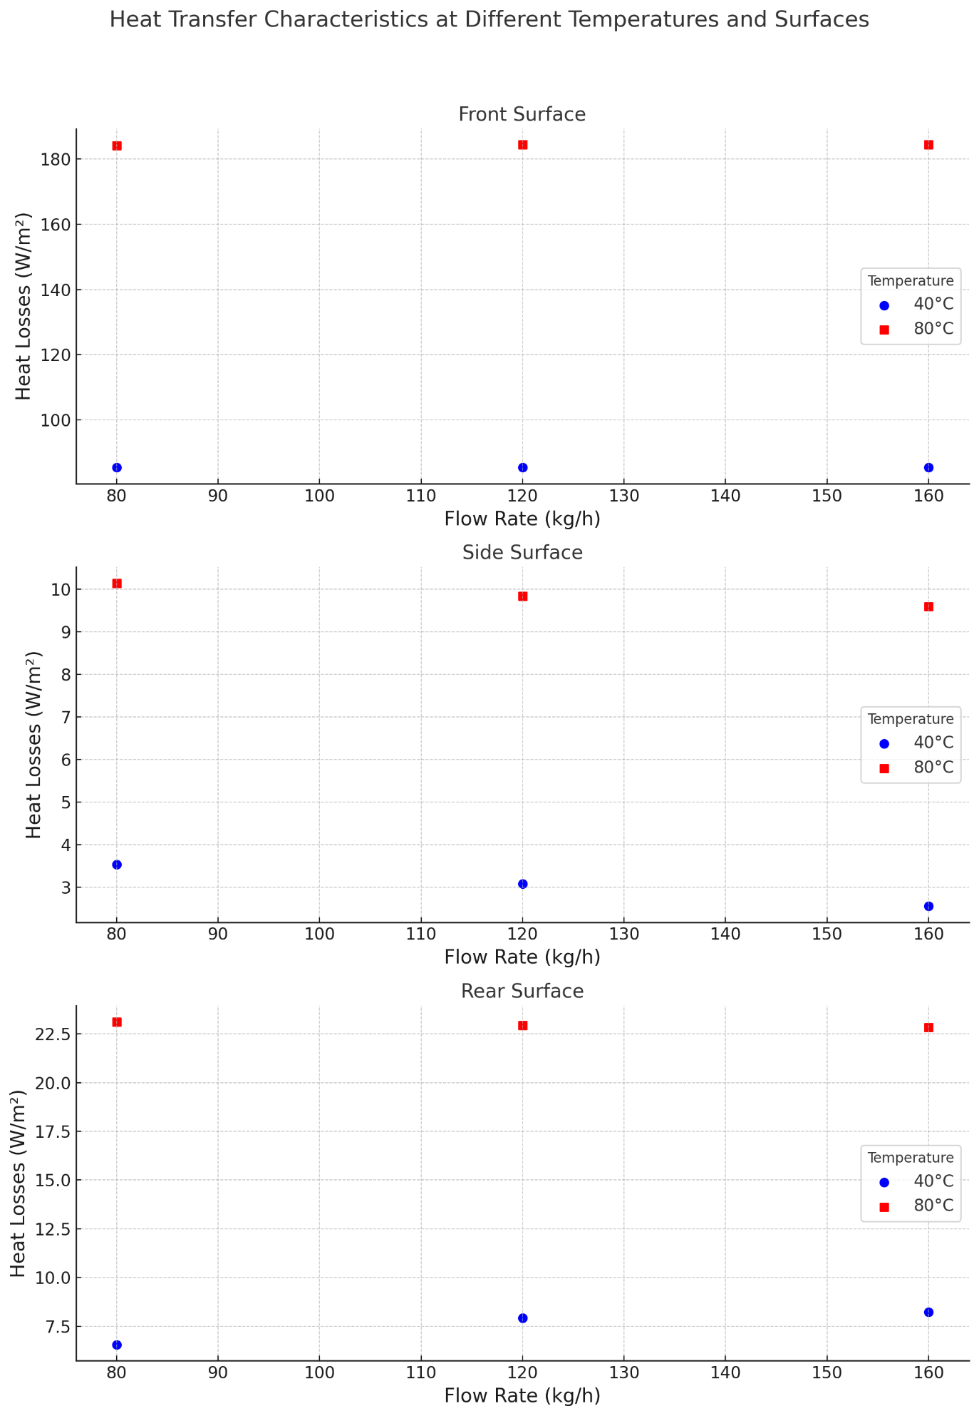

**Fig. 9.** Heat loss characteristics at different temperatures and surfaces

6. Conclusions

The results of the research work highlight the effectiveness of infrared imaging in improving solar thermal systems. This technology has tremendous potential and an important role in improving the reliability and efficiency of these systems. Appropriate infrared imaging techniques enable significant progress toward sustainable and cost-effective use of solar energy. Increasing the efficiency of photothermal conversion equipment positively impacts environmental protection. The average overall machine efficiency, i.e., OEE, is welcome in future research (Zwolińska et al. 2020).

Building a laboratory station for determining the emissivity of materials has made it possible to increase the accuracy of temperature measurements using a thermal imaging camera. It, in turn, has translated into much more accurate results in the study of the heat loss of a flat plate solar collector. During the research work, modifications to the laboratory bench were necessary. It turned out that the influence of the aluminium profiles on which the solar collector was originally mounted was significant for the results. As expected, the influence was strongest on the temperatures of the side surfaces and rear surfaces' temperatures. The reason for this is their direct contact with the frame. Modifying how the solar collector was mounted positively affected the ability to read the temperature distribution on each surface. It helped minimize the impact of interference from using aluminium profiles to mount the solar collector.

At 80°C, heat loss is much higher for each surface than at a temperature of 40°C. This is likely due to the large temperature difference from ambient (22°C). At 40°C, when the temperature of the medium is closer to ambient, losses reach much lower levels. Losses through the side walls of the collector decrease with the flow rate regardless of temperature due to the insulation used in the design under study. On the other hand, losses through the back plate of the collector behave differently at 40°C and 80°C: at high temperatures, they decrease, and at low temperatures, they increase with increasing flow velocity. This is probably because, at a higher temperature (80°C), the increased flow velocity of the medium allows better heat distribution inside the collector, resulting in lower losses through the back plate. At a lower temperature (40°C), the increased flow velocity may not be sufficient to distribute heat efficiently, leading to increased losses.

In summary, the thermographic results obtained and the calculations of thermal losses of the flat plate solar collector carried out on their basis indicate that the working medium's temperature significantly affects heat losses on all analyzed surfaces. However, the influence of the medium flow varies depending on the specific surface. The reason for this may be the complexity of the heat transfer process in this configuration.

More collector models using infrared cameras with better parameters will be studied to develop the research field. In addition, the collector's operation is planned to be monitored in real-time. Another direction worth exploring is the analysis of the ratio of the costs associated with using infrared imaging techniques to the gains from increasing the efficiency of the solar collector.

References

Alwi, O.A., Kamar, H.M., Mallah, A.R., Mohammed, H.A., Sabrudin, M.A.S., Newaz, K.M.S., Najafi, G., Yaseen, Z.M. (2021). Experimental and theoretical analysis of energy efficiency in a flat plate solar collector using monolayer graphene nanofluids. Sustainability, 13(10), 5416. https://doi.org/10.3390/su13105416

Arés-Muzio, O., Lizama-Tzec, I., Macias, J. D., Oskam, G., Cahue, A., de Coss, R., Cortes, C. (2014). Characterization of Thermal Losses in an Evacuated Tubular Solar Collector Prototype for Medium Temperature Applications. Energy Procedia, 57, 2121-2130. https://doi.org/10.1016/j.egypro.2014.10.177

Bellos, E., Tzivanidis, C. (2021). Investigation of a novel CO2 transcritical organic rankine cycle driven by parabolic trough solar collectors. Applied System Innovation, 4(3), 53. https://doi.org/10.3390/asi4030053

Bugała, A., Bugała, D., Jajczyk, J., Dąbrowski, T. (2021). Statistical Analysis of Electrical and Non-Electrical Parameters of Photovoltaic Modules in Controlled Tracking Systems. Rocznik Ochrona Srodowiska, 23, 694-714. https://doi.org/10.54740/ros.2021.049

Carlson, J., Menicucci, D., Vorobieff, P., Mammoli, A., He, H. (2014). Infrared imaging method for flyby assessment of solar thermal panel operation in field settings. Applied Thermal Engineering, 70(1), 163-171. https://doi.org/10.1016/j.applthermaleng.2014.05.008.

Carra, M. E., Setién, E., Valenzuela, L., López-Martín, R., Amador, C., Caron, S., ... Ávila-Marín, A. (2023). Study of parameters influence on the measurement of vacuum level in parabolic trough collectors' receivers using infrared thermography. Infrared Physics & Technology, 131, 104657. https://doi.org/10.1016/j.infrared.2023.104657

Chamier-Gliszczynski N., Trzmiel G., Jajczyk J., Juszczak A., Woźniak W., Wasiak M., Wojtachnik R., Santarek K. (2023). The Influence of Distributed Generation on the Operation of the Power System, Based on the Example of PV Micro-Installations, *Energies*, *16*(3), 1267. https://doi.org/10.3390/en16031267

Daghigh, R., Shafieian, A. (2016). Theoretical and experimental analysis of thermal performance of a solar water heating system with evacuated tube heat pipe collector. Applied Thermal Engineering, 103, 1219-1227. https://doi.org/10.1016/j.applthermaleng.2016.05.034

Duffie, J.A., Beckman, W. A. (2013). Solar Engineering of Thermal Processes. 2nd Edition. John Wiley & Sons, Hoboken. https://doi.org/10.1002/9781118671603

Feliński, P., Sekret, R. (2017). Effect of a low cost parabolic reflector on the charging efficiency of an evacuated tube collector/storage system with a PCM. Solar Energy, 144, 758-766. https://doi.org/10.1016/j.solener.2017.01.073

Grzesiak, S.S., Sulich, A. (2023). Electromobility: Logistics and Business Ecosystem Perspectives Review. Energies, 16(21), 7249. https://doi.org/10.3390/en16217249

Jafari, S., Sohani, A., Hoseinzadeh, S., Pourfayaz, F. (2022). The 3E Optimal Location Assessment of Flat-Plate Solar Collectors for Domestic Applications in Iran. Energies, 15(10), 3589. https://doi.org/10.3390/en15103589

Kabir, E., Kumar, P., Kumar, S., Adelodun, A., Kim, K.-H. (2017). Solar energy: Potential and future prospects. Renewable and Sustainable Energy Reviews, 82. https://doi.org/10.1016/j.rser.2017.09.094

Kalogirou, S. A. (2004). Solar thermal collectors and applications. Progress in Energy and Combustion Science, 30(3), 231-295. https://doi.org/10.1016/j.pecs.2004.02.001

Kaminski, K., Znaczko, P., Lyczko, M., Krolikowski, T., Knitter, R. (2019). Operational properties investigation of the flat-plate solar collector with poliuretane foam insulation. Procedia Computer Science, 159, 1730-1739. https://doi.org/10.1016/j.procs.2019.09.344

Kamiński, K., Królikowski, T., Błażejewski, A., Knitter, R. (2019a). Significant parameters identification for optimal modelling of the harp-type flat-plate solar collector. Smart Innovation, Systems and Technologies, 155, 495-505. https://doi.org/10.1007/978-981-13-9271-9_41

Kostrzewski, M. (2018). One Design Issue – Many Solutions. Different Perspectives of Design Thinking – Case Study. In: Uden L., Hadzima B., Ting IH. (Eds.) Knowledge Management in Organizations. KMO 2018. *Communications in Computer and Information Science*, 877, 179-190. Springer, Cham. https://doi.org/10.1007/978-3-319-95204-8_16

Kuczynski, W., Kaminski, K., Znaczko, P., Chamier-Gliszczynski, N., Piatkowski, P. (2021). On the correlation between the geometrical features and thermal efficiency of flat-plate solar collectors. *Energies*, 14(2), 261. https://doi.org/10.3390/en14020261.

Lenort, R., Baran, J., Wysokiński, M., Gołas, P., Bieńkowska-Gołasa, W., Golonko, M., Chamier-Gliszczyński, N. (2019). Economic and environmental efficiency of the chemical industry in Europe in 2010-2016. *Rocznik Ochrona Srodowiska*, *21*(2), 1398-1404.

Maćkowiak, A., Kostrzewski, M., Bugała, A., Chamier-Gliszczyński, N., Bugała, D., Jajczyk, J., Woźniak, W., Dombek, G., Nowak, K. (2023). Investigation into the Flow of Gas-Solids during Dry Dust Collectors Exploitation, as Applied in Domestic Energy Facilities – Numerical Analyses. *Eksploatacja i Niezawodnosc – Maintenance and Reliability*, 25(4). http://doi.org/10.17531/ein/174095

Mieński, R., Wasiak, I., Kelm, P. (2023). Integration of PV Sources in Prosumer Installations Eliminating Their Negative Impact on the Supplying Grid and Optimizing the Microgrid Operation. Energies, 16(8), 3479. https://doi.org/10.3390/en16083479

Nalina, B.S., Chilambarasan, M., Tamilselvi, S., Al Alahmadi, A.A., Alwetaishi, M., Mujtaba, M.A., Kalm, M.A. (2023). Design and Implementation of Embedded Controller-Based Energy Storage and Management System for Remote Telecom. Electronics, 12(2), 341. https://doi.org/10.3390/electronics12020341

Olchowik, W., Bednarek, M., Dąbrowski, T., Rosiński, A. (2023). Application of the Energy Efficiency Mathematical Model to Diagnose Photovoltaic Micro-Systems. Energies, 16(18), 6746. https://doi.org/10.3390/en16186746

Paś, J., Rosiński, A., Wetoszka, P., Białek, K., Klimczak, T., Siergiejczyk, M. (2022). Assessment of the Impact of Emitted Radiated Interference Generated by a Selected Rail Traction Unit on the Operating Process of Trackside Video Monitoring Systems. Electronics, 11(16), 2554. https://doi.org/10.3390/electronics11162554

Pluta, Z. (2000). *Theoretical Foundations of Photothermal Solar Energy Conversion*. Publishing house of the Warsaw University of Technology, Warszawa*.*

Rahman, M. A., Karim, M. R., Ehsan, M. M. (2023). Solar energy harvesting from evacuated flat plate collector: Design, thermo-economic analysis, and off design performance. Results in Engineering, 20, 101461. https://doi.org/10.1016/j.rineng.2023.101461

Suman, A. (2021). Role of renewable energy technologies in climate change adaptation and mitigation: A brief review from Nepal. Renewable and Sustainable Energy Reviews, 151, 111524. https://doi.org/10.1016/j.rser.2021.111524

Tao, M., Yu, Y., Zhang, H., Ye, T., You, S., Zhang, M. (2021). Research on the optimization design of solar energy-gas-fired boiler systems for decentralized heating. Energies, 14(11), 3195. https://doi.org/10.3390/en14113195

Tasmin, N., Farjana, S.H., Hossain, M.R., Golder, S., Mahmud, M.A.P. (2022). Integration of Solar Process Heat in Industries: A Review. Clean Technologies, 4(1), 97-131. https://doi.org/10.3390/cleantechnol4010008

Trzmiel, G., Jajczyk, J., Kardas-Cinal, E., Chamier-Gliszczynski, N., Wozniak, W., Lewczuk, K. (2021). The condition of photovoltaic modules under random operation parameters. Energies, 14(24), 8358. https://doi.org/10.3390/en14248358

Wang, H., Lei, H., Pei, X. (2023). Research on an Adaptive Compound Control Strategy of a Hybrid Compensation System. Processes, 11(7), 2109. https://doi.org/10.3390/pr11072109

Zheng, P., Liu, Y., Wu, H., & Wang, H. (2023). Non-invasive infrared thermography technology for thermal comfort: A review. Building and Environment, 111079. https://doi.org/10.1016/j.buildenv.2023.111079

Zhu, Y., Li, P., Ruan, Z., Yuan, Y. (2022). A model and thermal loss evaluation of a direct-absorption solar collector under the influence of radiation. Energy Conversion and Management, 251, 114933. https://doi.org/10.1016/j.enconman.2021.114933

Znaczko, P., Kaminski, K., Chamier-Gliszczynski, N., Szczepanski, E., Gołda, P. (2021). Experimental analysis of control methods in solar water heating systems. *Energies*, *14*(24), 8258. https://doi.org/10.3390/en14248258

Znaczko, P., Szczepanski, E., Kaminski, K., Chamier-Gliszczynski, N., Kukulski, J. (2021a). Experimental diagnosis of the heat pipe solar collector malfunction. A case study. *Energies*, *14*(11), 3050. https://doi.org/10.3390/en14113050

Znaczko, P., Kaminski, K., Chamier-Gliszczynski, N., Szczepanski, E., Gołda, P. (2022). Experimental analysis of control methods in solar water heating systems. Energies, 14(24), 8258. https://doi.org/10.3390/en14248258

Zwolińska, B., Tubis, A.A., Chamier-Gliszczyński, N., Kostrzewski, M. (2020). Personalization of the MES System to the Needs of Highly Variable Producticamieron. Sensors,20, 6484. https://doi.org/10.3390/s20226484