|  |  |  |  |
| --- | --- | --- | --- |
|  |  | | |
| **Rocznik Ochrona Środowiska** | | |
| Volume 25 | Year 2023 ISSN 2720-7501 | pp. 274-281 |
|  | https://doi.org/10.54740/ros.2023.029 open access | | |
|  | Received: October 2023 Accepted: October 2023 Published: November 2023 | | |

A Two-dimensional Numerical Model of Heat Exchange in the Soil Massif During   
the Operation of a Shallow Horizontal Soil Heat Exchanger

Boris Basok1, Anatoliy Pavlenko2, Oleksandr Nedbailo3, Ihor Bozhko4*, Maryna Moroz5

1Institute of Engineering Thermophysics of the National Academy of Sciences of Ukraine, Ukraine   
https://orcid.org/0000-0002-8935-4248

2 Kielce University of Technology, Poland   
https://orcid.org/0000-0002-8103-2578

3Institute of Engineering Thermophysics of the National Academy of Sciences of Ukraine, Ukraine   
https://orcid.org/0000-0003-1416-9651

4Institute of Engineering Thermophysics of the National Academy of Sciences of Ukraine, Ukraine   
https://orcid.org/0000-0001-7458-0835

5Institute of Engineering Thermophysics of the National Academy of Sciences of Ukraine, Ukraine   
https://orcid.org/0000-0001-5079-6340

*corresponding author's e-mail: bozhkoik@gmail.com

**Abstract:** The current article uses a two-dimensional numerical model to represent the results of theoretical studies of the heat exchange in the soil massif during the operation of a shallow horizontal soil heat exchanger. The analysis of literature sources showed that one of the important conditions for the effective operation of a shallow-soil heat exchange is its rational design parameters, such as the total length of the pipeline, the diameter of the pipe, the distance between the axis of the adjacent pipes, the depth of the heat exchanger placement, etc. A two-dimensional heat exchange model in the soil mass was developed, which made it possible to investigate the operation of a shallow horizontal soil heat exchanger. It was found that the step between the axis of the adjacent pipes of the multi-loop heat exchanger, which is 0.95 m, is optimal when creating a shallow horizontal soil heat exchanger in the soil conditions of Kyiv.

**Keywords:** shallow horizontal soil heat exchanger, heat flux, numerical modelling, renewable energy sources

1. Introduction

In Ukraine, autonomous heat pump heating, hot water supply, and air conditioning systems of buildings of various purposes designed to extract low-potential heat from the soil have become widespread. An important element of such systems is a shallow horizontal soil heat exchanger, whose efficiency significantly affects the coefficient of performance (COP) of the heat pump. The horizontal soil heat exchanger is usually a flat coil located in trenches where the heat carrier circulates. The advantage of shallow soil heat exchangers is the natural restoration in the warm period (owing to solar insolation or the use of the passive conditioning system) of the temperature of the soil massif after the operation of the heat pump system during the heating period.

Many publications are dedicated to the study of shallow soil heat exchangers. A paper (Lamarche 2019) proposes a simplified heat transfer model from underground horizontal heat exchanger tubes. The model simulates heat exchange between the water flowing inside the buried pipes and the surrounding soil, taking into account the soil surface's temperature, the soil's thermal properties, the distance between the pipes in each well and the distances between the wells. The model predicts the ground heat exchanger's required surface area, the pipes' length, the number of wells, and various configurations. The model also considers the pump power required to circulate the water through the soil heat exchanger.

The article (Saeidi Reza et al. 2023) shows the results of the study of cylindrical fins that were investigated for the first time in horizontal soil heat exchangers to improve the heat transfer and overall efficiency of the geothermal heat pump. These ribs have been investigated for various parameters: length, diameter, position, and material. Changes in the heat transfer rate with and without fins as soil properties change were also investigated. Cooling mode heat transfer simulations for a 1D-3D model showed that changing the fin diameter affects the outlet temperature and using non-isothermal flow for the tube. There is minimal difference between improvement and the increase in heat transfer rate when the fin exceeds 1 m.

Other works (Leski et al. 2021, Basok et al. 2022) show results of the numerical modelling that was carried out to study the minimum soil temperature that occurs during the extraction of thermal energy by the horizontal system of the soil heat exchanger under the conditions of the Central European climate. The influence of soil thermal conductivity, heat flow extracted from the soil, periodic interruptions in the operation of the heat exchanger, periodic supply of thermal energy to the soil, relative humidity of the surrounding air, the rate of evaporation, and the coefficient of convective heat transfer on the surface. Minimum temperatures were studied. As a result of the modelling, it was established that a high value of the thermal conductivity of the soil has a favourable effect on the operation of the installation with a soil heat exchanger.

The article's purpose (Albadry et al. 2022) was to review previous research on improving the heat and flow characteristics of the soil heat exchanger. Different factors were studied, such as:

* heat carrier (gas, antifreeze solution, microencapsulated suspension with phase transition and nanofluid),
* turbulence activator,
* soil heat exchanger (material and design parameters),
* backfill materials (conventional type, controlled material strength and material with the possibility of the phase transition),
* soil field (condition type, frozen soil and groundwater).

The paper (Liang et al. 2022) presents the thermal characteristics of a two-layer horizontal soil heat exchanger at different water mass flow rates in alternating and continuous cooling modes. A multilayer composite pipe was chosen as the material for the soil heat exchanger tubes. The influence of changes in the mass flow rate and operating conditions on the performance of a horizontal heat exchanger is discussed. For this purpose, an experimental two-layer soil heat exchanger was made. In the alternate mode of operation, the heat transfer was always higher than in the continuous mode of operation in the overhead heat exchanger.

The article (Lamarche 2019) presents an analytical model for the hourly modelling of ground heat exchangers with a horizontal configuration. The model is based on a new formalism of the finite linear source approach, which speeds up the simulation. The model presents a new approach to consider the effect of seasonal temperature fluctuations, especially when the inlet temperatures of the ground heat exchanger are specified. It also considers the effects of air-soil boundary conditions and thermal interference between different pipe sections in the buried field. The temperature, like the heat flow distribution along the ground heat exchanger, has become a part of the solution and was not determined in advance, as in previous models. The model does not consider possible phase changes due to ice formation or changes in moisture content associated with some horizontal configurations.

The purpose of the works (Šeďová et al. 2018, Basok et al. 2021, Pavlenko 2023) was to clarify the temperatures of the soil massif in the zone of the horizontal heat exchanger both during the heating season and during the idle period of the heat exchanger. The energy potential of the soil mass was estimated by the temperature difference of the soil mass in the heat exchanger area at the beginning and at the end of the heating season. The specific heat capacity of the soil heat exchanger was also determined, and the influence of the thermal resistance of the soil massif and the heat transfer coefficient between the inner wall of the heat exchanger pipe and the heat carrier was analysed.

2. Description of the Model

One of the important conditions for the effective operation of a shallow-soil heat exchange is its rational design parameters, such as the total length of the pipeline, the diameter of the pipe, the distance between the axis of the adjacent pipes, the depth of the heat exchanger placement, etc. The optimal values of these parameters can be obtained based on variant calculations of the thermal regimes of the heat exchangers with different specified values.

Since the accumulated heat of solar radiation is limited by a layer of soil with a thickness of no more than 10 m (Nakorchevskii 2008), for its extraction with the purpose of further use for the needs of heating systems and hot water supply, the most promising are systems using shallow horizontal soil heat exchanger. These include serpentine pipe systems, located at a depth below the depth of soil freezing with a step between pipes L = 0.5-1.5 m.

Below, the analysis of thermal processes in a soil massif equipped with such a pipe system is shown (see Fig. 1). In this case, you can limit yourself to the calculated depth of the massif H = 18 m. In the following calculations, the thermophysical properties of the soil were taken for podzolic soils.

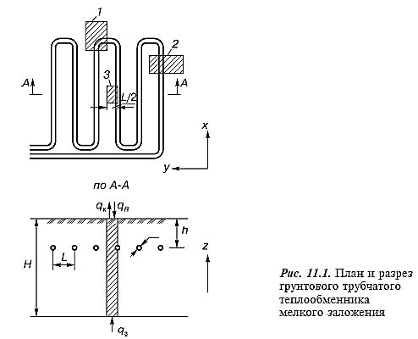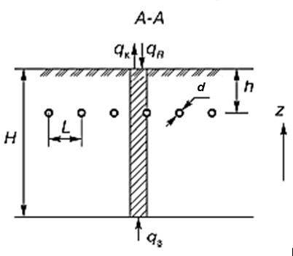

**Fig. 1.** The design of a shallow horizontal soil heat exchanger

Fig. 1 shows typical calculation zones, namely corner (1), peripheral (2), and central (3). The lateral boundaries of these zones are chosen so that the connection conditions with the associated sections are close to symmetrical, which simplifies the setting of boundary conditions for them. The central zone, which characterises the thermal processes on most of the pipe of the shallow soil heat exchanger, should be considered the main one. According to data from the literature (Honglei Sun et al. 2021), it is assumed that heat absorption by the system will not be large, and the temperature difference between the liquid heat carrier at the entrance to the system and the exit from it will not exceed several degrees Celsius.

Then, the thermal parameters calculated for zone 3 can be accepted as those corresponding to the average values for the entire pipe with fairly small deviations at the ends of the system. The thermal balance calculation establishes the measure of deviations. Therefore, the heat conduction equation for zone 3 can be written in a spatially two-dimensional formulation (*y*, *z*), which characterises the heat transfer per unit length of the pipe system by the formula:

 (1)

where:

λs – the coefficient of thermal conductivity of the soil massif,

ρs – soil density,

cs – heat capacity of the soil.

These thermophysical properties of the soil massif are considered unchanged.

The calculation area is shown in Fig. 2. Its height is *H* = 18 m. The width corresponds to half the step between the pipes *L*. If *L* = 0.5, then the width of the calculation area is *L*/2 = 0.25 m.

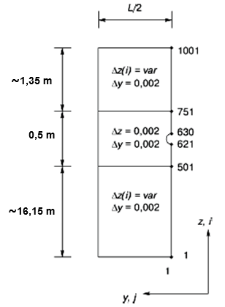

**Fig. 2.** Calculation area of a shallow horizontal soil heat exchanger

The initial conditions for equation (1) are set following the data given in (Lykov 1978). The soil temperature in Kyiv at a depth of 3.2 m from the earth's surface during the year has a value of 8.7-9.2°C. Based on this, the initial condition for equation (1) was taken as *T*(*0, z, y*) = const = 9°C. The time integration step is *Δt* = 90 s.

Boundary conditions of the third kind were established on the soil surface (*z* = 0), which take into account convection and radiation with the surrounding environment, as well as the influence of solar radiation

 (2)

where:

*αk* – the convection heat transfer coefficient,

*ε* – the degree of blackness of the earth's surface, which is taken to be equal to 0.9,

*c0* = 5.7 W/(m2K4) – radiation coefficient of an absolutely black body,

*Tp* – temperature of the outside air,

*Tamb* – the conventional temperature of the environment, which determines the radiation heat transfer from the soil surface,

*qs* – the heat flux density from solar radiation.

In the process of calculations, the time dependences of *Tp, Tamb,* and *qs* values, which change both during the year and the day, were approximated by polynomial dependences. The coefficient of convection heat transfer *αk* has been calculated using the equations:

at *w* > 5 m/s (3)

at *w* < 5 m/s (4)

where:

*w* – the wind speed, the average value for this area, has been determined from reference literature on meteorology.

The heat conduction equation describes the temperature field of a polyethylene pipe:

 (5)

where:

*λp* – the coefficient of thermal conductivity of polyethylene,

*ρp* – density of polyethylene,

*cp* – the heat capacity of polyethylene.

The thermophysical properties of the pipe material are considered unchanged. To simplify the calculations, the cylindrical surfaces of the polyethylene pipe *d* = 25×3.5 mm were replaced by broken lines, as shown in Fig. 3.

On the inner surface of the polyethylene pipe, that is, on the surface of its contact with the heat carrier, boundary conditions of the third kind are set in the form:

 (6)

where:

*λpe* – the coefficient of thermal conductivity of polyethylene,

*αt* – the coefficient of convection heat transfer from the inner surface of the heat exchanger pipe to the heat carrier,

*Tin* – temperature of the section of the inner surface of the pipe,

*Tt* – the temperature of the heat carrier,

*n* – the external normal to the internal surface of the pipe.

On the sections of the inner surface parallel to the ОZ axis, the direction of the normal n coincides with the direction of the y coordinate. On the sections parallel to the ОY axis, the normal n's direction coincides either with the direction of the z coordinate or with the opposite direction (-z).

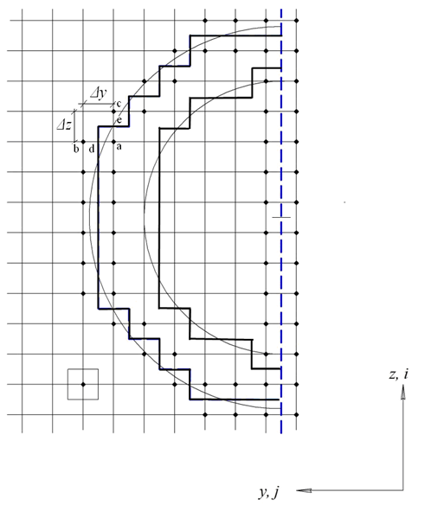

**Fig. 3.** Calculation area of a shallow horizontal soil heat exchanger pipe

The heat transfer coefficient *αt* from the inner surface of the heat exchanger pipe to the heat carrier is determined from the similarity equation:

 (7)

where:

*d* – the inner diameter of the pipe,

*Re* – the Reynolds number, which is determined by the speed of the heat carrier in the heat exchanger pipe,

*Pr* – the Prandtl number for the heat carrier.

Under the operation conditions of the shallow-soil heat exchanger during the heating period, the temperature of the soil near the pipe changes over time. To ensure the flow of heat from the soil massif to the pipes, the temperature of the heat carrier in the heat exchanger must also change accordingly over time. Boundary conditions of the fourth kind are set on the outer surface of the pipe in contact with the soil in the form

;  (8)

The heat transfer problem in the soil massif has been solved using the finite difference method. For its application, a two-dimensional difference grid was constructed, of which a fragment in the region near the collector is shown in Fig. 3. The grid step along the horizontal coordinate y has been taken as constant *Δy* = 0.002 m. The step along the vertical coordinate z in the vicinity of the pipe (0.5 m, Fig. 2) has been taken the same   
(*Δz* = 0.002 m) and beyond the specified area – variable, but such that it ensures the total depth of the calculation area *H* = 18 m.

Boundary conditions of the fourth kind on the outer surface of the pipe in finite differences will have the following form (Fig. 3):

;  (9)

The values of *Ta, Tb, and Tc* correspond to the temperature values in the main nodes of the difference grid; values of *Td and Te* are the temperature values at points on the outer contour of the heat exchanger pipe. Since these points are not included in the main nodes of the calculation grid, it is advisable to remove the temperature values *Td, Te,* from the calculation scheme. Using the above conditions (9) on the outer contour of the heat exchanger pipe, we obtain the following expressions for the heat fluxes on its outer surface:

;  (10)

where:

.

Since in this heat transfer model, it is assumed that the temperature of the heat transfer medium *Tt* is variable over time, its value is chosen under the condition that a certain temperature difference is maintained between nodes located on different sides of the outer contour of the pipe. The *ΔT* value determines the heat flows entering the pipe in the y and z directions. In the transition period, when there is no heating, it was assumed that *ΔТ* = 0. During the heating season, the temperature difference *ΔТ* between the external nodal points relative to the contour and the internal ones was constant. Two variants of the values of this temperature difference are considered: *ΔТ* = 0.05°С 7 and *ΔТ* = 0.10°С.

The numerical solution of the system of difference equations was carried out according to the implicit finite-difference scheme using the sweep method.

3. Results of Experimental Studies

The results of equation (1) for the case Δ*Т* = 0.10°С are shown in Figure 4, which shows the isotherms for the fourth year of system operation at the depth of the collector installation *h* = 1.6 m, the step between the pipes L = 0.5 m, for November 15, January 15 and March 15.

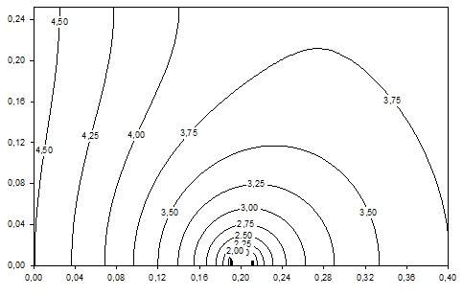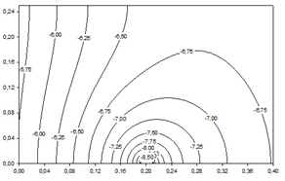

1. b)

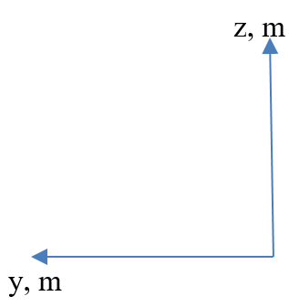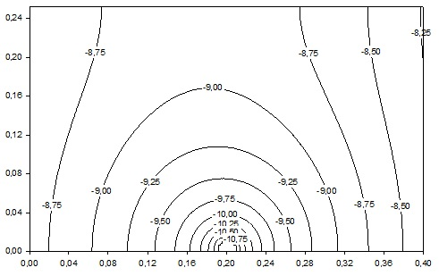

c)

**Fig. 4.** Distribution of the temperatures in the soil massif during the operation of a shallow horizontal soil heat exchanger at L = 0.5 m, ΔТ=0.1°С: a) for November 15; b) for January 15; c) for March 15

Since the heating season for the city of Kyiv lasts an average of 6 months (180 days), the presented data characterise the distribution of temperatures in the vicinity of the pipe a month after the start of heating, for the middle of the heating season, and a month before its end. The origin of the coordinates corresponds to a point located along the axis of the pipe (*y* = 0) 0.2 m below its centre. The maximum value of the ordinate axis corresponds to *y*max = *L*/2. This coordinate system is applied to all figures of this item. As can be seen from Fig. 4, at Δ*Т* = 0.1°С, significant soil freezing occurs. It requires using a working medium based on a non-freezing liquid and considerable cooling (to *Tt* ~ -12°С). The average temperature of the heat carrier in the heat exchanger pipe must be lower than the temperature of the inner surface of the pipe *Tv* by at least 1°С. For such conditions, using a 30% aqueous solution of propylene glycol as a heat carrier is advisable.

Improving the thermal performance of a shallow horizontal soil heat exchanger can be achieved by reducing the value of Δ*Т* or increasing the pitch between the pipes *L*. The calculated data can judge the influence of the pipe pitch L. Here, *L* = 1.5 m is taken, at Δ*T* = 0.05°С, the *Ts* value at the end of the heating period turned out to be positive (see Fig. 5).

z, m

z, m

z, m

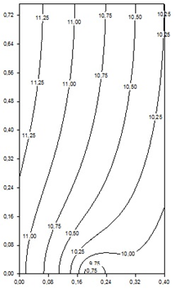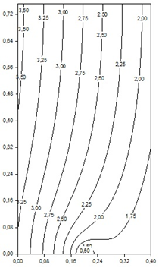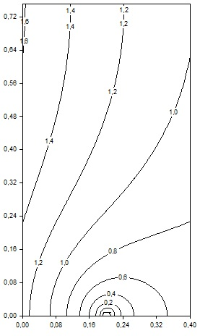

y, m

1. b) c)

**Fig. 5.** Distribution of temperatures in the soil massif during the operation of a shallow horizontal soil heat exchanger at L = 1.5 m, ΔТ = 0.05°С: a) for November 15; b) for January 15; c) for March 15

From the above calculations of the temperature fields, it is possible to conclude the temperature state of the soil massif during the long-term operation of the shallow-soil heat exchanger and about the necessary values of the heat carrier temperature in the heat exchanger tube to ensure its effective operation.

4. Conclusions

A two-dimensional heat exchange model in the soil mass was developed, which made it possible to investigate the operation of a shallow horizontal soil heat exchanger. It was found that the step between the axis of the adjacent pipes of the multi-loop heat exchanger, which is 0.95 m, is optimal when creating a shallow horizontal soil heat exchanger in the soil conditions of Kyiv. During the heating season, this step minimises the mutual influence of the neighbouring loops of the heat exchanger.

With the help of the obtained modelling results, it was possible to establish a slight influence of the wall thickness of the shallow horizontal soil heat exchanger pipe on its thermal characteristics. The operating pressure of the heat carrier is decisive for the thickness of the selection of the pipe wall.

The average calculated power of the thermal energy extracted from the soil from 1 metre of the shallow horizontal soil heat exchanger pipe was 28 W, confirmed by further experimental studies.

References

Albadry, Tahsean, Omran, Harith, AL-Shamkhee, Dhafer. (2022). Study of Two Layers Horizontal Ground Heat Exchanger Performance Under a Different Operation Mode Study of Two Layers Horizontal Ground Heat Exchanger Performance Under a Different Operation Mode. *IOP Conf. Ser.: Mater. Sci. Eng*., *928*, 0220431. https://doi.org/10.1088/1757-899X/928/2/022043

Basok, B., Davydenko, B., Koshlak, H., Novikov, V. (2022). Free Convection and Heat Transfer in Porous Ground Massif during Ground Heat Exchanger Operation, *Materials*, *15*(14), 4843. https://doi.org/10.3390/ma15144843

Basok, B, Davydenko, B, Pavlenko, A.M. (2021). Numerical Network Modeling of Heat and Moisture Transfer through Capillary-Porous Building Materials, *Materials*, *14*(8), 1819. https://doi.org/10.3390/ma14081819

Honglei, Sun, Yuchao, Fang, Zonghao, Yuan, Zhenqi, Weng, Dingyu, Ni. (2021). Analytical modeling for the calculation of underground train-induced vibrations in inhomogeneous soils with uncertainty, *AIP Advances*, *11*(11), 115321. https://doi.org/10.1063/5.0058234

Lamarche, L. (2021). Horizontal ground heat exchangers modelling*, Applied Thermal Engineering*, *155*, 534-545, <https://doi.org/10.1016/j.applthermaleng.2019.04.006>

Leski K., Luty P., Gwadera M., Król B. (2021). Numerical Analysis of Minimum Ground Temperature for Heat Extraction in Horizontal Ground Heat Exchangers, *Energies*, *14*, 5487. https://doi.org/10.3390/en14175487

Liang, Bin, Chen, M.Q., Orooji, Yasin. (2022). Effective parameters on the performance of ground heat exchangers, *A review of latest advances. Geothermics*, *98*, 102283. https://doi.org/10.1016/j.geothermics.2021.102283

Lykov, A.V. (1978). *Heat and mass transfer*. Handbook. 560 pp.

Nakorchevskii, A.I. (2008). *Theoretical and applied aspects of soil accumulation and heat extraction*. Kyiv: Scientific opinion. 150 pp.

Pavlenko A. (2023). Heat and Mass Transfer in Porous Materials. *Materials*, *16*(16), 5591. https://doi.org/10.3390/ma16165591

Saeidi, Reza, Noorollahi, Younes, Chang, Soowon, Yousefi, Hossein. (2023). A Comprehensive Study of Fin-Assisted Horizontal Ground Heat Exchanger for Enhancing the Heat Transfer Performance. *Energy Conversion and Management: X*, 18, 100359. https://doi.org/10.1016/j.ecmx.2023.100359

Šeďová, M., Adamovský, R., Neuberger, P. (2018). Analysis of ground massif temperatures with horizontal heat exchanger. *Research in Agricultural Engineering*, *59*, 91-97. https://doi.org/10.17221/30/2012-RAE