|  |  |  |  |
| --- | --- | --- | --- |
|  |  | | |
| **Rocznik Ochrona Środowiska** | | |
| Volume 25 | Year 2023 ISSN 2720-7501 | pp. 228-234 |
|  | https://doi.org/10.54740/ros.2023.023 open access | | |
|  | Received: October 2023 Accepted: October 2023 Published: November 2023 | | |

Variability of Odour Emissions from Selected Passive Area Source: Preliminary Analysis   
for a One-year Study at a Municipal Wastewater Treatment Plant in Poland

Piotr Sobczyński1, Urszula Miller2, Izabela Sówka3*

1ENVI Piotr Sobczyński, Poland

2Department of Environmental Protection Engineering, Faculty of Environmental Engineering,   
Wroclaw University of Science and Technology, Poland   
https://orcid.org/0000-0003-4556-4961

3Department of Environmental Protection Engineering, Faculty of Environmental Engineering,   
Wroclaw University of Science and Technology, Poland   
https://orcid.org/0000-0001-9810-4673

*corresponding author's e-mail: izabela.sowka@pwr.edu.pl

**Abstract:** Passive area sources, such as primary settling tanks, located in the area of wastewater treatment plants can significantly impact odour air quality. This paper presents the variability of odour emissions from the primary settling tank at the Municipal Wastewater Treatment Plant (MWWTP) during a one-year study of odour concentrations determined by dynamic olfactometry. The investigations indicated that the highest monthly average value of the specified odour emission rate was for July (49.89 ouE/m2/s). Preliminary statistical analysis results using a multiple regression model showed the statistical significance of the independent variables in the form of wastewater temperature and retention time concerning the specific odour emission rate values.

**Keywords:** specific odour emission rate, primary settling tanks, temporal variability

1. Introduction

Along with agricultural, food processing, industrial and other municipal facilities, wastewater treatment plants are the most commonly identified source of odours (Belgiorno et al. 2013). Any component of a municipal wastewater treatment plant can be a source of odour emissions, depending on the technological system of the wastewater treatment plant (WTTP) or the management of the wastewater treatment processes (Czarnota et al. 2023). The assessment of odour nuisance can be based on the measurements of odour concentration using dynamic olfactometry (Dincer & Muezzinoglu 2008, Capelli et al. 2011, González et al. 2022) or the concentrations of specific odour compounds using instrumental/analytical methods (Jeon et al. 2009, Kim et al. 2005, Brattoli et al. 2013). Similarly, field olfactometry (Cesca et al. 2007, Pan et al. 2007, Wiśniewska et al. 2020, Damuchali & Guo 2019) and, more commonly, the electronic nose as an artificial olfactory sense (Giungato et al. 2016, Wilson & Baietto 2009, Jońca et al. 2022) are used in the odour impact analyses. Field measurements are also used to estimate the odour impact area of existing facilities (Barczak & Kulig 2017, Kulig et al. 2022). Odour intensity results from field measurements, processed with statistical and geostatistical tools, can be used to determine the odour impact of an installation (Szymański et al. 2015, Hawko et al. 2021). Accurate dispersion model calculations cannot be carried out without accurately determining emissions from individual potential emission sources, so it is crucial to determine the variability of emissions with the highest possible temporal resolution.

Wastewater treatment plants are characterised by a considerable number and variety of odour sources and the lack of homogeneous, balanced emissions from technological processes. The emission rate of odour compounds and their mixtures varies between different WWTPs, depending on the type of source, the influent wastewater parameters, the technological solutions applied and the current ambient conditions (Capelli et al. 2009, Frechen 2004, Zhou et al. 2016, Lewkowska et al. 2016). Different odour emissions sources exist in municipal wastewater treatment plants: point, active area, passive area and volume sources (Lebrero et al. 2011). Depending on the type of odour source, an odour mixture consists of different chemical compounds whose proportions can vary (Capelli et al. 2008, Defoer et al. 2002, Hwang et al. 1995). Intertwined processes determine odour emission to the atmosphere from passive area sources such as wastewater reservoirs, primary settling tanks, bioreactors or secondary settling tanks. Mass transport from the liquid to the gaseous phase has been described extensively in the literature (Hudson & Ayoko 2008, Schwarzenbach et al. 2005). As a result of turbulent and molecular diffusion, odourant molecules are transported from the liquid volume to the liquid boundary layer at the surface of the liquid mirror. As a result of molecular diffusion, odorants are transported through the liquid and then through the gaseous part of the boundary layer into the air above the liquid mirror (Schwarzenbach et al. 2005). The further transport and emission of odour compound molecules from the tank surface depends on the local meteorological conditions, particularly wind speed and atmospheric stability class. The flow rate of a chemical compound from the liquid to the gas phase is influenced by the type of compound being analysed, its Henry's constant and the mass transfer coefficients in the liquid and gas layers, which depend on the turbulence in the liquid and gas phases (wind speeds at the level of the liquid table). Effluent temperature, viscosity, pH and effluent quality can also affect gaseous emissions.

This study aimed to analyse the variability of odour emissions from passive area sources – primary settling tanks – in the wastewater treatment in southwest Poland. Such studies are considered crucial, mainly because of the general tendency to increase municipal areas and expand residential housing areas in Poland – even in the close vicinity of wastewater treatment plants, which results in the deterioration of inhabitants' housing conditions.

2. Materials and Methods

2.1. Scope of study

The study was performed in the mechanical-biological wastewater treatment plant located in Lower Silesian province. The plant has been designed for a population equivalent (PE) of 1,100,000.

The scope of the research includes the selection of a passive area source that is characterised by high odour emissions and can be considered as one of the main sources contributing to the total odour emissions from the investigated municipal wastewater treatment plant. For this purpose, odour emission studies were carried out, and samples from odour sources selected based on a site visit and an analysis of the treatment and sludge treatment technology (chapter 3.1) were taken. Due to the significant contribution of primary settling tanks to total odour emissions from the selected MWWTP, measurements were carried out to determine the variability of odour emissions annually (chapter 3.2) from October 2014 to November 2015. Wastewater chemical oxygen demand (COD), temperature, pH, ambient temperature, humidity and atmospheric pressure were also measured.

2.2. Sampling, measurement and data analysis methods

Odorous gases sampling from the primary settling tanks followed VDI 3880 standard, "Olfactometry – Static Sampling" (VDI 3880:2011). The air samples were collected into PTFE bags using a special flow-through hood (dimensions: 1000 mm x 500 mm x 150 mm) designed to collect samples from passive area sources, and the sampler designed to collect mean odour samples over a 30-minute sampling period was used. 6 odour samples were collected on each study day, 3 samples were collected for each odour concentration result. The primary settling tank dimension parameters are summarised in Table 1.

**Table 1.** Characteristics of settling tank dimensions

|  |  |
| --- | --- |
| tank diameter | D = 42.0 m |
| central tank diameter | D2 = 4.5 m |
| sludge funnel diameter | D1 = 6.0 m |
| active area | A = 1.37 m2 |
| active volume | Va = 3.01 m3 |
| sludge funnel volume | V = 56.70 m3 |
| active height | Ha = 2.2 m |
| malfunction layer height | Hz = 0.7 m |
| sludge layer height | Hs = 1.1 m |
| side wall height | H = 3.6 m |
| sludge tank height | H2 = 4.5 m |

Each of the three samples was taken from different areas of the tank (Fig. 1). The First sample was taken near the scum baffle, the second in the middle and the third in the centre. From those 3 odour samples, one odour concentration was obtained. After 3 samples were collected, the operation was started again from the scum baffle. Because of the technical and working conditions of the tank, the sampling was conducted with a functioning scraper. During the sampling, ambient temperature, humidity and atmospheric pressure were measured using TESTO 435 portable station.

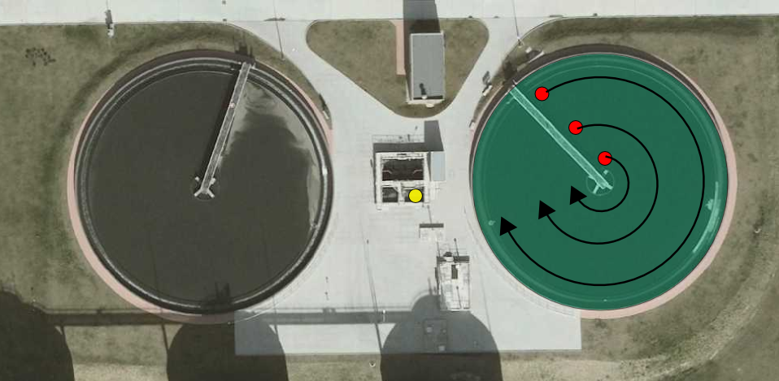

**Fig. 1.** The sampling points (source: mapy.geoportal.gov.pl/imap)

After being collected, the air samples were immediately transported (on average within 1 hour from the last sample) to the Olfactometry Laboratory to determine odour concentration with dynamic olfactometry, accordingly with the PN-EN: 13725 standard on "Air Quality. Determination of odour concentration by dynamic olfactometry" (PN-EN: 13725:2007). The measuring instrument was a TO8 olfactometer with the necessary supplies. Odour concentration results were used to calculate the specific odour emission rate (SOER), indicating the odour emission rate from the unit area over the specific time (ouE/m2/s). The specific odour emission rate was calculated according to VDI 3880 (VDI 3880:2011) as:

$SOER= \frac{c∙\dot{V}}{A}$ (1)

where:

SOER – specific odour emission rate, ouE/(m2/h),

c – odour concentration in odour sample, ouE/m3,

– volumetric flow rate under the sampling hood.

For wastewater sampling, wastewater was collected from the wastewater distribution chamber to the primary clarifiers for chemical oxygen demand (COD), pH and temperature determinations. For COD determinations, the wastewater was collected from the distribution chamber with a scoop, homogenised and determined according to Colometric Method 5220 D (Standard Methods). After homogenisation, the wastewater was diluted with distilled water in pre-prepared cuvettes containing sulphuric acid with silver nitrate, potassium dichromate and mercury sulphate. Wastewater for COD determination was collected three times – at the beginning of the first bag collection and at the end of the third and sixth bag collection. Two dilutions were made from each effluent collection – six effluent samples were taken from the three collections for COD determination. The samples were heated to 148 for 120 min in a NANOCOLOR VARIO-2 thermostat before being determined on the spectrophotometer. After cooling the samples, the absorbance of the prepared samples was measured at a wavelength of 600 nm on a WTW Photometer MPM 3000 spectrophotometer. pH measurements were made using the potentiometric method. Wastewater temperature was measured using an HGL type 38 thermometer with a resolution of 0.1°C.

Multiple regression was used to analyse the correlation between specific odour emission rate values and measured parameters. The analysis was performed in STATISTICA using 63 of 66 measurements. 3 of the measurements were excluded from the analysis due to abnormal on-site conditions (temporary inflow of acidified wastewater and excessive sedimentation in the sludge funnel), consequently leading to atypical measurement results.

3. Results and Discussion

Considering the technology of wastewater and sludge treatment, in the first stage of the study, primary settling tanks (PST), anaerobic tanks (AT), denitrification tanks (DT), digested sludge tanks (DST), gravity thickeners (GT), screening hall (SH), sludge dewatering station (SDS) and mechanical sludge dewatering facility (MSDF) were selected for emission analysis in the first stage of the study. The analyses showed significant differences in the obtained emission values and a significant, i.e. 83%, contribution of passive area sources to the total odour emissions from the selected sources located within the analysed MWWTP area (Fig. 2). Odour emissions from the primary settling tanks were the largest contributor to the total odour emissions from the selected passive area sources in the study area, so further analysis of the variability of specific emission rates focused on odour sampling from this emission source.

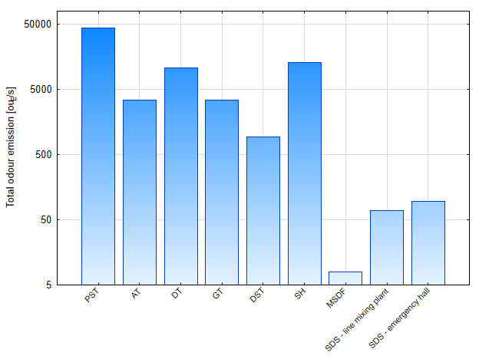

**Fig. 2.** Odour emission estimated from dynamic olfactometry measurements for the air samplescollected from the selected sources within the analysed MWWTP: PST – primary settling tanks, AT – anaerobic tanks, DT – denitrification tanks, DST – digested sludge tanks, GT – gravity thickeners, SH – screening hall, SDS – sludge dewatering station, MSDF – mechanical sludge dewatering facility

Analyses carried out showed that the highest values of the monthly averaged specific odour emission rates were obtained for July (49.89 ouE/m2/s), August (43.61 ouE/m2/s), September (37.39 ouE/m2/s) and May (36.79 ouE/m2/s). In contrast, the lowest specific odour emission rates were obtained for March (3.96 ouE/m2/s), February (4.86 ouE/m2/s) and January (6.12 ouE/m2/s).

The analysis of measurements and calculations confirmed that conditions, including higher temperatures, can occur, particularly in spring and summer, which are conducive to increased odour emissions and associated deterioration in air quality.

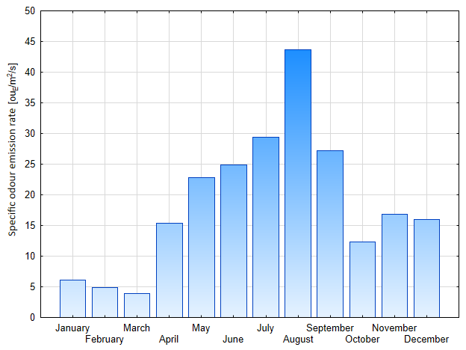

**Fig. 3.** Monthly averaged specific odour emission rate values

Multiple regression was used to demonstrate the relationship between measured parameters and specific odour emission rate values. Obtained results indicated the statistical relevance of the selected independent variables of wastewater temperature and retention time in the primary settling tanks (Fig. 4 and 5), and the resulting regression equation can be expressed as follows:

$E_{s}=-53.23+6.58∙T_{w}+3.19∙t_{h}$ (2)

where:

Es – specific odour emission rate from the tank, ouE/m2/s,

Tw – wastewater temperature, °C,

th – wastewater retention time, h.

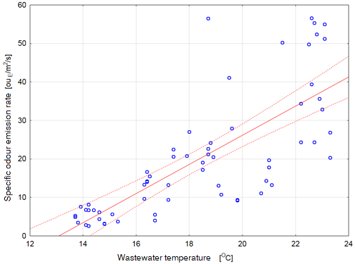

**Fig. 4.** Scatterplot of measured values of specific odour emissions in relation to the sewage temperature

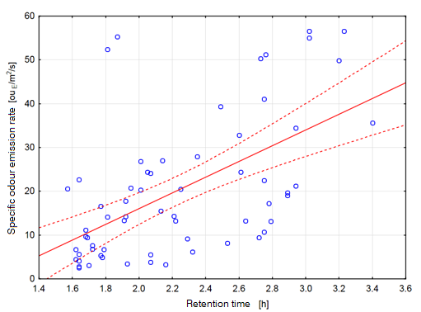

**Fig. 5.** Scatterplot of measured values of unit odour emission in relation to the time of sewage retention in the settling tank

The greatest influence on the specific odour emission rate was exerted by the wastewater temperature (Tw)   
– the standardised β coefficient for this variable was 0.64. The β coefficient for the variable retention time (th) was 0.21. The value of the standard estimation error was 10.20. The value of the correlation coefficient R = 0.77, with a value of determination coefficient of R2 of 0.60, which means that the model explained approximately 60% of the variation in the specific odour emission rates. The predicted values of specific odour emission rate (Es) obtained from the multiple regression calculations were in the range Es = 2.11-42.22 ouE/m2/s (Fig. 6). An analysis of the residual showed that the model calculations were more accurate at lower Es values and less accurate at higher Es values. The minimum residual value was – 18.41 ouE/m2/s and the maximum 30.28 ouE/m2/s. The most outliers of predicted values from measured values occurred for the following test days – one value calculated for 27.05.2015 and two values calculated for 20.08.2015 – 30.26 ouE/m2/s, 23.85 ouE/m2/s and 31.40 ouE/m2/s respectively. The highest relative error values were obtained for 19.10.2015 – 196% and 172% for sample 1 and sample 2, respectively.

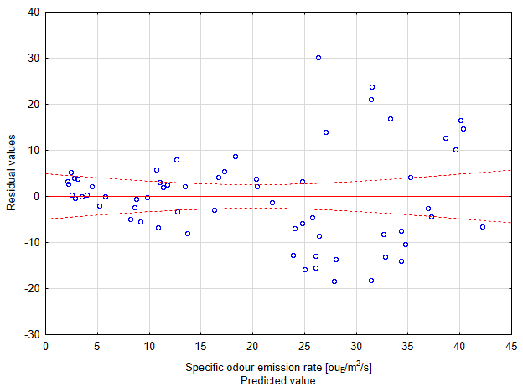

**Fig. 6.** Dispersion chart of residual values compared to measured specific odour emission rate (assuming 95% confidence interval: dashed line)

4. Conclusions

Passive area sources in municipal wastewater treatment plants, such as primary settling tanks, contribute significantly to the total odour emission rate. Odour emissions from primary settling tanks showed variability over the year. The highest specific odour emission rate values were observed in the summer months and the lowest in the winter months. During the study, the minimum and maximum values varied from 2.57 ouE/m2/s to 111.23 ouE/m2/s. In addition, special situations within the primary settling tanks, such as temporary inflow of acidified wastewater or excessive sedimentation in the sludge funnel, can affect emissions. Such events could lead to an overestimation of the emission rate from the primary settling tanks and then to erroneous conclusions regarding the odour impact of the plant.

The statistical analysis within the multiple regression model indicated the impact of the wastewater temperature and retention time on the specific odour emission rate values. However, it should be emphasised that the model explained about 60% of the variation in the specific odour emission rates. Therefore, to study the influence of the selected parameters on the particular odour emission rates of WWTPs, the non-normal nature of the emissions from surface waters should be taken into account, thus increasing the number of measurements and data considered in the study, as well as the use of advanced machine learning methods, given the non-linear nature of the processes studied.

References

Barczak, R.J., Kulig, A. (2017). Comparison of different measurement methods of odour and odorants used in the odour impact assessment of wastewater treatment plants in Poland. *Water Sci. Technol.*, *75*, 944-951. https://doi.org/10.2166/wst.2016.560

Belgiorno, V., Naddeo, V., Zarra, T. (2013). Odour characterisation and exposure effects. In: Belgiorno, V., Naddeo V., Zarra T. (Eds.) *Odour impact assessment handbook* (7-29). USA: John Wiley & Sons. https://doi.org/10.1002/9781118481264.ch2

Brattoli, M., Cisternino, E., Dambruoso, P.R., De Gennaro, G., Giungato, P., Mazzone, A., Palmisani, J., Tutino, M. (2013). Gas Chromatography Analysis with Olfactometric Detection (GC-O) as a Useful Methodology for Chemical Characterization of Odorous Compounds. *Sensors*, *13*, 16759-16800. https://doi.org/10.3390/s131216759

Capelli, L., Sironi, S., Del Rosso, R., Céntola, P. (2009). Predicting odour emissions from wastewater treatment plants by means of odour emission factors. *Water Res., 43*(7), 1977-1985. https://doi.org/10.1016/j.watres.2009.01.022

Capelli, L., Sironi, S., Del Rosso, R., Céntola, P.m Rossi, A., Austeri C. (2011). Urban Environmental Pollution.   
Odour impact assessment in urban areas: case study of the city of Terni. *Procedia Environ. Sci*., *4*, 151-157. https://doi.org/10.1016/j.proenv.2011.03.018

Capelli, L., Sironi, S., Del Rosso, R., Céntola, P., Il Grande, M. (2008). A comparative and critical evaluation of odour assessment methods on a landfill site. *Atmospheric Environment*, *42*(30), 7050-7058. https://doi.org/10.1016/j.atmosenv.2008.06.009

Cesca, J., Flanagan, A., Cunnington, M. (2007). Case study: Odour risk management at the WTP, one of Australia's largest & most unique WWTPs. *Semanticscholar*.

Czarnota, J., Masłoń, A., Pajura, R. (2023). Wastewater Treatment Plants as a Source of Malodorous Substances Hazardous to Health, Including a Case Study from Poland. *Int. J. Environ. Res. Public Health*, *20*, 5379. https://doi.org/10.3390/ijerph20075379

Damuchali, A.M., Guo, H. (2019). Evaluation of a field olfactometer in odour concentration measurement. *Biosyst. Eng*., *187*, 239-246, https://doi.org/10.1016/j.biosystemseng.2019.09.007

Defoer, N., De Bo, I., Van Langenhove, H., Dewulf, J., Van Elst, T. (2002). Gas chromatography–mass spectrometry as a tool for estimating odour concentrations of biofilter effluents at aerobic composting and rendering plants. *J. Chromatogr. A*, *970*(1-2), 259-273. https://doi.org/10.1016/S0021-9673(02)00654-4

Dincer, F., Muezzinoglu, A. (2008). Odor-causing volatile organic compounds in wastewater treatment plant units and sludge management areas. *Journal of Environmental Science and Health*, Part A 43, 1569-1574. https://doi.org/10.1080/10934520802293776

Frechen, F. (2004). Odour emission inventory of german wastewater treatment plants-odour flow rates and odour emission capacity. *Water Sci. Technol*., *50*(4), 139-146. https://doi.org/10.2166/wst.2004.0244

Giungato, P., de Gennaro, G., Barbieri, P., Briguglio, S., Amodio, M., de Gennaro, L., Lasigna F. (2016). Improving recognition of odors in a waste management plant by using electronic noses with different technologies, gas chromatography – mass spectrometry/olfactometry and dynamic olfactometry. *Journal of Cleaner Production*, *133*, 1395-1402. https://doi.org/10.1016/j.jclepro.2016.05.148

González, D., Gabriel, D., Sánchez, A. (2022). Odors Emitted from Biological Waste and Wastewater Treatment Plants: A Mini-Review. *Atmosphere*, *13*, 798. https://doi.org/10.3390/atmos13050798

Hawko, C., Verriele, M., Hucher, N., Crunaire, S., Leger, C., Locoge, N., Savary, G. (2021). A review of environmental odor quantification and qualification methods: The question of objectivity in sensory analysis. *Sci. Total Environ*., *795*, 148862. https://doi.org/10.1016/j.scitotenv.2021.148862

Hudson, N., Ayoko, G.A. (2008). Odour sampling 1: Physical chemistry considerations. *Bioresour. Technol*, *99*(10),   
3982-3992. https://doi.org/10.1016/j.biortech.2007.04.034

Hwang, Y., Matsuo, T., Hanaki, K., Suzuki, N. (1995). Identification and quantification of sulfur and nitrogen containing odorous compounds in wastewater. *Water Res.*, *29*(2), 711-718. https://doi.org/10.1016/0043-1354(94)00145-W

Jeon, E., Son, H., Sa, J. (2009). Emission characteristics and factors of selected odorous compounds at a wastewater treatment plant. *Sensors*, *9*(1), 311-326. https://doi.org/10.3390/s90100311

Jonca, J., Pawnuk, M., Arsen, A., Sówka, I. (2022). Electronic Noses and Their Applications for Sensory and Analytical Measurements in the Waste Management Plants – A Review. *Sensors*, *22*, 1510. https://doi.org/10.3390/s22041510

Kim, K., Choi, Y., Jeon, E., Sunwoo, Y. (2005). Characterisation of malodorous sulfur compounds in landfill gas.*Atmospheric Environment*, *39*(6), 1103-1112. https://doi.org/10.1016/j.atmosenv.2004.09.083

Kulig, A., Szyłak-Szydłowski, M., Wiśniewska, M. (2022). Application of Field Olfactometry to Monitor the Odour Impact of a Municipal Sewage System. *Energies*, *15*, 4015. https://doi.org/10.3390/en15114015

Lebrero, R., Bouchy, L., Stuetz, R., Munoz, R. (2011). Odor assessment and management in wastewater treatment plants: A review. *Critical Reviews in Environmental Science and Technology*, *41*(10), 915-950. https://doi.org/10.1080/10643380903300000

Lewkowska, P., Cieślik, B., Dymerski, T., Konieczka, P., Namieśnik, J. (2016). Characteristics of odors emitted from municipal wastewater treatment plant and methods for their identification and deodorisation techniques. *Environmental Research*, *151*, 573-586. https://doi.org/10.1016/j.envres.2016.08.030

Pan, L., Yang, S. X., DeBruyn, J. (2007). Factor analysis of downwind odours from livestock farms. *Biosystems Engineering*, *96*(3), 387-397. https://doi.org/10.1016/j.biosystemseng.2006.10.017

PN-EN: 13725:2007. *Air quality – Determination of odour concentration by dynamic olfactometry.*

Schwarzenbach, R. P., Gschwend, P. M., Imboden, D. M. (2005). *Environmental organic chemistry*. USA: John Wiley & Sons.

Szymański, K., Janowska, B., Piekarski, J. (2015). Methodological aspects of odorous substances measurement in the vicinity of a sewage treatment plant. *Annual Set The Environment Protection*, *17*, 603-615.

Wilson, A. D., Baietto, M. (2009). Applications and advances in electronic-nose technologies. *Sensors*, *9*(7), 5099-5148. https://doi.org/10.3390/s90705099

Wisniewska, M., Kulig, A., Lelicinska-Serafin, K. (2020). Olfactometric testing as a method for assessing odour nuisance of biogas plants processing municipal waste. *Arch. Environ. Prot.*, *46*, 60-68.https://doi.org/10.24425/aep.2020.134536

VDI 3880:2011. *Olfactometry – Static Sampling.*

Zhou, Y., Hallis, S.A., Vitko, T., Suffet, I.H. (2016). Identification, quantification and treatment of fecal odors released into the air at two wastewater treatment plants. *Journal of Environmental Management*, *180*, 257-263. https://doi.org/10.1016/j.jenvman.2016.05.046