|  |  |  |  |
| --- | --- | --- | --- |
|  |  | | |
| **Rocznik Ochrona Środowiska** | | |
| Volume 24 | Year 2022 ISSN 2720-7501 | pp. 307-325 |
|  | https://doi.org/10.54740/ros.2022.022 open access | | |
|  | Received: 28 October 2022 Accepted: 15 November 2022 Published: 28 November 2022 | | |

Negative Environmental Impacts of Production Technologies

Petr Besta

Department of Industrial Systems Management, Faculty of Materials Science and Technology, VŠB – Technical University of Ostrava, Czech Republic  
https://orcid.org/0000-0001-6309-708X

Kamila Janovská

Department of Industrial Systems Management, Faculty of Materials Science and Technology, VŠB – Technical University of Ostrava, Czech Republic  
https://orcid.org/0000-0002-1642-6466

Zdeněk Martínek

Department of Industrial Systems Management, Faculty of Materials Science and Technology, VŠB – Technical University of Ostrava, Czech Republic

Eva Švecová

Department of Industrial Systems Management, Faculty of Materials Science and Technology, VŠB – Technical University of Ostrava, Czech Republic  
https://orcid.org/0000-0002-8277-8590

Adam Drastich

Department of Industrial Systems Management, Faculty of Materials Science and Technology, VŠB – Technical University of Ostrava, Czech Republic

*corresponding autorhor e-mail: petr.besta@vsb.cz

**Abstract:** The current market environment is affected by several fundamental changes. A large number of these affect manufacturing companies the most. They are forced to continuously reduce their costs, improve the quality of service to their customers and adapt to a highly competitive environment. However, environmental requirements for production processes have become increasingly important in recent years. These are underpinned by legislative changes that put enormous pressure on manufacturers. Often, environmental requirements can also determine the economic success of a manufacturer. The areas that have a significant environmental impact include metallurgical technologies. These are currently predominantly based on the use of coke, which is produced from high-quality hard coal. The mining of raw materials also has significant environmental impacts. The article deals with analysing downstream production processes regarding their environmental impact. These are the areas of mining, ore processing and iron and steel production. These areas can be seen as downstream production stages. Iron ore processing and iron and steel production often occur within a single production organisation. Therefore, a possible overall optimisation in handling environmental impacts and treating pollutants can be assumed. The secondary objective of the paper is to analytically assess the potential reuse of the produced waste in production processes. The article is based on the research results carried out in a selected metallurgical enterprise in the Czech Republic.

**Keywords:** technology, waste, environment, sustainable development

1. Introduction

Industrial production is one of the essential pillars of economic development in many European countries. The introduction of sophisticated technologies, together with the actual knowledge and competencies, to the production, undoubtedly is an opportunity for the development of manufacturing companies and their achievement of being competitive within the domestic or global market (Zwolińska et al. 2020, Marczewska et al. 2020, Szajna et al. 2020). Yet, environmental aspects consideration is also of the highest necessity and should be well along with technology. Within the Czech Republic, manufacturing accounts for more than one-third of the gross domestic product. However, in addition to the positive aspects, production processes are also associated with negative externalities.

The most significant are negative environmental impacts. In addition to the high demands of customers, manufacturers must also comply with legislative environmental requirements (Aoki-Suzuki et al. 2021). In general, all metallurgical production activities are demanding production processes. It is essential to mention here that metallurgical processes can harm the environment not only in terms of the production activities themselves but also in terms of the associated operations (preparation of raw materials, waste processing, recycling (Chamier-Gliszczynski & Krzyzynski 2005), transportation, treatment of raw materials, reuse and recycling materials (Chamier-Gliszczyński 2010), etc. (Gabryelewicz et al. 2021).

Metallurgical processes are also demanding regarding raw materials quantity and quality requirements, be it ores or coal for coke production. The extraction of raw materials is a relatively separate complex issue with complicated environmental impacts. The linkage of mining and metallurgical technologies can be shown schematically in Figure 1.

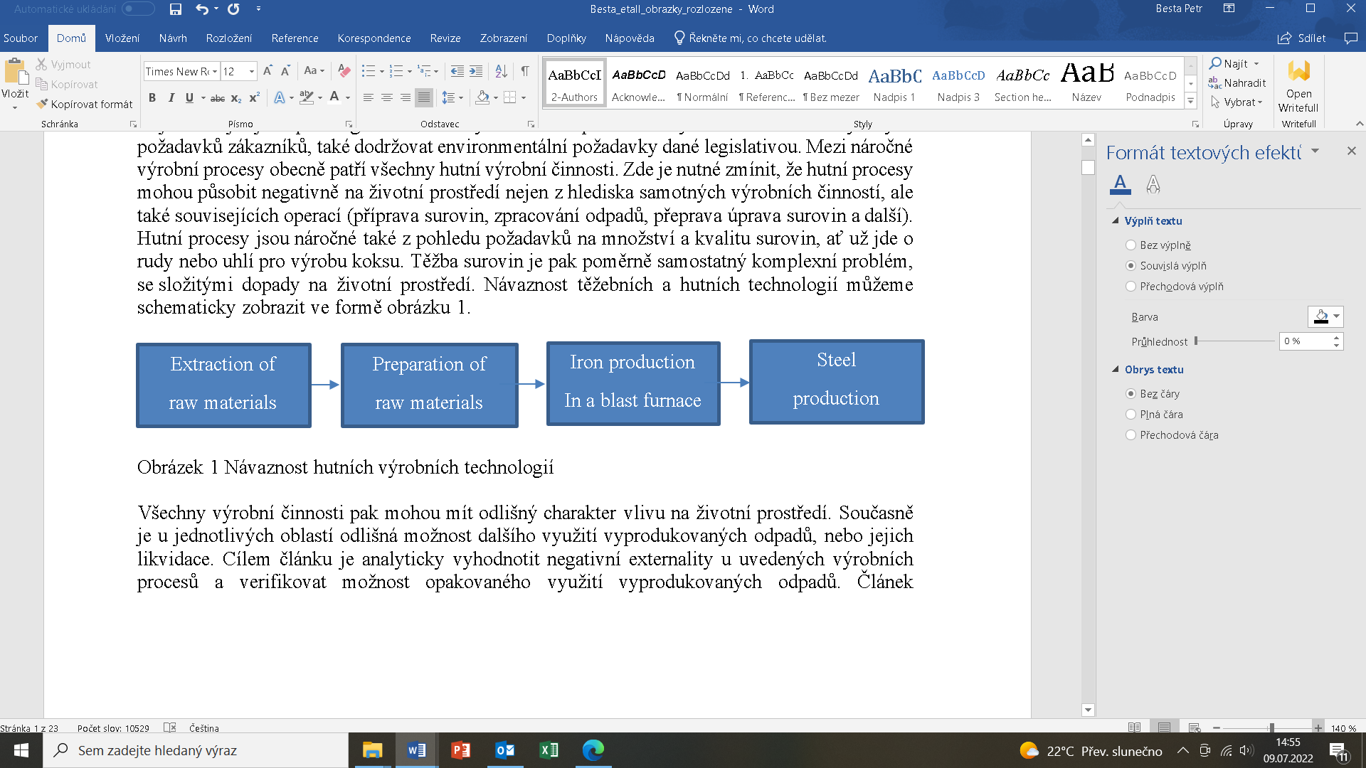

**Fig. 1.** Metallurgical production technology continuity

All production activities may have different environmental impacts (Lenort et al. 2019). At the same time, the possibility of the further use or disposal (Chamier-Gliszczyński 2011, Chamier-Gliszczynski 2011a) of the waste produced differs from one area to another (Fahimnia et al. 2015, Chamier-Gliszczyński 2011b). The paper aims to evaluate the negative externalities of the above-mentioned production processes analytically and to verify the possibility of reusing the produced waste. The article represents the research results carried out within a selected metallurgical enterprise in the Czech Republic.

2. Methods

The research aim of the paper is analytical-experimental. The negative externalities of four downstream mining and production processes were evaluated analytically. In the case of mining activities, the negative impacts, level of risk and reclamation options were assessed. In the case of metallurgical processes, the research focused mainly on the possibilities of reusing the produced waste. The chemical composition of the captured dust particles was determined based on research carried out in a selected metallurgical plant in the Czech Republic. At the same time, the problem areas in iron ore sintering, the level of risk and the potential impact on the surrounding area were evaluated. Similarly, the chemical composition of the slag and its possible further use were assessed in the case of blast furnaces and steel production. The basic types of waste produced by a blast furnace and downstream steel production were also evaluated analytically.

3. Mineral extraction

The basic raw materials for pig iron production are ores, coke and essential additives. In the case of ore raw materials and coke produced from hard coal, the extraction itself can be considered the initial operation. It can generally be done by surface or underground methods. In particular cases, for example, coal deposits can be exploited by underground gasification or leaching (Lapčík 2008).

In the case of iron ore mining, it also depends fundamentally on the nature of the deposit. Within the European deposits, ore resources are generally mined from greater depths than, for example, those in Australia. Mining there is generally of a subsurface nature.

Coal, ore or mineral deposits are usually mined by the deep mining method. The deep mining of coal deposits is carried out depending on the seam’s power, operation and technological characteristics to be mined. Mining activities have a significant impact on all components of the landscape. These are then permanently damaged and cause a disruption of the ecological balance and stability of the landscape ecosystems. The resulting changes lead to the destruction or disruption of native ecosystems in areas affected by mining. It mainly concerns agricultural land, where the formation of subsidence basins results in a relative rise in the groundwater level. It also includes land acquisition for tailings disposal from underground mines and treatment facilities for constructing various sedimentation basins. Watercourses may have altered catchment conditions in areas of intensive mining, and runoff is slowed. At the same time, wastewater from coal preparation plants and sedimentation basins is also discharged into streams. Mining activities also have a negative impact on buildings and roads. It damages buildings, utilities and other surface facilities. Other influences, such as environmental noise, vibrations or shocks, cannot be neglected (Lapčík 2008).

At the same time, mineral extraction is extremely time-consuming. It is usually a long-term process that can take decades in a given region. The environmental impacts of this activity can then be quite significant.

Renewing landscapes affected by mining processes and their secondary consequences is a complicated and complex matter. The idea is to develop a system of gradual adjustments that would guarantee the creation of entirely new structures and functions for the area. The primary purpose of these works is to restore or create agricultural land, forest crops, and water areas so that the landscape becomes an ecologically balanced environment (Lapčík 2008).

However, if we compare coal mining with other mined raw materials, there is significantly less solid waste that requires storage. Secondarily, this concerns, in particular, the handling of the accompanying rock, which can significantly affect the environment and contribute to changes in the landscape (Lapčík & Lapčíková 2010). The negative consequences are mainly related to the actual impact on the surrounding landscape. It can be due to several factors. One of the consequences may be due to undermining. In essence, this is the space created by deep mining. After mining, a basin is then formed, which was previously filled with the surrounding rock (Lapčík & Lapčíková 2010). The size of the mined bed where mining takes place plays a crucial role. The bed size can influence the rock’s subsidence up to the very surface. As a rule, the size of the subsidence trough can be several times larger than the size of the extraction area (Lapčík & Lapčíková 2010). The dominant subsidence is generally located in the centre of the basin.

Subsidence after mineral extraction is a dangerous and significant factor reshaping the landscape. The disposal of mining waste also has a considerable impact on the environment. By waste, we mean tailings, whether fine-grained or coarse-grained. Mining activities have created morphologically, and genetically conditioned forms of landscape relief commonly referred to as dumps and depressions. Tailing dumps vary in shape, area, height and volume. They are divided into those on which no new tailings are being dumped and are stabilised and those on which new tailings are being dumped (Raclavský 2001).

Coal sludge can be another significant negative factor. It can be thought of as a mixture of water and small coal particles. Most often, this coal sludge is produced during coal processing. Its allocation is usually in the form of sludge sumps. However, the creation of this negative externality is minimised by new technologies in coal processing. The current sludge sumps are gradually being disposed of, and the standard landscape reclamation will occur.

Another significant impact of mining may be on the water. It can be understood as opencast or mine water. In the case of mine water, it can be understood as groundwater or surface water that has entered deep mining areas. The assessment of the effects of mining on mine water is highly specific because mine water quality can change significantly during and after mining (Raclavský 2001). Mine water can then be divided into bearing water and non-bearing water. Bearing water is then directly accumulated in the bearing filling itself. Non-bearing waters may be either surface water from precipitation or an overburden or bedrock activity. The impact of mining can have a long-term impact on water quality, even after the mining activity has ceased.

A secondary negative impact of mining may be noise. It can be classified into two basic categories. Primarily, it is the noise of vehicles that transport raw materials outside the mining area. Secondary noise is the source of noise from the equipment used within the mining area (Lapčík 2008). In the case of smaller mining areas, noise from vehicles is more burdensome. The noise from mining equipment is a significant burden for large mining structures. In this case, the minimal noise impact from transport vehicles is also because, for bulk mining, rail transport is mainly used for transportation.

Table 1 shows a basic classification of the negative impacts that accompany mining. These can be seen primarily in the four elemental impacts – soil, water, vegetation, and air. The evaluation in Table 1 shows the values found in the conducted research. The research using the Brainstorming method was carried out as part of the project solution. Employees of the given mining company took part in the study. The aim was to identify potential risks for the given subjects. The values represent the rounded average rating.

In the case of land, forests, agricultural land, and urban development may be affected. We may also mention here the usually necessary permanent occupation of agricultural land or subsidence and changes in the relief of the landscape. However, coal mining can also affect the price of real estate (Kolala et al. 2020, Kitula 2006). In the case of water, both surface water and groundwater may be contaminated. In the case of water, this often results in, among other things, a substantial increase in acidity, which can adversely affect vegetation in the broader area. The consequences of mining can also affect the air. It is mainly due to the excessive volume of dust and fly ash. This not only affects the air itself but is deposited on the surface and saturates the soil and, secondarily, the water. The general duration of each impact and the level of risk to the surrounding area is also given in Table 1. This was defined on a scale of 1-10, with 1 representing the minimum risk and 10 representing the maximum risk.

**Table 1.** Characteristics of the main categories of mining impacts

|  |  |  |  |  |
| --- | --- | --- | --- | --- |
| Negative  impacts | Subjects | Duration | Risk level (1-10) | Reclamation |
| Soil | Forests | Long term | 5 | Yes |
| Agricultural land | Long term | 7 | Yes |
| Urban development | Long term | 5 | Yes |
| Water | Surface water | Medium-term | 9 | No |
| Groundwater | Medium-term | 9 | No |
| Vegetation | Agricultural crops | Medium-term | 6 | Yes |
| Forest vegetation | Long term | 6 | Yes |
| Landscape elements | Long term | 6 | Yes |
| Air | Local | Short term | 8 | No |
| Zoning | Short term | 4 | No |

The question of landscape reclamation is a separate matter. It can be understood as restoring a destroyed territory destroyed by human intervention or natural influences. Reclamation can be divided into agricultural, forestry, water management or recreational. In the case of agricultural reclamation, this may involve the creation of meadows, pastures or gardens. Forestry is based on planting traditional or purpose-built stands (stabilisation, recreation) (Lapčík 2008). In recent years, water reclamation has become very popular. It may involve the construction of water features for still or flowing water (Mojarradi et al. 2016). The creation of water areas within former mine workings also positively affects the landscape. The last reclamation option is associated with recreational activities. Therefore, it may also be linked to water reclamation. In the case of recreational use, it may involve the creation of areas for active leisure   
– sports grounds and parks. Specific reclamation measures should always respect the landscape character but also the ecological and aesthetic aspects.

4. Iron Ore Agglomerations

Blast furnace iron production is one of the production processes with several environmental impacts. Iron ore cannot be used in its raw state and must be technologically processed before use. The processed ore can be delivered to the blast furnace in the form of a sinter or pellets (Besta & Wicher 2017, Frolichova et al. 2015). Mostly sinter is used as the dominant input source for iron production in a blast furnace. Iron ore agglomeration can be divided into two basic parts - the cold and the hot section. The cold section is used to feed raw materials, adjust the grain size, and average the chemical composition of the material – crushing, grinding, sorting, homogenisation, and enrichment (Park et al. 2022). The task of the hot section is to produce the required quality of sinter from the supplied ores, concentrates, fuel and additives.

Agglomeration, or the sintering of iron ores, is heating the powder agglomeration mixture (ore part, fuel, additives) to such a temperature that the surface of individual grains of the charge is melted. The resulting melt forms liquid bridges between the grains, which after solidification, ensure the formation of a solid porous material – agglomerate. The sinter charge consists of sinter ore with a grain size below 10 mm, coke with a grain size below 3 mm and alkaline additives with a grain size below 3 mm. After mixing and pre-pelletising the mixture, the layer on the surface is ignited, forming a burning and sintering zone (burning front), which moves towards the sintering grate due to air seepage. When the sintering zone reaches the grid, the sintering process ends (Kret 2013). Before the actual sintering, the mixture of sinter ore, fine grain concentrate, additives and fuel is moistened (Lu 2017). It is pre-pelletised in the packing drum to reduce the proportion of fine-grained particles and increase the breathability of the mixture. The pre-pelletised mixture, deposited on the sintering device, is ignited on the surface of the layer by a strong external heat source. Due to the effect of the intaken air, the combustion gradually continues in other parts of the layer, in the direction of the intaken air, thus ensuring the formation and cooling of the melt (Kret 2013). The combustion temperature in the agglomeration layer is in the range of 1350-1500°C. The process is complete when the fuel burns out above the sintering grate. The sinter leaves the agglomeration plant, and is crushed, screened, cooled and transported to the blast furnace bins. The sorting process produces a proportion of fines and dust fraction called a reversible agglomerate. This reversible agglomerate is added to the agglomeration mixture, is around 25%, and is re-sintered (Kret 2013, Brož 1998).

The basic principle of ore sintering is shown in Figure 2. It is the hot section of the agglomeration where the actual sintering of ores occurs. The whole agglomeration process can then be described as the largest producer of pollutants within the blast furnace process. The greatest harm is mainly due to the emission of non-ferrous metals such as lead, cadmium, chromium or mercury. Agglomeration produces pollutants in both solid and gaseous forms. Generally speaking, emissions in an agglomeration plant are related to three dominant parts (preparation of the agglomeration mixture, sintering, cooling and treatment of the agglomerate). The latter two parts are also shown in Figure 2.

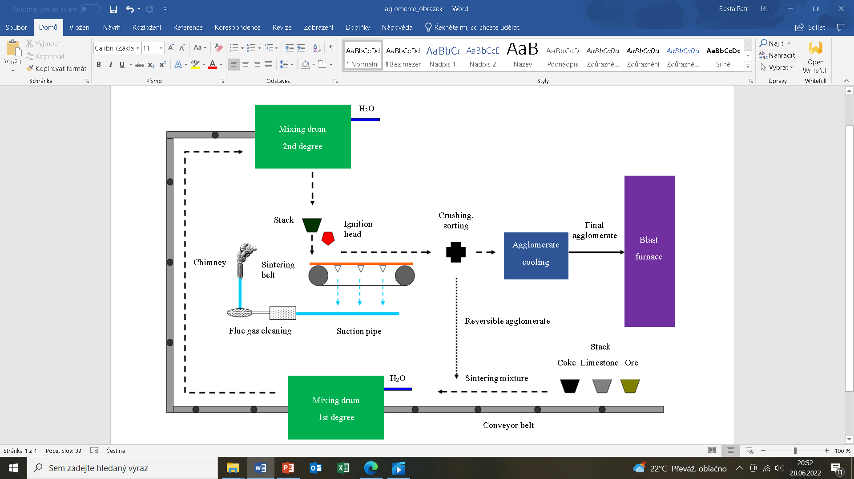

**Fig. 2.** Basic principle of iron ore sintering for blast furnace process   
(adapted from Kret 2013)

The mechanical treatment of ore raw materials occurs within the cold section of agglomeration. This process is primarily associated with the generation and spread of dust. It arises during transport and storage, but above all, during the mechanical processing of raw ore materials. Dust generation can be minimised by dust extraction in crushing plants. The spread of dust is then generally confined to the plant premises and does not directly threaten the wider environment. However, dust enters the environment secondarily by deposition on traffic routes and dispersing through the air. Reducing the amount of dust spread is possible by removing it from the surface.

The hot part of the agglomeration process has the greatest environmental impact. The flue gas exhausted under the grate (Figure 2) can have a temperature of over 1000°C (Lapčík 2008). It is cooled by air suction, and its temperature at the bottom of the chimney can still be around 150°C. The amount of flue gas is then directly dependent on the proportion of air intake and can average 3000 m3 (Lapčík 2008) per tonne of sinter produced. Scrubbers play a crucial role in reducing the environmental impact of emissions. There are two basic variants (mechanical and electrical). Mechanical separators are fundamentally less efficient. But the fundamental problem is that they cannot capture the finest dust. It is the most harmful to human health, as it is usually not caught by the respiratory system. At the same time, a large proportion of heavy metals are present in the finest dust particles. Electric separators have fundamentally higher efficiency. However, the problem is the organic substances that settle in them. These can substantially reduce their performance and must be removed along with dust regularly. The removed dust can then be reused in agglomeration (Figure 3). Figure 3 is based on the analysis of the monitored production process implemented in a selected metallurgical company in the Czech Republic. It is also based on theoretical knowledge published in the following sources (Kret 2013, Brož 2008).

As regards gaseous emissions, their composition depends on the technological process of the agglomeration process. The key factors include the amount of air drawn in, the composition of the agglomeration mixture, the rate of sintering and others. The most important pollutants are carbon oxides (CO, CO2) or sulphur oxides (SO2), but nitrogen oxides are also monitored. In the case of sulphur compounds, their content may be several kilograms per tonne of sinter produced. Sulphur can then be removed from the agglomeration mixture (desulphurisation) by increasing the amount of fuel (coke).

The cooling system used in agglomeration processes is also a significant environmental aspect. Water is used to cool the sintering belts themselves and in the operation of other production equipment. The water is generally treated in the settling tanks. The water used in flue gas dedusting has the highest ecological load. It may contain high concentrations of feedstock such as ore and coke. The concentration of these components can be up to 25 g/l (Lapčík 2008). The amount of water consumed is then linked to the amount of agglomerate produced. Generally speaking, the water volume can range from 0.4-0.6 m3 per tonne of agglomerate produced. It is a significant amount considering that sinter production for blast furnace operations can be in the millions of tonnes per year. The detected concentrations of selected elements in the dust are presented in Table 2. The values were measured as part of the implemented research (CZ.02.1.01/0.0/0.0/17_049/0008399).

The still high content of compounds containing iron should also be mentioned. It is also the reason why this waste material is reused in the blast furnace process. However, the problem is not only the presence of harmful elements but also the basicity of the material.

Agglomeration dust usually contains a higher content of acidic components (SiO2, Al2O3), which is also evident from the values shown in Table 2. The material is, therefore, strongly acidic, which is unsuitable for blast furnace use. A higher addition of alkaline substances (CaCO3) will be required to exploit this waste material further. Another problem with this waste material is the high content of other harmful elements such as sulphur, lead and phosphorus.

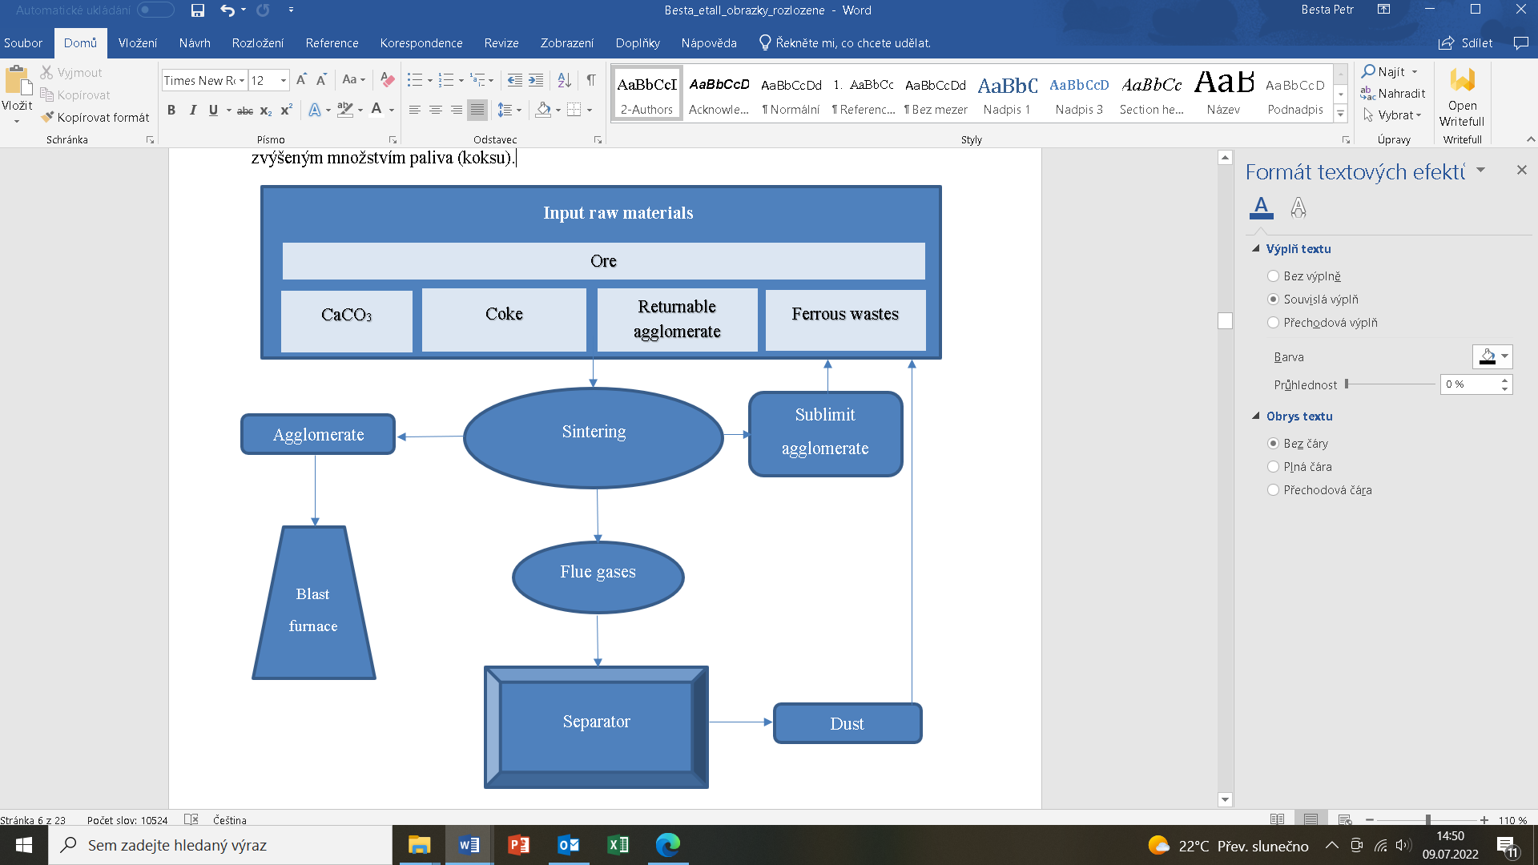

**Fig. 3.** Waste recovery in the agglomeration process

**Table 2.** Concentrations of selected elements and compounds in dust

|  |  |
| --- | --- |
| Chemical element – compound | Concentration (%) |
| Fe2O3 | 54.16 |
| FeO | 16.21 |
| SiO2 | 8.65 |
| Al2O3 | 1.61 |
| S | 0.68 |
| Pb | 0,45 |
| Cu | 0.02 |

**Table 3.** Basic environmental impacts of agglomeration production

|  |  |  |  |  |
| --- | --- | --- | --- | --- |
| Part | Causes | Harmful  substances | Risk level (1-10) | Influence on the surroundings |
| Cold  section | Crushing,  grinding | Dust | 6 | Local |
| Transport | Dust | 5 | Wider |
| Storage | Dust | 3 | Local |
| Hot section | Sintering | CO, CO2, SO2, NOx, Pb, Hg, Cr | 8 | Broad |
| Crushing | Dust | 6 | Local |
| Transport | Dust | 5 | Wider |
| Cooling – water | Coke, ore, metals | 6 | Local |

Table 3 summarises the main environmental impacts of ore sintering. The evaluation in Table 3 shows the specific detected values. The research using the Brainstorming method was carried out as part of the project solution. Employees of the given metallurgical company took part in the study. The aim was to identify potential risks for the given subjects. The values represent the rounded average rating.

The assessment also includes the quantified level of risk and impact on the surrounding area. It should be mentioned here that the agglomeration’s cold section mainly affects the environment in the agglomeration plant itself. The hot section where the sintering occurs can affect the broader environment with its negative externalities. The problem of ore sintering is also linked to current trends aimed at reducing the carbon footprint. Using coke as a fuel will always be associated with producing large amounts of carbon oxides.

**5. Iron and Steel Production**

The blast furnace process is a set of many physicochemical, thermal and mechanical processes, which do not proceed separately but in specific interconnections. These individual phenomena include the reduction of iron oxides and accompanying elements, fuel combustion processes in the bed, counterflow of gas, charge and liquid products of melting, dissociation processes, and reactions in solid and liquid phases (Brož 1998). Industrial production of iron from natural raw materials is currently carried out by three technologies: production of pig iron in a blast furnace, production of pig iron by fusion reduction, direct production of pig iron from ore. However, it should be noted that approximately 98% of pig iron produced still comes from blast furnaces.

The blast furnace charge consists of fuel, iron-ore raw materials and slag-forming additives. All raw materials must be supplied in a proportion that ensures the production of a certain quantity of pig iron of a given quality. The function of the fuel is to supply the blast furnace with the necessary amount of heat and reducing agent, to carburise the iron until it is saturated and to form a solid skeleton, especially in the lower part of the furnace, which facilitates the flow of gases through the blast furnace even at temperatures at which the ore materials soften and melt (Brož 1998). The function of the coke carrier skeleton is elementary and enables the passage of gases in the blast furnace and, therefore, the blast furnace process itself.

Out of the physicochemical processes in the blast furnace, the reduction of iron oxides is of fundamental importance, as it starts in the throat and, except for relatively small oxidation spaces in the lower part, covers the entire blast furnace. The main reducing agents in a blast furnace are carbon monoxide and carbon, but also hydrogen, which is part of hydrocarbon fuels. Reduction by carbon is referred to as direct, and reduction by carbon monoxide and hydrogen as indirect. The total degree of reduction of iron from its oxides is usually higher than 99%, and only a tiny part of it is transferred to the slag in the form of FeO. Iron evaporation loss can be considered negligible (Vanhatalo 2010, Brož 1998).

The environmental impacts of iron production in the blast furnace can be seen mainly in the following areas: blast furnace material handling, blast furnace throat area, blast furnace gas blow-off, blast furnace blow-off and waste (Lapčík 2008). Material handling is related to loading the input raw materials into the blast furnace. It happens essentially continuously throughout the blast furnace operation. So, dust should be removed regularly from the transport routes. The batching of raw materials into the blast furnace is also linked to another potential environmental impact resulting from a leaky throat. It can cause gas and dust to escape into the surrounding area. The blast furnace gas may contain up to 30g/m3 (Lapčík 2008) of dust particles and of course, also coke combustion products such as CO, CO2, SO2 and others. Blast furnace gas can also enter the atmosphere as exhaust gas during blast furnace operation or repair. The blast furnace gas is vented and treated as part of the blast furnace operation. The treatment is most often water-based, where circular sedimentation tanks are subsequently used. The sediments still have a high iron content and are reused in the blast furnace process. On average, they may contain 30-40% iron, 10-20% carbon, but also 10-15% alkaline components (CaO+MgO). The major negative environmental impact is related to the tapping of pig iron and slag itself. In this process, upward currents are created over the liquid metal, which lifts gaseous and solid substances. It can be partly solved by extracting the exhalations and removing or reusing them in the blast furnace. The waste generated during blast furnace gas treatment is one of the most voluminous, together with slag.

Blast furnace slag is a secondary product produced during the production of iron in a blast furnace. It contains mostly oxides that have not been reduced to metal. Sulphates are another important group of compounds, as the blast furnace technology of iron production allows a high degree of desulphurisation. The iron content of the charge then determines the amount of slag produced. The amount of slag produced decreases with the higher metallicity of the charge. Generally speaking, however, approximately 400-600 kg of slag is produced per tonne of pig iron. Table 4 shows the detected concentrations of selected elements and compounds in blast furnace slag. The values were measured as part of the implemented research (CZ.02.1.01/0.0/0.0/ 17_049/0008399).

The slag still contains a small amount of residual iron. Overall, it is usually around 4-5%. Some metallurgical companies have therefore considered reusing slag in the blast furnace process. The problem is the high content of acidic components (SiO2, Al2O3), which would require more alkaline additives. Table 5 shows the concentrations of selected elements and compounds within steel slag. It is also produced as a secondary product in the production of iron.

The main difference is in the iron content, which can be as high as 60-70% in this type of slag. For this reason, steel slag is used as a source of iron and a feedstock for blast furnaces. The alkaline nature of the slag is also a great advantage. The proportion of alkaline components (CaO+MgO) can be up to 20-30%. Steel slag is always highly alkaline and, therefore, is another source of free alkali in the blast furnace. The alkaline nature of steel slag is due to the type of lining used in oxygen converters, which is also alkaline.

**Table 4.** Concentrations of selected elements and compounds in blast furnace slag

|  |  |
| --- | --- |
| Chemical element – compound | Concentration (%) |
| Fe | 0.69 |
| FeO | 0.72 |
| P | 0,02 |
| S | 0.95 |
| CaO | 0.49 |
| MgO | 15.92 |
| SiO2 | 41.02 |
| Al2O3 | 6.62 |

**Table 5.** Concentrations of selected elements and compounds in steel slag

|  |  |
| --- | --- |
| Chemical element – compound | Concentration (%) |
| Fe | 47.14 |
| FeO | 22.92 |
| P | 0.69 |
| S | 0.09 |
| CaO | 24.17 |
| MgO | 7.42 |
| SiO2 | 5.59 |
| Al2O3 | 2.08 |

Oxygen converters dominate steel production in the Czech Republic. The basic raw materials for production are raw liquid iron, scrap metal, slag-forming additives and additives supporting the liquid state. The largest share is liquid iron, which accounts for approximately 70% of the total volume of the burden. The technology’s principle, primarily designed to reduce carbon and other elements, is to blow oxygen onto the liquid metal surface. Oxygen is blown through a cooled nozzle located on the axis of the oxygen converter. The oxygen must be high purity and be blown into the bath by suction. Oxygen purity is important to avoid adding harmful gases such as nitrogen to the bath (Kollmann & Jandl 2013). The underpressure of the blown gas is then necessary to generate sufficient kinetic energy to allow the gas to penetrate to the desired depth of the liquid metal. The oxygen stream creates a reaction zone in the bath where the temperature exceeds 2200°C. Under these conditions, iron and other accompanying elements are oxidised. The oxygen blowing time is approximately 15 minutes, and the total melting time, including lining repair, can take 60 minutes. The reduction of the carbon content in the steel then occurs from the 5th minute of blowing oxygen into the bath. It is due to the need for excess dissolved oxygen in the melt (Ji et al. 2020).

Worldwide, the majority of steel is still produced in oxygen converters. It is also the dominant technology in the Czech Republic. A major advantage of steel production in oxygen converters is the lower environmental impact compared to other technologies. Nowadays, it is possible to use efficient separation technology. In general, the total amount of gases in the case of an oxygen converter can be in the range of 70-90 m3/t of steel. The waste gas then contains a large amount of CO due to the technology of blowing oxygen into the liquid metal. It is also due to the high affinity of carbon for oxygen (Shamsuddin 2016). Another harmful gas contained in the waste gas is SO2. The concentration of sulphur in the liquid metal generally determines its quantity. Since effective desulphurisation can be carried out in the blast furnace process, its content is relatively low (40-60 mg/m3). The waste gas can then be combusted due to the high concentration of CO.

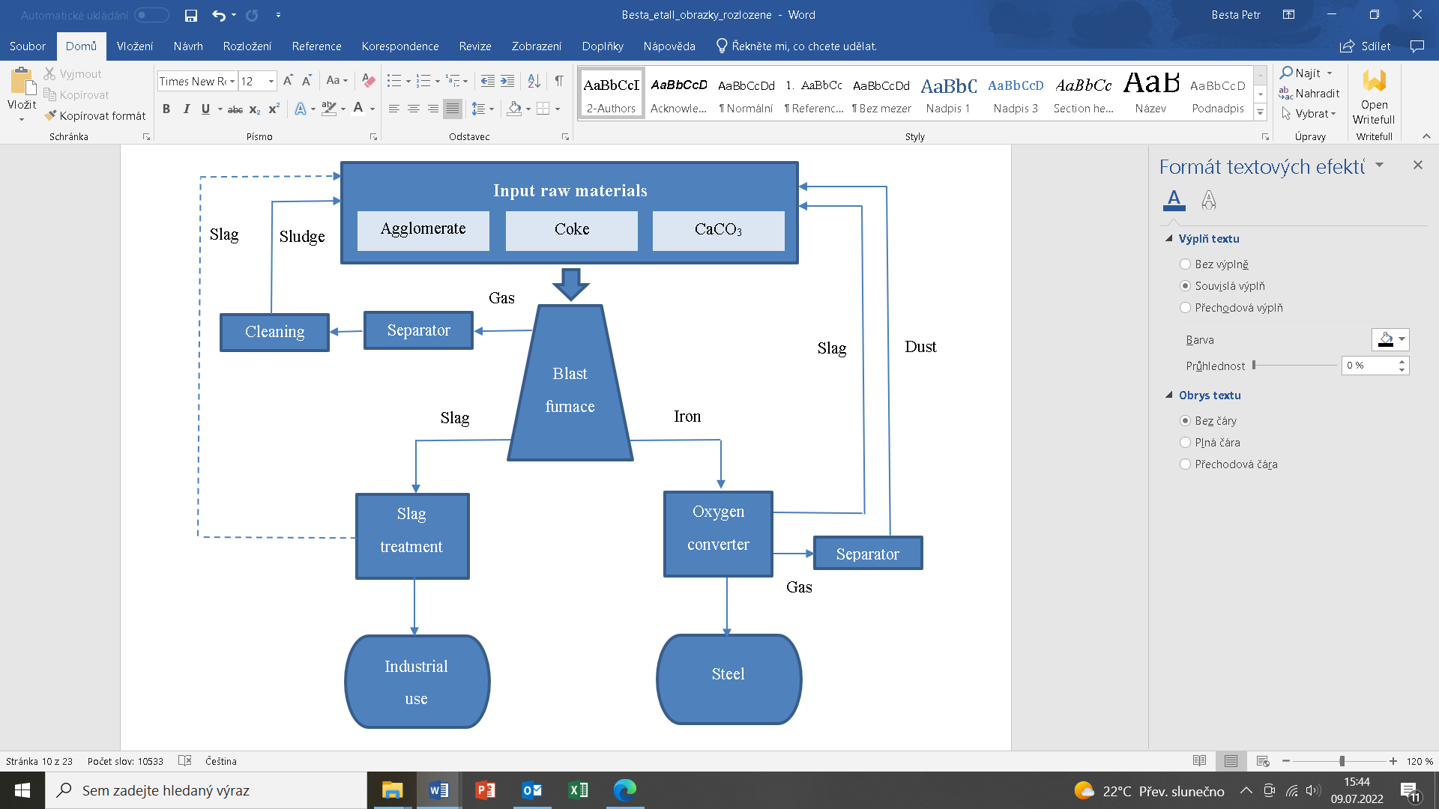

**Fig. 4.** Waste utilisation in iron and steel production

In addition to the gaseous components, the dust particles emitted during production in the oxygen converter also have a negative effect. Their quantity is then determined by the intensity of oxygen blowing into the liquid metal. The intensity of the process can also be influenced by the positioning of the nozzle, whose proximity to the surface increases the rectification zone and, therefore, the course of the reaction. In general, the dust content can be in the range of 200-400 g/m3 (Lapčík 2008), depending on the intensity of the production process. Active electric separators can reduce the harmful effects of particulate emissions. The captured dust can then be processed again. A comprehensive view of the production and use of waste in iron and steel production is included in Figure 4. The reuse of blast furnace slag in iron production is a rather theoretical alternative, so this material flow is shown in Figure 4 by a different line type. Figure 4 is based on the analysis of the monitored production process implemented in a selected metallurgical company in the Czech Republic. It is also based on theoretical knowledge published in the following sources (Kret 2013, Brož 2008).

6. Conclusions

Four downstream processes were analytically assessed as part of the research. The first area was coal mining as a potential feedstock for the production of coke, which is then used as fuel in the blast furnace. There are significant impacts on multiple levels, soil, water, vegetation or air. In most cases, the effects on the landscape are of a long-term nature. The main impact of mining is on the water and the surrounding land. However, current technologies offer interesting possibilities for reclaiming the landscape after mining has ceased. The creation of water areas for recreation is ubiquitous. Another area analysed was the sintering of iron ore. It is essentially a preparatory operation in blast furnace iron production. The sintering of ores has a highly negative impact on the environment. We can mention pollutants in the form of gases or solid waste in the form of dust. Research has confirmed that the captured dust particles can be reused due to their high iron content. At the same time, it was found that the most severe consequences concern the hot section of the agglomeration where the actual sintering occurs. Within the cold section of the agglomeration, where the mechanical treatment of ores occurs, the impact is mainly local and mostly concerns the plant premises. There was also a separate analytical evaluation iron and steel production area. In both cases, waste gas and slag are the most significant waste volume. For example, blast furnace slag can be used further after its treatment in the construction industry. The slag from steelmaking can be used again in the blast furnace due to its high iron content and basicity. The blast furnace gas can be further utilised beyond its combustion. Wet cleaning then produces blast furnace sludge which can be reused as a source of iron in the blast furnace. The gaseous part also covers the emission of dust particles, which can be captured and subsequently processed using separators. Generally speaking, despite the many negative impacts of these production processes, they allow the reprocessing of the pollutants produced.

The technology of iron production in a blast furnace using coke may be limited soon by current legislation. All this is due to the currently discussed requirements to reduce the carbon footprint. The use of carbon within the blast furnace is at the minimum possible level under current technological requirements. Therefore, reducing coke consumption and carbon production is inherently impossible with existing technologies. The blast furnace process is also at its maximum limits from the thermodynamic point of view. One must also ask if, with current trends, blast furnace iron production will not be replaced in the future by other direct or fusion reduction technologies. Iron as a material has the highest recycling rate of any material currently in use. Steel is nowadays a virtually irreplaceable material in terms of properties and price. However, iron and steel production may change significantly soon.

*The work was supported by the specific university research of the Ministry of Education, Youth and Sports of the Czech Republic No. SP2022/27.*

*The article was created thanks to the project   
No. CZ.02.1.01/0.0/0.0/17_049/0008399 from the EU and CR financial funds provided by the Operational Programme Research, Development and Education,   
Call 02_17_049 Long-Term Intersectoral Cooperation for ITI, Managing Authority: Czech Republic – Ministry of Education, Youth and Sports.*

References

Aoki-Suzuki, C., Dente, SMR., Tanaka, D., Kayo, C., Murakami, S., Fujii, C., Tanaka, K., Hashimoto, S. (2021). Total environmental impacts of Japanese material production. *Journal of industrial ecology*, *25*(6), 1474-1485. DOI: 10.1111/jiec.13152

Brož, L. (1998). *Hutnictví železa.* SNTL, 1998. (Original in Czech).

Besta, P., Wicher, P. (2017). The optimisation of the production of sinter as the feedstock of the blast furnace process. *Metalurgija*, *56*(1), 131-134.

Chamier-Gliszczynski, N., Krzyzynski, T. (2005). On modelling three-stage system of receipt and automotive recycling. *REWAS’04, Global Symposium on Recycling, Waste Treatment and Clean Technology 2005*, 2813-2814, Madrid, Spain, 26-29 September 2004, Conference Paper, ISBN: 8495520060.

Chamier-Gliszczyński, N. (2010). Optimal Design for the Environment of the Means Transportation: A Case Study of Reuse and Recycling Materials. *Sold State Phenomena, 165*, 244-249. DOI: 10.4028/www.scientific.net/SSP.165.244

Chamier-Gliszczyński, N. (2011). Recycling Aspect of End-of Life Vehicles. Recovery of Components and Materials from ELVs. *Key Engineering Materials, 450*, 421-424. DOI: 10.4028/www.scientific.net/KEM.450.421

Chamier-Gliszczyński, N. (2011a). Reuse, Recovery and Recycling System of End-of Life Vehicles. *Key Engineering Materials, 450*, 425-428. DOI: 10.4028/www.scientific. net/KEM.450.425

Chamier-Gliszczyński, N. (2011b). Environmental aspects of maintenance of transport means, end-of life stage of transport means. *Eksploatacja i Niezawodnosc – Maintenance and Reliability, 50*(2), 59-71. http://ein.org.pl/podstrony/wydania/50/pdf/07.pdf

[Fahimnia](https://www.google.cz/search?hl=cs&tbo=p&tbm=bks&q=inauthor:%22Behnam+Fahimnia%22&source=gbs_metadata_r&cad=7), B., [Bell](https://www.google.cz/search?hl=cs&tbo=p&tbm=bks&q=inauthor:%22Michael+G.H.+Bell%22&source=gbs_metadata_r&cad=7), G.H., [Hensher](https://www.google.cz/search?hl=cs&tbo=p&tbm=bks&q=inauthor:%22David+A.+Hensher%22&source=gbs_metadata_r&cad=7), D.A., [Sarkis](https://www.google.cz/search?hl=cs&tbo=p&tbm=bks&q=inauthor:%22Joseph+Sarkis%22&source=gbs_metadata_r&cad=7), J. (2015). *Green Logistics and Transportation: A Sustainable Supply Chain Perspective*. Springer, 2015.

Frolichova, M., Ivanisin, D., Maslejova, A., Findorak, R., Legemza, J. (2015). Iron-ore sintering process optimisation. *Archives of metallurgy and materials*, *60*(4), 2895-2899. DOI: 10.1515/amm-2015-0462

Gabryelewicz, I., Lenort, R., Wędrychowicz, M., Krupa, P., Woźniak, W. (2021), Environmental Loads Resulting from Manufacturing Technology, *Rocznik Ochrona Środowiska*, *23*, 613-628, ISSN: 1506-218X, DOI: 10.54740/ros.2021.043

Ji, YQ., Liu, CY., Yu, HC., Deng, XX., Huang, FX., Wang, XH. (2020). Oxygen transfer phenomenon slag molten steel for production of IF steel. *Journal of iron and steel research international*, *27*(4), 402-408. DOI: 10.1007/s4243-019-00285-z

Kitula, AGN. (2006). The environmental and socio-economic impacts of mining on local livelihoods in Tanzania: A case study of Geita District. *Journal of cleaner production*, *14*(3-4), 405-414. DOI: 10.1016/j.clepro.2004.01.012

Kolala, C., Polyakov, M., Fogarty, J. (2020). Impacts of mining on property values in Kalgoorlie Boulder, Western Australia. *Resources policy*, 68. DOI: 10.1016/j.resour-pol.2020.101777

Kret, J. (2013). *Teorie procesů při výrobě železa a oceli*, VŠB – Technical University of Ostrava. (Original in Czech).

Kollmann, T., Jandl, C. (2013). Basic oxygen furnace benchmarking – maintenance and process considerations. *Stahl und Eisen*, 133(12), 37-47.

Lapčík, V. (2008). *Výrobní a environmentální technologie*. Ostrava: VŠB – Technical University of Ostrava. (in Czech).

Lapčík, V., Lapčíková, M. (2010). Posuzování vlivu povrchové důlní činnosti na životní prostředí. *Životní prostředí*, *44*(1), 10-14. (in Czech).

Lenort, R., Baran, J., Wysokiński, M., Gołasa, P., Bieńkowska-Gołasa, W., Golonko, M., Chamier-Gliszczyński, N. (2019). Economic and environmental efficiency of the chemical industry in Europe in 2010-2016. *Rocznik Ochrona Srodowiska*, *21*(2), 1398-1404.

Lu, L. (2017). Important iron ore characteristics and their impacts on sinter quality – a review. *Mining, Metallurgy & Exploration*, *32*(1), 88-96.

Marczewska, M., Jaskanis, A., Kostrzewski, M. (2020). Knowledge, Competences and Competitive Advantage of the Green-Technology Companies in Poland. Sustainability, 12, 8826. DOI: 10.3390/su12218826.

Mojarradi, G., Razaei, R., Ketabi, A. (2016). Negative impacts of mine exploitations on rural of Tekab Township. *Journal of mining and Environment*, *7*(1), 57-66.

Park, J., Kim, E., Suh, IK., Lee, J. (2022). A short review of effect of iron ore selection on mineral phases of iron ore sinter. *Minerals*, *12*(1). DOI: 10.3390/min12010035

Raclavský, K. (2001). *Historický vývoj území – zpracování dílčích podkladů pro hodnocení dynamiky vlivů těžby na reliéf území*. Ostrava: VŠB – Technical University of Ostrava. (in Czech).

Shamsuddin, M. (2016). *Physical Chemistry of Metallurgical Processes.* New York: John Wiley & Sons.

Szajna, A., Stryjski, R., Woźniak, W., Chamier-Gliszczyński, N., Kostrzewski, M. (2020). Assessment of Augmented Reality in Manual Wiring Production Process with Use of Mobile AR Glasses. Sensors, 20(17), 4755. DOI: 10.3390/s20174755.

Vanhatalo, E. (2010). Multivariate process monitoring of an experimental blast furnace. *Quality and reliability engineering international*, *26*(5), 495-508. DOI: 10.1002/ qre.1070.

Zwolińska, B., Tubis, A.A., Chamier-Gliszczyński, N., Kostrzewski, M. (2020). Personalization of the MES System to the Needs of Highly Variable Production. Sensors, 20, 6484. DOI: 10.3390/s20226484.