 | Rocznik Ochrona Środowiska
 | Volume 24 | Year 2022 ISSN 2720-7501 | pp. 231-245
 | https://doi.org/10.54740/ros.2022.017 open access
 | Received: 02 September 2022 Accepted: 27 October 2022 Published: 14 November 2022
Defining Irrigation Scheduling Based on Crop Water Stress Index
and Physiological Parameters for Hybrid Corn in Semi-Arid Climate
Ali Beyhan Ucak
Department of Biosystem Engineering, Faculty of Agriculture,
Siirt University, Siirt, Turkey
https://orcid.org/0000-0003-4344-2848
Burak Saltuk
Department of Biosystem Engineering, Faculty of Engineering,
Alanya Alaaddin Keykubat University, Alanya/Antalya, Turkey
https://orcid.org/0000-0001-8673-9372
Roman Rolbiecki*
Department of Plant Irrigation and Horticulture,
University of Science and Technology in Bydgoszcz, Poland
https://orcid.org/0000-0001-6230-4227
Atilgan Atilgan
Department of Biosystem Engineering, Faculty of Engineering,
Alanya Alaaddin Keykubat University, Alanya/Antalya, Turkey
https://orcid.org/0000-0003-2391-0317
*corresponding author’s e-mail: rolbr@utp.edu.pl
Abstract: The goal of this study is to determine the crop water stress index (CWSI) and irrigation scheduling based on CWSI values, as well as to examine the correlations between CWSI, physiological parameters and grain yield of hybrid corn P31A34 in semi-arid climate conditions. In 2014 and 2015, the upper limit (UL) temperatures at which plants were entirely exposed to water stress were 1.178°C and 2.38°C, respectively. When the corn grain yield began to decline, the CWSI threshold value was 0.34, indicating the yield limit. Grain yield, crop water consumption, crop water stress index, chlorophyll content,
water use efficiency and leaf area index were found to have negative correlations (p ≤ 0.01) with CWSI values in both years of the study. The findings revealed that in semi-arid climate conditions, a maximum of 30% water deficit could be used during the growing period of the corn compared to full irrigation (I100) for water savings and that a water deficit greater than 30% results in considerable grain yield losses. In areas with limited water resources, the moderate water deficit (I70) may be a viable alternative to the I100.
Keywords: Corn, crop water stress index, irrigation time, correlation

1. Introduction
Climate change, caused by greenhouse gases such as carbon dioxide (CO₂) and methane (CH₄), is alarmingly raising the average global temperature. This has decreased overall precipitation and other water resources in the ecosystem (IPCC 2021). Forest fires and other natural events have enabled us to forecast future agricultural and meteorological droughts caused by climate change. Drought, defined by erratic rainfall and water scarcity, negatively impacts agricultural production, particularly cereal crops such as corn (Chartzoulakis and Bertaki 2015). Water scarcity is already a major concern worldwide, including in Turkey, as evidenced by the availability of water resources. If current trends continue, global water resources will deplete significantly by 2030 (Bazzaz 2020).
Many methods for detecting plant internal water status to design irrigation schemes have been discovered; however, the crop water stress index (CWSI) was developed to detect and quantify water stress in corn and is the most reliable method of determining crop water status (Bian et al. 2019, Camoglu et al. 2011). The CWSI employs two baselines: the lower limit (LL) and the upper limit (UL). When calculating the CWSI, it is critical to consider the relationship between the difference in crown temperature (Tc) and air temperature (Ta) with the vapour pressure deficit (VPD). The lower limit line represents the maximum transpiration rate in a well-watered crop, whereas the upper limit line represents Tc-Ta of a canopy with no transpiration and how canopy temperature does not respond to VPD (Gencoglan & Yazar 1999). Scientists discovered that avoiding water stress can increase vegetation cover by up to 70%, depending on the slope and cross-section of the LL threshold values. The LL slope was greater than the daily observed temperature when there was no water stress, and the crown temperature was greater than 27.4°C (Clawson & Blad 1982, Gago et al. 2015). When the lower and upper baselines are used as reference points, the CWSI value ranges from 0 to 1.0 (Anda 2009). The CWSI values change with atmospheric temperature and soil water content (Reginato 1983, Zia et al. 2012). Low canopy temperature (-5 to -1°C) would be sufficient for plant growth. However, the Ta equal to or higher than the canopy temperature (Tc) induces water stress (Orta et al. 2002).
The CWSI can be used to estimate the most optimal irrigation time, but it cannot be used to predict the amount of irrigation water required for each irrigation, as demonstrated by Nielsen and Gardner (1987).
As a result, the current research was carried out to determine CWSI values for the corn hybrid P31A34 and its irrigation scheduling and the correlations between CWSI, physiological and yield parameters. The CWSI of the P31A34 hybrid corn under semi-arid conditions was studied in this research.

2. Materials and Methods
2.1. Study Area
During the corn growing seasons of 2014 and 2015, field experiments were carried out at the Research Center of the Agricultural Faculty at Siirt University, Turkey (37° 58’ 13’’ N, 41° 50’ 51’’ E, altitude 581 m). Throughout the summer, dry and hot tropical air masses dominate the region, mostly located in Basra’s low-pressure centre. As a result, the daytime temperature exceeds 40°C, the average temperature is 26°C, and the lowest temperature is not less than 2.7°C. The highest and lowest long-term (ALS) average relative humidity values were recorded in January (70.2%) and August (26.9%). Table 1 shows the climate characteristics recorded during the corn-growing seasons.
2.2. Soil Properties
The soil texture at the experimental site is clayey, with pH values ranging from 7.03-7.67 and electrical conductivity (EC) ranging from 0.87-1.21 dS m⁻¹ (non-saline). The calcium carbonate content ranged from 27.5 to 36.6%, with subsoil containing more calcium carbonate than surface soil. Depending on the species studied, plant-accessible phosphorus concentrations and organic matter contents ranged from 8.61 to 19.43 kg/ha⁻¹ and 0.84 to 1.33%, respectively.
2.3. Experimental setup
The experiment was set up in a completely randomized block, with each treatment repeated three times. Planting was carried out with a pneumatic seeder on 1 June and 3 June, respectively, for the first and second years. Seeds were sown in rows 70 cm apart, with a plant-to-plant spacing of 18 cm. Each plot had four five-meter-long rows and a net plot size of 14 m⁻². On average, each plot had 110 to 115 plants.
Based on soil analyses, the fertilizer rates were 250 kg N (nitrogen) ha⁻¹ and 90 kg P (phosphorus) ha⁻¹. At sowing, half of the nitrogen fertilizer and all of the phosphorus fertilizer were applied in a 20:20:0 ratio (N:P₂O₅:K₂O). The remaining N was applied when the plants reached a height of 40 cm during the throat filling and hoeing period.

Table 1. Some of climate parameters of the experimental site
 | Months | The highest average temperature (°C) | Average temperature (°C) | The lowest average temperature(°C) | Average relative humidity (%) | Average wind velocity (m s⁻¹) | Mean solar days (h) | Total rainfall (mm/m⁻²)
ALY | May | 25.20 | 19.40 | 9.00 | 49.30 | 1.0 | 9.1 | 36.90
 | June | 27.20 | 26.00 | 17.80 | 34.90 | 1.1 | 11.6 | 11.50
 | July | 35.10 | 30.50 | 23.40 | 30.30 | 1.1 | 12.3 | 0.60
 | August | 34.50 | 30.30 | 27.00 | 29.50 | 1.0 | 11.4 | 2.70
 | September | 30.00 | 25.10 | 14.70 | 37.40 | 1.0 | 10.1 | 7.00
 | October | 24.50 | 17.90 | 12.70 | 42.00 | 1.0 | 7.2 | 50.9
2014 | May | 26.62 | 19.29 | 14.52 | 50.87 | 1.0 | 8.7 | 39.6
 | June | 26.09 | 28.16 | 20.00 | 35.50 | 1.1 | 11.5 | 10.6
 | July | 34.13 | 31.45 | 24.35 | 32.69 | 1.0 | 12.4 | 0.10
 | August | 33.92 | 31.19 | 24.23 | 32.95 | 1.0 | 11.3 | 0.40
 | September | 31.23 | 25.43 | 21.50 | 39.90 | 1.1 | 10.0 | 9.20
 | October | 24.30 | 16.80 | 11.50 | 42.30 | 1.1 | 7.0 | 55.10
2015 | May | 24.69 | 21.29 | 14.59 | 51.77 | 1.0 | 9.3 | 37.70
 | June | 28.19 | 28.41 | 20.25 | 34.40 | 1.1 | 12.0 | 9.30
 | July | 36.24 | 33.19 | 25.35 | 29.69 | 1.0 | 12.5 | 0.10
 | August | 35.92 | 32.45 | 24.73 | 29.95 | 1.0 | 11.5 | 0.00
 | September | 32.23 | 27.43 | 21.65 | 36.79 | 1.1 | 10.0 | 12.20
 | October | 21.10 | 19.70 | 12.00 | 44.20 | 1.0 | 7.3 | 69.20

2.4. Irrigation Treatments
There were three irrigation treatments: full irrigation (I100) and two deficit irrigation treatments that were 70% (I70) and 35% (I35) of the full irrigation. The irrigation water was applied using a drip irrigation system, which sent irrigation water through meters.
The amount of irrigation water used in each treatment was calculated using the method developed by Song et al. (2019). As shown below, the moisture content determined for each layer was calculated using equation 1.
$d=\frac{Pw ∙ As ∙ D}{10}$ (1)
Where d is the water content in depth (mm), Pw is the water content (%) found for each layer, As is the bulk density of soil (g cm⁻³), and D is the depth of each soil layer (cm).
In order to compute total water (dT) for 90 cm soil depth, the entire amount of water calculated for each layer was added together (equation 2).
$dT=d\left(0-30\right)+d\left(30-60\right)+d\left(60-90\right)$ (2)
It was calculated that each plot used a certain amount of water by multiplying total water, plot size, deficit percentage (1.00-0.70-0.35) and percentage of plant cover (equation 3).
$V=dT∙A∙Uo∙p$ (3)
Where V refers to the amount of water (L) consumed in the plots, A denotes the plot area (m⁻²), Uo indicates the per cent deficiency (%), and P represents the percentage of plant cover (%). The coverage percentage was computed using the crown width to the row spacing ratio. The actual P value was set at 0.30 in the beginning until 80% of plant coverage was reached, which was set at 0.8. The water balance equation (equation 4) was used as a foundation to quantify plant water consumption (Rashid et al. 2005).
$ET=P+I-Rf∓$ ΔS (4)
In the above equation, ET stands for evapotranspiration (mm), P stands for precipitation (mm), I stands for irrigation water (mm), Rf stands for runoff (mm), and ± ΔS stands for soil moisture change in the root zone or the difference in water storage between the start and end of a season (mm). Because the dripper flow rate was lower than the soil infiltration rate, no surface runoff occurred. We assumed there was no deep infiltration because irrigation water was used to bring the soil moisture content up to the field capacity. P was identified as zero because Rf and Dp did not occur.

2.5. Data Collection
The CWSI was calculated by the empirical method developed by Idso et al. (1984) (Eq. 5):
CWSI = [(Tc - Ta) - LL] / UL - LL (5)
In the equation, CWSI is plant water stress index, Tc is canopy temperature (°C), Ta is air temperature (°C), LL is a lower limit of water stress where the transpiration is at a potential rate, and UL is an upper limit of water stress where the plants do not transpire. The CC was measured using a portable chlorophyll meter (Minolta SPAD-502, Osaka, Japan). The value of CC increases when a value reaches 1.0 and decreases when a value comes closer to 0.
The water use efficiency (WUE) was estimated using equation 6 (Cheng et al. 2021).
WUE = GY/ETa (6)
In the equation, WUE is the water use efficiency (kg da⁻¹, mm), GY is the grain yield (kg da⁻¹), and ETa is the evapotranspiration (mm).
Chlorophyll content (CC, SPAD) was assessed using a portable chlorophyll meter (Minolta SPAD-502, Osaka, Japan), which measures the quantity of chlorophyll in a leaf indirectly. At least three measurements were collected from different locations on the same leaf, then averaged and used for further analysis (Rashid et al. 2005). The chlorophyll concentration was tested before and after irrigation on the same plant and leaves.
The leaf area index (LAI) was measured with a LI-COR LAI-2000 sensor and plotted. Measurements were taken between 12:00 and 15:00 when the sky was clear before and after irrigation. Five measurements were taken, and the average LAI representing the irrigation treatment was calculated (Papanikolaou et al. 2020).
2.6. Statistical Analysis
For statistical analysis, JUMP (Version 13.2.0) software was used. The variance analysis (ANOVA) was used to compare the mean values of parameters for each treatment, and the Least Significant Difference (LSD) was used to determine the difference between treatments. A correlation test was used to examine the relationship between the investigated parameters (Der and Everitt, 2002).

3. Results and Discussion
3.1. Plant Water Consumption (ET, mm)
The irrigation water in full and excessive water stress irrigation treatments was 644.00 and 225.40 mm, respectively, in the first year of the experiment and 672.00 and 235.20 mm in the second year (Table 2). The ET for the I100 irrigation treatment was 678.72 and 706.33 mm in the first and second years, respectively, while the ET for the I35 treatment was 237.55 and 247.16 mm.

Table 2. All traits of hybrid corn variety in 2014 and 2015
2014
IT | GY | CWSI | CC | LAI | WUE | ET | IW
I₁₀₀ | 1220.00 a | 0.27 c | 47.16 a | 4.66 a | 1.79 b | 678.72 | 644.00
I₇₀ | 884.00 b | 0.38 b | 42.78 b | 4.14 b | 1.86 a | 475.10 | 450.80
I₃₅ | 388.66 c | 0.60 a | 38.76 c | 3.39 c | 1.63 c | 237.55 | 225.40
Ortalama | 830.88 | 0.42 | 42.90 | 4.06 | 1.76 | 463.79 | 439.66
CV | 3.17 | 5.48 | 1.69 | 1.75 | 1.69
LSD (0.05) | 40.89** | 0.056** | 1.65** | 0.28** | 1.65**
2015
IT | GY | CWSI | CC | LAI | WUE | ET | IW
I₁₀₀ | 1130.66 a | 0.31 c | 46.16 a | 4.56 a | 1.59 | 706.33 | 672.00
I₇₀ | 778.00 b | 0.39 b | 41.78 b | 4.07 b | 1.47 | 494.53 | 470.40
I₃₅ | 375.33 c | 0.63 a | 37.76 c | 3.33 c | 1.50 | 247.16 | 235.20
Ortalama | 761.33 | 0.44 | 41.90 | 3.99 | 1.52 | 482.63 | 459.00
CV | 6.10 | 7.50 | 1.76 | 1.21 | 1.76
LSD (0.05) | 10.52** | 0.058** | 1.64** | 0.041** | 1.64**
+) I100: Full irrigation, I70: moderate water deficit, I35: Severe water deficit,
++) GY: Grain yield (kg da⁻¹), CWSI: Crop water stress index, CC: Chlorophyll content (Spad), IW: Irrigation water (mm), ET: Crop water consumption (mm), WUE: Water use efficiency (kg da⁻¹, mm), LAI: Leaf area index, IT: Irrigation treatment
+++) The means in the same column shown by the same letters are not significantly different at P ≤ 0.05.
++++) *, **: Significant at 0.05 and 0.01 level of probabilities, respectively, ns: not significant, CV: coefficient of variation
3.2. Water Use Efficiency
During the growth season, the WUE values, widely considered a reliable indicator of the amount of GY obtained per unit of ET, are reported in Table 2. In the first year, the highest and lowest WUE values were 1.86 kg da⁻¹ mm in the I70 treatment and 1.63 kg da⁻¹ mm in the I35 treatment, respectively. In the second year, the highest and lowest WUE values were 1.59 kg da⁻¹ mm in the I100 treatment and 1.50 kg da⁻¹ mm in the I35 treatment, respectively. During the first year of the experiment, the WUE value in the I70 treatment was slightly higher than the WUE value in the I100 treatment. The WUE value in the I100 application decreased during the first year as water consumption increased. The small differences in WUE values of I100 and I70 during the growing season can be attributed to the climate and water deficit treatments. The changes in WUE values observed in our study between years are consistent with the WUE values reported by (Gencoglan 1996). The WUE values for the least irrigation I35 treatment were 0.22 and 0.52 kg da⁻¹ mm in the first and second years respectively, and 1.0 and 0.96 kg da⁻¹ mm in the first and second years for the full irrigation I100 treatment. According to the experiment’s results by (Gencoglan 1996), the highest WUE value for I80 treatment was 1.12 kg da⁻¹ mm in the first year and 1.02 kg da⁻¹ mm in the second year, respectively.
3.3. Lower limit and upper limit
The Lower limit (LL) equation is used to explain the potential transpiration status of the corn variety, while the UL equation is used to characterize high water stress conditions, as shown in Figures 1 A and B. The findings of Idso (1982), which indicated a positive water vapour flow from the leaves to the atmosphere, are consistent with our observations. Throughout the growing season, the LL equation revealed a positive water vapour flow towards the atmosphere (Gencel 2009). The upper limit (UL) equation for the first year was Tc - Ta = 1.178 + 0.053 VPG
(R² = 0.898**) and for the second year, Tc - Ta = 0.103 VPG + 2.384 (R² = 0.904**). Because the slope of the UL equation was at its lowest, the differences in the leaf crown temperature and air temperature at UL were 1.178 and 2.384°C for the first and second years of the experiment, respectively. These findings agree with those reported by (Bouazzama et al. 2012). When the measurement values used in the calculation are less than the LL line, negative CWSI results can occur (Figures 1 A and B).

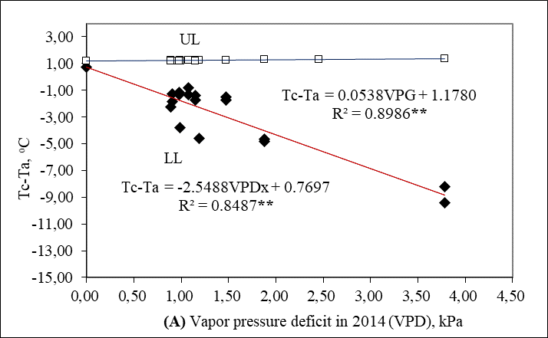
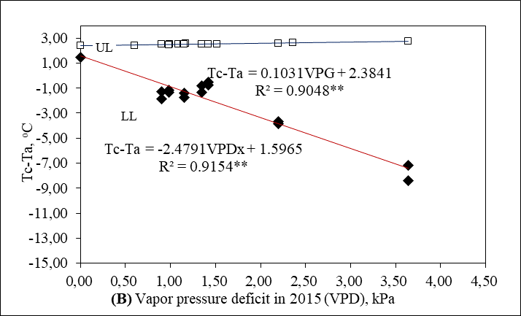
Fig. 1. A-B. LL and UL relationship graph of corn plants in 2014 and 2015
+) LL: lower limit of plants without water stress, UL: highest stress upper limit of plants
3.4. Crop Water Stress Index
Although the Crop water stress index (CWSI) values determined in the irrigation treatments were typically between 0 (no water stress) and 1 (highest stress), negative CWSI values were also discovered. The measurement values used in the calculation that were below the LL line produced negative CWSI results. In the first year, the I35 treatment had the highest mean CWSI value (0.60), while the I100 treatment had the lowest CWSI value (0.27). In the second year of the study, the I35 treatment had the highest CWSI value (0.63), while the I100 treatment had the lowest CWSI value (0.31). The daily CWSI values recorded during the growing season for the first and second years are depicted in Figures 2 A and B, respectively. When compared to full irrigation (I100), the CWSI values for moderate (I70) and severe (I35) water deficit treatments increased by 28.94 and 55%, respectively, in the first year. The CWSI values increased by 20.51 and 50.79% per cent in the second year, respectively. The level of CWSI increased due to the intensity of water stress.
CWSI values for the full irrigation (I100) treatment ranged between 0.13 and 0.43, while CWSI values for the least watered (I35) treatment ranged between 0.42 and 0.73, confirming our findings. Plants in the I0 treatment experienced severe water stress, and some plants showed signs of ageing, such as dried-out leaves and death (Koksal 1995, Sarker & Oba 2018, Sarker et al. 2019). Odemis and Bastug (1999) discovered that it takes 4 to 5 days for CWSI values to fall after irrigation. Furthermore, the researchers emphasized that plants suffer from water stress when the soil water content decreases, and the CWSI value rises.

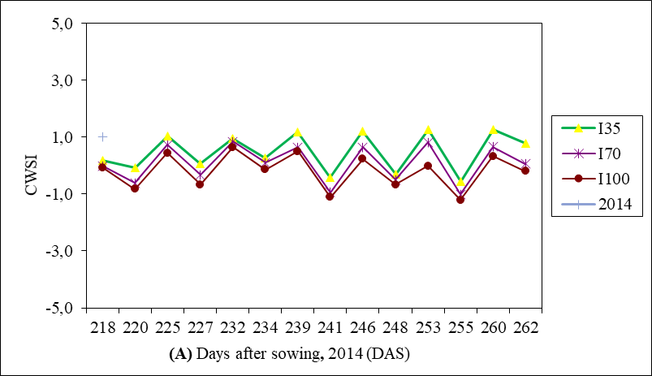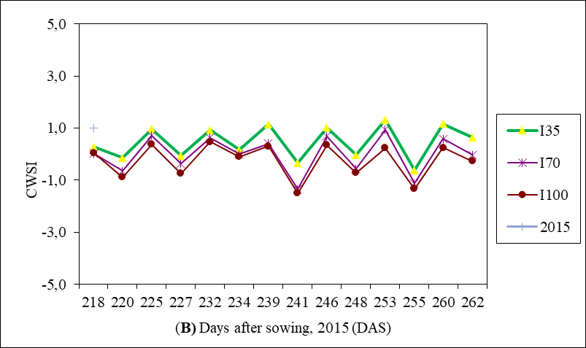
Fig. 2. A-B. Crop water stress index (CWSI) values determined in irrigation treatments in 2014 and 2015

Wang et al. (2020) also reported that the CWSI value varies with the amount of water applied and that high CWSI values resulted in yield losses. In agreement with our findings, Gencoglan and Yazar (1999) discovered that the threshold CWSI value derived from infrared and porometer readings was 0.19 and 0.26, respectively. When the CWSI value is ≥ 0.2, Reginato (1983) and Fattahi et al. (2018) discovered that the consequences of water stress never or only rarely occur. The obtained threshold CWSI values were consistent with those reported by Gencoglan and Yazar (1999); however, Koksal (1995) reported a slightly different threshold CWSI value. The disparities in CWSI values may be caused by different hybrid corn cultivars, which differ in tolerances for soil moisture deficits.
3.5. Yield Response Factor
The yield response factor (ky), which is essential in irrigation planning and measures the influence of water deficiency throughout the growing season on crop yield, was calculated as 0.59 in the first year and 0.99 in the second year, with a mean value of 0.79 for the two years. In contrast, Ucak et al. (2016) and Kara and Sahin (2021) reported ky values of 0.55 and 1.41, respectively. The (1 - Ya/Ym) = 0.79 (1 - ETa/ETm) value can be used in research to optimize the efficiency of water usage of corn plants using drip irrigation or in irrigation planning to predict the amount of potential yield loss under deficit irrigation water in semi-arid climatic conditions.
3.6. Leaf Area Index
The Leaf area index (LAI) values decreased as irrigation water used decreased. The I100 treatment produced the highest LAI value (4.66) in the first year, while the I35 treatment produced the lowest LAI value (3.39). Likewise, in the first year of the study, the I100 treatment had the highest LAI value (4.56), and the I35 treatment had the lowest LAI value (3.33) in the second year. Compared to the I100 treatment, the LAI values in I70 and I35 treatments decreased by 11.15 and 27.25%, respectively, in the first year and by 10.74 and 26.97%, respectively, in the second year. As a result, plant leaf area in water deficit treatments remained small compared to full irrigation treatments. Consistent with our findings, Zhang and Cai (2021) and Cheng et al. (2021) discovered that the leaf area of corn plants decreased as water stress increased. In addition, reduced leaf surface area has been reported as a result of photosynthesis being disrupted by dry root zone conditions (Wang et al. 2011).
3.7. Chlorophyll Content (CC, SPAD)
The I100 therapy had the highest CC, i.e. SPAD value (47.16) in the first year, while the I35 treatment had the lowest CC value (38.76). In the second year, the I100 treatment had the highest CC value (46.16), while the I35 treatment had the lowest CC value (37.76). Compared to the I100 treatment, the CC values for the I70 and I35 treatments decreased by 9.28 and 17.81% in the first year, respectively, and by 9.48 and 18.19% in the second year. The LAI and CC are interrelated physiological parameters and have a significantly high correlation. As expected, the CC has decreased in water deficit treatments because sufficient nutrients, particularly nitrogen, cannot be transported to the leaves (Wang et al. 2017, Cheng et al. 2021).
3.8. Grain Yield (GY, kg da⁻¹)
The I100 treatment produced the highest GY (1220.00 kg da⁻¹) in the first year, while the I35 treatment produced the lowest GY (388.66 kg da⁻¹). In the second year, the highest and lowest GL values were obtained in I100 and I35 treatments, respectively, as in the first year. When compared to the I100 treatment, grain yields in the I70 and I35 treatments declined by 27.54 and 68.14%, and 31.19 and 66.80%, respectively, in the first and second years. GY obtained in both years had a significant positive correlation with ET, WUE, CC and LAI parameters but a significant negative correlation with CWSI. The negative association suggested that GY decreased as CWSI values increased. Following the chain events, corn grain yield and starch ratio decreased, which was consistent with the findings (Yilmaz et al. 2010, Sampathkumar et al. 2014). The tasseling phase of corn has a substantial impact on grain yield. Water stress during this period affects pollen viability, negatively impacting fertilization and grain yield. The results of this investigation are congruent with those of earlier studies (Haseeb et al. 2018).
3.9. Correlation Analysis
All parameters studied had statistically significant negative (p ≤ 0.01) correlations with the CWSI. Throughout the first year of the experiment, CWSI was found to have significant negative relationships with GY (r = -0.995**), WUE
(r = -0.769**), CC (r = -0.955**), and LAI (r = -0.979**). The results revealed that an increase in CWSI was associated with a decrease in GY, WUE, CC and LAI values. GY value was found to have a significant positive relationship with ET
(r = 0.997**), WUE (r = 0.730**), CC (r = 0.978**), and LAI (r = 0.992**). The ET increased as GY increased, while GY decreased as CWSI increased. Furthermore, a statistically significant positive correlation was found between the CC, WUE, LAI and GY values. Similar to the first year, CWSI had significant negative relationships with GY (r = -0.970**), WUE (r = -0.826**), CC (r = -0.937**) and LAI (r = -0.986**) values in the second year. As the CWSI increased, GY, WUE, CC and LAI values decreased. GY had strong positive relationships with ET (r = 0.999**), WUE (r = 0.681**), CC (r = 0.985**), and LAI (r = 0.994**) values as well. The correlations found in this study are consistent with those found in previous studies (Song et al. 2019, Cheng et al. 2021).
4. Conclusions
The data revealed that when the CWSI threshold value is 0.34, the irrigation for the second crop corn variety grown in semi-arid climate conditions can begin. As a result of this research, it was discovered that irrigation at the CWSI threshold value of 0.34 was effective in preventing statistically significant yield losses. In other words, an increase in CWSI threshold value was associated with a significant decrease in grain production and yield. Water deficits of up to 30% can be implemented in semi-arid climate conditions throughout the corn-growing phase to save water compared to full irrigation (I100). Water scarcity of more than 30% will result in a significant reduction in grain yield. The moderate water deficit (I70) may be a viable alternative to the severe water deficit (I100) in water-stressed areas.
References
Anda, A. (2009). Irrigation timing in maize by using the crop water stress index (CWSI). Cereal Research Communications, 37, 613-620. DOI: 10.1556/CRC.37. 2009.4.15
Bazzaz, M. (2020). Alternate furrow irrigation can maintain grain yield and nutrient content and increase crop water productivity in dry season maize in sub-tropical climate of South Asia. Agricultural Water Managament, 238, 106-229, DOI: 10.1016/j.ag-wat.2020.106229
Bian, J., Zhang Z., Chen J., Chen H., Cui, C., Li, X., Chen, S., Fu, Q. (2019). Simplified evaluation of cotton water stress using high resolution unmanned aerial vehicle thermal imagery. Remote Sensing, 11, 267-284. DOI: 10.3390/rs11030267
Bouazzama, B., Xanthoulis, D., Bouaziz, A., Ruelle, P., Mailhol, J.C. (2012). Effect of water stress on growth, water consumption and yield of silage maize under flood irrigation in a semi-arid climate of Tadla (Morocco). Biotechnology Agronomy Society Environment, 16, 468-477.
Camoglu, G., Genç, L., Asık, S. (2011). The Effects of water stress on physiological and morphological parameters of sweet corn (Zea mays saccharata Sturt), Ege University Faculty of Agriculture Journal, 48, 141-149.
Clawson, K.L., Blad, B.L. (1982). Infrared thermometry for scheduling irrigation of corn, Agronomy Journal, 74, 311-316.
Chartzoulakis, K., Bertaki, M. (2015). Sustainable water management in agriculture under climate change. Agriculture and Agricultural Science Procedia, 4, 88-98, DOI: 10.1016/j.aaspro.2015.03.011
Cheng, M., Wang, H., Fan, J., Zhang, F., Wang, X. (2021). Effects of soil water deficit at different growth stages on maize growth, yield, and water use efficiency under alternate partial root-zone irrigation. Water Journal, 13(148), 1-19. DOI: 10.33 90/w13020148
Der, G., Everitt B.S. (2000). A handbook of statistical analyses using sas. Second Edition. 2002, CRC Press LLC., N.W. Corporate Blvd. Boca Raton. Florida 3431. USA.
Fattahi, K., Babazadeh, H., Najafi, P., Sedghi, H. (2018). Scheduling maize irrigation through crop water stress index (CWSI). Applied Ecology and Environment Research, 16, 7535-7549. DOI: 10.15666/aeer/1606_75357549
Gago, J., Douthe, C., Coopman, R.E., Gallego, P.P., Ribas-Carbo, M., Flexas, J., Escalona, J., Medrano, H. (2015). UAVs challenge to assess water stress for sustainable agriculture. Agricultural Water Management, 153, 9-19. DOI: 10.1016/j.ag-wat.2015.01.020
Gencoglan, C. (1996). Water yield relationships of corn plant, determination of root distribution and plant water stress index and investigation of the compatibility of the CERES Maize plant growth model to the region. Cukurova University, Institute of science and technology, Department of Agricultural Structures and Irrigation, doctoral thesis. 1996, Adana, Turkey.
Gencoglan, C., Yazar, A. (1999). Determination of crop water stress index (CWSI) and irrigation timing by utilizing infrared thermometer values on the first corn grown under Cukurova conditions. Turkish Journal of Agriculture and Forestry, 23, 87-95.
Gencel, B. (2009). Estimating amount of irrigation water to apply using crop water stress index on second crop maize. Cukurova University, Institute of science and technology, Department of Agricultural Structures and Irrigation, doctoral thesis. 2009, Adana, Turkey.
Haseeb, A., Waqas, L., Muhammad, F.J., Muhammad, D.A. (2018). Effect of salicylic acid on yield and yield components of maize under reduced irrigation. Agri Res & Tech: Open Access J. 15(2): 555947. DOI: 10.19080/ARTOAJ.2018.15. 555947
Howell, T.A., Yazar, A., Schneider, A.D., Dusek, D.A., Copeland, K.S. (1992). Lepa irrigation of corn and sorghum. Center Pivot Field at Usda-Ars. Conservation and Production Research Laboratory, Bushland, Tx.
Idso, S.B., Jackson, R.D., Pinter, P.J., Regina, R.J., Hatfield, J.L. (1981). Normalizing the stress-degree-day parameter for environmental variability. Agricultural Meteorology, 24, 45-55.
Idso, S.B. (1982). Non-water-stressed baselines: a key to measuring and interpreting plant water stress. Agriculture Meteorology, 27, 59-70.
IPCC. (2021). The intergovernmental panel on climate change. The physical science basis. (date accessed:09.10.2021). https://www.ipcc.ch/report/ar6/wg1/
Kara, S., Sahin, M. (2021). Water-yield relations of drip irrigated maize in arid and semi-arid regions. Anadolu Journal of AARI, 31, 9-20. DOI: 10.18615/anadolu. 949833
Koksal, H. (1995). A Study on the water-production functions of second crop corn plant and determining the suitability of different growth models to the region in Cukurova conditions. Cukurova University, Institute of science and technology, Department of Agricultural Structures and Irrigation, doctoral thesis. 1995, Adana, Turkey.
Nielsen, D.C., Gardner, B.R. (1987). Scheduling irrigations for corn with the crop water stress index (CWSI). Applied Agricultural Research, 2, 295-300.
Odemis, R., Bastug, R. (1999). Assessing crop water stress and irrigation scheduling in cotton through use of infrared thermometry technique. Turkish Journal of Agriculture and Foresty, 23, 31-37.
Orta, A., Erdem, T., Erdem, Y. (2002). Detemination of Water Stress Index in Sunflower. HELIA, 25(37), 27-38.
Papanikolaou, C.D., Sakellariou-Makrantonaki, M.A. (2020). Estimation of corn leaf area index and ground cover with vegetation indices as a result of irrigation dose. Journal of Agricultural Science, 12, 234-244. DOI: 10.5539/jas.v12n12p234
Rashid, M.T., Voroney, P., Parkin, G. (2005). Predicting nitrogen fertilizer requirements for corn by chlorophyll meter under different N availability conditions. Canadian Journal of Soil Science, 85, 147-159. DOI: 10.4141/S04-005ç
Reginato, R.J. (1983). Field qualification of crop water stress. Trans. Amer. Soc.of Agr. Eng., 26(3), 772-781.
Sampathkumar, A., Yan, A., Krupinski, P., Meyerowitz, E.M. (2014). Physical forces regulate plant development and morphogenesis. Current Biology, 24(10), R475-R483. DOI: 10.1101/784595
Sarker, U., Oba, S. (2018). Drought Stress Effects on Growth, ROS Markers, Compatible Solutes, Phenolics, Flavonoids and Antioxidant Activity in A. tricolor. Appl. Biochem. Biotech., 186, 999-1016. DOI: 10.1007/s12010-018-2784-5
Sarker, KK., Hossain, A., Timsina, J., Biswas, S.K., Kundu, B.C., Barman, A., Faisa, K., Murad, I., Aktera, F. (2019). Yield and quality of potato tuber and its water productivity are influenced by alternate furrow irrigation in a raised bed system. Agricultural Water Management, 224. DOI: 10.1016/j.agwat.2019.105750
Song, L., Jin, J., He, J. (2019). Effects of severe water stress on maize growth processes in the field. Sustainability, 11. 5086. DOI: 10.3390/su11185086
Ucak, A.B., Oktem, A., Sezer, C., Cengiz, R., Inal, B. (2016). Determination of arid and temperature resistant sweet corn (Zea mays saccharata Sturt) Lines. International Journal of Environmental &Amp; Agriculture Research (IJOEAR), 2, 79-88.
Wang, J., Kang, S., Zhang, F., Li, Z. (2011). Effects of controlled alternate partial rootzone irrigation on soil microorganism and growth of maize. Science Agriculture Sin., 39, 2056-2062. https://europepmc.org/article/cba/629915ç
Wang, Y., Janz, B., Engedal, T., Neergaard, A. (2017). Effect of irrigation regimes and nitrogen rates on water use efficiency and nitrogen uptake in maize. Agricultural Water Management, 179, 271-276. DOI: 10.1016/j.agwat.2016.06.007
Wang, X., Wang, G., Guo, T., Xing, Y., Mo, F., Wang, H., Fan, J., Zhang, F. (2020). Effects of plastic mulch and nitrogen fertilizer on the soil microbial community, enzymatic activity and yield performance in a dryland maize cropping system. European Journal of Soil Science, 72, 400-412. DOI: 10.1111/ejss.12954
Yilmaz, E., Akcay, S., Gürbüz, T., Dagdelen, N., Sezgin, F. (2010). Effect of different water stress on the yield and yield components of second crop corn in semi-arid climate. Journal of Food Agriculture and Environment, 8, 415-421.
Zhang, Z., Cai, H. (2021). Influences of water deficit on growth, development and grain yield in plastic-mulched spring maize. Journal of Irrigation and Drainage Engineering, 20(2), 13-16.
Zia, S., Wenyong, D., Spreer, W., Spohrer, K., Xiongkui, H., Müller, J. (2012). Assessing crop water stress of winter wheat by thermography under different irrigation regimes in North China Plain Int. J. Agric. Biol. Eng., 5, 1-11.

