 | Rocznik Ochrona Środowiska
 | Volume 25 | Year 2023 ISSN 2720-7501 | pp. 55-67
 | https://doi.org/10.54740/ros.2023.007 open access
 | Received: October 2022 Accepted: April 2023 Published: May 2023
Faeces As an Important Pollution Source of Airborne Pathogens
in Traveling from Swine Farm
Zhao Liangbin1,2, Zhang Wenjin1,2, Jiang Dongmei1,2, Bai Lin1,2, Hao Xiaoxia1,2*
1Lab of Animal Ecology and Environmental Control, College of Animal Science and Technology,
Sichuan Agricultural University, Huimin Road 211, Chengdu, Sichuan, 611130, China
2Farm Animal Genetic Resources Exploration and Innovation Key Laboratory of Sichuan Province,
Sichuan Agricultural University, Chengdu, 611130, China
*corresponding author's e-mail: 14124@sicau.edu.cn
Abstract: Airborne pathogens are the most important factor causing environmental issues on pig farms. Research on airborne swine-derived microbes has mainly concentrated on several specific microbes or pathogens. The present work was conducted to detect and identify the entire microbial community in piggery air and their dispersion by 16SrRNA sequencing. Fifteen faeces and eighty-four air samples were collected in swine barns and from different distances away from the barns, respectively. The results showed that the faeces and air share the most dominant bacteria. The top 10 genera belonged to Fimicutes, Proteobacteria and Bacteroidetes, and accounted for 54% and 76-84% of the total sequences. Moreover, great higher (P < 0.01) microbial diversity was detected in the faeces. This study indicated that a hygienic interval of 50 m should be set on swine farms to prevent the spreading infectious disease caused by airborne pathogens.
Keywords: air microorganism, 16SrRNA high-throughput sequencing, manure, piggery, swine
1. Introduction
The air inside and downwind of swine barns can contain high amounts of air pollutants, including gases, dust, fungi and bacteria classified as zoonotic agents, endotoxins and allergens (Malmberg et al. 1990, Dutkiewicz et al. 1994), which are also considered to be bioaerosols (Dungan 2012). These bioaerosols can present health risks for the animals in confined buildings, as well as for humans working in this atmosphere (Madelin & Wathes 1989, Whyte 1993, Bull et al. 2006, Hartung & Schulz 2008). Recently, concern has risen that these bioaerosols, when emitted from the animal houses through the exhaust air, may also pose a health risk for nearby residents or animals in neighbouring farms (Millner 2009). Some earlier experiments measured viable bacteria emitted from swine barns and found that E.coli was detected as far as 100 m away (Duan et al. 2009).
In the previous studies, only a small portion of the bacterial community was investigated by using older methods such as fluorescence in situ hybridization (FISH), denaturing gel gradient electrophoresis (DGGE) and terminal restriction fragment length polymorphism (T-RFLP) (Osborn et al. 2000, Pernthaler et al. 2002). The high-throughput sequencing method has been widely used for measuring all bacteria in swine environments, such as air and wastewater (Vestergaard et al. 2018, Yang et al. 2021). As an essential carrier of microorganisms, swine faeces has also been investigated in the microbial community for further treatment (Nakamura et al. 2020). However, little research focused on pathogens' transmission from faeces to air. The travel distance of airborne pathogens and their bacterial community composition is unclear.
In the present study, the 16Sr RNA high-throughput sequencing method was used to identify all airborne and faeces bacteria in the same farm to investigate the (1) diversity and composition differences; (2) sharing bacteria between faeces and air; (3) dispersion of pathogens in both faeces and air. The results can guide the biosecurity management of swine farms.
2. Materials and Methods
2.1. The swine farm description
The sampling was performed on a swine farm in the summer. The farm is located in the Sichuan basin in China, which is characteristically hilly with many large trees. The elevation is about 600 m above sea level. The wind direction around the farm location is irregular, and the main wind direction is not apparent. There were five kinds of a barn on the farm: gilt barn, mating barn, gestation barn, growing barn and finishing barn. A slatted floor was used for manure management. The workers provided feed, and water was supplied by automatic drinking nozzles. Vaccines were applied for swine routinely. Also, the researchers and workers used strict hygiene to prevent cross-infection.
2.2. The faeces and air samples collection
The faeces samples were collected in swine barns using sterilized tweezers with 5 ml sterilized phosphate-buffered saline (PBS, Beijing Aoboxing Bio-tech Co., Ltd., Beijing, China). Fifteen manure samples weighing about 2 grams were collected on the floor of five kinds of barns. In each barn, three sampling points were located at the midpoint and both ends of the diagonal. The faeces samples in centrifuge tubes were put into liquid nitrogen containers and returned to the lab on the collection day. The collection was carried out in different sites in the barn and ranged from 9:30 to 21:30.
A glass impingement airborne microorganism sampler (SKC BioSampler, SKC Inc., USA) was applied for bioaerosol collection as described by Kembel et al. (2012). The separation of the particulates from the air stream occurs by collision with a liquid surface in an impinger. All samplers were pasteurized in the lab at 121℃ for 30 min in advance. Sterile phosphate-buffered saline (PBS) (20-mL) was added into the collection vessel as a medium, and the liquids were maintained sterile before use. Eighty-four samples were collected at 0, 10, 20, 50, 100, 200 and 400 m away from the farm wall at the height of 1.5 m: 12 samples at each distance. Based on the wind direction before sampling, the sample collection sites were upwind (6 samples) and downwind (6 samples) from the farm. The 12 samples from 0 m were collected at the centre of the gilt barn, the mating barn, the gestation barn, the growing barn and the finishing barn. The collection time ranged from 09:30 to 21:30. Aerosol samples were collected by drawing the gas at a flow rate of 12.5 L/min for 30 min into the PBS collection medium. As previously described, the samplers were flash-frozen in liquid nitrogen in centrifuge tubes and returned to the lab on the collection day.
During bioaerosol sampling, the indoor and outdoor temperature (T), relative humidity (RH) and air flow rates were recorded at the exact location. Temperature and RH were measured with a Dewpoint Thermohygrometer (WD-35612, OAKTON, Germany). Air flow rates were measured by a portable anemometer (HD2303, Delta OHM, Italy). Climatic results are presented in Table 1. The indoor and outdoor T, RH and air flow rates were 26-31℃ and 25-34℃, 92-99% and 77-99%, 0.09-0.65 m/s and 0.01-0.91 m/s, respectively.

Table 1. Climatic parameters of swine farm during sampling
Sampling sites | T (℃) | RH (%) | Air flow rate (m/s)
Inside barn | 25.6-30.7 | 91.5-98.5 | 0.09-0.65
Outside barn | 25.4-34.2 | 77.3-99.1 | 0.01-0.91
Note: The air was sampled at 9:30-21:30 in July and August, 12 samples in each group.
2.3. DNA extraction and sequencing
Total DNA was extracted from faeces and air samples using the E.Z.N.A.® Stool DNA Kit (TaKaRa, Japan) and the E.Z.N.A.® Water DNA Kit (TaKaRa, Japan). Universal primers (F16S-27/R16S-1492) were used to amplify the segment of eubacterial 16S rRNA of air samples (Martin-Laurent et al. 2001). DNA was quantified using a Qubit 3.0 Fluorometer (Life Technologies, Shanghai, China). 16S rRNA gene amplicons were produced and submitted for sequencing on V4 (515F-806R) gene fragments. The PCR primers used were previously described by Zeng et al. (2017) (515F: 5ˊ-GTG CCA GCM GCC GCG GTA A-3ˊ and 806R:
5ˊ-GGA CTA CHV GGG TWT CTA AT-3ˊ). The PCR amplification reaction was performed at a final volume of 50 μL and followed by 30 cycles of 95℃ for 7 min, 94℃ for 1 min, 55℃ for 1 min, and 68℃ for 8 min. Both the PCR product from air samples and the extracted DNA from faeces samples were identified by 1% wt/vol Agarose-Gel Electrophoresis. The obtained 15 amplicons from each faeces sample were mixed to be three group samples, while the 12 air samples from each distance were combined to be three group samples for sequencing, which was performed on an Illumina HiSeq 2×250 (Illumina Ltd., Diego, California, USA).
2.4. Analyses of sequencing data
Sequence quality control and analyses were performed using the QIIME pipeline (Caporaso et al. 2010). Sequences were first quality filtered following previously published recommendations and then screened for chimaeras using the Usearch7.0 software and the Silva database (silva.gold.ng.fasta), filtered and then picked using UCLUST (Koubová et al. 2012). The operational taxonomic units (OTUs) picking was done under a similarity of over 97% using the database on the Greengenes website (http://greengenes.second-henome.com/). Any OTUs clustered with less than 10 reads were manually removed to ensure that unique OTUs were not over-estimated. Mothur (V1.32) and R software (Zeng et al. 2017) were used for further analysis.
2.5. Statistical methods
All data were analyzed by one-way analysis of variance (ANOVA) using SPSS version 27.0 software at a 95% confidence level to assess the group differences.
3. Results and Discussion
3.1. Bacterial community structure in both air and faeces
A total of 20421 sequences without chimaeras and 6855 sequences with chimaeras were obtained after processing 21 DNA samples (3 faeces samples and 18 air samples). The taxon was performed to reveal the community profile of the bacteria in faeces and air from the swine farm. There were 27, 70, 130, 237 and 504 identified bacteria at the Phylum, Class, Order, Family and Genus levels, respectively.
The relative abundance of bacteria at the phylum level was displayed in Fig. 1A. The top 3 phyla Fimicutes, Proteobacteria and Bacteroidetes accounted for about 96-98% of the total bacterial gene sequences, which was following the previous reports (Song et al. 2021). The Fimicutes was the predominant phylum both in faeces and air, followed by Proteobacteria were more abundant in the air, and Bacteroidetes were more abundant in faeces. A significant difference (P < 0.05) was found between faeces and air.
Moreover, the top 10 bacteria in faeces (54%) and air (76-84%) belonged to Fimicutes, Proteobacteria and Bacteroidetes are presented in Fig. 1B. Genera Prevotella, Pseudomonas, and unclassified Ruminococcaceae were the dominant bacteria in faeces, whereas they were Lactococcus, Pseudomonas, Acinetobacter in air. Significant relative abundant difference (P < 0.05) was recorded between faeces and air. Specifically, the abundance of Prevotella, unclassified Ruminococcaceae and unclassified Clostridiales in faeces (17%, 14% and 4%, respectively) were significantly higher than in air (0-0.05%, 0.35-0.60% and 1.13-1.80% in air at different distances). On the contrary, the relative abundance of Lactococcus, Pseudomonas, Acinetobacter, Flavobacterium, Streptococcus and unclassified Enterobacteriaceae in the air was higher than in faeces and Chryseobacterium in faeces was under the detection limit. Similar top 10 genera in swine manure were reported by Hao et al. (2021).

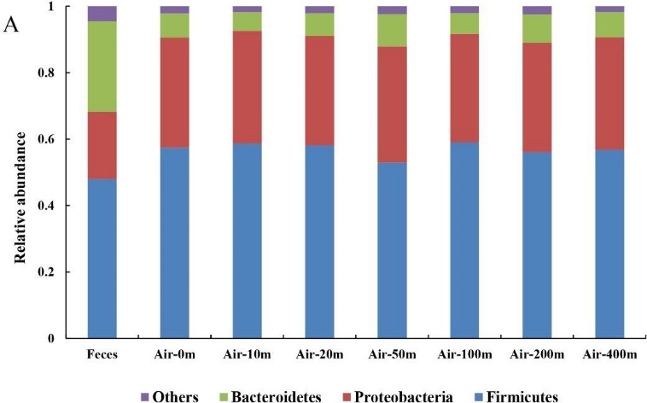 | 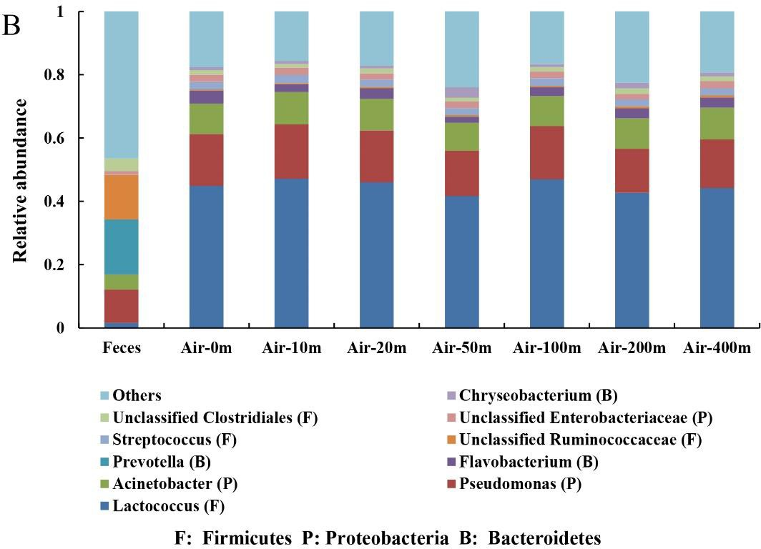
Fig. 1. Relative abundance of bacteria at the phylum (A) and Genus (B) levels in the faeces and air
3.2. Alpha and Beta diversity of bacteria
The richness and diversity of bacteria in faeces and air were analyzed by observed_species, Chao1, PD_whole_tree and Shannon statistical methods (Fig. 2). It was concluded that the bacterial diversity in faeces was apparently higher than in air (P < 0.001), while the similar diversity was found in the air at different distances. For instance, the Shannon index of faeces (8.05) was significantly (P < 0.001) higher than that for the air (average value 5.09), and there were no significant differences (P > 0.05) observed between Shannon indexes for air at each distance.
The beta diversity of bacteria in all samples was revealed by a weighted UniFrac distance matrix in the principal coordinates analysis (PCoA) diagram (Fig. 3). It could be concluded that there were apparent differences between the faeces and air samples (Fig. 3 A, C), based on the far distance in groups. However, no regularly located places were among the air samples collected at 0, 10, 20, 50, 100, 200 and 400 m from the swine barn (Fig. 3 B, D). Furthermore, the distance analyses indicated a great difference (P < 0.001) in the faeces-vs-air group, while all the air samples between distances didn't show significant (P > 0.05) change.
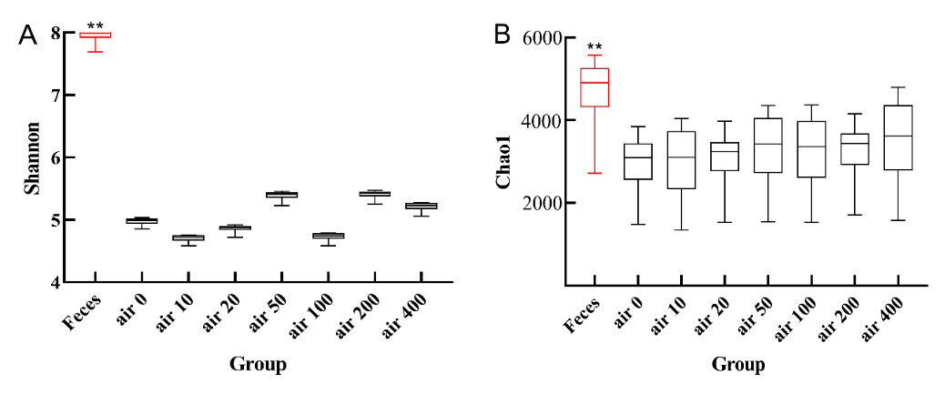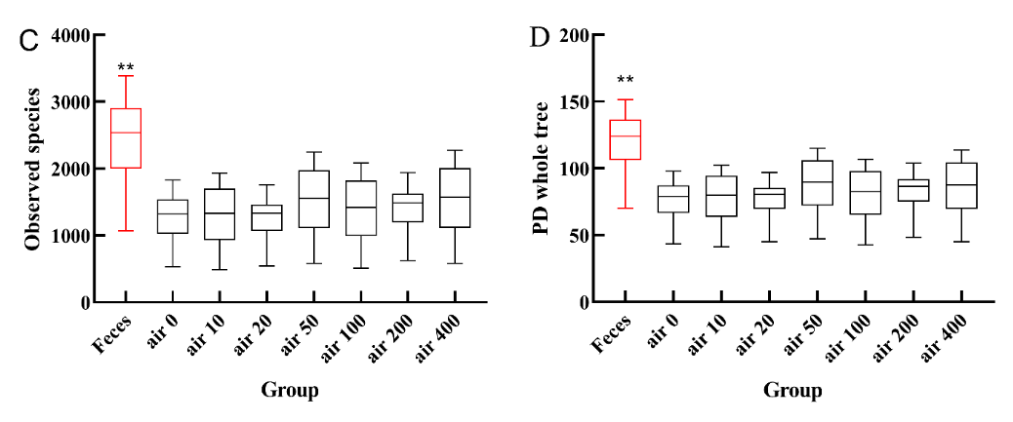
Fig. 2. The Shannon (A), observed_species (B), Chao1 (C) and PD_whole_tree (D) values in all samples

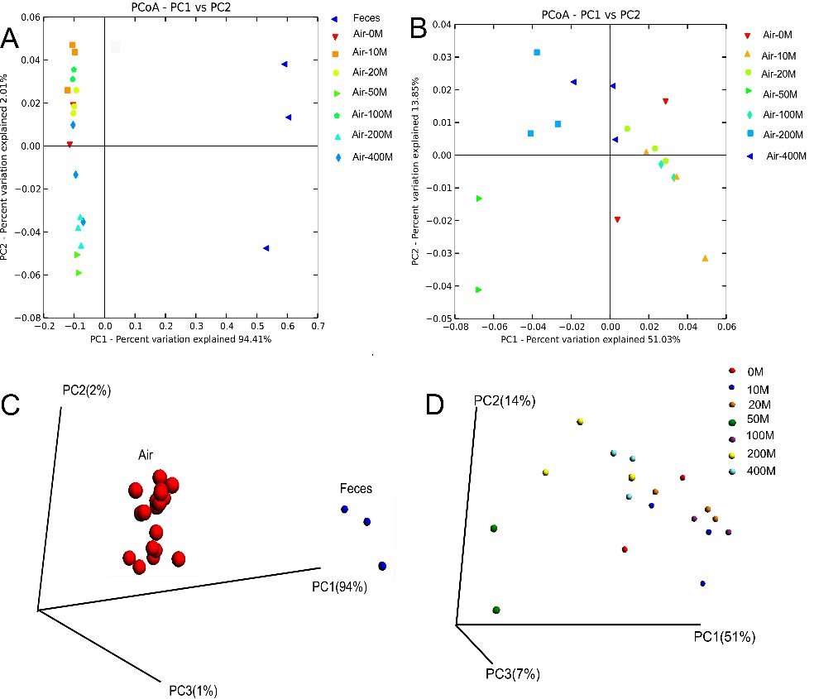
Fig. 3. The principal coordinates analysis (PCoA) diagram in all samples (A, C) and only air samples (B, D)
3.3. Sharing bacterial communities in air and faeces
The Venn diagrams were organized to measure all shared OTUs in faeces and air samples and are presented in Fig. 4. In total, 11214 and 6651 OTUs were detected in the air and faeces samples, respectively. The overlapped number was 4325 OTUs, which occupied 38% and 65% of the air and faeces samples, respectively. Moreover, 213 shared OTUs emerged after the OTUs clustering according to the Genus level. They were almost all of the faeces and 55% of the air. After clustering OTUs greater than 100 and 1000, the overlapped OTUs occupied more than 90% and 99% of the air, respectively. It means that the faeces and air share most of the bacteria, especially those in a dominant position.
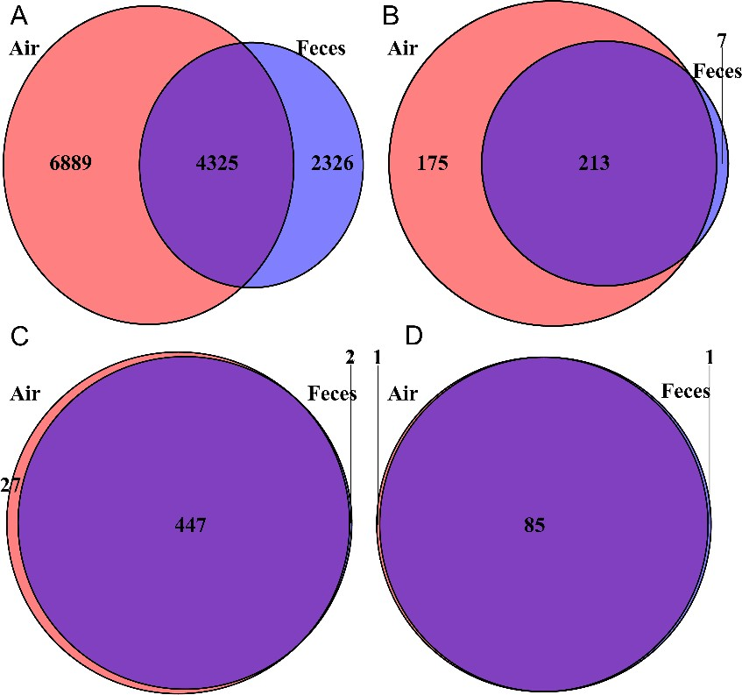
Fig. 4. The Venn diagrams of faeces and air samples by all OTUs (A); OTUs clustered according to the Genus level (B); OTUs clustered greater than 100 (C) and OTUs clustered greater than 1000 (D)
3.4. Pathogenic bacteria and their spreading
Six bacterial types (A, B, C1, C2, D and E) in all samples were classified by R software according to the abundance and existing site of OTUs (Table 2). A total of 132 OTUs were identified only in barn areas (C1), which means they do not cause pollution to the outside environment; 6689 OTUs inside the barn were less than outside (C2), which means they may come from the external environment. Especially the populations of 149 OTUs inside the barn were more changed than those outside, which were classified as type A. Therefore, it suggests that bacterial type A causes air pollution. In this way, the type B bacteria (1506 OTUs) have pollution potential as well cause their populations in the barn were higher than outside, even though they didn't change in a distance-dependent manner outside.

Table 2. The type and characteristics of bacteria at the Genus level
Bacterial Type | Characteristics | Total OTUs | Identified  Genera
A | Bacteria in the barn were more than outside,  and the populations changed in a distance-dependent manner | 149 | 16
B | Bacteria in the barn were more than outside,  and the populations did not change in a distance-dependent manner | 1506 | 97
C1 | Bacteria were detected only in the barn | 132 | 17
C2 | Bacteria outside the barn were more than inside | 6689 | 261
D | Bacteria were detected in the faeces, specifically | 969 | 35
E | Bacteria were detected in the air, specifically | 436 | 67

It was shown that 149 OTUs (A) were detected at 10 m distance, while 15 and 1 OTUs were detected at 20 m and 50 m, respectively (Table S1). This result indicates that only 15 of them could be spread to 20 m away, and 1 of them can get 50 m distance. However, 16 identified genera can be dispersed to 10 m away at the genus level. Only Prevotella was detected at 20 m distance from the barn. The Prevotella was reported as a pathogen that may cause aspiration pneumonia and lung abscesses (Tanaka 2008). It indicated that hygienic interval in swine farm design is crucial, following Platz et al. (1995), who found that the airborne bacteria and dust decreased significantly with increasing distance in the range of 0-10 m. Moreover, Keessen et al. (2011) reported it is difficult to detect the bacteria Clostridium at up to 20 m distance. Still, this study detected the Clostridiales at the 50 m distance (Table S1). It was revealed that Clostridiales are predominant microbes that mediate psychiatric disorders (Li et al. 2020). The existence of opportunistic pathogens in airborne communities evidenced potential health risks to farmers and other residents from swine bioaerosol exposure. All the results above support the conclusion that the hygienic interval should be set more than 50 m from the barn to prevent spreading infectious diseases caused by airborne bacteria in swine facilities.
Furthermore, bacteria present explicitly in the faeces and the air were classified as type D and E, respectively (Table 2). A total of 969 OTUs were detected in type D, 35 genera were identified, and 20 were reported pathogens. In comparison, there were 436 OTUs detected in type E, 67 genera were identified, and 34 reported pathogens (Table S2). The pathogens with OTUs greater than 10 in type D were Prevotella, Parabacteroides, Treponema and Bacteroide. It was reported that the Prevotella is bad to lung, Parabacteroides is related to abdominal infection, Treponema can cause helicobacter bacteria diseases such as syphilis, non-venereal syphilis, pinta and Yaws disease, and Bacteroides can cause abdominal infection (Tanaka 2008, Brook 2011, Knauf 2012, Cobo et al. 2021). The pathogens with OTUs greater than 10 in type E were Streptococcus which can cause septicemia, meningitis and pneumonia (Bonifait et al. 2014), Pseudomonas who generally affect lungs and urinary tract, or can cause burns and other blood infections (Todar 2006) and Chryseobacterium that can cause bacteremia (Dungan 2012). These results indicated that animal faeces are very important but not the only source of airborne pathogens. Therefore, it is necessary to take specific biological measures to control and prevent the spread of microorganisms.
4. Conclusions
It can be concluded from the results that the bacterial diversity in faeces was higher than in the air. Still, there were no significant differences among the air samples at different distances from the farm. The bacterial community compositions of faeces are differed from those in air, even though the faeces and air share most of the dominant bacteria. Moreover, pathogens present explicitly in the faeces and the air were Prevotella, Parabacteroides, Treponema, Bacteroide and Streptococcus, Pseudomonas, Chryseobacterium, respectively, animal faeces are only one of the source of airborne pathogens. Airborne pathogens Prevotella and Clostridiales could be spread 20 m and 50 m from the barn, respectively. So, the necessary hygienic distance of more than 50 m should be set to prevent spreading infectious diseases. Further research on the dispersion of prevalent pathogens in swine barns is needed.

This research was financially supported by the Sichuan Swine Innovation Team Construction Project
of National Modern Agricultural Industry Technology System of China [sccxtd-2022-08],
Natural Science Foundation of Sichuan Province [2022NSFSC1649]
and Sichuan Science and Technology Program [2021ZDZX0012].
References
Bonifait, L., Veillette, M., Létourneau, V., Grenier, D., Duchaine, C. (2014). Detection of Streptococcus suis in Bioaero-sols of Swine Confinement Buildings. Appl. Environ. Microb., 80, 3296-3304. https://doi.org/10.1128/AEM.04167-13
Brook, I. (2011). Antimicrobial treatment of anaerobic infections. Expert Opin. Pharmaco., 12, 1691-1707. https://doi.org/10.1517/14656566.2011.576672
Bull, S.A., Allen, V.M., Domingue, V.M., Allen, G., Jørgensen, F., Frost, J.A., Humphreyet, T.J. (2006). Sources of Campylobacter spp colonizing housed broiler flocks during rearing. Applied and Environmental Microbiology, 72, 645-652. https://doi.org/10.1128/AEM.72.1.645-652.2006
Caporaso, J.G., Kuczynski, J., Stombaugh, J., Bittinger, K., Bushman, F.D., Costello, E.K., Gordon, J.I. (2010). QIIME allows analysis of high-throughput community sequencing data. Nature Methods, 7, 335-336. https://doi.org/10.1038/nmeth.f.303
Cobo, F., Pérez-Carrasco, V., Gómez-Vicente, E., Martín-Hita, L., García-Salcedo, J.A., Navarro-Marí, J.M. (2021). Parabacteroides goldsteinii abdominal infection in a patient with lymphoma. Infectious Diseases Now, 52(2), 117-119. https://doi.org/10.1016/j.idnow.2021.04.004
Duan, H.Y., Chai, T, Liu, J.Z., Zhang, X.X., Qi, C.H., Gao, J., Yao, M.L. (2009). Source identification of airborne Escherichia coli of swine house surroundings using ERIC-PCR and REP-PCR. Environ. Res., 109(5), 511-517. https://doi.org/10.1016/j.envres.2009.02.014
Dungan, R.S. (2012). Use of a culture-independent approach to characterize aerosolized bacteria near an open-freestall dairy operation. Environ. Int., 41, 8-14. https://doi.org/10.1016/j.envint.2011.12.004
Dutkiewicz, J., Pomorski, Z.J.H., Sitkowska, J., Krysińska-Traczyk, E., Skórska, C., Prażmo, Z., Cholewa, G.,
Wójtowicz, H. (1994). Airborne microorganisms and endotoxin in animal houses. Grana, 33(2), 85-90.
https://doi.org/10.1080/00173139409427837
Hao, X., Ma, X., Zeng, B., Zhu, L., Shen, L., Yang, M., Hu, H., Jiang, D., Bai, L. (2021). Efficiency and mechanism of a vermicompost additive in enhancing composting of swine manure. Environ. Sci. Pollut. R., 28, 65791-65801. https://doi.org/10.1007/s11356-021-14498-x
Hartung, J. & Schulz, J. (2008). Risks caused by bio-aerosols in poultry houses. In: Thieme, O. & Pilling, D. (Eds.), Poultry in the twenty-first Century. Avian influenza and beyond. International poultry conference, Bangkok,
05-07.11.07, 1-11.
Keessen, E.C., Donswijk, C.J., Hol, S.P., Hermanus, C., Kuijper, E.J., Lipman, L.J.A. (2011). Aerial dissemination of Clostridium difficile on a pig farm and its environment. Environ. Res., 111(8), 1027-1032. https://doi.org/10.1016/j.envres.2011.09.014
Kembel, S.W., Jones, E., Kline, J., Northcutt, D., Stenson, J. (2012). Architectural design influences the diversity and structure of the built environment microbiome. The ISME journal, 6(8), 1469-1479. https://doi.org/10.1038/ismej.2011.211
Knauf, S., Batamuzi, E.K., Mlengeya, T., Kilewo, M., Lejora, I.A., Nordhoff, M., Ehlers, B., Harper, K.N., Fyumagwa, R., Hoare, R., Failing, K., Wehrend, A., Kaup, F.J., Leendertz, F.H., Matz-Rensing, K. (2012). Treponema infection associated with genital ulceration in wild baboons. Vet Pathol., 49, 292-303. https://doi.org/10.1177/0300985811402839
Koubová, A., Goberna, M., Simek, M., Chronáková, A., Pizl, V., Insam, H., Elhottová, D. (2012). Effects of the earthworm Eisenia andrei on methanogens in a cattle-impacted soil: A microcosm study. European Journal of Soil Biology, 48, 32-40. http://doi/org/10.1046/j.1523-1739.2000.99119.x
Li, J., Ma, Y., Bao, Z., Gui, X., Li, A.N., Yang, Z., Li, M.D. (2020). Clostridiales are predominant microbes that mediate psychiatric disorders. J. Psychiatr. Res., 130, 48-56. https://doi.org/10.1016/j.jpsychires.2020.07.018
Madelin, T.M. & Wathes, C.M. (1989). Air hygiene in a broiler house: Comparison of deep litter with raised netting floors. British Poultry Science, 30, 23-37. https://doi.org/10.1080/00071668908417122
Malmberg, P. (1990). Health effects of organic dust exposure in dairy farmers. Am. J. Ind. Med., 17(1), 7-15. https://doi.org/10.1002/ajim.4700170104
Martin-Laurent, F., Philippot, L., Hallet, S., Chaussod, R., Germon, J.C., Soulas, G. (2001). DNA extraction from soils: old bias for new microbial diversity analysis methods. Appl. Environ. Microb., 67(5), 2354-2359. https://doi.org/10.1128/AEM.67.5.2354-2359.2001
Millner, P.D. (2009). Bioaerosols associated with animal production operations. Bioresource Technology, 100, 5379-5385. https://doi.org/10.1016/j.biortech.2009.03.026
Nakamura, Y., Ishibashi, M., Kamitani, Y., Tsurumaru, H. (2020). Microbial Community Analysis of Digested Liquids Exhibiting Different Methane Production Potential in Methane Fermentation of Swine Feces. Appl. Biochem. Biotech., 191, 1140-1154. https://doi.org/10.1007/s12010-020-03228-7
Osborn, A.M, Moore, E.R.B., Timmis, K.N. (2000). An evaluation of terminal‐restriction fragment length polymorphism (T‐RFLP) analysis for the study of microbial community structure and dynamics. Environmental microbiology, 2(1), 39-50. http://doi/org/10.1046/j.1462-2920.2000.00081.x
Pernthaler, A., Pernthaler, J., Amann, R. (2002). Fluorescence in situ hybridization and catalyzed reporter deposition for the identification of marine bacteria. Appl. Environ. Microb., 68(6), 3094-3101. https://doi.org/10.1128/AEM.68.6.3094-3101.2002
Platz, S., Scherer, M., Unshelm, J. (1995). Burden of fattening pigs and the environment of the pig fattening farms caused by lung-passing dust particles, pig stall specific bacteria and ammonia. International journal of hygiene and environmental medicine, 196(5), 399.
Song, L., Wang, C., Jiang, G., Ma, J., Li, Y., Chen, H., Guo, J. (2021). Bioaerosol is an important transmission route of antibiotic resistance genes in pig farms. Environ. Int., 154, 106559. https://doi.org/10.1016/j.envint.2021.106559
Tanaka, S., Yoshida, M., Murakami, Y., Ogiwara, T., Shoji, M., Kobayashi, S., Fujisawa, S. (2008). The relationship of Prevotella intermedia, Prevotella nigrescens and Prevotella melaninogenica in the supragingival plaque of children, caries and oral halitosis. J. Clin. Pediatr. Dent., 32, 195-200. https://doi.org/10.17796/jcpd.32.3.vp657177815618l1
Todar, K. (2006). Pseudomonas aeruginosa. In Todar's Online Textbook of Bacteriology (pp. 1-2). Kenneth Todar University of Wisconsin-Madison Department of Bacteriology. Retrieved from http://textbookofbacteriology.net/index.html
Vestergaard, D.V., Holst, G.J., Basinas, I., Elholm, G., Schlünssen, V., Linneberg, A., Šantl-Temkiv, T., Finster, K., Sigsgaard, T., Marshall, I.P.G. (2018). Pig Farmers’Homes Harbor More Diverse Airborne Bacterial Communities Than Pig Stables or Suburban Homes. Frontiers in microbiology, 9. https://doi.org/10.3389/fmicb.2018.00870
Whyte, R.T. (1993). Aerial pollutants and the health of poultry farmers. World's Poultry Science Journal, 49, 139-156. https://doi.org/10.1019/WPS19930012
Yang, Y., Xing, S., Chen, Y., Wu, R., Wu, Y., Wang, Y., Mi, J., Liao, X. (2021). Profiles of bacteria/phage-comediated ARGs in pig farm wastewater treatment plants in China: Association with mobile genetic elements, bacterial communities and environmental factors. J. Hazard. Mater., 404, 124149. https://doi.org/10.1016/j.jhazmat.2020.124149
Yuan, W., Chai, T.J., Miao, Z.M. (2010). ERIC-PCR identification of the spread of airborne Escherichia coli in pig houses. Sci. Total Environ., 408(6), 1446-1450. https://doi.org/10.1016/j.scitotenv.2009.12.019
Zeng, B., Zhao, J., Guo, W., Zhang, S., Hua, Y., Tang, T., Li, Y. (2017). High-Altitude Living Shapes the Skin Microbiome in Humans and Pigs. Frontiers in microbiology, 8, 1929. https://doi.org/10.3389/fmicb.2017.01929

Supporting materials
Table S1. The spread of pathogens belonged to type A
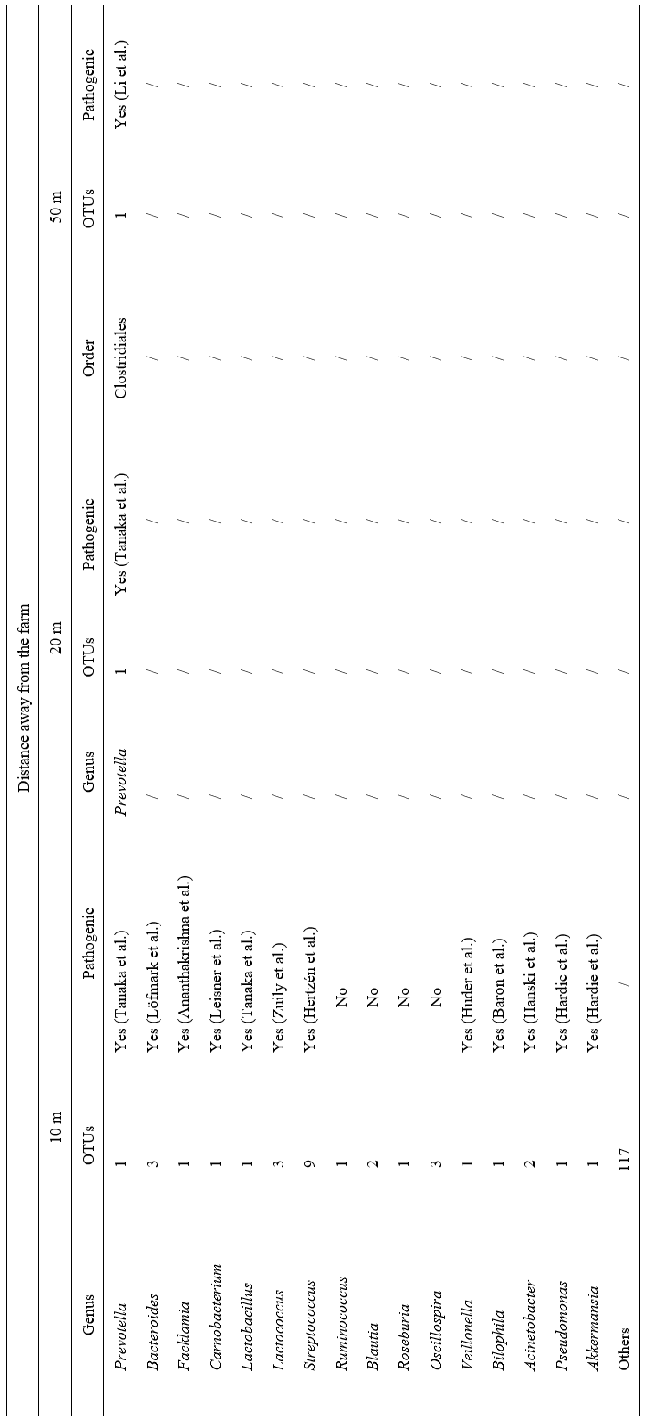
Table S2. The bacteria and their pathogenic property of type D and E
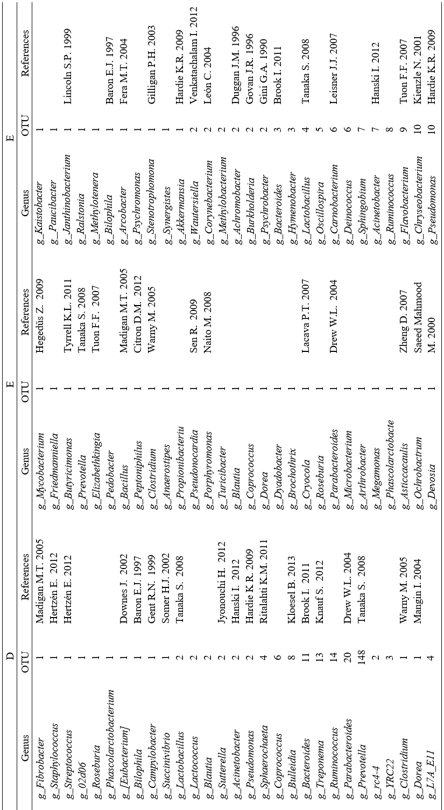
Table S2. cont.
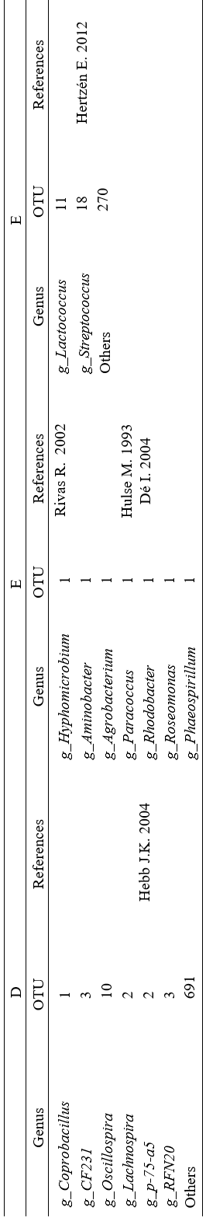

References for supporting materials
Ananthakrishna, R., Shankarappa, R.K., Jagadeesan, N., Math, R.S., Karur, S., Nanjappa, M.C. (2012). Infective Endocarditis: A Rare Organism in an Uncommon Setting. Case Reports in Infectious Diseases, 2012, 1-3. https://doi.org/10.1155/2012/307852
Baron, EJ. (1997). Bilophila wadsworthia: a unique Gram-negative anaerobic rod. Anaerobe, 3, 83-6. https://doi.org/10.1006/anae.1997.0075
Hardie, K., Pommier, S., Wilhelm S. (2009). The secreted proteins of Pseudomonas aeruginosa: their export machineries, and how they contribute to pathogenesis. Bacterial secreted proteins: secretory mechanisms and role in pathogenesis. Caister Academic Press, Norwich, United Kingdom, 2009, 451-458.
Hanski, I., von Hertzen, L., Fyhrquist, N., Koskinen, K., Torppa, K., Laatikainen, T., Karisola, P., Auvinen, P., Paulin, L., Makela, M.J., Vartiainen, E., Kosunen, T.U., Alenius, H., Haahtela, T. (2012). Environmental biodiversity, human microbiota, and allergy are interrelated. Proc. Natl. Academy Sci., 109, 8334-8339. https://doi.org/10.1073/pnas.1205624109
Hertzén, E., Johansson, L., Kansal, R., Hecht, A., Dahesh, S., Janos, M., Nizet, V., Kotb, M., Norrby-Teglund, A. (2012). Intracellular Streptococcus pyogenes in human macrophages display an altered gene expression profile. PLoS One, 7, e35218. https://doi.org/10.1371/journal.pone.0035218
Huder, J.B., Dimroth, P. (1993). Sequence of the sodium ion pump methylmalonyl-CoA decarboxylase from Veillonella parvula. J. Biol. Chem., 268, 24564-24571. https://doi.org/10.1016/S0021-9258(19)74504-9
Leisner, J.J., Laursen, B.G., Prévost, H., Drider, D., Dalgaard, P. (2007). Carnobacterium: positive and negative effects in the environment and in foods. FEMS microbiology reviews, 31(5), 592-613. http://doi.org/doi:10.1111/j.1574-6976.2007.00080.x
Li, J., Ma, Y., Bao, Z., Gui, X., Li, A.N., Yang, Z., Li, M.D. (2020). Clostridiales are predominant microbes that mediate psychiatric disorders. J. Psychiatr. Res., 130, 48-56. https://doi.org/10.1016/j.jpsychires.2020.07.018
Tanaka, S., Yoshida, M., Murakami, Y., Ogiwara, T., Shoji, M., Kobayashi, S., Fujisawa, S. (2008). The relationship of Prevotella intermedia, Prevotella nigrescens and Prevotella melaninogenica in the supragingival plaque of child-ren, caries and oral halitosis. J. Clin. Pediatr. Dent., 32, 195-200. https://doi.org/10.17796/jcpd.323.vp657177815618l1
Zuily, S., Mami, Z., Meune, C. (2011). Lactococcus garvieae endocarditis. Archives of Cardiovascular Diseases, 104, 138-139. https://doi.org/10.1016/j.acvd.2010.05.005
Baron, E.J. (1997). Bilophila wadsworthia: a unique Gram-negative anaerobic rod. Anaerobe, 3, 83-6. https://doi.org/10.1006/anae.1997.0075
Berlanga, M. (2005). Brock Biology of Microorganisms, 11th edn. International Microbiology, 8(2), 149-150. Retrieved from https://search.ebscohost.com/login.aspx?direct=true&db=aph&AN=20905443&lang=zhcn&site=ehost-live
Brook, I., (2011). Antimicrobial treatment of anaerobic infections. Expert Opinion on Pharmacotherapy, 12, 1691-1707. https://doi.org/10.1517/14656566.2011.576672
Citron, D.M., Tyrrell, K.L., Goldstein, E.J. (2012). Peptoniphilus coxii sp. nov. and Peptoniphilus tyrrelliae sp. nov. isolated from human clinical infections. Anaerobe, 18(2), 244-248. https://doi.org/10.1016/j.anaerobe.2011.11.008
Dé, I., Rolston, K.V., Han, X.Y. (2004). Clinical significance of Roseomonas species isolated from catheter and blood samples: analysis of 36 cases in patients with cancer. Clinical Infectious Diseases: an official publication of the Infectious Diseases Society of America, 38(11), 1579-1584. https://doi.org/10.1086/420824
Downes, J., Munson, M.A., Radford, D.R., Spratt, D.A., Wade, W.G. (2002). Shuttleworthia satelles gen. nov., sp. nov., isolated from the human oral cavity. International J. Systematic and Evolutionary Microbiology, 52, 1469-1475. https://doi.org/10.1099/00207713-52-5-1469
Drew, W.L. (2004). Sherris Medical Microbiology (4th ed., Chapter 41: Rabies). New York and London: McGraw Hill.
Duggan, J.M., Goldstein, S.J., Chenoweth, C.E., Kauffman, C.A., Bradley, S.F. (1996). Achromobacter xylosoxidans Bacteremia: Report of Four Cases and Review of the Literature. Clinical Infectious Diseases, 23(3), 569-576. https://doi.org/10.1093/clinids/23.3.569
Fera, M.T., Maugeri, T.L., Gugliandolo, C., Beninati, C., Giannone, M., La Camera, E., Carbone, M. (2004). Detection of Arcobacter spp. in the Coastal Environment of the Mediterranean Sea. Applied and Environmental Microbiology, 70(3), 1271-1276. https://doi.org/10.1128/AEM.70.3.1271-1276.2004
Gent, R.N., Telford, D.R., Syed, Q. (1999). An outbreak of campylobacter food poisoning at a university campus. Communicable disease and public health, 2(1), 39-42.
Gilligan, P., Lum, G., Vandamme, P., Whittier, S. (2003). Burkholderia, Stenotrophomonas, Ralstonia, Brevundimonas, Comamonas, Delftia, Pandoraea, and Acidovorax. In P.R. Murray, E.J. Baron, J., H. Jorgenson, M.A. Pfaller, R.H. Yolken (Eds.), Manual of clinical microbiology, 8, 729-748. Washington, DC, USA: ASM Press.
Gini, G.A. (1990). Ocular infection caused by Psychrobacter immobilis acquired in the hospital. Journal of clinical microbiology, 28(2), 400-401. https://doi.org/10.1128/jcm.28.2.400-401.1990
Govan, J.R., Deretic, V. (1996). Microbial pathogenesis in cystic fibrosis: mucoid Pseudomonas aeruginosa and Burkholderia cepacia. Microbiological Reviews, 60(3), 539-74. https://doi.org/10.1128/MMBR.60.3.539-574.1996

Hanski, I., von Hertzen, L., Fyhrquist, N., Koskinen, K., Torppa, K., Laatikainen, T., Karisola, P., Auvinen, P., Paulin, L., Makela, M.J., Vartiainen, E., Kosunen, T.U., Alenius, H., Haahtela, T. (2012). Environmental biodiversity, human microbiota, and allergy are interrelated. Proc. Natl. Academy Sci., 109, 8334-8339. https://doi.org/10.1073/pnas.1205624109
Hardie, K., Pommier, S., Wilhelm, S. (2009). The secreted proteins of Pseudomonas aeruginosa: their export machineries, and how they contribute to pathogenesis. Bacterial secreted proteins: secretory mechanisms and role in pathogenesis. Caister Academic Press, Norwich, United Kingdom, 2009: 451-458.
Hebb, J.K., Cohen, C.R., Astete, S.G., Bukusi, E.A., Totten, P.A. (2004). Detection of Novel Organisms Associated with Salpingitis, by Use of 16S rDNA Polymerase Chain Reaction. The Journal of Infectious Diseases, 190(12),
2109-2120. https://doi.org/10.1086/425929
Hegedűs, Z., Zakrzewska, A., Ágoston, V.C., Ordas, A., Rácz, P., Mink, M., Spaink, H.P., Meijer, A.H. (2009). Deep sequencing of the zebrafish transcriptome response to mycobacterium infection. Molecular Immunology, 46,
2918-2930. https://doi.org/10.1016/j.molimm.2009.07.002
Hertzén, E., Johansson, L., Kansal, R., Hecht, A., Dahesh, S., Janos, M., Nizet, V., Kotb, M., Norrby- Teglund, A. (2012). Intracellular Streptococcus pyogenes in human macrophages display an altered gene expression profile. PLoS One, 7, e35218. https://doi.org/10.1371/journal.pone.0035218
Hulse, M., Johnson, S., Ferrieri, P. (1993). Agrobacterium infections in humans: experience at one hospital and review. Clin Infect Dis, 16, 112-117. https://doi.org/10.1093/clinids/16.1.112
Irène, M., Régis, B., Philippe, S., Lionel, R, Malène, S., Yoram, B., Christel, N, Matthew, D.C., Jean- Frédéric, C., Philippe, M., Joël, D. (2004). Molecular inventory of faecal microflora in patients with Crohn's disease. FEMS microbiology ecology, 50(1), 25-36. https://doi.org/10.1016/j.femsec.2004.0
Jousimies-Somer, H., Summanen, P. (2002). Recent taxonomic changes and terminology update of clinically significant anaerobic gram-negative bacteria (excluding spirochetes). Clin Infect Dis, 35, 17-21. https://doi.org/10.1086/341915
Jyonouchi, H., Geng, L., Streck, D.L., Toruner, G.A. (2012). Immunological characterization and transcription profiling of peripheral blood (PB) monocytes in children with autism spectrum disorders (ASD) and specific polysaccharide antibody deficiency (SPAD): case study. Journal of Neuroinflammation, 9(4). https://doi.org/10.1186/1742-2094-9-4
Kienzle, N., Muller, M., Pegg, S. (2001). Chryseobacterium in burn wounds. Burns, 27(2), 179-182. https://doi.org/10.1016/S0305-4179(00)00087-5
Kloesel, B., Beliveau, M., Patel, R., Trousdale, R.T., Sia, I.G., (2013). Bulleidia extructa Periprosthetic Hip Joint Infection, United States. Emerging Infectious Diseases, 19(7), 1170-1171. https://doi.org/10.3201/eid1907.130078
Knauf, S., Batamuzi, E.K., Mlengeya, T., Kilewo, M., Lejora, I.A., Nordhoff, M., Ehlers, B., Harper, K.N., Fyumagwa, R., Hoare, R., Failing, K., Wehrend, A., Kaup, F.J., Leendertz, F.H., Matz-Rensing, K. (2012). Treponema infection associated with genital ulceration in wild baboons. Vet Pathol., 49, 292-303. https://doi.org/10.1177/0300985811402839
Leisner, J.J., Laursen, B.G., Prévost, H., Drider, D., Dalgaard, P. (2007). Carnobacterium: positive and negative effects in the environment and in foods. FEMS Microbiology Reviews, 31(5), 592-613. http://doi.org/doi:10.1111/j.1574-6976.2007.00080.x
León, C., Ariza, J. (2004). Guías para el tratamiento de las infecciones relacionadas con catéteres intravasculares de corta permanencia en adultos: conferencia de consenso SEIMC-SEMICYUC. Enfermedades Infecciosas y Microbiología Clínica, 22(2), 92-97. https://doi.org/10.1016/S0213- 005X(04)73041-4
Lincoln, S.P., Fermor, T.R., Tindall, B.J. (1999). Janthinobacterium agaricidamnosum sp. nov., a soft rot pathogen of Agaricus bisporus. International J. of Systematic Bacteriology, 49(4), 1577-1589. https://doi.org/10.1099/00207713-49-4-1577
Madigan, M.T., Martinko J.M. (2005). Brock Biology of Microorganisms, 11th edn. International microbiology, 8, 149-152.
Mahmood, M.S., Sarwari, A.R., Khan, M.A., Sophie, Z., Khan, E., Sami, S. (2000). Infective endocarditis and septic embolization with Ochrobactrum anthropi: case report and review of literature. The Journal of infection, 40(3), 287-290. https://doi.org/10.1053/jinf.2000.0644
Michel, W., Jacques, P., Aiqi F., George, K., Angela, T., Jon, B., Eric, F., L., Clifford M. (2005). Toxin production by an emerging strain of Clostridium difficile associated with outbreaks of severe disease in North America and Europe. The lancet, 366(9491), 1079-1084. https://doi.org/10.1016/s0140-6736(05)67420-x
Naito, M., Hirakawa, H., Yamashita, A., Ohara, N, Shoji, M., Yukitake, H., Nakayama, K., Toh, H., Yoshimura, F., Kuhara, S., Hattori, M., Hayashi, T., Nakayama, K. (2008). Determination of the Genome Sequence of Porphyromonas gingivalis Strain ATCC 33277 and Genomic Comparison with Strain W83 Revealed Extensive Genome Rearrangements in P. gingivalis. DNA Research, 15(4), 215-225. https://doi.org/10.1093/dnares/dsn013
Paulo, T.L., Jennifer, P., Fernando, D.A., Francisco, D., José, L.R., Thomas, A.M. (2007). Analysis of the bacterial com-munity in glassy-winged sharpshooter heads. Entomological Research, 37(4), 261-266. https://doi.org/10.1111/j.1748-5967.2007.00123.x
Ritalahti, K.M., Justicia Leon, S.D., Cusick, K.D., Ramos-Hernandez, N., Rubin, M., Dornbush, J., Löffler, F.E. (2011). Isolation of Sphaerochaeta (gen. nov.), free-living, spherical spirochetes, and characterization of Sphaerochaeta pleomorpha (sp. nov.) and Sphaerochaeta globosa (sp. nov.). International Journal of Systematic and Evolutionary Microbiology, 4933(865). Retrieved from http://www.ncbi.nlm.nih.gov/pubmed/21398503

Rivas, R., Velázquez, E., Willems, A., Vizcaíno, N., Subba-Rao, N.S., Mateos, P.F., Gillis, M., Dazzo, F.B., Martínez-Molina, E. (2002). A new species of Devosia that forms a unique nitrogen-fixing root-nodule symbiosis with the aquatic legume Neptunia natans (L.f.) druce. Applied and environmental microbiology, 68(11), 5217-5222. https://doi.org/10.1128/AEM.68.11.5217-5222.2002
Sen, R., Ishak, H.D., Estrada, D., Dowd, S.E., Hong, E., Mueller, U.G. (2009). Generalized antifungal activity and 454-screening of Pseudonocardia and Amycolatopsis bacteria in nests of fungus-growing ants. Proceedings of the National Academy of Sciences of the United States of America, 106(42), 17805-17810. https://doi.org/10.1073/pnas.0904827106
Sood, S., Nerurkar, V., Malvankar, S. (2010). Chryseobacterium meningosepticum cellulitis and sepsis in an adult female with pemphigus vulgaris. Indian Journal of Medical Microbiology, 28(3), 268-269. https://doi.org/10.4103/0255-0857.66481
Tanaka, S., Yoshida, M., Murakami, Y., Ogiwara, T., Shoji, M., Kobayashi, S., Fujisawa, S. (2008). The relationship of Prevotella intermedia, Prevotella nigrescens and Prevotella melaninogenica in the supragingival plaque of children, caries and oral halitosis. J. Clin. Pediatr. Dent., 32, 195-200. https://doi.org/10.17796/jcpd.32.3.vp657177815618l1
Tyrrell, K.L., Warren, Y.A., Citron, D.M., Goldstein, E.J. (2011). Re-assessment of phenotypic identifications of Bacteroides putredinis to Alistipes species using molecular methods. Anaerobe, 17(3), 130-134. https://doi.org/10.1016/j.anaerobe.2011.04.002
Venkatachalam, I., Teo, J., Balm, M.N.D., Fisher, D.A., Jureen, R., Lin, R.T.P. (2012). Klebsiella pneumoniae Carbapenemase-producing Enterobacteria in Hospital, Singapore. Emerging Infectious Diseases, 18. https://doi.org/10.3201/eid1808.110893
Zheng, D., Valdez-cruz, N., Armengol, G., Sevrez, C., Munoz-olaya, J., Yuan, Z., Crickmore, N. (2007). Co-expression of the mosquitocidal toxins Cyt1Aa and Cry11Aa from Bacillus thuringiensis subsp. israelensis in Asticcacaulis excentricus. Current Microbiology, 54(1), 58-62. http://dx.doi.org/10.1007/s00284-006-0352-7

