 | Rocznik Ochrona Środowiska
 | Volume 24 | Year 2022 ISSN 2720-7501 | pp. 202-213
 | https://doi.org/10.54740/ros.2022.015 open access
 | Received: 25 September 2022 Accepted: 10 October 2022 Published: 14 November 2022
Analysis of the Energy Efficiency
of the Earth-To-Air Heat Exchanger
Boris Basok
Institute of Engineering Thermophysics,
National Academy of Sciences of Ukraine, Ukraine
https://orcid.org/0000-0002-8935-4248
Anatoliy Pavlenko
Kielce University of Technology, Poland
https://orcid.org/0000-0002-8103-2578
Aleksandr Nedbailo
Institute of Engineering Thermophysics,
National Academy of Sciences of Ukraine, Ukraine
https://orcid.org/0000-0003-1416-9651
Ihor Bozhko*
Institute of Engineering Thermophysics,
National Academy of Sciences of Ukraine, Ukraine
https://orcid.org/0000-0001-7458-0835
Maryna Novitska
Institute of Engineering Thermophysics,
National Academy of Sciences of Ukraine, Ukraine
https://orcid.org/0000-0003-2867-101X
Hanna Koshlak
Kielce University of Technology, Poland,
https://orcid.org/0000-0001-8940-5925
Myroslav Tkachenko
Institute of Engineering Thermophysics,
National Academy of Sciences of Ukraine, Ukraine
https://orcid.org/0000-0001-8345-1613
*corresponding author’s e-mail: bozhkoik@gmail.com
Abstract: This article represents the results of experimental studies of the temperature regime during the long-term operation of the earth-to-air heat exchanger. The average annual, total monthly and daily average specific amounts of heat extracted from the soil or released into the soil mass, respectively, depending on the cold or warm periods of the year, were determined. Analyzing the given data allowed a monthly assessment of the energy efficiency of using the earth-to-air heat exchanger. It is noted that the most significant thermal contribution occurs in the middle of the warm and cold periods of the year when the most significant difference in temperature of the outside air and the soil massif is observed. The use of earth-to-air heat exchangers is one of the necessary tools to lower the energy consumption for modern air-conditioning systems of buildings due to their energy efficiency.
Keywords: geothermal ventilation, earth-to-air heat exchanger, experimental studies, numerical modelling, renewable energy sources
1. Introduction
The most significant potential for an increase in energy efficiency is in the area of heat supply of the country’s housing and communal services (Basok & Bazeev 2017, Koshlak & Pavlenko 2019, Pavlenko & Szkarowski 2018, Pavlenko & Koshlak 2015, Pavlenko et al. 2014). The primary solution for heating and air-cooling cost reduction is the thermal modernization of residential buildings to the level of an energy-efficient or passive house. In such houses, since they are sufficiently insulated, a larger amount of energy is spent not on heating but on ventilation of the premises. Therefore, the development of energy-efficient technical solutions for the ventilation of premises is currently the most relevant. One of these solutions is using Earth-to-Air Heat Exchangers, EAHE.
The EAHE is a pipeline or a system of pipelines located in the soil at a certain depth. It is known that the soil temperature at a depth below 2.0 m remains almost constant throughout all year. The air that is necessary for ventilation of the room, passing through the pipes located at such a depth, is being preheated in the cold period of the year and cooled in the warm period. The main advantages of such systems are simplicity; high potential for cooling in summer and heating in winter; low operational and maintenance costs; reduction of consumption of fossil fuels, and, accordingly, reduction of the level of greenhouse gas emissions.
Many factors affect the energy efficiency of the EAHE during its design and operation. These factors can be divided into three main categories:
- design of the heat exchanger (depth of the heat exchanger location; length, material and diameter of pipelines; quantity of pipelines),
- thermophysical properties of the soil (thermal conductivity, heat capacity, moisture),
- environmental parameters affecting the distribution of heat in the soil (share of radiation and convection in heat exchange; wind speed; type of vegetation or cover above the EAHE location; rate of evaporation and condensation).
The influence of these parameters on the efficiency of EAHE operation is widely presented in the literature. In general, all these works can be divided into categories according to the research method:
- Modelling that includes:
- Numerical or CFD models (Agrawal et al. 2019, Basok & Novitska 2017),
- Analytical models (Tzaferis et al. 1992),
- Models using artificial neural networks (Mihalakakou 2003, Basok et al. 2021a),
- Experimental studies (Díaz-Hernández et al. 2020),
- Hybrid (works that combine several methods) (Basok et al. 2021b),
- Evaluation of the economic and/or energy efficiency of the EAHE (Pfafferott 2003).

This study aims to evaluate the energy efficiency of the Earth-to-Air Heat Exchanger based on experimental data obtained with the help of the experimental stand designed and operated in the Institute of Engineering Thermophysics of the National Academy of Sciences of Ukraine (Basok et al. 2019, 2020).
2. Description of the Experimental Stand
The main element of the experimental stand is a U-shaped earth-to-air heat exchanger with a total length of 43 m (see Fig. 1). Its main technical characteristics are given in Table 1.

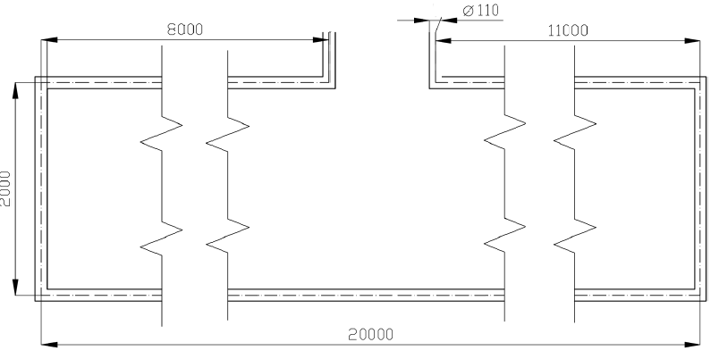
Fig. 1. Scheme and geometric dimensions of the EAHE

The heat exchanger is made of PVC-U pipes Ø110 mm and is located in the soil mass at a depth of 2.2 m (significantly lower than the seasonal depth of soil freezing in Kyiv). This heat exchanger is operated in two modes: in the warm season – air cooling mode, and in the cold period – supply air heating mode for the supply and exhaust ventilation system. The system uses a Vents TT 150 PRO axial fan with a consumption of electric power of 60 W for air circulation.
The study of the operation of the geothermal ventilation system was carried out in the mode of circulation of incoming air with a speed of 4.4 m/s in the core of the flow, which corresponds to the volume flow of air of 104.4 m³/h. The experimental stand is equipped with a measuring system – a Testo 405-V1 thermal anemometer, BME280 semiconductor sensors (a total of 32 sensors located in the soil near the heat exchanger) and secondary devices based on microprocessors (see Fig. 2).

Table 1. Technical characteristics of the EAHE
Parameter | Value
Quantity of pipelines | 1
The total length of the EAHE pipeline, m | 43
The internal diameter of the EAHE pipeline, m | 0.11
Depth of EAHE occurrence, m | 2.2
Airflow, dm³/s | 29
Airspeed, m/s | 4.4
Year of the start of the operation | 2018
The total duration of measurements, years | 2

The main parameters registered by the measuring complex that can indicate the heat exchanger’s efficiency are temperature, humidity and air pressure measured at the inlet and outlet of the EAHE.

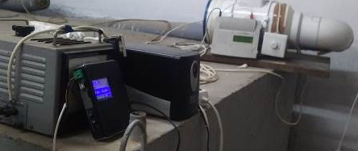
Fig. 2. Measuring complex of the experimental stand
3. Experimental Studies Results
A comparison of the temperature values at the inlet and outlet of the EAHE is shown in Fig. 3.
Figure 4 shows the dependencies reflecting the temperature behaviour of the EAHE. The temperature values have been divided by vertical lines into three zones: the heating period when the air temperature at the inlet of the heat exchanger is below 12°С, the air conditioning period when the entering air temperature is above 22°С and the period between them when there is no need for air conditioning and heating (according to the parameters of the thermal regime of the premises). In addition, during the heating period, sometimes during the day in sunny weather, the temperature of the air at the outlet of EAHE exceeds the temperature of the air at the inlet for several hours (Fig. 5a). Also, in summer, with relatively low air temperatures in the morning and evening, the temperature of the air entering the heat exchanger is lower than the temperature at its exit (Fig. 5b).
The ventilation air was almost insensitive to local changes (daily) in the ambient air temperature, and its temperature level was determined exclusively by the thermal regime of the soil mass surrounding the soil heat exchanger.
Daily fluctuations in the air temperature at the heat exchanger’s inlet do not sufficiently affect the temperature at its outlet. It is explained by the fact that the heat exchanger has a significant heat exchange area.

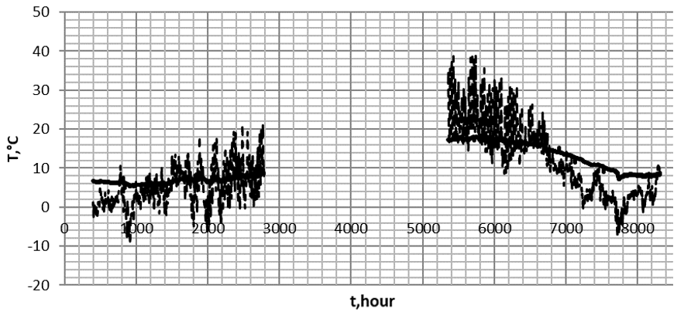
a)

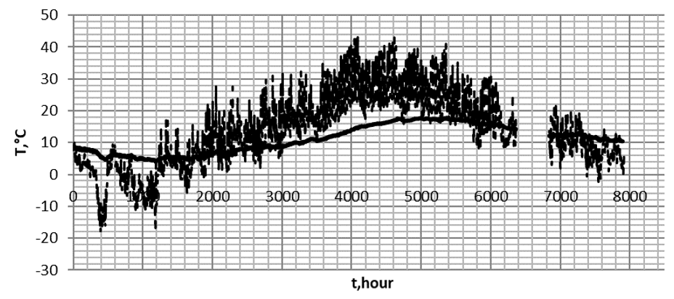
b)
Fig. 3. Values of air temperature at the inlet and outlet of the AEHE for 2020 (a) and 2021 (b), respectively, here: _ _ _ _ _ – inlet temperature; _______ – outlet temperature

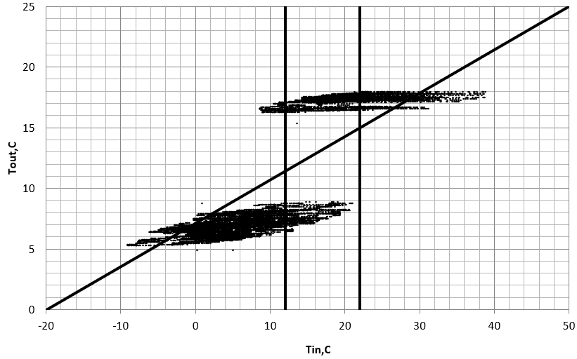
a)

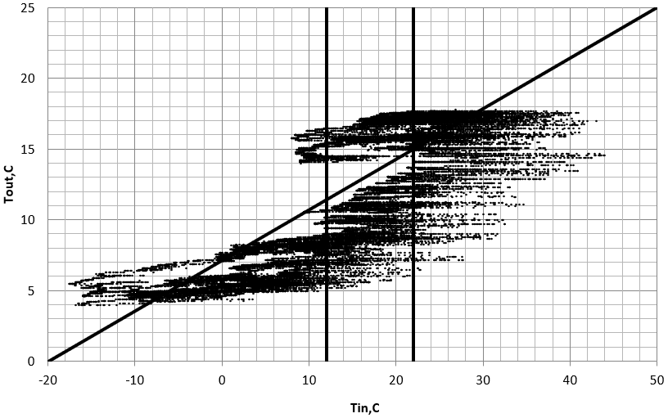
b)
Fig. 4. The dependence of the air temperature at the outlet of the EAHE on the temperature at the inlet for 2020 (a) and 2021 (b), respectively

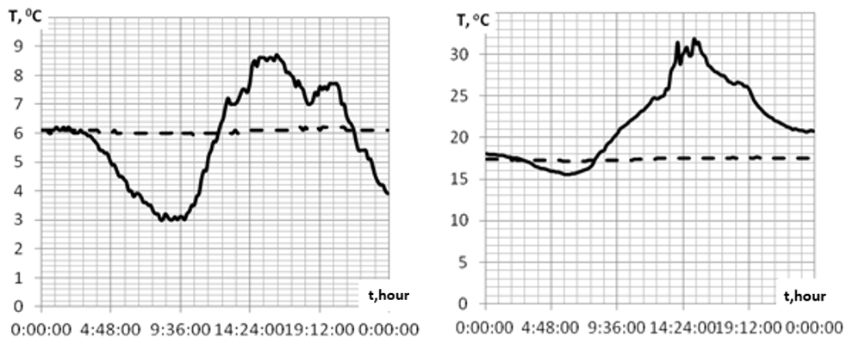
a) b)
Fig. 5. The temperature at the inlet ________ and at the outlet _ _ _ _ _ from the EAHE

Figure 6 shows the temperature values at the outlet of the EAHE for 2020 and 2021, respectively.

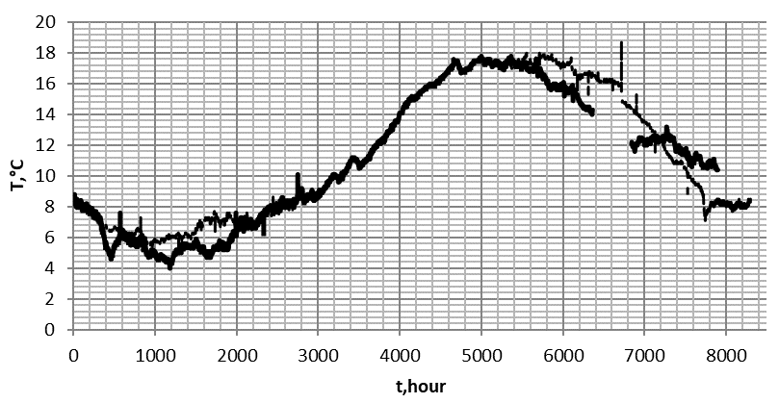
Fig. 6. The temperature at the outlet of the EAHE for: _ _ _ _ - 2020, ________ - 2021
4. Determination of the Thermal Power of the EAHE
The thermal power of the EAHE could be determined by the formula:
(1)

When considering the long-term use of the heat exchanger, it is possible to calculate the amount of heat needed to heat the supply air or its cooling during a specific period. Average annual indicators calculated from experimental data are shown in Table 2.
The air density used in formula (1) depends on the temperature, and its values have been taken from open-source literature.

Table 2. An average annual specific amount of heat extracted from the soil mass or discharged into it during the operation of the EAHE
Period of measurements | Units of measurement | 2020 | 2021
 |  | from 17 January up to 31 December | from 1 January up to  2 December
The time of EAHE use  in the heating mode | days | 147 | 130
Time of EAHE use in air cooling mode | days | 73 | 177
The amount of heat  extracted from the soil mass  for heating the supply air | kWh | 894 | 896
The amount of heat released into the soil mass during air cooling | kWh | 366 | 1536
An average daily specific amount of energy extracted from/discharged into soil mass from every meter  of the heat exchanger | W ∙ h/m | 141 / 117 | 160 / 202

Since the heat exchanger was practically not operated in the summer of 2020 (for technical reasons), data on air conditioning parameters are incomplete. Figure 7 represents data on the monthly average daily amount of heat extracted for heating and released for cooling during heat exchange with the soil mass (under the year-round operation of the EAHE). As can be seen from the charts, with the round-the-clock operation of the heat exchanger, it is possible to achieve savings of up to 9.53 kWh per day (average daily data for November 2020) for air heating in the cold period and up to 13.02 kWh per day (average daily data for June 2021) for air cooling in the warm period of the year.
Figure 8 presents the calculation of the total amount of heat for each month, which was extracted during heating and released during air cooling modes used over the years during the operation of the EAHE.

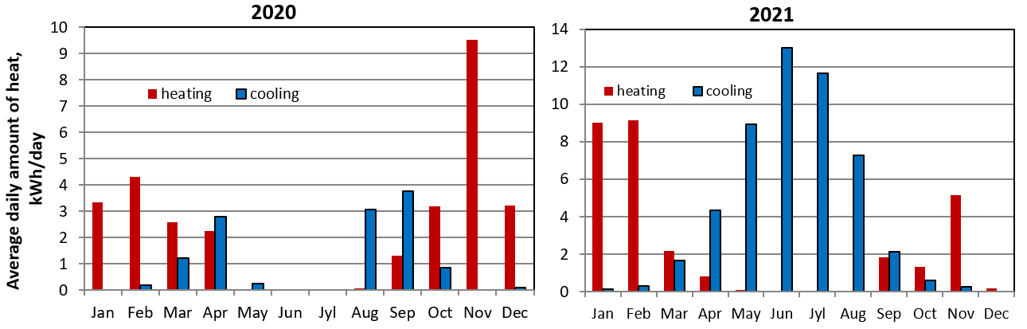
a) b)
Fig. 7. The average daily amount of heat extracted during heating and released during air cooling modes using an EAHE for 2020 (a) and 2021 (b), respectively

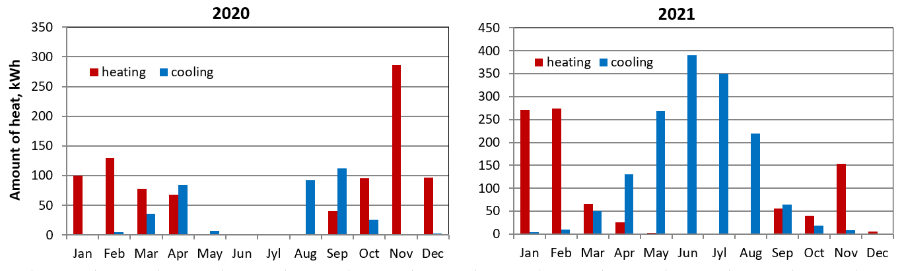
a) b)
Fig. 8. The total monthly amount of heat extracted during heating and released during air cooling modes using an EAHE for 2020 (a) and 2021 (b), respectively

Figure 9 shows the monthly values of the coefficient of effectiveness of the use of the EAHE. This coefficient is the ratio, respectively, of the amount of heat extracted during heating and released during air cooling modes using the geothermal ventilation system to the amount of consumed electrical energy to drive the axial fan.
It should be noted that the most significant thermal contribution from the operation of the EAHE takes place, respectively, in the middle of the warm and cold periods of the year, when the largest temperature difference between the outside air and the soil mass is observed. It can also be stated that in the off-season, using an EAHE in the regenerator mode is energetically inefficient since the above-mentioned temperature difference is insignificant.
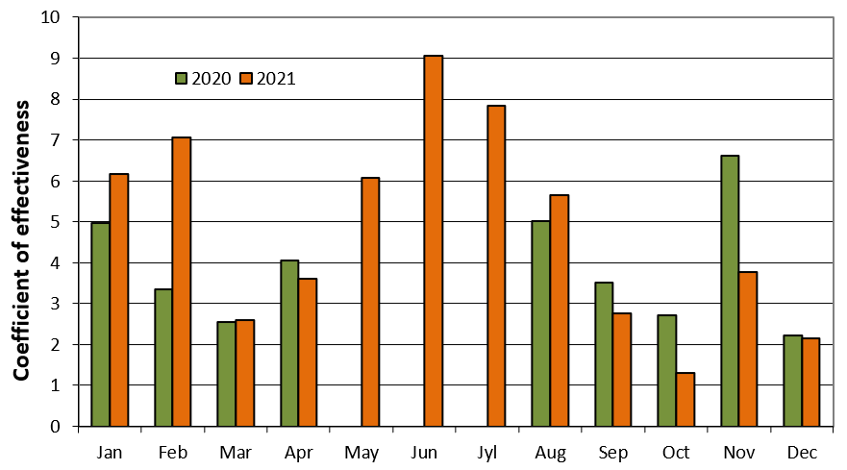
Fig. 9. Change in the values of the coefficient of effectiveness of the use of the EAHE during 2020-2021

This hypothesis is confirmed by the quantitative assessment of the effectiveness of the use of the earth-to-air heat exchanger with the help of the corresponding coefficient for the years of its operation.
5. Conclusions
In the warm period of the year, with significant daily fluctuations in the outside air temperature, the considered EAHE works in the regenerator mode. At the same time, the greatest value of the amount of heat released to the soil mass and the highest efficiency of air cooling takes place.
It is advisable to control the temperature of the outlet of EAHE to exclude condensate formation in the spring period of operation of the heat exchanger when the values of the average daily temperature of the outside air almost coincide with those of the soil mass near the heat exchanger.
In order to increase the energy efficiency of the building, the amount of heat that can be usefully used for seasonal maintenance of the thermal conditions of the premises is decisive. At the same time, using EAHE is one of the necessary tools for minimizing energy consumption for modern acclimatization systems.
References
Agrawal, K., Misra, R., Bhardwaj, M., Das Agrawal, G., Mathur, A. (2019). Computational Fluid Dynamics Simulation Based Comparison of Different Pipe Layouts in an EATHE System for Cooling Operation. ASME. J. Thermal Sci. Eng. Appl, 11, DOI: 10.1115/1.4042856
Basok, B., Bazeev, E. (2017). Innovative technologies for buildings are a priority for increasing energy efficiency in Ukraine. Thermophysics and Thermal Power Engineering, 39(4), 61-68. DOI: 10.31472/ihe.4.2017.09
Basok, B., Novitska, М. (2017). Thermophysical modeling of an air-ground heat exchanger for a thermal curtain of front walls of an experimental energy-efficient building. Thermophysics and Thermal Power Engineering, 39(1), 49-52. DOI: 10. 31472/ihe.1.2017.07
Basok, B., Novitska, M., Goncharuk, S., Moroz, M., Tymoshchenko, A. (2019). Experimental Passive House of the Institute of Engineering Thermophysics NAS of Ukraine. IEEE 6th International Conference on Energy Smart Systems (ESS),
108-111, DOI: 10.1109/ESS.2019.8764182
Basok, B., Novitska, M., Bozhko, I., Priemchenko, V., Tkachenko, M. (2020). Smart geothermal ventilation system. IEEE 7th International Conference on Energy Smart Systems (ESS), 226-229, DOI: 10.1109/ESS50319.2020.9160244
Basok, B., Novitska, М. Nedbailo, A., Tkachenko M., Bozhko I. (2021a) Prediction of the thermal state of the earth-to-air heat exchanger using an artificial neural network. POWER ENGINEERING: economics, technique, ecology, 2, 95-101.
Basok B, Bozhko I, Novitska M, Nedbailo A, Tkachenko M. (2021b) Numerical Modeling and Experimental Studies of the Operational Parameters of the Earth-To-Air Heat Exchanger of the Geothermal Ventilation System. Rocznik Ochrona Środowiska, 23, 42-64. DOI: 10.54740/ros.2021.003
Díaz-Hernández, H., Macias-Melo, E., Aguilar-Castro, K., Hernández-Pérez, I., Xamán, J., Serrano-Arellano, J., López-Manrique, L. (2020). Experimenta lstudy of an earth to air heat exchanger (EAHE) for warm humid climatic conditions, Geothermics, 84, DOI: 10.1016/j.geothermics.2019.101741
Koshlak, H., Pavlenko, A. (2019). Method of formation of thermophysical properties of porous materials. Rocznik Ochrona Środowiska, 21(2), 1253-1262.
Mihalakakou, G. (2003). On the heating potential of a single buried pipe using deterministic and intelligent techniques. Renew. Energy, 28(6), 917-927.
Pavlenko, A., Szkarowski, A., Janta-Lipińska, S. (2014). Research on burning of water black oil emulsions. Rocznik Ochrona Środowiska, 16(1), 376-385.
Pavlenko, A., Koshlak, H. (2015). Production of porous material with projected thermophysical characteristics. Metallurgical and Mining Industry, 7(1), 123-127.
Pavlenko, A., Szkarowski, A. (2018). Thermal insulation materials with high-porous structure based on the soluble glass and technogenic mineral fillers. Rocznik Ochrona Środowiska, 20, 725-740.
Pfafferott, J. (2003). Evaluation of earth-to-air heat exchangers with a standardized method to calculate energy efficiency. Energy and Buildings, 35, 971-983.
Tzaferis, A., Liparakis, D., Santamouris, M., Argiriou, A. (1992). Analysis of the accuracy and sensitivity of eight models to predict the performance of earth-to-air heat exchangers. Energy and buildings, 18(1), 35-43.

