 | Rocznik Ochrona Środowiska
 | Volume 24 | Year 2022 ISSN 2720-7501 | pp. 74-82
 | https://doi.org/10.54740/ros.2022.006 open access
 | Received: 13 June 2022 Accepted: 05 July 2022 Published: 14 November 2022
Use of Eco-friendly Protective Compounds to Increase Crack Resistance of Timber Structures
Alexander Shkarovskiy*
Koszalin University of Technology, Poland
Saint Petersburg State University of Architecture and Civil Engineering, Russia
https://orcid.org/0000-0002-2381-6534
Stefania Mironova
Saint Petersburg State University of Architecture and Civil Engineering, Russia
https://orcid.org/0000-0003-2730-017X
Shirali Mamedov
Saint Petersburg State University of Architecture and Civil Engineering, Russia
https://orcid.org/0000-0003-0366-1085
Egor Danilov
Saint Petersburg State University of Architecture and Civil Engineering, Russia
https://orcid.org/0000-0002-8919-4600
*corresponding author’s e-mail: szkarowski@wp.pl
Abstract: The paper presents the research results on using eco-friendly impregnation materials to reduce cracking in load-bearing timber elements. The behaviour of pine elements was studied when impregnation materials based on linseed oil were used. Statistical data are given on the reduction in the growth rate of the length and width of cracks, dependent on the number of protective layers of the finishing material. The effect of the absence of cracks on timber elements during atmospheric drying is described, considering the use of a three-layer paint and varnish coating. The effect of the increase in timber structures’ durability and corresponding cost and material consumption reduction in timber structures have been proven.
Keywords: timber structures, crack resistance, durability, eco-friendly protective materials
1. Introduction
Wood is the most eco-friendly building material, creating a comfortable and health-preserving environment. However, providing the durability of timber structures is an important problem. (Chernykh et al. 2020). One of the most significant shortcomings of timber as a building material is the presence of defects and damage in the form of cracks associated with the impact of force and technological peculiarities. (Frühwald 2007). When designing new structures and products from solid and glued timber and strengthening them, the influence of these defects has to be taken into account by increasing the safety factor (European Standard 2019, Code of Rules 2017), as a result, their material consumption increases, which affects consumption resources and ecology negatively in general. (Bi et al. 2022). Therefore, studying the causes of cracks, development of methods for their diagnosis and control (Sandoz & Netterer 1996), as well as the way to increase the crack resistance of products and structures made of solid and glued timber (Samyn 2022, Tarım & Küçükali 2017) is a relevant issue for modern research to extend the use of timber in construction (Berge 2007).
The movement of moisture in the log’s transverse direction begins when the moisture on the surface reaches the hygroscopicity limit. Between the inner layers, where moisture is in the cell cavities, and the surface, where moisture is only in the walls, there is a difference in capillary pressure, which is the stimulus for the movement of moisture (Ugolev 1971). The removal of bound moisture from the surface layers of the logs forms an uneven deformation over the section, i.e. surface wood dries out, and the layers following the surface retain their original dimensions. When the tensile stresses reach the limiting values, a grid of microcracks is formed on the surface of the log, which, during their development, increase and combine with each other, forming larger cracks, which, ultimately, when combined with other similar cracks, form a macrocrack (Glukhikh 2007). These cracks have a radial direction since, due to the weak bond between the core rays and wood fibres, the rupture of the wood tissue runs along the core rays (Bashkirova et al. 2022, Serov & Labudin 2013).
There are many ways to increase the crack resistance of timber (Chernykh et al. 2021). One of them is the use of special coatings that will protect the log house from the precipitation effects and serve as a barrier to moisture penetration (Tang et al. 2021). Historically, wax, paraffin, bituminous resins, a mixture of drying oil and lime, tree resin and chalk were used for these purposes (Belyaev et al. 2021). However, these materials have some drawbacks: they melt under the influence of sun rays (Onegin & Sergeevichev 2019).
The Authors undertook a series of systematic studies on the use of new materials for the protective coating of wood, devoid of this drawback. At the same time, emphasis was placed not only on the high technological properties of the material – a decrease in crack resistance but also on the environmental friendliness of the composition.
2. Materials and Methods
To prevent cracking, the authors made a comparative analysis of crack formation during the treatment of logs with oil-wax protective compounds from “Biofa” (Germany).
The following materials presented on the European market were studied (designation of articles according to the assortment of the company “Biofa”):
- primer – oil primer-antiseptic, art. 8750 (FD-EW-875010), it contains linseed and wood oils, desiccant, aliphatic hydrocarbons, biocidal additives;
- the primary coating – azure for wood, art. 1075, it contains linseed and other vegetable oils, rosin ester, fatty acid esters, desiccant, zinc oxide, and aliphatic hydrocarbons;
- top coat – protective oil, art. 2043 contains linseed oil, wood oil, fatty acid esters, rosin ester, aliphatic hydrocarbons, desiccant, and micro-wax.

Linseed oil is the main film-forming component of all “Biofa” materials used in the study. Although linseed oil, like all vegetable oils, is a complex mix, the main component (~ 95%) is full esters of glycerol and fatty acids, primarily unsaturated (triglycerides) of the general formula:
where:
R, R’, R” – alkyl residues of monobasic fatty acids of normal structure.

Linseed oil molecules are about 50 times smaller than synthetic resins and about ten times smaller than the densest wood pores (Sorokin et al. 1989, Chernykh 2010). Due to this factor, it penetrates deep into the wood and is well absorbed into the pores. As a result, the treated surfaces become mechanically and chemically more resistant since linseed oil belongs to the group of oils with a high drying capacity.
The ability to dry (i.e., to form a film) is determined by the number of double bonds in the triglyceride molecule and their mutual arrangement. Acid residues characterize drying oils with three and two double bonds in triglycerides (the total amount of such triglycerides reaches 70%). The primary acids that makeup flaxseed oil triglyceride include (Ashkenazi 1978):
- linolenic
СНз–СН₂–СН=СН–СН₂–СН=СН–СН₂–СН=СН–(СН₂)₇–СООН (52%);
- linoleic
СH₃–(СН₂)₄–СН=СН–СН₂–СН=СН–(СН₂)₇–СООН (16%);
- oleic
(СН₂)₇–СН=СН–(СН₂)₇–СООН (22%).
The curing process of materials containing vegetable oils is an intermolecular interaction along the double bonds of triglyceride fatty acid residues (Yona et al. 2021).
Under the action of oxidative polymerization initiators (desiccants), chain polymerization and oxypolymerization processes occur, leading to the formation of spatial polymers with intermolecular bonds of the
–C–C– and –C–O–C–
type. The introduction of mineral fillers improves the mechanical strength of the formed film.
However, wooden surfaces treated with linseed oil only have a pronounced tendency to be dirty. (Prieto & Kiene 2018). In order to eliminate this disadvantage, materials are used that, along with vegetable oils, include various waxes that form a thin layer on the surface, which increases abrasion resistance and gives the wooden surface dirt and water repellency (Eliseeva 2000). Compositions consisting of oils and waxes combine the advantages of both components and contribute to increasing the durability of timber structures.
3. Results and Discussion
Round pine logs with a diameter of 260 mm of natural moisture were used during the tests. All the samples were kept outdoors (with no shelter) for 11 weeks.
The samples were visually inspected daily; the formed cracks were evaluated using a probe, a depth gauge, and a ruler. Once a week, the moisture content of the samples was measured by the weighting method. In the case of a sharp increase in the number of cracks, the moisture content was measured twice a week. The dynamics of the appearance of cracks on the rounded logs showed the dependence on the number of applied layers of paint and varnish material: on the fourth week of the experiment, cracks appeared on samples without coatings, while on the samples with a three-layer coating, the first cracks were recorded on the ninth week. Logs with a two-layer coating showed an intermediate result: cracks appeared in the eighth week.
The growth of the width and length of cracks is presented in graphs in Figures 1, and 2. At the same time, the primer art is on samples with a three-layer coating. 8750 + azure art. 1075 + top coat art. 2043, the minimum number of cracks was observed, with the most minor geometric parameters (length and width). Such a protective coating system can be recommended as the most effective for a natural timber structure.

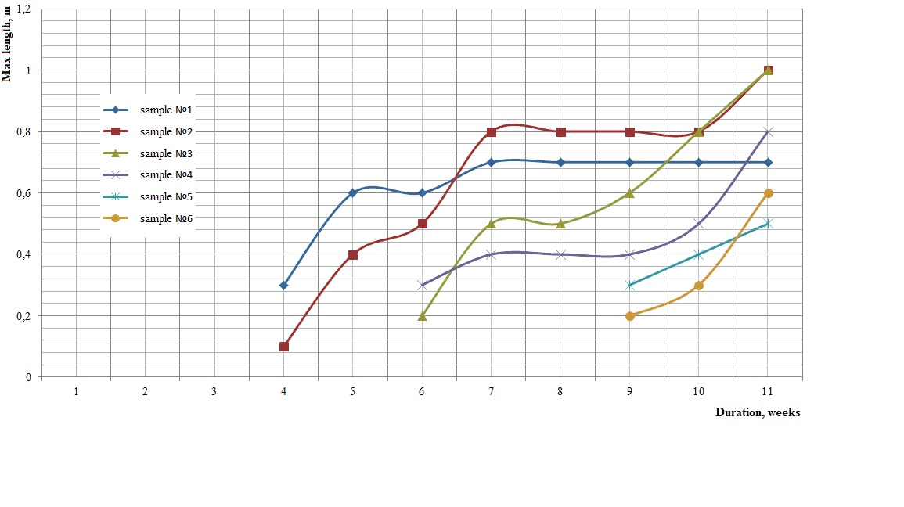
Fig. 1. Change of cracks length

Analysis of the obtained data on the use of protective coatings “Biofa” (Germany) allows us to state:
- application of a two-layer coating – primer art. 8750 + top coat art. 2043 (samples №3 and №4) slows down the process of cracking logs by two times,
- application of a three-layer coating – primer art.8750 + azure art.1075 + top coating art. 2043 (samples №5 and №6) slows down the cracking process by three times.

The humidity decreased slowly for samples coated with oil-wax compounds (Fig. 3), and no increase was observed due to rain.

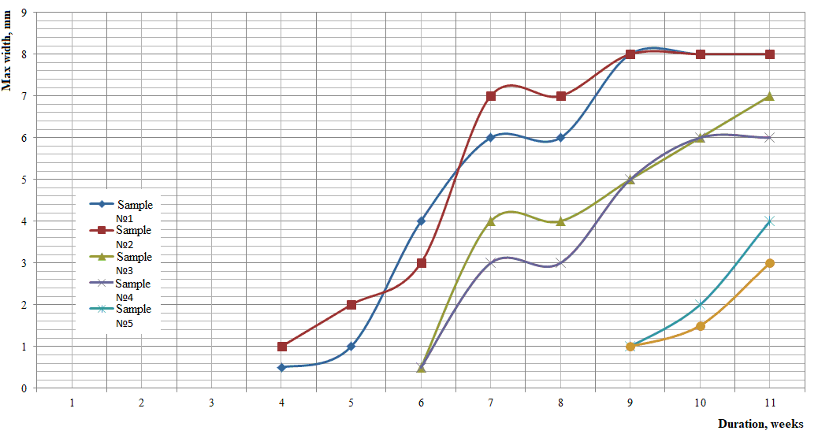
Fig. 2. Change of cracks width

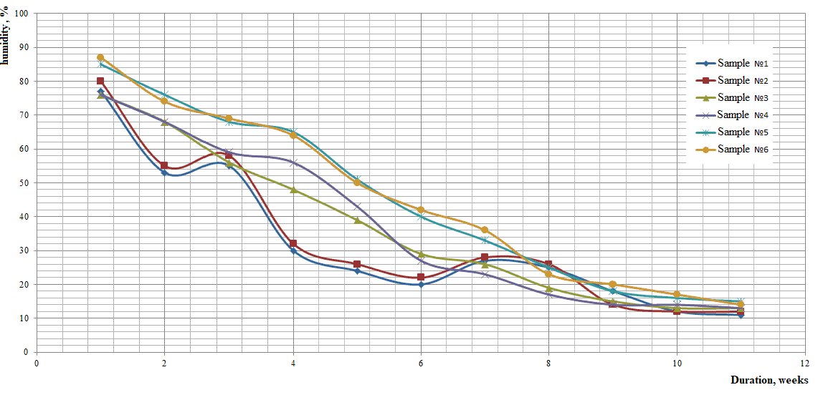
Fig. 3. Change of samples humidity

Even more illustrative is the visual comparison of samples of pine products after drying under identical conditions, shown in Fig. 4. On the sample with a three-layer coating with an eco-friendly protective agent, the onset of cracking can only be detected by microscopic examination.

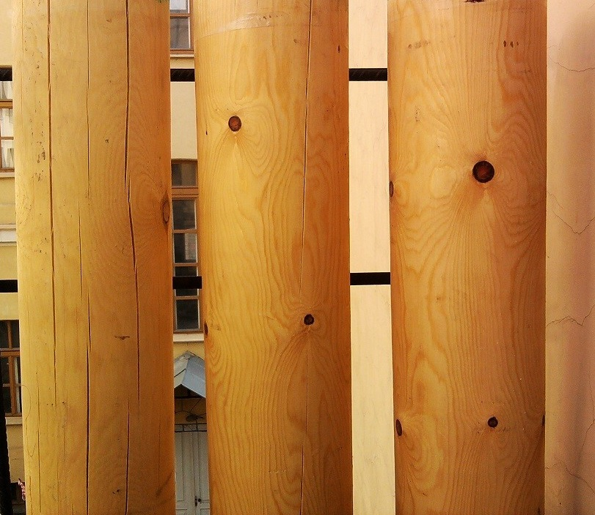
Fig. 4. Appearance of samples after drying process for 11 weeks (from left to right: an untreated sample, a two-layer coated sample, a three-layer coated sample)
4. Conclusions
The performed research allows us to recommend eco-friendly certified materials from the European manufacturer (“Biofa”, Germany) for wide use in timber construction.
The research has proven the high efficiency of using the system of oil-wax coatings offered by Biofa for wood processing to reduce its tendency to cracking.
Applying a two-layer coating slows down the process of wood cracking by two times, and a three-layer one – at least three times compared to the untreated samples.
A decrease in the cracking rate means a proven effect of increasing the durability of timber structures and a corresponding reduction in construction cost and material consumption.
References
Ashkenazi, E. (1978). Anisotropy of wood and wooden materials. Moscow: Forest industry (in Russian).
Bashkirova, K.A., Gazeev, M.V., Sviridov, A.V. (2022). Features of planning an experiment to develop a new paint and varnish composition for the formation of protective and decorative coatings on wood products. Conference Series: Earth and Environmental Science, 949(1). DOI: 10.1088/1755-1315/949/1/012065
Belyaev, A.O., Danilov, V.E., Morozova, M.V. (2021). Physical and mechanical properties of the surface of pine wood modified with an organomineral composition. Journal of Physics: Conference Series. 2124(1). DOI: 10.1088/1742-6596/2124/1/012019
Berge, B. (2009). Ecology of building materials. 2nd ed. Abingdon: Routledge.
Bi, Z., Morrell, J., Lei, Y., Yan, L., Ji, M. (2022). Eco-friendly and mildly modification of wood cell walls with heat treated wood extracts to improve wood decay resistance. Industrial Crops and Products, 184. 115079. DOI: 10.1016/j.indcrop.2022.115079
Chernykh, A. (2010). Timber house construction. Architecture. Structures. Estimate. St Petersburg: SPbGASU (in Russian).
Chernykh, A., Mironova, S., Mamedov S. (2020). Ecological peculiarities and problems of glued timber structures reinforcement. Rocznik Ochrona Srodowiska, 22(1). 203-213.
Chernykh, A., Glukhikh, V., Akopyan, A. (2021). On the issue of shrinkage stresses in the early and late zones of the annual layers of wood. Proceedings of St. Petersburg State Forest Technical Academy. No 201. 166-176 (in Russian).
Code of Rules. SP 64.13330.2017. Timber structures. Updated edition of SNiP 11-25-80 (2017). Moscow: The Ministry of Construction of Russia (in Russian).
Eliseeva, L. (2000). Criteria for choosing paints and varnishes for facades finishing. Building Materials, 10. 8-11 (in Russian).
European Standart CSN EN 14081-1. Timber structures - Strength graded structural timber with rectangular cross section - Part 1: General requirements (2019). Brussels: European Committee for Standardization.
Frühwald, A. (2007). The Ecology of Timber Utilization Life Cycle Assessment Carbon Management, etc. Hamburg: University of Hamburg.
Glukhikh, V. (2007). Anisotropy of wood as a factor to improve the quality of lumber drying. St. Petersburg: Publishing House of St. Petersburg University (in Russian).
Onegin, V., Sergeevichev, A. (2019). Features of the interaction of paint and varnish materials with the substrate. In: Scientific and technical conference on the results of research work in 2019. Collection of articles based on conference materials. Rep. Editor V. Sokolova. 375-378 (in Russian).
Prieto, J., Kiene, J. (2018). Wood Coatings. Hannover: Vincentz Network.
Samyn, P., Bosmans, J., Cosemans, P. (2022). Influence of UV curing parameters for bio-based versus fossil-based acrylates in mechanical abrasion. Express Polymer Letters, 16(7). 718-734. DOI: 10.3144/expresspolymlett.2022.53
Serov, E., Labudin, B. (2013). Glued timber structures: condition and development problems. Bulletin of higher educational institutions, 2(332). 137-146 (in Russian).
Sorokin, M., Kochnova, Z., Shode, L. (1989). Chemistry and technology of film-forming substances. Moscow: Chemistry (in Russian).
Tang, G. Li, Y., Buzoglu, Kurnaz, L., Li, J. (2021). Development of eco-friendly antifungal coatings by curing natural seed oils on wood. Progress in Organic Coatings, 161. 106512. DOI: 10.1016/j.porgcoat.2021.106512.
Tarım, A., Küçükali, U.F. (2017). Evaluating the Ecological Architecture: using the Wooden Material. Intern. Jour. of Archit. and Designe, 3(2). 1-12.
Ugolev, B. (1977). Deformability of wood and stress during drying. Moscow: Forest industry (in Russian).
Yona, A.M.C., Žigon, J., Kamlo, A.N., Pavlič, M., Dahle, S., Petrič, M. (2021). Preparation, surface characterization, and water resistance of silicate and sol‐silicate inorganic-organic hybrid dispersion coatings for wood. Materials, 14(13). DOI: 10.3390/ ma14133559.

